Concurrently Probing the Mechanical and Electrical Characteristics of Living Cells via an Integrated Microdevice
Johnson Q. Cui^{a,b}†, Ye Tian^{a,b,c}†, Zhihao Wu^{d,e}, Lu Zhang^{f}, William Chi-Shing Cho ^{g}, Shuhuai Yao^{f,h}, Yuan Lin ^{a,b,c}*
ª Department of Mechanical Engineering, The University of Hong Kong, Pok Fu Lam, Hong Kong 999077, China

^{b} Advanced Biomedical Instrumentation Centre, Hong Kong Science Park, Shatin, New Territories, Hong Kong 999077, China

^{c} HKU-Shenzhen Institute of Research and Innovation (HKU-SIRI), Shenzhen, Guangdong 518000, China

^{d} The Hong Kong University of Science and Technology (Guangzhou), Function Hub Nansha, Guangzhou, Guangdong 511400, China

^{e} Individualized Interdisciplinary Program, The Hong Kong University of Science and Technology, Clear Water Bay, Kowloon, Hong Kong 999077, China

^{f} Department of Chemical and Biological Engineering, The Hong Kong University of Science and Technology, Clear Water Bay, Kowloon, Hong Kong 999077, China

^{g} Department of Clinical Oncology, Queen Elizabeth Hospital, Hong Kong 999077, China

^{h} Department of Mechanical and Aerospace Engineering, The Hong Kong University of Science and Technology, Clear Water Bay, Kowloon, Hong Kong 999077, China

† These authors contributed equally
Corresponding Authors
*E-mail: ylin@hku.hk
Abstract
The mechanical and electrical properties of cells serve as critical indicators of their physiological and pathological state. Currently, distinct setups are required to measure the electrical and mechanical response of cells. In addition, most existing methods such as optical trap (OT) and atomic force microscope (AFM) are labor-intensive, expensive, and low-throughput. Here, we developed a microdevice that integrates automated cell trapping, deformation and electric impedance spectroscopy to overcome these limitations. Our device enables parallel aspiration of tens of trapped cells in a highly scalable manner by simply adjusting the applied pressures, allowing for rapid probing of the dynamic viscoelastic properties of cells. Furthermore, embedded microelectrodes enable concurrent investigations of the electrical impedance of cells. Through testing on different cell types, our platform demonstrated superior capabilities in comprehensive cell characterization and phenotyping, highlighting its great potential as a versatile tool for single cell analysis, drug screening, and disease detection.

Keywords: cell trapping, single cell characterization, cell viscoelasticity, cellular impedance, microfluidics, algorithm-assisted

Increasing evidence has shown that the mechanical and electrical responses of cells play critical roles in many biological and pathological processes, highlighting their great potentials as novel markers for diagnostics and drug screening[1]. For instance, studies have verified that cancer cells are generally softer compared to their benign counterparts[2]. In addition, the stiffness of tumor cells has been found to be negatively correlated to their invasiveness, making it a valuable indicator for assessing the metastatic potential of cell populations[3]. Recently, the viscous properties of cells or tissues were also reported to be related to the progression of diseases[4,5]. On the other hand, the electrical properties of cells provide valuable insights into their membrane morphology, ion channel status, cytoplasmic composition, and nuclear size[6]. For example, the electrical response of cell membrane directly reflects its ion channel status (e.g. Na⁺/K⁺ pump), which is responsible for maintaining the concentration gradients of ions across the cell membrane[7]. Consequently, cellular electrical properties have been widely used in cell phenotyping[8], differentiation monitoring[9], and drug screening[10]. For these reasons, intense efforts have been invested in the past few decades to the development of novel methods for measuring these physical properties of living cells.

Currently, mechanical characterization of cells at the single-cell level relies on techniques such as atomic force microscopy (AFM)[11], optical stretching[12], parallel plate rheometry[13], and pipette aspiration[14], where the underlying idea is to induce and analyze the deformation of cells under various external forces to extract its mechanical characteristics. However, the utilization of these methods typically requires expensive instruments and skilled personnel, making them difficult to achieve parallel measurement and impractical for non-specialized laboratory environments. Meanwhile, advancements have also been made in the field of cellular electrical property measurement, with methods such as impedance flow cytometry (IFC)[15-17] and electric impedance spectroscopy (EIS)[18-20] offering promising avenues. Most recently, efforts have been made to use the passage time or changed impedance signals [21] of cells in a narrow channel to estimate their deformation and mechanical properties. However, these kinds of measurements are indirect and therefore will be hard to achieve the precise control and accuracy of gold-standard single-cell characterization methods like AFM indentation and micropipette aspiration.

To increase the throughput for cell phenotyping, microfluidics has emerged as a promising strategy, facilitating the parallel manipulation of a significant cell population within purposefully designed testing zones, thus enabling rapid analysis. Indeed, various microfluidic devices have been developed to characterize the deformability[22], cortical tension, elastic modulus[23-25] and viscoelastic properties[26-28] of cells. Furthermore, advances in microfabrication technology have allowed the introduction of microelectrodes in the microfluidic chip, enabling functions such as electrorotation[29], EIS and IFC[30]. In this letter, building upon these observations, we developed a novel device to achieve concurrent single-cell mechanical and electrical characterization in a rapid and automatic manner. The integrated chip consists of a layer of microfluidic channels for cell trapping at multiple locations and a glass substrate deposited with gold electrodes, which enables parallel micro-pipette aspiration and EIS tests on individual cells using the same device. Furthermore, by employing a self-developed algorithm for cell contour segmentation and impedance spectrum analysis, mechanical and electrical properties of cells are calculated automatically according to the tests. Finally, by applying our platform to MCF-7 and HUVEC cells, we have demonstrated its capability to achieve accurate and comprehensive cell characterization and phenotyping.

As shown in Fig. 1a-c, our device consists of two layers, the top PDMS layer was fabricated from a standard soft lithography process, while the bottom glass substrate with patterned Au/Cr electrodes was fabricated with the lift-off technique, which were aligned and bonded via oxygen plasma to form a sealed device (refer to Supplementary Information for the fabrication details). Microchannels were subsequently treated with 1% Bovine Serum Albumin (BSA) solution to reduce possible adhesion between the cell and channel wall. In the PDMS layer, a series of hydrodynamic traps are connected for sequential cell separation and trapping. Due to the symmetry of the design, cells will travel through the middle channel by default and get trapped by the constriction part, and subsequent cells will go through the bypass channel and get trapped by the following traps. In this fashion, individual cells are sequentially trapped in designated locations in the chip. In our design, 20 trapping units are connected in series to form one single row of traps, which can be easily duplicated in parallel to increase the capacity. The width of the constriction channel is 5 μm so that cells with diameters larger than 8 μm can be robustly trapped, and the height of the channels is 15 μm so untrapped cells can flow freely (Picture of the device in Supplementary Fig. S1).
Similar to conventional micropipette aspiration, trapped cells can be further sucked into the constriction channel by aspiration pressure. As indicated in Fig. 1d, the dynamic response of cells during this process can be recorded and fed to an algorithm for automated measurement and calculation of their mechanical properties. Meanwhile, a potentiostat is connected to the electrode pairs on the substrate for conducting EIS, from which the electrical properties of cells can be inferred. In this fashion, the mechanical and electrical characteristics of cells can be obtained in a single setup.
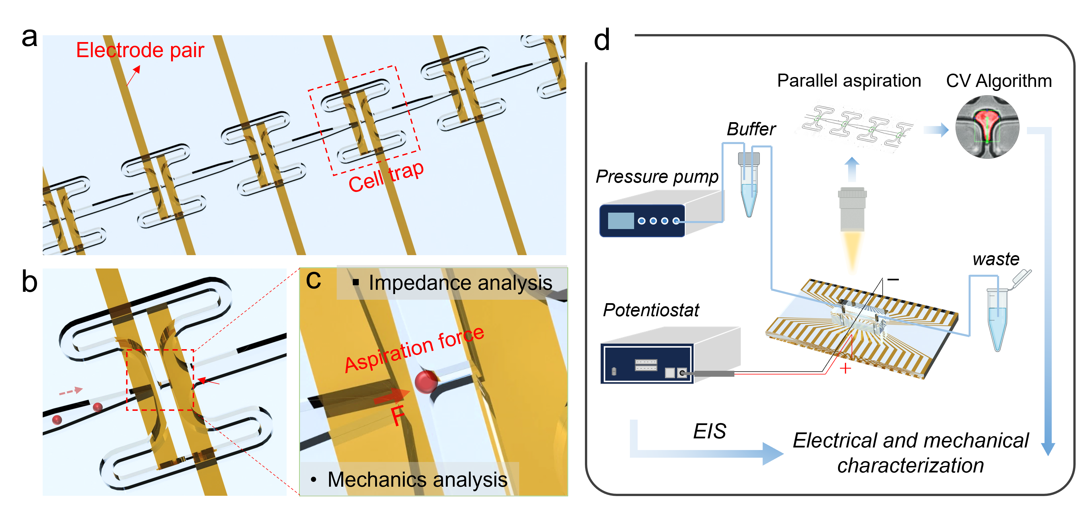
Figure. 1 a. Overview of the assembled device, which consists of a PDMS layer for cell trapping and a glass substrate deposited with interdigitated electrode pairs. b. A single-cell trapping unit with a symmetrical design enables sequential single-cell trapping. c. Enlarged view of cell deformation process where an aspiration pressure is exerted on the captured cell to trigger its deformation, meanwhile the impedance analysis can be conducted via the embedded microelectrodes. d. Experimental setup for achieving mechanical and electrical characterization of cells with our device. The deformation process was captured and analyzed using a computer vision algorithm for automated cell shape detection and calculation of mechanical properties. The electrode was connected to a potentiostat for conducting EIS, which enables electrical measurement of cells.

To accurately carry out parallel micropipette aspiration tests in our device, it’s essential to map out the pressure distribution throughout the chip. Here, both theoretical analysis and simulations were carried out to estimate the pressure drop (i.e. suction pressure) experienced by the trapped cells. For the simulation in Comsol Multiphysics 5.6, the fluid was set as liquid water. Pressure distribution within the domain was solved using the Laminar Flow module, and all channel boundaries were set as rigid walls with no slip conditions, we employed the design with two parallel rows of traps, each containing 20 cell trapping units in series.

Fig. 2a illustrates the simulated pressure contours and streamline distribution throughout the whole chip when all trapping sites are occupied, and the enlarged views of selected trapping units are given in the insets. When the device is employed for cell capture, we can assume the constriction channel is completely blocked by the captured cell and therefore the pressure drop is fully exerted on the cell (Fig. 2b). The velocity profiles at selected cross-sectional areas were obtained by numerical simulations, by which the corresponding flowrate at each channel can be calculated (Supplementary Fig. S2). The pressure distribution along the centerline of the microfluidic channel is extracted and plotted in Fig. 2c, and evidently, the pressure within the chip gradually decreases from the inlet to the outlet, and the pressure drops across different trapping sites are rather uniform with an average of 148 Pa and a standard deviation of ~1 Pa. However, once all the trapping sites are occupied, the pressure drop drastically increases to around 247±1 pa due to the increased hydraulic resistance.
In addition to flow simulation, theoretical analysis was also conducted where the microfluidic channel was simplified to a hydraulic circuit for pressure distribution calculation (Supplementary Fig. S3). Given the repetitive nature of our trapping unit design, the overall pressure distribution can be calculated from the hydrodynamic resistance ($R_{h}$,) and flowrate (Q) associated with each unit. Specifically, under a fixed pressure applied at the device inlet, the pressure drop of each segment is inversely proportional to its hydraulic resistance according to Hagen-Poiseuille’s law: ΔP = Q /$R_{h}$, thus, the pressure distribution can then be determined from the number of trapping units and the hydrodynamic resistance of a single trapping unit. As indicated in Fig. 2d, this theoretical estimation agrees rather well with our simulation results. The small discrepancy could be due to the approximation of the hydrodynamic resistance of the microfluidic channel. For this reason, simulation results were adopted for the subsequent analysis in this study.
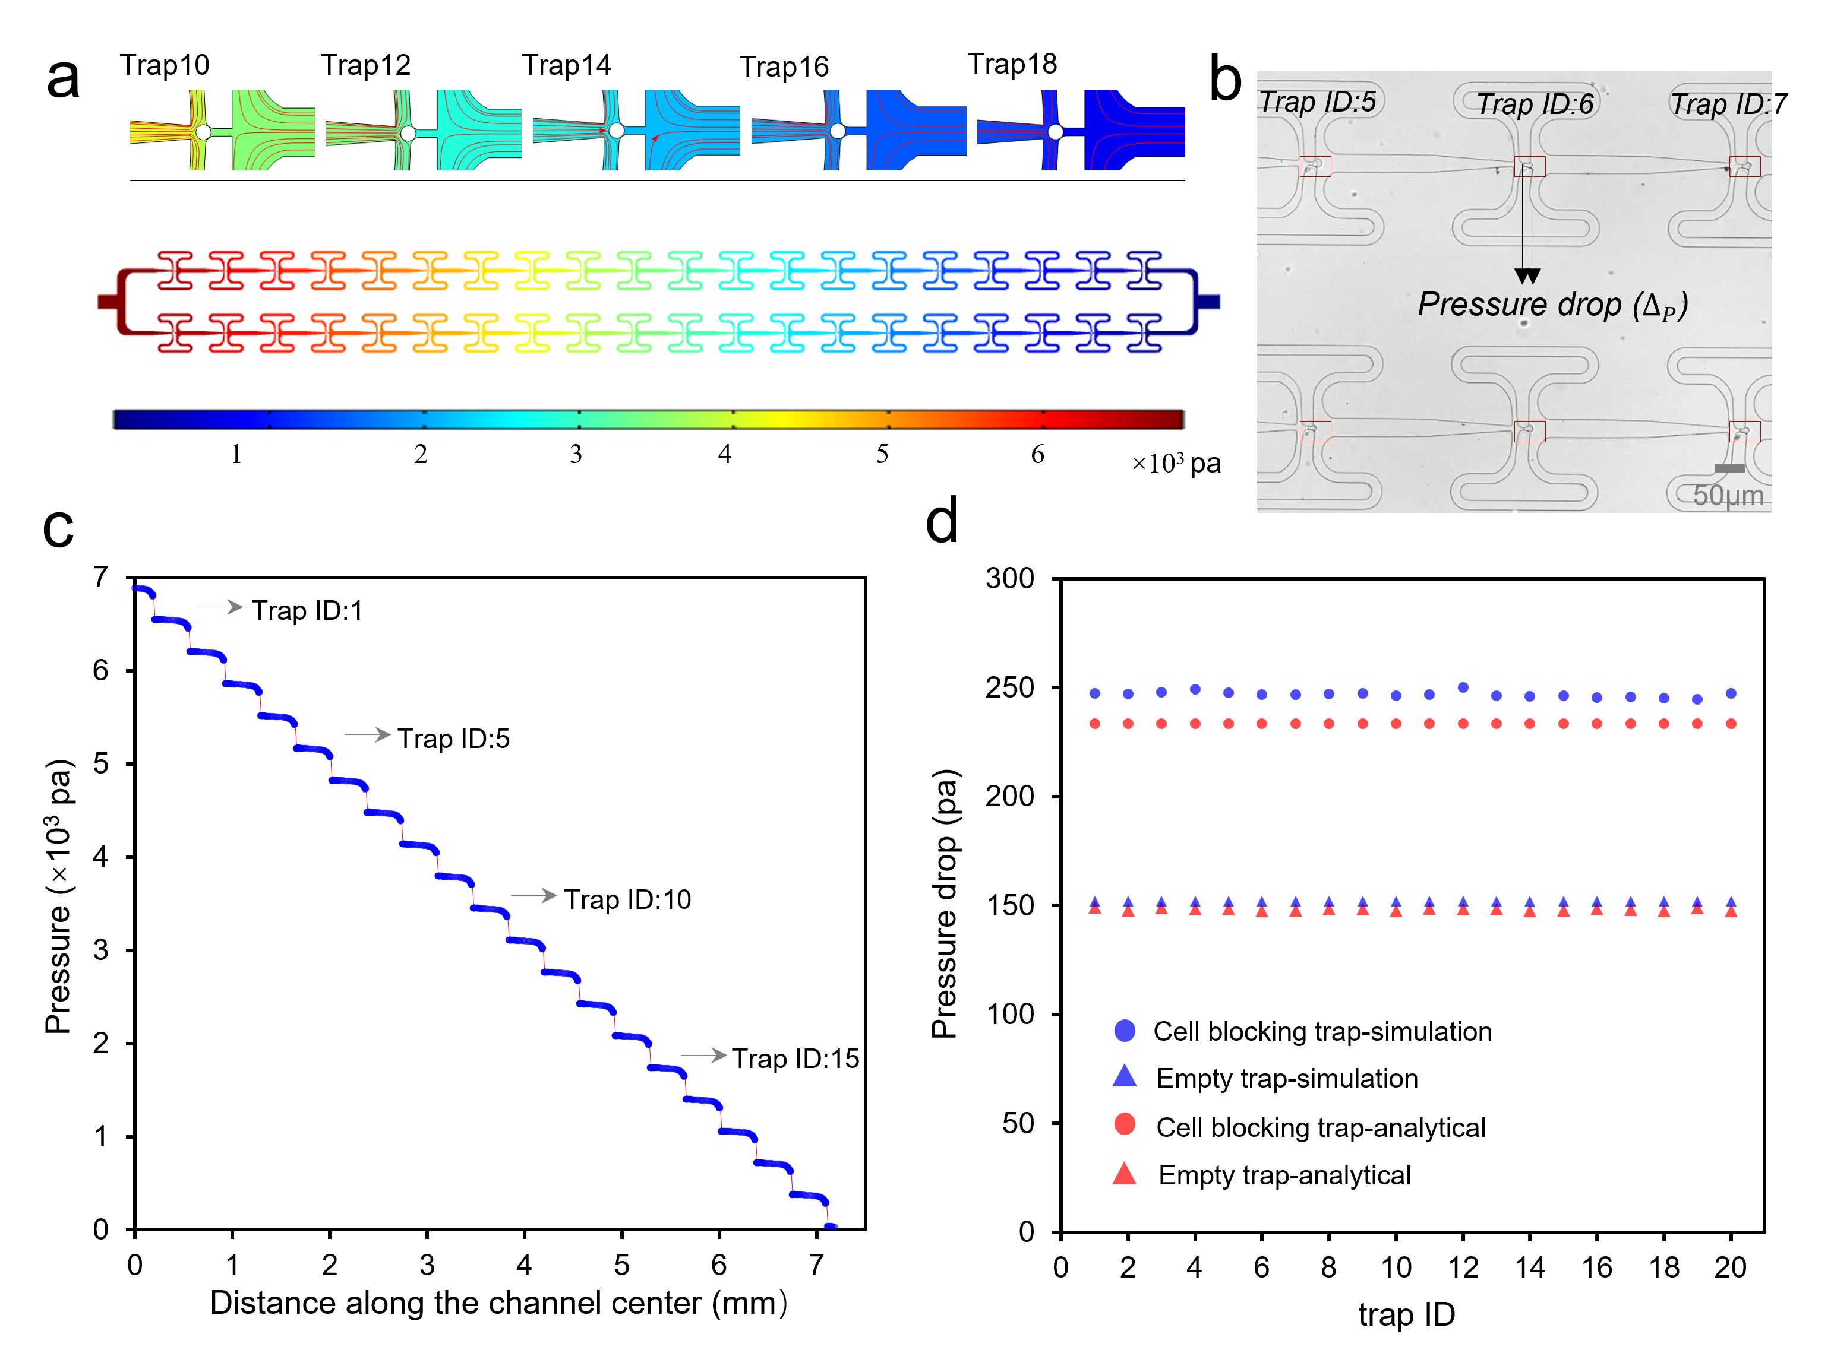
Figure. 2 a. Simulated pressure and fluid velocity distributions throughout the whole chip, the inset images depict the enlarged view of different occupied cell trapping units. b. Microscopy image showing the trapping and aspiration of six trapped cells. c. Simulated pressure profile along the centerline of our device. As expected, there exists a pressure drop across each occupied trapping unit. d. Pressure drop across all trapping sites without or without cells, both numerical simulation results and analytical calculation results are shown.

To test the trapping performance, cells were centrifuged and washed with PBS solution twice to get rid of debris. Air in the microfluidic chip was depleted using a PBS solution containing 1% BSA to ensure cells’ smooth loading. Afterwards, both MCF-7 cells and HUVEC cells were introduced into the microfluidic chip at an operating pressure between 3.45 kPa to 6.89 kPa, which is large enough to drive the cells in the chip yet not too excessive to squeeze trapped cells out of the constriction channel. As shown in Fig. 3a, a trapping efficiency of >92% was observed for both cell lines. After successful trapping of cells, a controlled pressure was used to trigger their aspiration deformation. To eliminate human errors, an algorithm for automated cellular deformation measurement and data interpretation was developed. The algorithm is based on computer vision which enables automated cell segmentation, geometric parameters extraction, and mechanical properties calculation. The workflow of the algorithm is illustrated in Fig. 3b. Essentially, the cell deformation process is first recorded in video format, which is then fed into the algorithm. For each frame, the algorithm performs binary image conversion by applying a proper threshold to facilitate edge detection and the determination of cell contours. After that, a transparent red mask is overlaid on top of the cell to indicate the cell shape and boundary, and a green bounding box is added to indicate the cell position. The pressure applied can be user-defined as the input for the algorithm and thus can easily be varied for different tests. Based on these, parameters like cell aspiration length and its evolution can be easily extracted from which key mechanical properties such as the elastic modulus and viscosity can be estimated. Fig. 3c demonstrates a microscopy view of multiple cells captured in serially connected trapping units, and Fig. 3d displays a series of time-lapsed images of the cell overlaid with the red mask under increasing aspiration pressure. Here, the thick green line segment marks the aspiration length under the applied pressure drop given at the bottom of each image. Not surprisingly, the aspiration length is positively correlated to the aspiration pressure.
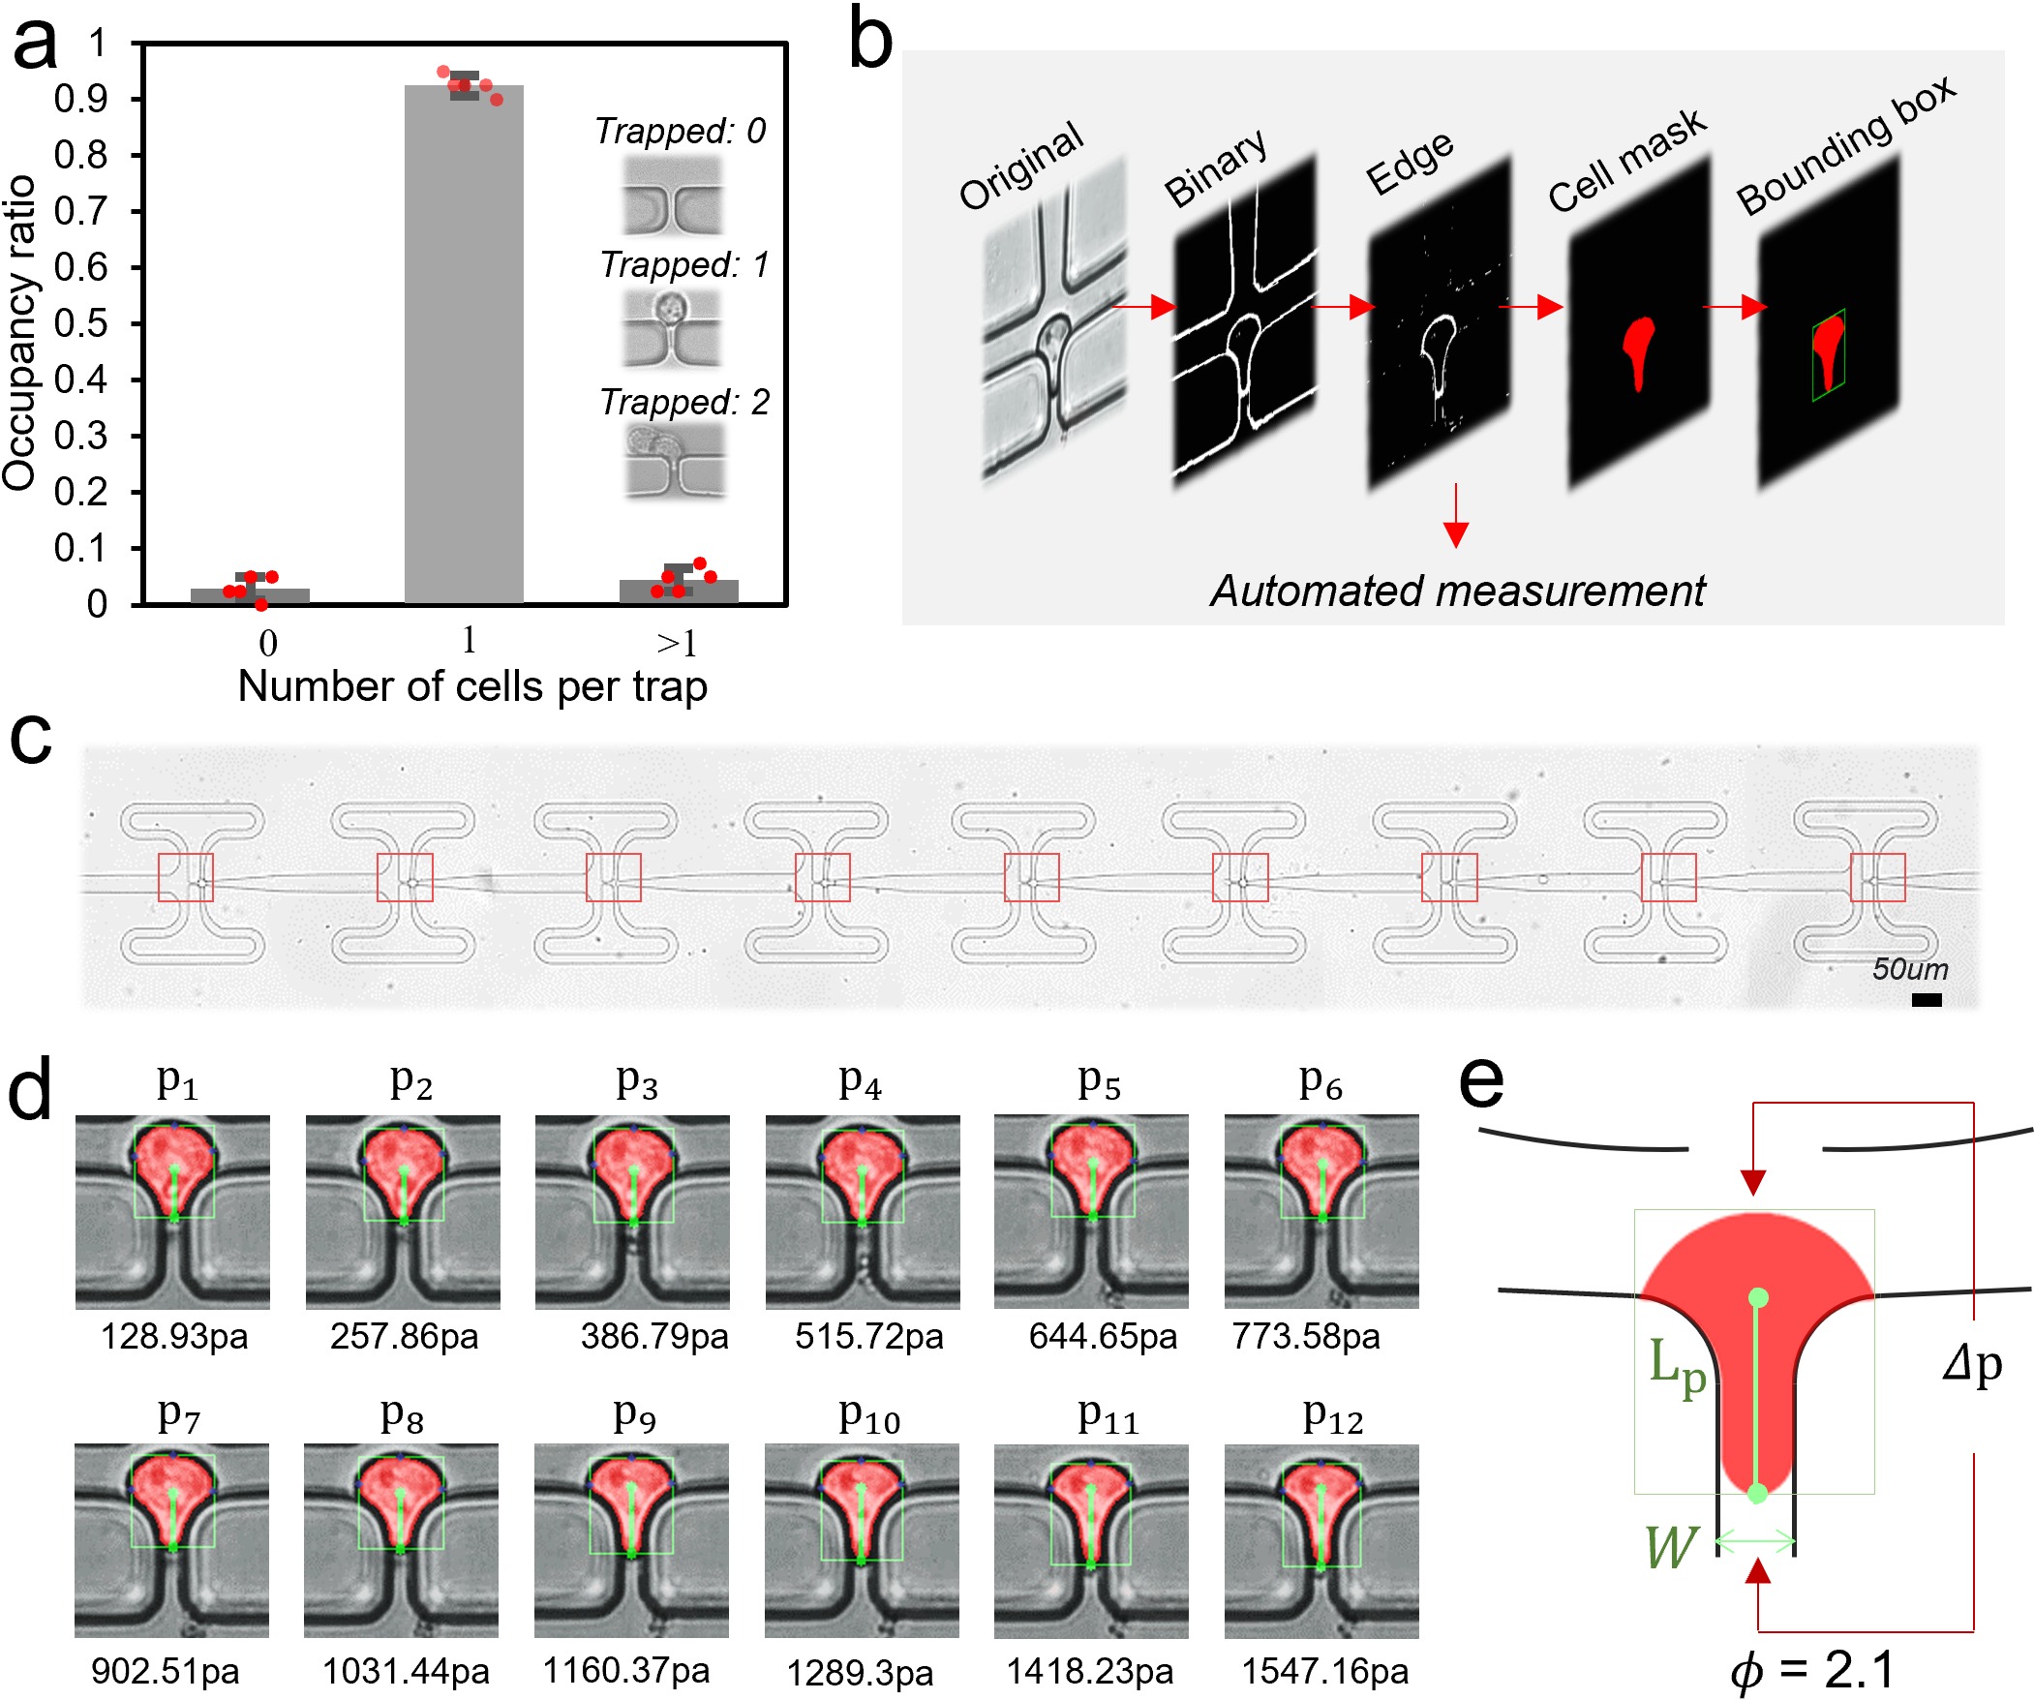
Figure. 3 a. The trapping efficiency of our device is above 92%. b. The pipeline of a custom developed computer vision algorithm for automated cell segmentation and measurement, where key quantities such as protrusion length, cell width, cell length, cell area, (gray value), and cell perimeter can all be measured and displayed in real time. c. A microscopy view of the device at work where trapped cells were marked by red squares. The scale bar represents 50μm. d. Demonstration of different protrusion lengths of a trapped MCF-7 cell under a continuously increasing aspiration pressure. The cell images were automatically segmented and overlaid in red color. A bounding box in green was also used to indicate the position of the cell. e. Schematic drawing of a deformed cell under aspiration, where $L_{p}$ is the protrusion length, W is the channel width, and $ϕ$ is a constant.

Two schemes of pressure profiles were applied to conduct parallel micropipette aspiration. In the first scheme, a slowly increasing pressure was applied at the inlet and real-time cell protrusion lengths under different pressure values were analyzed. Representative relationships between the aspiration length ($L_{p}$) and the applied pressure for MCF-7 cells and HUVEC cells are shown in Fig. 4a (as well as in Fig. S4). By treating the cell as a homogeneous elastic solid [31], its apparent modulus E can be estimated from the pressure drop $ΔP$ and $L_{p}$ as:
$E=\frac{\frac{3ΔPϕ}{2π}}{\frac{L_{ρ}}{R_{p}}}$=$\frac{3ϕ}{2π}*$ $\frac{ΔP}{\frac{L_{ρ}}{R_{p}}}$ (1)
where $R_{p}=\frac{W⋅H}{W+H}$ refers to the hydraulic radius of the constriction channel with the width ($W)$ and height ($H)$being $5μm$ and $15μm$ respectively (see Fig. 3e), and $ϕ$ is a geometry-related constant that typically assumes a value of 2.1[31]. As Fig. 4a indicates, the $L_{p} vs ΔP$ curve exhibits a bilinear trend, characterized by a gradual increase in aspiration length with the applied pressure initially. However, once a pressure threshold is surpassed, $L_{p}$exhibits a much more rapid growth with respect to $ΔP$, which is likely due to the friction between the channel/micropipette tip and the cell membrane that makes the initial entrance of the cell body into the channel difficult. By conducting line fitting on the data points above the critical pressure threshold from 20 trapped cells according to Eq. (1), the moduli of HUVEC and MCF-7 cell line were estimated to be ~201 and 448 Pa (Fig. 4b). These values are in broad agreement with previous studies[32,33].
Interestingly, after treatment with TNF-α at a concentration of 100ng/ml, a significant decrease (~30% for MCF-7 and ~20% for HUVEC cells) in the modulus of cells was observed. This is also consistent with the common knowledge that, as an inflammatory cytokine, TNF-α can increase membrane permeability[32,34], change intracellular ion concentrations [35,36] and subsequent cytoskeleton organization[37] of cells, eventually altering their mechanical properties.

In the second testing scheme, a fixed pressure of 4psi (~27.58 kPa) and 2psi (~13.79 kPa) was applied for MCF-7 and HUVEC cells respectively, and the time-dependent deformation response (i.e. the evolution of aspiration length $L_{p}$) was monitored, which allowed us to extract the viscoelastic properties of the cell. Specifically, according to Needham and Hochmuth[38], the apparent viscosity $η$ of the cell can be estimated as
$η=\frac{R_{p}Δp}{(\frac{ⅆLp}{ⅆt})m(1-\frac{R_{p}}{R}) }$ (2)
where R is the cell radius, and m is a constant taking the value of 6 empirically[39]. According to this equation, the viscosity of cells should be inversely proportional to the aspiration rate $\frac{ⅆLp}{ⅆt}$. It’s worth mentioning that this model treats the entire cell as a homogeneous droplet enclosed by the cell membrane while the influence of factors like cytoskeleton and nucleus are neglected. Therefore, the measured viscosity effectively reflects the combined effect of these subcellular structures along with the cytoplasm. Representative $Lp$ vs t curves obtained from our tests on both HUVEC and MCF-7 cells are provided in Fig. 4c (also see Fig. S4), and the corresponding viscosities for these two cell lines are calculated (based on 10 independent tests) to be around 1700 and 3000 Pa. s (Fig. 4d), respectively. It must be pointed out that many factors such as cell cycle and metabolic state have been found to influence the time-dependent response of cells, and therefore the cell viscosity measured from different methods varies in a relatively wide range, i.e. from ~10 to 10⁴ Pa. s [40]. To validate the versatility of our measurement, a cell solution with mixed cell types each labeled with distinct dyes was loaded into the chip and successfully differentiated based on their mechanical responses (refer to Fig. S5).
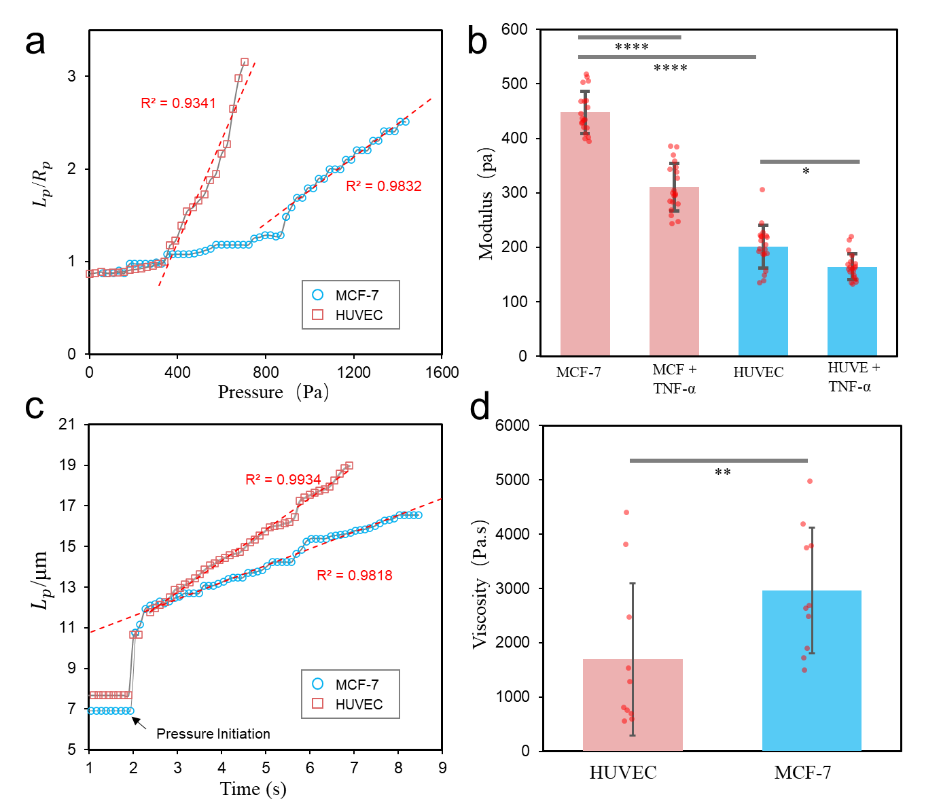
Figure. 4 a. Representative plot demonstrating the aspiration length of the cell as a function of the applied pressure difference. The linear region (above a threshold pressure) is fitted with Eq. (2) and the slope value is extracted for cell modulus estimation. b. Measured elastic moduli of different cell groups using our platform. 20 cells for each group were tested, error bars represent the standard error of the mean, and p values were obtained from the student’s t-test. c. Representative plot showing the aspiration length of cells as a function of time under a suddenly applied aspiration pressure from which the viscoelastic characteristics of cells can be inferred. d. Measured viscosity of HUVEC and MCF-7 cells. (two-tailed Student's t-test; *, 0.05 ≤ P < 0.1; **, +0.01 ≤ P < 0.05; ***, 0.001 ≤ P < 0.01; ****, p < 0.001).

For electrical properties measurement of cells, the electrode pairs on the microfluidic substrate were connected to a potentiostat, and a voltage of 0.5V was applied to the trapped cells with the frequency sweeping from 10³ Hz to 10⁷ Hz for conducting EIS. Here, we adopted a common single-shell spherical model in which the cell is represented by a homogeneous conducting cytoplasm enclosed by a dielectric shell[41,42]. When the cell is in an electric field, its dielectric response can be described by Maxwell’s mixture theory, the modeled electric circuit representation is shown in Fig. 5a[43]. Here, the cell is represented by a capacitor $C_{mem}$ (capacitance of the membrane) and a resistor $R_{i}$(resistance of the cytoplasm) connected in series. $C_{med}$ and $R_{med}$ denote the capacitance and resistance of the surrounding medium, whereas $C_{DL}$ represents the double-layer capacitance originated from the contact between electrode and medium, and $C_{s}$ represent the stray capacitance. Thus, the overall impedance of the cell and the surrounding medium can be expressed as:
$Z_{mix}^{*}=\frac{R_{med}(1+jωR_{i}C_{mem})}{jωR_{med}C_{mem}+(1+jωR_{i}C_{mem})(1+jωR_{med}C_{med})}$ (3)
where $ω$ is the angular frequency of the electric signal. The predicted overall impedance of the whole system then takes the form:
$Z_{theory}^{*}=\frac{2+jωC_{DL}Z_{mix}^{*}}{jωC_{DL}+2jωC_{s}-ω^{2}C_{DL}C_{s}Z_{mix}^{*}}$ . (4)
Fig. 5b shows the generic shapes of the impedance magnitude and phase spectrum from this model (Supplementary Fig.S6). Note that, the spectra will be dominated by $C_{DL}$ in low-frequency range (~10-10⁴ Hz) while $C_{s}$ becomes the dominant factor when the frequency is high (10⁷-10⁹ Hz) [44]. Therefore, the middle-frequency range is more suitable for extracting cellular electrical properties, such as the cell membrane capacitance $C_{mem}$ and cytoplasm conductivity $σ_{cyto}$. Typical recorded impedance magnitude and phase spectrum of cells during our tests are plotted in Fig. 5c-f. Specifically, these electric properties can be estimated by minimizing the difference between the measured impedance and theoretical impedance through this expression:
$min\sum_{i}{{[Z_{\exp\left(ω_{i}\right)}^{*}-Z_{\operatorname{theory}\left(ω_{i}\right)}^{*}]}^{2}}$ (5)
where i represents the experimental/theoretical data points. By adopting typical values from literatures[41,45] for cytoplasm permittivity ($ε_{i})$ and medium permittivity($ε_{med})$ ^{36, 39}, and directly measuring other parameters such as cell radius (R), medium conductivity ($σ_{med })$, double layer capacitance ($C_{DL})$, and stray capacitance ($C_{s}$) in our system (Table S1 in Supplementary material), the specific membrane capacitance (capacitance per unit area) and cytoplasm conductivity for HUVEC cells were estimated to be 6.14 mF/m² and 0.32S/m on average, while MCF-7 cells exhibit higher values with membrane capacitance being 11.28 mF/m² and cytoplasm conductivity being 0.53S/m (Fig. 5g), which are comparable to previous reports [46,47]. Furthermore, to exhibit the comprehensive characterization and phenotyping capability, we showed all measured properties in a 3D plot (Fig. 5h), where different cell groups exhibit clear separations. As discussed earlier, both mechanical and electrical properties of cells play vital roles in their differentiation, pathogenesis and other activities such as migration and division. Thus, a method allowing us to measure these properties simultaneously offers great advantages over conventional single-metric measurement approaches in drug screening, diagnostic applications, and single cell studies.
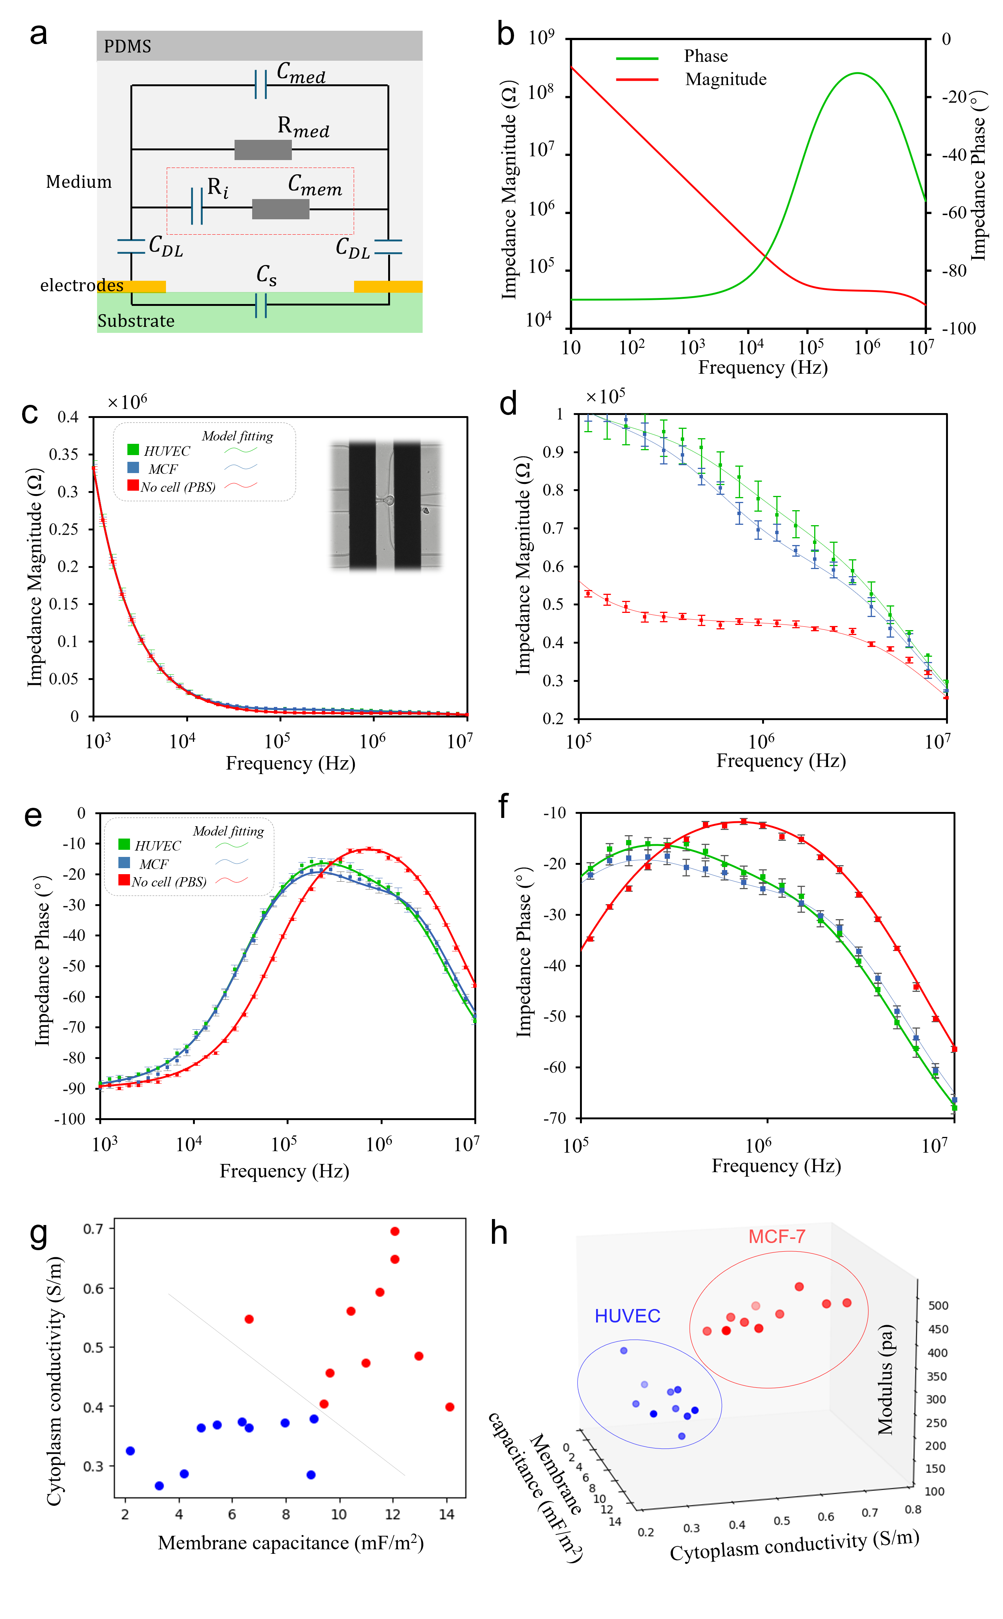
Figure. 5 a. Schematic of the electric circuit representing a single cell suspended in medium with a pair of planar electrodes according to Maxwell’s mixture theory. b. Representative plot showing the generic trend of the impedance magnitude and phase as functions of the frequency of the applied electric field. c. Measured relationship between the impedance magnitude and frequency of the excitation electric signal for pure PBS solution, HUVEC and MCF cells. 10 cells for each cell group were tested. d. Enlarged view of Figure c. e. EIS results showing the relationship between the impedance phase and frequency of the excitation electric signal. f. Enlarged view of figure e. g, h. Phase diagram illustrating the clear separation of MCF and HUVEC cells according to their cytoplasm conductivity and membrane capacitance (g), and modulus (h). Lighter colors correspond to deeper positions in the plot.

Table 1. Comparison of various cell characterization methods
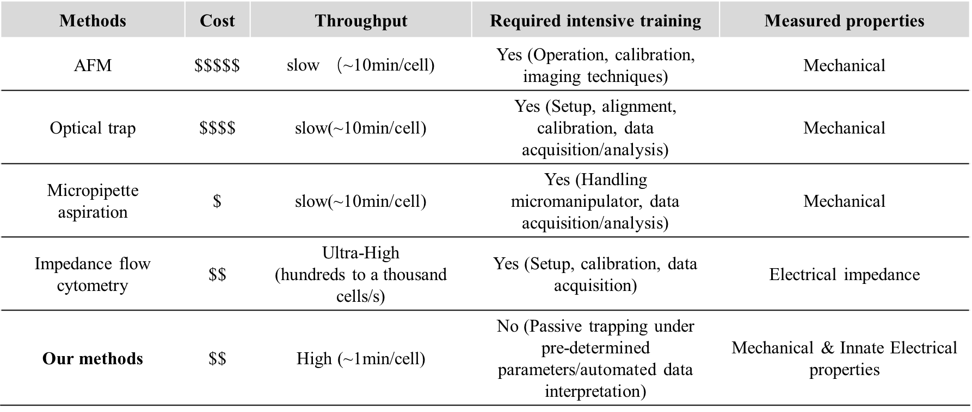
In summary, we have utilized the advantages of microfluidics to design an integrated device for characterizing the mechanical and electrical properties of cells at the single-cell level and addressing a significant gap in most existing cell characterization methods. By implementing serially connected cell trapping units in a highly scalable fashion, individual cells can be efficiently separated and trapped at designated spots on our chip, achieving a trapping efficiency exceeding 90 percent. Subsequently, parallel aspiration and EIS can be conducted to investigate the mechanical and electrical responses of each trapped cell. We then validated the comprehensive characterization and phenotyping capabilities of our device by testing HUVEC and MCF-7 cell lines. Key cellular properties, including elastic modulus, viscosity, cytoplasm conductivity, and specific membrane capacitance, were obtained and compared to their reported values.
As presented in Table.1, our approach offers several clear advantages over classic single-cell characterization methods such as AFM and micropipette aspiration. These advantages include scalability for parallel measurement, ease of operation and deployment, and automated data processing, making it potentially applicable for disease detection, drug screening, and cell phenotyping outside specialized laboratory settings.

Supporting information: Additional experimental details, methods, and data, including the simulation of flow field and analysis of the single-cell impedance model.

Author Contributions
Johnson Q. Cui: conceptualization, methodology, experiments, data curation, writing – original draft. Ye Tian: conceptualization, wafer fabrication, methodology, data curation, writing – review & editing. Zhihao Wu and Lu Zhang: assistance in cell culture and cell treatment. William Chi-Shing Cho: cell sample preparation, writing – review & editing. Shuhuai Yao: writing – review & editing, supervision. Yuan Lin: conceptualization, funding acquisition, writing – review & editing, supervision. All authors have given approval to the ﬁnal version of the manuscript.

Notes
The authors declare no competing financial interest.

Acknowledgements
This work was financially supported by the Research Grants Council of Hong Kong under the General Research Fund (Grant no. 16205619 and 17210520), ASPIRE League Partnership Seed Fund (Grant no. ASPIRE2019#2), the Health@InnoHK program of the Innovation and Technology Commission of the Hong Kong SAR Government, and the National Natural Science Foundation of China (Grant no. 12272332).

References

[1] S. Suresh, Biomechanics and biophysics of cancer cells, Acta biomaterialia. 3 (2007) 413–438.
[2] S.E. Cross, Y. Jin, J. Rao, J.K. Gimzewski, Nanomechanical analysis of cells from cancer patients, in: Anonymous Nano-Enabled Medical Applications, Jenny Stanford Publishing, 2020, pp. 547–566.
[3] V. Swaminathan, K. Mythreye, E.T. O'Brien, A. Berchuck, G.C. Blobe, R. Superfine, Mechanical stiffness grades metastatic potential in patient tumor cells and in cancer cell lines, Cancer Res. 71 (2011) 5075–5080.
[4] Z. Chang, L. Zhang, J. Hang, W. Liu, G. Xu, Viscoelastic multiscale mechanical indexes for assessing liver fibrosis and treatment outcomes, Nano Letters. 23 (2023) 9618–9625.
[5] Z. Chang, J. Zhang, Y. Liu, H. Gao, G. Xu, New mechanical markers for tracking the progression of myocardial infarction, Nano Letters. 23 (2023) 7350–7357.
[6] T.R. Carey, K.L. Cotner, B. Li, L.L. Sohn, Developments in label‐free microfluidic methods for single‐cell analysis and sorting, Wiley Interdisciplinary Reviews: Nanomedicine and Nanobiotechnology. 11 (2019) e1529.
[7] J. Kulbacka, A. Choromańska, J. Rossowska, J. Weżgowiec, J. Saczko, M. Rols, Cell membrane transport mechanisms: ion channels and electrical properties of cell membranes, Transport across natural and modified biological membranes and its implications in physiology and therapy. (2017) 39–58.
[8] D. Yang, Y. Zhou, Y. Zhou, J. Han, Y. Ai, Biophysical phenotyping of single cells using a differential multiconstriction microfluidic device with self-aligned 3D electrodes, Biosensors and Bioelectronics. 133 (2019) 16–23.
[9] L.R. Arias, C.A. Perry, L. Yang, Real-time electrical impedance detection of cellular activities of oral cancer cells, Biosensors and Bioelectronics. 25 (2010) 2225–2231.
[10] F. Asphahani, M. Zhang, Cellular impedance biosensors for drug screening and toxin detection, Analyst. 132 (2007) 835–841.
[11] M. Radmacher, M. Fritz, C.M. Kacher, J.P. Cleveland, P.K. Hansma, Measuring the viscoelastic properties of human platelets with the atomic force microscope, Biophys. J. 70 (1996) 556–567.
[12] J. Guck, R. Ananthakrishnan, H. Mahmood, T.J. Moon, C.C. Cunningham, J. Käs, The optical stretcher: a novel laser tool to micromanipulate cells, Biophys. J. 81 (2001) 767–784.
[13] O. Thoumine, A. Ott, O. Cardoso, J. Meister, Microplates: a new tool for manipulation and mechanical perturbation of individual cells, Journal of biochemical and biophysical methods 39.1-2 (1999): 47-62.
[14] R.M. Hochmuth, Micropipette aspiration of living cells, Journal of biomechanics 33, no. 1 (2000): 15-22.
[15] J. Chen, C. Xue, Y. Zhao, D. Chen, M. Wu, J. Wang, Microfluidic impedance flow cytometry enabling high-throughput single-cell electrical property characterization, International journal of molecular sciences. 16 (2015) 9804–9830.
[16] K.C. Cheung, M. Di Berardino, G. Schade‐Kampmann, M. Hebeisen, A. Pierzchalski, J. Bocsi, A. Mittag, A. Tárnok, Microfluidic impedance‐based flow cytometry, Cytometry part A. 77 (2010) 648–666.
[17] K. Cheung, S. Gawad, P. Renaud, Impedance spectroscopy flow cytometry: On‐chip label‐free cell differentiation, Cytometry Part A. 65 (2005) 124–132.
[18] L. Yang, Electrical impedance spectroscopy for detection of bacterial cells in suspensions using interdigitated microelectrodes, Talanta. 74 (2008) 1621–1629.
[19] A. El Hasni, C. Schmitz, K. Bui-Göbbels, P. Bräunig, W. Jahnen-Dechent, U. Schnakenberg, Electrical impedance spectroscopy of single cells in hydrodynamic traps, Sensors Actuators B: Chem. 248 (2017) 419–429.
[20] M.A. Mansor, M. Takeuchi, M. Nakajima, Y. Hasegawa, M.R. Ahmad, Electrical impedance spectroscopy for detection of cells in suspensions using microfluidic device with integrated microneedles, Applied Sciences. 7 (2017) 170.
[21] Y. Feng, J. Zhu, H. Chai, W. He, L. Huang, W. Wang, Impedance‐Based Multimodal Electrical‐Mechanical Intrinsic Flow Cytometry, Small. 19 (2023) 2303416.
[22] S. Byun, S. Son, D. Amodei, N. Cermak, J. Shaw, J.H. Kang, V.C. Hecht, M.M. Winslow, T. Jacks, P. Mallick, Characterizing deformability and surface friction of cancer cells, Proceedings of the National Academy of Sciences. 110 (2013) 7580–7585.
[23] L.M. Lee, J.W. Lee, D. Chase, D. Gebrezgiabhier, A.P. Liu, Development of an advanced microfluidic micropipette aspiration device for single cell mechanics studies, Biomicrofluidics. 10 (2016).
[24] Q. Guo, S. Park, H. Ma, Microfluidic micropipette aspiration for measuring the deformability of single cells, Lab on a Chip. 12 (2012) 2687–2695.
[25] L.M. Lee, A.P. Liu, A microfluidic pipette array for mechanophenotyping of cancer cells and mechanical gating of mechanosensitive channels, Lab on a Chip. 15 (2015) 264–273.
[26] K. Wang, X.H. Sun, Y. Zhang, T. Zhang, Y. Zheng, Y.C. Wei, P. Zhao, D.Y. Chen, H.A. Wu, W.H. Wang, Characterization of cytoplasmic viscosity of hundreds of single tumour cells based on micropipette aspiration, Royal Society open science. 6 (2019) 181707.
[27] R.C. Boot, A. Roscani, L. van Buren, S. Maity, G.H. Koenderink, P.E. Boukany, High-throughput mechanophenotyping of multicellular spheroids using a microfluidic micropipette aspiration chip, Lab on a Chip. 23 (2023) 1768–1778.
[28] A. Heydarian, D. Milani, S.M.M. Fatemi, An investigation of the viscoelastic behavior of MCF-10A and MCF-7 cells, Biochemical and Biophysical Research Communications 529, no. 2 (2020): 432-436.
[29] L. Huang, P. Zhao, W. Wang, 3D cell electrorotation and imaging for measuring multiple cellular biophysical properties, Lab on a Chip. 18 (2018) 2359–2368.
[30] Y. Xu, X. Xie, Y. Duan, L. Wang, Z. Cheng, J. Cheng, A review of impedance measurements of whole cells, Biosensors and Bioelectronics. 77 (2016) 824–836.
[31] D.P. Theret, M.J. Levesque, M. Sato, R.M. Nerem, L.T. Wheeler, The application of a homogeneous half-space model in the analysis of endothelial cell micropipette measurements, Journal of Biomechanical Engineering (1988): 190-199.
[32] H. Yang, M. Zhu, T. Chen, F. Niu, L. Sun, L. Cheng, Automated measurement of cell mechanical properties using an integrated dielectrophoretic microfluidic device, Iscience 25, no. 5 (2022).
[33] Y. Qin, K. Chen, W. Gu, X. Dong, R. Lei, Y. Chang, X. Bai, S. Xia, L. Zeng, J. Zhang, Small size fullerenol nanoparticles suppress lung metastasis of breast cancer cell by disrupting actin dynamics, Journal of Nanobiotechnology. 16 (2018) 1–14.
[34] T. Chen, X. Zhang, G. Zhu, H. Liu, J. Chen, Y. Wang, X. He, Quercetin inhibits TNF-α induced HUVECs apoptosis and inflammation via downregulating NF-kB and AP-1 signaling pathway in vitro, Medicine 99, no. 38 (2020): e22241.
[35] T.A. White, A. Xue, E.N. Chini, M. Thompson, G.C. Sieck, M.E. Wylam, Role of transient receptor potential C3 in TNF-α–enhanced calcium influx in human airway myocytes, American journal of respiratory cell and molecular biology 35, no. 2 (2006): 243-251.
[36] J.J. Matsuda, M.S. Filali, J.G. Moreland, F.J. Miller, F.S. Lamb, Activation of swelling-activated chloride current by tumor necrosis factor-α requires ClC-3-dependent endosomal reactive oxygen production, Journal of Biological Chemistry, 285(30), 22864-22873.
[37] S.B. Koukouritaki, E.A. Vardaki, E.A. Papakonstanti, E. Lianos, C. Stournaras, D.S. Emmanouel, TNF-α induces actin cytoskeleton reorganization in glomerular epithelial cells involving tyrosine phosphorylation of paxillin and focal adhesion kinase, Molecular medicine. 5 (1999) 382–392.
[38] D. Needham, R.M. Hochmuth, Rapid flow of passive neutrophils into a 4 μm pipet and measurement of cytoplasmic viscosity, Journal of Biomechanical Engineering (1990): 269-276.
[39] Evans E, Yeung A. Apparent viscosity and cortical tension of blood granulocytes determined by micropipet aspiration. Biophysical journal. 1989 Jul 1;56(1):151-60.
[40] K. Wang, X.H. Sun, Y. Zhang, T. Zhang, Y. Zheng, Y.C. Wei, P. Zhao, D.Y. Chen, H.A. Wu, W.H. Wang, Characterization of cytoplasmic viscosity of hundreds of single tumour cells based on micropipette aspiration, Royal Society open science 6, no. 3 (2019): 181707.
[41] T. Sun, N.G. Green, S. Gawad, H. Morgan, Analytical electric field and sensitivity analysis for two microfluidic impedance cytometer designs, IET nanobiotechnology 1, no. 5 (2007): 69-79.
[42] H. Morgan, T. Sun, D. Holmes, S. Gawad, N.G. Green, Single cell dielectric spectroscopy, Journal of Physics D: Applied Physics 40, no. 1 (2006): 61.
[43] Y. Feng, L. Huang, P. Zhao, F. Liang, W. Wang, A microfluidic device integrating impedance flow cytometry and electric impedance spectroscopy for high-efficiency single-cell electrical property measurement, Anal. Chem. 91 (2019) 15204–15212.
[44] C. Honrado, P. Bisegna, N.S. Swami, F. Caselli, Single-cell microfluidic impedance cytometry: From raw signals to cell phenotypes using data analytics, Lab on a Chip 21, no. 1 (2021): 22-54
[45] M. Carminati, G. Ferrari, M.D. Vahey, J. Voldman, M. Sampietro, Miniaturized impedance flow cytometer: Design rules and integrated readout, IEEE transactions on biomedical circuits and systems 11, no. 6 (2017): 1438-1449.
[46] K. Kinosita Jr, T.Y. Tsong, Voltage-induced pore formation and hemolysis of human erythrocytes, Biochimica et Biophysica Acta (BBA)-Biomembranes 471, no. 2 (1977): 227-242.
[47] L. Huang, P. Zhao, W. Wang, 3D cell electrorotation and imaging for measuring multiple cellular biophysical properties, Lab on a Chip 18, no. 16 (2018): 2359-2368.

TOC Graphic
