Construction waste reduction in buildings through modular and offsite construction
Yang Zhang¹, Wei Pan², Yue Teng³, and Siwei Chen⁴
¹ PhD Candidate, Department of Civil Engineering, The University of Hong Kong, Hong Kong, China,
Email: yangzhg@connect.hku.hk
² Professor, Department of Civil Engineering, The University of Hong Kong, Hong Kong, China
(Corresponding Author), Email: wpan@hku.hk
³ Research Assistant Professor, Department of Building and Real Estate, The Hong Kong Polytechnic University, Hong Kong, China, Email: yue.teng@polyu.edu.hk
⁴ PhD Candidate, Department of Civil Engineering, The University of Hong Kong, Hong Kong, China,
Email: swchenly@connect.hku.hk

Abstract
Construction waste causes severe environmental problems. Reducing construction waste generation becomes a major policy measure of governments to achieve sustainable development. Offsite construction approaches are effective for reducing onsite construction waste. Nevertheless, there lacks a clear understanding of the types and amounts of construction waste that different offsite construction approaches can reduce. This study aims to investigate the performance of the modular construction (MC) approach in construction waste generation and reduction and how it differs from that of the non-modular offsite construction (NMOC) approaches through comparing 59 selected cases of building projects that adopt these offsite approaches compared with stick-built construction. Results indicated that the adoption of offsite construction contributed to significant onsite construction waste reduction. On average, adopting MC reduced 78.8% overall construction wastes, outperforming other construction approaches. The level of prefabrication influenced onsite construction waste generation and reduction the most, followed by the other properties like building typology, density, and material used. Seven knowledge gaps were identified in the area of waste identification, quantification, and assessment. The findings demonstrate the advantages of using offsite construction in waste control and management, and add to the existing body of knowledge on onsite construction waste generation and on waste reduction through adopting MC. The identified knowledge gaps point directions of future research on waste reduction through offsite construction.
Keywords: Construction waste; Modular construction; Prefabrication; Offsite construction

Practical applications
The results of this paper suggest that the adoption of offsite construction can contribute to significant onsite construction waste reductions compared with conventional in-situ construction. Specifically, buildings adopting the modular construction (MC) approach can reduce overall construction wastes by around 80% and outperform other non-modular offsite construction approaches, including those that adopt one-dimensional prefabricated beams and columns, two-dimensional prefabricated panels, or three-dimensional prefabricated pods, based on the analysis of 59 building cases covering different levels of prefabrication, building typologies, building densities, and building materials. This study contributes to the investigation of onsite construction waste by proposing a systematic assessment method addressing different construction waste types and assessment criteria. It facilitates a better understanding of the advantages of offsite construction in terms of waste control and management, especially MC, which was underexplored in the literature. Seven knowledge gaps were identified in the area of construction waste identification, quantification, and assessment. Addressing these knowledge gaps will contribute to better construction waste control and management, especially in MC projects.

Introduction
Construction waste refers to solid waste, such as abandoned substances (e.g., excavated soil, building debris, broken and surplus concrete waste, broken timber formwork, plasterboard, and metal scrap) generated from construction and demolition activities (EPD, 2021a; Zhang and Pan, 2021). Countries and cities with highly dense populations and numerous construction projects such as Hong Kong typically generate a high proportion of construction waste, accounting for more than 40% of the total waste (EPD, 2021b; Hao et al., 2020). The increase in construction waste has caused severe environmental problems worldwide (Bakchan et al., 2019; Ding et al., 2018). Hence, reducing construction waste generation, particularly wastes from the construction sites of newly-built projects in high-density cities, is crucial and has been a government policy to achieve sustainable development (EPD, 2021a; Li et al., 2020; Kylili and Fokaides, 2017).

Since the beginning of the 21st century, offsite construction, which adopts prefabricated building components produced in offsite factories and then delivered to construction sites, has been recognized as an effective approach to reducing construction waste (Gibb, 1999; Shen et al., 2000). Some studies have examined the effectiveness of construction waste reduction through using one-dimensional (1D) framed prefabricated beams and two-dimensional (2D) panelized components (Jaillon and Poon, 2008; Lu et al., 2021). For example, Jaillon et al. (2009) found a general waste reduction of 52% by using prefabricated building components compared with conventional stick-built construction (SC). Yu et al. (2021) reported that the adoption of prefabrication could reduce the total waste generation by 60%. From the case study conducted by Tam et al. (2007), prefabrication could reduce concrete waste by 90%, metal waste from rebar offcuts by 92%, and masonry waste (e.g., plastering) by up to 100%. By adopting a big data investigation of 114 high-rise building cases in Hong Kong, Lu et al. (2021) proposed that building cases using prefabricated components reduced onsite waste generation by 770 kg/m² (equivalent to 15%) on average. These results, albeit varying from each other significantly, demonstrate the effectiveness of using prefabrication for construction waste reduction.

Recent studies have also examined the use of modular construction (MC) to reduce construction waste (Loizou et al., 2021; Zhang and Pan, 2021; Nabi and El-adaway, 2020). The three-dimensional (3D) enclosed usable spaces called modules are prefabricated in offsite factories and delivered to the construction site, where they are assembled to form the building structure (Gibb, 1999; Pan and Hon, 2020; Pan et al., 2023). MC is considered as an innovative offsite construction approach, different from those non-modular offsite construction (NMOC) approaches including the above-mentioned 1D, 2D or 3D offsite construction using framed, panelized, or pod prefabrication, respectively, in terms of their structural design, prefabrication, and site construction (Wang et al., 2021; Lawson et al., 2012; Pan et al., 2020a). Similar to those NMOC approaches, MC has been considered to lead to significant construction waste reductions because it ensures a more controllable environment during module production (DDA, 2021; MBI, 2019; Yang et al., 2021). Most of onsite works is shifted to the factory, thus achieving significant construction waste reduction on site theoretically. However, only a few studies have demonstrated a better waste reduction performance of MC than other NMOC approaches with detailed analysis (Pan et al., 2020a; Ajayi et al., 2015; Zhang et al., 2022). Inefficient management and investigation of construction waste has been considered to be one of the potential risks impacting the project performance of modular building projects (Abdul Nabi & El-adaway, 2021; Abdul Nabi et al., 2023).

As outlined above, onsite construction waste generation and reduction through the NMOC approaches has been acknowledged in academia and industry. However, MC as an emerging construction approach having been promoted for wide adoption worldwide recently, has received little research attention regarding its construction waste generation and reduction performance. There still lacks a clear and systematic understanding of the types and amounts of construction waste that the MC approach can generate and reduce. Therefore, this study aims to investigate the performance of the MC approach in construction waste generation and reduction and how it differs from that of the NMOC approaches. This aim was achieved by a meta-analysis of the detailed construction waste data collected from 59 building project cases that adopted MC, NMOC, and SC approaches and that covered different building attributes. The remainder of this paper is organized as follows. Section 2 explains the methodology, and Section 3 compares and analyzes the construction waste reduction performance of the project cases that adopted MC, NMOC, and SC approaches. Section 4 discusses the results and elaborates on the knowledge gaps identified through literature review and meta-analysis. Finally, Section 5 summarizes the findings and draws conclusions.

Methodology
This study adopted the preferred items for systematic reviews and meta-analysis (PRISMA) method to examine the construction waste generation and reduction performance of offsite construction approaches systematically. The PRISMA method includes two major aspects: systematic review and meta-analysis (Moher et al., 2009). In the systematic review, previous research and empirical projects on construction waste generation and reduction performance in offsite building cases were collated. The meta-analysis was conducted to normalize the construction waste generation results of these cases such that they could be compared at the same baseline level (Fig. 1).
[insert Fig. 1 here]

Literature search and case collection
Previous articles on construction waste generation and reduction using offsite construction approaches were searched using the Scopus and Web of Science databases. The keywords used for the search were “construction waste”, “offsite”, “prefabricated”, “prefabrication”, “modular construction”, “modular building”, “industrialized construction”, “IBS”, and “PPVC” with the search domain specified as “title/abstract/keywords”. An initial search found 4500 articles and a further screening of the titles and abstracts helped to identify 283 relevant journal articles. After reading the 283 articles, only 22 articles containing detailed case information and results were selected for further data extraction and normalization.

In addition to the literature search, waste information from some empirical offsite building projects was collected for data supplementation. Construction waste information from six cases worldwide using MC and one case in Hong Kong using panelized construction (i.e., Level 2 offsite construction) was obtained by the review of project reports and documents (Zhang and Pan, 2021). In addition, interviews were conducted with relevant project stakeholders to supplement the data collection through reviewing the project documents. The interviews helped obtain in-depth and detailed data on the selected MiC building projects that were not provided or made explicit in the project documents, such as waste ratios of specific building materials and empirical waste management experience in the MiC projects during the module production and site construction. After examining 22 articles and 7 empirical projects, in total 10 MC, 30 NMOC, and 19 SC cases were identified for further analysis (Appendix 1).

Data extraction and normalization

Project data extraction
Four types of information on the collected cases were collated: building type of the building case, building type of the baseline case (i.e., the case used for construction waste generation comparison in the literature), adopted offsite construction method, and level of prefabrication. The building type information includes building density, typology, and material used. Building density is categorized as low-rise (up to 3 stories), medium-rise (4–9 stories), or high-rise (more than 9 stories) (Teng et al., 2018). Building typology is classified as residential, commercial, educational, and other buildings. Building material indicates the major material (e.g., concrete, steel, and timber) adopted to characterize the building’s structural properties.

According to the offsite technology scheme, offsite construction methods can be classified into four levels: component and sub-assembly (Level 1), non-volumetric assembly (Level 2), volumetric assembly (Level 3), and MC (Level 4) (Gibb, 1999) (Fig. 2). However, due to the data inaccessibility from the reviewed articles (i.e., many of them did not provide detailed data on their building cases regarding the types of prefabricated components), it would be impossible to further classify these cases into Level 1, 2, and 3 under Gibb (1999)’s offsite construction scheme, while still ensuring the reliability of the data analysis. Hence, this study simplifies the classification by proposing a three-level scheme based on the four-level offsite technology scheme (Gibb, 1999) in order to: 1) differentiate the MC from the NMOC approaches; and 2) classify the various construction approaches to also include conventional stick-built construction (SC) for comparison. The three levels are: 1) SC method, in which in-situ works dominate construction activities, particularly work on the building structure with few prefabricated components (Dong et al., 2015; Breccolotti et al., 2016). As reviewed in previous articles, the building cases using this construction method all adopted stick-built construction. 2) NMOC method, which covers Level 1, 2, and 3 offsite construction, wherein 1D (e.g., prefabricated columns and beams) or 2D panelized prefabricated components (e.g., precast slabs and drywalls) or some simple 3D pods (e.g., precast kitchen pods) are used in the building cases; and 3) MC method, which adopts prefabricated 3D modules as major units to form the structure (e.g., modular integrated construction (MiC) in Hong Kong and prefabricated prefinished volumetric construction (PPVC) in Singapore). In principle, this three-level scheme follows the logic of the four-level offsite construction scheme developed by Gibb (1999). It has been proven feasible and adopted for differentiating MC from other construction approaches in the literature on modular building and construction (Pan et al., 2020b).
[insert Fig. 2 here]

The level of prefabrication indicates the extent to which prefabricated elements has been adopted in the superstructure of an entire building. In practice, the prefabrication rate can be used to represent this information (Jaillon and Poon, 2014). However, many of the identified articles did not provide such information on their building cases. Thus, this study proposes three levels of prefabrication based on the type of prefabricated component and its contribution to the building structure. 1) The low level of prefabrication means only nonstructural prefabricated components are adopted (e.g., prefabricated staircases, façades, and partition drywalls). 2) The medium level of prefabrication indicates that some prefabricated components for horizontal structural connections are further used (e.g., semi-precast floor slabs and precast beams). 3) The high level of prefabrication expresses that prefabricated components for vertical structural connections are further adopted (e.g., precast structural walls and columns).

Construction waste data extraction
As different waste quantification methods have been used in previous studies, normalizing the case results using the same indicator is necessary. In the initial review, the amount of waste generated and the percentage of waste reduced were examined in most articles. Accordingly, this study adopts two indicators to normalize and quantify the construction waste generation performance of the MC, NMOC, and SC approaches and the waste reduction performance by using the MC and NMOC approaches. The indicators are 1) construction waste generation index (CWI) and 2) construction waste reduction potential (CWR) (Zhang and Pan, 2021; Lu et al., 2021). The CWI is employed to quantify the construction waste generation performance (Hao et al., 2020; Tam and Hao, 2014; Lu et al., 2021). It was recognized as objective and appropriate for assessing and comparing the amount of generated construction waste (Pan et al., 2020b; Jaillon et al., 2009). The calculation of the CWI is as follows:
CWI = Q_{CW}/SFA (1)
Where Q_{CW} is the quantity of the considered construction waste type (unit: kg or t), and SFA is the selected floor area (unit: m²) of the building to account for the construction waste (gross floor area (GFA) and construction floor area (CFA) are typically adopted). According to the review, only one article quantified the amount of waste in terms of volume (i.e., m³) (Lam et al., 2019). Thus, the results of that article are excluded from the current research because they are incomparable with those of other identified projects and articles.

According to the examination of the building cases from the literature and empirical projects, two methods to calculate the Q_{CW} are identified. The first method is to obtain onsite waste quantity data, which can be directly collected from project management documents and records such as waste sorting and truck delivery records. This method reflects the actual onsite waste generation performance of the examined building project. Therefore, the value of quantified waste amount and corresponding CWI results imply the consideration of the overall onsite building material consumption, building properties, and onsite construction activities’ influence. The several selected empirical projects and most of the examined cases from the literature adopted this method. The other method is to estimate the waste amount by timing the total material quantity with corresponding onsite waste ratios. A few articles used this method in examining building cases (Li et al., 2013; Shen et al., 2000; Tam et al., 2007). The material amount was quantified based on bills of quantities or drawings and the used waste ratios were project-specified, indicating the consideration of total material quantity and the onsite waste management performance of their examined building cases. Both methods have been validated as feasible for waste quantification in corresponding literature and empirical projects’ practice, and can provide objective and useful waste quantity data for the meta-analysis in this study. Therefore, the CWI results should be objective to reveal the waste performance of the building project, which internally have considered the corresponding project’s properties and management performance.

The level of performance in reducing a specific type of construction waste under each building case using the offsite approach is measured by the CWR (Pan et al., 2020b; Lu et al., 2021). Only the CWR of cases that use SC buildings with the same building type and similar project scale (i.e., close SFA) as baseline were calculated in order to ensure the comparability among different offsite approaches, as follows:
CWR = (CWI_{SC}-CWI_{offsite})/CWI_{SC}×100% (2)
Where CWI_{SC} and CWI_{offsite} are the construction waste indices (unit: kg/m²) of the considered construction waste type in the corresponding baseline SC and offsite approach cases, respectively (the same floor area unit is considered in both cases). As shown in Appendix 1, some examined building cases provided and validated the CWR results according to their corresponding analysis. These results were checked and used for the analysis in this study. For those building cases with CWI results of both offsite and corresponding SC baseline cases, the CWR results were calculated using Formula (2) accordingly. Since the SC buildings with the same type and similar project scale were used for the assessment, CWR results should be objective for evaluating the waste reduction performance of offsite construction approaches.

Onsite overall construction wastes (simplified as “overall waste”) and four major types of construction wastes, including concrete, metal, masonry, and timber waste, are analyzed in this study. Overall waste includes the general onsite waste and is typically the most important factor for quantifying the amount of construction waste (Bakchan et al., 2019; Bilal et al., 2016). Concrete waste, such as surplus and broken concrete, is generated from onsite wet concreting works. Metal waste, such as metal scraps, mainly includes rebar offcuts and broken steel products from onsite works. Masonry waste, such as wastes generated from plastering, broken gypsum boards, and masonry blocks, is generated from onsite masonry works. Timber waste includes waste timber products, such as broken timber formwork, bamboo scaffolding, timber mold, and wasted boards. Because different construction approaches are primarily adopted for superstructure construction, the construction waste generated during substructure construction (e.g., foundation and basement) is excluded from this study (EPD, 2021b; Lachimpadi et al., 2012). Compared with considering all construction waste amounts, excluding the waste generated during substructure construction better reveals the variations in waste generation and reduction among different construction approaches.

Meta-analysis of construction waste reduction performance of different waste types
Meta-analysis was conducted to measure the typical construction waste generation and reduction performance of the different construction approaches. Box-and-whisker plots were adopted in this study, which are effective for comparing and showing the properties of normalized data in different categories (Teng et al., 2018; Lu et al., 2021). The construction waste generation and reduction performance of the identified cases were analyzed using the CWI and CWR defined above. Different building typologies, densities, materials, and prefabrication levels were examined to identify their influence on the waste reduction performance of different construction waste types.

Results and analyses

Cross-case comparisons of construction waste generation and reduction between MC, NMOC, and SC

Comparison of CWI of overall construction waste between MC, NMOC, and SC
The waste results of 6 MC, 20 NMOC, and 14 SC building cases were identified feasible for the overall waste CWI analysis (Fig. 3). In this figure, the results of steel and timber building cases are separately shown. The CWI results quantified by CFA and GFA indicated a significant decrease in the overall construction waste generated using the MC and NMOC approaches compared with that of the SC approach. The average CWIs quantified by the CFA were 35.5, 99.7, and 258.1 kg/m² for MC, NMOC, and SC, respectively, whereas those quantified by the GFA were 21.8, 21.7, and 72.6 kg/m², respectively. When the results of both floor area types (CFA and GFA) were combined, the average CWIs were 28.7, 84.1, and 205.1 kg/m², respectively. Specifically, despite only a few CWI results were obtained from non-concrete MC and NMOC building cases (i.e., the MC or NMOC building cases using steel or timber as the primary material), these cases generated significant smaller CWI than their concrete building counterparts. Nevertheless, more detailed CWI results from MC and NMOC building cases with different primary materials are expected for more comprehensive analysis in the future.

Compared with the average CWI of the SC approach, the average CWIs of MC and NMOC decreased by 86.2% (70.0% using GFA) and 61.4% (70.2% using GFA), respectively (Table 1). When the results of cases using CFA and GFA were combined, the average CWI of MC decreased by 86.0%, which was higher than that of NMOC (59.0%). The results from these cases agreed with the findings that the offsite construction approach could reduce the overall onsite construction waste generation, as presented in previous studies (Ajayi et al., 2015; Nabi and El-adaway, 2020; Pan et al., 2020a). It should be noted that the meta-analysis presented in this study aims to identify the general trends and universal findings on the waste performance of MC and NMOC approaches, rather than investigating into a specific case using a cause-effect logic. It can be seen in Fig. 3 that a few SC cases also showed similar good waste performance as MC and PC cases, which may highly probably benefit from an excellent onsite waste management practice and project execution.
[insert Fig. 3 here]
[insert Table 1 here]

Comparison of CWI of the four major types of construction waste between MC, NMOC, and SC
The CWIs of the four types of construction waste were further examined. Because many cases did not provide the quantities of all four waste types, only the data available from each case were extracted for CWI calculation and comparison. The numbers of available cases for quantifying the four waste types are listed in Table 2. It is worth noting that only several steel MC cases provided detailed CWI results of the four waste types. No concrete MC case was identified with available data for this analysis.

The waste quantities from the 4 MC, 18 NMOC, and 10 SC cases were extracted and normalized to quantify the CWI of concrete waste. Similar to the overall waste generation, the CWIs of the MC and NMOC cases of all four waste types were significantly less than those of the SC cases. This indicated that the waste generation of the major types of waste of offsite construction approaches was less than that of the SC approach.
[insert Table 2 here]

The difference in CWI of concrete waste between the offsite approaches and SC was the most significant among the four waste types. For the results quantified by CFA (Fig. 4), only one steel MC case reported 6.0 kg/m² of concrete waste generation, whereas those of the NMOC and SC cases (all were concrete buildings) ranged 2.1–38.1 and 13.7–47.7 kg/m², respectively. The reductions in the average CWI were approximately 80% and 63% for MC and NMOC, respectively. In terms of the results quantified by the GFA (Fig. 5), only three steel MC cases reported 0.4–9.1 kg/m² concrete waste generation. One steel NMOC case generated 0.26 kg/m² concrete waste, and the other eight concrete NMOC cases reported 0.36–17.7 kg/m² concrete waste generation. Both MC and NMOC reached a 95% reduction in the average CWI comparing to SC (26.6–211.4 kg/m², averaged 73.6 kg/m²).

Compared with the amount of concrete waste, the quantities of the other three types of waste generated were lower. The masonry waste generated in the three steel MC cases was minimal (two cases with zero generation and one case generating 0.6 kg/m²). For the NMOC cases, the CWI of masonry waste was higher than those of the MC cases: 0.1–6.1 kg/m² (CFA) and 0–3.4 kg/m² (GFA). Both the MC and NMOC cases presented slight variations in masonry waste generation. However, the results of the SC cases, 0.2–8.3 kg/m² (CFA) and 1.5–43.2 kg/m² (GFA), were considerably different among the examined cases. Compared with the SC cases, the average CWI of the MC and NMOC cases decreased by 98% and 86.7%, respectively.

As for metal waste, no MC building case was identified using the CFA to quantify metal waste generation. Two steel MC cases reported relevant data, which were further normalized to the CWI using the GFA, being 2.0 and 8.4 kg/m². The CWIs of metal waste of the NMOC cases were slightly lower, 0.2–4 and 0.01–5.3 kg/m² using the CFA and GFA, respectively. The steel NMOC case generated 0.11 kg/m². Because these MC cases were low-rise steel modular buildings that directly used steel modules to form an entire structure, they generated more metal waste than the NMOC cases. In contrast to these MC and NMOC cases, the SC cases had an even higher metal waste generation ranging 1.0–3.3 and 1.1–46.3 kg/m² using the CFA and GFA, respectively.

In terms of timber waste, both the MC and NMOC cases exhibited smaller CWIs than the SC cases. The results of the four steel MC cases were 3.5 kg/m² (CFA) and 0.1–4.4 (GFA) kg/m², whereas those of the NMOC cases were 0.3–7.8 kg/m² (CFA) and 0.02–7.6 kg/m² (GFA). The steel NMOC case generated even less timber waste (0.004 kg/m²). The results of the SC cases were 7.3–10.5 kg/m² (CFA) and 1.1–16.2 kg/m² (GFA).
[insert Fig. 4 and Fig. 5 here]

Comparison of CWR between MC and NMOC
To accurately measure the construction waste reduction of MC and NMOC to their corresponding SC counterparts, the CWR of the MC and NMOC cases was further examined in terms of the overall waste and four major waste types (Fig. 6). Only the MC and NMOC cases using stick-built concrete buildings with similar building types and building scales as baseline cases were selected for the CWR analysis.

Regarding the overall waste reduction, the CWR of the identified 8 MC cases ranged 70%–85%, indicating a generally higher waste reduction performance than the 17 NMOC cases (Table 3). In terms of the four waste types, although CWR data was only available for a few MC cases, the results indicated the noticeably high waste reduction performance of the MC approach. Timber waste was reduced significantly, and more than 97% waste reduction was achieved in the two MC cases. This reduction exceeds the average timber waste reduction performance of MC (75%) reported by a survey in the US (MBI, 2021). The concrete waste of the three MC cases was reduced by an average of 81.8%. With respect to masonry and metal waste, only one MC case was identified for each waste type, with 74% and 80% waste reductions, respectively.
[insert Fig. 6 here]

Compared with the MC group, more NMOC cases were analyzed. The CWR of the overall waste of the NMOC cases ranged 14%–91% with an average of 57.6%. The CWR of masonry waste showed a wide variation from 10% to as high as 100% averaging 62.3%. The other three waste types (concrete, metal, and timber wastes) of the NMOC cases also exhibited considerable variations with average CWR values of 65.4%, 56.6%, and 76.0%, respectively.
[insert Table 3 here]

Influence of building properties on waste reduction performance of MC and NMOC
As presented in the previous section, the CWI and CWR of different construction approaches significantly vary, indicating that building properties, such as building typology and materials, may also influence waste generation and reduction. Thus, the influence of building properties on the CWR performance of MC and NMOC was further examined. Four building properties were examined: level of prefabrication, building typology, building density, and building material.

Influence of level of prefabrication on CWR performance of MC and NMOC
Previous articles have reported the level of prefabrication as an important factor in construction waste reduction; however, only a few articles have provided a detailed analysis of the relationship between the two factors. Theoretically, a high level of prefabrication in a building indicates the adoption of a considerable number of prefabricated components, enabling more onsite construction work to be shifted to the offsite factory, thus more significantly reducing the waste generated on site (Mao et al., 2013; Tam et al., 2005). According to the definition presented in Section 2.2.1, all the MC cases had a high level of prefabrication. Low, medium, and high levels of prefabrication were observed in the identified NMOC cases. Particularly, no data was available to quantify the CWRs of metal and timber wastes in NMOC cases with low prefabrication levels.

Generally, the results indicate a positive correlation between the level of prefabrication and CWR for all waste types; that is, a high level of prefabrication results in a high percentage of construction waste reduction. This observation is consistent with the findings reported in other articles. With regard to overall waste, the high level of prefabrication in the MC and NMOC cases achieved more than 70% CWR performance, whereas the CWR of the medium level of prefabrication in the NMOC cases was approximately 60%–70%. A wide variation exists (15%–70%) for the NMOC cases with a low level of prefabrication. Nevertheless, this variation is considerably larger than that of the NMOC and MC cases with medium-to-high levels of prefabrication.

The CWR of the four waste types showed the same trend as the CWR of the overall waste. Significant differences in the CWR performance among different prefabrication levels of NMOC cases could be observed in the concrete and metal wastes. The concrete and metal waste reduction potentials of the NMOC cases with a high level of prefabrication were virtually 95% and 85%, respectively, whereas the maximum CWR values of the NMOC cases with a medium level of prefabrication only reached approximately 75% and 55%, respectively.

Influence of building typology on CWR performance of MC and NMOC
The CWR results of the MC and NMOC cases in terms of the three major building typologies, i.e., residential (simplified as “Res”), commercial (“Com”), and educational (“Edu”) buildings were further examined. The results indicated that the CWR had no significant tendency among the different building typologies. High variations in overall waste ranging 14%–91% were observed in NMOC residential building cases. The variation in the CWR of commercial and educational buildings was considerably small. However, this phenomenon may have been caused by the limited sample size of NMOC cases.

The significant CWR advantage of commercial buildings could only be found in masonry and timber wastes. Regarding the masonry waste, NMOC commercial buildings showed a CWR potential exceeding 85% up to 100%, whereas the CWR results of NMOC residential buildings were 11%–81%. In terms of timber waste, the average CWR of NMOC commercial buildings reached 84%, whereas that of NMOC residential buildings was 74%, with a minimum CWR of only 32%.

Influence of building density on CWR performance of MC and NMOC
The CWR results of MC and NMOC cases in terms of building density (i.e., low-rise, medium-rise, and high-rise buildings) were investigated. Similarly, owing to the limited sample size, especially the few cases identified for the four waste types, the influence of building density was insignificant. However, in terms of the overall and concrete wastes, the low-density cases had better CWR performance than the high-density cases. As regards the overall waste, the CWR performance of several low-density MC and NMOC cases exceeded 80%. In contrast, the CWR of high-density MC cases was 70%–85%. The CWR of high-density NMOC cases was 21%–91%. The 7 NMOC cases did not provide detailed information on their density; hence, their results were marked as “NA”. The information provided by Jaillon et al. (2009) indicated that these 7 cases were probably medium-to-high-rise buildings. Therefore, their results are expected to be lower than the average CWR of medium-to-high-rise NMOC cases.

Influence of building material on CWR performance of MC and NMOC
The CWR results for the MC and NMOC cases using different building materials (i.e., concrete, steel, and timber) were also examined. Only one NMOC timber building provided CWR results for the overall waste; no CWR results for other waste types were identified in timber building cases.

Concrete buildings exhibited inferior CWR performance compared with steel or timber buildings in terms of the overall, concrete, masonry, and timber wastes. Regarding the overall waste, the CWR of steel and timber buildings exceeded 70%, whereas that of concrete buildings was 14%–91% averaging 54%. The CWR results of the other three types of waste showed similar trends.

In contrast, the CWR of metal waste differed; the NMOC steel building case had a smaller CWR (50%) than the average CWR (58%) of the NMOC concrete building case. This may be due to the higher metal waste generated by steel buildings, which have more steel components than concrete buildings.

Discussion

Construction waste generation and reduction through MC and NMOC approaches
The results clearly demonstrated the advantages of using the MC and NMOC approaches for onsite construction waste reduction compared with the SC approach. Regarding onsite construction waste generation, both the CWI results of the MC and NMOC cases quantified by CFA and GFA were significantly lower than those of the SC cases in all the waste types. On average, the MC cases generated 28.7 kg/m² of overall waste, significantly lower than that of NMOC cases (84.1 kg/m²) and SC cases (205.1 kg/m²). The quantified CWR results indicate the same finding, with an averaged CWR of overall waste achieving 77.8% and 57.6% for MC and NMOC cases, respectively.

The MC approach generally shows a better onsite construction waste generation potential (i.e., low CWI and high CWR results) than the NMOC approach. However, this does not mean the NMOC approach cannot achieve a high waste reduction potential. This finding can be identified from the CWR results of the four waste types, which indicate that the CWR performance of NMOC is similar to or even better than that of MC when the level of prefabrication is high in these NMOC cases. For example, in terms of the overall waste, the MC cases had a CWR performance ranging from 70% to 85%. In contrast, the NMOC cases with a high level of prefabrication mostly had a CWR performance exceeding 85% (except in one case). A similar trend was observed in concrete, masonry, and metal wastes.

The generation of different types of waste through the offsite approaches also differs. Concrete waste generated the most through the MC and NMOC approaches, significantly larger than the other three waste types. Based on the results, the average CWI of MC and NMOC cases reached 5.8 and 8.4 kg/m², respectively. Considering the site works of offsite buildings, this result is highly expected to be caused by the adoption of the in-situ concrete core and concrete connections for prefabricated components in offsite buildings, which are commonly in concrete MC and NMOC buildings (Wang et al., 2021; Pan et al., 2022). In steel MC or NMOC buildings, the concrete in-situ core or some prefabricated components are also often used, especially for medium- and high-rises (Liew et al., 2019).

Identified seven knowledge gaps
Through the literature review and meta-analysis, seven knowledge gaps were identified regarding construction waste identification, quantification, and assessment, which are discussed below (Fig. 7).
[insert Fig. 7 here]

Knowledge gaps in construction waste identification for offsite construction approaches
First, significant inconsistencies in construction waste types and classification schemes have been observed in the construction waste identification for the MC, NMOC, and SC buildings. This knowledge gap is one of the main reasons for the inconsistent results of the onsite construction waste generation and reduction performance among different offsite cases. For example, some articles have examined all construction wastes from soil excavation to foundation construction (Lu et al., 2021). Although the waste from this source is included in onsite construction waste and usually constitutes a considerable proportion (70%–95%) (EPD, 2021a), it is not influenced by the construction approach. Consequently, counting this waste in statistics will result in a negligible difference in waste generation amount between the SC and offsite building cases. Moreover, this inconsistency impedes the comparison of waste generation and reduction results reported by different articles, since normalization is necessary when the articles involve different waste types. Future research is recommended to standardize and harmonize the waste classification schemes or methods.

Second, offsite waste generation during prefabrication or module production in the factories has rarely been examined in previous studies. Transferring onsite work and consumed building materials to offsite prefabrication production (e.g., prefabricated components and modules) may generate more offsite waste in the factory. Ignoring this part in waste estimation may lead to biased life-cycle waste performance results for offsite building projects. The offsite waste may be larger than onsite waste, as reported by a MC project in the UK, in which the onsite waste was 9 kg/m² while offsite waste was 25 kg/m² (Lawson et al., 2012). Theoretically, with a higher prefabrication rate, the consumed materials and generated wastes in the factories should be more compared to those on the construction site. However, offsite building projects tend to have different waste assessment and management practices and different project stakeholders tend to assess and manage the offsite and onsite wastes separately. According to the site and factory visits and the interviews with the stakeholders of several offsite building projects, the different practices are mainly caused by: 1) that the factory and the construction site, normally located in different cities or even countries and affiliated with different jurisdictions, may follow different regulations or guidelines for waste quantification and management; and 2) that the offsite factories are often associated with sub-contractors but without a direct contractual relationship with the main contractor of the project. Consequently, the main contractor (usually responsible for site construction) may prefer offsite construction as onsite waste can be significantly reduced and site waste management can be improved. Nevertheless, significant site waste reduction can be achieved through the adoption of offsite construction approaches, which becomes a main motivation for the local government where the construction site is located to promote offsite construction. For example, many MC and NMOC cases examined in this study are located in Hong Kong which is a high-density city facing limited developable land resources, insufficient housing supply, and severe construction waste disposal problems. Reducing construction waste is crucial and has been a government policy to achieve sustainable development in Hong Kong (EPD, 2021a). Onsite waste reduction is one of the major reasons that modular and offsite construction have been promoted in Hong Kong, and has also been acknowledged in other cities or countries (MBI, 2021). Therefore, the investigation into the onsite construction waste generation and reduction performance of MC and NMOC approaches is meaningful and actually crucial for policy and practical decision-making particularly in those cities which face severe construction waste management issues.

As a supplement to the aforementioned analysis, the review of the articles and building cases in this study indicates that offsite waste can be far better managed than onsite waste, because it has a more controlled environment that enables total waste reduction. For the NMOC approach, previous studies have identified that a low waste generation rate of approximately 2% in offsite factories can be achieved, resulting in a greater total waste reduction compared with SC projects (Lu and Yuan, 2013; Lawson et al., 2012). Similar low waste generation rates (3%–5%) have been reported by other cities worldwide, proving that the NMOC approach can effectively reduce onsite and total wastes (Tavares et al., 2021; Hao et al., 2020).

As reported from the examined MC cases, the MC approach also demonstrates excellent offsite waste control and reduction performance in module production. Lawson et al. (2012) reported that in the UK, the waste generated in the factory was 5% of the overall construction material weight; this was lower than the industrial average value of 10%–15%. A concrete MC case in Hong Kong reported less than 1% concrete and metal waste generation from concrete and rebar offcuts in the factory (Pan et al., 2020a); this amount was lower than the reported average value in NMOC projects (2% by material weight) (Lu and Yuan, 2013). A concrete MC case in Singapore reported 30% less offsite waste generation than panelized prefabrication (Thai et al., 2020). The low offsite waste generation rate of the MC approach is caused by the implementation of advanced manufacturing technology in the factory, providing precise material quantification for module production with controllable waste generation (Pan et al., 2020a; MBI, 2021). To resolve the gap, similar studies must be conducted to obtain more convincing results in the future.

Knowledge gaps in construction waste quantification for offsite construction approaches
In terms of waste quantification, an apparent knowledge gap exists in the use of different units, indicators, and methods for quantifying the amount of construction waste and reduction performance. Similar to the inconsistency in waste identification, different standards and methods exist for waste quantification, hindering the cross-case comparison of waste performance among the cases reported in different articles. In terms of units, both volume and weight have been used in previous studies. Transforming the waste volume to waste weight can be difficult because different waste types have different densities (Hao et al., 2020). Floor area units, such as CFA, GFA, and those not clearly defined, have also been mixed and used in previous studies (Tavares et al., 2021). As for methods, some studies have adopted the waste ratio to calculate the waste amount (Li et al., 2013; Shen et al., 2000; Tam et al., 2007), and others have directly quantified the amount by referring to site records (Lu et al., 2021; Lachimpadi et al., 2012). Therefore, more explorations are expected to standardize the units, indicators, and methods for quantifying waste generation and reduction performance, which will undoubtedly benefit cross-case comparisons. In-depth analysis of the construction waste performance with other innovative and scientific indicators is encouraged for future research.

Another gap in waste quantification is the lack of detailed investigation on the exact waste sources and generation performance in terms of specific components, especially for research based on data collected from empirical building cases. Some studies have examined different waste types and quantified the amount of waste generated by different building components. However, their results were mostly calculated by multiplying the material amount of the component by a predefined “waste generation rate” which was determined based on experience; consequently, the results might differ from the waste amount in real-life projects (Lam et al., 2019; Llatas and Osmani, 2016). The main reason for this knowledge gap is a lack of precise monitoring and assessment tools for waste quantification to achieve this level of detail (Liu et al., 2019; Liu et al., 2015). To identify waste sources, future research must propose detailed site waste monitoring and quantification schemes or systems, such as using building information modeling (BIM), for site waste management, by which more precise evaluation and optimization of waste generation and reduction can be achieved (Zulkefli et al., 2020; Shukra and Zhou, 2020).

Knowledge gaps in construction waste assessment for offsite construction approaches
In terms of construction waste assessment, the insufficient project data provided by building cases is identified as the first knowledge gap. Information, such as prefabrication rate, adopted prefabricated components, and their locations, is typically briefly described or may not even be reported in many building cases from the examined articles. A lack of such information impedes the detailed investigation of the relationship between specific prefabricated component types (or prefabrication rates) and waste generation and reduction. It should also be noted that project execution and onsite waste management can have a significant influence on waste generation and reduction performance, and that using the SC approach may not always lead to more waste generation and likewise using the MC approach may not necessarily drive down waste (Fig. 3). However, the project waste management skills or performance are difficult to evaluate quantitively, with rare data of the examined building cases from the literature and empirical projects. Although considerable work and the accessibility to project data may be required to resolve this gap, more in-depth research is necessary (Lu et al., 2021).

Another knowledge gap is the lack of research on the reuse and recycling performance of construction waste. Although the 3R (reduce, reuse, recycle) or even the 5R (3R plus repair and recover) waste management strategy has been proposed and implemented (EPD, 2021a; Hill et al., 2023), only a few studies have investigated such performance or quantified the amount of reused and recycled wastes due to the lack of relevant information (Lachimpadi et al., 2012; Zhang and Pan, 2021). Offsite approaches have advantages in waste reuse and recycling because of the more controllable construction environment. Hence, relevant studies are expected to understand both the waste generation and disposal thoroughly.

Further, limited studies have been conducted on the construction waste generation and reduction performance of the MC approach. Few studies have examined waste in MC cases in detail, although some publications and reports recognize the excellent waste reduction performance due to the low onsite waste generation and good construction waste management in modular building projects (Liu et al., 2023). Further studies are essential to evaluate the performance and investigate the construction waste management and reduction strategies for modular buildings more systematically.

Conclusions
This paper reviews and analyzes the construction waste generation and reduction performance of modular construction (MC) and non-modular offsite construction (NMOC) in comparison with stick-built construction (SC) approaches. The comparison is substantiated by analyzing the construction waste data of 59 building cases collected through the combination of the literature and empirical sources. Two indicators, construction waste generation index (CWI) and construction waste reduction potential (CWR), are used to examine the waste generation of the MC, NMOC, and SC approaches, and the waste reduction performance of the MC and NMOC approaches, respectively. The main findings and conclusions of this paper are provided as follows.

First, the study proves the significantly lower onsite construction waste generation by using the MC and NMOC approaches than the SC approach. On average, the adoption of the MC approach achieved 79% overall waste reduction, 82% concrete waste reduction, 74% masonry waste reduction, 80% metal waste reduction, and 97% timber waste reduction. In comparison, the NMOC approach achieved 58% overall waste reduction, 65% concrete waste reduction, 62% masonry waste reduction, 57% metal waste reduction, and 76% timber waste reduction. In addition, the offsite waste in the factories of the two offsite construction approaches was controlled at a very low generation rate, ensuring a reduction in the total waste onsite and offsite. This finding confirms the advantages of offsite construction in waste control and management. It can resolve the critical and urgent waste generation and disposal problems confronting many cities worldwide (Ajayi et al., 2015; Doust et al., 2020).

Second, MC and NMOC, albeit both being offsite construction approaches, show different performance levels in waste generation and reduction regarding different types of waste. The MC approach generally shows a better onsite waste reduction potential than the NMOC approach. The level of prefabrication influences the generation and reduction of different waste types most significantly, followed by other properties including building typology, building density, and building material. Therefore, identifying building case properties before conducting an in-depth analysis of construction waste generation and reduction potential is necessary to ensure a more effective cross-case comparison.

Third, seven knowledge gaps are identified based on the results of the comprehensive literature review and meta-analyses. The identified knowledge gaps are 1) inconsistent construction waste types and classification, 2) rare examination of waste of offsite construction, 3) different units, indicators, and methods for waste quantification, 4) unspecified sources and building components for waste generation, 5) insufficient project data for detailed waste generation analysis, 6) few investigations on waste reuse and recycling, and 7) few studies on MC’s waste generation and reduction, which are associated with the research problems in construction waste identification, quantification, and assessment. Resolving these gaps can result in a more systematic and reliable analysis of construction waste performance of offsite construction approaches, and contribute to better waste management practices in building projects using offsite construction, especially MC.

This study contributes to the construction waste investigation by proposing a systematic assessment method addressing different construction waste types and assessment criteria. It facilitates a better understanding of the advantages of offsite construction in terms of waste control and management. The results also add to the existing knowledge on the construction waste generation and reduction of offsite approaches, especially the MC approach that has been under-explored in the literature. Moreover, understanding the identified knowledge gaps directs future research on waste reduction through offsite construction.

This study is limited in terms of the selection of cases for analysis. The data of 59 MC, NMOC, and SC cases were identified from 22 articles and 7 empirical building projects as acceptable for the meta-analysis because of the required data quality in the filtering and data normalization procedure. Nevertheless, these normalized results can ensure the robust and objective evaluation of the construction waste generation and reduction performance of the offsite construction approaches. Future research should investigate the quantification of construction waste data and the collection of detailed project information for more practical projects, such as waste amount, waste type, project properties, and adopted prefabricated components. Specifically, considering both offsite and onsite building material quantity and corresponding wastes from the lifecycle perspective is encouraged for more scientific and systematic estimation of the waste performance of offsite building projects in future research.

Data Availability
All data, models, or code generated or used during the study are available from the authors by request.

Acknowledgements
The work presented in this paper was supported by the Environment and Conservation Fund (ECF) and Woo Wheelock Green Fund (WWGF) (Project No. ECF 107/2019) of the Government of the Hong Kong Special Administrative Region, and the Collaborative Research Fund (Project No. C7047-20G) of the Hong Kong Research Grants Council.

Appendix 1 Overview of the examined building cases in this study
[insert Appendix 1 table here]

References
Abdul Nabi, M. & El-Adaway, I. H. 2021. Understanding the Key Risks Affecting Cost and Schedule Performance of Modular Construction Projects. Journal of Management in Engineering, 37, 04021023.
Abdul Nabi, M., Elsayegh, A. & El-Adaway Islam, H. 2023. Understanding Collaboration Requirements for Modular Construction and Their Cascading Failure Impact on Project Performance. Journal of Management in Engineering, 39, 04023043.
Ajayi, S. O., Oyedele, L. O., Bilal, M., Akinade, O. O., Alaka, H. A., Owolabi, H. A. & Kadiri, K. O. 2015. Waste effectiveness of the construction industry: Understanding the impediments and requisites for improvements. Resources Conservation and Recycling, 102, 101-112.
Bakchan, A., Faust, K. M. & Leite, F. 2019. Seven-dimensional automated construction waste quantification and management framework: Integration with project and site planning. Resources, Conservation and Recycling, 146, 462-474.
Begum, R. A., Satari, S. K. & Pereira, J. J. 2010. Waste generation and recycling: Comparison of conventional and industrialized building systems. American Journal of Environmental Sciences, 6, 383-388.
Bilal, M., Oyedele, L. O., Akinade, O. O., Ajayi, S. O., Alaka, H. A., Owolabi, H. A., Qadir, J., Pasha, M. & Bello, S. A. 2016. Big data architecture for construction waste analytics (CWA): A conceptual framework. Journal of Building Engineering, 6, 144-156.
Breccolotti, M., Gentile, S., Tommasini, M., Materazzi, A. L., Bonfigli, M. F., Pasqualini, B., Colone, V. & Gianesini, M. 2016. Beam-column joints in continuous RC frames: Comparison between cast-in-situ and precast solutions. Engineering Structures, 127, 129-144.
Cao, X., Li, X., Zhu, Y. & Zhang, Z. 2015. A comparative study of environmental performance between prefabricated and traditional residential buildings in China. Journal of Cleaner Production, 109, 131-143.
DDA. 2021. Prefabrication and Modular Construction 2020. Dodge Data & Analysis.
Ding, Z. K., Gong, W. Y., Li, S. H. & Wu, Z. Z. 2018. System Dynamics versus Agent-Based Modeling: A Review of Complexity Simulation in Construction Waste Management. Sustainability, 10, 13.
Dong, Y. H., Jaillon, L., Chu, P. & Poon, C. S. 2015. Comparing carbon emissions of precast and cast-in-situ construction methods – A case study of high-rise private building. Construction and Building Materials, 99, 39-53.
Doust, K., Battista, G. & Rundle, P. 2020. Front-end construction waste minimization strategies. Australian Journal of Civil Engineering, 11.
EPD. 2021a. Construction waste [Online]. Available: https://www.epd.gov.hk/epd/misc/cdm/introduction.htm [Accessed Jul. 24 2023]. Environmental Protection Department, HKSAR Government.
EPD. 2021b. Waste Data & Statistics [Online]. Available: https://www.wastereduction.gov.hk/en/assistancewizard/waste_red_sat.htm [Accessed Jul. 24 2023]. Environmental Protection Department, HKSAR Government.
Gibb, A. G. F. 1999. Off-site fabrication: prefabrication, pre-assembly and modularisation, John Wiley & Sons.
Hao, J. L., Chen, Z. K., Zhang, Z. H. & Loehlein, G. 2020. Quantifying construction waste reduction through the application of prefabrication: a case study in Anhui, China. Environmental Science and Pollution Research, 12.
Hill, W., Jalloul, H., Movahedi, M. & Choi, J. 2023. Sustainable Management of the Built Environment from the Life Cycle Perspective. Journal of Management in Engineering, 39, 03123001.
Jaillon, L. & Poon, C. S. 2008. Sustainable construction aspects of using prefabrication in dense urban environment: a Hong Kong case study. Construction Management and Economics, 26, 953-966.
Jaillon, L. & Poon, C. S. 2014. Life cycle design and prefabrication in buildings: A review and case studies in Hong Kong. Automation in Construction, 39, 195-202.
Jaillon, L., Poon, C. S. & Chiang, Y. H. 2009. Quantifying the waste reduction potential of using prefabrication in building construction in Hong Kong. Waste Management, 29, 309-320.
Kylili, A. & Fokaides, P. A. 2017. Policy trends for the sustainability assessment of construction materials: A review. Sustainable Cities and Society, 35, 280-288.
Lachimpadi, S. K., Pereira, J. J., Taha, M. R. & Mokhtar, M. 2012. Construction waste minimisation comparing conventional and precast construction (Mixed System and IBS) methods in high-rise buildings: A Malaysia case study. Resources, Conservation and Recycling, 68, 96-103.
Lam, P. T. I., Yu, A. T. W., Wu, Z. & Poon, C. S. 2019. Methodology for upstream estimation of construction waste for new building projects. Journal of Cleaner Production, 230, 1003-1012.
Lawson, R. M., Ogden, R. G. & Bergin, R. 2012. Application of modular construction in high-rise buildings. Journal of Architectural Engineering, 18, 148-154.
Li, J., Ding, Z., Mi, X. & Wang, J. 2013. A model for estimating construction waste generation index for building project in China. Resources, Conservation and Recycling, 74, 20-26.
Li, J. R., Zuo, J., Jiang, W. P., Zhong, X. Z., Li, J. G. & Pan, Y. L. 2020. Policy instrument choice for construction and demolition waste management: the case study of Shenzhen, China. Engineering Construction and Architectural Management, 27, 1283-1297.
Li, Z. D., Shen, G. Q. & Alshawi, M. 2014. Measuring the impact of prefabrication on construction waste reduction: An empirical study in China. Resources Conservation and Recycling, 91, 27-39.
Liew, J. Y. R., Chua, Y. S. & Dai, Z. 2019. Steel concrete composite systems for modular construction of high-rise buildings. Structures, 21, 135-149.
Liu, H. X., Sydora, C., Altaf, M. S., Han, S. & Al-Hussein, M. 2019. Towards sustainable construction: BIM-enabled design and planning of roof sheathing installation for prefabricated buildings. Journal of Cleaner Production, 235, 1189-1201.
Liu, Z., Osniani, M., Demian, P. & Baldwin, A. 2015. A BIM-aided construction waste minimisation framework. Automation in Construction, 59, 1-23.
Liu, Z., Hwang, B.G. & Lim Justin, M. 2023. Prefabricated and Prefinished Volumetric Construction: Assessing Implementation Status, Perceived Benefits, and Critical Risk Factors in the Singapore Built Environment Sector. Journal of Management in Engineering, 39, 04023045.
Llatas, C. & Osmani, M. 2016. Development and validation of a building design waste reduction model. Waste Management, 56, 318-336.
Loizou, L., Barati, K., Shen, X. & Li, B. 2021. Quantifying Advantages of Modular Construction: Waste Generation. Buildings, 11, 622.
Lu, W., Lee, W. M. W., Xue, F. & Xu, J. 2021. Revisiting the effects of prefabrication on construction waste minimization: A quantitative study using bigger data. Resources, Conservation and Recycling, 170, 105579.
Lu, W. & Yuan, H. 2013. Investigating waste reduction potential in the upstream processes of offshore prefabrication construction. Renewable and Sustainable Energy Reviews, 28, 804-811.
Lu, W., Yuan, H., Li, J., Hao, J. J. L., Mi, X. & Ding, Z. 2011. An empirical investigation of construction and demolition waste generation rates in Shenzhen city, South China. Waste Management, 31, 680-687.
Mao, C., Shen, Q. P., Shen, L. Y. & Tang, L. Y. N. 2013. Comparative study of greenhouse gas emissions between off-site prefabrication and conventional construction methods: Two case studies of residential projects. Energy and Buildings, 66, 165-176.
MBI. 2019. Modular Advantage- The Innovation Edition Fourth Quarter 2019, Modular Building Institute.
MBI. 2021. Permanent Modular Construction Report 2020. Modular Building Institute.
Moher, D., Liberati, A., Tetzlaff, J., Altman, D. G. & Group, P. 2009. Preferred reporting items for systematic reviews and meta-analyses: the PRISMA statement. Annals of internal medicine, 151, 264-269.
Nabi, M. A. & El-Adaway, I. H. 2020. Modular Construction: Determining Decision-Making Factors and Future Research Needs. Journal of Management in Engineering, 36, 21.
Pan, W. & Hon, C. K. 2020. Briefing: Modular integrated construction for high-rise buildings. Proceedings of the Institution of Civil Engineers: Municipal Engineer, 173, 64-68.
Pan, W., Parker, D. & Pan, M. 2023. Problematic Interfaces and Prevention Strategies in Modular Construction. Journal of Management in Engineering, 39, 05023001.
Pan, W., Wang, Z. & Zhang, Y. 2022. Novel discrete diaphragm system of concrete high-rise modular buildings. Journal of Building Engineering, 51, 104342.
Pan, W., Zhang, Z. Q., Xie, M. C. & Ping, T. Y. 2020a. Modular Integrated Construction for High-rises: Measured Success. Hong Kong: The University of Hong Kong.
Pan, W., Zhang, Z. Q., Xie, M. C. & Ping, T. Y. 2020b. Modular Integrated Construction Performance Measurement: Guidebook. The University of Hong Kong, Hong Kong.
Shen, L. Y., Tam, V. W. Y., Tam, C. M. & Ho, S. 2000. Material wastage in construction activities–a Hong Kong survey. Proceedings of the first CIB-W107 international conference, 125-31.
Shukra, Z. A. & Zhou, Y. 2020. Holistic green BIM: a scientometrics and mixed review. Engineering, Construction and Architectural Management. 28(9), 2273-2299.
Tam, C. M., Tam, V. W. Y., Chan, J. K. W. & Ng, W. C. Y. 2005. Use of prefabrication to minimize construction waste - a case study approach. International Journal of Construction Management, 5, 91-101.
Tam, V. W. Y. & Hao, J. J. L. 2014. Prefabrication as a mean of minimizing construction waste on site. International Journal of Construction Management, 14, 113-121.
Tam, V. W. Y., Tam, C. M., Zeng, S. X. & Ng, W. C. Y. 2007. Towards adoption of prefabrication in construction. Building and Environment, 42, 3642-3654.
Tavares, V., Soares, N., Raposo, N., Marques, P. & Freire, F. 2021. Prefabricated versus conventional construction: Comparing life-cycle impacts of alternative structural materials. Journal of Building Engineering, 41, 102705.
Teng, Y., Li, K. J., Pan, W. & Ng, T. 2018. Reducing building life cycle carbon emissions through prefabrication: Evidence from and gaps in empirical studies. Building and Environment, 132, 125-136.
Thai, H. T., Ngo, T. & Uy, B. 2020. A review on modular construction for high-rise buildings. Structures, 28, 1265-1290.
Wang, Z., Pan, W. & Zhang, Y. 2021. Parametric study on module wall-core system of concrete modular high-rises considering the influence of vertical inter-module connections. Engineering Structures, 241, 112436.
Yang, Y., Pan, M., Pan, W. & Zhang, Z. 2021. Sources of Uncertainties in Offsite Logistics of Modular Construction for High-Rise Building Projects. Journal of Management in Engineering, 37, 04021011.
Yu, S., Liu, Y., Wang, D., Bahaj, A. S., Wu, Y. & Liu, J. 2021. Review of thermal and environmental performance of prefabricated buildings: Implications to emission reductions in China. Renewable and Sustainable Energy Reviews, 137.
Zhang, Y. & Pan, W. Reducing construction waste through modular construction. Proceedings of the 26th International Symposium on Advancement of Construction Management and Real Estate, 2021 Beijing, China.
Zhang, Z., Pan, W. and Xie, M. 2022. Systematic key performance indicators for measuring modular integrated construction. Proceedings of the Institution of Civil Engineers - Engineering Sustainability, 1-16.
Zulkefli, N. S., Mohd-Rahim, F. A. & Zainon, N. 2020. Integrating Building Information Modelling (BIM) and Sustainability to Greening Existing Building: Potentials in Malaysian Construction Industry. International Journal of Sustainable Construction Engineering and Technology, 11, 76-83.

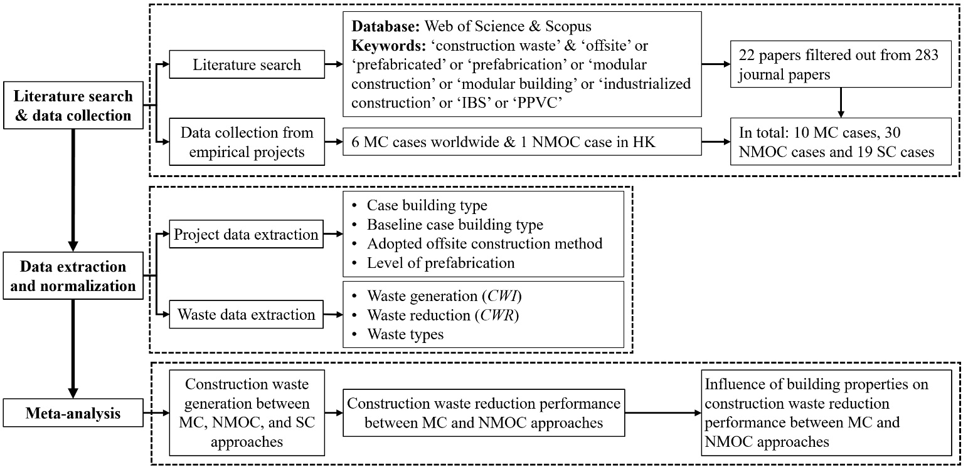
Fig. 1 Overview of research methodology

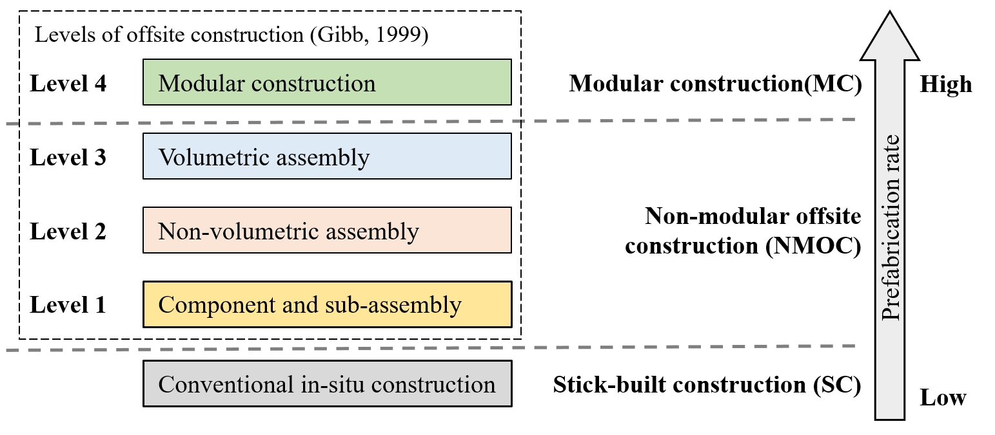
Fig. 2 Classification of construction methods for construction waste analysis

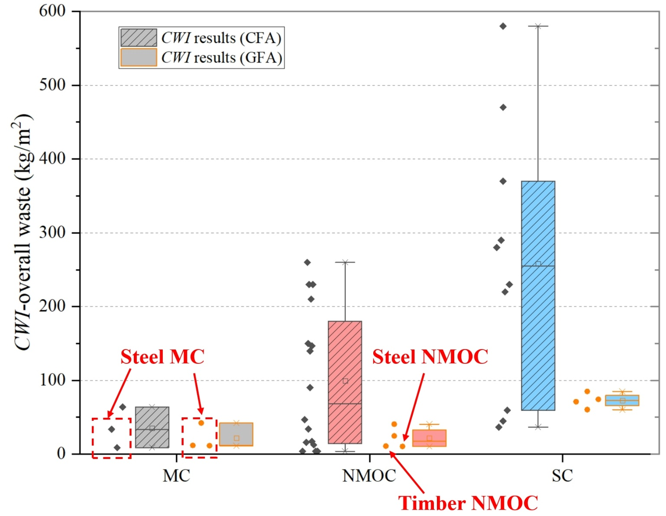
Fig. 3 CWI of overall waste of MC, NMOC, and SC cases
(CWI: construction waste generation index; GFA: gross floor area; CFA: construction floor area; MC: modularized construction; NMOC: non-modular offsite construction; SC: stick-built construction)

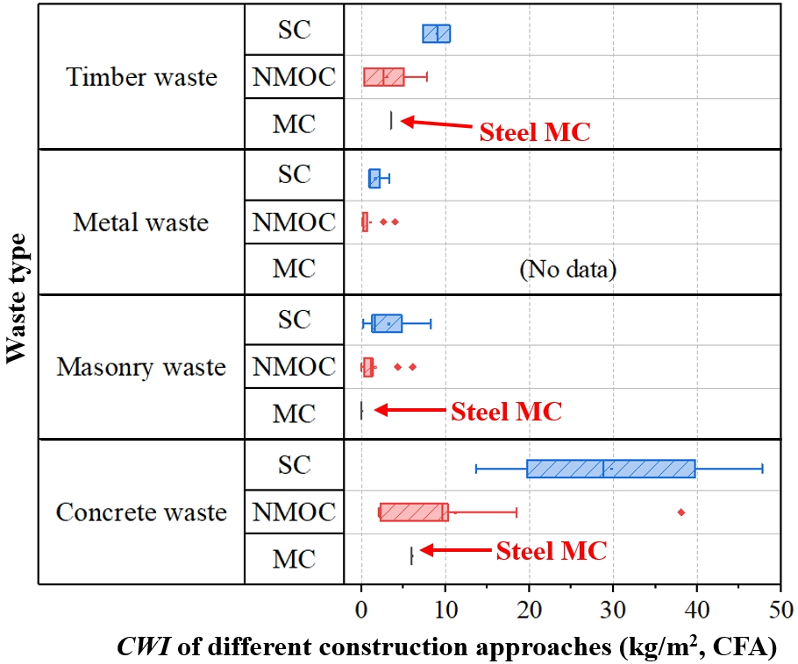
Fig. 4 CWI of concrete, masonry, metal, and timber waste of MC, NMOC, and SC cases (CWI results quantified by CFA)

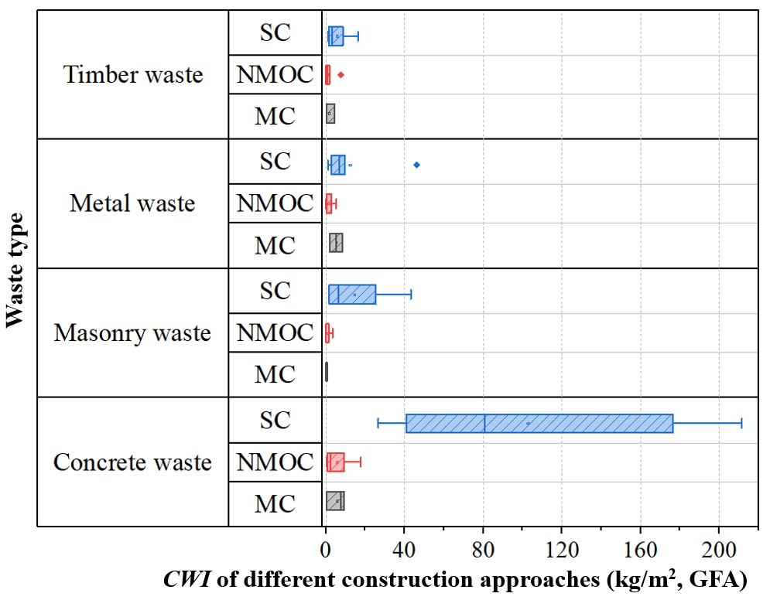
Fig. 5 CWI of concrete, masonry, metal, and timber waste of MC, NMOC, and SC cases (CWI results quantified by GFA)

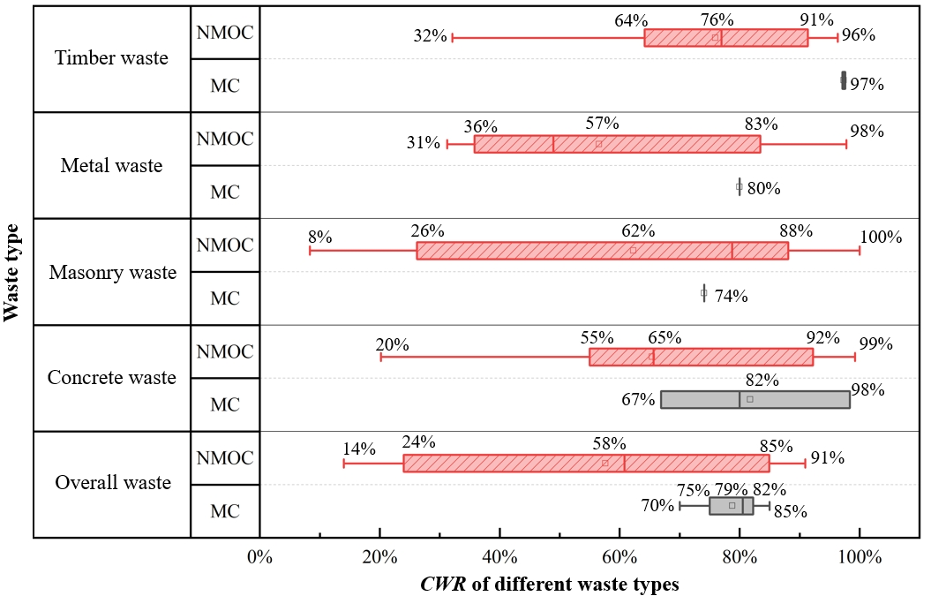
Fig. 6 CWR results of overall waste and four waste types of MC and NMOC cases

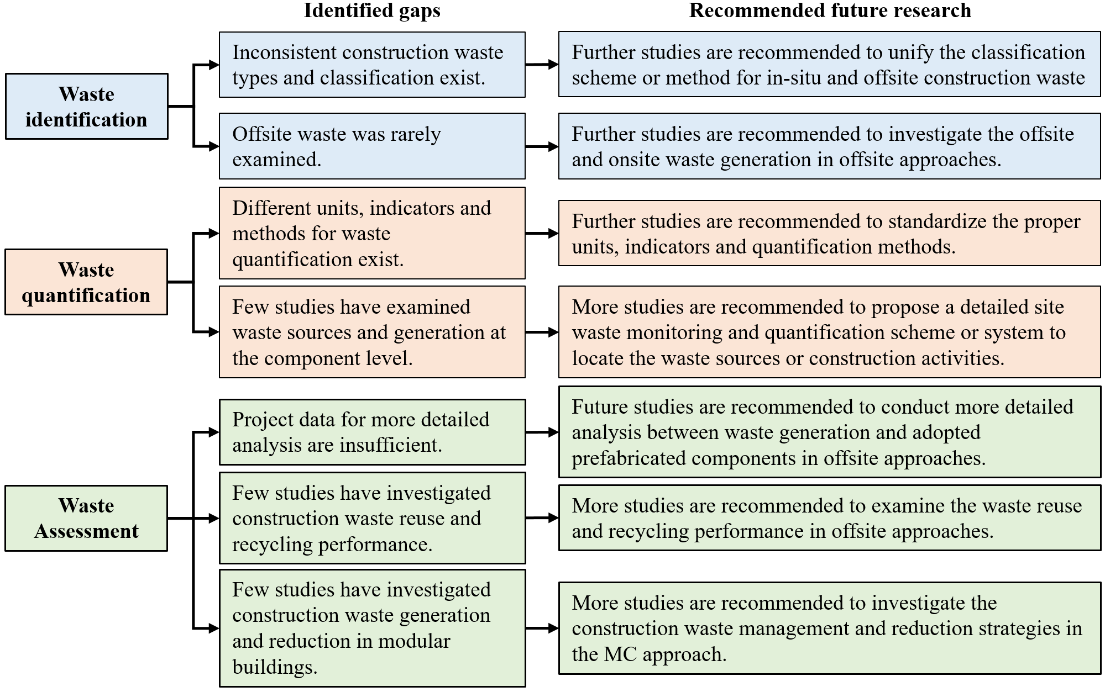
Fig. 7 Knowledge gaps and recommended research on construction waste performance of offsite approaches

