Soft layered composites with wrinkling-activated multi-linear elastic behavior, stress mitigation, and enhanced strain energy storage
Narges Kaynia, Nicholas X. Fang, Mary C. Boyce

Dr. Narges Kaynia
Department of Mechanical Engineering, Massachusetts Institute of Technology, Cambridge, MA 02139, USA
Email: narges.kaynia@gmail.com
Prof. Nick X. Fang
Current Address: Department of Mechanical Engineering, The University of Hong Kong, Pok Fu-Lam, Hong Kong SAR
Email: nicxfang@hku.hk

Prof. Mary C. Boyce
Department of Mechanical Engineering
Columbia University
New York, New York 10027
Email: mb3814@columbia.edu

Keywords: soft composites, energy storage, wrinkling, stress mitigation, effective stiffness, energy absorption, metamaterials

Abstract
Soft elastomeric composite materials constituting of an elastomeric matrix with dilute concentrations of thin, relatively higher modulus interfacial layers are presented and demonstrated to exhibit enhanced strain energy storage together with a bi-/multi-linear elastic behavior and stress mitigation – all with little to no weight penalty. Our study reveals the governing mechanism for these features to be the activation of wrinkling of the embedded interfacial layers upon reaching a critical strain, thereby amplifying energy storage in both the matrix and the interfacial layers. Furthermore, the energy storage in the composite is substantially greater than the sum of the energy storage of the isolated material constituents. The new features of the composite material behavior can be tailored by the concentration of the interfacial layers, and the elastic properties of the elastomeric matrix and interfacial layers. The results are demonstrated and validated through analytical derivations, finite element analysis, and experiments. The analytical expressions provide the ability to quantitatively design and predict the material performance. These soft layered composites point to opportunities in expanding these enhancements to networked interlayers, multi-functional interlayers, and viscoelastic elastomeric matrices for viscous damping together with energy storage.

1. Introduction
Tunable and active materials have emerged as a promising class of materials which exhibit changes in properties or behavior on-demand based on an external stimulus, allowing the creation of adaptive multifunctional materials. [1-11] The tunability can be governed by the inherent material behavior [12-15] as well as by geometric design of the constituent materials [16-22]. In this paper, we focus on a class of soft composite or hybrid materials with adaptive enhanced energy storage mechanisms, stress mitigation, and a switchable effective stiffness, which give bilinear (even multi-linear) elastic behavior – all at nearly constant material density.
The energy storage capabilities of a homogeneous elastic material can be found readily from the elastic constitutive behavior. Indeed, highly deformable elastomeric materials are known and widely used in our daily-life experience for their energy storage capabilities – from the simple rubber band, to wide-ranging intricate seals, to earthquake mitigation bearings, to sneakers, and more. By introducing microstructural features and designs into a homogeneous material, the effective properties and the energy absorption of the materials can be greatly altered and enhanced. [23-24] A primary set of examples are cellular materials with patterned, honeycomb or foam microstructures which alter the deformation mechanisms of the parent material and thus provide dramatically altered effective behavior – including changes in elasticity, plasticity, energy storage and/or dissipation. [23-28]
Herein, we focus on enhancing energy storage in fully dense soft elastomeric materials via embedding dilute (low volume fraction) concentrations of comparatively stiff thin inner layers (referred to as “interfacial layers”). A variation of this, being relatively stiff thin surface layers coating synthetic and natural soft substrates, has been widely studied by many investigators. The thin surface layers experience a wrinkling instability when reaching a critical compressive state induced by various stimuli (e.g., mechanical, environmental, growth, shrinkage) enabling new functions and/or properties [e.g., 18-19, 29-32]. The instability of embedded interfacial layers within a matrix, creating a multilayered composite, has also been studied, both for concentrated [33-35] and dilute composites. [35-37] It was established that for dilute concentrations, the dominant mode of instability of the thin interfacial layers is a wrinkling pattern (whereas the high concentration case exhibits a long wavelength instability). Analytical models were developed predicting the onset conditions and the wavelength of the wrinkling instability. [35] The wrinkling of the interfacial layers occurs throughout the composite. Ubiquitous instability-induced pattern transformations have also been found in periodically structured porous elastomers. [6] The ubiquity of the microstructure transformation was also found to trigger changes in phononic bandgap behavior in both the periodic porous elastomers [8] and the layered composites. [9]
The present work capitalizes on intentionally inducing wrinkling in dilute concentrations of relatively stiff interfacial layers within an elastomeric matrix to create soft composites with tailorable effective mechanical behavior and dramatically enhanced energy-storage. This tunable soft composite exhibits a change in the energy storage mechanism upon reaching a critical condition by activating an instability which, in turn, gives an increase in energy storage in both the elastomer and the interfacial layers. Such synergistic effect is remarkable, as the achievable specific strain energy stored in the hybrid composite will be shown to be greater than the sum of that achievable from the isolated phases. The soft composite also provides a behavior which mitigates load transfer and exhibits a decrease in the effective macroscopic stiffness – giving a bilinear elastic response. The switch in the composite’s effective properties and behavior occur at a critical threshold of compressive loading, which can be tailored by the geometric features of the structure and the relative contrast in material elastic properties. Analytical models are developed predicting the deformation mechanisms, the pathways towards enhanced energy storage, the effective macroscopic nonlinear elastic stress-strain behavior, and the evolution in effective macroscopic stiffness of these composite materials. Finite element simulations (FE) and physical mechanical experiments are performed to validate the analytical model.

2. Analytical and Finite Element Results
2.1 Overview of the Soft Layered Composite in Compression
Here, an overview of the features of the compressive stress-strain behavior of a soft layered composite is first presented in order to frame the analytical methods and results of the subsequent sections. Figure 1 shows the stress-strain curve for an exemplar case of a soft composite under plane strain compression. This composite consists of an elastomeric matrix with a dilute concentration, f, of initially straight and relatively stiff thin plates (also referred to herein as interfacial layers). The representative behavior is computed using analytical models presented in the next sections. For reference and comparison purposes, the stress-strain behavior for a homogeneous soft elastomeric matrix as well as that for an array of initially straight, relatively stiff thin plates spaced to provide an equivalent f are also shown in the graph. This exemplar case considers a soft composite with interfacial layer/matrix plane strain modulus ratio of ${\overline{E}}_{1}/{\overline{E}}_{0}$=100, with ${\overline{E}}_{0}$=1.3MPa and volume fraction f=0.02.
Figure 1a shows the homogeneous elastomeric matrix material to display a soft linear elastic stress-strain response with modulus ${\overline{E}}_{0}$. On the other hand, the effective stress-strain behavior of the initially straight layers, spaced to provide a volume fraction f=0.02, show an initial linear response of modulus f ${\overline{E}}_{1}$ which is then followed by a distinct rollover at a critical plateau stress as the plates undergo mode 1 buckling. Note that the critical buckling condition for these isolated plates depends on the length of the plates via the well-known Euler buckling criteria where buckling occurs at a strain of ($π/12){(t/L)}^{2}$ . Hence, the effective stress-strain behavior and critical condition are shown for two representative sample lengths (as shown more clearly in the exploded view of the stress-strain curves at small strains shown in the inset).
For the soft composite, the initial stress-strain behavior is linear following the rule of mixtures with ${\overline{E}}_{}^{comp}=\left(1-f\right){\overline{E}}_{0}+f{\overline{E}}_{1}$ , but then departs from any summation response. The strain at which the composite departs from linearity is dramatically delayed when compared to that found for the buckling of the isolated plates. The soft matrix surrounding the interfacial layers suppresses the mode 1 buckling of the plates since the required localized matrix deformation to accommodate this mode is energetically not favorable. As the macroscopic compressive strain increases, it becomes more energetically favorable for the interfacial layers to buckle at a higher mode (i.e., a shorter wavelength, lower amplitude wrinkling mode) together with accompanying localized matrix deformation. Upon wrinkling of the interfacial layers, the composite stress-strain curve rolls over to a lower tangent modulus being essentially that of the matrix modulus. Indeed, a bilinear elastic behavior is found. The elastic stress-strain response of the composite is hence greater than the sum of its constituent components due to: 1) the composite retaining its initial increased stiffness to larger strain as a result of the delayed instability, and 2) then followed by the rollover to a reduced post-wrinkling tangent modulus. This enhanced response also portends to the strain energy storage – i.e., the composite structure enhances the strain energy stored in both the matrix and interfacial layers. In the following sections, more in depth theory and mechanisms of these behaviors are provided which show that the level of enhancement can be tailored by the contrast in constituent material properties and concentration of layers.

a) | 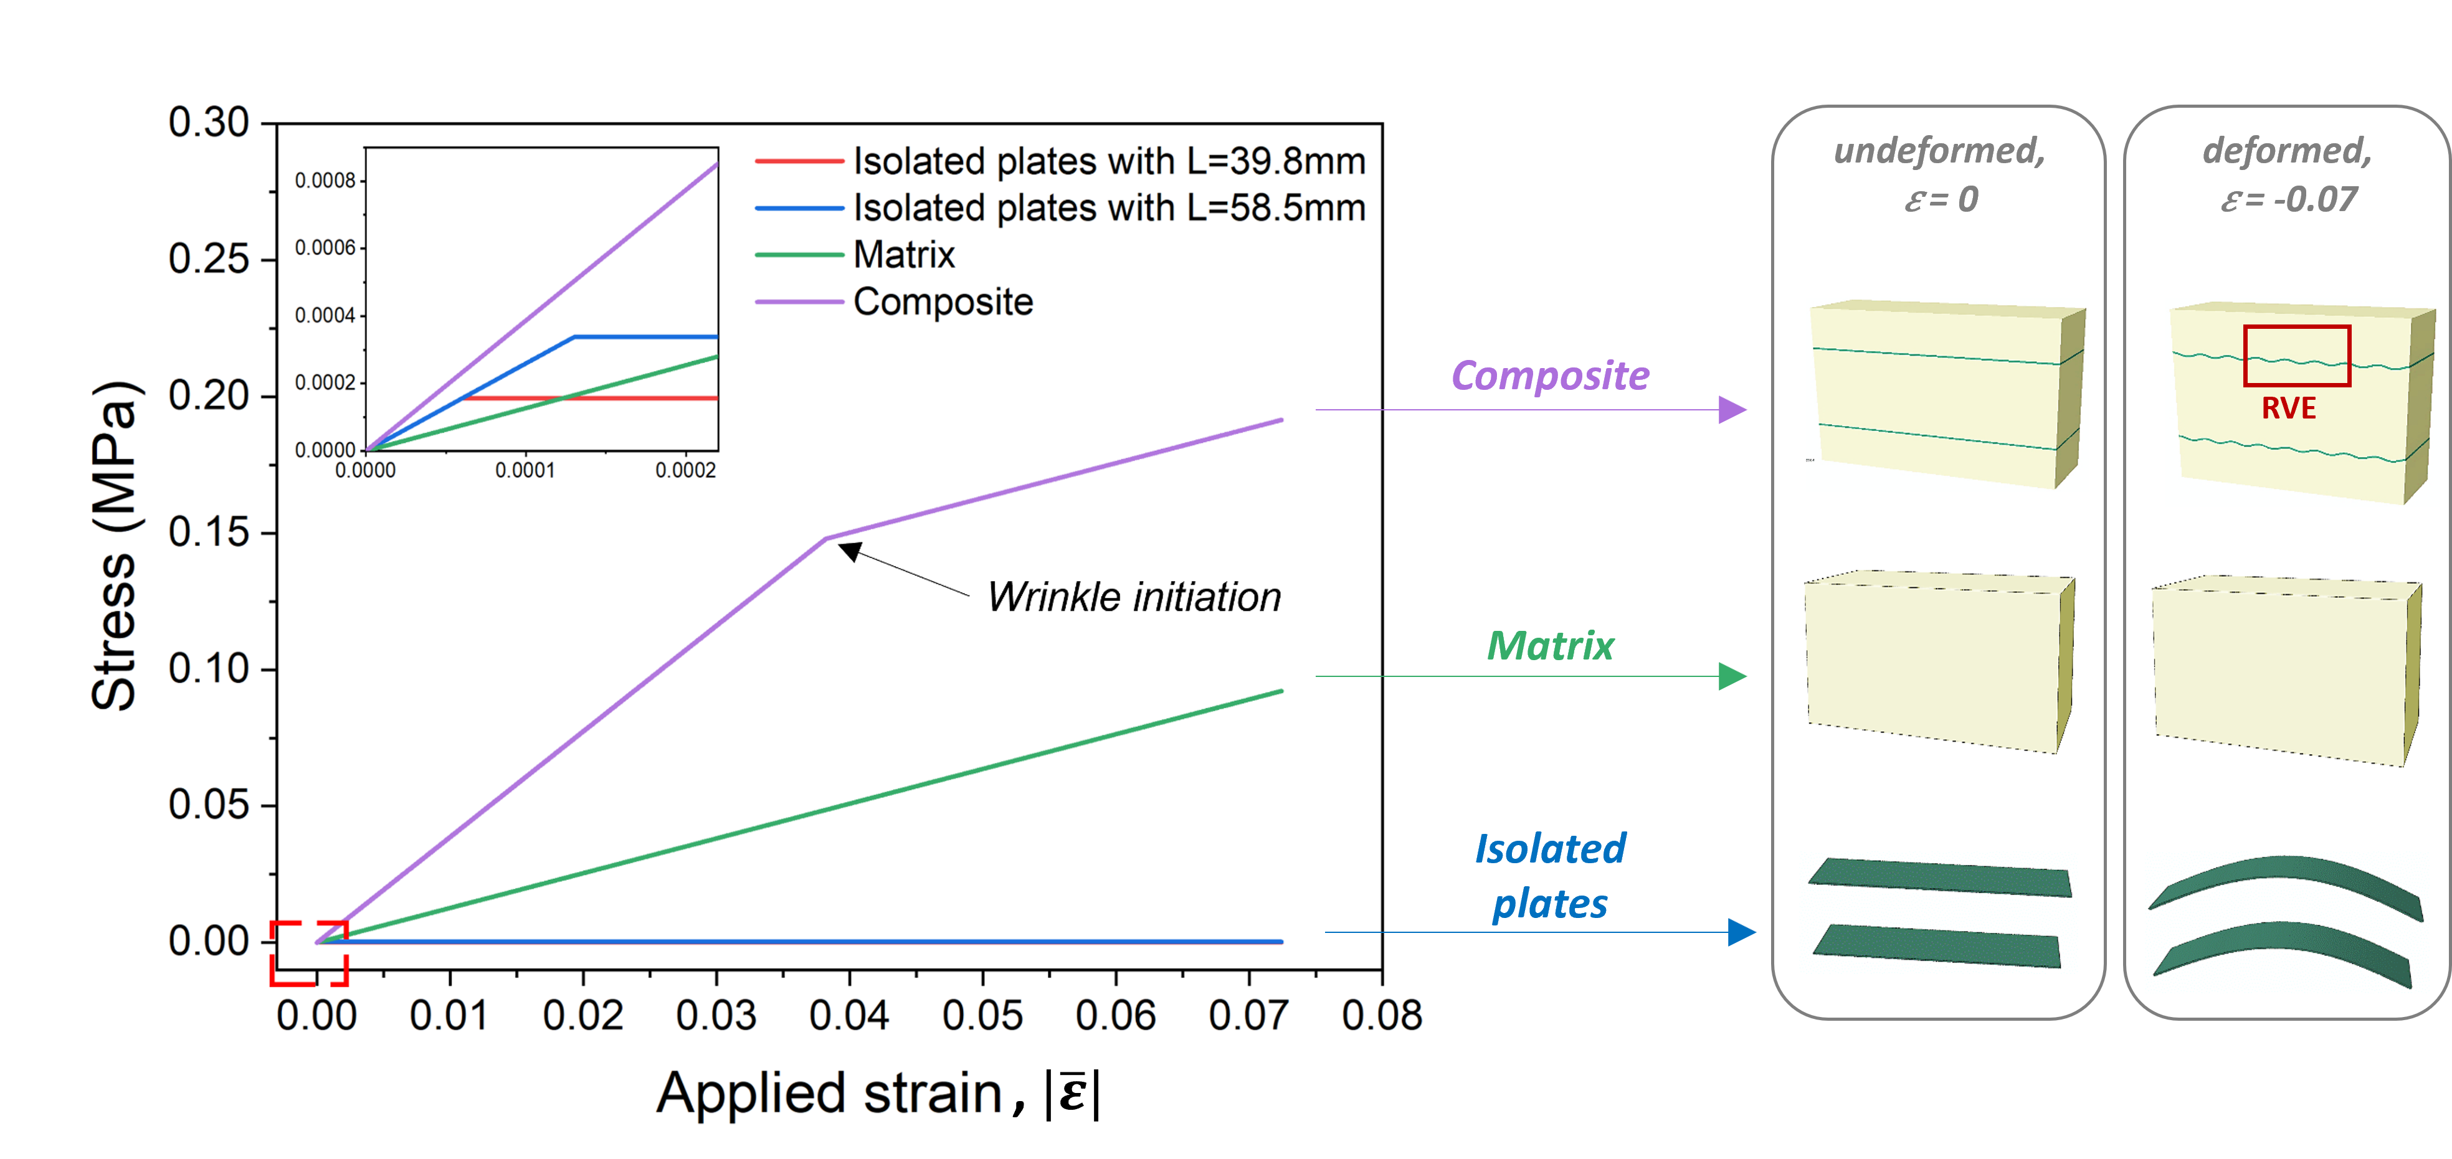
b) | 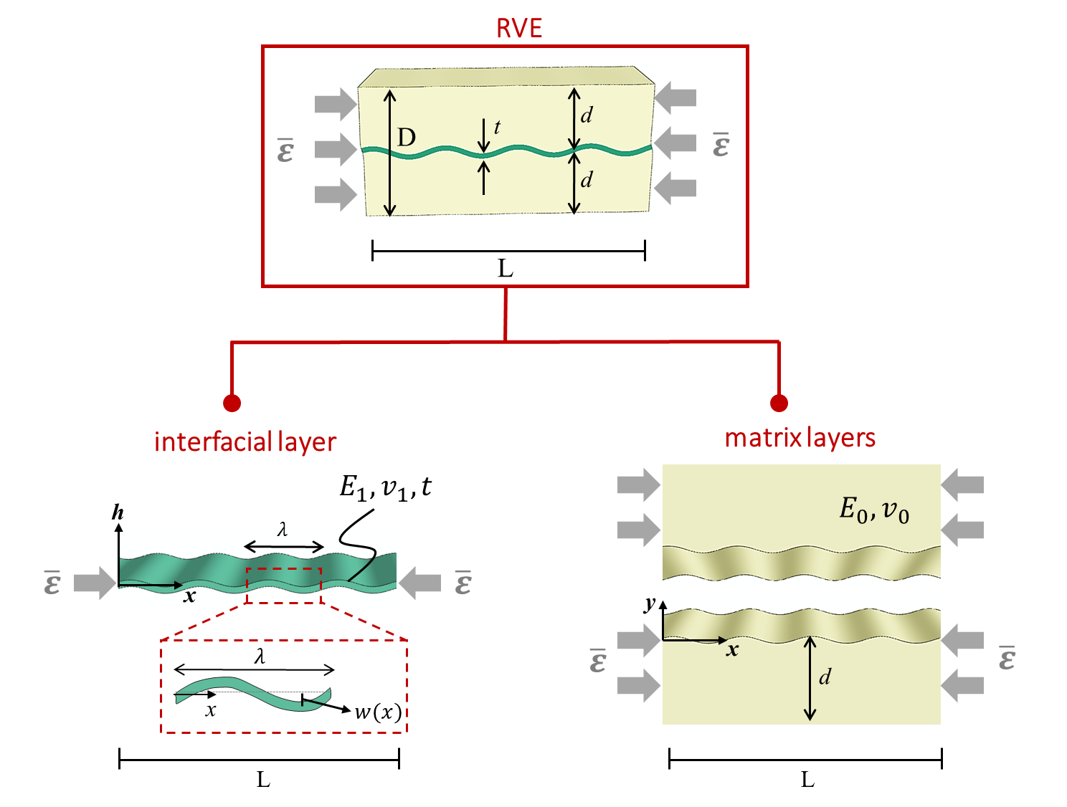
Figure 1. a) The stress-strain curves for three periodic structures; structure-1: straight interfacial layers (E₁= 100MPa, ${\overline{E}}_{1}=130MPa,$f=t/D=0.021: thickness t=0.5mm, separation D=24mm), structure-2: homogeneous matrix (E₀ =1MPa, ${\overline{E}}_{0}=1.3MPa$), and structure-3: composite composed of stiff straight interfacial layers embedded in soft matrix (stiffness ratio ${\overline{E}}_{1}/{\overline{E}}_{0}=$100) with f=0.021. At a compression strain of $\overline{ε}=-0.07$, the strain energy density for the composite is 1.9 times greater than the sum of the straight layers and the simple matrix when in isolation. b) Schematic of a representative volume element (RVE) of a multilayered periodic composite structure consisting of initially straight, thin stiff interfacial layers embedded in a soft matrix after subjected to a critical level of compression. When a macroscopic compressive strain greater than the critical strain is applied, |$\overline{ε}$| > |${\overline{ε}}_{cr}$|, the interfacial layers undergo instability giving wrinkling patterns with wavelength $λ\left(\overline{ε}\right)$ and amplitude $w\left(x, \overline{ε} \right)$.

2.2 Deformation Mechanisms, Strain and Strain Energy Fields in the Soft Composite during Compression
2.2.1 Analytical Model
The underlying deformation and associated energy storage mechanisms of these soft composites Figure 1b) can be understood through analytical models of the stress, strain and corresponding strain energy density fields within the composite. In turn, these then provide a basis for the macroscopic stress-strain behavior and also the quantitative ability to design and tailor the soft composite.
Prior to Wrinkling
Prior to wrinkling of the interfacial layers, the compressive strain in both the interfacial layer and the matrix is that of the applied strain:
$ε_{x}^{matrix}= ε_{x}^{int.layer}=\overline{ε}$ (1)
The axial stress in the matrix and the interfacial layer are given by the product of their respective modulus and the macroscopic strain (here, we are taking the case of plane strain):
$σ_{x}^{matrix}={\overline{E}}_{0}ε_{x}^{matrix}$ and $σ_{x}^{int.layer}={\overline{E}}_{1}ε_{x}^{int.layer }$ (2)
where the plane strain modulus of the interfacial layer and the matrix material are given by:
${\overline{E}}_{1}=\frac{E_{1}}{1-v_{1}^{2}}$ , ${\overline{E}}_{0}=\frac{E_{0}}{1-v_{0}^{2}}$
with $E_{k}$and $v_{k}^{}$ being the Young’s modulus and Poisson’s ratio of each phase. Hence, the effective modulus of the composite, with interfacial layer concentration of f=t/D, follows the rule of mixtures and is simply weighted by the volume fraction of each component and its modulus:
${\overline{E}}_{}^{comp}=\left(1-f\right){\overline{E}}_{0}+f{\overline{E}}_{1}$ (3)
Critical Conditions for Onset of Interfacial Layer Wrinkling
The onset of wrinkling occurs at a critical applied strain and gives the departure from the initial linear stress-strain behavior. In isolation, as indicated in the overview, an interfacial layer would buckle in mode one (Figure 1a) which is the critical condition energetically favoring buckling over a homogeneous compression. However, when supported by a “foundation” such as when surrounded here by a soft matrix, buckling of the interfacial layer also requires locally deforming the matrix which is energetically costly; hence ongoing compression of the interfacial layers is energetically favored over buckling until reaching a larger critical macroscopic strain, at which point the higher mode wrinkling instability is then favored over uniform compression. The critical applied compressive strain, ${\overline{ε}}_{cr}$, for wrinkling of the interfacial layers was found for plane strain in [35] and considers a waveform with internal lateral deflection of the thin layers given by $w\left(x,\overline{ε}\right)\sim \sin\left(\frac{ 2πx}{λ_{cr}} \right)$ where $λ_{cr}$ is the critical wavelength (wavelength at the onset of wrinkling):
${\overline{ε}}_{cr}=- A{\left(\frac{{\overline{E}}_{1}}{{\overline{E}}_{0}}\right)}^{-\frac{2}{3}}$, where A$= 3^{\frac{2}{3}}{\left[\frac{3-4v_{0}}{{\left(1-v_{0}\right)}^{2}}\right]}^{-\frac{2}{3}}=3^{\frac{2}{3}}{(\left(3-{\overline{v}}_{0}\right)\left(1+{\overline{v}}_{0}\right))}^{-\frac{2}{3}}$ (4)
$λ_{cr}=t∙B{\left(\frac{{\overline{E}}_{1}}{{\overline{E}}_{0}}\right)}^{\frac{1}{3}}, where B=π 3^{-\frac{1}{3}}{\left[\frac{3-4v_{0}}{{\left(1-v_{0}\right)}^{2}}\right]}^{\frac{1}{3}}= π 3^{-\frac{1}{3}}{\left[\left(3-{\overline{v}}_{0}\right)\left(1+{\overline{v}}_{0}\right)\right]}^{\frac{1}{3}}$ (5)
which also gives $\frac{λ_{cr}}{t}=\frac{π}{{|{\overline{ε}}_{cr}|}_{}^{ \frac{1}{2}}}$. Note that the “plane strain Poisson’s ratio” of the interfacial layer and matrix material are given by ${\overline{v}}_{1}=\frac{v_{1}}{1-v_{1}}$ and ${\overline{v}}_{0}=\frac{v_{0}}{1-v_{0}}$
The corresponding critical stress of the composite is then $σ_{cr}^{}={\overline{E}}_{}^{comp}{\overline{ε}}_{cr}$ . Upon wrinkling, the stress and strain fields in the interfacial layers will reflect the bending in the periodic waveform; wrinkling also produces a dramatic change in the matrix stress and strain fields near the interfacial layers as the matrix deforms to accommodate the waveform. Analytical expressions for the post-wrinkling waveform, strain and stress, and strain energy density fields are developed below, followed by the strain energy density.

Post Wrinkling: Strain, Stress and Strain Energy Density Fields following Wrinkling
When the applied strain $\overline{ε}$ reaches the critical value ${\overline{ε}}_{cr}$, the interfacial layer will take on a wrinkling waveform and the lateral displacement, $w\left(x,\overline{ε}\right)$, is given by [35]:
$w\left(x, \overline{ε} \right)=w_{max}\left(\overline{ε} \right)\sin\left(\frac{ 2πx}{λ\left(\overline{ε}\right)} \right)$ (6)
where $w_{max}\left(\overline{ε}\right)$ is the post-buckling amplitude and $λ\left(\overline{ε}\right)$ is the post-buckling wavelength of the wrinkling pattern:
$w_{max}\left(\overline{ε} \right)=\frac{λ\left(\overline{ε} \right)}{π}\sqrt{ \left|\overline{ε}\right|- |{\overline{ε}}_{cr}|}$ , (7)
$λ\left(\overline{ε} \right)=λ_{cr}e^{-\left|\overline{ε}\right|}$ (8)
Note that as the applied strain increases, $λ\left(\overline{ε}\right)$ is reduced from $λ_{cr}$ due to the geometry of compressing the waveform. [18]
To determine analytical expressions for the strain and stress fields, we take the liberty of assuming small strain conditions, while acknowledging going to modest levels of deformation.
- Interfacial Layer Strains: Approximating the interfacial layer as a thin plate provides a useful simplification for the local strain and stress distribution in the interfacial layer. The local strain in the interfacial layer then consists of a superposition of the strain at the mid-plane of the interfacial layer and strain distribution through the layer thickness due to bending:
$ε_{x}^{int. layer}\left(x,y, \overline{ε}\right)={\overline{ε}}_{cr}-y\frac{4π}{λ\left(\overline{ε}\right)}{\sqrt{\left|\overline{ε}\right|-\left|{\overline{ε}}_{cr}\right|}}\sin\left(\frac{ 2πx}{λ\left(\overline{ε}\right)} \right)$ (9)
where x is the location along the interfacial layer, y is the distance away from the center of the interfacial layer such that $y∈\left[-\frac{t}{2},\frac{t}{2} \right]$, and $\overline{ε}$ is the macroscopic compressive strain. Taking a plane strain condition and linear elasticity, the local axial stresses are approximated by: $σ_{x}^{int. layer}\left(x,y, \overline{ε}\right)={\overline{E}}_{1}ε_{x}^{int. layer}\left(x,y, \overline{ε}\right)$. Finite element (FE) simulations were performed and verified the analytical predictions (which assumed small strains) for the local strains in the interfacial layer in the composite for a range of different geometries and material combinations (more detailed derivations, analysis, and results can be found in [37]).
- Matrix Strains: The local strain fields in the matrix layers in the post-wrinkling region are found by evaluating the effect of the macroscopic compression together with the effects due to the interfacial layer wrinkling. The wrinkling of the interfacial layer strongly influences the width and depth of the stressed zone of the deformed matrix near to the interfacial layer, $|y|≤ λ(\overline{ε})$. This influence diminishes as the distance away from the interfacial layer increases, $|y|≥ λ(\overline{ε})$, and the deformation is then essentially that of the macroscopic compression of the matrix. We use a small strain assumption, constructing a linear model to evaluate the local strains in the matrix to be the superposition of the macroscopic compression strain, $\overline{ε}$, and the local strain distribution in the matrix due to the wrinkling of the interfacial layer. Taking a plane strain condition and linear elasticity, we find the local stresses and strains in the matrix due to the wrinkling deformation by first defining an Airy’s stress function for the matrix. [35, 37, 38] Then, we take derivatives of the Airy’s stress function to obtain the local stresses. By obtaining the associated strains due to wrinkling from the elastic constitutive relation, and superposing these with the strains from the macroscopic compression, the following final expressions are obtained for the local axial normal strain, transverse normal strain, and shear strain in the matrix:
$ε_{x}^{matrix}\left(x,±y,\overline{ε}\right)=\overline{ε}±\frac{4π^{2}w_{max}\left(1+{\overline{v}}_{0}\right)}{λ^{2}\left(3-{\overline{v}}_{0}\right)} \left|y\right| sin\left(\frac{2πx}{λ}\right) e^{\left(-\frac{2π|y|}{λ}\right)}$
$ε_{y}^{matrix}\left(x,±y,\overline{ε}\right)=-{\overline{v}}_{0}\overline{ε}∓\frac{4π^{2}w_{max}}{λ^{2}\left(3-{\overline{v}}_{0}\right)}\left[\frac{λ\left(1-{\overline{v}}_{0}\right)}{π}+\left(1+{\overline{v}}_{0}\right) \left|y\right|\right]sin\left(\frac{2πx}{λ}\right) e^{\left(- \frac{2π|y|}{λ}\right)}$ (10)
$ε_{xy}^{matrix}\left(x,±y,\overline{ε}\right)=∓\frac{4πw_{max}}{λ\left(3-{\overline{v}}_{0}\right)}\left[1-{\overline{v}}_{0}+\frac{2π\left(1+{\overline{v}}_{0}\right)}{λ} \left|y\right|\right]cos\left(\frac{2πx}{λ}\right) e^{\left(- \frac{2π|y|}{λ}\right)}$
where x is the location along the matrix layer$,$y is the distance across the matrix layer, $\overline{ε}$ is the macroscopic strain, and $w_{max}\left(\overline{ε}\right)$ and $λ\left(\overline{ε}\right)$ are the wrinkling amplitude and wavelength (Equations 7 and 8). Note that the end exponential term shows the wrinkling-induced matrix strains to decay with distance y from the interfacial layer; here we take $λ$ as the characteristic length for the decay (i.e. St Venant’s principle).
- Stored Energy Contributions: As the layered composite is compressed through the pre-wrinkling, wrinkling, and post-wrinkling region, it is storing energy. The local strain energy density at a material point is given by $\int{{\vec{σ}}^{k}d{\vec{ε}}^{k}}$ where ${\vec{σ}}^{k}$and ${\vec{ε}}^{k}$ are the two-dimensional stress and strain tensor at the material points in each phase k of the composite, k$∈$[int.layer, matrix].

2.2.2 Results
Figure 2. Analytical and finite element results for strain distributions in the matrix for a composite with ${\overline{E}}_{1}/{\overline{E}}_{0}$=200, E₀=1MPa (i.e. ${\overline{E}}_{0}=1.3MPa$), f=t/D=0.02, t=0.5mm at a macroscopic compressive strain of $\overline{ε}=-0.07$=3${\overline{ε}}_{cr}$. The enhanced strains near the interfacial layer illustrate the matrix accommodation of the layer wrinkling and are observed to diminish to that of homogeneous compression over a distance of approximately one wavelength away from the layer. Finite element results support the analytical solution. Details of the finite element model are provided in the supporting information.

Figure 2 shows the strain distributions in the matrix calculated from our analytical models together with results from finite element (FE) simulations at a macroscopic strain of $\overline{ε}=-0.07$for an exemplar case of ${\overline{E}}_{1}/{\overline{E}}_{0}$= 200, f=t/D= 0.02. The results show the dramatic impact of the wrinkling on altering and enhancing the strain field in the matrix near to the interfacial layer - enhancing normal strains and creating significant local shear straining which, in turn, result in an enhancement in energy storage in the matrix (to be shown next). The results also demonstrate that the strains reach the uniform compression state for y > $λ\left(\overline{ε}\right)$, which verifies the assumption taking $λ$ as the characteristic length for the affected region. [37]

Contours of the strain energy density in the matrix and in the interfacial layers for three cases (of elastic modulus contrast and interfacial layer volume fraction) are shown in Figure 3. The results show the dramatic enhancement in strain energy (stored energy) in the matrix material near the interfacial layers as compared to that in the matrix under uniform compression, as well as the strain energy distribution in the interfacial layers due to the bending from wrinkling. We see that a higher modulus contrast between interfacial layer and matrix (${\overline{E}}_{1}/{\overline{E}}_{0}$) results in a longer wavelength and also greater strain energy in the matrix as it responds to the bending of the stiffer interfacial layer.

a) | 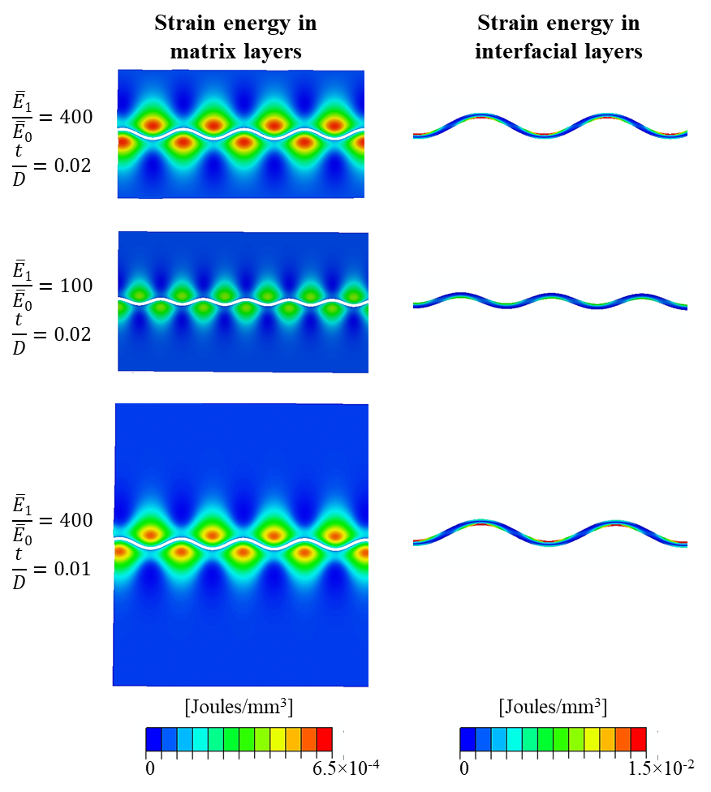
b)
c)
Figure 3. FE contours of the strain energy density in the matrix layers and in the interfacial layers of different composites at macroscopic applied strain of $|\overline{ε|}=0.07$. The composites vary in material properties $({\overline{E}}_{1})$, and/or interfacial layer concentration (f=t/D), while the composite modulus is set constant at E₀=1MPa (i.e. ${\overline{E}}_{0}=1.3MPa$); a) ${\overline{E}}_{1}/{\overline{E}}_{0}=400$ and t/D=0.02; b) ${\overline{E}}_{1}/{\overline{E}}_{0}=100$and t/D=0.02; c) ${\overline{E}}_{1}/{\overline{E}}_{0}=400$ and t/D=0.01

2.3 Macroscopic Response of the Soft Composite during Compression
2.3.1 Analytical Model
While the strain and strain energy density contours provide information on the mechanisms of energy storage within the composite material, it is also instructive to understand the full integrated contribution of each phase to the overall energy storage of the composite.
The total strain energy in each phase is obtained by integrating over the volume of the phase: $u_{k}\left(\overline{ε}\right)=\int{{\vec{σ}}^{k}d{\vec{ε}}^{k} {dV}^{k}}$ . Therefore, the total energy stored, $u_{Total}$, in the composite material at any macroscopic applied loading,$\overline{ε}$, is the sum of the energy stored in the two phases – i.e., the interfacial layers and the surrounding matrix layers:
$u_{Total}(\overline{ε})=u_{int.layer}(\overline{ε})+u_{matrix}(\overline{ε})$ with $u_{k}\left(\overline{ε}\right)=\int{{\vec{σ}}^{k}d{\vec{ε}}^{k} {dV}^{k}}$ (11)
The strain energy density function, $U_{k}$ for each phase k is then found by normalizing the total strain energy of the phase by the material volume, calculating the strain energy per unit volume of initial geometry: $U_{k}=\frac{u_{k}\left(\overline{ε}\right)}{V_{initial}^{k}}$.
For a composite with a volume fraction of interfacial layers f and of matrix layers ($1-f)$, the strain energy density as a function of the macroscopic applied load of $\overline{ε}$ is then found to be:
$U_{Total}\left(\overline{ε}\right)=fU_{int.layer}^{}\left(\overline{ε}\right)+(1-f)U_{matrix}^{}\left(\overline{ε}\right)$ (12)
Prior to wrinkling, as the strain state is uniform throughout the composite, the strain energy density is simply:
$U_{Total}\left(\overline{ε}\right)=\frac{1}{2}{\overline{E}}_{}^{comp}{\overline{ε}}^{2}=\frac{1}{2}\left[(1-f){\overline{E}}_{0}+f{\overline{E}}_{1}\right]{\overline{ε}}^{2}$ (13)
Once wrinkling occurs, the inhomogeneous strain energy distributions in the interfacial layers and matrix must be integrated to obtain the total strain energy in each phase as described earlier in Section 2.2.1. After neglecting higher order terms and also approximating $λ\sim λ_{cr}$, the strain energy density contributions for the interfacial layer, $U_{int.layer}\left(\overline{ε}\right),$ and for the matrix layers, $U_{matrix}\left(\overline{ε}\right)$ are found to be:

$U_{int.layer}\left(\overline{ε}\right)≈\frac{1}{2} {\overline{E}}_{1} {\overline{ε}}_{cr}^{2}+\frac{{\overline{E}}_{1} π^{2} \left(\left|\overline{ε|}-{|\overline{ε}}_{cr}\right|\right)}{3 ({λ/t)}^{ 2}}$ (14)

$U_{matrix}\left(\overline{ε}\right)≈\frac{1}{2}{\overline{E}}_{0} {\overline{ε}}^{2}+\frac{{\overline{E}}_{0}π ({w_{max}/λ)}^{ 2}({λ/t)}^{ }}{ {\left(3-{\overline{v}}_{0}\right)}^{}\left(1+{\overline{v}}_{0}\right)}\frac{2f}{(1-f)}$ (15)

Using expressions for $w_{max}/λ$ and $λ/t$ from earlier gives:
$U_{int.layer}\left(\overline{ε}\right)≈\frac{1}{2} {\overline{E}}_{1} {\overline{ε}}_{cr}^{2}+ \frac{1}{3}{\overline{E}}_{1} A {\left(\frac{{\overline{E}}_{1}}{{\overline{E}}_{0}}\right)}^{-\frac{2}{3}}\left(\left|\overline{ε|}-{|\overline{ε}}_{cr}\right|\right)$ (16)

$U_{matrix}\left(\overline{ε}\right)≈\frac{1}{2}{\overline{E}}_{0} {\overline{ε}}^{2}+ {\overline{E}}_{0} \frac{2f}{(1-f)} \frac{{\left(\frac{{\overline{E}}_{1}}{{\overline{E}}_{0}}\right)}^{1/3}\left(\left|\overline{ε|}-{|\overline{ε}}_{cr}\right|\right)}{ {\left(3-{\overline{v}}_{0}\right)}^{}\left(1+{\overline{v}}_{0}\right)A^{1/2}}$ (17)

The strain energy density of the composite is then the weighted sum of these contributions (Equation 12).
Alternatively, it is often also useful to have the strain energy density expressed directly from the stress-strain curve of the composite material, here broken down into pre- (first term) and post- (second and third term) wrinkling contributions. Hence, the strain energy density of the composite can also equivalently be expressed as:
$U_{Total}\left(\overline{ε}\right)=$ $\frac{1}{2} σ_{cr}^{} {\overline{ε}}_{cr}^{}+ σ_{cr}^{} \left(\left|\overline{ε|}-{|\overline{ε}}_{cr}\right|\right)+\left(1-f\right) \frac{1}{2}{\overline{E}}_{post-wrinkling}^{comp}{\left(\left|\overline{ε|}-{|\overline{ε}}_{cr}\right|\right)}^{2}$ (18)
Note, we can approximate ${\overline{E}}_{post-wrinkling}^{comp}$ to be equal to ${\overline{E}}_{0}^{}$ in the post-wrinkling stage, giving:
$U_{Total}\left(\overline{ε}\right)≈\frac{1}{2} σ_{cr}^{} {\overline{ε}}_{cr}^{}+ σ_{cr}^{} \left(\left|\overline{ε|}-{|\overline{ε}}_{cr}\right|\right)+\left(1-f\right) \frac{1}{2}{\overline{E}}_{0}{\left(\left|\overline{ε|}-{|\overline{ε}}_{cr}\right|\right)}^{2}$ (19)
Noting that $σ_{cr}^{}=(\left(1-f\right){\overline{E}}_{0}+f{\overline{E}}_{1}){\overline{ε}}_{cr}$ and ${\overline{ε}}_{cr}=- A{\left(\frac{{\overline{E}}_{1}}{{\overline{E}}_{0}}\right)}^{-\frac{2}{3}}$ (and some algebra), $U_{Total}\left(\overline{ε}\right)$ can be further rewritten as follows:
$U_{Total}\left(\overline{ε}\right)= {f{\overline{E}}_{0}\left(\frac{{\overline{E}}_{1}}{{\overline{E}}_{0}}\right)}^{\frac{1}{3}}A\left(\left|\overline{ε}\right|-\frac{1}{2}\left|{\overline{ε}}_{cr}^{}\right| \right)+ \frac{1}{2}\left(1-f\right) {\overline{E}}_{0}{\overline{ε}}^{2}$ (20)
Note that, the macroscopic axial stress-strain behavior of the composite is obtained by differentiating the strain energy density expression:
${\overline{σ}}_{x}^{comp}\left(\overline{ε}\right)=\frac{d U_{Total}\left(\overline{ε}\right)}{d \overline{ε}}$ (21)
The tangent stiffness of the composite, ${\overline{E}}_{x}^{comp}$, can be calculated by differentiating the effective macroscopic stress:
${\overline{E}}_{x}^{comp}\left(\overline{ε}\right)=\frac{d {\overline{σ}}_{x}^{comp}\left(\overline{ε}\right)}{d \overline{ε}}=\frac{d^{2}U_{Total}\left(\overline{ε}\right)}{d {\overline{ε}}^{ 2}}$

2.3.2 Results
Effect of the Ratio of Interfacial Layer/Matrix Modulus
Figure 4 shows the analytical results (as also validated by finite element analysis) for the strain energy density evolution and the macroscopic stress-strain behavior of composites for modulus ratio ${\overline{E}}_{1}/{\overline{E}}_{0}$ ranging from 25 to 400 while keeping the interfacial layer concentration constant at $f=t/D=$0.021. (Note that modulus ratios 500 or greater for t/D=0.021 are transitioning from a wrinkling to a long wave instability and therefore are not applicable here [35]).
Figure 4a shows the strain energy density contribution for the interfacial layers (calculated per unit volume of interfacial layer (left axis) and calculated per unit volume of the total composite (right axis)). For the lowest modulus contrast of ${\overline{E}}_{1}/{\overline{E}}_{0}$ =25 , wrinkling onset would occur at a critical strain of 0.097; since the plot goes to a strain of 0.07, the effect of wrinkling is not seen in the ${\overline{E}}_{1}/{\overline{E}}_{0}$ =25 curves. For the higher modulus contrast cases, the results show a clear bifurcation point at the critical strain of wrinkling onset where the slope of the graph changes from the quadratic increase of uniform compression. In the post-wrinkling region, |$\overline{ε}$| > |${\overline{ε}}_{cr}$|, the slope is reduced since the ongoing increase in strain energy in the interfacial layer is now a result of the bending of the wrinkling pattern which accommodates the further increase in applied strain. Note that the isolated plates would have buckled at a dramatically lower strain and hence would have relatively inconsequential contribution to energy storage.
Figure 4b shows the strain energy density in the matrix layers of the composite to increase dramatically in the post-wrinkling region, |$\overline{ε}$| > |${\overline{ε}}_{cr}$|. This increase in matrix strain energy density is due to the large localized deformations occurring in the matrix layers. Comparing the strain energy density in the matrix layers of the composites with the strain energy density of a homogeneous matrix (dash-dot line in Figure 4b), it is clear that the overall matrix strain energy density of the composites in the post-wrinkling region is strongly enhanced by the strain energy from the local deformations in the matrix due to the wrinkling. For example, at post-wrinkling strain of $\overline{ε}={-0.07=4.5\overline{ε}}_{cr}$, the strain energy density of the matrix layers of the composite with ${\overline{E}}_{1}/{\overline{E}}_{0}$ =400 is more than 2.5 times greater than for a homogeneous matrix undergoing compression. Hence, the addition of a small fraction of relatively stiff layers provides a rather dramatic enhancement in energy storage in the matrix.
Figure 4c shows the total strain energy density for composites over the range of ${\overline{E}}_{1}/{\overline{E}}_{0}$. The energy stored in the composite continues to monotonically increase as the applied strain exceeds the critical strain of the composite, i.e. even though the interfacial layers have wrinkled. This is a direct effect of the strain energy contribution from the matrix layers increasing in the post-wrinkling region (Figure 4b) together with the ongoing bending energy of the interfacial layers (Figure 4a). As an example, for the exemplar case of ${\overline{E}}_{1}/{\overline{E}}_{0}$ =400, t/D=0.021, the increase in the overall strain energy density of the composite at a strain of 0.07, is 4 times greater than that of the homogeneous matrix (and at relatively constant material density – meaning a much higher specific energy density as well).

a) | 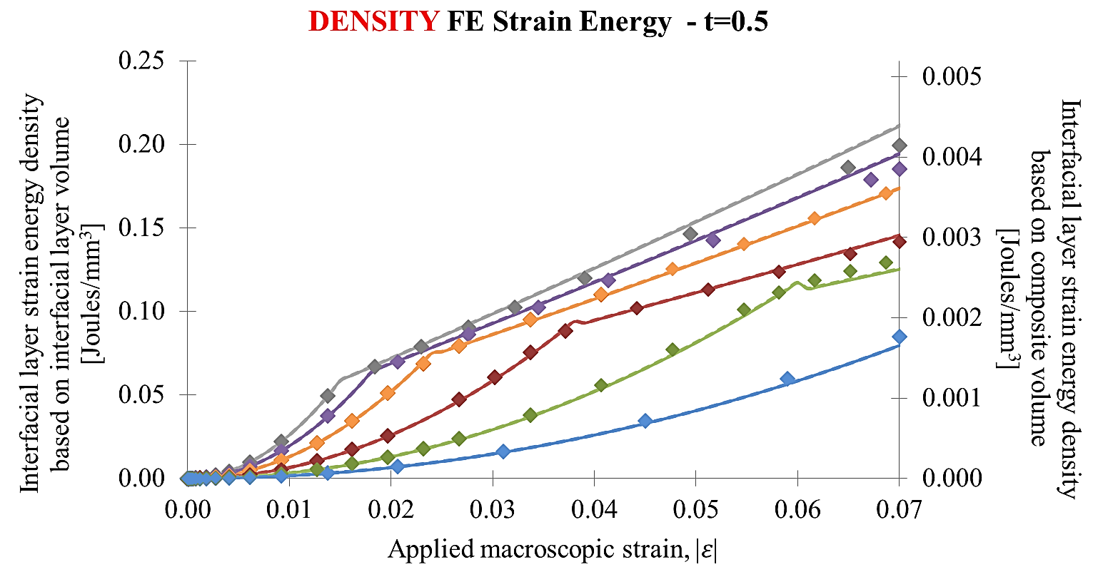 | b) | 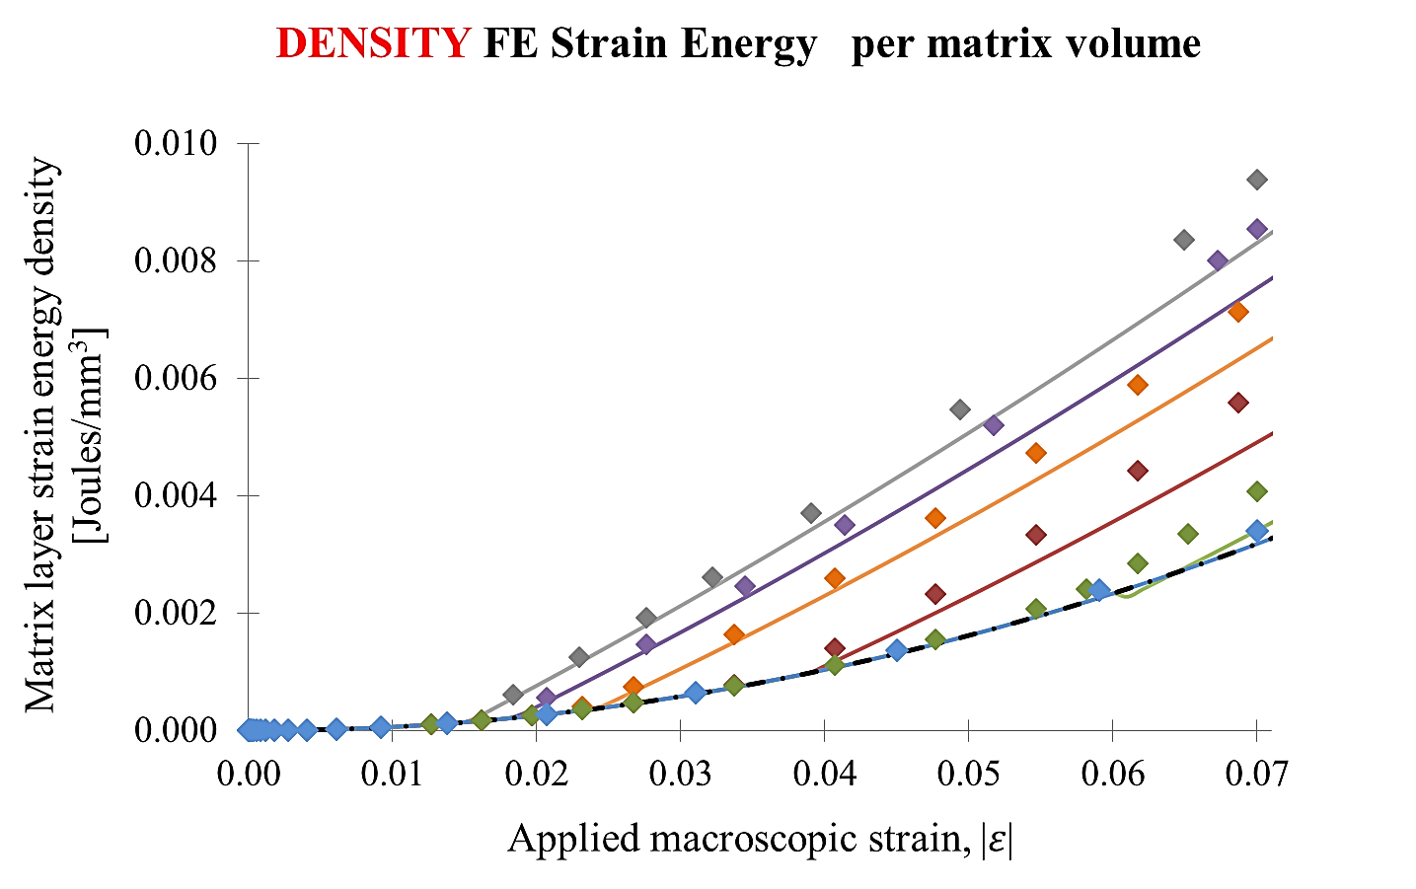
c) | 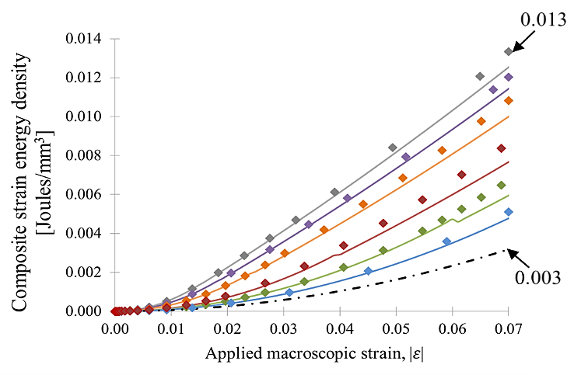 | d) | 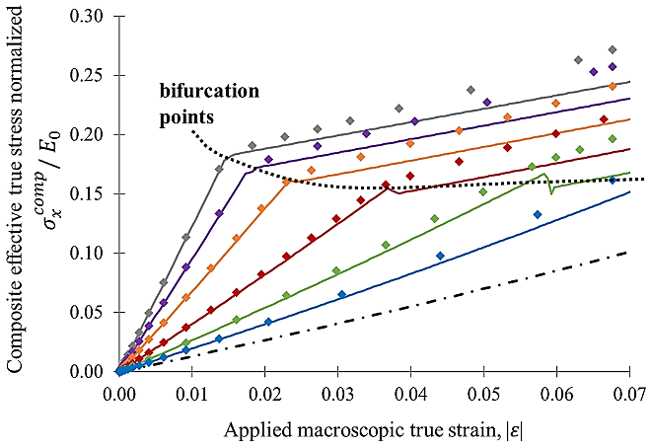
e) | 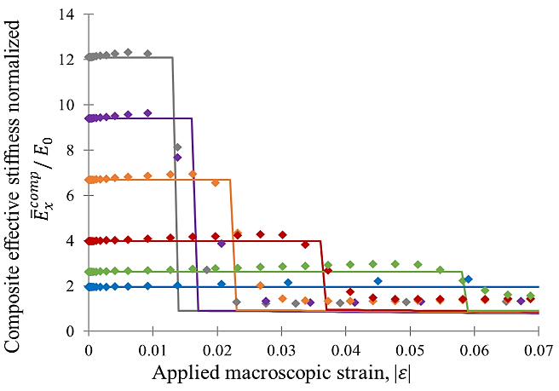
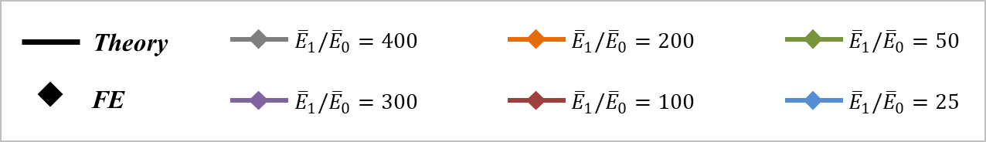
Figure 4. Analytical (line) and FE (symbols) results as a function of macroscopic strain, $\overline{ε},$ for different composites with varying stiffness ratios between the interfacial layer and the matrix, ${\overline{E}}_{1}/{\overline{E}}_{0}∈[25-400]$, with E₀=1MPa (i.e. ${\overline{E}}_{0}=1.3MPa$), with interfacial layer concentration of f$=$t/D=0.021; a) Strain energy density in the interfacial layer; calculated based on volume of interfacial layer on left axis, and calculated based on volume of total composite on right axis. b) Strain energy density in the matrix layers of the composites. Dashed-dot line shows compression of a homogeneous matrix layer. c) Strain energy density in the full composite. d) The effective true stress-strain curves normalized with respect to the stiffness of the matrix, ${\overline{\overline{σ}}}_{x}^{comp}/ E_{0}$. e) The effective stiffness normalized with respect to the stiffness of the matrix, ${\overline{E}}_{x}^{comp}/ E_{0}$.

As the composites are compressed macroscopically through the pre- and into the post-wrinkling region, the wrinkling acts to mitigate the stress level increase needed for further compression, as evidenced by the decrease in slope in the macroscopic composite stress-strain curve (Figure 4d). Prior to wrinkling, the straight interfacial layers contribute significantly to the stiffness of the composite via the Voigt rule of mixtures model; however, we note that given the dilute concentration level, the overall stiffness remains in the range of a soft elastomeric material. When the applied strain $\overline{ε}={\overline{ε}}_{cr}$, a clear bifurcation point is observed in the effective true stress-strain curve clearly demonstrating the point at which the wrinkling instability occurs.
Post wrinkling, the tangent stiffness is observed to decrease to essentially that of the matrix. Hence, the post-wrinkling increase in stress with strain is mitigated, which indicates that these composites can be used to mitigate and limit load transfer, while still absorbing deformation and storing energy. Moreover, these composite materials exhibit a bilinear elastic behavior. We note that although the features of the stress-strain curve are similar to those of an elastic-plastic material, which exhibits an initial linear elastic modulus, followed by a clear yield point giving the onset of plasticity, followed by a reduced post-yield slope (and energy dissipation following yield), here we have a bilinear elastic material with a bifurcation at a critical stress due to wrinkling of the interfacial layers followed by a post-bifurcation reduced elastic modulus – all of which are reversible elastic events storing energy.
Figure 4e further demonstrates this change in tangent modulus and shows the effective modulus normalized with respect to the matrix modulus, ${\overline{E}}_{x}^{comp}/ {\overline{E}}_{0}$, for composites with different ${\overline{E}}_{1}/{\overline{E}}_{0}$ at f=t/D=0.021, as a function of the applied macroscopic strain, $\overline{ε}$. It is apparent that the effective modulus drops promptly as the applied strain exceeds the critical strain, $|\overline{ε|}>|{\overline{ε}}_{cr}|$.

Effect of Interfacial layer concentration
The effect of the volume fraction of the interfacial layers was studied by varying the concentration f=t/D $∈\left[0.007, 0.01, 0.014, 0.017\right]$at constant ${\overline{E}}_{1}/{\overline{E}}_{0}=$400. Figure 5 shows the results for the evolutions in strain energy densities, the effective stress-strain behavior, and effective modulus for these composites. The results show that the energy storage density, initial modulus, critical stress at wrinkling onset, and post-wrinkling modulus all increase with increase in concentration. It is important to emphasize that the critical strain at which the interfacial layer will undergo wrinkling instability is independent of geometric features and only depends on the stiffness ratio, ${\overline{E}}_{1}/{\overline{E}}_{0}$ (Equation 5). Figure 5 depicts this by showing clear bifurcation points in the energy density plots and effective property plots that are all at the same applied strain, $\overline{ε}= {\overline{ε}}_{cr}$= -0.015. Hence, for a given constituent modulus contrast ${\overline{E}}_{1}/{\overline{E}}_{0}$, we can tailor the composite initial modulus, the post-wrinkling behavior and the energy storage by altering the concentration f. For example, after a strain of $\overline{ε}$=-0.07, the relative composite energy storage as compared to the homogeneous matrix at a concentration of $f=0.007$is magnified by a factor of 2.3 (=0.007/0.003), and for a concentration of $f=0.017$, the magnification in energy storage is 4.0 (=0.012/0.003). These are dramatic increases in energy storage for very dilute modification of the soft matrix.

a) | 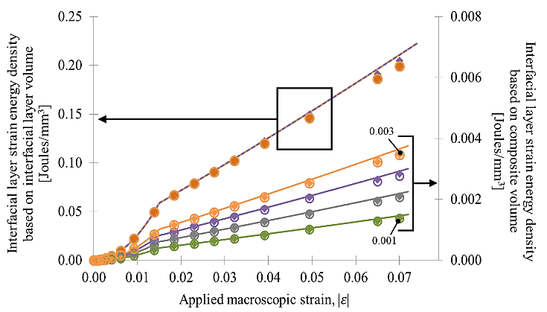 | b) | 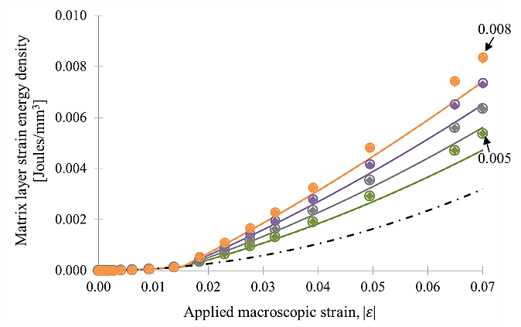
c) | 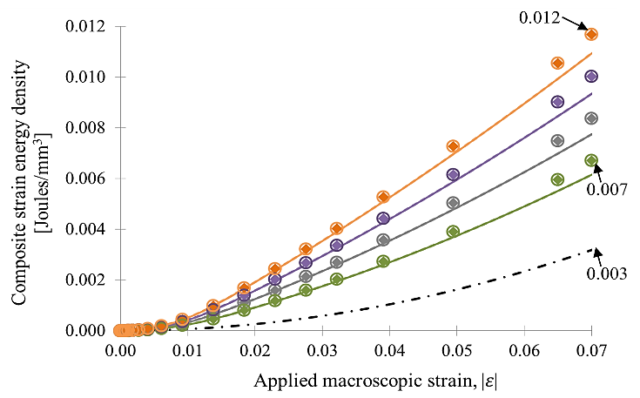 | d) | 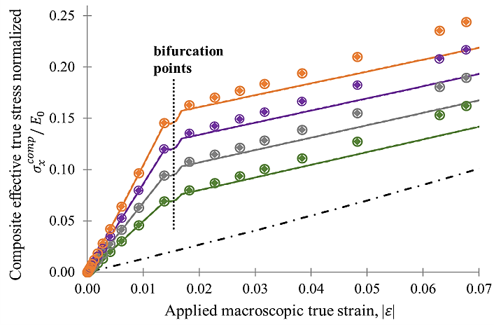
e) | 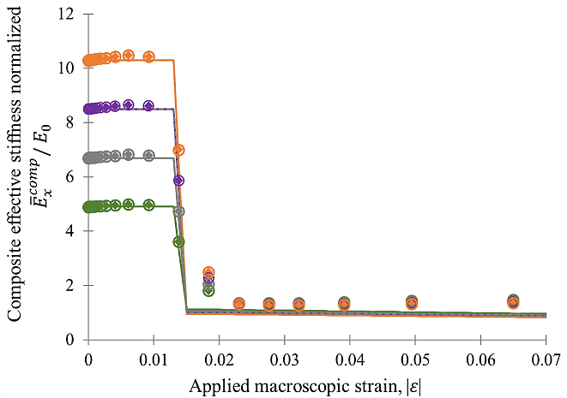
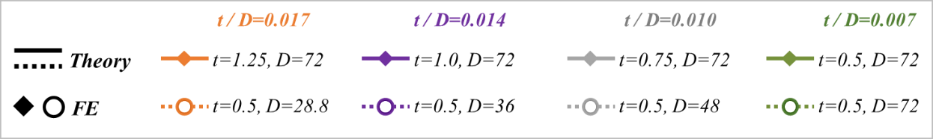
Figure 5. Analytical (lines) and FE (symbols) results as a function of macroscopic strain, $\overline{ε},$ for composites with varying interfacial layer concentrations, $f=t/D∈[0.007-0.017]$, with material properties: ${\overline{E}}_{1}/{\overline{E}}_{0}=400$ and E₀=1MPa (i.e. ${\overline{E}}_{0}=1.3MPa$); a) Strain energy density in the interfacial layer; calculated based on volume of interfacial layer on left axis and calculated based on volume of total composite on right axis b) Strain energy density in the matrix layers of the composites. Dashed-dot line shows compression of a homogeneous matrix. c) Strain energy density in the full composite. d) The effective true stress-strain curves for the different composites normalized with respect to the stiffness of the matrix, ${\overline{\overline{σ}}}_{x}^{comp}/ {\overline{E}}_{0}$. e) The effective modulus normalized with respect to the modulus of the matrix, ${\overline{E}}_{x}^{comp}/ {\overline{E}}_{0}$.

3. Experimental Validation
To validate the analytical and simulation results presented in this paper, physical experiments were carried out using 3D-printed multi-material prototypes fabricated by an Objet500 Connex Multi-Material 3D Printer. [37] The soft matrix layers were printed using the material TangoPlus, TP (initial Young’s Modulus E₀ =0.6±0.1MPa), while the interfacial layers were printed using the material VeroWhite, VW (Young’s Modulus E₁=600±100MPa), or a Digital Material (DM) with Shore95 (Young’s modulus of E₁=23±1MPa). The out-of-plane dimension for all samples was 12mm (depth). The planar dimensions of the composites were: length $L∈[76, 36]mm$, interfacial layer thickness $t ∈\left[0.5, 1\right]mm$, and spacing of $D∈[10.5, 41, 80.5]mm$ (where D=2d+t). For single layered composites, the width of the samples were taken wide enough to reflect the appropriate dilute concentration and to also appropriately capture periodic boundary conditions used in the analytical models (i.e. D > λ which is the region demonstrating any local deformation as shown in section 2 of this paper). The 3D-printed samples were compressed macroscopically with strain, $\overline{ε}$, using a Zwick/Roell Z2.5 mechanical tester. The samples were sandwiched between optically clear acrylic plates (to ensure plane strain conditions) and lubricated with mineral oil to reduce friction between the sample and the plates. Images of the surface deformation and wrinkling were captured with a high-resolution camera, while the macroscopic stress-strain behavior of the composites were recorded. It is worth noting that in these experiments no debonding was observed between the matrix and the interfacial layers.
Figure 6 shows the compressive macroscopic stress-strain curves obtained from the physical experiments (solid red line), compared with the results predicted by the analytical models 2 (marked as grey zone, where the zone includes the uncertainty in the material properties of these 3d-printed materials). Images from the un-deformed and deformed physical samples are also shown for each experiment illustrating the wrinkling pattern. Figure 6a depicts a high modulus ratio case with a ${\overline{E}}_{1}/{\overline{E}}_{0}$ranging from [715-1400] (accounting for property uncertainty) and a very low interfacial layer concentration of f=0.0062. These stress-strain results show a distinct change in slope at a strain of ~0.008 accompanied by wrinkling. The experiments are in good agreement with the analytical models of this paper (shown here accounting for the range in properties). Additionally, the experimentally observed initial modulus and post-wrinkling modulus of the composite can be used together with the analytical models to reduce modulus properties for the matrix and the interfacial layers; this calculation infers ${\overline{E}}_{0}$=0.68MPa and ${\overline{E}}_{1}$=920MPa, giving $\frac{{\overline{E}}_{1}}{{\overline{E}}_{0}}=1353$, which are within the stated range of separately obtained constituent properties.
Figure 6b shows the case of a soft composite with a much lower modulus contrast ${\overline{E}}_{1}/{\overline{E}}_{0}$ ranging from [31-48] (again this range accounts for property uncertainty) and the same low volume fraction f=0.0062. For this case, wrinkling is anticipated at a much larger applied strain between 0.06 – 0.08 and observed to be accompanied by a very modest change in slope as expected given the low modulus contrast ${\overline{E}}_{1}/{\overline{E}}_{0}$ and the low f ; again showing good agreement with the model range. Taking this same low modulus contrast, but now higher volume fractions of f=0.024 and 0.047 shown, respectively, in Figures 6c and 6d, we observe a more distinct change in slope to accompany wrinkling, with wrinkling again occurring at the larger level strain.
Furthermore, while the stress-strain curves do not depend on the interfacial layer thickness t, the wavelength of a wrinkle does depend linearly on t (Equation 5). The specimen images of Figures 6 c and d provide results comparing t=1mm to t=0.5mm, respectively, for the same modulus contrast. These results show the corresponding wavelengths to also differ by a factor of two, consistent with the analytical model. In all cases evaluated, there is good agreement between the analytical predictions and the results from the physical experiments for the macroscopic stress-strain behavior of the composites.

a) | b)
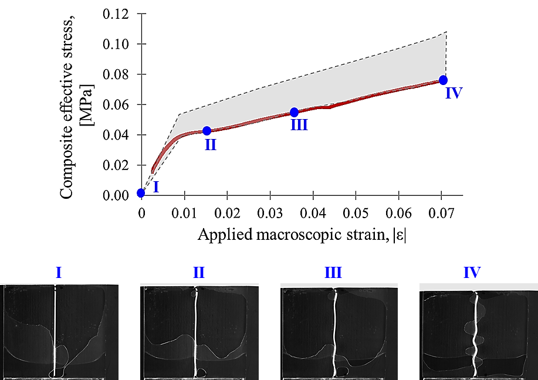 | 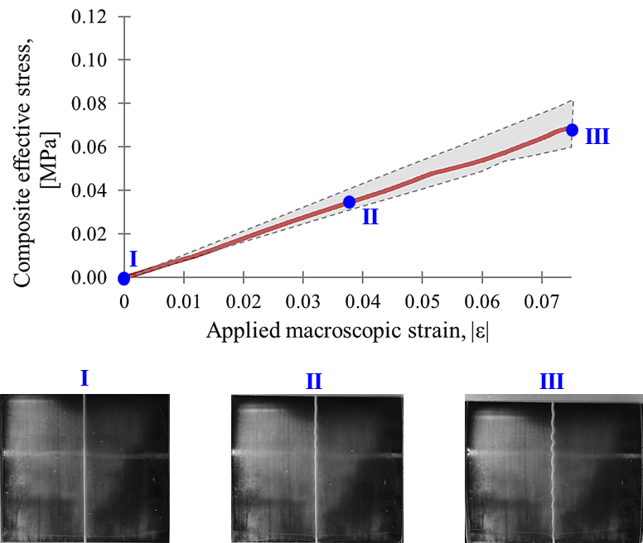
c) | d)
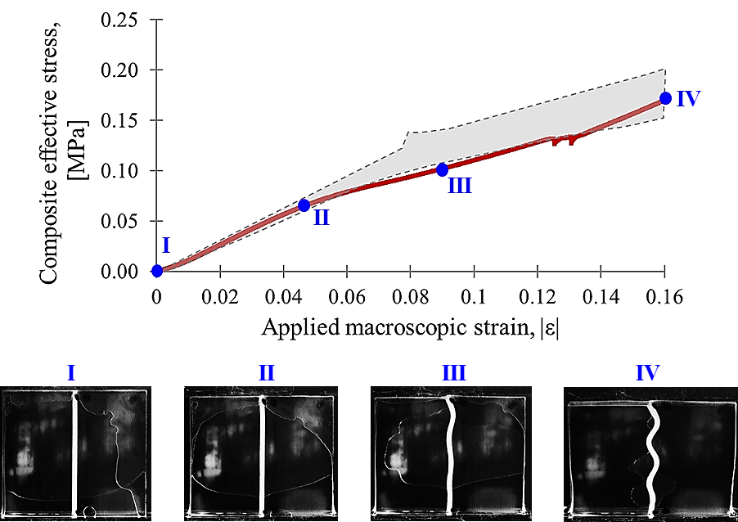 | 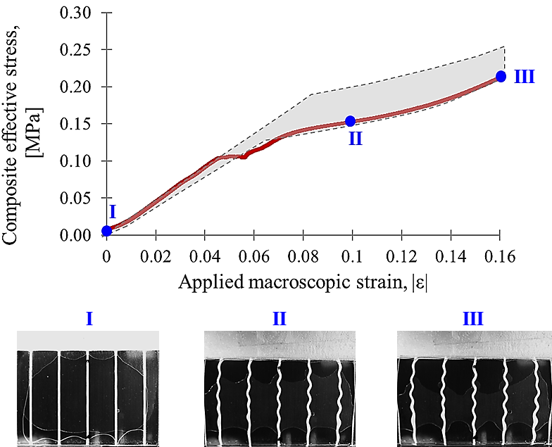
Figure 6. Experimental and theoretical effective stress-strain curves for compression of different composites with varying stiffness ratio, E₁/E₀, or varying interfacial layer concentration, t/D, when matrix is constantly chosen to be “TP” with E₀=0.6±0.1MPa;
a) Interfacial layer is VW with E₁=600±100MPa giving ${\overline{E}}_{1}/{\overline{E}}_{0}$in range of [715-1400], f=t/D=0.0062 (D=80.5mm, t=0.5mm), and L=76mm.
b) Interfacial layer is DM with E₁=23±1MPa giving ${\overline{E}}_{1}/{\overline{E}}_{0}$in range of [31-48] , f=t/D=0.0062 (D=80.5mm, t=0.5mm), and L=76mm.
c) Interfacial layer is DM with E₁=23±1MPa giving ${\overline{E}}_{1}/{\overline{E}}_{0}$in range of [31-48], f=t/D=0.024 (D=41mm, t=1mm), and L=36mm.
d) Interfacial layer is DM with E₁=23±1MPa giving ${\overline{E}}_{1}/{\overline{E}}_{0}$in range of [31-48], f=t/D=0.047 (D=10.5mm, t=0.5mm), and L=36mm.
4. Discussion and Conclusions
The ability to harness the mechanism of wrinkling of interfacial layers embedded within an elastomeric matrix was demonstrated to be a functional feature for the design of soft composites with dramatically enhanced energy storage properties and bilinear elastic behavior. The behavior can be tailored by the selection of the elastic modulus contrast of the interfacial layers to that of the matrix, ${\overline{E}}_{1}/{\overline{E}}_{0}$, and/or the (dilute) volume fraction concentration of the interfacial layers, f=t/D. The enhanced energy storage exhibited by the composite is greater than that achievable by the sum of that of the isolated constituents. This enhancement result is due to the matrix preventing mode 1 buckling of the interfacial layers which provide two contributions: (1) the delay in instability to a much larger strain (i.e., where wrinkling occurs) provides axial compression of the matrix and interfacial layers to greater strain and hence enhances the strain energy achievable in uniform compression; and (2) upon wrinkling, the high magnitude of localized strain in the matrix provides a dramatic increase in strain energy in the matrix with ongoing straining.
The enhancement in energy storage can be further examined by comparison of that achieved by a the soft composite normalized by that of the homogeneous matrix:
${U_{normalized}\left(\overline{ε}\right)= U}_{Total}\left(\overline{ε}\right)/U_{homogeneous}^{}\left(\overline{ε}\right)$ (22)
where $U_{homogeneous}^{}\left(\overline{ε}\right)=\frac{1}{2}{\overline{E}}_{0} {\overline{ε}}^{2}$ and $U_{Total}\left(\overline{ε}\right)$ is given by Equation 13 prior to wrinkling and by Equation 19 after wrinkling (or, alternatively also expressed in Equation 20). This means, $U_{normalized}^{}\left(\overline{ε}\right)$ can be expressed as follows:
$U_{normalized}\left(\overline{ε}\right)=\frac{{\overline{E}}_{}^{composite}}{{\overline{E}}_{0}}=1+f(\frac{{\overline{E}}_{1}}{{\overline{E}}_{0}}-1)$ prior to wrinkling
$U_{normalized}\left(\overline{ε}\right)=1+ f ( 2{\left(\frac{{\overline{E}}_{1}}{{\overline{E}}_{0}}\right)}^{\frac{1}{3}}A\frac{\left(\overline{ε}-\frac{1}{2}{\overline{ε}}_{cr}^{}\right)}{{\overline{ε}}^{2}}-1 )$ post wrinkling (23)
Hence, the enhancement $U_{normalized}\left(\overline{ε}\right)$ provides guidelines for the material design and also provides the dependency on the applied strain. Figure 7 shows a plot for the case of f=0.02 and varying the modulus contrast from 100 to 400 showing: (i) prior to wrinkling, the dramatic (3 to 9 times) enhancement due to the uniform compression of the interfacial layers (where the surrounding elastomer enables the delayed instability and hence enhanced energy storage); and (ii) upon wrinkling, the enhanced energy storage now results from the increased localized strain in the matrix and the bending energy in the interfacial layers and begins to steady out at an amplification factor of 2.5 to 4.
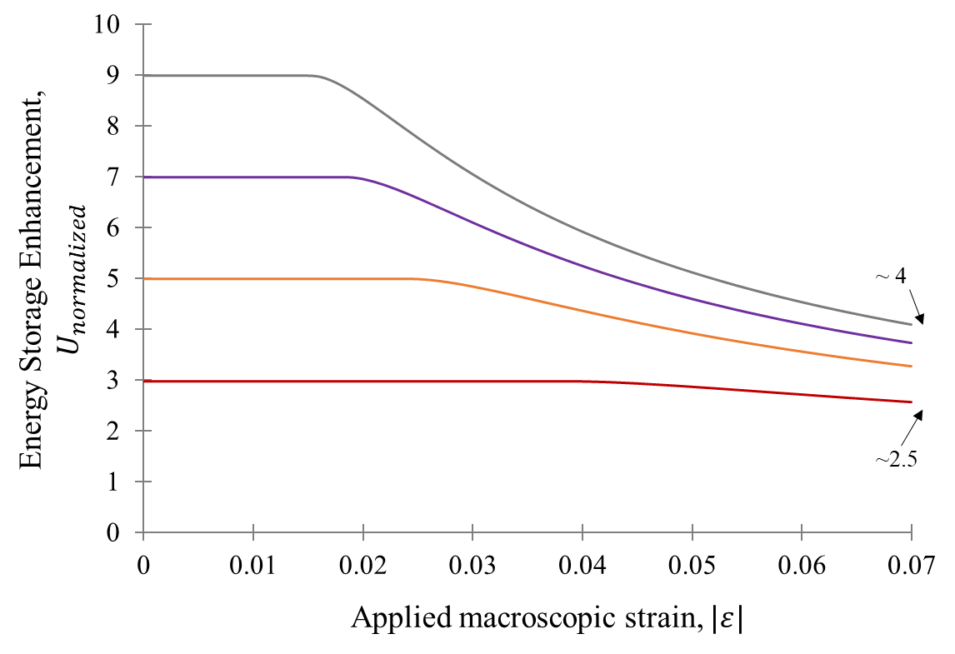
Figure 7. Analytical results showing the enhanced energy storage in the soft composite compared to that of a homogeneous matrix ${U_{normalized}\left(\overline{ε}\right)= U}_{Total}\left(\overline{ε}\right)/U_{homogeneous}^{}\left(\overline{ε}\right),$ as a function of macroscopic strain, $\overline{ε},$ for different composites with varying stiffness ratios between the interfacial layer and the matrix, ${\overline{E}}_{1}/{\overline{E}}_{0}∈[100-400]$, with E₀=1MPa (i.e. ${\overline{E}}_{0}=1.3MPa)$, and interfacial layer concentration of $f=$t/D=0.02. The result show energy enhancement of 3-9 times in the composite prior to wrinkling, and 2.5-4 times post wrinkling.

Moreover, geometric features of the composite can be tailored to achieve further design elements. As an example, Figure 8 evaluates a multilayered composite consisting of repeating features of alternating interfacial layers with different properties E₁ and E₂, Poisson ratio v₁ and v₂, thickness t₁ and t₂, and distance between the layers of D₁ and D₂, embedded in a matrix with modulus E₀ and Poisson ratio v₀. Figure 8a shows the composite strain energy density, the effective true stress-strain curve, and the composite’s effective stiffness for the case where the interfacial layer concentrations of each are identical at $f=\frac{t_{1}}{D_{1}}=\frac{t_{2}}{D_{2}}=0.02$ , but the material properties, E₁ and E₂, are varied. For comparison, the dashed curves show the results for different composites where $\frac{{\overline{E}}_{1}}{{\overline{E}}_{0}}=\frac{{\overline{E}}_{2}}{{\overline{E}}_{0}}$, while the solid lines show the result for when the dashes curves are combined such that the composites have different interfacial layers: $\frac{{\overline{E}}_{1}}{{\overline{E}}_{0}}≠\frac{{\overline{E}}_{2}}{{\overline{E}}_{0}}$. Having different material properties for the interfacial layers acts to further tune the strain energy density as a function the applied strain; the stress-strain behavior now exhibits two bifurcation points since the two types of interfacial layers wrinkle at different critical strains, which also gives the multiple changes in tangent stiffness. Hence, by creating multi-material and multilayered composites, we can control and mitigate the effective stress level of the composite, as well as tuning its effective stiffness as a function of the applied strain, $\overline{ε}$, creating a multi-linear elastic material.
Additionally, Figure 8b shows the effect of different concentrations of different interfacial layer types on the composite’s strain energy density, effective stress-strain behavior, and effective stiffness. For comparison, the dashed lines show the results for identical concentrations $f=\frac{t_{1}}{D_{1}}=\frac{t_{2}}{D_{2}}$ and equal to 0.02 or 0.005. The solid lines show that by combining these results, such that $\frac{t_{1}}{D_{1}}≠\frac{t_{2}}{D_{2}}$, the strain energy density, effective stress-strain behavior, and stiffness can be tuned.
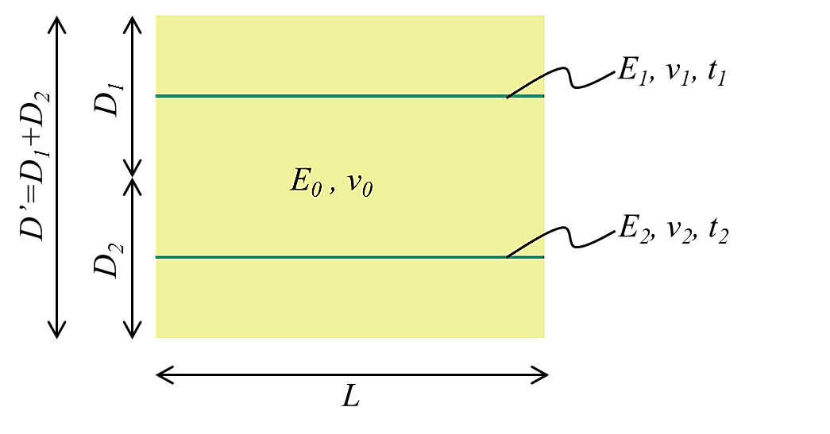
(a) | (b)
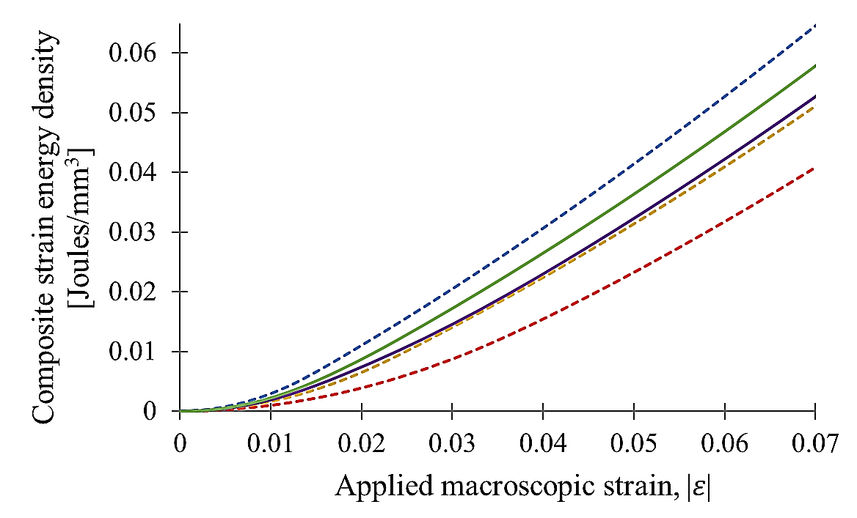 | 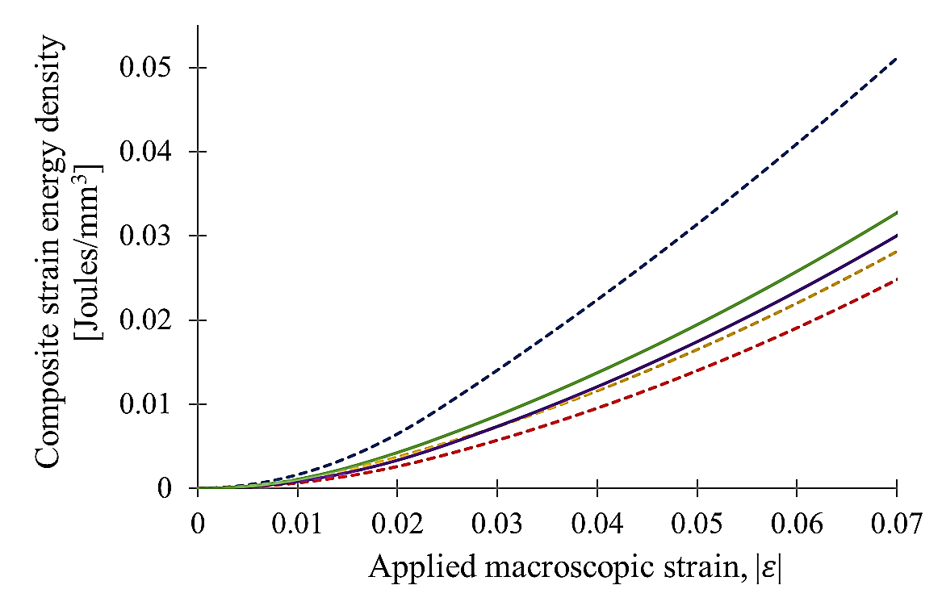
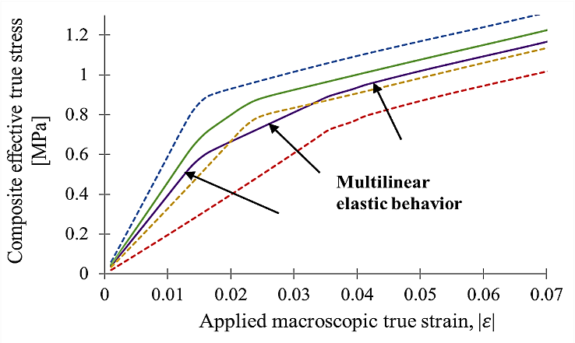 | 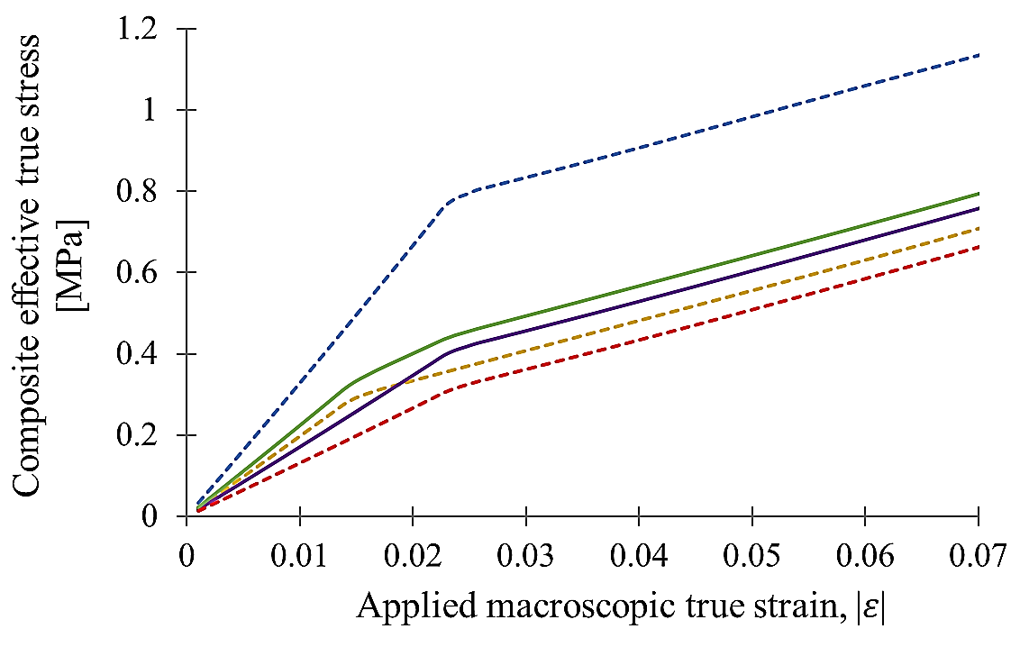
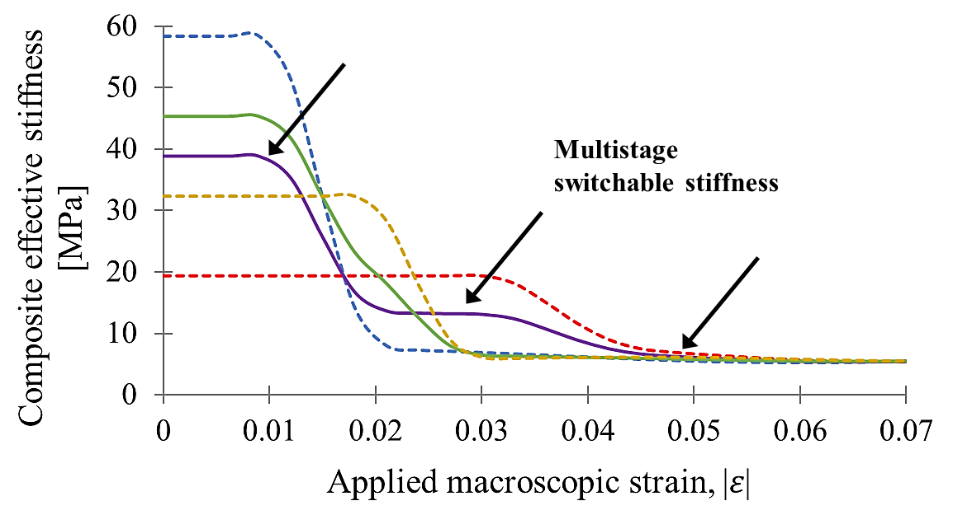 | 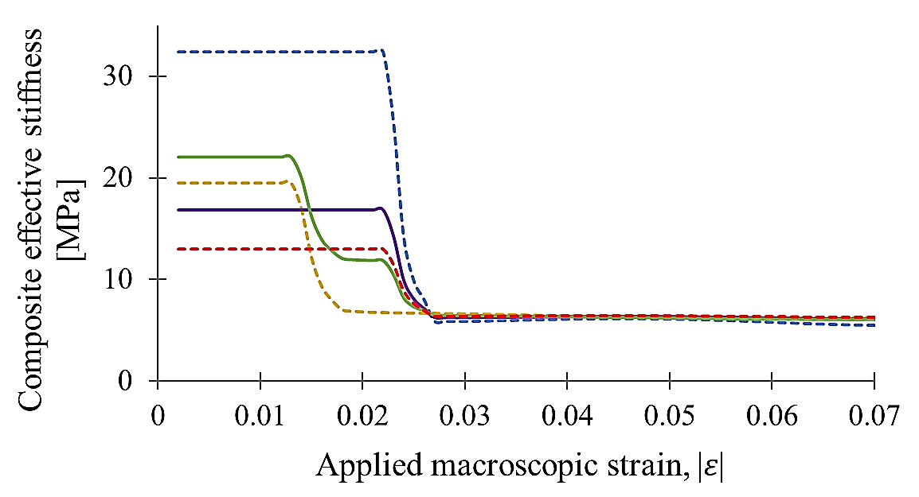
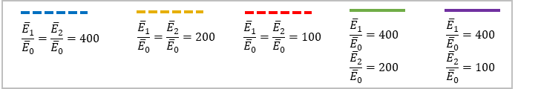 | 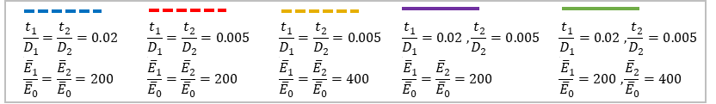
Figure 8. Designing multi-material and multilayered composites with new and tunable effective behavior. For all cases the following are kept constant: E₀=5MPa (i.e. ${\overline{E}}_{0}=6.5MPa$), t₁=t₂=0.5mm and L=60mm. The composite’s strain energy density, effective true stress-strain curve, and effecive stiffness as function of applied strain, $\overline{ε}$, for when: a) Constant gemetry, $t_{1}/D_{1}=t_{2}/D_{2}=0.02$, but changing materials, $E_{1}≠E_{2}$, such that ${\overline{E}}_{1}/{\overline{E}}_{0} and {\overline{E}}_{2}/{\overline{E}}_{0}∈[100, 200, 400]$; b) Changing concentration of interfacial layers: $t_{1}/D_{1} and t_{2}/D_{2}∈[0.02, 0.005]$, for when ${\overline{E}}_{1}/{\overline{E}}_{0} and {\overline{E}}_{2}/{\overline{E}}_{0}∈[100, 200, 400]$.

In summary, the ability to design and provide enhanced energy storage in an elastomeric material by embedding very dilute concentrations of thin, relatively higher modulus interfacial layers, was demonstrated. The resulting materials exhibit the expected enhancement in initial modulus (while remaining in the soft elastomeric range), a bifurcation point at a critical strain (and hence also critical stress) level to a reduced softer elastic modulus as a result of activating wrinkling in the interfacial layers – hence also giving us a composite with a bilinear elastic behavior. The wrinkling produces enhanced localized straining in the elastomer matrix which, in turn, dramatically enhances the strain energy stored in the matrix at any given strain. These results were quantified and verified through analytical modeling, finite element simulations, and physical experiments. The analytical expressions furthermore provide quantitative design expressions and guidelines for the dependencies of the new features and behavior on the concentration of interfacial layers, and the elastic properties of the matrix and the interfacial layers.
These results provide a basis for further design opportunities. The extension to create elastomeric materials with multi-linear elastic behavior with concomitant enhanced energy storage was illustrated as one direction. Pursuing elastomeric composites with more complex geometries of networks of thin, relatively stiff layers [37, 39] and the enhanced energy storage capacity provides an additional avenue of research. Enhancement with relatively stiff interfacial layers that also exhibit piezoelectric behavior [10, 37] would extend these results to another form of energy harvesting. Furthermore, pursuing viscoelastic elastomeric matrices with thin interfacial layers has recently been shown to provide a rate-dependence to the wrinkling behavior [40] and, in other work, alternately thin layers of stiff elastic and thin viscoelastic layers has shown enhanced damping [41]. The enhanced energy density in the matrix demonstrated herein shows the potential for a new avenue to tune damping in elastomeric materials designed for storage and damping applications. Consequently, the results presented in this paper can be valuable for many applications within the medical, manufacturing, sports, and defense industries.

Acknowledgment
The authors gratefully acknowledge financial support from the MIT Institute of Soldier Nanotechnology program as well as from BASF for this research.

References
- R. F. Gibson, Composite Structures, 2010, 92, 2793-2810.
- J. P. Thomas, M. A. Qidwai. Acta Materialia, 2004, 52, 2155-2164.
- J.-H. Lee, C. Y. Koh, J. P. Singer, S.-J. Jeon, M. Maldovan, O. Stein, E. L. Thomas, Advanced Materials, 2014, 26, 532-569.
- E. Manias, J. Chen, N. Fang, X. Zhang, Applied Physics Letter, 2001, 11, 79.
- S. Minko, M. Muller, M. Motornov, M. Nitschke, K. Grundke, M. Stamm, J. Am. Chem. Soc., 2003, 125, 13
- K. Bertoldi, M.C. Boyce, S. Deschanel, S.M. Prange, T. Mullin, Journal of the Mechanics and Physics of Solids 2008, 56, 8, 2642-2668.
- K. Bertoldi, P. M. Reis, S. Willshaw, T. Mullin, Advanced Materials, 2010, 22, 361-366.
- K. Bertoldi, M.C. Boyce, Physical Review B, 2008 (2), 78, 18, 184107.
- S. Rudykh, M.C. Boyce, Physical Review Letters, 2014, 112, 3, 034301.
- P. Jiao, J. Mueller, J.R. Raney, X. Zheng, A.H. Alavi, Nature Communications, 2023, 14, 6004.
- Y. Tang, Y. Chi, J. Sun, T. Huang, O.H. Maghsoudi, A. Spence, J. Zhao, H. Su, J. Yin, Science Advances, 2020, 6, 1-12.
- S.-K. Ahn, R. M. Kasi, S.-C. Kim, N. Sharmaa, Y. Zhoub, Soft Matter, 2008, 4, 1151–1157.
- J.-Y. Sun, X. Zhao, W. R. K. Illeperuma, O. Chaudhuri, K. H. Oh, D. J. Mooney, J. J. Vlassak, Z. Suo, Nature, 2012, 489.
- M. A. C. Stuart, W. T.S. Huck, J. Genzer, M. Muller, C. Ober, M. Stamm, G. B. Sukhorukov, I. Szleifer, V. V. Tsukruk, M. Urban, F. Winnik, S. Zauscher, I. Luzinov, S. Minko, Nature Materials, 2010, 9.
- D. Roy, J N. Cambre, B. S. Sumerlin, Progress in Polymer Science, 2010, 35.
- J. U. Surjadi, L. Gao, H. Du, X. Li, X. Xiong, N. X. Fang, Y. Lu, Advanced Engineering Materials, 2019, 21, 1800864.
- T. Mullin, S. Deschanel, K. Bertoldi, M.C. Boyce, Phys. Rev. Lett., 2007, 99.
- X. Chen, J. W. Hutchinson, J. Appl. Mech., 2004, 71, 597-603.
- Z.Y. Huang, W. Hong, Z. Suo, JMPS, 2005, 53, 2101-2118.
- Q. Wang, X. Zhao, Journal of Applied Mechanics, 2014, 81.
- T. Chen, M. Pauly, P.M. Reis, Nature, 2021, 589, 387.
- D. C hen, Y. Xiang, N. Arora, Q. Yao, J. Li, S. Rudykh, Composite Structures, 2023, 322, 117337.
- L. J. Gibson, M. F. Ashby, Cellular solids: Structure and properties, Cambridge University Press, Cambridge, UK, 1997.
- S. K. Maiti, L. J. Gibson, M. F. Ashby, Acta metall., 1984, 32, 11, 1963-1975.
- S. D. Papka, S. Kyriakides, J. Mech. Phys. Solids, 1994, 42, 10, 1499-1532.
- W.Y. Jang, A. M. Kraynik, S. Kyriakides, Int. J. Solids Structures, 2008, 45, 1845-1875.
- S. D. Papka, S. Kyriakides, Int. J. Solids Structures, 1998, 35, 3-4, 239-267.
- J.E. Pechac, M.J. Frazier, Extreme Mechanics Letters, 2022, 51, 101580.
- B. Li, Y.-P. Cao, X.-Q. Feng, H. Gao, Soft Matter, 2012, 8.
- E. Cerda, L. Mahadevan, Physical review letters, 2003, 90, 7.
- J. Yin, J. L. Yague, D. Eggenspieler, K. K. Gleason, M. C. Boyce, Advanced Materials, 2012, 24, 5441-5446.
- J. Shen, A. Pirrera, R.M.J. Groh, Proc. Roy. Soc. A, 2022, 478, 20220173.
- S.-Y. Hsu, T.J. Vogler, S. Kyriakides, Journal of Applied Mechanics, 1998, 65.
- B. W. Rosen, American Society for Metals, Metals Park, OH, 1965.
- Y. Li, N. Kaynia, S. Rudykh, M. C. Boyce, Advanced Engineering Materials, 2013, 15, 10.
- W.-H. Xie, X. Huang, Y.-P. Cao, B. Li, X.-Q. Feng, Composites Science and Technology, 2014, 99, 89-95.
- Narges Kaynia, Doctoral Thesis: Instability-induced transformation of interfacial layers in composites and its multifunctional applications: Massachusetts Institute of Technology (MIT), 02, 2016.
- H. G. Allen, Analysis and Design of Structural Sandwich, Pergamon, New York, NY, USA, 1969.
- C. Gao, V. Slesarenko, M. C. Boyce, S. Rudykh , Y. Li, Scientific Reports, 2018, 8. 11834.
- V. Slesarenko, S. Rudykh, Soft Matter, 2016, 12, 3677.
- T. Sain, J. Meaud, G. Hulbert, E.M. Arruda, A.M. Waas, Composite Structures, 2013, 101, 104-110.

