Accepted by
- Department of Physics, The Chinese University of Hong Kong, New Territories, Hong Kong 999077, China.
- Spallation Neutron Source Science Centre, Dongguan 523803, China.
- Institute of High Energy Physics, Chinese Academy of Sciences, Beijing 10049, China.
- Department of Physics and Centre for Processable Electronics, Imperial College London, Blackett Laboratory, London, SW7 2AZ UK.
- Department of Mechanical Engineering, The University of Hong Kong, Pokfulam, Hong Kong 999077, China
- Beijing Key Laboratory of Ionic Liquids Clean Process, Institute of Process Engineering, Chinese Academy of Sciences, Beijing, China.
- National Synchrotron Radiation Research Centre, 101 Hsin-Ann Road, Science-Based Industrial Park, Hsinchu 30077, Taiwan.
- Department of Chemical Engineering & College of Semiconductor Research, National Tsing Hua University, Hsinchu 300044, Taiwan.
- Institute of Materials Research, Tsinghua Shenzhen International Graduate School, Tsinghua University, Shenzhen 518055, China.
‡ Y.F., L.X., and Y.L. contributed equally to this work.
Supplementary Information available: See DOI: 10.1039/x0xx00000x

Energy & Environmental Science

October 08, 2024

Enhancing inter-domain connectivity by reducing fractal dimension: the key to passivating deep traps in organic photovoltaics
Yuang Fu,‡ª Luhang Xu,‡ª Yuhao Li,‡^{abc} Emily J. Yang,^{d} Yu Guo,^{e} Guilong Cai,^{af} Pok Fung Chan,ª Yubin Ke,^{*bc} Chun-Jen Su,^{g} U-Ser Jeng,^{gh} Philip C. Y. Chow,^{e} Ji-Seon Kim,^{d} Man-Chung Tang,^{*i} Xinhui Lu^{*a}
The detrimental impact of non-geminate recombination on high-performance organic photovoltaics has been recognised and primarily attributed to bimolecular recombination. However, the recent surge in Y-series acceptor-based systems draws attention to deep-trap-assisted monomolecular recombination. This study reveals the morphological origin of deep traps in the prototypical PM6:Y6 system, identifying isolated crystalline and amorphous Y6 domains as key contributors. The findings underscore the importance of improving inter-acceptor domain connectivity for effective trap passivation. For the first time, we have pinpointed a crucial metric for inversely quantifying the inter-acceptor domain connectivity: the crystalline domain fractal dimension (D_{f}). Due to the self-similar nature of fractal structures, the fractal dimension propagates across multi-length scales and can be controlled by tunning local intermolecular aggregation motifs. Remarkably, combining diiodide benzene (DIB) as the additive and layer-by-layer (LBL) processing effectively promotes the more extended backbone order of Y6 molecules, consequently reducing the fractal dimension and passivating deep traps. By applying this strategy to another high-performance system, D18:L8BO, a benchmark efficiency of 19.6% was achieved, among the highest efficiencies reported for LBL OPVs.
Broader context
The complex structure within the active layer of organic photovoltaics (OPVs) makes it challenging to establish a clear relationship between the molecular structure, processing condition, and device performance. In this study, we explore the morphological origin of inefficiencies in OPVs, focusing on deep-trap-assisted monomolecular recombination. Using advanced techniques to examine both the morphological and electrical characteristics, we identified isolated crystalline and amorphous acceptor domains as the primary sources of deep electron traps. We introduced a new concept for measuring inter-acceptor domain connectivity: the fractal dimension, which quantifies the space-filling property of crystalline acceptor domains. Essentially, the smaller the fractal dimension, the better the inter-acceptor domain connectivity and the fewer the electron traps. Due to the multi-length scale self-similar nature of fractal structures, small-scale changes in intermolecular aggregations can significantly impact the fractal dimension, which determines large-scale inter-domain connectivity. This can be controlled by carefully selecting additives and processing methods. Our findings underscore the importance of both crystalline and amorphous morphology at multi-length scales to enhance the performance of OPV devices, surpassing 20% efficiency and advancing towards industrialisation.
Introduction
Since the introduction of non-fullerene acceptors (NFAs) ITIC¹ and Y6,² there has been a rapid improvement in the power conversion efficiency (PCE) of organic photovoltaics (OPVs), surpassing 20% for single-junction devices.³ Thanks to the large molecular quadrupole moments of most NFAs with planar conjugated backbones and symmetric push-pull structures, the band bending at the donor (D)/acceptor (A) interface strongly suppresses geminate recombination,^{4, 5} leaving non-geminate recombination as the main loss channel in high-performance OPVs. While previous studies often pointed to bimolecular recombination as the primary non-geminate recombination mechanism in OPVs,^{6, 7} recent findings indicate that the quadrupole-induced interfacial band bending can also suppress bimolecular recombination by reducing the population of free charge carriers near the D/A interface, which reduces the Langevin reduction factor (γ) to below 0.01 for high-performance OPVs.⁸⁻¹⁰ This has sparked interest in re-examining the role of trap-assisted recombination, especially under reverse and low forward bias conditions where the charge carrier density within the active layer is low due to efficient charge extraction.
While both shallow and deep traps affect OPV performances, the impact of the former has been proven minor in Y6-based OPV systems as the typical Urbach energy is close to the thermal energy at room temperature (~0.025 eV).^{11, 12} On the other hand, deep traps within OPV active layers, which act as monomolecular recombination centres according to the Shockley-Read-Hall (SRH) model,¹³ deserve more attention. Zeiske et al. observed deep traps with depths of 0.4-0.6 eV in a large set of fullerene and NFA-based systems using intensity-dependent photocurrent (IPC) measurements.¹⁴ Zhang et al. observed 40% more traps in layer-by-layer-processed OPVs (LBL OPVs) compared to conventional bulk-heterojunction (BHJ) OPVs with the same active layer materials,¹⁵ suggesting the origin of deep traps may be related to active layer morphology. Recently, our group observed much stronger phase segregation in chlorobenzene (CB)-processed PM6:Y6 blend film compared to the chloroform (CF)-processed one and an over three-fold increase in bulk trap density (N_{tb}) in the corresponding devices.¹⁶ Despite their importance, the morphological origin of deep traps remains unclear, and there is a lack of effective methods to passivate them.
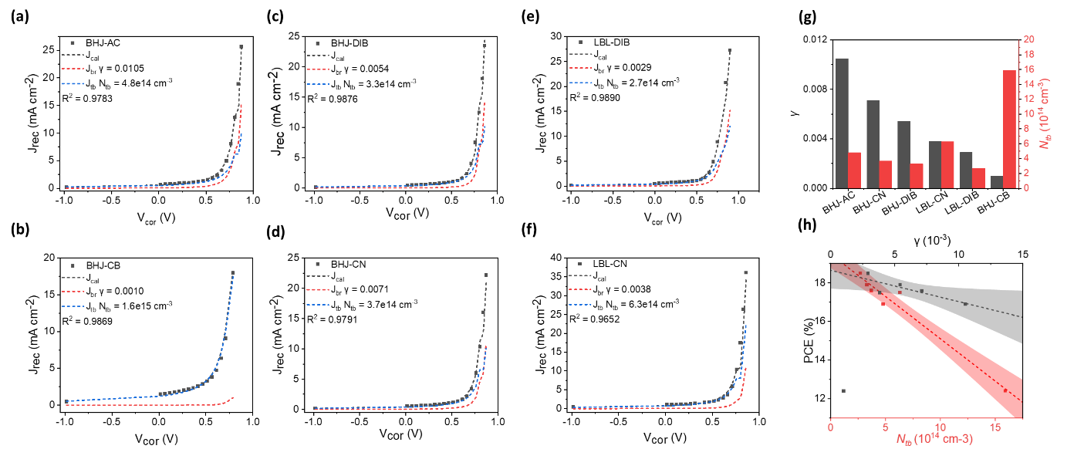
Herein, we investigated the morphological origin of deep traps in the prototypical PM6:Y6 system fabricated under various conditions. We observed a strong correlation between N_{tb} and the fractal dimension (D_{f}) of crystalline Y6 domains, quantifying their space-filling property. As the Y6 crystalline domain adopts a more open structure (with a lower D_{f}), its size (2R_{gc}) extends to a larger scale while the size of the surrounding amorphous D:A intermixed domain (ξ) shrinks and concomitantly, N_{tb} decreases. Through deuteration labelling, the sizes of amorphous Y6 aggregates (2R_{ga}) dispersed within amorphous intermixed domains were also estimated by grazing-incidence small-angle neutron scattering (GISANS). Considering the large LUMO offset between PM6 and Y6, we propose that isolated crystalline Y6 domains and poorly connected amorphous Y6 aggregates within amorphous D:A intermixed domains act as deep electron traps due to the lack of percolation pathways. Therefore, effective trap passivation can be achieved by enhancing inter-acceptor domain connectivity through reducing D_{f}.
Figure 1 Impact of processing methods on recombination kinetics. a-f Recombination current fittings using a linear superposition of bimolecular recombination (J_{br}) and bulk trap-assisted recombination (J_{tb}) currents for PM6:Y6 systems processed under different conditions. γ stands for the Langevin reduction factor of bimolecular recombination, while N_{tb} is the density of deep traps within the bulk active layer. The quality of the fitting is represented by R². The summary of fitting results and their correlations with device performances are shown in g and h, respectively.
Remarkably, we found that D_{f} could be controlled by tuning local intermolecular packing motifs due to the multi-length scale self-similar nature of the fractal structure. In contrast to liquid additive chloronapthalene (CN), the incorporation of solid additive diiodide-benzene (DIB) enhances the J-type backbone order of Y6 molecules, which propagates to larger length scales, resulting in a reduced D_{f} and, consequently, much-improved inter-domain-connectivity and suppressed N_{tb}. The impact is especially pronounced for LBL OPVs, where the separate deposition of donors and NFAs amplifies the difference in NFA morphology induced by additives. Applying this strategy to the D18:L8BO LBL devices leads to an impressive PCE of 19.6%, which is among the highest PCEs reported for LBL OPVs.
Results and Discussions
PM6:Y6 systems with diversified bimolecular and monomolecular-types of non-geminate recombination
To begin with, we fabricated OPV devices based on the prototypical PM6:Y6 system, employing a conventional structure of ITO/PEDOT:PSS/active layer/PNDIT-F3N/Ag. A common method involves dissolving PM6 and Y6 in a mixture of CF and 0.5 vol% CN, followed by thermal annealing of the casted film, denoted as “BHJ-CN”. To understand the impact of solvents, we substituted CF with CB, which has a higher boiling point, denoted as “BHJ-CB”. To investigate the influence of additives, we fabricated (using CF as the solvent) as-cast devices without additives (“BHJ-AC”) and with the solid additive DIB (“BHJ-DIB”). The layer-by-layer deposition method has been shown to yield better performance¹⁷ and stability¹⁸ and be more compatible with large-scale manufacturing¹⁹ than the conventional one-step deposition. Therefore, we also fabricated LBL devices (using CF as the solvent) with CN or DIB incorporated into the Y6 layer, denoted as “LBL-CN” or “LBL-DIB”, respectively. Further recipe details can be found in the Experimental Method section in Supporting Information. Device performances are summarised in Table 1, with representative J-V and EQE curves displayed in Figure S1.
As shown in Figure S1a, the BHJ-CN device exhibits a V_{oc} of 0.851 V, a J_{SC} of 27.0 mA cm⁻², and an FF of 76.7%, resulting in a satisfying PCE of 17.6%, aligning with previous studies.²⁰ Upon changing the solvent from CF to CB, the BHJ-CB device displays reduced performance across all three photovoltaic parameters. The 48 meV decrease in V_{OC} is attributed to the larger D:A energy offset in BHJ-CB induced by stronger charge-quadrupole interaction.⁸ Yet, the causes behind the diminished J_{SC} and FF necessitate further investigation. Figure S1b displays the influence of additives on BHJ device performance. Relative to BHJ-AC, the incorporations of CN and DIB followed by thermal annealing enhance both FF and J_{SC} at the expense of a slight decrease in V_{OC}, with BHJ-DIB achieving a slightly higher PCE of 17.9% compared to BHJ-CN. Interestingly, the effect of additives appears to be more pronounced on LBL devices than on BHJ devices, as shown in Figure S1c. Compared to BHJ-CN, LBL-CN shows improved J_{sc}, which can be attributed to a more symmetrical exciton generation profile within the active layer due to vertical phase segregation in LBL devices, which suppresses the formation of the space-charge layer due to charge accumulation.²¹⁻²⁴ Despite the improved J_{sc}, LBL-CN shows only comparable efficiency to its BHJ counterpart, mainly due to its low FF of 74.8%. In sharp contrast, LBL-DIB shows much improved FF (from 74.8% to 77.9%) and J_{SC} (from 28.0 mA cm⁻² to 28.7 mA cm⁻²), resulting in a champion PCE of 18.5%. Additionally, we note that the V_{oc}s of DIB-incorporated devices are slightly lower than those of the CN-incorporated counterparts. This mainly arises from the red-shifted EQE edge in the DIB-incorporated devices, while the overall V_{oc} loss remains comparable (Figure S1e, f, and Figure S2).
Table 1 A summary of device characteristics as well as the fitting results from voltage-dependent capacitance spectroscopy for PM6:Y6 devices processed under different conditions.
Devices | V_{OC} ª  (V) | J_{SC} ª  (mA cm^{–2}) | J_{SC}^{b}  (mA cm^{–2}) | FF ª  (%) | PCE ª  (%) | γ | N_{tb}  (cm⁻³)
BHJ-AC | 0.868  (0.861±0.003) | 26.8  (26.2±0.4) | 25.6 | 72.4  (71.7±0.6) | 16.9  (16.2±0.4) | 0.0105 | 4.8$×10$¹⁴
BHJ-CN | 0.851  (0.850±0.004) | 27.0  (26.6±0.4) | 26.0 | 76.7  (76.7±0.3) | 17.6  (17.3±0.4) | 0.0071 | 3.7$×10$¹⁴
BHJ-DIB | 0.839  (0.837±0.004) | 27.4  (27.1±0.3) | 26.4 | 78.0  (77.7±0.3) | 17.9  (17.6±0.2) | 0.0054 | 3.3$×10$¹⁴
LBL-CN | 0.844  (0.839±0.004) | 28.0  (27.9±0.1) | 26.6 | 74.8  (74.7±0.6) | 17.5  (17.3±0.2) | 0.0038 | 6.3$×10$¹⁴
LBL-DIB | 0.831  (0.830±0.004) | 28.7  (28.2±0.4) | 27.7 | 77.9  (77.3±0.4) | 18.5  (18.1±0.2) | 0.0029 | 2.7$×10$¹⁴
BHJ-CB | 0.803  (0.801±0.003) | 22.0  (21.6±0.4) | 20.8 | 70.3  (70.2±1.4) | 12.4  (12.1±0.2) | 0.0010 | 1.6$×10$¹⁵
ª Figures of merits for champion devices with average values and standard deviation (in parenthesis) obtained from at least 10 independent devices. ^{b} J_{sc} obtained from integrating the EQE spectrum with the AM1.5G solar spectrum.

To quantify the variations in device performances induced by different non-geminate recombination channels, we performed voltage-dependent capacitance spectroscopy,²⁵ from which the bias-dependent charge carrier density (n) and effective mobility μ_{eff} can be derived as a function of corrected bias (V_{cor} = V-JR_{s}) (Figure S3). This allows us to fit the recombination current (J_{rec}), which is the difference between photocurrent (J_{ph}) and its saturated value at -2 V (denoted as the saturated photocurrent, J_{sat}), using a linear superposition of bimolecular (J_{br}) and bulk trap-assisted (J_{tb}) recombination current (see Experimental Methods) from which the Langevin reduction factor ($γ)$ of bimolecular recombination and bulk trap density (N_{tb}) can be extracted. A comparison of results from voltage-dependent capacitance spectroscopy and intensity-dependent J-V measurements is shown in Figures S4 and S5.
Figure 1a-f reveals distinct non-geminate recombination mechanisms in the same D:A blend systems affected by different solvents, additives, and processing methods. As shown in Figure 1 g and Table 1, BHJ-AC has the largest γ (0.0105) but a moderate N_{tb} ($4.8×10$¹⁴ cm⁻³), indicating the strongest bimolecular recombination, in sharp contrast to BHJ-CB, which shows the smallest γ (0.0010) but the largest N_{tb} $(1.6×{10}^{15}$cm⁻³), giving rise to the overall worst performance due to the severe monomolecular recombination. Incorporating additives to BHJ devices mainly reduces the bimolecular recombination, as γ decreases to 0.0071 (for BHJ-CN) and 0.0054 (for BHJ-DIB), while N_{tb} is only suppressed marginally to $3.7×{10}^{14}$cm⁻³ and $3.3×{10}^{14}$cm⁻³, respectively. In contrast, LBL-CN exhibits smaller γ (0.0038) than BHJ devices, indicating further reduced bimolecular recombination. However, more deep traps are formed in LBL-CN ($6.3×{10}^{14}$cm⁻³), consistent with previous study.¹⁵ Fortunately, replacing CN with DIB effectively passivates the deep traps in LBL devices, simultaneously maintaining low γ (0.0029) and N_{tb} ($2.7×{10}^{14}$cm⁻³), thus leading to the best device performance. Consistently, slower charge recombination kinetics in DIB-processed films compared to CN-processed films were also observed from transient absorption spectroscopy measurements (Figure S6 and S7.) The results indicate that DIB is a more suitable additive for high-performance LBL-OPVs than CN, mainly due to its ability to suppress deep traps.²⁶⁻²⁸
The impact of different non-geminate recombination channels on device performance is summarised in Figure 1h. Although γ scales negatively with PCE, there is significant scatter around the trend, with BHJ-CB being the most notable outlier. In fact, the magnitude of $γ$remains small (below 0.01) for the 6 blend systems studied. This indicates that bimolecular recombination in PM6:Y6 systems is strongly suppressed due to the large molecular quadrupole moment associated with Y6.^{8, 9} In sharp contrast, the negative correlation between PCE and N_{tb} is much stronger and less scattered, mainly through the suppression of J_{sc} and FF (Figure S8). This emphasises the pivotal role of suppressing deep traps for high-performance OPVs based on Y-series NFAs.
Isolated Y6 domain as the morphological origin of deep traps
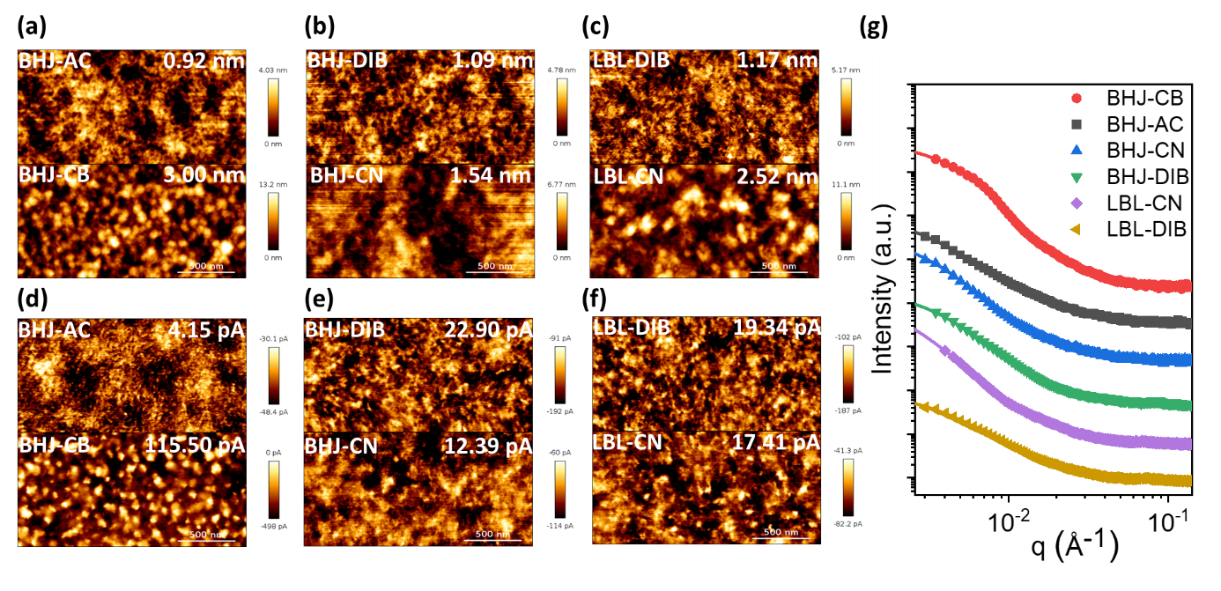
Next, we explored the morphological origin of deep traps and the morphological advantages of DIB-processed devices in trap passivation, especially for LBL devices. We first probed the surface morphology of blend films using atomic force microscopy (AFM). Topography (Figure 2a-c) mappings show that all active layers have smooth surfaces with root-mean-square (RMS) roughness ranging from 0.9 to 3.0 nm. From both topography and phase mappings (Figure S9), the surfaces of BHJ-AC, BHJ-DIB, and LBL-DIB appear to have extended domains in contrast to BHJ-CB, BHJ-CN, and LBL-CN, which exhibit large populations of granular-shaped domains. Conductive-AFM (c-AFM) was utilised to further probe the D/A phase separation degree. Taking advantage of the HOMO offset between PM6 and Y6 (see Experimental Method),²⁹⁻³¹ bright regions with low local hole currents can be identified as Y6-rich domains. Figure 2d-f shows notable differences in the spatial variations of local hole currents, quantified as the RMS current,^{29, 30} between different films. The RMS current of BHJ-AC (4.15 pA) is the smallest among all six films (Figure 2d), suggesting the Y6 molecules form intricate networks within the PM6 matrix, so the extent of phase separation is below the spatial resolution of the c-AFM tip (~10 nm, see Experimental Methods), consistent with the observed strongest bimolecular recombination.^{32, 33} In sharp contrast, the c-AFM image of BHJ-CB shows large, spherical Y6 domains that are isolated from each other. The RMS current of 110.80 pA is significantly higher than the rest films, suggesting a large HOMO offset between strongly phase-segregated D/A domains, in line with our previous study.⁸ Compared to BHJ-AC, the incorporation of additives increases the RMS current (Figure 2e and f), which indicates enhanced phase separation between PM6 and Y6, consistent with the suppressed bimolecular recombination (Figure S10). Notably, in CN-processed films, phase separation is accompanied by the change in domain shapes from extended fibril-like to more granular-like. In contrast, incorporating DIB retains fibril-like domains of BHJ-AC, as further discussed below.
Figure 2 Morphology characterizations of blend films. a-c topography and d-f current mappings of PM6:Y6 blend films processed under different conditions. The root-mean-square (RMS) variations of heights and currents are labelled at the insets. The in-plane GISAXS linecuts of corresponding blend films (dots) and their best fittings (solid lines) are shown in g.
To obtain a statistical analysis of average domain sizes and shapes, we performed grazing-incidence small-angle X-ray scattering (GISAXS) and neutron scattering (GISANS) measurements for blend films.^{16, 34} The two-dimensional (2-D) GISAXS patterns of all films are available in Figure S11, with the corresponding in-plane linecuts and their best fittings shown in Figure 2g and Figure S12. The contribution from amorphous D:A intermixed domain is quantified using the Debye−Anderson−Brumberger (DAB) model.³⁵ Although PM6 and Y6 have similar scattering length densities (SLDs),¹⁶ the much stronger tendency of Y6 molecules to aggregate³⁶ allows us to assign the main scattering feature in blend films to crystalline Y6 domains, modelled with a spherical form factor multiplied by either a fractal³⁴ structure factor (for CF-processed films) or a hard-sphere³⁷ structure factor (for BHJ-CB). Thus, three fitting parameters can be obtained from GISAXS for CF-processed films, which are $ξ$ (D:A intermixed domain size), 2$R_{gc}$(Y6 crystalline domain size), and D_{f} (the fractal dimension quantifying the space-filling property of Y6 crystalline domains), while for BHJ-CB, only $ξ$ and 2$R_{gc}$ are obtained. For GISANS measurements, deuterated Y6 (d-Y6) was used instead of Y6 to enhance the scattering length density of Y6 phases so that the size of amorphous Y6 aggregates (2$R_{ga}$) embedded within the D:A intermixed domains can be determined from the fitting at high-q region.¹⁶ We performed GISANS measurements for BHJ-DIB, LBL-CN, and LBL-DIB (Figure S13), while for the other films, we referred to the results obtained from our previous study.¹⁶ The fitting results from both measurements are summarised in Table 2 in the order of increased D_{f}.
Table 2 A summary of active layer morphology: the sizes (2R_{gc}) and fractal dimensions (D_{f}) of crystalline Y6 domains, as well as the correlation lengths (ξ) of PM6:Y6 intermixed domains fitted from the GISAXS and the sizes of amorphous Y6 aggregates (2R_{ga}) fitted from GISANS profiles for PM6:Y6 blend films processed under different conditions.
Samples | ξ (nm) | 2R_{gc} (nm) | D_{f} | 2R_{ga} (nm) | ξ /2R_{ga}
LBL-DIB | 24.1 | 74.2 | 2.13 | 8.1 | 3.00
BHJ-DIB | 27.9 | 49.1 | 2.24 | 6.6 | 4.23
BHJ-AC | 28.8 | 33.2 | 2.43 | 7.8ª | 3.69
BHJ-CN | 31.0 | 18.1 | 2.61 | 10.6ª | 2.93
LBL-CN | 39.9 | 17.2 | 3.00 | 5.9 | 6.80
BHJ-CB | 5.6 | 57.3 | N/A | 7.6ª | N/A
ª Those results were obtained from our previous work.
As shown in Figure 3a, an intriguing correlation can be identified for the five CF-processed films: as D_{f} decreases, 2$R_{gc}$ increases while $ξ$ decreases. A similar trend has also been observed in polymer:fullerene systems.³⁴ Since all blend films have the identical D:A ratio, these correlations could be interpreted by considering the space-filling property of Y6 crystalline domains embedded in the matrix of D:A intermixed domains. BHJ-AC has a $ξ$ of 28.8 nm and $2R_{gc}$ of 33.2 nm with a median D_{f} of 2.43, indicating loosely packed but extended Y6 crystalline domains surrounded by the matrix of amorphous D:A intermixed domains, consistent with the c-AFM result. The incorporation of CN induces Y6 crystalline domains to agglomerate, which is reflected by D_{f} increases to 2.61 and 3.00 while $2R_{gc}$ decreases to 18.1 and 17.2 nm for BHJ and LBL films, respectively. As Y6 crystalline domains shrink, the amorphous intermixed matrix surrounding Y6 becomes less separated and thus $ξ$ increases concomitantly to 31.0 and 39.9 nm, respectively. In stark contrast, BHJ-DIB and LBL-DIB show larger $2R_{gc}s$ of 49.1 and 74.2 nm with a lower D_{f} of around 2.24 and 2.13, accompanied by a shrinkage in ξ to 27.9 and 24.1 nm, respectively. The incorporation of DIB has an opposite effect compared to CN. It induces Y6 molecules to form larger and more extended crystalline domains, which then partition the amorphous intermixed domains around them, thus reducing $ξ$. We also note that the large 2R_{gc}s of BHJ-DIB and LBL-DIB do not hinder efficient exciton dissociation, as proved using transient absorption spectroscopy measurements (Figure S6 and S7). This is because the low-D_{f} network formed by Y6 molecules in those films ensures abundant D:A interface for diffusion-limited exciton dissociation to take place (see Supplementary Note 1 for further discussion)^{34, 38, 39}.
From GISANS data, the fitted sizes of amorphous d-Y6 aggregates are summarised in Table 2. Compared to BHJ-CN, which has a $2R_{ga}$ of 10.6 nm,¹⁶ LBL-CN shows a much suppressed $2R_{ga}$of 5.9 nm, which is likely due to the limited interdiffusion of d-Y6 into PM6 during sequential deposition so that there is not enough time for short-range aggregates to grow. Notably, the value of $2R_{ga}$ is slightly increased to 8.1 nm for LBL-DIB. Considering the typical p-i-n structure of LBL films and the fact that DIB is a volatile additive preferentially bound with d-Y6,⁴⁰ it is likely that the evaporation of DIB molecules during thermal annealing allows d-Y6 to coalescence, forming larger amorphous aggregates. Considering both crystalline and amorphous domains, the distinct morphology of CF-processed films with DIB and CN are illustrated in Figure 3b. For the CB-processed film (BHJ-CB), the crystalline Y6 domains are represented using a hard-sphere structure factor with a large $2R_{gc}$ of 57.3 nm. This indicates that Y6 molecules no longer form a percolating fractal network but form spherically-shaped domains due to over-phase segregation with PM6, which agrees with the direct observations from c-AFM.
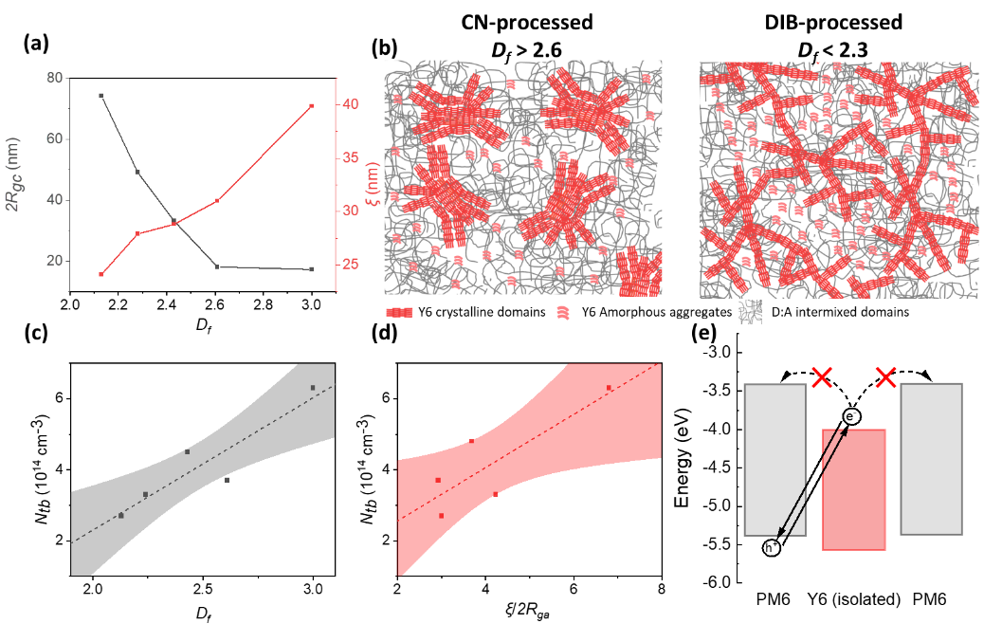
When comparing active layer morphology with device characteristics, we found that both D_{f} and $ξ/2R_{ga}$ scales positively with the bulk trap density (N_{tb}) obtained from capacitance spectroscopy, as shown in Figure 3c and d. Based on this, we proposed that isolated Y6 domains are the morphological origin of deep traps, as shown in Figure 3e. After exciton dissociation, electrons formed at isolated Y6 domains have a low chance of escape due to the large LUMO offset of around 0.6 eV between PM6 and Y6. Those trapped electrons subsequently act as recombination centres for free holes in PM6. Therefore, both isolated crystalline and amorphous Y6 domains act as deep electron traps due to the lack of percolating pathways. Additionally, although the GISAXS profile of BHJ-CB can no longer be fitted using the fractal model, the fact that Y6 molecules in this system segregate into spherical domains that are isolated from each other results in inferior inter-crystalline domain connectivity and, consequently, the highest N_{tb} and the worst device performance. Since the energy level alignments shown in Figure 3e are commonly employed in high-performance OPV systems and because NFA small molecules/oligomers have a much stronger tendency to agglomerate than polymer donors, we anticipate that the performance loss due to electron trapping in isolated NFA domains universally exists for high-performance OPVs.
Figure 3 Correlation between active layer morphology and bulk trap density. a Variation in the sizes (2R_{gc}) and fractal dimensions (D_{f}) of Y6 crystalline domains and the correlation lengths (ξ) of PM6:Y6 amorphous intermixed domains for 5 CF-processed blend systems. b The schematics showing distinct active layer morphology formed when the active layer is processed with DIB or CN as the additive. c positive correlation between D_{f} and N_{tb} as well as d the positive correlation between ξ/2R_{ga} and N_{tb}. The 90% confidence zone is shown as the shaded area. e Energy level diagram showing that isolated Y6 domains dispersed in the matrix of PM6 will act as electron traps due to the large LUMO offset between PM6 and Y6, which subsequently act as recombination centres for free holes in PM6.
Based on these results, we propose that the key to trap passivation is to form percolated crystalline NFA domains with a low D_{f}, which not only extends the crystalline NFA network for long-range charge transport but also partitions amorphous intermixed domains into smaller pieces to enhance the connectivity of amorphous NFA aggregates. However, maintaining a low D_{f} for trap passivation may contradict the need to enhance phase separation for suppressing bimolecular recombination, as shown in the comparison of BHJ-AC before and after thermal annealing (Figure S14 and Table S1). This emphasises the need to choose the right additive for further morphology regulation. In this regard, it is intriguing to find that replacing CN with DIB as the processing additive leads to a simultaneous suppression of γ and N_{tb}. Compared to BHJ devices, the effect is more pronounced for LBL devices, where donor and acceptor materials are deposited separately. This suggests that the variation in D_{f} may originate from the distinct packing structures of Y6 molecules depending on the choices of additives, which becomes more pronounced for LBL films, as further discussed below.
Fundamental mechanisms to achieve a low fractal dimension
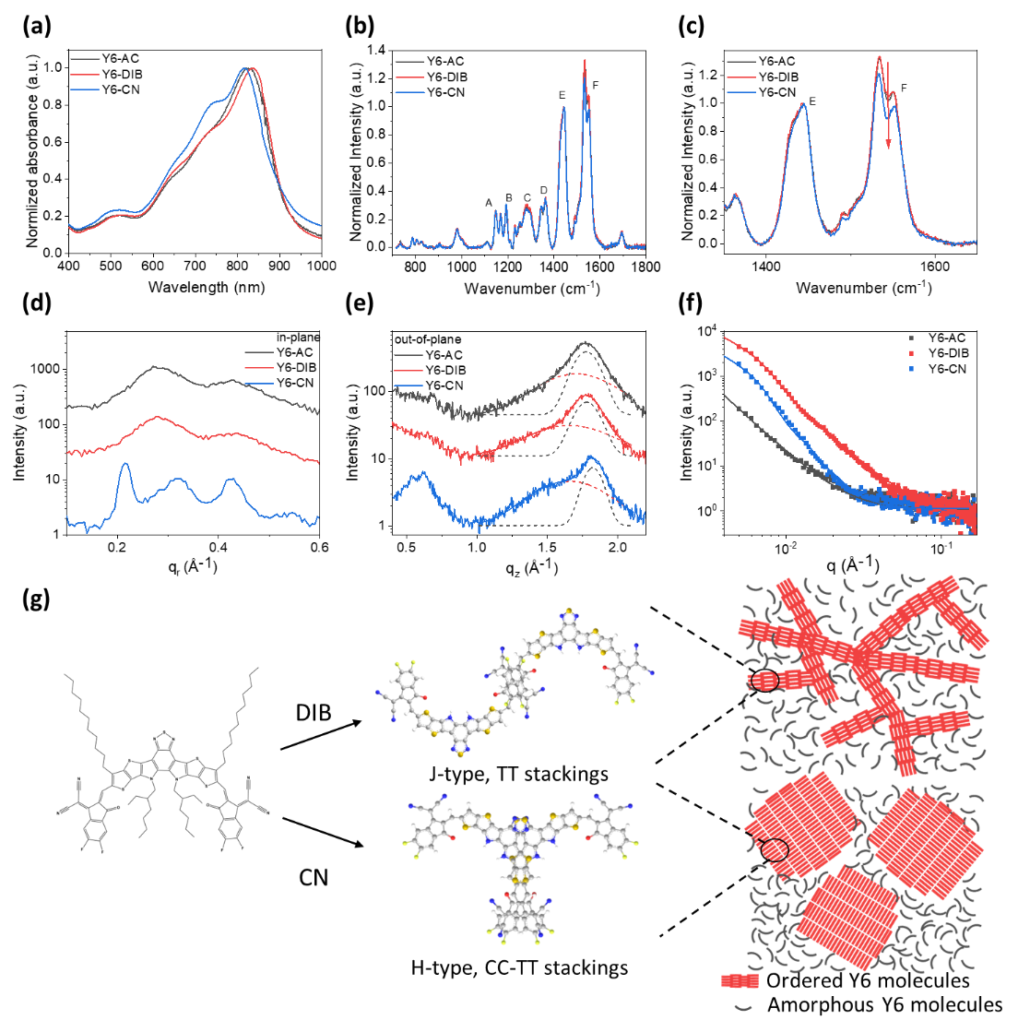
To understand the microscopic origin of DIB over CN in achieving a low D_{f}, we investigated intermolecular aggregations of Y6 using ultraviolet-visible (UV-Vis) absorption spectroscopy. Neat Y6 films processed under the same conditions as those used in blend films are denoted as Y6-AC, Y6-DIB, and Y6-CN, respectively. As shown in Figure 4a, the 0-0 absorption peak of Y6-AC is located at 826 nm with a weak 0-1 shoulder at 730 nm, indicating primarily J-aggregate formation.⁴¹ The absorption spectrum of Y6-DIB is similar to that of Y6-AC, but the 0-0 peak is further red-shifted by 14 nm, suggesting an increased population of J-aggregates. Conversely, the 0-0 peak of Y6-CN is blue-shifted to 815 nm compared to Y6-AC, accompanied by a significant increase in the relative intensity of the 0-1 shoulder, indicating an increased population of H-aggregates. Similar trends were also observed for blend films with CN and DIB, especially for LBL films (Figure S15).
Figure 4 Multi-length scale morphology characterisations of Y6 neat films processed under different conditions. a UV-Vis absorption spectra and b Resonant Raman scattering spectra. The enlarged Raman spectra between 1350 and 1650 cm⁻¹ are shown in c to highlight the selective quenching of peak F for Y6-CN. The 1-D GIWAXS intensity profiles along the d in-plane and e out-of-plane directions. Gaussian fittings were performed for the π- π peaks to deconvolute the main peak from its shoulder. The 1-D in-plane GISAXS linecuts (dots) with their best fits (solid lines) are shown in f. g Schematics showing distinct morphology evolutions of Y6 neat films induced by CN and DIB.
We then probed the crystalline packing structures of neat Y6 films using 2-D grazing-incidence wide-angle X-ray scattering (GIWAXS, Figure S16). In the low-q region of in-plane GIWAXS linecuts (Figure 4d), Y6-AC exhibits two peaks at 0.28 and 0.42 Å⁻¹, corresponding to the (002) and (003) peaks resulting from the terminal group π-π stackings (T-T) of Y6 molecules to form strong backbone order.⁴² The diffraction pattern of Y6-DIB closely resembles that of Y6-AC, but with a higher peak intensity (Figure S17), suggesting a stronger backbone order. In contrast, Y6-CN shows triple peaks at 0.22, 0.32, and 0.43 Å⁻¹, suggesting the formation of a well-defined monoclinic crystal structure.⁴³ Along the out-of-plane direction (Figure 4e), additional doublet peaks at around 0.6 Å⁻¹ appear only in Y6-CN, accompanied by an increase in the relative intensity of the shoulder peak at 1.65 Å⁻¹. The doublets at around 0.6 Å⁻¹ have been assigned to the long-range order of Y6 dimers with a CC-TT configuration (core-to-core and terminal-to-terminal overlaps).^{43, 44} Based on this, we assign the shoulder peak at 1.65 Å⁻¹ to the local core-to-core overlap between Y6 molecules as the steric hindrance effect of the branched side chains on the Y6 core units would increase the C-C packing distance compared to the T-T packings that constitute the main π- π peak, as supported by earlier single crystal analysis results.⁴⁵ Due to different alignments of monomer transition dipoles, Y6 dimers with T-T overlaps are J-type while those with CC-TT overlaps are H-type,⁴⁶ consistent with the absorption spectra. Notably, the difference in crystalline structures of Y6 processed by CN and DIB becomes less pronounced in BHJ films (Figure S18) but is largely retained in LBL films (Figure S19).
Resonant Raman spectra of neat Y6 films were also measured to probe intramolecular conformations of Y6 molecules, which are affected by their different packing motifs in the solid state. As shown in Figure 4b and c, the nearly identical spectra of Y6-AC and Y6-DIB suggest similar molecular conformations. In contrast, the spectrum of Y6-CN shows selective quenching of peak F, corresponding mainly to the C=N and C=C vibration on the central benzothiadiazole (BT) unit (see Figure S20a and b for peak assignments). DFT simulations suggest that these spectral changes stem from an increased dihedral angle within the BT core group (Figure S20c), indicating molecules in Y6-CN possess more twisted core groups than Y6-AC and Y6-DIB. This is likely induced by the steric hindrance effect of core-group side chains during CC-TT stackings. Additionally, it is known that the stacking of two BT cores is assisted by the non-covalent sulphur-nitrogen interaction,⁴⁷ which may redistribute electron density around nitrogen atoms, causing the quenching of peak F. In either case, the measured Raman spectral change supports our conclusion that stackings in Y6-CN involve more CC-TT overlaps.
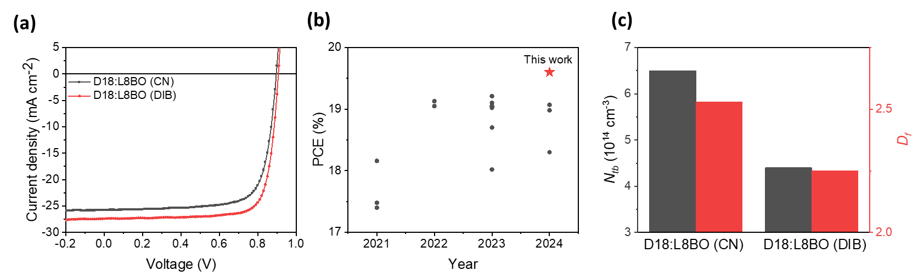
Distinct packing structures, in turn, affect crystalline domain shapes on a larger scale. As shown in Figure 4f and Figure S21, the in-plane GISAXS linecuts of Y6 films with increased populations of J-type T-T stackings (Y6-AC and Y6-DIB) can be fitted with a low- D_{f} (2.5) fractal network model. In stark contrast, the linecut of Y6-CN with more H-type CC-TT stackings exhibits a pronounced shoulder in the low-q region followed by q⁻⁴ decay, which can be fitted using a single hard-sphere term, indicating agglomeration of Y6 crystalline domains. Consistent trends were also observed in AFM topography and phase mappings (Figure S22).
Figure 5 A comparison of D18:L8BO LBL devices with CN or DIB incorporated into L8BO layer. a J-V curves for CN and DIB-incorporated devices. b A comparison of PCEs reported for LBL-OPVs based on Y-series NFAs published in the last four years with champion PCE reported in this work. c Comparing bulk trap density (N_{tb}) and fractal dimension (D_{f}) between the CN and DIB-incorporated LBL devices.
Table 3 A summary of device performance of D18:L8BO LBL devices with CN or DIB incorporated into the L8BO layer as well as the fitting results from voltage-dependent capacitance spectroscopy.
Devices | V_{OC} ª  (V) | J_{SC} ª  (mA cm^{–2}) | J_{SC}^{b}  (mA cm^{–2}) | FF ª  (%) | PCE ª  (%) | γ | N_{tb}  (cm⁻³)
CN | 0.897  (0.899±0.007) | 25.8  (24.7±0.9) | 25.0 | 75.5  (76.1±0.7) | 17.4  (16.9±0.4) | 0.005 | 6.5$×10$¹⁴
DIB | 0.907  (0.905±0.003) | 27.4  (26.9±0.3) | 26.0 | 78.7  (78.5±0.4) | 19.6  (19.1±0.2) | 0.005 | 4.4$×10$¹⁴
ª Figures of merits for champion devices together with the average values and standard deviation (in parenthesis) obtained from 15 independent devices. ^{b} J_{sc} obtained from integrating the EQE spectrum with the AM1.5G solar spectrum.
Such a strong correlation between the local intermolecular packing motifs and the large-scale domain shapes can be understood from the multi-length scale self-similar nature of fractal structures, as shown in Figure 4g. Previous work shows that CN molecules with a high boiling point and solubility for Y6 can be inserted between Y6 end groups to maximise their mutual Van der Waals interaction. This leaves sufficient time and space for neighbouring Y6 molecules to reorganise, which promotes the CC-TT overlaps.⁴⁸ Although CC-TT stackings with larger intermolecular coupling have been reported to assist local exciton and charge transport,⁴⁹ excessive CC-TT stackings lead to agglomeration of Y6 crystalline domains, which harms the inter-domain connectivity in mesoscale. In contrast, DIB mainly interacts with Y6 molecules through the electrostatic interaction between electron-deficient iodine atoms on DIB and electron-rich cyano groups on Y6 end groups.^{40, 50} Since DIB is a volatile solid additive with a much smaller molecular size than CN, the incorporation of DIB mainly enhances the intrinsic J-type backbone order (T-T overlaps) of Y6 without inducing excessive CC-TT overlaps. As a result, extended fractal networks of Y6 crystalline domains are formed in neat and blend films, improving inter-domain connectivity and passivating the deep traps. Unlike one-step deposition, NFAs in LBL-OPVs are deposited separately, so their multi-length scale morphology is more affected by the processing condition, especially the choices of additives. Additionally, we note that neat PM6 films exhibit extended fractal networks with a low D_{f} of 2.1, typical for conjugated D:A copolymers, and their morphology is unaffected by the incorporation of either CN or DIB (Figure S23-26). Therefore, control over the multilength-scale inter-domain connectivity of NFAs is the key to passivating deep traps in high-performance LBL-OPVs.⁵¹
General application in another high-performance LBL system
At last, we fabricated LBL devices based on another high-performance system-D18:L8BO.⁵² As shown in Figure 5a and Table 3, LBL devices incorporating DIB exhibit much better performance than their CN-incorporated counterparts (EQE data shown in Figure S27). The champion efficiency of 19.6% is the highest PCE reported for LBL-OPVs (Figure 5b). Results from capacitance spectroscopy (Figure 5c and Figure S28) show that the higher J_{SC} (27.4 v.s. 26.0 mA cm⁻²) and FF (79.0 v.s. 77.3%) of the DIB-incorporated device mainly originate from passivation of deep traps, in-line with the results of intensity-dependent J-V measurements (Figure S29). In-plane GISAXS linecuts of neat L8BO films (Figure S30) demonstrate a similar impact of DIB and CN on crystalline domain shapes of L8BO with L8BO-CN fitted using a single hard-sphere model while L8BO-DIB fitted using a fractal model. Distinct L8BO domain shapes in neat films are well adopted in LBL blend films (Figure S31), where the DIB-processed film has a smaller D_{f}, larger 2R_{gc} and a smaller ξ compared to the corresponding CN-processed film, as summarised in Figure 5c and Table S2. Consistent trends were observed in AFM and c-AFM mappings of neat and blend films (Figure S32). This confirms the generality of our trap-passivation strategy for state-of-the-art LBL-OPVs.
Conclusions
Our work uncovered, for the first time, the morphological origin of deep traps in high-performance OPVs, which are isolated NFA domains due to the much deeper LUMOs of NFAs compared to polymer donors, while the HOMO offset is negligible. Since such energy level alignment is commonly employed in high-performance OPVs, the efficiency loss due to electron trapping should be universal.
Based on this, we propose that the fractal dimension (D_{f}) of crystalline NFA domains is the key indicator of inter-acceptor domain connectivity. A relatively lower D_{f} not only extends the crystalline NFA networks for long-range charge transport but also partitions the amorphous phase into smaller domains, improving the connectivity between amorphous NFA aggregates. Since GISAXS linecuts of polymer:NFA blend films are commonly fitted using the sum of a DAB term and a fractal term,⁵³ a straightforward way to inspect the film fractal dimension is to check the gradient of the double-log plot of the linecut (q^{-Df}) It is also applicable to strongly agglomerated systems that can only be fitted with the hard-sphere structure factor, giving rise to an effective D_{f} of 4.
Due to the multi-length scale self-similar nature of the NFA fractal network, D_{f} is highly dependent on the local packing motifs of NFAs. The effect is especially pronounced for LBL-OPVs where the separate depositions of donor and NFA amplify the difference in NFA morphology induced by e.g., additives. A high fraction of NFAs with J-type T-T overlaps promotes polymer-like backbone packings, forming a low-D_{f} network to passivate deep traps. This is in line with the experience learned in the field of organic field effect transistor (OFET), where high-molecular-weight (M_{w}) polymers exhibit higher mobilities compared to their more crystalline, low-M_{w} counterparts due to the formation of tie chains through polymer backbones that guarantee the inter-domain connectivity.^{54, 55} Therefore, future work should be focused on simultaneously achieving a high degree of crystallinity while maintaining a moderately low fractal dimension. This can be achieved by enhancing the backbone order of NFAs to form polymer-like percolation networks. Further optimising active layer morphology based on those guidelines is an important step in pushing the PCE of OPV towards its theoretical limit.
Author contributions
Y.F. fabricated and characterised PV devices, including J-V and voltage-dependent capacitance spectroscopy measurements. L.X. and Y.F. performed AFM and c-AFM measurements and analysed the results. Y.L. and Y.K. performed GISANS measurements. G.C. and M.-C.T. synthesised d-Y6 molecules for GISANS measurements. Y.L., Y.F., and X.L. analysed GISANS data. Y.F. measured Raman scattering measurements. E.J.Y. and J.S.K. performed DFT simulations to understand the measured spectral change. Y.F. performed GIWAXS measurements of neat and blend films and GISAXS measurements of neat films. P.F.C., C.-J.S., and U.-S.J. performed GISAXS measurements of blend films. Y.F. and X.L. analysed all the X-ray scattering data. Y.G. and P.C.Y.C. performed transient absorption spectroscopy measurements and analysed the results. Y.F. and X.L. prepared the manuscript. M.-C.T. contributed to data analysis and revised manuscript preparation. X.L. supervised this work. All authors provided revisions.
Conflicts of interest
There are no conflicts of interest to declare.
Data availability
The data supporting this article have been included as part of the Supplementary Information.

Acknowledgments
The authors acknowledge the financial support from the National Natural Science Foundation of China (No. 52122004) and the Guangdong-Hong Kong-Macao Joint Laboratory for Neutron Scattering Science and Technology (TC2116291). The work described in this paper was fully supported by a grant from the National Natural Science Foundation of China (Project No. 22275114), Science and Technology Planning Project of Shenzhen Municipality (Grant number: WDZC20220817160017003). We thank the beam time and technical support provided by the small-angle neutron scattering sector at China Spallation Neutron Source and 23A SWAXS beamline at NSRRC, Hsinchu.
References

1. Y. Lin, J. Wang, Z.-G. Zhang, H. Bai, Y. Li, D. Zhu and X. Zhan, Advanced Materials, 2015, 27, 1170-1174.
2. J. Yuan, Y. Zhang, L. Zhou, G. Zhang, H.-L. Yip, T.-K. Lau, X. Lu, C. Zhu, H. Peng, P. A. Johnson, M. Leclerc, Y. Cao, J. Ulanski, Y. Li and Y. Zou, Joule, 2019, 3, 1140-1151.
3. S. Guan, Y. Li, C. Xu, N. Yin, C. Xu, C. Wang, M. Wang, Y. Xu, Q. Chen, D. Wang, L. Zuo and H. Chen, Advanced Materials, 2024, n/a, 2400342.
4. A. Markina, K.-H. Lin, W. Liu, C. Poelking, Y. Firdaus, D. R. Villalva, J. I. Khan, S. H. K. Paleti, G. T. Harrison, J. Gorenflot, W. Zhang, S. De Wolf, I. McCulloch, T. D. Anthopoulos, D. Baran, F. Laquai and D. Andrienko, Advanced Energy Materials, 2021, 11, 2102363.
5. L. Perdigón-Toro, H. Zhang, A. Markina, J. Yuan, S. M. Hosseini, C. M. Wolff, G. Zuo, M. Stolterfoht, Y. Zou, F. Gao, D. Andrienko, S. Shoaee and D. Neher, Advanced Materials, 2020, 32, 1906763.
6. M. Stolterfoht, A. Armin, B. Philippa, R. D. White, P. L. Burn, P. Meredith, G. Juška and A. Pivrikas, Scientific Reports, 2015, 5, 9949.
7. S. R. Cowan, N. Banerji, W. L. Leong and A. J. Heeger, Advanced Functional Materials, 2012, 22, 1116-1128.
8. Y. Fu, T. H. Lee, Y.-C. Chin, R. A. Pacalaj, C. Labanti, S. Y. Park, Y. Dong, H. W. Cho, J. Y. Kim, D. Minami, J. R. Durrant and J.-S. Kim, Nature Communications, 2023, 14, 1870.
9. Y. Wu, Y. Li, B. van der Zee, W. Liu, A. Markina, H. Fan, H. Yang, C. Cui, Y. Li, P. W. M. Blom, D. Andrienko and G.-J. A. H. Wetzelaer, Scientific Reports, 2023, 13, 4717.
10. C. Poelking, J. Benduhn, D. Spoltore, M. Schwarze, S. Roland, F. Piersimoni, D. Neher, K. Leo, K. Vandewal and D. Andrienko, Communications Physics, 2022, 5, 307.
11. J. Wu, J. Lee, Y.-C. Chin, H. Yao, H. Cha, J. Luke, J. Hou, J.-S. Kim and J. R. Durrant, Energy & Environmental Science, 2020, 13, 2422-2430.
12. Y. Zhang, G. Cai, Y. Li, Z. Zhang, T. Li, X. Zuo, X. Lu and Y. Lin, Adv. Mater., 2021, 33, 2008134.
13. W. Shockley and W. T. Read, Physical Review, 1952, 87, 835-842.
14. S. Zeiske, O. J. Sandberg, N. Zarrabi, W. Li, P. Meredith and A. Armin, Nature Communications, 2021, 12, 3603.
15. J. Zhang, M. H. Futscher, V. Lami, F. U. Kosasih, C. Cho, Q. Gu, A. Sadhanala, A. J. Pearson, B. Kan, G. Divitini, X. Wan, D. Credgington, N. C. Greenham, Y. Chen, C. Ducati, B. Ehrler, Y. Vaynzof, R. H. Friend and A. A. Bakulin, Advanced Energy Materials, 2019, 9, 1902145.
16. G. Cai, Y. Li, Y. Fu, H. Yang, L. Mei, Z. Nie, T. Li, H. Liu, Y. Ke, X.-L. Wang, J.-L. Brédas, M.-C. Tang, X. Chen, X. Zhan and X. Lu, Nat. Commun., 2024, 15, 2784.
17. K. Jiang, J. Zhang, C. Zhong, F. R. Lin, F. Qi, Q. Li, Z. Peng, W. Kaminsky, S.-H. Jang, J. Yu, X. Deng, H. Hu, D. Shen, F. Gao, H. Ade, M. Xiao, C. Zhang and A. K. Y. Jen, Nature Energy, 2022, 7, 1076-1086.
18. S. Min, S. H. Han, C. Park, K. Y. Ryu and K. Kim, Solar RRL, 2021, 5, 2100592.
19. R. Sun, Q. Wu, J. Guo, T. Wang, Y. Wu, B. Qiu, Z. Luo, W. Yang, Z. Hu, J. Guo, M. Shi, C. Yang, F. Huang, Y. Li and J. Min, Joule, 2020, 4, 407-419.
20. L. Zhu, M. Zhang, G. Zhou, T. Hao, J. Xu, J. Wang, C. Qiu, N. Prine, J. Ali, W. Feng, X. Gu, Z. Ma, Z. Tang, H. Zhu, L. Ying, Y. Zhang and F. Liu, Adv. Energy Mater., 2020, 10, 1904234.
21. S. Luo, C. Li, J. Zhang, X. Zou, H. Zhao, K. Ding, H. Huang, J. Song, J. Yi, H. Yu, K. S. Wong, G. Zhang, H. Ade, W. Ma, H. Hu, Y. Sun and H. Yan, Nature Communications, 2023, 14, 6964.
22. X. Liao, Q. Xie, Y. Guo, Q. He, Z. Chen, N. Yu, P. Zhu, Y. Cui, Z. Ma, X. Xu, H. Zhu and Y. Chen, Energy & Environmental Science, 2022, 15, 384-394.
23. S. Lai, Y. Cui, Z. Chen, X. Xia, P. Zhu, S. Shan, L. Hu, X. Lu, H. Zhu, X. Liao and Y. Chen, Advanced Materials, 2024, 36, 2313105.
24. L. Wen, H. Mao, L. Zhang, J. Zhang, Z. Qin, L. Tan and Y. Chen, Advanced Materials, 2024, 36, 2308159.
25. V. V. Brus, C. M. Proctor, N. A. Ran and T.-Q. Nguyen, Advanced Energy Materials, 2016, 6, 1502250.
26. J. Qin, Q. Yang, J. Oh, S. Chen, G. O. Odunmbaku, N. A. N. Ouedraogo, C. Yang, K. Sun and S. Lu, Advanced Science, 2022, 9, 2105347.
27. L. Zhu, M. Zhang, J. Xu, C. Li, J. Yan, G. Zhou, W. Zhong, T. Hao, J. Song, X. Xue, Z. Zhou, R. Zeng, H. Zhu, C.-C. Chen, R. C. I. MacKenzie, Y. Zou, J. Nelson, Y. Zhang, Y. Sun and F. Liu, Nature Materials, 2022, 21, 656-663.
28. R. Zeng, L. Zhu, M. Zhang, W. Zhong, G. Zhou, J. Zhuang, T. Hao, Z. Zhou, L. Zhou, N. Hartmann, X. Xue, H. Jing, F. Han, Y. Bai, H. Wu, Z. Tang, Y. Zou, H. Zhu, C.-C. Chen, Y. Zhang and F. Liu, Nat. Commun., 2023, 14, 4148.
29. O. Douhéret, L. Lutsen, A. Swinnen, M. Breselge, K. Vandewal, L. Goris and J. Manca, Appl. Phys. Lett., 2006, 89.
30. L. S. C. Pingree, O. G. Reid and D. S. Ginger, Nano Letters, 2009, 9, 2946-2952.
31. P. S. Fernando and J. M. Mativetsky, The Journal of Physical Chemistry C, 2023, 127, 9903-9910.
32. S. M. Hosseini, N. Tokmoldin, Y. W. Lee, Y. Zou, H. Y. Woo, D. Neher and S. Shoaee, Solar RRL, 2020, 4, 2000498.
33. K. Vandewal, J. Widmer, T. Heumueller, C. J. Brabec, M. D. McGehee, K. Leo, M. Riede and A. Salleo, Advanced Materials, 2014, 26, 3839-3843.
34. J. Mai, T.-K. Lau, J. Li, S.-H. Peng, C.-S. Hsu, U. S. Jeng, J. Zeng, N. Zhao, X. Xiao and X. Lu, Chem. Mater., 2016, 28, 6186-6195.
35. H.-C. Liao, C.-S. Tsao, T.-H. Lin, C.-M. Chuang, C.-Y. Chen, U. S. Jeng, C.-H. Su, Y.-F. Chen and W.-F. Su, Journal of the American Chemical Society, 2011, 133, 13064-13073.
36. J. Fang, Z. Wang, Y. Chen, Q. Zhang, J. Zhang, L. Zhu, M. Zhang, Z. Cui, Z. Wei, H. Ade and C.-Q. Ma, Cell Reports Physical Science, 2022, 3, 100983.
37. J. W. Kiel, A. P. R. Eberle and M. E. Mackay, Physical Review Letters, 2010, 105, 168701.
38. Z. Chen, X. Chen, B. Qiu, G. Zhou, Z. Jia, W. Tao, Y. Li, Y. M. Yang and H. Zhu, The Journal of Physical Chemistry Letters, 2020, 11, 3226-3233.
39. X. Liao, M. Liu, H. Pei, P. Zhu, X. Xia, Z. Chen, Y. Zhang, Z. Wu, Y. Cui, G. Xu, M. Gao, L. Ye, R. Ma, T. Liu, X. Lu, H. Zhu and Y. Chen, Angewandte Chemie International Edition, 2024, 63, e202318595.
40. J. Fu, H. Chen, P. Huang, Q. Yu, H. Tang, S. Chen, S. Jung, K. Sun, C. Yang, S. Lu, Z. Kan, Z. Xiao and G. Li, Nano Energy, 2021, 84, 105862.
41. N. J. Hestand and F. C. Spano, Chemical Reviews, 2018, 118, 7069-7163.
42. Y. Xiao, J. Yuan, G. Zhou, K. C. Ngan, X. Xia, J. Zhu, Y. Zou, N. Zhao, X. Zhan and X. Lu, J. Mater. Chem. A, 2021, 9, 17030-17038.
43. X. Xia, L. Mei, C. He, Z. Chen, N. Yao, M. Qin, R. Sun, Z. Zhang, Y. Pan, Y. Xiao, Y. Lin, J. Min, F. Zhang, H. Zhu, J.-L. Bredas, H. Chen, X.-K. Chen and X. Lu, J. Mater. Chem. A, 2023, 11, 21895-21907.
44. G. Zhang, X.-K. Chen, J. Xiao, P. C. Y. Chow, M. Ren, G. Kupgan, X. Jiao, C. C. S. Chan, X. Du, R. Xia, Z. Chen, J. Yuan, Y. Zhang, S. Zhang, Y. Liu, Y. Zou, H. Yan, K. S. Wong, V. Coropceanu, N. Li, C. J. Brabec, J.-L. Bredas, H.-L. Yip and Y. Cao, Nature Communications, 2020, 11, 3943.
45. F. Lin, K. Jiang, W. Kaminsky, Z. Zhu and A. K. Y. Jen, Journal of the American Chemical Society, 2020, 142, 15246-15251.
46. D. Kroh, F. Eller, K. Schötz, S. Wedler, L. Perdigón-Toro, G. Freychet, Q. Wei, M. Dörr, D. Jones, Y. Zou, E. M. Herzig, D. Neher and A. Köhler, Advanced Functional Materials, 2022, 32, 2205711.
47. S. Ghosh, S. Das, N. R. Kumar, A. R. Agrawal and S. S. Zade, New Journal of Chemistry, 2017, 41, 11568-11575.
48. L. Mei, X. Xia, R. Sun, Y. Pan, J. Min, X. Lu, A. K.-Y. Jen and X.-K. Chen, Small, 2024, 20, 2305977.
49. G. Kupgan, X. K. Chen and J. L. Brédas, Materials Today Advances, 2021, 11, 100154.
50. G. Cai, Z. Chen, X. Xia, Y. Li, J. Wang, H. Liu, P. Sun, C. Li, R. Ma, Y. Zhou, W. Chi, J. Zhang, H. Zhu, J. Xu, H. Yan, X. Zhan and X. Lu, Advanced Science, 2022, 9, 2200578.
51. Y.-J. Xue, Z.-Y. Lai, H.-C. Lu, J.-C. Hong, C.-L. Tsai, C.-L. Huang, K.-H. Huang, C.-F. Lu, Y.-Y. Lai, C.-S. Hsu, J.-M. Lin, J.-W. Chang, S.-Y. Chien, G.-H. Lee, U. S. Jeng and Y.-J. Cheng, J. Am. Chem. Soc., 2024, 146, 833-848.
52. H. Lu, W. Liu, G. Ran, Z. Liang, H. Li, N. Wei, H. Wu, Z. Ma, Y. Liu, W. Zhang, X. Xu and Z. Bo, Angewandte Chemie International Edition, 2023, 62, e202314420.
53. Y. Xiao and X. Lu, Materials Today Nano, 2019, 5, 100030.
54. R. J. Kline, M. D. McGehee, E. N. Kadnikova, J. Liu, J. M. J. Fréchet and M. F. Toney, Macromolecules, 2005, 38, 3312-3319.
55. R. Noriega, J. Rivnay, K. Vandewal, F. P. V. Koch, N. Stingelin, P. Smith, M. F. Toney and A. Salleo, Nature Materials, 2013, 12, 1038-1044.

