Visualizing Triplet Energy Transfer in Organic Near-Infrared Phosphorescent Host-Guest Materials

Zihao Deng,[a] Fan-Cheng Kong,[b] Ziqi Deng,[c] Jiaming Zhou,[b] Shengyi Yang,[a] Shan He,[a] Jianyu Zhang,[a] Yunfei Zuo,[a] Jin Wang,[a] Xinmeng Chen,[a] Ryan T. K. Kwok,[a] Guocheng Jia,[a] Philip C. Y. Chow,[b] David Lee Phillips,[c] Parvej Alam,*[d] Jacky W. Y. Lam,*[a] Ben Zhong Tang*[a,e]

[a] Zihao Deng, Shengyi Yang, Shan He, Jianyu Zhang, Yunfei Zuo, Jin Wang, Xinmeng Chen, Ryan T. K. Kwok, Guocheng Jia, Jacky W. Y. Lam, Ben Zhong Tang
Department of Chemistry and the Hong Kong Branch of Chinese National Engineering Research Center for Tissue Restoration and Reconstruction, The Hong Kong University of Science and Technology, Clear Water Bay, Kowloon, Hong Kong, China
E-mail: alamparvej@cuhk.edu.cn, chjacky@ust.hk, and tangbenz@cuhk.edu.cn
[b] Fan-Cheng Kong, Jiaming Zhou, Philip C. Y. Chow
Department of Mechanical Engineering, The University of Hong Kong, Pokfulam, Hong Kong, China
[c] Ziqi Deng, David Lee Phillips
Department of Chemistry, The University of Hong Kong, Pokfulam, Hong Kong, China
[d] Parvej Alam
Clinical Translational Research Center of Aggregation-Induced Emission, School of Medicine, The Second Affiliated Hospital, School of Science and Engineering, The Chinese University of Hong Kong, Shenzhen (CUHK-Shenzhen), Guangdong, 518172, China
[e] Ben Zhong Tang
School of Science and Engineering, Institute of Aggregate Science and Technology, The Chinese University of Hong Kong, Shenzhen (CUHK-Shenzhen), Guangdong, 518172, China

Supporting information for this article is given via a link at the end of the document.

Accepted by:
Angewandte Chemie International Edition
21, September, 2024

Abstract: Limited by the energy gap law, purely organic materials with efficient near-infrared room temperature phosphorescence are rare and difficult to achieve. Additionally, the exciton transition process among different emitting species in host-guest phosphorescent materials remains elusive, presenting a significant academic challenge. Herein, using a modular nonbonding orbital-π bridge-nonbonding orbital (n-π-n) molecular design strategy, we develop a series of heavy atom-free phosphors. Systematic modification of the π-conjugated cores enables the construction of a library with tunable near-infrared phosphorescence from 655 to 710 nm. These phosphors exhibit excellent performance under ambient conditions when dispersed into a 4-bromobenzophenone host matrix, achieving an extended lifetime of 11.25 ms and a maximum phosphorescence efficiency of 4.2%. Notably, by eliminating the interference from host phosphorescence, the exciton transition process can be visualized in hybrid materials under various excitation conditions. Spectroscopic analysis reveals that the improved phosphorescent performance of the guest originates from the triplet-triplet energy transfer of abundant triplet excitons generated independently by the host, rather than from enhanced intersystem crossing efficiency between the guest singlet state and the host triplet state. The findings provide in-depth insights into constructing novel near-infrared phosphors and exploring emission mechanisms of host-guest materials.

Introduction
Over the last decade, purely organic room temperature phosphorescence (RTP) materials have emerged as a promising alternative to heavy metal-based phosphors due to their facile preparation, low toxicity, and tunable properties.[1] Near-infrared (NIR) phosphors, particularly, have attracted considerable attention for their potential applications in deep-tissue bioimaging, tumor diagnosis, and optoelectronic devices.[2] However, realizing NIR RTP materials remains challenging due to the energy gap law, which promotes the nonradiative decay of excitons.[3] Therefore, researchers have been trying to develop efficient and persistent NIR RTP materials by modifying the structures of known red luminophores to stabilize their triplet states. Nevertheless, these efforts have had limited success so far, as few effective strategies have emerged. The development of NIR phosphors has primarily focused on modifying specific cores like 4,4-difluoro-4-bora-3a,4a-diaza-s-indacene,[4] pyrene,[5] and difluoroboron β-diketonate.[6] Despite some novel systems, their intricate structures hinder the development of a rational design strategy to guide further research.[7] Moreover, numerous materials fail to exhibit desirable properties, further limiting their applications.[8] Consequently, it is imperative to develop a facile and reliable strategy to construct novel NIR RTP systems with high performance, expanding the variety of materials and potential applications.
Additionally, doping phosphors into small-molecule hosts is an efficient technique to promote phosphorescent performance.[9] The rigid environment provided by the host matrix can effectively restrict molecular motion and the penetration of moisture and oxygen, inhibiting the quenching effects of on triplet excitons.[10] Compared with polymer matrices, some suitable small-molecule hosts can more significantly improve the luminescence properties of the phosphors. However, the mechanism underlying the contribution of hosts remains unclear. Generally, the small-molecule host is a type of phosphor in the solid state, with its lowest excited triplet state (T₁) energetically located between the lowest excited singlet state (S₁) and T₁ state of the guest molecule. Due to the narrowed energy gap between the guest singlet state (S₁(G)) and the host triplet state (T₁(H)), it has been proposed that highly efficient intersystem crossing (ISC) can occur between these two states, facilitating the generation of substantial triplet excitons. Subsequently, the excitons accumulated at T₁(H) undergo the triplet-triplet energy transfer (TTET) to T₁(G), thereby boosting the phosphorescence from the guest.[2a, 5, 11] Nevertheless, this proposition faces a theoretical issue: the ISC of excitons is challenging to occur between different species due to the required spin-orbit coupling (SOC).[12] Meanwhile, the dynamics of this ISC between two molecules are unclear. Besides, it is noteworthy that most reported guests exhibit yellow-green phosphorescence, which overlaps with the phosphorescent emissions of widely used small-molecule hosts such as triphenylamine, triphenylphosphine,[11c] and benzophenone.[13] This spectral overlap interferes with the analysis of exciton dynamics in hybrid materials. So far, the exciton transition process has not been visualized to support the proposed mechanism. In contrast, NIR phosphors, with their low triplet energy levels, effectively prevent mutual interference of triplet excitons from different species, providing a reliable perspective to elucidate the exciton transition process in doping systems comprehensively.

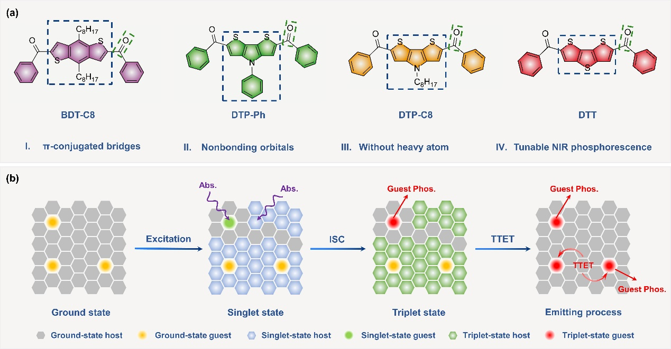
Scheme 1. (a) Design strategy, molecular structures, and novel functions of NIR RTP molecules. (b) Exciton transition mechanisms of NIR RTP host-guest systems under optimal conditions. Upon excitation, both the host and guest can absorb the incident light and be excited to their respective singlet state. Through the ISC process, the excited singlet hosts and guests can undergo a transition to their corresponding excited triplet state. Subsequently, the abundant triplet excitons generated by the host transfer their energy to the guest triplet state with the lowest energy level in the system through the TTET process, resulting in the NIR RTP from the guest. The intrinsic triplet excitons of the guest, combined with those transferred from the host, collectively contribute to the enhanced phosphorescent performance of the host-guest material.

Herein, as shown in Scheme 1, we devised a novel NIR RTP system based on nonbonding orbital-π bridge-nonbonding orbital (n-π-n) typed molecules. The extended π-conjugated cores with high charge density decrease the triplet state energy, while the attached carbonyl groups balance the n-π* and π-π* transitions, boosting the ISC efficiency and triplet stabilization.[14] A series of phosphors that emit efficient and durable NIR phosphorescence was developed without relying on heavy atoms’ assistance. By doping these compounds into a 4-bromobenzophenone (BP-Br) host matrix, their performance was significantly enhanced. The host-guest materials exhibited persistent NIR RTP emissions in 655-710 nm, with phosphorescence efficiencies of 1.6-4.2% and lifetimes of 3.8-11.25 ms (Table S2), performing excellently compared to the reported organic NIR RTP compounds. By altering the conjugated core, the properties of RTP can be finely tuned through the variations of electronic effects, demonstrating the remarkable versatility of this strategy. Furthermore, unlike the pure guests, we noticed that the luminescence of host-guest materials was excitation-dependent. Spectroscopic analysis revealed the exciton transition mechanism between the host and the guest, demonstrating the enhanced phosphorescent performance of the guest did not result from the improved ISC process between S₁(G) and T₁(H) despite their narrow energy gap. Instead, upon the optimal excitation, the host and guest materials generated different triplet excitons independently. High-concentration host material can produce abundant triplet excitons, which then transfer to T₁(G) through TTET, enhancing guest performance significantly. This work not only proposes effective strategies for constructing NIR RTP materials but also provides a comprehensive and novel perspective for analyzing the exciton transition process in host-guest materials. It also establishes a framework for understanding the effects of host materials on guest molecules, which can further guide the development of host-guest systems for efficient NIR RTP applications.

Results and Discussion

Photophysical Properties of NIR Phosphors

Based on the π-conjugated cores of 4,8-dioctylbenzo[1,2-b:4,5-b']dithiophene, 4-phenyl-4H-dithieno[3,2-b:2',3'-d]pyrrole, 4-octyl-4H-dithieno[3,2-b:2',3'-d]pyrrole, and dithieno[3,2-b:2',3'-d]thiophene, a series of NIR phosphors were synthesized and named as BDT-C8, DTP-Ph, DTP-C8, and DTT, respectively (Scheme S3). Their chemical structures were confirmed by 1H NMR spectroscopy, 13C NMR spectroscopy, high-resolution mass spectrometry (HRMS) (Figures S1-S18), and single crystal X-ray diffraction. High-performance liquid chromatography (HPLC) analysis displayed single peaks at the absorption of 365 and 400 nm, respectively, indicating their high purity and eliminating the effects of impurities (Figure S19).[15]
Firstly, the photophysical properties of all compounds were examined in the dilute solution state. Due to the different electronic effects of the cores, these phosphors exhibited distinct characteristics in the absorption spectra, with various absorption edges ranging from 410 to 470 nm. Notably, BDT-C8 exhibited two structured absorption bands centered at ~350 and ~440 nm. Besides, their features remained stable in different solvents, demonstrating negligible solvatochromism for the system (Figure S20). In dilute tetrahydrofuran at room temperature, the photoluminescence (PL) spectra of compounds showed single peaks from 433 to 478 nm, corresponding to their fluorescence emissions (Figure S21a). Upon cooling to 77 K, the steady-state and delayed PL spectra displayed new emission bands with dual peaks between 610 and 702 nm, accompanied by lifetimes in millisecond scale. For instance, DTT exhibited two emission peaks at 610 and 655 nm with similar lifetimes of 16.04 and 15.86 ms, respectively, indicating its typical phosphorescence (Figure S21b-f). Moreover, at the monitored wavelengths of these peaks, the similar excitation-phosphorescence spectra suggested that these bands originated from different vibrational energy levels in the T1 state of the same emitter (Figure S22). The same conclusion can be applied to the other compounds as well.
To further explore the phosphorescent properties in the monomer state, we doped the compounds into the polymethyl methacrylate (PMMA) film (1 wt%). At room temperature, the phosphorescence of doped films can be readily activated by UV irradiation. Among phosphors, the DTT-doped PMMA film exhibited the highest phosphorescence efficiency with emission peaks at 620 and 660 nm, giving comparable lifetimes of 7.42 and 7.48 ms, respectively (Figure S23). Additionally, DTP-C8/PMMA film exhibited the highest lifetime of 11.01 ms, displaying NIR emissions at 647 and 690 nm. Notably, although BDT-C8/PMMA film showed the longest emission wavelength at 710 nm, only faint phosphorescence with the shortest lifetime of 2.36 ms was observed. It should be ascribed to the poor ISC efficiency and strong nonradiative decay inherent to BDT-C8. By modulating the electronic effects of core structures, we successfully achieved tunable NIR phosphorescence ranging from 660 to 710 nm. When the temperature decreased to 77 K, the emissions exhibited slight blueshifts owing to the suppressed vibrational relaxation of molecules at low temperatures, displaying clearer fine structures with enhanced performance (Figure S24). Under this condition, the phosphorescent properties of doped PMMA films were nearly identical to those of frozen solutions, demonstrating their ability to restrict molecular motions to induce phosphorescence.
Inspired by their efficient NIR emissions, we aimed to explore the potential of these compounds for achieving persistent phosphorescence under ambient conditions. Consequently, we investigated their photophysical properties in the crystalline state. However, none of the crystals exhibited RTP (Figure S25). The crystals exhibited strong π-π interactions, which can quench excitons through triplet-triplet annihilation (TTA).[16] Besides, upon excitation, the dense π-π stacking in the crystals resulted in the formation of unstable excimer, which further quenched triplet excitons at room temperature (Figures S26-S29).[17] Hence, crystallization is not a viable strategy for inducing phosphorescent emissions in these compounds under ambient conditions.

Photophysical Properties of NIR Phosphorescent Host-Guest Materials

Since fabricating host-guest materials is another effective method to activate RTP, we selected 4-bromobenzophenone (BP-Br) as a host matrix to incorporate guest phosphors. BP-Br tends to crystallize in the phase transition process, providing a rigid environment that can restrict molecular motions and prevent the quenching effects of moisture and oxygen on phosphorescence. Besides, as a phosphorescent material, its T1 state is energetically located between the S1 and T1 states of our guests. This strategic alignment of energy levels is not only beneficial for enhancing the performance of guest phosphors, as suggested by the previous research, but also presents an opportunity to investigate the exciton transition mechanism in host-guest materials systemically.
Through the melt-casting method, the guests can be uniformly dispersed into the BP-Br host. All compounds exhibited high decomposition temperatures and stable subcooling states, confirming their good thermal stability (Figure S30). At a doping concentration of 1 wt%, the powder X-ray diffraction results indicated the guests can efficiently insert into the crystal lattice of the host and affect its crystallization process, supporting the strong intermolecular interactions between the host and the guest (Figure S31). Under 365 nm excitation, the prompt and delayed PL spectra revealed the host-guest materials exhibited the typical phosphorescence of guests from 655 to 710 nm, with DTP-C8/BP-Br giving the longest lifetime of 11.25 ms (Figures 1a-c and S32). Unexpectedly, the excitation-emission mappings showed that the optimal excitation wavelengths for fluorescence and phosphorescence were different, indicating the luminescence of these host-guest materials was excitation-dependent (Figures 1d and S33). For instance, DTP-C8/BP-Br primarily exhibited fluorescence from the DTP-C8 at 506 nm under ~420 nm excitation. In contrast, upon 310 nm irradiation, the phosphorescence at 650 and 690 nm from the DTP-C8 dominated the emission (Figure 1d). Generally, with varying excitation wavelengths, the fluorescence and phosphorescence intensity changes are consistent because the triplet excitons always derive from the ISC process of singlet excitons. Changes in excitation wavelength are unlikely to significantly impact ISC efficiency unless the system possesses multiple ways to populate the triplet states and subsequent radiative decay pathways. However, the excitation-phosphorescence mapping demonstrated the phosphorescent characteristics of DTP-C8/BP-Br did not change with excitation wavelength, maintaining dual emissions at 650 and 690 nm (Figure 1e). Meanwhile, the time-resolved emission (TRES) mapping correlated with the phosphorescence spectrum, confirming the phosphorescence originated solely from the T1 state of DTP-C8 (Figure 1f). Similarly, the other three hybrid materials also exhibited phosphorescence from guests, regardless of the excitation wavelength (Figures S34 and S35).
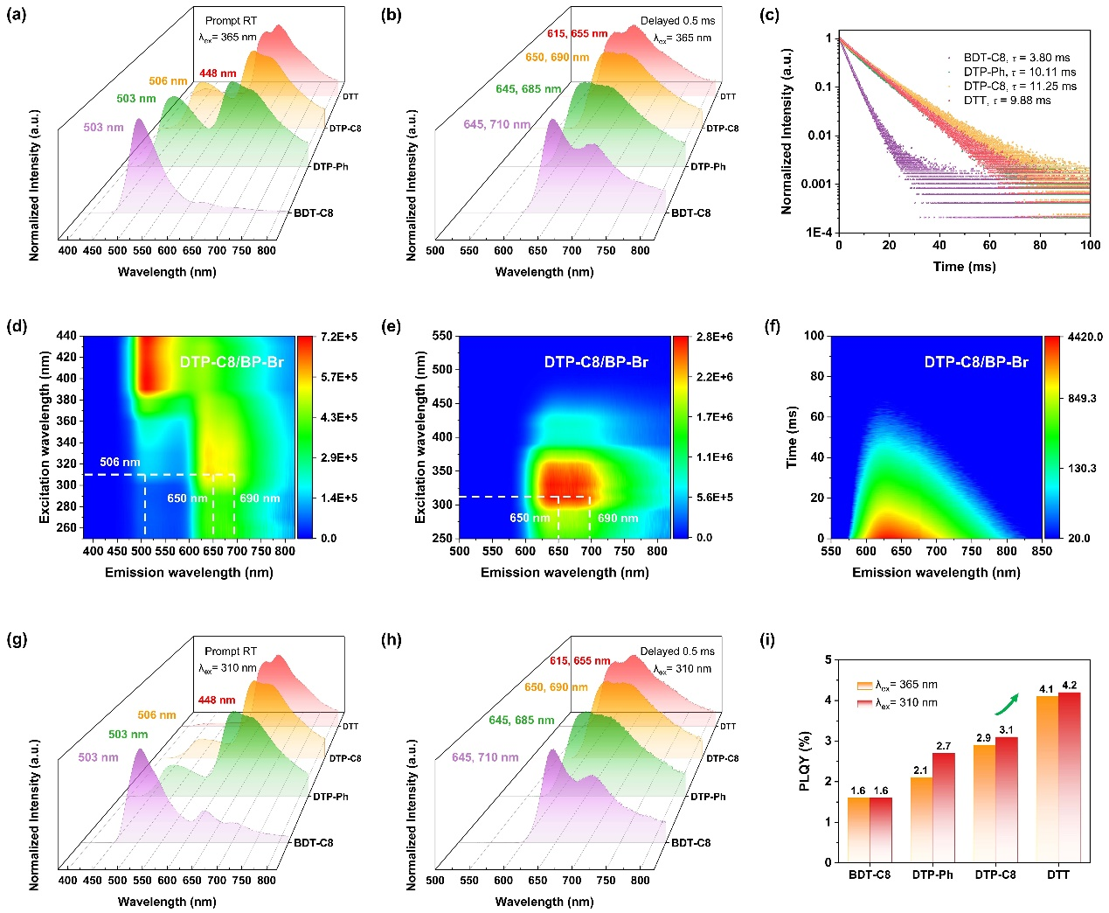
Figure 1. (a) Normalized steady-state PL spectra and (b) normalized phosphorescence spectra of four phosphors doped in the BP-Br matrix (1 wt%) at room temperature. (c) Time-resolved decay curves of their first phosphorescent emission peaks at room temperature. The excitation wavelength is 365 nm. (d) Excitation-emission mapping and (e) excitation-phosphorescence mapping of DTP-C8/BP-Br at room temperature. (f) TRES mapping of DTP-C8/BP-Br at room temperature. (g) Normalized steady-state PL spectra and (h) normalized phosphorescence spectra of four phosphors doped in the BP-Br matrix (1 wt%) at room temperature. The excitation wavelength is 310 nm. (i) The phosphorescence efficiencies of four host-guest materials under 310 and 365 nm excitation, respectively.
A comparison of the prompt and delayed PL spectra under 310 and 365 nm excitations revealed a significant increase in the phosphorescence emission ratio under 310 nm excitation, even though the emitting species remained unchanged in both conditions (Figure 1g,h). The higher phosphorescence ratio observed at 310 nm excitation suggested the critical role of the BP-Br in facilitating the population of the guest triplet excitons responsible for phosphorescence. This phenomenon was further validated by the improved phosphorescence efficiencies of all materials in this condition. By varying the excitation wavelength from 365 to 310 nm, the phosphorescence efficiency of DTP-C8/BP-Br increased from 2.9% to 3.1%, with DTT/BP-Br exhibiting the highest value of 4.2% (Figure 1i). As a result, the variation of excitation wavelength effectively modulated the ratio between fluorescence and phosphorescence emission, leading to the alteration in the luminescence of the doping system.
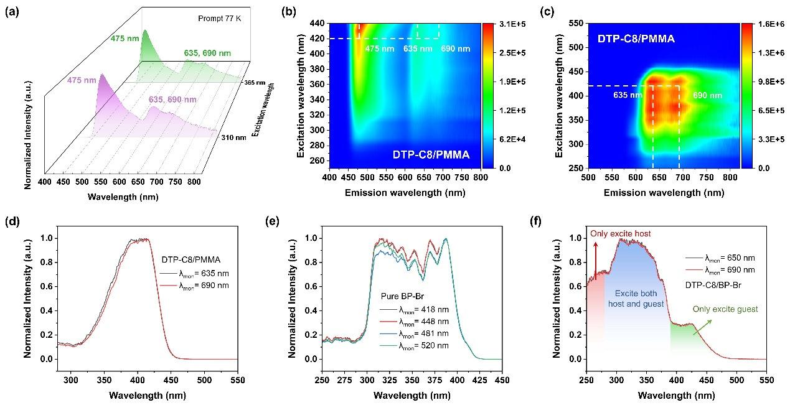
Figure 2. (a) Normalized steady-state PL spectra of DTP-C8 doped in the PMMA matrix (1 wt%) at 77 K. (b) Excitation-emission mapping and (c) excitation-phosphorescence mapping of DTP-C8/PMMA at 77 K. (d) Excitation-phosphorescence curves of DTP-C8/PMMA at 77 K. (e) Excitation-phosphorescence curves of BP-Br in the solid state at room temperature. (f) Excitation-phosphorescence curves and excitation attribution of DTP-C8/BP-Br (1 wt%) at room temperature. The monitored wavelengths are their phosphorescence emission peaks.

Notably, the emission of DTP-C8/PMMA film exhibited no excitation dependence, giving the strongest fluorescent and phosphorescent emissions simultaneously under ~420 nm excitation (Figure 2a-c). The different excitation characteristics of DTP-C8/PMMA and DTP-C8/BP-Br indicated that the phosphorescent BP-Br host significantly influenced the emitting mechanism of the guest. To verify this hypothesis, we examined the excitation-phosphorescence spectra, which offered valuable insights into the exciton transition process. The excitation-phosphorescence spectrum of the DTP-C8/PMMA film ranged from 280 to 450 nm, giving the optimal value at ~420 nm (Figure 2d). Oppositely, the spectrum of DTP-C8/BP-Br exhibited an evident step at 390 nm (Figure 2f), accompanied by the optimal excitation range of 250-390 nm. Coincidentally, the phosphorescence of pure BP-Br can be effectively excited within 250-390 nm (Figure 2e), corresponding to the enhanced excitation intensity of DTP-C8/BP-Br. Evidently, the excitation-phosphorescence spectra of DTP-C8/BP-Br covered the spectral properties of both DTP-C8/PMMA and BP-Br, allowing it to be divided into three regions dominated by different emitters. In the first region (250-280 nm), only BP-Br in DTP-C8/BP-Br can be efficiently excited, potentially leading to triplet energy transfer to DTP-C8. The second spectral region (280-390 nm) had a dominant effect, where both DTP-C8 and BP-Br can absorb the irradiation. Triplet excitons that contributed to phosphorescence were generated through energy transfer from BP-Br and direct excitation of DTP-C8. The combination of these two triplet population pathways led to the enhanced NIR RTP. In the third region (beyond 390 nm), the spectrum displayed a lower platform attributed to the intrinsic excitation of DTP-C8, delivering inferior phosphorescence efficiency.
Under the optimal excitation condition (at 310 nm), the BP-Br host appears to be the main excited species, generating abundant triplet excitons. Subsequently, the triplet excitons of BP-Br transfer to the guest triplet state through the energy transfer process, cooperating with the intrinsic triplet excitons from the guest to greatly improve its phosphorescent performance through radiative decay. The excitation characteristics of the other three hybrid materials were also analyzed (Figures S36-S38), demonstrating the advantages of NIR phosphors in reflecting the exciton transition mechanism for host-guest materials in detail.
To further confirm our inference, we investigated the photophysical properties of host-guest materials at various doping concentrations. With increasing doping ratio from 1 to 10 wt%, the quenching on phosphorescence was observed due to the TTA of excitons and the formation of triplet excimer in the dark state, consistent with typical crystal behaviors. Notably, under 310 nm excitation, the proportions of phosphorescence in the overall emissions increased significantly for all materials, regardless of the doping ratios (Figures S41 and S42). Besides, with the variation of excitation wavelength, the fluorescence and phosphorescence efficiencies for all materials were collected (Figures S43-S46). Obviously, as the excitation wavelength increased, the fluorescence efficiencies of materials were improved while their phosphorescence efficiencies decreased. This abnormal emission behavior further demonstrated that the fluorescence and phosphorescence properties of hybrid materials were dominated by the guest and host, respectively. Beyond providing a rigid environment for guests, the phosphorescent properties of host material played a crucial role in determining the performance of host-guest materials.
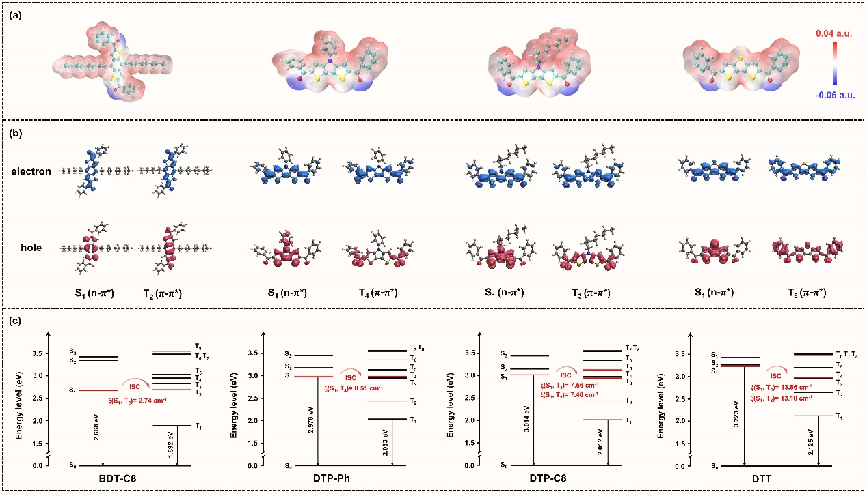
Figure 3. (a) ESP analysis of four compounds in the monomer state. (b) Hole-electron analysis of efficient ISC pathways in four compounds, such as BDT-C8 (S1→T2), DTP-Ph (S1→T4), DTP-C8 (S1→T3), and DTT (S1→T6). (c) Vertical excitation energy level diagrams and dominant SOC matrix elements of four compounds in the monomer state. The structures of monomers for optimization are extracted from the crystal structures.
To obtain a deeper insight into the derivation of guest phosphorescence, the theoretical calculations were carried out at the B3LYP(D3BJ)/def2-TVZP level. Foremost, the atomic charges for all the π-conjugated cores were computed using the restrained electrostatic potential (RESP) methodology. The DTT core possessed the lowest charge density with a value of 1.36, while that of the BDT-C8 core reached 2.17 (Figure S47 and Tables S3-S6). Evidently, corresponding to the phosphorescence spectra, the larger atomic charges of conjugated cores resulted in the redshifted phosphorescent emissions of designed molecules. Based on our n-π-n typed design strategy, RESP charge calculation can be a convenient method to select suitable π bridges among massive conjugated cores to fabricate NIR phosphors. Meanwhile, the electrostatic potential (ESP) was displayed to visualize the charge distributions in different molecules (Figure 3a). The regions of dense electron density were located on the carbonyl groups. For π-conjugated cores, without charge accumulation, they acted as π bridges to efficiently transmit charges among different moieties. Moreover, time-dependent density functional theory (TD-DFT) calculations were carried out to explore the ISC process of compounds (Figures S48-S51 and Tables S7-S10). The energy level diagrams showed the T1 state of DTT exhibited the highest energy level of 2.125 eV, while that of BDT-C8 had the lowest value of 1.892 eV (Figure 3c). For all phosphors, the variations in calculated triplet energies were consistent with those of phosphorescent emission wavelengths. Notably, the calculated T1 state of BP-Br was located between the S1 and T1 states of these guests, allowing direct energy transfer from the host to the guest (Figure S52). Furthermore, the SOC matrix elements were calculated to estimate the effect of different conjugated cores. The computed SOC constants (ξ) of the DTT monomer were substantial at ξ(S1, T4) = 13.86 cm-1 and ξ(S1, T6) = 13.10 cm-1, enabling efficient ISC and strong phosphorescence (Table S11). Hole-electron analysis further validated that efficient ISC occurred through these transition pathways. As shown in Figure 3b, the S1 and T6 states of DTT consisted of electronic states with n-π* and π-π* transition characteristics, respectively. This configuration can facilitate the intrinsic ISC process according to El-Sayed rules. In contrast, the SOC constant of BDT-C8 with a value of ξ(S1, T2) = 2.74 cm-1 was much lower, and its effective transition pathways were less than other phosphors, representing the poor ISC efficiency that supported its faint phosphorescence. Overall, the calculated results were coordinated with the experimental measurements.

Triplet Exciton Transition Mechanisms

Figure 4a showed the colors of four host-guest materials under different excitation conditions. Under 365 nm excitation, BDT-C8/BP-Br, DTP-Ph/BP-Br, and DTP-C8/BP-Br with doping concentrations of 1 wt% exhibited cyan emissions, while the DTT/BP-Br performed violet due to the strong phosphorescence of DTT. Upon 310 nm excitation, the colors of the materials changed significantly. BDT-C8/BP-Br displayed a green-yellow emission. The colors of DTP-Ph/BP-Br and DTP-C8/BP-Br turned into deep yellow. Notably, DTT/BP-Br produced a pale red emission due to the enhancement of phosphorescence. Regardless of the excitation wavelength, all materials exhibited durable deep-red afterglow upon removal of irradiation except for BDT-C8/BP-Br, whose phosphorescence was too faint to be observed by the naked eye.
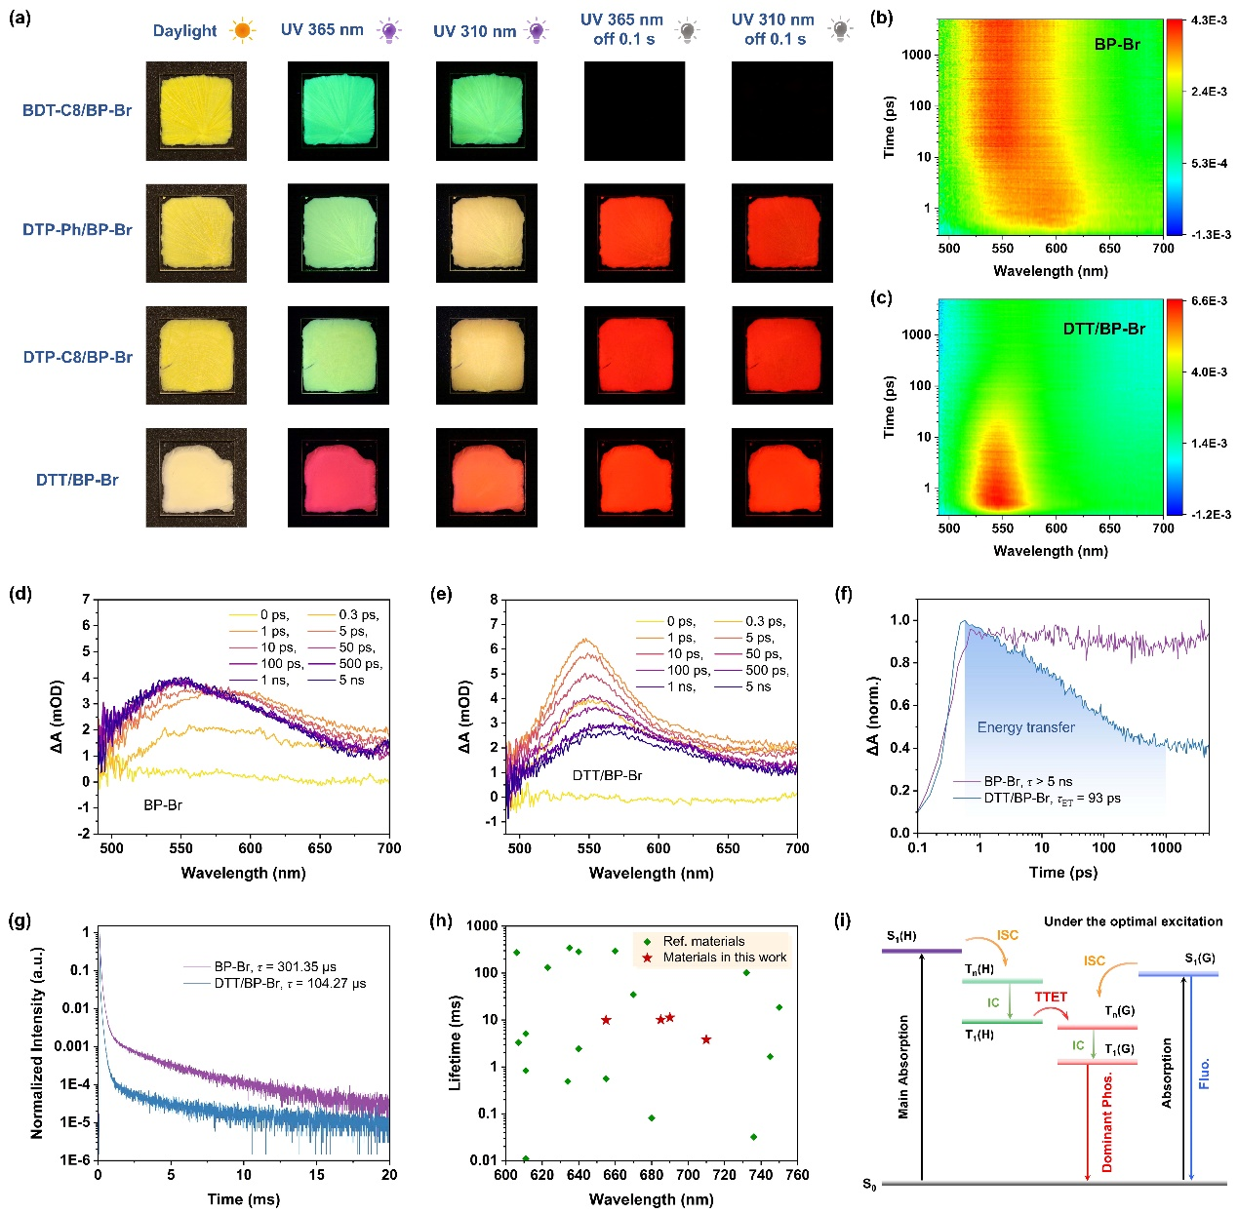
Figure 4. (a) Photographs of four host-guest materials in daylight and under 310 or 365 nm irradiation ON/OFF, respectively. The fs-TA mappings of (b) pure BP-Br and (c) DTT/BP-Br (1 wt%) thin films at room temperature, respectively. The fs-TA spectra of (d) pure BP-Br and (e) DTT/BP-Br films at indicated delays, respectively. (f) TA kinetics probed at 550 nm of pure BP-Br and DTT/BP-Br films. (g) Time-resolved decay curves of pure BP-Br and DTT/BP-Br films at the monitored wavelength of 450 nm, corresponding to the phosphorescent peak of BP-Br. (h) Phosphorescent emission wavelengths and corresponding lifetimes of red/NIR RTP materials reported in the literature and our work. Our results are marked as stars. (i) The proposed mechanism of the exciton transition in host-guest materials under the optimal excitation.

To visualize the exciton transition process in the host-guest materials, the femtosecond transient absorption (fs-TA) experiments were conducted at room temperature. Pure BP-Br exhibited a broad excited-state absorption (ESA) band centered at 550 nm, which was attributed to the absorption from T1 to Tn states. It possessed persistent triplet absorption with an ultralong lifetime that exceeded the maximum time delay of the instrument (5 ns; Figure 4b,d). However, after doping DTT of 1 wt% into the BP-Br film, the intensity of the ESA band at 550 nm exhibited rapid decay as the time delay increased from ~0.3 ps to 5 ns (Figure 4c,e). Under 355 nm excitation, both BP-Br and DTT were excited, resulting in the hybrid absorption of these two species contributing to the initial spectrum. With increasing delayed time, since BP-Br had a higher triplet energy level and doping concentration in the system, the reduction of absorption corresponded to the energy transfer process from the triplet BP-Br to the triplet DTT.[18] By fitting the kinetic curve from 0.3 ps to 1 ns, we found that the effective TTET occurred within 93 ps (Figure 4f). Under 266 nm excitation, the spectra of both films were dominated by the absorption of high-concentration BP-Br. The rapid decay of BP-Br absorption in DTT/BP-Br film further confirmed the TTET from the host to the guest (Figure S54). In addition, the measurements of time-resolved PL spectra validated the TTET efficiency between these two species (Figure 4g). At 450 nm, pure BP-Br exhibited phosphorescent lifetimes of 301.35 μs, which decreased to 104.27 μs after doping with DTT, with the calculated efficiency of TTET approaching 65.4%.[19] The kinetic results for the emission and absorption of the triplet excitons in the materials remained consistent. Overall, these data provided visible evidence for generating substantial triplet excitons in the host, which will effectively transfer to the triplet of the guest through TTET, boosting the guest performance remarkably.
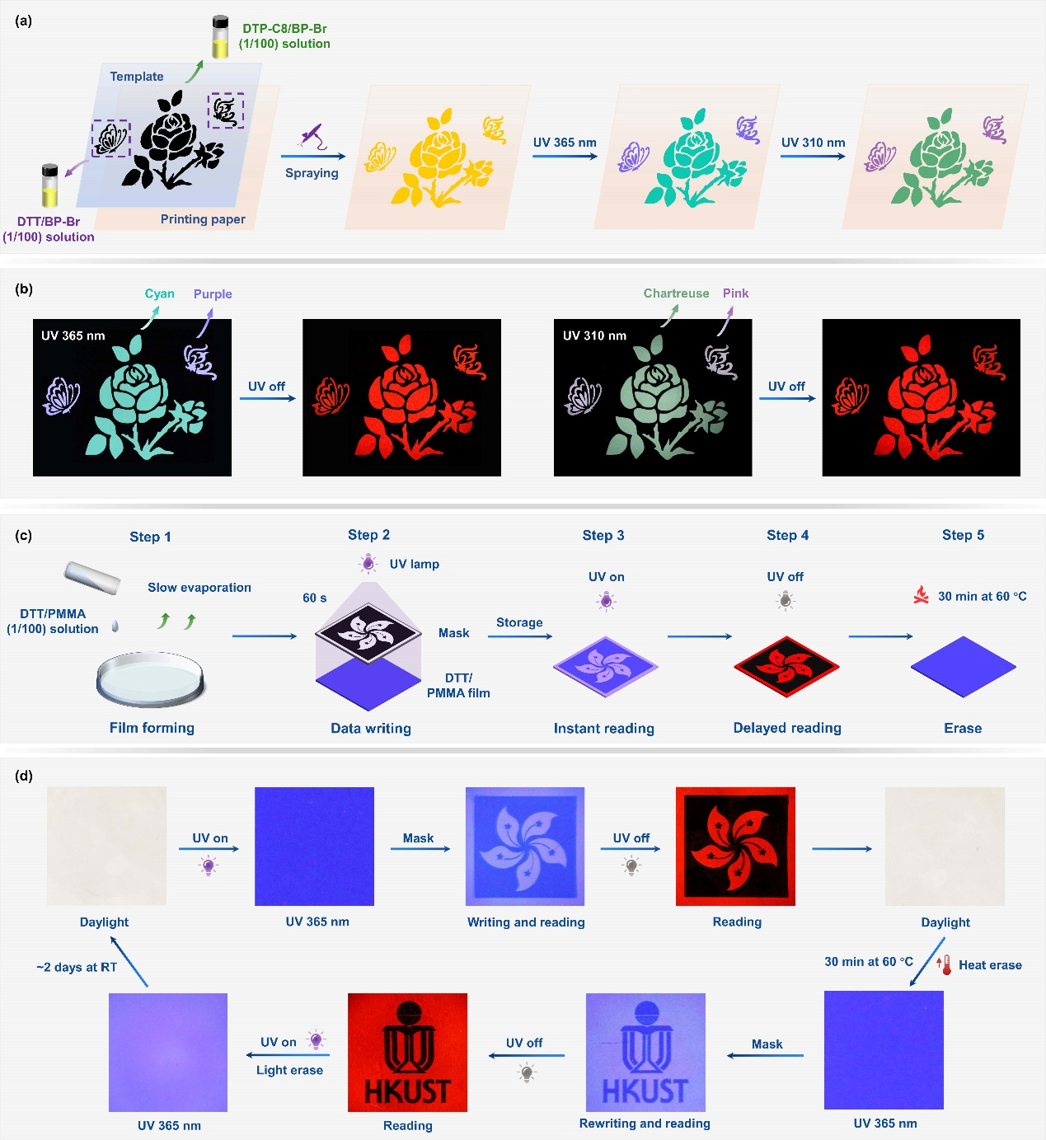
Figure 5. (a) The schematic diagram of security ink application. The graphics of the butterflies and the rose are printed with the toluene solutions of DTT (0.5 mg/mL)/BP-Br (50 mg/mL) and DTP-C8 (0.5 mg/mL)/BP-Br (50 mg/mL), respectively. (b) Fluorescent and phosphorescent photographs of the graphics under 365 and 310 nm excitation ON/OFF, respectively. (c) The schematic diagram of encryption. The DTT/PMMA (1:100) film is fabricated by the slow evaporation of CH2Cl2 solution in the mold. Upon the 365 nm irradiation for 60 s, the patterns can be recorded through the protection of a mask. Under the UV light, the blue fluorescence enables instant reading of the information while red phosphorescence provides delayed reading, allowing for a dual decoding mode. Erasure of the data to recover the initial state can be achieved by heating it to 60 °C for 30 minutes. (d) Photographs of DTT/PMMA film under daylight and UV ON/OFF states in the cycle of writing, reading, recovering, and rewriting.

Based on the above results, the exciton transition mechanisms in host-guest materials can be concluded. Under the optimal excitation, the ground states of the host (S0(H)) and guest (S0(G)) are initially excited (Figure 4i). Subsequently, the excitons at the lowest excited singlet states of host (S1(H)) and guest (S1(G)) undergo the ISC process to their respective excited triplet states Tn(H) and Tn(G). The excitons at these two states then populate the lowest triplet states of host (T1(H)) and guest (T1(G)) through rapid internal conversion (IC), respectively. Notably, due to the ultrahigh concentration of the host in the mixed materials, quantities of triplet excitons are contributed by the host material. Then, these abundant excitons at T1(H) transfer to T1(G), which possesses the lowest energy level to trap excitons in the system through efficient TTET. Combined with the intrinsic triplet excitons of the guest, the phosphorescent performance can be enhanced several times. The emission processes are expressed as follows:
$$\begin{aligned}S_{0}\left(H\right)+S_{0}\left(G\right)\underset{→}{Exc}S_{1}\left(H\right)+S_{1}\left(G\right)\underset{→}{ISC}T_{n}\left(H\right)+T_{n}\left(G\right)\#\left(1\right)\end{aligned}$$
$$\begin{aligned}T_{n}\left(H\right)+T_{n}\left(G\right)\underset{→}{IC}T_{1}\left(H\right)+T_{1}\left(G\right)\#\left(2\right)\end{aligned}$$
$$\begin{aligned}T_{1}\left(H\right)\underset{→}{TTET}T_{n}\left(G\right)\underset{→}{IC}T_{1}\left(G\right)\#\left(3\right)\end{aligned}$$
$$\begin{aligned}Determining step: T_{1}\left(G\right)⟶S_{0}\left(G\right)+hν\#\left(4\right)\end{aligned}$$
In previous research, it is widely believed that the guest primarily absorbs the excitation energy under optimal conditions. Since there is a narrow energy gap between S1(G) and T1(H), the ISC efficiency between these two states could be enhanced significantly to produce abundant triplet excitons, which promote the phosphorescent performance of the guest (Figure S56).[2a, 5, 11, 20] However, our findings demonstrate that T1(H) does not serve as a bridge to improve the intrinsic ISC efficiency of the guest. Instead, upon excitation, the host material independently generates substantial triplet excitons, which then transfer to T1(G) through TTET, significantly boosting the guest phosphorescence. Furthermore, we conclude the exciton transition mechanisms upon various excitations, offering a comprehensive perspective to analyze the dynamics of triplet excitons in host-guest materials (Figure S57). The conclusion sheds light on why guests often perform poorly in polymer matrices. It also reinforces the idea that even when different small-molecule hosts have triplet energy levels suitably aligned to minimize the energy gap with the guest singlet state, the phosphorescent properties of the guest are distinct due to variations in the host ISC and TTET efficiencies.
Considering the diverse photophysical properties of host-guest materials, their applications in anti-counterfeiting and encryption were investigated. Toluene solutions consisting of guests and hosts with a weight ratio of 1:100 were prepared to paint the graphic (Figure 5a). With the help of a hollow template, the rose pattern was created using the DTP-C8/BP-Br solution, while two butterflies were sprayed with the DTT/BP-Br solution. Under 365 nm UV irradiation, the rose appeared cyan, while the butterfly patterns exhibited purple. When the excitation changed to 310 mm, the colors in the rose and butterflies converted to chartreuse and pink, respectively, due to the enhanced phosphorescent emissions. Despite diverse excitation wavelengths, all regions performed bright deep-red afterglow upon removing UV irradiation (Figure 5b). The ability to resolve patterns under different excitation conditions demonstrated their great potential to serve as security ink. Additionally, a rewritable device was developed by fabricating a DTT-doped PMMA film (Figure 5c,d). Upon exposing the thin film to the 365 nm UV light through a mask for 60 s, the protected region retained the deep-blue fluorescence while the residual region exhibited red phosphorescence due to the consumption of triplet oxygen, effectively recording a high-resolution bauhinia pattern. The film appeared transparent under daylight to protect information. It utilized a dual mode of fluorescence and phosphorescence to read data, and the rewritten function can be easily realized through further UV irradiation or heating to recover the initial state. Impressively, the information can be maintained for 2 days (Figure S58). Also, these compounds exhibited stable performance under repeated UV irradiation, indicating their long-term durability (Figure S59). These versatile encryption platforms, based on their brilliant writing, erasing, and rewriting ability, open possibilities for secure data storage applications.

Conclusion
Conclusively, we implemented a novel strategy to develop a series of n-π-n typed NIR phosphors without incorporating heavy atoms. Based on the extended π-conjugated cores with high charge density, the carbonyl groups with nonbonding orbitals were attached to improve the ISC efficiencies and stabilize the triplet states of molecules. Modulating the charge density of conjugated cores enabled fine-tuning NIR phosphorescent properties, demonstrating the universality of this strategy. Notably, doping these molecules into the host matrix BP-Br significantly enhanced their performance, exhibiting the persistent NIR RTP from 655 to 710 nm, with the highest phosphorescence efficiency of 4.2% and the longest lifetime of 11.25 ms. Their emission wavelengths with prolonged lifetimes surpassed the majority of reported organic NIR RTP materials while maintaining promising phosphorescence efficiencies (Figure 4h and Table S12). Most importantly, based on spectroscopic analysis, we visualized the exciton transition process in host-guest materials, indicating that the narrow energy gap between S1(G) and T1(H) cannot facilitate the ISC process between different species to boost guest phosphorescence. In fact, under optimal conditions, the high-concentration host can be excited independently to produce abundant triplet excitons, which then transfer to T1(G) through TTET, significantly enhancing the guest’s performance. Our investigation not only proposes a rational guideline for designing efficient NIR phosphors but also provides deep insights into understanding exciton transition mechanisms in host-guest systems, further guiding the research of triplet excitons’ dynamics and potential applications.

Acknowledgements
This work was supported by the National Natural Science Foundation of China Grant (52250410355, 21788102, and 22205197), the Research Grants Council of Hong Kong (16307020 and C6014-20W), the Innovation and Technology Commission (ITC-CNERC14SC01), the Natural Science Foundation of Guangdong Province (2019B121205002 and 2019B030301003), Shenzhen Key Laboratory of Functional Aggregate Materials (ZDSYS20211021111400001), and the Science Technology Innovation Commission of Shenzhen Municipality (KQTD20210811090142053 and JCYJ20220818103007014).

Keywords: near-infrared phosphors • room temperature phosphorescence • triplet exciton transition • host-guest materials • n-π-n typed molecules

[1] a) L. Gu, H. Shi, L. Bian, M. Gu, K. Ling, X. Wang, H. Ma, S. Cai, W. Ning, L. Fu, H. Wang, S. Wang, Y. Gao, W. Yao, F. Huo, Y. Tao, Z. An, X. Liu, W. Huang, Nat. Photon. 2019, 13, 406; b) Z. An, C. Zheng, Y. Tao, R. Chen, H. Shi, T. Chen, Z. Wang, H. Li, R. Deng, X. Liu, W. Huang, Nat. Mater. 2015, 14, 685; c) H. Li, J. Gu, Z. Wang, J. Wang, F. He, P. Li, Y. Tao, H. Li, G. Xie, W. Huang, C. Zheng, R. Chen, Nat. Commun. 2022, 13, 429; d) W. Zhao, Z. He, B. Z. Tang, Nat. Rev. Mater. 2020, 5, 869; e) Q. Zhou, C. Yang, Y. Zhao, Chem 2023, 9, 2446; f) O. Bolton, K. Lee, H. J. Kim, K. Y. Lin, J. Kim, Nat. Chem. 2011, 3, 205.
[2] a) Y. Zhang, J. Li, J. Zhao, X. Li, Z. Wang, Y. Huang, H. Zhang, Q. Liu, Y. Lei, D. Ding, Angew. Chem. Int. Ed. Engl. 2024, 63, e202313890; b) S. M. A. Fateminia, Z. Mao, S. Xu, Z. Yang, Z. Chi, B. Liu, Angew. Chem. Int. Ed. Engl. 2017, 56, 12160; c) C. Lin, Z. Wu, H. Ma, J. Liu, S. You, A. Lv, W. Ye, J. Xu, H. Shi, B. Zha, W. Huang, Z. An, Y. Zhuang, R.-J. Xie, Nat. Photon. 2024, 18, 350; d) J. Yang, X. Zhen, B. Wang, X. Gao, Z. Ren, J. Wang, Y. Xie, J. Li, Q. Peng, K. Pu, Z. Li, Nat. Commun. 2018, 9, 840.
[3] a) J. S. Wilson, N. Chawdhury, M. R. Al-Mandhary, M. Younus, M. S. Khan, P. R. Raithby, A. Köhler, R. H. Friend, J. Am. Chem. Soc. 2001, 123, 9412; b) F. Liao, J. Du, X. Nie, Z. Wu, H. Su, W. Huang, T. Wang, B. Chen, J. Jiang, X. Zhang, G. Zhang, Dyes Pigm. 2021, 193, 109505.
[4] S. Iwakiri, R. Hasegawa, Y. Kubo, ChemPhotoChem 2022, 6, e202200073.
[5] F. Xiao, H. Gao, Y. Lei, W. Dai, M. Liu, X. Zheng, Z. Cai, X. Huang, H. Wu, D. Ding, Nat. Commun. 2022, 13, 186.
[6] X. F. Wang, H. Xiao, P. Z. Chen, Q. Z. Yang, B. Chen, C. H. Tung, Y. Z. Chen, L. Z. Wu, J. Am. Chem. Soc. 2019, 141, 5045.
[7] a) Y. Fan, S. Liu, M. Wu, L. Xiao, Y. Fan, M. Han, K. Chang, Y. Zhang, X. Zhen, Q. Li, Z. Li, Adv. Mater. 2022, 34, e2201280; b) S. Kuila, A. Ghorai, P. K. Samanta, R. B. K. Siram, S. K. Pati, K. S. Narayan, S. J. George, Chem. Eur. J. 2019, 25, 16007.
[8] a) T. Ono, K. Kimura, M. Ihara, Y. Yamanaka, M. Sasaki, H. Mori, Y. Hisaeda, Chem. Eur. J. 2021, 27, 9535; b) L. Xiao, Y. Wu, Z. Yu, Z. Xu, J. Li, Y. Liu, J. Yao, H. Fu, Chem. Eur. J. 2018, 24, 1801.
[9] a) X. Yan, H. Peng, Y. Xiang, J. Wang, L. Yu, Y. Tao, H. Li, W. Huang, R. Chen, Small 2022, 18, e2104073; b) S. Guo, W. Dai, X. Chen, Y. Lei, J. Shi, B. Tong, Z. Cai, Y. Dong, ACS Mater. Lett. 2021, 3, 379; c) X. Y. Dai, M. Huo, Y. Liu, Nat. Rev. Chem. 2023, 7, 854.
[10] J. Guo, C. Yang, Y. Zhao, Acc. Chem. Res. 2022, 55, 1160.
[11] a) Z. Xie, X. Zhang, H. Wang, C. Huang, H. Sun, M. Dong, L. Ji, Z. An, T. Yu, W. Huang, Nat. Commun. 2021, 12, 3522; b) H. Deng, G. Li, H. Xie, Z. Yang, Z. Mao, J. Zhao, Z. Yang, Y. Zhang, Z. Chi, Angew. Chem. Int. Ed. Engl. 2024, 63, e202317631; c) Y. Lei, W. Dai, J. Guan, S. Guo, F. Ren, Y. Zhou, J. Shi, B. Tong, Z. Cai, J. Zheng, Y. Dong, Angew. Chem. Int. Ed. Engl. 2020, 59, 16054; d) W. Qiao, M. Yao, J. Xu, H. Peng, J. Xia, X. Xie, Z. Li, Angew. Chem. Int. Ed. Engl. 2023, 62, e202315911.
[12] T. J. Penfold, E. Gindensperger, C. Daniel, C. M. Marian, Chem. Rev. 2018, 118, 6975.
[13] X. Liu, W. Dai, J. Qian, Y. Lei, M. Liu, Z. Cai, X. Huang, H. Wu, Y. Dong, J. Mater. Chem. C 2021, 9, 3391.
[14] a) H. Ma, Q. Peng, Z. An, W. Huang, Z. Shuai, J. Am. Chem. Soc. 2019, 141, 1010; b) S. Chanmungkalakul, C. Wang, R. Miao, W. Chi, D. Tan, Q. Qiao, E. C. X. Ang, C. H. Tan, Y. Fang, Z. Xu, X. Liu, Angew. Chem. Int. Ed. Engl. 2022, 61, e202200546.
[15] C. Chen, Z. Chi, K. C. Chong, A. S. Batsanov, Z. Yang, Z. Mao, Z. Yang, B. Liu, Nat. Mater. 2021, 20, 175.
[16] W. Ye, H. Ma, H. Shi, H. Wang, A. Lv, L. Bian, M. Zhang, C. Ma, K. Ling, M. Gu, Y. Mao, X. Yao, C. Gao, K. Shen, W. Jia, J. Zhi, S. Cai, Z. Song, J. Li, Y. Zhang, S. Lu, K. Liu, C. Dong, Q. Wang, Y. Zhou, W. Yao, Y. Zhang, H. Zhang, Z. Zhang, X. Hang, Z. An, X. Liu, W. Huang, Nat. Mater. 2021, 20, 1539.
[17] Z. Deng, J. Zhang, J. Zhou, W. Shen, Y. Zuo, J. Wang, S. Yang, J. Liu, Y. Chen, C. C. Chen, G. Jia, P. Alam, J. W. Y. Lam, B. Z. Tang, Adv. Mater. 2024, 36, e2311384.
[18] M. Li, M.-J. Sun, J. Yang, D. Huo, J. Lv, D. Shi, Y.-W. Zhong, Y. Wan, J. Phys. Chem. C 2022, 126, 11033.
[19] J. Sun, M. Shu, N. Wang, Q. Wang, H. Cao, X. Zhang, B. Wang, J. Zhao, Dyes Pigm. 2022, 202, 110297.
[20] a) J. Yang, X. Wu, J. Shi, B. Tong, Y. Lei, Z. Cai, Y. Dong, Adv. Funct. Mater. 2021, 31; b) M. Zuo, T. Li, H. Feng, K. Wang, Y. Zhao, L. Wang, X. Y. Hu, Small 2024, 20, e2306746; c) X. Han, K. Chen, Y. Lei, J. Huang, S. Wei, Z. Cai, H.-y. Wu, M.-c. Liu, X.-b. Huang, Y. Dong, ACS Mater. Lett. 2022, 4, 1764; d) Y. Lei, J. Yang, W. Dai, Y. Lan, J. Yang, X. Zheng, J. Shi, B. Tong, Z. Cai, Y. Dong, Chem. Sci. 2021, 12, 6518.

Entry for the Table of Contents
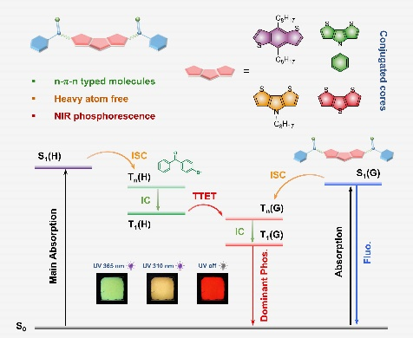
Novel NIR phosphors are constructed using a n-π-n molecular design strategy. Their phosphorescence can be readily modulated by altering the conjugated core structures. When incorporated into a 4-bromobenzophenone host, these materials exhibit efficient NIR phosphorescence ranging from 655-710 nm. Analysis of the exciton transition process reveals that the enhanced phosphorescence of the guest originates from the triplet energy transfer of abundant triplet excitons generated independently by the host material.

