Pure-Red Electroluminescence of Quantum-Confined CsPbI₃ Perovskite Nanocrystals Obtained by the Gradient Purification Method
Haochen Liu^{a,#}, Xiangtian Xiao^{b,#}, Ye Wu^{a,#}, Ding Zhuª, Jiayun Sun^{b}, Desui Chenª, Bing Tangª, Shixun Wangª, Arsenii Portniaginª, Kunnathodi Vighneshª, Wallace C. H. Choy^{b,}*, Andrey L. Rogach^{a,}*
ªDepartment of Materials Science and Engineering, and Centre for Functional Photonics (CFP), City University of Hong Kong, 83 Tat Chee Avenue, Hong Kong S.A.R. 999077, P. R. China
^{b}Department of Electrical and Electronic Engineering, The University of Hong Kong, Pokfulam Road, Hong Kong S.A.R. 999077, P. R. China
* Corresponding author.
Email: chchoy@eee.hku.hk (W.C.); andrey.rogach@cityu.edu.hk (A.R.)

Abstract: Pure-red emission light-emitting diodes (LEDs) are highly desirable for display and lighting applications. Here, we present a synergistic approach to fabricate pure-red emission LEDs based on quantum-confined CsPbI₃ nanocrystals (NCs). By introducing ZnI₂ acting as a co-precursor and passivating agent into the synthesis, and applying a gradient post-synthesis purification method allowing us to obtain size-selected fractions with precisely adjusted emission colors, we obtained uniform and small (about 6 nm), quantum-confined CsPbI₃ NCs exhibiting high stability in ambient conditions and a superior photoluminescence quantum yield of up to 88%. These NCs exhibited the tendency to undergo oriented attachment, resulting in self-assembled superstructures with a pure-red emission at 629 nm. Importantly, partial recrystallization into fused superstructures led to removal of the insulating ligand barriers. LEDs based on the CsPbI₃ NCs showed pure-red electroluminescence picked at 633 nm, with an external quantum efficiency of 14.7% and a luminance of over 1000 cd/m². Our study reveals the mechanism behind the oriented attachment and assembly of small, quantum-confined CsPbI₃ NCs, and contributes to the development of pure-red electroluminescent LEDs.
- Introduction
Cesium lead halide (CsPbX₃, X = I, Br, Cl) perovskite nanocrystals (NCs) are promising materials for light-emitting diodes (LEDs) due to their bright and tunable photoluminescence (PL) and high defect tolerance[1-5]. Pure-red emission in the spectral range of 620-650 nm (the optimal wavelength is 630 nm) is essential for high-definition displays based on the Rec. 2020 standard, and several efforts have been made to achieve it using perovskite NCs. Two main approaches have been reported to produce pure-red emitting perovskite NCs: (i) using mixed Br⁻/I⁻ halide compositions, which unfortunately suffer from the phase segregation under electrical bias; and (ii) reducing the size of CsPbI₃ NCs towards strong quantum confinement regime (about 6 nm or smaller). The latter approach, however, had several drawbacks so far, mostly related to the issues of poor charge transport, as well as inferior stability caused by residual long-chain organic ligands oleate (OA⁻) and oleylammonium (OLA⁺) on surface, which were difficult to be removed thoroughly. To overcome these challenges, various optimization strategies have been developed. Ligand exchange is considered to be one of the most feasible modifications to replace partial long-chain organic ligands with short-chain and more active ligands. These additives can form strong chemical bonds with surface that avoid unexpected growth to maintain pure spectrum. Meanwhile, the conductivity of NCs film can be improved that will be beneficial for carrier injection[6]. For instance, focusing on strongly confined pure red CsPbI₃ NCs, Yao et al.[7] used a sequential ligand post-treatment with 1-hydroxy-3-phenylpropan-2-aminium and tributylsulfonium to produce pure-red emitting CsPbI₃ NCs-based LEDs with 6.4% external quantum efficiency (EQE). Bakr et al.[8] used lecithin as a zwitterionic ligand to fabricate LEDs with 7.1% EQE and 33 min half-lifetime at 200 cd/m². Tian et al.[9] used a dual-ligand synergistic post-treatment with 3-phenyl-1-propylamine and tetrabutylammonium iodide to produce LEDs with 20.8% EQE and 3775 cd/m² luminance. Halpert et al.[10] used cysteine as a ligand, and demonstrated LEDs with 18% EQE. However, all these ligand exchange methods also have irreconcilable drawbacks, that limit their reproducibility. The adding amount of post treated ligands should be precisely evaluated, and purification steps should be repeated for restricted times, otherwise it will destroy structural integrity of the perovskite NCs, lead to phase transition, release unwanted by-products. Therefore, it is necessary to develop an easier and more effective in-situ surface passivation method that avoids the mentioned issues. The in-situ passivation method can also preserve the high photoluminescence quantum yield (PL QY), highly colloidal stability and benign charge transport properties of strongly confined CsPbI₃ NCs.
Here, we report a synthetic approach by introducing ZnI₂ as a co-precursor and passivating agent to synthesize small (about 6 nm) quantum-confined CsPbI₃ NCs, and then applying a gradient purification technique to isolate the size-selected fractions of the NCs with precisely adjusted emission colors, aimed at achieving their pure-red emission. The resulting NCs exhibited high stability in ambient conditions, and a superior PL QY of up to 88%. Interestingly, these CsPbI₃ NCs showed a remarkable phenomenon of oriented attachment, resulting in self-assembled superstructures with a pure-red emission at 629 nm. Importantly, partial recrystallization into fused superstructure led to removal of the insulating ligand barriers, and could eventually facilitate the charge transport of solid-state devices made from NCs[11]. We used the CsPbI₃ NCs to fabricate pure-red LEDs with an electroluminescence (EL) peak at 633 nm, EQE of 14.7%, and luminance of over 1000 cd/m².
- Experimental section
- Materials
Cesium carbonate (Cs₂CO₃, 99.995%, 255645-50G), oleic acid (OA, 90%, 3645252-1L), octadecene (ODE, 90%, O806-1L), lead (II) iodide (PbI₂, 99.999%, 203602-50g) and zinc iodide (＞98%, 223883-50g) were obtained from Sigma-Aldrich. Oleylamine (OLA, C18: 80~90%, O106967-500ml), n-octane (＞99%), n-hexane (AR), methyl acetate (MeOAc, AR, 98%), and ethanol (AR) were purchased from Aladdin. Poly(3,4-ethylene dioxythiophene)poly(styrenesulfonate) (PEDOT:PSS, Clevios PVP AI4083) was purchased from Heraeus. 1,3,4,5,7,8-hexafluorotetracyanonaphthoquinodimethane (F6-TCNNQ, >98%) and molybdenum (VI) oxide (MOo₃, >99.9%) were obtained from J&K Scientific. Poly [N,N'-bis(4-butylphenyl)-N,N'-bis(phenyl)-benzi (Poly-TPD) was purchased from 1-Material Inc., and tris(1-phenyl-1H-benzimidazol-2-yl)benzene (TPBi, 99.5%), and LiF (99.99%) were purchased from Lumtec. All these chemicals were used as received without further purification.
- Synthesis and Fabrication
Synthesis of Cs-oleate solution. A 50 ml three-neck-flask flask was filled with 0.2 g of Cs₂CO₃, 2 ml OA and 20 ml ODE, and stirred under vacuum at 120 ºC to remove moisture and O₂. The flask was degassed for one hour and purged with N₂ three times. The resulting Cs-oleate solution in ODE was kept in N₂ at 100 ºC until it was used as a Cs precursor for the synthesis of CsPbI₃ NCs.
Synthesis of CsPbI₃ NCs. A mixture of 340 mg (0.74 mmol) PbI₂, 360 mg (1.13 mmol) ZnI₂, 3 ml OA and 3 ml OLA in 15 ml ODE was placed into a 100 ml three-neck-flask and heated under vacuum at 120 ºC until a clear solution was obtained. The flask was filled with N₂ and the temperature was quickly raised to 150 ºC. 2 ml Cs-oleate precursor was swiftly injected into the flask, and the solution color turned red immediately. The reaction was quenched after 10 s by cooling the flask in an ice bath.
Gradient purification. To realize the size-selective precipitation of perovskite NCs, we used MeOAc as an anti-solvent added to the crude solution at a volume ratio of 1:2, followed by centrifugation at 7800 rpm for 5 min. The first centrifuged precipitate (1st CP) was discarded, and another 12.5 ml of MeOAc was added to the supernatant. By repeating the centrifugation, the second centrifuged precipitate (2nd CP, ~100 mg) was collected, and again 12.5 ml of MeOAc was added to the supernatant, which was centrifuged again to collect the third and final centrifuged precipitate (3rd CP, ~100 mg). All the precipitates were dissolved in octane for further studies.
Device Fabrication. Indium tin oxide (ITO) coated glass substrates were thoroughly cleaned with detergent, deionized water, acetone, and ethanol in an ultrasonic bath. The cleaned substrates were dried under N₂ flow, and treated with UV-ozone for 15 min. Then, PEDOT:PSS was spin-coated onto the ITO glass at 3500 rpm for 45 s, followed by thermal annealing at 135 °C for 20 min in air. On top of that layer, MoO₃ was deposited using thermal evaporation at a rate of 0.002 nm s⁻¹ under high vacuum (≈1 × 10⁻⁵ Pa). The hole transporting layer of poly-TPD (5 mg/mL in chlorobenzene) was spin-coated onto the MoO₃ layer at 3000 rpm for 45 s in an N₂-filled glove box, followed by thermal annealing at 125 °C for 20 minutes. The layer of F6-TCNNQ (0.75 mg/mL in chlorobenzene) was spin-coated on Poly-TPD film at 4500 rpm for 45 s, followed by thermal annealing at 120 °C for 20 minutes. CsPbI₃ NCs dispersed in octane were sequentially spin-coated twice onto the F6-TCNNQ layer (4000 rpm for 45 s). Subsequently, TPBi (40 nm), LiF (1 nm), and Al (120 nm) layers were deposited by thermal evaporation under a high vacuum (≈1 × 10⁻⁵ Pa).
- Characterization
Transmission electron microscopy (TEM) was performed on JEOL 2100F at 200 kV. X-ray diffraction (XRD) patterns were collected on a D2 PHASER XE-T X-ray Diffractometer System - 2nd gen (Bruker Co.) with a Cu-Kα radiation (λ=1.54060 Å) source. Ultraviolet photoelectron spectroscopy (UPS) and X-ray photoelectron spectroscopy (XPS) were performed on a Thermo Fisher ESCALAB250 spectrometer. Absorption and PL spectra were collected on a Cary 50 UV-Vis spectrometer and a Cary Eclipse fluorescence spectrometer, respectively. PL QY measurements were carried out on an FLS1000 spectrometer (Edinburgh Instruments).
Performance characterization of the fabricated LEDs was conducted in an N₂-filled glove box without any encapsulation and at room temperature. A Keithley 2635 sourcemeter and a fiber optic integration sphere (Ocean Optics FOIS-1) coupled to a spectrometer (Ocean Optics QE 65 000) were used for the current density-voltage-luminance measurements. The measurement system was calibrated by a standard tungsten halogen light source (Ocean Optics HL-3P-INT-CAL). The operational stability of the LEDs was estimated in the dark using the same system.
- Results and Discussion
Figure S1 provides a schematic illustration of ZnI₂-treated CsPbI₃ NCs synthesized via the hot-injection method[12]. The pristine CsPbI₃ NCs prepared in the absence of ZnI₂, which are also schematically sketched in Figure S1, have a larger size (~12 nm) with a deep red emission of 671 nm (Figure S2), and contain abundant surface defects. By adding ZnI₂ as an extra I⁻ source, the as-prepared NCs are size-confined (~6 nm) with fewer surface defects[13-15]. It is perceived that the lower electronegativity and smaller ionic radius of Zn²⁺ make it more likely to fall off from the perovskite lattice, so that Pb²⁺ cations can substitute Zn²⁺ and attach to I⁻ anions[16]. This fall-off and attachment process inhibits the further growth of the CsPbI₃ NCs and results in their size confinement, which is depicted in Figure 1c. XPS data confirms this assumption, as no Zn signals were detected for all three fractions of the ZnI₂-treated CsPbI₃ NCs prepared by the gradient purification method (Figure S3).
After the synthesis of any colloidal NCs, a purification procedure is needed to separate the desired product from the by-products and impurities that are present in the reaction mixture. As illustrated in Figure 1a, a conventional purification procedure for perovskite NCs involves addition of MeOAc as an antisolvent to the crude solution, which causes all NCs to precipitate in one step[17]. The centrifuged precipitate (CP) is then collected, and the supernatant that contains by-products and impurities is discarded. The emissive cubic α-phase of CsPbI₃ NCs that is thermodynamically unstable at room temperature makes the purification of these NCs quite challenging, as they undergo phase transformation into a non-perovskite δ-CsPbI₃ phase under ambient conditions[18,19]. The antisolvent MeOAc also plays the role of a “bad solvent” in this procedure, and may cause optical and structural degradation of CsPbI₃ NCs by the extraction of surface ligands, eventually leading to their dissolution. Herein, small-sized CsPbI₃ NCs with bright pure-red emission and narrow size distribution were obtained by a gradient purification at room temperature, as shown in Figure 1b. This procedure, which has been widely used for size-selective fractionation of II-VI semiconductor NCs such as CdS and CdSe quantum dots in the past[20,21], has been more recently employed by Jang et al.[22] as a pre-centrifugation step to eliminate undesirable residues formed in the synthesis of α-CsPbI₃ perovskite NCs, and by Chen et al.[23] who used a low temperature (−15 °C) gradient centrifugation method to achieve small-sized CsPbI₃ NCs. The centrifugal force causes the larger and heavier NCs to settle at the bottom of the centrifuge tube, while the smaller and lighter ones remain as the supernatant. As illustrated in Figure 1b, we discarded the 1st CP and added MeOAc again to the supernatant until it turned turbid; after centrifugation, the 2nd CP was collected. We repeated the process once more to obtain even smaller NCs, resulting in the 3rd CP. Photographs of these three solutions presented in Figure S4 show that the color of the supernatant after the 3rd centrifugation is already pale red, indicating that most of the NCs were extracted at this stage. We noticed that we could also vary the antisolvent amount and perform more purification steps to achieve more accurate control over the final NCs’ size and distribution using this gradient purification procedure. The size/shape distribution and oriented attachment between NCs during the gradient purification are graphically represented in Figure 1d, which will be discussed in detail below, based on the sample’s characterization data.
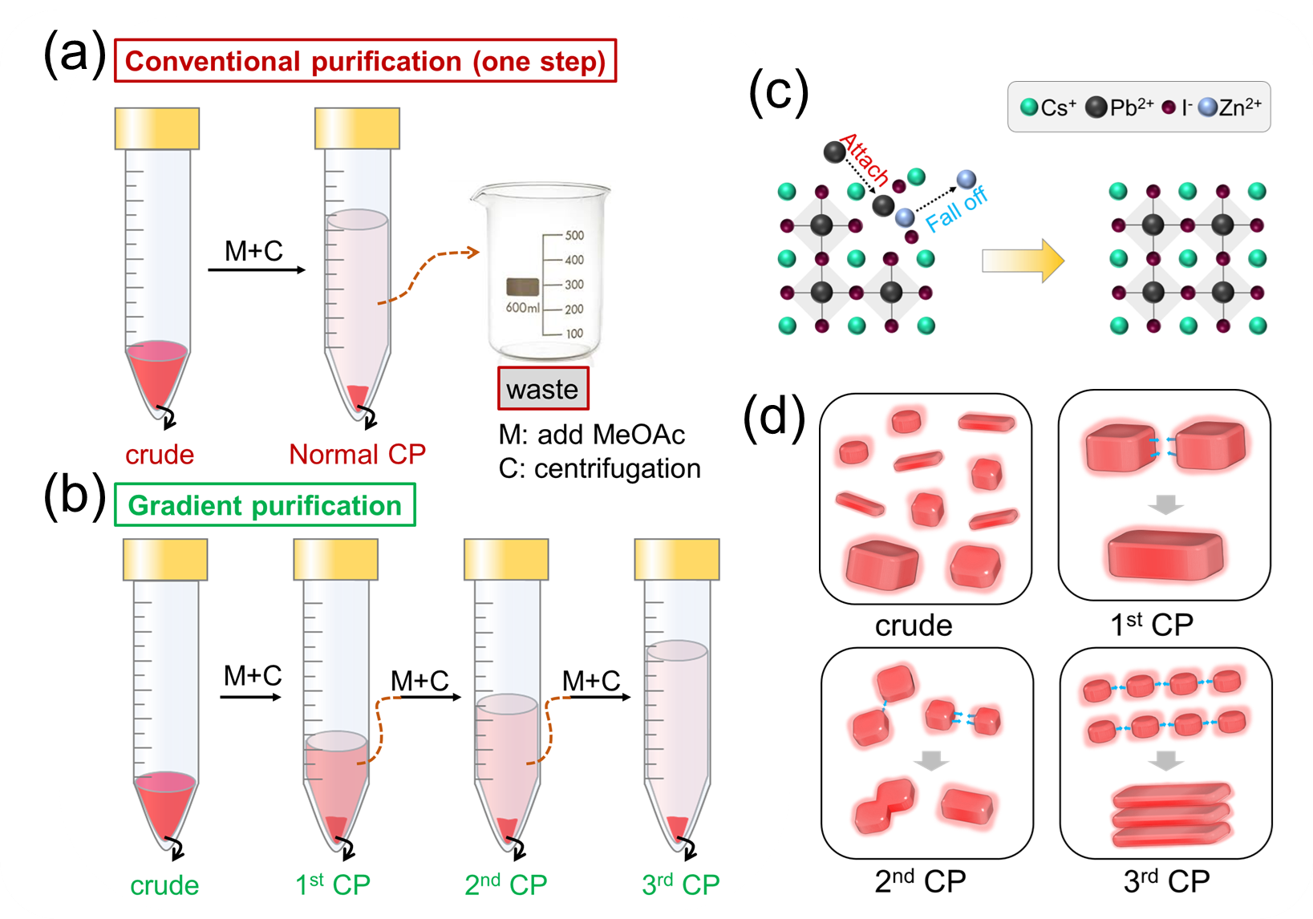
Figure 1. Schematic illustration of (a) conventional purification and (b) gradient purification of perovskite NCs. (c) Zn²⁺ cations fall off from the perovskite lattice, and Pb²⁺ cations replace them by attaching to I⁻ anions during the CsPbI₃ NCs formation. (d) Illustration of size/shape distribution of the CsPbI₃ NCs during the 1st, 2nd and 3rd CP steps, and of oriented attachment between NCs.
To study the optical and structural properties of the crude sample and CsPbI₃ NCs prepared by the gradient purification method, they were subjected to UV-vis absorption, PL and XRD measurements as shown in Figure 2. The crude sample exhibited a sharp excitonic absorption peak at 500 nm (Figure 2a), indicating the formation of 2D L₂[CsPbI₃]_{n-1}PbI₄ perovskite nanoplatelets[24,25] (in this formulae, L=OA, OLA; n is the number of octahedral monolayers). The crude sample showed three PL peaks, including two narrow peaks with maxima at 512 nm and 560 nm, and a broader PL peak centered at 612 nm, which points out the presence of n=1, 2 nanoplatelets[26] and some small, presumably dot-shaped NCs[12]. Indeed, the overall PL spectral profile of the crude sample could be fitted by using four Gaussian peaks (shaded areas in Figure 2a) that correspond to the emission peaks of 2D nanoplatelets (512 nm and 559 nm), as well as 2nd CP (624 nm) and 3rd CP (604 nm) samples, respectively. The XRD pattern (Figure 2b) of the crude sample revealed two broad peaks corresponding to the nanoplatelets and residual reactants[27], indicating that those are the main products here.
As some 2D nanoplatelets in the supernatant were also collected in the 1st CP sample after the pre-centrifugation step, the resulting absorption and PL spectra of 1st CP (Figure 2a) showed both absorption and emission peaks from 2D nanoplatelets (512 nm and 559 nm) and larger NCs (654 nm). XRD pattern of the 1st CP sample (Figure 2b) also revealed diffraction peaks both from 2D nanoplatelets and bulk perovskite unit cell, and the XRD peaks appeared at 14.1° and 28.5° could be indexed to (100) and (200) planes of CsPbI₃ cubic phase. After further purification steps, the absorption, PL, and diffraction signals from 2D nanoplatelets vanished, and the 2nd CP and 3rd CP both demonstrated a broader first excitonic absorption peak and emission peak corresponding to smaller NCs. Additionally, the XRD pattern of 2nd CP and 3rd CP NCs revealed periodic peaks (periodicity=1.73°=5.08 nm) at small 2-theta angles up to ∼20°, with a peak split at 28.5°, indicating the formation of self-assembled superstructures[24,28,29]. A notable feature of the 2nd and 3rd CP NCs obtained by the gradient precipitation is that they have single, symmetric, and narrow PL peaks with full width at half maxima (FWHM) of 48 and 44 nm, respectively (Figure 2a), whereas the 1st CP fraction still exhibited multiple and broad PL peaks. Such single, narrow PL peaks are advantageous for LED applications, as they offer a narrow emission bandwidth and a high color purity. Furthermore, the NCs exhibited high stability in solution under ambient conditions, as no yellow precipitate of the non-perovskite δ-CsPbI₃ phase[18,19] has been observed after several weeks of storage.
To further quantify the parameters of the obtained self-assembled superstructures, the diffraction peak of the 3rd CP sample was extracted and fitted with Python program. After performing several steps to prepare the data for fitting, such as removing the baseline, correcting the intensity, and converting the horizontal axis to q-scale (Å ⁻¹), the fitting results are shown in Figure S5. The atomic periodicity (d) is 0.62 nm, which corresponds to the α-phase CsPbI₃ (110) plane[30]. The inter-particle distance (L) is considered as the efficient ligand length, which was estimated here as 37.6 ± 1.0 Å, consistent with previous studies which used OLA and OA as ligands[29,31]. The number of layers of metal halide octahedra (N) was estimated to be 2.88 ± 0.84, indicating the strong quantum-confinement effect in the obtained NCs. The periodicity (Λ) of superstructures (see discussion below) is around 50 Å, calculated from the equation of Λ = d (N − 1) + L.
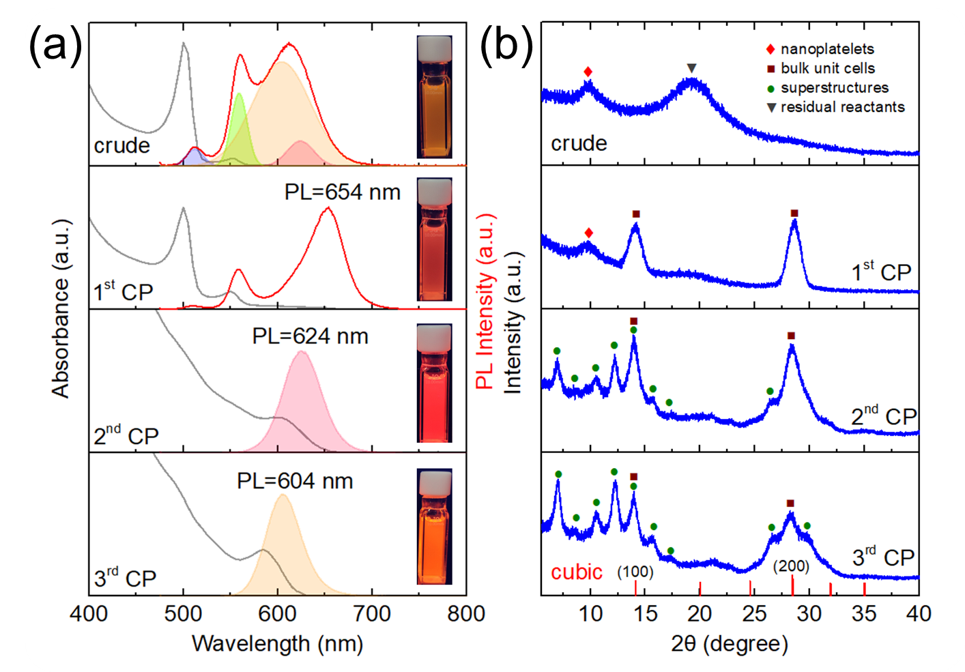
Figure 2. (a) UV-vis absorption and PL spectra of the crude sample and CsPbI₃ NCs obtained as 1st, 2nd and 3rd CP during the gradient precipitation. The 2nd CP and 3rd CP samples both show single, symmetric and narrow PL peaks, whereas the crude and 1st CP exhibit multiple and broad emissions. Inset: photographs of corresponding NC solutions taken under UV light. (b) XRD patterns of the crude and 1st, 2nd and 3rd CP samples. The symbols of diamonds (◆), square (■), green circles (•), and inverted triangle (▼) mark the signals corresponding to the nanoplatelets, bulk perovskite unit cells, self-assembled superstructures, and residual reactants, respectively.
Figure S6a shows the TEM image of the NCs from the 1st CP sample, which have a wide size distribution and some irregular shapes. The average size of these NCs is 9.1±3.8 nm, as calculated from the TEM images and shown in the histogram in Figure S6b. In contrast, the NCs from the 2nd CP and 3rd CP have narrower size distributions and regular shapes, as seen from their TEM images (Figure 3). The average size of the NCs of the 2nd CP and 3rd CP is 6.1±0.8 nm and 3.3±0.4 nm, respectively, as shown in Figure S6c and Figure S6d. Moreover, it was found that both cube-shaped and dot-shaped NCs are partially fused together to form some short rod-like structures in the 2nd CP sample (Figure 3a-b). We observed that the cube-shaped NCs were attached at the edges, while the dot-shaped ones had a larger surface area for contact between them. In contrast, there are large-scale periodic self-assembled superstructures formed by partially fused, small, dot-shaped NCs in the TEM image of the 3rd CP sample, as shown in Figure 3c-d. The measured periodicity value here is 5.03 nm (Figure S7), which is perfectly consistent with the Λ value calculated from XRD pattern as discussed above.
The process when individual particles fuse to form larger structures by the same crystallographic orientation fuse has been denoted as “oriented attachment” and “regrowth” in previous literature[32,33]. Our observations suggest that the shape and size of perovskite NCs would affect their oriented attachment and the morphology of the resulting superstructures[34]. The self-assembled superstructures observed in our study are formed during the solvent evaporation[35] when we made the samples by drop casting on the TEM grid. The NCs undergo a process of entropy-driven ordering as the solvent evaporated, leading to a close-packed arrangement. The fused NCs aligned parallel to each other due to the capillary forces, and eventually stacked side-to-side to form the superlattices. The self-assembly process is also influenced by the interactions of organic ligands[36], and it was reported that metal halide perovskite NCs can undergo oriented attachment due to their soft ionic nature and low formation energy[32]. As the surface ligands on perovskite NCs are loosely attached and highly dynamic[37-39], their assembly process is accompanied by the fusion of the NCs[33]. It was reported that OLA⁺ ions can replace the surface Cs⁺ sites of the perovskite crystal lattice[40,41], while OA⁻ ions stabilize the NCs in the colloidal state by counter-balancing the OLA⁺ ions on the surface[42]. Figure S8 schematically demonstrates how CsPbI₃ NCs in the superstructures are stabilized by the presence of OLA⁺ ions acting as spacers.
Different kinds of superstructures formed from the perovskite NCs through oriented attachment during gradient purification are graphically represented in Figure 1d. In the crude solutions of the as-synthesized nanoparticles, the size distribution is inhomogeneous and rather broad, including NCs with both dot-shaped and platelet-shaped morphologies[15,23,43]. After adding antisolvent to the crude solution, the larger NCs aggregate and precipitate during the 1st centrifugation, and the resulting 1st CP NCs are still inhomogeneous. The medium-sized NCs (both cube-shaped and dot-shaped) precipitate after the 2nd centrifugation, and they possess a narrower size distribution, which makes them more likely to undergo oriented attachment growth into rod-like structures. Finally, the small dot-shaped NCs collected from the precipitate after the 3rd CP are the most uniform, making them form large-scale periodic self-assembled superstructures.
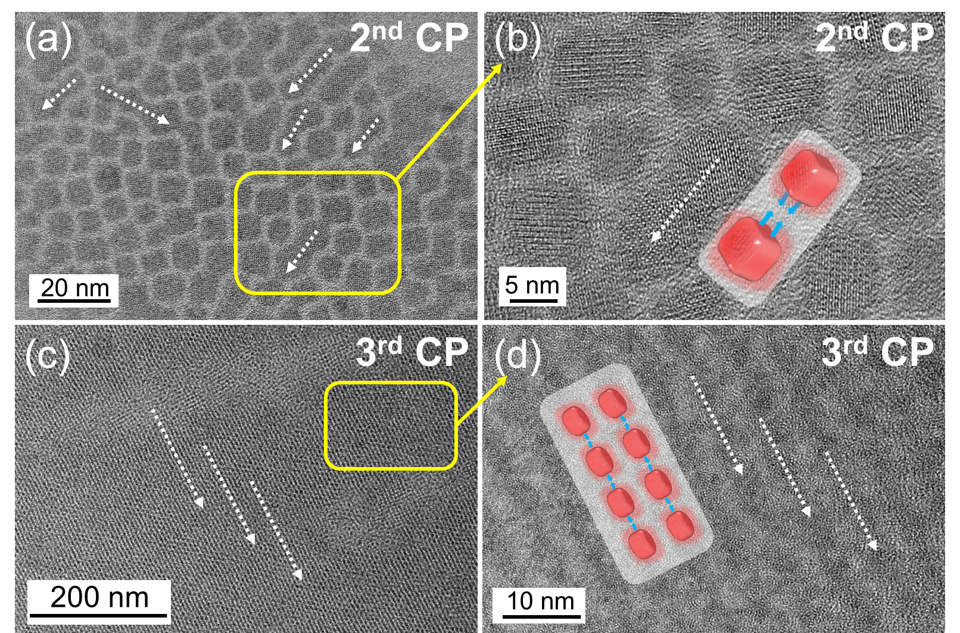
Figure 3. TEM images of CsPbI₃ NCs from (a-b) 2nd CP and (c-d) 3rd CP obtained by the gradient purification method. The 2nd CP sample shows some short rod-like structures formed by oriented attachment growth, while the 3rd CP sample demonstrates large-scale periodic self-assembled superstructures. The yellow boxes in (a) and (b) indicate the regions that are magnified in (b) and (d), respectively. The schematic pictures depict the oriented attachment growth of NCs, and the white dashed arrows indicate the fusion direction.
Previous studies have suggested that smaller NCs tend to have stronger ligand binding than bigger ones because they have a larger surface-to-volume ratio and higher surface energy[44,45]. This also means that smaller NCs experience a stronger thermodynamic driving force to reduce their surface energy by forming stable ligand shells. Figure S9 shows the XPS spectra of the 1st, 2nd and 3rd CP samples. The binding energies of Cs 3d, Pb 4f, I 3d and N 1s are shifted to higher levels for the samples in this row, which indicates that the smaller size indeed results in stronger binding between the ligands and the perovskite lattice. The N 1s signal is weak, but we still can observe that the 1st CP sample demonstrated an amide peak at 399.7 eV produced by the condensation reaction between OLA and OA, and it shifted to a higher binding energy (402.2 eV) because of amine protonation occurring in 2nd CP and 3rd CP sample.
CsPbI₃ NCs obtained as the 2nd CP and the 3rd CP could both be used for LED fabrication, as they have single, symmetric, and narrow PL peaks. We made LED devices based on CsPbI₃ NCs obtained as the 2nd CP (Figure 4c), which emit pure-red light in solution at 629 nm, very close to the best pure-red wavelength of 630 nm. Figure 4a shows the photographs of this NC solution (PL QY=88%) taken under daylight and UV light. Figure 4b illustrates the energy level diagram of the materials used for each layer of the LEDs (see Experimental section). We selected PEDOT:PSS with a work function of 5.1 eV as the hole injection layer, and Poly-TPD with a valence band at 5.4 eV as the hole transport layer owing to their optimal energy level alignment for hole injection and transport, resepctively. TPBi was employed as the electron transport layer, with an electron injection barrier from Al/LiF as low as 0.2 eV. The LEDs exhibited EL peak at 633 nm (Figure 4c), which is slightly red-shifted (4 nm) as compared to PL spectra; this can be attributed to the fluorescence resonance energy transfer process that occurs within the close-packed films of NCs with somewhat broadened size-distribution[9]. The fabricated LED demonstrated a maximum luminance of over 1000 cd/m² with a relatively low turn-on voltage of 2.7 V (Figure 4d), and achieved a peak EQE of 14.7% (Figure 4e). Such relatively low turn-on voltage and high EQE could be realized due to the following aspects: (i) evaporating a thin interface layer of MoO₃ on top the PEDOT:PSS film in order to reduce the hole injection barrier from 0.3 eV to nearly 0 eV (Figure S10); and (ii) inserting an thin F6-TCNNQ interface layer between Poly-TPD and CsPbI₃ NCs in order to reduce the hole injection barrier between Poly-TPD and CsPbI₃ NCs (Figure S11). This increased the hole injection rate and reduced the accumulation of charge carriers at the interface potential barrier, resulting in superior device performance. We have also separately investigated how MoO₃ and F6-TCNNQ affect the device performance (Figure S12). Figure S12a shows that the device with both MoO₃ and F6-TCNNQ had the smallest leakage current at low voltage and the largest current density at high voltage, suggesting the synergistic effect of MoO₃ and F6-TCNNQ. Figure S12b shows that the device with both MoO₃ and F6-TCNNQ had the smallest turn-on voltage, implying the lowest injection barrier. The device with only MoO₃ had a lower turn-on voltage, but still higher than the device with both MoO₃ and F6-TCNNQ. Figure S12c shows that the device with both MoO₃ and F6-TCNNQ had the largest EQE, implying the highest charge recombination efficiency. The device with only MoO₃ had a higher EQE, but still lower than the device with both MoO₃ and F6-TCNNQ. The EL peak position remained stable when the applied voltage increased from 4 V to 6.5 V, indicating that the color of the LED does not vary upon change of applied voltage (Figure 4f). The LED operating half-lifetime (T₅₀) is 27 minutes at an initial luminance of 91 cd/m² (Figure S13). Overall, the performance of our devices was comparable or even better to other recently reported red-emissive LEDs in terms of EL peak position (pure-red light requirement), EQE, and maximum luminance (Table S1 and the related discussion in SI).
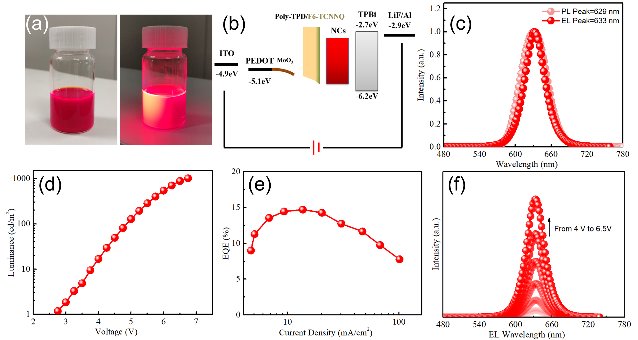
Figure 4. (a) Photograph of the pure-red emissive CsPbI₃ NCs in solution (PL maximum 629 nm, PL QY=88%) taken under daylight and UV light. (b) Energy level diagram of the materials used for each layer of the LEDs. (c) Comparison of PL and EL spectra of fabricated CsPbI₃ NCs-based LED. The PL peak of NCs is at 629 nm, excited at 450 nm. The EL peak is slightly red-shifted to 633 nm. (d) Luminance-voltage characteristics of fabricated LED. The maximum luminance is over 1000 cd/m² with a relatively low turn-on voltage of 2.7 V. (e) EQE-current density characteristics of fabricated LED. The peak EQE is 14.7%. (f) EL spectra of the LEDs acquired under voltage ranging from 4-6.5 V.
Conclusions
In this work, we presented a synthetic approach for the pure-red emissive CsPbI₃ NCs, and used them to fabricate pure-red LEDs. By introducing ZnI₂ as a co-precursor in the synthesis, and using a gradient purification method, we obtained CsPbI₃ NCs with pure-red emission at 629 nm and a high PL QY of 88%. The LEDs based on these NCs demonstrated a pure-red EL peak at 633 nm, with a peak EQE of 14.7% and a maximum luminance of 1011 cd/m². We also revealed the formation mechanism of the self-assembled NC superstructure occurring through the oriented attachment. Our work provides a new strategy to fabricate pure-red emission LEDs, which is promising for advancing the field of perovskite nanomaterials and their lighting applications.

Credit author statement
Haochen Liu: Conceptualization, Investigation, Writing-Original Draft. Xiangtian Xiao, Ye Wu: Investigation, Writing-Original Draft. Ding Zhu, Desui Chen, Arsenii Portniagin, Kunnathodi Vighnesh: Investigation. Bing Tang, Shixun Wang: Formal analysis, Validation, Investigation. Wallace C. H. Choy, Andrey L. Rogach: Supervision, Project administration, Funding acquisition. Andrey L. Rogach: Writing-Review & Editing.
Declaration of competing interest
The authors declare that they have no known competing financial interests or personal relationships that could have appeared to influence the work reported in this paper.
Data availability
Data will be made available on request.
Acknowledgments
We acknowledge financial support from the Research Grant Council of Hong Kong (C7035-20G) and the project MHP/068/21 from the Innovation and Technology Fund of Hong Kong.
References
[1] F. Fang, W. Chen, Y. Li, H. Liu, M. Mei, R. Zhang, J. Hao, M. Mikita, W. Cao, R. Pan, K. Wang, X. W. Sun, Employing Polar Solvent Controlled Ionization in Precursors for Synthesis of High-Quality Inorganic Perovskite Nanocrystals at Room Temperature, Advanced Functional Materials 28 (2018) 1706000, https://doi.org/https://doi.org/10.1002/adfm.201706000.
[2] Q. A. Akkerman, G. Rainò, M. V. Kovalenko, L. Manna, Genesis, challenges and opportunities for colloidal lead halide perovskite nanocrystals, Nature Materials 17 (2018) 394-405, https://doi.org/10.1038/s41563-018-0018-4.
[3] Y. Wu, X. Li, H. Zeng, Highly Luminescent and Stable Halide Perovskite Nanocrystals, ACS Energy Letters 4 (2019) 673-681, https://doi.org/10.1021/acsenergylett.8b02100.
[4] H. Huang, M. I. Bodnarchuk, S. V. Kershaw, M. V. Kovalenko, A. L. Rogach, Lead Halide Perovskite Nanocrystals in the Research Spotlight: Stability and Defect Tolerance, ACS Energy Letters 2 (2017) 2071-2083, https://doi.org/10.1021/acsenergylett.7b00547.
[5] J. Shamsi, A. S. Urban, M. Imran, L. De Trizio, L. Manna, Metal Halide Perovskite Nanocrystals: Synthesis, Post-Synthesis Modifications, and Their Optical Properties, Chemical Reviews 119 (2019) 3296-3348, https://doi.org/10.1021/acs.chemrev.8b00644.
[6] Y.-K. Wang, F. Yuan, Y. Dong, J.-Y. Li, A. Johnston, B. Chen, M. I. Saidaminov, C. Zhou, X. Zheng, Y. Hou, K. Bertens, H. Ebe, D. Ma, Z. Deng, S. Yuan, R. Chen, L. K. Sagar, J. Liu, J. Fan, P. Li, X. Li, Y. Gao, M.-K. Fung, Z.-H. Lu, O. M. Bakr, L.-S. Liao, E. H. Sargent, All-Inorganic Quantum-Dot LEDs Based on a Phase-Stabilized α-CsPbI₃ Perovskite, Angewandte Chemie International Edition 60 (2021) 16164-16170, https://doi.org/https://doi.org/10.1002/anie.202104812.
[7] Y.-F. Lan, J.-S. Yao, J.-N. Yang, Y.-H. Song, X.-C. Ru, Q. Zhang, L.-Z. Feng, T. Chen, K.-H. Song, H.-B. Yao, Spectrally Stable and Efficient Pure Red CsPbI₃ Quantum Dot Light-Emitting Diodes Enabled by Sequential Ligand Post-Treatment Strategy, Nano Letters 21 (2021) 8756-8763, https://doi.org/10.1021/acs.nanolett.1c03011.
[8] W. J. Mir, A. Alamoudi, J. Yin, K. E. Yorov, P. Maity, R. Naphade, B. Shao, J. Wang, M. N. Lintangpradipto, S. Nematulloev, A.-H. Emwas, A. Genovese, O. F. Mohammed, O. M. Bakr, Lecithin Capping Ligands Enable Ultrastable Perovskite-Phase CsPbI₃ Quantum Dots for Rec. 2020 Bright-Red Light-Emitting Diodes, J. Am. Chem. Soc. 144 (2022) 13302-13310, https://doi.org/10.1021/jacs.2c04637.
[9] M. Xie, J. Guo, X. Zhang, C. Bi, L. Zhang, Z. Chu, W. Zheng, J. You, J. Tian, High-Efficiency Pure-Red Perovskite Quantum-Dot Light-Emitting Diodes, Nano Letters 22 (2022) 8266-8273, https://doi.org/10.1021/acs.nanolett.2c03062.
[10] D. Chen, P. K. Ko, C. H. A. Li, B. Zou, P. Geng, L. Guo, J. E. Halpert, Amino Acid-Passivated Pure Red CsPbI₃ Quantum Dot LEDs, ACS Energy Letters 8 (2023) 410-416, https://doi.org/10.1021/acsenergylett.2c02243.
[11] Y. Yang, J. T. Lee, T. Liyanage, R. Sardar, Flexible Polymer-Assisted Mesoscale Self-Assembly of Colloidal CsPbBr₃ Perovskite Nanocrystals into Higher Order Superstructures with Strong Inter-Nanocrystal Electronic Coupling, J. Am. Chem. Soc. 141 (2019) 1526-1536, https://doi.org/10.1021/jacs.8b10083.
[12] L. Protesescu, S. Yakunin, M. I. Bodnarchuk, F. Krieg, R. Caputo, C. H. Hendon, R. X. Yang, A. Walsh, M. V. Kovalenko, Nanocrystals of Cesium Lead Halide Perovskites (CsPbX₃, X = Cl, Br, and I): Novel Optoelectronic Materials Showing Bright Emission with Wide Color Gamut, Nano Letters 15 (2015) 3692-3696, https://doi.org/10.1021/nl5048779.
[13] P. Liu, W. Chen, W. Wang, B. Xu, D. Wu, J. Hao, W. Cao, F. Fang, Y. Li, Y. Zeng, R. Pan, S. Chen, W. Cao, X. W. Sun, K. Wang, Halide-Rich Synthesized Cesium Lead Bromide Perovskite Nanocrystals for Light-Emitting Diodes with Improved Performance, Chemistry of Materials 29 (2017) 5168-5173, https://doi.org/10.1021/acs.chemmater.7b00692.
[14] J. Y. Woo, Y. Kim, J. Bae, T. G. Kim, J. W. Kim, D. C. Lee, S. Jeong, Highly Stable Cesium Lead Halide Perovskite Nanocrystals through in Situ Lead Halide Inorganic Passivation, Chemistry of Materials 29 (2017) 7088-7092, https://doi.org/10.1021/acs.chemmater.7b02669.
[15] Y. Dong, T. Qiao, D. Kim, D. Parobek, D. Rossi, D. H. Son, Precise Control of Quantum Confinement in Cesium Lead Halide Perovskite Quantum Dots via Thermodynamic Equilibrium, Nano Letters 18 (2018) 3716-3722, https://doi.org/10.1021/acs.nanolett.8b00861.
[16] J. Hu, C. Bi, X. Zhang, Y. Lu, W. Zhou, Z. Zheng, Y. Tang, F. Lu, Z. Yao, B. Tian, X. Wang, K. Selvakumar, J. Tian, M. Sui, Yellow-light emitted single halide CsPbI₃ nanowire, Applied Materials Today 29 (2022) 101592, https://doi.org/https://doi.org/10.1016/j.apmt.2022.101592.
[17] Y. Zhang, T. D. Siegler, C. J. Thomas, M. K. Abney, T. Shah, A. De Gorostiza, R. M. Greene, B. A. Korgel, A “Tips and Tricks” Practical Guide to the Synthesis of Metal Halide Perovskite Nanocrystals, Chemistry of Materials 32 (2020) 5410-5423, https://doi.org/10.1021/acs.chemmater.0c01735.
[18] M. Qin, P. F. Chan, X. Lu, A Systematic Review of Metal Halide Perovskite Crystallization and Film Formation Mechanism Unveiled by In Situ GIWAXS, Advanced Materials 33 (2021) 2105290, https://doi.org/https://doi.org/10.1002/adma.202105290.
[19] Q. Zhao, A. Hazarika, L. T. Schelhas, J. Liu, E. A. Gaulding, G. Li, M. Zhang, M. F. Toney, P. C. Sercel, J. M. Luther, Size-Dependent Lattice Structure and Confinement Properties in CsPbI₃ Perovskite Nanocrystals: Negative Surface Energy for Stabilization, ACS Energy Letters 5 (2020) 238-247, https://doi.org/10.1021/acsenergylett.9b02395.
[20] A. Chemseddine, H. Weller, Highly Monodisperse Quantum Sized CdS Particles by Size Selective Precipitation, Berichte der Bunsengesellschaft für physikalische Chemie 97 (1993) 636-638, https://doi.org/https://doi.org/10.1002/bbpc.19930970417.
[21] A. L. Rogach, A. Kornowski, M. Gao, A. Eychmüller, H. Weller, Synthesis and Characterization of a Size Series of Extremely Small Thiol-Stabilized CdSe Nanocrystals, The Journal of Physical Chemistry B 103 (1999) 3065-3069, https://doi.org/10.1021/jp984833b.
[22] H. S. Yang, E. H. Suh, S. H. Noh, J. Jung, J. G. Oh, K. H. Lee, D. Lee, J. Jang, Facile low-energy and high-yield synthesis of stable α-CsPbI₃ perovskite quantum dots: Decomposition mechanisms and solar cell applications, Chemical Engineering Journal 454 (2023) 140331, https://doi.org/https://doi.org/10.1016/j.cej.2022.140331.
[23] W. Shen, Z. Su, S. Chen, Y. Dai, Y. Qiu, Y. Chen, J. Jiang, J. Zhang, Y. Wang, H. Cui, Y. He, K. Cao, B. Cai, L. Liu, S. Chen, Spectrally Stable Pure Red CsPbI₃ Quantum Dots Light-Emitting Diodes via Effective Low Temperature Gradient Centrifugation Separation and Surface Modification, Advanced Optical Materials (2023) 2300306, https://doi.org/https://doi.org/10.1002/adom.202300306.
[24] C. M. Guvenc, S. Balci, Seed-Mediated Synthesis of Colloidal 2D Halide Perovskite Nanoplatelets, ChemNanoMat 7 (2021) 1249-1257, https://doi.org/https://doi.org/10.1002/cnma.202100315.
[25] Y. Wu, C. Wei, X. Li, Y. Li, S. Qiu, W. Shen, B. Cai, Z. Sun, D. Yang, Z. Deng, H. Zeng, In Situ Passivation of PbBr₆⁴⁻ Octahedra toward Blue Luminescent CsPbBr₃ Nanoplatelets with Near 100% Absolute Quantum Yield, ACS Energy Letters 3 (2018) 2030-2037, https://doi.org/10.1021/acsenergylett.8b01025.
[26] M. C. Weidman, M. Seitz, S. D. Stranks, W. A. Tisdale, Highly Tunable Colloidal Perovskite Nanoplatelets through Variable Cation, Metal, and Halide Composition, ACS Nano 10 (2016) 7830-7839, https://doi.org/10.1021/acsnano.6b03496.
[27] M. H. J. H. Al-Atia, H. K. Saeed, A. R. Fliayh, A. J. Addie, Investigating the effects of calcination temperatures on the structure of modified nanosilica prepared by sol-gel, Colloids and Surfaces A: Physicochemical and Engineering Aspects 520 (2017) 590-596, https://doi.org/https://doi.org/10.1016/j.colsurfa.2017.02.020.
[28] S. Toso, D. Baranov, U. Filippi, C. Giannini, L. Manna, Collective Diffraction Effects in Perovskite Nanocrystal Superlattices, Accounts of Chemical Research 56 (2023) 66-76, https://doi.org/10.1021/acs.accounts.2c00613.
[29] S. Toso, D. Baranov, C. Giannini, L. Manna, Structure and Surface Passivation of Ultrathin Cesium Lead Halide Nanoplatelets Revealed by Multilayer Diffraction, ACS Nano 15 (2021) 20341-20352, https://doi.org/10.1021/acsnano.1c08636.
[30] A. Swarnkar, A. R. Marshall, E. M. Sanehira, B. D. Chernomordik, D. T. Moore, J. A. Christians, T. Chakrabarti, J. M. Luther, Quantum dot–induced phase stabilization of α-CsPbI₃ perovskite for high-efficiency photovoltaics, Science 354 (2016) 92-95, https://doi.org/10.1126/science.aag2700.
[31] S. K. Mehetor, H. Ghosh, N. Pradhan, Acid–Amine Equilibria for Formation and Long-Range Self-Organization of Ultrathin CsPbBr₃ Perovskite Platelets, The Journal of Physical Chemistry Letters 10 (2019) 1300-1305, https://doi.org/10.1021/acs.jpclett.9b00333.
[32] J. Liu, X. Zheng, O. F. Mohammed, O. M. Bakr, Self-Assembly and Regrowth of Metal Halide Perovskite Nanocrystals for Optoelectronic Applications, Accounts of Chemical Research 55 (2022) 262-274, https://doi.org/10.1021/acs.accounts.1c00651.
[33] C. Pacholski, A. Kornowski, H. Weller, Self-Assembly of ZnO: From Nanodots to Nanorods, Angewandte Chemie International Edition 41 (2002) 1188-1191, https://doi.org/https://doi.org/10.1002/1521-3773(20020402)41:7<1188::AID-ANIE1188>3.0.CO;2-5.
[34] N. Petersen, M. Girard, A. Riedinger, O. Valsson, The Crucial Role of Solvation Forces in the Steric Stabilization of Nanoplatelets, Nano Letters 22 (2022) 9847-9853, https://doi.org/10.1021/acs.nanolett.2c02848.
[35] G. Rainò, M. A. Becker, M. I. Bodnarchuk, R. F. Mahrt, M. V. Kovalenko, T. Stöferle, Superfluorescence from lead halide perovskite quantum dot superlattices, Nature 563 (2018) 671-675, https://doi.org/10.1038/s41586-018-0683-0.
[36] J. Pan, X. Li, X. Gong, J. Yin, D. Zhou, L. Sinatra, R. Huang, J. Liu, J. Chen, I. Dursun, A. M. El-Zohry, M. I. Saidaminov, H.-T. Sun, O. F. Mohammed, C. Ye, E. H. Sargent, O. M. Bakr, Halogen Vacancies Enable Ligand-Assisted Self-Assembly of Perovskite Quantum Dots into Nanowires, Angewandte Chemie International Edition 58 (2019) 16077-16081, https://doi.org/https://doi.org/10.1002/anie.201909109.
[37] C.-H. Kuan, S.-H. Yang, Surface ligand engineering of perovskite nanocrystals with a conjugated sulfonate ligand for light-emitting applications, Materials Advances 3 (2022) 7824-7832, https://doi.org/10.1039/D2MA00595F.
[38] F. Haydous, J. M. Gardner, U. B. Cappel, The impact of ligands on the synthesis and application of metal halide perovskite nanocrystals, Journal of Materials Chemistry A 9 (2021) 23419-23443, https://doi.org/10.1039/D1TA05242J.
[39] W. Zheng, Z. Li, C. Zhang, B. Wang, Q. Zhang, Q. Wan, L. Kong, L. Li, Stabilizing perovskite nanocrystals by controlling protective surface ligands density, Nano Research 12 (2019) 1461-1465, https://doi.org/10.1007/s12274-019-2407-7.
[40] A. Dutta, S. K. Dutta, S. Das Adhikari, N. Pradhan, Phase-Stable CsPbI₃ Nanocrystals: The Reaction Temperature Matters, Angewandte Chemie International Edition 57 (2018) 9083-9087, https://doi.org/https://doi.org/10.1002/anie.201803701.
[41] J. Khan, I. Ullah, J. Yuan, CsPbI₃ perovskite quantum dot solar cells: opportunities, progress and challenges, Materials Advances 3 (2022) 1931-1952, https://doi.org/10.1039/D1MA01075A.
[42] L. M. Wheeler, E. M. Sanehira, A. R. Marshall, P. Schulz, M. Suri, N. C. Anderson, J. A. Christians, D. Nordlund, D. Sokaras, T. Kroll, S. P. Harvey, J. J. Berry, L. Y. Lin, J. M. Luther, Targeted Ligand-Exchange Chemistry on Cesium Lead Halide Perovskite Quantum Dots for High-Efficiency Photovoltaics, J. Am. Chem. Soc. 140 (2018) 10504-10513, https://doi.org/10.1021/jacs.8b04984.
[43] G. Almeida, L. Goldoni, Q. Akkerman, Z. Dang, A. H. Khan, S. Marras, I. Moreels, L. Manna, Role of Acid-Base Equilibria in the Size, Shape, and Phase Control of Cesium Lead Bromide Nanocrystals, ACS Nano 12 (2018) 1704-1711, https://doi.org/10.1021/acsnano.7b08357.
[44] S. Cosseddu, R. Pascazio, C. Giansante, L. Manna, I. Infante, Ligand dynamics on the surface of CdSe nanocrystals, Nanoscale 15 (2023) 7410-7419, https://doi.org/10.1039/D2NR06681E.
[45] W. Shen, L. Yang, J. Feng, Y. Chen, W. Wang, J. Zhang, L. Liu, K. Cao, S. Chen, Environmentally Friendly Syntheses of Self-Healed and Printable CsPbBr3 Nanocrystals, Inorganic Chemistry 61 (2022) 8604-8610, https://doi.org/10.1021/acs.inorgchem.2c01113.

Supporting Information
Pure-Red Electroluminescence of Quantum-Confined CsPbI₃ Perovskite Nanocrystals Obtained by the Gradient Purification Method
Haochen Liu^{a,#}, Xiangtian Xiao^{b,#}, Ye Wu^{a,#}, Ding Zhuª, Jiayun Sun^{b}, Desui Chenª, Bing Tangª, Shixun Wangª, Arsenii Portniaginª, Kunnathodi Vighneshª, Wallace C. H. Choy^{b,}*, Andrey L. Rogach^{a,}*
ªDepartment of Materials Science and Engineering, and Centre for Functional Photonics (CFP), City University of Hong Kong, 83 Tat Chee Avenue, Hong Kong S.A.R. 999077, P. R. China
^{b}Department of Electrical and Electronic Engineering, The University of Hong Kong, Pokfulam Road, Hong Kong S.A.R. 999077, P. R. China
* Corresponding author.
Email: chchoy@eee.hku.hk (W.C.); andrey.rogach@cityu.edu.hk (A.R.)

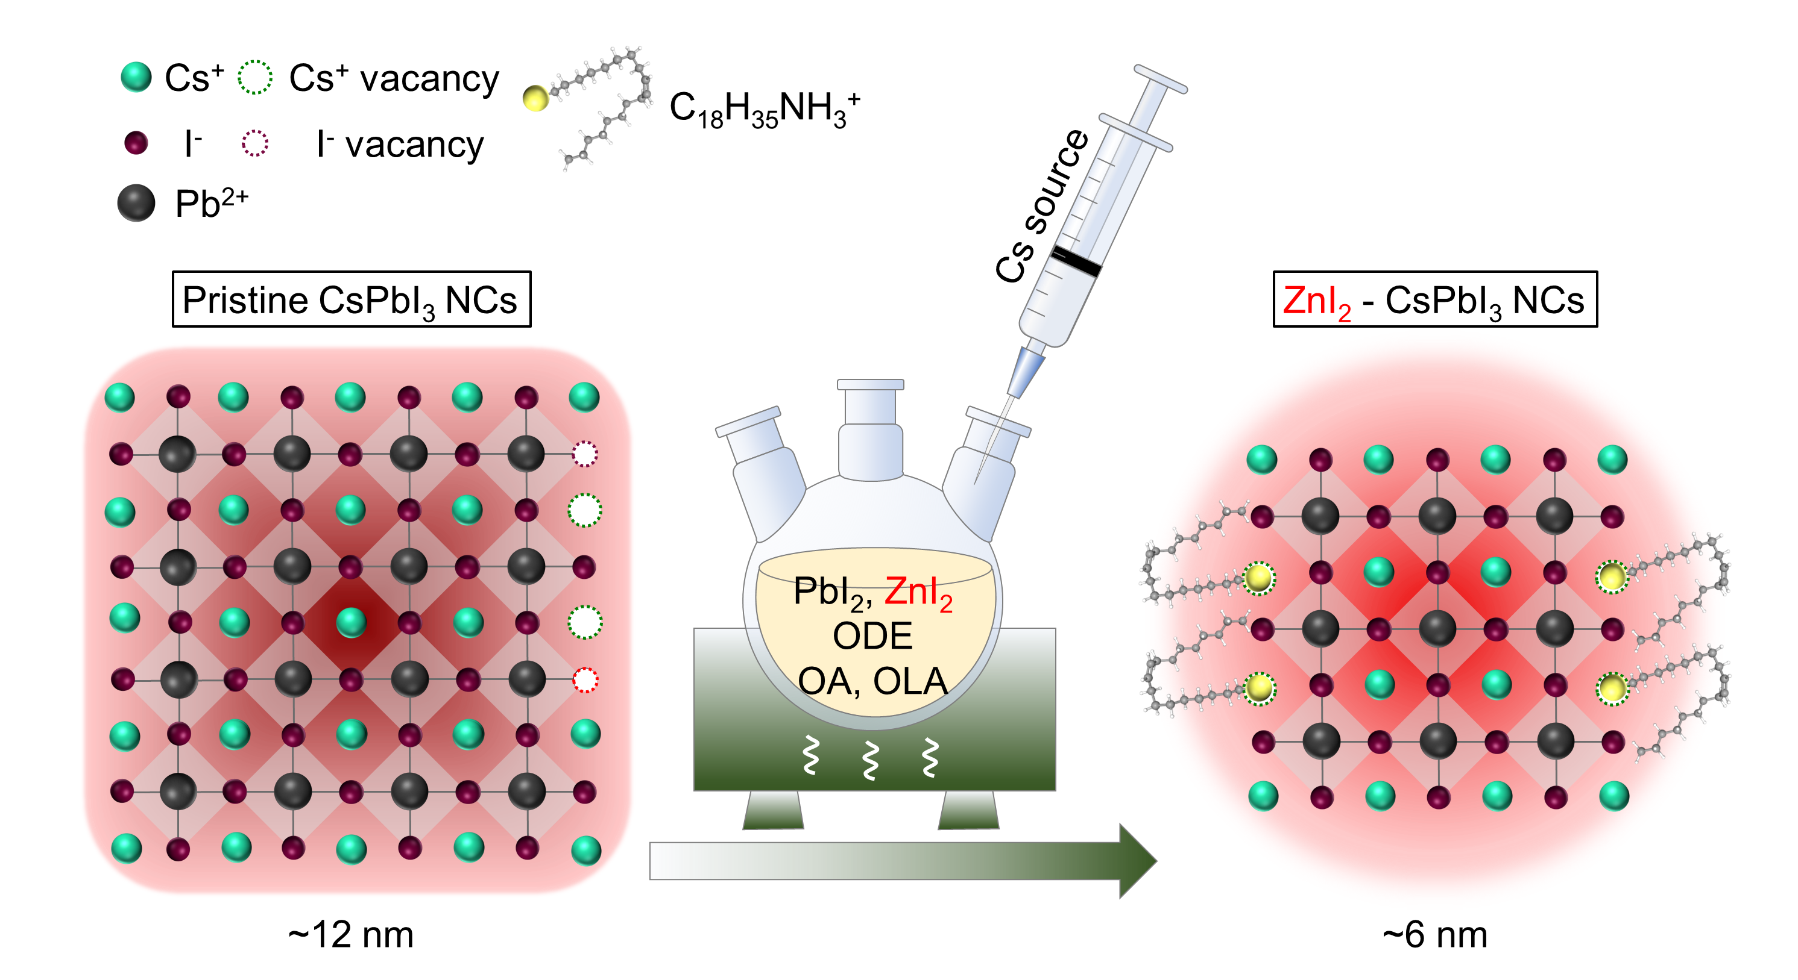
Figure S1. Schematic illustration of pristine CsPbI₃ NCs and zinc iodide-passivated CsPbI₃ NCs synthesized by hot-injection method. The pristine CsPbI₃ NCs prepared in the absence of ZnI₂ are larger in size (~12 nm), and with abundant surface defects. By adding ZnI₂ as an extra I⁻ source, the NCs are size-confined (~6 nm) with fewer surface defects.
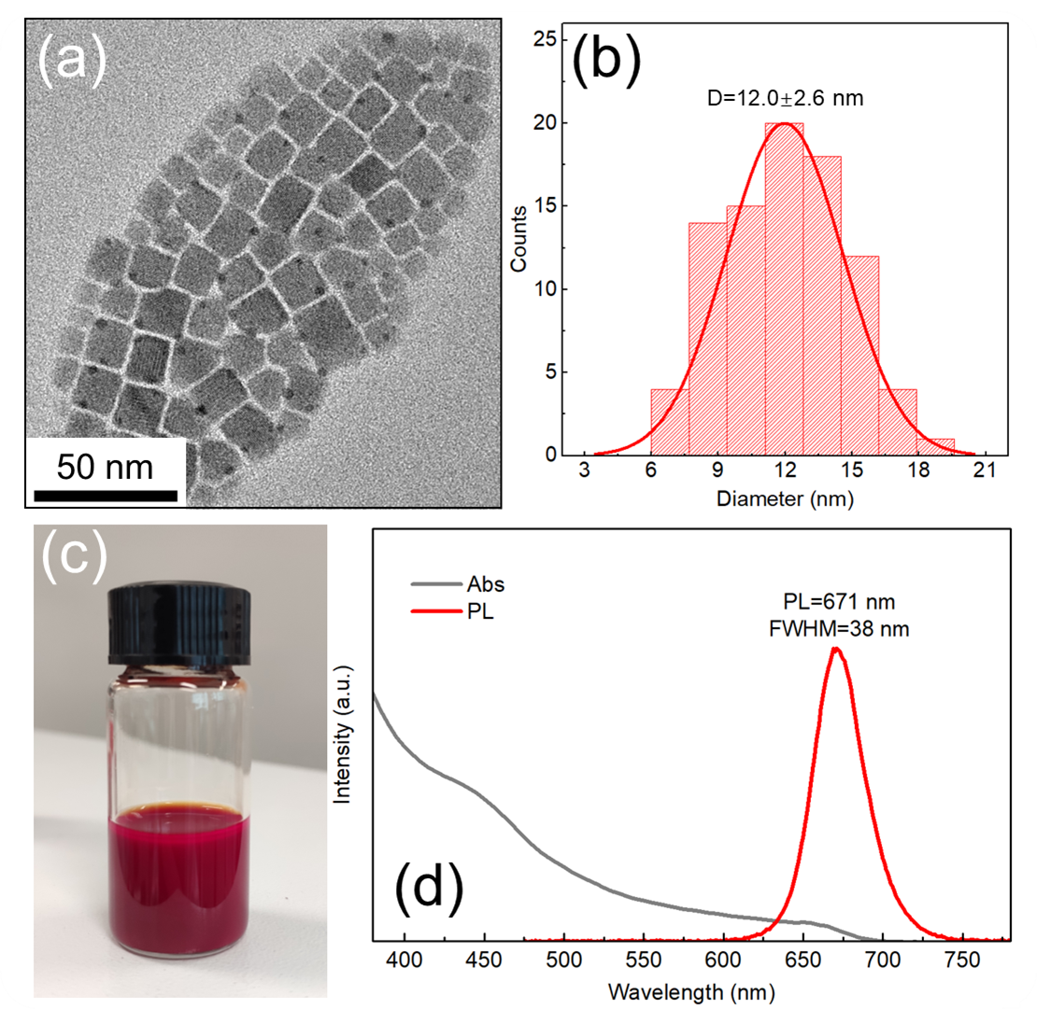
Figure S2. (a) TEM image and (b) corresponding size distribution histogram of pristine CsPbI₃ NCs prepared in the absence of ZnI₂. (c) Photograph (taken under daylight) and (d) UV-vis absorption and PL spectra of pristine CsPbI₃ NCs solution.
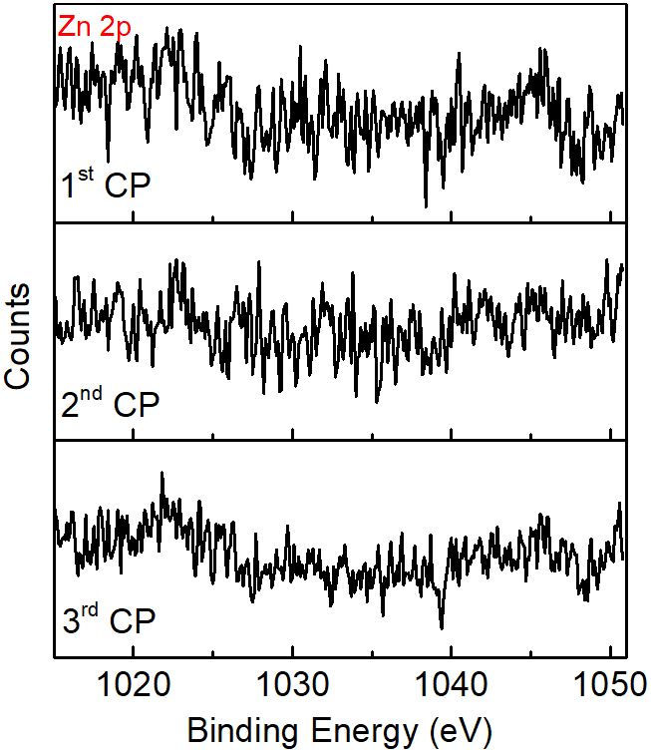
Figure S3. XPS spectra of Zn 2p of the three fractions of the CsPbI₃ NCs prepared by the gradient purification method, where no Zn signals were detected.
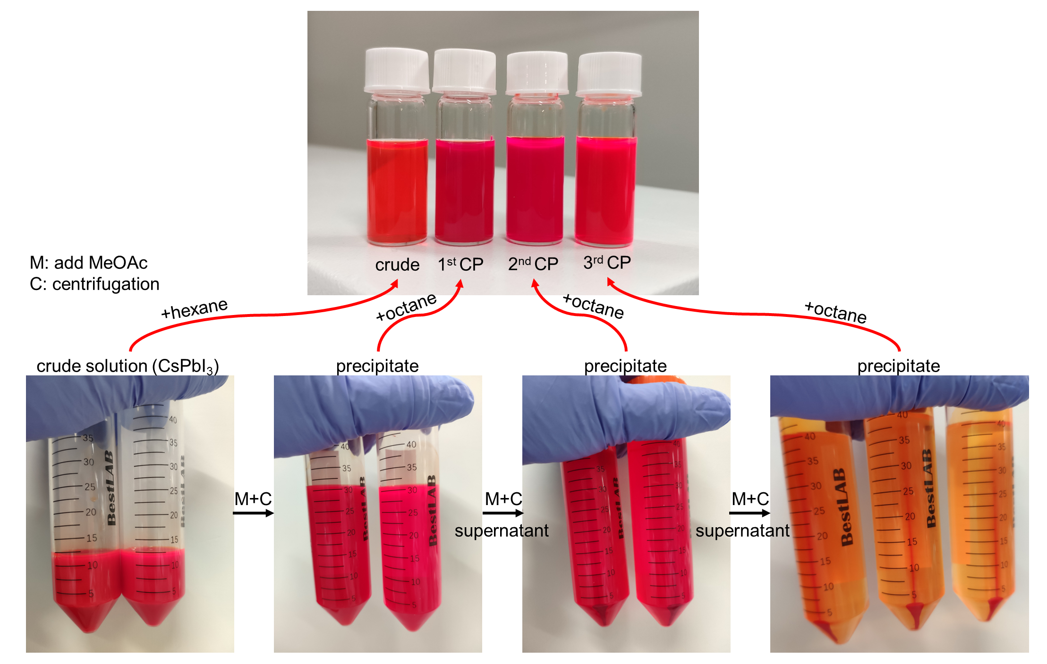
Figure S4. Photographs of the crude solution and size-selected fractions of CsPbI₃ NCs obtained during the gradient purification. The color of the supernatant after the 3rd centrifugation is already pale red, indicating that most of the NCs were extracted at this stage.
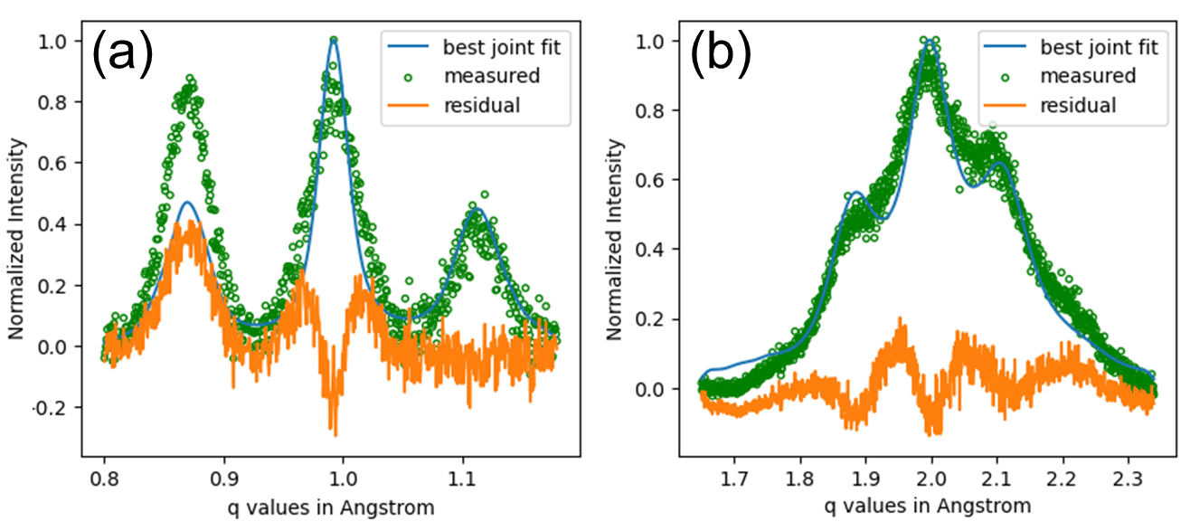
Figure S5. Fitted XRD peaks of the 3rd CP sample obtained by the gradient purification method of CsPbI₃ NCs, calculated with Python program. The calculated atomic periodicity (d), inter-particle distance (L), and the number of layers of metal halide octahedra (N) are 0.62 nm, 37.6 ± 1.0 Å, and 2.88 ± 0.84, respectively. The periodicity of the superstructure (Λ) is around 50 Å, calculated from the equation Λ = d (N − 1) + L.
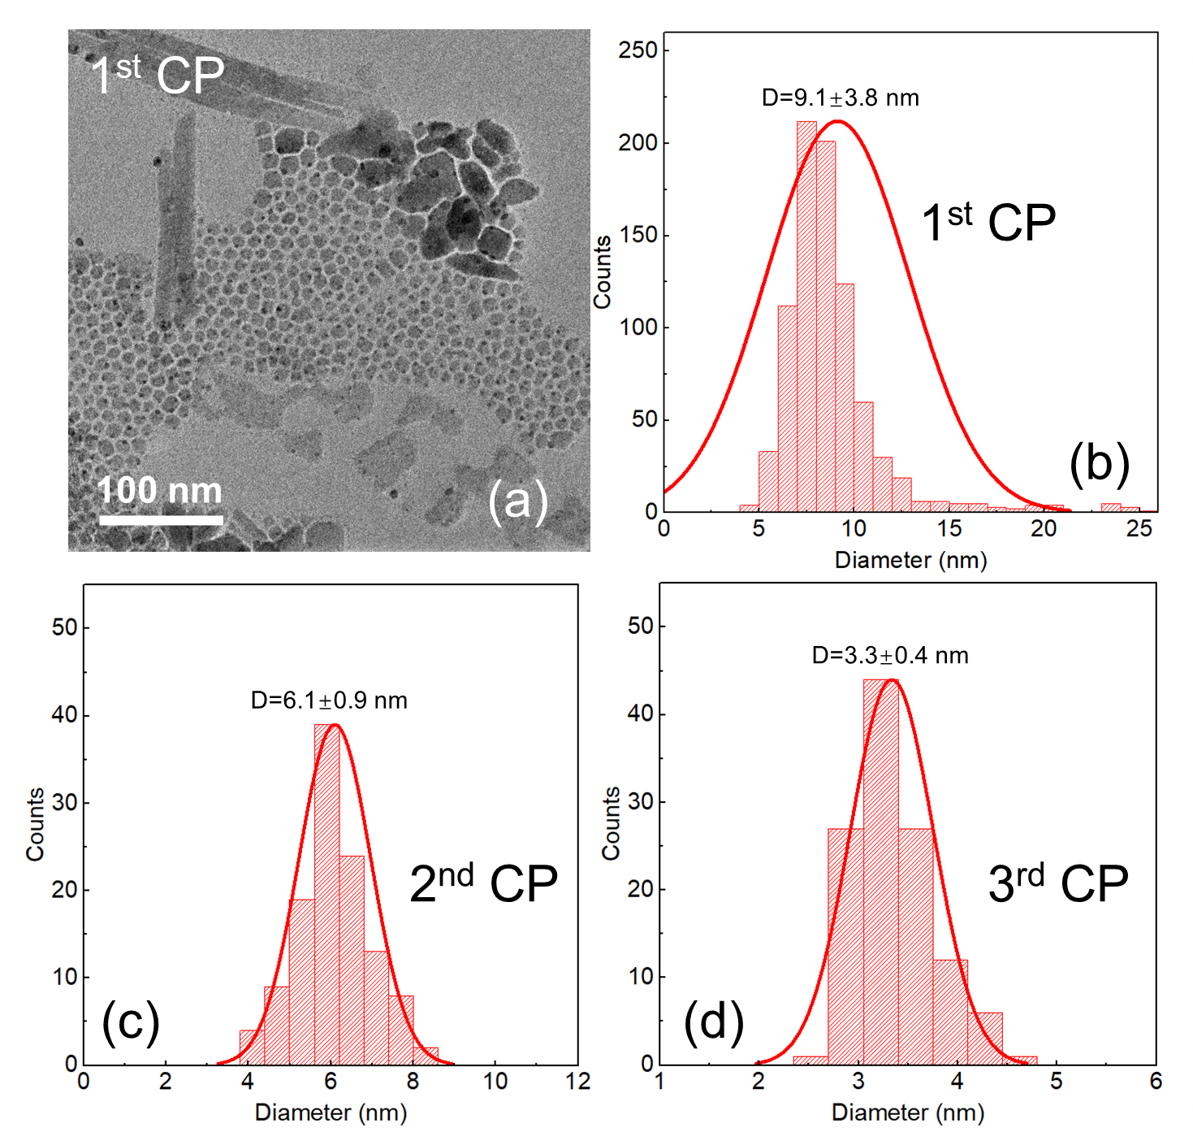
Figure S6. (a) TEM image and (b) the corresponding size distribution histograms of the 1st CP sample obtained by the gradient purification method of CsPbI₃ NCs. The TEM image shows that the 1st CP contains NCs with a broad size distribution and some irregular shapes. The solid line in (b) is a fit with a normal distribution, and the average size (9.1 nm) and standard deviation (3.8 nm) are obtained from this fit. (c,d) Size distribution histograms obtained from corresponding TEM images (not shown) of (c) the 2nd CP and (d) the 3rd CP samples obtained by the gradient purification method of CsPbI₃ NCs. These NCs show much narrower size distributions, with average sizes of 6.1±0.9 nm and 3.3±0.4 nm, respectively.
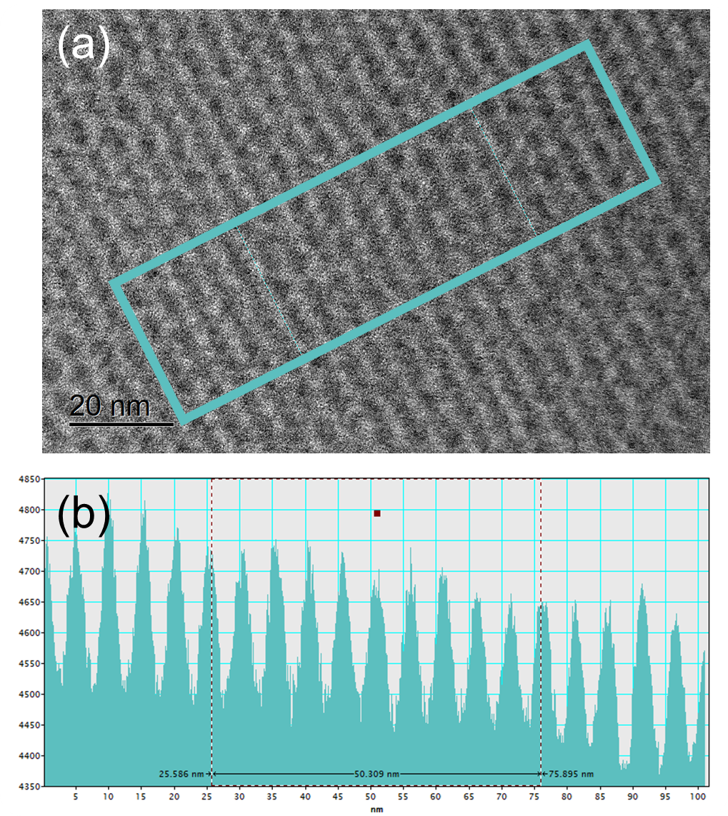
Figure S7. (a) TEM image and (b) the data analysis using Gatan Digital Micrograph Software for the 3rd CP sample obtained by the gradient purification method of CsPbI₃ NCs. (a) TEM image shows a self-assembled superstructure composed of fused NCs. The blue rectangle indicates the selected area for analysis. (b) Graph of the data analysis of the superstructure, showing the periodic values along the x-axis. The x-axis represents the distance in nanometers, and the y-axis represents the intensity in arbitrary units. By reading the distance from the status bar with ten periodicities, we obtain the periodicity value of this self-assembled superstructure as 5.03 nm.
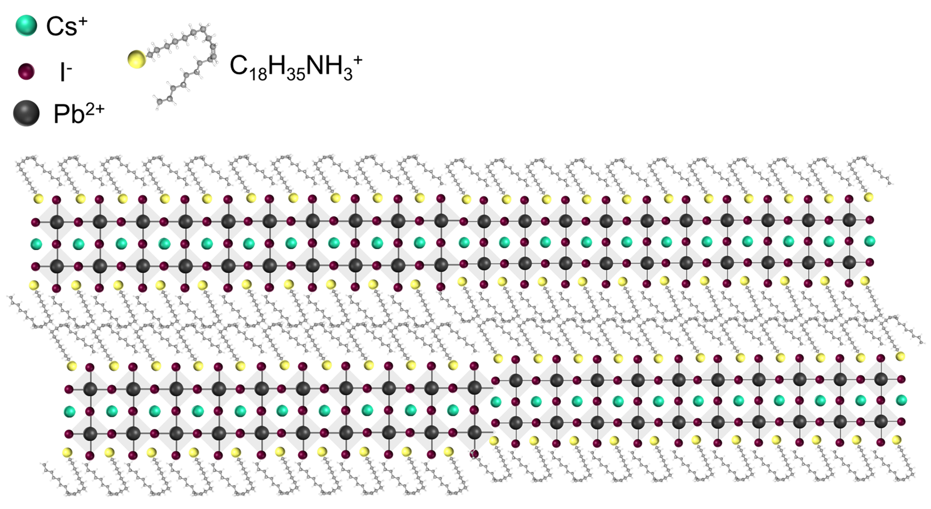
Figure S8. Schematic illustration of CsPbI₃ NCs stabilized by OLA⁺ ions acting as a spacer.
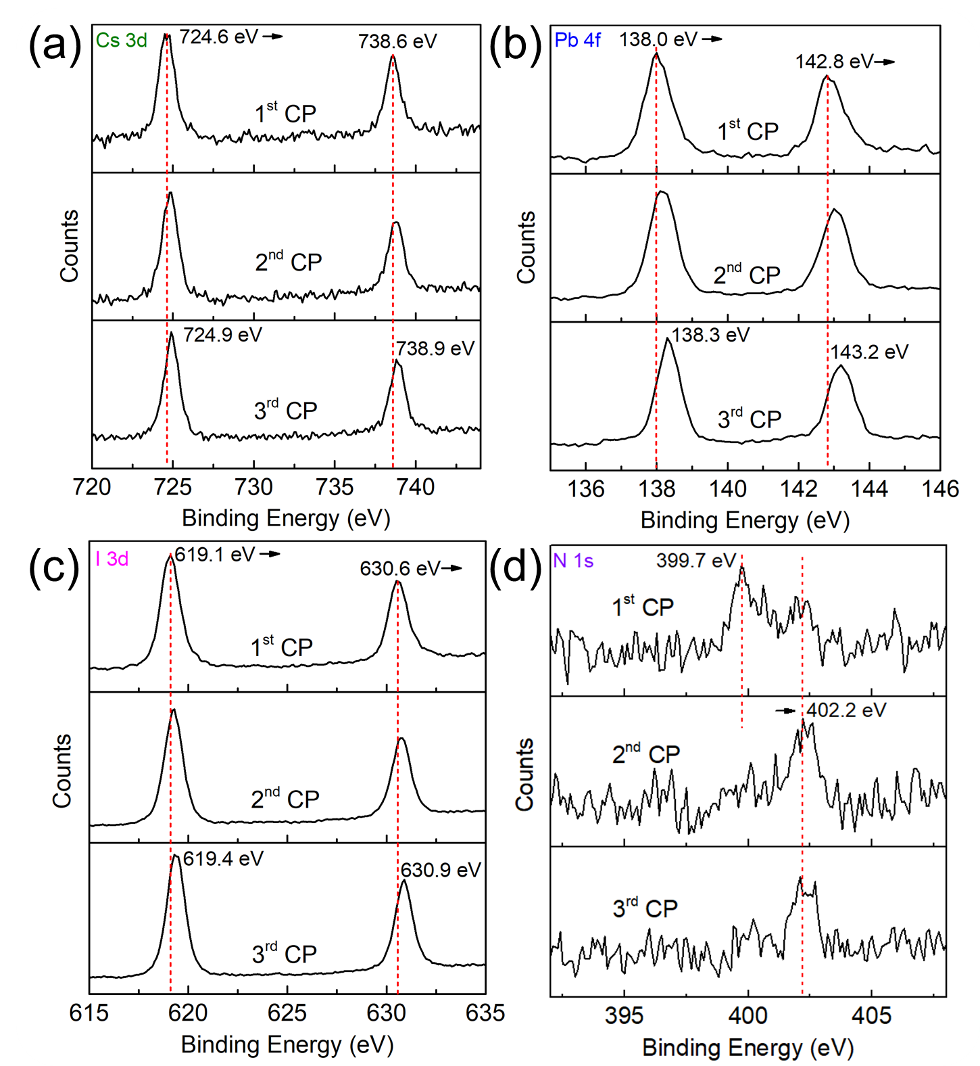
Figure S9. XPS spectra of (a) Cs 3d, (b) Pb 4f, (c) I 3d and (d) N 1s for CsPbI₃ NCs obtained as 1st, 2nd and 3rd CP during the gradient purification method.

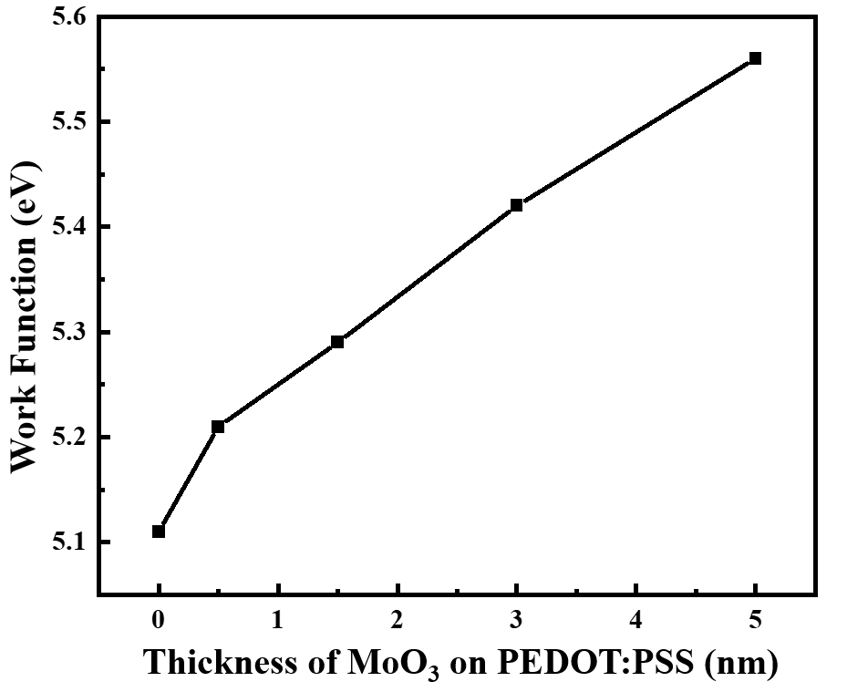
Figure S10. Work function value of the PEDOT:PSS/MoO₃ films with different MoO₃ thickness. The valence band (VB) of Poly-TPD is at around -5.4 eV, as shown in Figure S11. To minimize the injection barrier between PEDOT:PSS and Poly-TPD, 3 nm thin MoO₃ film was used.
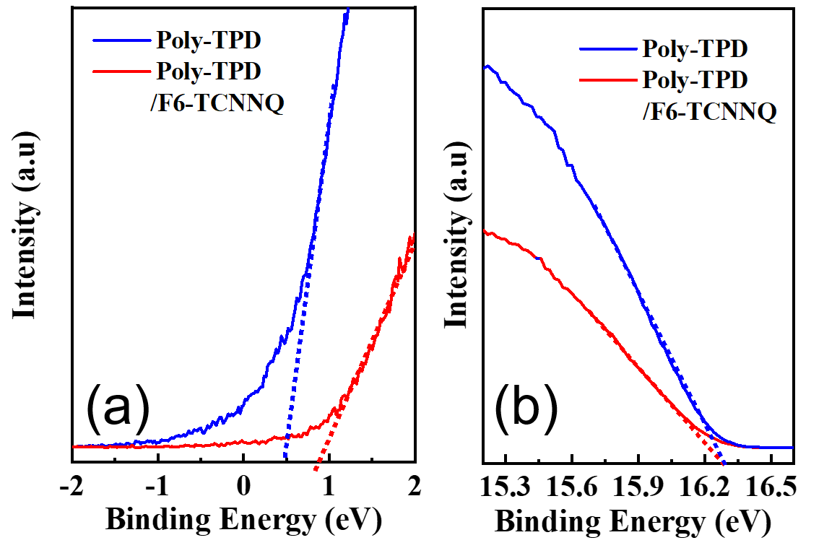
Figure S11. (a) The VB edge region and (b) the secondary-electron cutoff region of ultraviolet photoelectron spectra. By using the equation of VB = 21.2 − (E_{cutoff} − E_{onset}), the VB levels of Poly-TPD film with and without F6-TCNNQ were estimated to be -5.4 eV and -5.8 eV, respectively.
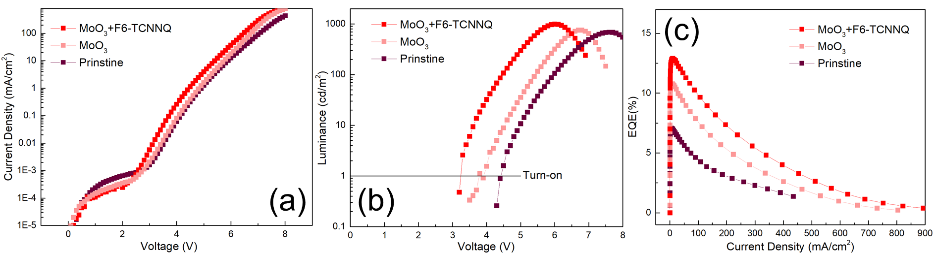
Figure S12. Effects of MoO₃ and F6-TCNNQ on device performance. (a) Current density -voltage curves of three different devices: pristine device, device with MoO₃, and device with both MoO₃ and F6-TCNNQ. The device with both MoO₃ and F6-TCNNQ showed the lowest leakage current at low voltage and the highest current density at high voltage, indicating the synergistic effect of MoO₃ and F6-TCNNQ. (b) Luminance-voltage curves of the same three devices. The device with both MoO₃ and F6-TCNNQ had the lowest turn-on voltage, indicating the smallest injection barrier. The device with only MoO₃ had a reduced turn-on voltage, but still higher than the device with both MoO₃ and F6-TCNNQ. (c) EQE-current density curves of the same three devices. The device with both MoO₃ and F6-TCNNQ had the highest EQE, indicating the highest charge recombination efficiency. The device with only MoO₃ had an improved EQE, but still lower than the device with both MoO₃ and F6-TCNNQ.
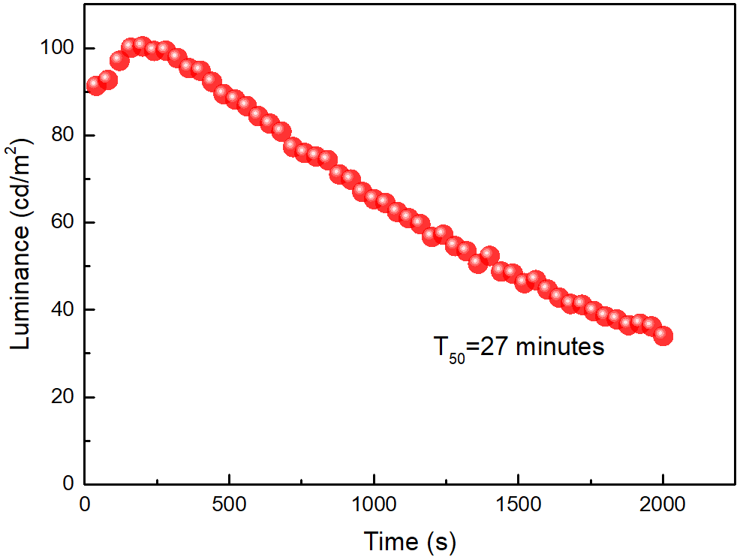
Figure S13. Operational stability results of the fabricated pure-red emitting CsPbI₃ NCs-based LED device, and the operating half-lifetime (T₅₀) is 27 minutes at an initial luminance of 91 cd/m².
Table S1. Comparison of the performance characteristics for the previously reported pure-red emission CsPbI₃ NC-based LEDs [1-6] with the devices realized in our work.
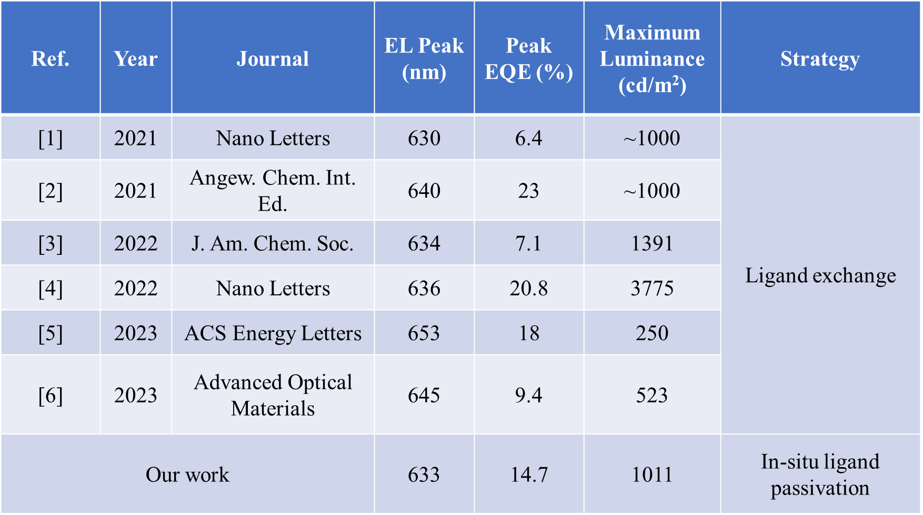
From Table S1, one can see that the performance of our devices is comparable to that of other reported LEDs in terms of EL peak, peak EQE, and maximum luminance. As shown in Table S1, our devices demonstrated an EL peak at 633 nm, which is better in terms of achieving pure-red emission than the reported values in Refs. [2-6]. Furthermore, our devices achieved a peak EQE of 14.7%, which is higher than the recently reported values in Refs. [1, 3, 6]. Moreover, our devices also exhibited a high maximum luminance of 1011 cd/m², which is comparable to the reported values in Refs. [1-2, 5-6]. We notice that our devices were produced using CsPbI₃ NC obtained by simple in-situ ligand passivation strategy, whereas others have employed the ligand exchange method [1-6].
References
[1] Y.-F. Lan, J.-S. Yao, J.-N. Yang, Y.-H. Song, X.-C. Ru, Q. Zhang, L.-Z. Feng, T. Chen, K.-H. Song, H.-B. Yao, Spectrally Stable and Efficient Pure Red CsPbI₃ Quantum Dot Light-Emitting Diodes Enabled by Sequential Ligand Post-Treatment Strategy, Nano Letters 21 (2021) 8756-8763, https://doi.org/10.1021/acs.nanolett.1c03011.
[2] Y.-K. Wang, F. Yuan, Y. Dong, J.-Y. Li, A. Johnston, B. Chen, M. I. Saidaminov, C. Zhou, X. Zheng, Y. Hou, K. Bertens, H. Ebe, D. Ma, Z. Deng, S. Yuan, R. Chen, L. K. Sagar, J. Liu, J. Fan, P. Li, X. Li, Y. Gao, M.-K. Fung, Z.-H. Lu, O. M. Bakr, L.-S. Liao, E. H. Sargent, All-Inorganic Quantum-Dot LEDs Based on a Phase-Stabilized α-CsPbI₃ Perovskite, Angewandte Chemie International Edition 60 (2021) 16164-16170, https://doi.org/https://doi.org/10.1002/anie.202104812.
[3] W. J. Mir, A. Alamoudi, J. Yin, K. E. Yorov, P. Maity, R. Naphade, B. Shao, J. Wang, M. N. Lintangpradipto, S. Nematulloev, A.-H. Emwas, A. Genovese, O. F. Mohammed, O. M. Bakr, Lecithin Capping Ligands Enable Ultrastable Perovskite-Phase CsPbI₃ Quantum Dots for Rec. 2020 Bright-Red Light-Emitting Diodes, J. Am. Chem. Soc. 144 (2022) 13302-13310, https://doi.org/10.1021/jacs.2c04637.
[4] M. Xie, J. Guo, X. Zhang, C. Bi, L. Zhang, Z. Chu, W. Zheng, J. You, J. Tian, High-Efficiency Pure-Red Perovskite Quantum-Dot Light-Emitting Diodes, Nano Letters 22 (2022) 8266-8273, https://doi.org/10.1021/acs.nanolett.2c03062.
[5] D. Chen, P. K. Ko, C. H. A. Li, B. Zou, P. Geng, L. Guo, J. E. Halpert, Amino Acid-Passivated Pure Red CsPbI₃ Quantum Dot LEDs, ACS Energy Letters (2023) 410-416, https://doi.org/10.1021/acsenergylett.2c02243.
[6] W. Shen, Z. Su, S. Chen, Y. Dai, Y. Qiu, Y. Chen, J. Jiang, J. Zhang, Y. Wang, H. Cui, Y. He, K. Cao, B. Cai, L. Liu, S. Chen, Spectrally Stable Pure Red CsPbI₃ Quantum Dots Light-Emitting Diodes via Effective Low Temperature Gradient Centrifugation Separation and Surface Modification, Advanced Optical Materials (2023) 2300306, https://doi.org/https://doi.org/10.1002/adom.202300306.

