Constructing multi-functional polymeric-termination surface enables high performance flexible perovskite LEDs

Chunyu Liu, Dezhong Zhang, Jiayun Sun, Dongyu Li, Qi Xiong, Benzheng Lyu, Wenbin Guo,* and Wallace C.H. Choy*

C. Liu, D. Zhang, J. Sun, D. Li, Q. Xiong, B. Lyu, W. C.H. Choy
Department of Electrical and Electronic Engineering, the University of Hong Kong, Hong Kong, China
E-mail: chchoy@eee.hku.hk
C. Liu, W. Guo
State Key Laboratory of Integrated Optoelectronics, College of Electronic Science and Engineering, Jilin University, Changchun, China.
E-mail: guowb@jlu.edu.cn
J. Sun
Department of Electronic and Electrical Engineering, Southern University of Science and Technology, Shenzhen, China.

Keywords: flexible, functional group, polymer, surface, pure primary color

Abstract
Flexible perovskite light-emitting diodes (f-PeLEDs) have attracted increasing interest to realize true-color, low-cost, and light-weight wearable optoelectronic and flexible display applications. However, their external quantum efficiency (EQE) and mechanical stability lag far behind because of the inherent surface and brittle issues of polycrystalline perovskite films. In this work, a multi-functional polymeric-termination surface of perovskite film is constructed for achieving efficient and mechanically stable f-PeLEDs. It takes the roles to not only reduce defects through equipping coordination groups to improve emission properties, but also optimize film morphology and eliminate pinholes to solve the long-standing issue of leakage current. Meanwhile, the polymeric-termination surface with anchoring points and polymeric soft chains on perovskites demonstrates synergetic effects beyond the corresponding functional group-only or polymer-only strategies in reducing the Young’s modulus and improving the mechanical flexibility. Ultimately, the record EQE of 22.1% and significantly enhanced mechanical stability of maintaining 82% of the initial performance after 2000 bending cycles with radius of 5 mm are achieved in pure-green f-PeLEDs. The work paves the way for the development of high-performance flexible optoelectronic devices.

1. Introduction
Metal halide perovskites have been widely studied as emitters in light-emitting diodes (LEDs) because of their tunable emission wavelength, high photoluminescence quantum yield (PLQY), and high color purity.^{[1-5]} These uniquely position perovskites to fulfill the color gamut requirements (Rec. 2020) for ultrahigh definition displays at low-cost.^{[6-10]} Recently, a high external quantum efficiency (EQE) of more than 20% has been achieved in pure-green and pure-red perovskite LEDs (PeLEDs) based on rigid glass substrates.^{[11-14]} Comparatively, the EQE of flexible PeLEDs (f-PeLEDs) lags far behind and the mechanical flexibility is still unsatisfactory,^{[10,15-19]} which will greatly hinder their potential applications in emerging flexible optoelectronics and display applications.
Although extensive efforts have been spent on improving the performance of rigid PeLEDs, there are less progress in f-PeLEDs. Some studies were conducted on fabricating new flexible electrodes,^{[20,21]} optimizing the carrier transport layers or interfaces,^{[22,23]} and improving the output coupling of f-PeLEDs.^{[15]} However, the EQE and mechanical stability of f-PeLEDs are largely limited by the intrinsic shortcomings of perovskite emitting films including the poor optical and electrical properties induced by defects and undesirable surface morphology,^{[24-27]} as well as inherent mechanical flexibility originated from the brittleness of polycrystalline perovskites.^{[28,29]} Overall, more effects are needed to further enhance the efficiency and mechanical stability of f-PeLEDs.
Some approaches based on organic functional chemicals have been developed to improve the performance of f-PeLEDs. Ethyl cellulose was introduced into the perovskite films, which could reduce defects and improve the deformation resistance of the perovskite by cross-linking between perovskites and ethyl cellulose molecules, thus showing 12.1% of EQE and improved flexible stability.^{[16]} Besides, a self-healing strategy based on the additive of silane molecule of (3,3,3-trifluoropropyl) trimethoxysilane was incorporated into the perovskite films, which could passivate defects and generate a flexible Si-O-Si network, thereby resulting in a green f-PeLED with an EQE of 16.2%.^{[30]} In addition, a bionic structure in perovskite films was developed by employing a polymer-assisted crystal regulation method with a soft elastomer of diphenylmethane diisocyanate polyurethane. A sky-blue device with EQE of 13.5% and a high resistance to flexural strain was achieved.^{[31]} Meanwhile, the perovskite crystallization was improved by introducing ethanolamine in the buried transport layer to reduce perovskite defects and improve the charge injection, ultimately obtaining an enhanced EQE of 17.1% at 514 nm in planar device structure.^{[15]} These approaches for perovskite film and transport layer have been investigated to decrease defects and improve mechanical properties. However, the f-PeLED performance still needs to be further improved. Nowadays, the reported EQE of green f-PeLEDs without output coupling structures is far below 20%. Actually, apart from the bulk phase of perovskite films that has been widely studied, the film surface is also an important issue because the surface properties of the perovskite films prepared on the flexible substrate is more difficult to control,^{[15,25,32]} which causes further optical and electrical concerns because of defects and pinholes. In addition, the cracking of perovskite films usually begins at the surface during bending,^{[16,29]} which makes surface optimization promising. Consequently, it is highly desirable to develop effective and specific approaches for surface optimization of perovskites in the f-PeLEDs.
In this work, we demonstrate the strategy of constructing a polymeric-termination surface for perovskite films to achieve high-performance f-PeLEDs. The polymeric-termination surface constructed by polyvinyl acetate (PVAC) leads to the significantly improved optical and electrical properties due to effective defect passivation and pinholes elimination at the film surface. Together with functional groups and polymer synergetic effects, the strategy considerably decreases the Young's modulus and improves the mechanical bending stability of perovskite films. We conduct a systematic comparison between different treatment materials, and the contribution from functional groups and polymer effects are revealed respectively, while the contribution of small-molecular-termination and polymeric-termination surface on mechanical stability has been seldom studied. Based on above advantages, a record EQE of 22.1%, much higher than previous reports, for pure-green f-PeLEDs is realized. Simultaneously, the mechanical flexibility of device is obviously enhanced.

2. Results and Discussion
The f-PeLEDs are fabricated with the device structure as shown in Figure 1a. The detail device fabrication process is provided in experimental section (Supporting Information). To explore the superior treatment material and corresponding mechanisms, three organic molecules are introduced to form the perovskite film surface and improve the performance of f-PeLEDs, including the small molecule of pentaerythritol tetraacetate (PTTA) with functional groups but no polymer effects (FG-only), the polymer of polystyrene (PS) without functional groups but with polymer effects (polymer-only), and the polymer of PVAC with functional groups and polymer synergetic (simultaneous) effects. The systematic comparison of these three chemicals is analyzed in revealing the mechanism about f-PeLEDs performance improvement. The control case without any treatment on the perovskite is also studied. The perovskite treatment process with these three chemicals is described in experimental section. The EQE comparison in Figure 1b and 1c indicates that all of the three chemicals can improve the EQE of f-PeLEDs but in different degrees. While the peak EQE of control device is 12.0%, both FG-only PTTA and polymer-only PS devices show improvements to 16.9% and 18.0%, respectively. Remarkably, PVAC devices enable the highest EQE of 22.1%, which is a record value of f-PeLEDs in the pure-green emission region (Figure 1d). The EL emission (Figure S1a) locates at 532 nm at different bias voltage with CIE coordinates of (0.189, 0.768) very close to the Rec. 2020 standard (Figure S1b) for the true-color flexible display applications.^{[33,34]}

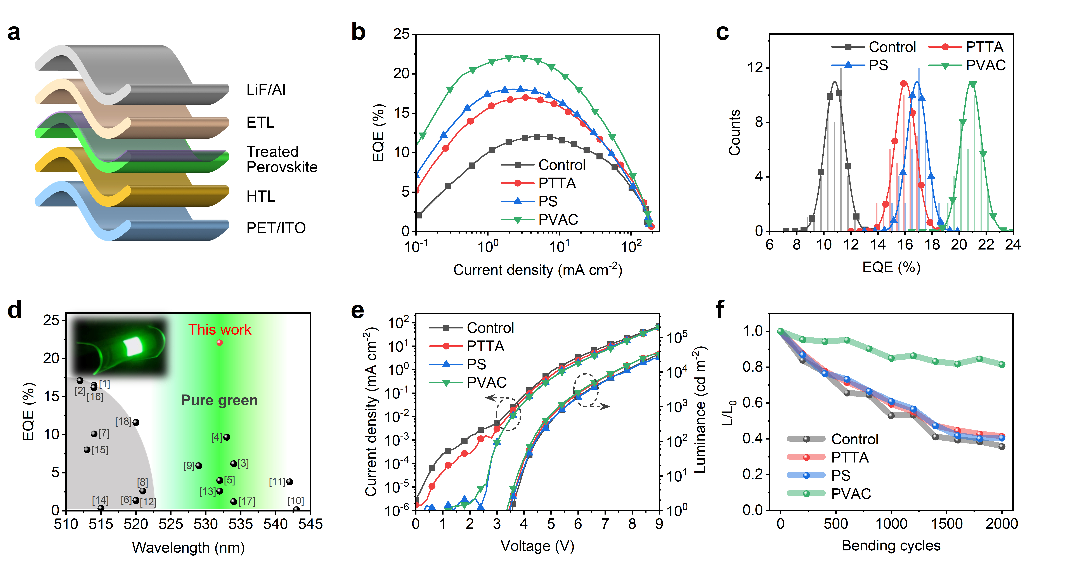
Figure 1. a) Device structure of f-PeLEDs. b) EQE curves and c) EQE distribution of devices with different organic materials treatment. d) EQE comparison of reported green f-PeLEDs in planar device structure. The references are listed in Table S1. Inset shows an electroluminescence image of our f-PeLED. e) Current density-voltage-luminance characteristics and f) mechanical stability of devices.

The suppression of leakage current is very important for achieving highly efficient f-PeLEDs. From the current density-voltage-luminance characteristics (Figure 1e), there are obvious leakage currents in the control and PTTA devices. Differently, the f-PeLEDs treated with polymer (PS and PVAC) demonstrate great advantages in diminishing the leakage current as will be explained later. Meanwhile, devices with PTTA and PVAC treatment exhibit slightly higher luminance and lower turn-on voltage, and their operational stability is double that of control and PS devices (Figure S2). In addition, the mechanical stability of f-PeLEDs with bending radius of 5 mm is characterized (Figure 1f). Our results show that neither FG-only PTTA nor polymer-only PS can improve the mechanical stability of f-PeLEDs. The luminance of control, PTTA-, and PS-based f-PeLEDs decays to about 40% of their initial values after 2000 bending cycles. Interestingly, the PVAC one with groups and polymer effects shows significant enhancement in the mechanical stability, remaining 82% of initial performance under the same bending stress without any wavelength shift in emission (Figure S3). Consequently, the FG-only and polymer-only treatment can provide some improvement in EQE but no contribution to the mechanical stability of f-PeLEDs. PVAC with the synergetic effect simultaneously improve the EQE and mechanical stability of f-PeLEDs.
To reveal the mechanisms of enhanced performance of f-PeLEDs, the chemical interactions of the three organic materials with perovskite are analyzed first. All of them have good solubility in the antisolvent of ethyl acetate (EA) and are simply incorporated during the antisolvent-washing process.^{[35,36]} The chemical structures and antisolvent-washing process schematic are shown in Figure 2a. Their FTIR spectra are shown in Figure 2b-d. The characteristic peaks of C=O and C-O-C arising from PTTA at wavenumbers of 1732.4 and 1232.2 cm⁻¹ shift to lower wavenumbers of 1727.2 and 1226.4 cm⁻¹ on addition to PbBr₂ respectively, which implies that the functional groups can interact with Pb²⁺ by lone-pair electrons simultaneously. The steady characteristic peaks of PS indicate the relatively weak chemical interaction between PS and Pb²⁺. The similar results to PTTA are achieved for PVAC due to the same functional groups of C-O-C and C=O. Both the peaks shift from 1235.6 and 1732.9 cm⁻¹ to lower wavenumber of 1229.2 and 1727.5 cm⁻¹, respectively, demonstrating the strong chemical interaction between PVAC and Pb²⁺. The chemical interactions of three materials in the perovskite films are further verified by the X-ray photoelectron spectroscopy (XPS) as the Pb 4f and Br 3d spectra shown in Figure 2e and 2f. Similar peaks shift toward lower binding energy is observed for perovskite films treated with PTTA and PVAC due to the changed electron cloud density, while PS-treated perovskite film shows almost no shift compared to the control sample consistent to the FTIR results. Therefore, it can be concluded that the perovskite films can be similarly passivated by PTTA and PVAC attributing to their functional coordination groups. Depth-profiling XPS is further employed to analyse the distribution of functional chemicals in the perovskite film as shown in Figure S4 and Figure 2g. Due to the inevitable adsorption of trace oxygen gas, the oxygen content at the surface of control and PS-treated films is higher than in the bulk. For the PTTA- and PVAC-treated perovskite films, the oxygen content near the surface is much higher than that of control sample, and just slightly higher when the depth exceeds 20 nm, indicating that most of the treatment chemical exists near the surface of perovskite film, thus constructing the small-molecular-termination or polymeric-termination surface. From the X-ray diffraction (XRD) results (Figure S5), the crystallization of perovskite films is almost the same. The treatment materials are dominantly distributed near the surface of the perovskite film, which will be beneficial to passivate the main emitting region of quasi-2D perovskite film to improve the PLQY, and also to regulate the surface morphology of film.

Figure 2. a) Schematic of perovskite film preparation with treatment materials in the antisolvent, as well as the chemical structures of PTTA, PS, and PVAC. FTIR spectra of b) PTTA, c) PS, and d) PVAC without and with PbBr₂. XPS analysis on e) Pb 4f and f) Br 3d spectra of different perovskite films. g) Oxygen atomic content in the control, PTTA-, PS- and PVAC-treated films with different etching depth by argon ion.
On the basis of the chemical interaction effects of functional groups, the optical properties of perovskite films could be improved which is one of the important contributions to the improvement of EQE. The absorbance spectra of perovskite films without and with different materials treatment are basically consistent (Figure 3a). Differently, the PL emission of perovskite films with PTTA and PVAC are obviously higher than control and PS-treated films due to the effective defect passivation by functional groups. The PLQYs are ca. 60% for control and PS-treated films, and obviously enhanced to over 90% for PTTA and PVAC-treated films (Figure 3b). The corresponding PL decay are measured (Figure 3c), and the average lifetime (τ) is obtained by three index fitting. The fitting parameters for time-resolved PL decay curves are shown in Table S2. With the strong chemical interaction by PTTA or PVAC, the τ of perovskite films is extended compared with control and PS-treated samples, contributing the changes in recombination behaviors. The radiative and nonradiative recombination rate (k_{r}, k_{nr}) of perovskite films can be calculated using the equations of PLQY = k_{r}/(k_{r} + k_{nr}) and τ = (k_{r} + k_{nr})⁻¹.^{[37,38]} As shown in Figure 3d, the k_{nr} of control and PS-treated films are almost the same, while there is an obvious decrease for PTTA and PVAC samples, fully proving that the defect-induced nonradiative recombination is effectively suppressed by PTTA and PVAC with functional groups. Notably, the EQE of different devices are not completely consistent with the recombination behaviors of perovskite films. The polymer-only PS-treated device also demonstrates obvious EQE enhancement. These results indicate that the EQE enhancement of f-PeLEDs is not only related to the improvement of optical and recombination behaviors, but also depends on some other contributions from the polymer effect.
By comparing the morphology of perovskite films in Figure 3e, it can be found that there are numerous pinholes on the surface of control film, which will act as the carrier transport channels and form leakage current in devices. The poor surface morphology with pinholes are rarely observed on rigid substrates, but widely reported in f-PeLEDs,^{[24,39,40]} which could be related to the decreased ITO electrode quality on the flexible substrates^{[41-43]} and the different strain encountered by the perovskite films during preparation.^{[44,45]} For the FG-only PTTA-treated film, the pinholes still exist. On the contrary, the polymer-only PS and simultaneous PVAC-treated films exhibit a smooth surface without any pinholes. With the understanding of the morphology, we analyze the changes in the electrical properties of perovskite films by single-carrier (electron-only) devices as shown in Figure S6. The leakage current of electron-only devices with PS and PVAC treatment is suppressed as compared to the control and PTTA-treated devices, which is consistent with the suppression of leakage current in PeLEDs (Figure 1e). Meanwhile, the electron current density of PS and PVAC devices is lower than that of control and PTTA-treated devices. The results indicate that the polymers not only solve the leakage current issue but also slow down the electron injection, further benefitting to the injection balance of electrons and holes in the f-PeLEDs as the mobility of the electron transport layer (1,3,5-tri(1-phenylbenzimidazol-2-yl)benzene (TPBi)) is much higher than that of the hole transport layer (poly(9-vinylcarbazole) (PVK)).^{[46,47]} In addition, due to the hydrophobicity of polymers and their good coverage on the surface of perovskite, the moisture resistance of films with PS and PVAC treatment is obviously improved as shown the increased water contact angle of films (Figure S7), as well as the slower PL intensity decay of films in the air with RH of 70% (Figure S8). Consequently, the enhanced EQE of PeLEDs is attributed to the improved optical properties by functional groups and the promoted electrical performance of the perovskite films by polymer effects. The advantages can be combined to achieve the EQE breakthrough by PVAC with functional groups and polymer effects simultaneously.

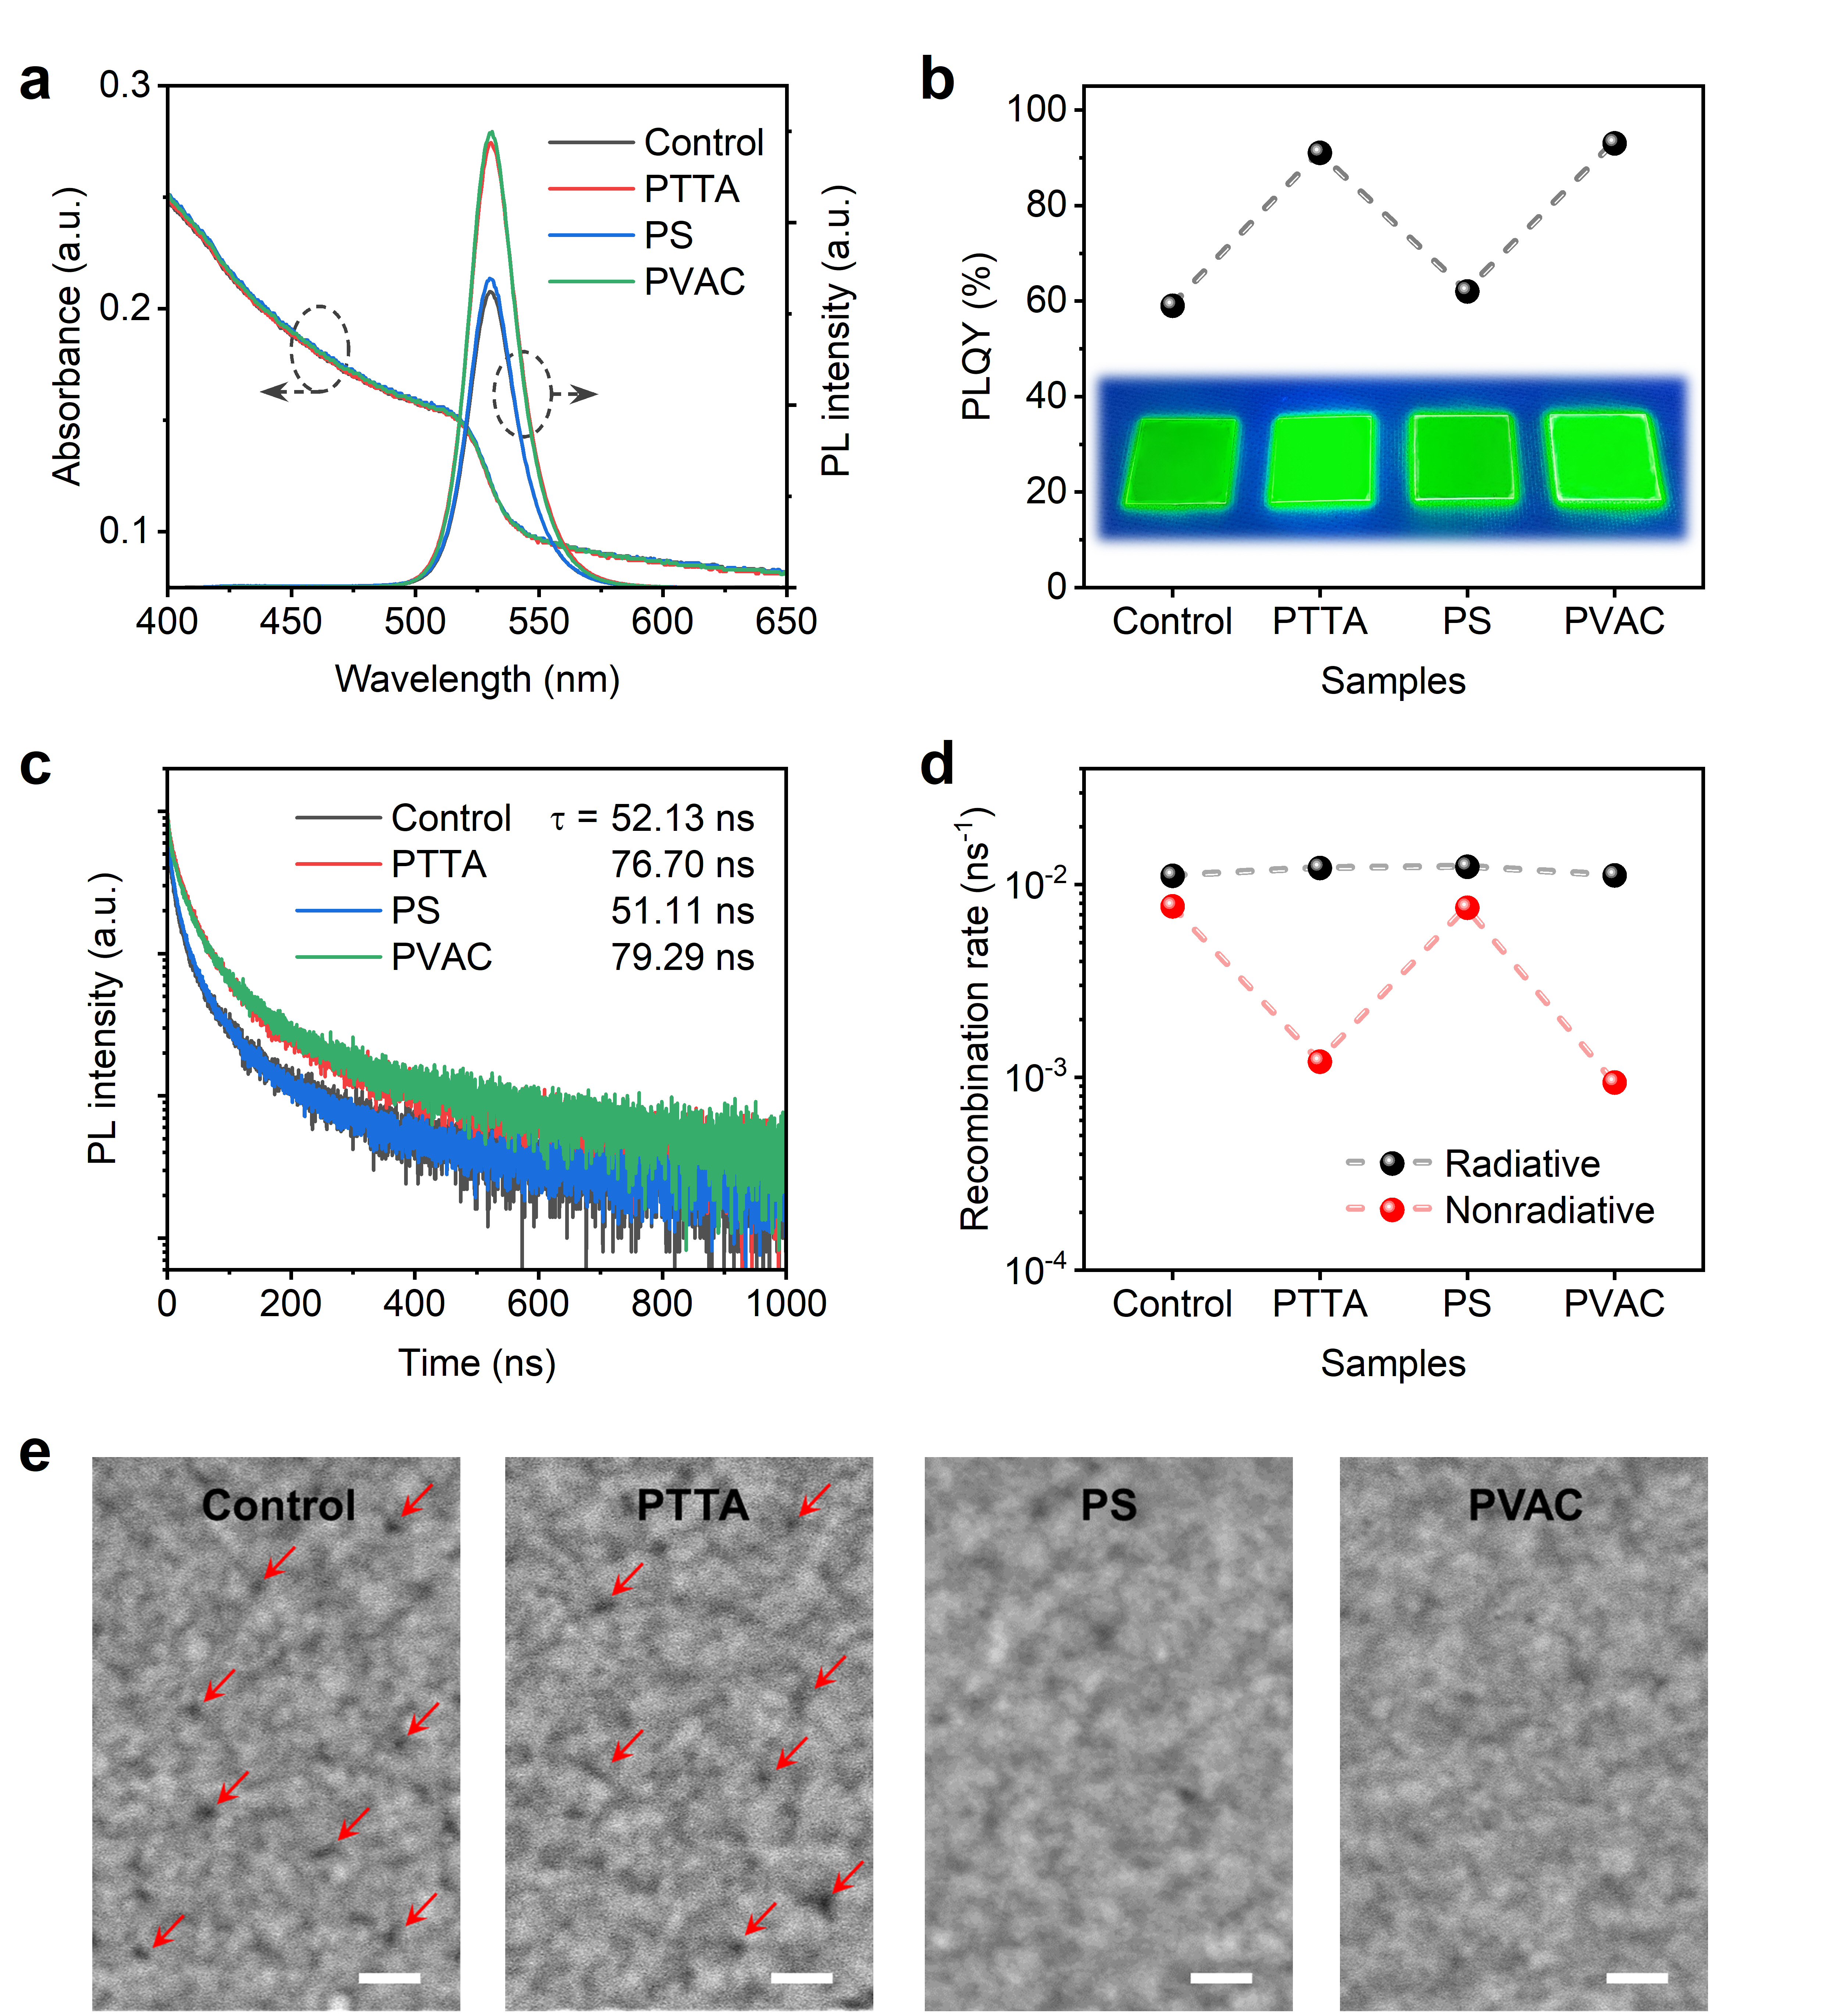
Figure 3. a) Absorbance and PL spectra, b) PLQY, c) PL decay, d) radiative and nonradiative recombination rate, and e) SEM images of perovskite films without and with different organic materials treatment.

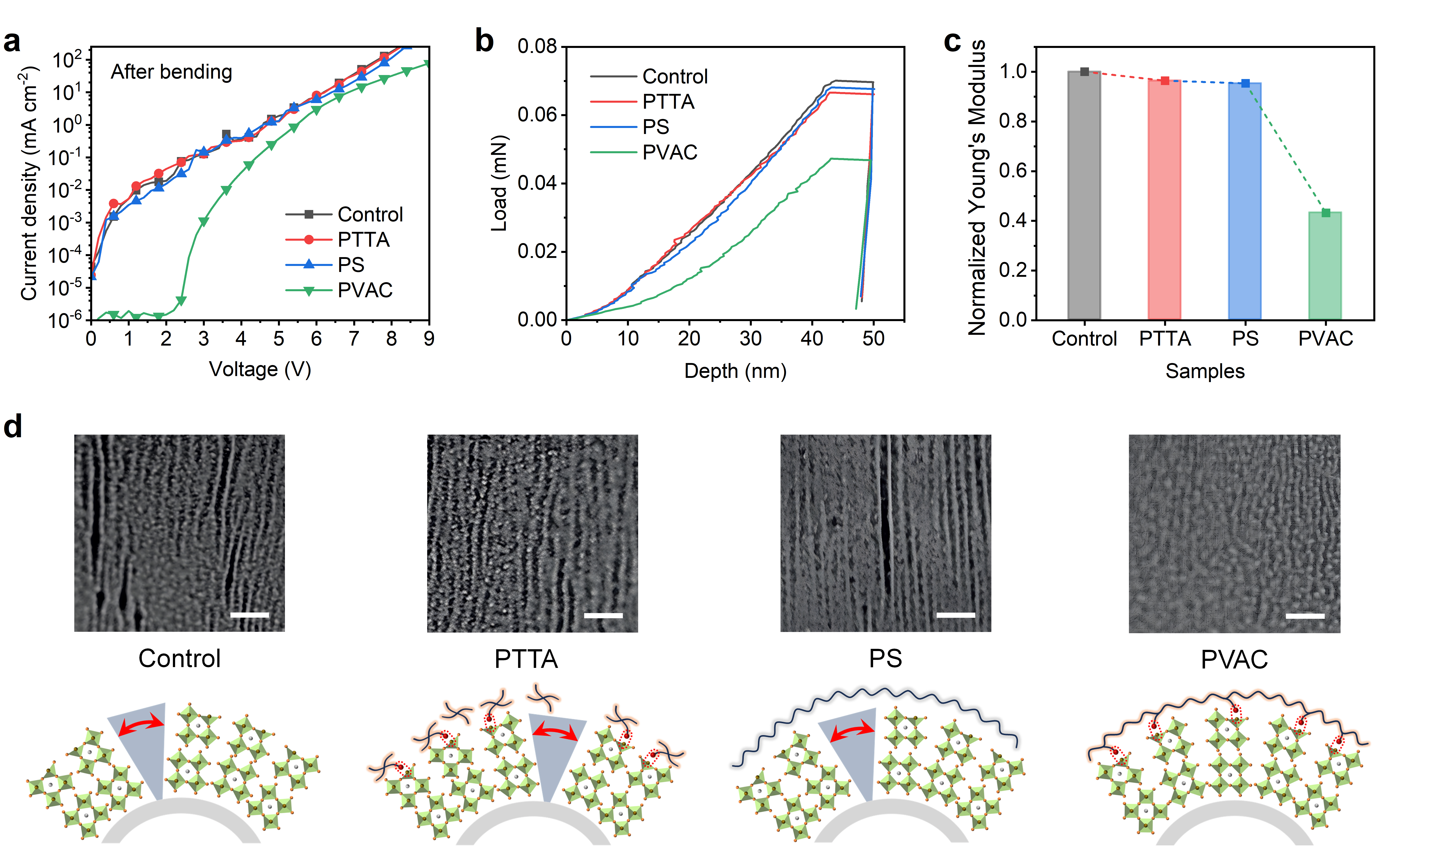
Figure 4. a) Current density-voltage curves of different f-PeLEDs after bending. b) Nano-indentation measurement curves and c) Young's modulus of different films. d) Surface morphology of films after bending and corresponding bending mechanisms.

Unparallelly, as compared to the trend of EQE, the mechanical stability of f-PeLEDs cannot be improved by the treatment of neither FG-only PTTA nor polymer-only PS, and only the device with PVAC treatment demonstrates the improved mechanical stability. To investigate the reasons of the performance degradation, optical and electrical measurements of samples after bending have been carried out. For the optical properties, the PL intensity of all the films only slightly decreased after 2000 bending cycles with radius of 5 mm (Figure S9), indicating that the perovskite materials have not been destroyed and the optical performance of the films has only slightly changed. Regarding the electrical propertied, the current density-voltage curves of control, both FG-only PTTA, and polymer-only PS devices after bending show very large leakage current (Figure 4a). In contrast, the PVAC-treated device maintains good rectification characteristics without leakage current, which contributes to the higher performance of f-PeLEDs after bending. The nano-indentation measurement is carried out to intuitively characterize the mechanical properties of perovskite films (Figure 4b), further obtaining the Young's modulus of all samples in Figure 4c. The Young's modulus of PTTA- or PS-treated perovskite films is similar to the control film, and the film with PVAC treatment is obviously decreased, indicating its better mechanical flexibility, which is consistent with the mechanical stability of f-PeLEDs. The surface morphology of films after bending is further compared in Figure 4d. Irrecoverable cracks can be observed in the perovskite films except the PVAC-treated sample, which should be the direct cause of the large leakage current of devices. Only the PVAC-treated device demonstrates improved mechanical stability due to the combination of advantages of polymeric chains and coordination groups. The PVAC can anchor to the perovskite and further provide stress protection during bending by forming surface polymeric network, thus avoiding the formation of cracks. Overall, the coordination groups as arching points and the polymeric chains to form surface network are decisive parameters to improve the mechanical stability resisting bending stress.

3. Conclusion
In summary, we developed the strategy of constructing a multi-functional polymeric-termination surface via the treatment of PVAC to achieve highly efficient and mechanically stable f-PeLEDs. The optical, electrical, and mechanical properties of perovskite films are simultaneously improved by PVAC treatment, which cannot be achieved by corresponding small molecule FG-only PTTA or polymer-only PS. The polymeric-termination surface not only reduces the nonradiative recombination of perovskite film by defect passivation, but improves the electrical properties by optimizing surface morphology and eliminating pinholes to suppress the leakage current. Meanwhile, the Young's modulus of perovskite film is obviously decreased, leading to the improved flexibility. The pure-green f-PeLEDs achieve a record EQE of 22.1%, and the mechanical stability is also significantly improved. This work provides the simple and effective strategy for achieving high-performance flexible perovskite optoelectronic devices.

Supporting Information
Supporting Information is available from the Wiley Online Library or from the author.

Acknowledgements
D. Zhang and C. Liu contributed equally to this work. This work is supported by University Grant Council of the University of Hong Kong Grants (Grant# 202011159254 and 202111159113). General Research Fund (Grant# 17211220, 7200021 and 17200823) and Collaborative Research Fund (Grant No. C7035-20G). from the Research Grants Council (RGC), as well as Innovation and Technology Fund from Innovation and Technology Commission (Grant No. ITS/277121FP) of Hong Kong Special Administrative Region, China.

Received: ((will be filled in by the editorial staff))
Revised: ((will be filled in by the editorial staff))
Published online: ((will be filled in by the editorial staff))

References
[1] K. Lin, J. Xing, L. N. Quan, F. P. G. de Arquer, X. Gong, J. Lu, L. Xie, W. Zhao, D. Zhang, C. Yan, W. Li, X. Liu, Y. Lu, J. Kirman, E. H. Sargent, Q. Xiong, Z. Wei, Nature 2018, 562, 245.
[2] H. Cho, S.-H. Jeong, M.-H. Park, Y.-H. Kim, C. Wolf, C.-L. Lee, J. H. Heo, A. Sadhanala, N. Myoung, S. Yoo, S. H. Im, R. H. Friend, T.-W. Lee, Science 2015, 350, 1222.
[3] Y. Cao, N. Wang, H. Tian, J. Guo, Y. Wei, H. Chen, Y. Miao, W. Zou, K. Pan, Y. He, H. Cao, Y. Ke, M. Xu, Y. Wang, M. Yang, K. Du, Z. Fu, D. Kong, D. Dai, Y. Jin, G. Li, H. Li, Q. Peng, J. Wang, W. Huang, Nature 2018, 562, 249.
[4] A. Fakharuddin, M. K. Gangishetty, M. Abdi-Jalebi, S.-H. Chin, A. R. bin Mohd Yusoff, D. N. Congreve, W. Tress, F. Deschler, M. Vasilopoulou, H. J. Bolink, Nat. Electron. 2022, 5, 203.
[5] J. S. Kim, J.-M. Heo, G.-S. Park, S.-J. Woo, C. Cho, H. J. Yun, D.-H. Kim, J. Park, S.-C. Lee, S.-H. Park, E. Yoon, N. C. Greenham, T.-W. Lee, Nature 2022, 611, 688.
[6] T.-H. Han, K. Y. Jang, Y. Dong, R. H. Friend, E. H. Sargent, T.-W. Lee, Nat. Rev. Mater. 2022, 7, 757.
[7] X.-K. Liu, W. Xu, S. Bai, Y. Jin, J. Wang, R. H. Friend, F. Gao, Nat. Mater. 2021, 20, 10.
[8] Y.-H. Kim, J. S. Kim, T.-W. Lee, Adv. Mater. 2019, 31, 1970335.
[9] R. Yu, C. Li, B. Zhao, Z. a. Tan, Laser Photonics Rev. 2023, n/a, 2300780.
[10] S. Kumar, J. Jagielski, N. Kallikounis, Y.-H. Kim, C. Wolf, F. Jenny, T. Tian, C. J. Hofer, Y.-C. Chiu, W. J. Stark, T.-W. Lee, C.-J. Shih, Nano Lett. 2017, 17, 5277.
[11] J. Zhang, B. Cai, X. Zhou, F. Yuan, C. Yin, H. Wang, H. Chen, X. Ji, X. Liang, C. Shen, Y. Wang, Z. Ma, J. Qing, Z. Shi, Z. Hu, L. Hou, H. Zeng, S. Bai, F. Gao, Adv. Mater. 2023, 35, 2303938.
[12] Y. Gao, Y. Liu, F. Zhang, X. Bao, Z. Xu, X. Bai, M. Lu, Y. Wu, Z. Wu, Y. Zhang, Q. Wang, X. Gao, Y. Wang, Z. Shi, J. Hu, W. W. Yu, Y. Zhang, Adv. Mater. 2022, 34, 2207445.
[13] M. Xie, J. Guo, X. Zhang, C. Bi, L. Zhang, Z. Chu, W. Zheng, J. You, J. Tian, Nano Lett. 2022, 22, 8266.
[14] Y. B. Cao, D. Q. Zhang, Q. P. Zhang, X. Qiu, Y. Zhou, S. Poddar, Y. Fu, Y. D. Zhu, J. F. Liao, L. Shu, B. T. Ren, Y. C. Ding, B. Han, Z. B. He, D. B. Kuang, K. F. Wang, H. B. Zeng, Z. Y. Fan, Nat. Commun. 2023, 14, 4611.
[15] Y. Shen, M.-N. Li, Y. Li, F.-M. Xie, H.-Y. Wu, G.-H. Zhang, L. Chen, S.-T. Lee, J.-X. Tang, ACS Nano 2020, 14, 6107.
[16] S. Q. Sun, P. Jia, M. Lu, P. Lu, Y. B. Gao, Y. Zhong, C. Y. Tang, Y. Zhang, Z. N. Wu, J. Y. Zhu, Y. T. Zhang, W. W. Yu, X. Bai, Adv. Funct. Mater. 2022, 32, 2204286.
[17] C. Chen, T.-H. Han, S. Tan, J. Xue, Y. Zhao, Y. Liu, H. Wang, W. Hu, C. Bao, M. Mazzeo, R. Wang, Y. Duan, Y. Yang, Nano Lett. 2020, 20, 4673.
[18] D. Zhang, T. Huang, L. Duan, Adv. Mater. 2020, 32, 1902391.
[19] X. Zhao, Z.-K. Tan, Nat. Photonics 2020, 14, 215.
[20] L. Liu, H. Yang, Z. Zhang, Y. Wang, J. Piao, Y. Dai, B. Cai, W. Shen, K. Cao, S. Chen, ACS Appl. Mater. Interfaces 2023, 15, 21344.
[21] H.-K. Seo, H. Kim, J. Lee, M.-H. Park, S.-H. Jeong, Y.-H. Kim, S.-J. Kwon, T.-H. Han, S. Yoo, T.-W. Lee, Adv. Mater. 2017, 29, 1605587.
[22] S. Y. Lee, Y. S. Nam, J. C. Yu, S. Lee, E. D. Jung, S.-H. Kim, S. Lee, J.-Y. Kim, M. H. Song, ACS Appl. Mater. Interfaces 2019, 11, 39274.
[23] S. Y. Lee, S.-H. Kim, Y. S. Nam, J. C. Yu, S. Lee, D. B. Kim, E. D. Jung, J.-H. Woo, S.-m. Ahn, S. Lee, K.-J. Choi, J.-Y. Kim, M. H. Song, Nano Lett. 2019, 19, 971.
[24] K.-G. Lim, T.-H. Han, T.-W. Lee, Energy Environ. Sci. 2021, 14, 2009.
[25] L. Zhao, N. Rolston, K. M. Lee, X. Zhao, M. A. Reyes-Martinez, N. L. Tran, Y.-W. Yeh, N. Yao, G. D. Scholes, Y.-L. Loo, A. Selloni, R. H. Dauskardt, B. P. Rand, Adv. Funct. Mater. 2018, 28, 1802060.
[26] P. Jia, M. Lu, S. Sun, Y. Gao, R. Wang, X. Zhao, G. Sun, V. L. Colvin, W. W. Yu, Adv. Mater. Interfaces 2021, 8, 2100441.
[27] H. Liu, G. Shi, R. Khan, S. Chu, Z. Huang, T. Shi, H. Sun, Y. Li, H. Zhou, P. Xiao, T. Chen, Z. Xiao, Adv. Mater. 2024, 36, 2309921.
[28] J. Lu, X. Guan, Y. Li, K. Lin, W. Feng, Y. Zhao, C. Yan, M. Li, Y. Shen, X. Qin, Z. Wei, Adv. Mater. 2021, 33, 2104414.
[29] A. Liu, I. S. Mukhin, R. M. Islamova, J. Tian, Adv. Funct. Mater. 2023, n/a, 2312209.
[30] J. Zang, L. Cai, Y. Zou, Y. Li, G. Bai, Z. Hong, Z. Chen, C. Jiang, Y. Song, X. Zeng, T. Song, B. Sun, Adv. Optical Mater. 2022, 10, 2200566.
[31] X. Qian, Y. Shen, L.-J. Zhang, M. Guo, X.-Y. Cai, Y. Lu, H. Liu, Y.-F. Zhang, Y. Tang, L. Chen, Y. Tang, J. Wang, W. Zhou, X. Gao, H. Mao, Y. Li, J.-X. Tang, S.-T. Lee, ACS Nano 2022, 16, 17973.
[32] Y.-F. Li, S.-Y. Chou, P. Huang, C. Xiao, X. Liu, Y. Xie, F. Zhao, Y. Huang, J. Feng, H. Zhong, H.-B. Sun, Q. Pei, Adv. Mater. 2019, 31, 1807516.
[33] Y. Yin, Z. Hu, M. U. Ali, M. Duan, L. Gao, M. Liu, W. Peng, J. Geng, S. Pan, Y. Wu, J. Hou, J. Fan, D. Li, X. Zhang, H. Meng, Adv. Mater. Technol. 2020, 5, 2000251.
[34] T. Zhao, H. Liu, M. E. Ziffer, A. Rajagopal, L. Zuo, D. S. Ginger, X. Li, A. K. Y. Jen, ACS Energy Lett. 2018, 3, 1662.
[35] X. Yang, X. Zhang, J. Deng, Z. Chu, Q. Jiang, J. Meng, P. Wang, L. Zhang, Z. Yin, J. You, Nat. Commun. 2018, 9, 570.
[36] D. Ma, K. Lin, Y. Dong, H. Choubisa, A. H. Proppe, D. Wu, Y.-K. Wang, B. Chen, P. Li, J. Z. Fan, F. Yuan, A. Johnston, Y. Liu, Y. Kang, Z.-H. Lu, Z. Wei, E. H. Sargent, Nature 2021, 599, 594.
[37] Z. Xiao, R. A. Kerner, N. Tran, L. Zhao, G. D. Scholes, B. P. Rand, Adv. Funct. Mater. 2019, 29, 1807284.
[38] D. Zhang, Y. Fu, H. Zhan, C. Zhao, X. Gao, C. Qin, L. Wang, Light Sci. Appl. 2022, 11, 69.
[39] D. H. Jung, J. H. Park, H. E. Lee, J. Byun, T. H. Im, G. Y. Lee, J. Y. Seok, T. Yun, K. Lee, S. O. Kim, Nano Energy 2019.
[40] F. Zhao, D. Chen, S. Chang, H. Huang, K. Tong, C. Xiao, S. Chou, H. Zhong, Q. Pei, J. Mater. Chem. C 2017, 5, 531.
[41] H. S. Jung, G. S. Han, N.-G. Park, M. J. Ko, Joule 2019, 3, 1850.
[42] Y. Li, L. Meng, Y. Yang, G. Xu, Z. Hong, Q. Chen, J. You, G. Li, Y. Yang, Y. Li, Nat. Commun. 2016, 7, 10214.
[43] S. Kim, H. Oh, I. Jeong, G. Kang, M. Park, ACS Appl. Electron. Mater. 2021, 3, 3207.
[44] D. B. Kim, J. W. Lee, Y. S. Cho, Adv. Funct. Mater. 2021, 31, 2007131.
[45] H. Liang, W. Yang, J. Xia, H. Gu, X. Meng, G. Yang, Y. Fu, B. Wang, H. Cai, Y. Chen, S. Yang, C. Liang, Adv. Sci. 2023, 10, 2304733.
[46] Y. Zou, M. Ban, Y. Yang, S. Bai, C. Wu, Y. Han, T. Wu, Y. Tan, Q. Huang, X. Gao, T. Song, Q. Zhang, B. Sun, ACS Appl. Mater. Interfaces 2018, 10, 24320.
[47] S. Yuan, T. Fang, J. Huang, X. Li, C. Wei, Y. Zhou, Y. Li, X. Zheng, J. Huang, J. Su, G. Baryshnikov, W. C. H. Choy, H. Zeng, B. Xu, ACS Energy Lett. 2023, 8, 818.

A multi-functional polymeric-termination surface is constructed on the perovskite films to achieve highly efficient and mechanically stable flexible perovskite light-emitting diodes. The polymeric-termination surface with functional groups and polymer synergetic effects can improve the optical, electrical, and mechanical properties of perovskite films simultaneously. A record efficiency and obviously improved flexible stability of devices are achieved.

C. Liu, D. Zhang, J. Sun, D. Li, Q. Xiong, B. Lyu, W. Guo,* W. C.H. Choy*

Constructing multi-functional polymeric-termination surface enables high performance flexible perovskite LEDs

ToC figure
