Bian, C., Jing, J., Zheng, G., Chu, Z. & Wang, R. (2024). Scalable Fabrication of Fiber-End Microtips Containing Diamond Defects for Sensing Application. IEEE Photonics Technology Letters.
DOI: 10.1109/LPT.2024.3422420
Scalable Fabrication of Fiber-End Microtips Containing Diamond Defects for Sensing Application
Ce Bian
Jixiang Jing
Gaohan Zheng
Zhiqin Chu
Ruohui Wang
School of Physics
Northwest University, Xi’an, China
Electronic Engineering and the School of Biomedical Sciences, The University of Hong Kong
Corresponding authors: Ruohui Wang, School of Physics, Northwest University, Xi’an, China.Email: rwang@nwu.edu.cn. Zhiqin Chu, Department of Electrical and Electronic Engineering and the School of Biomedical Sciences, The University of Hong Kong, Hong Kong, China. Email: zqchu@eee.hku.hk.

Submitted to IEEE Photonics Technology Letters March 14 2024;
Revised June 27 2024;
Accepted June 29 2024.
Author Biographies
Ce Bian is a PhD student in the Department of Physics, Northwest University, Xi’an, China. His research interest includes optical fiber humidity sensing technology.
Jixiang Jing, PhD, is a postdoctoral researcher in the Department of Electrical and Electronic Engineering at The University of Hong Kong. His research interests are in quantum technologies and optical devices.
Gaohan Zheng is a PhD student in the School of Physics at Northwest University. His research interests include Atomic Force Microscopy and material science.
Zhiqin Chu, PhD, is Associate Professor in the Department of Electrical and Electronic Engineering and holds a Joint Appointment with the School of Biomedical Sciences at The University of Hong Kong. His research interests are in precision biosensing, biophysics, and diamond technologies.
Ruohui Wang, PhD, is professor in the School of Physics at Northwest University. His research interests include optical fiber sensing technology and microresonator sensors.

Scalable Fabrication of Fiber-End Microtips Containing Diamond Defects for Sensing Application

Abstract:
We propose a novel and efficient approach to incorporate quantum nanosensors in a tunable microstructure on the end facet of an optical fiber. Specifically, we fabricated a polymer microtip probe containing nanodiamonds using a light-induced self-writing waveguide technique. The shape of the microtips can be modulated by the curing parameters and their corresponding influence on embedded optical defects in nanodiamonds has been numerically and experimentally investigated. With the developed cone-like microtips serving as photonic structures, the introduced resonant peak at 690 nm enhances the fluorescence collection efficiency of incorporated nanodiamonds containing nitrogen vacancy (NV) centers. Based on such a waveguide coupled NV fluorescence, we have found a new avenue for performing all-optical thermometry with improved performance. Considering its easy manufacturing and flexible architecture, our proposed microtip integrated with diamond defects will open up new possibilities for quantum enhanced fiber optic sensing.

Keywords
Optical Fiber, Nanodiamonds, Nitrogen Vacancy, Self-written Waveguide

SECTION I.
Introduction
Remarkable spin properties of nitrogen-vacancy (NV) centers in nanodiamonds (NDs) offer unique opportunities for ultra-sensitive nanoscale magnetic fields, electric fields and temperature sensing applications [1], [2], [3]. In a typical sensing experiment, the photoluminescence (PL) signal from the NV centers is detected by light guided through optical components such as objectives, lenses, and spectroscopes [4], [5], [6]. However, such cumbersome light coupling systems in laboratory demonstrations might limit the real-world application of the NV-based sensor.
Schröder et al. [7] reported a method by placing a pre-selected ND directly on the fiber facet. The photon collection efficiency is equivalent to a far-field collection via an objective with a numerical aperture of 0.82. However, the positioning of a single ND particle is complicated and an atomic force microscope (AFM) is needed. Neumann et al. [8] utilize a FL temperature probe consisting of a single quantum system in a solid-state matrix, namely the negatively charged nitrogen-vacancy (NV) center in diamond, which allows probe sizes down to ∼ 5 nm. The embedding process of ND particles in application platforms requires precise alignment. Similarly, the proposed by Schirhagl and Degen et al. has certain limitations on the coupling, excitation, and collection of NDs [9], [10].
Optical fiber is a type of waveguide that utilizes the principle of total reflection of light to achieve long-distance and low loss transmission of optical signals in the working band. Recently, several methods to integrate NV centers onto optical fibers have been proposed. A straightforward is to attach the NV center-containing NDs onto a fiber end facet. Early work reported attaching microdiamonds which contain a large number of NV centers than that in NDs [11], [12], [13], [14]. In 2019, Duan et al. optimized the microdiamonds coupling method to further improve the PL collection efficiency. Nevertheless, the NV centers in microdiamonds might have poor optical and spin properties, hindering their application in quantum sensing [15]. As a comparison, NDs integrated with optical fiber has been proposed as a single photon source. In 2014, Liebermeister et al. reported a coupling method of placing a single ND in a fiber taper region for PL excitation and collection [16], [17]. However, the positioning of a single ND particle is complicated and precise instruments such as atomic force microscopes are needed for this placement. In addition, collection efficiency and repeatability are also poor. Although coupling multiple NDs to the fiber taper further improves the PL collection efficiency and the fabrication method is easier, the poor robustness of the fiber taper cannot meet the mechanical requirements of the probe in complex environments [18], [19].
In this letter, we explore the implementation of light-induced self-written waveguide (SWW) techniques for integrating NV centers with multimode optical fiber. Light-induced self-writing of waveguides is a technology that uses laser to induce solidification of liquid polymer precursor sandwiched between two optical fibers to fabricate a conical polymer microtip on one fiber’s end facet, thereby realizing a practical optical sensor. Unlike conventional self-written waveguides used for fiber interconnects, a fiber microtip can be fabricated because of the doping of NDs into the UV-curable photopolymer materials. The shape of the coated optical fiber facet can be easily and effectively controlled by tuning the curing time and NDs doping concentration. The unique feature of the integration method is that a resonant peak at 690 nm wavelength can be observed in the spectrum, which in turn enhances the all-optical thermometry measurement. Compared with the temperature sensing based on optically detected magnetic resonance, the proposed configuration facilitates all-optical thermometry and has the advantages of being simple, straightforward [20], and easily interrogated using any suitable spectrometer. The all-optical measurement results show that the sensor has excellent temperature sensitivity, giving it broad prospects in microfluidic and biological temperature measurement.
SECTION II.
Fabrication of the Probe
The fabrication procedure is shown in Fig. 1(a). In step 1 we prepared a mixture of UV adhesive (Thorlabs, Norland Optical adhesive-NOA68) and nanodiamonds at a concentration of 6 mg/ml. This adhesive undergoes polymerization upon illumination with UV light (Wyoptics, D2000L). In step 2 we turned on the deuterium light source on for a period of time. The blocking and scattering effect of NDs on the UV light in the doped polymer precursor leads to increased energy loss in the propagating beam so that the mixture closer to the optical axis in the adhesive is easier to be cured, thereby forming a cone structure. In step 3, the remaining uncured mixture is washed away with ethanol. The microtip is fabricated using a light-induced self-written waveguide technique [21]. The experimental set up for SWW fabrication is shown in Fig. 1(b). The UV light provides a bright broadband light from 185nm to 650 nm. In the process of polymer waveguide formation, two multimode fibers (MMFs, YOFC, Core diameter: 62.5 μ m, cladding diameter: 125 μ m, NA: 0.275±0.015) are aligned end-to-end using translation stages. Whereas previously reported SWWs used single-mode fiber, in this work we chose a multimode fiber with a core diameter of 62.5 μ m as the lead-in fiber to improve the PL coupling efficiency. Fig. 1(c) shows photographic and scanning electron microscope (SEM) images of the self-written conical microtip on the fiber end facet.
<Figure 1>
Fig. 2 schematically depicts the experimental setup for optical measurement. Using a dichromatic mirror and lens, a 532 nm laser is coupled into the multimode sensor fiber equipped with NDs on its end facet. The generated PL signal was then coupled into the spectrometer (Horiba iHR320) through the original channel. A 600 nm long pass filter was placed in front of the spectrometer to filter out the 532 nm pump laser. The optical properties of the fabricated microtip were characterized using the setup in Fig. 2. The shape of the microtip waveguide can be controlled by varying the concentration of NDs in UV adhesive and the curing time, both of which affect the NV PL coupling efficiency.
<Figure 2>
SECTION III.
Results and Discussion
As shown in the microscope images in Fig. 3(a), waveguide structures with lengths of 90.9 (L3), 52.1 (L2) and 29.4 (L1) μ m were obtained using curing times of 3 min, 2 min and 1.5 min, respectively. When the input power of the UV light source is constant, reducing the curing time reduces the total curing energy and consequently the total volume of the solidified waveguide. As the length of the waveguide cone structure decreases, the shape of the cone tip becomes rounder, which also indicates that UV light more easily solidifies the waveguide at a shorter distance due to the obstruction and dispersion of NDs. The graph in Fig. 3(a) shows the PL spectrum collected from the waveguide cone at 50 mW laser excitation power. It can be seen that the PL collection intensity increases as the length of waveguide cone decreases. The length difference between L1 and L3 waveguide cones is about 60 μ m, and the corresponding PL peak collection intensity increased by approximately 143%. The reduction of collection efficiency is caused by the additional loss caused by the increased waveguide length. We conclude that for the waveguide cones mixed with NDs, there is an inverse relationship between the length and the intensity of PL collection.
<Figure 3>
We next studied the influence of the mixing concentration of NDs in the adhesive on the curing of the waveguide cone. The curing time was set to 1.5 minutes and we fabricated cones with ND concentrations of 4 mg/ml and 10 mg/ml. The micrographs in Fig. 3(b) show the waveguide cones obtained at ND concentrations of 4 mg/ml(L5), 6 mg/ml(L1) and 10 mg/ml(L4). It can be seen that greater ND concentration decreases the diameter of the waveguide cone, while the length of the microtip remains almost constant. This can be explained as follows: For the tip with higher ND concentration, a considerable part of the ultraviolet light transmitted in the waveguide is scattered by the NDs, thereby reducing the curing efficiency of the UV light. The graphs in Fig. 3(b) show the comparison of PL collection spectra of L4, L1 and L5. It can be seen that the PL intensity gradually increases with the increase of concentration. Compared with L5, the peak intensity of PL in L4 increased by about 122%, indicating a certain relationship between the improvement of PL collection efficiency and the increase of NDs concentration. However, due to the different shapes of the three tips after solidification, it cannot be concluded that the improvement of collection efficiency is entirely caused by the increase of NDs concentration, which requires further investigation.
In order to verify the influence of NV centers on the formation of the waveguide cone, we fabricated a microtip with NDs containing few NV centers. The ND concentration in the adhesive was 6 mg/ml and other curing parameters were the same as those for L3. Fig. 4(a) shows the micrograph of the ND structure without NV centers and the spectra at different excitation powers. The length of the microtip waveguide is 92.3 μ m, which is almost the same as that of L3. Therefore, we believe that for the same curing parameters and mixture concentration, the presence of NV center has little effect on the curing shape of waveguide cone. From the spectra at different excitation powers, we observe that the spectral intensity increases with the increase of excitation power, and the zero-phonon line unique to NV centers cannot be observed at 637 nm. We believe that the spectral intensity here is caused by background noise.
<Figure 4>
It is worth noting that there is a resonant peak at 690 nm, and the contrast and intensity of the resonant peak both increase with the increase of power. As shown in Fig. 3, a resonant peak at the same spectral position can be also observed in the spectra for microtip containing NV centers. Since the resonance peak can be observed in microtips both with and without NV centers, we can conclude that cone-shape waveguide itself performs as a resonant cavity. To confirm this, we used the finite-difference time-domain method to simulate the resonance of the waveguide cone, as shown in Fig. 4(b). In the model, the wavelength range of the light source is set as 400–800 nm. The diameter of fiber core and cladding are 62.5 μ m and 125 μ m, respectively, and the length of waveguide cone is set as 90 μ m. The refractive index is 1.56, which is the same as UV-cured adhesive used in the experiment. The simulation results in Fig. 4(b) show that there is a very strong resonant peak at 690 nm, which is quite consistent with the experimental results.
Finally, the fabricated waveguide cone probe was demonstrated for all-optical temperature measurement. We place three sensors of different ND concentrations (L4, L1, L5) into a water bath, and the initial PL signals at the temperature of 25°C were recorded. The PL spectra were recorded at intervals of 5°C from 25°C to 55°C. Fig. 5 (a), shows the temperature response curves of probe L5. We found that the PL collection intensity of the probe decreased after the probe was put into water from air at a temperature of 25°C due to the significant change of the environmental refractive index. The contrast between the resonant peak height in water and the characteristic peak of NV centers is significantly enhanced compared with that in air. This is mainly due to the larger PL loss in water, and the characteristic peak intensity of NV centers will decrease relative to the resonant peak intensity. It is also worth noting that the contrast of the resonant peak decreases with the increase of the concentration of the NDs in the adhesive in the waveguide cone, which is mainly because the increase of NDs further blocks the resonance effect of PL and background light in the waveguide cone (resonator cavity). With increasing temperature, the resonant peak and PL characteristic peak of L5 decrease. This can be attributed to the refractive index decrease of the UV adhesive induced by thermal expansion, which consequently causes the leakage of excitation light and PL signals. The linewidth of the resonant peak is only 6 nm, which helps us observe the intensity of the resonant peak thereby enabling accurate determination of the environmental temperature. Fig. 5(b) shows linear fits to the resonant peak intensity vs temperature of the three waveguide cone probes. For every 1 ° increases in temperature, the corresponding resonant peak intensity decreases by 4, 8.6 and 15.4 counts, respectively. This indicates that the higher the concentration of NDs in the waveguide cone, the more sensitive the PL collection intensity is to temperature change.
<Figure 5>
SECTION IV.
Conclusion
In conclusion, we proposed and demonstrated an efficient self-written conical waveguide method to integrate ND-containing UV-curable adhesive with optical fiber. SWW is a maskless and controllable process, thus various forms of UV adhesive based optical waveguides can be prepared using this method. The FL collection efficiency can be increased by optimizing the length of the conical waveguide and the concentration of NDs. The optimization of length and NDs concentration increased the FL collection efficiency by approximately 143% and 122%, respectively. Based on waveguide modulated NV FL, we used the integrated probe to measure the temperature by an all-optical method. This coupling method provides new insight for sensitive measurement of temperature.
Acknowledgements
This work was supported in part by the Science and Technology on Electromechanical Dynamic Control Laboratory, China, under Grant 6142601CX2201; and in part by the National Natural Science Foundation of China under Grant 62075181. The work of Zhiqin Chu was supported in part by the Hong Kong Special Administrative Region (HKSAR) Innovation and Technology Fund (ITF) through the Platform Projects of the Innovation and Technology Support Programmer (ITSP) under Grant ITS/293/19FP and in part by Guangdong Special Support Project under Grant 2019BT02X030.
References
- R. Staacke et al., “Isotropic scalar quantum sensing of magnetic fields for industrial application,” Adv. Quantum Technol., vol. 3, no. 8, Aug. 2020, Art. no. 2000037.
- M. S. J. Barson et al., “Nanoscale vector electric field imaging using a single electron spin,” Nano Lett., vol. 21, no. 7, pp. 2962–2967, Apr. 2021.
- J. Yun, K. Kim, S. Park, and D. Kim, “Temperature selective thermometry with sub-microsecond time resolution using dressed-spin states in diamond,” Adv. Quantum Technol., vol. 4, no. 11, Nov. 2021, Art. no. 2100084.
- S. Bogdanovi´c et al., “Robust nano-fabrication of an integrated platform for spin control in a tunable microcavity,” APL Photon., vol. 2, no. 12, Dec. 2017, Art. no. 126101.
- K. O. Ho et al., “Recent developments of quantum sensing under pressurized environment using the nitrogen vacancy (NV) center in diamond,” J. Appl. Phys., vol. 129, no. 24, Jun. 2021, Art. no. 241101.
- L. W. Russell, E. C. Dossetor, A. A. Wood, D. A. Simpson, and P. J. Reece, “Optimizing optical tweezers experiments for magnetic resonance sensing with nanodiamonds,” ACS Photon., vol. 8, no. 4, pp. 1214–1221, Apr. 2021.
- T. Schröder, A. W. Schell, G. Kewes, T. Aichele, and O. Benson, “Fiberintegrated diamond-based single photon source,” Nano Lett., vol. 11, no. 1, pp. 198–202, Jan. 2011.
- P. Neumann et al., “High-precision nanoscale temperature sensing using single defects in diamond,” Nano Lett., vol. 13, no. 6, pp. 2738–2742, Jun. 2013.
- R. Schirhagl, K. Chang, M. Loretz, and C. L. Degen, “Nitrogen-vacancy centers in diamond: Nanoscale sensors for physics and biology,” Annu. Rev. Phys. Chem., vol. 65, no. 1, pp. 83–105, Apr. 2014.
- C. L. Degen, F. Reinhard, and P. Cappellaro, “Quantum sensing,” Rev. Mod. Phys., vol. 89, no. 3, 2017, Art. no. 035002.
- I. V. Fedotov et al., “Electron spin manipulation and readout through an optical fiber,” Sci. Rep., vol. 4, no. 1, pp. 1–6, Jul. 2014.
- I. V. Fedotov et al., “Fiber-based thermometry using optically detected magnetic resonance,” Appl. Phys. Lett., vol. 105, no. 26, Dec. 2014, Art. no. 261109.
- I. V. Fedotov, S. M. Blakley, E. E. Serebryannikov, P. Hemmer, M. O. Scully, and A. M. Zheltikov, “High-resolution magnetic field imaging with a nitrogen-vacancy diamond sensor integrated with a photonic-crystal fiber,” Opt. Lett., vol. 41, no. 3, pp. 472–475, Feb. 2016.
- I. V. Fedotov et al., “Fiber-optic magnetic-field imaging,” Opt. Lett., vol. 39, pp. 6954–6957, Dec. 2014.
- D. Duan et al., “Efficient nitrogen-vacancy centers’ fluorescence excitation and collection from micrometer-sized diamond by a tapered optical fiber in endoscope-type configuration,” Opt. Exp., vol. 27,pp. 6734–6745, Mar. 2019.
- L. Liebermeister et al., “Tapered fiber coupling of single photons emitted by a deterministically positioned single nitrogen vacancy center,” Appl.Phys. Lett., vol. 104, no. 3, Jan. 2014, Art. no. 031101.
- M. Fujiwara, H.-Q. Zhao, T. Noda, K. Ikeda, H. Sumiya, and S. Takeuchi, “Ultrathin fiber-taper coupling with nitrogen vacancy centers in nanodiamonds at cryogenic temperatures,” Opt. Lett., vol. 40,no. 24, pp. 5702–5705, 2015.
- I. V. Fedotov et al., “Fiber-optic magnetometry with randomly oriented spins,” Opt. Lett., vol. 39, no. 23, pp. 6755–6758, Dec. 2014.
- X. Liu et al., “Fiber-integrated diamond-based magnetometer,” Appl. Phys. Lett., vol. 103, no. 14, Sep. 2013, Art. no. 143105.
- P. C. Tsai, C. P. Epperla, J. S. Huang, O. Y. Chen, C. C. Wu, and H. C. Chang, “Measuring nanoscale thermostability of cell membranes with single gold-diamond nanohybrids,” Angew. Chem. Int. Ed., vol. 56, pp. 3025–3030, Mar. 2017.
- M. Kagami, T. Yamashita, and H. Ito, “Light-induced self-written threedimensional optical waveguide,” Appl. Phys. Lett., vol. 79, no. 8, pp. 1079–1081, Aug. 2001.

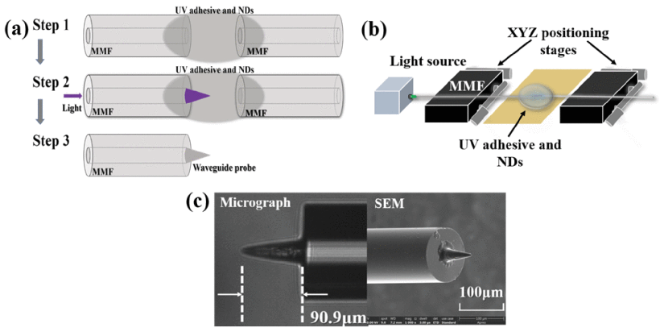
Fig. 1. (a) Schematic diagram of the fabrication procedure of the microtip; (b) Schematic diagram of experimental set up for SWW fabrication; (c) Micrograph and SEM images of self-written microtips.
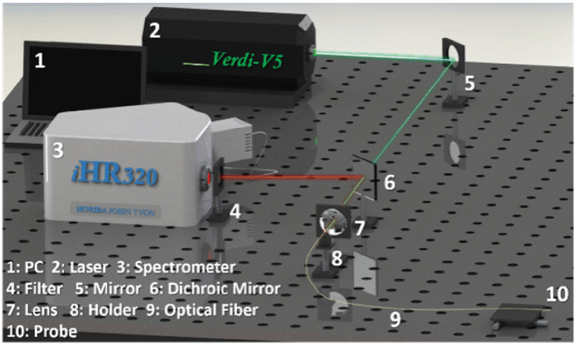
Fig. 2. Schematic diagram of the experimental setup
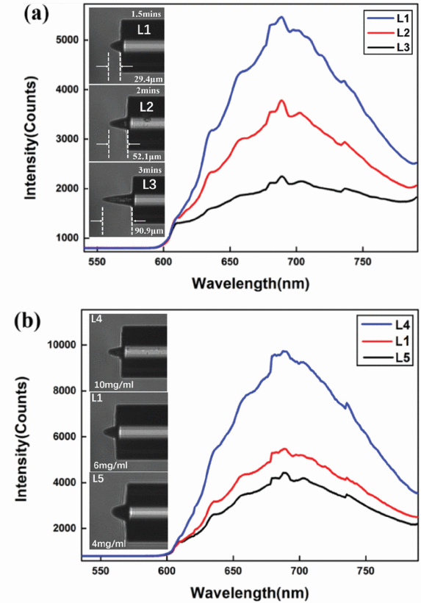
Fig. 3. The measured fluorescence spectrum of fabricated NV-containing microtips with different parameters (Insets: Micrographs). (a) Different lengths: 29.4 μ m (L1), 52.1 μ m (L2) and 90.9 μ m (L3), and the concentration is all 6mg/ml; (b) Different concentrations: 10 mg/mL (L4), 6 mg/Ml (L1) and 4 mg/mL (L5).

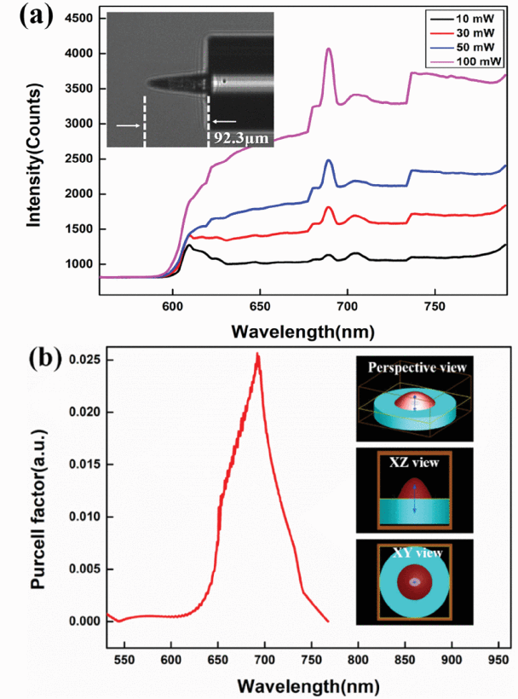
Fig. 4.The NV fluorescence enhanced by cone-like waveguide structure. (a) Resonance peak intensity of a cone-like microtip with NDs containing few NV centers at different excitation powers; (b) Simulated resonance spectrum of the cone-like waveguide.
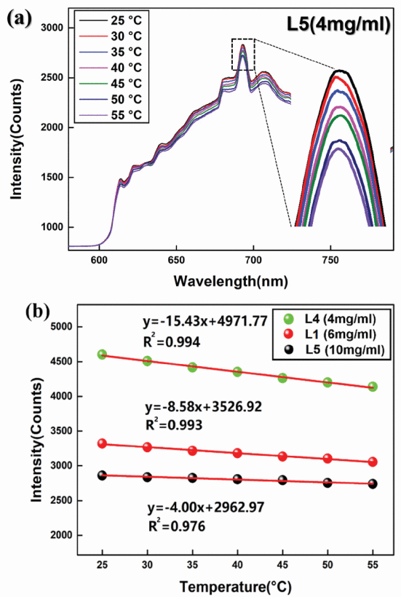
Fig. 5. Experiment demonstration of the fiber microtips for all optical temperature measurement. (a) The temperature response curves of probe L5; (b) The linear fits to the resonant peak intensity vs temperature of the three probes.

