Crystallography of a new Mn(V,Ti,Al)₂O₄ compositionally complex spinel oxide in a BCC compositionally complex alloy
H. Jiang^{a, b}, K.P. Yuª, X.C. Liu^{c}, L.H. He ^{d,e}, B.B. He ^{b*}, M.X. Huang^{a*}
ªDepartment of Mechanical Engineering, The University of Hong Kong, Pokfulam Road, Hong Kong, China
^{b}Department of Mechanical and Energy Engineering, Southern University of Science and Technology, Shenzhen, 518055, China
^{c}Institute of Metals, College of Materials Science and Engineering, Changsha University of Science and Technology, Changsha, 410114, China
^{d}Beijing National Laboratory for Condensed Matter Physics, Institute of Physics, Chinese Academy of Sciences, Beijing, 100190, China
^{e}Spallation Neutron Source Science Center, Dongguan, 523803, China
*Corresponding author: Dr. B.B. He: e-mail: hebb@sustech.edu.cn, Tel: +86-755-88015374
*Corresponding author: Dr. M.X. Huang: email: mxhuang@hku.hk, Tel: +85228597906; Fax: +85228585415

Abstract
The concept of compositionally complex alloy (CCA) has recently been applied in developing compositionally complex oxide (CCO). In this contribution, we discovered a new CCO with a spinel structure that is embedded in a new body-centered cubic CCA matrix. The crystal structure of the newly found CCO is characterized by neutron diffraction and high-resolution transmission electron microscopy. It is found that the chemical formula of the new CCO is Mn(V,Ti,Al)₂O₄, where the Mn atoms occupy the tetrahedral position while the V, Ti and Al atoms share the octahedral sites. The elements that take the octahedral sites are interchangeable. The mechanical behavior was characterized by nano-indentation experiments and the localized strength of CCA is effectively promoted with the existence of CCO. The present work illustrates that the combination of new CCO with new CCA matrix could be a new strategy to develop new oxide-metal composites.

Keywords: compositionally complex alloy; compositionally complex oxide; spinel structure; crystallography; nano-indentation.

Since first reported nearly two decades ago [1], compositionally complex alloy (CCA) [2-4], which is also known as high entropy alloy (HEA) [5-7] or medium-entropy alloy (MEA) [8-10] has been substantially investigated in recent years. Rather than having to require five or more elements within a single metallic material, the definition of CCA is broadened by incorporating either a varied amount or a lower number of constituting elements. To develop unique properties for harsh environment applications such as nuclear plants, different properties of CCA/HEA including thermal [11, 12], magnetic [13, 14], and mechanical [15-19] have been investigated. Interestingly, the concept of high entropy has recently been applied in developing new high entropy oxide (HEO) [20-23]. Different types of HEO are classified according to the crystal structures, including rock salt HEO [24, 25], Fluorite-type HEO [26, 27], Perovskite-type HEO [28-30] and Spinel-type HEO [31, 32]. However, the classification of HEO still tends to be limited to the fact that the number of cations per equivalent position has to be greater than or equal to five [22, 33, 34]. The terminology of compositionally complex oxide (CCO) has a more relaxed definition which allows multiple elements of cations residing on one or more sublattice and does not make assumptions about whether they are randomly distributed [34].
Traditionally, oxides have been extensively integrated for decades into metallic matrices, forming various metal-oxide composites [35], including aluminum- [36], and molybdenum- [37, 38] matrix composites. Nano-sized oxide particles are often employed in oxide dispersion strengthened (ODS) steels [39-44] for potential applications in nuclear plants. It is noted that these existing oxides have simple chemical compositions and are largely different from CCO.
The combination of new CCO in new CCA is worthy of investigation which could bring new discoveries of oxide-metal composite. Here, we report a new CCO with a rod-like morphology embedded in a new low-activation body-centered cubic (BCC) CCA matrix. This new CCO has a chemical composition of Mn(V,Ti,Al)₂O₄, which is determined by detailed elemental analysis. The present work focuses on the crystal structure investigation of this newly developed CCO.
The BCC CCA matrix with a chemical composition of VCrMn_{0.66}Fe_{0.33}Ti_{0.01} (in atomic percentage) was designed based on thermodynamic calculation using ThermoCalc software with the TCFE8 database. V was selected owing to the outstanding performance of V-based alloys in fusion reactors and its high melting point. The selection of Cr was due to its infinite solid solubility in V and contribution to corrosion resistance. Mn and Fe were added to enhance the high-entropy effect, such as lattice distortion, and also to reduce the cost of alloy production. All elements are low-activation with BCC crystal structure. The aim of Ti doping is to absorb possible atmosphere impurities such as O and N. This CCA was fabricated by vacuum arc melting of high-purity metals under argon atmosphere. The 35g ingot was flipped and remelted for five times to ensure the homogeneity of chemical compositions. The cuboid specimens with a dimension of 10 mm× 6 mm× 3 mm were prepared from the ingot by using wire electrical discharge machining and then sealed in the vacuumed quartz tube for isothermal heat treatment at 650 ℃ for 48 h and finally quenched in water. The actual elemental composition and microstructure of the heat-treated samples were characterized by scaning electron microscope (SEM, Sigma 300) equipped with energy dispersive spectroscopy (EDS, Oxford X-Max) detector and electron back-scattering diffraction detector (EBSD, Oxford Symmetry S3). The samples for SEM observation were prepared by initial grounding with silicon carbide grinding papers from p240 to p4000 and final polishing using 0.06 μm colloidal silica suspensions. Based on the preliminary results obtained from the SEM-EDS analysis, transmission electron microscopy (TEM, Talos F200X) armed with a high-angle angular-dark-field (HAADF) detector and super-X EDS detector was used to identify the chemical composition and crystal structure of the new CCO. The specimens for high-resolution transmission electron microscopy (HRTEM) observation were prepared by focused ion beam (FIB) milling from the site-specific region using the lift-out and final thinning method. To verify the existence of the CCO in the BCC CCA matrix and to obtain accurate crystal structure, neutron diffraction tests were performed using the general purpose powder diffractometer (GPPD) at the China Spallation Neutron Source (CSNS). Samples were loaded in 9mm TiZr cans and patterns were collected at room temperature with wavelength band 0.1-4.9Å. Time-of-flight (TOF) neutron data were collected from the 90 ° detector bank with fine radial collimator. The nanoindentation test was performed to verify the strengthening effect of the new CCO on CCA using Bruker Hysitron PI 88 Picoindenter with a Berkovich indenter with a half angle of 65.3° under peak load of 1000 μN at room temperature.
The present CCA matrix has a dominated single-phase BCC microstructure with coarse grain size as demonstrated by EBSD measurement shown in Fig. 1(a). This is consistent with the thermodynamic calculation which also indicates the formation of single BCC phase as long as the temperature does not reach the onset precipitation temperature of both laves and sigma phases (Fig. S1). Note that the noticeable particles within the matrix could be inclusions introduced during the melting process (Fig. 1(a)). The EDS mapping results confirm relatively homogeneous distribution of alloying elements (Fig. 1(b)). The actual composition of the CCA matrix is listed in Table 1, which is consistent with the initial design of chemical composition (VCrMn_{0.66}Fe_{0.33}Ti_{0.01}). Note that the minor Al content could be due to the impurity during fabrication process.
Interestingly, intensive CCOs with rod-like morphology are distributed in the matrix (Fig. 1(c)). Note that the distribution of the CCO depends on the observed depth of the samples. The area fraction of CCO decreases from 3.8% to almost 0% from edge to center (~1.5mm) of the specimen. The gradient distribution of CCO is most likely due to the gradual oxidation starting from the outside part to the inner part of the specimen during isothermal heat treatment. Although the samples were sealed in a quartz tube, the residual oxygen may react with the (Ti,Al)-riched inclusion and finally formed the CCO. The area fraction is determined based on the multiple SEM images at different locations and thickness using the ImageJ software. The existence of precipitates in BCC matrix can also be verified from the neutron diffraction experiment (Fig. 1(d)). The dominated BCC phase in the present CCA has a lattice parameter a=0.291 nm and most of the detected minor peaks are because of the presence of CCO.
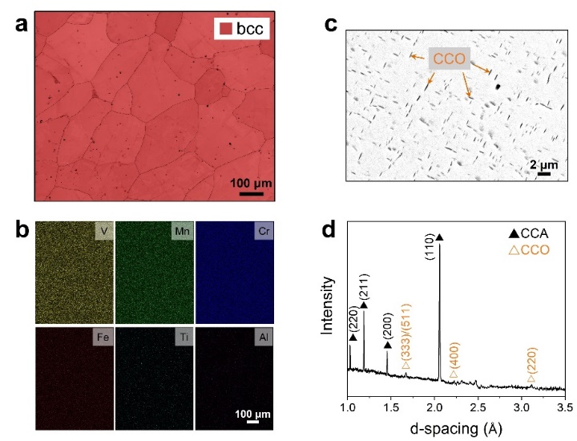
Fig. 1. (a) EBSD phase map overlapped with band contrast, (b) EDS mapping, (c) backscattered electron (BSE) image and (d) Neutron diffraction peak profiles of the presentCCA containing the compositionally complex oxides.

The CCO is subjected to detailed TEM elemental analysis (Fig. 2). Fig. 2(a) is the HAADF-STEM image where the CCO can be clearly identified in the CCA matrix based on the contrast and morphology. This CCO is enriched with Ti, Al, and O and is depleted with Cr and Fe as confirmed from the HAADF-EDS mapping (Fig. 2(b)). In addition, the CCO has a smaller content of V and Mn as compared to that of matrix. The semi-quantitative analysis on the local variation of chemical composition between CCA and precipitate is carried out by using STEM-EDS line-scanning (Fig. 2(c)). The atomic fraction of Ti and Al in the CCO is ~11% and ~7%, respectively. In contrast, these two elements are negligible in the CCA matrix (Table 1). Surprisingly, Cr and Fe which are two principal constituent elements can no longer be detected in the CCO (Fig. 2(c)). The atomic percentage of V in the precipitate is ~21%, which is smaller than that in the matrix (~33%). In contrast, the content of Mn in the precipitate exhibits a very limited reduction as compared to that in matrix (Table 1). Note that the exact concentration of O which belongs to light element in CCO could be subjected to minor error (~2%) using the present detection technique. However, the high concentration of O in the CCO unambiguously confirms the precipitate is indeed oxide (Table 1). A selected area of STEM-EDS mapping on the precipitate is shown in Fig. 2(d). Different from the reported oxides in V-based alloys [45-47], no one or two of the metallic elements in the CCO phase are dominant. Thus, the present rod-like CCO in the CCA matrix can be considered as a new CCO. Among the different alloying elements, the free energy of oxidation of Cr and Fe is the highest while that of Ti and Al is the lowest under isothermal holding at 650 ℃ (Fig. S2), which may suggest that the Ti and Al could replace the Cr and Fe during the formation of CCO to some extent.
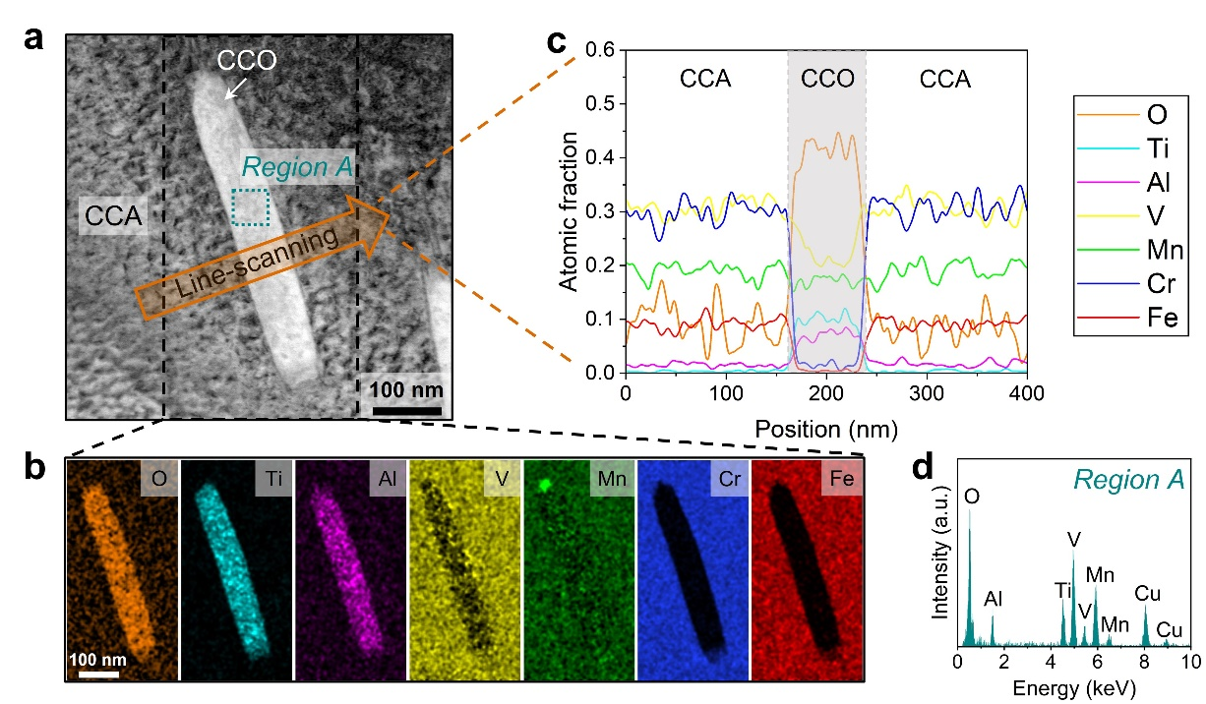
Fig. 2. (a) HAADF-STEM image showing the lamellar morphology of CCO in CCA. (b) HAADF-EDS mapping and (c) line-scanning results of the black-dashed rectangular and orange region, respectively. (d) The HAADF-EDS spectrum of CCO as marked by region A in (a). Cu peak is the artificial signal given by the Cu grid and is not considered in the calculation of the chemical composition of CCO.

Table 1
The actual chemical composition of CCA and region A. Oxygen content in CCA is not concluded.
Area | Actual composition (at. %)
Area | V | Cr | Mn | Fe | Ti | Al | O
CCA | 33.4 | 33.9 | 22.0 | 10.2 | 0.4 | 0.1 | -
Region A | 21.1 | 0 | 19.2 | 0 | 11.0 | 6.8 | 41.9

Detailed analysis on the crystal structures of both CCA matrix and CCO are carried out using HRTEM as presented in Fig. 3. The area containing both CCA matrix and CCO is selected (Fig. 3(a)), with enlarged high-resolution images of three representative regions shown in Fig. 3(b)(d)(f), respectively. According to the fast Fourier transformation (FFT), the lattice parameter of CCO is determined as a=b=c=0.872 nm and the d-spacing of plane (220) is calculated to be 0.31 nm, which corresponds to a typical spinel structure. In general, the chemical formula of compound with a spinel structure can be written as AB₂O₄, where A and B are two metallic elements. The metallic elements tend to occupy either tetrahedral sites or octahedral sites in the crystal structure. However, the EDS result of the CCO shows a more complex element composition as around Mn:V:Ti:Al = 3:3:2:1 in atomic percentage (Table 1). From this perspective, the rod-like CCO can be considered as spinel-type compositionally complex oxide. Note that the atomic ratio of metallic elements in the present CCO is calculated as Mn/(V+Ti+Al)=19.2/38.9, which is close to 1/2. On the one hand, sites A and sites B are always occupied by divalent cations and trivalent cations, respectively. Note that the most common valences of V, Ti, Al are trivalent while Mn is divalent. On the other hand, Mn tends to form MnV₂O₄, MnTi₂O₄, and MnAl₂O₄ while taking the divalent tetrahedral position. Considering the above scenarios, Mn atoms are deemed to occupy the sites A while V, Ti, Al atoms occupy sites B together in current CCO. Therefore, the chemical formula of the CCO can be determined as Mn(V,Ti,Al)₂O₄. The CCA matrix has a BCC structure with a lattice parameter a=b=c=0.291 nm and a d-spacing of (011) plane of 0.21 nm (Fig. 3(d)-(e)). Note that the peaks labeled with the orange hollow triangle in neutron diffraction analysis (Fig. 1(d)) show the same lattice parameter of CCO given by the HRTEM, even though their intensity is much weaker compares to the CCA. Thus, the TEM observation is consistent with the neutron diffraction analysis. Fig. 3(f) exhibits a high-resolution image of a region overlapped with CCO and CCA matrix. The FFT diffractogram in Fig. 3(g) shows that there are two sets of diffraction patterns corresponding to CCO and CCA. The green circles in Fig. 3(g) represent the overlapped diffractogram of the two phases. A specific parallel relationship between the CCO and CCA ((220)_{CCO} // (011)_{CCA}) is confirmed from the diffraction analysis (Fig. 3(g)).
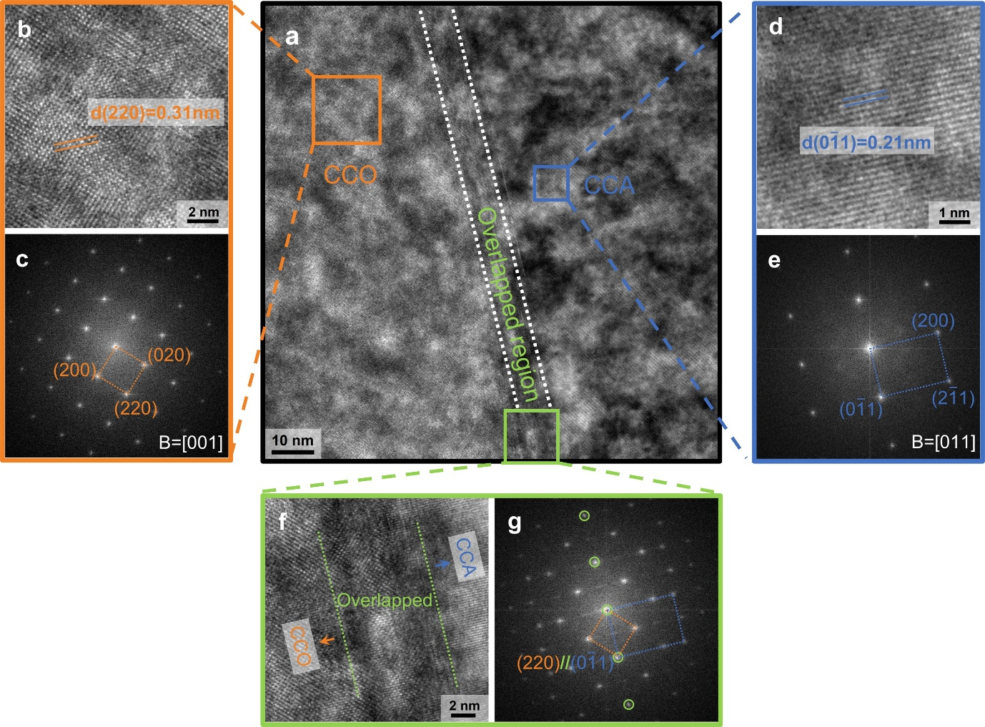
Fig. 3. (a) HRTEM image of the interface of CCO and CCA. (b), (d) and (f) Enlarged high-resolution images of CCO, CCA, and overlapped area in (a), respectively. (c) and (e) The FFT diffractogram of (b) and (d), respectively. (g) FFT diffractogram of (f) showing a specific parallel relationship (220)_{CCO} // (011)_{CCA} between the CCO and CCA.

To clarify the occupancy of each atom in the present CCO, a three-dimensional crystal structure model was established as shown in Fig. 4(a) by using VESTA. Mn atoms are likely to take the tetrahedral sites of spinel structure (Fig. 4(a)), which are surrounded by green tetrahedrons (Fig. 4(b)). Meanwhile, the octahedral sites in spinel structure are shared by V, Ti and Al atoms and indicated by black octahedrons (Fig. 4(b)). Note that the occupancy of V, Ti, Al is interchangeable without preference. Therefore, the amount of atoms of each element in the crystal schematic model which is a single repeating unit can represent only an approximate number rather than the true atomic percentage. The two-dimensional view of Fig. 4(a) along [110] direction is shown in Fig. 4(c), where the oxygen atoms are deleted manually for clarity. Such two-dimensional view can be well correlated to the atomic-resolution STEM image of the CCO crystal structure which is also captured along [110] direction (Fig. 4(d)). The tetrahedral sites are demonstrated by green circles (Fig. 4(d)), which correspond to the occupancy of Mn atoms. The V, Ti and Al atoms are shown in yellow, cyan and purple squares, respectively (Fig. 4(d)). These atoms share octahedral sites together. The crystal structure and parameters of the present CCO can be finally determined as Mn(V,Ti,Al)₂O₄ and a=b=c=0.872 nm, respectively.

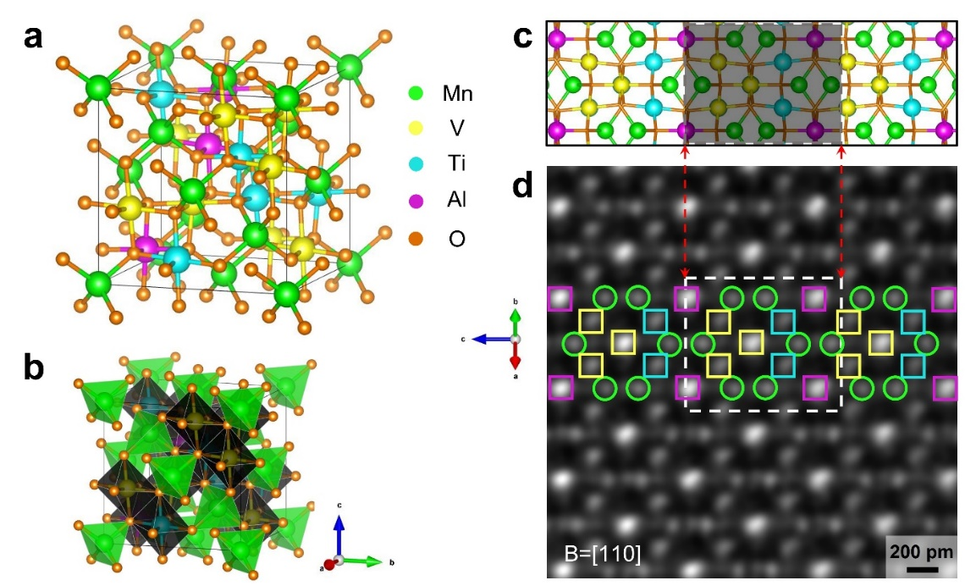
Fig. 4. (a) A three-dimensional view of the crystal structure model of the CCO. Note that the occupancy of V, Ti, Al is interchangeable. (b) Mn atoms take the tetrahedral sites (shown in green), while V, Ti, Al atoms share the octahedral sites (shown in black). (c) Schematic and (d) atomic-resolution STEM image of the crystal structure observed along [110] direction. Oxygen atoms are deleted for clarity.

A series of in-situ nano-indentation experiments have been conducted on different parts of specimens with and without the CCO to analyze the mechanical properties from the perspective of load-displacement curve and nanohardness. The nano-indentation impressions shown in Fig. 5(a) were distributed on the CCA matrix and the distances between two near indents were at least 2 μm, which is larger than the length of five indents. The indentation results with the CCO, which is the darker contrast precipitates in Fig. 5(a), were presented in Fig. 5(b). The size of indents in Fig. 5(b) is smaller than that in Fig. 5(a) and the data was analyzed in Fig. 5(c)-(d). Interestingly, the load-displacement curve (Fig. 5(c)) showing the displacement of CCA matrix is significantly larger than the one with CCO under the same peak load. In other words, the strength of CCA is reinforced by the introduction of CCO. As plotted in Fig. 5(d), the results of in-situ nanoindentation demonstrate the nanohardness of the CCA matrix is lower than that of the CCO+CCA. The average nanohardness of the CCA matrix equals to 9.20 GPa and the value of the CCO+CCA is 11.45 GPa. Thus, the CCO is harder than the CCA matrix at room temperature and the presence of CCO can effectively elevate the localized strength of CCA.
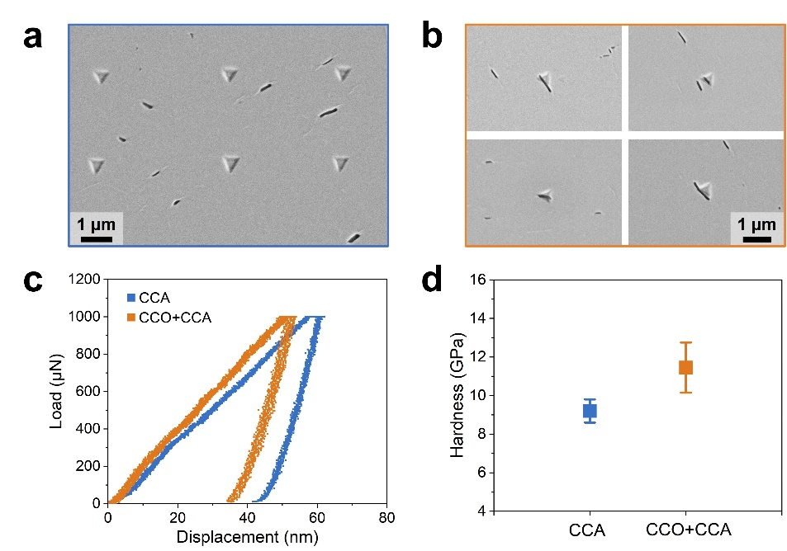
Fig. 5. SEM images showing the indents on (a) CCA matrix and (b) CCO+CCA. (c) The load-displacement curves of CCA matrix and CCO+CCA. (d) The average nanohardness of CCA matrix and CCO+CCA. The error bar represents the standard deviation of at least four measurements.

In summary, we report a new CCO which is embedded in a new low-activation BCC CCA matrix. Based on the detailed microstructure characterization using both HRTEM and neutron diffraction, the crystal structure of the new CCO is determined as spinel with a chemical formula of Mn(V,Ti,Al)₂O₄, in which Mn:V:Ti:Al = 3:3:2:1 in atomic percentage. Moreover, it is found that the introduction of CCO can increase the localized strength of CCA matrix from ~9.20 GPa up to ~11.45 GPa. The present work shows that combining new CCO with new CCA could be a new strategy to develop new oxide-metal composites.

CRediT authorship contribution statement
H. Jiang: Conceptualization, Investigation, Data curation, Formal analysis, Writing – original draft. K.P. Yu: Investigation. X.C. Liu: Investigation. L.H. He: Investigation. B.B. He: Project administration, Conceptualization, Supervision, Writing – review & editing, Funding acquisition. M.X. Huang: Project administration, Conceptualization, Supervision, Writing – review & editing, Funding acquisition.

Data availability
The raw data required to reproduce these findings are available from the corresponding author of this paper. The processed data required to reproduce these findings are available from the corresponding author of this paper.

Declaration of Competing Interest
On behalf of all authors, the corresponding authors state that there is no conflict of interest.

Acknowledgement
M.X. Huang acknowledges the support from National Key Research and Development Program of China (No. 2019YFA0209900), National Natural Science Foundation of China (No. 52130102) and Research Grants Council of Hong Kong (No. R7066-18). B.B. He acknowledges the financial support from the National Natural Science Foundation of China (Grant No. U52071173), Science and Technology Innovation Commission of Shenzhen (Project No. JCYJ20210324120209026) and Major Talent Programs of Guangdong Province (Contract No. 2019QN01C435).
References
[1] J.W. Yeh, S.K. Chen, S.J. Lin, J.Y. Gan, T.S. Chin, T.T. Shun, C.H. Tsau, S.Y. Chang, Adv. Eng. Mater. 6(5) (2004) 299-303.
[2] J. Jensen, B. Welk, R. Williams, J. Sosa, D. Huber, O. Senkov, G. Viswanathan, H. Fraser, Scr. Mater. 121 (2016) 1-4.
[3] Y. Qiu, Y. Hu, A. Taylor, M. Styles, R. Marceau, A. Ceguerra, M. Gibson, Z. Liu, H. Fraser, N. Birbilis, Acta Mater. 123 (2017) 115-124.
[4] A. Fantin, G.O. Lepore, A.M. Manzoni, S. Kasatikov, T. Scherb, T. Huthwelker, F. d'Acapito, G. Schumacher, Acta Mater. 193 (2020) 329-337.
[5] Y. Lu, Y. Dong, H. Jiang, Z. Wang, Z. Cao, S. Guo, T. Wang, T. Li, P.K. Liaw, Scr. Mater. 187 (2020) 202-209.
[6] M. Wang, Y. Lu, T. Wang, C. Zhang, Z. Cao, T. Li, P.K. Liaw, Scr. Mater. 204 (2021) 114132.
[7] T. Xiong, S. Zheng, J. Pang, X. Ma, Scr. Mater. 186 (2020) 336-340.
[8] S. Pan, J. Zhang, B. He, M. Huang, Materials Science Engineering: A 852 (2022) 143692.
[9] X. Yang, Y. Xi, C. He, H. Chen, X. Zhang, S. Tu, Scr. Mater. 209 (2022) 114364.
[10] S. Yoshida, T. Bhattacharjee, Y. Bai, N. Tsuji, Scr. Mater. 134 (2017) 33-36.
[11] A. Karati, K. Guruvidyathri, V. Hariharan, B. Murty, Scr. Mater. 162 (2019) 465-467.
[12] Y. Zhao, H. Chen, Z. Lu, T. Nieh, Acta Mater. 147 (2018) 184-194.
[13] V. Chaudhary, R. Chaudhary, R. Banerjee, R. Ramanujan, Mater. Today 49 (2021) 231-252.
[14] O. Schneeweiss, M. Friák, M. Dudová, D. Holec, M. Šob, D. Kriegner, V. Holý, P. Beran, E.P. George, J. Neugebauer, Physical Review B 96(1) (2017) 014437.
[15] E. Ma, X. Wu, Nat Commun 10(1) (2019) 5623.
[16] S. Wei, S.J. Kim, J. Kang, Y. Zhang, Y. Zhang, T. Furuhara, E.S. Park, C.C. Tasan, Nat Mater 19(11) (2020) 1175-1181.
[17] H. Jiang, M. Wang, M.X. Huang, Appl. Phys. Lett. 121(16) (2022).
[18] Y. Ikeda, B. Grabowski, F. Körmann, Mater. Charact. 147 (2019) 464-511.
[19] A. Asabre, A. Kostka, O. Stryzhyboroda, J. Pfetzing-Micklich, U. Hecht, G. Laplanche, Materials & Design 184 (2019) 108201.
[20] C.M. Rost, E. Sachet, T. Borman, A. Moballegh, E.C. Dickey, D. Hou, J.L. Jones, S. Curtarolo, J.-P. Maria, Nat. Commun. 6(1) (2015) 8485.
[21] B. Yue, W. Dai, X. Zhang, H. Zhang, W. Zhong, B. Liu, S. Kawaguchi, F. Hong, Scripta Materialia 219 (2022) 114879.
[22] A. Sarkar, B. Breitung, H. Hahn, Scr. Mater. 187 (2020) 43-48.
[23] S. Marik, D. Singh, B. Gonano, F. Veillon, D. Pelloquin, Y. Bréard, Scripta Materialia 183 (2020) 107-110.
[24] J. Wang, D. Stenzel, R. Azmi, S. Najib, K. Wang, J. Jeong, A. Sarkar, Q. Wang, P.A. Sukkurji, T. Bergfeldt, Electrochem 1(1) (2020) 60-74.
[25] M. Biesuz, J. Chen, M. Bortolotti, G. Speranza, V. Esposito, V.M. Sglavo, J. Mater. Chem. A 10(44) (2022) 23603-23616.
[26] J. Gild, M. Samiee, J.L. Braun, T. Harrington, H. Vega, P.E. Hopkins, K. Vecchio, J. Luo, J. Eur. Ceram. Soc. 38(10) (2018) 3578-3584.
[27] L. Spiridigliozzi, C. Ferone, R. Cioffi, G. Dell'Agli, Acta Mater. 202 (2021) 181-189.
[28] Z. Liu, S. Xu, T. Li, B. Xie, K. Guo, J. Lu, Ceram. Int. 47(23) (2021) 33039-33046.
[29] S. Zhou, Y. Pu, Q. Zhang, R. Shi, X. Guo, W. Wang, J. Ji, T. Wei, T. Ouyang, Ceram. Int. 46(6) (2020) 7430-7437.
[30] S. Jiang, T. Hu, J. Gild, N. Zhou, J. Nie, M. Qin, T. Harrington, K. Vecchio, J. Luo, Scr. Mater. 142 (2018) 116-120.
[31] Z. Grzesik, G. Smoła, M. Miszczak, M. Stygar, J. Dąbrowa, M. Zajusz, K. Świerczek, M. Danielewski, Journal of the European Ceramic Society 40(3) (2020) 835-839.
[32] A. Mao, F. Quan, H.-Z. Xiang, Z.-G. Zhang, K. Kuramoto, A.-L. Xia, J. Mol. Struct. 1194 (2019) 11-18.
[33] A. Sarkar, B. Eggert, R. Witte, J. Lill, L. Velasco, Q. Wang, J. Sonar, K. Ollefs, S.S. Bhattacharya, R.A. Brand, Acta Mater. 226 (2022) 117581.
[34] M. Brahlek, M. Gazda, V. Keppens, A.R. Mazza, S.J. McCormack, A. Mielewczyk-Gryń, B. Musico, K. Page, C.M. Rost, S.B. Sinnott, APL Mater. 10(11) (2022) 110902.
[35] J. Llorca, C. Gonzalez, Journal of the Mechanics and Physics of Solids 46(1) (1998) 1-28.
[36] P. Ganguly, W.J. Poole, D.J. Lloyd, Scripta Materialia 44(7) (2001) 1099-1105.
[37] P.M. Cheng, G.J. Zhang, J.Y. Zhang, G. Liu, J. Sun, Materials Science and Engineering A-Structural Materials Properties Microstructure and Processing 640 (2015) 320-329.
[38] G. Liu, G.J. Zhang, F. Jiang, X.D. Ding, Y.J. Sun, J. Sun, E. Ma, Nat. Mater. 12(4) (2013) 344-350.
[39] C.A. Williams, P. Unifantowicz, N. Baluc, G.D. Smith, E.A. Marquis, Acta Materialia 61(6) (2013) 2219-2235.
[40] M. Dadé, J. Malaplate, J. Garnier, F. De Geuser, F. Barcelo, P. Wident, A. Deschamps, Acta Materialia 127 (2017) 165-177.
[41] P. Dou, A. Kimura, R. Kasada, T. Okuda, M. Inoue, S. Ukai, S. Ohnuki, T. Fujisawa, F. Abe, Journal of nuclear materials 444(1-3) (2014) 441-453.
[42] T. Stan, Y. Wu, J. Ciston, T. Yamamoto, G.R. Odette, Acta Materialia 183 (2020) 484-492.
[43] G. Spartacus, J. Malaplate, F. De Geuser, D. Sornin, A. Gangloff, R. Guillou, A. Deschamps, Scripta Materialia 188 (2020) 10-15.
[44] C.R. Massey, D.T. Hoelzer, K.A. Unocic, Y.N. Osetskiy, P.D. Edmondson, B. Gault, S.J. Zinkle, K.A. Terrani, Acta Materialia 200 (2020) 922-931.
[45] A. Impagnatiello, D. Hernandez-Maldonado, G. Bertali, E. Prestat, D. Kepaptsoglou, Q. Ramasse, S.J. Haigh, E. Jimenez-Melero, Scr. Mater. 126 (2017) 50-54.
[46] A. Impagnatiello, S.M. Shubeita, P.T. Wady, I. Ipatova, H. Dawson, C. Barcellini, E. Jimenez-Melero, Scr. Mater. 130 (2017) 174-177.
[47] A. Impagnatiello, T. Toyama, E. Jimenez-Melero, J. Nucl. Mater. 485 (2017) 122-128.

