The dual role of TRIP effect on ductility and toughness of a medium Mn steel

C. Hu ^{a, b}, C. P. Huang ^{a, b}, Y. X. Liu ^{a, b}, A. Perlade ^{c}, K. Y. Zhu ^{c}, M. X. Huang ^{a, b, *}

ª Department of Mechanical Engineering, The University of Hong Kong, Pokfulam Road, Hong Kong, China
^{b} Shenzhen Institute of Research and Innovation, The University of Hong Kong, Shenzhen, China
^{c} ArcelorMittal Research, Voie Romaine-BP30320, 57583, Maizières-lès-Metz, France
*Corresponding author: M. X. Huang, Email: mxhuang@hku.hk, Tel: +85239177906, Fax: +85228585415

Abstract:
In this study, the tensile and fracture behaviors of a medium Mn steel fabricated by two thermomechanical processes, namely intercritical annealing (IA) and room-temperature quenching and partitioning (RT Q&P), were investigated. The IA steel consists of ultrafine-grained, fully recrystallized ferrite and austenite, while the RT Q&P steel is comprised of martensite matrix and retained austenite. The austenite in the IA steel is less stable due to its lower carbon content. High-resolution micro-digital image correlation (micro-DIC) results reveal moderate strain localization at boundaries in the RT Q&P steel. On the contrary, strain is highly localized in the austenite of the IA steel, making austenite transform into fresh martensite quickly and promoting the work hardening rate, i.e., transformation-induced plasticity (TRIP) effect. However, this intensive TRIP leads to premature decohesion at boundaries and sudden fracture without post-elongation. The J-integral-based resistance curves (J-R curve) were also measured for both steels. The crack-initiation toughness of the IA steel is 22% less due to its frequent martensite cracking and intergranular decohesion. In contrast, the hierarchical microstructure in the RT Q&P steel suppresses brittle fracture and enables significant crack tip blunting, resulting in a high fracture toughness. The present work illustrates the dual role of TRIP on ductility and fracture toughness, namely, intensive TRIP is useful for tensile strength and uniform elongation, but is harmful to fracture toughness, which contradicts the common belief that TRIP is beneficial for both ductility and toughness.
In this study, the tensile and fracture behaviors of a medium Mn steel fabricated by two thermomechanical processes, namely intercritical annealing (IA) and room-temperature quenching and partitioning (RT Q&P), were investigated. The IA steel consists of ultrafine-grained, fully recrystallized ferrite and austenite, while the RT Q&P steel is comprised of martensite matrix and retained austenite. High-resolution micro-digital image correlation results reveal moderate strain localization at boundaries in the RT Q&P steel. On the contrary, strain is highly localized in the austenite of the IA steel, making austenite transform into fresh martensite quickly and promoting the work hardening rate, i.e., transformation-induced plasticity (TRIP) effect. However, this intensive TRIP leads to premature decohesion at boundaries and sudden fracture without post-elongation. The J-integral-based resistance curves (J-R curve) were also measured for both steels. The crack-initiation toughness of the IA steel is 22% less due to its frequent martensite cracking and intergranular decohesion. The present work illustrates the dual role of TRIP on ductility and fracture toughness, namely, intensive TRIP is useful for tensile strength and uniform elongation, but is harmful to fracture toughness.

Keywords: Medium Mn steel; Fracture toughness; Ductility; Quenching and partitioning; Intercritical annealing.

Introduction
It has been a consistent pursuit to manufacture lightweight structures for automotive applications, and an effective way to realize this target is to employ advanced high-strength steels (AHSS). In addition to high strength, fracture toughness is also essential for structural materials. However, these two desirable properties are mutually exclusive for most structural materials such as steels, and this inborn conflict is the well-known strength-toughness trade-off [1-3]. This contradiction can be understood by considering that the strengthening of steels aims at blocking or inhibiting dislocation glide by various defects [4], which will inevitably induce strain localization or even initiate microcracks. As a result, these strengthening approaches are unsuitable for applications where fracture resistance is vital. On the other hand, a main contribution to the fracture toughness of steels comes from the dislocation activity near crack tip [1]. This mechanism leads to the general but unfortunate conclusion: a steel with higher strength will have more limited dislocation movement and hence lower fracture toughness.
As one of the most promising AHSS, the design, structures and properties of medium manganese steels (MMS) have been extensively investigated [5, 6]. Compared to the first generation AHSS, the weight percentage of Mn in MMS is increased to 3~12% to stabilize austenite and invoke more transformation-induced plasticity (TRIP) effect. It is generally accepted that the TRIP effect during tensile tests is desirable as it induces geometrically necessary dislocations (GND) and promotes dislocation interactions. It has been widely reported that the superior work hardening capacity and enhanced uniform elongation of MMS are mainly due to its intensive TRIP effect [4, 7-10]. For example, Han et al. observed two peaks in the work-hardening curve in a MMS and ascribed it to the double TRIP phenomenon [11]. Raabe et al. proposed that the martensite matrix could become ductile since nanolayer austenite at grain boundary could provide TRIP effect [12]. The importance of TRIP effect is also well reflected in the design of quenching and partitioning (Q&P) steels because more austenite fraction usually leads to better uniform elongation in the Q&P steels [13, 14].
Compared to the tensile properties and deformation behaviors of MMS, their fracture mechanisms are less investigated, and the quantitative measurements of their fracture toughness are even less. Most research adopted Charpy impact tests to measure the toughness of MMS [15, 16]. However, the impact tests suffer from strict geometry requirements, and the high strain-rate makes separating crack initiation and growth stage challenging. In addition, it is well known that the high strain rate of the Charpy test causes adiabatic heating, therefore the temperature rising may stabilize the austenite in MMS and convolute the interpretation of TRIP stability [17]. In contrast, the J-integral-based resistance curve (J-R curve) method could be used to measure the quasi-static fracture property of elastic-plastic materials quantitatively. The main advantage of the J-R curve approach is that size-independent fracture toughness values can be obtained once specific conditions are satisfied.
As discussed before, the beneficial effect of TRIP on tensile ductility is widely reported, but it also raises a question: how will TRIP affect the fracture toughness of MMS? Since the volume fraction of austenite in MMS can be as high as 70% [18], the resulting TRIP phenomenon can be very intense, but its influence on the fracture behavior of MMS is rarely reported. In this regard, it is commonly believed that TRIP can enhance fracture toughness as it promotes plasticity deformation and induces compressive stress near crack tip due to volume expansion[19]. These beneficial effects, usually referred to as TRIP-toughening or TRIP-induced crack termination mechanisms, are often used along with other advantageous mechanisms to explain the exceptional fatigue or fracture properties in steels[2, 20, 21]. However, an in-depth study of the separate role of TRIP effect on fracture toughness is still missing.
In order to focus on the influence of TRIP effect on the fracture behavior of MMS, we choose a model MMS as our material and two processing methods to obtain different initial austenite fraction and elucidate the strength-ductility-toughness relationship. The first processing route is intercritically annealing (IA). This processing route is widely used in industry, and the strength and ductility of IA steels can be adjusted by altering the dislocation density, heating rate, IA temperature and holding time[16, 22-27]. The second processing method is room-temperature quenching and partitioning (RT Q&P) [28]. The Q&P route proposed by Speer et al. is an effective way to obtain high-strength steels[13, 29]. In this treatment, most austenite transforms to martensite during the first quenching process, and the fresh martensite is tempered during the sequent partitioning stage. More importantly, the carbon atoms diffuse into retained austenite during the partitioning stage. The content and stability of retained austenite, which are the dominant factors of the mechanical properties of Q&P steels[9], are affected by the austenitization temperature[30, 31], quenching temperature[14, 32], and partitioning time and temperature[33, 34].
To summarize, a MMS was processed by IA and RT Q&P routes to obtain different microstructures and mechanical properties in this paper. The deformation mechanisms during tensile tests were examined, the quantitative fracture toughness was obtained, and the fracture properties were compared. This work identifies the dual role of TRIP on ductility and toughness in MMS and can provide insights into designing steels with a good combination of strength, ductility and fracture toughness.

Experiments
A MMS with a composition of Fe-0.2C-9.3Mn-2Al (wt.%) was used in this study. The austenitization temperature A_{e3} is around 780 ℃ according to Thermo-Calc software using the TCFE 7 database. Two thermomechanical processing methods were used and illustrated schematically in Fig. 1(a) and (b). The first route was the RT Q&P route[28]. Samples were cut from a hot-rolled plate and then held at 825℃ for 10 minutes, followed by water-quenching to room temperature. After that, they were partitioned at 250℃ for 10 minutes and water-quenched again. The partitioning time and temperature have been carefully optimized to give the best combination of strength, ductility and toughness using bulk samples. In the second IA process, the same hot-rolled steel plate was further cold-rolled for 50% thickness reduction. Afterward, the plate was intercritically annealed at 675℃ for 60 minutes, followed by water-quenching to room temperature. The IA temperature was chosen to give similar tensile strength and total elongation with the RT Q&P steel for better comparison. All tensile samples have gauge dimension of 12×4×2 mm (length×width×thickness).
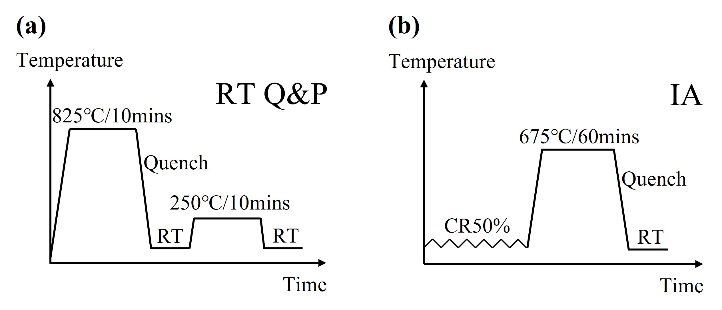
Figure 1 The processing routes of (a) RT Q&P steel and (b) IA steel
All samples subjected to the thermomechanical treatments shown in Fig. 1 were subjected to deep mechanical polishing, and a surface layer of ~0.25 mm in thickness was removed on each side, ensuring the decarbonized surface layer was eliminated completely. The tensile tests were performed using a servo hydraulic MTS810 system (MTS Corporation, Eden Prairie, MN, USA) equipped with a 10 mm extensometer (Epsilon Technology, Jackson, WY, USA) at a strain rate of 5×10⁻⁴/s. The digital image correlation (DIC) technique was conducted to reveal Lüders bands[27]. High-resolution micro-DIC characterization[35] during the tensile tests was performed on a Kammrath & Weiss in-situ tensile stage (Kammrath & Weiss GmbH, Schwerte, Germany). The 50 nm colloidal silica nanoparticles were used to form a dense and uniform speckle pattern on the sample surface. The open-source software Ncorr[36] was utilized to reveal strain partitioning at the grain scale [37].
The compact tension (C(T)) samples with dimension W = 20 mm and thickness B = 1.5 mm were chosen to measure the quasi-static fracture toughness according to the ASTM E1820 standard[38]. Compared to single edge notch bending sample, which is also frequently used to measure fracture toughness, C(T) sample is more suitable for thin-plate materials and consumes less material. After C(T) samples were manufactured by electrical discharge machining, they were fatigue-loaded to form pre-crack. The fatigue load was kept low enough to ensure a small plastic zone around the crack tip and stopped until the pre-crack had a total length of 0.5W. The final pre-cracking force was 250 N, which corresponded to a stress intensity factor of 11.4 MPa×m^{1/2}. After pre-cracking, all samples were grooved on both surfaces, and the grooving depth was 0.1 times the sample thickness. The crack opening displacement (COD) was recorded by a 3 mm COD gauge. At least six successful samples were tested for each steel. The Vickers hardness tests were performed on tensile and C(T) specimens. The indentation force was 200-gram (HV_{0.2}), and the holding time was 20 seconds.
For microstructure characterization, all samples were electropolished using the solution of 10% (volume fraction) perchloric acid and 90% glacial acetic acid. The polished samples were characterized by Zeiss Sigma 300 field emission scanning electron microscopy (FE-SEM, Zeiss, Jena, Germany) equipped with an Oxford Symmetry electron backscatter diffraction (EBSD) detector (Oxford Instruments, Oxfordshire, UK). The operating voltages of SEM and EBSD were 5 kV and 20 kV, and the scanning step size of EBSD was 0.05 μm. The obtained EBSD data was analyzed using HKL CHANNEL5 software. The transmission electron microscopy (TEM) samples were prepared by twinjet electropolishing with the solution of 5% perchloric acid, 25% glycerol and 70% ethanol, and the characterization was performed on Thermo scientific Talos F200X STEM (Thermo Fisher Scientific, MA, USA) operated at 200 kV. The X-ray diffraction (XRD) measurements were performed on a laboratory diffractometer (Rigaku, Tokyo, Japan) using Cu Kα in one-dimensional reflection mode. Synchrotron XRD (18 keV, wavelength 0.068879 nm) measurements were performed at the BL14 beamline of Shanghai synchrotron radiation facility (SSRF). All samples used for XRD measurements were mechanically polished to a cube of 10×3×1.2 mm (length×width×thickness) and then electropolished. The polishing procedure removed more than 500 μm from the surface to ensure that both decarburization and residual stress layers had been removed sufficiently. The diffraction pattern was collected in two-dimensional reflection mode by an image plate detector and then transformed into one-dimensional data using FIT2D package. The dislocation density evolution during tensile tests was calculated by the modified Williamson-Hall (MWH) method based on the synchrotron XRD results[39].

Results

3.1 Initial microstructure
The band contrast (BC) map and inverse pole figure (IPF) of austenite in Fig.2 (a) clearly show the martensite matrix and a small amount of retained austenite in the RT Q&P steel. The high-angle annular dark field (HAADF) image in Fig. 2(b) depicts martensite lath and retained austenite, where austenite is in black contrast and confirmed by selected area electron diffraction (SAED) in the blue circle. Fig. 2(c) presents the corresponding enlarged TEM image inside the white box in (b). High density of dislocations can be observed in martensite (red arrows) and retained austenite (blue arrows).
Fig. 2(d) shows the BC and IPF of austenite of the IA steel before deformation. Both ultrafine austenite and ferrite grains can be observed with low local misorientation, and most grains are equiaxed with the average grain size of 0.81 and 0.70 μm, respectively. Fig. 2(e) and (f) show the HAADF image and Mn weight percentage mapping by EDS, revealing that the Mn weight percentage in austenite is much higher than in ferrite.
The stacking fault energy (SFE) of the austenite in the RT Q&P steel is calculated to be 21.2 mJ/m², while the austenite in the IA steel has a SFE of 24.0 mJ/m². They both fall into the TRIP-dominated region, which agrees well with experimental findings. Detailed calculation processes can be found in the appendix.
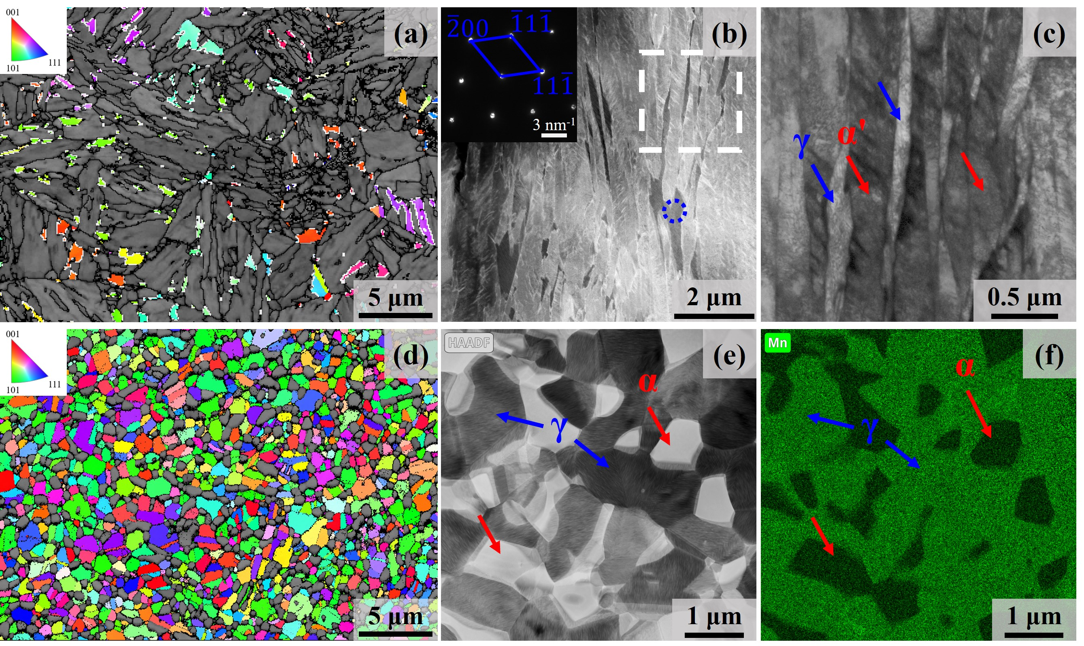
Figure 2 Initial microstructures of the RT Q&P (a-c) and IA steel (d-f). (a) IPF of austenite and BC map, (b) HAADF image with SAED in the blue circle with the zone axis being [011] of austenite, (c) enlarged TEM image inside the white rectangular in (b) of the RT Q&P steel, austenite and martensite are indicated by blue and red arrows, respectively; (d) IPF of austenite and BC map, (e) HAADF image, (f) Mn weight percentage distribution shown in (e) of the IA steel, austenite and ferrite are indicated by blue and red arrows, respectively

3.2 Tensile properties
The tensile properties of the RT Q&P and IA samples are shown in Fig. 3. The RT Q&P sample has continuous yielding with a yield stress of ~1000 MPa, while the IA sample undergoes yield plateau, and the lower yield stress is ~750 MPa. As for the ductility, the RT Q&P sample has 10% uniform elongation and ~20% total elongation, while the IA sample has ~25% uniform elongation but no post-elongation. Obvious Portevin-Le Chatelier eﬀect is observed in the IA sample. The inset in Fig. 3(a) presents the local strain obtained by DIC at chosen elongation levels, namely 3%, 7% for the RT Q&P sample and 3%, 15% for the IA sample. The RT Q&P sample shows uniform deformation at both strains. In contrast, homogenous deformation only occurs at 15% elongation of the IA sample, and clear Lüders bands propagating from the lower part to the upper part of the tensile sample can be seen at 3% elongation.
The true stress-strain curves and corresponding work hardening rate (WHR) curves are shown in Fig. 3(b). Smoothing procedure using Matlab toolbox ‘Sgolay’ was performed before obtaining WHR data since directly calculated WHR curve from original data is in large fluctuation. The WHR of the RT Q&P sample is high initially and decreases continuously until 0.1 strain. On the other hand, the WHR curve of the IA sample shows two distinct stages after the yield plateau. When strain increases from 0.05 to 0.13, WHR rises consistently to ~7000 MPa. At the sequent stage, WHR starts decreasing, and the sample fractures when WHR is still higher than true stress.
The austenite volume fraction measured by lab and synchrotron XRD is presented in Fig. 3(c). For the RT Q&P sample, the initial retained austenite fraction is 12% and decreases slightly to 9% at 0.03 strain. When strain increases to 0.07, the austenite fraction decreases rapidly to less than 1%. For the IA sample, the initial austenite fraction is around 70% and falls to 52% at the end of the yielding plateau. When deformation continues, the austenite fraction drops rapidly. About 10% austenite remains at 0.15 strain and further decreases to 3% after fracture.
Fig. 3(d) presents the Vickers hardness (HV_{0.2}) evolution during tensile tests. Before deformation, the RT Q&P steel already has a high hardness value (420), and the hardness further enhances to 470 after fracture. In marked contrast, the initial hardness of the IA sample is much lower (309), but it rapidly boosts to 483 after fracture.
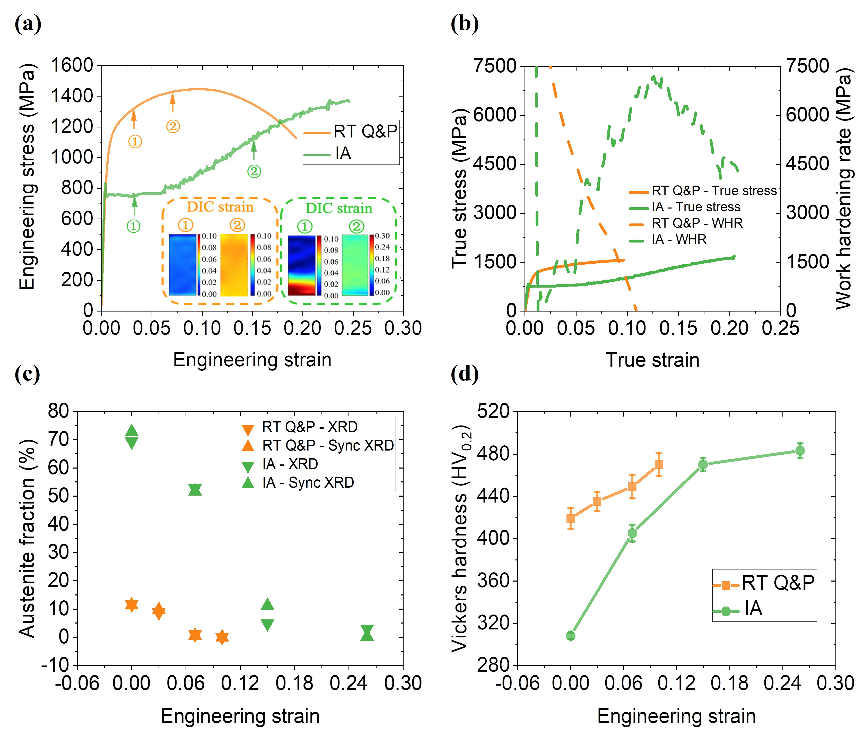
Figure 3 Tensile behavior of the IA and the RT Q&P steel, (a) engineering stress-strain curves with DIC results of strain in the inset, (b) true stress-strain and work hardening rate curves, (c) austenite fraction, (d) Vickers hardness evolution during tension
To better reveal strain partitioning and deformation mechanisms, micro-DIC was used during tensile tests. Fig. 4 (a) and (b) display the initial microstructure of the RT Q&P steel, and (c) to (e) are the distribution of local uniaxial strain at the global strain of 3%, 7% and 10%. Fig. 4(c) demonstrates that even at minor global deformation, strain localization is already established at block boundary, packet boundary and prior austenite grain boundary (PAGB), as shown by the white dash lines in Fig. 4(a) and (c). The strain localization is permanent since the localized high strain does not mitigate as global strain increases, as presented by Fig. 4(d) and (e). The maximum, minimum and average strain computed by DIC at different global strains is plotted in Fig. 4(f). It is found that the average strain agrees well with the nominal global strain, demonstrating the reliability of micro-DIC results. The minimum local strain keeps constant at around zero, indicating that some areas deform negligibly until 10% global strain. On the other hand, the maximum local strain boosts rapidly, reaching 25% at 10% global strain. Fig. 4 (g) displays the local strain profile along the solid white line in Fig. 4(b) and (e), and it reveals considerable strain variation at different blocks inside the same packet. Fig. 4(h) shows that the tensile fracture surface is full of ductile dimples, which agrees well with its tensile curves.
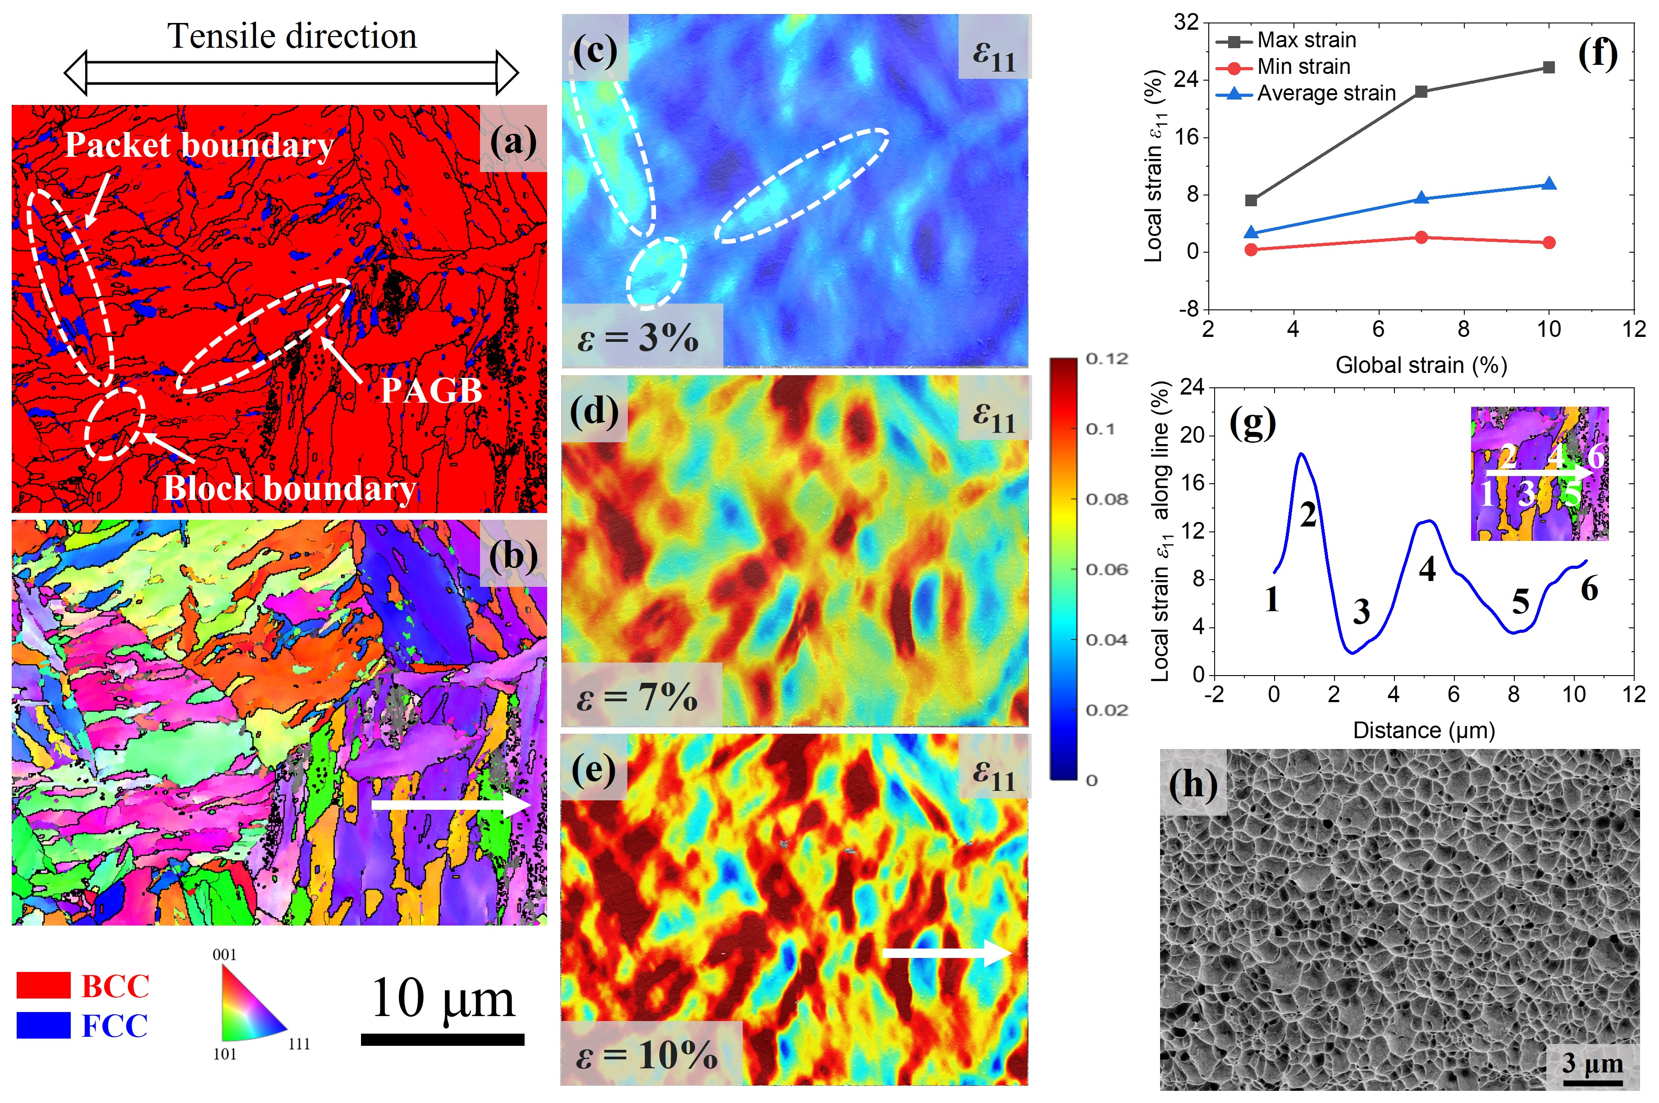
Figure 4 Micro-DIC results of the RT Q&P steel, (a) phase map, martensite is in red and austenite is in blue, (b) IPF map of the plane normal before testing, (c) to (e) local uniaxial strain distribution at global strain of 3%, 7% and 10%, (f) local strain evolution with global strain, (g) strain localization along the solid white line in (e), (h) fracture surface. The legend and scale bar of (a) to (e) are shown in the bottom left
The micro-DIC result of the IA steel is presented in Fig. 5. Similarly, Fig. 5(a) and (b) show the initial microstructure, and the local strain evaluated at the global strain of 7% (the end of Lüders bands), 15% and 23% are presented in Fig. 5(c) to (e). The result at 7% strain reveals that strain is mainly localized at the austenite area (white dash lines in (a) and (c)). The EBSD phase map at 7% strain (not shown here) confirms that these highly deformed austenite grains have transformed into martensite already. Since these fresh martensite grains are much harder than surrounding ferrite or austenite, high strain and stress gradients emerge along phase boundaries, leading to easy boundary decohesion and initiation of microcracks, as shown in the inset of Fig. 5(e). The local strain values in austenite/martensite are collected, and the first ten grains with the highest and lowest strain are classified as high-strain and low-strain grains, respectively. The statistical results are presented in Fig. 5(f). High-strain grains are generally less stable austenite grains that transform early during deformation. This observation indicates some fresh martensite grains carry incredibly high strain (~37%). Fig. 5(g) displays the local strain profile along the solid white line in Fig. 5(b) and (e). A strain valley (~15%) is observed near grain 1, while a peak value (~45%) emerges at grain 3, demonstrating the vast strain gradient in such a small distance (~30% difference over 1μm). Fig. 5(h) displays the corresponding tensile fracture surface, where flat quasi-cleavage surfaces (yellow arrows, more evidence can be found in the appendix) and intergranular microcracks (red arrows) can also be observed in addition to ductile dimples.
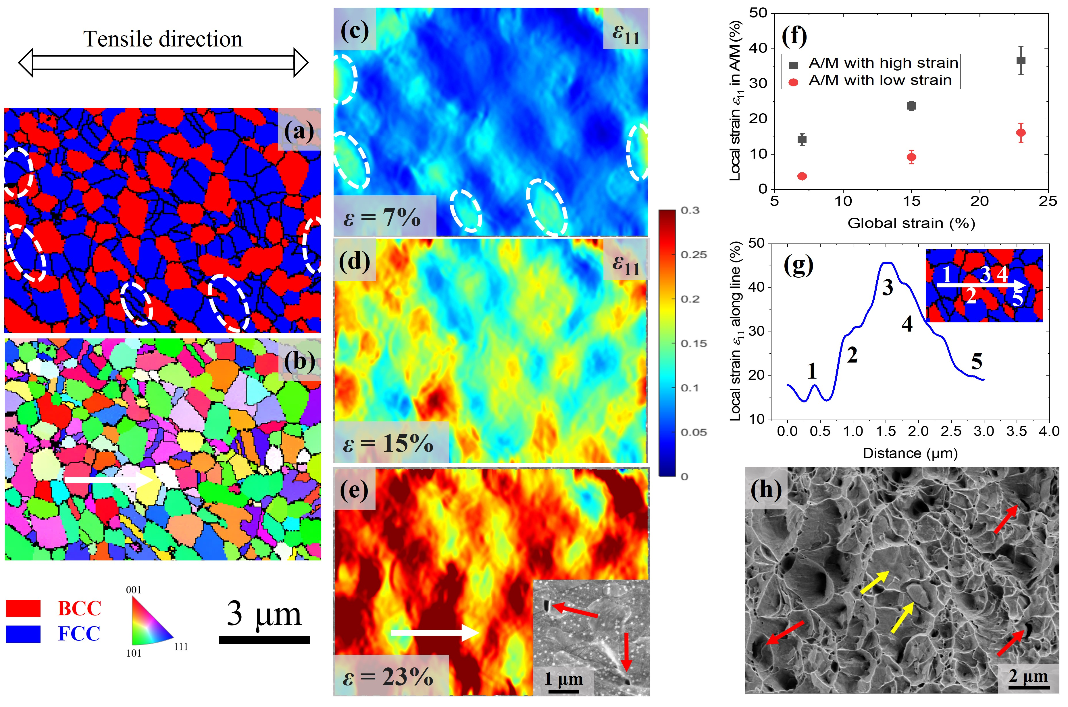
Figure 5 Micro-DIC results of the IA steel, (a) phase map, ferrite is in red and austenite is in blue, (b) IPF map of the plane normal before testing, (c) to (e) local uniaxial strain distribution at global strain of 7%, 15% and 23%, the inset of (e) shows micro-crack initiation at phase boundaries, (f) local strain of ten most and ten least deformed grains, (g) strain localization along the solid white line in (e), (h) fracture surface. The legend and scale bar of (a) to (e) are shown in the bottom left

3.3 Fracture properties
According to the ASTM E1820 standard, the fracture properties were measured and presented in Fig. 6. It has been confirmed that all requirements in the standard have been satisfied; therefore, the corresponding plane strain crack-initiation toughness K_{JIc} can be obtained by:
${\text{K}}_{\text{JIc }}\text{= }\sqrt{\text{E}{\text{J}}_{\text{Ic}}/\text{(1-}{\text{μ}}^{\text{2}}\text{)}}$ (1)
Where J_{IC} is the J-integral at the intersection of 0.2 mm construction line and fitted resistance curve, E is elastic modulus and μ is Poisson's ratio.
Fig. 6(a) shows that the K_{JIc} of the RT Q&P steel is 89.9 $\text{MPa}\sqrt{\text{m}}$, which is 22% higher than that of the IA steel (73.9 $\text{MPa}\sqrt{\text{m}}$). On the other hand, when the crack extension increases to 1.5 mm, the corresponding resistance (referred to as crack growth toughness at 1.5 mm, K_{J1.5}) of these two materials becomes very close (129.2 and 138.4 $\text{MPa}\sqrt{\text{m}}$ for the RT Q&P and the IA steel, respectively). To compare the mechanical performance of two steels comprehensively, two parameters (i.e., uniform elongation and the product of uniform elongation and ultimate tensile strength) are used to measure tensile properties while fracture toughness K_{JIc} stands for fracture property. Fig. 6(b) schematically presents the comparison and reveals that tensile performance is promoted but fracture toughness deteriorates due to more TRIP in the IA steel.
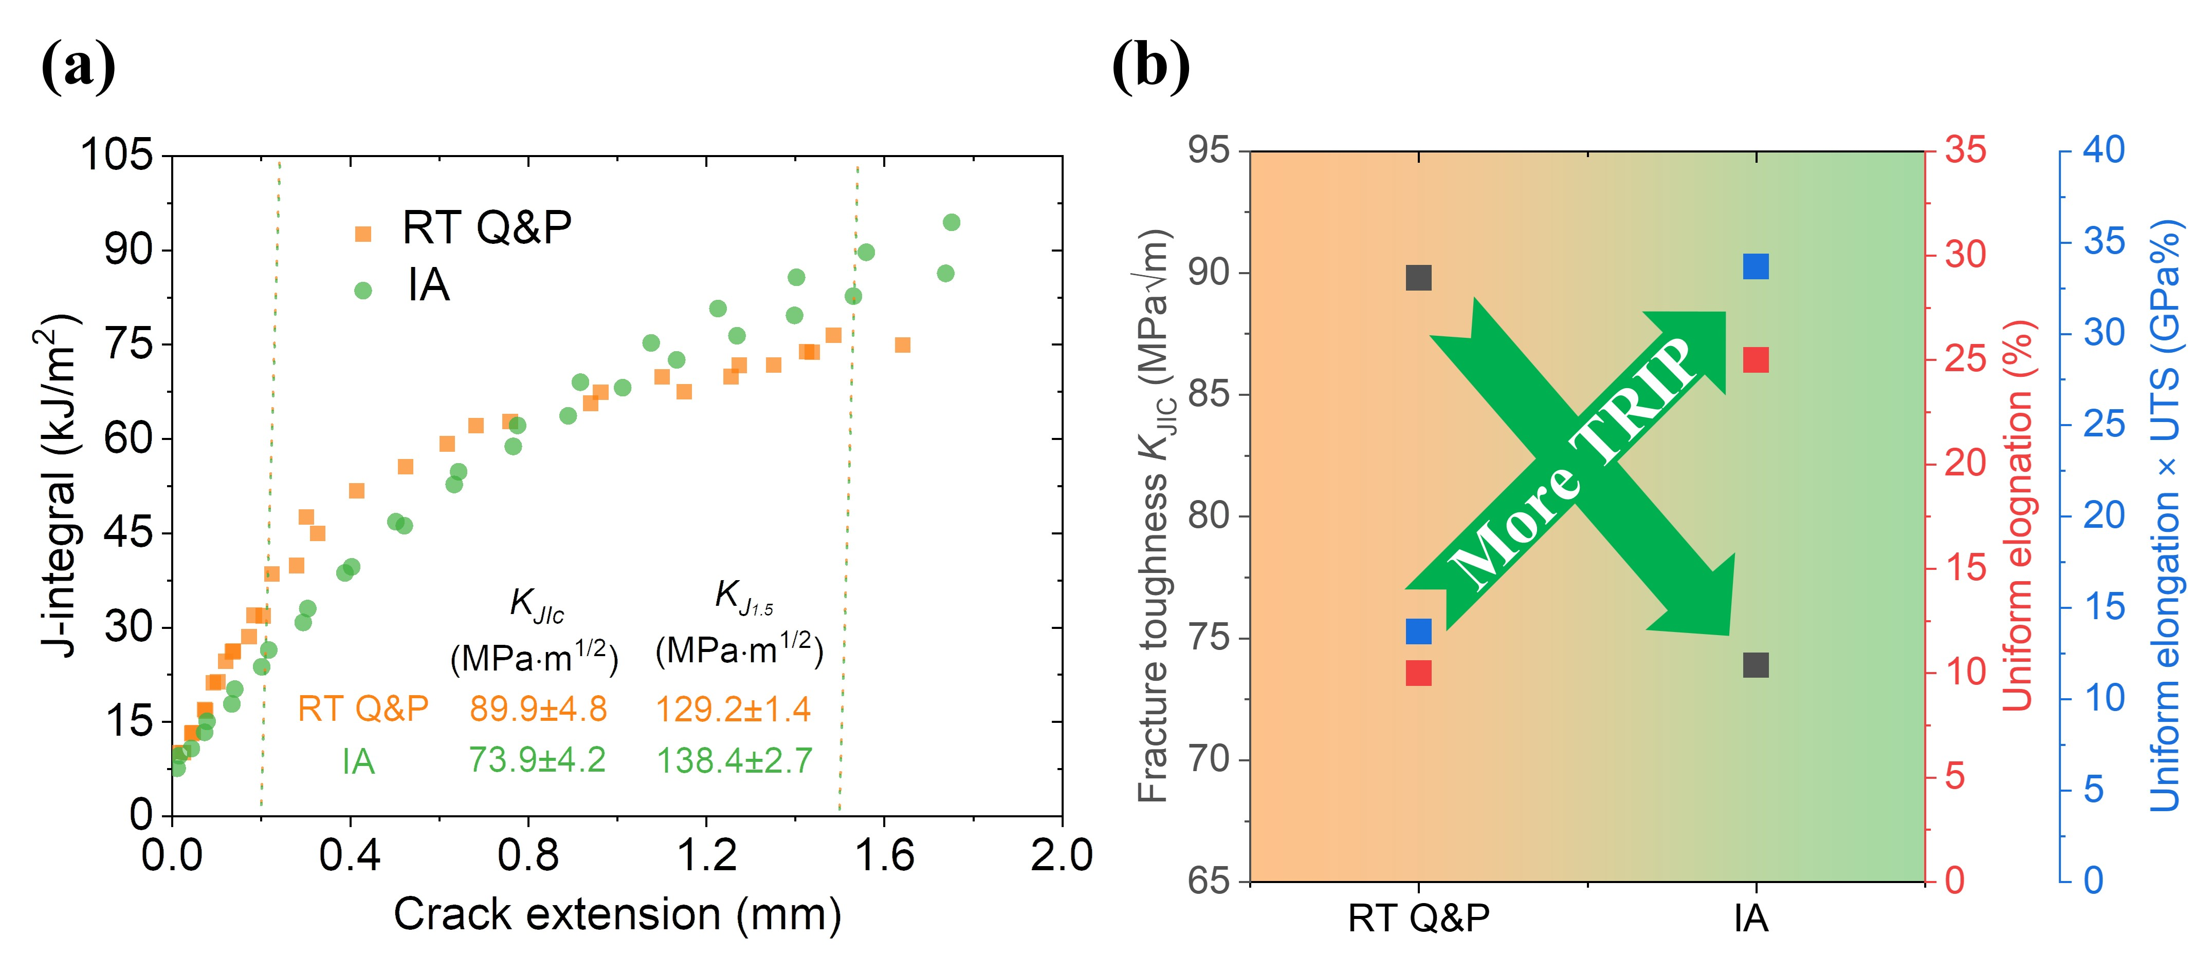
Figure 6 Mechanical properties of the IA and RT Q&P steel, (a) fracture toughness data from two representative samples of each steel, (b) schematic diagram of the tensile and fracture properties comparison
The fracture surfaces of the IA and RT Q&P C(T) sample are presented in Fig. 7. The macroscopic fracture surface of the RT Q&P steel in Fig. 7(a) is more rugged and decorated with ramp surfaces. In contrast, the surface of the IA sample in Fig. 7(c) is smooth with few short delamination cracks. At higher magnification, Fig. 7(b) demonstrates that ductile shear dimples still dominate in C(T) samples of the RT Q&P steel, contributing to the relatively high crack-initiation fracture toughness. On the other hand, the IA sample has mixed fracture types, including dimples, intergranular and quasi-cleavage fracture.
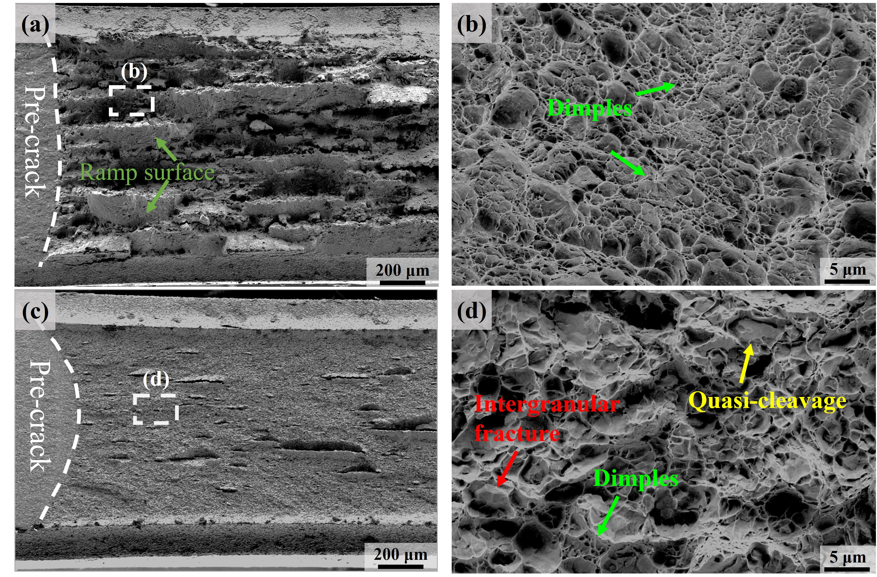
Figure 7 The fracture surface of the IA and RT Q&P C(T) samples at different magnifications, (a) and (b) are of RT Q&P sample, (c) and (d) are of IA sample
Interrupted tests were performed on C(T) samples that had been pre-cracked to study how crack initiates from fatigue pre-crack. The C(T) samples used here were grooved only on one side, and the non-grooved side was employed for EBSD and SEM characterization. Fig. 8(a) is the phase map of the RT Q&P steel after pre-cracking, and the IPF of two selected areas (white dash line indicates crack path determined after fracture) are shown in (b1) and (c1), while (b2) and (c2) are SEM images taken after crack just went through the respective area. Block 1 and 2 in Fig. 8(b1) belong to the same packet, and block 3 is in another packet. Fig. 8(b2) shows that crack goes along the block boundary (i.e., 1 and 2) at first but gets deflected when it meets another packet. After deflection, the crack goes through block 3 trans-granularly. Similarly, block 4 and 6 in Fig. 8(c) are identified in the same packet, while block 5 and 7 are in other packets. In addition to the 4-5 block boundary, the crack cuts through block 6 directly. Additionally, significant plastic deformation is observed at boundaries of 4-5 and 5-7. Fig. 8(d) shows the complete crack path after the test, where a tortuous crack path is observed. Fig. 8(e) presents the Von-Mises strain expressed in the undeformed state from micro-DIC results, and it shows that the strain distribution is less localized with several high-strain branches, and the main high-strain band is ~8 μm wide. The plastic zone at the free surface was estimated to be ~ 72 μm (see appendix for detailed calculation).
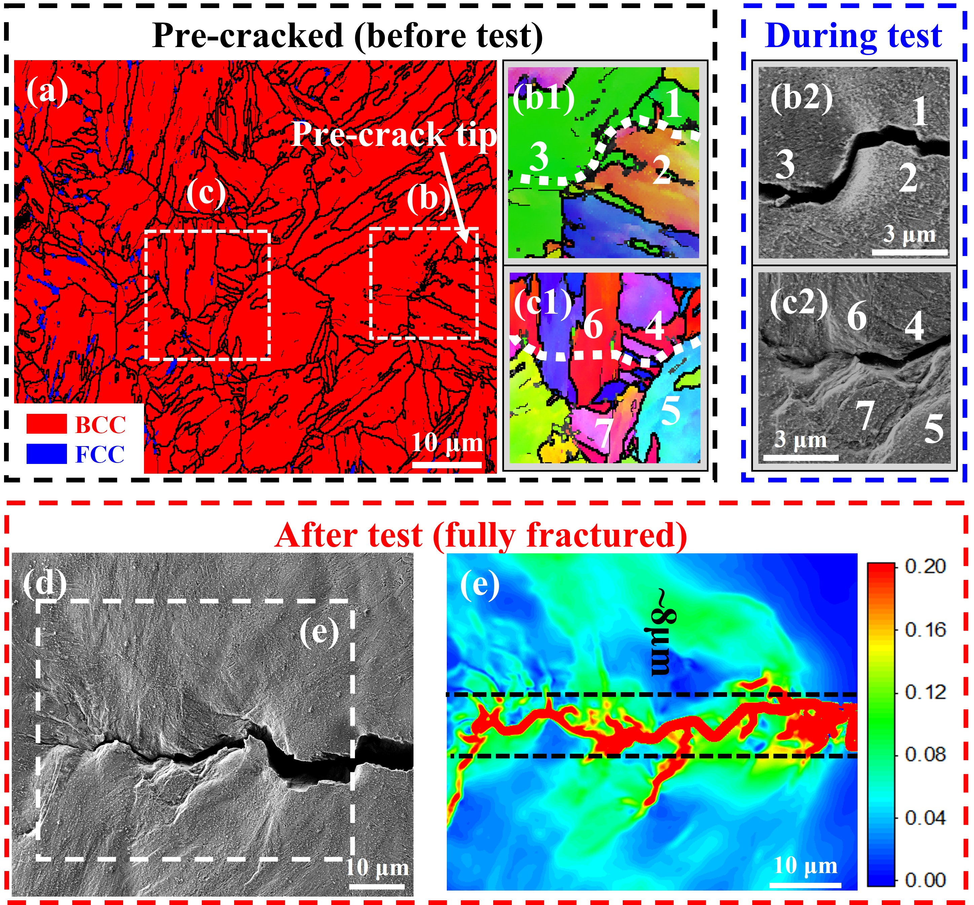
Figure 8 Interrupted crack initiation test of RT Q&P steel, (a) initial phase map, (b1) IPF and (b2) SEM of the first selected area, (c1) IPF and (c2) SEM of the second selected area, (d) SEM of the fractured sample showing crack path, (e) Von-Mises strain from DIC computation
The same results of the IA steel are presented in Fig. 9. Fig. 9(a) is the phase map after pre-cracking, and two areas are selected and presented in (b) and (c). The grains are labeled 1 to 7 in (b) and 8 in (c). Grain 1, 3, 6 are identified as ferrite, and grain 2, 4, 5, 7 and 8 are austenite initially, but they all transform into martensite after the crack reaches their respective areas (EBSD map not shown here). By comparing Fig. 9(b1) and (b2), the crack is observed to grow along grain boundaries of 1-3, 2-5, 4-5, 5-6 and 5-7, indicating the high tendency of interfacial cracking. On the other hand, Fig. 9(c1) and (c2) confirm that brittle cleavage fracture occurs in large austenite after it transforms into martensite (confirmed by EBSD results since the straight crack path is very close to the cleavage plane of martensite). Fig. 9(d) shows that the surface after crack growth is flat without noticeable relief. This distinct feature demonstrates minimal plastic deformation in the IA steel. Fig. 9 (e) shows the Von-Mises strain from micro-DIC results, and it also confirms that the high strain region is very straight and localized in a small band narrower than 2 μm. The plastic zone at the free surface was estimated to be ~ 127 μm.
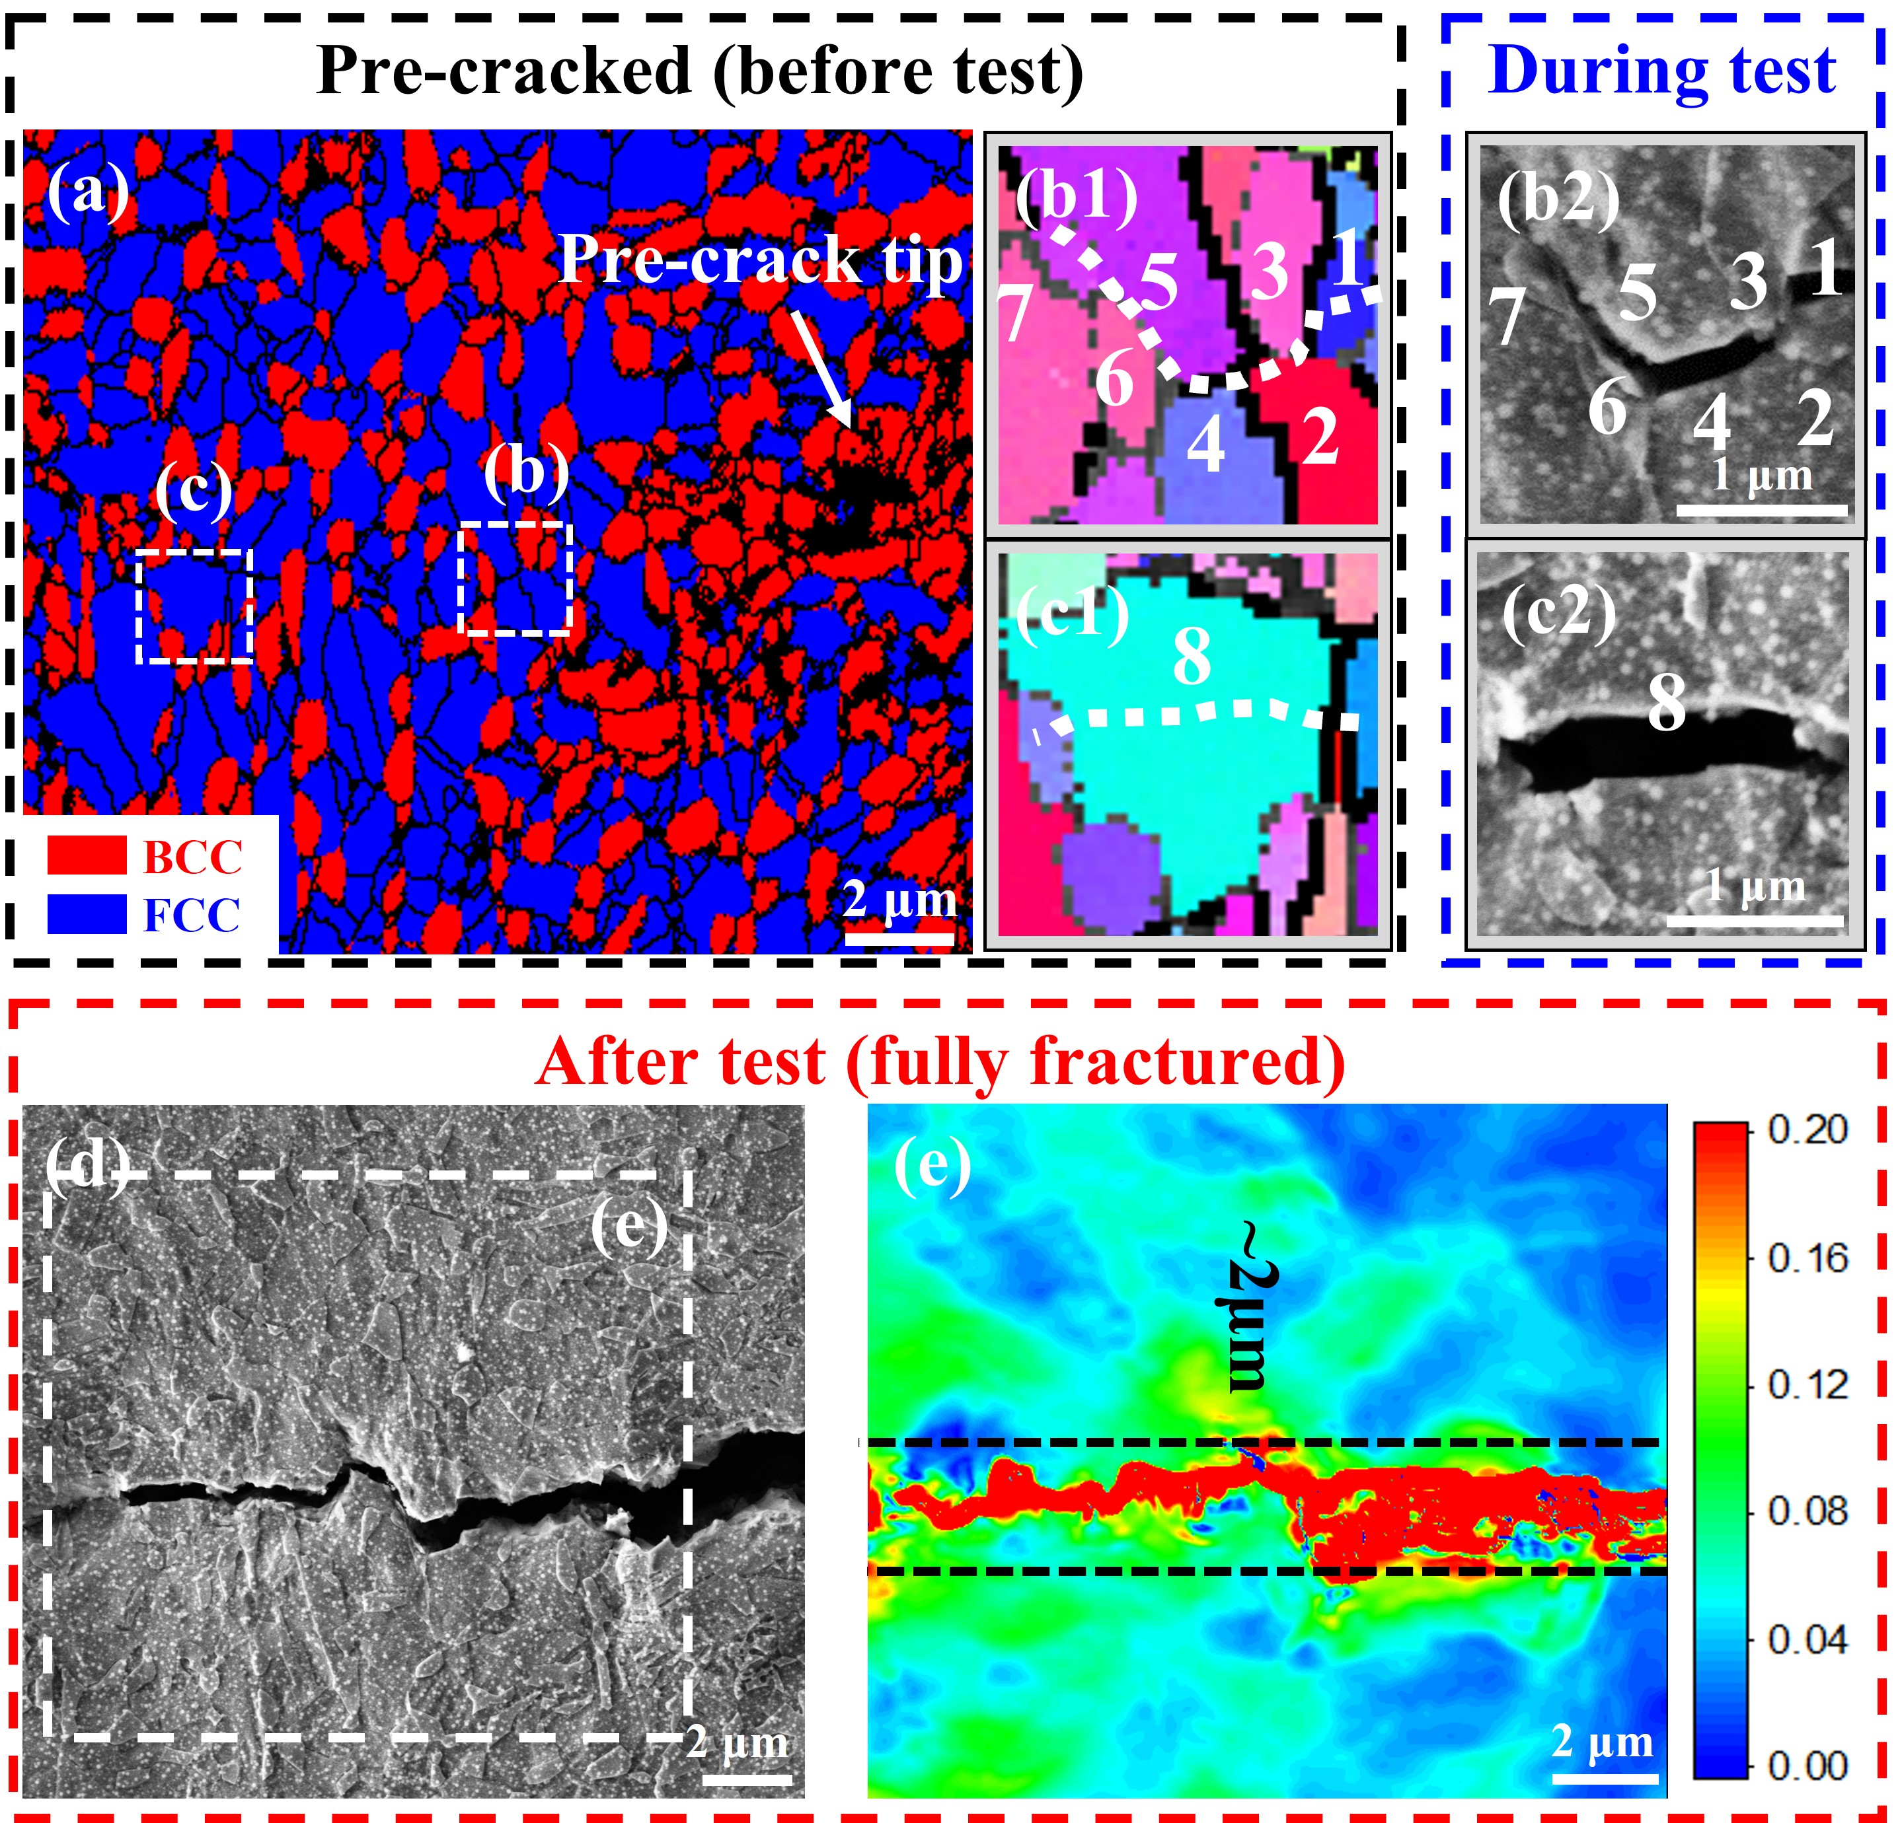
Figure 9 Interrupted crack initiation test of IA steel, (a) initial phase map, (b1) IPF and (b2) SEM of the first selected area, (c1) IPF and (c2) SEM of the second selected area, (d) SEM of the fractured sample showing crack path, (e) Von-Mises strain from DIC computation
Since Fig. 8 and 9 focus on the crack initiation process, and the figures are taken on the free surfaces where plane-stress condition prevails, additional EBSD characterizations on the middle-thickness after crack extension of 1.8mm are performed, as shown by the IPF and phase mapping in Fig. 10. Fig. 10(a) demonstrates that the crack propagates in a ductile way, i.e., by voids formation and coalescence, in the RT Q&P sample. The crack goes through the prior austenite grain at the upper right region and then deflects and ceases to grow after it meets with the PAGB (white dash line). Another large, coalesced void forms at the adjacent PAGB in front of the current crack tip. Both observations agree well with Fig. 8 despite different stress states and further confirm that the fracture process is ductile in the RT Q&P steel. On the other hand, the IPF and phase maps of the IA sample are shown in Fig. 10(c) and (d). The crack tip radius is much smaller than the RT Q&P sample, indicating that crack tip blunting and associated plastic deformation is limited. The inset in Fig. 10(c) confirms that the crack goes along grain boundary. The phase map in Fig. 10(d) reveals that almost all austenite near the crack tip has transformed into martensite and indicates extensive TRIP effect, which has salient influence on the fracture mechanisms. The estimated size of the plastic zone of the RT Q&P and IA steel are 1750 μm and 3680 μm, respectively.
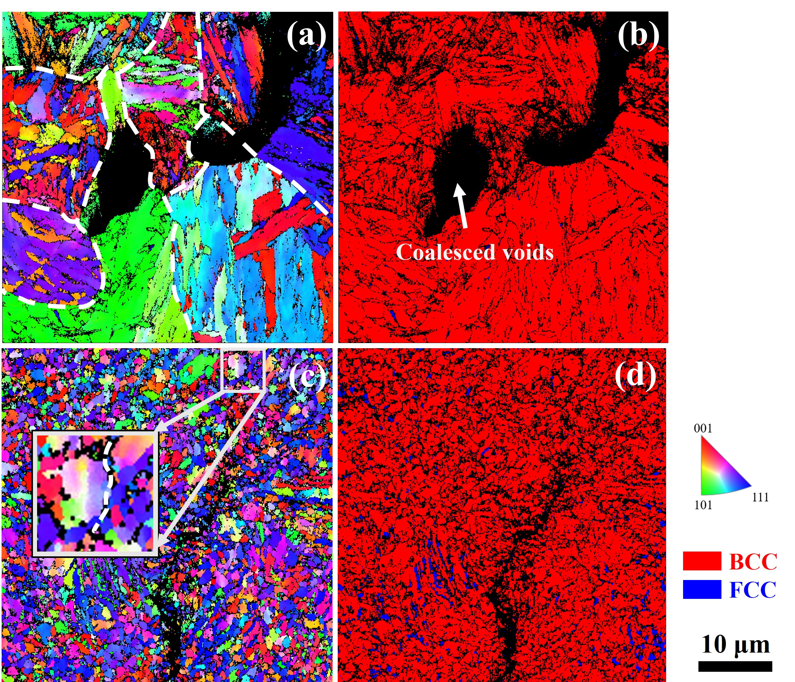
Figure 10 Crack growth behavior of the IA and RT Q&P steel, (a) IPF, (b) phase map of the RT Q&P C(T) sample, (c) IPF and (d) phase map of the IA C(T) sample. White dash lines in (a) stand for PAGB, white dash line in the inset of (c) is crack growth path. The legend and scale bar are at the right bottom
After the fracture toughness tests, the Vickers hardness distribution near the crack tip was measured, and the results are presented in Fig. 11(a) to (d). For the IA sample in Fig. 11(c) and (d), the hardness near the crack tip reaches ~600 and is much higher than the value of fractured tensile specimens (~483). Compared to the IA sample, the hardness enhancement around the crack tip of the RT Q&P steel is limited, which agrees well with the trends in Fig. 3(d). However, the hardened region of the RT Q&P steel is larger than the IA sample. This comparison again implies that crack tip hardening is not localized, and surrounding materials around the crack tip more uniformly accommodate the plastic deformation in the RT Q&P sample. On the contrary, the crack propagates in a brittle manner in the IA steel, causing its plastic deformation capacity to be not fully exploited and surrounding materials not work-hardened.
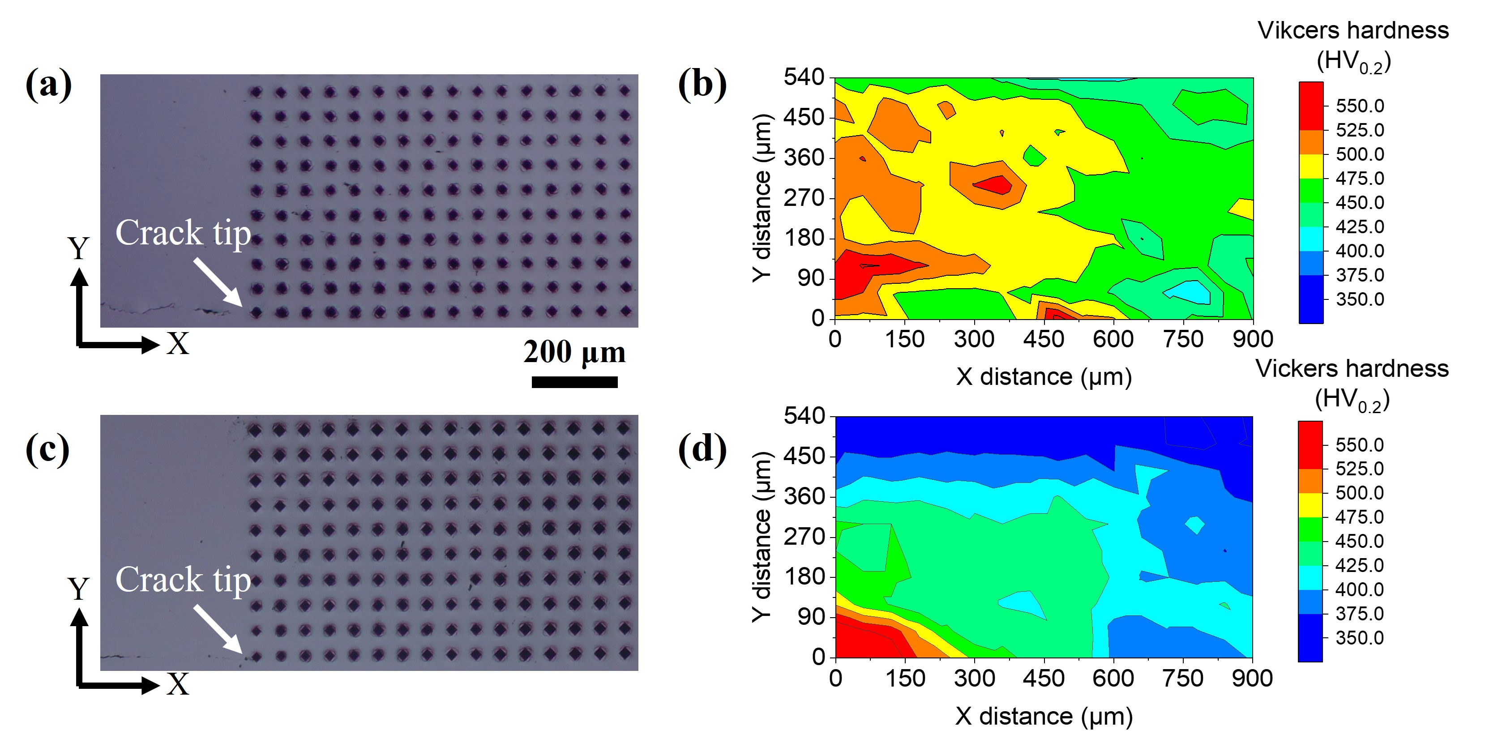
Figure 11 Vickers hardness matrix with a spacing of 60μm and hardness distribution, (a) and (b) are of the RT Q&P steel, (c) and (d) are of the IA steel

4. Discussion

4.1 Deformation mechanisms during tensile tests
The IA and the RT Q&P steel exhibit distinct tensile properties in yielding behavior, work hardening and damage initiation mechanisms, which will be discussed in detail.
For the RT Q&P steel, around 88% austenite has transformed into martensite during room-temperature quenching. This displacive martensitic transformation induces a high density of dislocation and internal residual stress in the martensite matrix. The following short partitioning treatment relieves most residual stress. Nevertheless, the remaining dislocation density in the martensite matrix of the RT Q&P steel is still high, as demonstrated in Fig. 2(c). The martensite matrix with dense dislocations provides improved yield strength and continuous yielding behavior. In marked contrast, due to the prolonged annealing at high temperature, the initial microstructure of the IA steel consists of recrystallized ferrite and austenite. Therefore, the IA steel exhibits lower yield stress and discontinuous yielding behavior, as confirmed by the DIC results in the inset of Fig. 3(a).
Dislocation density calculation by the MWH method using synchrotron XRD results was performed to explain the deformation of two materials. According to the MWH theory, the shape of diffraction peaks is related to the microstructural features, including average crystalline size (L) and dislocation density (ρ) by[39, 40]:
$∆K=0.9/L+{πA^{2}b^{2}ρ}^{\frac{1}{2}}\left(K{\overline{C}}^{1/2}\right)/1+O(K^{4}\overline{C})$ (2)
where b is the magnitude of the Burgers vector, ρ is the dislocation density, and K is the Bragg position, ΔK is the full width at half maximum (FWHM) of the diffraction peaks. $\overline{C}$ is the average dislocation contrast factor in consideration of the elastic anisotropy and expressed by[41]:
$\overline{C}=C_{h00}\left(1-q(h^{2}k^{2}+ k^{2}l^{2}+ l^{2}h^{2})/{(h^{2}+ k^{2}+ l^{2})}^{2}\right)$ (3)
where both $C_{h00}$ and q depend on three anisotropic elastic constants C₁₁, C₁₂ and C₄₄, and q represents the respective fraction of screw and edge dislocation. For both steels, the elastic constants C₁₁=169GPa, C₁₂=82GPa and C₄₄=96GPa are taken for austenite, and C₁₁=230GPa, C₁₂=135GPa and C₄₄=116GP for ferrite and martensite[42].
Fig. 12(a) and (b) show the first 11 peaks at different strain levels of the RT Q&P and IA steels obtained by synchrotron XRD. The first five FCC peaks and four BCC peaks were used to perform a linear fit between $∆K$ and $K{\overline{C}}^{\frac{1}{2}}$. The MWH plot of the IA steel at 0% strain is presented in Fig. 12(c) for illustration, and good fitting can be obtained for all samples. The dislocation density evolution of both steels is shown in Fig. 12(d). It should be noted that dislocation density is not evaluated after fracture in both materials because FCC peaks become too weak to obtain reliable results. Before deformation, the dislocation inside both austenite and ferrite phases of the IA steel is scarce (~ 2×10¹⁴/m²), which is around one order less compared to the RT Q&P steel (14×10¹⁴/m² of the austenite and 25×10¹⁴/m² of the martensite)[43]. As engineering strain increases, dislocations multiplicate rapidly in the IA steel, and the FCC phase has a slightly higher density than the BCC phase at both 0.07 and 0.15 strain. For the RT Q&P steel, retained austenite also possesses higher dislocation multiplication rate compared to martensite.
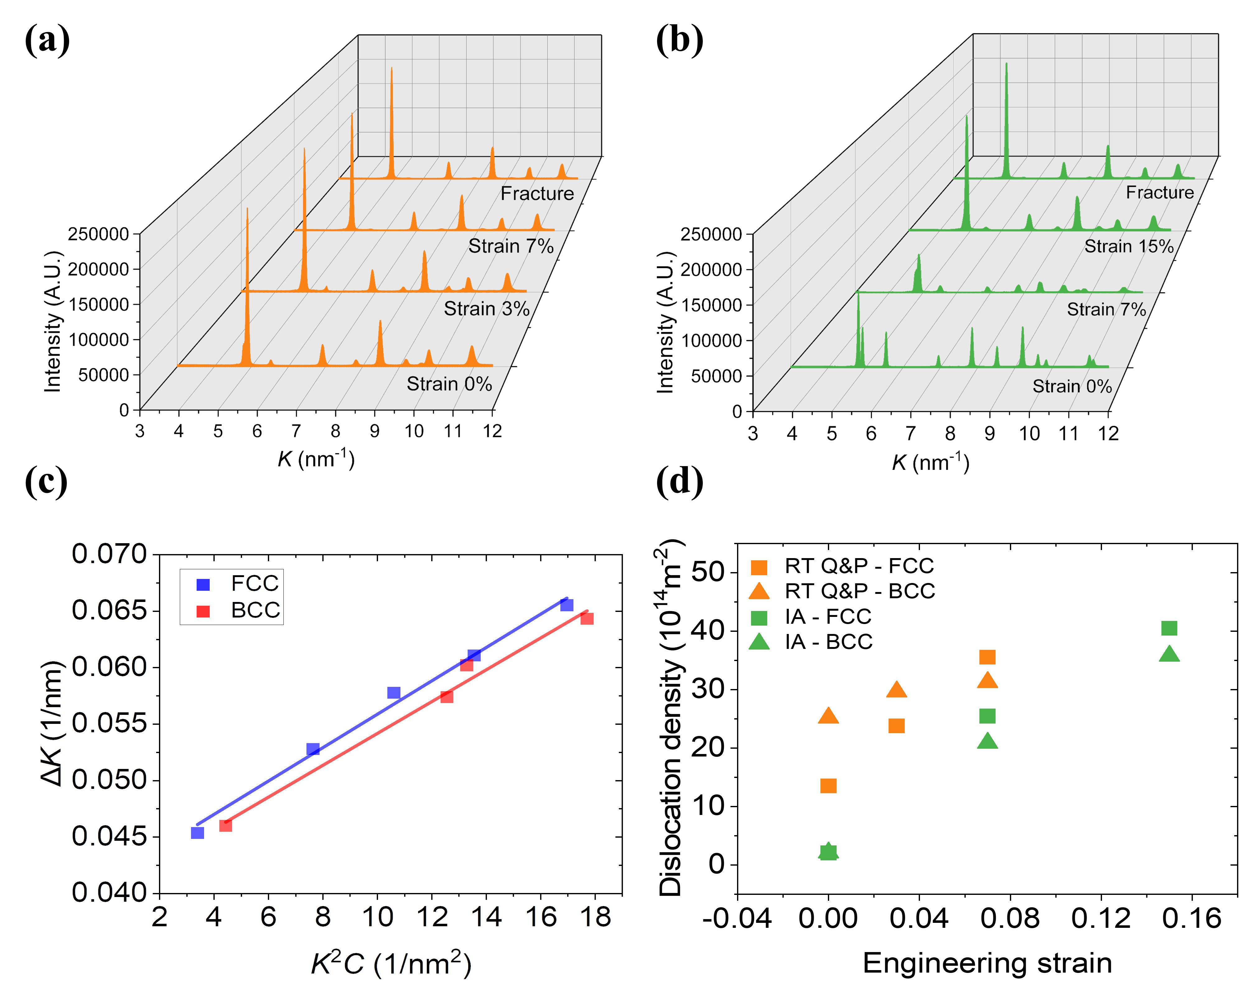
Figure 12 Synchrotron XRD and dislocation density results, (a), (b) K profile at different strain levels of RT Q&P and IA steel, (c) MWH plot of the IA steel at strain 0% using first 4 BCC peaks and 5 FCC peaks, (d) evolution of dislocation density
The work hardening behaviors of the IA and the RT Q&P steel also differ remarkably, as shown in Fig. 3(b). The WHR curve of the RT Q&P steel decreases consistently and meets with the true stress-strain curve where necking occurs. Dislocation activity is dominant at strain levels lower than 0.03 since only around 3% austenite has transformed in this strain range. When strain goes beyond 0.03, more TRIP occurs and retards the decline of WHR. After 0.07 strain, almost all retained austenite has transformed, and the WHR curve drops faster. On the other hand, the WHR curve of the IA steel is more complex. Around 15% austenite has already transformed within the yielding plateau stage, indicating the insufficient stability of austenite. The early transformation of less stable austenite induces plenty of GNDs, as reflected by the high dislocation multiplication rates in Fig. 12(d). These numerous GNDs are very effective in enhancing WHR. Extensive martensitic transformation continues until 0.13 strain value, resulting in ceaseless multiplication of GNDs and continuously ascending WHR. As the strain exceeds 0.15, the austenite has almost been exhausted, and the proliferation of GNDs due to TRIP also suspends. Therefore, further work hardening mainly comes from dislocation interactions, and WHR starts decreasing until fracture.
The IA steel consists of ~70% interconnected austenite, and over 60% has transformed into martensite after 0.15 strain. As presented in Fig. 5(f), some austenite/martensite grains sustain tensile strain as high as ~40%, which is beyond the deformation capacity of martensite with similar carbon content[44]. In other words, a large number of untempered martensite grains are severely deformed and bear high stress[32]. On the other hand, some austenite/martensite grains are less deformed and carry strain less than global strain. This non-uniform deformation induces high strain gradients from grain to grain. Therefore, voids or micro-cracks can quickly form along boundaries. Besides, fresh martensite grains are also susceptible to cleavage fracture, explaining the sudden fracture without necking in the IA tensile sample and intergranular and quasi-cleavage fracture in Fig. 5(h). On the other hand, the martensite matrix in the RT Q&P steel has been partitioned, and less carbon remains inside the martensite matrix, so it is not brittle and susceptible to damage. In addition, since the retained austenite in the RT Q&P steel is less in amount and not interconnected closely, even after voids initiate near fresh martensite, it cannot coalesce to form disastrous cracks. Therefore, the RT Q&P tensile sample fails in a ductile way and has considerably large post-elongation.

4.2 Fracture mechanisms
To obtain a reliable K_{JIc}, several requirements, including sample thickness and crack tunneling, must be satisfied. All requirements in the ASTM E1820 standard have been met in present measurements; therefore, reliable K_{JIc} values can be obtained. The RT Q&P steel has a relatively high K_{JIc} value, which is not only superior to the current IA steel but also 30% higher than other Q&P steels with similar strength levels[45]. The crack growth behavior at the free surface (Fig. 8) and the middle-thickness section (Fig. 10) do not show a perceivable difference for the RT Q&P steel. The crack can propagate through individual blocks (Fig. 8(c)) or along hierarchical boundaries (i.e., block, packet boundary and PAGB in Fig. 8(b), Fig. 10(a) and (b)). This propagation along boundaries is not traditional intergranular fracture but in the way of voids formation and coalescence (Fig. 10(a) and (b)) and involves considerable plastic deformation (Fig. 8(d) and (e)). Besides, the crack can also get deflected when it meets packet boundary (Fig. 8(b)) or PAGB (Fig. 10(a) and (b)). Therefore, these synergic mechanisms contribute to good toughness in the RT Q&P steel despite its high yield stress.
On the other hand, the EBSD phase map of the IA steel in Fig. 10 confirms that martensitic transformation has occurred sufficiently around the crack tip, so the TRIP-toughening should play a significant role considering that the volume fraction of austenite is ~70% before deformation[2, 19]. Aided by its low yield stress and high work hardening capacity, it is expected that the fracture toughness of IA steel should be excellent. However, the experimental results contradict the expectations and imply that the massive TRIP here is detrimental to fracture toughness. As shown in Fig. 10(d), there exist numerous fresh martensite grains around the crack tip, and these martensite grains contain high carbon content (~0.32% from the calculation by Thermo-Calc) and cannot deform compatibly with surrounding ferrite. Therefore, damage can form and propagate in brittle manners (i.e., intergranular fracture and quasi-cleavage in Fig. 9), leading to that crack tip blunting and plastic deformation is restricted (Fig. 9, 10 and 11).
The fracture surfaces of the C(T) samples also show sharp contrast and reveal their fracture mechanisms. The macroscopic fracture surface of the C(T) sample of the RT Q&P steel is more rugged, as shown in Fig. 7(a). The rugged surface is featured by substantive shear dimples, and more dimples can form on the ramp surface to consume more energy, leading to a relatively high crack-initiation toughness. However, since the work hardening capacity of the RT Q&P steel is limited, and no additional toughening mechanism occurs as the crack grows, the crack-growth toughness of the RT Q&P sample does not significantly enhance as the IA steel. The C(T) sample of the IA steel has a smoother fracture surface at low magnification in Fig. 7(c) though some delamination occurs in the central areas as the crack grows over 1mm. These delamination cracks form because of the ascending stress around the crack tip and large stress triaxiality in the center and are assumed to promote crack growth resistance by consuming energy to create new surfaces and alleviating stress triaxiality.
The Vickers hardness distribution around the crack tip is shown in Fig. 11. A significant hardness enhancement is observed in the vicinity of the crack tip in the IA sample. This remarkably high hardness is mainly attributed to the massive fresh martensite with 0.32% carbon content. On the other hand, the hardness promotion is limited in the RT Q&P sample, which agrees with its less intense TRIP and dislocation multiplication. Since the hardness enhancement is mainly associated with plastic deformation and work hardening, the material with higher hardness promotion is assumed to undergo more severe deformation and possess better crack resistance. However, the hardness-enhancement region in the IA sample is localized near the crack tip and displays a considerable hardness gradient (Fig. 11). In contrast, the hardness is more uniformly distributed in the RT Q&P sample. This observation also helps explain the unexpectedly low toughness of the IA steel since the hardened region is too small and brittle to invoke significant plastic deformation in surrounding materials and resist crack growth.
To further confirm the main proposal that TRIP is beneficial for the work hardening rate but detrimental to the toughness of this MMS, especially in the IA steel, another processing method was applied based on the IA route. Additional cold-rolling (30% reduction) was used on the IA plate to transform the austenite early. The XRD result in Fig. 13(a) confirms that the remaining austenite is only ~14% for this new material. In order to eliminate fresh martensite, additional partitioning (250℃ for 10mins) was applied to the new plate; hence this material is termed as IA-CR-T sample. The tensile and fracture properties of IA and IA-CR-T samples are presented in Fig. 13(b) and (c) for comparison. It clearly shows that after transforming austenite before tension, the working hardening capacity and uniform elongation deteriorate for the IA-CR-T sample. Since fresh martensite is removed from the IA-CR-T sample, considerable post-elongation is observed. As for the tensile fracture surface in Fig. 13(d), the IA-CR-T sample is dominated by dimples, and no brittle features can be observed. Besides, it is unexpected that the crack-initiation toughness (K_{JIc}) of the IA-CR-T sample even improves slightly (i.e., 86.44 $\text{Mpa}\sqrt{\text{m}}$ compared to 73.9$\text{MPa}\sqrt{\text{m}}$ of the IA sample). This comprehensive comparison strongly supports the claim that even though TRIP offers enhanced work hardening capacity, it also leads to premature fracture and deterioration of toughness due to coalesced fresh martensite.
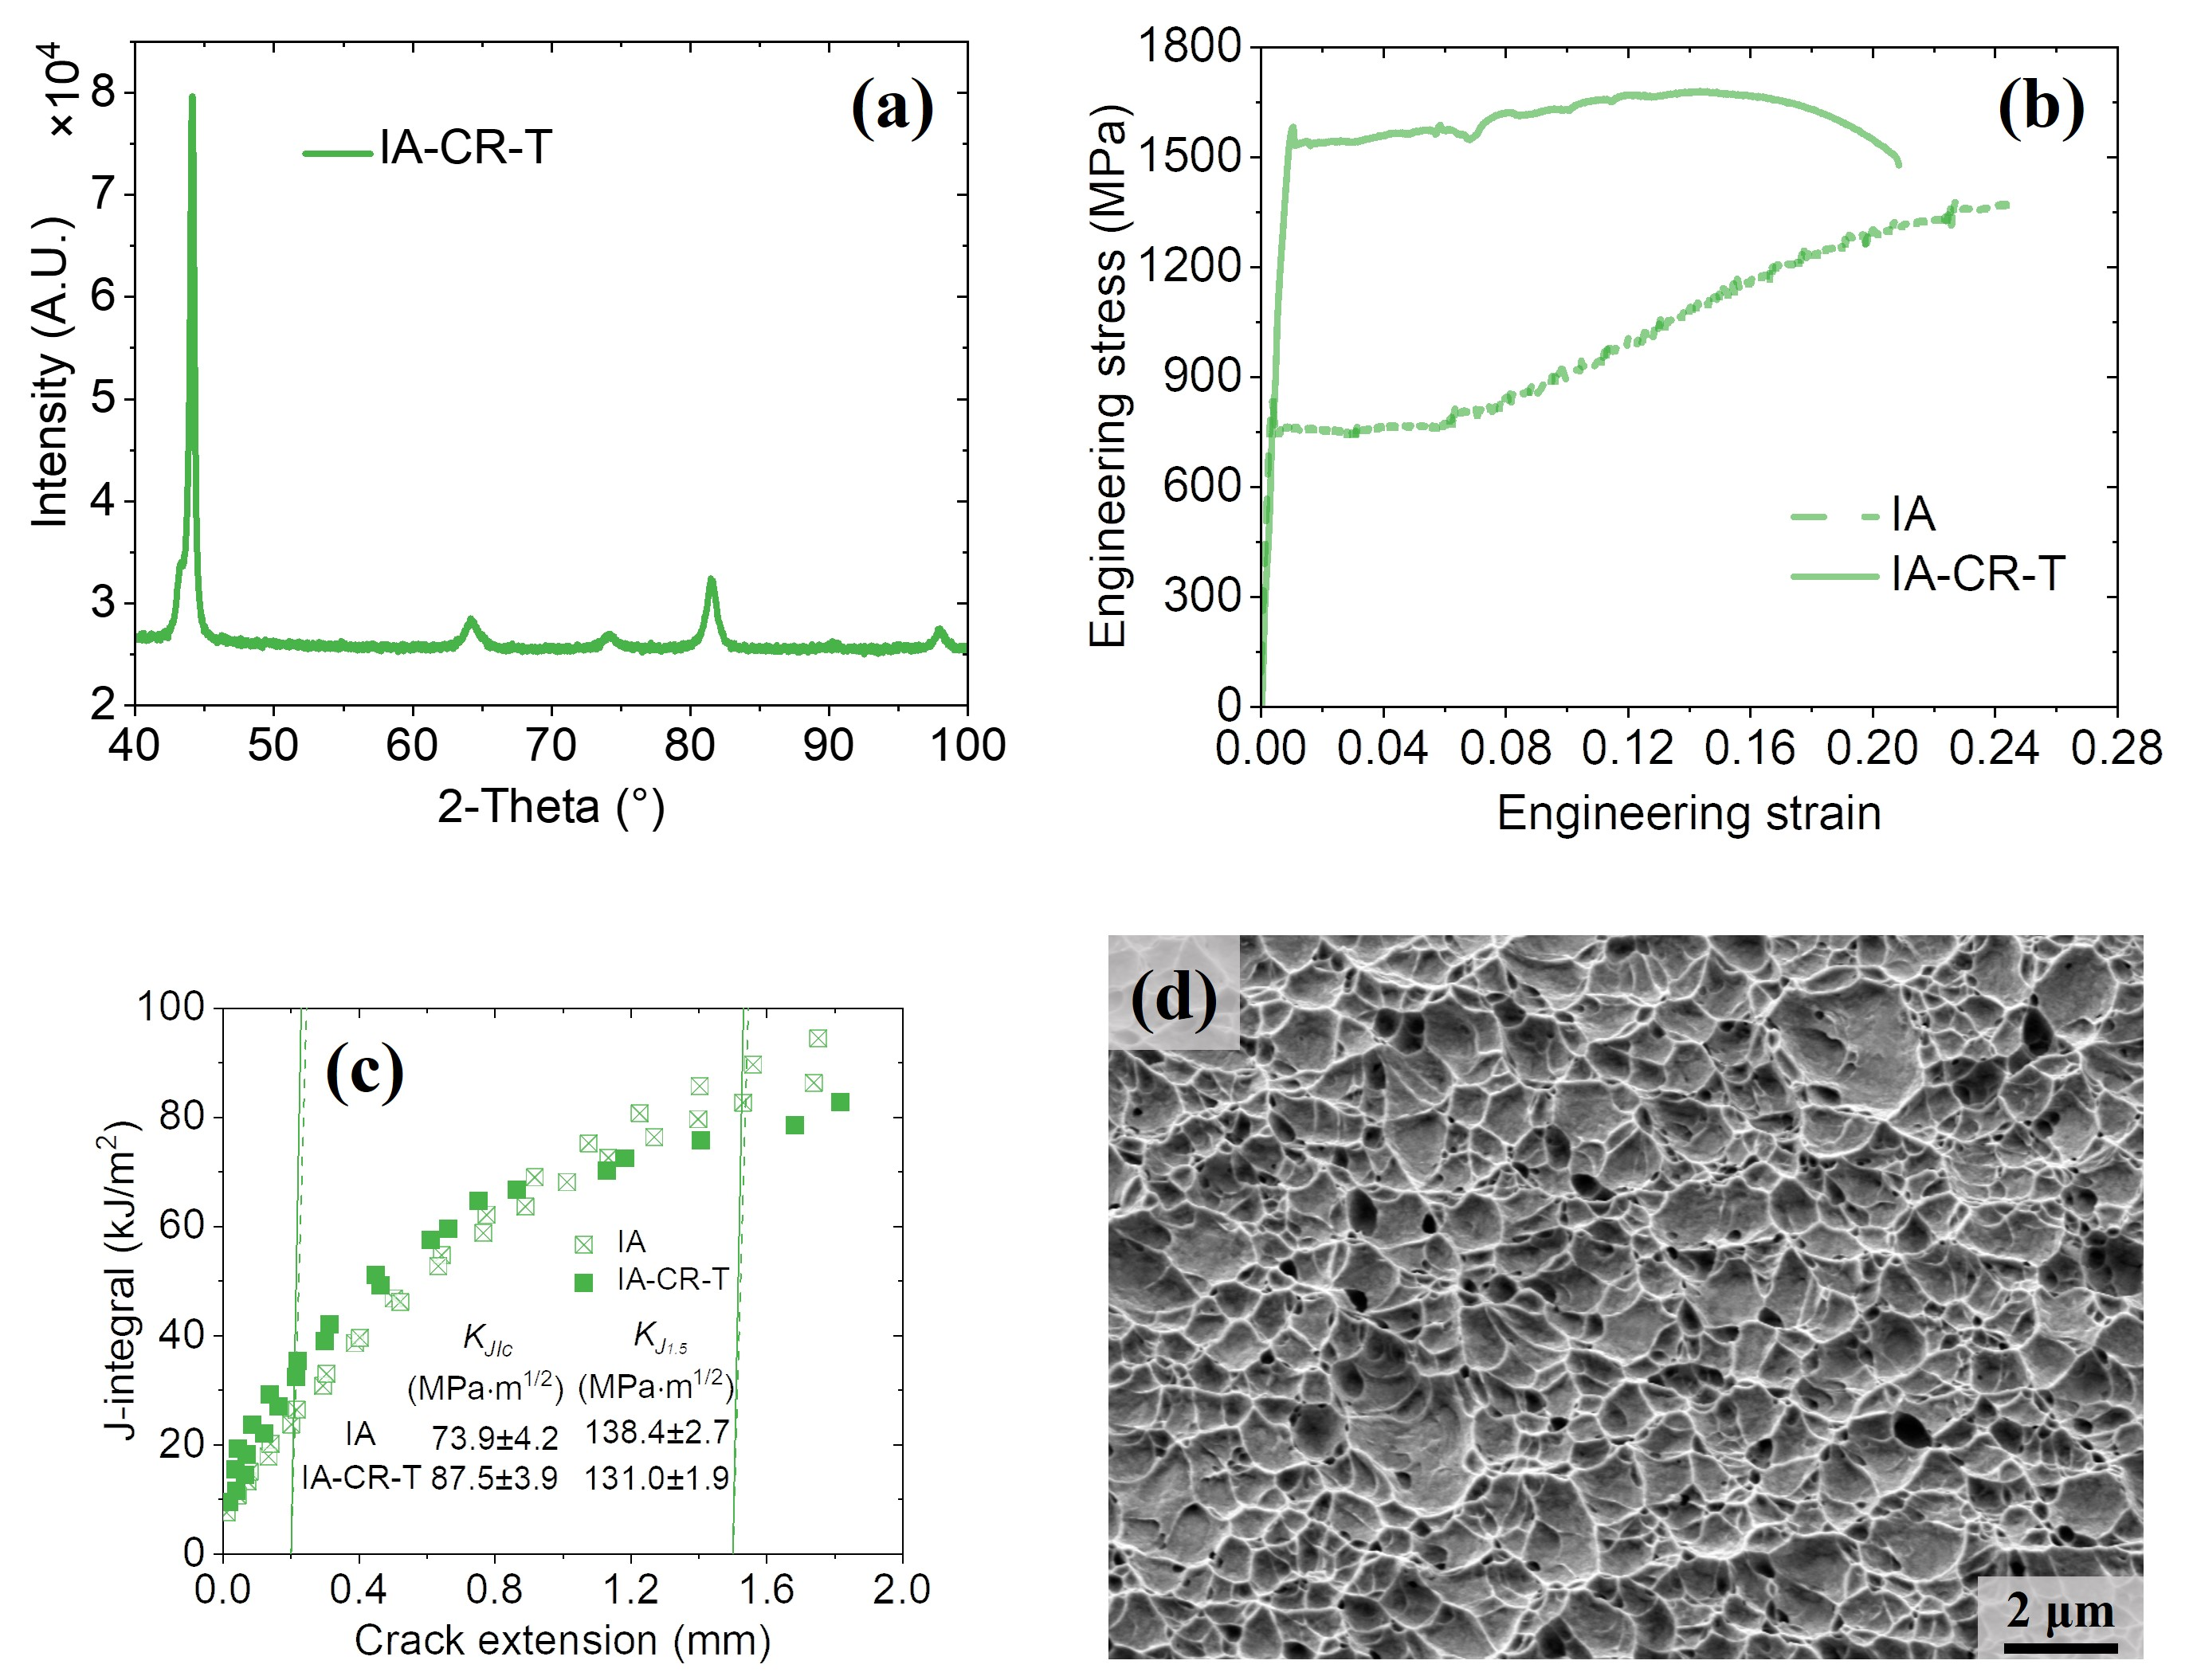
Figure 13 The mechanical properties of IA-CR-T sample, (a) XRD result, (b) engineering stress-strain curve, (c) J-R curve, (d) tensile fracture surface
Based on six EBSD maps and over twenty SEM figures of the crack growth path in both steels, statistical results can be obtained, and the corresponding illustrations of their fracture mechanisms are shown in Fig. 14. In the RT Q&P steel, around 37% fracture events are along hierarchical boundaries (i.e., block, packet boundary and PAGB), and in other cases crack mainly propagates through blocks trans-granularly. On the contrary, the total percentage of fresh martensite cracking (green color) or phase/grain boundary decohesion (yellow color) is over 90% in the IA steel, and only less than 10% fracture process involves ductile ferrite (grey). More figures of each type can be found in the appendix.
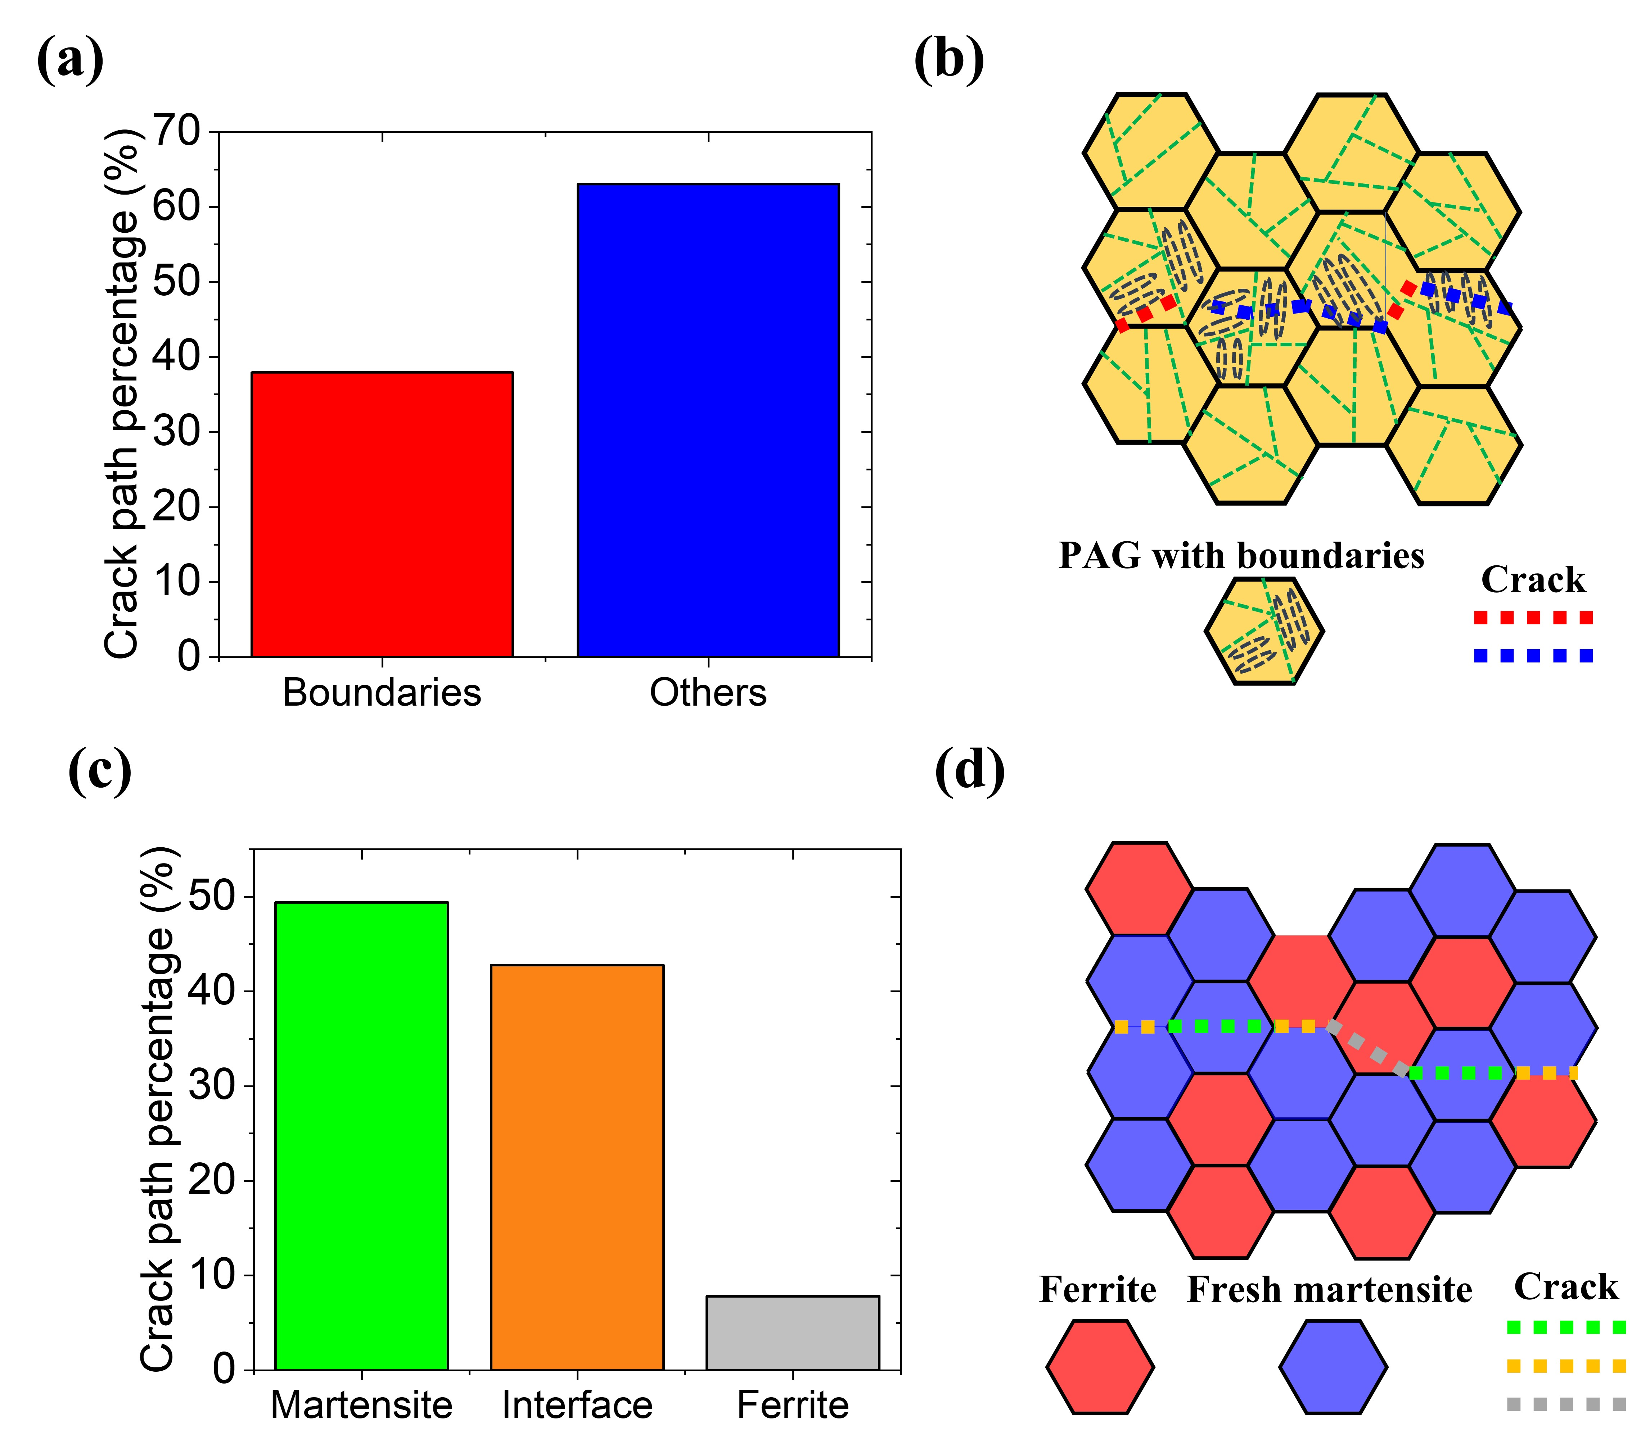
Figure 14 Statistical results and illustration of the fracture mechanisms of two steels, (a) and (b) are of the RT Q&P steel, dash lines represent crack path, the red line is cracking along boundaries, the blue line is trans-granular fracture, (c) and (d) are of the IA steel, ferrite grain is in red and fresh martensite grain is in blue, dash lines represent crack path, the green line means martensite cracking, the yellow line means boundary decohesion and the grey line means ferrite cracking

4.3 Implication of the current study
Strength, ductility and toughness are essential and desirable properties for structural materials, but it is challenging to realize an excellent synergy for metals and alloys. It was proposed that prolonging ductility could enhance toughness since better ductility meant higher plastic deformation capacities before fracture. Some literature also used the product of strength and uniform elongation (PSUE) to measure toughness since it is roughly related to the absorbed energy before necking. These general conclusions can result in a misconception: more TRIP in steels is desirable since it can both enhance plasticity and PSUE. However, these relationships do not hold for the current steels. As evidenced by Fig. 6 and Fig. 13, the RT Q&P steel and IA-CR-T steel both have much higher yield stress and inferior ductility than the IA steel. However, they also possess improved crack-initiation toughness and similar crack-growth toughness compared to the IA steel. Similarly, the PSUE is also not directly related to the crack-initiation toughness since the IA steel also has much better PSUE than the RT Q&P steel (Fig. 6). Therefore, based on the wisdom of 'the right microstructure leading to the right property and hence for the right application'[46], it is proposed that MMS with high austenite fraction (such as the IA steel) should be used in applications where ductility are the biggest concerns. In contrast, MMS fabricated by the RT Q&P process is more appropriate for applications with stringent requirements of high yield stress and good crack-initiation resistance.

5. Conclusion
In the present work, a MMS was processed by IA and RT Q&P routes, and their tensile and fracture properties were tested and compared. Based on the experimental observations, several conclusions can be drawn as follows.
(1) The IA steel consists of recrystallized, ultrafine-grained ferrite and austenite and has relatively low yield stress. Nevertheless, its work hardening rate and uniform elongation are considerable due to profuse TRIP effect. In contrast, the RT Q&P steel has higher yield stress because of its martensite matrix with dense dislocation. Its work hardening rate decreases monotonically, leading to lower uniform elongation.
(2) High-resolution micro-DIC results during tensile tests indicate strain localization occurs in both steels. For the RT Q&P steel, higher strain is located at PAGB, packet and block boundaries. In the IA steel, strain is mainly concentrated at the austenite region, and this preferential strain partitioning leads to abundant and fast martensitic transformation.
(3) Compared to the RT Q&P steel, the IA steel has unexpectedly worse crack-initiation toughness despite its lower yield stress. The crack in the RT Q&P steel can propagate in a ductile way and involves significant plastic deformation. On the other hand, because of copious fresh martensite and significant strain gradient among grains, martensite cracking and intergranular decohesion dominate the fracture process of the IA steel.
(4) For the IA steel, more TRIP effect significantly enhances the work hardening rate and tensile ductility. However, it also results in premature fracture and inadequate crack-initiation toughness considering its low yield stress, though its crack-growth toughness is quite high. In contrast, the RT Q&P steel with weaker TRIP effect has a better synergy of yield stress and crack-initiation toughness. The comparison between IA and RT Q&P steels demonstrates that intensive TRIP effect is beneficial for tensile strength and uniform elongation, but is harmful to crack-initiation fracture toughness.

Declaration of competing interest
The authors declare that they have no known competing financial interests or personal relationships that could have appeared to influence the work reported in this paper.

Acknowledgment
M.X.H. acknowledges the support from National Natural Science Foundation of China (No. 52130102), National Key Research and Development Program of China (No. 2019YFA0209900), Research Grants Council of Hong Kong (No. R7066-18), Guangzhou Municipal Science and Technology Project (No. 202007020007) and Guangdong Basic and Applied Basic Research Foundation of China (No. 2020B1515130007). Shanghai Synchrotron Radiation Facility (SSRF) is acknowledged for supporting the synchrotron X-ray diffraction experiments at the Beam Line No. BL14B1.

Appendix
Estimation of stacking fault energy (SFE)
The SFE of the austenite was calculated using the following equation [47]:
$Γ=2ρΔG^{γ-ϵ}+2σ^{γ/ϵ}$ (A.1)
$ΔG^{γ-ϵ}= {ΔG}_{FeMnX}^{γ-ϵ}+ χ_{c}{ΔG}_{FeMnX/C}^{γ-ϵ}+ ΔG_{mg}^{γ-ϵ}$ (A.2)
Where ρ is the molar surface density of atoms in the closely-packed planes, and $σ^{γ/ϵ}$ = 8 mJ/m² is the energy per surface unit of a closely-packed interface between FCC γ and HCP ɛ. $ΔG^{γ-ϵ}$ is the free molar enthalpy of the transformation from FCC to HCP structure, which contains chemical contribution from substitutional elements ${ΔG}_{FeMnX}^{γ-ϵ}$, Carbon ${ΔG}_{FeMnX/C}^{γ-ϵ}$ and a magnetic term due to the Néel transition.
For the RT Q&P steel, the Mn and Al content in austenite is assumed to be identical to the nominal composition due to the high cooling rate during water quenching process and their sluggish diffusion during partitioning. Based on our 3D atom probe tomography characterization of the same material with similar processing route (only slight difference in the austenitization temperature), the C content in the retained austenite is 0.29% wt. Therefore, the SFE is calculated to be 21.2 mJ/m², which falls into the TRIP-dominant region [48].
For the IA steel, STEM-EDS shows that the average weight percent of Mn in austenite is ~12.4%, which is close to the calculation results (12.8%) by software ThermoCalc. This good agreement indicates that the austenite has reached equilibrium state. Since C content cannot be indexed readily using STEM-EDS or EELS due to its low content, we choose to use ThermoCalc result for SFE calculation, which reports 0.32% C, 12.8% Mn and 1.7% Al. Based on these values, the SFE is calculated to be 24.0 mJ/m².
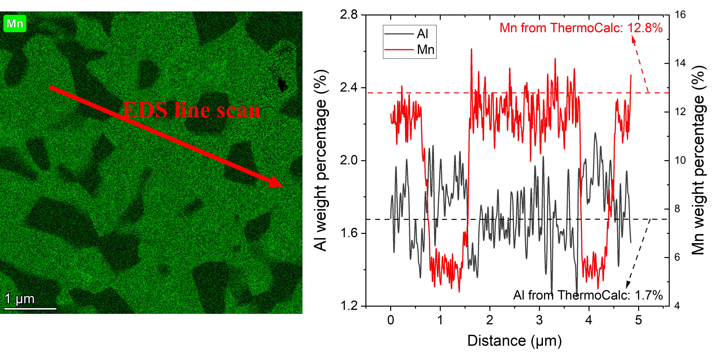
Fig. A. 1 STEM-EDS of Mn and Al compared to ThermoCalc results

Quasi-cleavage fracture in tensile sample of the IA steel
The following figures show two representative sites of quasi-cleavage fracture, and EDS results confirm these two grains have high Mn and low Al content, so they are probably austenite/fresh martensite grains, which have higher probability of quasi-cleavage fracture.
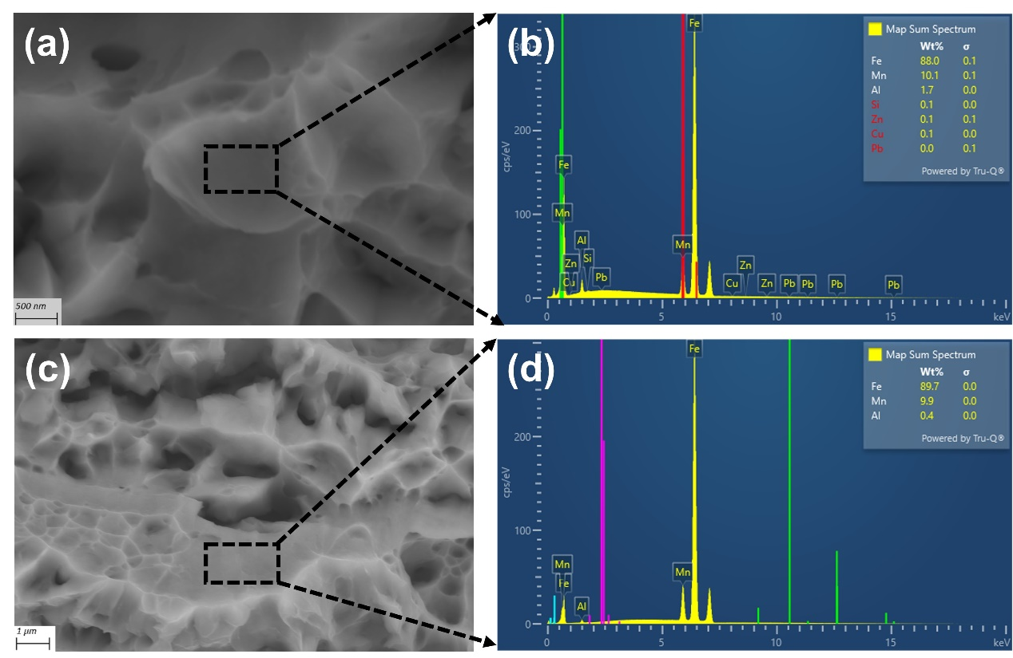
Fig. A. 2 Two typical quasi-cleavage fracture sites with their respective EDS mapping

Estimation of plastic zone near crack tip
For the plastic zone estimation in Fig. 8 and 9, we use the following formula as the EBSD was performed on the free surface where plane-stress condition shall dominate:
$r_{p}= \frac{1}{π}{\left(\frac{K}{σ_{y}}\right)}^{2}$ (A.3)
Where r_{p} is plastic zone size, K is stress intensity factor and $σ_{y}$ is yield strength. In Fig. 10, the plastic zone was estimated to follow:
$r_{p}= \frac{1}{3π}{\left(\frac{K}{σ_{y}}\right)}^{2}$ (A.4)
For Fig. 8 and Fig. 9, K is taken as 15 $\text{MPa}\sqrt{\text{m}}$ for both steels, which is slightly higher than K used in final pre-cracking and much lower than K_{JIC}. Hence, the corresponding plastic zone is calculated to be 72 μm and 127 μm for the RT Q&P and IA steel, respectively.
For Fig. 10, K is derived from the measured J-integral at ~1.8 mm crack extension. Hence, the corresponding plastic zone is calculated to be 1750 μm and 3680 μm for the RT Q&P and IA steel, respectively.

Typical crack growth path in the C(T) sample of the IA steel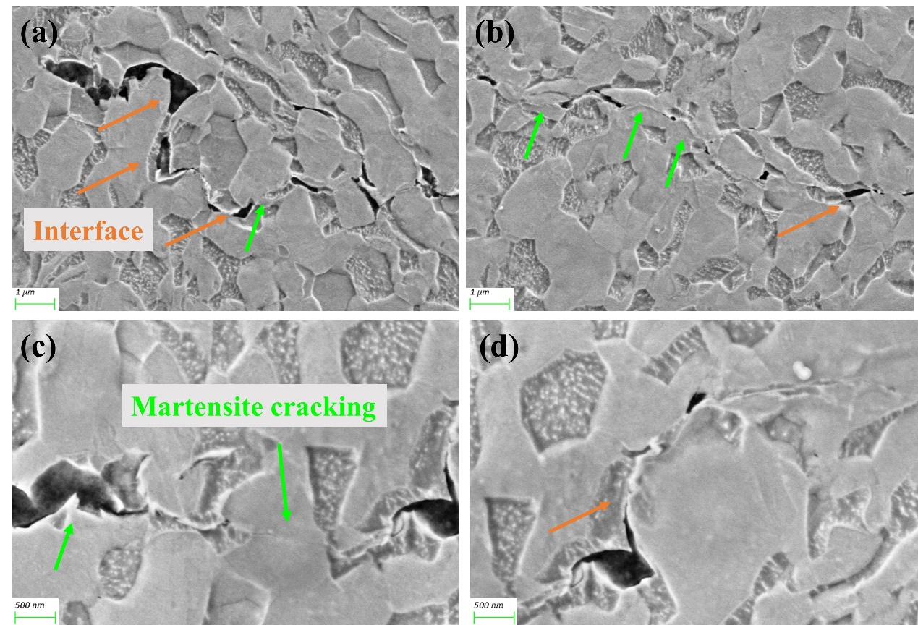
Fig. A. 3 Typical crack growth path in the IA steel, where orange arrows point to interface decohesion while green arrows show martensite cracking

Reference
[1] R.O. Ritchie, The conflicts between strength and toughness, Nat Mater 10(11) (2011) 817-22.
[2] L. Liu, Q. Yu, Z. Wang, J. Ell, M.X. Huang, R.O. Ritchie, Making ultrastrong steel tough by grain-boundary delamination, Science 368(6497) (2020) 1347-1352.
[3] B. Gludovatz, A. Hohenwarter, D. Catoor, E.H. Chang, E.P. George, R.O. Ritchie, A fracture-resistant high-entropy alloy for cryogenic applications, Science 345(6201) (2014) 1153-8.
[4] B.B. He, B. Hu, H.W. Yen, G.J. Cheng, Z.K. Wang, H.W. Luo, M.X. Huang, High dislocation density-induced large ductility in deformed and partitioned steels, Science 357(6355) (2017) 1029-1032.
[5] S.S. Xu, J.P. Li, Y. Cui, Y. Zhang, L.X. Sun, J. Li, J.H. Luan, Z.B. Jiao, X.L. Wang, C.T. Liu, Z.W. Zhang, Mechanical properties and deformation mechanisms of a novel austenite-martensite dual phase steel, International Journal of Plasticity 128 (2020).
[6] Y. Zou, H. Ding, Y. Zhang, Z. Tang, Microstructural evolution and strain hardening behavior of a novel two-stage warm rolled ultra-high strength medium Mn steel with heterogeneous structures, International Journal of Plasticity 151 (2022).
[7] T. Hojo, M. Koyama, B. Kumai, Y. Shibayama, A. Shiro, T. Shobu, H. Saitoh, S. Ajito, E. Akiyama, Comparative study of stress and strain partitioning behaviors in medium manganese and transformation-induced plasticity-aided bainitic ferrite steels, Scripta Materialia 210 (2022).
[8] J.H. Kim, G. Gu, M. Koo, E.-Y. Kim, J.-S. Lee, D.-W. Suh, Enhanced ductility of as-quenched martensite by highly stable nano-sized austenite, Scripta Materialia 201 (2021).
[9] L. Liu, B.B. He, G.J. Cheng, H.W. Yen, M.X. Huang, Optimum properties of quenching and partitioning steels achieved by balancing fraction and stability of retained austenite, Scripta Materialia 150 (2018) 1-6.
[10] M.M. Wang, C.C. Tasan, D. Ponge, D. Raabe, Spectral TRIP enables ductile 1.1 GPa martensite, Acta Materialia 111 (2016) 262-272.
[11] J. Han, S.-J. Lee, J.-G. Jung, Y.-K. Lee, The effects of the initial martensite microstructure on the microstructure and tensile properties of intercritically annealed Fe–9Mn–0.05C steel, Acta Materialia 78 (2014) 369-377.
[12] D. Raabe, S. Sandlöbes, J. Millán, D. Ponge, H. Assadi, M. Herbig, P.P. Choi, Segregation engineering enables nanoscale martensite to austenite phase transformation at grain boundaries: A pathway to ductile martensite, Acta Materialia 61(16) (2013) 6132-6152.
[13] E.J. Seo, L. Cho, B.C. De Cooman, Application of Quenching and Partitioning Processing to Medium Mn Steel, Metallurgical and Materials Transactions A 46(1) (2014) 27-31.
[14] E.J. Seo, L. Cho, Y. Estrin, B.C. De Cooman, Microstructure-mechanical properties relationships for quenching and partitioning (Q&P) processed steel, Acta Materialia 113 (2016) 124-139.
[15] M. Kuzmina, D. Ponge, D. Raabe, Grain boundary segregation engineering and austenite reversion turn embrittlement into toughness: Example of a 9 wt.% medium Mn steel, Acta Materialia 86 (2015) 182-192.
[16] J. Han, A.K. da Silva, D. Ponge, D. Raabe, S.-M. Lee, Y.-K. Lee, S.-I. Lee, B. Hwang, The effects of prior austenite grain boundaries and microstructural morphology on the impact toughness of intercritically annealed medium Mn steel, Acta Materialia 122 (2017) 199-206.
[17] N. Vazquez-Fernandez, G. Soares, J. Smith, J. Seidt, M. Isakov, A. Gilat, V. Kuokkala, M. Hokka, Adiabatic heating of austenitic stainless steels at different strain rates, Journal of Dynamic Behavior of Materials 5(3) (2019) 221-229.
[18] J. Xu, Z. Wang, Y. Yan, J. Li, M. Wu, Effect of hot/warm rolling on the microstructures and mechanical properties of medium-Mn steels, Materials Characterization 170 (2020).
[19] S.D. Antolovich, B. Singh, On the toughness increment associated with the austenite to martensite phase transformation in TRIP steels, Metallurgical and Materials Transactions B 2(8) (1971) 2135-2141.
[20] M. Koyama, Z. Zhang, M. Wang, D. Ponge, D. Raabe, K. Tsuzaki, H. Noguchi, C.C. Tasan, Bone-like crack resistance in hierarchical metastable nanolaminate steels, Science 355(6329) (2017) 1055-1057.
[21] Y. Zou, Y.B. Xu, Z.P. Hu, S.Q. Chen, D.T. Han, R.D.K. Misra, G.Z. Wang, High strength-toughness combination of a low-carbon medium-manganese steel plate with laminated microstructure and retained austenite, Materials Science and Engineering: A 707 (2017) 270-279.
[22] B. Sun, D. Palanisamy, D. Ponge, B. Gault, F. Fazeli, C. Scott, S. Yue, D. Raabe, Revealing fracture mechanisms of medium manganese steels with and without delta-ferrite, Acta Materialia 164 (2019) 683-696.
[23] S. Jing, H. Ding, Y. Ren, Z. Cai, A new insight into annealing parameters in tailoring the mechanical properties of a medium Mn steel, Scripta Materialia 202 (2021).
[24] J. Han, Y.-K. Lee, The effects of the heating rate on the reverse transformation mechanism and the phase stability of reverted austenite in medium Mn steels, Acta Materialia 67 (2014) 354-361.
[25] K. Steineder, D. Krizan, R. Schneider, C. Béal, C. Sommitsch, On the microstructural characteristics influencing the yielding behavior of ultra-fine grained medium-Mn steels, Acta Materialia 139 (2017) 39-50.
[26] B.B. He, Z.Y. Liang, M.X. Huang, Nanoindentation investigation on the initiation of yield point phenomenon in a medium Mn steel, Scripta Materialia 150 (2018) 134-138.
[27] X.G. Wang, L. Wang, M.X. Huang, Kinematic and thermal characteristics of Lüders and Portevin-Le Châtelier bands in a medium Mn transformation-induced plasticity steel, Acta Materialia 124 (2017) 17-29.
[28] B.B. He, L. Liu, M.X. Huang, Room-Temperature Quenching and Partitioning Steel, Metallurgical and Materials Transactions A 49(8) (2018) 3167-3172.
[29] J. Speer, D.K. Matlock, B.C. De Cooman, J.G. Schroth, Carbon partitioning into austenite after martensite transformation, Acta Materialia 51(9) (2003) 2611-2622.
[30] B.B. He, S. Pan, M.X. Huang, Extra work hardening in room-temperature quenching and partitioning medium Mn steel enabled by intercritical annealing, Materials Science and Engineering: A 797 (2020).
[31] L. Cho, E.J. Seo, B.C. De Cooman, Near-Ac3 austenitized ultra-fine-grained quenching and partitioning (Q&P) steel, Scripta Materialia 123 (2016) 69-72.
[32] Z. Xiong, P.J. Jacques, A. Perlade, T. Pardoen, Characterization and Control of the Compromise Between Tensile Properties and Fracture Toughness in a Quenched and Partitioned Steel, Metallurgical and Materials Transactions A 50(8) (2019) 3502-3513.
[33] J. Hidalgo, C. Celada-Casero, M.J. Santofimia, Fracture mechanisms and microstructure in a medium Mn quenching and partitioning steel exhibiting macrosegregation, Materials Science and Engineering: A 754 (2019) 766-777.
[34] Z. Wang, M.X. Huang, Optimising the strength-ductility-toughness combination in ultra-high strength quenching and partitioning steels by tailoring martensite matrix and retained austenite, International Journal of Plasticity 134 (2020).
[35] C.C. Tasan, J.P.M. Hoefnagels, M. Diehl, D. Yan, F. Roters, D. Raabe, Strain localization and damage in dual phase steels investigated by coupled in-situ deformation experiments and crystal plasticity simulations, International Journal of Plasticity 63 (2014) 198-210.
[36] J. Blaber, B. Adair, A. Antoniou, Ncorr: Open-Source 2D Digital Image Correlation Matlab Software, Experimental Mechanics 55(6) (2015) 1105-1122.
[37] Y.Z. Li, M. Wang, M.X. Huang, In-situ measurement of plastic strain in martensite matrix induced by austenite-to-martensite transformation, Materials Science and Engineering: A 811 (2021).
[38] ASTM, Standard test method for measurement of fracture toughness, ASTM E1820-20, 2020.
[39] M. Wang, M.X. Huang, Abnormal TRIP effect on the work hardening behavior of a quenching and partitioning steel at high strain rate, Acta Materialia 188 (2020) 551-559.
[40] Y.Z. Li, S.L. Zhao, S.H. He, C.P. Huang, M.X. Huang, Enhancing yield stress and uniform elongation in an ultrathin packaging steel via controlling dislocation density, International Journal of Plasticity 155 (2022).
[41] T. Ungar, I. Dragomir, A. Revesz, A. Borbely, The contrast factors of dislocations in cubic crystals: the dislocation model of strain anisotropy in practice, Journal of Applied Crystallography 32(5) (1999) 992-1002.
[42] H.M. Ledbetter, R.P. Reed, Elastic properties of metals and alloys, I. Iron, nickel, and iron‐nickel alloys, Journal of Physical and Chemical Reference Data 2(3) (1973) 531-618.
[43] Y. Zhao, X. Tong, X.H. Wei, S.S. Xu, S. Lan, X.L. Wang, Z.W. Zhang, Effects of microstructure on crack resistance and low-temperature toughness of ultra-low carbon high strength steel, International Journal of Plasticity 116 (2019) 203-215.
[44] M. Calcagnotto, Y. Adachi, D. Ponge, D. Raabe, Deformation and fracture mechanisms in fine- and ultrafine-grained ferrite/martensite dual-phase steels and the effect of aging, Acta Materialia 59(2) (2011) 658-670.
[45] R. Wu, W. Li, S. Zhou, Y. Zhong, L. Wang, X. Jin, Effect of Retained Austenite on the Fracture Toughness of Quenching and Partitioning (Q&P)-Treated Sheet Steels, Metallurgical and Materials Transactions A 45(4) (2013) 1892-1902.
[46] Q. Lu, Q. Lai, Z. Chai, X. Wei, X. Xiong, H. Yi, M. Huang, W. Xu, J. Wang, Revolutionizing car body manufacturing using a unified steel metallurgy concept, Sci Adv 7(49) (2021) eabk0176.
[47] A. Dumay, J.-P. Chateau, S. Allain, S. Migot, O. Bouaziz, Influence of addition elements on the stacking-fault energy and mechanical properties of an austenitic Fe–Mn–C steel, Materials Science and Engineering: A 483 (2008) 184-187.
[48] B. De Cooman, O. Kwon, K.-G. Chin, State-of-the-knowledge on TWIP steel, Materials Science and Technology 28(5) (2012) 513-527.

