Defect size and cross-linker properties controlled fracture of biopolymer networks

Bingxian Tang¹, Fuqiang Sun¹, Xi Wei^{1,2}, Guangkui Xu³ and Yuan Lin^{1,2,4*}
¹ Department of Mechanical Engineering, The University of Hong Kong, Hong Kong, China
² Advanced Biomedical Instrumentation Centre, Hong Kong Science Park, Shatin, New Territories, Hong Kong
³ Department Engineering Mechanics, Xi’an Jiaotong University, Xi’an, Shaanxi, China
⁴ HKU-Shenzhen Institute of Research and Innovation (HKU-SIRI), Shenzhen, Guangdong, China
* Corresponding author: ylin@hku.hk

Abstract
Damage in cytoskeleton can occur frequently during processes like cell migration and division. However, the question of how the presence of micro-cracks affects the deformation and fracture response of such bio-filament networks remains unclear. Here, we report a computational study to address this unsettling issue where large deformation and thermal fluctuations of individual biopolymers, as well as the forced breaking of crosslinks between them, have all been taken into account. It was found that the introduction of micro-cracks could alter the fracture path inside the network, change its ductility and actually result in an increased fracture energy of the material. More interestingly, we showed that on average the maximum fracture resistance will be achieved when the crack length is a few times of the network pore size, highlighting the flaw insensitive nature of such materials. Finally, the network fracture energy was observed to increase with the linear stiffness of crosslinking molecules monotonically but reach its minimum at an intermediate rotational stiffness value. In addition to enhancing our understanding of how cytoskeleton performs different cellular duties, findings here could also provide useful information for the development of high performance biological materials in the future.

Keywords: Biopolymer network, Defect size, Fracture response, Cross-linker.

1. Introduction
Cytoskeleton and biological tissues/gels are dynamic biopolymer networks, constructed by a variety of crosslinking molecules, and play crucial roles in many in vivo and in vitro processes [1-4]. For example, cytoskeleton shields the cell from external disruptive forces and maintains its proper internal partition [5]. In addition, the cytoskeletal network needs to be partially disrupted or undergo irreversible re-arrangements [6,7] during cellular activities such as division and migration. On the other hand, degradable polymers have been increasingly used in different sustainability and healthcare applications [8], including drug delivery [9], resorbable device [10] etc. It is conceivable that micro damages/cracks will be introduced to the cytoskeleton/biological gels during these aforementioned processes (or even during their formation [11]), and therefore affect their mechanical integrity as well as capability to function properly.
Extensive efforts have been spent in the past few decades to reveal key factors regulating the fracture response of biopolymer materials. For example, the critical role of water content in regulating the fatigue fracture and hysteresis of hydrogels have been elucidated by several investigations [12,13]. In particular, it was shown that siloxane bonds in stressed polydimethylsiloxane (PDMS) can react with water molecules, leading to a crack propagation speed orders of magnitude higher than the overall degradation rate of the material [14]. On the other hand, the presence of stiff fibers in the soft PDMS matrix can help to re-distribute the stress near the crack tip [14], slow down the water-siloxane bond reactions and eventually retard the crack growth. Furthermore, the stiffness of cross-linkers was also found to affect the fracture behavior of biological gels with softer crosslinking molecules leading to larger fracture energy of the material [15,16]. This suggests that, in general, the rigidity and toughness of biopolymer materials are negatively correlated. However, interestingly, a recent study showed that such stiffness-toughness conflict can be resolved by having much more polymer entanglements than cross-links in the material [17]. The reason is that dense entanglements allow a polymer chain to transfer its tension to many other chains while, at the same time, sparse crosslinks prevent the network from unraveling.
Despite these aforementioned efforts, the fundamental question of how the presence of damages influences the bulk fracture response of biopolymer materials remains unclear. Intuitively, one would expect that micro cracks will make rupture of the material more easily. On the other hand, it is conceivable that the introduction of micro damages could change the rupture path of the random biopolymer network and therefore lead to an altered, or even increased, fracture energy. Here we report a computational investigation to address this unsettling issue. Specifically, the deformation and fracture response of randomly generated actin networks, with or without prescribed micro cracks, were systematically examined via the combined finite element – Langevin dynamics (FEM-LD) method [18,19] where important factors like the enforced breakage of cross-linkers between F-actins and the large deformation of individual filament have all been taken into account. We will show that, surprisingly, the network fracture energy actually reaches its maximum when the length of introduced micro cracks is a few times of the average pore size of network. Physical mechanisms behind this interesting finding, as well as its implications in our understanding of different cellular processes and the development of new biological materials, will also be discussed.

2. Computational model
To investigate the influence of micro cracks on the deformation and fracture response of biopolymer materials. 2D networks were generated by randomly placing N straight filaments, each with the same length L, inside a W×W (W =2L) square area, refer to Fig. 1a. Periodic boundary conditions were enforced on the left and right edges of the square, whereas filaments at the upper and lower boundary were assumed to have the same orientations and angle changes during deformation. When two filaments intersect each other, a cross-linker was added at the intersecting point to prevent them from separating and rotating with respect to each other. Finally, a horizontal crack (cutting all filaments it crosses into two) was introduced at the center of the network (Fig. 1a).
To simplify the analysis, we proceed by treating each cross-linker as a combined linear and rotation spring (Fig. 1b), with a stored elastic energy given by
$E_{c}=\frac{1}{2}k_{S}d^{2}+\frac{1}{2}k_{T}{(θ-θ_{0})}^{2}$, (1)
where $k_{S}$ and $k_{T}$ are the linear and angular spring constants of the crosslinking molecule, $d$ stands for the separation distance between two opposing points and $(θ-θ_{0})$ represents the change in the relative angle between two filaments. Effectively, a restraining force F and moment M with amplitudes taking the form
$\left[\begin{matrix}F_{x} \\ F_{y} \\ M\end{matrix}\right]=\left[\begin{matrix}k_{s} & 0 & 0 \\ 0 & k_{s} & 0 \\ 0 & 0 & k_{T}\end{matrix}\right]∙\left[\begin{matrix}δ_{x} \\ δ_{y} \\ θ-θ_{0}\end{matrix}\right]$ (2)
were introduced to act on both filaments at their crosslinking point. Furthermore, a cross-linker was assumed to break once the energy stored inside $E_{c}$ is over a critical value $E_{lim}$. Finally, each filament was described as a Euler-Bernoulli beam [20] in the present study.

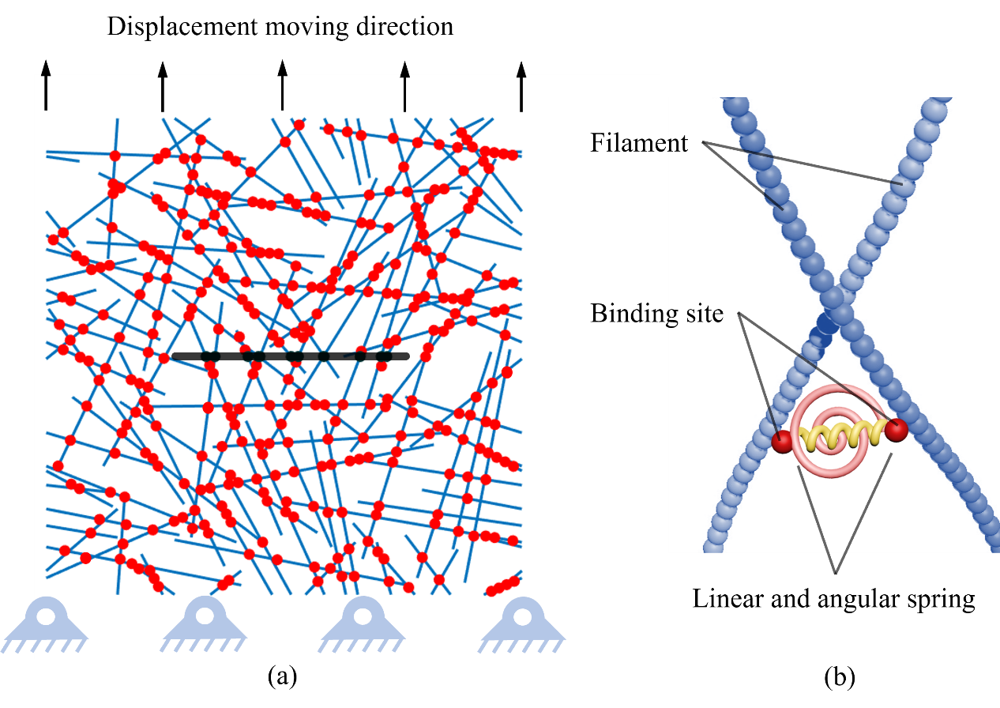
Fig. 1. (a) – A crack (represented by the back line) is introduced to the random network consisting of multiple actin filaments where crosslinking points between filaments are indicated by red dots. Periodic boundary conditions are enforced on the left and right edge of the network, and the upper and lower boundary share the same angular change. During simulations, the bottom of the network is fixed while its top is assumed to move with a constant speed. (b) – The cross-linker is modeled as a combined linear and angular springing restraining the relative separation and rotation between two filaments.

With these descriptions at hand, the deformation and fracture response of the network was then examined via the combined finite element-Langevin dynamics (FEM-LD) method [18,19] where thermal fluctuations of filaments were captured by applying stochastic loads on them. Specifically, within each discretized filament segment (with length $∆x$), a random force $f$ (following Gaussian distribution) with amplitude given by
$<f,f>=\frac{2ξk_{B}T}{∆x∆t}$ (3)
was assumed to be acting on it during each time step (with increment $∆t$). Here $k_{B}T$ is thermal energy and $ξ$ represents the viscous coefficient of the surrounding medium in resisting the movement of the filament [21]. Since we focused on the tensile behavior of the network, its bottom was assumed to be fixed while its upper boundary was forced to move with a constant speed $\dot{δ}$ during simulations (Fig. 1). To take into account large deformations of filaments during the rupturing process, nonlinear beam formulation [18,19,22,23] was adopted in calculating the elastic energy stored in them.

3. Simulation
In this study, simulations were conducted on 26 randomly generated networks, each consisting of 70 F-actin filaments. The average pore size, normalized by the filament length L, of these networks was found to be around 0.05, refer to Fig. 2, which is much smaller than the length of crack introduced. In addition, the randomness of the networks was confirmed by the evenly distributed orientation angles of filaments (Fig. 2) as well as their small Hermans' orientation parameter [24], calculated to be ~0.06.

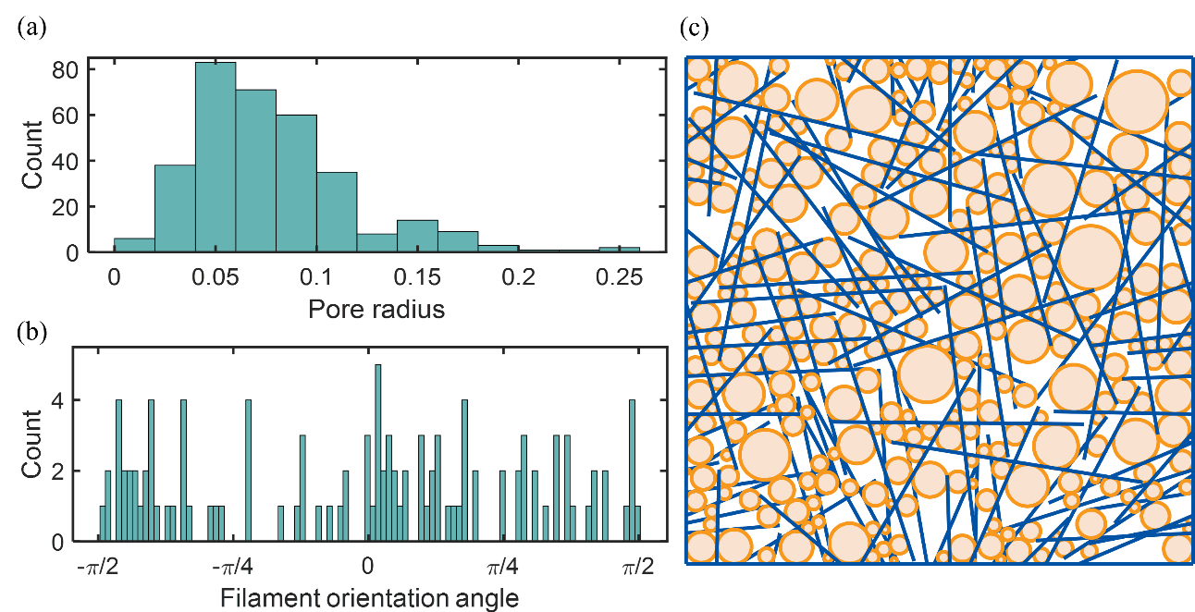
Fig. 2. (a) – Distribution of the size of pores (normalized by filament length L) in the random network shown on the right that consists of 70 filaments. (b) – Distribution of the orientation angles of filaments within the network. (c) – The random network consists of 70 filaments. Here, the pore size is defined as the diameter of the largest inscribed circle (indicated by the orange regions) in each empty area.

The filament length L in this study was adopt as 1.2$μm$, a value that is comparable to the rough size of F-actins in the cell cortex [2]. Given that the stretching and bending rigidities of actin filament were reported to be around 35 nN and 10-15$μm×k_{B}T$ [18], respectively, we chose $EAL/{k_{B}T=10}^{7}$ and ${EI/k}_{B}TL$ =10 in our simulations where the entire network was divided into approximately 1800 elements. Since more than 23 types of crosslinking proteins have been identified in cells with totally different properties [25, 26], the linear ($k_{S}$) and rotational ($k_{T}$) stiffness of cross-linkers can vary a lot. Here, the normalized values of these two parameters were fixed as ${10}^{6}$ and $1$, respectively (see Table 1), unless specified otherwise.
To examine the role of viscous dissipation in the deformation response of the network, the percentages of different energies (including the stretching and bending energies of filaments, elastic energies stored in the cross-linkers and viscous dissipation) stored/dissipated in the network from a representative simulation (in the absence of thermal excitations) are shown in Fig. 3. Clearly, except at the very beginning, viscous dissipation is negligible (under the small loading rate $\dot{δ}∆t/L=0.0001$ adopted here, refer to Table 1) and therefore should not play any significant role in the fracture response to be presented next.

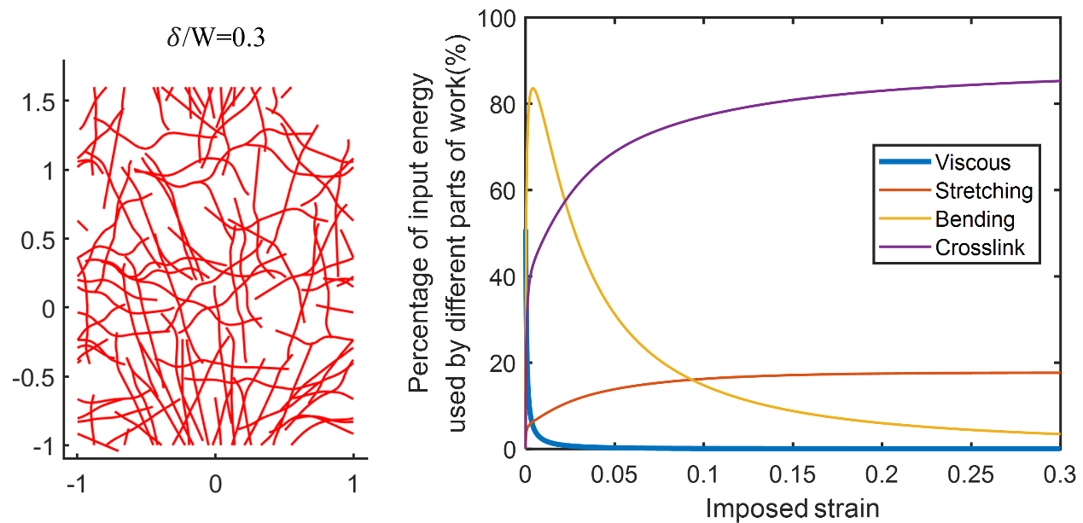
Fig. 3. (a) – Snapshot of the deformed network at an imposed strain of 0.3. (b) – Comparison of different energies stored/dissipated in the deformed network. Here, viscous means the energy dissipated by deforming/moving the network in the viscous medium.

Table 1 List of parameters used in the simulations [18,19]
Parameter | Physical meaning | Real value | Normalized value | Normalization Rules
N | Filament number | 70 | 70
W | Network size | 2.4$μm$ | 2 | $$W/L$$
L | Filament contour length | 1.2$μm$ | 1 | $$L/L$$
EA | Stretching rigidity | 35 nN | $${10}^{7}$$ | $$EAL/k_{B}T$$
EI | Bending rigidity | 12 $μm×k_{B}T$ | 10 | $${EI/k}_{B}TL$$
$$k_{B}T$$ | Thermal energy | $$4.11×{10}^{-3} nN∙nm$$
$$k_{S}$$ | Stretching stiffness of adjacent beads |  | $${10}^{6}$$ | $$k_{S}L^{2}/k_{B}T$$
$$k_{T}$$ | Bending stiffness of neighboring segments along each filament |  | $${10}^{0}$$ | $$k_{T}L/k_{B}T$$
$$E_{lim}$$ | Cross-linker binding energy | $${6k}_{B}T$$ | 6 | $$E_{lim}/k_{B}T$$
$$\dot{δ}$$ | Upper boundary moving speed |  | 0.0001 | $$\dot{δ}∆t/L$$
$$∆t$$ | Time increment |  | 0.0001 | $$∆tk_{B}T/{ξL}^{3}$$
S | Crack size | 0~1.68$μm$ | 0~0.7 | S$/W$

4. Results

4.1 Introduction of micro-cracks alters the fracture path of the network and its ductility
To examine how the presence of defects influences the fracture response of bio-filament materials, micro-cracks with different sizes were introduced at the center of random actin networks subjected to uniaxial stretching in the vertical direction (Fig. 4). Interestingly, it was found that, without any crack (or if the crack size is very small), cross-linkers started to break at the most vulnerable points within the network (Fig. 4). These broken crosslinks distributed rather randomly at the beginning and then got connected as imposed strain grows, eventually leading to the total rupture of the network. In comparison, the presence of a crack with relatively large sizes could cause crosslinks near its edge to break in a successive manner, resulting in the propagation of the crack more or less along its initial direction.
Our simulations also indicated that the apparent ductility of the network was crack-size dependent. Interestingly, the network ductility actually increases with the crack length initially before dropping to very small levels (i.e. total rupture of the network occurred quickly) under large introduced cracks, refer to Fig. 5 and the Supplementary Video.

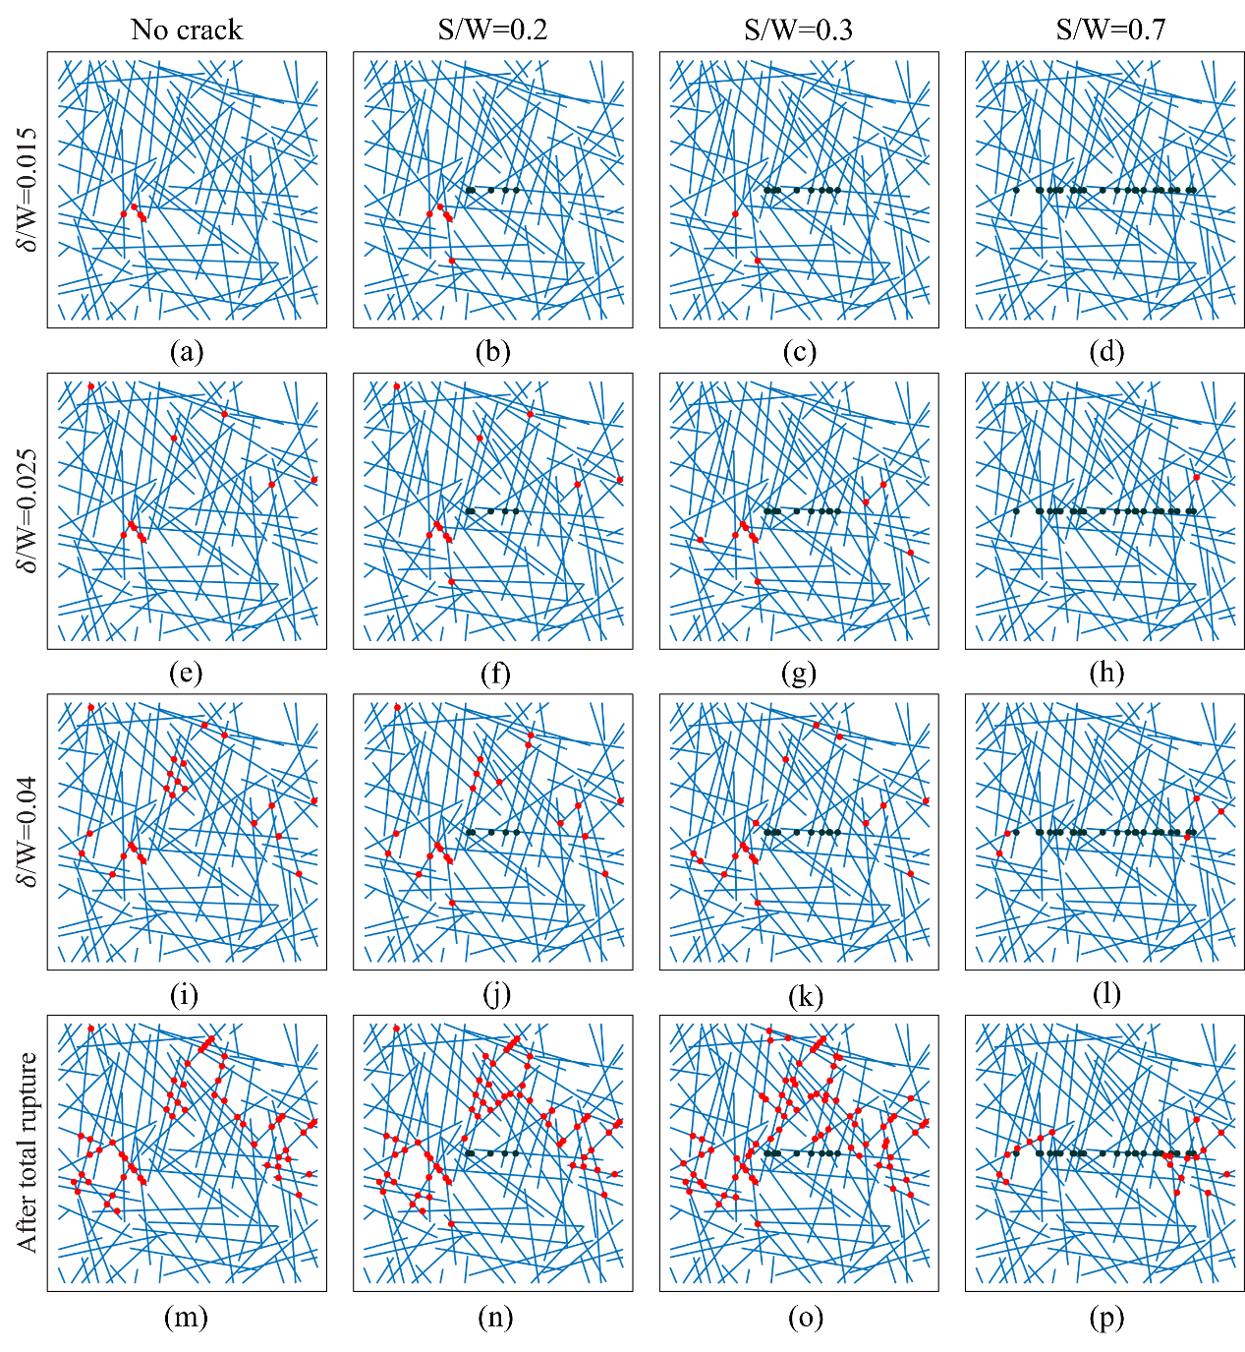
Fig. 4. Distribution of broken crosslinks (marked by the red dots) within the same network under four different introduced crack sizes.

4.2 Maximum fracture energy achieved at intermediate introduced crack size
It is conceivable that this aforementioned change of rupture path and ductility will be accompanied with an altered network fracture energy. Indeed, as shown in Fig. 5, the fracture energy (or equivalently the amount of work done by external load) was found to strongly depend on the size of the crack introduced. Surprisingly, this energy (along with the total number of broken crosslinks within the network, see Fig. 6) reached the maximum at an intermediate crack size (Fig. 5). On the other hand, under the same imposed strain, the magnitude of external force decreased as the size of introduced crack grows (Fig. 7), indicating that the network becomes softer under such circumstance.

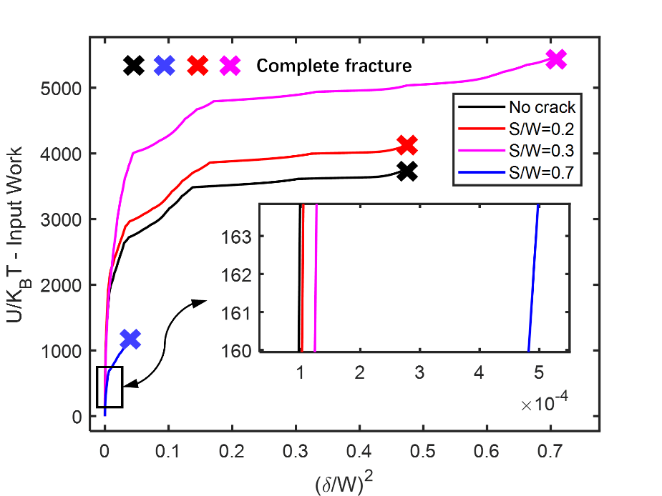
Fig. 5. Work done by the external load as a function of the imposed deformation under different introduced crack sizes. Since the input work is plotted against $δ^{2}$ (with 𝛿 being the imposed deformation) here, the slope of each curve reflects the apparent stiffness of the network.

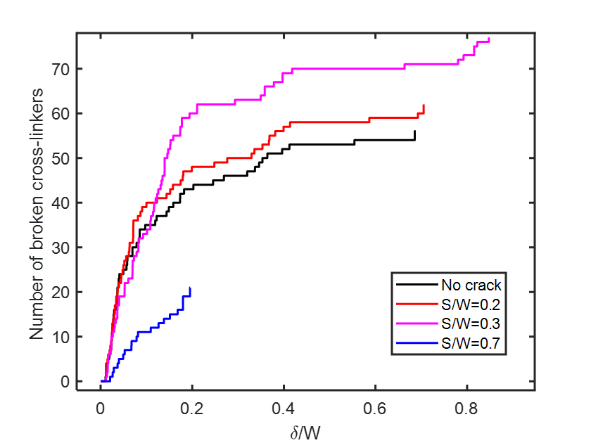
Fig. 6. Number of broken cross-linkers as a function of the imposed deformation under different introduced crack sizes.

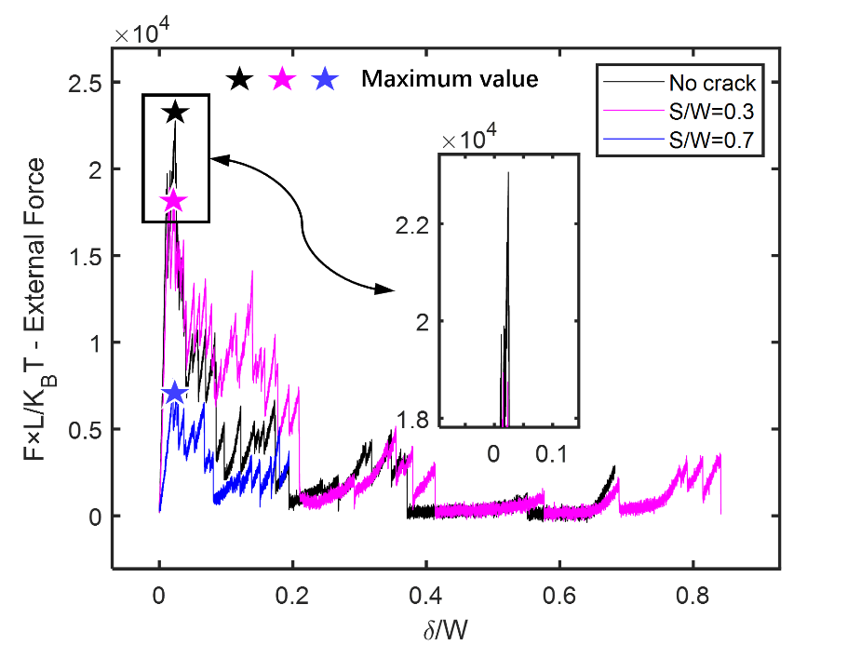

Fig. 7. Force-displacement curves for the same network with or without introduced cracks.

To see whether this is a general feature, similar simulations were conducted on a total of 26 randomly generated networks (containing the same number of filaments) to identify the optimum crack length in each of them leading to maximized fracture energy. The distribution of optimum crack size is shown in Fig. 8 which clearly shows that, on average, the network fracture toughness reaches the maximum at an introduced crack length of ~S/W=0.3.

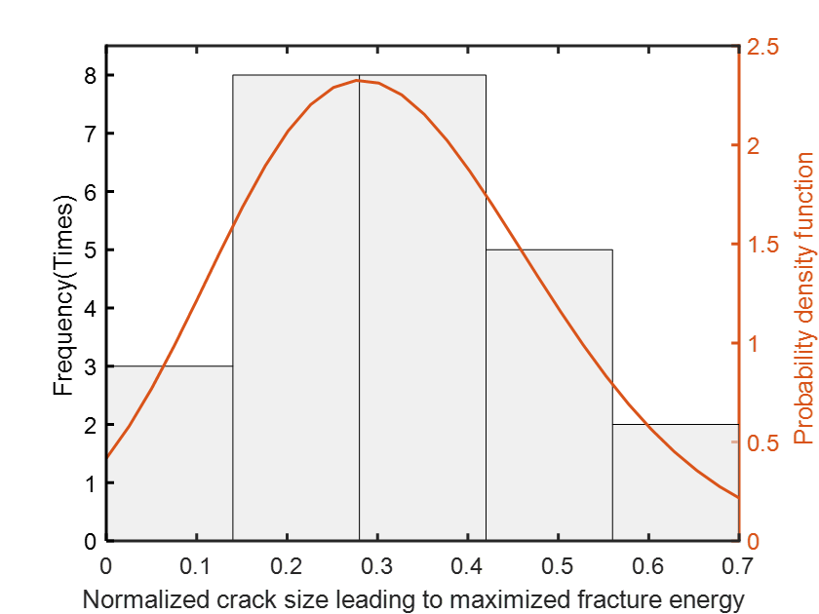
Fig. 8. Distribution of the optimum crack size (based on 26 randomly generated networks) leading to maximized fracture energy.

4.3 Influence of cross-linker properties on the network fracture energy
Besides defect size, it is conceivable that the fracture response should also be tightly regulated by the physical properties of the cross-linker. Indeed, as illustrated in Fig. 9, the network fracture energy was found to increase monotonically with the linear stiffness of cross-linkers but will reach its minimum at intermediate rotational compliance values. This is consistent with our previous study [19] which showed that most of the strain energy will be stored in the distorted filaments with rigid cross-linkers while the imposed deformation will be “evenly” distributed among significantly more crosslinking molecules with high rotational compliance, both leading to a relatively high fracture energy.

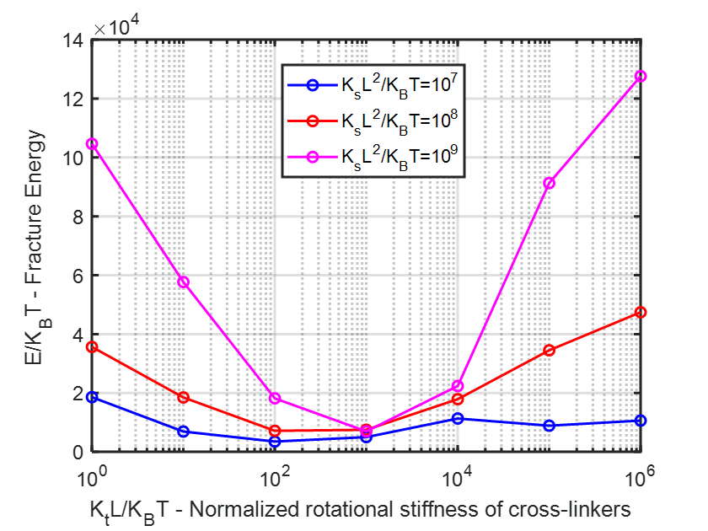
Fig. 9. The fracture energy of networks as a function of the linear and rotational compliance of crosslinking molecules. Results here are based on simulations of the network shown in Fig. 4 (with S/W=0.3) where the crosslink binding energy was fixed as ${6k}_{B}T$. Note that the three curves correspond to three different linear stiffness values of cross-linkers.

5. Discussion and Conclusion
The strong non-monotonic relationship between network fracture energy and length of introduced cracks indicates an unintuitive toughening mechanism of biopolymer materials via the presence of defects. Physically, this is likely due to several reasons. First of all, it is well-known that the presence of cracks leads to a tradeoff between stiffness and toughness [17,27] of materials. In our case, introducing micro-cracks to the network will make crosslinks near their edges easily to break, which weakens the network’s ability to resist deformation. At the same time, filaments attached with failed cross-linkers are still attached to the rest of the network through other engaged crosslinks, referring to Fig. 10. This results in an increase in the effective chain length (defined as the distance between two adjacent active crosslinks), allowing the network to undergo larger deformation and therefore absorb more energy before fracture [17,28-30]. Indeed, as shown in Fig. 5, the stiffness of the network decreases with the size of the crack introduced but the fracture energy actually increases with the crack-length initially.

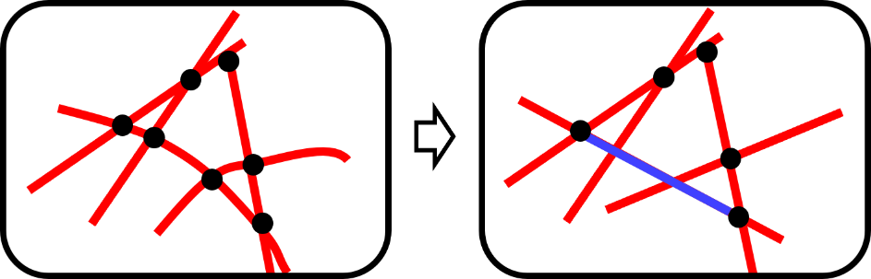
Fig. 10. Schematic diagram showing the rupture of crosslinkers leads to a larger effective chain length. Black nodes represent engaged crosslinks while red lines indicate individual filaments. The blue line shows that a longer effective chain is induced by the breakage of two cross-linkers.

On the other hand, this kind of toughening effect hinges on the assumption that the introduced crack does not rapidly develop into a catastrophically penetrating one [31]. In general, there are two types of fracture for filamentous networks. One is global-like fracture which typically happens in networks with no pre-inserted cracks, see Fig. 4(a). Under such circumstance, the system will explore all possible fracture paths and then choose the easiest one to propagate. For random networks (consisting of filaments with the same length), this always leads to global failure of the material via the interconnection of many short local cracks within the network. Another type of fracture is localized rupture which usually occurs when the size of introduced crack is significantly larger than that of the pores between filaments (Fig. 4(d)). In this case, severe stress concentration near the edges of the large crack [32] will cause rapid breakage of crosslinks in that region and eventually lead to a catastrophically penetrating crack propagation along its initial direction. Note that, since the amount of total broken cross-linkers in this scenario is much smaller than that in brittle-like fracture mentioned above (Fig. 4(m) versus Fig. 4(p)), the network will exhibit a much-reduced material strength.
Interestingly, in the transition regime where the length of introduced cracks is comparable to the network pore size, both types of fracture event can occur within the network [33]. Specially, in this case, the introduced crack will propagate to certain extent but not develop into a penetrating one (Fig. 4(n) and Fig. 4(o)). At the same time, inadequate stress concentration near the crack tip cannot prevent the breakage of crosslinks in other places. Consequently, more cross-linkers will get broken in this transition regime which translates to a maximized fracture energy (Fig. 4(o) and Fig 8).
Given that the cytoskeletal network needs to be partially disrupted or irreversibly re-arranged in different cellular processes, findings from this study could greatly help us understand how cells regulate their cytoskeleton to perform biological duties such as spreading [34-36], embryo development [37,38], volume regulation [39,40] and migration [41,42]. In addition, the toughening mechanism and the optimum crack length (around a few times of the pore size of the network), for achieving maximized fracture energy, identified here may also provide critical insights for the development of new biopolymer materials for, for example, regenerative medicine and drug delivery applications [43-45].

Acknowledgments
This work was supported by the Re (Project No.: GRF/17257016, GRF/17210618, GRF/17210520), Health@InnoHK program of the Innovation and Technology Commission of the Hong Kong SAR Government, and the National Natural Science Foundation of China (Project No. 11872325).

References
- A.R. Bausch, K. Kroy, A bottom-up approach to cell mechanics, Nat. Phys. 2 (2006) 231-238.
- D.A. Fletcher, R. D. Mullins, Cell mechanics and the cytoskeleton, Nature. 463 (2010) 485-492.
- F. Burla, Y. Mulla, B.E. Vos, A. Aufderhorst-Roberts, G.H. Koenderink, From mechanical resilience to active material properties in biopolymer networks, Nat. Rev. Phys. 1 (2019) 249-263.
- F. Meng, E.M. Terentjev, Theory of semiflexible filaments and networks, Polymers. 9 (2017) 52-79.
- B. Wickstead, K. Gull, The evolution of the cytoskeleton, J. Cell Biol. 194 (2011) 513-525
- C. Storm, J.J. Pastore, F.C. MacKintosh, T.C. Lubensky, P.A. Janmey, Nonlinear elasticity in biological gels, Nature. 435 (2005) 191-194.
- C.P. Broedersz, F.C. MacKintosh, Modeling semiflexible polymer networks, Rev. Mod. Phys. 86 (2014) 995-1036.
- J. Zou, S. Wu, J. Chen, X. Lei, Q. Li, H. Yu, S. Tang, D. Ye, Highly Efficient and Environmentally Friendly Fabrication of Robust, Programmable, and Biocompatible Anisotropic, All‐Cellulose, Wrinkle‐Patterned Hydrogels for Cell Alignment, Adv. Mater. 31 (2019) 46-53.
- N. Kamaly, B. Yameen, J. Wu, O.C. Farokhzad, Degradable controlled-release polymers and polymeric nanoparticles: mechanisms of controlling drug release, Chem. Rev. 116 (2016) 2602-2663.
- C.M. Boutry, L. Beker, Y. Kaizawa, C. Vassos, H. Tran, A.C. Hinckley, R. Pfattner, S. Niu, J. Li, J. Claverie, Z. Wang, Biodegradable and flexible arterial-pulse sensor for the wireless monitoring of blood flow, Nat. Biomed. Eng. 3 (2019) 47-57.
- M. Shi, J. Steck, X. Yang, G. Zhang, J. Yin, Z. Suo, Cracks outrun erosion in degradable polymers, Extreme Mech. Lett. 40 (2020) 100978.
- J. Tang, J. Li, J.J. Vlassak, Z. Suo, Fatigue fracture of hydrogels, Extreme Mech. Lett. 10 (2017) 24-31.
- Z. Wang, C. Xiang, X. Yao, P. Le Floch, J. Mendez, Z. Suo, Stretchable materials of high toughness and low hysteresis, Proc. Nat. Acad. Sci. USA 116 (2019) 5967-5972.
- Q. Jiao, M. Shi, T. Yin, Z. Suo, J.J. Vlassak, Composites retard hydrolytic crack growth, Extreme Mech. Lett. 48 (2021) 101433.
- Y. Tanaka, K. Fukao, Y. Miyamoto, Fracture energy of gels, Eur. Phys. J. E. 3 (2000) 395-401.
- T. Baumberger, C. Caroli, D. Martina, Fracture of a biopolymer gel as a viscoplastic disentanglement process, Eur. Phys. J. E. 21 (2006) 81-89.
- J. Kim, G. Zhang, M. Shi, Z. Suo, Fracture, fatigue, and friction of polymers in which entanglements greatly outnumber cross-links, Science. 374 (2021) 212-216.
- Y. Lin, X. Wei, J. Qian, K.Y. Sze, V.B. Shenoy, A combined finite element-Langevin dynamics (FEM-LD) approach for analyzing the mechanical response of bio-polymer networks, J. Mech. Phys. Solids. 62 (2014) 2-18.
- X. Wei, Q. Zhu, J. Qian, Y. Lin, V.B. Shenoy, Response of biopolymer networks governed by the physical properties of cross-linking molecules, Soft Matter. 12 (2016) 2537-2541.
- O.A. Bauchau, J.I. Craig, Euler-Bernoulli beam theory, Structural Analysis. 163 (2009) 173-221.
- W. Coffey, Y.P. Kalmykov, J.T. Waldron, The Langevin Equation, World scientific series in contemporary chemical physics, Volume 4, 2004.
- G.S. Payette, J.N. Reddy, Nonlinear quasi‐static finite element formulations for viscoelastic Euler–Bernoulli and Timoshenko beams, Int. J. Numer. Meth. Bio. 26 (2010) 1736-1755.
- M.A. Crisfield, Nonlinear finite element analysis of solids and structures, Volume 1: Essentials, 1991.
- J.J. Hermans, P.H. Hermans, D. Vermaas, A. Weidinger. Quantitative evaluation of orientation in cellulose fibres from the X‐ray fibre diagram, Recl. Trav. Chim. Pays-Bas. 65 (1946) 427-47.
- T. Kreis, R. Vale, Cytoskeletal and motor proteins, Oxford Univ. Press. Volume 2, 1999.
- S.J. Winder, K.R. Ayscough, Actin-binding proteins, J. Cell Sci. 118 (2005) 651-654.
- R.O. Ritchie, The conflicts between strength and toughness, Nat. Mater. 10 (2011) 817-822.
- B. Gong, J. Lin, X. Wei, J. Qian, Y. Lin, Cross-linked biopolymer networks with active motors: Mechanical response and intra-network transport, J. Mech. Phys. Solids. 127 (2019) 80-93.
- J.Y. Sun, X. Zhao, W.R.K. Illeperuma, O. Chaudhuri, K.H. Oh, D.J. Mooney, J.J. Vlassak, Z.G. Suo, Highly stretchable and tough hydrogels, Nature. 489 (2012) 133-136.
- E. Ducrot, Y. Chen, M. Bulters, R.P. Sijbesma, C. Creton, Toughening Elastomers with Sacrificial Bonds and Watching Them Break, Science. 344 (2014) 186-189.
- Y.Q. Wang, R. Fritz, D. Kiener, J.Y. Zhang, G. Liu, O. Kolednik, R. Pippan, J. Sun, Fracture behavior and deformation mechanisms in nanolaminated crystalline/amorphous micro-cantilevers, Acta Mater. 180 (2019) 73-83.
- R. Long, C.Y. Hui, J.P. Gong, E. Bouchbinder, The Fracture of Highly Deformable Soft Materials: A Tale of Two Length Scales, Annu. Rev. Condens. Matter Phys. 12 (2021) 71-94.
- L. Ramos, A. Laperrousaz, P. Dieudonné, C. Ligoure, Structural Signature of a Brittle-to-Ductile Transition in Self-Assembled Networks, Phys. Rev. Lett. 107 (2011) 148302.
- L. Yang, Z. Gong, Y. Lin, V. Chinthapenta, Q. Li, T.J. Webster, B.W. Sheldon, Disordered Topography Mediates Filopodial Extension and Morphology of Cells on Stiff Materials. Advanced Functional Materials. (2017) 1702689.
- C.A. Reinhart-King, M. Dembo, D.A. Hammer, The Dynamics and Mechanics of Endothelial Cell Spreading. Biophysical Journal. 89 (2005) 676-689.
- H. Jiang, J. Qian, Y. Lin, Y. Ni, L. He, Aggregation Dynamics of Molecular Bonds Between Compliant Materials. Soft Matter. 11 (2015) 2812-2820.
- A. Lardennois, G. Pásti, T. Ferraro, F. Llense, P. Mahou, J. Pontabry, D. Rodriguez, S. Kim, S. Ono, E. Beaurepaire, An actin-based viscoplastic lock ensures progressive body-axis elongation. Nature. 573 (2019) 266-270.
- C. Fang, X. Wei, X. Shao, Y. Lin, Force-mediated cellular anisotropy and plasticity dictate the elongation dynamics of embryos. Science Advances. 7 (2021) eabg3264.
- R.M. Adar, S.A. Safran, Active volume regulation in adhered cells. Proc. Nat. Acad. Sci. USA 117 (2020) 5604-5609.
- T.H. Hui, K.W. Kwan, T.T.C. Yip, H.W. Fong, K.C. Ngan, M. Yu, S. Yao, A.H.W. Ngan, Y. Lin, Regulating the Membrane Transport Activity and Death of Cells via Electroosmotic Manipulation. Biophysical Journal. 110 (2016) 2769-2778.
- K.M. Yamada, M. Sixt, Mechanisms of 3D cell migration, Nat. Rev. Mol. Cell Biol. 20 (2019) 738-752.
- Y. Lin, Mechanics model for actin-based motility, Physical Review E. 79 (2009) 021916.
- J. Wang, L. Li, Coupled elasticity–diffusion model for the effects of cytoskeleton deformation on cellular uptake of cylindrical nanoparticles, J. R. Soc., Interface. 12 (2015) 20141023.
- W. Yuan, H. Wang, C. Fang, Y. Yang, X. Xia, B. Yang, Y. Lin, G. Li, L. Bian, Microscopic local stiffening in supramolecular hydrogel network expedites stem cell mechanosensing in 3D and bone regeneration. Materials Horizons 8 (2021) 1722–1734.
- G. Chen, Z Shen, A Iyer, U.F. Ghumman, S. Tang, J. Bi, W. Chen, Y. Li, Machine-Learning-Assisted De Novo Design of Organic Molecules and Polymers: Opportunities and Challenges. Polymers 12 (2020) 163.

