Time-dependent response of bio-polymer networks regulated by catch and slip bond-like kinetics of cross-linkers
X. Wei^{a,b}, C. Fang^{a,b}, B. Gong^{c} , X. Shao^{a,b}, F. Sun^{d} , J. Qian^{c,*}, Y. Lin^{a,b,*}

ª Department of Mechanical Engineering, The University of Hong Kong, Hong Kong, China

^{b} HKU-Shenzhen Institute of Research and Innovation (HKU-SIRI), Guangdong, China

^{c} Department of Engineering Mechanics, Key Laboratory of Soft Machines and Smart Devices of Zhejiang Province, Zhejiang University, Hangzhou, Zhejiang, China

^{d} Department of Chemical and Biological Engineering and Center of Systems Biology & Human Health, The Hong Kong University of Science and Technology, Hong Kong, China

* Corresponding authors: ylin@hku.hk and jqian@zju.edu.cn

Abstract
Although evidence has indicated that the presence of catch bond-like crosslinking proteins can significantly alter the viscoelastic response of bio-polymer networks, a detailed mechanistic understanding is still lacking. Here we report a computational investigation to examine how catch- or slip-bond kinetics of crosslinking molecules affects the time-dependent behavior of realistic F-actin and collagen networks. Specifically, it was found that, under oscillating shear, the rate of cross-linkers getting ruptured and then reformed reaches the maximum at intermediate driving frequency, eventually leading to a locally peaked bulk loss modulus of the network. Interestingly, when a pre-stress was applied the position of such peak shifted to higher frequencies for networks with slip bond cross-linkers. In comparison, the peaked loss modulus of actin network constructed by catch bond-like crosslinking molecules was reached at a lower driving frequency because of the stabilization effect of pre-stress on such cross-linkers. Similarly, the appearance of catch bond cross-linkers was also found to greatly alter the hysteresis of networks under staircase of sinusoidal shear excitations, all in good agreement with experimental observations. Finally, we showed that stress relaxation in slip-bond collagen networks becomes faster under increasing imposed strain, in direct contrast to networks constructed by catch bond crosslinking proteins where the characteristic timescale for stress decay grows with the strain. By elucidating the mechanism by which crosslink kinetics profoundly affects the bulk behavior of biopolymer networks, our study provides useful insights for the development of future biomaterials and understanding the physical role of cytoskeleton in various cellular processes.

Introduction

Cells employ the intracellular cytoskeleton, a dynamic network of bio-filaments, to migrate, divide, and maintain their shapes in response to external stimuli [1-3]. It is commonly believed that the mechanical response of cytoskeleton is heavily influenced by the properties of a wide range of binding proteins interconnecting individual filaments together [4-6]. To elucidate the exact biochemical and physical roles of these cross-linking molecules (in how cytoskeleton behaves), reconstituted in vitro biopolymer network, as a model system, has become increasingly popular [7-10]. For example, it was shown that networks constructed by permanent and rigid cross-linkers exhibit strong non-linear elasticity, with the apparent modulus capable of undergoing order of magnitude increase upon the application of a few percent of strain [11]. This strain stiffening phenomenon is believed to be driven by the bending to stretching transition of the dominant deformation mode of filaments [12, 13]. Interestingly, a recent study also suggested that stress paths (formed by axially stretched polymers which carry most of the load) can be developed within the network under relative large strain, leading to power-law stiffening behaviors [14].

On the other hand, rich time-dependent behaviors of bio-filament networks with transient cross-linkers (that can dissociate and rebind) have also been reported. For instance, it was observed that biopolymer networks with dynamic crosslinks behave like solid on short timescales that are too short for dissociation of cross-linkers to occur, yet exhibiting fluid-like response on timescales (such as minutes) that are much larger than the characteristic time for cross-linker binding/unbinding [15]. Experiments have also revealed that the breakage of transient cross-linkers strongly depends on the force applied on them [16-22]. Specifically, the dissociation rate of many crosslinking molecules was found to increase exponentially with the force, a feature often referred to as slip-bond behavior [15, 23, 24]. In contrast, the response of some actin binding proteins, such as $α$-actinin-4 [22] and heavy meromyosin (HMM) [25], was reported to be catch bond-like, that is the presence of force (within certain range) actually makes it harder for such crosslinks to disengage.

It is conceivable that different binding kinetics between slip and catch bond-like crosslinking molecules will lead to distinct bulk response of networks constructed by them, which has indeed been observed in several recent experiments [21]. Unfortunately, although intense theoretical effort has been spent on networks with slip bond cross-linkers [26-29], very few mechanistic studies on the influence of catch bond kinetics of cross-linkers on the network viscoelasticity can be found. Here, by adopting the combined finite element – Langevin dynamics (FEM-LD) approach developed recently (where the bombardment of medium molecules on the filament was represented by a randomly distributed force causing its deflection along with a viscous drag against its movement [30-32]), we systematically examined how the presence of catch bond cross-linkers affects the time-dependent behavior, including the rheological response, hysteresis and stress relaxation, of realistic F-actin and collagen networks. Specifically, it was found that, due to the stabilization effect of force on catch bond-like cross-linkers, the peak position of loss modulus of network will shift to lower driving frequencies as the applied pre-stress increases, in direct contrast to networks with slip-bond cross-linkers. In addition, we showed that the appearance of catch bond-like crosslinks also significantly alters the hysteresis and relaxation behavior of the bio-polymer networks, all in good agreement with experimental observations.

Computational Model

In silico bio-filament networks were constructed by randomly placing N straight filaments, of equal length $L$, into a box (with a length of $3L$ for each side) where periodic boundary conditions were enforced on both the horizontal and vertical direction, refer to Fig. 1. At the intersection point of filaments, a cross-linker (Fig. 1) was added to constrain the relative movement of two filaments being connected. Note that, by varying the values of N and L, we can effectively change filament density and average crosslink distance within the network. The elastic properties of filaments are characterized by two parameters: the stretching rigidity $EA$ and the bending rigidity $EI$, with $E$ being Young’s modulus, $A$ and $I$ being the area and area moment of inertia of the cross-section, respectively. The bulk response of network was probed by moving the top surface of the box horizontally (according to the type of test to be examined) while fixing the bottom of the box.

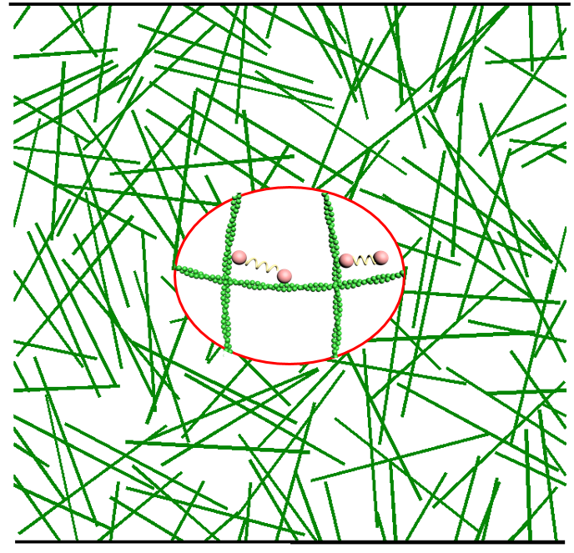
Figure 1. A randomly generated network consisting of numerous equal-sized filaments cross-linked by transient proteins that undergo kinetic dissociation and rebinding.

During the simulation, each filament was discretized into 40 nonlinear beam elements where the total Lagrangian formulation [33] was adopted to handle possible large deformations of the filament. In addition, to account for thermal undulations of individual filament, the network was assumed to be immersed in a viscous medium (with viscosity $ξ$) that exerts a drag force on a deforming/moving filament as [34]
$f_{viscous}=-ξV$ (1)
with $V$ being the velocity of filament segment in the transverse direction. In addition, the bombardments of fluid molecules on the filament effectively generate a random force distribution $f$ acing on it, which according to Langevin must satisfy:

$<f\left(\overset{⃑}{x},t\right)> =0, <f\left(\overset{⃑}{x},t\right) f\left(\overset{⃑}{y},τ\right)>=2ξk_{B}Tδ\left(\overset{⃑}{x}-\overset{⃑}{y}\right)δ\left(t-τ\right)$ (2)

where $\overset{⃑}{x}$ and $\overset{⃑}{y}$ are position vectors, $t$ and $τ$ represent time variables and $k_{B}T$ is the thermal energy. Essentially, the Dirac functions $δ\left(\overset{⃑}{x}-\overset{⃑}{y}\right) and δ\left(t-τ\right)$ here ensure spatial and temporal independence of the random force. A detailed description of the combined finite element – Langevin dynamics (FEM-LD) formulation as well as its implementation can be found in our previous study [31].

Binding kinetics of cross-linkers

As pointed out above, points where two filaments intersect were treated as cross-linkers. Physically, crosslinking protein will prevent two filaments from separating from each other. To describe such effect, the crosslinks were modeled as linear springs with a spring constant $k_{s}$. In addition, to account for the transient nature of crosslinking molecules, crosslinks were allow to dissociate with a rate $k_{off}$. On the other hand, each broken crosslink was assumed to be able to re-bind with a rate $k_{on}$. From thermodynamic argument, the breakage rate of a crosslink without any external force can be expressed as [35]
$k_{off}^{0}=k_{0}exp⁡(\frac{{-∆E}_{0}}{k_{B}T})$, (3)
where $k_{0}$ is a thermal oscillation frequency of the crosslink and ${∆E}_{0}$ is the energy barrier for it to transit from the bound to unbound state (Fig. 2).

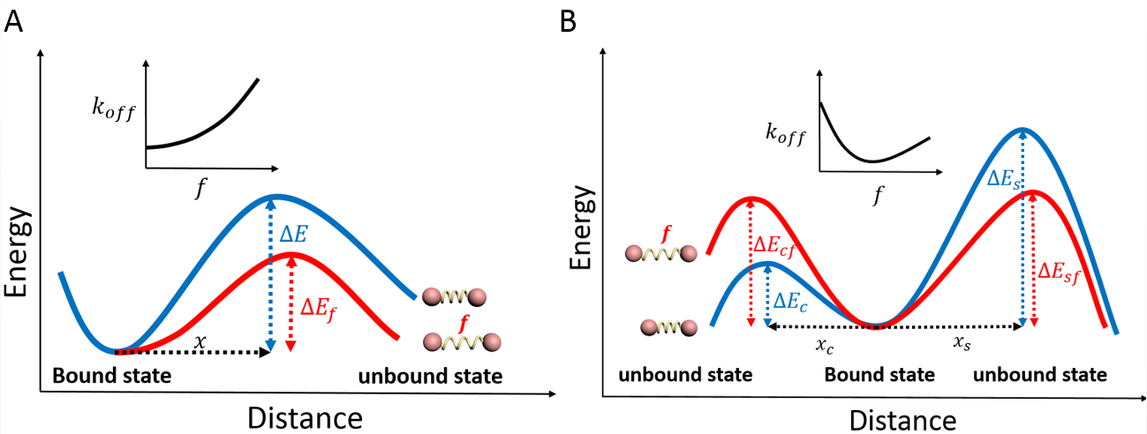
Figure 2. Schematic force-modulated energy profiles of slip bond- (left) and catch bond-like (right) crosslinks. Insets illustrate the relationship between the dissociation rate and applied force on crosslinks. For slip bond-like crosslinks, the force will lower the barrier energy between the bound and unbound state, leading to a dissociation rate monotonically increasing with the force. In comparison, the breakage of a catch bond-like crosslink can follow two pathways, with energy barriers increasing and decreasing with the force respectively. As a result, the dissociation rate will decrease with the force initially before reaching the minimum and then increasing with the force after that.

Once a force is applied on the crosslink, its dissociation rate will change. Specifically, for slip bond-like cross-linker, the force is expected to lower the barrier energy and result in an increased breakage rate as
$k_{off}=k_{off}^{0}exp⁡(\frac{fx}{k_{B}T})$, (4)
where $x$ (usually of the order of a few tenths of nanometer) represents the distance between the bound state and the transition barrier along the dissociation path (Fig. 2A). On the hand, the presence of force (within certain range) could decrease the breaking rate of catch bond-like crosslinks. One simply description to capture such behavior is the so-called two pathway model, where the dependence of $k_{off}$ on $f$ is given by

$k_{off}=k_{s}^{0}\exp\left(\frac{x_{s}f}{k_{B}T}\right)+k_{c}^{0}exp⁡(\frac{-x_{c}f}{k_{B}T})$. (5)
Essentially, the energy profile in this case is the superposition of those from a conventional slip bond (with $k_{s}^{0}$ and $x_{s}$ being the characteristic breakage rate and transition distance) and a catch bond as illustrated in Fig. 2B. Note that, for the catch bond dissociation pathway, the energy barrier actually increases (by the amount of $x_{s}f$) once a force is applied. Here, $k_{c}^{0}$ and $x_{c}$ are the base-line dissociation rate and characteristic length of the catch bond, respectively. If the energy barrier corresponding to the slip bond part is higher than that of the catch bond (i.e. $k_{s}^{0}$ is much smaller than $k_{c}^{0}$ in Eq. (5)), then the crosslink will dissociate along the catch bond pathway (Fig. 2) initially and therefore the presence of force will make it harder to break. Of course, as $f$ becomes larger, the first term on the right-hand side of Eq. (5) will eventually take over, resulting in an increasing dissociation rate (of the crosslink) with the applied force at this high load regime.

On the other hand, a broken crosslink was allowed to rebind to the original binding sites on the two filaments. In this case, the association rate was assumed to be given by
$k_{on}=k_{on}^{0}exp⁡(\frac{{-E}_{r}}{k_{B}T})$, (6)
where $k_{on}^{0}$ is the crosslinking rate between two filaments when their binding sites are placed sufficiently close to each other, $E_{r}=\frac{1}{2}κ_{s}δ^{2}$ represents the elastic energy stored in the re-formed crosslink, with $δ$ being the separation between two binding sites from opposing filaments, and $κ_{s}$ stands for the effective spring constant of the crosslinking molecule. Note that, once re-formed, the force sustained by the crosslink is $f=κ_{s}δ$.

These kinetic descriptions were then implemented in the FEM-LD method described above ([32]) to investigate the time-dependent response of networks under various testing conditions.

Results and discussion

Pre-stress modulated rheological response of F-actin network

We first examined the rheological response of the constructed network as well as how such behavior is modulated by the pre-stress within the network. Under such circumstance, a constant shear strain was first applied to the network (to induce a pre-stress level of ~1.2 Pa) by moving the upper boundary horizontally and fixing the bottom of the network. After that, a small oscillating strain $γ_{0}\sin{(ωt)}$, with $γ_{0}=$0.1%, was then superimposed to the network. The average stress $σ$ induced in the network was recorded from the simulation to obtain the frequency-dependent differential complex modulus: $K\left(ω\right)=δσ(ω)/δγ(ω)$, with the real ($K'$) and imaginary ($K''$) part representing the differential storage (elasticity) and loss (viscosity) modulus of the network respectively. By varying the driving frequency $ω$ from ${10}^{-2} to {10}^{3}$ rad/s in the simulations, the so-called rheological spectrum (i.e. the relationship between $K'$ or $K''$ and $ω$) can be obtained.

To make a close connection to the experiment conducted by Mulla et al. [19] where the average crosslink distance within the actin gel was estimated to be ~$0.5 μm$, the length and total number of filaments in our network were chosen as $L=3 μm$ and $N=120$. For F-actin, the bending and stretching rigidity of filament are $EI=k_{B}T×12 μm$ and $EA=34 nN$ [36]. Given that the dissociation and association rates of α-actinin-4, a catch bond-like crosslinking protein used in that study, were believed to be in the range of $0.1\sim 1{0 s}^{-1}$ and $60 s^{-1}$ [37] respectively, the kinetic parameters in Eq. (5) were chosen as $k_{s}^{0}=0.2 s^{-1}$,$x_{s}=0.2 nm$, $k_{c}^{0}=20 s^{-1}$ and $x_{c}=1 nm$ in our simulations. All parameters adopted in the present study, along with their values and sources, are summarized in Table 1. Interestingly, our results based on six randomly generated networks indicate that the storage modulus increases with the driving frequency initially (i.e. at relatively small $ω$ values), reaches a plateau and then grows rapidly with $ω$ again at high driving frequencies (Fig. 3A). In comparison, the loss modulus reaches a local maximum at an intermediate value of $ω$ (Fig. 3B). Changing the pre-stress level from 0 to 1.2 Pa resulted in an increase in both moduli. More interestingly, the presence of pre-stress also shifted the peak position of $K''$ to lower driving frequencies. These predictions are in excellent agreement with experimental data (given by the circular and square symbols in Fig. 3) of α-actinin-4 crosslinked actin gels [19].

Table 1
Parameters adopted for different cross-linkers of bio-polymer networks
Variable and Physical meaning | α-actinin-4 | HMM | collagen
Breakage rate along the slip pathway  $k_{s}^{0}$ ($s^{-1}$) | 0.2 [38] | 0.06 | 0.05
Characteristic length of the slip pathway  $$x_{s} (nm)$$ | 0.2 | 0.1 | 0.5
Breakage rate along the catch pathway  $k_{c}^{0}$ ($s^{-1}$) | 20 | 10 | 5
Characteristic length of the catch pathway $x_{c} (nm)$ | 1 | 1 | 5
Breakage rate of in slip bond formulation  $k_{off}^{0} (s^{-1})$ | 15 | 0.09 [39] | 0.1 [20]
Characteristic length in slip bond formulation  $x (nm)$ | 0.5 | 0.5 | 1
Rebinding rate  $k_{on}^{0}$ ($s^{-1}$) | 60 [37] | 5 | 5
Spring constant  $κ_{s} (pN/nm)$ | 12 | 120 | 10

We have also conducted simulations by assuming that each crosslink behaves like a slip bond with the dissociation rate given by Eq. (4). By selecting $k_{off}^{0}=15s^{-1}$ and $x=$0.5nm (and the same $κ_{s}$ and $k_{on}^{0}$ values as the previous case), simulation results can match the experiment under zero pre-stress. However, once a pre-stress of 1.2 Pa was added, predictions started to deviate from measurement data significantly. In particular, the peak of the local maximum of $K''$ shifted to higher frequencies (Fig. 3B) in this case, which is opposite to experimental observations [19].
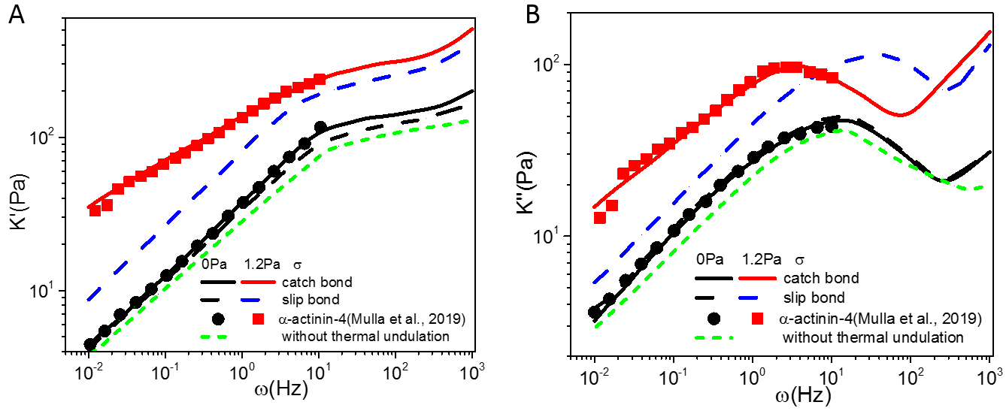

Figure 3. The storage (A) and loss (B) modulus of F-actin networks as functions of the driving frequency. Note that, without pre-stress, the frequency spectra obtained from the catch bond (black line) and slip bond (black dash line) network simulations are almost identical and fit well with experiment observations (black circle). However, under a pre-stress of 1.2Pa, the simulated response (blue dash line) of slip bond network deviates significantly from experiment whereas good agreement between measurement data (red square) and catch bond network results (red line) is maintained. Simulation results presented here represent the average of six different networks with random configurations.

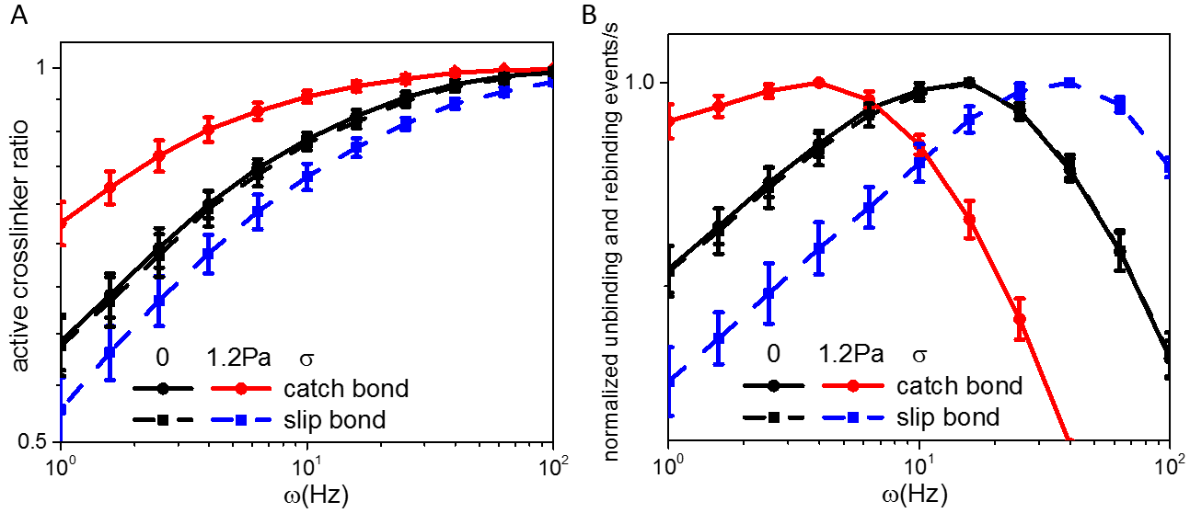
To understand the physics behind these intriguing results, we proceed by analyzing the average fraction of crosslinks remaining engaged during the imposed oscillatory deformation as well as the rate of crosslinks got ruptured but then reformed (not necessarily on the same crosslinks). As shown in Fig. 4A, the average number of engaged crosslinks kept increasing with $ω$. This is likely due to the fact that, under high driving frequency, crosslinks don’t have sufficient time to dissociate and hence most of them will remain engaged, eventually leading to an elevated storage modulus with increasing $ω$. Furthermore, the appearance of pre-stress was found to stabilize catch bond-like cross-linkers, resulting in an increased engaged fraction (Fig. 4A) and $K'$ (Fig. 3A). In comparison, a smaller engaged fraction of slip bond crosslinks was induced by pre-stress, indicating the disruptive effect of force in this case. Interestingly, the rate for cross-linkers to get ruptured and then reformed is maximized at an intermediate driving frequency (Fig. 4B). Physically, this means that the dissipation of energy reaches a local maximum at intermediate value of $ω$ and hence leads to a peaked loss modulus there (Fig. 3B). Another observation from Fig. 4B is that, for networks constructed by slip bond-like crosslinks, pre-stress causes the peak to shift to higher driving frequencies, whereas such peak for catch bond networks will shift to smaller $ω$ values. To see such difference more clearly, the frequency leading to peaked $K''$ as a function of the applied pre-stress is plotted in Fig. 5, where again excellent agreement between our simulations and experimental data by Mulla et al. [19] has been achieved.

Figure 4. A – Percentage of cross-linkers that remain engaged/active. B – Normalized unbinding and rebinding events per second as a function of the driving frequency. Clearly, the rate of cross-linkers getting ruptured and then reformed reaches the maximum at an intermediate driving frequency, eventually leading to a locally peaked loss modulus.

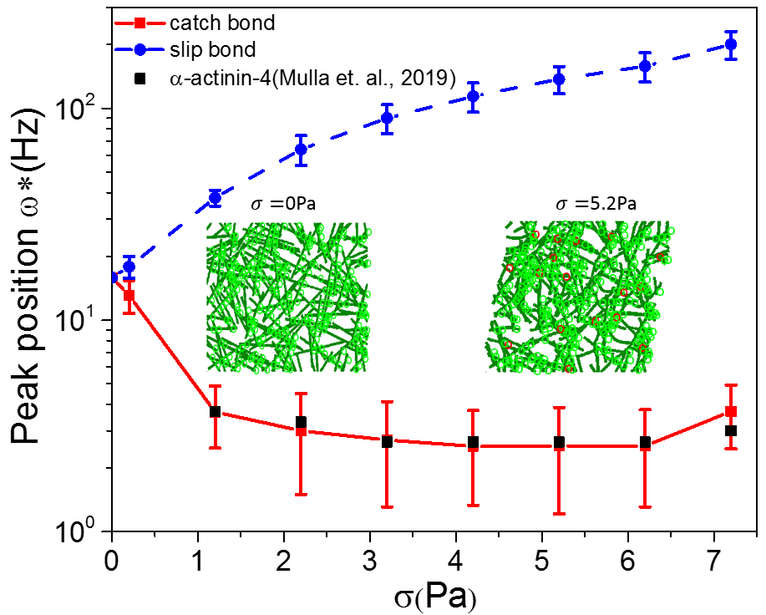

Figure 5. The peak position (of the loss modulus) under different values of pre-stress. For slip bond networks, the peak shifts to higher driving frequencies monotonically as the pre-stress increases. In contrast, the peak moves to lower frequencies for networks constructed by catch bond-like crosslinks. Experimental data from a recent study by Mulla et al. are also shown for comparison. Initial configurations of the deformed network, under a pre-stress of 0 and 5.2 Pa, are given in the insets where engaged/broken cross-linkers are indicated by the green/red circles.

Next, we examined the influence of the crosslink density and filament length on the bulk rheological response of the network. Specifically, from our simulations, the storage and loss moduli of networks corresponding to $L=1, 2 and 3μm$ are shown in Fig. 6. Not surprisingly, both $K'$ and $K''$ increase with decreasing L (or, equivalently, increasing crosslink density given that the total number of cross-linkers within the network was fixed in the present study). Finally, we want to point out that both moduli were found to decrease slightly if entropy effect (i.e. thermal fluctuations) was neglected in the simulation (Fig. 3A and 3B), which is consistent with previous studies [31] showing that “hardening” of the network will take place at a smaller strain level if thermal undulations of filament were taken into account.

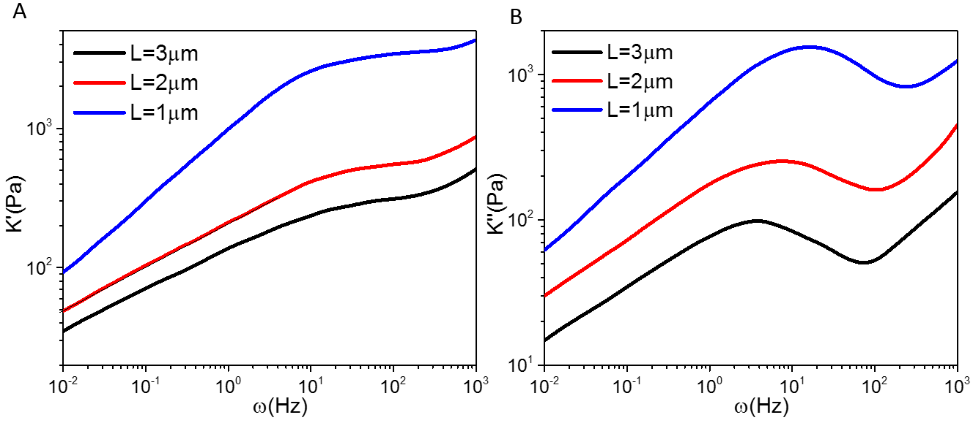
Figure 6. Influence of filament length on the storage ($K'$) and loss modulus ($K''$) of the network (under a pre-stress of $1.2Pa$).

Hysteresis of actin networks

Recently, Wolff and co-workers [40] examined the hysteresis of reconstituted F-actin networks crosslinked by heavy meromyosin (HMM), a stiff cross-linker for actin. Interestingly, it was found that the stress-strain curve of such network under one cycle of small amplitude sinusoidal strain is almost elliptical. However, under relatively large strain amplitude, the hysteresis curve first assumed a convex shape and then became concave (Fig. 7). To understand the mechanics behind, we carried out simulations by modeling the HMM as a catch bond or slip bond crosslink. In particular, given that the dissociation rate of HMM was around 0.09 $s^{-1}$ [39], kinetic parameters in Eqs. (4) and (5) were chosen as $k_{off}^{0}=0.09 s^{-1}$ and $x=0.5 nm$, and $k_{s}^{0}=0.06 s^{-1}$,$x_{s}=0.1 nm$, $k_{c}^{0}=10 s^{-1}$, $x_{c}=1 nm$ respectively. In addition, since the binding energy between actin and HMM was reported to be $\sim 4k_{B}T$, $k_{on}^{0}$ was taken to be $5 s^{-1}$. Finally, the stiffness of HMM was chosen heuristically as $κ_{s}=120 pN/nm$. During simulations, an oscillating shear (at 0.025 Hz) with amplitude of 5%, 16% or 28% (identical to those used in experiment [40]) was applied to the network whose response within the full deformation cycle was then recorded.

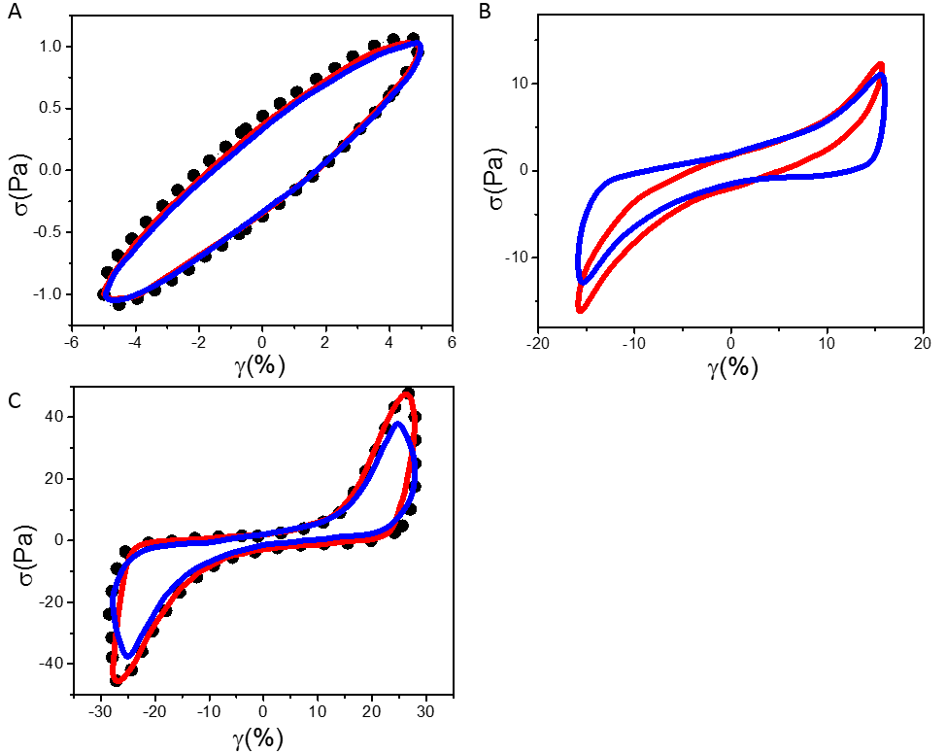
Figure 7. Hysteresis curves of actin networks cross-linked by HMM under an oscillatory shear strain of $γ\left(t\right)=γ_{0}\sin{(ωt)}$, with$γ_{0}=5\% \left(A\right), 16\% \left(B\right) and 28\%$ (C). Simulation results from catch bond and slip bond networks are represented by the red and blue line, respectively. Experimental data (under 5% and 28% oscillating shear) reported by Wolff et al. [39] are shown by the dot symbols in (A) and (C).

As shown in Fig. 7A, the observed hysteresis curve can be well explained by either slip bond or catch bond description of HMM when a 5% oscillating shear strain was imposed. However, once the strain magnitude became relatively large, the recorded hysteresis response of network can only be explained by treating HMM as a catch bond cross-linker, while deviating significantly from predictions from the slip bond formulation (Fig. 7B and 7C). In particular, when the imposed strain is large, the maximum stress that can be achieved in catch bond networks is noticeably larger than that in slip bond networks, presumably again due to the initial stabilization effect of force on catch bond-like crosslinks.

Stress relaxation

Relaxation test is also widely used to characterize the viscoelastic response of biological materials. For example, a recent study by Nam et al. [20] showed that stress relaxation in collagen gels becomes faster and faster as the imposed initial strain increases, a phenomenon they believed to originate from the force-dependent unbinding of cross-linkers. To test whether this is indeed the case, we simulated the relaxation response of randomly generated collagen networks. In this case, the total number, length, bending and stretching rigidity of filaments were chosen as $N=120$, $L=2 μm$, $EI=k_{B}T×20 μm$ and $EA=22 nN$ [20]. No reported values on the properties of naturally formed crosslinks between collagen fibers can be found, so corresponding parameters were selected heuristically to best match the experimental data. Specifically, for slip bond formulation, we chose $k_{on}^{0}=5 s^{-1}$, $k_{off}^{0}=0.1 s^{-1},x=1 nm$ and $κ_{s}=10 pN/nm$. In comparison, these parameters were selected as $k_{on}^{0}=5 s^{-1}$ and $k_{s}^{0}=0.05 s^{-1}$,$x_{s}=0.5 nm$, $k_{c}^{0}=5 s^{-1}$, $x_{c}=5 nm$ in the catch bond formulation. During the simulation, a fixed shear strain of 2 or 5% was imposed suddenly to the network, the resulting stress level (within the network) was then monitored for 30 seconds.

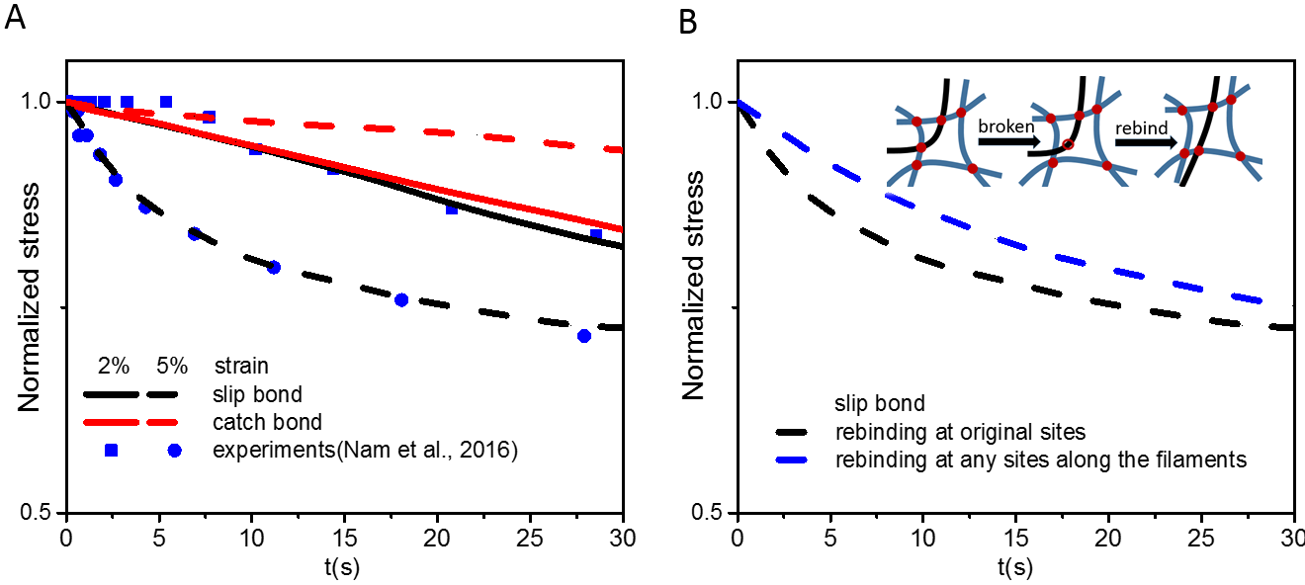

Figure 8. A – Stress relaxation of the collagen network under a 2% or 5% strain. B – Simulated relaxation response of the collagen (slip bond) network under 5% strain if rebinding of crosslink is allowed to take place only at original sites, or at any binding sites along the filament (as schematically shown in the inset).

As illustrated in Fig. 8, the relaxation behavior of the network under 2% strain can be reasonably explained by both the slip bond and catch bond description. However, under 5% strain, stress relaxation in the catch bond network became slower (again likely due to that the elevated stress makes the catch bond-like crosslink more stable) than that when the strain level is 2%, which is opposite to what was observed on collagen gel. These observations suggest that crosslinks between collagen fibers should behave like a slip bond, rather than a catch one. Indeed, results from our slip bond network simulation under 5% strain also agreed very well with the observed relaxation behavior (Fig. 8A).

One thing must be pointed out is that, for simplicity, broken crosslinks were only allowed to rebind to the original binding sites on opposing filaments in our simulations. In reality, it is conceivable that crosslinks can be reformed at other binding sites along the filament (refer to the inset of Fig. 8B). To examine how this will influence the relaxation behavior of the network, we allocated 40 (equally distributed) binding sites along each filament. Once broken, the crosslinking molecule was assumed to attach to one of the filament (a process that was randomly determined) and was then allowed to bind to the nearest binding site (not necessary the original one as illustrated in the inset of Fig. 8B) from another filament. Interestingly, the relaxation of slip bond networks under such circumstance became much slower (Fig. 8B), which can be understood by realizing that more broken crosslinks can be re-formed in this case leading to a stronger resistance against the imposed deformation as well as a slower decay of the stress.

Conclusion

In summary, we have presented a computational model to examine how the time-dependent behaviors of bio-polymer networks, including frequency dependence of storage/loss modulus, hysteresis loop and relaxation response, are regulated by different binding/dissociation kinetics of crosslinks. We showed that, under oscillating shear, the bulk loss modulus of networks will reach a local maximum at intermediate driving frequency, reflecting a peaked rate of cross-linkers getting ruptured and then reformed at that point. Interestingly, when a pre-stress is applied, the position of such peak shifts to lower frequencies for networks constructed by catch bond cross-linkers because of the stabilization effect of pre-stress on crosslinks, in direct contrast to networks with slip bond crosslinking molecules (where the peak moves to higher driving frequencies). Similar distinct influence of catch and slip bond like cross-linkers has also been found in the hysteresis and relaxation response of networks. It must be pointed out that, compared to previous studies where the model was constructed either semi-phenomenally [18] or from the behavior of single filament (along with mean field assumptions), important factors like the dissociation/association of individual crosslinks, network structure and thermal excitations have all been taken into account in our approach explicitly, enabling us to systematically examine how the binding kinetics of cross-linkers dictate the bulk behavior of the network as well as elucidate the mechanisms behind. In addition, given that the filament length and cross-linker density adopted in our simulations were all comparable to the reported/measured values, we feel that a close connection between theory and experiment has been achieved. Finally, we want to emphasize that since all simulations were carried out in a two-dimensional configuration, possible twisting of filaments was neglected here. How such new feature influences the time-dependent response of 3d networks (when compared to 2d ones) is certainly something warrants further investigation.

Given that different cellular processes can take place over a wide spectrum of timescales, findings here will help us understand how cytoskeletal networks deform viscoelastically in phenomena such as cell migration [41, 42], adhesion [43, 44] and embryo development [45]. In addition, the mechanistic insights provided by the present study could also be useful for the design and development of new biopolymeric materials [46-48]. Finally, it is conceivable that our computational model can serve as a platform for analyzing other intriguing phenomena such as the shear-induced structural evolution (i.e. alignment of filaments) of biological gels [49] or the enhanced intracellular transport [50, 51] caused by active stress (generated by motor proteins within the network) in the future.

Acknowledgement
Y. L. acknowledges financial support from the Research Grants Council of the Hong Kong Special Administration Region (Project No.: GRF/17257016, GRF/17210618), and the National Natural Science Foundation of China (Project No. 11872325). J. Q. acknowledges financial support from the National Natural Science Foundation of China (11672268).

References

[1] D.A. Fletcher, R.D. Mullins, Cell mechanics and the cytoskeleton, Nature 463(7280) (2010) 485-492.
[2] T. Kreis, R. Vale, Guidebook to the extracellular matrix, anchor, and adhesion proteins, Sambrook and Tooze Publications (1999).
[3] B. Alberts, Molecular Biology of the Cell, 6th ed.. ed., Oxford: Taylor & Francis Group (2014).
[4] N. Bonakdar, R. Gerum, M. Kuhn, M. Spörrer, A. Lippert, W. Schneider, K.E. Aifantis, B. Fabry, Mechanical plasticity of cells, Nature materials 15(10) (2016) 1090-1094.
[5] O. Lieleg, M.M. Claessens, A.R. Bausch, Structure and dynamics of cross-linked actin networks, Soft Matter 6(2) (2010) 218-225.
[6] R. Clément, B. Dehapiot, C. Collinet, T. Lecuit, P.-F. Lenne, Viscoelastic dissipation stabilizes cell shape changes during tissue morphogenesis, Current biology 27(20) (2017) 3132-3142.
[7] N. Basnet, H. Nedozralova, A.H. Crevenna, S. Bodakuntla, T. Schlichthaerle, M. Taschner, G. Cardone, C. Janke, R. Jungmann, M.M. Magiera, Direct induction of microtubule branching by microtubule nucleation factor SSNA1, Nature cell biology 20(10) (2018) 1172-1180.
[8] G. Foffano, N. Levernier, M. Lenz, The dynamics of filament assembly define cytoskeletal network morphology, Nature communications 7(1) (2016) 1-8.
[9] M.L. Gardel, F. Nakamura, J.H. Hartwig, J.C. Crocker, T.P. Stossel, D.A. Weitz, Prestressed F-actin networks cross-linked by hinged filamins replicate mechanical properties of cells, Proceedings of the National Academy of Sciences 103(6) (2006) 1762-1767.
[10] P. Lang, E. Frey, Disentangling entanglements in biopolymer solutions, Nature communications 9(1) (2018) 1-8.
[11] C. Storm, J.J. Pastore, F.C. MacKintosh, T.C. Lubensky, P.A. Janmey, Nonlinear elasticity in biological gels, Nature 435(7039) (2005) 191-194.
[12] P. Onck, T. Koeman, T. Van Dillen, E. van der Giessen, Alternative explanation of stiffening in cross-linked semiflexible networks, Physical review letters 95(17) (2005) 178102.
[13] T. Van Dillen, P. Onck, E. Van der Giessen, Models for stiffening in cross-linked biopolymer networks: A comparative study, Journal of the Mechanics and Physics of Solids 56(6) (2008) 2240-2264.
[14] G. Žagar, P.R. Onck, E. Van Der Giessen, Two fundamental mechanisms govern the stiffening of cross-linked networks, Biophysical journal 108(6) (2015) 1470-1479.
[15] C.P. Broedersz, M. Depken, N.Y. Yao, M.R. Pollak, D.A. Weitz, F.C. MacKintosh, Cross-link-governed dynamics of biopolymer networks, Physical review letters 105(23) (2010) 238101.
[16] D.L. Huang, N.A. Bax, C.D. Buckley, W.I. Weis, A.R. Dunn, Vinculin forms a directionally asymmetric catch bond with F-actin, Science 357(6352) (2017) 703-706.
[17] A.J. Licup, S. Münster, A. Sharma, M. Sheinman, L.M. Jawerth, B. Fabry, D.A. Weitz, F.C. MacKintosh, Stress controls the mechanics of collagen networks, Proceedings of the National Academy of Sciences 112(31) (2015) 9573-9578.
[18] B.T. Marshall, M. Long, J.W. Piper, T. Yago, R.P. McEver, C. Zhu, Direct observation of catch bonds involving cell-adhesion molecules, Nature 423(6936) (2003) 190-193.
[19] Y. Mulla, F. MacKintosh, G.H. Koenderink, Origin of slow stress relaxation in the cytoskeleton, Physical review letters 122(21) (2019) 218102.
[20] S. Nam, K.H. Hu, M.J. Butte, O. Chaudhuri, Strain-enhanced stress relaxation impacts nonlinear elasticity in collagen gels, Proceedings of the National Academy of Sciences 113(20) (2016) 5492-5497.
[21] M. Norstrom, M.L. Gardel, Shear thickening of F-actin networks crosslinked with non-muscle myosin IIB, Soft Matter 7(7) (2011) 3228-3233.
[22] N.Y. Yao, C.P. Broedersz, M. Depken, D.J. Becker, M.R. Pollak, F.C. MacKintosh, D.A. Weitz, Stress-enhanced gelation: A dynamic nonlinearity of elasticity, Physical review letters 110(1) (2013) 018103.
[23] T. Kim, W. Hwang, R.D. Kamm, Dynamic role of cross-linking proteins in actin rheology, Biophysical journal 101(7) (2011) 1597-1603.
[24] F. Meng, E.M. Terentjev, Fluidization of transient filament networks, Macromolecules 51(12) (2018) 4660-4669.
[25] O. Lieleg, K. Schmoller, M.M. Claessens, A. Bausch, Cytoskeletal polymer networks: viscoelastic properties are determined by the microscopic interaction potential of cross-links, Biophysical journal 96(11) (2009) 4725-4732.
[26] C.P. Broedersz, F.C. MacKintosh, Modeling semiflexible polymer networks, Reviews of Modern Physics 86(3) (2014) 995.
[27] F. Burla, Y. Mulla, B.E. Vos, A. Aufderhorst-Roberts, G.H. Koenderink, From mechanical resilience to active material properties in biopolymer networks, Nature Reviews Physics 1(4) (2019) 249-263.
[28] B. Gong, X. Wei, J. Qian, Y. Lin, Modeling and simulations of the dynamic behaviors of actin-based cytoskeletal networks, ACS Biomaterials Science & Engineering 5(8) (2019) 3720-3734.
[29] F. Meng, E.M. Terentjev, Theory of semiflexible filaments and networks, Polymers 9(2) (2017) 52.
[30] B. Hu, V. Shenoy, Y. Lin, Buckling and enforced stretching of bio-filaments, Journal of the Mechanics and Physics of Solids 60(11) (2012) 1941-1951.
[31] Y. Lin, X. Wei, J. Qian, K. Sze, V. Shenoy, A combined finite element-Langevin dynamics (FEM-LD) approach for analyzing the mechanical response of bio-polymer networks, Journal of the Mechanics and Physics of Solids 62 (2014) 2-18.
[32] X. Wei, Q. Zhu, J. Qian, Y. Lin, V. Shenoy, Response of biopolymer networks governed by the physical properties of cross-linking molecules, Soft matter 12(9) (2016) 2537-2541.
[33] M.A. Crisfield, Non-linear finite element analysis of solids and structures, Wiley New York1993.
[34] W. Coffey, Y.P. Kalmykov, The Langevin equation: with applications to stochastic problems in physics, chemistry and electrical engineering, World Scientific2012.
[35] G.I. Bell, Models for the specific adhesion of cells to cells, Science 200(4342) (1978) 618-627.
[36] X. Liu, G.H. Pollack, Mechanics of F-actin characterized with microfabricated cantilevers, Biophysical journal 83(5) (2002) 2705-2715.
[37] S.M.V. Ward, A. Weins, M.R. Pollak, D.A. Weitz, Dynamic viscoelasticity of actin cross-linked with wild-type and disease-causing mutant α-actinin-4, Biophysical journal 95(10) (2008) 4915-4923.
[38] N.Y. Yao, D.J. Becker, C.P. Broedersz, M. Depken, F.C. MacKintosh, M.R. Pollak, D.A. Weitz, Nonlinear viscoelasticity of actin transiently cross-linked with mutant α-actinin-4, Journal of molecular biology 411(5) (2011) 1062-1071.
[39] B. Guo, W.H. Guilford, Mechanics of actomyosin bonds in different nucleotide states are tuned to muscle contraction, Proceedings of the National Academy of Sciences 103(26) (2006) 9844-9849.
[40] L. Wolff, P. Fernández, K. Kroy, Resolving the stiffening-softening paradox in cell mechanics, PloS one 7(7) (2012).
[41] Y. Lin, Mechanics model for actin-based motility. Phys Rev E. 79 (2009) 021916.
[42] Y. Lin, V.B. Shenoy, B. Hu, L. Bai. A Microscopic Formulation for the Actin-Driven Motion of Listeria in Curved Paths Biophysical Journal 99 (2010) 1043-1052.
[43] J. Qian, J. Lin, G.-K. Xu, Y. Lin, H. Gao. Thermally assisted peeling of an elastic strip in adhesion with a substrate via molecular bonds. Journal of the Mechanics and Physics of Solids 101 (2017) 197-208.
[44] S. He, C. Liu, X. Li, S. Ma, B. Huo, B. Ji. Dissecting collective cell behavior in polarization and alignment on micropatterned substrates. Biophysical Journal. 109 (2015) 489-500.
[45] Y. Gao, S.-L. Xue, Q. Meng, B. Li, X.-Q. Feng. Multiscale fracture mechanics model for the dorsal closure in Drosophila embryogenesis. Journal of the Mechanics and Physics of Solids 127 (2019) 154-166.
[46] A. Ghoorchian, J.R. Simon, B. Bharti, W. Han, X. Zhao, A. Chilkoti, G.P. López, Bioinspired Reversibly Cross‐linked Hydrogels Comprising Polypeptide Micelles Exhibit Enhanced Mechanical Properties, Advanced Functional Materials 25(21) (2015) 3122-3130.
[47] Y. Li, S. Tang, M. Kröger, W.K. Liu, Molecular simulation guided constitutive modeling on finite strain viscoelasticity of elastomers, Journal of the Mechanics and Physics of Solids 88 (2016) 204-226.
[48] J. Wu, Z. Zhao, C.M. Hamel, X. Mu, X. Kuang, Z. Guo, H.J. Qi, Evolution of material properties during free radical photopolymerization, Journal of the Mechanics and Physics of Solids 112 (2018) 25-49.
[49] X. Zhao, Designing toughness and strength for soft materials, Proceedings of the National Academy of Sciences 114(31) (2017) 8138-8140.
[50] B. Gong, J. Lin, X. Wei, J. Qian, Y. Lin, Cross-linked biopolymer networks with active motors: mechanical response and intra-network transport, Journal of the Mechanics and Physics of Solids 127 (2019) 80-93.
[51] J.L. Wang, Y.W. Yang, M.R. Yu, G.Q. Hu, Y. Gan, H.J. Gao, X.H. Shi, Diffusion of rod-like nanoparticles in non-adhesive and adhesive porous polymeric gels. Journal of the Mechanics and Physics of Solids 112 (2018) 431-457.

