Optimizing bendability of AlSi-coated 2GPa-grade press-hardened steel by double austenitization
M. Guan ^{a,b}, Y. Wang ^{a,b}, Y.X. Liu ^{a,b}, Z. Wang ^{c*}, M.X. Huang ^{a,b*}
ª Department of Mechanical Engineering, The University of Hong Kong, Pokfulam Road, Hong Kong, China
^{b} Shenzhen Institute of Research and Innovation, The University of Hong Kong, Shenzhen 518000, China
^{c} General Motors China Science Lab, Shanghai 201206, China
*Corresponding author.
E-mail address: mxhuang@hku.hk (M. X. Huang); zhou.wang@gm.com(Z. Wang)
Abstract
The present work, for the first time, demonstrates that a new heat treatment process involving double austenitization can effectively optimize the coating structure and prior austenite grain size (PAGS) of an AlSi-coated 2GPa-grade press hardened steel (PHS), resulting in an improvement of bendability while keeping similar ultimate tensile strength (UTS). It is found that the interdiffusion ferrite layer in the coating structure is responsible for the improvement of bendability while the controlled PAGS keeps similar UTS. More specifically, it shows that the interdiffusion ferrite layer with high Al content is brittle and detrimental to bendability. Consequently, a double austenitization process is employed to produce an interdiffusion ferrite layer with an Al content lower than 4 wt.%, resulting in an improvement of bending angle over 60° while keeping similar UTS.

Keywords: Press-hardened steel; AlSi coating; Prior austenite grain size; Bendability; Interdiffusion ferrite

Press-hardened steel (PHS) has been widely adopted on automobile components, which enhances both lightweighting and crash resistance due to the high strength level [1-4]. AlSi coating is used to improve the surface quality of PHS after hot stamping, which effectively suppresses oxidation and decarburization [5-7]. Currently, AlSi coatings are a widely used technique for PHS in the global automotive industry. It is noted that PHS used in automobiles must possess high enough bending toughness to avoid pre-mature failure in service [8]. At present, the most common PHS, AlSi-coated 22MnB5, reaches an ultimate tensile strength (UTS) of 1.5GPa and has a bending angle over 60° [9-11] that represents a satisfactory bending toughness for automotive applications. However, when the UTS increases to 2GPa in AlSi-coated 34MnB5 PHS, the bending angle decreases to 50° or lower [12]. The low bending angle causes safety concerns and limits the application of such PHS.
Besides steel substrate, AlSi coating has been found important to the bendability of PHS [13-15]. Interestingly, contradictory results on the effect of AlSi coating on the bendability of PHS have been reported [14, 15]. On one hand, AlSi coating reacts with steel substrate to form brittle intermetallics like Fe₂Al₅ and FeAl, which form coating cracks, cause stress concentration, and induce localized shear fracture during bending. Thus, reducing the AlSi coating's thickness has been suggested for better bendability [13, 16]. On the other hand, an interdiffusion ferrite layer mainly consisting of ferrite forms between the intermetallics layer and martensite substrate [17]. The interdiffusion ferrite layer has been suggested to be ductile which can prevent the propagation of surface cracks induced by brittle intermetallic layer [18]. Based on this argument, prolonged austenitization has been used to obtain a thicker interdiffusion ferrite layer, aiming to improve PHS’s bendability [14]. However, contradicting results are reported for such an approach of prolonged austenitization [15]. For this reason, more research should be conducted to clarify the role of the interdiffusion ferrite layer on the bendability of AlSi-coated PHS. In addition, although much work has been done on improving the bendability of AlSi-coated 1.5GPa-grade PHS, little or no work has been reported on improving the bendability of AlSi-coated 2GPa-grade PHS. Therefore, research for understanding and improving the bendability of AlSi-coated 2GPa-grade PHS is urgently needed for the automotive and steel industry, which is the aim of the present work.
The AlSi-coated 2GPa-grade PHS employed in the present study was received in an as-annealed state from an industrial coil. The chemical composition of steel substrate and AlSi coating before heat treatment is given in Table 1. The initial coating structure before heat treatments can be found in Fig. S1 in supplementary.
Table 1
Chemical composition of steel substrate and AlSi coating (in wt.%).
 | Mn | Si | Al | C | Cr | V | B | Fe
Steel substrate | 1.74 | 0.61 | 0.54 | 0.34 | 0.24 | 0.15 | 0.0023 | Bal.
AlSi coating | -- | 9 | Bal. | -- | -- | -- | -- | 2

The as-received PHS was cut to 100mm × 65mm × 1.2mm and subjected to different press hardening treatments. The names and heat treatments of samples were listed in Table 2 and a schematic showing the heat treatment process was added to Fig. S2 in supplementary. It needs to be mentioned that the heat treatment of “SA 930” is similar to conventional heat treatment for PHS employed in the industry [19]. The other three samples were subjected to a new heat treatment process involving double austenitization. The first austenitization step is employed to obtain different coating structures, while the second austenitization step is used to control PAGS. While the austenitization temperature is relatively high in the first austenitization step, the temperature for the second austenitization step is as low as 850 °C and the holding time is short (5 minutes) to refine the PAGS that was coarsened during the first austenitization step. The quenching step is conducted by two copper plates with the size of 300mm × 210mm × 30mm. All four samples were subjected to a final heat treatment of baking at 170 °C for 20 minutes, which simulates the paint baking process used in industrial production.

Table 2
Heat treatment steps
No. | First step |  | Second Step |  | Designation
No. | Austenitization | Cooling | Austenitization | Cooling | --
1 | 930 °C 7 min | Die quench | -- | -- | SA 930
2 | 930 °C 7 min | Air cooling to 200 °C | 850 °C 5 min | Die quench | DA 930
3 | 980 °C 20 min | Air cooling to  200 °C | 850 °C 5 min | Die quench | DA 980
4 | 1100 °C 30 min | Air cooling to 200 °C | 850 °C 5 min | Die quench | DA 1100

The uniaxial tensile tests were conducted using an MTS-810 universal tensile machine at a quasi-static strain rate of $3×{10}^{-4} s^{-1}$ at room temperature. A 25-mm extensometer was used for strain measurement. The bending test was conducted according to the VDA-238-100 standard widely used in the automotive industry [20]. The size of the tested samples is 60 mm × 60 mm × 1.2 mm. The maximum bending angle is calculated according to Eq. S1 (in supplementary). Each test has been repeated at least three times to ensure repeatability. The samples for scanning electron microscopy (SEM), energy dispersive spectroscopy (EDS), and electron backscatter diffraction (EBSD) were mounted and ground with sandpaper followed by vibration polish with colloidal silica. For PAGS measurement, EBSD images of these materials were analyzed by a MATLAB toolbox (METX) to identify the prior austenite grain boundaries (PAGB). Line interception method was used to calculate PAGS. Samples for interrupted bending test were machined by electrical discharge machining (EDM) in the center of bended samples and prepared in the same way for SEM. Transmission electron microscopy (TEM) used in this study is Talos F200X with a voltage of 200 keV. TEM samples were prepared by focus ion beam (FEI quanta 200 3D).
Mechanical properties of the four materials are shown in Fig. 1 and Table 3. UTS of all materials are over 1800MPa, satisfying the strength requirements for commercial 2GPa-grade PHS defined by the automotive and steel industry. Compared to other samples, the UTS of DA 1100 sample decreased slightly to 1846 MPa, which will be explained later in the characterization part. Besides, the total elongations of all materials are very similar. Fig. 1 (b-d) shows the bending test results. While the bending angles of SA 930 and DA 930 are comparable, there is a clear degradation of bendability in DA 980 and a noticeable enhancement in DA 1100. The superior bendability of DA 1100 is further confirmed in Fig. 1 (d). DA 1100 absorbs 24.7% more energy than SA 930 in bending test. In summary, DA 1100 obtains a bending angle of 62° at a UTS of 1846 MPa, while SA930, whose heat treatment is similar to current industrial production, only obtains a bending angle of 50° at a similar UTS.
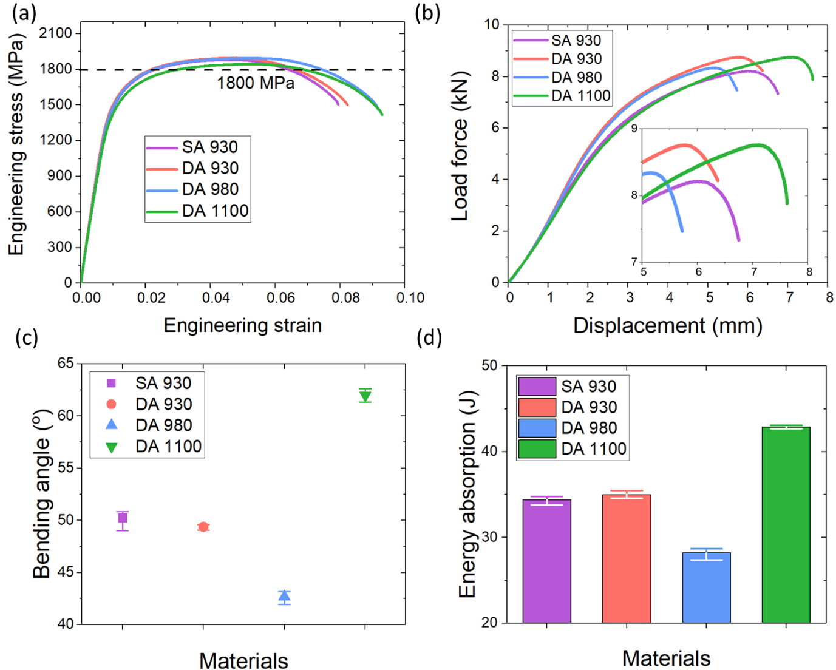
Fig. 1. (a) Uniaxial tensile tests, (b) VDA-238-100 standard punch head displacement-load force curve of the bending test, (c) VDA-238-100 standard bending angles, and (d) energy absorption for the four tested materials. The displacement range for energy absorption calculation is from 0 to the place where the load force is 30 N smaller than the peak value (according to the VDA-238-100 standard). SA stands for single austenitization and is similar to standard heat treatment process of industrial PHS. DA stands for double austenitization.

Table 3
Mechanical properties of samples
 | SA930 | DA930 | DA980 | DA1100
Yield stress (MPa) | 1473.4 ± 22.5 | 1520.5 ± 39.6 | 1517.7 ± 40.1 | 1446.0 ± 24.7
Ultimate tensile stress (MPa) | 1891.1 ± 12.4 | 1899.8 ± 4.9 | 1893.0 ± 0.6 | 1846.7 ± 2.7
Total elongation (%) | 8.0 ± 0.2 | 8.1 ± 0.5 | 8.9 ± 0.3 | 9.1 ± 0.3
Maximum bending angle (°) | 50.2 ± 1.0 | 49.2 ± 0.3 | 42.7 ± 0.7 | 62.0 ± 0.6
Maximum bending force (N) | 8296.6 ± 58.3 | 8799.5 ± 63.3 | 8257.8 ± 112.3 | 8700.8 ± 127.2
Energy absorption (J) | 34.4 ± 0.5 | 35.0 ± 0.5 | 28.2 ± 0.7 | 42.9 ± 0.2

To understand the mechanism for the outstanding bendability of DA 1100, both martensite substrates and coating structures are investigated. First, the PAGS of all four materials is given in Figure 2. While DA 930, DA 980, and DA 1100 have similar PAGS, the SA 930 shows a larger one because the other three samples were subjected to a second austenitization at a lower temperature of 850 °C. The hardness of martensite substrates of the four materials is shown in Fig. S3 in supplementary. The hardness is comparable for all materials while the DA series have a slightly higher value due to smaller PAGS.
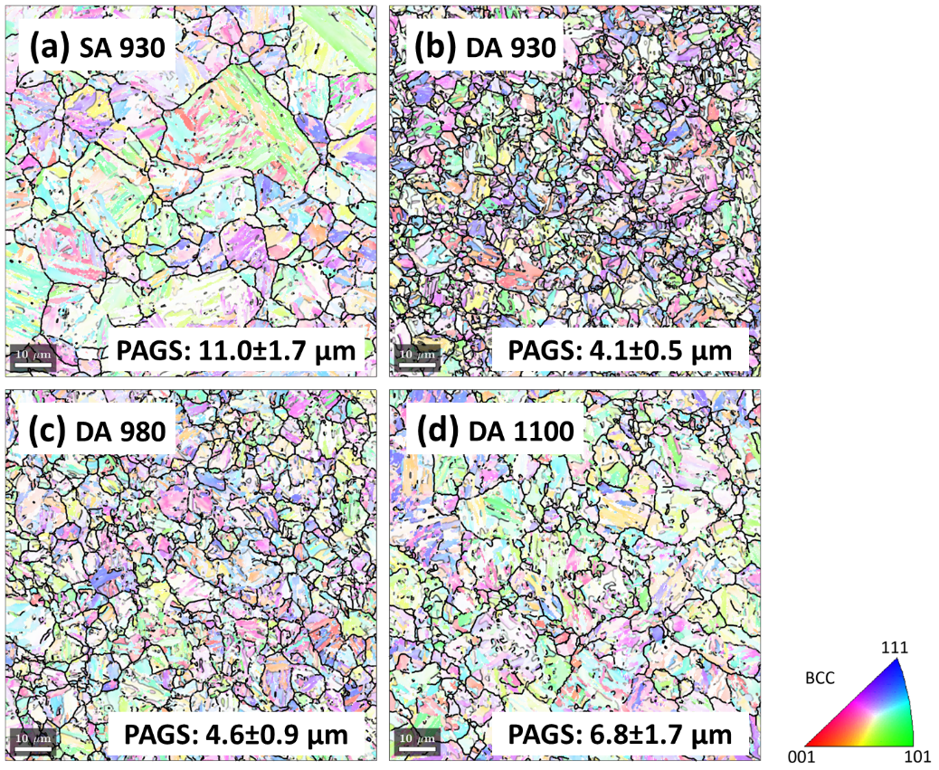
Fig. 2. PAGB lines of martensite substrates of (a) SA 930, (b) DA 930, (c) DA 980, and (d) DA 1100. The backgrounds are faded EBSD images.
The coating structures of four materials are shown in Fig. 3. In all materials, coating has been identified only as body-centered cubic (BCC) ferrite structure, though FeAl and Fe₃Al also exist and cannot be extinguished from ferrite phase by EBSD due to the similarity of crystal structures [13, 14]. SA 930 and DA 930 have similar coating structures, including both coating thickness and grain size. It is because of their similar heat treatments except for the extra second austenitization step of DA 930. However, the temperature of the second austenitization is much lower than the first one. The EDS line scan and nanoindentation of the two coatings, which are shown in Fig. S4 in supplementary, prove their similarity. Therefore, the influence of the second austenitization step on coating structure is negligible.
The microstructures of DA 980 and DA 1100 are shown in Fig. 3 (c-d). Compared with DA 930, the thickness of AlSi coating increases to 46 µm and 70 µm in DA 980 and DA 1100 (Table 4), respectively, due to more intensive interdiffusion processes. The coating of DA 1100 is 70 µm thick and in the structure of ferrite with tensile strength ranges from 400-600 MPa[21]. The calculation, considering the tensile strength and thickness of both coating and substrate, shows the tensile strength of DA 1100 ranges from 1800 MPa to 1823 MPa, which is close to the experiment result. Therefore, larger coating thickness accounts for the slight decrease in tensile strength of DA 1100 due to the lower strength of coating.
While the coating structures are similar for SA 930 and DA 930, the PAGS of DA 930 is much smaller than SA 930. Refinement of PAGS has been proven to be an effective way to enhance the bendability of PHS[22]. However, this work finds contradictory. there is no perceptible improvement in bendability for DA 930, which reveals that, for the present 2GPa-grade PHS, the deterioration of bendability cannot be compensated by simply refining the PAGS in the range from 11.0 µm to 4 µm, which is the most typical range for PAGS of industrial PHS. Therefore, it can be concluded that the superior bendability of DA 1100 over SA 930 is not due to the refinement of PAGS. The coating structure is likely the deciding factor affecting the bendability of the present 2GPa-grade Al-Si coated PHS.
EDS is used to identify phase composition of different coating layers, with Al content presented in Fig. 3 (e). EDS results of other elements can be found in supplementary Fig. S5. Table 4 summarizes the thickness of phases in different coatings. For simplicity, both Fe₃Al and FeAl are identified as intermetallic (IM) in this work due to their low fracture toughness[23, 24]. The phases and phase boundary determination in coatings are confirmed by SAED patterns which are shown in Fig. S6 in supplementary. It is clear the DA 930 and DA 980’s ferrite has higher Al content than the ferrite in DA 1100.
The thickening of coatings is due to the diffusion of Al from coating to substrate, which is driven by chemical driving force. The diffused Al transfers the martensite substrate to IM or interdiffusion ferrite according to Al concentration to reach the thermal dynamic equilibrium. 6.5-7% Al (wt.%) has been found to be the boundary value for IM and ferrite in this work. In higher austenitization temperature and longer time, Al diffuses longer into substrate and its concentration decreases. When Al concentration drops lower than 6.5-7%, IM transfers to ferrite. Therefore, compared with DA 930, both IM and ferrite thicken in DA 980 due to the diffusion of Al. In DA 1100, IM disappears because the intensive diffusion of Al depletes Al in IM.
Table 4
Characteristics of coating layer and substrate of samples subjected to double austenitization
 | DA930 | DA980 | DA1100
PAGS of substrate (µm) | 4.1 ± 0.5 | 4.6 ± 0.9 | 6.8 ± 1.7
Total coating thickness (µm) | 22.4 | 46.0 | 70.8
Thickness of IM layer (µm) | 16.6 | 24.0 | 0
Thickness of interdiffusion ferrite layer (µm) | 5.8 | 20.0 | 68.0
Thickness of interdiffusion ferrite layer with Al content higher than 4% w.t (µm) | 3.0 | 14.3 | 0

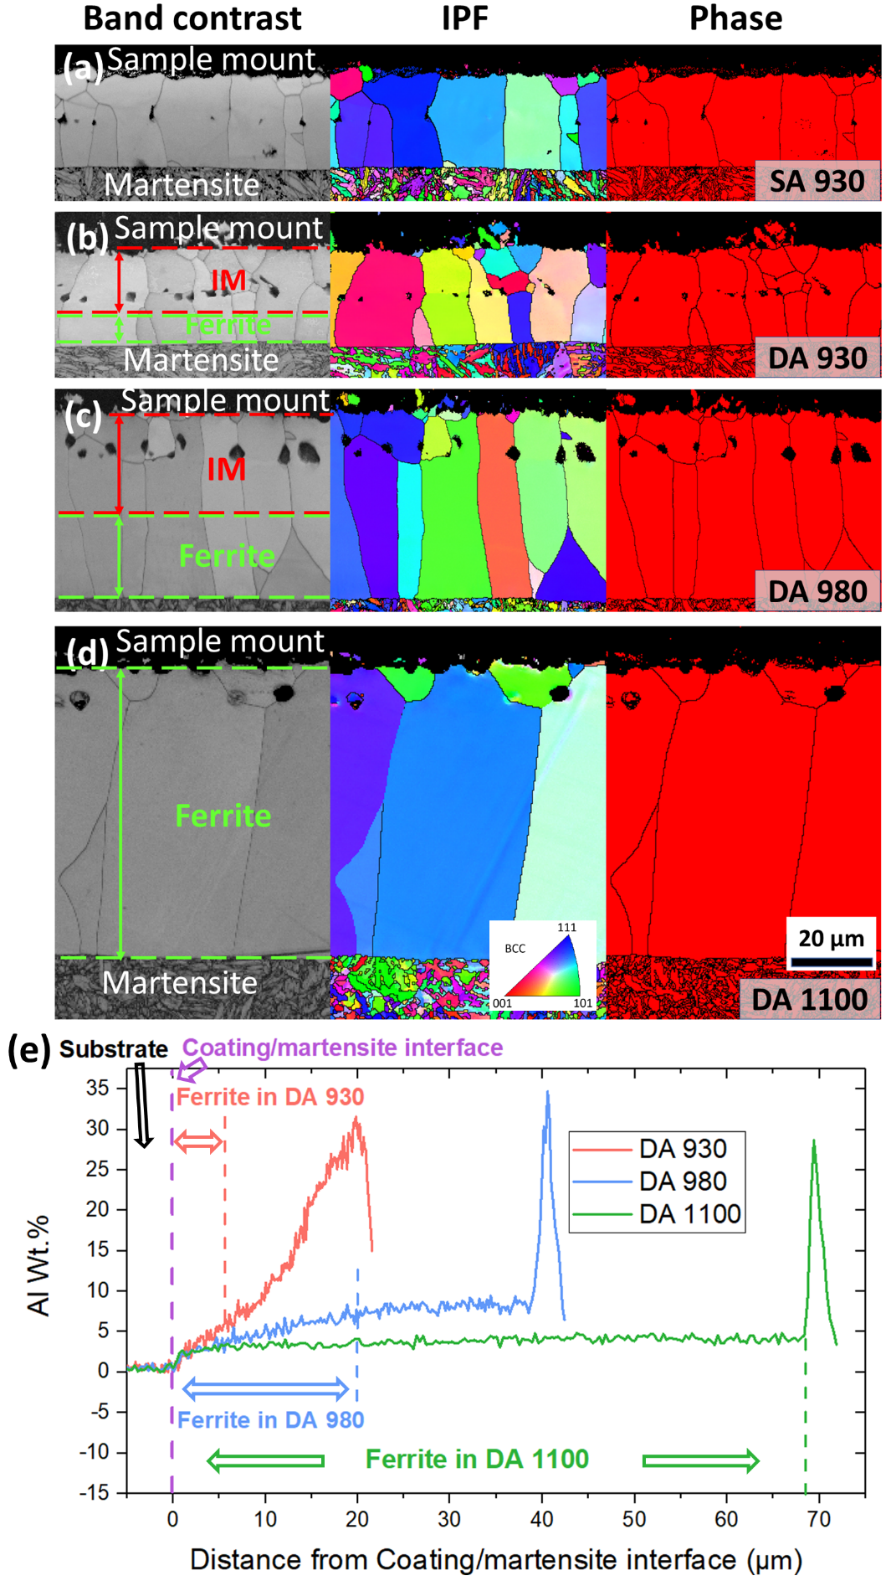
Fig. 3. EBSD band contrast maps, inverse pole figure (IPF) maps, and phase maps of Al-Si coatings on (a) SA 930, (b) DA 930, (c) DA 980, and (d) DA 1100. For band contrast maps, the phases and phase boundary determination in coatings are made according to SAED patterns which are shown in Fig. S6 in supplementary. IM stands for intermetallics including both FeAl and Fe₃Al. For phase maps, red color represents BCC phase including ferrite, FeAl, and Fe₃Al phases due to the detection limit of EBSD. (e) EDS line scans of Al-Si coatings on the three DA samples. The detailed scanning positions are shown in Fig. S7 in supplementary.
Although it has been reported that thickening interdiffusion ferrite layer in coating can improve the bendability of Al-Si coated PHS [14], the present work finds the contrary. DA 930 exhibits much better bendability than DA 980, but DA 930 has a much thinner interdiffusion ferrite layer than DA 980. In other words, the thickening of ferrite reversely compromises the bendability of DA 980. The influence from martensite substrate can be excluded because DA 930 and DA 980 have similar PAGS in martensite structure as they shared the same second austenitization process. Differently, DA 1100 has the largest thickness of interdiffusion ferrite layer and much better bendability than both DA 930 and DA 980. It indicates the thickness of interdiffusion ferrite layer alone cannot explain the bendability difference among these three samples. Other factors must be considered.
Al concentrations in interdiffusion ferrite layers of DA 930 and DA 980 are clearly higher than DA 1100 as Fig.3 and Table 4 have shown. Besides, the tensile test of modeling Fe-Al ferrite alloys, which is shown in Fig. S8 in supplementary, indicates a small change in Al content can lead to significant changes in mechanical properties. For example, the ductility of Fe-3% Al (wt.%) is double that of Fe-5% Al. The first principle calculation verifies the ductility of steel changes significantly with Al content[25]. Therefore, the Al concentration influences the fracture behaviors of ferrite on coatings.
The fractography of coating structures after bending fracture is shown in Fig. 4. For coating of DA 930, grain facets can be clearly observed for IM, which is a typical feature of intergranular (IG) fracture. Interdiffusion ferrite in DA 930 exhibits a cleavage fracture feature. Brittle cleavage fracture has been observed for both IM and interdiffusion ferrite in the coating of DA 980. Consequently, the interdiffusion ferrite in both DA 930 and DA 980 fractures in brittle fracture mode. On the contrary, slanted surface and microvoids coalescence (MVC) dimples, which are a typical feature of ductile fracture, are observed mostly on fracture surface of ferrite on DA 1100.
Ferrite on coatings of DA 930 and DA 980, which mostly consists of brittle, high Al content ferrite, fractures in brittle fracture mode during the bending. Ferrite fractures in brittle fracture mode has a low fracture toughness ranging from 19 to 41 MPa$\sqrt{m}$ [26], which is much lower than that of martensite substrate and similar to IM[23, 24]. Therefore, the thickening of interdiffusion ferrite in DA 980 essentially adds the thickness of the brittle layer, thus leading to the deterioration of bendability when compared with DA 930.
Ferrite on DA 1100, which fully consists of low Al content, more ductile ferrite, fractures in ductile/brittle transition mode in bending. In this fracture mode, the fracture toughness of ferrite increases significantly and exceeds that of martensite substrate[24, 26-28]. Therefore, the interdiffusion ferrite in DA 1100 prevents the propagation of cracks effectively, which leads to a noticeable improvement in bendability.

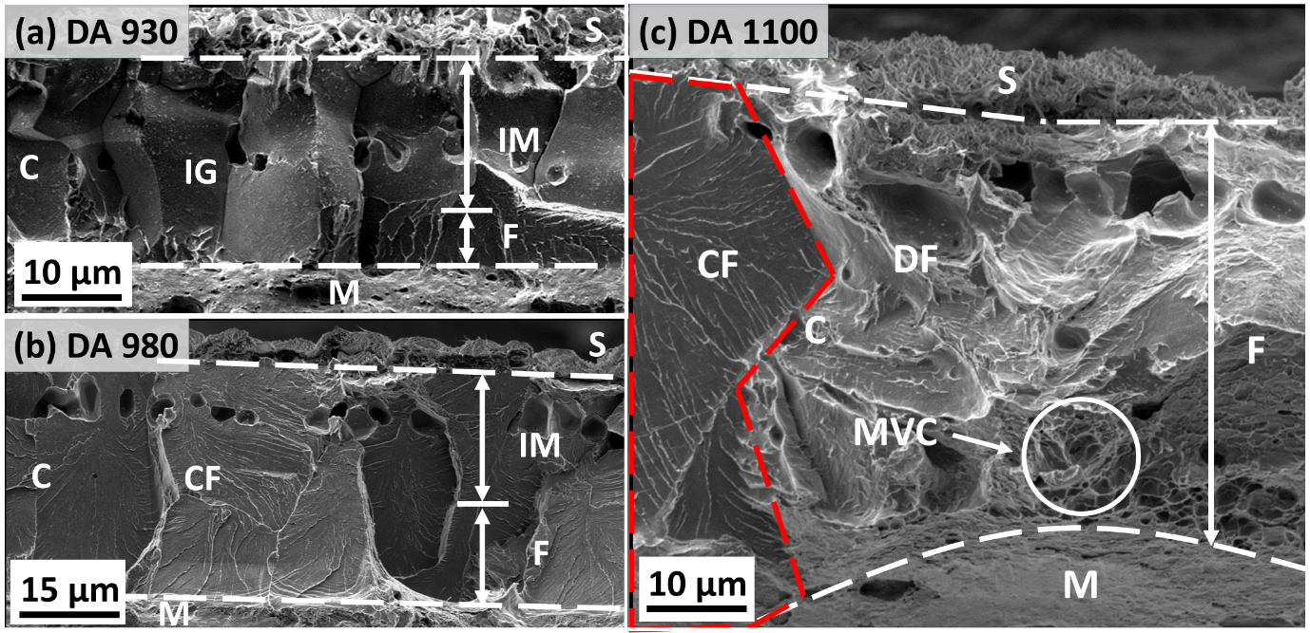
Fig. 4. Fractography after bending tests of Al-Si coating structures on (a) DA 930, (b) DA 980, and (c) DA 1100. C: coating; S: surface; M: martensite; IG: intergranular fracture; CF: cleavage fracture; DF: ductile fracture; MVC: microvoids coalescence; IM: intermetallics; F: ferrite.
IPF and local misorientation mapping of the major cracks (the longest crack in coating structure) formed in interrupted bending tests are shown in Fig. 5. For DA 980 interrupted at 40° and DA 930 interrupted at 46°, their surface cracks have completely penetrated the coating structure and reached the martensite substrate. The low misorientation angles around the paths of surface cracks indicate the coating structures accommodate little bending strain during the propagation of surface cracks, which is consistent with fractography results (Fig. 4 (a-b)). For DA 1100 interrupted at 58°, the surface crack is still trapped in the interdiffusion ferrite layer. Large misorientation angles around the crack tip of DA 1100 indicate the interdiffusion ferrite layer accommodates a large amount of bending strain during the propagation of surface cracks, which demonstrates ductile fracture happens in the interdiffusion ferrite layer. This result matches the fractography of DA 1100 and further proves ductile fracture happens in the bending process of coating on DA 1100.
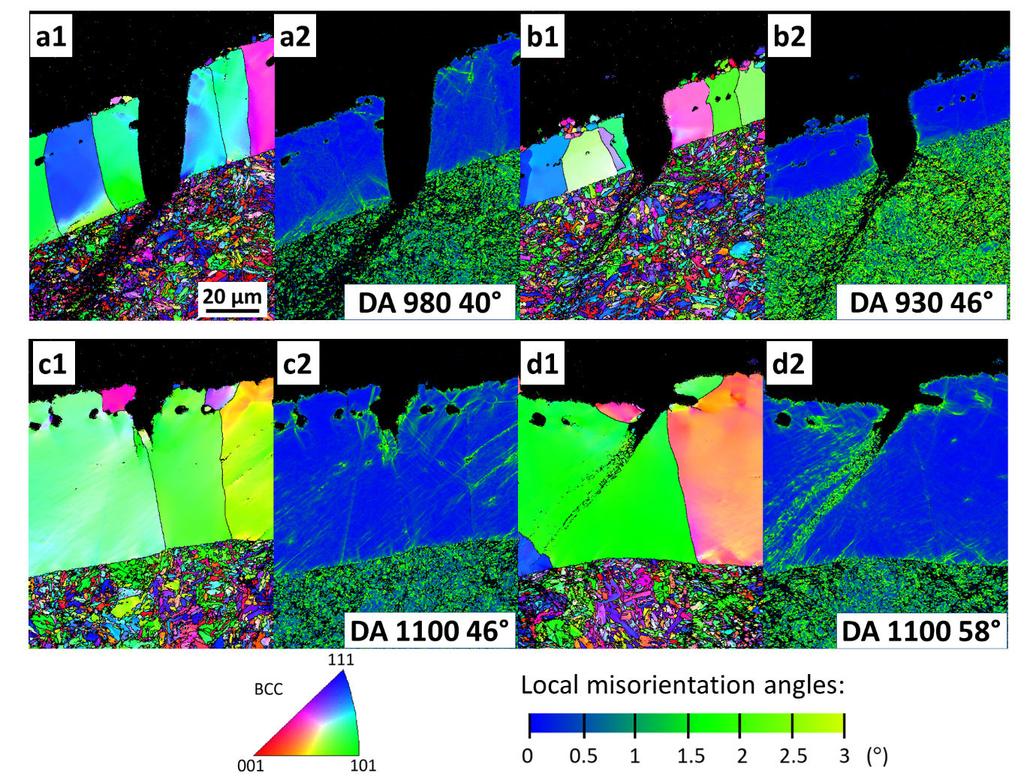
Fig. 5. EBSD IPF maps and local misorientation maps of major cracks at AlSi coating structures on (a1-a2) DA 980 interrupted at 40°, (b1-b2) DA 930 interrupted at 46°, (c1-c2) DA 1100 interrupted at 46°, and (d1-d2) DA 1100 interrupted at 58°.
In summary, this work proposes a new heat treatment process involving double austenitization to improve the bendability of AlSi-coated 2GPa-grade PHS while keeping similar UTS. It is found that the interdiffusion ferrite layer is the key factor for improving bendability. For the first time, this work found that the interdiffusion ferrite can be divided into two kinds of ferrite layers with high and low Al contents, respectively. The ferrite with high Al content is brittle and detrimental to bendability while the other ferrite with low Al content is ductile and beneficial for improving bendability.

Acknowledgment
M.X. Huang acknowledges the support from National Key Research and Development Program of China (No. 2019YFA0209900), National Natural Science Foundation of China (No. 52130102), Innovation and Technology Fund (ITP-004-21AP), Research Grants Council of Hong Kong (No. R7066-18).

Reference
[1] H. Karbasian, A.E. Tekkaya, J Mater Process Tech 210(15) (2010) 2103-2118.
[2] D.W. Fan, B.C. De Cooman, steel research international 83(5) (2012) 412-433.
[3] T. Taylor, A. Clough, Materials Science and Technology 34(7) (2018) 809-861.
[4] Z.S. Chai, Q. Lu, J. Hu, L.Y. Wang, Z. Wang, J.F. Wang, W. Xu, Journal of Materials Science & Technology 135 (2023) 34-45.
[5] K.R. Jo, L. Cho, D.H. Sulistiyo, E.J. Seo, S.W. Kim, B.C. De Cooman, Surface & Coatings Technology 374 (2019) 1108-1119.
[6] W.J. Cheng, C.J. Wang, Materials Characterization 61(4) (2010) 467-473.
[7] C.M. Klassen, R.D.L. Smith, K.J. Daun, Materials Characterization 189 (2022).
[8] O. Bouaziz, H. Zurob, M.X. Huang, Steel Research International 84(10) (2013) 937-947.
[9] A. Merklein, J. Lechler, J Mater Process Tech 177(1-3) (2006) 452-455.
[10] W.S. Choi, B.C. De Cooman, Steel Research International 85(5) (2014) 824-835.
[11] Z.C. H. Yi, Z. Liu, D. Yang, X. Xiong, Hot press-formed component, hot press-formed pre-coating steel plate and hot press-formed technique, in: C.N.I.P. Administration (Ed.) Mstar Technology Ltd (suzhou), China, 2019.
[12] L. Cho, D.H. Sulistiyo, E.J. Seo, K.R. Jo, S.W. Kim, J.K. Oh, Y.R. Cho, B.C. De Cooman, Materials Science and Engineering a-Structural Materials Properties Microstructure and Processing 734 (2018) 416-426.
[13] Z. Wang, Z.H. Cao, J.F. Wang, M.X. Huang, Scripta Materialia 192 (2021) 19-25.
[14] J. Yoo, S. Kim, S. Kim, J. Oh, S.H. Kim, S. Lee, S.S. Sohn, M.C. Jo, Acta Materialia 225 (2022).
[15] L. Golem, L. Cho, J.G. Speer, K.O. Findley, Materials & Design 172 (2019).
[16] Z.R. Hou, W. Song, H.L. Yi, J.F. Wang, J.Y. Min, Materials 15(20) (2022).
[17] M. Windmann, A. Rottger, W. Theisen, Surface & Coatings Technology 226 (2013) 130-139.
[18] Z.X. Gui, W.K. Liang, Y.S. Zhang, Science China-Technological Sciences 57(9) (2014) 1785-1793.
[19] S.D. Drillet Pascal, Kefferstein Ronald., Coated steel strips, methods of making the same, methods of using the same, stamping blanks prepared from the same, stamped products prepared from the same, and articles of manufacture which contains, in: C.N.I.P. Administration (Ed.) ArcelorMittal SA, China, 2014.
[20] VDA 238-100, 2017.
[21] R. Rana, C. Liu, R.K. Ray, Scripta Materialia 68(6) (2013) 354-359.
[22] J. Wang, C. Enloe, J. Singh, C. Horvath, Sae International Journal of Materials and Manufacturing 9(2) (2016) 488-493.
[23] A. Kubošová, M. Karlík, P. Haušild, J. Prahl, Materials Science Forum 567-568 (2007) 349-352.
[24] Z.H. Cao, B.N. Zhang, M.X. Huang, Journal of Materials Science & Technology 124 (2022) 109-115.
[25] B. Zhou, (2022).
[26] H. Qiu, T. Hanamura, S. Torizuka, ISIJ International 54(8) (2014) 1958-1964.
[27] R.J. Klassen, M.N. Bassim, M.R. Bayoumi, H.G.F. Wilsdorf, Materials Science and Engineering 80(1) (1986) 25-35.
[28] T.L. Anderson, Fracture mechanics : fundamentals and applications, CRC press2017.

