Experimental studies on durability performances of ultra-lightweight low-carbon LC³ cement composites against chloride ingression and carbonation
Zhenyu HUANG¹, Tingting LIANG², Lijie CHEN^{3*}
1 Guangdong Provincial Key Laboratory of Durability for Marine Civil Engineering, Shenzhen University, Shenzhen, China
2 Shenzhen Shenshui Guangming Water Co., Ltd, Shenzhen 518107, China
3 Department of Civil Engineering, The University of Hong Kong, Pokfulam Road, Hong Kong, China

Abstract
This study aims to experimentally evaluate the durability performances of a novel ultra-lightweight low-carbon calcined clay cement composite (ULCC-LC³) for use in sustainable concrete. The durability performances of ULCC-LC3 were characterized by conducting rapid chloride migration tests, accelerated carbonation tests, MIP and TGA tests. Results indicate that using LC³ is beneficial for improving chloride resistance of ULCC-LC³ due to refined pore structure while the carbonation resistance performance can be reduced due to less content of cement and pozzolanic reaction. The MIP tests showed the effect of using LC³ on microstructure of ULCC without carbonation was reducing the volume of porosity coarser than gel pores while increasing the volume of gel pores. The cementitious matrix of mixes with LC³ was significantly densified by carbonation. The carbon emission and energy consumption were significantly decreased by 41.9% and 26.7% respectively by replacing cement with calcined clay and limestone. However, it was noted that the use of superplasticizer increased the energy consumption especially for the mix with LC3.
Keywords: Ultra-lightweight, Low-carbon, LC³ cement, Durability, Chloride ingression, Carbonation.
- Introduction
With the goal of achieving carbon neutrality by 2050 [1], reducing the embodied carbon in reinforced concrete (RC) has become a priority in the construction industry as RC has been found to contribute to 17% of CO2 emissions worldwide [2]. Ultra-lightweight cement composite (ULCC) is a novel material with low density (<1500 kg/m3), high compressive strength (60 MPa), and high specific strength (47 kPa/(kg/m3)). ULCC consists of ordinary Portland cement (OPC), cenosphere, silica fume, water, fibers, and chemical additives. The high specific strength of ULCC makes it well suited for use in offshore floating structures [3]. However, the sustainability of ULCC is threatened by its high cement content (500 ~ 801 kg/m3) [4-6]. This has led to the need for a supplementary cementitious material (SCM) to reduce the OPC content in ULCC structures. Limestone calcined clay cement (LC3) is a novel cementitious material, in which OPC is partially replaced by limestone and calcined clay (LC2). The global availability of LC2 makes it a promising option for reducing the OPC content in ULCC [5-6]. The carbon footprint of LC3-blended concrete has been shown to decrease by 16%~50% [7-9] due to the reduced content of OPC in concrete mix.
Despite the widespread investigation of the use of Ultra-lightweight Cement Composite (ULCC) in steel-concrete-steel sandwich components and reinforced concrete [10-14], research into its durability performance against chloride attack and carbonation remains limited. Liu et. al. [15, 16] conducted rapid chloride penetration tests on cylindrical ULCC samples at 28 days and found very low chloride ion penetrability with a total charge passed of 153 coulombs, as defined by ASTMC1202 [17]. In comparison, normal weight concrete, used as a reference in [15], showed moderate chloride ion penetrability with a total charge passed of 2890 coulombs. Du [18] studied the impact of adding nano-silica on the microstructures, mechanical properties, and durability of ULCC and found that it improved the compaction of lightweight particles in the interfacial transition zone, increased the compressive strength, and enhanced resistance to water and chloride penetration. Chia et al. [19] evaluated the autogenous shrinkage and total shrinkage of various types of concrete using the modified method in ASTM C426 [20], and determined creep based on ASTM C512/512M [20]. To examine the possible harmful effect of the silica of cenospheres in alkali-silica reaction (ASR), Wang et al. [21] tested the characteristics and stability of cenospheres in lightweight cement composites. It was found that the use of cenospheres was not potentially deleterious due to ASR.
LC³ is a blend of clinker, calcined clay, limestone, and gypsum. The addition of gypsum serves to regulate the rapid hardening of fresh concrete after mixing. The use of calcined clay and limestone as supplementary cementitious material and filler has been widely investigated [22-24], but their combination as a high-level replacement for ordinary Portland cement (OPC), ranging from 40% to 80%, only began in 2012 [25-27]. Since then, there has been growing interest in incorporating LC³ into reinforced concrete (RC) [28-32]. LC3 has several advantages, including superior sustainability, technical feasibility, cost-effectiveness, and global availability, compared to other blended cements that use traditional supplementary cementitious materials (SCMs) [9, 26, 33, 34]. Maraghechi et al. [35] found that the kaolinite content of calcined clay is critical for the chloride diffusivity of LC3 mortar, which can be two orders of magnitude lower than that of a Portland cement system. The improved durability of LC3 was attributed to its refined pore structure, as supported by chloride migration tests in chloride-laden environments [36]. Guo et al. [37] found that the rapid migration coefficient of LC3 concrete made with recycled aggregate can be reduced by 94% without significantly compromising compressive strength, compared to a reference group. On the other hand, the carbonation performance of LC3 concrete has been found to be lower compared to its OPC counterparts [26, 38]. The effects of increasing the substitution level of OPC in LC3 concrete generally align with those observed in traditional SCM concrete, such as reduced alkalinity [39-41].
Although LC3 and ULCC are promising in the next generation of low carbon, low weight and high mechanical performance cementitious composites, studies on the durability performances of ULCC-LC3 remain unavailable but urgently required. This study aims to investigate the resistance of ultra-lightweight low-carbon limestone calcined clay cement composites (ULCC-LC3) to chloride attack and carbonation. The performance of ULCC-LC3 against chloride attack was characterized through rapid chloride migration (RCM) tests, while its carbonation resistance was studied through accelerated carbonation tests (ACT). The hydration heat evolution and hydration products of ULCC-LC3 were evaluated using isothermal calorimetry (IC) and thermal gravimetric analysis (TGA), respectively. Microscopic examinations using a mercury intrusion porosimeter (MIP) and a scanning electron microscope (SEM) were conducted to uncover the underlying mechanisms of the interaction between ULCC and LC3. The sustainability performance of ULCC-LC3 was further rationalized through a life cycle assessment (LCA) analysis.
- Experimental methods

2.1 Raw materials and mix design
The raw materials used in this study to produce ULCC-LC3 are: ordinary Portland cement (OPC), cenosphere, silica fume, calcined clay, limestone, gypsum, a superplasticizer, a shrinkage reducing admixture (SRA), tap water, and polyethylene (PE) fiber. The morphologies of the raw materials are displayed in Figure 1, while Table 1 shows the chemical compositions of the solids. The physical and mechanical properties of the PE fiber are detailed in Table 2. QK300 cenospheres with average particle sizes ranging from 20 to 300 µm were sourced from Tangshan, Hebei province. The clays were obtained from industrial kaolinite tailings and calcined at temperatures of 700 to 800°C with 50% kaolinite. A polycarboxylate superplasticizer was utilized to reduce water demand by up to 40%, and SRA was added to decrease drying shrinkage by 80% at 28 days. In this study, the slumps of the mixes range from 180 mm-205 mm with good workability. Figure 2 presents the particle size distribution of the raw materials used in this study, showing that they are well-graded and thus ensuring good compaction of the cementitious composites.
The mix design of ULCC-LC3 is shown in Table 3. The water/binder ratio is 0.27 and there are 12 groups of mixes in this study. The first six groups of mixes were mixed without PE fiber, while the last six groups were mixed with 1% PE fiber by volume. The traditional ULCC without mixing LC3 and PE fibers was used as a reference for the first six groups. The remaining five groups were characterized by the weight proportion of clinker (% of binder) and the mass ratio of calcined clay to limestone. For example, 50-2:1 refers to a group of mix in which 50% of the binder is clinker (by subtracting the content of CaSO₄ from OPC according to Table 1) and the mass ratio of calcined clay to limestone is 2:1. The last six groups of mixes were similar to the first six groups, except for the inclusion of 1% PE fibers by volume and an increased content of superplasticizer. The last six groups were characterized by an additional notation "-1" in their group names, indicating the volume proportion of PE fibers.
OPC, calcined clay, limestone powder, gypsum powder, cenosphere, and silica fume were dry mixed in a mixer for 10 minutes at an ultra-slow speed. Then, three-fourths of the superplasticizer was mixed with water and added to the mixer. The mixture was mixed for an additional 5 minutes at a slow speed, followed by high-speed mixing for 5 minutes after adding the shrinkage reducing admixture (SRA) and the remaining superplasticizer. For groups with PE fibers, the high-speed mixing was extended for another 5 minutes during which the PE fibers were added. The cementitious composites were compacted on a vibration table for 20 seconds. A plastic sheet was used to cover the samples after casting for 24 hours, and they were then cured in a standard moisture curing room (25℃, 100% humidity) until the designated ages.

2.2 Tests for mechanical properties
The compressive strengths of the first six groups without PE fibers in Table 3 were determined by testing 100mm cubic specimens on Days 1, 3, 7, and 28. For each hydration age, three cubic specimens were tested. As for the last six groups with PE fibers in Table 3, three duplicate 100mm cubic specimens were tested on Day 28. To obtain the elastic modulus of each mix in Table 3, cylindrical specimens with a diameter of 100mm and a height of 200mm were cast. The modulus was determined by conducting compressive tests on three duplicate specimens. The tensile strengths of the last six groups with PE fibers in Table 3 were determined by testing four duplicate dog-bone specimens.

2.3 Tests for material characterization
The isothermal calorimeter used in this study was the TAM Air 8-channel by TA Instruments. The first six groups of mixes without PE fibers as shown in Table 3 were prepared for isothermal calorimetry (IC) testing. The samples were sealed in 20mL ampoules and tested at 23°C for 72 hours.
The thermalgravimetric analysis (TGA) was performed using a STA 409 PC Luxx simultaneous thermal analyzer produced by Netzsch-Gerätebau GmbH. TGA samples were selected from the center of the crushed cubic specimens after compressive tests on Days 3 and 28, respectively. To stop hydration, the samples were immersed in isopropanol for 48 hours, then placed in a vacuum desiccator cabinet for 72 hours under a pressure of -0.1 MPa and temperature of 60°C. After drying, the samples were ground and sieved through a standard 200 mesh sieve, and 10 mg of filtered powder was tested from ambient temperature to 1000°C at a heating rate of 10°C per minute using 50mL/min nitrogen gas. The pore structure of the specimens was investigated using Pore Master 60 mercury intrusion porosimetry (MIP). The pore size distribution ranges from 0.0036 to 950 µm, with pressure ranging from 0 to 60,000psia. In IC, TGA and MIP tests, three duplicate samples were tested for each mix.

2.4 Tests for durability performances subject to chloride attack and carbonation
The chloride resistance of ULCC-LC3 was studied through rapid chloride migration (RCM) tests in accordance with Chinese standard GB/T 50082-2009 [42]. Standard specimens, 100 mm in diameter and 50 mm in thickness, were cast for the first 6 groups listed in Table 3 without PE fibers and were water-cured for 28 days. Three duplicate specimens were cast for each mix. Afterwards, the surfaces of the specimens were ground and immersed in a saturated NaOH solution for 24 hours. The unidirectional chloride penetration was ensured by applying an epoxy resin coating to the side surfaces of the specimens before the RCM tests. The following equation was used to evaluate the chloride resistance performance of the specimens:
where D_{RCM} denotes the non-steady-state chloride ion migration coefficient in m²/s, U denotes the applied voltage in V, T denotes the average value of initial and final temperatures of anodic solution in °C, L denotes the specimen thickness in mm, X_{d} denotes the average chloride penetration depth in mm and t denotes the testing period in hours.
The carbonation resistance of ULCC-LC3 was evaluated through accelerated carbonation tests (ACT) in accordance with Chinese standard GB/T50082-2009 [42]. For the first 6 groups without PE fiber in Table 3, 100 mm cubic specimens were cast to test carbonation depths on days 7, 28, 56, 84 and 112. 15 cubes were cast for each group, with 3 cubes being tested for a specific age. The specimens were moisture-cured at 20 °C and 95% RH for 26 days and then dried for 2 days at 60 °C. Prior to ACT, four side surfaces were coated with epoxy resin to ensure uni-directional carbonation. The ACT was conducted in a carbonation chamber CCB-70W, where the temperature, relative humidity, and CO2 concentration were kept at 20 ± 2 °C, 70 ± 5%, and 20 ± 3%, respectively. The carbonation depths were measured by spraying a 1% phenolphthalein solution on the exposed surface of the split specimens. The carbonation depth of a specimen was calculated as the average of the carbonation depths of at least 20 measurement points.

2.5 Life cycle assessment
This study carried out a life cycle assessment (LCA) to evaluate the benefits of using LC3 in ultra-low calcium cement (ULCC) in reducing the carbon footprint and energy consumption of cementitious materials. The LCA was performed using the GaBi software, in accordance with the ISO 14040 [43] and ISO 14044 [44] standards. The system boundary was defined as "cradle to gate" and the functional unit was set as the production of 1 cubic meter of ULCC-LC3.
The LCA was performed for two groups: ULCC and 50-2:1. The carbon emissions and energy consumptions of the raw materials, including cement, water, calcined clay, limestone, gypsum and superplasticizer, were obtained from the GaBi software database and existing literature [45]. Silica fume and cenosphere were considered as by-products of silicon and coal-combustion production, respectively, and no additional processing was required before mixing. Table 4 presents the carbon footprint and energy consumption of raw materials.
- Experimental results and discussions

3.1 Mechanical performances
Figure 3 shows the compressive strengths of groups without PE fibers at 1, 3, 7, and 28 days. The trend of the compressive strength development over time changes due to the addition of LC3 in ULCC. On Day 1, the compressive strength of ULCC is 48.5% of the 28-day compressive strength, while the compressive strengths of groups with LC3 range from 22.6% to 31.9% of the 28-day compressive strengths. The 3-day compressive strengths of ULCC and 50-1:1 are 53.1% and 55.6% of their 28-day compressive strengths, respectively. The compressive strengths further increase to 91.5% and 95.1% of the 28-day compressive strengths on Day 7 for ULCC and 50-1:1, while the ratios of 7-day compressive strength to 28-day compressive strength for the remaining groups range from 72.1% to 78.9%. This indicates that the hydration process for ULCC and mixes with low calcined clay content is almost complete on Day 7, while there is still significant compressive strength development after Day 7 for mixes with high calcined clay content. This can be explained by the pozzolanic reaction of calcined clay, in which reactive silica and alumina in calcined clay react with portlandite, a hydration product of cement. The pozzolanic reaction occurs later than cement hydration, so mixes with high calcined clay content generally show a delayed strength development.
It is interesting to examine the impact of LC3 on the compressive strength of ULCC. As shown in Figure 3, the pronounced reductions in early compressive strength due to the addition of LC3 in ULCC only occur on Day 1. After that, there are no significant decreases in compressive strength as a result of replacing OPC with limestone and calcined clay. In fact, the compressive strength of the LC3 mixes is higher than that of ULCC on Day 28, except for the 50-1:1 group.
Figure 4 presents the effect of calcined clay and limestone on the 28-day compressive strength and elastic modulus of groups with and without PE fibers. Comparing Figure 4(a) to Figure 4(b), it is clear that the elastic modulus increases significantly from around 10 GPa to around 17 GPa by adding PE fibers. Note that the elastic modulus can be substantially reduced by replacing OPC with calcined clay and limestone in groups without PE fibers, as shown in Figure 4(a), but LC3 does not significantly decrease the elastic modulus for groups with PE fibers, as shown in Figure 4(b). The results in Figure 4 provide evidence for the use of PE fibers in increasing the elastic modulus of ULCC-LC3. The 28-day compressive strength of groups with PE fibers increases due to the inclusion of LC3, with the exception of the 50-1:1-1 group. This is similar to the trend observed in groups without PE fibers.
The tensile properties, including cracked stress, tensile strength, tensile strain, and strain energy of groups with PE fibers are presented in Figure 5. As shown in Figure 5 (a), using LC3 has a beneficial effect on increasing cracked stress. This is because the cracked strength is dependent on the pore size of the cementitious material. The pore structure can be refined by calcined clay, limestone, and the product of the pozzolanic reaction, CASH gel. As shown in Figure 5(b), the tensile strength is also significantly increased by replacing OPC with calcined clay and limestone, which can also be contributed by the pore size refinement effect. Furthermore, the tensile strain can be decreased from 5.3% to 4.5% by using calcined clay as shown in Figure 5(c). The reason for this phenomenon needs further investigation. The strain energy of ULCC-1 can increase by 12.9% to 34.1% when OPC is replaced by calcined clay and limestone as shown in Figure 5(d), indicating the strain energy is controlled by the increase in tensile strength despite the decline in tensile strain for ULCC-LC3. A higher strain energy is beneficial for increasing the energy absorption capacity of cementitious composite. In conclusion, the use of LC3 in ULCC is generally beneficial in terms of compressive strength, elastic modulus, and tensile properties.

3.2 IC, MIP and TGA tests
Figure 6 presents the heat evolution rate per gram of solid and heat evolved per gram of solid in IC tests. As shown in Figure 6(a), there is only one peak corresponding to the hydration of CaO‧3SiO₂ (C3S) for ULCC. For mixes with LC3, two hydration peaks can be seen. The first peak corresponds to the hydration of silicate, and the second is the aluminate peak [46]. The silicate peak of ULCC occurs around 14 hours, while the first silicate peak of ULCC-LC3 occurs around 6-7 hours, which can be attributed to the "filler effect" of calcined clay and limestone, and the strong nucleation facilitated by the high specific surface area of calcined clay. As a result, the hydration of ULCC-LC3 is accelerated and the second aluminate peak is heightened. Figure 6(a) shows that the maximum peak of ULCC-LC3 is lower compared to ULCC. This can be explained by two reasons. Firstly, the content of C3S, which is an important source of hydration heat, is reduced by using LC3 in ULCC. Secondly, the interaction between silica fume and cenosphere (fly ash) can significantly retard the hydration of OPC as found in [47]. Figure 6(b) shows that the cumulative heat released decreases as the replacement level of OPC with calcined clay and limestone increases, or the proportion of OPC decreases, correlated with the reduced content of clinker and C3S. In conclusion, a significant dilution effect [48] is observed when partially replacing OPC with calcined clay and limestone.
Figure 7 presents the pore size distribution and cumulative intrusion volume curves of samples without PE fibers on Day 3 and Day 28. The cumulative intrusion volume curve records the process of increasing applied pressure, during which the pressure exerted is inversely proportional to pore size, as indicated by the well-known Washburn equation [49]. The pore size distribution diagram is derived from the normalized intrusion volume of mercury with the pore size in a logarithmic scale [50]. Based on the results of MIP, the following parameters can be determined: overall porosity, intrudable porosity, and critical pore diameter. The overall porosity can be obtained by dividing the volume of mercury infiltrated into the sample by the volume of the sample. The calculation process can be referred to the standard GB/T 21650.1-2008 [51]. The intrudable porosity can be obtained by reading the highest point on the cumulative porosity plot, and the critical pore diameter corresponds to the peak in the pore size distribution [52]. Table 5 presents the critical parameters characterizing the pore structure of the concrete mixes without PE fibers in this study. On Day 3, the characteristic peaks of all mixes are located between 0.01 μm and 0.1 μm. However, on Day 28, these peaks are significantly shifted towards smaller pore sizes (0.003 μm to 0.01 μm), indicating that the pore structures have been refined. On Day 28, the characteristic peaks of 65-2:1 and 50-2:1 are similar to those of ULCC, as seen in Figure 7(b). Additionally, replacing OPC with calcined clay and limestone can shift the critical pore diameter towards smaller sizes on Day 3 and larger sizes on Day 28, as shown Table 5.
The porosity of ULCC-LC3 on Day 28 is of special interest. As the ratio of calcined clay to limestone increases, the intrudable porosity decreases from 34.82% to 32.18% and 32.93% on Day 28 as shown in Table 5. The porosity of ULCC-LC3 can also be refined by increasing the OPC content, as seen by comparing the critical parameters of 45-2:1, 50-2:1, and 65-2:1 in Table 5. One can find that the overall porosity and intrudable porosity of ULCC-LC3 are higher as compared with those of ULCC on Day 28 as shown in Table 5. It appears that the increased overall porosity and intrudable porosity does not correlate with the enhance mechanical performances by partially replacing OPC with LC2 as found in Section 3.1.
In order to get more insights on correlating the enhanced mechanical performances with microscopic pore structure of ULCC-LC3, the cumulative pore volume curves of ULCC and ULCC-LC3 mixes without PE fibers are shown in Figure 7(c). In Figure 7(c), it can be seen that the cumulative pore volume curves of ULCC and ULCC-LC3 on Day 28 intersect at a pore diameter around 0.01 μm (gel pores), above which the pore volumes of ULCC-LC3 are lower than that of ULCC. This indicates that the benefits of replacing OPC with calcined clay and limestone on the 28-day porosity of ULCC are the decreased overall pore volume for pores coarser than gel pores.
Figure 8 displays the mass changes and differential thermogravimetric (DTG) curves for mixes without polyethylene fibers on Days 3 and 28. The hydration products in the cementitious matrix, including ettringite (Aft), monocarbon aluminate (Mc), hemicarbon aluminate (Hc), calcium silicate hydrate (CSH), and calcium aluminum silicate hydrate (CASH), decompose between 20°C and 300°C. Calcium hydroxide (CH) dehydrates between 350°C and 550°C. Calcium carbonate (CaCO₃) decomposes into CO₂ and CaO after 600°C. As seen in Figure 8, there are peaks corresponding to the decompositions of Mc and Hc, which are produced by the reactions between CaCO₃ and the aluminates in calcined clay and fly ash. However, most of the CaCO₃ acts as filling and nucleation sites in the cementitious matrix. Figure 8 clearly shows that replacing OPC with LC2 can significantly decrease the content of CH and increase the content of CaCO₃ on Day 3 and Day 28.
Table 6 shows the contents of hydrate water and CH on Days 3 and 28, as per the methods described in [53]. The hydrate water in all mixes increases from Day 3 to Day 28 due to the hydration of the cementitious materials. For the mixes with LC3, the CH content on Day 28 ranges from 31.6% to 53.1% of that in ULCC, indicating that calcined clay consumes CH in the pozzolanic reaction. Most of the mixes in Table 6 show a decrease in CH content from Day 3 to Day 28 due to the pozzolanic reaction, except for the groups 50-1:1 and 45-2:1, which have increased 28-day CH content compared to their 3-day content. This may be explained by the large proportions of limestone and calcined clay in these groups, which fill the pores during hydration. The pozzolanic reaction may be slowed due to the dense pore structure of the cementitious matrix, particularly at later stages of hydration. Therefore, increasing the level of OPC replacement with calcined clay and limestone cannot consume more CH.

3.3 RCM test
Table 7 lists the data obtained from these tests. The migration coefficients of chloride ions on Day 28 were found to be between 0.5~1.5 × 10⁻¹² m²/s, which showed a decrease of 86.1%~95.4% compared to the migration coefficient of 10.8 × 10⁻¹² m²/s for normal concrete with similar compressive strength [54]. Mixes with LC3 also showed a decrease of 33.3%~66.7% in chloride ion migration coefficients compared to ULCC. According to Table 8, ULCC was considered to have a medium chloride ion migration coefficient, while those of mixes with LC3 were considered low. The results indicate that the addition of calcined clay and limestone can reduce the migration of chloride ions.
The density of ULCC-LC3 was found to be around 60% of that of normal concrete, indicating a coarser pore structure. It was expected that the chloride diffusion resistance of ULCC-LC3 would be lower than normal concrete, however, the opposite was found. This is because the majority of the porosity in ULCC-LC3 is contributed by cenospheres, which are hollow spheres that do not connect with each other. The pozzolanic reactions between cenospheres and silica fume further densify the cementitious matrix, thus increasing the resistance to chloride ions. This result is consistent with previous studies [16]. The use of LC3 in ULCC provides two benefits for chloride resistance: 1) refinement of the pore structure of the cementitious matrix as revealed by the MIP results in this study and 2) the pozzolanic reaction of calcined clay, which forms CASH gel that can trap chloride ions and increase resistance to their migration [55].

3.4 ACT
The carbonation depth measurements from Day 7 to Day 112 for mixes without PE fibers are shown in Figure 9. The carbonation depths of ULCC are 0 mm on both Day 7 and Day 112, indicating excellent carbonation resistance performance. However, the carbonation depths of ULCC-LC3 are significantly higher than those of ULCC on Day 7 and continue to develop over time. This indicates a significant degradation in carbonation performance of ULCC-LC3 compared to ULCC, which can be explained by: 1) reduced content of OPC and 2) consumption of CH in pozzolanic reaction. As a result, the content of CH in cementitious matrix of ULCC-LC3 for buffering pH of pore solution is significantly lower than that of ULCC mix as shown in Table 6. As revealed by MIP tests, the overall volume for pores coarser than gel pores can be reduced by using LC3, which is beneficial for resisting carbonation due to a lower CO₂ diffusion coefficient. The reduced overall carbonation resistance performance of ULCC-LC3 indicates that the reduced content of CH due to the partial replacement of OPC and pozzolanic reaction is dominant for carbonation performance of ULCC-LC3.
To compare the carbonation resistance performance of ULCC-LC3 with existing data, Equations (2) and (3) are used to translate the accelerated carbonation depths into actual carbonation coefficients [39, 40, 56]:
(2)
(3)
where K_{acc} denotes the accelerated carbonation coefficient in mm/y^{0.5}, D_{c} denotes the depth of carbonation in mm, t denotes the time in years, K_{a} denotes the actual carbonation coefficient in mm/y^{0.5}, K_{e} denotes the environmental factor that considers the effect of moisture content on the carbonation coefficient, C₀ denotes the concentration of CO₂ in actual exposure, and C_{acc} denotes the concentration of CO₂ in the accelerated carbonation test (20% in this study).
In this study, the accelerated carbonation depths as shown in Figure 9 were used to calculate the accelerated carbonation coefficients using Equation (2). The average value of the accelerated carbonation coefficients was then substituted into Equation (3) to determine the actual carbonation coefficient under moderate to high humidity (XC3). The values for K_{e} and C₀ in Equation (3) were chosen as 0.6 and 0.1% respectively based on previous studies [57-60].
Figure 10 presents the actual carbonation coefficients obtained from Equations (2) and (3). The actual carbonation coefficient for ULCC is shown to be 0 mm/y^{0.5}, which does not mean carbonation is absent, but rather that the dense cementitious matrix of ULCC reduces the diffusion coefficient of CO₂ to a negligible level. This is due to its low water/binder ratio of 0.27. Figure 10 (a) shows the effect of the ratio of calcined clay and limestone on the actual carbonation coefficient and highlights that the carbonation resistance of ULCC-LC3 decreases as the proportion of calcined clay increases with a constant calcined clay and limestone content. Figure 10 (b) demonstrates the impact of decreasing OPC content on the actual carbonation coefficient, with the cementitious matrix becoming more prone to carbonation as OPC content decreases. The effects of the increased calcined clay ratio and decreased OPC content on actual carbonation coefficient will be further analyzed in the MIP and TGA tests results.
Two concrete mixes with similar compressive strengths to ULCC-LC3 are shown in dash lines for reference in Figure 10. The first carbonation coefficient of 2.12 mm/y^{0.5} is for a normal concrete mix with a water/binder ratio of 0.45, in which 50% of OPC was replaced with ground granulated blast furnace slag (GGBS) [59]. The second carbonation coefficient of 3.11 mm/y^{0.5} is for a lightweight aggregate concrete (LWAC) mix with a water/binder ratio of 0.31 [61], in which 20% of OPC was replaced with grade II fly ash (FA) and shale haydite was used as a lightweight aggregate. The carbonation coefficients of the two reference concrete mixes were obtained by conducting accelerated carbonation test and transferring the accelerated carbonation coefficient into actual carbonation coefficient using the same way as ULCC-LC3 in this study. The values for K_{e} and C₀ in Equation (3) were also 0.6 and 0.1% respectively. Figure 10 shows that, despite the fact that the use of LC3 in ULCC increases the carbonation coefficient, the carbonation resistance performance of ULCC-LC3 remains better than normal and lightweight concrete mixes with similar compressive strengths. On Day 112, samples were collected from the carbonation chamber and divided into two groups based on the presence or absence of carbonation, as indicated by the phenolphthalein solution. Only non-carbonated samples were collected for ULCC, as there was no significant carbonation present on Day 112 (as seen in Figure 9). MIP tests were then performed on the collected samples and the results are shown in Figure 11. UC and C denote before and after carbonation, respectively. The critical peaks of all mixes (Figure 11) are located between 0.003 to 0.01 micrometers. Table 9 lists the overall porosity, intrudable porosity, and critical pore diameter for mixes without PE fibers. The results show that the cementitious matrix of mixes with LC3 is significantly densified by carbonation, as evidenced by a decrease in overall porosity and intrudable porosity. The critical pore diameter slightly decreases for all mixes except for 50-1:1. The densification of pore structure of ULCC-LC3 upon carbonation can be explained by the larger molar volume of calcium carbonate produced by the carbonation of CH filling the pores [62].
Pores are classified into gel pores (<0.0045 micrometers), transition pores (0.0045 to 0.05 micrometers), capillary pores (0.05 to 0.1 micrometers), and macro pores (>0.1 micrometers) (as per [63]). The comparison of pore volume fractions on Day 112 with and without carbonation is shown in Figure 12. Results show that the volume fractions of capillary pores are minimal, with a maximum value of 0.95%. Carbonation has a significant impact on the pore size distribution, causing an increase in the volume fractions of gel and transition pores by 3.65 to 19.67%. Unlike [63], this study found that the pore structure was dominated by macro pores without carbonation, while most of the pores were transition pores with carbonation, indicating that carbonation mostly occurs in macro pores. These macro pores are filled with calcium carbonate produced by the carbonation of CH and CSH gels, resulting in a decrease in overall porosity.
TGA tests were also performed on 112-day samples with and without carbonation and the results are shown in Figure 13. The DTG curves show three peaks: CASH and Aft (20 to 300°C), CH (350 to 550°C), and CaCO₃ (>600°C). The contents of CH and CaCO₃ (CC) can be calculated and are listed in Table 10. Results show that CH content decreases upon carbonation. Using LC3 leads to a significant decrease in CH content due to the pozzolanic reaction between calcined clay and CH, as well as partial replacement of OPC by calcined clay and limestone. The CH content without carbonation is inversely proportional to the amount of calcined clay, as seen in the lowest CH contents in groups with the highest amount of calcined clay (50-3:1 and 45-2:1).

3.5 LCA
Figure 14 compares the carbon emissions and energy consumption of ULCC and 50-2:1 mixes. Cement production is the primary contributor to both carbon emissions and energy consumption in both mixes. Replacing cement with calcined clay and limestone results in a significant decrease of 41.9% in carbon emissions and 26.7% in energy consumption. It's worth noting that the use of superplasticizer is a significant source of energy consumption, particularly for the mix with LC3 (50-2:1). LC3 can reduce the workability of cementitious materials, thus requiring more superplasticizer to achieve the desired workability in 50-2:1. However, the benefits of using LC3 are not outweighed by the increased volume of superplasticizer required in 50-2:1.
- Conclusions
This paper proposes a novel ultra-lightweight low-carbon LC3 cement composite (ULCC-LC3). The compressive and tensile performances of ULCC-LC3 were tested. The resistances towards chloride ion ingression and carbonation of ULCC-LC3 were investigated through rapid chloride migration and accelerated carbonation tests. Additionally, isothermal calorimetry (IC), mercury intrusion porosimetry (MIP) and thermogravimetric analysis (TGA) were conducted to get more insights. The benefits of using ULCC-LC3 in reducing carbon emission and energy consumption were demonstrated by a life cycle assessment. The results of this study suggest that the use of LC3 in the preparation of ultra-lightweight low-carbon cement composites offers a promising alternative for reducing carbon emissions and energy consumption, without compromising on the durability performances against chloride ingression and carbonation. However, further research is required to optimize the mix design and evaluate the long-term durability of LC3 composites. Based on the results presented in the study, the following conclusions can be drawn:
(1) A novel ultra-lightweight low-carbon LC3 cement composite (ULCC-LC3) is developed with favorable mechanical performances and low density (1500 kg/m³). The compressive strength performances of ULCC-LC3 are not lower than those of ULCC for a hydration age later than 3 days.
(2) The use of limestone calcined clay (LC3) as a partial replacement for cement in the cementitious mixes significantly decreases the carbon emission and energy consumption. The carbon emission and energy consumption in both ULCC and 50-2:1 mixes are primarily led by the use of cement, and the replacement of cement with calcined clay and limestone reduces these values by 41.9% and 26.7%, respectively.
(3) The chloride ion resistance of ULCC-LC3 is significantly improved as compared with ULCC and normal concrete with similar compressive strength. This is explained by the refined pore structure and increased chloride binding capacity.
(4) The carbonation performance of ULCC-LC3 is reduced as compared with ULCC, but is still better as compared with normal concrete and lightweight aggregate concrete with similar compressive strengths. The mechanism of using LC3 in ULCC on reducing carbonation resistance performance lies in the reduced content of cement and pozzolanic reaction between calcined clay and Ca(OH)₂.
(5) The results of the MIP tests indicate that for ULCC mixes without carbonation, the use of LC3 results in an increase in overall porosity with increased proportion of gel pores but significantly decreased volume of pores coarser than gel pores. On the other hand, the cementitious matrix in mixes with LC3 is densified by carbonation, resulting in a reduction of overall porosity and intrudable porosity. The results of the TGA tests also support this conclusion, with a decrease in CH content upon carbonation. The pore size distribution analysis shows that carbonation primarily occurs in macro pores and results in an increase in the volume fractions of gel and transition pores, while decreasing the overall porosity.
(6) It should be noted that the use of superplasticizer is a significant source of energy consumption, particularly for the 50-2:1 mix containing LC3. The workability of the cementitious materials is reduced by adding LC3, resulting in a higher demand for superplasticizer, which partially offsets the benefits of using LC3.

Acknowledgments
The authors would like to acknowledge the research grant received from the National Natural Science Foundation of China (Grants Nos. 51978407), Guangdong Outstanding Youth Fund (Grants No. 2022B1515020037), Shenzhen International Science and Technology Cooperation Project (Grants No. GJHZ20200731095802008), Guangdong Natural Science Foundation (Grants No. 2021A1515010932) and Guangdong Provincial Key Laboratory of Durability for Marine Civil Engineering (SZU) (Grant No. 2020B1212060074).

References
[1] A. Guterres, Carbon neutrality by 2050: the world’s most urgent mission, United States (2020).
[2] P. Purnell, The carbon footprint of reinforced concrete, Advances in cement research 25(6) (2013) 362-368.
[3] Y. Zhou, Y. Zheng, L. Sui, F. Xing, J. Hu, P. Li, Behavior and modeling of FRP-confined ultra-lightweight cement composites under monotonic axial compression, Compos. B. Eng. 162 (2019) 289-302.
[4] K. Sohel, K. Al-Jabri, M. Zhang, J.R. Liew, Flexural fatigue behavior of ultra-lightweight cement composite and high strength lightweight aggregate concrete, Constr. Build. Mater. 173 (2018) 90-100.
[5] Z. Huang, J.R. Liew, M. Xiong, J. Wang, Structural behaviour of double skin composite system using ultra-lightweight cement composite, Constr. Build. Mater. 86 (2015) 51-63.
[6] Z. Huang, L. Sui, F. Wang, S. Du, Y. Zhou, J. Ye, Dynamic compressive behavior of a novel ultra-lightweight cement composite incorporated with rubber powder, Compos. Struct. 244 (2020) 112300.
[7] R.G. Pillai, R. Gettu, M. Santhanam, S. Rengaraju, Y. Dhandapani, S. Rathnarajan, A.S. Basavaraj, Service life and life cycle assessment of reinforced concrete systems with limestone calcined clay cement (LC3), Cem. Concr. Res. 118 (2019) 111-119.
[8] M.U. Hossain, Chi S. Poon, Ya H. Dong, D. Xuan, Evaluation of environmental impact distribution methods for supplementary cementitious materials, Renewable and Sustainable Energy Reviews 82 (2018) 597-608.
[9] H. Zhu, W. Chen, S. Cheng, L. Yang, S. Wang, J. Xiong, Low carbon and high efficiency limestone-calcined clay as supplementary cementitious materials (SCMs): Multi-indicator comparison with conventional SCMs, Constr. Build. Mater. 341 (2022) 127748.
[10] J.-B. Yan, J.-Y. Wang, J.R. Liew, X. Qian, L. Zong, Ultimate strength behaviour of steel–concrete–steel sandwich plate under concentrated loads, Ocean Engineering 118 (2016) 41-57.
[11] Z. Huang, J.R. Liew, Structural behaviour of steel–concrete–steel sandwich composite wall subjected to compression and end moment, Thin-Walled Structures 98 (2016) 592-606.
[12] Z. Huang, J.R. Liew, Compressive resistance of steel-concrete-steel sandwich composite walls with J-hook connectors, Journal of Constructional Steel Research 124 (2016) 142-162.
[13] Z. Huang, K. Padmaja, S. Li, J.R. Liew, Mechanical properties and microstructure of ultra-lightweight cement composites with fly ash cenospheres after exposure to high temperatures, Constr. Build. Mater. 164 (2018) 760-774.
[14] Z. Huang, F. Wang, Y. Zhou, L. Sui, P. Krishnan, J.-Y.R. Liew, A novel, multifunctional, floatable, lightweight cement composite: development and properties, Materials 11(10) (2018) 2043.
[15] X. Liu, K.-S. Chia, M.-H. Zhang, R.J. Liew, Water and chloride ion penetration resistance of high-strength ultra lightweight cement composite, Proceedings of the 1st International Congress on Durability of Concrete, Norwegian Concrete Association, 2012, pp. 1-9.
[16] X. Liu, K.S. Chia, M.-H. Zhang, Development of lightweight concrete with high resistance to water and chloride-ion penetration, Cem. Concr. Compos. 32(10) (2010) 757-766.
[17] ASTM, ASTM C1202: Standard test method for electrical indication of concrete's ability to resist chloride ion penetration, American Social Test. Materials 4(2) (2012) 1-8.
[18] H. Du, Properties of ultra-lightweight cement composites with nano-silica, Constr. Build. Mater. 199 (2019) 696-704.
[19] K.-S. Chia, X. Liu, J.-Y. Liew, M.-H. Zhang, Experimental study on creep and shrinkage of high-performance ultra-lightweight cement composite of 60 MPa, Structural Engineering and Mechanics 50(5) (2014) 635-652.
[20] ASTM C426-22, Standard test method for linear drying shrinakge of concrete masonry units, American Society for Testing and Materials, 2022.
[21] J.-Y. Wang, M.-H. Zhang, W. Li, K.-S. Chia, R.J. Liew, Stability of cenospheres in lightweight cement composites in terms of alkali–silica reaction, Cem. Concr. Res. 42(5) (2012) 721-727.
[22] V.M. John, B.L. Damineli, M. Quattrone, R.G. Pileggi, Fillers in cementitious materials—Experience, recent advances and future potential, Cem. Concr. Res. 114 (2018) 65-78.
[23] Y. Cao, Y. Wang, Z. Zhang, Y. Ma, H. Wang, Recent progress of utilization of activated kaolinitic clay in cementitious construction materials, Compos. B. Eng. 211 (2021) 108636.
[24] H. Du, S. Dai Pang, High-performance concrete incorporating calcined kaolin clay and limestone as cement substitute, Constr. Build. Mater. 264 (2020) 120152.
[25] M. Antoni, J. Rossen, F. Martirena, K. Scrivener, Cement substitution by a combination of metakaolin and limestone, Cem. Concr. Res. 42(12) (2012) 1579-1589.
[26] K. Scrivener, F. Martirena, S. Bishnoi, S. Maity, Calcined clay limestone cements (LC3), Cem. Concr. Res. 114 (2018) 49-56.
[27] J. Yu, D.K. Mishra, C. Hu, C.K.Y. Leung, S.P. Shah, Mechanical, environmental and economic performance of sustainable Grade 45 concrete with ultrahigh-volume Limestone-Calcined Clay (LCC), Resour. Conserv. Recy. 175 (2021).
[28] S.S. Berriel, A. Favier, E.R. Domínguez, I.S. Machado, U. Heierli, K. Scrivener, F.M. Hernández, G. Habert, Assessing the environmental and economic potential of Limestone Calcined Clay Cement in Cuba, J. Clean. Prod. 124 (2016) 361-369.
[29] S. Joseph, S. Bishnoi, S. Maity, An economic analysis of the production of limestone calcined clay cement in India, Indian Concr. J 90(11) (2016) 22-27.
[30] Y. Cancio, S. Sánchez, F. Martirena, I. Sánchez, K. Scrivener, G. Habert, Economic and ecological assessment of Cuban housing solutions using alternative cement, Sustainable Built Environment Regional Conference, 2016, pp. 292-297.
[31] F. Martirena, K. Scrivener, Low Carbon Cement LC 3 in Cuba: ways to achieve a sustainable growth of cement production in emerging economies, Calcined clays for sustainable concrete, Springer2018, pp. 318-321.
[32] Y. Zhao, Y. Gao, G. Chen, S. Li, A. Singh, X. Luo, C. Liu, J. Gao, H. Du, Development of low-carbon materials from GGBS and clay brick powder for 3D concrete printing, Constr. Build. Mater. 383 (2023) 131232.
[33] M. Sharma, S. Bishnoi, F. Martirena, K. Scrivener, Limestone calcined clay cement and concrete: A state-of-the-art review, Cem. Concr. Res. 149 (2021).
[34] Z.-y. Huang, Y.-s. Huang, W.-y. Liao, N.-x. Han, Y.-w. Zhou, F. Xing, T.-b. Sui, B. Wang, H.-y. Ma, Development of limestone calcined clay cement concrete in South China and its bond behavior with steel reinforcement, Journal of Zhejiang University-SCIENCE A 21(11) (2020) 892-907.
[35] H. Maraghechi, F. Avet, H. Wong, H. Kamyab, K. Scrivener, Performance of Limestone Calcined Clay Cement (LC3) with various kaolinite contents with respect to chloride transport, Mater. Struct. 51(5) (2018) 1-17.
[36] Y. Dhandapani, T. Sakthivel, M. Santhanam, R. Gettu, R.G. Pillai, Mechanical properties and durability performance of concretes with Limestone Calcined Clay Cement (LC3), Cem. Concr. Res. 107 (2018) 136-151.
[37] M. Guo, G. Gong, Y. Yue, F. Xing, Y. Zhou, B. Hu, Performance evaluation of recycled aggregate concrete incorporating limestone calcined clay cement (LC3), J. Clean. Prod. 366 (2022).
[38] M. Khan, Q. Nguyen, A. Castel, Carbonation of limestone calcined clay cement concrete, Calcined Clays for Sustainable Concrete, Springer2018, pp. 238-243.
[39] S. von Greve-Dierfeld, B. Lothenbach, A. Vollpracht, B. Wu, B. Huet, C. Andrade, C. Medina, C. Thiel, E. Gruyaert, H. Vanoutrive, I.F. Saéz del Bosque, I. Ignjatovic, J. Elsen, J.L. Provis, K. Scrivener, K.-C. Thienel, K. Sideris, M. Zajac, N. Alderete, Ö. Cizer, P. Van den Heede, R.D. Hooton, S. Kamali-Bernard, S.A. Bernal, Z. Zhao, Z. Shi, N. De Belie, Understanding the carbonation of concrete with supplementary cementitious materials: a critical review by RILEM TC 281-CCC, Mater. Struct. 53(6) (2020).
[40] L. Chen, R.K.L. Su, Experimental and numerical investigations on macrocell corrosion of partially carbonated reinforced concrete with supplementary cementitious materials, Cem. Concr. Compos. (2022) 104827.
[41] V. Shah, K. Scrivener, B. Bhattacharjee, S. Bishnoi, Changes in microstructure characteristics of cement paste on carbonation, Cem. Concr. Res. 109 (2018) 184-197.
[42] GB/T 50082-2009, Standard for test methods of long-term performance and durability of ordinary concrete, AQSIQ Beijing, China, 2009.
[43] I.O.f. Standardization, Environmental management: life cycle assessment; Principles and Framework, ISO2006.
[44] I.O.f. Standardization, Environmental management: life cycle assessment; requirements and guidelines, ISO Geneva, Switzerland2006.
[45] J. Yu, J. Yao, X. Lin, H. Li, J.Y. Lam, C.K. Leung, I.M. Sham, K. Shih, Tensile performance of sustainable Strain-Hardening Cementitious Composites with hybrid PVA and recycled PET fibers, Cem. Concr. Res. 107 (2018) 110-123.
[46] F. Avet, K. Scrivener, Investigation of the calcined kaolinite content on the hydration of Limestone Calcined Clay Cement (LC3), Cem. Concr. Res. 107 (2018) 124-135.
[47] B. Langan, K. Weng, M. Ward, Effect of silica fume and fly ash on heat of hydration of Portland cement, Cem. Concr. Res. 32(7) (2002) 1045-1051.
[48] Y. Briki, M. Zajac, M.B. Haha, K. Scrivener, Impact of limestone fineness on cement hydration at early age, Cem. Concr. Res. 147 (2021) 106515.
[49] ISO 15901-1, Evaluation of pore size distribution and porosity of solid materials by mercury porosimetry and gas adsorption - Part 1: Mercury porosimetry, International Organization for Standardization, 2016.
[50] K.K. Aligizaki, Pore structure of cement-based materials: testing, interpretation and requirements, Crc Press2005.
[51] G.T. 21650.1−2008, Pore Size Distribution and Porosity of Solid Materials by Mercury Porosimetry and Gas Adsorption-Part 1: Mercury Porosimetry, Standardization Administration of the People’s Republic of China, 2008.
[52] H. Ma, Mercury intrusion porosimetry in concrete technology: tips in measurement, pore structure parameter acquisition and application, Journal of porous materials 21(2) (2014) 207-215.
[53] K. De Weerdt, M.B. Haha, G. Le Saout, K.O. Kjellsen, H. Justnes, B. Lothenbach, Hydration mechanisms of ternary Portland cements containing limestone powder and fly ash, Cem. Concr. Res. 41(3) (2011) 279-291.
[54] L. Fu, Application propsect of novel low-carbon cement LC3, Chinese cement 9 (2020) 98-102.
[55] M. Thomas, R. Hooton, A. Scott, H. Zibara, The effect of supplementary cementitious materials on chloride binding in hardened cement paste, Cem. Concr. Res. 42(1) (2012) 1-7.
[56] R. Neves, F. Branco, J. de Brito, Field assessment of the relationship between natural and accelerated concrete carbonation resistance, Cem. Concr. Compos. 41 (2013) 9-15.
[57] A. MLeemann, F. Moro, Carbonation of concrete: the role of CO2 concentration, relative humidity and CO2 buffer capacity, Mater. Struct. 50(1) (2016).
[58] R. Dhir, P. Hewlett, Y. Chan, Near-surface characteristics of concrete: prediction of carbonation resistance, Mag. Concr. Res. 41(148) (1989) 137-143.
[59] L. Chen, Corrosion rate of macrocell corrosion in reinforced concrete and service life modeling of carbonated concrete containing supplementary cementitious materials, Ph.D. Thesis, University of Hong Kong, Hong Kong, 2022.
[60] S. Shriram, K. Ramamurthy, S. Ramakrishnan, Effect of occupant-induced indoor CO2 concentration and bioeffluents on human physiology using a spirometric test, Building and Environment 149 (2019) 58-67.
[61] Y. Gao, L. Cheng, Z. Gao, S. Guo, Effects of different mineral admixtures on carbonation resistance of lightweight aggregate concrete, Constr. Build. Mater. 43 (2013) 506-510.
[62] B. Wu, G. Ye, Development of porosity of cement paste blended with supplementary cementitious materials after carbonation, Constr. Build. Mater. 145 (2017) 52-61.
[63] J. Liu, X. Fan, J. Liu, H. Jin, J. Zhu, W. Liu, Investigation on mechanical and micro properties of concrete incorporating seawater and sea sand in carbonized environment, Constr. Build. Mater. 307 (2021) 124986.

Table 1 Chemical compositions of OPC, silica fume, calcined clay, limestone and gypsum
Oxide | OPC (%) | Silica fume  (%) | Calcined clay (%) | Limestone powder (%) | Gypsum powder (%)
SiO₂ | 22.37 | 96.00 | 52.70 | 0.30 | 3.09
Al₂O₃ | 4.36 | 0.30 | 36.90 | 0.10 | 1.34
K₂O | 0.35 | 0.60 | 3.49 | - | 0.05
Fe₂O₃ | 3.38 | 0.30 | 1.99 | 0.08 | 0.36
MgO | 2.48 | 0.40 | 0.28 | 0.64 | 1.31
SO₃ | 2.4 | 0.20 | 0.12 | - | 40.87
CaO | 61.08 | 0.20 | 0.04 | 81.13 | 30.51
Others | 3.58 | 2.00 | 4.27 | 17.73 | 23.26

Table 2 Physical and mechanical properties of PE fiber
Density  (g/cm³) | Length  (mm) | Diameter  (um) | Elastic modulus  (GPa) | Tensile strength  (MPa) | Rupture strain  (%)
0.97 | 12 | 24 | 120 | 3000 | 2~3

Table 3 Mix design of ULCC-LC³
Group | OPC  (kg/m³) | Calcined clay  (kg/m³) | Limestone  (kg/m³) | Gypsum  (kg/m³) | Cenosphere  (kg/m³) | Silica fume  (kg/m³) | Water  (kg/m³) | Superplasticizier  (kg/m³) | SRA  (kg/m³) | PE fiber (%)
ULCC | 873.9 | 0 | 0 | 0 | 287.6 | 97.1 | 264.9 | 4.3 | 9.3 | 0
50-1:1 | 464.0 | 196.6 | 196.6 | 16.6 | 287.6 | 97.1 | 264.9 | 6.5 | 9.3 | 0
50-2:1 | 464.0 | 262.2 | 131.1 | 16.6 | 287.6 | 97.1 | 264.9 | 8.3 | 9.3 | 0
50-3:1 | 464.0 | 294.9 | 98.3 | 16.6 | 287.6 | 97.1 | 264.9 | 8.5 | 9.3 | 0
45-2:1 | 418.6 | 291.3 | 145.7 | 18.4 | 287.6 | 97.1 | 264.9 | 9.0 | 9.3 | 0
65-2:1 | 600.4 | 174.8 | 87.4 | 11.4 | 287.6 | 97.1 | 264.9 | 6.7 | 9.3 | 0
ULCC-1 | 873.9 | 0 | 0 | 0 | 287.6 | 97.1 | 264.9 | 4.6 | 9.3 | 1
50-1:1-1 | 464.0 | 196.6 | 196.6 | 16.6 | 287.6 | 97.1 | 264.9 | 6.9 | 9.3 | 1
50-2:1-1 | 464.0 | 262.2 | 131.1 | 16.6 | 287.6 | 97.1 | 264.9 | 8.7 | 9.3 | 1
50-3:1-1 | 464.0 | 294.9 | 98.3 | 16.6 | 287.6 | 97.1 | 264.9 | 9.1 | 9.3 | 1
45-2:1-1 | 418.6 | 291.3 | 145.7 | 18.4 | 287.6 | 97.1 | 264.9 | 9.6 | 9.3 | 1
65-2:1-1 | 600.4 | 174.8 | 87.4 | 11.4 | 287.6 | 97.1 | 264.9 | 7.0 | 9.3 | 1

Table 4 CO₂ emission and energy consumption of raw materials
Item | OPC | Calcined clay | Limestone | Gypsum | Cenosphere | Silica fume | Water | Superplasticizier
CO₂ emission (kg/kg) | 0.88 | 0.11 | 0.003 | 0.11 | 0 | 0 | 0 | 1.31
Energy consumption (MJ/kg) | 3.60 | 1.67 | 0.04 | 1.64 | 0 | 0 | 0.2 | 29.4
Table 5 Critical pore structure parameters from MIP test results
Group | Day 3 |  |  | Day 28
Group | Overall porosity  (%) | Intrudable porosity  (%) | Critical pore diameter  (um) | Overall porosity  (%) | Intrudable porosity  (%) | Critical pore diameter  (um)
ULCC | 44.59 | 31.76 | 0.03530 | 42.48 | 30.28 | 0.00409
50-1:1 | 46.91 | 34.92 | 0.02062 | 46.03 | 34.82 | 0.00497
50-2:1 | 46.53 | 34.57 | 0.01762 | 43.57 | 32.18 | 0.00431
50-3:1 | 49.12 | 36.96 | 0.02108 | 44.06 | 32.93 | 0.00948
45-2:1 | 48.31 | 37.58 | 0.01370 | 43.85 | 32.77 | 0.00942
65-2:1 | 45.54 | 34.26 | 0.02181 | 41.78 | 30.28 | 0.00413

Table 6 Contents of chemically bound water and CH from TGA test results
Group | Chemically bound water (%) |  | CH  (%)
Group | Day 3 | Day 28 | Day 3 | Day 28
ULCC | 8.47 | 14.89 | 7.07 | 6.65
50-1:1 | 7.51 | 9.95 | 3.08 | 3.35
50-2:1 | 6.25 | 9.15 | 3.02 | 2.31
50-3:1 | 6.78 | 8.88 | 3.53 | 2.10
45-2:1 | 7.76 | 9.33 | 2.50 | 3.21
65-2:1 | 6.67 | 9.40 | 3.94 | 3.53
Table 7 Results of RCM tests
Group | Specimen | Temperature  (°C) | Specimen thickness  (mm) | Penetration depth  (mm) | Testing period  (h) | Voltage  (V) | Chloride ion migration coefficient | Average migration coefficient
ULCC | 1 | 24.40 | 51.3 | 9.6 | 24 | 60 | 2.2 | 1.5
ULCC | 2 | 24.45 | 51.3 | 5.3 | 24 | 60 | 1.2 | 1.5
ULCC | 3 | 24.40 | 51.5 | 5.2 | 24 | 60 | 1.1 | 1.5
50-1:1 | 1 | 25.35 | 50.0 | 4.4 | 24 | 60 | 0.9 | 0.8
50-1:1 | 2 | 25.40 | 50.3 | 4.0 | 24 | 60 | 0.8 | 0.8
50-1:1 | 3 | 25.35 | 50.7 | 2.9 | 24 | 60 | 0.6 | 0.8
50-2:1 | 1 | 24.60 | 51.8 | 2.6 | 24 | 60 | 0.5 | 0.6
50-2:1 | 2 | 24.40 | 51.9 | 3.3 | 24 | 60 | 0.7 | 0.6
50-2:1 | 3 | 24.15 | 50.1 | 3.5 | 24 | 60 | 0.7 | 0.6
50-3:1 | 1 | 24.50 | 51.7 | 2.1 | 24 | 60 | 0.4 | 0.5
50-3:1 | 2 | 24.45 | 51.5 | 2.9 | 24 | 60 | 0.6 | 0.5
50-3:1 | 3 | 24.50 | 51.2 | 2.2 | 24 | 60 | 0.4 | 0.5
45-2:1 | 1 | 25.05 | 50.1 | 6.1 | 24 | 60 | 1.3 | 1.0
45-2:1 | 2 | 25.00 | 50.3 | 4.5 | 24 | 60 | 1.0 | 1.0
45-2:1 | 3 | 24.75 | 50.7 | 3.7 | 24 | 60 | 0.8 | 1.0
65-2:1 | 1 | 25.10 | 51.8 | 2.6 | 24 | 60 | 0.5 | 0.6
65-2:1 | 2 | 24.90 | 51.6 | 2.9 | 24 | 60 | 0.6 | 0.6
65-2:1 | 3 | 24.90 | 51.7 | 2.9 | 24 | 60 | 0.6 | 0.6

Table 8 Evaluation of chloride ion migration coefficients
Chloride ion migration coefficient  (10⁻¹² m²/s) | >10 | 10~5 | 5~1 | 1~0.5 | 0.5~0.1 | 0.1~0.5 | <0.05
Evaluation | Very high | High | Medium | Low | Very low | Extremely low | Negligible

Table 9 Comparison between critical parameters for pore structures with and without carbonation
Group | Without carbonation |  |  | With carbonation
Group | Overall porosity  (%) | Intrudable porosity  (%) | Critical pore diameter  (um) | Overall porosity  (%) | Intrudable porosity  (%) | Critical pore diameter  (um)
ULCC | 37.56 | 25.13 | 0.00402 | - | - | -
50-1:1 | 44.06 | 35.02 | 0.00480 | 35.74 | 28.00 | 0.00497
50-2:1 | 46.83 | 40.51 | 0.00451 | 46.58 | 39.33 | 0.00445
50-3:1 | 49.48 | 46.72 | 0.00457 | 45.79 | 37.99 | 0.00454
45-2:1 | 48.94 | 43.41 | 0.00458 | 41.14 | 30.60 | 0.00441
65-2:1 | 48.58 | 43.43 | 0.00432 | 41.65 | 33.27 | 0.00431

Table 10 Contents of CH and CC on Day 112 with and without carbonation
Group | CH content without carbonation  (%) | CH content with carbonation  (%) | CC content with carbonation  (%) | CC content by carbonation of CH  (%)
ULCC | 4.33 | - | - | -
50-1:1 | 2.01 | 1.32 | 8.23 | 0.94
50-2:1 | 1.97 | 1.34 | 1.40 | 0.85
50-3:1 | 1.61 | 1.46 | 0.46 | 0.21
45-2:1 | 1.33 | 1.02 | 1.16 | 0.42
65-2:1 | 2.37 | 1.79 | 1.19 | 0.78

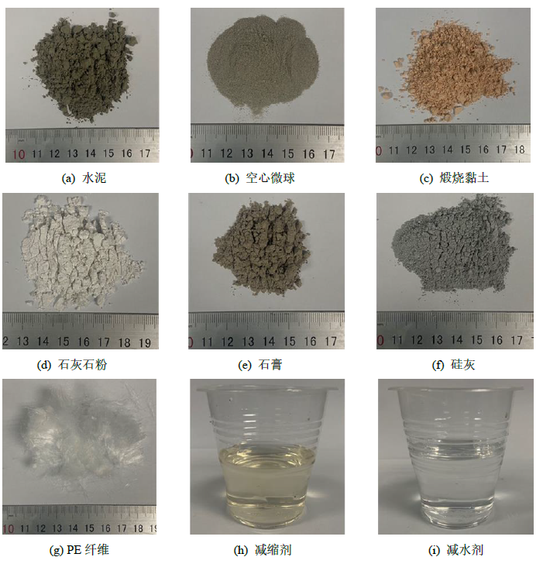
(a) OPC (b) Cenosphere (c) Calcined clay
(d) Limestone (e) Gypsum (f) Silica fume
(g) PE fiber (h) SRA (i) Superplasticizer
Figure 1 Morphologies of raw materials for ULCC-LC³

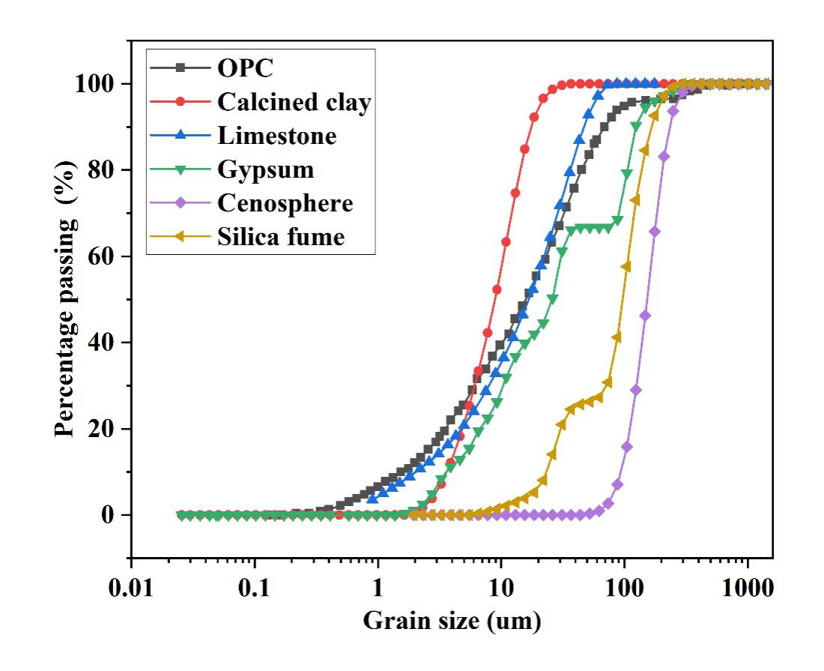
Figure 2 Particle size distribution curves for raw solid materials
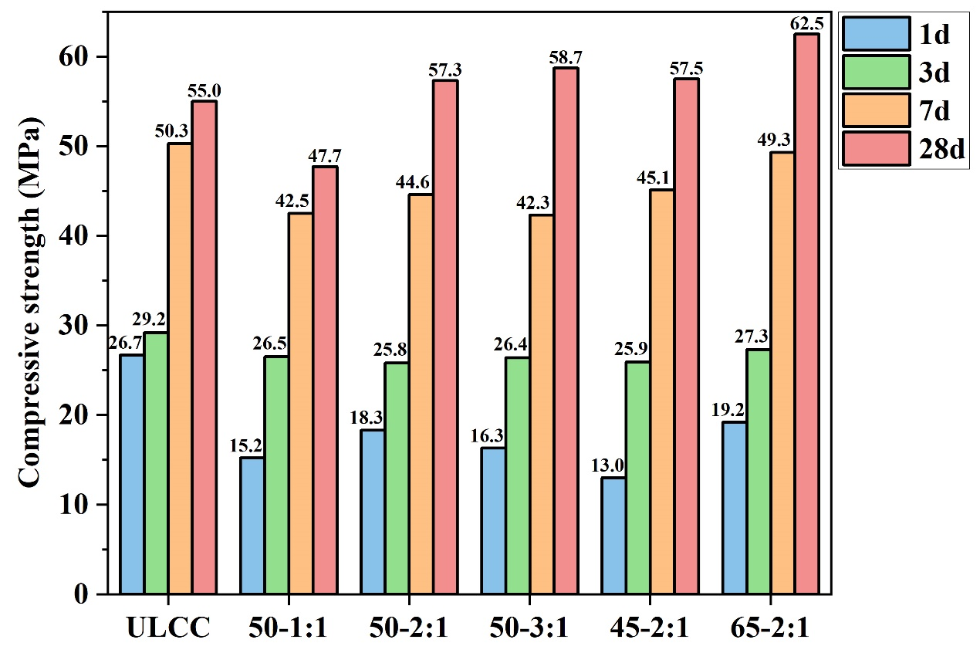
Figure 3 Development of compressive strengths with different hydration ages for groups without PE fibers

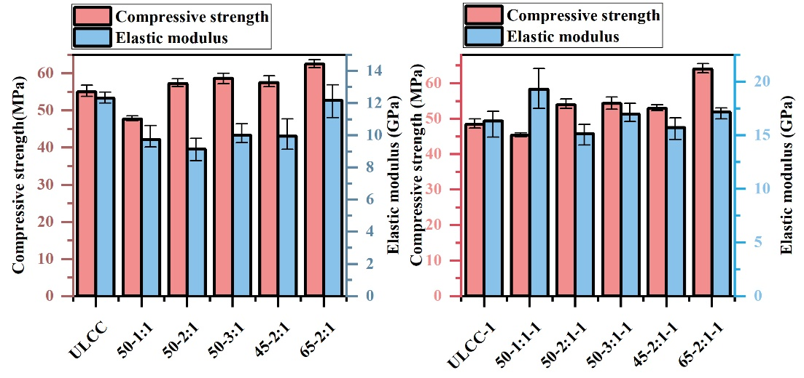
Figure 4 Compressive strengths and elastic modulus on Day 28
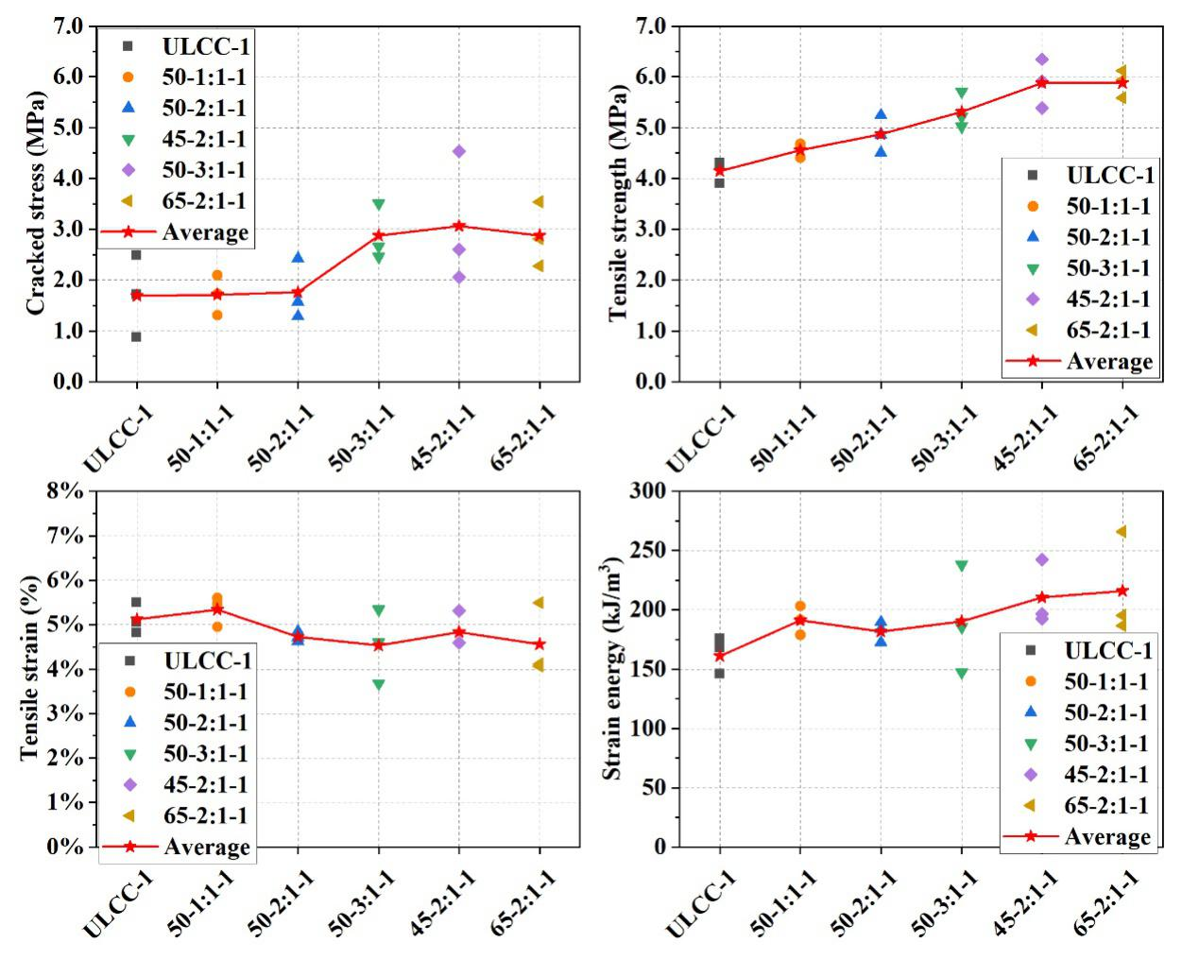
Figure 5 Tensile properties for mixes with PE fibers

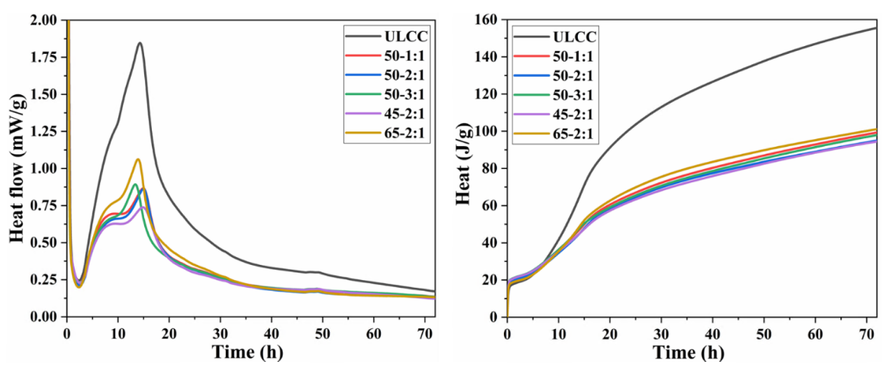
Figure 6 Results of IC tests

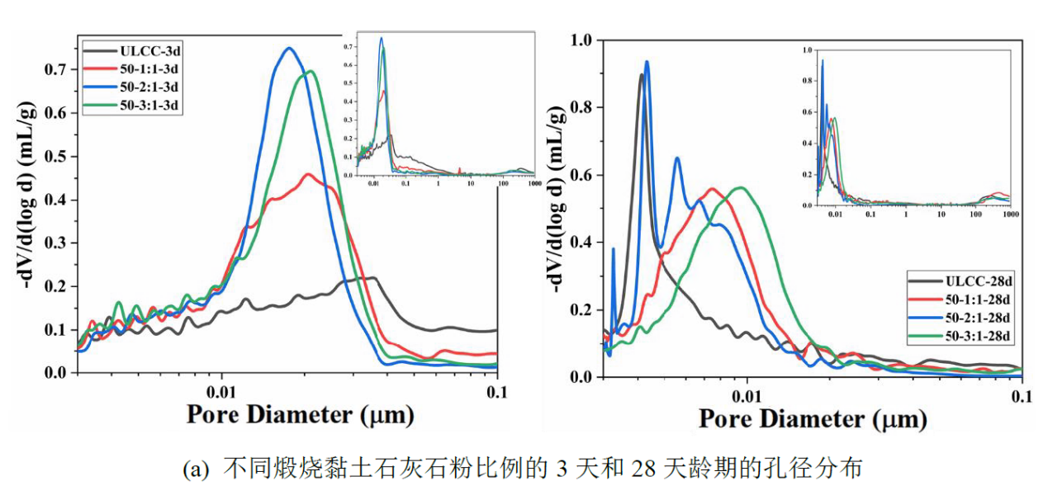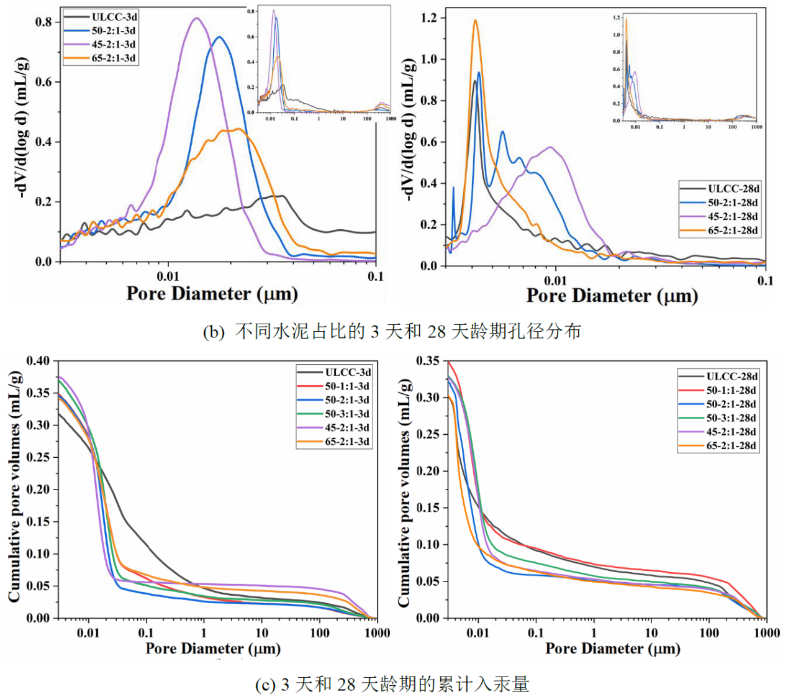
Figure 7 Effects of LC³ on pore size distributions on Day 3 and Day 28
(a) Pore size distributions with different ratios of calcined clay to limestone
(b) Pore size distributions with different contents of OPC
(c) Cumulative volumes of mercury intrusion

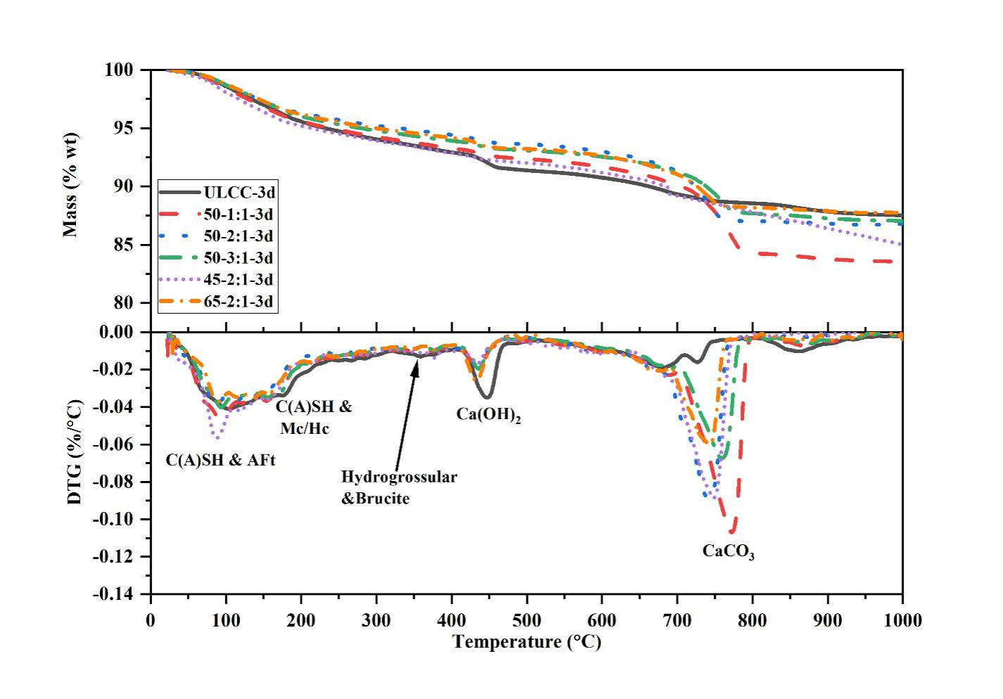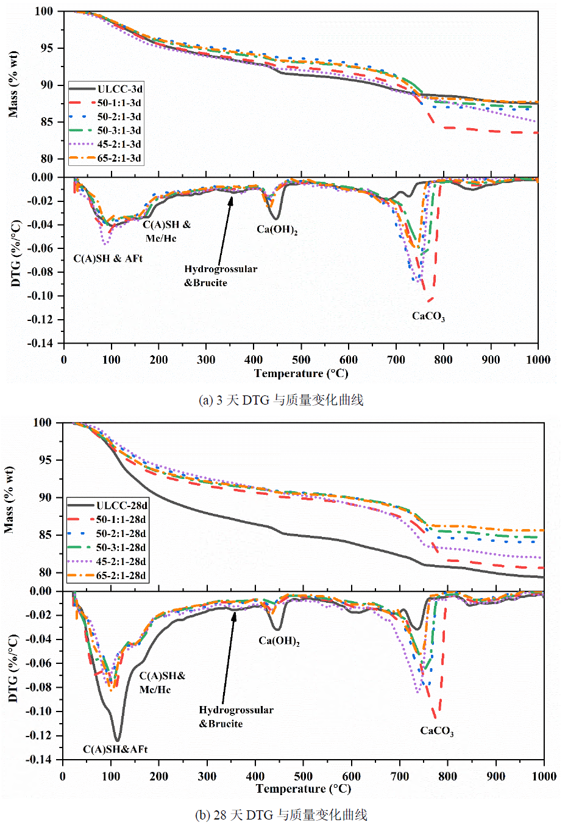
(a) Results of TGA tests on Day 3
Figure 8 Results of TGA tests on Day 3 and Day 28
(b) Results of TGA tests on Day 28

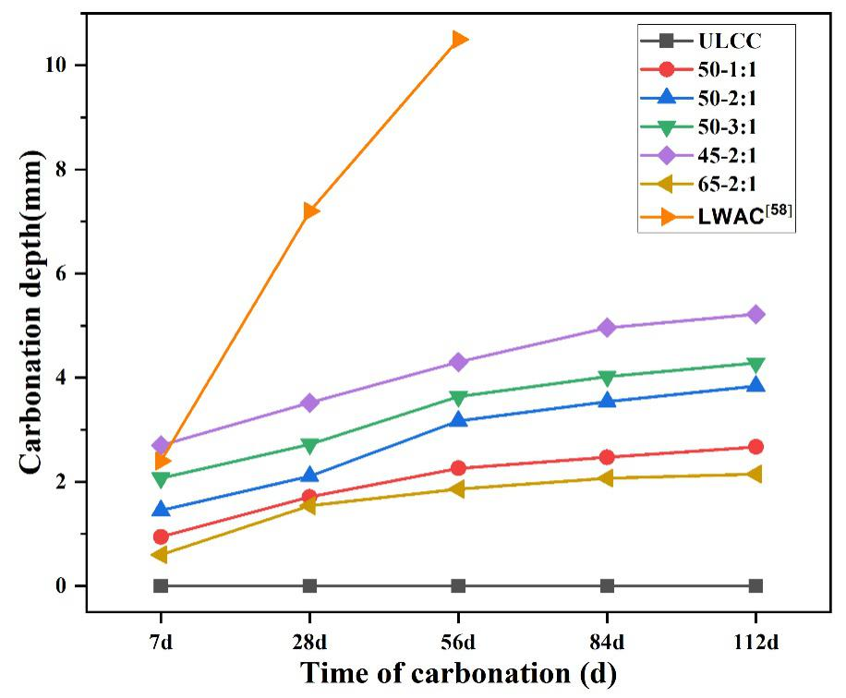
Figure 9 Evolution of carbonation depths under different ages
Figure 10 Actual carbonation coefficients and comparison with existing data. (a) Effect of calcined clay proportion, (b) effect of OPC content. 50% GGBS-0.45 denotes normal concrete with water/binder ratio of 0.45, in which 50% OPC is replaced by GGBS. 20% FA-0.31-LWA denotes lightweight aggregate concrete with water/binder ratio of 0.31, in which 20% OPC is replaced by FA. Reference mixes with similar compressive strengths of ULLC-LC³ were selected.

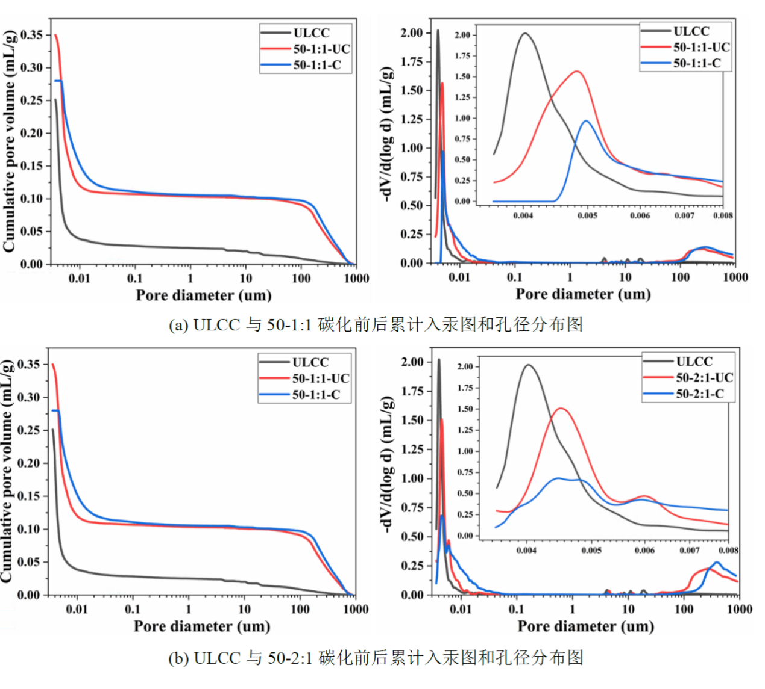
- Comparison of cumulative pore volume and pore size distribution before and after carbonation of ULCC and 50-1:1
- Comparison of cumulative pore volume and pore size distribution before and after carbonation of ULCC and 50-2:1

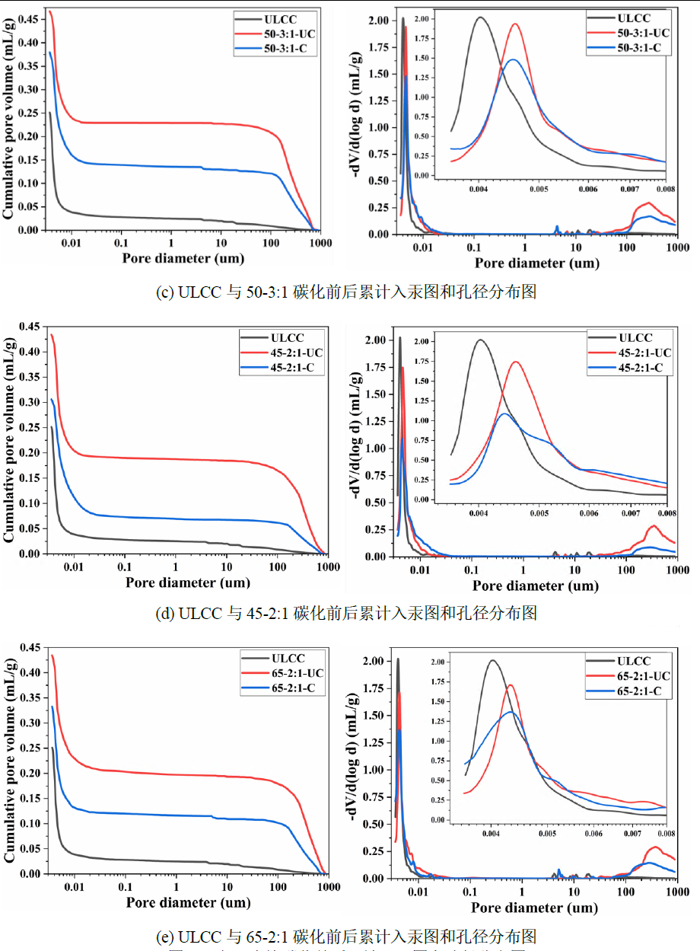
Figure 11 Comparisons of MIP test results on samples with and without carbonation on Day 112.
- Comparison of cumulative pore volume and pore size distribution before and after carbonation of ULCC and 50-3:1
- Comparison of cumulative pore volume and pore size distribution before and after carbonation of ULCC and 45-2:1
- Comparison of cumulative pore volume and pore size distribution before and after carbonation of ULCC and 65-2:1
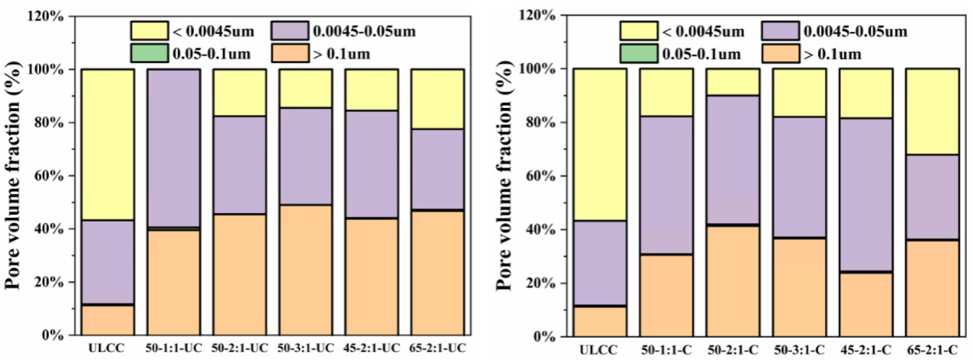
Figure 12 Pore volume fraction of different pores on Day 112 with and without carbonation
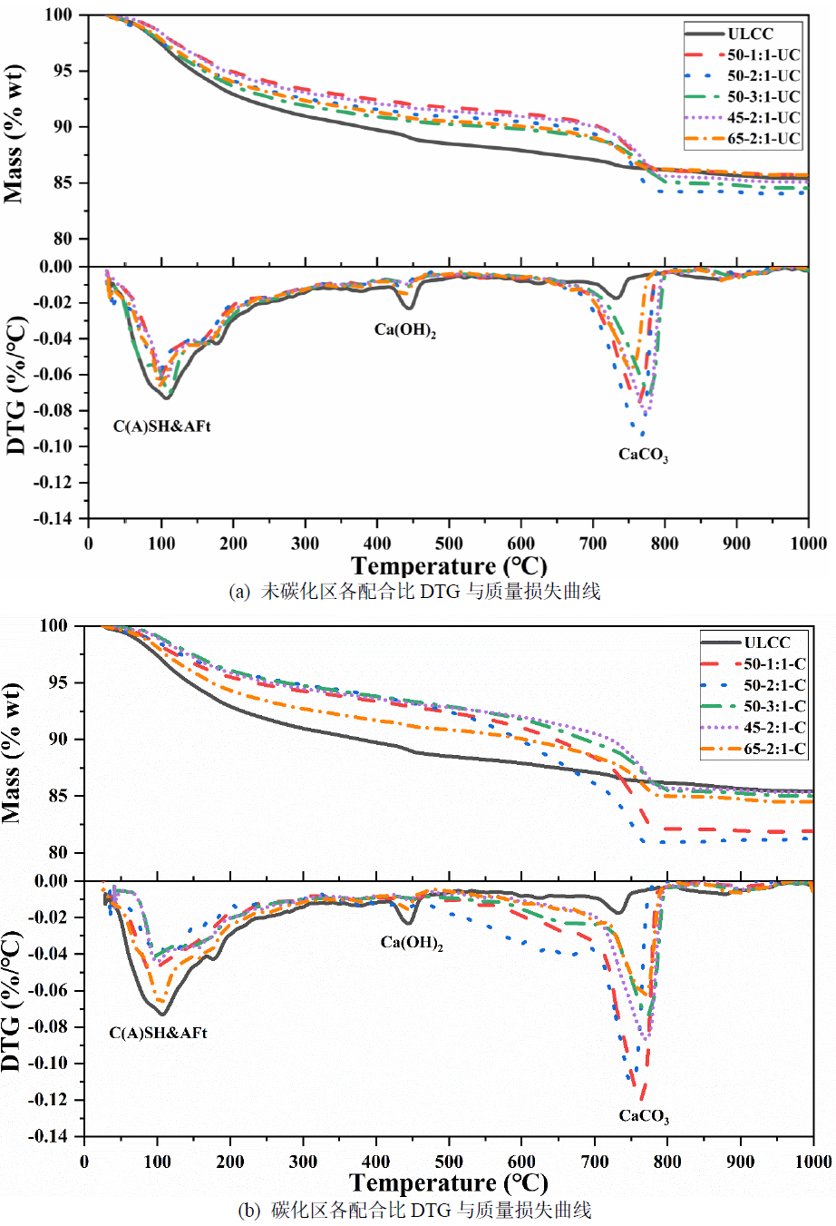
Figure 13 Comparisons of TGA test results with and without carbonation
- Results of TGA without carbonation
- Results of TGA with carbonation

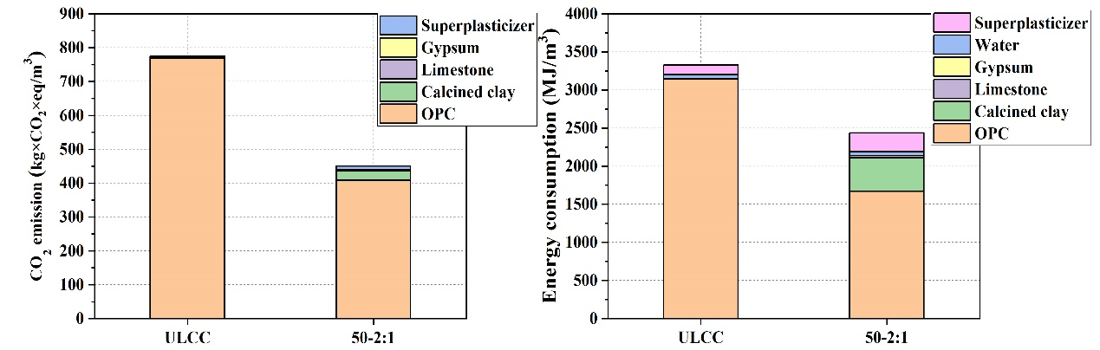
Figure 14 Comparison between carbon emissions and energy consumptions of ULCC and 50-2:1
41.9%
26.7%

