Bond behavior of helically wound FRP bars with different surface characteristics in fiber-reinforced concrete
Zhiwei Shan ¹, Kun Liang ², Lijie Chen ^{2*}
¹ China-Pakistan Belt and Road Joint Laboratory on Smart Disaster Prevention of Major Infrastructures, Southeast University, Nanjing 210096
² Department of Civil Engineering, The University of Hong Kong, Pokfulam Road, Hong Kong, China

*Correspondence email: chenlj1993@google.com

Abstract: Bond behavior of fiber reinforced polymer (FRP) bar in concrete is critical for structural performances. This study investigates the effects of bar type, steel fiber content and surface characteristics on the bond behavior of FRP bars. Pull-out tests of basalt and glass FRP bars with different rib heights (smooth, shallow and deep) were conducted in concretes with various steel fiber contents (0%, 1.0% and 1.5%). Experimental results indicate that bond strength of FRP bars is significantly affected by the height of rib. The bond strength can be significantly increased from less than 2.5 MPa to 30 MPa by increasing rib height from 0 to 0.76 mm. The inclusion of 1.0 % steel fibers in volume can prevent the splitting failure. A novel bar geometry-based model for calculating the bond strength of helically wound FRP bars is proposed by combining the experimental data in this study and existing data in literatures.
Keywords: Bond behavior; helically wound FRP bar; fiber reinforced concrete, surface characteristics

1. Introduction

1.1 Background
Over decades, reinforced concrete (RC) structures have been threatened by the corrosion of steel reinforcement [1-3]. Enormous economic costs [4] have been spent on the maintenance of existing RC structures which subject to carbonation-induced or chloride attack corrosion [5, 6]. The use of fiber reinforced polymer (FRP) bars [7-13] is a promising solution to this durability problem because of their non-corrosive nature and good mechanical performances. One of critical parameters in designing RC structures is the bond strength between reinforcing bars and concrete [14]. Structural performances such as stiffness and strength show a high degree of dependence on the bond strength [15, 16]. The bond strength design becomes more important in congested beam-column and column-footing joints. It is therefore of significance to investigate the bond strength of FRP bars in concrete.
FRP bars are made by reinforcing polymer matrix [17] (vinyl ester, polyurethane and epoxy resins) with fibers [18-21] (aramid, basalt, carbon and glass) in a pultrusion process [22]. To enhance the bond between FRP bars and concrete, various surface processing methods have been proposed such as sand coating, helically wrapping and helically wounding. FRP bars have been divided into three types [23]: non-deformed bars with a rough surface to increase chemical adhesion and mechanical friction, deformed bars with a round cross section and ribs to increase mainly mechanical interlocking and deformed bars with a noncircular cross section and ribs. Deformed bars with a round cross section and ribs to increase mainly mechanical interlocking can be further divided into three types [18, 19, 24, 25] as shown in Figure 1: helically wound bar, helically wrapped bar and indented bar. Helically wound bar is made by wounding a smooth bar with a helical strand. The strand is removed at the end of manufacturing. Helically wrapped bar is made by spirally wrapping a bundle of fibers on the surface of a smooth bar. The fibers are attached to the bar by epoxy resin. Indented bar is formed by cutting the perimeter of a smooth bar in an undulated way.
Various factors can affect the bond strength of reinforcements, including concrete compressive strength [24, 26], rebar diameter [25, 27], cover thickness [28, 29], bond length [29, 30], casting height [31, 32], transverse confinement [33, 34]. These factors have been well considered in design standards [20, 35]. However, the effects of various surface characteristics (e.g. relative rib area [36]) on the bond strength of FRP bars have not been included in the design standards. Compared with traditional steel bars, the bond behavior of FRP bars in concrete has been complicated by the wide variations in the constitutional composition, bar geometry and surface processing procedures of FRP bars. Solyom and Balazs [24] investigated the effects of various surface processing procedure on the bond behavior of FRP bars in concrete. Bar geometry and processing quality have been found to affect the bond strength. Moreover, the increase in concrete lug ratio from 0.17 to 0.30 can double the bond strength between FRP and concrete. The effects of surface conditions (smooth, helically wound, helically wrapped and sand coating) and bar geometry on the bond behavior of basalt FRP (BFRP) bars were also studied by Fahmy et. al. [19]. They found the bond stiffness can be enhanced by using sand coating. The bond-slip behavior of helically wound BFRP can be tailored by changing the rib spacing and rib height. Hao et. al. [18] found that the bond slip behavior varies in view of the changes in rib geometries (rib spacing and rib height). They proposed a rib height of 6% of bar diameter and a rib spacing identical to bar diameter to achieve an optimal bond slip behavior. Zenon and Kypros [37] found that the bond strength of GFRP bars can be increased from 5 MPa to 12 MPa by increasing the rib height from 0.25 mm to 0.75 mm. Baena et. al. [25] reported the effects of rebar geometry, type of fiber and surface treatments on the bond behavior of FRP bars. They also proposed a novel bond slip model considering the effect of bar diameter. Apart from experimental studies, a numerical study was conducted to investigate the effect of rib spacing on the bond strength of helically wrapped CFRP bars by Sasmal et. al. [38]. Decreasing rib spacing can lead to an increase in the bond strength if the rib spacing is above 0.8 times of the bar diameter.

1.2 Outline of this study
The literature review has indicated that the surface characteristic such as bar geometry and surface processing method can strongly affect the bond behavior of FRP bars. But there has been little consideration of these effects in both theoretical and practical design models. This underlines the importance of correlating the bond behavior of FRP bars with surface characteristics in a systematical way. To fill this research gap, this study aims to investigate the effect of rib height and rib spacing on the bond strength of helically wound FRP bars. The bond behaviors of steel bars, glass FRP (GFRP) bars and BFRP bars were experimentally studied with various rib heights (smooth, shallow rib and deep rib). Different contents of steel fibers (0%, 1.0% and 1.5% in volume) were mixed during concrete casting. Furthermore, a novel bond strength model is proposed for helically wound FRP ribbed bars by combining the experimental data in this study and existing data in literatures. The effects of concrete compressive strength, rib height, concrete lug ratio, cover thickness and bond length are included in this model.

1.3 Research significance
The effects of surface characteristics are of great importance in determining the bond strength of helically wound FRP bars under pull-out failure. The novelty of this study lies in a model correlating the surface characteristics with the bond strength of helically wound FRP bars.

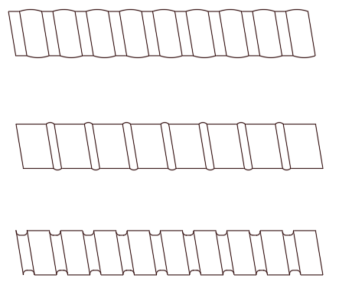
(a)
(b)
(c)
Figure 1 Types of common deformed FRP bars. (a) Helically wound bar, (b) helically wrapped bar and (c) indented bar.

2. Experimental program

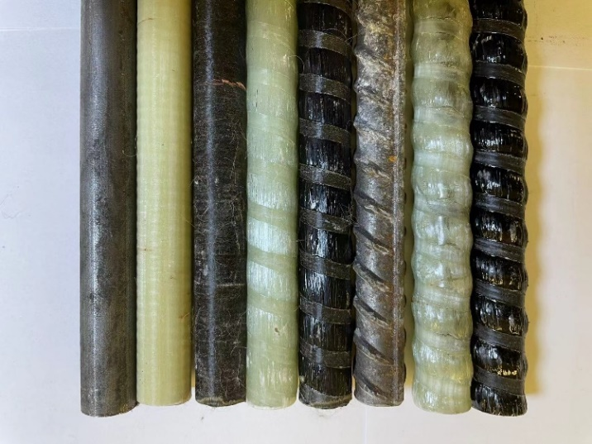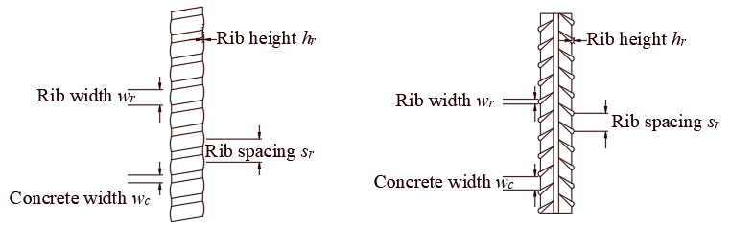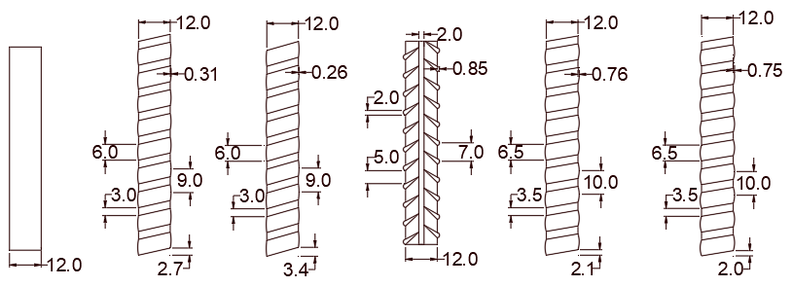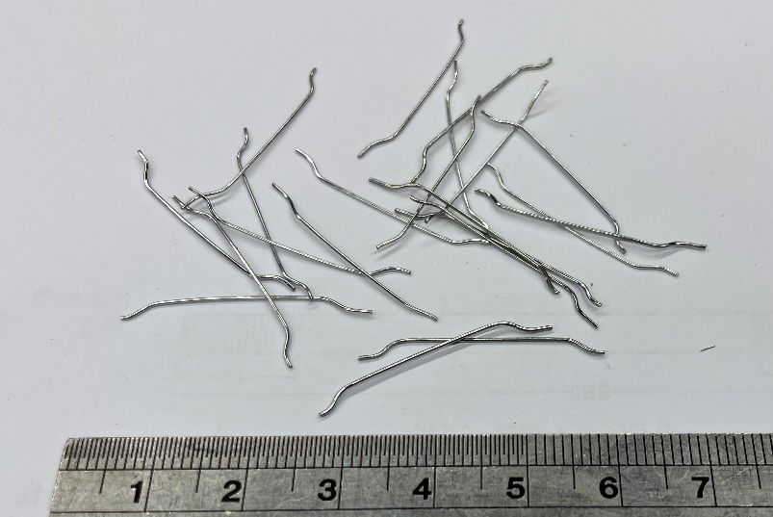2.1 Materials
(a)
S
G
B
G-S
B-S
S-R
G-D
B-D
(c)
(d)
S/G/B
G-S
B-S
S-R
G-D
B-D
Figure 2 Bars and fiber used in this study. (a) Photo of bars, (b) photo of steel fibers, (c) schematic diagram of geometrical dimensions of bars and (d) geometrical dimensions of bars. S for steel, G for GFRP and B for BFRP. Null for smooth bar, R for ribbed steel bar, S for shallow rib and D for deep rib.

(b)

In this study, three types of bars are investigated, namely steel bar, glass fiber reinforced polymer (GRFP) bar, basalt fiber reinforced polymer (BFRP) bar. For steel bar, two surface conditions are considered: smooth steel bar without rib and ribbed steel bar. For FRP bar, there are three types of surface conditions: smooth, shallow rib and deep rib. Figure 2 (a) shows the 8 types of bars studied in this paper. Each type of bar is represented by the type (S for steel, G for GFRP and B for BFRP) and surface condition (null for smooth bar, R for ribbed steel bar, S for shallow rib and D for deep rib). As shown in Figure 2 (c), the geometry of a ribbed bar is depicted by rib width, rib height and rib spacing. Figure 2 (d) shows the schematic diagram of the investigated bars with geometrical dimensions. The geometrical dimensions can also be found in Table 1. The diameter of all bars in this study is 12 mm as shown in Figure 2 (d). The tensile strength and elastic modulus of the bars are also presented in Table 1.
The concrete mix design in this study is shown in Table 2. Fresh tap water was used during concrete casting. The cement is CEM I 52.5N ordinary Portland cement in compliance with BS EN197-1:2000. The W/C ratio is 0.45. Natural river sand with a percentage passing 600 um sieve of 20.4% was used as fine aggregate. Crushed gravel with a maximum size of 10 mm was used as coarse aggregate. Hooked steel fiber with a length of 30 mm and a diameter of 0.5 mm was used as shown in Figure 2 (b). As shown in Table 2, there are three concrete mixes in this study with different fiber volume content (0%, 1% and 1.5%). The average 28-day compressive strengths of standard cubes of the concrete mixes are 56.2, 60.8 and 64.5 MPa.
In this study, there are 8 types of bars and 3 types of concrete mixes. As a result, there are 24 types of concrete specimens. For each type of concrete specimen, two duplicates were cast. Therefore, the number of the tested concrete specimens is 48.

Table 1 Properties of bars used in this study
Name of bars | Types of bars | Surface condition | Rib height  (mm) | Rib width  (mm) | Concrete width  (mm) | Rib spacing (mm) | Tensile strength (MPa) | Elastic modulus  (GPa)
S | Steel | No rib | - | - |  | - | 355 | 199.1
S-R | Steel | Rib | 0.85 | 2.0 | 5.0 | 7.0 | 467 | 200.4
G | GFRP | No rib | - | - |  | - | 1310 | 48.3
G-S | GFRP | Shallow rib | 0.31 | 6.0 | 3.0 | 9.0 | 1285 | 50.2
G-D | GFRP | Deep rib | 0.76 | 6.5 | 3.5 | 10.0 | 1321 | 49.6
B | BFRP | No rib | - | - |  | - | 1120 | 54.3
B-S | BFRP | Shallow rib | 0.26 | 6.0 | 3.0 | 9.0 | 1225 | 55.6
B-D | BFRP | Deep rib | 0.75 | 6.5 | 3.5 | 10.0 | 1287 | 54.7

Table 2 Proportions and compressive strengths of concrete mixes
Steel fiber volume  (%) | Water  (kg/m³) | Cement  (kg/m³) | W/C  ratio | River sand  (kg/m³) | 10 mm crushed gravel  (kg/m³) | Cubic compressive strength  (MPa)
0 | 190 | 423 | 0.45 | 867 | 866 | 56.2
1.0 | 190 | 423 | 0.45 | 867 | 866 | 60.8
1.5 | 190 | 423 | 0.45 | 867 | 866 | 64.5

2.2 Specimen preparation
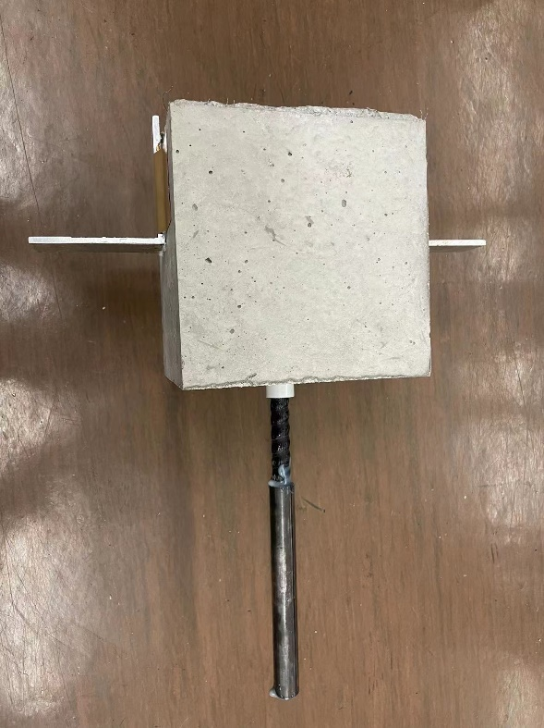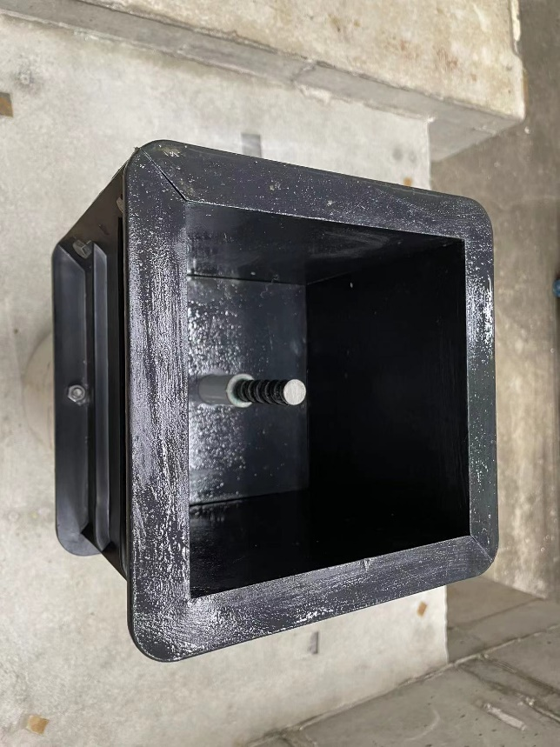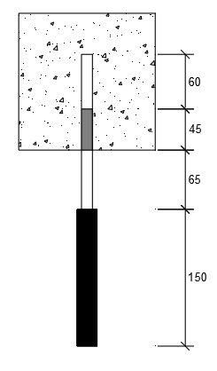
Figure 3 Specimen preparation. (a) Plastic formwork, (b) cross section (unit: mm) and (c) concrete specimen
(a)
(b)
(c)
PVC tube
Steel tube
Figure 3 shows the procedure for preparing a specimen. The formwork is a standard plastic cube with dimensions of 150 mm x 150 mm x 150 mm. As shown in Figure 3 (a), a hole was drilled on the bottom surface of a formwork. Then a PVC tube was inserted in the hole to hold a tested rebar. The length of the PVC tube is fixed as 45 mm as shown in Figure 3 (b). Upon inserting the PVC tube, a tested bar was installed accordingly. The bond length of a tested bar is 60 mm (5 x bar diameter). To prevent the end of a bar from crushing due to the gripping system during the test, a steel tube with a length of 150 mm was attached on the end of the bar by using epoxy resin according to ACI 440.3R-12 [39]. After air cured for 28 days, two aluminum angles were attached on the side surfaces of a concrete specimen as shown in Figure 3 (c) by firstly using epoxy resin glue (Araldite). After hardening of Araldite, adhesive tape was also used to fix the aluminum angles. In this way, the stability of the aluminum angles during testing is confirmed. No damages will be induced by using this installation method.

2.3 Test setup and testing procedure
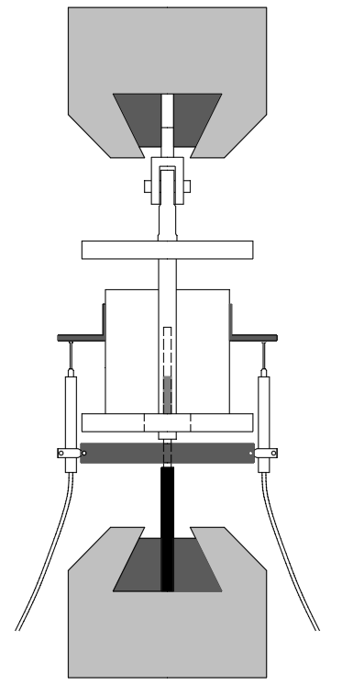
Figure 4 Setup of pull-out test
Fixed grip
Pull down
LVDT
Aluminum
angle
Test specimen
Fixed by screws
Steel frame
Figure 4 illustrates the setup of the pull-out test in this study. The design of the experimental setup is based on CSA standard S806-02 [40]. An MTS machine (MTS810) with a maximum load of 250 kN was used. There are two 647 hydraulic wedge grips in the MTS machine. A steel frame, for the placement of the test specimen, was clasped by the upper grip. The test specimen was placed on the steel frame with the end steel tube grasped by the lower grip. During the pull-out test the upper grip was fixed, while the lower grip pulled the test specimen down. In order to measure the slip between the bar and concrete, a steel holder with two liner variable displacement transducers (LVDTs) was connected to the bar by fixing screws. The probe of a LVDT was set against the aluminum angle and released gradually during the test. The measurement results of the two LVDTs are averaged to obtain the slip between the bar and concrete. The MTS machine operates with a displacement control (0.3 mm/min) during the pull-out test. The maximum displacement of the LVDT is 50 mm.

3. Test result

3.1 Failure modes
There are two primary failure modes in this study: pull-out failure (Figure 5) and splitting failure (Figure 6). In pull-out failure, a concrete specimen fails due to the loss of the bond between the bar and concrete. In splitting failure, a concrete specimen splits in two halves as shown in Figure 6. The splitting failure appears to be caused by the tensile failure of the cross section corresponding to the tested bar. This failure will be explained in further details in Section 4.
Figure 7 shows the morphology of the bars with different failure types. For the pull-out failure in this study, there is no significant effect of fiber content on the morphology of bars. Therefore, Figure 7 only presents the typical morphologies of the bars in pull-out failure specimens without emphasizing the difference in fiber content. Figure 7 (a) presents the smooth steel bar, smooth GFRP bar and smooth BFRP bar after pull-out failure. It can be observed that the smooth steel bar is almost free of concrete residual. On the other hand, the morphologies of the smooth GFRP and BFRP bars upon pull-out failure are different from that of the steel bar. Although the GFRP and BFRP bars are visually smooth as shown in Figure 2 (a), there are concrete residuals with a specific spacing attached on the FRP bars after pull-out failure. In order to enhance the bonding between fiber and epoxy resin matrix, a helically strand was also used for wrapping smooth GFRP and BFRP bars at the end of production. As a result, the surface of the smooth GFRP and BFRP bars is implicitly ribbed. This can be used to explain why there are concrete residuals on the surface of the smooth FRP bars.
Figure 7 (b) and Figure 7 (c) present the morphologies of bars with shallow ribs and deep ribs after pull-out failure respectively. By comparing Figure 7 (b) and Figure 7 (c), one may conclude that there is no significant effect of rib height on the morphologies of FRP bars after pull-out failure. As shown in Figure 7 (c), it appears that the type of ribbed bar can significantly affect the bar morphology after pull-out failure. Concrete residual is found between the ribs of the steel bar. The concrete residual for ribbed GFRP and BFRP bars is found on the ribs of the bars, while almost absent between the ribs of the bars. More importantly, the ribs in the bond zone of the FRP bars disappear after pull-out failure as compared with the no-bond zone. This is because the ribs of the FRP bars are introduced by helically wrapping. In other words, the ribs are the composite of fibers and epoxy resin matrix with a low interlaminar shear strength. Therefore, the ribs of the FRP bars are prone to be removed by the abrasion with a relatively high strength concrete during pull-out tests.
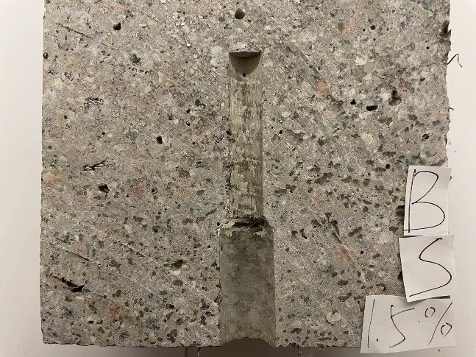
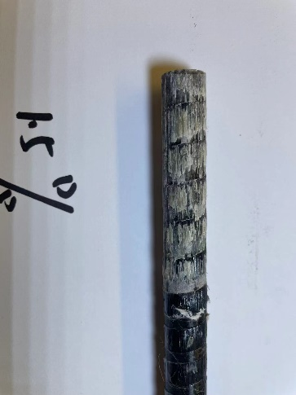
The fiber content has a significant effect on the occurrence of the splitting failure in this study. Table 4 presents the types of failure of the specimens in this study. It can be observed that the splitting failure is only found for the bars with deep ribs embedded in fiber-free concrete. In these cases, the pull-out strength is relatively high due to the deep ribs. The splitting failure occurs due to the tensile failure of concrete cross section before the pull-out failure. By adding steel fibers, the growth in the tensile strength of concrete can be higher than that in the bond strength. As a result, the splitting failure is absent for the fiber-reinforced concrete with deep ribbed bars. Figure 7 (d) shows the morphology of deep ribbed bars embedded in fiber-free concrete. Concrete residual is found between the ribs and the rib in bond zone is still present after the splitting failure.
(a)
(b)
Figure 5 Pull-out failure. (a) concrete and (b) BFRP bar.

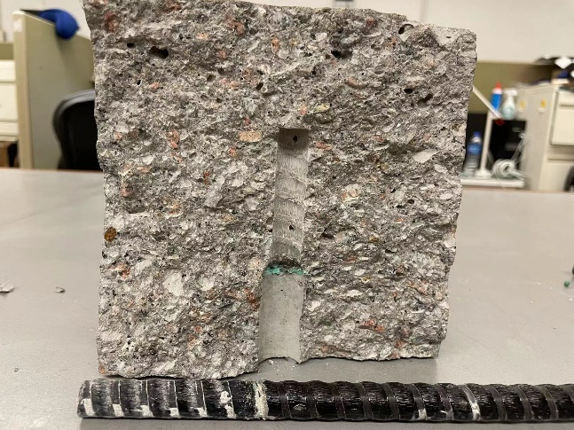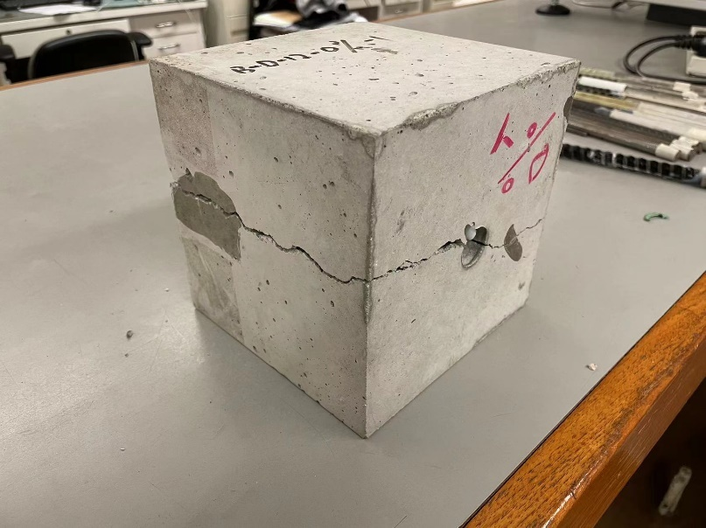
(a)
(b)
Figure 6 Splitting failure. (a) Perspective view and (b) splitted surface.
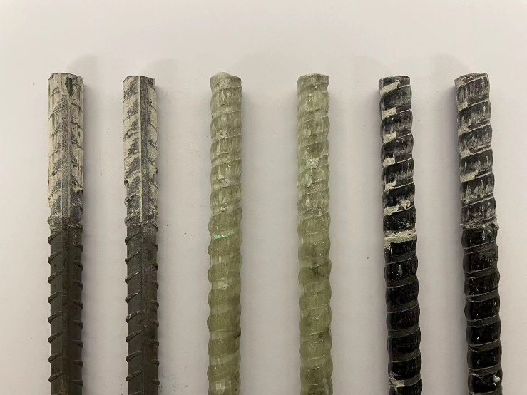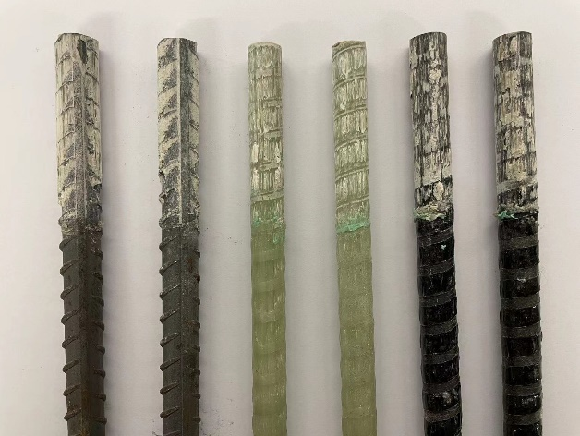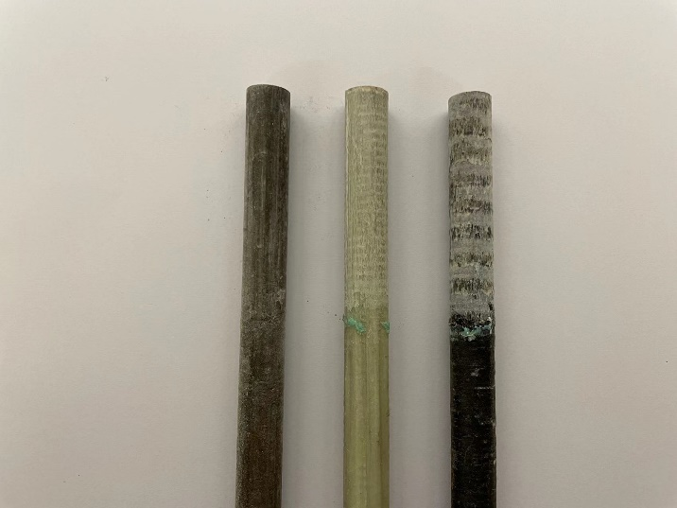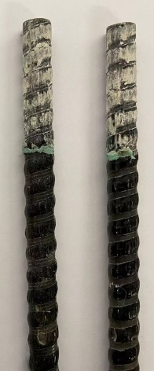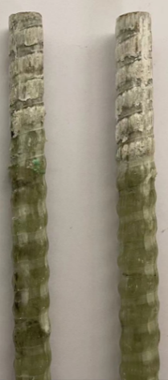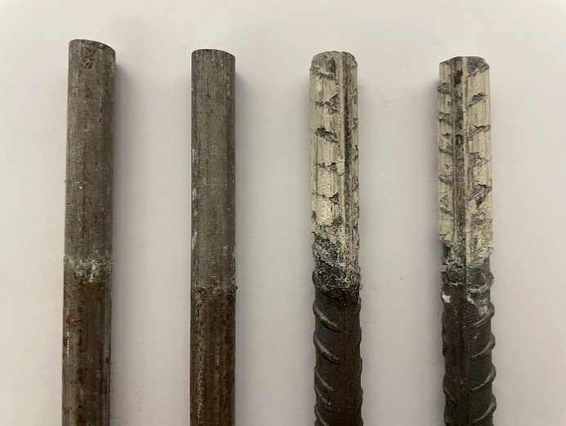
Free of residual
Figure 7 Morphology of bars after failure. (a) smooth bars after pull-out failure, fiber content: 0%, (b) bars with shallow ribs after pull-out failure, fiber content: 0%, (c) bars with deep ribs after pull-out failure, fiber content: 1% and (d) bars with deep ribs after splitting failure, fiber content: 0%.
(a)
(b)
(c)
(d)
With residual
Residual between ribs
Residual on ribs
Absence of rib
in bond zone
Presence of rib
in bond zone

3.2 Bond strength
This section presents the experimental results of bond strengths influenced by different factors.
In this study, the bond stress is calculated by:
where τ_{u} denotes the bond strength, P_{max} denotes the maximum load during the pull-out test, d denotes the bar diameter, L denotes the bond length (5d). Table 4 summarizes the experimental results of bond strengths.

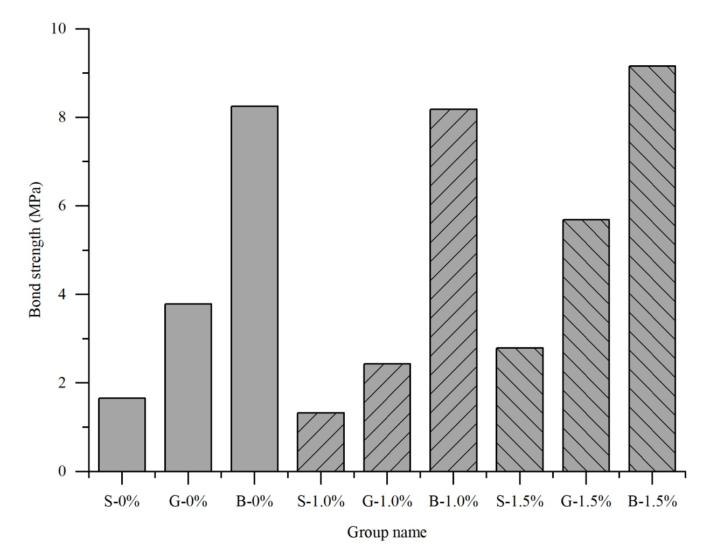
3.2.1 Effect of bar type
Figure 8 Effect of rebar type on bond strength of smooth bar.

Figure 8 shows the effect of bar type on the bond strength of the smooth bars with different fiber contents. Regardless of the fiber content, the rank of the bond strengths of the smooth bars is steel bar < GFRP bar < BFRP bar. Table 3 shows the ratios of the bond strength of the smooth FRP bars to those of the smooth steel bars with different fiber contents. The effect of bar type is independent of the fiber content. The bond strengths of the smooth GFRP bars are around twice as large as those of the smooth steel bars. The bond strength of a steel smooth bar can be increased by around 450% in 0% and 1% fiber contents by comparing with BFRP bar, although this increase is 129% in 1.5% fiber content. In conclusion, one may increase the bond strength of a smooth steel bar by at least 100% using a smooth GFRP/BFRP bar.
For a smooth bar, only the friction between bar surface and concrete contributes to the bond strength. As mentioned in Section 3.1, implicit ribs were induced by the post-wrapping process of the smooth FRP bars, leading to an enhanced friction between the smooth FRP bars and concrete. The bond strength of a smooth helically wound FRP bar is therefore higher than that of a smooth steel bar.

Table 3 Effect of rebar type on bond strength of smooth bar with different fiber contents using steel bar as reference.
Bar type | Fiber content
Bar type | 0% | 1.0% | 1.5%
Steel (S) | 1.0 | 1.0 | 1.0
GFRP (G) | 2.28 | 1.83 | 2.04
BFRP (B) | 4.97 | 6.17 | 2.29

3.2.2 Effect of fiber content
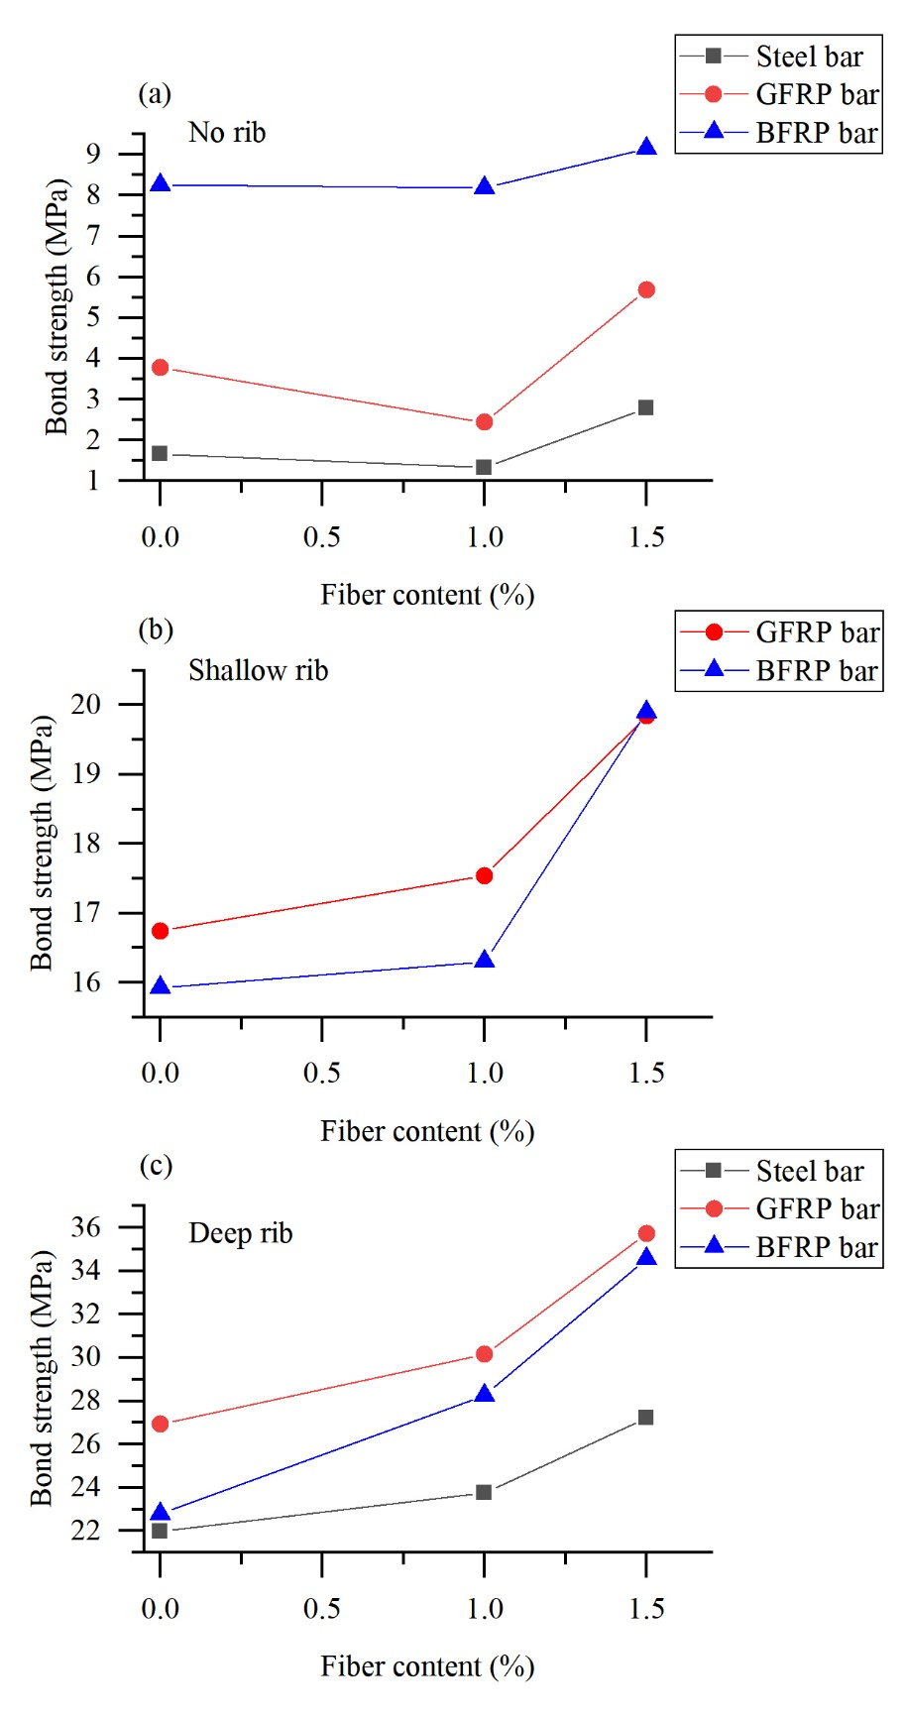
Figure 9 Effect of fiber content on bond strength. (a) No rib, (b) shallow rib, (c) deep rib.

Figure 9 shows the effect of fiber content on the bond strength of bars with different types of ribs. As revealed by Figure 9 (a), there is no significant effect of fiber content on the bond strengths of the smooth bars regardless of the type of bars. In Figure 9 (b), the bond strength of an FRP bar with shallow rib increases with the increase in fiber content. For the bars with deep rib, the bond strengths are also enhanced by increasing the fiber content.
As shown in Table 2, the concrete compressive strength increases with the fiber content (0%,1.0% and 1.5%) from 56.2 MPa to 60.8 MPa and 64.5 MPa. The bond strength of a smooth bar is mainly due to the chemical bond and physical friction between the bar and the surrounding concrete [18]. The results in Figure 9 (a) indicates that the increase in compressive strength does not enhance the chemical bond and physical friction between the smooth bar and the concrete. As for the ribbed bar, the bond strength consists of the chemical bond and physical friction and the mechanical interlocking led by the existence of the rib. The effect of increasing fiber content on the bond strengths of the ribbed bars in this study can be explained by the increase in the compressive strength, leading to an enhanced mechanical interlock effect.

3.2.3 Effect of rib height
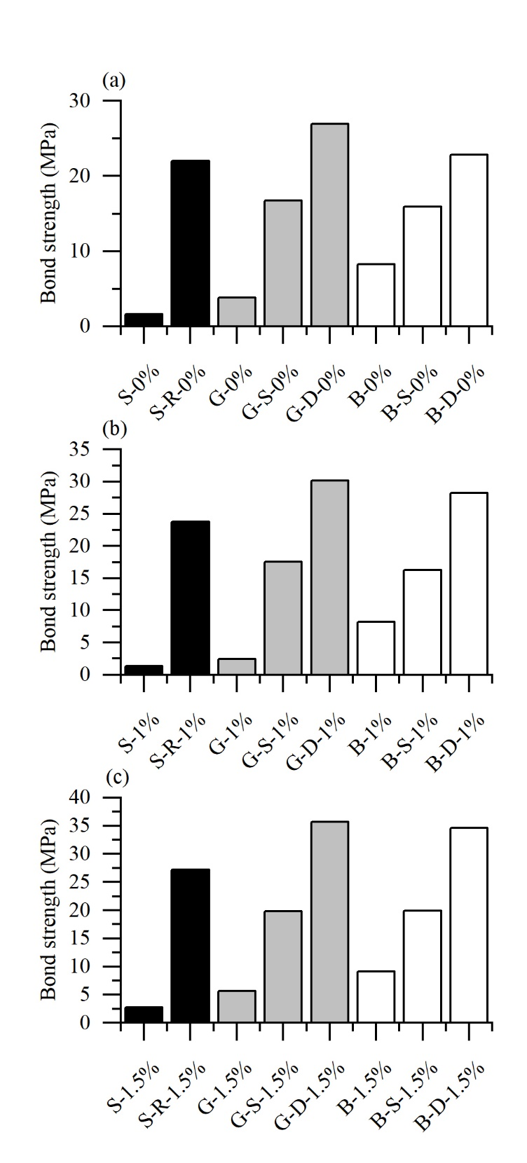
Figure 10 Effect of rib height on bond strength. Fiber content: (a) 0%, (b) 1.0% and (c) 1.5%
Effect of fiber content on bond strength. (a) No rib, (b) shallow rib, (c) deep rib.

Figure 10 shows the effect of rib height on the bond strength with different fiber contents. It is obvious that the bond strength is significantly increased by increasing the rib height regardless of the type of bar and fiber contents. For example, the bond strength of GFRP bar embedded in 1% fiber content concrete shows an increase from 2.44 MPa to 30.14 MPa by increasing the rib height from 0 to 0.76 mm.
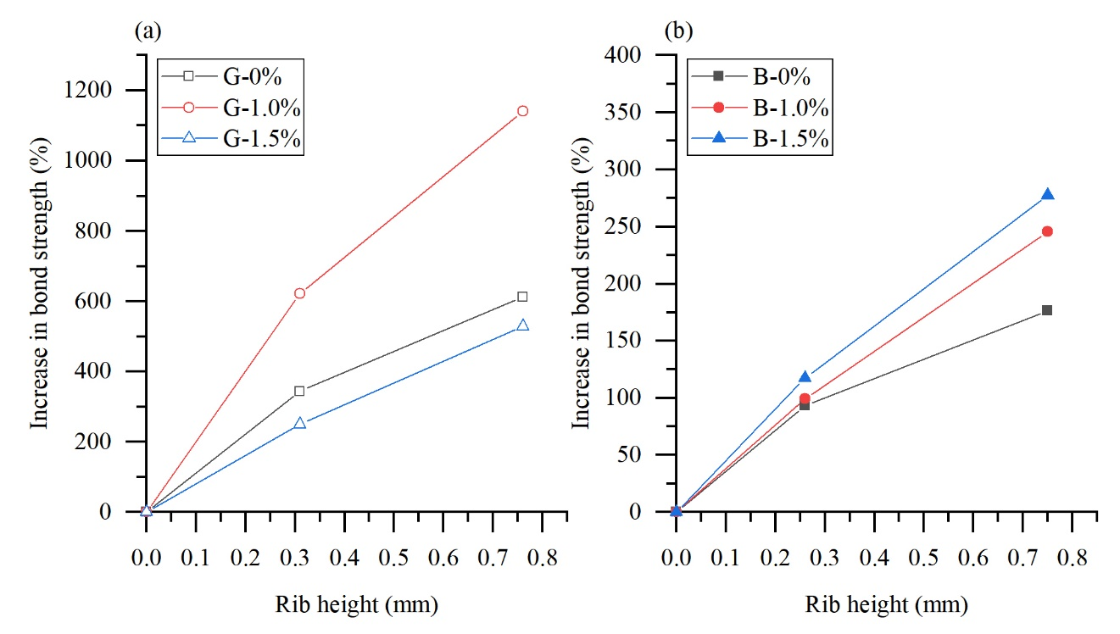
Figure 11 Effect of rib height on increase in bond strength of FRP bars. Bar type: (a) GFRP, (b) BFRP
Figure 11 presents the percentage increase in the bond strength of the FRP bars in this study. Although the effect of increasing rib height appears marginal, the bond strength of a GFRP bar can be increased by as high as 1140% while that of a BFRP bar can be increased by over 250%. The effect of increasing rib height on the bond strength of BFRP bars is also increased by increasing the fiber content.
As mentioned above, the bond strength of a ribbed FRP bar consists of chemical bonding, physical friction and mechanical interlocking between the bar and concrete. By increasing the height of rib, the bond strength is significantly increased as shown in Figure 10 and Figure 11. This indicates that the increase in rib height can enhance the mechanical interlocking of a ribbed FRP bar and the mechanical interlocking plays a significant role in the bond strength of a ribbed FRP bar. This mechanical interlocking can also be influenced by other surface characteristics of a ribbed FRP bar (e.g., spacing of ribs) and the relationship between the strength of the FRP bar and surrounding concrete. This will be further studied in Section 4.

3.3 Bond stress-slip behavior
This section presents the bond stress-slip behavior of the concrete specimens.
In this study, the slip between the bar and concrete is obtained by subtracting the elongation of the bar segment between the bonded section and the position at which the steel holder for LVDTs is fixed from the measurement result of LVDTs:
where s is the slip between the bar and concrete, s_{LVDT} is the average measurement results of two LVDTs, F is the pull-out force measured by the MTS machine, l is the length of the bar segment between the bonded section and the position at which the steel holder for LVDTs is fixed (100 mm in this study), E_{b} is the elastic modulus of the bar, A_{b} is the nominal cross-sectional area of the bar.
Figure 12, Figure 13 and Figure 14 present the bond stress – slip behavior in this study. The behavior is similar for two duplicate specimens, therefore only the result of one specimen is presented herein for simplicity.
It is of great importance to note that the shape of the bond stress – slip curve is significantly affected by the type of bar. As shown in Figure 12 (a), Figure 13 (a) and Figure 14 (a), for smooth steel bars, the bond stress increases linearly prior to the peak load. After then, the bond stress sharply declines. As a comparison, for ribbed steel bars, the bond stress undergoes a significant stiffness softening before reaching the peak load. This is because for smooth steel bars, the bond strength mainly comes from chemical adhesion and static friction between concrete and bars prior to the slip of the bars and concrete. With the occurrence of the slip, the contact surface between the steel bars and concrete is broken. This is followed by the rapid dissipation of the chemical adhesion and the conversion of static friction into sliding friction. Whereas for ribbed steel bars, the mechanical interlocking dominates the bond stress after the slip occurs. The bond stress starts to decrease only after the concrete around bar ribs is damaged. In addition, the steel bars have a far greater modulus of elasticity and strength compared to concrete. Concrete would be sheared along the contour of the ribs of steel bars during the pull-out process. The shearing failure of concrete is irreversible, resulting in a curve without damped sinusoidal shape as observed for ribbed steel bars during the descent phase. As for GFRP and BFRP bars, as shown in Figure 12 (b), (c), Figure 13 (b), (c) and Figure 14 (b), (c), all bond stress – slip curves follow a damped sinusoidal shape even for smooth bars. The wave number of the bond stress – slip curve corresponds to the number of ribs for ribbed GFRP and BFRP bars as shown in Figure 7. The failure mechanism of FRP bars is different from that of ribbed steel bars. When slip occurs, mechanical interlocking also dominates the bond stress of ribbed the ribbed FRP bars. However, unlike the ribbed steel bars, the wear and deformation of the ribs of FRP bars occur along with the damage of surround concrete during the pull-out process. The wear and extrusion of FRP ribs is a multi-step process. Once an FRP rib passes through concrete lugs, the wear and extrusion would occur. After the rib of the FRP bars passes through the narrowest part of the concrete lug, the extrusion part of the rib rebounds, resulting in a temporary increase in bond stress when passing through the next concrete lug. This repeated process leads to the appearance of the damped sinusoidal shape in the descent phase. Similar conclusion can also be found in [19].
Another important issue for the bond stress – slip curve is the slip corresponding to the peak load. Table 4 provides the slip at the peak load of all concrete specimens. Based on the experimental results of this study, one can conclude that the existence of rib for the steel bar can increase the slip at peak load. The slip at peak load can be increased due to the rib for the FRP bars, although the maximum slip at peak load generally occurs for FRP bars with shallow rib instead of deep rib.

Table 4 Test results of pull-out test specimens
Specimen name | Sample no. | P_{max}  (kN) | s_{m} (mm) | s_{m}ª (mm) | (MPa) | (MPa) |  |  | Failure mode | f_{cu}  (MPa)
S-0% | 1 | 3.6 | 0.02 | 0.05 | 1.59 | 1.66 | 0.21 | 0.22 | P | 56.2
S-0% | 2 | 3.9 | 0.07 | 0.05 | 1.73 | 1.66 | 0.23 | 0.22 | P | 56.2
S-R-0% | 1 | 49 | 1.42 | 1.16 | 21.67 | 21.98 | 2.89 | 2.93 | p | 56.2
S-R-0% | 2 | 50.4 | 0.90 | 1.16 | 22.29 | 21.98 | 2.97 | 2.93 | P-S | 56.2
B-0% | 1 | 15.4 | 2.51 | 2.57 | 6.81 | 8.25 | 0.91 | 1.10 | P | 56.2
B-0% | 2 | 21.9 | 2.63 | 2.57 | 9.69 | 8.25 | 1.29 | 1.10 | P | 56.2
G-0% | 1 | 10.2 | 0.97 | 0.98 | 4.51 | 3.78 | 0.60 | 0.50 | P | 56.2
G-0% | 2 | 6.9 | 0.99 | 0.98 | 3.05 | 3.78 | 0.41 | 0.50 | P | 56.2
B-S-0% | 1 | 35.8 | 3.18 | 3.11 | 15.84 | 15.93 | 2.11 | 2.12 | P | 56.2
B-S-0% | 2 | 36.2 | 3.04 | 3.11 | 16.01 | 15.93 | 2.14 | 2.12 | P | 56.2
G-S-0% | 1 | 35.2 | 3.32 | 3.46 | 15.57 | 16.74 | 2.08 | 2.23 | P | 56.2
G-S-0% | 2 | 40.5 | 3.60 | 3.46 | 17.91 | 16.74 | 2.39 | 2.23 | P | 56.2
B-D-0% | 1 | 53 | 1.01 | 0.93 | 23.44 | 22.80 | 3.13 | 3.04 | S | 56.2
B-D-0% | 2 | 50.1 | 0.85 | 0.93 | 22.16 | 22.80 | 2.96 | 3.04 | S | 56.2
G-D-0% | 1 | 60.1 | 0.88 | 0.93 | 26.58 | 26.94 | 3.55 | 3.59 | S | 56.2
G-D-0% | 2 | 61.7 | 0.98 | 0.93 | 27.29 | 26.94 | 3.64 | 3.59 | S | 56.2
S-1% | 1 | 3.4 | 0.08 | 0.20 | 1.50 | 1.33 | 0.19 | 0.17 | P | 60.8
S-1% | 2 | 2.6 | 0.31 | 0.20 | 1.15 | 1.33 | 0.15 | 0.17 | P | 60.8
S-R-1% | 1 | 53.1 | 1.34 | 1.13 | 23.49 | 23.78 | 3.01 | 3.05 | P | 60.8
S-R-1% | 2 | 54.4 | 0.93 | 1.13 | 24.06 | 23.78 | 3.09 | 3.05 | P | 60.8
B-1% | 1 | 12.8 | 2.79 | 2.70 | 5.66 | 8.18 | 0.73 | 1.05 | P | 60.8
B-1% | 2 | 24.2 | 2.62 | 2.70 | 10.70 | 8.18 | 1.37 | 1.05 | P | 60.8
G-1% | 1 | 5.6 | 1.00 | 0.99 | 2.48 | 2.44 | 0.32 | 0.31 | P | 60.8
G-1% | 2 | 5.4 | 0.98 | 0.99 | 2.39 | 2.44 | 0.31 | 0.31 | P | 60.8
B-S-1% | 1 | 34.4 | 3.01 | 3.05 | 15.22 | 16.30 | 1.95 | 2.09 | P | 60.8
B-S-1% | 2 | 39.3 | 3.10 | 3.05 | 17.38 | 16.30 | 2.23 | 2.09 | P | 60.8
G-S-1% | 1 | 40.8 | 3.53 | 3.50 | 18.05 | 17.54 | 2.31 | 2.25 | P | 60.8
G-S-1% | 2 | 38.5 | 3.47 | 3.50 | 17.03 | 17.54 | 2.18 | 2.25 | P | 60.8
B-D-1% | 1 | 62.1 | 0.64 | 1.16 | 27.47 | 28.27 | 3.52 | 3.62 | P | 60.8
B-D-1% | 2 | 65.7 | 1.68 | 1.16 | 29.06 | 28.27 | 3.73 | 3.62 | P | 60.8
G-D-1% | 1 | 68.3 | 1.77 | 1.98 | 30.21 | 30.14 | 3.87 | 3.87 | P | 60.8
G-D-1% | 2 | 68 | 2.19 | 1.98 | 30.08 | 30.14 | 3.86 | 3.87 | P | 60.8
S-1.5% | 1 | 6.3 | 0.01 | 0.03 | 2.79 | 2.79 | 0.35 | 0.35 | P | 64.5
S-1.5% | 2 | 6.3 | 0.04 | 0.03 | 2.79 | 2.79 | 0.35 | 0.35 | P | 64.5
S-R-1.5% | 1 | 60.6 | 4.01 | 5.37 | 26.80 | 27.20 | 3.34 | 3.39 | P | 64.5
S-R-1.5% | 2 | 62.4 | 6.72 | 5.37 | 27.60 | 27.20 | 3.44 | 3.39 | P | 64.5
B-1.5% | 1 | 21.3 | 2.26 | 2.30 | 9.42 | 9.16 | 1.17 | 1.14 | P | 64.5
B-1.5% | 2 | 20.1 | 2.33 | 2.30 | 8.89 | 9.16 | 1.11 | 1.14 | P | 64.5
G-1.5% | 1 | 15.8 | 0.95 | 0.89 | 6.99 | 5.69 | 0.87 | 0.71 | P | 64.5
G-1.5% | 2 | 9.9 | 0.83 | 0.89 | 4.38 | 5.69 | 0.55 | 0.71 | P | 64.5
B-S-1.5% | 1 | 44.7 | 3.28 | 3.24 | 19.77 | 19.90 | 2.46 | 2.48 | P | 64.5
B-S-1.5% | 2 | 45.3 | 3.19 | 3.24 | 20.04 | 19.90 | 2.49 | 2.48 | P | 64.5
G-S-1.5% | 1 | 46.5 | 2.91 | 3.00 | 20.57 | 19.84 | 2.56 | 2.47 | P | 64.5
G-S-1.5% | 2 | 43.2 | 3.10 | 3.00 | 19.11 | 19.84 | 2.38 | 2.47 | P | 64.5
B-D-1.5% | 1 | 74.7 | 1.68 | 1.94 | 35.83 | 34.57 | 4.46 | 4.30 | P | 64.5
B-D-1.5% | 2 | 75.3 | 2.21 | 1.94 | 33.31 | 34.57 | 4.15 | 4.30 | P | 64.5
G-D-1.5% | 1 | 81 | 2.01 | 2.06 | 35.83 | 35.72 | 4.46 | 4.45 | P | 64.5
G-D-1.5% | 2 | 80.5 | 2.12 | 2.06 | 35.61 | 35.72 | 4.43 | 4.45 | P | 64.5
Note: f_{cu} = compressive strength; P_{max} = Peak load; s_{m} = slip at peak load; s_{m}ª = average slip at peak load; = bond strength; = average bond strength for duplicate specimens; = nominalized bond strength; = average nominalized bond strength for duplicate specimens; P is pull-out failure; E is end rupture failure; S is splitting failure; P-S is pull-out failure followed by splitting failure.
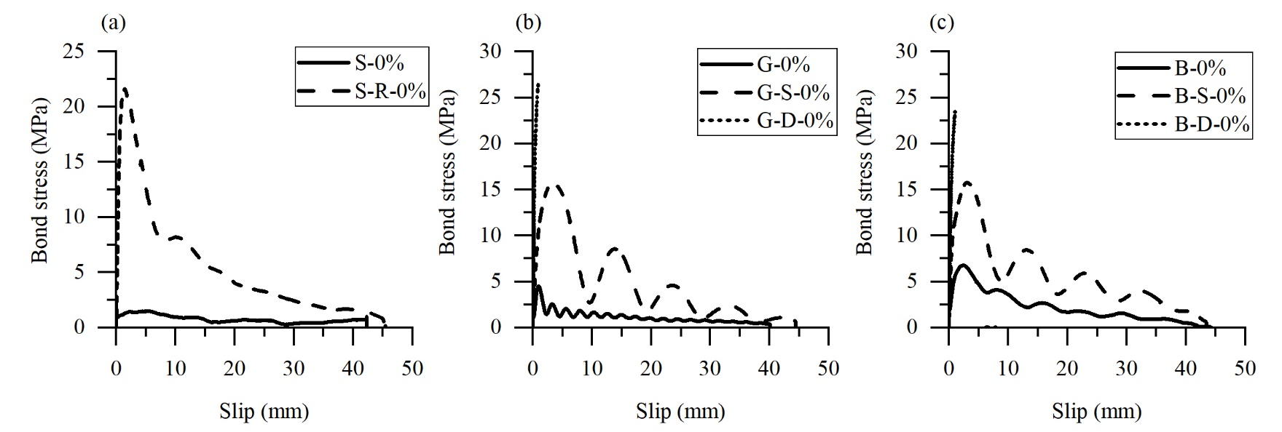
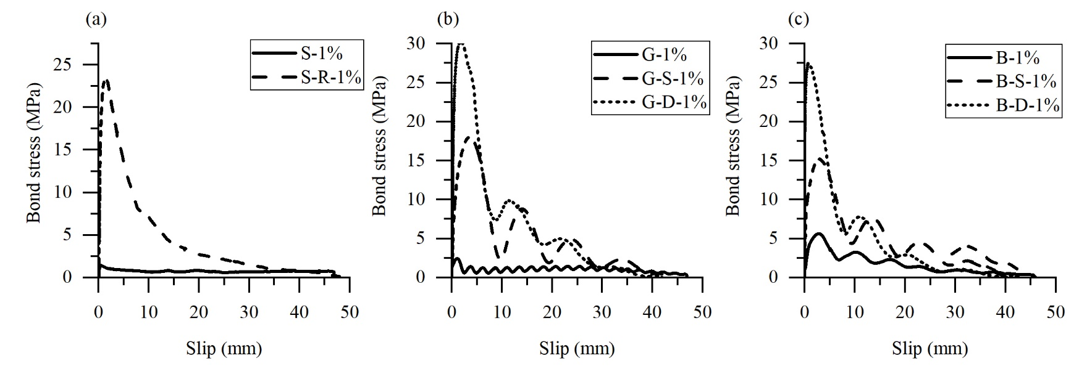
Figure 12 Bond stress – slip relationship of specimen with 0% fiber content. (a) Steel bars, (b) GFRP bars and (c) BFRP bars.

Figure 13 Bond stress – slip relationship of specimen with 1% fiber content. (a) Steel bars, (b) GFRP bars and (c) BFRP bars.

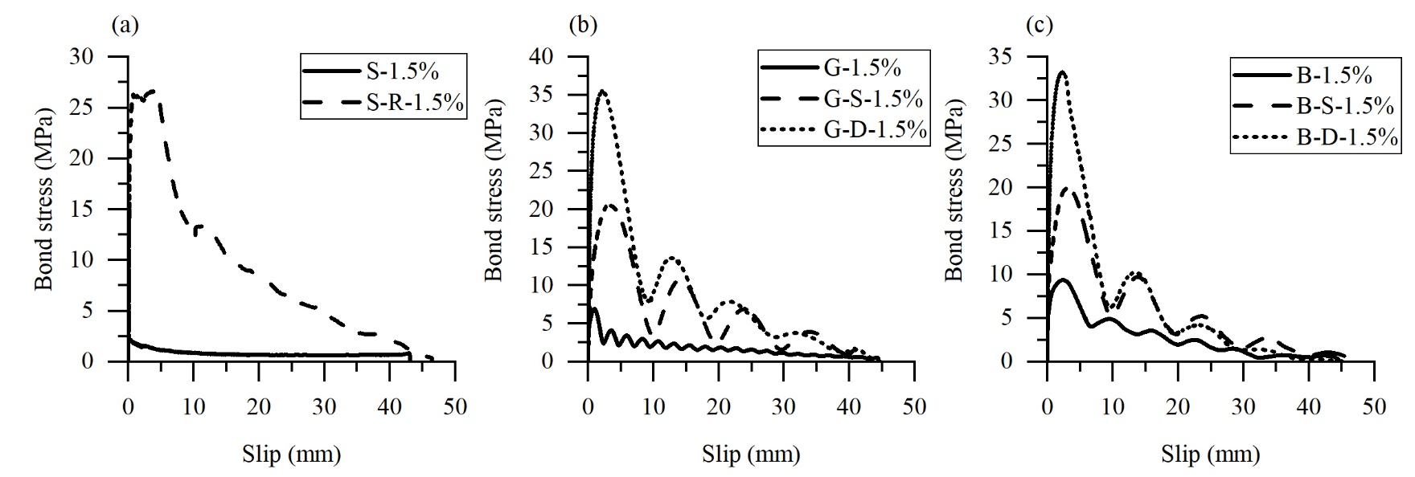
Figure 14 Bond stress – slip relationship of specimen with 1.5% fiber content. (a) Steel bars, (b) GFRP bars and (c) BFRP bars.

4. Bond strength model

4.1 Examination of existing models
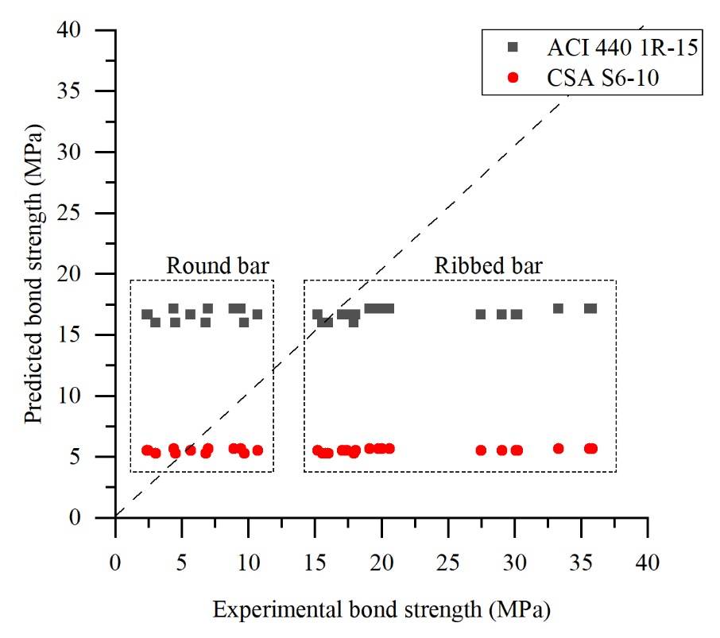
Figure 15 Comparison of bond strengths obtained by experiments and existing methods
The bond strength of FRP bars can be calculated by the equation given by ACI 440 1R-15 [20]:
where u denotes bond strength (MPa), $\sqrt{f_{c}^{'}}$ denotes specified concrete compressive strength (MPa), c denotes concrete cover thickness (mm), d_{b} denotes bar diameter (mm), l_{b} denotes bond length, α denotes location factor of the bar (1.5 for bars with casting height more than 300 mm, 1.0 for others).
The bond strength of FRP bars can be calculated by the equations given by CSA S6-10 [35]:
where u denotes bond strength (MPa), d_{cs} denotes smallest value of concrete cover or 2/3 of spacing of bars (mm), K_{tr} denotes transverse reinforcement index, E_{FRP} denotes elastic modulus of FRP bar (MPa), E_{s} denotes elastic modulus of steel (MPa), f_{cr} denotes cracking stress of concrete (0.40 $\sqrt{f_{c}^{'}}$ for normal-weight concrete), k₁ denotes location factor for FRP bars (1.3 for bars with casting height more than 300 mm, 1.0 for others), k₄ denotes bar surface factor, which is the ratio of the bond strength of an FRP bar to that of a deformed steel bar with the same cross-sectional area as the FRP bar (less than 1.0, can be 0.8 if no experimental data available), d_{b} denotes bar diameter (mm).
Figure 15 compares the experimental bond strength in this study and the calculated bond strengths by ACI440 1R-15 and CSA S6-10. The bond strengths calculated by ACI 440 1R-15 are higher than those by CSA S6-10. By using the equations given by ACI440 1R-15, the bond strengths of the round bars are overestimated, while those of the ribbed bars are underestimated. The bond strengths of the round bars calculated by CSA S6-10 are more accurate as compared with those by ACI 440 1R-15, on the other hand, the bond strengths of the ribbed bars given by CSA S6-10 are significantly underestimated.
More importantly, it can be observed that the predicted bond strengths of ribbed bars are close to those of round bars since there is no consideration of rib height in the design equations. It is necessary to consider the effects of bar geometry (rib height and rib spacing) on the bond strength of helically wound FRP bars.

4.2 Proposed bond strength model of helically wound FRP bars
This section proposes a novel bond strength model for helically wound FRP bars.
As discussed above, ribs are introduced to enhance the mechanical interlocking so that the bond strength of a ribbed bar can be significantly improved. The increase in rib height h_{r} undoubtedly leads to a raise in the bond strength as shown in Figure 10 and Figure 11. The rib spacing s_{r} is also important since it represents how many ribs in unit length can contribute to resisting pull-out force. By considering these two parameters, Diab et.al. [28] proposed a bond strength model for steel reinforcements considering the rib height effect:
where f_{cu} denotes compressive strength of concrete cube (MPa), h_{r} denotes rib height (mm), s_{r} denotes rib spacing (mm), other parameters remain the same meanings as mentioned above. By comparing Equation with Equation , one can find that they are similar in format with the only difference of the term (h_{r}/s_{r}) in Equation .
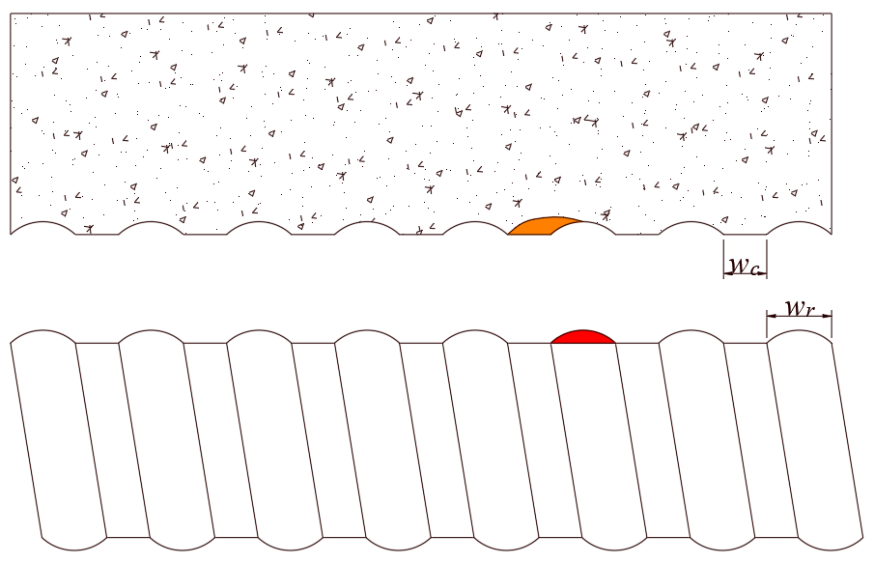
Concrete crushing
Rib shearing off
Figure 16 Schematic diagram for pull-out failure of helically wound FRP bar
It should be noted that the modes of pull-out failure are totally different for steel reinforcement and FRP bar as shown in Figure 7 (c). The rib of the steel bar is intact while that of the FRP bar is absent after pull-out failure. Figure 16 illustrates the pull-out failure of a helically wound FRP bar. The ribs of a helically wound FRP bar are not as rigid as those of a steel bar. As a result, the ribs of an FRP bar may be destroyed during the pull-out process. It is therefore necessary to consider the failure of the ribs of FRP bars in bond strength model.
Apart from h_{r} and s_{r}, concrete lug ratio C_{LR} can be used to describe the bar geometry [24]:
where w_{c} denotes concrete width (or clear spacing between ribs), w_{r} denotes rib width.
As shown in Figure 16, the concrete lug ratio calculated by Equation may be not representative for helically wound FRP bar since Equation assumes the longitudinal section of a rib is rectangular. The following equation is proposed to consider the undulation of a rib:
The rib lug ratio R_{LR} can be calculated by:
The contributions of concrete lug and rib lug on the bond strength depend on the concrete compressive strength. More specifically, the concrete crushing dominates when the concrete strength is relatively low. When the concrete compressive strength is moderate, the pull-out failure is a mix of concrete crushing and rib shearing off. Once the concrete compressive strength is above 85 MPa [41], the pull-out failure is controlled by rib shearing off and no further increase in bond strength can be found with the increase in concrete strength.
Available pull-out bond strengths of helically wound FRP bars in literatures [18, 19, 24, 25] have been collected and combined with the experimental data in this study. It has been found that the increase in concrete lug ratio can enhance the bond strength [24]. In this study, the terms C_{LR}(f_{c}/25) and R_{LR}(f_{f}/700) are proposed to represent the contribution of concrete lug and rib lug on the bond strength. 25 and 700 are minimum compressive strength of concrete and minimum tensile strength of FRP bars in MPa in the database of this study.
Based on Equation , we propose the following equation to calculate the bond strength of helically wound FRP bars by introducing the terms C_{LR}(f_{c}/25) and R_{LR}(f_{f}/700):
where τ_{u} is bond strength of a helically wound FRP bar (MPa), f_{c} is cylindrical compressive strength of concrete (MPa), f_{f} is tensile strength of FRP bar, k is a factor to consider the effect of concrete strength on the contributions of concrete crushing and rib shearing off. In other words, k is used to regulate these effects with different concrete strengths. By multi regression analysis on the database of this study, the values of a_{1,} a_{2,} a_{3,} a_{4,} a_{5,} a_{6,} a₇ are 0.57, 0.20, 14.54, 1.14, 2.60, 0.03, 1.10 respectively. It should be noted that the range of the height of rib (h_{r}) to be used in Equation is only within 1.6%~9.0% d. For data out of this range, further research is needed.
Figure 17 shows the comparison between the fitted bond strength by using Equation and the experimental data in this study and existing literatures. It can be observed that the experimental bond strengths can be well calculated by using the proposed equation, especially as compared with the calculated bond strengths by existing standards (Figure 15).
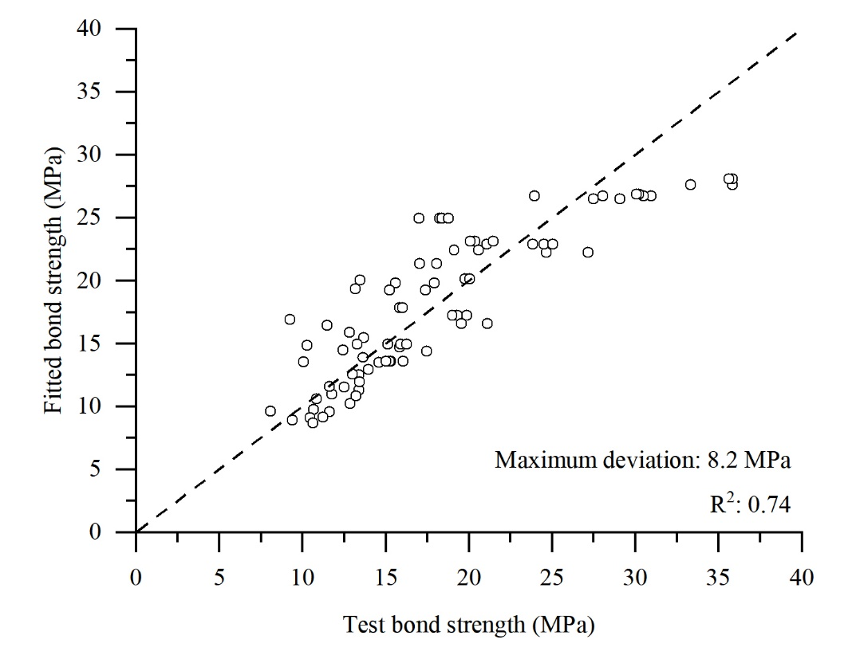
Figure 17 Comparison between fitted and experimental bond strengths. 81 samples in total, 21 samples in this study and 60 samples from existing literatures [18,19,24,25].
To further validate the proposed model in this study, another set of data was selected from [21]. The comparison between the bond strengths under a pull-out failure in [21] and the calculated bond strengths by using Equation is shown in Table 5. It can be observed that the experimental bond strength can be well predicted by using the proposed theoretical equation in this study. Most of the deviations by using Equation are around or below 10%.
To the best knowledge of the authors, all experimental data on the bond strength under pull-out failure of helically wounded FRP bars in existing literatures [18, 19, 21, 24, 25] have been included in this study. It is shown that the proposed theoretical equation can well predict the bond strength of helically wounded FRP bars. However, further research efforts are undoubtedly necessary in developing a more sophisticated model if more experimental data on this aspect are available.
Table 5 Comparison with the experimental data in [21]
Notation of the Specimen in [21] | Experimental bond strength (MPa) | Bond strength by Equation (MPa) | Deviation (%)
G8WO/4.5-11-4.5-10-1/C30 | 11.39 | 10.33 | -9.3
G8WO/4.5-11-4.5-10-1/C35 | 14.70 | 14.11 | -4.0
G8WO/4.5-11-4.5-10-1/C40 | 11.81 | 15.88 | 34.5
G8WO/4.5-11-2.5-10-1/C30 | 11.43 | 10.29 | -10.0
G8WO/4.5-11-3.5-10-1/C30 | 11.47 | 10.31 | -10.1
G12WO/4.5-11-4.5-10-1/C30 | 10.17 | 11.95 | 17.5
G8WO/4.5-7-4.5-10-1/C30 | 11.50 | 10.33 | -10.2
G8WO/4.5-11-4.5-20-1/C20 | 8.78 | 8.16 | -7.1
G8WO/4.5-11-4.5-10-1/C20 | 9.29 | 8.54 | -8.1
G8WO/4.5-11-4.5-10-0/C20 | 9.31 | 8.54 | -8.3

4.3 Use of the proposed model in practice
It should be noted that the calculated bond strength by Equation is based on the pull-out failure. The bond between FRP bars and concrete would fail in splitting failure if the tensile strength of concrete is insufficient, as observed in the fiber-free group in this study (Table 4). Splitting failure is a pre-mature failure due to the insufficient tensile strength of concrete. The bond strength of splitting failure is lower than that in pull-out failure. Therefore, 1% of steel fiber in volume or other effective measures to prevent splitting failure are recommended in using Equation .
By combining the existing data in literatures and experimental data in this study, a novel bond strength model has been proposed as Equation . In this model, the effects of concrete compressive strength, tensile strength of FRP bars, height of ribs, spacing of ribs, bonded length, bar diameter and cover thickness on the bond strength of helically wound FRP bars have been considered. One can calculate the bond strength of helically wound FRP bar based on Equation if the input parameters are available. It should be noted that the bond strength may be influenced by other factors, e.g., casting heights, radial confinement, etc. One should fully consider other possible effects in calculating the bond strength of helically wound FRP bars using Equation .

6. Conclusion
This study experimentally investigates the effects of reinforcement type, surface characteristics and steel fiber content on the bond behavior of FRP bars. A novel bar geometry-based bond strength model is further proposed for helically wound FRP bars. Based on the results of this study, the following conclusions can be drawn:
1. A novel bond strength model for helically wound FRP bars is proposed. This model is featured with the inclusions of concrete compressive strength, bar geometry, cover thickness and bond length. This model fills the research gap in the models in current design standards, in which the bar geometry effects on the bond strength have not been considered.
2. The bond behavior of FRP bars is different from that of traditional steel reinforcement. The bond stress - slip curve of FRP bars shows a sinusoidal decay after peak, while that of traditional steel reinforcement drops down directly after peak. The ribs of an FRP bar can be destroyed during the pull-out process while the rib of a steel bar remains intact.
3. Increase in rib height can significantly enhance the bond strength of reinforcements. The mechanical interlocking between bars and concrete can be improved by increasing rib height. The bond strength of a smooth FRP bar can be increased by at least 250% as compared with an FRP bar with deep rib.
4. Increase in fiber content can enhance the bond strength of ribbed reinforcements and avoid splitting failure. By increasing fiber content in concrete, the improvement of bond strength of ribbed reinforcements is due to the increase in concrete compressive strength and mechanical interlocking. Another advantage of using fibers in concrete is to increase the tensile strength of concrete and therefore prevent splitting failure. The bond strength of an FRP bar and concrete can be fully utilized.

Acknowledgement
The research carried out in this paper gratefully acknowledges financial support from “the Fundamental Research Funds for the Central Universities”.
References
[1] L. Bertolini, B. Elsener, P. Pedeferri, E. Redaelli, R. Polder, Corrosion of steel in concrete, Wiley Online Library2013.https://doi.org/10.1002/9783527651696.
[2] L. Chen, R.K.L. Su, Corrosion rate measurement by using polarization resistance method for microcell and macrocell corrosion: Theoretical analysis and experimental work with simulated concrete pore solution, Constr. Build. Mater. 267 (2021) 121003.https://doi.org/10.1016/j.conbuildmat.2020.121003.
[3] L. Chen, R.K.L. Su, On the corrosion rate measurement of reinforcing steel in chloride induced macrocell corrosion, Cem. Concr. Compos. (2022) 104775.https://doi.org/10.1016/j.cemconcomp.2022.104775.
[4] G.H. Koch, M.P. Brongers, N.G. Thompson, Y.P. Virmani, J.H. Payer, Corrosion cost and preventive strategies in the United States, Federal Highway Administration, United States, 2002.
[5] L. Chen, R.K.L. Su, Effect of high rebar temperature during casting on corrosion in carbonated concrete, Constr. Build. Mater. 249 (2020) 118718.https://doi.org/10.1016/j.conbuildmat.2020.118718
[6] L. Chen, R.K.L. Su, Influence of rebar geometry on the steel-concrete interface of reinforced concrete, Constr. Build. Mater. 304 (2021) 124668.https://doi.org/10.1016/j.conbuildmat.2021.124668.
[7] A. Pavlović, T. Donchev, D. Petkova, N. Staletović, Sustainability of alternative reinforcement for concrete structures: Life cycle assessment of basalt FRP bars, Constr. Build. Mater. 334 (2022).https://doi.org/10.1016/j.conbuildmat.2022.127424.
[8] I. Shakir Abbood, S.a. Odaa, K.F. Hasan, M.A. Jasim, Properties evaluation of fiber reinforced polymers and their constituent materials used in structures – A review, Mater. Today 43 (2021) 1003-1008.https://doi.org/10.1016/j.matpr.2020.07.636.
[9] X. Hu, J. Xiao, K. Zhang, Q. Zhang, The state-of-the-art study on durability of FRP reinforced concrete with seawater and sea sand, J. Build. Eng. 51 (2022) 104294.https://doi.org/10.1016/j.jobe.2022.104294.
[10] J. Dashti, M. Nematzadeh, Flexural behavior of GFRP bar-reinforced calcium aluminate cement concrete beams containing forta-ferro fibers in acidic environment, Constr. Build. Mater. 265 (2020) 120602.https://doi.org/10.1016/j.conbuildmat.2020.120602.
[11] S. Fallah-Valukolaee, S. Hashemi, M. Nematzadeh. (2022). Effect of steel fiber on flexural performance of bilayer concrete beams with steel and GFRP rebars: Experiments and predictions. Paper presented at the Struct.https://doi.org/10.1016/j.istruc.2022.03.007.
[12] M. Nematzadeh, S. Fallah-Valukolaee, Experimental and analytical investigation on structural behavior of two-layer fiber-reinforced concrete beams reinforced with steel and GFRP rebars, Constr. Build. Mater. 273 (2021) 121933.https://doi.org/10.1016/j.conbuildmat.2020.121933.
[13] S.-A. Hosseini, M. Nematzadeh, C. Chastre, Prediction of shear behavior of steel fiber-reinforced rubberized concrete beams reinforced with glass fiber-reinforced polymer (GFRP) bars, Compos. Struct. 256 (2021) 113010.https://doi.org/10.1016/j.compstruct.2020.113010.
[14] M.S. Thakur, S.M. Pandhiani, V. Kashyap, A. Upadhya, P. Sihag, Predicting bond strength of FRP bars in concrete using soft computing techniques, Arab. J. Sci. Eng 46(5) (2021) 4951-4969.https://doi.org/10.1007/s13369-020-05314-8.
[15] J. Li, R.J. Gravina, S.T. Smith, P. Visintin, Bond strength and bond stress-slip analysis of FRP bar to concrete incorporating environmental durability, Constr. Build. Mater. 261 (2020) 119860.https://doi.org/10.1016/j.conbuildmat.2020.119860.
[16] S. Mousa, H.M. Mohamed, B. Benmokrane, Cracking and crack control in circular concrete bridge members reinforced with fiber-reinforced polymer bars, Journal of Bridge Engineering 24(1) (2019) 04018108.https://doi.org/10.1061/(asce)be.1943-5592.0001335.
[17] B. Benmokrane, M. Hassan, M. Robert, P.V. Vijay, A. Manalo, Effect of Different Constituent Fiber, Resin, and Sizing Combinations on Alkaline Resistance of Basalt, Carbon, and Glass FRP Bars, J. Compos. Constr. 24(3) (2020).https://doi.org/10.1061/(asce)cc.1943-5614.0001009.
[18] Q. Hao, Y. Wang, Z. He, J. Ou, Bond strength of glass fiber reinforced polymer ribbed rebars in normal strength concrete, Constr. Build. Mater. 23(2) (2009) 865-871.https://doi.org/10.1016/j.conbuildmat.2008.04.011.
[19] M. F. M. Fahmy, S. A. S. Ahmed, Z. Wu, Bar surface treatment effect on the bond-slip behavior and mechanism of basalt FRP bars embedded in concrete, Constr. Build. Mater. 289 (2021).https://doi.org/10.1016/j.conbuildmat.2021.122844.
[20] ACI 440.1R-15, Guide for the Design and Construction of Structural Concrete Reinforced with Fiber-Reinforced Polymer (FRP) Bars, American concrete institute, MI, USA, 2015.
[21] B. Basaran, I. Kalkan, Investigation on variables affecting bond strength between FRP reinforcing bar and concrete by modified hinged beam tests, Compos. Struct. 242 (2020).https://doi.org/10.1016/j.compstruct.2020.112185.
[22] A. Ahmed, S. Guo, Z. Zhang, C. Shi, D. Zhu, A review on durability of fiber reinforced polymer (FRP) bars reinforced seawater sea sand concrete, Constr. Build. Mater. 256 (2020).https://doi.org/10.1016/j.conbuildmat.2020.119484.
[23] G. Portnov, C. Bakis, E. Lackey, V. Kulakov, FRP Reinforcing bars—designs and methods of manufacture (Review of Patents), Mech. Compos. Mater. 49(4) (2013) 381-400.https://doi.org/10.1007/s11029-013-9355-1.
[24] S. Solyom, G.L. Balázs, Bond of FRP bars with different surface characteristics, Constr. Build. Mater. 264 (2020).https://doi.org/10.1016/j.conbuildmat.2020.119839.
[25] M. Baena, L. Torres, A. Turon, C. Barris, Experimental study of bond behaviour between concrete and FRP bars using a pull-out test, Compos. B. Eng. 40(8) (2009) 784-797.https://doi.org/10.1016/j.compositesb.2009.07.003.
[26] H. Jahangir, D.R. Eidgahee, A new and robust hybrid artificial bee colony algorithm–ANN model for FRP-concrete bond strength evaluation, Compos. Struct. 257 (2021) 113160.https://doi.org/10.1016/j.compstruct.2020.113160.
[27] B. Basaran, I. Kalkan, Investigation on variables affecting bond strength between FRP reinforcing bar and concrete by modified hinged beam tests, Compos. Struct. 242 (2020) 112185.https://doi.org/10.1016/j.compstruct.2020.112185.
[28] A.M. Diab, H.E. Elyamany, M.A. Hussein, H.M. Al Ashy, Bond behavior and assessment of design ultimate bond stress of normal and high strength concrete, Alex. Eng. J. 53(2) (2014) 355-371.https://doi.org/10.1016/j.aej.2014.03.012.
[29] L. Huang, J. Chen, X. Tan, BP-ANN based bond strength prediction for FRP reinforced concrete at high temperature, Eng. Struct. 257 (2022) 114026.https://doi.org/10.1016/j.engstruct.2022.114026.
[30] M. Alhawat, A. Ashour, Bond strength between corroded steel reinforcement and recycled aggregate concrete, Struct. 19 (2019) 369-385.https://doi.org/10.1016/j.istruc.2019.02.001.
[31] T. Marchment, J. Sanjayan, Bond properties of reinforcing bar penetrations in 3D concrete printing, Autom. Constr. 120 (2020) 103394.https://doi.org/10.1016/j.autcon.2020.103394.
[32] F. Moccia, M. Fernandez Ruiz, G. Metelli, A. Muttoni, G. Plizzari, Casting position effects on bond performance of reinforcement bars, Struct. Concr. 22(3) (2021) 1612-1632.https://doi.org/10.1002/suco.202000572.
[33] M.F. Sulaiman, C.-K. Ma, N.M. Apandi, S. Chin, A.Z. Awang, S.A. Mansur, W. Omar, A review on bond and anchorage of confined high-strength concrete, Struct. 11 (2017) 97-109.https://doi.org/10.1016/j.istruc.2017.04.004.
[34] M.A. Köroğlu, Artificial neural network for predicting the flexural bond strength of FRP bars in concrete, Sci. Eng. Compos 26(1) (2019) 12-29.https://doi.org/10.1515/secm-2017-0155.
[35] CAN/CSA S6-10, Canadian Highway Bridge Design Code, Canadian Standards Association (CSA), Ontario, Canada, 2010.
[36] G. Metelli, G.A. Plizzari, Influence of the relative rib area on bond behaviour, Mag. Concr. Res. 66(6) (2014) 277-294.https://doi.org/10.1680/macr.13.00198.
[37] Z. Achillides, K. Pilakoutas, Bond behavior of fiber reinforced polymer bars under direct pullout conditions, J. Compos. Constr. 8(2) (2004) 173-181.https://doi.org/10.1061/~ASCE!1090-0268~2004!8:2~173!
[38] S. Sasmal, C.P. Khatri, K. Ramanjaneyulu, V. Srinivas, Numerical evaluation of bond–slip relations for near-surface mounted carbon fiber bars embedded in concrete, Constr. Build. Mater. 40 (2013) 1097-1109.https://doi.org/10.1016/j.conbuildmat.2012.11.073.
[39] ACI 440.3 R-04, Guide Test Methods for Fiber-Reinforced Polymers (FRPs) for Reinforcing or Strengthening Concrete Structures, American Concrete Institute, Farmington Hills, USA, 2004.
[40] CSA S806-02, Design and construction of building components with fibre-reinforced polymers, Canadial Standards Association, Canada, 2002.
[41] K. Hossain, D. Ametrano, M. Lachemi, Bond strength of GFRP bars in ultra-high strength concrete using RILEM beam tests, J. Build. Eng. 10 (2017) 69-79.https://doi.org/10.1016/j.jobe.2017.02.005.

