Liu H, Wu C, Lin S, Xi N, Lou VWQ, Hu Y, Or CKL, Chen Y. From Skin Movement to Wearable Robotics: The Case of Robotic Gloves. Soft Robot. 2024 Oct;11(5):755-766. doi: 10.1089/soro.2023.0115. Epub 2024 Jan 18. PMID: 38237109.

From Skin Movement to Wearable Robotics: The Case of Robotic Gloves

Hao Liu
Changchun Wu
Senyuan Lin
Ning Xi
Vivian W Q Lou
Yong Hu
Calvin K L Or
Yonghua Chen
Introduction
Our human beings conduct various activities of daily life (ADL) by controlling the movement of skeletal joints through muscles. However, some people may completely or partially lose the mobility of certain joints due to illness,¹⁻³ accidents,⁴ and aging,⁵. Wearable robotic devices have been developed to assist patients with weak muscles to do specified exercises for rehabilitation. ⁶⁻¹⁴ In the human body, hands play a pivotal role in human-environment interaction, and wearable robotic gloves have thus become a research hotspot in recent years.
Researchers are increasingly interested in the design of soft robots composed of soft materials and soft robotic gloves based on various actuators are reported in recent years.¹⁵⁻²⁰ Compared with hand exoskeletons with bulky rigid linkage systems and cable-driven robotic gloves with frightening forced flexion motions,²¹⁻²⁸ soft robotic gloves are safer, more compliant, and more comfortable. Besides, due to the inherent compliance of soft actuators, dexterous, safe, and adaptive grasping can be achieved without sophisticated mechatronic systems.²⁹ Soft actuators used in soft robotic gloves are usually placed on the dorsum of fingers and controlled by air pressure to help flex fingers.³⁰⁻³⁵ Researchers have developed various interface methods to anchor actuators on hands, such as fabric glove,³⁶ soft polymer-based anchoring support,³⁷ Velcro straps,²⁴ etc.
So far, researchers are preoccupied with soft actuator development but neglected the influence of interface methods, which may severely impair hand movement and even cause user discomfort. The human skin is a highly elastic material with an ability to safely stretch an average of 60 to 75 percent. ^{38,39} When a joint rotates, the skin covering this joint elongates or contracts. When wearing a robotic device, if the side of the actuator in touch with the skin is too tight, it can hinder skin movement, thus restricting joint rotation. In summary, there are three research gaps in developing an ergonomic robotic glove: 1. The quantitative measurement of macroscopic elongation of local (around joints) and global skin (whole finger) on the finger back and opisthenar during full finger flexion; 2. Tabulation of recommended nominal strain values at different hand regions. 3. Interface methods with minimum user discomfort and impedance to skeletal joint motion; 4. Evaluation of interface methods on the performance of robotic gloves.
To design formfitting gloves, researchers tried to use 3D scanners to characterize skin deformation in hand regions.⁴⁰ These data are not suitable for robotic glove design as skin movements on finger joints and the whole finger are not measured. Besides, the reliability is severely restricted by the sway of measured hands, scanner resolution, and hidden hand regions.⁴¹ In this paper, we propose a reliable contactless vision-based skin motion measurement method that can measure all skin elongation on the hand providing useful data for designing ergonomic robotic gloves.
In the measurements, thirty healthy subjects were invited to test the skin elongation corresponding to the opisthenar and distal interphalangeal, proximal interphalangeal, and metacarpophalangeal joints (DIP, PIP, and MCP joints) of five fingers. Based on data from skin movement measurements, robotic glove design guidelines are proposed, and recommended nominal strain values at different hand regions are tabulated. To develop an ergonomic soft robotic glove, we present an elastomer-constrained flat tube actuator (EFTA) assisting finger flexion through pressure-controlled extension. Quasistatic modeling of the EFTA is developed to estimate EFTA’s performance, and experimental tests are conducted to characterize the performance of the EFTA.
Based on the EFTA, we developed two soft robotic glove prototypes to evaluate the impact of the human-robot interface. One is based on a typical fabric glove, and the other is a strap structure designed with references to the proposed robotic glove design guidelines. 10 subjects were invited to experiment with gloves for range of motion (ROM) and grip strength measurements. On average, the strap structure design achieves 2.5 times of ROM, and 4.3 times of grip strength compared to the fabric glove design. The comparison of subjective experience in wearing the two gloves is measured by a 5-point Likert scale questionnaire. The result shows that most subjects consider the strap structure more comfortable than the typical fabric glove.
Skin motion on the dorsal hand
Mechanism of skin motion
The skin covering finger joints is abundant in wrinkles that will flatten when fingers bend. Due to the elasticity and the rough microstructure (Fig. 1) of the epidermal skin, the skin on the opisthenar is also stretched during finger flexion. In finger motion, the PIP and DIP joints are coupled,⁴² and the MCP joint is independent. If you pin the skin of the opisthenar near the middle finger MCP joint and try to bend all MCP joints, you will feel an obvious obstruction in bending. But if you try to bend only the PIP joints at the same condition, the motion of these joints has no obstruction. This implies that the skin motion of the opisthenar is dependent on the motion of the MCP joint. To quantify the macroscale elongation of the skin, the dorsal skin motion of each finger is simplified into a line motion along the extensor. The corresponding skin from the wrist to the fingertip along each finger is separated into four regions: the opisthenar, the MCP joint, the PIP joint, and the DIP joint as shown in Fig. 1.
Skin elongation
Wrinkles on the dorsal finger are mainly concentrated around the PIP joint in each finger. In addition, flattish wrinkles exist on the skin over the MCP joints, and the skin of this region shows high elasticity. The skin over the DIP joint is relatively tight and smooth. Meanwhile, the skin elongation of each region is also positively related to the ROM of each joint, and the ROM of the PIP joint is larger than other joints.⁴³
In this study, we measured the maximum skin elongation. Locations of markers and labels for region division and skin movement measurement are shown in Fig. 2. Fifteen labels are pasted on the opisthenar (Fig. 2A) to define the skin elongation of the opisthenar along the direction of each finger. For example, on the opisthenar corresponding to the index finger direction (Fig. 2), the skin elongation is:
$ɛ_{IO}=\frac{（l_{IO1}^{1}+l_{IO2}^{1}）-（l_{IO1}^{0}+l_{IO2}^{0}）}{（l_{IO1}^{0}++l_{IO2}^{0}）}×100\%$,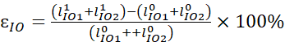, (1)
where $l_{IO1}^{0}$ and $l_{IO1}^{1}$ are lengths of section 1 on the opisthenar of the index finger at extension and flexion respectively. Similarly, the skin elongation of the whole index finger is found by:
$ɛ_{IF}=\frac{（l_{Imcp}^{1}+l_{Ipip}^{1}+l_{Idip}^{1}）-(l_{Imcp}^{0}+l_{Ipip}^{0}+l_{Idip}^{0}）}{(l_{Imcp}^{0}+l_{Ipip}^{0}+l_{Idip}^{0}）}×100\%$.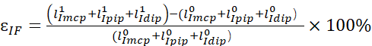 (2)
To evaluate the skin motion at the MCP joint region, the elongation is:
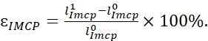 $ɛ_{IMCP}=\frac{l_{Imcp}^{1}-l_{Imcp}^{0}}{l_{Imcp}^{0}}×100\%.$ (3)
The skin elongations of all regions are evaluated in the same way. For the thumb, only the interphalangeal (IP) and MCP joints are considered in evaluating the skin elongation of the whole thumb. The skin on the dorsal hand is divided into 19 local regions, and 5 global regions (Supplementary Fig. S1).
Skin motion test
Participants
30 healthy subjects were recruited to participate in the skin motion measurement tests. Before testing, record the subjects' information as Supplementary Table S1, and all tests used the dominant hand without any wound or disease history. The experimental procedures were approved by the Human Research Ethics Committee of the University of Hong Kong with number EA1903040. We have the informed written consent of the participant.
Protocol
Before testing, the investigator puts labels and scales on the subject’s hands and uses a marker pen to divide joints like Fig. 3A. The labels are distributed along the direction of extensors at finger full extension state. The markers are to measure the skin length of neighbor joints, which are printed on the middle section of each phalange.
During the skin motion test, subjects were asked to try their best to bend their fingers while their hand motions were recorded by a camera (Fig. 3B). Scales put on the hand are metrics to calibrate the imaging system to physical units (mm). Subjects were asked to do specific hand gestures (Figs. 3C-I). Firstly, the skin motion on the opisthenar for four fingers was imaged in Fig. 3C. The surface of the opisthenar relating to the thumb was recorded individually in Fig. 3D. With the palm facing upwards, the skin movement on the thumb back was captured like Fig. 3E. For some fingers, the front finger was adjusted to avoid blocking markers and scale on the tested finger (Figs. 3F-H). The measurement of the ring and little fingers (Figs. 3H, I) were conducted by overturning the hand. For subjects with fingers not flexible, the investigator could help them to adjust hand gestures without influencing skin motions in the tested area (Fig. 3H (II)).
Data analysis
The distances between adjacent markers/labels were measured using the software Image J as Supplementary Fig. S2, and skin elongations were calculated based on equations (1)-(3). Statistical analyses were performed using Statistical Package for the Social Sciences (SPSS) Version 27 (IBM, USA). Firstly, a Shapiro-Wilk test was performed to estimate the normality of data distribution of the 24 hand regions grouped by gender. If the p-value of the S-W test is larger than 0.05, the null hypothesis (H0-the data is not normally distributed) is not rejected, and the independent samples t-test is used to compare differences in skin elongations of all hand regions caused by gender. All tests were two-sided, and statistical significance was determined using p values, with a value of < 0.05 considered statistically significant.
Results
The skin elongation results grouped by gender are presented in Figs. 4. For the whole finger skin motion the skin elongation of the five fingers is plotted in Fig. 4A. The skin elongations (Fig. 4B) on the opisthenar are significantly smaller than the other regions. Similarly, elongations of the skin covering joint regions are presented in Figs. 4C-E. The little finger has a significantly higher average elongation at all joints compared to other fingers. Notably, the skin covering the IP/PIP joint is stretched by an average of 45.0% during finger flexion.
The skin elongations relating to all regions do not show evidence of non-normality, which is proven by the Shapiro-Wilk test (p>0.05) (Supplementary Table S2). Based on this outcome, independent samples t-test is chosen to compare the skin elongation difference of 24 regions caused by gender (Supplementary Table S3). The results showed that there is no significant difference in skin elongations of all regions between male and female groups.
Based on the skin movement measurement results, the following guidelines about robotic glove designs are proposed: 1. There should be holes or stretchable fabric around joints in soft robotic gloves. 2. If stretchable fabric is used, nominal strain values of such fabric at different regions of hand are suggested in Table 1 (average value of skin strain from all subjects). 3. Strains on the opisthenar region are measured along each finger, and recommended strain values are also provided in Table 1. 4. There should be inelastic fabric on the glove corresponding to the phalange and opisthenar regions to anchor actuators stably on hand.
Elastomer-constrained flat tube actuator
Based on the design guidelines above, an elastomer-constrained flat tube actuator (EFTA) is proposed. This actuator design has different strain values when different elastomer material hardness is used. Thus, it is possible to fabricate actuators whose strain values conform to those tabulated in Table 1.
Design of the EFTA
In the EFTA, the flat tube is folded and embedded into a silicone rubber matrix (Fig. 5A). When inflating, the folds inside the silicone rubber will bulge, enabling the extension of the EFTA (Supplementary Movie). When deflating, the EFTA will return to its original position due to the elasticity of silicone rubber. The EFTA is used to drive finger joint rotation as shown in Supplementary Fig. S3.
Materials and Fabrication of the EFTA
The flat tube used in this paper is a polyethylene heat shrink tube with an inner diameter of 8.5mm and a wall thickness of 0.15mm. The elastomer is silicone rubber (Ecoflex-0030, Smooth-on Inc., USA). The fabrication process of the EFTA is depicted in Supplementary Fig. S4.
Characterization of the EFTA
In this research, we have developed a quasistatic model of the EFTA based on the three-dimensional constitutive model of rubber materials.^{44,45} The quasistatic model is inferred in Supplementary Appendix AP1, and Supplementary Fig. S5.
Strain test
During the test, one end of the EFTA was fixed, and another end was connected to a linear guide rail. The experimental platforms used for the strain, dynamic response, and cyclic load tests are the same as shown in Fig. 5B. For the strain test, the air pressure increased from 0 to 120 kPa. For every 10 kPa increment, we measured the length of the EFTA. The strain test was conducted five times, and the average values together with error bars are plotted in Fig. 5C. The EFTA extends with a strain of 62.5% at 120 kPa pressure input.
Actuation force test
For the force test, the air pressure input is increased from 0 up to 150 kPa. For each 10 kPa increment, the actuator force was recorded as in Fig. 5D. The test was conducted five times, and the mean values with error bars are presented in Fig. 5E. When air pressure reaches 150 kPa, the actuator force $F_{EFTA}$ is up to 27.08N.
Dynamic response test
The pressure input is 90 kPa provided by the air tank, and exchange frequencies of the inflating and deflating are controlled using a solenoid valve. The extension of the EFTA was recorded by a laser distance sensor with a sampling frequency of 100 Hz. Actuating the EFTA from its initial state (0 kPa) to the fully extended state 90kPa takes 1.06s (Fig. 5F), and the recovery time is 1.6s. During inflating, the actuator extends rapidly at the beginning and then slows down to a balanced state because of the increasing resistance force of the silicone rubber. During recovery, the actuator contracts dramatically at first and then slows down, which is caused by the diminishing release of air pressure and the attenuation of the elastic force of the silicone rubber structure. The EFTA motion cycles with exchange frequencies of inflation and deflation spanning from 0.25 to 2 Hz were tested to evaluate the dynamical behavior (Supplementary Fig. S6).
Cyclic load test
The inflating/deflating exchange frequency for the cycle test is 0.5Hz, and the cycle was conducted almost 5000 times with 95kPa pressure input. The strain of the FFTA slightly increases with the increase of the cycle time (Fig. 5G). This might be caused by the degradation of the silicone rubber walls. The curves of the EFTA at the first and last three cycle times in the cycle test are singled out and shown in Fig 5. G(I) and (III) respectively. The EFTA strain in the first three cycles is in the range of 2.2%-45.1%, and the strain range changes to 9.7-62.2% in the last three cycles.
Soft robotic gloves based on the EFTA
Design
The skin on the dorsal side of the fingers elongates during finger flexion, while the palm-side skin is compressed simultaneously (Fig. 6A). Based on the design guidelines of robotic gloves proposed in the previous section, an ergonomic strap interface structure imposing few restrictions on skin motion is proposed in Fig. 6B. The strap consists of a low elastic fabric layer providing pliable and comfortable support on the palm side of fingers, and a double-sided Velcro tape for quick wear.
To investigate the influence of the human-robot interface, two robotic gloves based on the EFTA are built and evaluated. One is based on the strap interface, named the glove version a in Fig. 6C(I). The other one is based on the commonly used fabric glove interface (glove version b in Fig. 6C(II)). The actuators used in glove version a are the same as version b for each finger. In glove version a, the bottom of the EFTA is stretchable with strain values roughly in line with the proposed design guidelines. The actual strain values of each EFTA in glove version a at 90kPa are shown in Table 2. Meanwhile, in glove version b, EFTAs are attached to inextensible Velcro tapes. For the index, middle, and ring fingers, the design parameters of actuators for the three fingers are the same (Supplementary Table S5). For the little finger, the length of each EFTA unit is smaller than that of the index finger by 4mm, and the EFTA for each joint has one less fold to accommodate the size of the little finger. For the thumb, the EFTA parameters are the same as those of the index finger without the DIP joint. Four sizes (small, medium, large, and extra-large) of fabric gloves are designed to provide a base for modular quick disassembly and assembly achieved by Velcro tapes. The inflating and deflating of both robotic gloves are controlled by a control box with a weight of 650g (Supplementary Fig. S7).
When input air pressure is 90 kPa and the user keeps the hand in a relaxed state, glove version a can completely clench the user's hand, but glove version b only bends the finger almost 80 degrees (Supplementary Movie). A further comparison between proposed robotic gloves and classic soft robotic gloves from previous research is also shown in Supplementary Table S4. The proposed EFTA-driven glove version a can provide a comparable motion range and gripping force at a much smaller input air pressure.
Performance comparison of soft robotic gloves
10 subjects were invited to do the ROM test and grip force test using two robotic gloves. After experimenting with the two robotic gloves, they were asked to fill out a questionnaire. The questionnaire evaluates subjective assessment on five points: motion assistance, strength assistance, comfort level, motion obstruction, and safety level, which are marked as Q1-Q5 respectively. The higher score the robotic glove gets, the better assessment the subjects give. To avoid errors caused by the sequence of robotic glove use, half of the participants did glove performance tests using the glove version a first, and the other half were tested in the reverse sequence.
Grip force test
During the grip force test, participants were required to relax their dominant hands and put their hands flat on the table wearing robotic gloves (Figs. 7A, B). Then, the subjects kept relaxing, and the investigator activated robotic gloves to continuously grip the hand dynamometer (Vernier, USA) three times (Fig. 7C). Grip forces using the two gloves were tested. As shown in Fig. 7D, the average grip force of overall subjects for glove version b is only 1.8$±$0.4 N. Meanwhile, the average grip force of glove version a is up to 7.74 N, which is 4.3 times the gripping force of glove version b.
ROM test
To evaluate the range of motion (ROM) assisted by robotic gloves, a ROM meter is designed in this research (Fig. 8A). Compared with other ROM estimation methods (like using goniometer,⁴⁶ electromagnetic tracking system,¹¹ and image processing¹⁷), the ROM meter is more convenient, available, and intuitionistic, without fussy marker/sensor preprocess and complex image/signal postprocessing. Before activating robotic gloves, subjects placed the dominant hands flat on the table and extended their fingers, and then adjusted the ROM meter to the proper position and zeroized it (Fig. 8B (I)). Then subjects were asked to relax their hand, and robotic gloves were activated to squeeze the ROM meter. The test results of the ROM can be read directly through the electronic screen (Fig. 8B (II)). Each glove was tested three times to alleviate errors.
The ROM of each subject and the average value of all subjects using two gloves are illustrated in Fig. 8C. Although the ROM meter has resistance due to the return spring and the friction of the linear guide rod, some subjects (e.g., M15) were able to reach the maximum range with the help of glove version a. The average ROMs of overall participants for glove versions a and b are 57.86$±$11.44 mm and 23.64$±$6.69 mm respectively. Compared to the conventional fabric glove interface, the strap interface increases the ROM by almost 2.5 times.
Subjective evaluation and comparison of soft robotic gloves
After the ROM test and grip force test, participants wearing gloves moved their hands to feel the obstruction of the gloves. Finally, they were asked to fill out a questionnaire (Supplementary Table S6). Figure 9 shows the questionnaire results about the average scores of each question and the overall average scores of the five questions. In each of the questions, the scores of glove version a are distinctly larger than glove version b. The overall average scores for glove versions a and b are 4.34$±$0.84 and 3.08$±$1.13, respectively. Notably, for Q3 and Q4, glove version a scores average 3.8 and 4.2 points respectively which are far larger than glove version b (2.8 and 2.5 points). This shows that the ergonomic strap interface is more comfortable and dexterous compared with the conventional fabric glove interface.
During the characterization of the soft robotic gloves, most participants feel the robotic glove version a is more comfortable than glove version b. However, for a special case, YFM 14, she feels the robotic glove version b is more comfortable than version a. The reason is that the strap size and the distance between EFTAs are not adjustable. So, for this case, the size of glove version a is not suitable for her hand size. Even with the mismatch of glove size, in the ROM tests and gripping force tests, glove version a still shows better performance compared with glove version b.
Discussion and conclusion
Skin motion is a commonly neglected factor in wearable robot design, and there is no quantitative study on skin elongation and its effect on robotic performance in previous research. In this work, we proposed a measurement strategy for skin movement using vision, and 30 subjects were invited to conduct this test. Based on the data acquired from the skin motion test, we proposed design guidelines for robotic gloves, and suggested nominal strain values for different glove regions. To design a soft robotic glove with few restrictions to skin deformation during hand motions, an elastomer-constrained flat tube actuator (EFTA) was developed. Based on the EFTA and design guidelines, we fabricated a robotic glove version a with an ergonomic strap interface that does not hinder skin motion at all, and a robotic glove version b with a traditional fabric glove that is almost inextensible along finger directions to study the influence of hindering skin motions on robotic glove performance. The soft robotic glove version a presents significantly better mechanical performance and comfort level than the conventional fabric glove interface. The main users of soft robotic gloves are the elderly who have impotent hand functions, and their hands are more fragile and sensitive than young people. The robotic glove version a abided by the proposed design guideline solved the pain point of the inflexible human-robot interface, and reduced discomfort to the user.
This is still an early study. Some limitations and further developments are summarized as: 1. Optimized selection of elastomer material and its optimum structural design. This allows better actuator durability and conformance of strain values to the recommended values. 2. In this study, we only tested two extreme designs: one with free skin motion (version a) and the other is constrained skin motion by inextensible fabric (version b), there might be other possibilities for robotic glove design. 3. Strain values of actuators do not fully conform to the recommended values because only a single elastomer material was used to make prototype actuators. To better follow the recommended strain values, different elastomer materials should be used to fabricate actuators for different finger joints. 4. The methodology of hand skin motion and its effect studies can be further extended to knee joint, elbow, wrist, ankle, and shoulder robots where large skin movements are observed. 5. The subjects invited for skin motion tests are all Chinese. There may be differences in skin elongation for people from other races.

Disclosure statements
No competing financial interests exist.
Funding information
The work described in this paper was fully supported by a grant from the Research Grants Council of the Hong Kong Special Administrative Region, China (Project no. [T42-717/20-R]).
Data sharing statement
The authors declare that the data supporting the findings of this study are available within the paper and its supplementary information files or from the corresponding authors upon reasonable request.
Author contributions
Y.C. and H.L. conceived the ideas and designed the research. H.L. conducted the experimental works and analyzed data. H.L. designed and fabricated the experimental platform and robotic glove prototypes. H.L., C.W., and S.L. contributed to modeling and performed the MATLAB simulation. H.L. and Y.C. wrote the manuscript. Y.C., N.X., V.W.L., Y.H and K.L.O. commented on measurements. All authors discussed the results and contributed to the final manuscript.

Supplementary Materials

Supplementary Appendix SA1

Supplementary Figures S1-S7

Supplementary Tables S1-S6

Supplementary Movie

References and Notes
- Muellbacher W, Richards C, Ziemann U, et al. Improving hand function in chronic stroke. Arch Neurol 2002;59(8):1278-1282.
- Krigger KW. Cerebral palsy: an overview. Am Fam Physician 2006;73(1):91-100.
- GBD 2016 Lifetime Risk of Stroke Collaborators. Global, regional, and country-specific lifetime risks of stroke, 1990 and 2016. N Engl J Med 2018;379(25):2429-2437.
- Snoek GJ, IJzerman MJ, Hermens HJ, et al. Survey of the needs of patients with spinal cord injury: impact and priority for improvement in hand function in tetraplegics. Spinal cord 2004;42(9):526-532.
- Sayer AA, Syddall H, Martin H, et al. The developmental origins of sarcopenia. J Nutr Health Aging 2008;12:427-432.
- Cianchetti M, Laschi C, Menciassi A, et al. Biomedical applications of soft robotics. Nat Rev Mater 2018;3(6):143-153.
- Tong RKY,(ed). Wearable Technology in Medicine and Health Care. Elsevier Academic: London, UK; 2018.
- Thalman C, Artemiadis P. A review of soft wearable robots that provide active assistance: Trends, common actuation methods, fabrication, and applications. Wearable Technol 2020;1:e3.
- Awad LN, Bae J, O’donnell K, et al. A soft robotic exosuit improves walking in patients after stroke. Sci Transl Med 2017;9(400):eaai9084.
- O'Neill CT, McCann CM, Hohimer CJ, et al. Unfolding textile-based pneumatic actuators for wearable applications. Soft Robot 2022, 9(1), 163-172.
- Polygerinos P, Wang Z, Galloway KC, et al. Soft robotic glove for combined assistance and at-home rehabilitation. Robot Auton Syst 2015;73:135-143.
- Skidmore J, Artemiadis P. Unilateral floor stiffness perturbations systematically evoke contralateral leg muscle responses: a new approach to robot-assisted gait therapy. IEEE Trans Neural Syst Rehabilitation Eng 2015;24(4):467-474.
- Walker S, Firouzeh A, Robertson M, et al. 3D Printed Motor-Sensory Module Prototype for Facial Rehabilitation. Soft Robot 2022;9(2):354-363.
- Park YL, Chen BR, Pérez-Arancibia NO, et al. Design and control of a bio-inspired soft wearable robotic device for ankle–foot rehabilitation. Bioinspir Biomim 2014;9(1):016007.
- Rus D, Tolley MT. Design, fabrication and control of soft robots. Nature 2015;521(7553):467-475.
- Yap HK, Khin PM, Koh TH, et al. A fully fabric-based bidirectional soft robotic glove for assistance and rehabilitation of hand impaired patients. IEEE Robot Autom Lett 2017;2(3):1383-1390.
- Heung KH, Tong RK, Lau AT, et al. Robotic glove with soft-elastic composite actuators for assisting activities of daily living. Soft robot 2019;6(2):289-304.
- Al-Fahaam H, Davis S, Nefti-Meziani S. The design and mathematical modelling of novel extensor bending pneumatic artificial muscles (EBPAMs) for soft exoskeletons. Robot Auton Syst 2018;99:63-74.
- Connolly F, Wagner DA, Walsh C J. Sew-free anisotropic textile composites for rapid design and manufacturing of soft wearable robots. Extreme Mech Lett 2019;27:52-58.
- Yun SS, Kang BB, Cho KJ. Exo-glove PM: An easily customizable modularized pneumatic assistive glove. IEEE Robot Autom Lett 2017;2(3):1725-1732.
- Rosen J, Ferguson PW, (eds). Wearable Robotics: Systems and Applications. Elsevier Academic: London, UK; 2020.
- Heo P, Gu GM, Lee SJ, et al. Current hand exoskeleton technologies for rehabilitation and assistive engineering. Int J Precis Eng Manuf 2012;13:807-824.
- Zhou MA, Ben-Tzvi P. RML glove—An exoskeleton glove mechanism with haptics feedback. IEEE/ASME Trans Mechatron 2014;20(2):641-652.
- Sandoval-Gonzalez O, Jacinto-Villegas J, Herrera-Aguilar I, et al. Design and development of a hand exoskeleton robot for active and passive rehabilitation. Int J Adv Robot Syst 2016;13(2):66.
- In H, Kang BB, Sin M, et al. Exo-glove: A wearable robot for the hand with a soft tendon routing system. IEEE Robot Autom Mag 2015;22(1):97-105.
- Gerez L, Chen J, Liarokapis M. On the development of adaptive, tendon-driven, wearable exo-gloves for grasping capabilities enhancement. IEEE Robot Autom Lett 2019;4(2):422-429.
- Liu H, Wu C, Lin S, et al. Finger flexion and extension driven by a single motor in Robotic Glove Design. Adv Intell Syst 2023;5:2200274.
- Kim DH, Lee Y, Park HS. Bioinspired high-degrees of freedom soft robotic glove for restoring versatile and comfortable manipulation. Soft Robot 2022; 9(4): 734-744.
- Li Y, Chen Y, Ren T, et al. A dual-mode actuator for soft robotic hand. IEEE Robot Autom Lett 2021;6(2):1144-1151.
- Ge L, Chen F, Wang D, et al. Design, modeling, and evaluation of fabric-based pneumatic actuators for soft wearable assistive gloves. Soft robot 2020;7(5):583-596.
- Cappello L, Galloway KC, Sanan S, et al. Exploiting textile mechanical anisotropy for fabric-based pneumatic actuators. Soft robot 2018;5(5):662-674.
- Guo N, Sun Z, Wang X, et al. Simulation analysis for optimal design of pneumatic bellow actuators for soft-robotic glove. Biocybern Biomed Eng 2020;40(4):1359-1368.
- Zhao H, Jalving J, Huang R, et al. A helping hand: Soft orthosis with integrated optical strain sensors and EMG control. IEEE Robot Autom Mag 2016;23(3):55-64.
- Zhao H, Li Y, Elsamadisi A, et al. Scalable manufacturing of high force wearable soft actuators. Extreme Mech Lett 2015;3:89-104.
- Moseley P, Florez JM, Sonar HA, et al. Modeling, design, and development of soft pneumatic actuators with finite element method. Adv Eng Mater 2016;18(6):978-988.
- Feng M, Yang D, Gu G. High-force fabric-based pneumatic actuators with asymmetric chambers and interference-reinforced structure for soft wearable assistive gloves. IEEE Robot Autom Lett 2021;6(2):3105-3111.
- Kang BB, Choi H, Lee H, et al. Exo-glove poly II: A polymer-based soft wearable robot for the hand with a tendon-driven actuation system. Soft robot 2019;6(2):214-227.
- Kalra A, Lowe A, Al-Jumaily AM. Mechanical behaviour of skin: a review. J Mater Sci Eng 2016;5(4):1000254.
- Nagano K, Fyffe G, Alexander O, et al. Skin microstructure deformation with displacement map convolution. ACM Trans Graph 2015;34(4):109-1.
- Nasir SH, Troynikov O. Influence of hand movement on skin deformation: A therapeutic glove design perspective. Appl Ergon 2014;60:154-162.
- Lee W, Yang X, Yoon S, et al. Comparison of a semiautomatic protocol using plastering and three-dimensional scanning techniques with the direct measurement protocol for hand anthropometry. Hum Factors Ergon Manuf Serv Ind 2017;27(3):138-146.
- Hahn P, Krimmer H, Hradetzky A, et al. Quantitative analysis of the linkage between the interphalangeal joints of the index finger: An in vivo study. J Hand Surg 1995;20(5):696-699.
- Bain GI, Polites N, Higgs BG, et al. The functional range of motion of the finger joints. J Hand Surg Eur Vol 2014;40(4):406-411.
- Arruda EM, Boyce MC. A three-dimensional constitutive model for the large stretch behavior of rubber elastic materials. J Mech Phys Solids 1993;41(2):389-412.
- Polygerinos P, Wang Z, Overvelde JT, et al. Modeling of soft fiber-reinforced bending actuators. IEEE Trans Robot 2015;31(3):778-789.
- Correia C, Nuckols K, Wagner D, et al. Improving grasp function after spinal cord injury with a soft robotic glove. IEEE Trans. Neural Syst Rehabil Eng 2020;28(6):1407-1415.
- Kang BB, Lee H, In H, et al. Development of a polymer-based tendon-driven wearable robotic hand. In: Proc. IEEE Int. Conf. Robot. Autom (ICRA); 2016; pp. 3750-3755.
- Polygerinos P, Galloway KC, Sanan S, et al. EMG controlled soft robotic glove for assistance during activities of daily living. In: Proc. IEEE Int. Conf. Rehabil. Robot.(ICORR); 2015; pp. 55-60.

FIG.1. Schematic of skin motion on the hand and the division of four regions: the opisthenar, the MCP joint, the IP/PIP joint, and the DIP joint.

FIG.2. Characterization of the skin motion on finger back and the opisthenar. (A) Markers, labels, and scales pasted on the hand back. (B) Skin motion on fingers is characterized using a line motion on the boundary in the side view. Figure (I) shows labels and scales when the finger fully extends, and figure (II) presents the complete finger flexion state.

FIG.3. Skin motion test setup and protocol. (A) Markers, labels, and scales placement on hand. (B) Experiment setup of skin motion measurement. Subjects sit at a table and place their hands under a camera for imaging different hand gestures. (C) Imaging the dorsal hand along with four fingers (except for the thumb). (D) Imaging the dorsal hand along the thumb. (E) Imaging the thumb. (F) Imaging the index finger. (G) Imaging the middle finger, and (H) Imaging the ring fingers. (I) Imaging the little finger.

FIG.4. Skin elongation of finger back and the opisthenar during full finger flexion. (A-B) Elongation of skin on the whole finger and the opisthenar respectively. (C-E) Elongation of skin covering the MCP, IP/PIP, and DIP joints respectively. The skin on the thumb back is divided into two regions without the DIP joints.
FIG.5. Design and characterization of the EFTA. (A) Schematic design of the EFTA. The structure of the EFTA consists of a folded flat tube and a silicone rubber matrix. (B) Experimental platform of the strain test, response test, and cyclic load test. One end of the EFTA is fixed, and the other end connected to a linear guide rail. (C) Strain against input air pressure, results from testing and modeling. (D) Experimental platform of the actuator force test. The original position calibration of the force gauge is adjusted by a linear sliding table before the actuator force test. (E)Actuator force against input air pressure, results from testing and modeling. (F) Response time test result. (G) Cyclic load test results. (II) and (III) present the enlarged view of motion cycles at the first and last three cycles respectively.

FIG.6. Design of soft robotic gloves. (A) Skin motions on the finger during finger flexion. (B) Ergonomic strap interface. (C)Two soft robotic gloves. (I) the robotic glove version a with the strap interface, and (II) the robotic glove version b with the conventional fabric glove interface.

FIG.7. Grip force test. (A) Experiment setup of the grip force test. The subject sits on the stool and grasps the hand dynamometer with glove actuation. (B) Hand grip force test. The subject grips on a force bar actuated by the robotic glove. (C)Comparison of the grip forces provided by robotic glove versions a and b. (D) Grip force test result.
FIG.8. ROM test. (A) Design of the ROM meter. (B) Illustration of the ROM test for hand actuated by a robotic glove. (C) ROM test results.

FIG.9. Subjective comparison of user experience using the two robotic gloves. Q1-5 refers to questions about motion assistance, hand strength assistance, comfort level, degree of obstruction, and safety level respectively.

Supplementary Information for the manuscript
From skin movement to wearable robotics: the case of robotic gloves

Authors:
Hao Liu¹, Changchun Wu¹, Senyuan Lin¹, Ning Xi², Vivian W. Q. Lou ³, Yong Hu⁴, Calvin K. L. Or² and Yonghua Chen^{1,} *
Affiliations:
¹Department of Mechanical Engineering, University of Hong Kong, Hong Kong.
²Department of Industrial and Manufacturing Systems Engineering, University of Hong Kong, Hong Kong.
³Department of Social Work and Social Administration; Sau Po Centre on Ageing, University of Hong Kong, Hong Kong.
⁴Department of Orthopaedics and Traumatology, University of Hong Kong, Hong Kong.

*Corresponding author Email: yhchen@hku.hk

Supplementary appendix SA1: Quasistatic model of the EFTA
A quasistatic model was developed that infers the explicit relationship between input pressure, strain, and output force by taking into consideration both the hyperelastic material property of silicone rubber and the geometry of the actuator.
Actuator force model
When one end of the EFTA is fixed and another end connects a fixed force gauge, the actuator force can be calculated by:
$F_{EFTA}=Pwl_{0}sinθ$, (4)
where $w$, $l_{0}$, and $θ$ are the width, length, and dip angle of the flat tube for each folded chamber, and P is the input pressure. In the EFTA experimental characterization, $w$, $l_{0}$, and $sinθ$ are 13.6 mm, 17mm, and 0.9955, respectively, measured from the physical EFTA. The actuator forces based on equation (4) are plotted in Fig. 5D for comparison with experimental values.
Strain model
The schematic of the strain model is provided in Supplementary Fig. S4. The EFTA can be separated into six silicone rubber walls, a flat tube with a corrugated structure, and silicone rubber interference structures. The silicone rubber interference structures can enhance the interaction of each folded unit. ³⁵ When the thrust force generated by air pressure equals the elastic resistance generated by the elastomer matrix, the EFTA reaches a force balance, $F_{EFTA}=F_{e}$. In the EFTA, only four walls provide elastic resistance, and the walls in front and back do not contribute to the force balance. The silicone elastomer was modeled as an incompressible Neo-Hookean material, which may be expressed as $λ_{1}λ_{2}λ_{3}$=1. Meanwhile, the strain energy $W$ of the silicone elastomer can be calculated by:
$W=\frac{μ}{2}(I_{1}-3)$, (5)
where μ is the initial shear modulus of the silicone rubber matrix, $I_{1}$ is the first invariant of the three principal stretch ratios$λ_{1}$ $λ_{2}$ and $λ_{3}$ (x, y, and z directions in fig. S5), ^{43,44} respectively.
$I_{1}=λ_{1}^{2}+λ_{2}^{2}+λ_{3}^{2}$ (6)
The principal nominal stresses$s_{i}$ could be presented by:
$s_{i}=\frac{∂W}{∂λ_{i}}-\frac{p}{λ_{i}}$, (7)
where $p$ is the Lagrange multiplier. For walls $α/α^{'}$ parallel to the x-z plane, the contraction of the wall in y direction is ignored due to the small deformation in the wall thickness: $λ_{yα}=1, λ_{xα}λ_{yα}λ_{zα}$=1, $λ_{xα}=λ_{α}$, $λ_{zα}=\frac{1}{λ_{α}}$.
$s_{xα}=s_{xα}^{'}=\frac{∂W}{∂λ_{xα}}-\frac{p}{λ_{xα}}$=$\overline{μ}$($λ_{α}$-$\frac{1}{λ_{α}^{3}}$) (8)
Similarly, the relationship between principal nominal stresses$s_{xβ}$ and principal stretch ratios$λ_{β}$ of walls $β/β^{'}$ is: $s_{xβ}=s_{xβ}^{'}=\overline{μ}$($λ_{β}$-$\frac{1}{λ_{β}^{3}}$), and $λ_{β}=λ_{α}=λ_{x}$. The elastic resistances of the four walls are:
$F_{e}=2s_{x}(l_{y}t_{z}+l_{z}t_{y})$, (9)
where wall thickness $t_{z}=t_{y}=1mm$ and$\overline{μ}=0.314 MPa$(ecoflex-0030 silicone, Smooth-on Inc., USA) in this study (45). The size of the elastomer matrix cuboid used in the modeling and experimental characterization is $26mm×16mm×19mm$ ($l_{x}×l_{y}×l_{z}$) as Supplementary Fig. S4. And the stretch ratios can be calculated by:
$2\overline{μ}\left(λ_{x}-\frac{1}{λ_{x}^{3}}\right)(l_{y}t_{z}+l_{z}t_{y})=Pwl_{0}Sinθ$ (10)
The theoretical values of the strain modeling were calculated by MATLAB (MathWorks, USA) and plotted in Fig. 5C for comparison with experimental values.
For the strain model, it can be seen that experimental results are largely in line with the theoretical modeling value. For the actuator force model, the basic trend of the experimental result and theoretical value is the same. A major factor for the increasing discrepancy might be due to the change of interference between the flat tube folds and the silicone encapsulate materials when the EFTA actuator is expanding. Meanwhile, when air pressure is increased beyond 100kPa, slight buckling of the EFTA actuator is observed which may further distort the actuator force and air pressure curve. This model can be used to predict the strain of the EFTA under different design parameters and pressure inputs, which provides a guideline for designing robots using EFTA.

Supplementary Figures
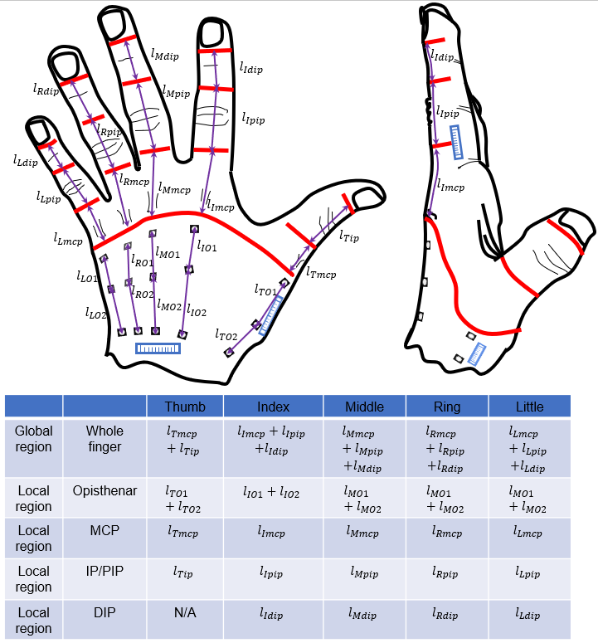
Supplementary Figure 1. Twenty-four regions measured on the opisthenar and dorsal fingers.
To characterize the skin motion, the skin on five dorsal fingers is divided into 14 local regions based on the finger joints, and the skin on the opisthenar is separated into 5 local regions along the finger directions. The whole part from the fingertip to the edge of the MCP joint of each finger is defined as a global region (altogether 5 global regions). They are measured for reflecting the global skin elongation of each finger.

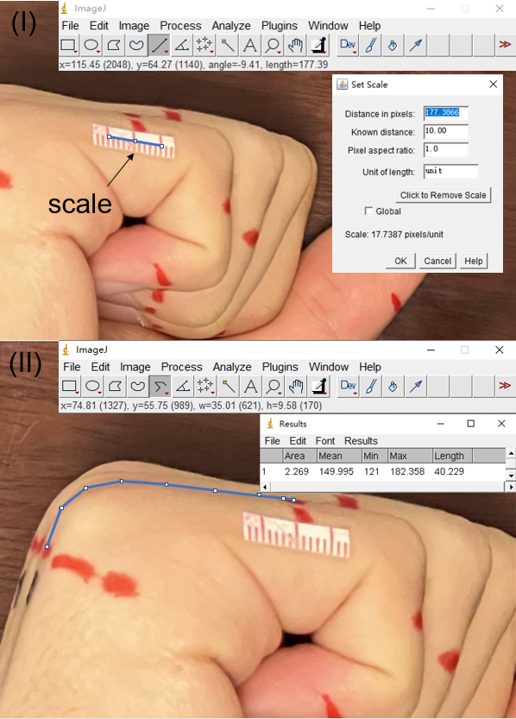
Supplementary Figure 2. Image processing for the skin motion measurement based on the Image J software.
For each picture, the physical size of pixels is calibrated to a known metric (mm) referred to as the scale (I). After calibration, the length of the skin outline can be measured directly using the segmented line tool (II).
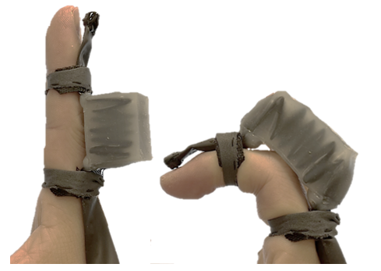
Supplementary Figure 3. Joint rotation driven by the EFTA. The EFTA bends passively to adapt to the finger joint rotation.
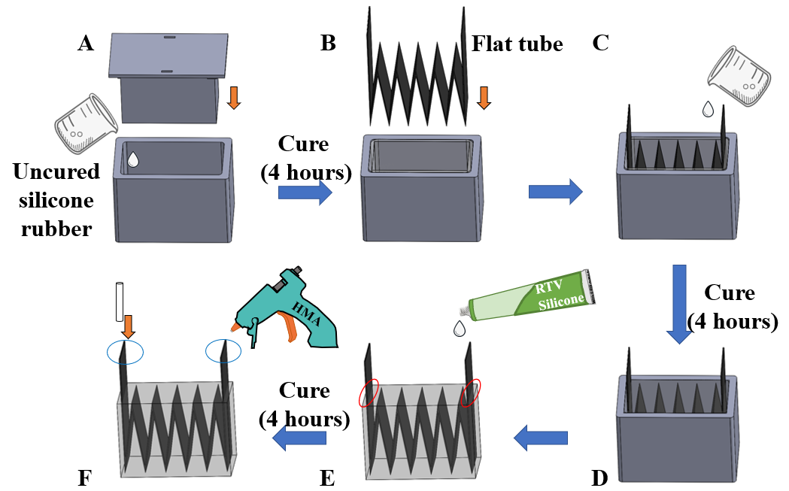
Supplementary Figure 4. Fabrication process of the EFTA actuator
(A) Molding silicone rubber layers with the same thickness. (B) Inserting a fishing line into the flat tube to ensure smooth air flow and inserting the folded flat tube into the mold. (C) Molding the EFTA. (D) Waiting for curing. (E) Gluing flat tube and silicone rubber together using silicone sealant (799 one component RTV silicone, KUPA industrial Ltd., HK). (F) Plugging the air tube into one end of the EFTA, and seal both ends using hot melt adhesive.
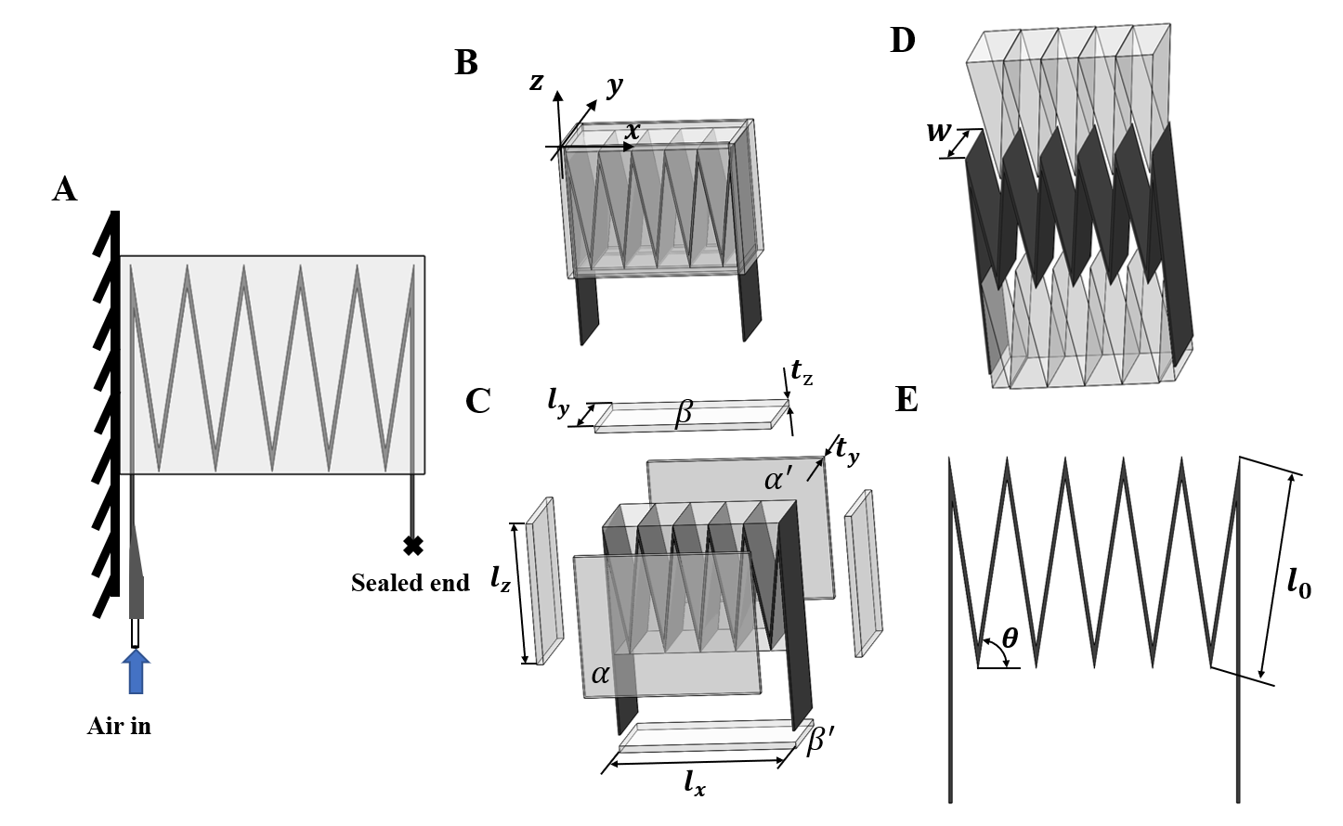
Supplementary Figure 5. Quasistatic model of the EFTA actuator.
(A) Side view of the EFTA at initial state. One end of the EFTA is fixed on a wall, and another end move freely. (B) Coordinate system of the model. x-axis and y-axis are parallel to the length side and width side of the cuboid elastomer matrix respectively. (C) Six walls (rubber layers) of the silicone cuboid structure. Four walls ($α,α^{'},β,β^{'}$) generates resilient force during extension. (D) Triangular prism silicone rubber interference structure. In modeling, assuming the Triangular prism silicone rubber interference structure connects each fold and do not deform. (E) Side view of the corrugated structure (fold) of the flat tube. The flat tube is evenly folded and distributed.

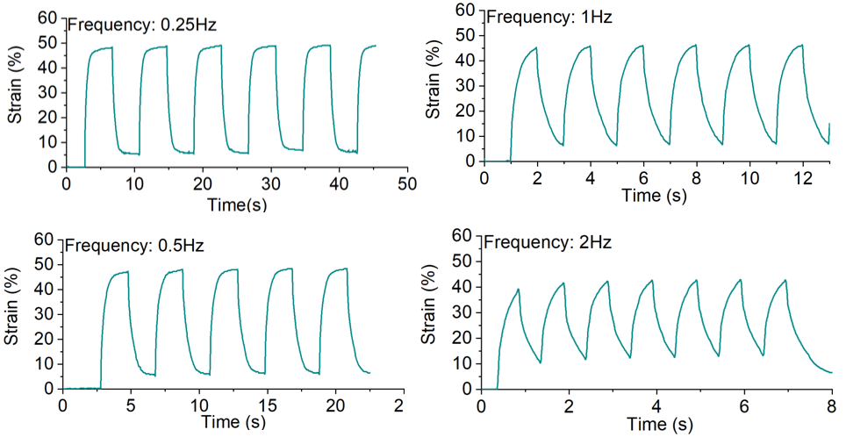
Supplementary Figure 6. Dynamic response of the EFTA in various inflating/releasing frequencies. Responses to inflating and releasing with frequencies spanning from 0.25 Hz to 2 Hz for a sample EFTA.

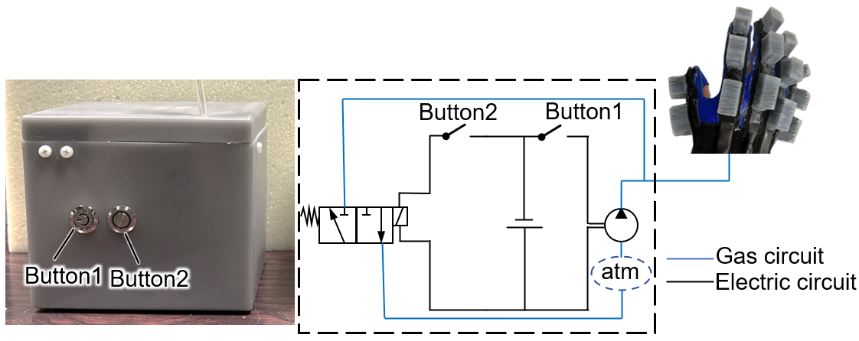
Supplementary Figure 7. Control box of soft robotic gloves. The control box consists of a mini pump (90 kPa pressure output), battery, solenoid valve, buttons, and 3D-printed box made of Tough1500 Resin materials (Formlabs, USA), and the actuator inflation and deflation are controlled by two buttons.

Supplementary Tables

Supplementary Table 1. Subject information.

Subject_ID | Gender | Age | Dominant hand | Height (cm) | Weight (kg) | BMI (kg/m²)
M1 | Male | 22 | R | 178 | 77.1 | 24.3
M2* | Male | 22 | R | 173 | 55 | 18
M3 | Male | 22 | R | 172 | 71 | 24.7
M4* | Male | 22 | R | 174 | 62 | 20.6
M5 | Male | 24 | R | 184 | 82.7 | 24.4
M6 | Male | 24 | L | 183 | 82.6 | 24.7
M7 | Male | 24 | R | 175.5 | 77.9 | 25.3
M8* | Male | 25 | R | 177.5 | 94.5 | 30
M9* | Male | 25 | R | 171.5 | 78.5 | 26.7
M10 | Male | 23 | R | 176.5 | 74.4 | 23.9
M11 | Male | 21 | R | 181 | 119.4 | 36.4
M12 | Male | 23 | R | 177 | 809 | 25.8
M13 | Male | 22 | R | 182 | 95.1 | 28.7
M14 | Male | 20 | R | 183 | 77.5 | 23.1
M15* | Male | 28 | R | 172 | 59.2 | 20
FM1 | Female | 31 | R | 156 | 53 | 21.8
FM2 | Female | 24 | R | 165 | 65.6 | 24.1
FM3 | Female | 30 | R | 158 | 56.6 | 22.7
FM4 | Female | 31 | R | 163 | 48.2 | 18.1
FM5 | Female | 22 | R | 167 | 68.9 | 24.7
FM6* | Female | 24 | R | 165 | 57.2 | 21
FM7* | Female | 23 | R | 162 | 51.3 | 18.8
FM8* | Female | 23 | R | 158 | 46.4 | 18.6
FM9 | Female | 20 | R | 154 | 42.8 | 18
FM10 | Female | 20 | R | 154 | 45.4 | 19.1
FM11 | Female | 23 | R | 156 | 51.6 | 21.2
FM12 | Female | 23 | R | 156 | 43.1 | 17.7
FM13 | Female | 28 | R | 162 | 55.4 | 21.1
FM14* | Female | 24 | R | 160 | 52.3 | 20.4
FM15* | Female | 22 | R | 162 | 63.2 | 24.1
All participants had no wound or disease history to the measured hands.
Subjects with a * mark mean that they participated in the soft robotic gloves test.

Supplementary Table 2. Normality test of the skin elongation on the 24 hand regions grouped by gender.

 | Gender | Measured fingers | Shapiro-Wilk test
 | Gender | Measured fingers | Statistic | df | p-value
Skin elongation of whole fingers | Male | Thumb | 0.939 | 15 | 0.376 > 0.05
Skin elongation of whole fingers | Male | Index | 0.967 | 15 | 0.804 > 0.05
Skin elongation of whole fingers | Male | Middle | 0.945 | 15 | 0.454 > 0.05
Skin elongation of whole fingers | Male | Ring | 0.973 | 15 | 0.902 > 0.05
Skin elongation of whole fingers | Male | Little | 0.923 | 15 | 0.215 > 0.05
Skin elongation of whole fingers | Female | Thumb | 0.902 | 15 | 0.103 > 0.05
Skin elongation of whole fingers | Female | Index | 0.908 | 15 | 0.128 > 0.05
Skin elongation of whole fingers | Female | Middle | 0.919 | 15 | 0.187 > 0.05
Skin elongation of whole fingers | Female | Ring | 0.924 | 15 | 0.223 > 0.05
Skin elongation of whole fingers | Female | Little | 0.970 | 15 | 0.865 > 0.05
Skin elongation of opisthenar regions | Male | Thumb | 0.896 | 15 | 0.082 > 0.05
Skin elongation of opisthenar regions | Male | Index | 0.892 | 15 | 0.071 > 0.05
Skin elongation of opisthenar regions | Male | Middle | 0.965 | 15 | 0.787 > 0.05
Skin elongation of opisthenar regions | Male | Ring | 0.922 | 15 | 0.210 > 0.05
Skin elongation of opisthenar regions | Male | Little | 0.906 | 15 | 0.119 > 0.05
Skin elongation of opisthenar regions | Female | Thumb | 0.923 | 15 | 0.217 > 0.05
Skin elongation of opisthenar regions | Female | Index | 0.909 | 15 | 0.129 > 0.05
Skin elongation of opisthenar regions | Female | Middle | 0.924 | 15 | 0.225 > 0.05
Skin elongation of opisthenar regions | Female | Ring | 0.962 | 15 | 0.719 > 0.05
Skin elongation of opisthenar regions | Female | Little | 0.920 | 15 | 0.192 > 0.05
Skin elongation of MCP joints | Male | Thumb | 0.935 | 15 | 0.324 > 0.05
Skin elongation of MCP joints | Male | Index | 0.898 | 15 | 0.088 > 0.05
Skin elongation of MCP joints | Male | Middle | 0.887 | 15 | 0.061 > 0.05
Skin elongation of MCP joints | Male | Ring | 0.898 | 15 | 0.088 > 0.05
Skin elongation of MCP joints | Male | Little | 0.896 | 15 | 0.084 > 0.05
Skin elongation of MCP joints | Female | Thumb | 0.964 | 15 | 0.754 > 0.05
Skin elongation of MCP joints | Female | Index | 0.958 | 15 | 0.663 > 0.05
Skin elongation of MCP joints | Female | Middle | 0.927 | 15 | 0.242 > 0.05
Skin elongation of MCP joints | Female | Ring | 0.959 | 15 | 0.672 > 0.05
Skin elongation of MCP joints | Female | Little | 0.953 | 15 | 0.565 > 0.05
Skin elongation of IP/PIP joints | Male | Thumb | 0.959 | 15 | 0.676 > 0.05
Skin elongation of IP/PIP joints | Male | Index | 0.963 | 15 | 0.740 > 0.05
Skin elongation of IP/PIP joints | Male | Middle | 0.941 | 15 | 0.397 > 0.05
Skin elongation of IP/PIP joints | Male | Ring | 0.969 | 15 | 0.837 > 0.05
Skin elongation of IP/PIP joints | Male | Little | 0.964 | 15 | 0.760 > 0.05
Skin elongation of IP/PIP joints | Female | Thumb | 0.892 | 15 | 0.071 > 0.05
Skin elongation of IP/PIP joints | Female | Index | 0.966 | 15 | 0.787 > 0.05
Skin elongation of IP/PIP joints | Female | Middle | 0.938 | 15 | 0.353 > 0.05
Skin elongation of IP/PIP joints | Female | Ring | 0.986 | 15 | 0.996 > 0.05
Skin elongation of IP/PIP joints | Female | Little | 0.970 | 15 | 0.854 > 0.05
Skin elongation of DIP joints | Male | Index | 0.943 | 15 | 0.420 > 0.05
Skin elongation of DIP joints | Male | Middle | 0.954 | 15 | 0.586 > 0.05
Skin elongation of DIP joints | Male | Ring | 0.919 | 15 | 0.185 > 0.05
Skin elongation of DIP joints | Male | Little | 0.907 | 15 | 0.123 > 0.05
Skin elongation of DIP joints | Female | Index | 0.966 | 15 | 0.787 > 0.05
Skin elongation of DIP joints | Female | Middle | 0.935 | 15 | 0.319 > 0.05
Skin elongation of DIP joints | Female | Ring | 0.963 | 15 | 0.738 > 0.05
Skin elongation of DIP joints | Female | Little | 0.980 | 15 | 0.968 > 0.05

Supplementary Table 3. t-test results comparing males and females on the skin elongation on the 24 hand regions.
 |  | Levene's Test for Equality of Variances |  | t-test
 |  | F | Sig. | t-value | df | Sig. (2-tailed)
Opisthenar | Thumb | <0.01 | 0.96 | -0.05 | 28.00 | 0.96
Opisthenar | Index* | 5.70 | 0.02<0.05 | 2.03 | 20.16 | 0.06
Opisthenar | Middle | 0.11 | 0.75 | 1.94 | 28.00 | 0.06
Opisthenar | Ring | 0.02 | 0.89 | 1.23 | 28.00 | 0.23
Opisthenar | Little | 0.42 | 0.52 | 0.63 | 28.00 | 0.53
Whole finger | Thumb | 0.67 | 0.42 | 1.57 | 28.00 | 0.13
Whole finger | Index | 0.01 | 0.92 | -1.67 | 28.00 | 0.11
Whole finger | Middle | 1.98 | 0.17 | 1.41 | 28.00 | 0.17
Whole finger | Ring | 0.02 | 0.89 | 0.07 | 28.00 | 0.94
Whole finger | Little | 0.07 | 0.79 | -1.46 | 28.00 | 0.16
MCP | Thumb | 1.14 | 0.29 | 0.25 | 28 | 0.80
MCP | Index | 2.81 | 0.10 | -0.83 | 28 | 0.41
MCP | Middle | 1.49 | 0.23 | 2.02 | 28 | 0.05
MCP | Ring | 0.06 | 0.82 | -0.26 | 28 | 0.80
MCP | Little | 0.29 | 0.59 | -1.87 | 28 | 0.07
IP/PIP | Thumb* | 10.7 | <0.01 | 2.04 | 18.37 | 0.06
IP/PIP | Index | 1.79 | 0.19 | -0.25 | 28 | 0.80
IP/PIP | Middle | 1.63 | 0.21 | -0.15 | 28 | 0.88
IP/PIP | Ring | 1.33 | 0.26 | 1.69 | 28 | 0.10
IP/PIP | Little | 0.25 | 0.62 | -0.02 | 28 | 0.98
DIP | Index* | 26.56 | <0.01 | 1.38 | 16.92 | 0.19
DIP | Middle | 0.28 | 0.60 | -0.05 | 28.00 | 0.96
DIP | Ring | 0.42 | 0.52 | -0.46 | 28.00 | 0.65
DIP | Little | 0.10 | 0.76 | -0.39 | 28.00
*indicates that the variance in the male group is significantly different from that of female groups (the p-value of Levene's test < 0.05).

Glove  classification  based on actuation methods | Tendon-driven actuator ^{37,47} | Fiber-reinforced soft elastomer actuator ^{11,48} | Fabric-based soft actuator ⁴⁶ | EFTA  (Glove version a) | EFTA  (Glove version b)
Glove weight | 104g | 207g | 122g-147g# | 135.3g | 183.5-194.7g#
Pressure requirement | N/A | 413 kPa | 172.4 kPa  (25psi) | 90 kPa | 90 kPa
Maximum bending angle (index finger) | 164.5 degrees | 250 degrees | 157.25 degrees* | 242.8 degrees | 78.8 degree
Grip strength | 20.4N for the cylindrical objects with a diameter of 50mm | 14.15 N for the cylindrical objects with a diameter of 100 mm | 9.5 ± 4.6 N* | 7.74 ± 3.66 N | 1.81 ± 0.40N
Human-robot  Interface method | 3D-printed tendon anchoring  support | Fabric glove | Fabric glove | Strap interface | Fabric glove
Note:
1. The grip strength of different gloves cannot compare to each other directly because of the different hand gestures and instruments.
2. * means the bending angle and the grasp force of the glove are tested with the active force provided by participants with tetraplegia and the glove simultaneously.
3. # means the glove has different sizes.
Supplementary Table 4. Comparison between the robotic glove proposed in the paper and other major robotic gloves from the literature.

 | DIP | IP/PIP | MCP
Length | 17.5mm | 26mm | 32mm
Width | 16mm
Height | 19mm
Wall thickness | 1mm
Length of folds $l_{0}$ | 17mm
Number of folds | 4 | 6 | 9
Distance between each adjacent EFTA unit: 15mm

Supplementary Table 5. Major parameters of EFTA actuators for index, middle, and ring fingers.

Supplementary Table 6. Questionnaire on the experience of using robotic gloves.

 | Questions | Strongly agree  (5) | Agree  (4) | Neural  (3) | Disagree  (2) | Strongly disagree  (1)
The assistive function assessment of hand robots
Q1.1 | The hand robot_version a can help your finger flexion. | □ | □ | □ | □ | □
Q1.2 | The hand robot_version b can help your finger flexion. | □ | □ | □ | □ | □
Q2.1 | The hand robot_version a can improve your hand strength. | □ | □ | □ | □ | □
Q2.2 | The hand robot_version b can improve your hand strength. | □ | □ | □ | □ | □
The comfort level assessment of hand robots
Q3.1 | You feel comfortable when using the hand robot_version a. | □ | □ | □ | □ | □
Q3.2 | You feel comfortable when using the hand robot_version b. | □ | □ | □ | □ | □
The degree of obstruction assessment of hand robots
Q4.1 | The hand robot_version a does not obstruct your hand movement when the power of the robot is off. | □ | □ | □ | □ | □
Q4.2 | The hand robot_version b does not obstruct your hand movement when the power of the robot is off. | □ | □ | □ | □ | □
Safety assessment
Q5.1 | The design of hand robot_version a is very safe. | □ | □ | □ | □ | □
Q5.2 | The design of hand robot_version b is very safe. | □ | □ | □ | □ | □

