Machine learning prediction of corrosion rate of steel in carbonated cementitious mortars

Haodong Ji, Hailong Ye*

Department of Civil Engineering, The University of Hong Kong, Pokfulam, Hong Kong, China
*Corresponding author, hlye@hku.hk

Abstract: Corrosion rate (i.e., corrosion current density), a crucial kinetic parameter for predicting and modeling service-life performance of reinforced concrete structures, can be estimated using empirical and physics-based models. However, existing corrosion rate predictive models have limited applicability and lowered accuracy to complex scenarios when the material composition and corrosion conditions are substantially varied. In this work, machine learning approach is explored to predict the corrosion rate of steel based on a comprehensive experimental dataset. To consider the wide variation of binder composition and corrosion environment in marine concrete, the experiment involves a broad range of mixture design parameters and relative humidity levels. The result shows that electrical resistivity is the most relevant factor to corrosion rate, and its relationship with corrosion rate is highly dependent on the chloride-to-hydroxide concentration ratio ([Cl⁻]/[OH⁻]). Of the various machine learning algorithms tested, support vector regression demonstrates the highest predictability for corrosion rate. Using the feature selection method, electrical resistivity, pore solution composition ([Cl⁻]/[OH⁻]), cement content, and corrosion potential are identified as the major related features for corrosion rate prediction of steel in carbonated cementitious mortars. The results demonstrate that machine learning is a promising tool for predicting the corrosion rate of steel embedded in cementitious mortars.

Keywords: steel corrosion, corrosion rate, machine learning, support vector regression, feature selection.

1 Introduction

Corrosion of steel reinforcement is a prevalent material deterioration phenomenon that has led to severe safety issues and increased life-cycle costs of concrete infrastructure. The steel bar in reinforced concrete is highly susceptible to corrosion under harsh conditions including the marine environment, where coupled effects of carbonation and chloride ingress can shift the steel from a passive state to an active state [1–4]. Corrosion rate, typically expressed as the instantaneous corrosion current density in an electrochemical unit, can be used to calculate the steel mass loss over time for projecting the long-term performance and service life of reinforced concrete structures [5,6]. Given the significance of this kinetic parameter, many corrosion rate predictive models have been developed in the past decades, including mainly empirical models and electrochemical models [7–10]. Empirical models aim to establish a direct relationship between the corrosion rate and relevant influencing factors such as chloride content, pH value, water-to-binder ratio (W/B), and relative humidity (RH) [7,11]. Typically, these predictive models are expressed as regressive formulas and are convenient and practical to use. Electrochemical models, on the other hand, are based on the principles of electrochemistry, and the governing differential equations can be implemented by Finite Element Method to simulate the electrochemical reactions occurring on the surface of steel, thereby facilitating a depiction of the corrosion process and calculation of the corrosion rate [8,12]. Nevertheless, the existing models currently in use have encountered some challenges. For instance, empirical models are solely applicable to forecasting corrosion scenarios characterized by similar material and environmental conditions, such as the cases of steel corrosion occurring under identical compositional conditions of cementitious systems; they tend to lose accuracy when there are significant variations in the binder composition and environmental settings; On the other hand, electrochemical models can be time-consuming, costly, and challenging to obtain appropriate electrochemical parameters due to the complex materials and environmental conditions involved [9].

Machine learning (ML) is a subfield of artificial intelligence that involves developing predictive models based on sample data, without requiring explicit programming or rule-based algorithms [13]. Recently, utilizing the ML approach to predict corrosion rate and corrosion behaviors of steel and other metals in complex service environments has received growing interest. The ML approach has been preliminarily explored in various corrosion fields, such as pipeline corrosion [14], atmosphere corrosion [13,14], and marine corrosion of low-alloy steel [17–19], where ML has demonstrated high fidelity in predicting corrosion rate [20]. Despite the great promise of ML in corrosion fields, its application to steel corrosion in reinforced concrete structures has not been investigated yet. Although a large volume and variety of corrosion information on reinforced concrete is available in the literature, it is often characterized by sparsity and incompleteness. Consequently, the establishment of adequate datasets for ML is challenging, given the disparate sets of corrosion-related information and properties provided in various sources [21]. In general, corrosion-related information comprises a number of material and environmental factors, such as chloride content, pH value, electrical resistivity, water content of concrete, and RH, all of which can considerably impact corrosion rate [6,22]. These factors are interrelated, with some being dependent on each other, such as water content and RH, while some are independent, such as chloride content and pH value [6]. Investigating the interdependent relationships between these factors to discern their respective influences on corrosion rate is challenging, yet paramount for effective ML modeling.

This work aims to develop a ML model for predicting the corrosion rate of steel embedded in carbonated cementitious materials that can account for a wide variation of material composition and environmental conditions. Additionally, this work investigates the quantitative effect of various factors on corrosion rate through corrosion data analysis and feature selection method. The corrosion rate predictive models are built by five different ML algorithms trained on a corrosion dataset obtained through a comprehensive experimental campaign.

2 Experimental details to obtain corrosion data

2.1 Materials and Mixture
Cementitious mortars composed of solely ordinary Portland cement (OPC) or blended cement incorporating various types and contents of supplementary cementitious materials (SCMs), including ground granulated blast-furnace slag (GGBS), fly ash (FA), and silica fume (SF), were considered. The chemical composition and particle size distribution of raw materials are given in Table S1 and Figure S1 in the supplementary data. The mixture design of mortars was based on the univariate approach, involving 5 variables (i.e., chloride content, W/B, the relative proportion of GGBS, FA, and SF) and 6 different levels for each variable, as listed in Table S2 in the supplementary data. The ranges of those variables were chosen according to the typical values stipulated in Codes of Practice and Design Manuals in Hong Kong [23] and the literature [24–28]. As a result, 30 samples with different compositions and proportioning parameters were prepared to investigate the effect of various material parameters on the corrosion rate. The 30 samples were sorted into five groups based on the variables, namely Cl group, WB group, GGBS group, FA group, and SF group. Given the inadequate workability in samples with a W/B ratio of 0.30 and 0.35, 1% and 2% (by binder weight) of superplasticizer were incorporated, respectively. Furthermore, the sand-to-binder mass ratio was kept at 1:1 for all mixtures.

2.2 Samples preparation
The plate mortar specimens of 10 mm × 100 mm × 105 mm were devised (similar to that used in [24,29]), each of which was embedded with six carbon steel bars (diameter = 2 mm, length = 110 mm, Chinese standard Q235), an Ag/AgCl powder sintering electrode, and a stainless steel grid, as shown in Figure S2 in the supplementary data. After mixing the raw materials according to the ASTM C305 [30], the fresh mortar was poured into customized molds. Then, the samples were cured in a moist cabinet (>95% RH, 30 ℃) for 24 hours. After demolding, the exposed steel bars were attached to copper wire via welding, followed by sealing the connectors with epoxy to prevent crevice corrosion. Subsequently, the samples were matured for 28 days at 30°C under vacuum-sealed conditions, during which corrosion was considered stagnant because of lack of oxygen. To analyze the pore solution composition, degree of saturation, and porosity of the samples, additional mortar samples were cast. The freshly mixed mortars were poured into cylindrical molds (diameter = 28 mm, height = 110 mm) and cured under sealed condition for 28 days. Afterwards, the specimens were sliced into discs of 10 mm in thickness for further experimentation.

2.3 Exposure conditions
After sealed curing for 28 days, the samples were stored in a carbonation chamber programmed to 10% CO₂ concentration (equivalent to 10⁵ ppm), 70% RH, and 30 ℃. The Cl and WB groups were carbonated for 60 days, while the GGBS, FA, and SF groups were carbonated for 30 days. Except for Cl-0.0, WB-0.30, and WB-0.35, all the samples were fully carbonated as verified by a phenolphthalein indicator sprayed on a segmented surface of the mortar samples. After carbonation, the samples were transferred to environmental chambers maintaining various RH levels (i.e., 56%, 68%, 75%, 84%, 92%, and 97% RHs) using saturated salt solutions (such as NaBr, KI, NaCl, KCl, KNO₃, and K₂SO₄), as per the ASTM E104 [31]. Due to the small thickness of the samples, the mortar would reach hygroscopic equilibrium (daily mass change within 0.1% as per ASTM C1498 [32]) with the environment within approximately 2 weeks [24,29].

2.4 Electrochemical tests
The electrochemical tests were conducted using a Gamry Reference 600+ potentiostat after exposing the samples to the six different RH levels for various durations up to 2 weeks. For each sample at a designated time, six measurements of corrosion rate and corrosion potential were taken, as well as five measurements of electrical resistivity of the mortars (will be elaborated later). The mean values with the standard error of the corrosion rate, corrosion potential, and electrical resistivity were then calculated and represented for each individual sample.

2.4.1 Corrosion rate
The corrosion rate of steel, as indicated by the corrosion current density, was determined using the Linear Polarization Resistance method (LPR) in a three-electrode configuration [33]. The polarization resistance (Rp _{with IR-drop}) was measured using LPR with a scanning rate of 0.1667mV/s at ±10mV around the open circuit potential. The IR-drop was indirectly corrected by impendence measurements. The ohmic resistance R_{Ω} (the effect of IR-drop) was measured by using the electrochemical impedance spectroscopy (EIS) over a frequency range of 10⁵ to 1 Hz (50-frequency logarithmical distribution) at ± 10 mV around the open circuit potential. The value of R_{Ω} was obtained by fitting the Nyquist plot and considering the intercepted value on the real impedance axis. Subsequently, the Rp value was calculated by subtracting the R_{Ω} from Rp _{with IR-drop}. Then, the corrosion rate i_{corr} was calculated by the Stern-Geary equation as:
$$\begin{aligned}i_{corr}=\frac{B}{Rp} \#\left(1\right)\end{aligned}$$
Where B is the Stern-Geary constant. For actively corroding steel in concrete, the constant is taken as 26 mV. The corrosion rate was calculated based on the area of steel in contact with the mortar (i.e., 6.28 cm²), which represents the average corrosion rate of the entire steel bar.

2.4.2 Corrosion potential
The corrosion potential of the steel was determined by the open circuit potential method. The potential at which the rate of potential change was less than 1 mV/min was recorded as the corrosion potential, in accordance with the guidelines of the International Union of Pure and Applied Chemistry (IUPAC) [34]. To calibrate the embedded Ag/AgCl sensor, a traditional glass Ag/AgCl reference electrode was directly contacted with the part of the sample near the embedded Ag/AgCl sensor. Subsequently, the corrosion potential was then converted to the potential under the Cu/CuSO₄ electrode.

2.4.3 Electrical resistivity
The electrical resistivity of mortar samples between two adjacent steel bars was determined using a two-electrode configuration. EIS tests were conducted in a frequency range of 10⁵ to 1 Hz (50-frequency logarithmical distribution) at ±10 mV around the open circuit potential. The electrical resistivity of mortar was calculated by multiplying the measured electrical resistivity with a geometry factor of 66.667 mm. The geometry factor was determined by dividing the cross-sectional area of the samples (100 mm × 10 mm) by the distance between adjacent steel bars (15 mm) [24,35]. The results of the electrical resistivity measured using this method have been proved to be closely aligned with those obtained by the conventional two-point uniaxial method, with an error margin of 2% [24].

2.5 Pore solution composition
To investigate the influence of pore solution composition on corrosion rate, the pH value and the free chloride content of each sample were quantified using the cold water extraction method (CWE) [36]. Before and after carbonation, 7 g mortar samples were ground till passing through a 150 μm sieve. For the pH value measurement, 4 g mortar particles were mixed with 8 ml deionized water and stirred for 5 minutes. The resulting suspension was then filtered through a 0.45 μm nylon syringe filter to remove solid particles, and the pH value of the water extraction solution was measured using a Metrohm SevenCompact pH meter. For free chloride content measurement, 3 g mortar particles were mixed with 15 ml deionized water. The suspension was boiled for 5 mins and left to leach for 24 hours as per ASTM C1218 [37]. The resulting suspension was then filtered through a 0.45 μm nylon syringe filter, and the free chloride content was titrated using a 0.1 M AgNO₃ solution by a Metrohm Titrando 905 titrator.

The determination of pore solution composition considered the dilution effect during the water extraction process. This method ensured a more accurate assessment of the actual pore solution composition and its impact on the corrosion rate. More precisely, the mass of free water in samples (w) was determined by measuring the difference in weight before and after oven drying at 105 °C for 24 h. Subsequently, the ion concentration of the pore solution (c_{p}) was derived from the ion concentration of water extraction solution (c_{e}) that was measured [36]:
$$\begin{aligned}c_{p}=c_{e} \frac{w+w_{e} }{w}\#\left(2\right)\end{aligned}$$
where w_{e} is the mass of water extraction solution.

2.6 Degree of saturation and porosity
The weight of mortar samples (m) was measured after being exposed to six RH levels. Subsequently, the samples were immersed in water and vacuumed for 3 hours to ensure saturation and determine the saturated weight (m_{satd}) [38]. The immersed apparent mass (m_{app}) of samples was measured as per ASTM C642 [39]. The samples were then dried in an oven at 105 °C for 24 h to measure their dry weight (m_{dry}). Therefore, the degree of saturation (DoS) of the samples equilibrated at specific RH levels was calculated as:
$$\begin{aligned}DoS=\frac{m-m_{dry}}{m_{satd}-m_{dry}} \#\left(3\right)\end{aligned}$$
And the capillary porosity of each sample was calculated as:
$$\begin{aligned}Porosity= \frac{m_{satd}-m_{dry}}{m_{satd}-m_{app} }\#\left(4\right)\end{aligned}$$

3 Machine learning methods

3.1 Feature selection method
Random Forest Regression (RFR) is an ensemble algorithm that is based on decision trees and is used to reduce the variance of a model by simultaneously building multiple decision trees. In Random Forest, the contribution of each feature to the model can be evaluated by computing the importance of input features, which can be further used for model optimization and feature selection [40]. In this study, an RFR ML model was established with all features and run 10 times to obtain the average contribution of each feature. Then the level of correlation between two different variables was evaluated using the Pearson correlation coefficient method, which is a ratio of the covariance and standard deviation between the variables. This coefficient can range between -1 and 1, where a value of 1 indicates a perfect positive correlation, -1 represents a perfect negative correlation, and 0 indicates complete irrelevance [41].

3.2 Machin learning approach
Supervised machine learning comprises two algorithm categories, namely regression and classification, in which regression algorithms are commonly used in corrosion science to predict corrosion rates. In this study, five widely used supervised machine learning algorithms were utilized, including multiple linear regression (MLR), support vector regression (SVR), random forest regression (RFR), XGBoost, and artificial neural network (ANN). The mechanisms of these algorithms were outlined in numerous previous literature [42–44] and hence not elaborated here. To implement these algorithms, machine learning libraries such as Scikit-Learn and Keras were utilized in the Python programming language.

3.3 Machine learning implementation methodology
Initially, feature selection was performed to identify the primary features influencing corrosion rate. Subsequently, the corrosion data was partitioned into training and testing sets. Various machine learning algorithms were employed to build models combined with the feature selection results and determine the most effective algorithm according to different evaluation metrics. The hyperparameters of the various algorithms were obtained using the Grid Search CV method. Following this, critical input features were determined through experimental analysis and feature selection methods. Finally, the machine learning model was constructed using critical input features and the best-performing algorithm.

3.4 Evaluation metrics of model’s performance
The coefficient of determination (R²) and mean squared error (MSE) were employed to assess the accuracy of the model predictions. In the best case, the predicted value exactly matches the target value, which results in R² = 1 and MSE = 0 [41]. They are defined as follows:
$$\begin{aligned}R^{2}=1- \frac{\sum_{i=1}^{n}{{\left(y_{i}-f_{i}\right)}^{2}}}{\sum_{i=1}^{n}{{\left(y_{i}-\overline{y}\right)}^{2}}}\#\left(5\right)\end{aligned}$$
$$\begin{aligned}MSE=\frac{1}{n} \sum_{i=1}^{n}{{\left(y_{i}-f_{i}\right)}^{2}}\#\left(6\right)\end{aligned}$$

Where $n$ represents the number of samples in the test set, $y_{i}$ denotes the target value, $f_{i}$ represents the predicted value, $\overline{y}$ denotes the mean target value of all test samples.

4 Corrosion results and discussions

4.1 Properties of cementitious materials
The free chloride content (FCC, given in weight percentage, wt.%, relative to the binder mass), pH value, and porosity of the mortar samples before and after carbonation were measured, to further assess their impact on the corrosion rate of steel. Figure 1 illustrates the correlation between FCC and the incorporated chloride content, W/B, and SCMs proportion (The notation “BC” represents the samples before carbonation). It is evident that all samples experience an increase in FCC after carbonation, due to the release of bound chloride from hydration products [45]. The FCC is proportional to the amount of incorporated chloride, and its value remains nearly unaffected by variations in the W/B and the SCMs proportion, regardless of the carbonation status (uncarbonated or carbonated). The black dashed line in the figure represents the FCC in the reference sample, which is the mean value of samples labeled Cl-1.2 and WB-0.45. For the SCMs-containing samples, the FCC is slightly higher than that of the reference sample after carbonation, since SCMs-containing binders are more vulnerable to carbonation than the OPC pastes, and hence release more bound chloride after carbonation [46,47].

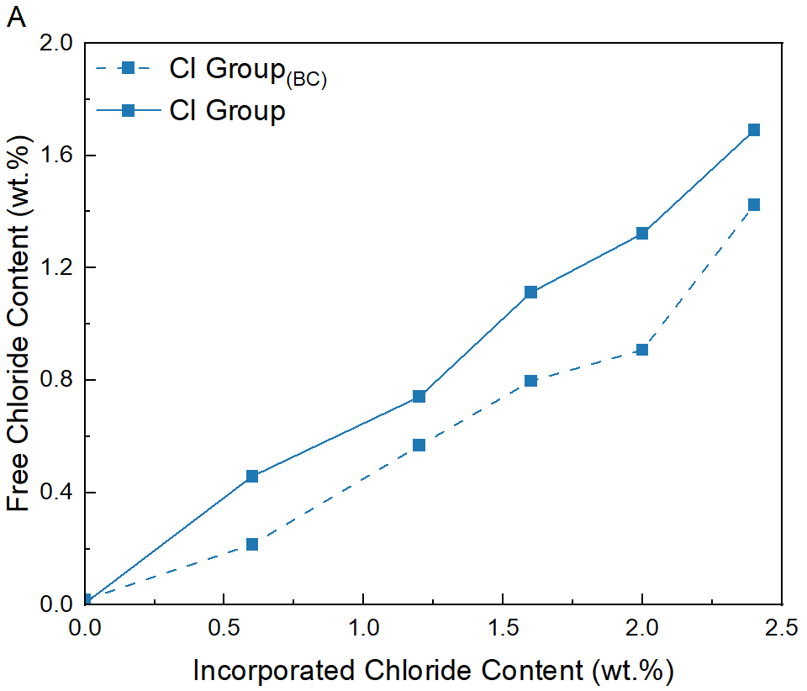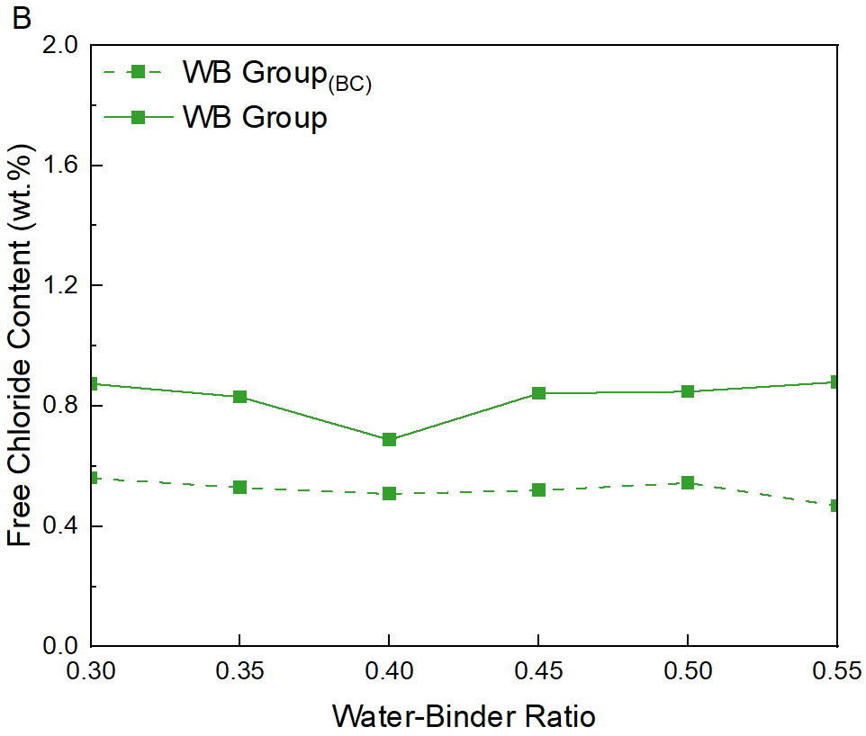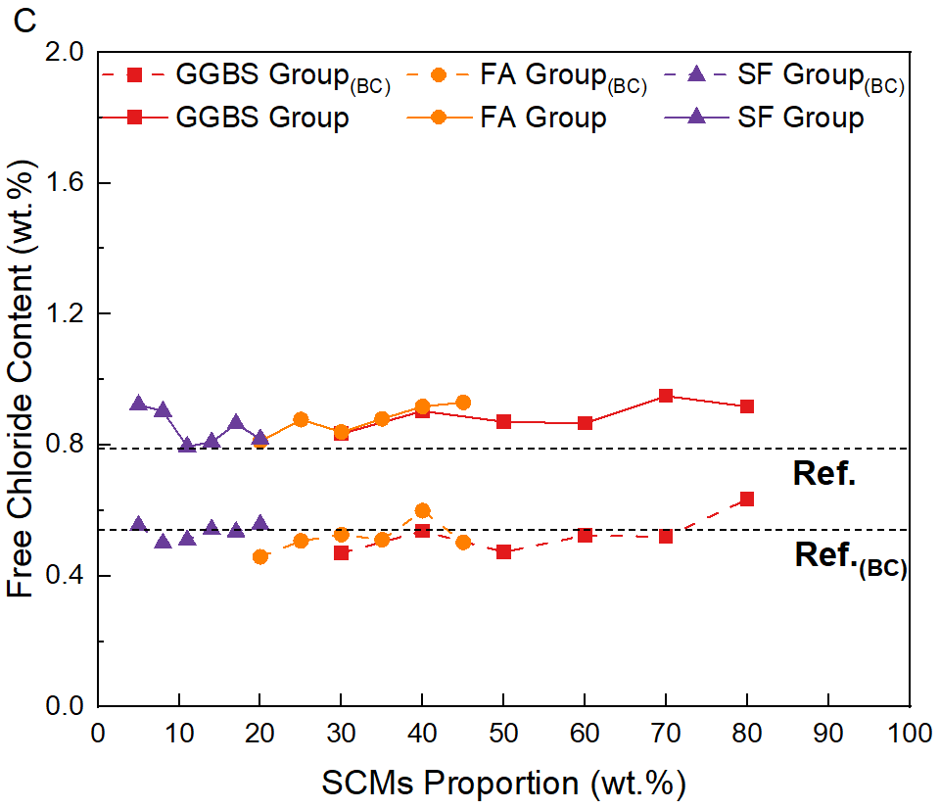
Figure 1 The free chloride content of mortar samples with and without carbonation. (A) the free chloride content of Cl group; (B) the free chloride content of WB group; (c) the free chloride content of SCMs group

Figure 2 displays the variation of pH value in the pore solution of cementitious mortars, as a function of the incorporated chloride content, W/B, and SCMs proportion. Prior to carbonation, the pH value is roughly 14.0 for all samples, but it varies among the samples after carbonation (except for Cl-0, WB-0.30, and WB-0.35 mixes, which were not fully carbonated according to the phenolphthalein indicator). For the Cl group, the pH value of the carbonated samples ranges from about 12 to 12.5, regardless of the amount of incorporated chloride (except for the Cl-0 sample). For the WB group, the pH of the carbonated samples decreases down to 11 as the W/B ratio increases to 0.55, which can be attributed to the fact that a higher W/B ratio results in less portlandite formation, higher porosity, and poorer resistance to carbonation [47,48]. For the SCMs group, the pH value of carbonated samples tends to decrease with an increase in the SCMs proportion, as pozzolanic reaction of SCMs consumes portlandite and lowers alkalinity. Moreover, the binders with a higher proportion of SCM have lower overall calcium availability for carbonation.

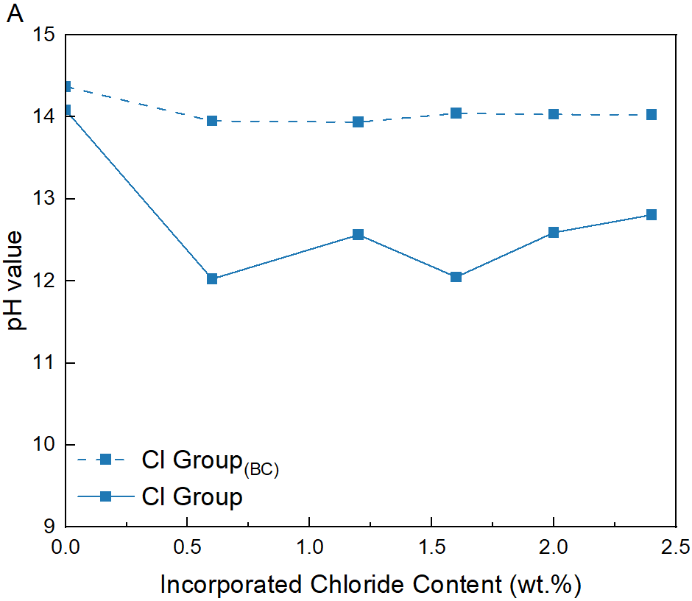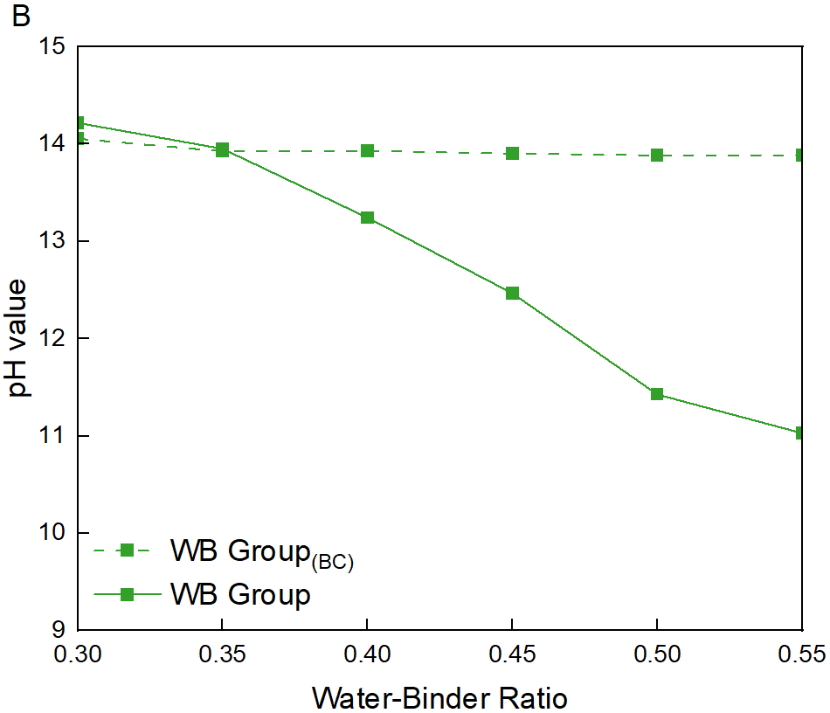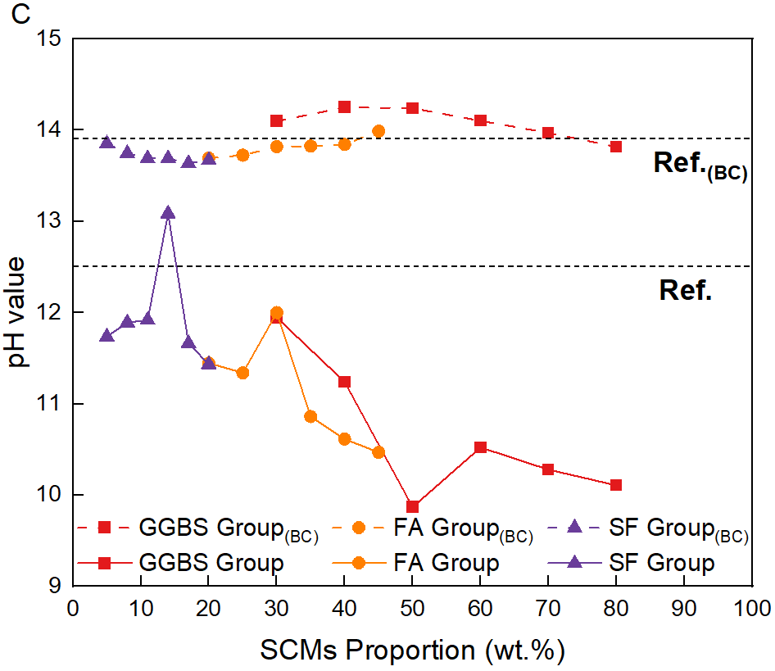
Figure 2 The pH value of different mortar samples with and without carbonation. (A) the pH value of Cl group; (B) the pH value of WB group; (c) the pH value of SCMs group

Figure 3 illustrates the porosity of various mortar samples before and after carbonation. All samples exhibit a decrease in porosity after carbonation, attributed to the deposition of calcium carbonate precipitates in pores [49]. In the Cl group, the porosity of mortar samples remains nearly constant, while it tends to increase with the W/B and SCMs proportion. The increased proportion of SCMs in mortars leads to decreased formation of hydration products and higher porosity [50]. However, in the SF group, the porosity increases with the proportion of SF, which contradicts the findings in the literature [51]. This discrepancy may be attributed to the absence of a superplasticizer in the SF group, which compromises the dispersibility of SF particles (note: superplasticizer was intentionally not added in SF group to eliminate its potential influence on electrical resistivity).

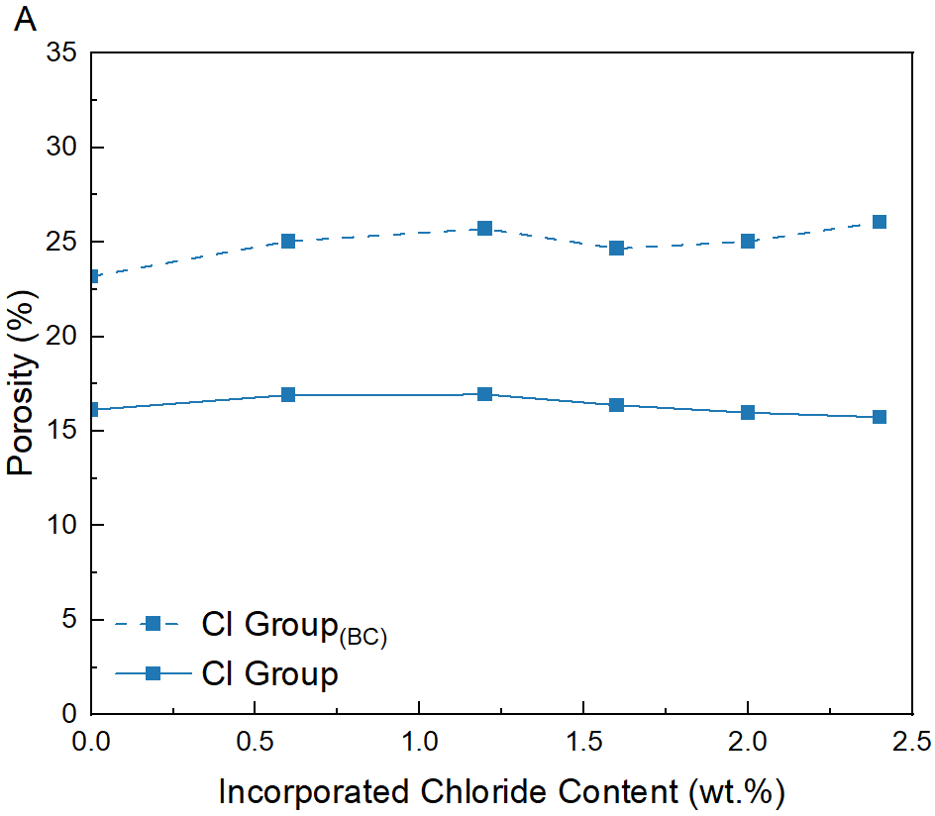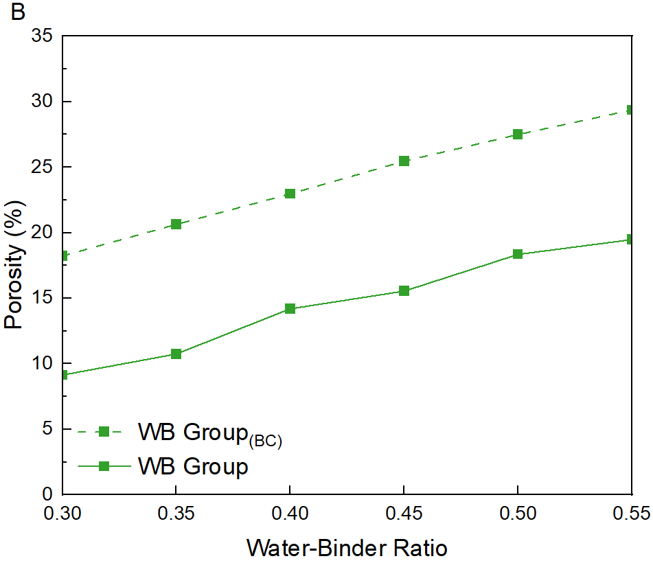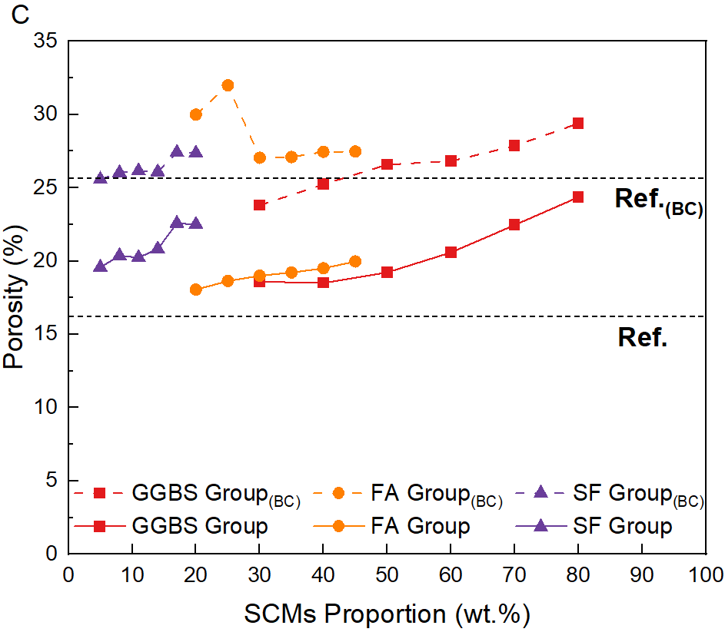
Figure 3 The porosity of different mortar samples with and without carbonation. (A) the porosity of Cl group; (B) the porosity of WB group; (c) the porosity of SCMs group

Overall, the FCC appears to be largely influenced by the amount of incorporated chloride, whereas the pH and porosity are primarily related to the W/B and SCMs proportion. Thus, it can be inferred that the FCC is almost independent of pH and porosity, while an apparent correlation exists between pH and porosity. The concentration ratio of free chloride ions to hydroxide ions ([Cl⁻]/[OH⁻]) is an important parameter affecting the corrosion rate of steel [52]. As such, the interrelationship between [Cl⁻]/[OH⁻], pH, and porosity of the carbonated samples was explored, as depicted in Figure 4. A strong negative correlation between [Cl⁻]/[OH⁻] and pH is observed (Pearson correlation coefficient = -0.96). This pH versus [Cl⁻]/[OH⁻] correlation is influenced by the value of FCC, which has a range spanning only one order of magnitude; therefore, after applying a logarithmic transformation, the influence becomes relatively small. The correlation coefficient between pH and porosity is -0.86, as both parameters are influenced by variations in the W/B and SCMs proportion. Moreover, a positive correlation between [Cl⁻]/[OH⁻] and porosity is observed (correlation coefficient = 0.75).

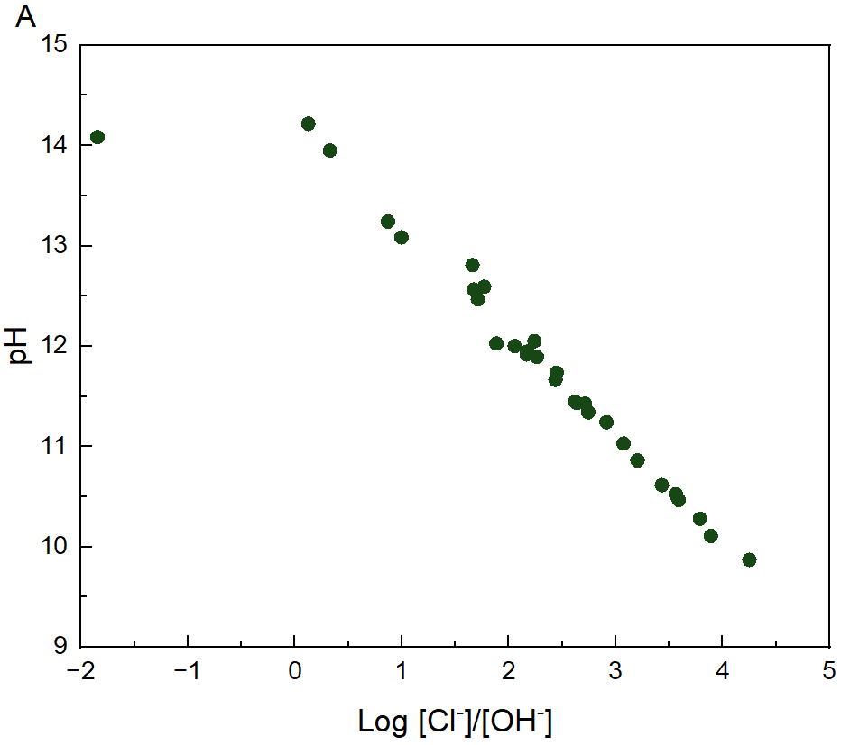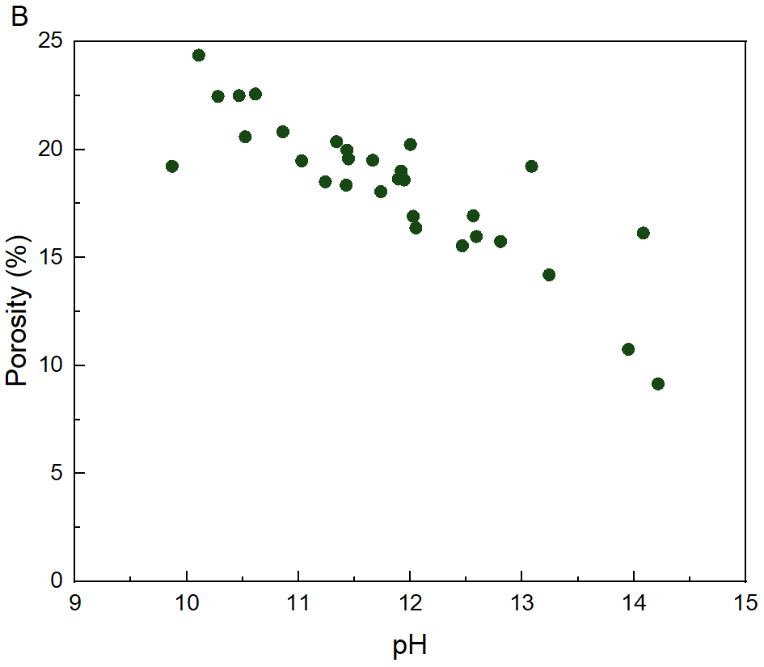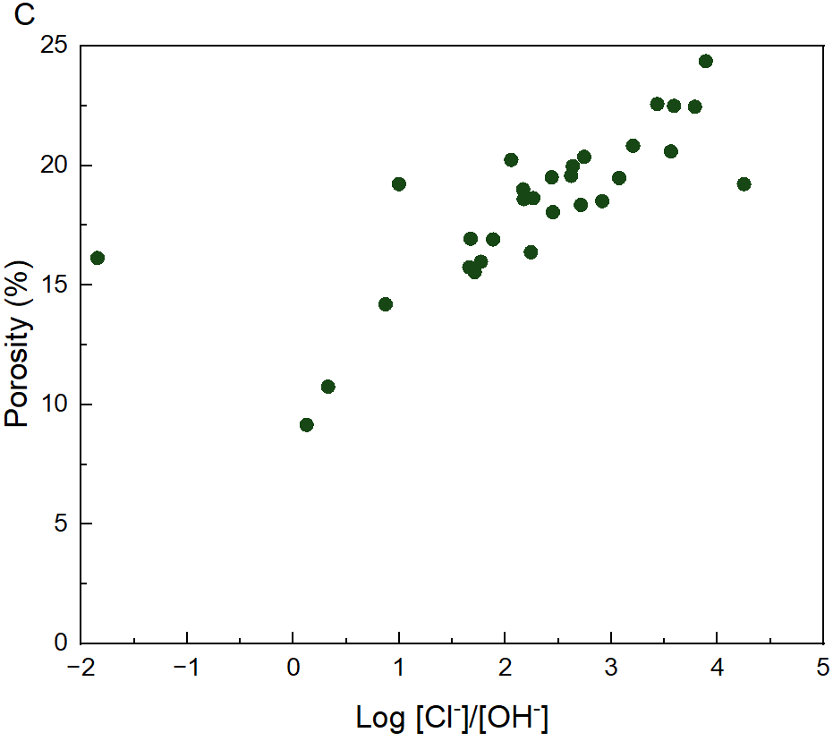
Figure 4 The relationship between different materials properties. (A) the relationship between log [Cl⁻]/[OH⁻] and pH; (B) the relationship between pH and porosity; (C) the relationship between log [Cl⁻]/[OH⁻] and porosity

4.2 Influence of relative humidity on corrosion rate
Figure 5 depicts the correlation between the corrosion rate of steel and the RH level at which the samples are equilibrated to. The grey strip in the figure represents the range of the critical corrosion rate (i_{corr,} between 0.1 and 0.2 μA/cm²), below which the steel is considered inactive [53]. It is evident that the corrosion rate increases steadily with an increase in RH, regardless of binder composition or W/B, indicating that RH dominantly impacts the corrosion rate. Moreover, the corrosion rate is influenced by the chloride content, W/B, and the proportion of SCMs, and tends to increase with the increase of their values. This can be attributed to the fact that higher chloride content and porosity, as well as lower pH value, favor the electrochemical dissolution of steel [6,52]. The corrosion rate of most SCMs group is greater than that of the reference group, indicating that the mortars incorporating SCMs tend to show lower corrosion resistance after carbonation. However, under low relative humidity conditions, certain samples such as GGBS-0.3, GGBS-0.4, and the SF group demonstrate a lower corrosion rate than the reference group. This phenomenon can be attributed to a greater reduced extent of ion diffusion coefficient in these samples at low humidity conditions, which restricts steel dissolution and consequently diminishes corrosion rate [24].

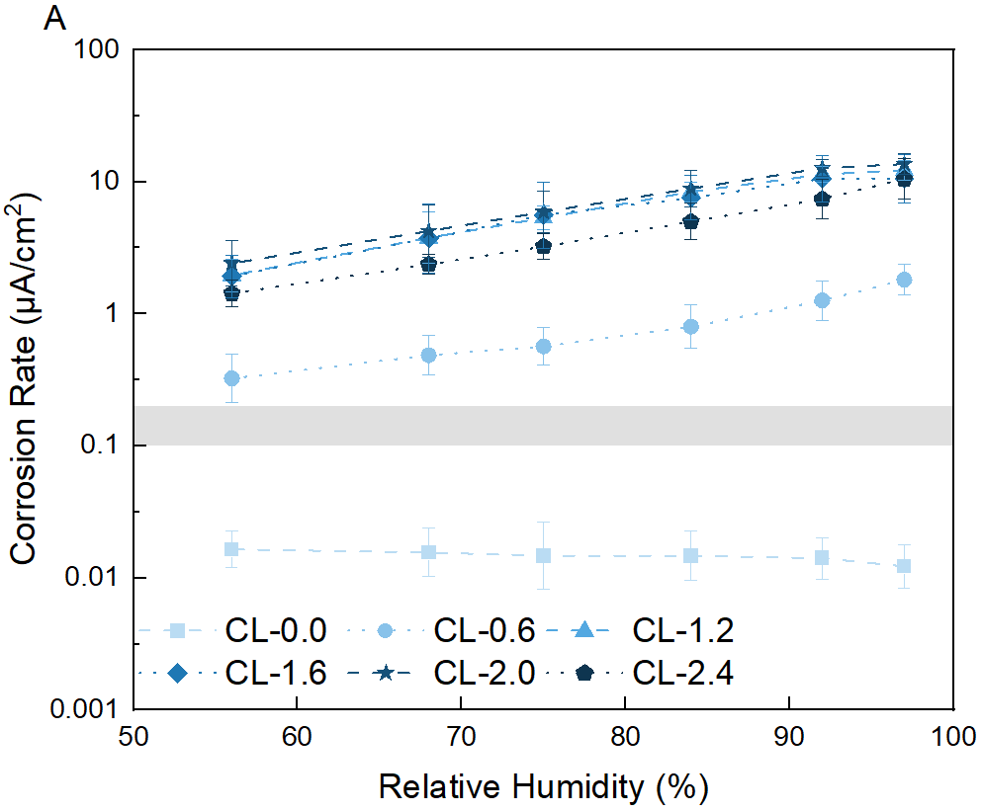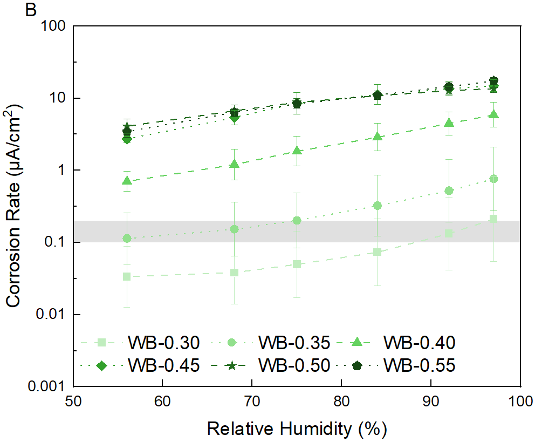
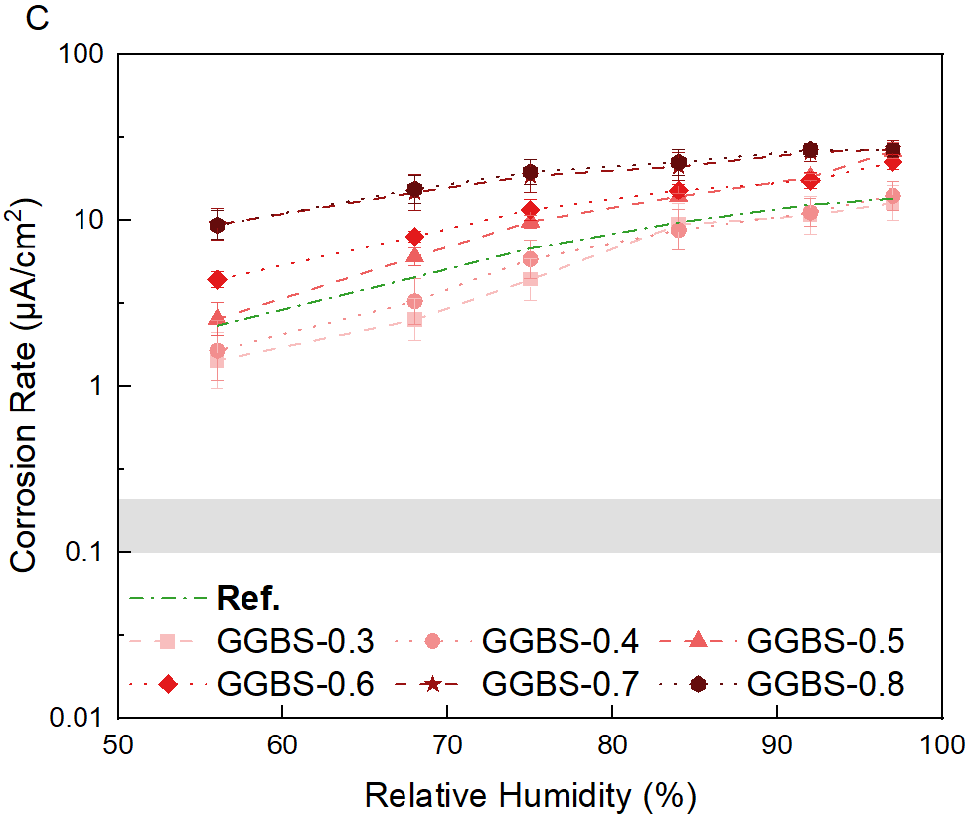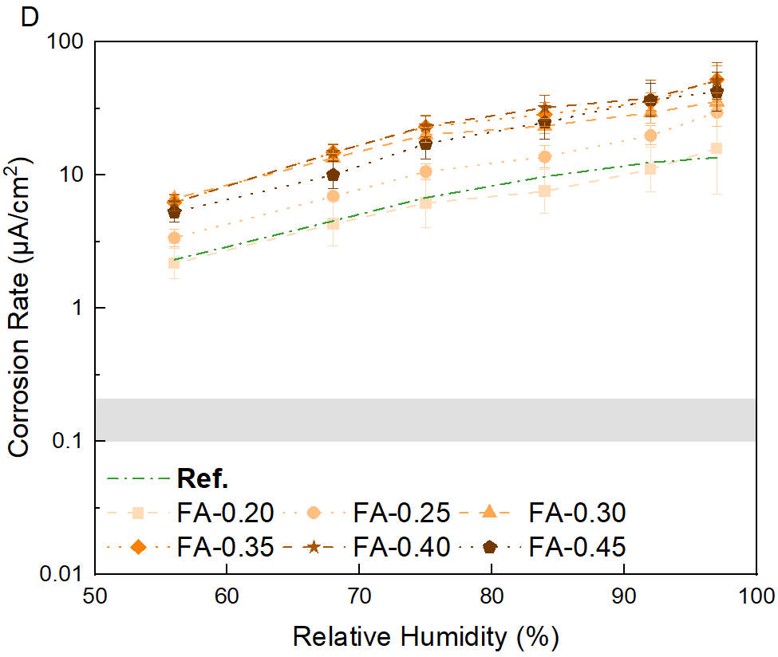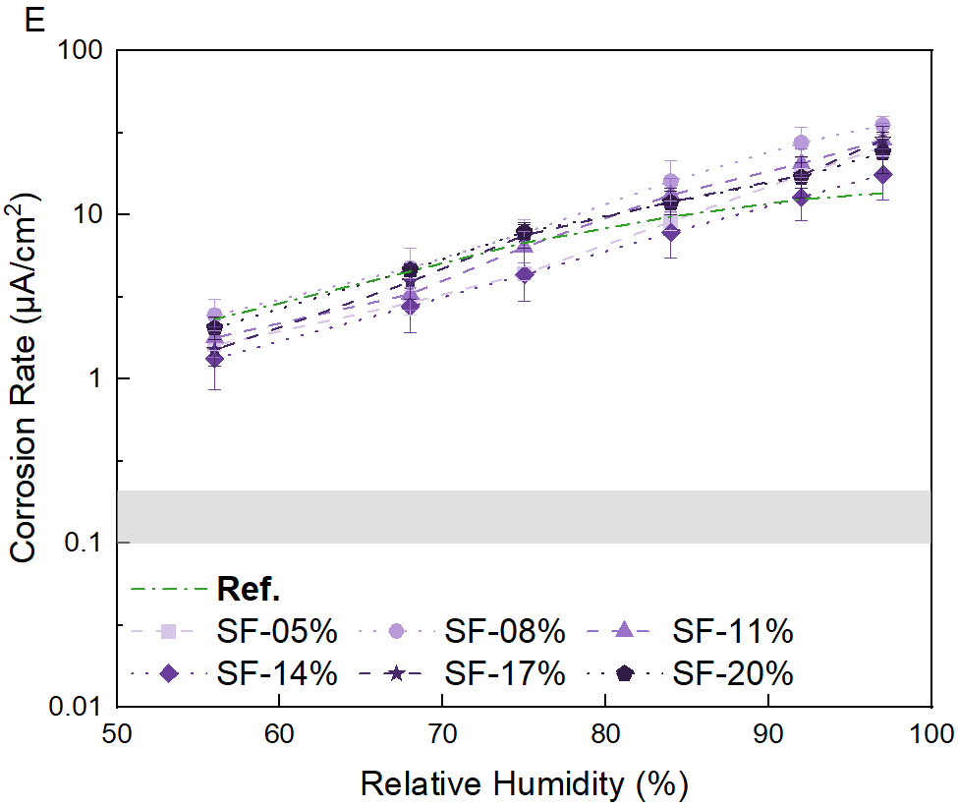
Figure 5 The corrosion rate of steel in mortar samples of (A) Cl Group, (B) WB Group, (C) GGBS Group, (D) FA Group and (E) SF Group after being exposed to various RH levels.

4.3 Influence of materials properties on corrosion rate
Figure 6 illustrates the correlation between various material properties and corrosion rate. The results show that the pH value exhibits an inverse relationship with corrosion rate, wherein an increase in pH value leads to a decrease in corrosion rate. However, the relationship between corrosion rate and FCC is ambiguous, although there appears to be a general trend of increased corrosion rate with increasing FCC. The potential reason lies in the substantial variation of pH values among different samples, which plays a more dominant role, leading to a broad range of fluctuation in the corrosion rate. While chloride ions are recognized as aggressive ions that facilitate the corrosion of steel, hydroxide ions act as inhibitory ions that impede the corrosion of steel [52]. Therefore, the relationship between FCC and corrosion rate needs to consider the effect of hydroxide ions, namely [Cl⁻]/[OH⁻]. The results indicate that the corrosion rate of embedded steel increases with an increase in [Cl⁻]/[OH⁻] of the pore solution. Furthermore, porosity affects the corrosion rate, as increased porosity leads to higher corrosion rates due to facilitated ion transport through interconnected pores [54]. Based on the findings, the higher corrosion rate observed in the systems with a higher chloride content, SCMs proportion, and higher W/B, can be attributed to their higher FCC, lower pH value, and larger porosity.

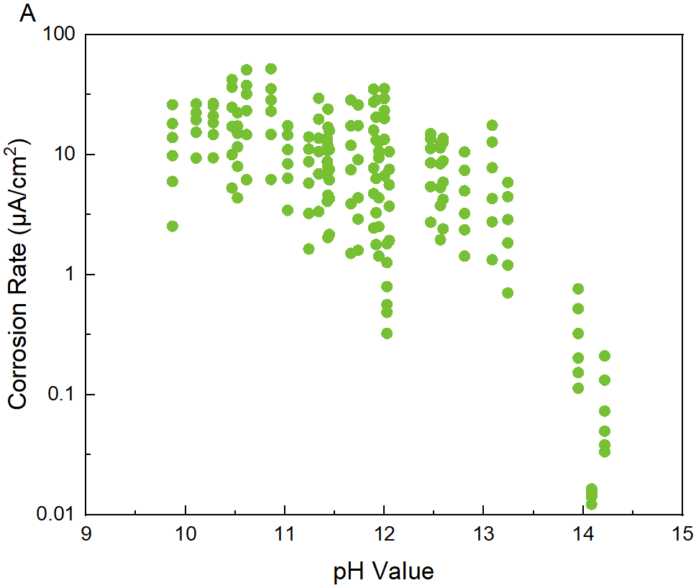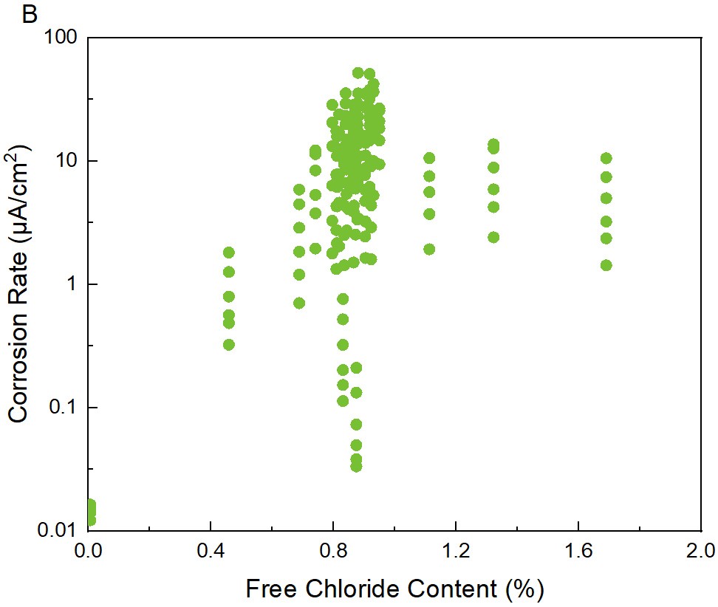
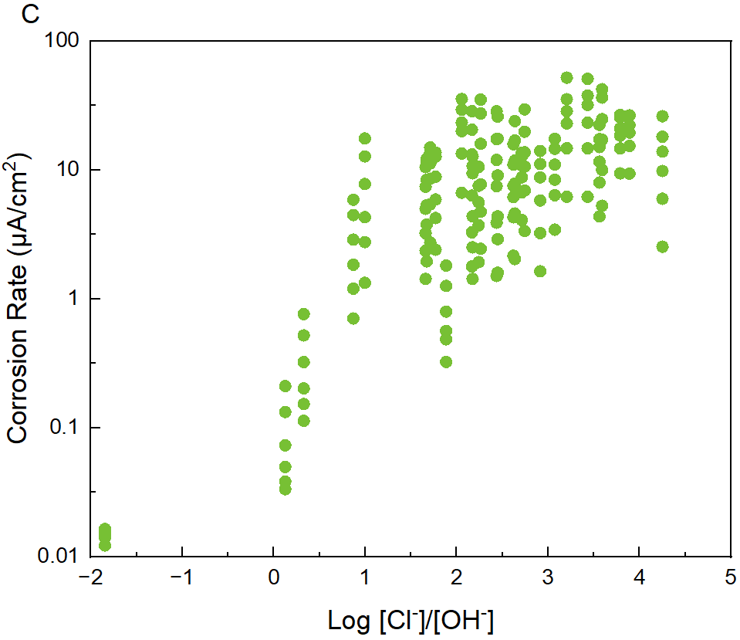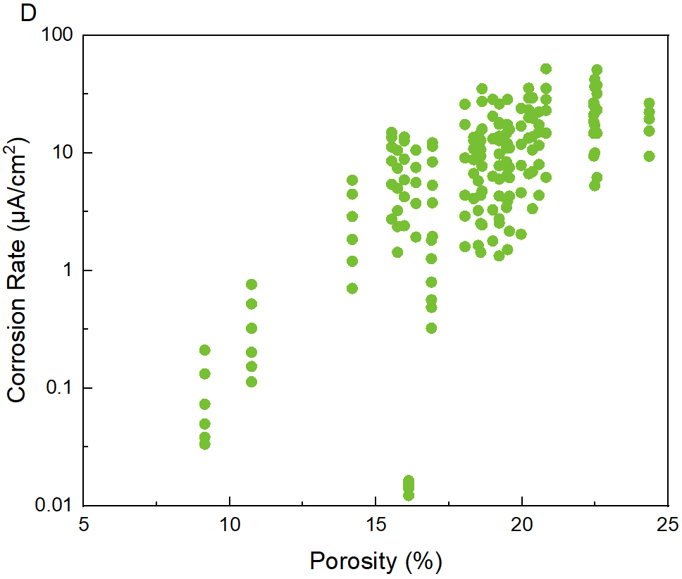
Figure 6 The relationship between corrosion rate and (A) pH value, (B) FCC, (C) log [Cl⁻]/[OH⁻], and (D) porosity

4.4 Influence of electrical resistivity on corrosion rate
The corrosion rate is influenced by pore structure (which affects the ion diffusion coefficient) and pore solution chemistry (including FCC and pH). These same factors simultaneously affect the electrical resistivity (ER), resulting in a linear relationship between corrosion rate and ER [24]. Figure 7 (A) depicts the correlation between corrosion rate and the ER, indicating that the former decreases as the latter increase, exhibiting a linear relationship. The data points that are circled in the figure deviate from the overall trend, where the left data corresponds to sample WB-0.30 and WB-0.35, which are impacted by the addition of water reducer that alters the ER but barely affects the corrosion rate of steel. The right data relates to sample Cl-0.0, where the steel bars remain in a passive state.

The relationship line between ER and corrosion rate is mainly influenced by hydroxide ion concentration (pH value), as explained in [24]. As noted in Section 4.3, a strong correlation exists between [Cl⁻]/[OH⁻] and pH as well as porosity, suggesting that this relationship line is affected similarly by [Cl⁻]/[OH⁻], pH, and porosity. The impact of [Cl⁻]/[OH⁻] on the relationship between corrosion rate and ER is further explored. As shown in Figure 7 (B), the dataset was evenly partitioned into four segments, each comprising 42 data points, based on the [Cl⁻]/[OH⁻] ratios arranged in ascending order. The first initial part was labeled as [Cl⁻]/[OH⁻]-1, representing the lowest [Cl⁻]/[OH⁻] value in that part of the data. Successive parts were labeled [Cl⁻]/[OH⁻]-2, [Cl⁻]/[OH⁻]-3, and [Cl⁻]/[OH⁻]-4, to indicate an increasing [Cl⁻]/[OH⁻] value. A line was then fitted to each part (excluding the data from WB-0.30 and WB-0.35). Table 1 presents the slope, intercept, and R² of the fitted lines for these four parts of the data. It is observed that with an increase in [Cl⁻]/[OH⁻], the slope increases while the intercept decreases, indicating the relationship line between corrosion rate ER is strongly related to the [Cl⁻]/[OH⁻] ratio.

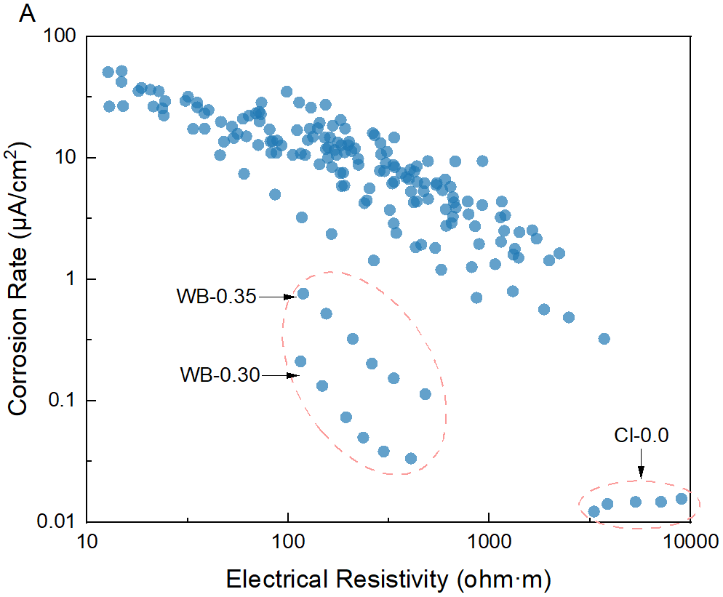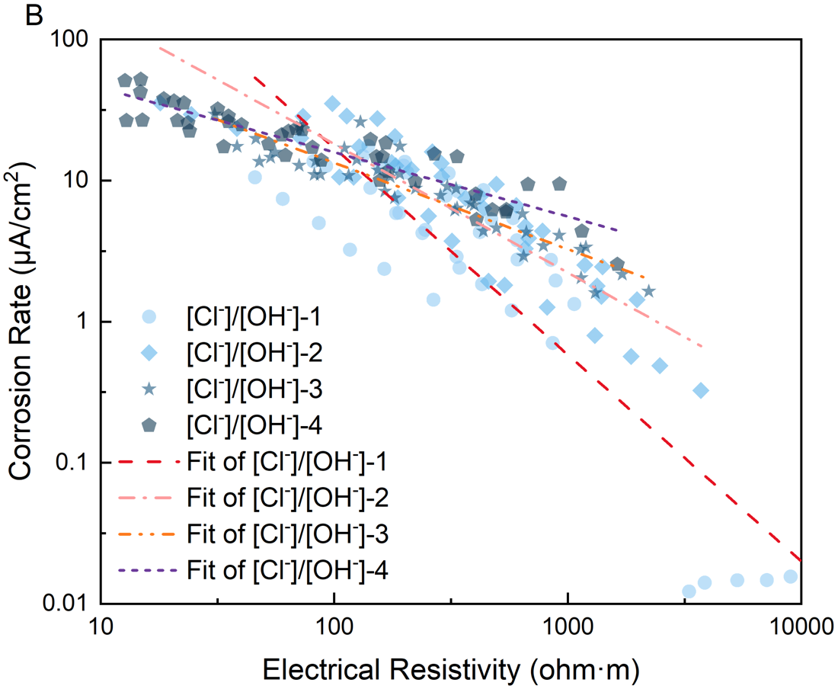
Figure 7 (A) The relationship between corrosion rate and electrical resistivity; (B) the relationship affected by [Cl⁻]/[OH⁻]

Table 1 The fitting parameters of the linear fitting line
 | Range of log [Cl⁻]/[OH⁻] | Slope | Intercept | R²
Fitting line of [Cl⁻]/[OH⁻]-1 | -1.84 - 1.77 | -1.465 | 4.162 | 0.803
Fitting line of [Cl⁻]/[OH⁻]-2 | 1.89 - 2.44 | -0.912 | 3.083 | 0.810
Fitting line of [Cl⁻]/[OH⁻]-3 | 2.45 - 3.07 | -0.612 | 2.350 | 0.857
Fitting line of [Cl⁻]/[OH⁻]-4 | 3.20 - 4.25 | -0.456 | 2.111 | 0.846

4.5 Influence of other factors on corrosion rate
Figure 8 shows the relationship between corrosion rate and other factors. Specifically, it shows that an increase in corrosion potential corresponds to a decrease in corrosion rate, suggesting a higher corrosion rate is observed when the corrosion potential is more negative, whereas a lower corrosion rate, with greater variability, is observed at a more positive corrosion potential. Therefore, the corrosion potential can serve as an indicator of steel corrosion. Additionally, the corrosion rate increases exponentially with water content, which is associated with the RH level in the environment. However, there is no significant correlation between the corrosion rate and DoS.

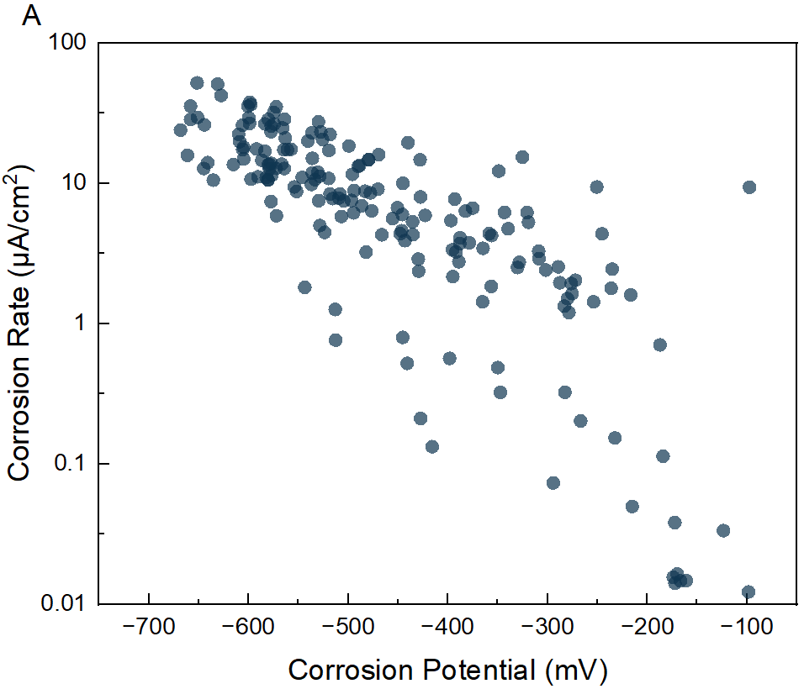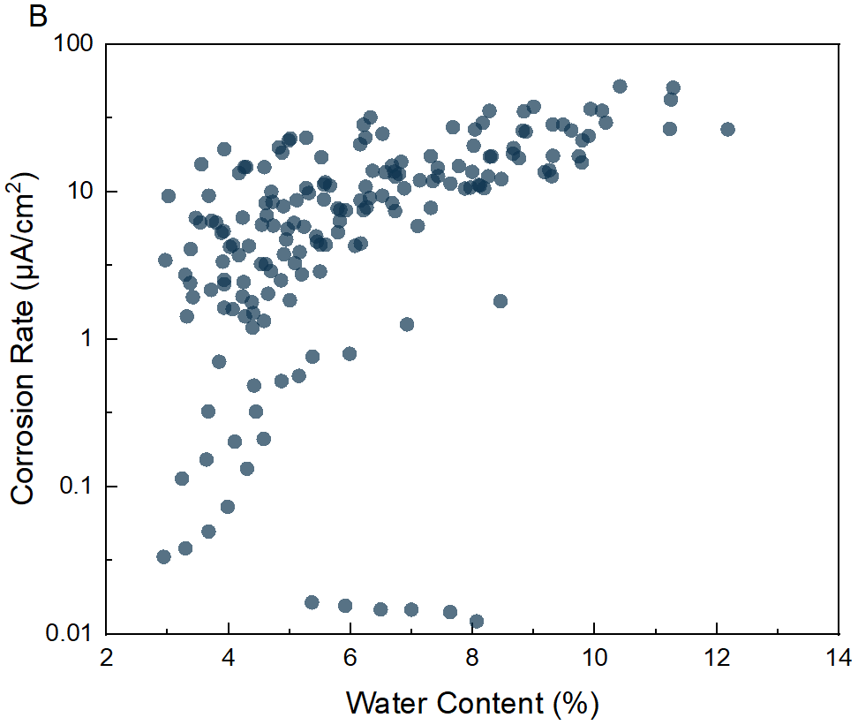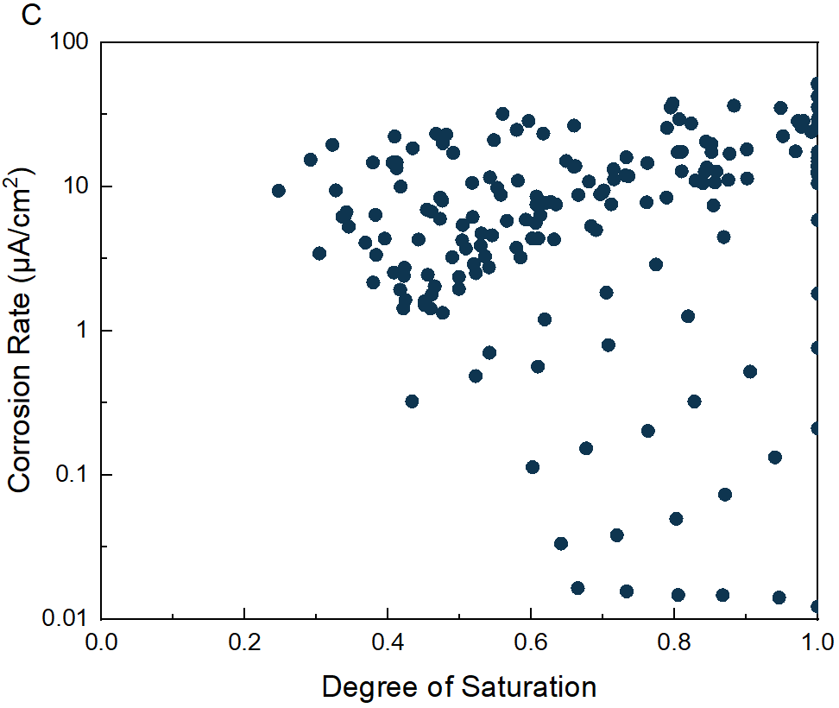
Figure 8 The relationship between corrosion rate and (A) corrosion potential, (B) water content, and (C) DoS

5 Machine learning model establishment

5.1 Data review and feature selection
A total of 180 groups of corrosion data were obtained from the comprehensive experiment, comprising 30 groups under 6 different RH levels and 15 features. The distribution of the corrosion rate data is illustrated in Figure 9. The count of corrosion rate decreases with the increase in corrosion rate, and most of the corrosion rate is lower than 30 μA/cm².

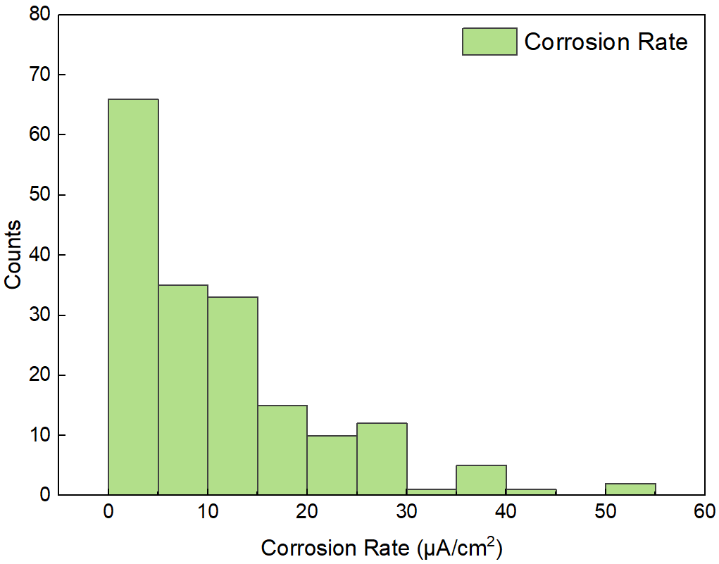
Figure 9 Histogram for the corrosion rate distribution for all the 180 groups

Table 2 lists the potential features related to the corrosion rate, which can be divided into four categories, namely mixture parameters, materials properties, environmental parameters, and electrochemical parameters. Mixture parameters refer to variables associated with the design and formulation of the mixture. Material properties encompass physical property (such as porosity) and the chemical composition of the pore solution (including pH and FCC) within the hardened mortar sample. Environmental parameters encompass the crucial parameters that are intimately linked to external conditions, such as relative humidity. Lastly, electrochemical parameters, as considered in this paper, are the parameters that intricately relate to the electrical properties of the mortar samples and the intricate electrochemical process of steel corrosion, including ER, corrosion potential, and [Cl⁻]/[OH⁻] of electrolyte (i.e., pore solution). It should be noted that the material properties depend on the mixture parameters, while the electrochemical parameters depend on both the material properties and the environmental parameters.

Table 2 The details of corrosion related factors
Category | Influencing factors | Minimum Value | Maximum Value
Mixture Parameters | Cement Proportion (wt.%) | 20 | 100
Mixture Parameters | GGBS Proportion (wt.%) | 0 | 80
Mixture Parameters | Fly Ash Proportion (FA, wt.%) | 0 | 45
Mixture Parameters | Silica Fume Proportion (SF, wt.%) | 0 | 20
Mixture Parameters | Water-to-binder Ratio (W/B) | 0.30 | 0.55
Mixture Parameters | Incorporated Chloride Content (ICC, wt.%) | 0.0 | 2.4
Material Properties | Free Chloride Content (FCC, wt.%) | 0.01 | 1.69
Material Properties | pH value | 9.87 | 14.22
Material Properties | Porosity (%) | 0.09 | 0.24
Environmental Parameters | Relative Humidity (RH, %) | 56 | 97
Environmental Parameters | Degree of Saturation (DoS) | 0.25 | 1.00
Environmental Parameters | Water Content (Water-C, %) | 0.06 | 0.24
Electrochemical Parameters | log [Cl⁻]/[OH⁻] | -1.84 | 4.25
Electrochemical Parameters | Electrical Resistivity (ER, ohm) | 12.72 | 12168
Electrochemical Parameters | Corrosion Potential (CP, mV) | -668 | -97

Including all features can potentially yield improved fitting results; nevertheless, when working with a small dataset, including an excessive number of features can impede the adaptability of the model and result in overfitting. Hence, it is crucial to engage in feature selection to address these challenges effectively. According to the methods described in Section 3.1, these 15 features of the corrosion data were screened by calculating their importance to the corrosion rate in the RFR ML model. As shown in Figure 10, electrical resistivity is the most significant feature, followed by corrosion potential, indicating the high relevance of these parameters to the corrosion rate. To reduce the inclusion of unimportant features, the first 8 features, namely electrical resistivity, corrosion potential, water content, porosity, cement proportion, fly ash proportion, pH value, and log [Cl⁻]/[OH⁻], were selected as candidate key features. Moreover, to facilitate the comparison of selected features by RFR, the Supplementary data includes the results of feature selection using the Spearman correlation coefficient method and the maximal information coefficient. The findings from all three selection methods exhibit similar outcomes. Consequently, this study utilizes the feature selection results obtained from RFR for subsequent analysis.

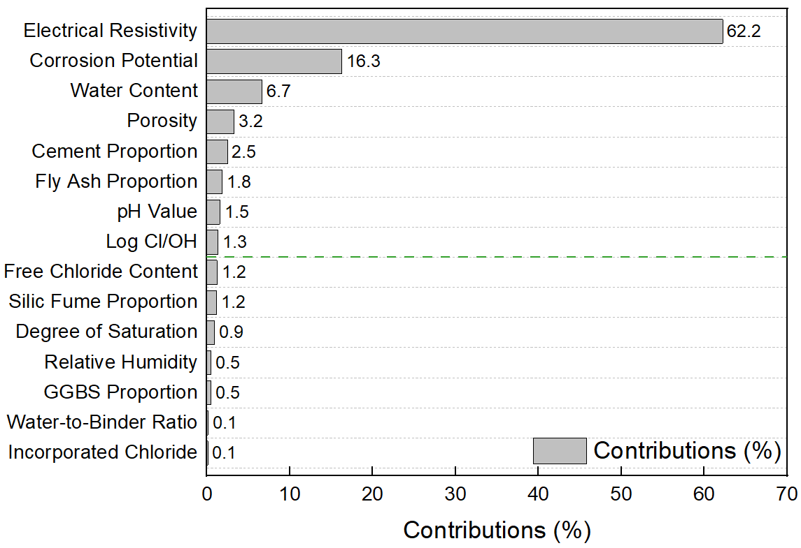
Figure 10 Contributions (%) of the 15 features to the corrosion rate

However, some of the features may be interdependent on each other, while others might not. In this regard, the Pearson correlation coefficient was utilized to evaluate the correlation between each influencing factor, as displayed in Figure 11. In this figure, the circle diameter and color represent the correlation coefficient and correlation, respectively. A larger diameter corresponds to a higher correlation coefficient, where red denotes positive correlation and blue denotes negative correlation. A strong correlation between the two features was identified if the absolute value of the coefficient exceeded 0.8. Consequently, strongly correlated factors groups were identified from the figure, namely (FCC, ICC), (pH, log [Cl⁻]/[OH⁻]), (Porosity, pH), (Water Content, DoS), (Water Content, RH), and (DoS, RH). From all strongly correlated features groups, the one with the highest contribution among the candidate key features was selected. Hence, in these strongly correlated groups, the final selection was porosity and water content. Based on the aforementioned feature selection method, the final key features were identified as electrical resistivity (the logarithm was taken during training due to its wide distribution range), corrosion potential, water content, porosity, cement proportion, and fly ash proportion.

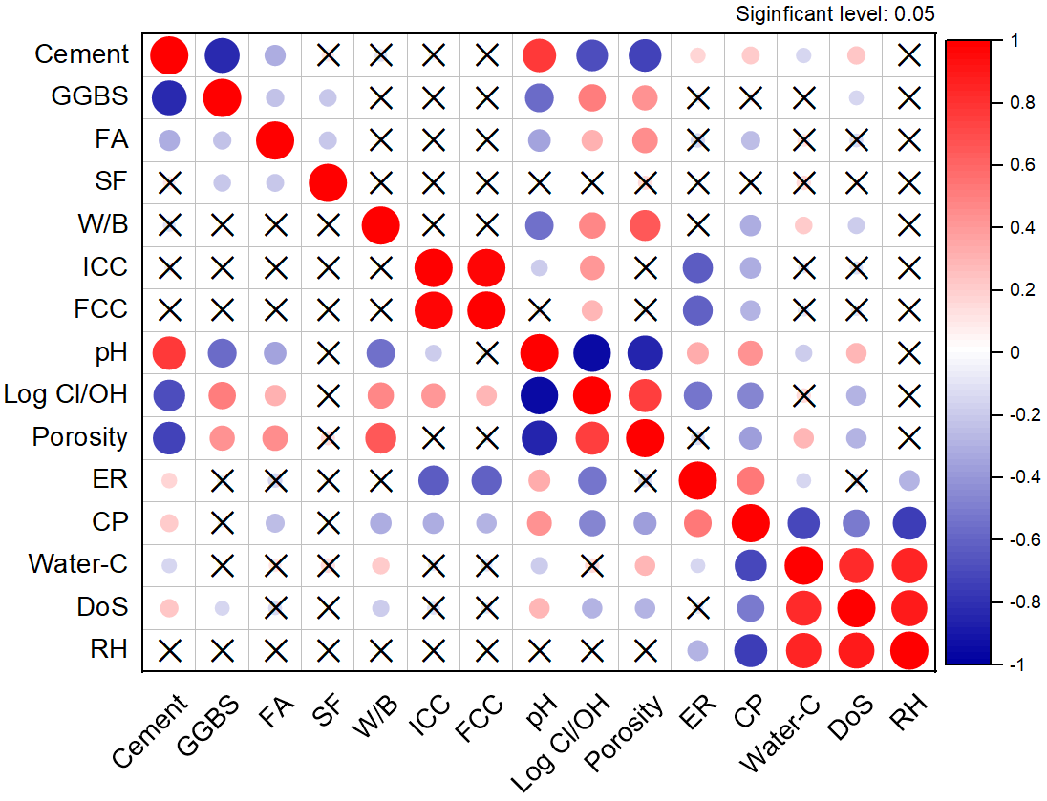
Figure 11 Person correlation coefficient of each factor

5.2 Establishment and evaluation of various ML model

5.2.1 Dataset division ratio and model hyperparameters
To ensure accurate and reliable predictions, it is essential to split the corrosion data into separate training and test sets. The performance of the model on the test set generally improves as the proportion of the training set increases. However, when the training set constituted 90% of the data, the R² decreases, which could be attributed to overfitting [14,55]. Therefore, the final ratio for the training set was selected as 80% to strike a balance between maximizing the model's performance and avoiding overfitting.

This study employed five distinct ML algorithms to construct the prediction model. The MLR algorithm did not necessitate hyperparameters, while the SVR, RFR, XGBoost, and ANN algorithms utilized Grid Search CV to search for suitable hyperparameters. Hyperparameters that were not disclosed in this study were set to their default configuration, with the R² and MSE serving as the evaluation metric. The final hyperparameters selected have been presented in Table 3.

Table 3 The hyperparameters of different algorithms
Algorithm | Hyperparameters
SVR | C=100 | Gamma=0.1
RFR | Max depth=8 | Number of estimators=13
XGBoost | Max depth=3 | Number of estimators=8 | Learning rate=0.3
ANN | Neurons=6 | Batch size=2 | Epochs=200

5.2.2 Model performance
The performance of various ML algorithms in predicting the corrosion rate is demonstrated in Figure 12 (random seed = 9). The predicted corrosion rate is plotted against the measured corrosion rate, and the evaluation metric employed is the R². Ideally, for accurate predictions, the data points in the plot should fall along with the 45° diagonal line. All the models demonstrate a promising outcome, indicating the feasibility of machine learning approach for predicting corrosion rates.

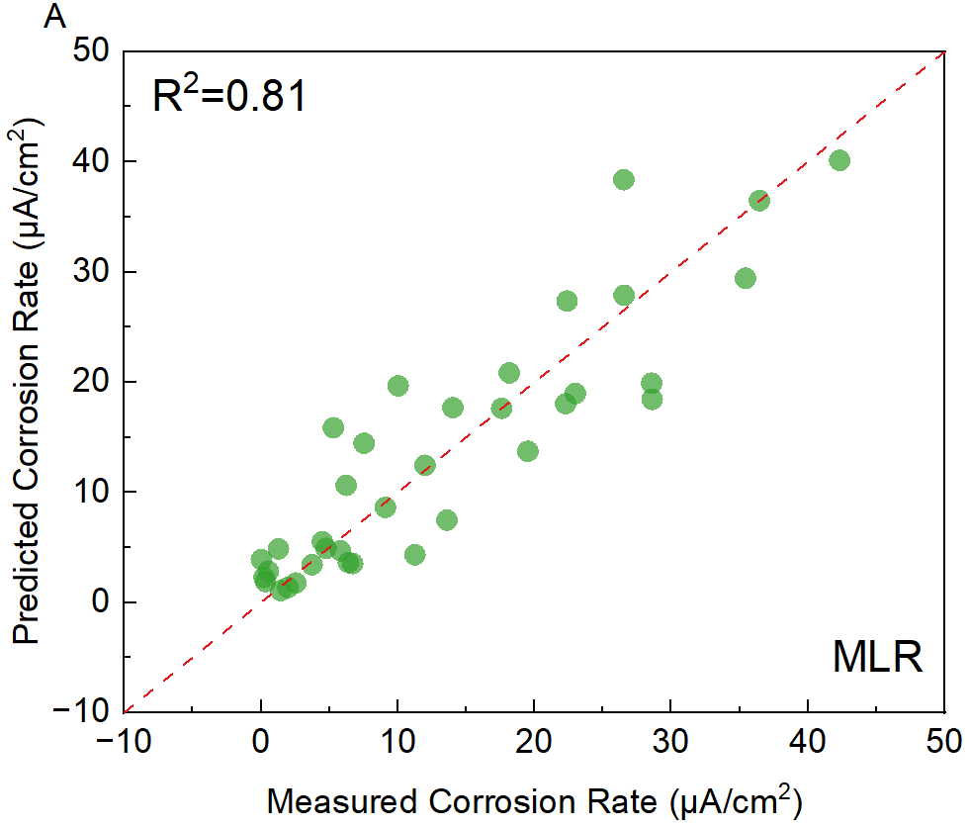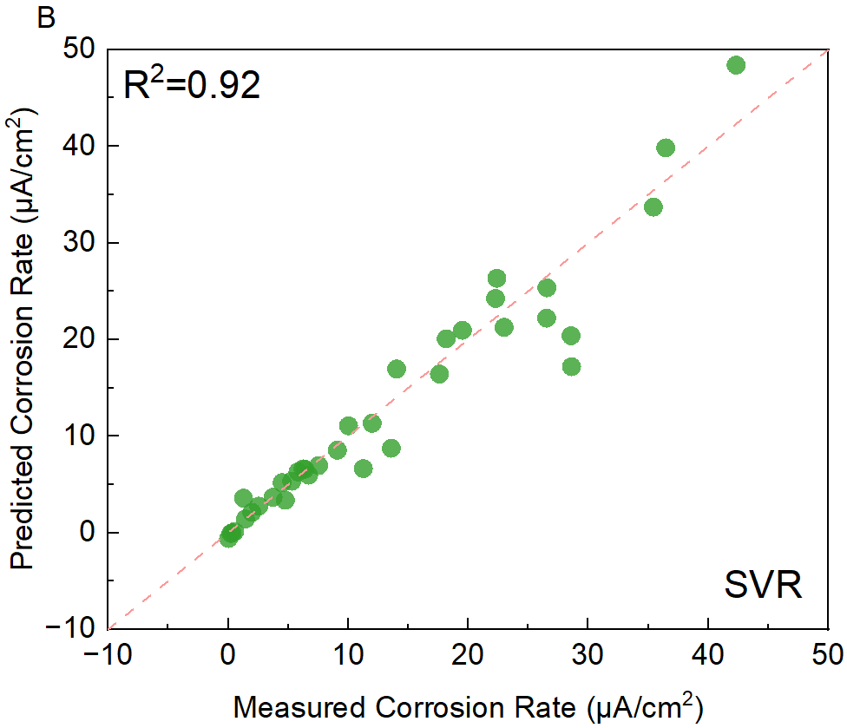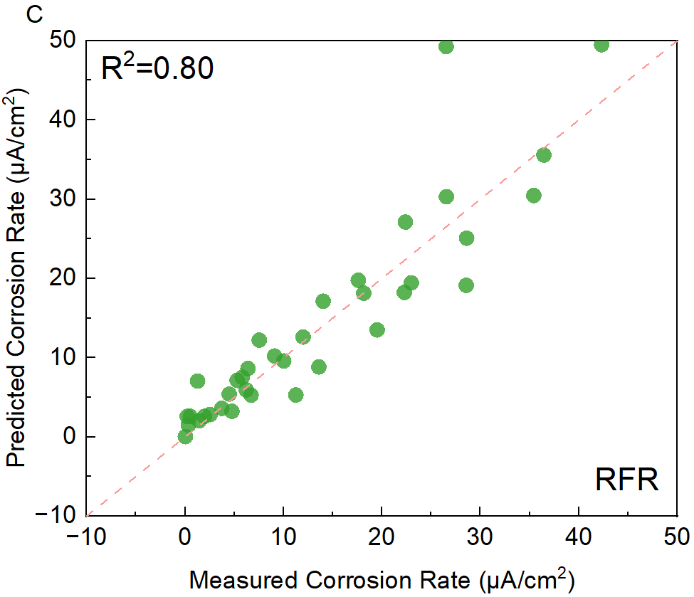
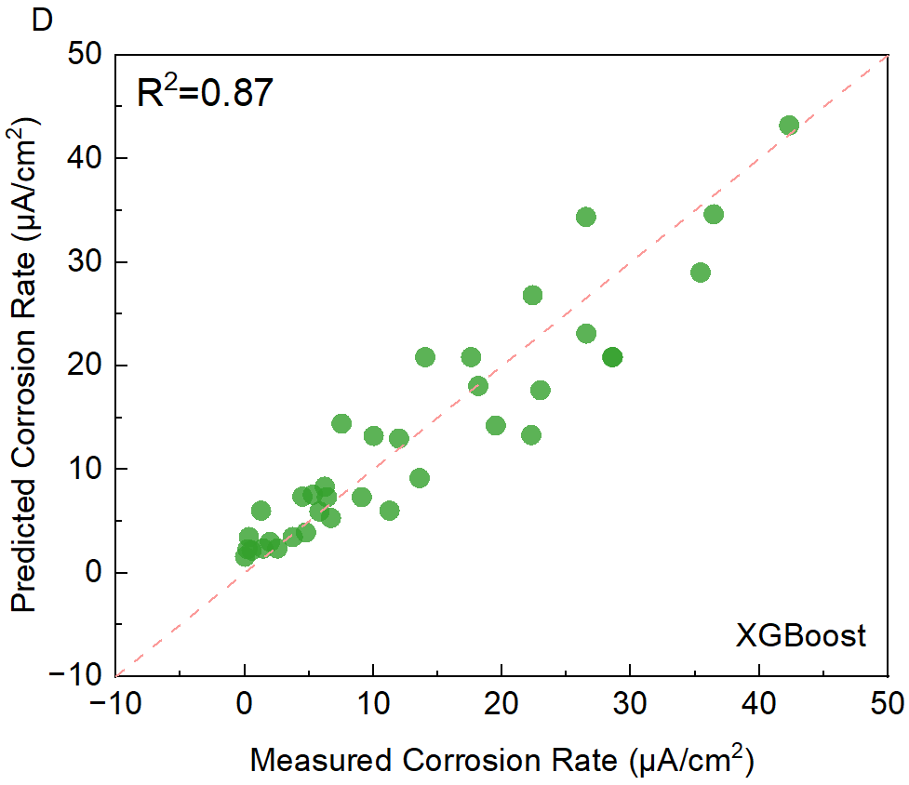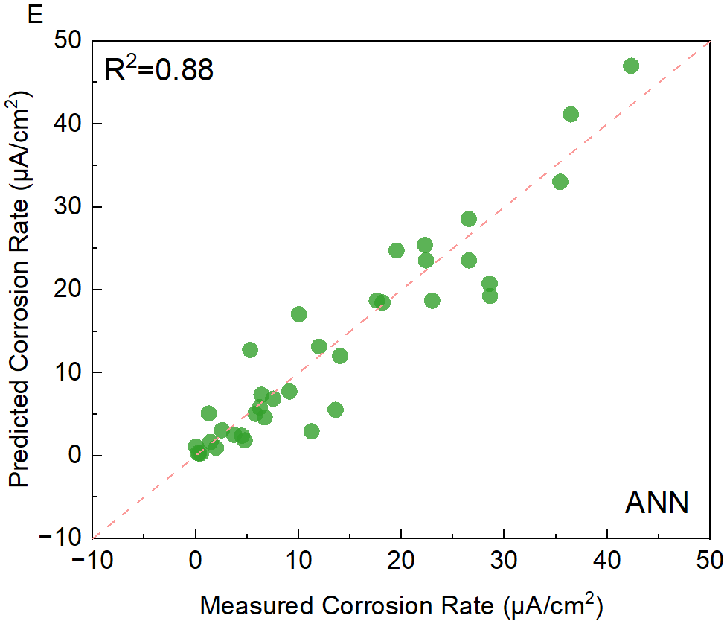
Figure 12 The performance of different ML models using (A) Multiple Linear Regression (MLR), (B) Support Vector Regression (SVR), (C) Random Forest Regression (RFR), (D) XGBoost and (E) Artificial Neural Network (ANN) algorithms

Table 4 presents the average R² and MSE of various models after running 10 times (10 different random seeds). The results indicate that the SVR algorithm exhibits the highest model performance on the test set. However, there is a possibility of overfitting during the training process, which typically results in poor generalization performance on the test set, despite good performance on the training set [19]. In this study, the ratio of the R² on the test set to the training set was employed to evaluate the likelihood of overfitting, from which smaller ratios indicate a higher likelihood of overfitting. It is worth noting that the SVR model exhibits the highest ratio, which suggests a lower probability of overfitting. Compared with other algorithms, the SVR algorithm performs the best on the corrosion dataset acquired in this study, which can be attributed to its strong adaptability to small datasets, robust handling of noise and outliers, and the inclusion of a regularization term that helps prevent overfitting [56–58]. Consequently, the SVR algorithm is chosen for modeling in the ensuing study.

Table 4 The performance of different models. MSE and R² were calculated in the training and testing sets
Model | R² of test set (R₁²) | R² of training set (R₂²) | R₁²/ R₂² | MSE of test set
MLR | 0.78 | 0.83 | 0.94 | 23.57
SVR | 0.90 | 0.94 | 0.95 | 11.81
RFR | 0.84 | 0.97 | 0.86 | 18.44
XGBoost | 0.86 | 0.99 | 0.86 | 16.33
ANN | 0.84 | 0.93 | 0.91 | 16.85

5.3 Optimal model
5.3.1 Feature selection based on the experiment analysis.
In Section 5.1, the selection of input features was carried out based on the application of the RFR algorithm and Pearson correlation coefficient method. However, it is crucial to consider the underlying mechanism of these features with respect to the corrosion rate, as well as to follow the principle of achieving better predictability with fewer features. Consequently, this section undertakes the process of reselecting more appropriate input features by considering the experimental analysis outcomes presented in Sections 4.3 and 4.4, in conjunction with the feature selection method explicated in Section 5.1.

The input features utilized in this study are categorized into four distinct groups: mixture parameters, material properties, environmental parameters, and electrochemical parameters. Amongst the electrochemical parameters, electrical resistivity and corrosion potential were found to exhibit the highest level of correlation on corrosion rate, as depicted in Figure 10. Both features have been observed to have a strong correlation with corrosion rate, with electrical resistivity being affected by log [Cl⁻]/[OH⁻], while corrosion potential serves as a representation of the corrosion state, as illustrated in sections 4.4 and 4.5. Therefore, the most relevant features, namely electrical resistivity and log [Cl⁻]/[OH⁻] were identified as the key feature, while corrosion potential was selected as the candidate key feature. Moving on to the mixture parameters, the proportion of cement and fly ash was observed to exhibit a significant level of contribution, with cement being the primary cementitious material utilized in engineering practice. As such, cement proportion was selected as the candidate key feature. Regarding material properties, both pH value and log [Cl⁻]/[OH⁻] were identified as high contributors to the corrosion rate. Considering that log [Cl⁻]/[OH⁻] was already selected as one of the key features and that pH has a strong correlation with log [Cl⁻]/[OH⁻], only porosity was chosen as the candidate key feature for material properties. In terms of environmental parameters, the water content was found to have the most significant impact on corrosion rate, and thus, was chosen as the candidate key feature. In summary, the chosen input features were electrical resistivity, log [Cl⁻]/[OH⁻], corrosion potential, water content, cement proportion, and porosity, as presented in Table 5. These selections were based on a comprehensive analysis of the mechanism between the features and corrosion rate.

Table 5 Features selection according to the experimental analysis
Category | Key features | Candidate key features
Electrochemical parameters | Electrical Resistivity, [Cl⁻]/[OH⁻] | Corrosion potential
Mixture parameters | - | Cement proportion
Materials properties | - | Porosity
Environmental parameters | - | Water content

Based on the selected input features, there were 16 possible feature combinations, including 6 features (1 type), 5 features (4 types), 4 features (6 types), 3 features (4 types), and 2 features (1 type). To achieve better prediction results with fewer features, the next step was to obtain the optimal model. SVR was chosen as the model algorithm due to its best prediction performance in the previous section.

5.3.2 Model performance
The SVR algorithm with the Grid Search CV method was utilized to select the hyperparameters, and the 16 feature combinations were predicted using R² and MSE as the evaluation metrics. The optimum feature combination results for different numbers of features are presented in Table 6.

Table 6 The optimal performance (R²) of different features combinations
Features Combination |  |  |  |  |  | R²
ER | [Cl⁻]/[OH⁻] | Cement proportion | Corrosion Potential | Porosity | Water content | 0.87
ER | [Cl⁻]/[OH⁻] | Cement proportion | Corrosion Potential | Porosity |  | 0.93
ER | [Cl⁻]/[OH⁻] | Cement proportion | Corrosion Potential |  |  | 0.92
ER | [Cl⁻]/[OH⁻] | Cement proportion |  |  |  | 0.90
ER | [Cl⁻]/[OH⁻] |  |  |  |  | 0.74

The ER is the most significant factor contributing to the corrosion rate of steel. The ratio of chloride ions to hydroxide ions ([Cl⁻]/[OH⁻]) plays a crucial role in modulating the relationship between ER and corrosion rate. Thus, these two factors are deemed to be the most significant factors for predicting the corrosion rate. The proportion of cement content possesses a considerable influence on mixture design, as it is closely related to the overall alkaline content of the cementitious system and carbonation resistance. When SCMs are incorporated into the mixture, they replace a portion of cement and reduce the overall alkaline content, which can negatively impact the corrosion rate after full carbonation. Therefore, the importance of cement content is also significant in predicting the corrosion rate. Corrosion potential is a crucial parameter that directly reflects the corrosion state of steel bars, and it exhibits a strong correlation with the corrosion rate. In the case of porosity, there is a significant correlation between porosity and log [Cl⁻]/[OH⁻] (Pearson correlation coefficient: 0.75), indicating a relatively slight contribution to the corrosion rate. However, it has been observed that removing the feature of water content leads to improved model performance. Although water content does have an apparent contribution to the corrosion rate, its relationship with corrosion rate is not well-defined when the water content is lower, as depicted in Figure 8 (B). Moreover, water content exhibits a significant correlation with corrosion potential (Pearson correlation coefficient: 0.70). Hence, it is possible that the inclusion of water content in the model introduces information redundancy, thereby leading to a decline in model performance. After comprehensive consideration, the combination of four features (ER, log [Cl⁻]/[OH⁻], cement proportion, and corrosion potential) as the optimal set of predictors for the steel corrosion rate model is identified. This combination has fewer features and yields a relatively higher R² value. Compared with the feature selection used in Section 5.1, after considering the experiment findings, the model performance has a higher R² value with fewer features.

5.4 Limitation of ML model
The ML-based corrosion rate predictive model presented in this paper demonstrates strong performance on its own dataset. However, despite the consideration of various factors, some limitations may still exist. First, the corrosion data used in this study were obtained from carbonated mortar samples, which may not be easily extrapolated to the corrosion scenarios of uncarbonated mortars. For instance, the input feature ER, in this paper, is highly influenced by the degree of carbonation due to changes in porosity and pore solution chemistry, and therefore cannot be straightforwardly extended to uncarbonated scenarios. Moreover, the correlation between ER and corrosion rate may deviate with the degree of carbonation (as suggested in [24]), making it challenging to extend the model to uncarbonated mortars. Furthermore, there are differences between corrosion rates observed in laboratory settings and in real-world environments. In the actual environment, external factors including relative humidity and temperature change periodically and randomly, and the samples may also be influenced by various random effects, leading to differences in corrosion rates between laboratory and field settings. Additionally, it is noteworthy that the ER and porosity values obtained from mortar samples differ from those of concrete. Hence, it becomes imperative to establish the correlation between these parameters and convert them accordingly to align with the distinctive characteristics of real concrete. Therefore, it is essential to establish the relationship between the corrosion rate in the laboratory and that in the actual environment. Additionally, to enhance the applicability of the ML model, more datasets from the literature should be acquired based on the obtained key features.

Conclusions

The study gathered a comprehensive experimental dataset on corrosion of steel embedded in carbonated cementitious mortars, in which the experimental campaign encompassed various binder compositions, mixture design parameters, and relative humidity levels. The machine learning approach was employed to predict the corrosion rate of steel, which yielded highly promising results. The study arrived at the following main conclusions:

(1) Cementitious mortars incorporating supplementary cementitious materials (SCMs) and having high water-to-binder ratios, tend to exhibit poor corrosion resistance after carbonation. This is primarily because of their larger porosity, lower pH, and high FCC (i.e., high ([Cl⁻]/[OH⁻]) than the reference mortars, which create favorable conditions for corrosion.

(2) The relative importance of various material and environmental factors on the corrosion rate of steel was investigated, where electrochemical parameters, particularly electrical resistivity and corrosion potential, show the most significant impact on the corrosion rate. Additionally, the relationship between electrical resistivity and corrosion rate is highly affected by the [Cl⁻]/[OH⁻].

(3) Among the various ML models evaluated, the Support Vector Regression model exhibited the best predictability for corrosion rate, with the highest model accuracy and a relatively low risk of overfitting.

(4) By combining feature selection methods with experimental analysis, a larger R² and fewer features were identified compared with the machine learning method selection alone. The key features that impact corrosion rate are electrical resistivity, chloride-to-hydroxide concentration ratio ([Cl⁻]/[OH⁻]), cement proportion, and corrosion potential.

Data availability
The data that support the finding of this study are available from the corresponding author upon reasonable request.

Declaration of competing interest
The authors declare that they have no known competing financial interests or personal relationships that could have appeared to influence the work reported in this paper.

Acknowledgements
The work was funded by the Shenzhen-Hong Kong-Macau Technology Research Programme (Type C) 2023 (Project number: SGDX20220530111404028) and The University of Hong Kong through Seed Fund for PI Research. Any opinions, findings and conclusions or recommendations expressed in this material are those of the authors and do not necessarily reflect the views of the sponsors.

Reference

1. Montemor, M. F., Cunha, M. P., Ferreira, M. G., & Simões, A. M. (2002). Corrosion behaviour of rebars in fly ash mortar exposed to carbon dioxide and chlorides. Cement and Concrete Composites, 24(1), 45–53.
2. Pradhan, B., & Bhattacharjee, B. (2011). Rebar corrosion in chloride environment. Construction and Building Materials, 25(5), 2565–2575.
3. Ji, H., Tian, Y., Zhao, R., Jin, N., Jin, X., Tian, Z., Yan, D., & Ye, H. (2020). Passivation and Depassivation of HPB335 Carbon Steel in Simulated Concrete Pore Solution. International Journal of Electrochemical Science, 15(7), 6488–6507.
4. Tian, Y., Zhang, G., Ye, H., Zeng, Q., Zhang, Z., Tian, Z., Jin, X., Jin, N., Chen, Z., & Wang, J. (2023). Corrosion of steel rebar in concrete induced by chloride ions under natural environments. Construction and Building Materials, 369, 130504.
5. Hope, B. B., Page, J. A., & Ip, A. K. C. (1986). Corrosion rates of steel in concrete. Cement and Concrete Research, 16(5), 771–781.
6. Stefanoni, M., Angst, U., & Elsener, B. (2018). Corrosion rate of carbon steel in carbonated concrete – A critical review. Cement and Concrete Research, 103, 35–48.
7. Lu, Z.-H., Lun, P.-Y., Li, W., Luo, Z., Li, Y., & Liu, P. (2019). Empirical model of corrosion rate for steel reinforced concrete structures in chloride-laden environments. Advances in Structural Engineering, 22(1), 223–239.
8. Xia, J., Shen, J., Li, T., & Jin, W.-L. (2022). Corrosion prediction models for steel bars in chloride-contaminated concrete: a review. Magazine of Concrete Research, 74(3), 123–142.
9. Yu, B., Yang, L., Wu, M., & Li, B. (2014). Practical model for predicting corrosion rate of steel reinforcement in concrete structures. Construction and Building Materials, 54, 385–401.
10. Dong, Z., Gu, X.-L., Jin, Z.-H., Poursaee, A., & Ye, H. (2022). Experimental and Numerical Investigations on the Rate-Limiting Step for Macrocell Corrosion of Reinforcing Steel in Concrete. Journal of Materials in Civil Engineering, 34(1), 04021407.
11. Otieno, M., Beushausen, H., & Alexander, M. (2011). Prediction of corrosion rate in reinforced concrete structures – a critical review and preliminary results. Materials and Corrosion, 63(9), 777–790.
12. Yu, Y., Gao, W., Castel, A., Chen, X., & Liu, A. (2021). An integrated framework for modelling time-dependent corrosion propagation in offshore concrete structures. Engineering Structures, 228, 111482.
13. Tom Mitchell. (1997). Machine Learning. McGraw Hill.
14. Qu, Z., Tang, D., Wang, Z., Li, X., Chen, H., & Lv, Y. (2021). Pitting Judgment Model Based on Machine Learning and Feature Optimization Methods. Frontiers in Materials, 8, 348.
15. Zhi, Y., Yang, T., & Fu, D. (2020). An improved deep forest model for forecast the outdoor atmospheric corrosion rate of low-alloy steels. Journal of Materials Science & Technology, 49, 202–210.
16. Yan, L., Diao, Y., & Gao, K. (2020). Analysis of Environmental Factors Affecting the Atmospheric Corrosion Rate of Low-Alloy Steel Using Random Forest-Based Models. Materials, 13(15), Article 15.
17. Wang, Z., Sobey, A. J., & Wang, Y. (2021). Corrosion prediction for bulk carrier via data fusion of survey and experimental measurements. Materials & Design, 208, 109910.
18. Diao, Y., Yan, L., & Gao, K. (2021). Improvement of the machine learning-based corrosion rate prediction model through the optimization of input features. Materials & Design, 198, 109326.
19. Yan, L., Diao, Y., Lang, Z., & Gao, K. (2020). Corrosion rate prediction and influencing factors evaluation of low-alloy steels in marine atmosphere using machine learning approach. Science and Technology of Advanced Materials, 21(1), 359–370.
20. Coelho, L. B., Zhang, D., Van Ingelgem, Y., Steckelmacher, D., Nowé, A., & Terryn, H. (2022). Reviewing machine learning of corrosion prediction in a data-oriented perspective. Npj Materials Degradation, 6(1), Article 1.
21. Li, X., Zhang, D., Liu, Z., Li, Z., Du, C., & Dong, C. (2015). Materials science: Share corrosion data. Nature, 527(7579), Article 7579.
22. Hornbostel, K., Larsen, C. K., & Geiker, M. R. (2013). Relationship between concrete resistivity and corrosion rate – A literature review. Cement and Concrete Composites, 39, 60–72.
23. Code of Practice for Structural Use of Concrete 2013. (2020). Building Department, Hong Kong.
24. Tian, Z., & Ye, H. (2022). Mechanisms underlying the relationship between electrical resistivity and corrosion rate of steel in mortars. Cement and Concrete Research, 159, 106867.
25. Chen, Z., & Ye, H. (2021). Sequestration and release of nitrite and nitrate in alkali-activated slag: A route toward smart corrosion control. Cement and Concrete Research, 143, 106398.
26. Hong, K., & Hooton, R. D. (1999). Effects of cyclic chloride exposure on penetration of concrete cover. Cement and Concrete Research, 29(9), 1379–1386.
27. Castro, P., De Rincon, O. T., & Pazini, E. J. (2001). Interpretation of chloride profiles from concrete exposed to tropical marine environments. Cement and Concrete Research, 31(4), 529–537.
28. B A, H. (2015). The Mechanical Properties of Concrete Incorporating Silica Fume as Partial Replacement of Cement. International Journal of Emerging Technologies and Advanced Engineering, 5, 270.
29. Stefanoni, M., Angst, U. M., & Elsener, B. (2018). Electrochemistry and capillary condensation theory reveal the mechanism of corrosion in dense porous media. Scientific Reports, 8(1), Article 1.
30. Standard Practice for Mechanical Mixing of Hydraulic Cement Pastes and Mortars of Plastic Consistency (No. C305). (2020). ASTM.
31. Standard Practice for Maintaining Constant Relative Humidity by Means of Aqueous Solutions (No. E104). (2020). ASTM.
32. Standard Test Method for Hygroscopic Sorption Isotherms of Building Materials (No. C1498). (2016). ASTM.
33. Matthews, D. B. (1975). The Stern-Geary and related methods for determining corrosion rates. Australian Journal of Chemistry, 28(2), 243–251.
34. Du, Z., Wang, P., Chen, Z., Cui, D., Jin, Z., & Zhang, H. (2022). All-solid-state, long term stable, and embedded pH sensor for corrosion monitoring of concrete. Journal of Building Engineering, 57, 104978.
35. Layssi, H., Ghods, P., Alizadeh, A. R., & Salehi, M. (2015). Electrical resistivity of concrete. Concrete International, 37(5), 41–46.
36. Plusquellec, G., Geiker, M. R., Lindgård, J., Duchesne, J., Fournier, B., & De Weerdt, K. (2017). Determination of the pH and the free alkali metal content in the pore solution of concrete: Review and experimental comparison. Cement and Concrete Research, 96, 13–26.
37. Standard Test Method for Water-Soluble Chloride in Mortar and Concrete (No. C1218). (2020). ASTM.
38. Safiuddin, Md., & Hearn, N. (2005). Comparison of ASTM saturation techniques for measuring the permeable porosity of concrete. Cement and Concrete Research, 35(5), 1008–1013.
39. Standard Test Method for Density, Absorption, and Voids in Hardened Concrete (No. C642). (2021). ASTM.
40. Zhi, Y., Jin, Z., Lu, L., Yang, T., Zhou, D., Pei, Z., Wu, D., Fu, D., Zhang, D., & Li, X. (2021). Improving atmospheric corrosion prediction through key environmental factor identification by random forest-based model. Corrosion Science, 178, 109084.
41. John A. Rice. (2006). Mathematical Statistics and Data Analysis. Cengage Learning.
42. Chou, J.-S., Ngo, N.-T., & Chong, W. K. (2017). The use of artificial intelligence combiners for modeling steel pitting risk and corrosion rate. Engineering Applications of Artificial Intelligence, 65, 471–483.
43. Aghaaminiha, M., Mehrani, R., Colahan, M., Brown, B., Singer, M., Nesic, S., Vargas, S. M., & Sharma, S. (2021). Machine learning modeling of time-dependent corrosion rates of carbon steel in presence of corrosion inhibitors. Corrosion Science, 193, 109904.
44. Taffese, W. Z., & Sistonen, E. (2017). Machine learning for durability and service-life assessment of reinforced concrete structures: Recent advances and future directions. Automation in Construction, 77, 1–14.
45. Chang, H. (2017). Chloride binding capacity of pastes influenced by carbonation under three conditions. Cement and Concrete Composites, 84, 1–9.
46. Arya, C., Buenfeld, N. R., & Newman, J. B. (1990). Factors influencing chloride-binding in concrete. Cement and Concrete Research, 20(2), 291–300.
47. Sun, M., Sun, C., Zhang, P., Liu, N., Li, Y., Duan, J., & Hou, B. (2021). Influence of carbonation on chloride binding of mortars made with simulated marine sand. Construction and Building Materials, 303, 124455.
48. Vollpracht, A., Lothenbach, B., Snellings, R., & Haufe, J. (2016). The pore solution of blended cements: a review. Materials and Structures, 49(8), 3341–3367.
49. Šavija, B., & Luković, M. (2016). Carbonation of cement paste: Understanding, challenges, and opportunities. Construction and Building Materials, 117, 285–301.
50. Cyr, M. (2013). 8 - Influence of supplementary cementitious materials (SCMs) on concrete durability. In F. Pacheco-Torgal, S. Jalali, J. Labrincha, & V. M. John (Eds.), Eco-Efficient Concrete (pp. 153–197). Woodhead Publishing.
51. Siddique, R. (2011). Utilization of silica fume in concrete: Review of hardened properties. Resources, Conservation and Recycling, 55(11), 923–932.
52. Thangavel, K., & Rengaswamy, N. S. (1998). Relationship between chloride/hydroxide ratio and corrosion rate of steel in concrete. Cement and Concrete Composites, 20(4), 283–292.
53. Alonso, C., Andrade, C., Castellote, M., & Castro, P. (2000). Chloride threshold values to depassivate reinforcing bars embedded in a standardized OPC mortar. Cement and Concrete Research, 30(7), 1047–1055.
54. Glass, G. K., & Buenfeld, N. R. (2000). Chloride-induced corrosion of steel in concrete. Progress in Structural Engineering and Materials, 2(4), 448–458.
55. Deng, B.-C., Yun, Y.-H., Liang, Y.-Z., Cao, D.-S., Xu, Q.-S., Yi, L.-Z., & Huang, X. (2015). A new strategy to prevent over-fitting in partial least squares models based on model population analysis. Analytica Chimica Acta, 880, 32–41.
56. Al-Anazi, A. F., & Gates, I. D. (2012). Support vector regression to predict porosity and permeability: Effect of sample size. Computers & Geosciences, 39, 64–76.
57. Liong, S.-Y., & Sivapragasam, C. (2002). Flood Stage Forecasting with Support Vector Machines. JAWRA Journal of the American Water Resources Association, 38(1), 173–186.
58. Awad, M., & Khanna, R. (2015). Support Vector Regression. In M. Awad & R. Khanna (Eds.), Efficient Learning Machines: Theories, Concepts, and Applications for Engineers and System Designers (pp. 67–80). Apress.

