Simple and Environmentally Friendly Metal Recovery from Waste Printed Circuit Boards by Using Deep Eutectic Solvents

Qi Zhao¹, Shengshou Ma¹, Wanghoe Ho¹, Yixuan Wang¹, Jaden Yuen Ho Tao², Kaimin Shih^{1,}*

¹ Department of Civil Engineering, The University of Hong Kong, Pokfulam Road, Hong Kong, HKSAR, China
² Baulkham Hills High School, 419A Windsor Road, Baulkham Hills, New South Wales 2153, Australia

Abstract:
Increased environmental awareness has necessitated the development of a simple and environmentally friendly method for metal recovery from waste printed circuit boards (WPCBs). Deep eutectic solvents (DESs) are environmentally friendly and non-aqueous lixiviants that can leach metal oxides to replace mineral acids. In this study, three choline chloride (ChCl)-based DESs were synthesized, using ethylene glycol, oxalic acid (OA), and glycolic acid (GA) as the hydrogen bond donors in the eutectic mixtures. The time-dependent leaching yields and saturated loading capacities of the DESs to typical metal oxides and Ag were evaluated. Considering the leaching performances, a simple and environmentally friendly method for metal recovery from WPCBs was established, based on two-stage DES leaching processes. The research object was the mixed metal powder collected from the mechanical processing of WPCBs. The results indicated that 90.35% of Zn, 87.47% of Pb, and 16.77% of Cu were removed from the mixed metal powder after calcination by leaching of the ChCl-GA DES and precipitation of the oxalic acid solution. When the residue was subjected to ChCl-OA DES leaching, Cu was recovered by diluting ChCl-OA DES with water. Specifically, 74.93% of Cu was separated in the form of CuC₂O₄·2H₂O with a purity of > 98 wt.%. The Sn remaining in the aqueous solution was efficiently recovered by the addition of reduced Fe powder, and the recovery yield of Sn in the recovery product was 51.29%. Finally, the advantages of a simplified and environmentally friendly process framework, are highlighted by a comparison of the recovery strategy for WPCB proposed in this study with conventional pyro- and hydro-metallurgical approaches.

Keywords: Deep eutectic solvent, Waste printed circuit board, Metal recovery, Environmentally friendly.

1. Introduction
With rapid advancements in electronic technologies, exponentially increasing amounts of waste printed circuit boards (WPCBs) are being produced yearly. Every year, more than 5 million tons of WPCBs accumulate as municipal solid waste worldwide [1], and this aggregation is gradually becoming a worrying issue [2]. Until now, most WPCBs have been treated by incineration and landfilling. However, these operations adversely affect the environment. For example, toxic chemicals such as dioxins, furans, polybrominated organic pollutants, and polycyclic aromatic hydrocarbons are produced by WPCB incineration, which may lead to air pollution [3]. Moreover, the landfilling of WPCBs is associated with the leaching of heavy metals, which then pollute the soil and groundwater [4]. Notably, WPCBs are attractive resources in terms of metal sustainability and mineral value. In particular, the proportion of Cu in WPCBs is 13 - 26 times that in the primary ores [5], and the contents of precious metals such as Ag, Au, and Pt in WPCBs are dozens of times those in their concentrates [6]. Therefore, the recycling of WPCBs can help mitigate the environmental impact associated with their disposal and increase resource utilization [7]. WPCBs typically implemented pyro- or hydrometallurgical route to recover the valuable metals at an industrial scale [8]. These processing routes are complicated and involve multiple steps. Moreover, these approaches are environmentally unfriendly and may not be in line with strict environmental regulations. For example, toxic gases are generated during the pyrolysis of WPCBs, and the pyrometallurgical processes are characterized by low recovery yields [9]. Hydrometallurgical processing routes involve the consumption of large volumes of chemicals [10]. Mineral acids and strong oxidants are used for leaching; precipitants are used for separation; and organic solvents are used for the for solvent extraction of metals. A massive stream of hazardous solid residues and wastewater is generated in these processes, which must be treated before being discharged [11]. Consequently, it is necessary to develop simple and environmentally friendly processing schemes to realize metal recovery from WPCBs.
Deep eutectic solvents (DESs) are environmentally friendly solvents that have attracted considerable interest since their advent in 2003. Representative DESs include eutectic mixtures in which carboxylic acids or alcohols act as hydrogen bond donors (HBDs) and quaternary ammonium salts act as hydrogen bond acceptors (HBAs) [12]. Owing to the strong and complex hydrogen bonding network formed in DESs, their melting points are lower than those of the parent compounds, and thus, DESs can exist in the liquid form at room temperature [13]. DESs enable the dissolution of metal oxides through the proton attack and exhibit leaching selectivity to certain metal oxides through the formation of specific complexes [14]. Moreover, DESs are ecologically friendly, non-toxic, low-cost, and readily biodegradable [15,16], which make them superior alternatives to conventional solvents. In recent decades, the use of DESs as replacement mineral acids for recycling waste has been widely explored, e.g., for Li and Co recovery from spent batteries [17,18] and rare earth recovery from spent fluorescent lamps [19]. However, research on the use of DESs for metal recovery from WPCBs remains limited, potentially because the compositions of various sources of WPCBs are more complicated than those of the abovementioned types of waste [20].
In this study, the WPCB were first treated by dismantling, crushing, and sorting for the pre-separation of mixed metals and non-metal materials. The mixed metal powder was then subjected to calcination, the metallic component of WPCBs are reported to mainly consists of CuO (> 50%) and smaller proportions of Cu₂O, Fe₂O₃, ZnO, SnO₂, and PbO after calcination [21]. Three types of environmentally friendly DESs were synthesized via mixing and heating, where choline chloride (ChCl) was used as the HBA and the HBDs were ethylene glycol (EG), oxalic acid (OA), and glycolic acid (GA), as typical di-hydroxyl, di-carboxyl, and hydroxyl–carboxyl ligands, respectively. These ligands were selected owing to their low costs, which render their use in large-scale industrial processes viable. The time-dependent leaching behaviors and saturated loading capacities of the abovementioned metal oxides and Ag (representing the precious metal group) by the three DESs at 50 ℃ were explored. Considering the leaching performance of the DESs, a simple and environmentally friendly method for metal recovery from WPCBs was established and evaluated. The key advantage of this method lies in its simplified approach for targeted metal recovery, achieved by the simple addition of water into the DESs. This stands in stark contrast to the complex steps typically involved in conventional metal recovery processes. Furthermore, the environmentally friendly nature of this method is noteworthy, as the chemicals used in the study are non-toxic and readily biodegradable. This significantly reduces the environmental impact and potential risks associated with metal recovery processes. The advantage in terms of the process complexity and environmental impacts of this method was highlighted by a comparison with pyro- and hydro-metallurgy on metal recovery of WPCBs.

2. Experimental
2.1 Materials
ChCl (99%) was purchased from Sinopharm. EG (99%), OA (99%), and GA (98%) were obtained from J & K Scientific, BDH Laboratory, and Sigma-Aldrich, respectively. Individual metal powders of CuO, Fe₂O₃, SnO₂, PbO, ZnO, Ag, and Fe with a purity of 99.99% were provided by Yingtai Metal Material Co. (Shandong, China). Cu₂O (99%) was purchased from J & K Scientific. The metal powders were ground to a particle size of 200 mesh (< 75 μm). All chemicals were stored in sealed bottles at 50 ℃ before use.
The mixed metal powder from mechanically treated WPCBs was provided by Zhengyang Machinery Equipment Co., Ltd. (Zhengzhou, China). Raw WPCBs were pre-processed by auto-dismantling to remove the electronic components. Subsequently, the WPCB motherboards were subjected to primary crushing using a biaxial shredder, secondary crushing using a hammer mill, and tertiary crushing using a high-speed turbine pulverizer. The mixed metal powders were separated from the non-metallic powders using an electrostatic separator, and a high-gradient magnetic separator was used to remove the paramagnetic components (Fe and Ni). According to a technical report from Zhengyang Machinery Equipment Co., Ltd., the content of non-metallic materials, e.g., resin, and ceramics, in the mixed metal powder after purification was < 3%, and Cu, Fe, Zn, Sn, and Pb accounted for > 94% of the total metal contents. The mixed metal powder was placed in a porcelain crucible without a lid and subjected to calcination in air at 1100 ℃ for 10 h using a muffle furnace. Next, the mixed metal oxide powders were grounded to 200 mesh and stored in a sealed container.

2.2 DES preparation
The DESs were synthesized through a simple procedure of mixing and heating. ChCl was weighed out with individual EG, OA, and GA in molar ratios of 1:2. The reagents were stirred with a glass rod to ensure complete mixing and then loaded into sealed glass containers. The containers were placed in an oven, the synthesis temperature was maintained at 50 °C, and the synthesis time was three days. Eventually, clear and homogeneous transparent liquids of the DESs were obtained.

2.3 Metal oxide and Ag leaching experiments
To explore the time-dependent leaching behaviors of the DESs, 0.01 mol of the DESs (2.84 g, 3.2 g, and 2.92 g of ChCl-EG, -OA, and -GA DESs, respectively) and individual metal powder containing 0.001 mol of metals, i.e., CuO (0.08 g), Cu₂O (0.07 g), Fe₂O₃ (0.08 g), ZnO (0.08 g), SnO₂ (0.15 g), PbO (0.22 g), and Ag (0.11 g), were weighed and added to 10-mL vials. These vials were placed on a heating plate at 50 °C, and the mixtures were agitated through magnetic stirring at 100 rpm. The vials were extracted in time intervals of 1 h over the 8 h overall process. The sampled DESs were filtered using syringe filters (pore size of 0.45 μm, RephiQuik). To quantify the saturated loading capacities of the ChCl-OA DES to metals, an excess of metal oxide powder was added to 0.01 mol of DESs. The DESs were sampled and filtered after two weeks. The metal concentrations in the leachates were analyzed by inductively coupled plasma optical emission spectroscopy (ICP-OES, Agilent 5110, Agilent Technologies) after digestion using a thermos-reaction (HI-839800, Hanna Instruments) and dilution. The leaching efficiencies (E) by DESs were calculated as
$E=\frac{C_{DES}V_{DES}}{m_{ini}}×100\%$ (1)
where C_{DES} is the metal concentration in the DES leachate (g/dm³); V_{DES} is the volume (dm³) of the DES used for leaching; and m_{ini} is the initially added metal mass (g), which is determined by dissolution in a hot HNO₃ solution. The distribution ratios (D) of the metal oxides in the liquid and solid in the leaching process can be expressed as
$D=\frac{C_{DES}V_{DES}}{m_{ini}-C_{DES}V_{DES}}=\frac{E}{1-E}$ (2)
The separation factor (β) of the metal oxides (1) to other metal oxides (2) by leaching was defined as
$β_{1/2}= \frac{D_{1}}{D_{2}}=\frac{E_{1}/(1-E_{1})}{E_{2}/(1-E_{2})}$ (3)

2.4 Recovery method
The mixed metal powder (5 g) was treated by calcination and then leached by the ChCl-GA DES (42 g ChCl + 45.6 g GA) at 50 ℃ while stirring at 100 rpm for 2 h. After filtration, 1 mol/dm³ aqueous OA solution with nine times of the volume was added to the filtrate, and Zn-rich oxalate was obtained as blue precipitate after standing for 2 h. The filter residue was leached using the ChCl-OA DES (42 g ChCl + 54 g OA) at 50 ℃ for 8 h while stirring at 100 rpm, followed by filtration. The residue after filtration, which was prepared using sprayed gold, underwent analysis via scanning electron microscopy-energy dispersive X-ray analysis (SEM-EDX, Hitachi S-4800). The filtrate was diluted 10 times with deionized water, and the blue precipitate of CuC₂O₄·2H₂O was separated after 2 h. Subsequently, 1 g Fe powder was added to the filtrate, and the dark yellow precipitate of Sn-rich oxalate was separated after standing for 2 h. The recovery products were washed with deionized water three times and then dried in an oven at 50 ℃ overnight. The recovery experiments were repeated once. The phase compositions of the mixed metal powder before and after calcination and the obtained recovery products were determined by X-ray diffraction (XRD, D8, Bruker) at a scan speed of 0.5°/min. The metal contents were measured by ICP-OES after digestion and appropriate dilution. Assuming that the recovery products are all metal oxalate, the recovery yields of the metals (R_{M}) and purity (wt.%) of CuC₂O₄·2H₂O can be expressed as in Eqs. (4) and (5), respectively:
$R_{M}=\frac{m_{M}}{m_{M, tot}}×100\%$ (4)
$Purity=\frac{m_{Cu}}{\sum_{\begin{aligned}M=Cu, Fe, \\ Zn,Sn,Pb\end{aligned}}{m_{M}}}×100\%$ (5)
where subscript M indicates the metal elements (Cu, Fe, Zn, Sn, and Pb), and subscript tot represents the metal contents in the mixed metal powder after calcination. The other minor metal impurities in the WPCBs were not monitored.

3. Results and discussion
3.1 Synthesis of DESs
Three DESs were prepared, where ChCl was adopted as the HBA and EG, OA, and GA as the HBDs. The chemical structures of the materials are shown in Fig. 1a. All the materials were solid at 50 ℃ except EG. Figure 1b shows the appearance of the synthesized DESs at different incubation times. The ChCl-EG and -GA DESs melted within a day, whereas the ChCl-OA DES required two days for complete melting. The temperature at the vial bottom decreased in all cases, reflecting the endothermic process of the DES melting to liquid. Although all the DESs could exist as homogeneous liquids at room temperature, the subsequent leaching experiments were conducted at 50 ℃ considering the higher viscosity of ChCl-OA DES at lower temperatures [22].
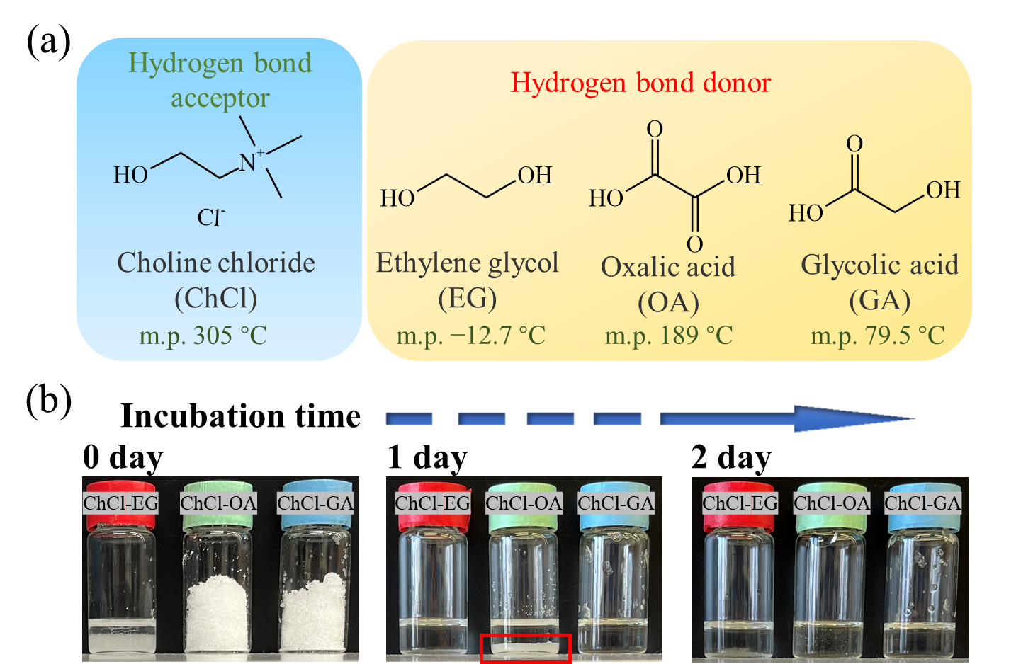
Fig. 1 (a) Chemical structures and melting points (m.p.) of choline chloride (C₅H₁₄ClNO), ethylene glycol (C₂H₆O₂), oxalic acid (C₂H₂O₄), and glycolic acid (C₂H₄O₃). The melting point data were extracted from the CRC Handbook of Chemistry and Physics [23]. (b) Appearance of DESs at different incubation times at 50 ℃.

3.2 Leaching performance
To evaluate the leaching efficiencies of the DESs to metal oxides, the leaching yields to CuO, Cu₂O, Fe₂O₃, ZnO, SnO₂, PbO, and Ag by aqueous HCl and DESs as lixiviants were plotted over time, as shown in Fig. 2a. The HCl solution exhibited the best leaching performance, and more than 80% of the metal oxides could be leached by the HCl solution in 3 h [24]. The leaching yields by ChCl-EG DES were low, with one fifth of the metal oxides leached within 8 h. The leaching efficiencies of the ChCl-OA DES to metal oxides except Fe₂O₃ were satisfactory (more than 60% in 8 h) [25]. The ChCl-GA DES exhibited leaching selectivity to ZnO, and its yield was considerably higher than that of the other metal oxides. Table S1 summarizes the separation factors of ZnO to other metal oxides leached by HCl and the ChCl-OA and -GA DESs. In general, higher separation factors indicate superior separation performances of the metal oxides dissolved in the liquid with the other metal oxides that remain undissolved in the solid form by leaching. The separation factors of ZnO to CuO and Cu₂O by the ChCl-GA DES were > 7 and > 4, respectively, higher than those associated with HCl and ChCl-OA, especially in the initial stage of leaching. Ag exhibited poor dissolution and was almost insoluble in the HCl solution and DESs. Compared with the HCl solution, the DESs were more effective in promoting metal separation owing to their selective leaching property, although the leaching yields for the DESs were lower than those using HCl solution. It is worth noting that the DES composed of ChCl with OA exhibits high leaching effectiveness for the mixed metal powder, whereas the metal powder can not be effectively dissolved by OA molecules in the aqueous system because the formed metal oxalate precipitated on the powder surface and inhibited further leaching in the powder interior [26].
Fig. 2 (a) Leaching yield (%) to metals using HCl and the ChCl-EG, -OA, and -GA DESs as a function of time at 50 ℃. The concentration and volume of the aqueous HCl solution were 2 mol/dm³ and 5 dm³, respectively, and 0.01 mol of DESs were used. (b) Appearance of CuO-bearing aqueous HCl (left) and ChCl-OA (medium) and -GA (right) DES media after 8-h leaching.

Figure 2b (please see the upper left corner of Figure 2) shows the appearance of CuO bearing HCl, ChCl-OA, and -GA DES media. Images of other metal oxides are not shown because they were either colorless or exhibited the same color as the HCl and DES solutions. The CuO-bearing HCl solution was blue, typical of Cu²⁺ in aqueous environments. The CuO-bearing ChCl-OA and -GA DESs were bright yellow, with slight differences in the color depth. The distinctive yellow color of the CuO-bearing DESs was attributable to the formation of [CuCl₄]²⁻ [27], which has been previously demonstrated in high Cl⁻ media through extended X-ray absorption fine structure analyses [28]. This metal speciation in the DESs was the most likely reason for the leaching selectivity exhibited by the DESs to metal oxides.
Furthermore, the saturated loading capacities of the metal oxides were examined to evaluate the leaching performance by DESs. As shown in Fig. 3, the more acidic ChCl-OA and -GA DESs had considerably higher loadings of metal oxides than the ChCl-EG DES, potentially because a higher acidity was required to break the metal-oxide bonds acting as oxygen acceptors to promote leaching [29]. The saturated loading capacities for ZnO by the ChCl-OA and -GA DESs were 84.8 mg/g and 67.7 mg/g, respectively, consistent with the results of Zumer et al. [25]. In particular, the saturated loading capacity of ZnO was the highest among the studied metal oxides, potentially because of the formation of strong Zn complexes in the DESs [28]. Shak et al., who compared the stability constants of different metals with Cl⁻, suggested that Zn-Cl complexes are more stable than other metal complexes [30]. The order of saturated loading capacities by the ChCl-OA DES was ZnO > Cu₂O > PbO > CuO > SnO₂ > Fe₂O₃, consistent with previously reported results [31,32]. SnO₂ and Fe₂O₃ were more stable and difficult to dissolve owing to their higher charge and higher Lewis acidity values [33]. In addition, although the amounts of hydroxyl (-OH) and carboxyl groups (-COOH) in the ChCl-GA DESs were half the sum of those in the ChCl-EG and -OA DESs, the saturated loading capacities of the ChCl-GA DESs to metal oxides were more than half the sum of those of ChCl-EG and ChCl-OA, as shown in Fig. 3. This result suggested that the metal speciation in the DESs was related to not only the media acidity and concentration of Cl⁻, but also the anions from the deprotonated HBD used as a ligand [34].

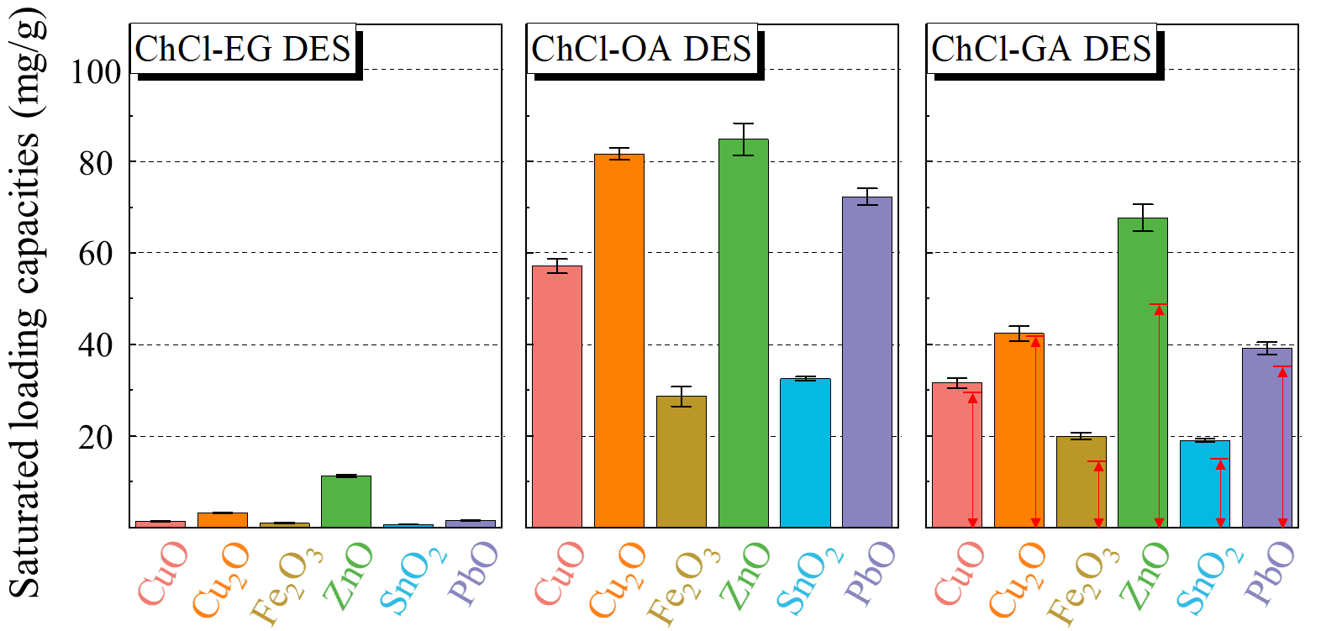
Fig. 3 Saturated loading capacities to metal oxides using ChCl-EG, -OA, and -GA DESs at 50 ℃. The red arrows indicate that the saturated loading capacity of ChCl-GA is half the sum of those of ChCl-EG and -OA.

3.3 Metal recovery from WPCBs by DESs
3.3.1 Recovery by two-step DES leaching
Figure 4 shows the proposed method for selective metal recovery from WPCBs, based on two-step leaching by the ChCl-OA and -GA DESs. First, the raw WPCBs were treated by mechanical processing, including dismantling, crushing, and sorting. Because the mechanical treatment of the WPCBs is not the focus of this study, the details are not presented here. The collected mixed metal powder was heated in air at 1100 °C for 10 h. The mixed metal powder was subjected to calcination for three reasons. First, the small amount of residual resin could be removed by calcination. Second, calcination helped convert the metals to their oxide forms, as indicated by a study on WPCB pyrolysis [35], and the metal oxides could be more easily dissolved than metals or alloys. Third, the metal speciation was rendered consistent, given that the same metals existed in different alloys and components before the calcination.
The mixed metal powder obtained after calcination was leached by the ChCl-GA DES for 2 h. The underlying mechanism of the ChCl-GA DES leaching to metal oxides can be formulated (Eq. 6).
${MO}_{x}+yA_{DES}^{-}+2xH_{DES}^{+}→{[MA_{y}]}_{DES}^{2x-y}+x{H_{2}O}_{DES}$ (6)
where A⁻ is the coordinated Cl⁻ or deprotonated HBD, and it is important to note that the chemical coordination numbers (x, y, z) and metal complexes can vary for different metal oxides. The leaching process involves the availability of protons from the HBD (GA or OA in this study) in the DES. These protons effectively attack the crystal structure of metal oxides and facilitate the dissolution of metal oxides. Additionally, the Cl⁻ anions provided by HBA (ChCl), can play a crucial role in stabilizing the leached metal ions by forming metal-chloro complexes [36][37]. As demonstrated in Figure 2b, the distinctive yellow color observed in Cu-bearing DES demonstrated the presence of CuCl₄²⁻ as the predominant Cu. The deprotonated HBD as coordinating anions can likely participate the formation of metal complexes in DES media. However, it is worth noting that the species of other metals in DESs, such as Pb, Sn, could not be identified through visual detection based on color or through ultraviolet-visible (UV-Vis) absorption spectroscopy due to their spectroscopic silence [38].
The powder was allowed to be leached by the ChCl-GA DES for 2 h to ensure the low dissolution of metal oxides other than ZnO. In particular, the high separation factors of ZnO with metal oxides (Table S1) facilitated the separation of ZnO from other solid metal oxides. After filtration, the metals in the leachate could be recovered as the precipitate of the Zn-rich oxalate through the addition of OA solution to the ChCl-GA DES. The reactions in this process could be expressed as follows:
${[{MA}_{y}]}_{DES}^{2x-y}\underset{→}{H_{2}O}M_{aq}^{2x+}+yA_{aq}^{-}$ (7a)
$M_{aq}^{2x+}+xC_{2}O_{4,aq}^{2-}+zH_{2}O→{{M(C_{2}O_{4})}_{x}∙zH_{2}O}_{s}$ (7b)
where the subscripts DES, aq, and s represent the DES media, aqueous media, and solid, respectively. The residue was subjected to ChCl-OA DES leaching, in which Cu and part of the Fe and Sn were dissolved. All the precious metals remained in the insoluble matter after filtering, and thus, this part was termed the precious-metal-rich residue. When water is added to the filtrate, CuCl₄²⁻ ions as the dominant Cu species in the ChCl-OA DES, would dissolve in the water and subsequently convert to Cu²⁺ ions. Simultaneously, the OA ligands dissolved in aqueous solution could also undergo conversion to form C₂O₄²⁻ ions. In this aqueous environment, Cu²⁺ ions can interact with the C₂O₄²⁻ ions, leading to the formation of CuC₂O₄·2H₂O with an extremely low solubility product (K_{sp} = 4.43 × 10⁻¹⁰) in an aqueous solution [23]. Fast-settling blue solid precipitation observed is attributed to the formation of CuC₂O₄·2H₂O when introducing water into DES systems. The chemical reactions of Pb recovery were similar to those of Cu. The dissolved Fe³⁺ and Sn⁴⁺ remained in the high-concentration OA solution, potentially in their oxalate complex forms as [Fe(C₂O₄)₃]³⁻ [39] and [Sn(C₂O₄)₃]²⁻ [40], respectively. The reduction of Fe³⁺ and Sn⁴⁺ from aqueous raffinate was achieved by introducing Fe powder. The Sn-rich oxalate precipitation involved the following reactions:
${Fe}_{s}+2{[{Fe(C_{2}O_{4})}_{3}]}_{aq}^{3-}+2{H_{2}O}_{aq}→{3FeC_{2}O_{4}∙2H_{2}O}_{s}+3C_{2}O_{4,aq}^{2-}$ (8a)
${Fe}_{s}+{[{Sn(C_{2}O_{4})}_{3}]}_{aq}^{2-}+4{H_{2}O}_{aq}→{FeC_{2}O_{4}∙2H_{2}O}_{s}+{SnC_{2}O_{4}∙2H_{2}O}_{s}+C_{2}O_{4,aq}^{2-}$ (8b)
The mixed metal before and after calcination and the recovery products obtained using the proposed strategy were characterized. Figure 5 shows the corresponding images and XRD patterns (for phase analysis), and Fig. 6 shows the metal flow map from the mixed metal powder after calcination to the recovery products. Detailed information about the metal content in each recovery product is presented in Table S2 of Supplementary Material. The recovery yields of the studied metals were not restricted by the saturated loading capacities of the DESs according to the results shown in Fig. 3.
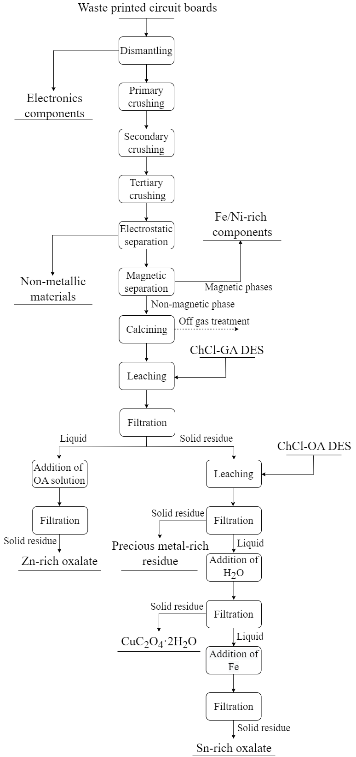
Fig. 4 Processing route for metal recovery from WPCBs by mechanical treatment and DES leaching

3.3.2 Mixed metal powders before and after calcination
As shown in Figs. 5a and b, the mixed metal powder before calcination was red and included a small amount of silver-white solids with non-uniform particle sizes, classified as solders. The mixed metal powder appeared as a homogeneous black solid after calcination. The XRD analysis of the initial samples indicated the presence of Cu as the dominant phase along with Cu–Sn and Cu–Fe alloys. Moreover, several unidentified signals were observed because of the complex components of WPCBs [41]. The XRD patterns of the samples subjected to calcination displayed strong diffraction peaks corresponding to CuO. Other metal oxide phases, namely Cu₂O, Fe₂O₃ and ZnO, were identified, along with several unassigned weak peaks. Table 1 summarizes the metal mass and distribution in weight. The metal distribution of the WPCBs in this study was similar to that reported by Ghodrat [42]. Cu accounted for > 60 wt.%, followed Pb, Sn, Fe, and Zn in the mixed metal powder before calcination. Although Pb-related phases were not identified in the XRD patterns, the metal analysis showed that Pb in the mixed metal powder before and after calcination accounted for 14.87 wt.% and 7.67 wt.%, respectively. The loss of more than half of the mass of Sn and Pb after calcination was likely attributable to their low melting points.

Table 1 Metal mass (g) and distribution in weight (wt.%) of the mixed metal powder before and after calcination. The values in the parentheses following numerical values represent the corresponding standard deviations in duplicate experiments.
Metals | Initial |  | Calcination
Metals | Mass (g) | Distribution (wt.%) | Mass (g) | Distribution (wt.%)
Cu | 2.82 (0.08) | 62.53 | 2.62 (0.09) | 75.07
Fe | 0.26 (0.01) | 5.76 | 0.20 (0.02) | 5.73
Zn | 0.25 (0.01) | 5.54 | 0.23 (0.00) | 6.59
Sn | 0.51 (0.04) | 11.31 | 0.17 (0.01) | 4.87
Pb | 0.67 (0.12) | 14.86 | 0.27 (0.02) | 7.74

3.3.3 Zn-rich oxalate
Figure 5c shows that the XRD measurements of the collected blue precipitate matched the reference patterns for the CuC₂O₄·2H₂O, ZnC₂O₄·2H₂O, and PbC₂O₄·2H₂O phases, and no significant impurity phases related to Fe, Sn, and Pb were detected. The metal analysis (Fig. 6) evidenced the presence of 90.35% of Zn, 16.77% of Cu, and 80.47% of Pb. The Fe and Sn contents were below the detection limit of ICP-OES and could not be quantified, although the time-dependent leaching results (Fig. 2) showed that approximately 20% of SnO₂ and Fe₂O₃ could be dissolved by the ChCl-GA DES in 2 h. The significant inhibition of the dissolution of Fe and Sn could potentially be attributed to the competing effect of the Cu and Zn components with high contents and leaching reactivities. Notably, the coexistence of Cu in Zn-rich oxalate is undesirable because it can decrease the subsequent recovery yields of Cu. According to the results of the ChCl-GA leaching, Cu₂O was more easily leached than CuO. Therefore, the calcination temperature and time should be optimized to inhibit the formation of Cu₂O and minimize the amount of Cu in the Zn-rich oxalate. Moreover, the recovery of Zn and Pb must be comprehensively considered because of their lower usefulness than those of other metals.

3.3.4 Precious-metal-rich residue
Instead of the initially added black solid of mixed metal powder after calcination, a small amount of blue precipitate was observed on the filter paper (Fig. 5d). SEM images and the corresponding EDX spectra of the precious metal rich residue are given in Figure S1 of Supplementary. Microscopic morphology revealed that the particles of precious metal rich residue were predominantly spherical in nature. EDX spectra showed a major presence of Cu (> 99%) with a minor amount of Fe. The identification of CuC₂O₄·2H₂O as the Cu compound was deduced from the blue color observed in the filter papers, as the reaction of the protons in the DES with the metal oxides formed a small volume of water, resulting in a small amount of Cu precipitation. To investigate the presence of precious metals, Ag was selected as a representative due to the sample preparation involving sprayed gold. However, regrettably, EDX analysis did not detect the presence of Ag in the precious metal-rich residue. The contents of precious metals in the original PCBs were found to be extremely low, comprising less than 0.33% of the metallic composition. This rarity of precious metals may explain their absence in the current residue. To improve the chances of detecting and characterizing these precious metals form the precious metal rich residue, it is suggested to optimize the experimental conditions to generate a reduced amount of CuC₂O₄·2H₂O and to use a larger quantity of adopted mixed metal powder for leaching experiments.

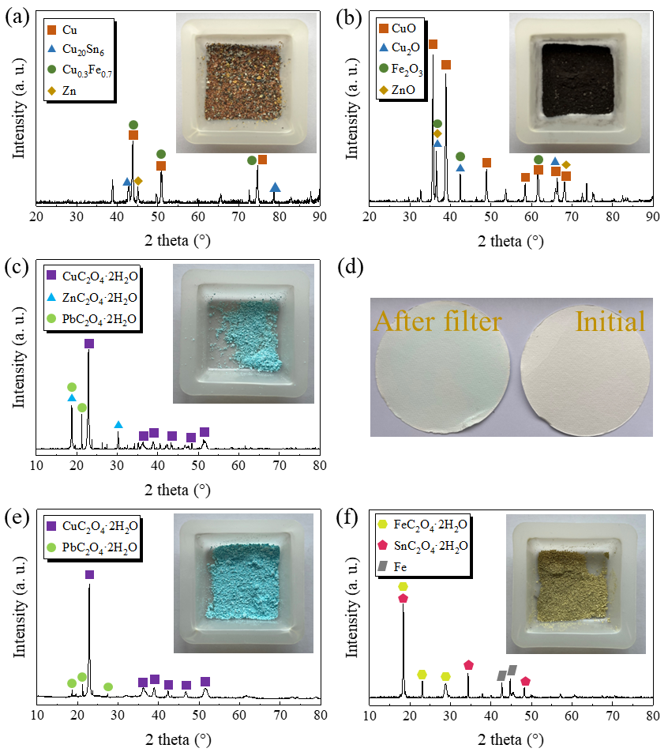
Fig. 5 Appearance and XRD patterns of the mixed metal powder (a) before and (b) after calcination and the recovery products: (c) Zn-rich oxalate, (e) CuC₂O₄·2H₂O, and (f) Sn-rich oxalate. (d) Images of filter paper before and after filtration by the ChCl-OA DES.

3.3.5 CuC₂O₄·2H₂O
The recorded XRD patterns (Fig. 5e) could be indexed to CuC₂O₄·2H₂O and classified as the orthorhombic β-phase. The metal analysis demonstrated that the recovery yield of Cu reached 74.93%, and the purity of CuC₂O₄·2H₂O was approximately 98.06 wt.%, with minor quantities of Pb. Zn, Fe, and Sn were not observed.

3.3.6 Sn-rich oxalate
The dark yellow precipitate was subjected to XRD analysis, and the results indicated the formation of Fe, FeC₂O₄·2H₂O, and SnC₂O₄·2H₂O (Fig. 5f). The recovery yields of Sn and Fe were 51.29% and 75.68%, respectively. The recovery yield of Fe was calculated by excluding the mass of the added reduced Fe powder. The nonnegligible mass loss of Sn may be attributable to the following two causes: (1) Partial Sn components remained in the precious-metal-rich residue owing to incomplete dissolution; and (2) the obtained oxalate product SnC₂O₄·2H₂O exhibited higher solubility in the highly concentrated oxalate solution, resulting in the lower recovery efficiencies by precipitation [43].

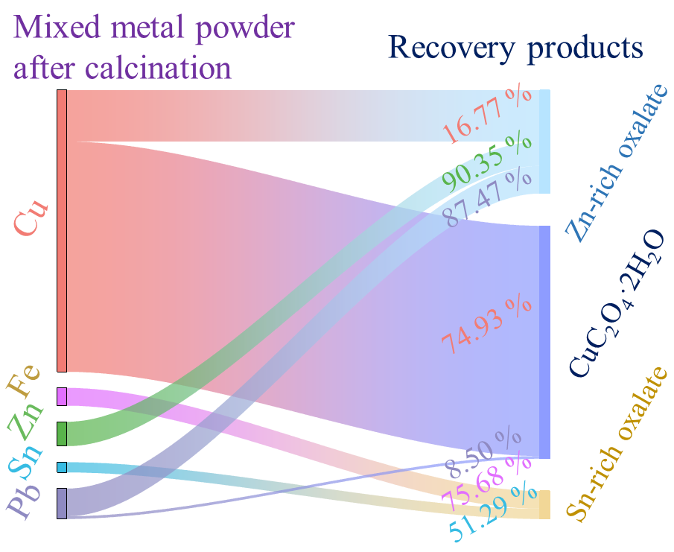
Fig. 6 Metal flow map from the oxidized mixed metal powder to recovery products. The width of flow represents the metal mass. The values correspond to the recovery yields of targeted metals as the average values in the duplicate experiments. The recovery yield of Fe in the Sn-rich oxalate is calculated by subtracting the mass of additional Fe powder. The metal contents in each recovery product lower than the detection limit of ICP-MS or the recovery rate of < 2% are not shown here.

It is worth noting that the introduction of water into DESs leads to the disruption of their hydrogen bond network, ultimately destroying the DES structure [44]. The attempt to recycle DES through evaporation from the solution containing ChCl and either GA or OA proves to be challenging due to the moisture absorption property, particularly noticeable in ChCl [45]. The incomplete removal of water will significantly adversely affect the leaching performance of the rescued DESs, because the CuC₂O₄·2H₂O can be formed by the existing H₂O and then precipitated on the surface of the mixed metal powder. Reducing the usage of ChCl by adjusting the ratio of HBD to HBA may be an effective approach for DES recycling and warrant further investigation. In addition, the recovery of the chemicals employed in this method, including ChCl, GA, and OA, is necessary to be further discussed from a cost perspective.

3.4 Advantages of the recovery strategy for WPCB proposed in this study.
The comparisons of the proposed method with conventional pyro- and hydrometallurgical processes on WPCBs are summarized in Table 2 from the process complexity and environmental impacts point of view. In the pyrometallurgical process, the crushed rare PCBs are liquefied in a furnace or in a molten bath to remove non-metallic constituents, which inevitably produces a large number of toxic gases, such as dioxins and furans [46]. The low distribution ratios of the target metals in the slag phase and metal alloy phase result in their low recovery rate [47]. Generally, pure metal can be obtained followed by the combined electrolytic refining technology [48]. The hydrometallurgical process would also produce a number of hazardous gases, such as NO_{x} and HCl gases, in the concentrated HNO₃ and HCl leaching, respectively [49][50]. Although there are almost no gases produced using H₂SO₄ and OA as leaching agents, they exhibit an extremely poor metal solubilization compared to HNO₃ and HCl. For example, Jadhav et al. found that total Cu dissolution by HCl and HNO3 leaching required 22 and 96 hours, respectively, whereas Cu dissolution using H₂SO₄ and OA for 96 hours only reached 8.8% and 9.89% [46]. Separation of individual metals by hydrometallurgy also requires the additional technology because of the low leaching selectivity of mineral acids, such as the combination of the chemical precipitation, or solvent extraction, which makes the hydrometallurgical process more complicated [51], and the produced solid and liquid wastes need to be treated before discharge [50].
Although the mixed metal powder was subjected to calcination for strengthening the DES leaching processes in the strategy proposed in this work, the re-separation by mechanical processing ensures that the content of non-metallic materials in mixed metal powder is generally < 3%. In addition, it is widely accepted that DES have negligible vapour pressures [52]. Therefore, the gases produced in this method can be neglected in the calcination and DES leaching processes. The metal separation in this study is simple, only by diluting of OA solution for Zn-oxalate precipitation, diluting of water for CuC₂O4·2H₂O precipitation, and adding Fe for Sn-oxalate precipitation. Most importantly, all the chemicals used in this study are environmentally friendly, non-toxic and readily degradable compared to the mineral acid, toxic precipitant and solvents. Therefore, this study presented a simple and environmentally friendly recovery strategy for WPCB based on mechanical processing and two-stage DES leaching, superior to the conventional pyro- and hydro-metallurgical recovery treatment for WPCBs. However, the proposed method does not exhibit a significant advantage in metal recovery yield at the current experimental condition compared to pyrometallurgy and hydrometallurgy. As a result, the experimental conditions, e.g., the ratio of HBA to HBD in DES, the appropriate L/S ratio, leaching temperature, and the volume of added water, are needed to be further optimized in the following study. These optimizations are crucial to enhance leaching selectivity, improve the recovery efficiency of valuable metals, and ensure higher purity of the obtained products.

Table 2 Comparisons of the proposed method with conventional pyro- and hydrometallurgical processes
 | Process complexity | Environmental impacts | Recovery yields of target metals
Pyrometallurgy | Simple but low recovery rate. General combination with electrolytic refining to obtain the pure metals. | A quantity of toxic gases can be produced from non-metallic components in WPCB incineration and melting. | Cu: 82.17%  (Pyrolysis- electrowinning)[53]
Hydrometallurgy | Relatively complex (other separation methods, such as chemical precipitation, solvent extraction, are required). | Hazardous gases can be produced during HNO₃ and HCl leaching processes, and the effluent generated is harmful to the environment due to the use of mineral acids and toxic solvents. | Cu: 99.47  (H₂SO₄-H₂O₂)[54]  Cu: 96%  Sn: 81%  (Acid/FeCl₃ leaching-electrowinning) [55]
Proposed method in this study | Simple. The recovery of Zn, Cu and Sn can be achieved only by the addition of oxalic acid, water, and Fe powder, into DESs or aqueous solution. | The chemical used in this study is non-toxic and readily biodegradable. However, a small number of toxic gases would be generated during the calcination. The chemical precipitation method adopted for metal recovery is effective and is not entirely exempt from having adverse effects on the environment. | Cu: 85.21%  Fe: 75.29%  Zn: 83.12%  Sn: 22.09%  Pb: 38.67%

4. Conclusions
Three DESs were synthesized by a simple procedure of mixing and heating, using ChCl as the HBA and EG, OA, and GA as the HBDs in the eutectic mixtures, respectively. The time-dependent leaching yields and saturated loading capacities of the three DESs to CuO, Cu₂O, Fe₂O₃, SnO₂, PbO, ZnO, and Ag were explored. More than 60% of each metal oxide except Fe₂O₃ could be effectively leached by the ChCl-OA DES within 8 h. Meanwhile, the leaching yield of ZnO by the ChCl-GA DES was approximately 90% in 2 h, while less than half of the other metal oxides were dissolved. Considering these results, a simple and environmentally friendly strategy for metal recovery from WPCBs was established based on two-step DES leaching. The raw WPCBs were treated by mechanical processing, including dismantling, crushing, and sorting, and the mixed metal powder was collected. The powder was subjected to calcination, followed by ChCl-GA DES treatment. A blue precipitate formed when OA solution was introduced to the ChCl-GA DES. The precipitate contained ZnC₂O₄·2H₂O, PbC₂O₄·2H₂O, and CuC₂O₄·2H₂O, with the recovery yields for Zn, Pb, and Cu being 90.35%, 87.47%, and 16.77%, respectively. The residue was subjected to ChCl-OA DES leaching. Cu was recovered by diluting the ChCl-OA DES leachate with water. Specifically, 74.93% of Cu was precipitated in the form of CuC₂O₄·2H₂O with a purity of 98.06 wt.%. The remaining Sn in the aqueous solution was efficiently recovered by the addition of reduced Fe powder, with the Sn recovery yield being 51.29%. The recovery yields of the target metals and purity of CuC₂O₄·2H₂O could potentially be enhanced by optimizing the experimental conditions.
Compared with the conventional pyro and hydrometallurgical recovery process, the proposed recovery strategy is simple and requires low-cost and environmentally friendly chemicals, e.g., ChCl, OA, GA, and Fe powder, thus the proposed framework can thus promote metal recovery from WPCBs through a facile and green approach.

Conflicts of Interest
The authors declare no conflict of interest.

Author Contributions
Qi Zhao: Conceptualization, Methodology, Writing-Original, Visualization; Shengshou Ma: Resources; Wanghoe Ho: Methodology; Yixuan Wang: Visualization; Jaden Yuen Ho Tao: Writing-Review, Discussion & Editing; Kaimin Shih: Conceptualization, Writing-Review, Discussion & Editing, Supervision, Funding acquisition

Acknowledgments
The authors acknowledge the research fund provided by the Research Grants Council of Hong Kong (Project 17208120) and thank Mr. Zheng (Recycle Machinery Group, Zhengyang Machinery Equipment Co., Ltd., Zhengzhou, China) for providing the mixed metal powder from the waste printed circuit boards.

Supplementary Materials
The supplementary data associated with this article can be found in the online version at

References
[1] D. Khrustalev, A. Tirzhanov, A. Khrustaleva, M. Mustafin, A. Yedrissov, A new approach to designing easily recyclable printed circuit boards, Sci. Rep. 12 (2022) 1–9. https://doi.org/10.1038/s41598-022-26677-y.
[2] Y. Xian, Y. Tao, F. Ma, Y. Zhou, Recovery of metals from heat-treated printed circuit boards via an enhanced gravity concentrator and high-gradient magnetic separator, Materials (Basel). 14 (2021). https://doi.org/10.3390/ma14164566.
[3] A. Santaolalla, P.N.L. Lens, A. Barona, N. Rojo, A. Ocio, G. Gallastegui, Metal extraction and recovery from mobile phone PCBs by a combination of bioleaching and precipitation processes, Minerals. 11 (2021) 1004.
[4] P. Hadi, P. Gao, J.P. Barford, G. McKay, Novel application of the nonmetallic fraction of the recycled printed circuit boards as a toxic heavy metal adsorbent, J. Hazard. Mater. 252–253 (2013) 166–170. https://doi.org/10.1016/j.jhazmat.2013.02.037.
[5] A. Batnasan, K. Haga, H.H. Huang, High-pressure oxidative leaching and iodide leaching followed by selective precipitation for recovery of base and precious metals from waste printed circuit boards ash, Metals (Basel). 9 (2019) 363. https://doi.org/10.3390/met9030363.
[6] Y. Qi, X. Yi, Y. Zhang, F. Meng, J. Shu, F. Xiu, Z. Sun, S. Sun, Effect of ionic liquid [MIm]HSO₄ on WPCB metal-enriched scraps refined by slurry electrolysis, Environ. Sci. Pollut. Res. 26 (2019) 33260–33268.
[7] A. Amato, A. Becci, F. Beolchini, Sustainable recovery of Cu, Fe and Zn from end-of-life printed circuit boards, Resour. Conserv. Recycl. 158 (2020) 104792. https://doi.org/10.1016/j.resconrec.2020.104792.
[8] Ž. Kamberović, M. Ranitović, M. Korać, Z. Andjić, N. Gajić, J. Djokić, S. Jevtić, Hydrometallurgical process for selective metals recovery from waste-printed circuit boards, Metals (Basel). 8 (2018). https://doi.org/10.3390/met8060441.
[9] P.R. Jadhao, E. Ahmad, K.K. Pant, K.D.P. Nigam, Environmentally friendly approach for the recovery of metallic fraction from waste printed circuit boards using pyrolysis and ultrasonication, Waste Manag. 118 (2020) 150–160. https://doi.org/10.1016/j.wasman.2020.08.028.
[10] I. Birloaga, F. Vegliò, Study of multi-step hydrometallurgical methods to extract the valuable content of gold, silver and copper from waste printed circuit boards, J. Environ. Chem. Eng. 4 (2016) 20–29. https://doi.org/10.1016/j.jece.2015.11.021.
[11] M. Rezaee, H. Abdollahi, R. Saneie, A. Mohammadzadeh, A cleaner approach for high-efficiency regeneration of base and precious metals from waste printed circuit boards through stepwise oxido-acidic and thiocyanate leaching, Chemosphere. 298 (2022) 134283. https://doi.org/10.1016/j.chemosphere.2022.134283.
[12] G. Zante, M. Boltoeva, Review on hydrometallurgical recovery of metals with deep eutectic solvents, Sustain. Chem. 1 (2020) 238–255. https://doi.org/10.3390/suschem1030016.
[13] E.L. Smith, A.P. Abbott, K.S. Ryder, Deep eutectic solvents (DESs) and their applications, Chem. Rev. 114 (2014) 11060–11082. https://doi.org/10.1021/cr300162p.
[14] A.P. Abbott, G. Capper, D.L. Davies, R.K. Rasheed, P. Shikotra, Selective extraction of metals from mixed oxide matrixes using choline-based ionic liquids, Inorg. Chem. 44 (2005) 6497–6499. https://doi.org/10.1021/ic0505450.
[15] K. Radošević, M. Cvjetko Bubalo, V. Gaurina Srček, D. Grgas, T. Landeka Dragičević, R.I. Redovniković, Evaluation of toxicity and biodegradability of choline chloride based deep eutectic solvents, Ecotoxicol. Environ. Saf. 112 (2015) 46–53. https://doi.org/10.1016/j.ecoenv.2014.09.034.
[16] S. Tahir, U.Y. Qazi, Z. Naseem, N. Tahir, M. Zahid, R. Javaid, I. Shahid, Deep eutectic solvents as alternative green solvents for the efficient desulfurization of liquid fuel: A comprehensive review, Fuel. 305 (2021) 121502. https://doi.org/10.1016/j.fuel.2021.121502.
[17] M.K. Tran, M.T.F. Rodrigues, K. Kato, G. Babu, P.M. Ajayan, Deep eutectic solvents for cathode recycling of Li-ion batteries, Nat. Energy. 4 (2019) 339–345. https://doi.org/10.1038/s41560-019-0368-4.
[18] P.G. Schiavi, P. Altimari, M. Branchi, R. Zanoni, G. Simonetti, M.A. Navarra, F. Pagnanelli, Selective recovery of cobalt from mixed lithium ion battery wastes using deep eutectic solvent, Chem. Eng. J. 417 (2021) 129249. https://doi.org/10.1016/j.cej.2021.129249.
[19] I.M. Pateli, A.P. Abbott, K. Binnemans, N. Rodriguez Rodriguez, Recovery of yttrium and europium from spent fluorescent lamps using pure levulinic acid and the deep eutectic solvent levulinic acid-choline chloride, RSC Adv. 10 (2020) 28879–28890. https://doi.org/10.1039/d0ra05508e.
[20] K. Huang, J. Guo, Z. Xu, Recycling of waste printed circuit boards: A review of current technologies and treatment status in China, J. Hazard. Mater. 164 (2009) 399–408. https://doi.org/10.1016/j.jhazmat.2008.08.051.
[21] B. Li, S.G. Zhang, K. Zhang, D.A. Pan, J.J. Tian, D.T. Zhang, Preparation of pure SnO₂ powders from tin slag of printed circuit boards waste, Rare Met. 33 (2014) 749–753. https://doi.org/10.1007/s12598-014-0366-4.
[22] A.P. Abbott, D. Boothby, G. Capper, D.L. Davies, R.K. Rasheed, Deep eutectic solvents formed between choline chloride and carboxylic acids: Versatile alternatives to ionic liquids, J. Am. Chem. Soc. 126 (2004) 9142–9147. https://doi.org/10.1021/ja048266j.
[23] D.R. Lide, W.M.M. Haynes, G. Baysinger, L.I. Berger, H.V. Kehiaian, D.L. Roth, K. Kuchitsu, D. Zwillinger, M. Frenkel, R.N. Goldberg, CRC Handbook of Chemistry and Physics, 90th ed (2009). Journal of the American Chemical Society.
[24] S.A.A. Panghal, I.M.S. Mallick, Urban mining: Recovery of metals from printed circuit boards, Int. J. Environ. Sci. Technol. 19 (2022) 9731–9740. https://doi.org/10.1007/s13762-021-03662-y.
[25] P. Zürner, G. Frisch, Leaching and selective extraction of indium and tin from zinc flue dust using an oxalic acid-based deep eutectic solvent, ACS Sustain. Chem. Eng. 7 (2019) 5300–5308. https://doi.org/10.1021/acssuschemeng.8b06331.
[26] M. Saidan, B. Brown, M. Valix, Leaching of electronic waste using biometabolised acids, Chinese J. Chem. Eng. 20 (2012) 530–534. https://doi.org/10.1016/S1004-9541(11)60215-2.
[27] R. Marin Rivera, G. Zante, J.M. Hartley, K.S. Ryder, A.P. Abbott, Catalytic dissolution of metals from printed circuit boards using a calcium chloride-based deep eutectic solvent, Green Chem. 24 (2022) 3023–3034. https://doi.org/10.1039/d1gc04694b.
[28] J.M. Hartley, C. Ip, G.C.H. Forrest, K. Singh, S.J. Gurman, K.S. Ryder, A.P. Abbott, G. Frisch, EXAFS study into the speciation of metal salts dissolved in ionic liquids and deep eutectic solvents, Inorg. Chem. 53 (2014) 6280–6288. https://doi.org/10.1021/ic500824r.
[29] A. Batnasan, K. Haga, A. Shibayama, Leaching and adsorption of gold from waste printed circuit boards using iodine-iodide solution and activated carbon, Eng. J. 20 (2016). https://doi.org/10.4186/ej.2016.20.4.29.
[30] K. Shah, K. Gupta, B. Sengupta, Selective separation of copper and zinc from spent chloride brass pickle liquors using solvent extraction and metal recovery by precipitation-stripping, J. Environ. Chem. Eng. 5 (2017) 5260–5269. https://doi.org/10.1016/j.jece.2017.09.061.
[31] J. Richter, M. Ruck, Synthesis and dissolution of metal oxides in ionic liquids and deep eutectic solvents, Molecules. 25 (2020) 78. https://doi.org/10.3390/molecules25010078.
[32] A.P. Abbott, G. Capper, D.L. Davies, K.J. McKenzie, S.U. Obi, Solubility of metal oxides in deep eutectic solvents based on choline chloride, J. Chem. Eng. Data. 51 (2006) 1280–1282. https://doi.org/10.1021/je060038c.
[33] I.M. Pateli, D. Thompson, S.S.M. Alabdullah, A.P. Abbott, G.R.T. Jenkin, J.M. Hartley, The effect of pH and hydrogen bond donor on the dissolution of metal oxides in deep eutectic solvents, Green Chem. 22 (2020) 5476–5486. https://doi.org/10.1039/d0gc02023k.
[34] N. Rodriguez Rodriguez, L. MacHiels, K. Binnemans, p-Toluenesulfonic acid-based deep-eutectic solvents for solubilizing metal oxides, ACS Sustain. Chem. Eng. 7 (2019) 3940–3948. https://doi.org/10.1021/acssuschemeng.8b05072.
[35] R. Khayyam Nekouei, F. Pahlevani, R. Golmohammadzadeh, M. Assefi, R. Rajarao, Y.H. Chen, V. Sahajwalla, Recovery of heavy metals from waste printed circuit boards: statistical optimization of leaching and residue characterization, Environ. Sci. Pollut. Res. 26 (2019) 24417–24429. https://doi.org/10.1007/s11356-019-05596-y.
[36] S. Riaño, M. Petranikova, B. Onghena, T. Vander Hoogerstraete, D. Banerjee, M.R.S. Foreman, C. Ekberg, K. Binnemans, Separation of rare earths and other valuable metals from deep-eutectic solvents: A new alternative for the recycling of used NdFeB magnets, RSC Adv. 7 (2017) 32100–32113. https://doi.org/10.1039/c7ra06540j.
[37] N. Peeters, K. Binnemans, S. Riaño, Solvometallurgical recovery of cobalt from lithium-ion battery cathode materials using deep-eutectic solvents, Green Chem. 22 (2020) 4210–4221. https://doi.org/10.1039/d0gc00940g.
[38] G. Damilano, A. Laitinen, P. Willberg-Keyriläinen, T. Lavonen, R. Häkkinen, W. Dehaen, K. Binnemans, L. Kuutti, Effects of thiol substitution in deep-eutectic solvents (DESs) as solvents for metal oxides, RSC Adv. 10 (2020) 23484–23490. https://doi.org/10.1039/d0ra03696j.
[39] Z. Liu, J. Huang, Y. Zhang, T. Liu, P. Hu, H. Liu, Q. Zheng, Separation and recovery of iron impurities from a complex oxalic acid solution containing vanadium by K₃Fe(C₂O₄)₃·3H₂O crystallization, Sep. Purif. Technol. 232 (2020) 115970. https://doi.org/10.1016/j.seppur.2019.115970.
[40] N. Audebrand, M.L. Vaillant, J.P. Auffrédic, D. Louër, Synthesis, open-framework structure and thermal behaviour of ammonium tin oxalate, Sn₂(NH₄)₂(C₂O₄)₃·3H₂O, Solid State Sci. 3 (2001) 483–494. https://doi.org/10.1016/S1293-2558(00)01148-1.
[41] R.K. Nekouei, F. Pahlevani, M. Mayyas, S. Maroufi, Direct transformation of waste printed circuit boards into high surface area t-SnO₂ for photocatalytic dye degradation, J. Environ. Chem. Eng. 7 (2019) 103133. https://doi.org/10.1016/j.jece.2019.103133.
[42] M. Ghodrat, M.A. Rhamdhani, G. Brooks, M. Rashidi, B. Samali, A thermodynamic-based life cycle assessment of precious metal recycling out of waste printed circuit board through secondary copper smelting, Environ. Dev. 24 (2017) 36–49. https://doi.org/10.1016/j.envdev.2017.07.001.
[43] A. Mcauley, G.H. Nancollas, Complex formation in solutions of copper oxalate, Trans. Faraday Soc. 56 (1960) 1165–1171. https://doi.org/0.1039/tf9605601165.
[44] M. Li, C. Zhu, T. Fu, X. Gao, Y. Ma, Effect of water on amine-based deep eutectic solvents (choline chloride + monoethanolamine): Structure and physicochemical properties, J. Environ. Chem. Eng. 10 (2022) 106952. https://doi.org/10.1016/j.jece.2021.106952.
[45] S. Wang, Z. Li, H. Wang, C. Yuan, K. Liu, M. Yuan, Y. Wang, Study on the structure and properties of choline chloride toughened polylactide composites, Polym. Bull. 80 (2022) 9237–9252. https://doi.org/10.1007/s00289-022-04499-2.
[46] U. Jadhav, H. Hocheng, Hydrometallurgical recovery of metals from large printed circuit board pieces, Sci. Reports. (2015) 1–10. https://doi.org/10.1038/srep14574.
[47] Y. Ding, S. Zhang, B. Liu, H. Zheng, C. chi Chang, C. Ekberg, Recovery of precious metals from electronic waste and spent catalysts: A review, Resour. Conserv. Recycl. 141 (2019) 284–298. https://doi.org/10.1016/j.resconrec.2018.10.041.
[48] B. Ghosh, M.K. Ghosh, P. Parhi, P.S. Mukherjee, B.K. Mishra, Waste printed circuit boards recycling: an extensive assessment of current status, J. Clean. Prod. 94 (2015) 5–19. https://doi.org/10.1016/j.jclepro.2015.02.024.
[49] V.V. Gande, S. Vats, N. Bhatt, S. Pushpavanam, Sequential recovery of metals from waste printed circuit boards using a zero-discharge hydrometallurgical process, Clean. Eng. Technol. 4 (2021) 100143. https://doi.org/10.1016/j.clet.2021.100143.
[50] G. van Weert, E.M.L. Peek, Reagent recovery in chloride hydrometallurgy - some missing links, Hydrometallurgy. 29 (1992) 513–526.
[51] Y. Park, Y. Eom, K. Yoo, M.K. Jha, Leaching of copper from waste-printed circuit boards (PCBs) in sulfate medium using cupric ion and oxygen, Metals (Basel). 11 (2021). https://doi.org/10.3390/met11091369.
[52] N.M. Stephens, E.A. Smith, Structure of deep eutectic solvents (DESs): What we know, what we want to know, and why we need to know it, Langmuir. 38 (2022) 14017–14024. https://doi.org/10.1021/acs.langmuir.2c02116.
[53] P. Sivakumar, D. Prabhakaran, M. Thirumarimurugan, Optimization studies on recovery of metals from printed circuit board waste, Bioinorg. Chem. Appl. 2018 (2018). https://doi.org/10.1155/2018/1067512.
[54] J. Hao, X. Wang, Y. Wang, Y. Wu, F. Guo, Optimizing the leaching parameters and studying the kinetics of copper recovery from waste printed circuit boards, ACS Omega. 7 (2022) 3689–3699. https://doi.org/10.1021/acsomega.1c06173.
[55] J.A. Barragan, C. Ponce De León, J.R. Alemán Castro, A. Peregrina-Lucano, F. Gómez-Zamudio, E.R. Larios-Durán, Copper and antimony recovery from electronic waste by hydrometallurgical and electrochemical techniques, ACS Omega. 5 (2020) 12355–12363. https://doi.org/10.1021/acsomega.0c01100.

* Corresponding author: Kaimin Shih, kshih@hku.hk. Phone: +852 2859 1973; Fax: +852 2559 5337

