Constriction size retention criterion for calcium-alginate / polydimethylsiloxane microcapsules in granular materials
Ke Chen¹, Rui Qi¹, Xin Xing¹, Adnan Sufian², Sérgio D.N. Lourenço^{1*}
¹ Department of Civil Engineering, The University of Hong Kong, Hong Kong S.A.R., China
² School of Civil Engineering, The University of Queensland, Brisbane Qld 4072, Australia
* Corresponding author (lourenco@hku.hk)

Abstract
Microcapsules have demonstrated to self-heal cementitious materials. However, their prospect in granular materials and other porous cemented materials remains to be tested. An initial challenge to tackle is to ensure the microcapsules retention in open, interconnected porous media. The purpose of this study is to investigate the retention of microcapsules in gravel under the influence of seepage. This scheme largely coincides with the intention of geotechnical filters to prevent the excessive washout of base soils. A mathematical model previously designed for cohesionless soil is used to establish an initial retention criterion based on the constriction size distribution of gravel (the minimum pore opening size distribution formed by various gravel packings) and, the particle size distribution of microcapsules (made of calcium alginate/polydimethylsiloxane) and an equivalent control material (glass beads). The proposed model is verified experimentally by washout tests on microcapsules-gravel and glass beads-gravel mixtures. Optical microscopy is used to assess the integrity of microcapsules after testing. The lower washout of microcapsules compared with cohesionless glass beads could be attributed to their adhesive nature. By incorporating the influence of size change of microcapsules during drying, which is an intrinsic property of the microcapsules, a modified empirical equation is presented for soft and adhesive microcapsules, demarcating the boundary between effective and ineffective retention for microcapsules-gravel mixtures.
Keywords: Microcapsules; granular materials; porous media; constriction size; washout tests

Highlights
- Constriction size is used to design microcapsules - granular materials mixtures.
- Permeability/washout of glass beads/microcapsules in gravel mixtures are monitored.
- Washout of glass beads and microcapsules depend on constriction size of gravel.
- Loss of microcapsules is minor due to their adhesion-prone and swelling nature.

Graphical Abstract
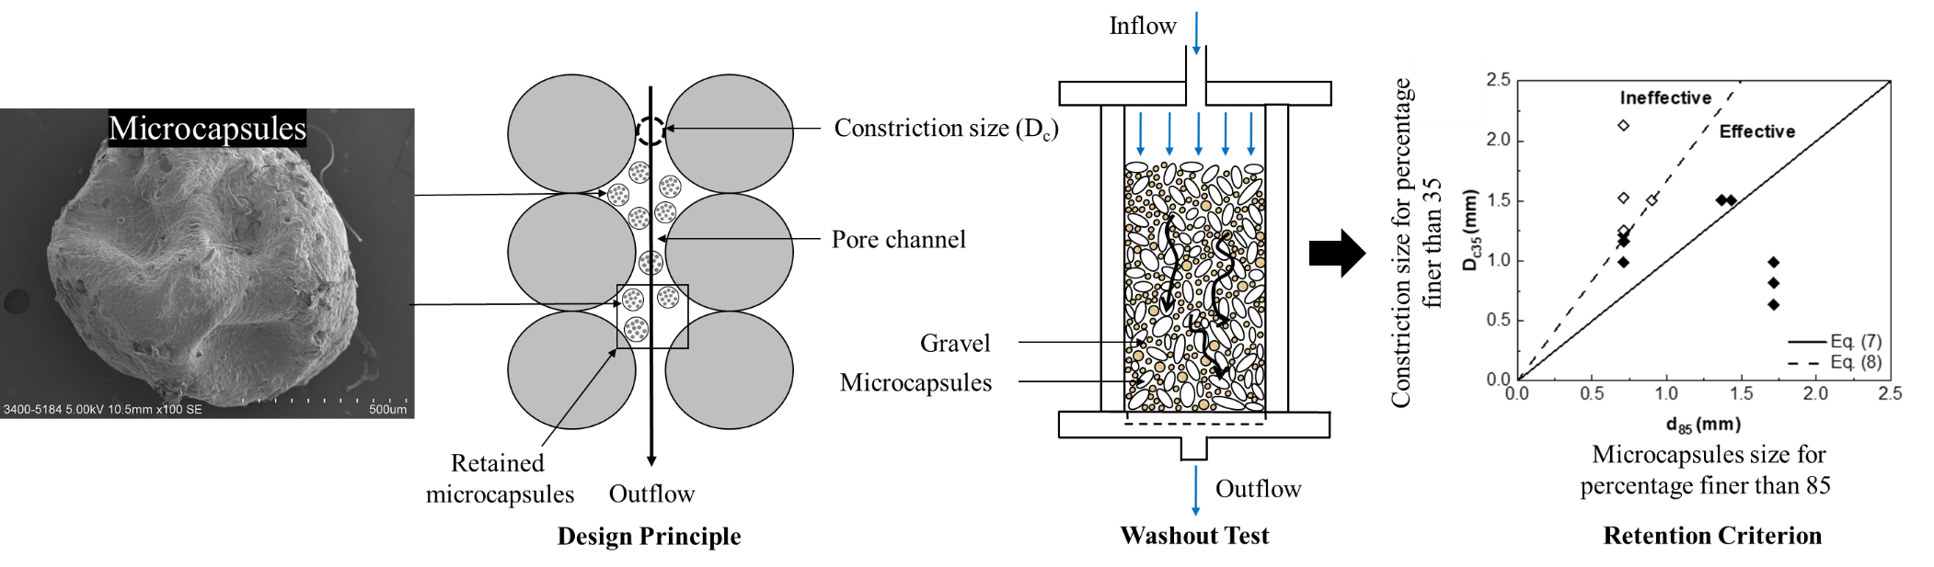

Introduction
Microcapsules were originally developed for self-healing of polymeric composites (White et al., 2001) and have since been widely used in cementitious construction materials (Garcia et al., 2010; Yang et al., 2011). The self-healing effect could be triggered by crack propagation through the microcapsules, by which the healing agents could be released to fill the cracks. This results in recovery of important properties such as permeability, strength and stiffness (Han et al., 2021). For cementitious materials, the particle size of microcapsules should be designed considering the size of microcracks (Kanellopoulos et al., 2016). However, for granular materials and other cemented granular materials, the particle size of microcapsules should have an optimum range so that the microcapsules break and release the cargo into the pores. Xu et al. (2020) suggested that the particle size of microcapsules mixed in cemented coral sand should be larger than the average pore size of the specimen so that they could be cracked during compression.
To date, the investigation of the effectiveness of microcapsules on porous media (e.g., granular materials and other cemented granular materials) remains unexplored. As microencapsulation approaches have been successfully implemented in cementitious materials, it then emerges as a potential solution to switch or enhance the physical properties of granular materials. Irrespective of specific applications and encapsulation techniques, the first issue to be addressed is the microcapsules retention in the pore network. The microcapsules’ size should be designed to prevent them from either being crushed or displaced through the pore network. Specifically, there should be a match between particle size distribution (PSD) of the granular material and the microcapsule size distribution (MSD). The particle size of microcapsules should be large enough to keep them from being washed away by seepage, and simultaneously small enough to allow their retention in pores (Fig. 1). These competing design purposes coincides with the dual role of filters, which play a significant role in the performance of embankment dams. The particle sizes in filters are required to be sufficiently small to prevent the migration of base materials, whilst sufficiently large to allow the seeping water to flow through the filters without the build-up of pore water pressure (Terzaghi, 1922; Babu and Srivastava, 2007). These two competing design requirements have prompted various criteria based on PSD characteristics of filter and base materials.
Criteria for filter design have been generally divided into two categories: empirical relations and mathematical models, where criteria have been validated using laboratory studies on base-filter combinations. Most empirical relations are connected with those developed by Terzaghi (1922) and concentrated on given size ratios for base soil (i.e., the soil adjacent to a filter or drainage zone through which water may pass) and the filter particles (i.e., sand or gravel having a gradation designed to prevent movement of soil particles from a base soil by flowing water) (NRCS, 1994), such as D₁₅/d₁₅ and D₁₅/d₈₅ (Here, D and d represent the size of filter and base respectively, and D_{a} or d_{a} exhibits the percentage by mass of the material that is finer than D_{a} or d_{a}). However, these ratios were expressed across a broad range of soils (e.g., Sherard et al., 1984; USBR, 1987; Honjo and Veneziano, 1989; NRCS, 1994; Indraratna et al., 1996; Fannin, 2008; ICOLD, 2013). Therefore, it is challenging to unbiasedly select any one of them for microcapsules-soil design. In contrast, mathematical models can be formulated to capture behaviors such as particle erosion, migration and retention. Babu and Srivastava (2007) presented an analytical solution to calculate D₁₅, which took factors such as pore size, permeability, and factor of safety against piping into account.
In filter design, the process of particle infiltration, transport and retention with time is explicitly or implicitly considered when the base soils are washed into void spaces of the underlying filter. For soil-microcapsules mixtures under a hydraulic gradient, microcapsules retention is achieved by storing them in pores formed by soil particles in a similar way. Hence, the filter design model forms a basis to create a method for microcapsules retention, as the geometry of the pore system can be quantitatively estimated (Kenney et al., 1985; Lone et al., 2005; Indraratna et al., 2007; Raut and Indraratna, 2008; Moraci et al., 2012; Vincens et al., 2015; Shire and O’Sullivan, 2016). Following this model, a physical parameter (controlling constriction size, D_{c35}) is adapted and is defined by the diameter of the largest rounded particle that can pass through the pore throats. In other words, if the sizes of microcapsules are larger than the controlling constriction sizes by some extent, it is anticipated that most of the microcapsules can be stored in pores for future use. However, the application of the controlling constriction size concept designed for cohesionless soils to predict the retention capability of microcapsules requires further investigation. Microcapsules can be adhesive, experience shrinkage and swelling due to the drying and wetting, and can form aggregates (Jimenez et al., 2010; Kak et al., 2021), all of which are features not common with the cohesionless soils considered in developing the controlling constriction size concept. Nevertheless, the analytical model for cohesionless soils provides a basis to design soil-microcapsules mixture, while the different physicochemical properties (high adhesion and low density) of microcapsules should be incorporated.
In this study, calcium alginate/polydimethylsiloxane (PDMS) microcapsules and gravel, both with different gradations are selected. Calcium alginate microcapsules, which have the advantage of being biodegradable and non-toxic, were produced by the ionic gelation method (Cesari et al., 2016). The constriction size distribution (CSD) of the gravel will be determined using a mathematical model of filtration, which considers the particle size distribution and relative density of the gravel. The controlling constriction size of gravel (D_{c35}) and the characteristic size of microcapsules (d₈₅) are obtained for experimental design. To verify the effectiveness of this mathematical model, a laboratory investigation using a modified filtration apparatus was carried out on a number of microcapsule-gravel and glass beads-gravel mixtures. Glass beads were used as an analogue granular material for which existing retention criteria for cohesionless soils are applicable. Glass beads have comparable composition to cohesionless soils, yet with rounded shape and broad size range similar to the microcapsules considered in this study. Hence, the influence of particle shape and size can be omitted, enabling the study to focus on the influence of adhesion. With similar considerations, Wu et al. (2012) used glass beads and sand separately to study the influence of particle shape on the CSD of filters. The aim of this study is to adapt existing retention criteria for cohesionless base soil for the retention of soft and adhesive microcapsules in granular materials. Specific objectives are: (1) to present a mathematical model to form the basis of microcapsules retention in granular media, (2) to compare the MSD and CSD of gravel by using the controlling constriction size parameter, (3) to assess the effect of various combinations of CSDs of gravel on microcapsules and glass beads washouts, (4) to validate the mathematical model based on the experimental data and, (5) to present an empirical criterion capable of describing microcapsule retention in granular materials after considering adhesion and size change.

Mathematical constriction model for microcapsule-gravel mixtures
2.1. Constriction size distribution
The mathematical formulation of the constriction size distribution (CSD) and the controlling constriction size (D_{c35}) for microcapsule-gravel mixtures is adapted from Indraratna et al. (2007). Filter permeability and migration of fines are related to the constriction size, as it represents the smallest pore size for capturing moving particles. In void models, constriction size was defined as the minimum pore opening size formed by a particle packing as shown in Fig. 2(a) (Aydilek et al., 2005). Most of the packings were assumed to be formed by uniform or nonuniform sized spheres. Firstly, considering the densest arrangement, the constriction size $D_{cD}$ was determined by three particles, which can be obtained by solving the below equation (Humes, 1996; Reboul et al., 2010):
${(\frac{2}{D_{1}})}^{2}+{(\frac{2}{D_{2}})}^{2}+{(\frac{2}{D_{3}})}^{2}+{(\frac{2}{D_{cD}})}^{2}=0.5{\left[\left(\frac{2}{D_{1}}\right)+\left(\frac{2}{D_{2}}\right)+\left(\frac{2}{D_{3}}\right)+(\frac{2}{D_{cD}})\right]}^{2}$ (1)
Where $D_{1}$, $D_{2}$ and $D_{3}$ are the diameter of the particles. This equation is mainly based on the plane geometry to estimate $D_{cD}$. For a loose arrangement, four particles stack together to form a constriction as shown in Fig. 2(b). The constriction area $S_{L}$ among any four particles is given by (Silveira, 1975; Indraratna et al., 2007; Moraci et al., 2012):
$S_{L}=\frac{1}{8}(\left(D_{1}+D_{2}\right)\left(D_{1}+D_{4}\right)sinα+\left(D_{2}+D_{3}\right)\left(D_{2}+D_{4}\right)sinγ-(αD_{1}^{2}+βD_{2}^{2}+γD_{3}^{2}+δD_{4}^{2}))$ (2)
Where $α$, $β$, $γ$ and $δ$ are angles of the quadrilateral formed by connecting the center of the four spheres. By adjusting the angles, the maximum space area $S_{L, max}$ can be obtained. By assuming that the maximum space area $S_{L, max}$ is equivalent to the area of a circle as illustrated in Fig. 2(c), the diameter is the corresponding constriction size $D_{cL}$ in the loosest arrangement, which is given by:
$D_{cL}=\sqrt{\frac{4S_{L,max}}{π}}$ (3)
The frequency of different constriction sizes depends on the frequency of the three or four particle sizes, thus leading to the CSD, which can be calculated statistically. For instance, the frequency $P_{D}$ of $D_{cD}$ in the densest state is a function of the frequency of the three particle sizes ($P_{i}, P_{j}$ and $P_{k}$, which are the percentages finer than specific sizes by mass) obtained from the PSD:
$P_{D}=\frac{3!}{n_{i}!n_{j}!n_{k}!}{(P_{i})}^{n_{i}}{(P_{j})}^{n_{j}}{(P_{k})}^{n_{k}}$ (4)
Where $n_{i}$, $n_{j}$ and $n_{k}$ refer to the number of times the particle size $D_{i}$, $D_{j}$ and $D_{k}$ appear in a specific combination considered. Note that $n_{i}=0$, $1$, $2$, or $3$ and $n_{i}+n_{j}+n_{k}=3$. Similarly, the frequency $P_{L}$ of $D_{cL}$ in the loosest state can be written as:
$P_{L}=\frac{4!}{n_{i}!n_{j}!n_{k}!n_{l}!}{(P_{i})}^{n_{i}}{(P_{j})}^{n_{j}}{(P_{k})}^{n_{k}}{(P_{l})}^{n_{l}}$ (5)
Note that $n_{i}=0$, $1$, $2$, $3$, or $4$ and $n_{i}+n_{j}+n_{k}+n_{l}=4$. These frequencies can be computed, and the CSD of either densest or loosest state is presented as a cumulative distribution.
Two cases are shown in Fig. 2(a) and (c) representing the densest and loosest states of particle packing, respectively. Real assemblies of particles are likely to exist in an intermediate state between the aforementioned extremes. To estimate the constriction size in any random packing, the relative density was introduced (Lock et al., 2001; Indraratna et al., 2007; Shire and O’Sullivan, 2016):
$D_{c}=D_{cD}+P_{c}(1-R_{d})(D_{cL}-D_{cD})$ (6)
Where $D_{c}$ is the constriction size for a given value of the percent finer $P_{c}$ at a given relative density $R_{d}$, which can be obtained by finding the maximum, minimum and current void ratio. An example of this method is shown in Fig. 3, where the CSD is computed based on a given PSD of gravel ranging from 2.0 mm to 11.2 mm. Since the size of microcapsules to be used in this study vary between 0.35 mm and 1.80 mm, gravel larger than 1.80 mm should be selected to ensure that constriction sizes are larger than microcapsules size. The loosest and the densest CSDs are plotted as boundaries, and three CSDs correspond to relative density of 0.8, 0.6 and 0.4 are also computed and plotted in Fig. 3.
2.2. Controlling constriction size
Kenney et al. (1985) used a one-dimensional infiltration model of a void network to quantify the controlling constriction size (i.e., diameter of the largest base particle that can migrate through the filter). They considered that a base soil particle smaller than the controlling constriction size will not be retained in a filter of a given thickness. The controlling constriction size, which is the governing property of a granular filter, is related to factors such as the particle shape, the porosity of the filter, the filtration length, and a representative grain size of the filter. Based on the infiltration depth model proposed by Locke et al. (2001), Indraratna et al. (2007) suggested that the constriction size for a percentage finer than 35% (D_{c35}) by mass can be defined as the controlling constriction size. In other words, a base soil particle smaller than D_{c35} may not be retained unless the pores become clogged by finer particles (Kenney et al., 1985). In both conventional filter design and constriction size-based filter design, d₈₅ by mass was used as a representative size for the microcapsules. For an effective base-filter combination, d₈₅ must be larger than D_{c35} to ensure that at least 15% of the base soil can sustain and fulfill self-filtration, which is a process that larger base particles will not be washed away, making the constriction sizes smaller upon their retention. From this perspective, a controlling constriction size-based criterion considering PSD, CSD, R_{d} (i.e., the relative density), C_{u} and the initiation of self-filtration can be adapted for microcapsules retention design as:
$\frac{d_{85}}{D_{c35}}>1$ (7)

Materials and methods
3.1. Experimental set-up for washout tests
The experimental set-up (Fig. 4) consists of a cylinder of 75 mm diameter and 220 mm length. A faucet spout type base of 126 mm was provided at the end of the cylinder for discharge of water and microcapsules. A wire mesh of 75 mm (sieve) was placed at the top of the base to support the mixture and separate gravel and microcapsules. A flowmeter was connected between the inlet and water tank for regulating the inflow of water. Two manometers were inserted at 100 mm distance alongside the cylinder. Note that the internal diameter of the cylinder should be at least 12 times the maximum particle size of the soil to be tested (BS 1377-5:1990). Therefore, to use gravel larger than 6 mm, a second apparatus with 180 mm in diameter and 400 mm in height, was utilized to conduct the washout tests (other parts remain unchanged).
3.2. Materials
3.2.1 Microcapsules
Calcium alginate/polydimethylsiloxane microcapsules were selected based on their size compatibility with granular materials (μm to mm range) and prior experience with their synthesis. A separate study investigated their healing performance on sands (Qi et al., 2022). Despite polydimethylsiloxane (PDMS) being used to hydrophobize surfaces, cargo release was not observed during the washout tests, as demonstrated in the subsequent results. Therefore, any hydrophobizing effects of PDMS on gravel are insignificant.
PDMS was encapsulated in calcium alginate shells by the ionic gelation method. Sodium alginate (NaC₆H₇O₆) and calcium chloride (CaCl₂) were utilized to form the shell. PDMS is in a liquid form and its density is 965kg/m³. The microcapsules were synthesized in a series of steps: (1) sodium alginate was firstly dissolved in 100g deionized water. (2) PDMS was added into the sodium alginate solution and emulsified with a homogenizer until a stable oil-water emulsion was formed. Note that the mass of PDMS to water (PDMS loading) is 10%. (3) The emulsion droplets were then dripped into a calcium chloride solution through a PTFE tube by means of a syringe pump. (4) After the microcapsules were produced, they were immersed in a calcium chloride solution bath for 24 hours, rinsed with distilled water and filtered. The microcapsules were then dried (25°C, 60% relative humidity) for further use. The MSDs were characterized by a dynamic image analyzer (QicPic™, Sympatec GmbH). Microcapsules with sizes of approximately 0.35-1.80 mm were produced. Scanning electron microscopy (SEM) (Zeiss LEO, 1530 FEG) was used to image the surface characteristics of dried microcapsules as shown in Fig. 5.
3.2.2 Glass beads
Calcium alginate/polydimethylsiloxane microcapsules have a lower specific gravity (0.965) than traditional base materials, such as sand (approximately 2.65 for silicates). As a result, their interaction with seeping water in the pore network is likely to differ from similarly sized silicate minerals. To assess their dynamics under seepage, glass beads with similar glass bead size distribution (GSD) and shape (Table 1, Fig. 6) are considered as a control group, with the results compared to microcapsules.
3.2.3 Gravel
Clean granite gravel ranging in size from 2.36 mm to 16.00 mm was mixed with microcapsules for sample preparation. For ease of comparison, all materials were analyzed to obtain 50% median values of shape (i.e., aspect ratio, sphericity and convexity) as summarized in Table 1 (Yao, 2019). Testing was conducted in uniform and well-graded gravel samples. Uniform gravel was prepared by mechanical sieving to obtain the desired uniformity coefficient ranging from 1.05 to 1.20 (for uniform soils, C_{u} < 2, C_{u} = d₆₀/d₁₀). Aiming to present a criterion also valid for well-graded gravel, samples were produced with the uniformity coefficient ranging from 2.58 to 3.82. The specific gravity of the granite gravel was 2.65. The mixtures were compacted in a cylinder in several lightly tamped layers to reach a required relative density of 50% for ease of calculating the corresponding constriction size distribution (CSD).
The main gradation features of microcapsules, glass beads, and gravel as well as their corresponding CSDs are presented in Fig. 7. A total of 24 experiments were conducted with microcapsules and glass beads tested in various combinations, as outlined below and detailed in Table 2.
- Groups M^{L} and B^{L}: uniformly graded gravel (i.e., G1, G2 and G3) with CSDs smaller than MSD and GSD (or d₈₅>D_{c35}) were selected and mixed with microcapsules and glass beads separately to form six samples (i.e., M^{L}G1, M^{L}G2, M^{L}G3, B^{L}G1, B^{L}G2 and B^{L}G3), where M stands for microcapsules, G for gravel, the superscript L for large microcapsules with d₈₅>D_{c35}, and B for glass beads (Fig. 7a).
- Groups M^{S} and B^{S}: gravel with CSDs larger than MSD and GSD (or d₈₅<D_{c35}) were combined with microcapsules and glass beads to make another twelve experimental groups (i.e., M^{S}G3, M^{S}G4, M^{S}G5, M^{S}G6, M^{S}G7, M^{S}G8, B^{S}G3, B^{S}G4, B^{S}G5, B^{S}G6, B^{S}G7, B^{S}G8), as shown in Fig. 7(b), where the superscript S for small microcapsules with d₈₅<D_{c35}. Three samples of gravel (i.e., G3, G4 and G5) are uniformly graded (C_{u}=1.06 to 1.19) while the other three samples (i.e., G6, G7 and G8) are well-graded (C_{u}=2.58 to 3.93) . Note that the controlling constriction sizes of G6, G7 and G8 are similar (from 1.221 to 1.255 mm).
- Groups M* and B*: In order to demarcate an horizontal boundary in terms of d₈₅-D_{c35} relationship between effective and ineffective experimental cases, microcapsules and glass beads with varying sizes (M^{*1}, M^{*2}, M^{*3}, B^{*1}, B^{*2} and B^{*3}) were combined with uniformly graded gravel (i.e., G9) to form another six samples (i.e., M^{*1}G9, M^{*2}G9, M^{*3}G9, B^{*1}G9, B^{*2}G9 and B^{*3}G9), as shown in Fig. 7(c).
In total, twenty-four samples, among which microcapsules and glass beads were split evenly, are tested for evaluation of the retention criteria.
The ratio of mass of microcapsules/glass beads to the mass of gravel was set as 2%, which provided a measurable washout amount. Moreover, prior studies showed 2% microcapsules were sufficient to guarantee the self-healing efficiency of cementitious materials (Pelletier et al., 2011; Kanellopoulos et al., 2016; Cao et al., 2021). Average water temperature at the time of testing was 24.1ºC with a density of 0.9973 g/cm³, its average pH was 6.35 and its viscosity was approximately 1.0 mPa$∙$s.
3.3. Washout test procedure
The tests started by a constant downward flow of 9 L/min, with the water head difference measured in timed intervals (i.e., around 10-15 minutes). The permeability of mixtures can then be calculated according to Darcy’s Law ($k=Q∙L/(A∙∆h)$. Specifically, $Q$ is the rate of collected effluent water, $L$ is the distance between the two manometers, $A$ is the bottom area of the cylinder, and $∆h$ refers to the water head difference at each time interval. The washout (microcapsules or glass beads) was collected at approximately 20-minute intervals and later weighed after air drying. The test was continued until the rate of outflow, or the water head difference became relatively constant with time, along with no more washouts. This whole test was completed in approximately 2h. After completion, the mixtures were removed and optical microscopy (Leica F015026) was used to investigate if microcapsules were cracked during sample preparation, flushing, and drying. This is because the outer shell layer of microcapsules is soft and thin, thus microcapsules integrity may be affected by the impacts between gravel particles.
The results of all tests were classified as effective or ineffective. Effective sand/gravel-microcapsules combinations were defined as those able to retain most of the microcapsules, with washout less than 5.0%. Conversely, ineffective cases were associated with washout larger than 5.0%, or observable damage of microcapsules due to small constriction size. In sand filter design, borderline success cases are implicitly indicated where no significant quantity of base materials pass through the filter (Lone et al., 2005). In experiments carried out by Sherard et al. (1984), soil particles smaller than 0.1×D₁₅ size could pass through the filter, while work by Kenney et al. (1985) suggested that soil particles of up to 0.2×D₁₅ size of the filter were generally found to be able to pass through the filter. Observed from successful filter design cases, soil particles of up to 0.1×D₁₅ size largely account for 3%-15% of the base soil (Indraratna et al., 1996). The apparent discrepancy between these results may be due to differences in filter type and/or flow pattern (i.e., laminar flow and turbulent flow) (Powrie, 2018). As the allowable washout of base materials in filters are not clearly defined, it is challenging to establish a critical value of washout for microcapsules with no previous studies conducted on microcapsules retention to date. For water purification, slow sand filters can produce very high-quality water with pathogens removal from 90% to 99% without the need of chemical aids (Huisman and Wood, 1974). In this study, 5.0% is adopted as a conservative critical value for microcapsules retention.

Results and discussion
Test results of the 24 experiments are presented in Table 2 for gravel with microcapsules or glass beads. For both gravel-microcapsules and gravel-glass beads mixtures, effective cases are marked in terms of small washout percentage (<5%), while the other groups are judged as ineffective due to excessive washout mass (>5%).
4.1. Washout tests on gravel-microcapsules mixtures
The percentage of washout and permeability versus time of various gravel-microcapsules mixtures are shown in Fig. 8. A constant permeability and washout were attained with elapsed time. For instance, the permeability decreases from around 1.41×10⁻²m/s to 0.60×10⁻² m/s after 1h, while the percentage of washout also remains unchanged with a value of approximately 0.45% for M^{L}G1 as shown in Fig. 8. This is because when a stable mixture structure is established, there will be no more washout or particle transport to alter the porosity of the whole mixture, and hence, the permeability will not undergo further changes. However, a permeability in the range of 10⁻¹ m/s and larger was expected for saturated gravel (Powrie, 2018). The relatively lower permeability obtained (10⁻² m/s range) for the gravel mixtures can be explained by various factors: (1) Trapped air bubbles in crevices of the angular gravel was visible throughout the washout tests. Trapped air reduces the degree of saturation leading to a drop in the unsaturated permeability by orders of magnitude (McWhorter, 1985); and (2) While most permeability values reported in the literature refer to rounder grains, this study used angular gravel. Rounded particles achieve a higher permeability than angular particles due to smaller specific surface area, and hence, their permeability is higher than more irregular soil particles with similar particle size (Zieba, 2017; Powrie, 2018). As for the initial drop of permeability (1.41-0.60, 1.86-1.35, 2.11-1.82 and 2.98-2.88 cm/s) shown in M^{L}G1, M^{L}G3, M^{S}G3 and M^{S}G5, it can be attributed to a tendency for the mixture to densify as the hydraulic gradient increased for downward flow (Powrie, 2018), whilst no visual densification was observed after two-hour flushing. In the M^{S} and M* cases, the washouts were more significant but did not change permeability significantly, as the fines content (e.g., microcapsules) only accounted for 2% of gravel by mass ratio. It is observed that larger D_{c35} will result in a greater washout and larger final permeability, which can be demonstrated by M^{L}G1, M^{L}G2, M^{L}G3, M^{S}G3, M^{S}G4 and M^{S}G5. The difference of final washout and permeability among M^{S}G6, M^{S}G7 and M^{S}G8 appears to be irregular due to their similar controlling constriction sizes. In addition, when the gravel remains unchanged and the size (i.e., d₈₅) of microcapsules reduces, a greater washout can be obtained as can be seen from M^{*1}G9, M^{*2}G9 and M^{*3}G9.
4.2. Washout tests on gravel-glass beads mixtures and comparison to gravel-microcapsules mixtures
The percentage of washout and permeability versus time of various gravel-glass beads mixtures are shown in Fig. 9. The trend of permeability and washout is similar to the samples in Fig. 8. In general, with larger CSDs, a greater washout percentage can be obtained if the MSD or GSD remains the same. For example, when 0.35-0.75 mm microcapsules are considered, the percentage of washout increases with increasing gravel size from 2.582% to 10.348% (i.e., M^{S}G3, M^{S}G4 and M^{S}G5). Similarly, when 0.30-0.80 mm glass beads are considered, the percentage of washout with increasing gravel size increases from 31.818% to 85.659% (i.e., B^{S}G3, B^{S}G4 and B^{S}G5). Also, the rate of washout of glass beads is generally faster than microcapsules. For example, in the first 10 minutes, the rate of washout was 0.174%/min, 0.419%/min and 0.473%/min for M^{S}G3, M^{S}G4 and M^{S}G5, respectively, and 0.967%/min, 1.636%/min and 3.613%/min for B^{S}G3, B^{S}G4 and B^{S}G5, respectively. In addition, more time was required for the percentage of washout to reach a steady state.
For gravel-microcapsules mixtures, when the CSDs of gravel is smaller than the MSD (i.e., M^{L}G1, M^{L}G2 and M^{L}G3), limited microcapsule washout is observed (smaller than 1.5%), since most of the microcapsules are blocked in the pore throats and cannot be flushed away by seeping water. However, even for gravel with CSDs larger than the MSD (i.e., M^{S}G3, M^{S}G4 and M^{S}G5), the microcapsules discharge is not evident (smaller than 10.5%), which contradicts with the proposed model aimed at designing filters for cohesionless granular materials.
For gravel-glass beads mixtures, when the CSDs of gravel are smaller than the GSD (i.e., B^{L}G1, B^{L}G2 and B^{L}G3), the glass beads discharges are relatively small in similar quantities to M^{L}G1, M^{L}G2 and M^{L}G3 for the same reason. Nevertheless, for gravel with CSDs larger than the GSD (i.e., B^{S}G3, B^{S}G4 and B^{S}G5), the washout of glass beads is relatively large (within 30%-85%) compared to M^{S}G3, M^{S}G4 and M^{S}G5 (2.5%-10.5%). Similarly, when the size of glass beads remains unchanged, larger controlling constriction size of gravel will cause a greater washout of glass beads and increase permeability (B^{L}G1, B^{L}G2, B^{L}G3, B^{S}G3, B^{S}G4 and B^{S}G5). Increasing washout is expected when d₈₅ of glass beads is reduced while keeping D_{c35} constant, as specified by B* cases.
Overall, for both microcapsules and glass beads, a smaller d₈₅/D_{c35} ratio, which represents smaller particle size of microcapsules or glass beads and larger controlling constriction size of gravel, will result in more significant washout as shown in Fig. 10. In order to ascertain whether the final washout will affect the final permeability of the mixture, the relationship is reflected in Fig. 11. For microcapsule-gravel mixtures, a non-linearly increasing trend can be observed between the amount of washout and permeability with an approximately 6-fold increase in permeability observed when the amount of washout increased from 0.5% to 10%. However, the relationship between washout percentage and permeability is less clear for the glass beads-gravel mixture, and the observed scatter may be attributed to the inhomogeneity of the mixtures (Ke and Takahashi, 2014).
4.3. An empirical equation for microcapsules retention in porous media
Twenty-four sets of experimental data for both effective and ineffective microcapsules-gravel and glass beads-gravel mixtures are plotted in Fig. 12 for validating the constriction size-based retention model given in Eq. (7). In Fig. 12(b), the criterion is based on Eq. (7) which can successfully predict the effective and ineffective cases for glass bead-gravel mixtures, with only one borderline case which was experimentally evaluated to be effective, but according to Eq. (7) was in the ineffective zone. However, Fig. 12(a) indicates that Eq. (7) cannot separate the effective cases from the ineffective cases for a wide range of microcapsule-gravel mixtures. Instead, Eq. (7) is modified to fit the current experimental data as:
$\frac{d_{85}}{D_{c35}}>0.6$ (8)
The ratio 0.6 can be quantitatively explained by accounting for the microcapsule’s shrinkage during drying (Fig. 13). Microcapsules form aggregates after synthesis. However, with air drying, the diameter of single microcapsules decreases to a range between 0.35-0.75 mm or 1.25-1.80 mm. During each flushing test lasting for two hours, the dry microcapsules would absorb water and swell, thus the originally presented retention criterion (i.e., Eq. (7)) mainly designed for cohesionless rigid granular materials such as sand, gravel and glass beads needed to be adapted so as to be applicable to adhesive and soft microcapsules. It is worth noting that the median diameter of microcapsules reduced by approximately 40%, which coincides with the reduction in the percentage of the ratio from 1 to 0.6 in Fig. 13. These experimental findings demonstrate that the underlying phenomena behind the difference in the behavior of microcapsules to glass beads are the particle-scale characteristics associated with the soft and adhesive microcapsules, along with their shrink/swell features. Future research aims to systematically explore these particle-scale characteristics using computational simulations employing the discrete element to model interactions between microcapsules and microcapsules-gravels, which can be coupled with computational fluid dynamics (Smith et al. 2020, Che et al. 2021) or pore network models (van der Linden et al. 2018, Sufian et al. 2019) to model interaction with seeping fluid. These computational simulations will provide a route to further refine the initial retention criteria presented in Eq. (8) and with the aid of sensitivity analysis for computationally intensive models (Vu-Bac et al. 2016) identify the particle-scale characteristics that contribute to the difference in behavior associated with microcapsule-gravel mixtures.
4.4. Washout differences and adhesion of microcapsules
A major outcome of the washout tests is that a greater number of microcapsules were retained within the mixtures than glass beads. The density of glass beads (2.52 g/cm³) is greater than that of the microcapsules (0.965 g/cm³), thus glass beads are more likely to be washed away for downward seepage flow. To further explore why most of the microcapsules were retained, optical microscopy was used to image samples collected after the washout tests, and to assess whether the calcium alginate shell was cracked after compaction, flushing and drying. Imaging revealed that microcapsules adhered to the surface of the gravel grains. After drying for 1 day, the microcapsules exhibited shrinkage due to water loss (Bannikova et al., 2018), but were still able to adhere to the gravel as shown in Fig. 14(a). Furthermore, microcapsules were also found to form chains or aggregates as indicated in Fig. 14(b), which explains the reason for the greater constriction sizes that result in a relatively large loss of glass beads (i.e., 30%-85%) do not correlate with the washout of microcapsules (i.e., 2.5%-12.5%). In order to investigate how the adhesion of microcapsules solely contributed to the retention capability quantitatively compared with glass beads, fitting curves obtained in Fig. 10 and size change value of microcapsules in Fig. 13 were used to predict the washout of microcapsules/glass beads under different size ratios, and also to determine the critical size ratio, which would result in washout larger than 5%. The quantitative prediction in Fig. 15 showed that the critical size ratio of glass beads and microcapsules was 1.02 and 0.97 respectively, which approximately agreed with Eq. (7). Again, this is attributed to a greater retention of the microcapsules due to their adhesive characteristics. Also, it is noticeable that when d₈₅/D_{c35}<1, the percentage of washout of microcapsules will be smaller than that of glass beads, highlighting the influence of adhesion. Note that compaction, flushing and drying did not cause any visible damage to the microcapsules when observed by the microscope. PDMS is known to be adhesive and calcium alginate is weakly adhesive, which demonstrates the ability of the microcapsules to attach to each other and against the surface of the gravel (Stanton et al., 2012; Ye et al., 2017; Arno et al., 2020).

Conclusions
This study established a design criterion for microcapsules retention in granular media by adapting the methodology considered for cohesionless gravel/sand filters. The conceptual model for filter design provided a basis for the design of microcapsules in granular media and is based on establishing a controlling constriction size. An extensive set of washout tests were conducted to validate experimentally the applicability of this constriction-size based mathematical model by monitoring the loss of microcapsules and glass beads (a control material) in gravel. Major outcomes are as follows:
(1) With increasing D_{c35} of gravel and decreasing d₈₅ of microcapsules or glass beads, more washouts and larger final permeability could be observed. Both cumulative washouts and permeability where constant after 2-hour flushing, implying a stable mixture structure.
(2) The experimental results suggest that the controlling constriction-based model is applicable to cohesionless glass beads retention in porous media because of their negligible cohesion and similar specific gravity to common minerals. In detail, if the representative size of glass beads (d₈₅) is larger than the controlling constriction size of gravel (D_{c35}), most of the glass beads can be retained (>95%), while significant amount of glass beads (>5%) will be lost if d₈₅ is smaller than the controlling constriction size of gravel.
(3) By pondering the size change of microcapsules during drying, the same controlling constriction-based criterion can establish a threshold between effective and ineffective microcapsules-gravel mixtures design. For microcapsules-gravel mixtures, $d_{85}/D_{c35}>0.6$ is proposed, while existing criteria remain valid for glass beads-gravel mixtures.
(4) The adhesion-prone nature of the calcium alginate/polydimethylsiloxane microcapsules reduced the washout compared with glass beads. Predictive results showed that the adhesion could improve the retention capability of microcapsules, making them more difficult to be washed away.
Note that further investigation is needed on well-graded granular materials, and microcapsules of various origins will be required to validate this design criterion.

Acknowledgements

This work was supported by a Collaborative Research Fund from the Research Grants Council Hong Kong (C6006-20GF).

References
[1] White, S. R., Sottos, N. R., Geubelle, P. H., Moore, J. S., Kessler, M. R., Sriram, S. R., ... & Viswanathan, S. (2001). Autonomic healing of polymer composites. Nature, 409(6822), 794-797.
[2] Garcia, A., Schlangen, E., & Van de Ven, M. (2010). Two ways of closing cracks on asphalt concrete pavements: microcapsules and induction heating. In Key Engineering Materials (Vol. 417, pp. 573-576). Trans Tech Publications Ltd.
[3] Yang, Z., Hollar, J., He, X., & Shi, X. (2011). A self-healing cementitious composite using oil core/silica gel shell microcapsules. Cement and Concrete Composites, 33(4), 506–512.
[4] Han, T., Wang, X., Li, D., Li, D., Xing, F., & Han, N. (2021). Influence of strain rate on mechanical characteristic and pore structure of self-healing cementitious composites with epoxy/urea-formaldehyde microcapsules. Construction and Building Materials, 268, 121138.
[5] Kanellopoulos, A., Giannaros, P., & Al-Tabbaa, A. (2016). The effect of varying volume fraction of microcapsules on fresh, mechanical and self-healing properties of mortars. Construction and Building Materials, 122, 577–593.
[6] Xu, D., Chen, W., & Fan, X. (2020). Experimental investigation of particle size effect on the self-healing performance of microcapsule for cemented coral sand. Construction and Building Materials, 256, 119343.
[7] Terzaghi, K. V. (1922). Der grundbruch an stauwerken und seine verhutung. Wasserkraft, 17, 445-449.
[8] Babu, G. L. S., & Srivastava, A. (2007). A procedure for the design of protective filters. Canadian geotechnical journal, 44(4), 490-495.
[9] Natural Resources Conservation Services (NRCS). (1994). Gradation design of sand and gravel filters. National engineering handbook, Chap. 26, Part 633, USDA, Washington, D.C.
[10] Sherard, J. L., Dunnigan, L. P., & Talbot, J. R. (1984). Basic properties of sand and gravel filters. Journal of Geotechnical Engineering, 110(6), 684-700.
[11] United States Bureau of Reclamation (USBR). (2011). Design standard No. 13 Embankment dams–chapter 5, protective filters.
[12] Honjo, Y., & Veneziano, D. (1989). Improved filter criterion for cohesionless soils. Journal of Geotechnical Engineering, 115(1), 75-94.
[13] Indraratna, B., Dilema, E. L. G., & Vafai, F. (1996). An experimental study of the filtration of a lateritic clay slurry by sand filters. Proceedings of the Institution of Civil Engineers-Geotechnical Engineering, 119(2), 75-83.
[14] Fannin, J. (2008). Karl Terzaghi: from theory to practice in geotechnical filter design. Journal of geotechnical and geoenvironmental engineering, 134(3), 267-276.
[15] ICOLD (International Commission on Large Dams). (2013). Bulletin on internal erosion of dams, dikes and their foundations.
[16] Kenney, T. C., Chahal, R., Chiu, E., Ofoegbu, G. I., Omange, G. N., & Ume, C. A. (1985). Controlling constriction sizes of granular filters. Canadian Geotechnical Journal, 22(1), 32-43.
[17] Lone, M. A., Hussain, B., & Asawa, G. L. (2005). Filter design criteria for graded cohesionless bases. Journal of geotechnical and geoenvironmental engineering, 131(2), 251-259.
[18] Indraratna, B., Raut, A. K., & Khabbaz, H. (2007). Constriction-based retention criterion for granular filter design. Journal of Geotechnical and Geoenvironmental Engineering, 133(3), 266-276.
[19] Raut, A. K., & Indraratna, B. (2008). Further advancement in filtration criteria through constriction-based techniques. Journal of geotechnical and geoenvironmental engineering, 134(6), 883-887.
[20] Moraci, N., Mandaglio, M. C., & Ielo, D. (2012). A new theoretical method to evaluate the internal stability of granular soils. Canadian Geotechnical Journal, 49(1), 45-58.
[21] Vincens, E., Witt, K. J., & Homberg, U. (2015). Approaches to determine the constriction size distribution for understanding filtration phenomena in granular materials. Acta Geotechnica, 10(3), 291-303.
[22] Shire, T., & O'Sullivan, C. (2016). Constriction size distributions of granular filters: a numerical study. Géotechnique, 66(10), 826-839.
[23] Jimenez, M., Garcia, H. S., & Beristain, C. I. (2010). Effect of water activity on physical properties of conjugated linoleic acid (CLA) microcapsules. Journal of food process engineering, 33(3), 434-447.
[24] Kak, A., Parhi, A., Rasco, B. A., Tang, J., & Sablani, S. S. (2021). Improving the oxygen barrier of microcapsules using cellulose nanofibres. International Journal of Food Science & Technology, 56(9), 4258-4267.
[25] Cesari, A., Loureiro, M. V., Vale, M., Yslas, E. I., Dardanelli, M., & Marques, A. C. (2020). Polycaprolactone microcapsules containing citric acid and naringin for plant growth and sustainable agriculture: physico-chemical properties and release behavior. Science of the Total Environment, 703, 135548.
[26] Wu, L., Nzouapet, B. N., Vincens, E., & Bernat-Minana, S. (2012). Laboratory experiments and the determination of the constriction size distribution of granular filters. In Proceedings of 6th international conference on scour and erosion (ICSE-6).
[27] Aydilek, A. H., Oguz, S. H., & Edil, T. B. (2005). Constriction size of geotextile filters. Journal of geotechnical and geoenvironmental engineering, 131(1), 28-38.
[28] Humes, C. (1996, May). A new approach to compute the void size distribution curves of protective filters. In Proceedings of Geofilters (Vol. 96, pp. 57-66).
[29] Reboul, N., Vincens, E., & Cambou, B. (2010). A computational procedure to assess the distribution of constriction sizes for an assembly of spheres. Computers and Geotechnics, 37(1-2), 195-206.
[30] Silveira, A., de Lorena Peixoto, T., & Nogueira, J. (1975, November). On void size distribution of granular materials. In Proceedings of the 5th Pan American conference on soil mechanics and foundation engineering, Buenos Aires (pp. 161-177).
[31] Locke, M., Indraratna, B., & Adikari, G. (2001). Time-dependent particle transport through granular filters. Journal of geotechnical and geoenvironmental engineering, 127(6), 521-529.
[32] Qi, R., Chen, K., Lin, H., Lourenço, S. D. N., & Kanellopoulos, A. (2022). Controllable hydrophobization of sands with Ca-alginate/polydimethylsiloxane microcapsules. (Submitted)
[33] Yao, T. (2019). Characterization of soil grain surface roughness and its change with normal loading. HKU Theses Online (HKUTO).
[34] Pelletier, M. M., Brown, R., Shukla, A., & Bose, A. (2011). Self-healing concrete with a microencapsulated healing agent. Cem. Concr. Res, 8, 1055.
[35] Cao, B., Souza, L., Xu, J., Mao, W., Wang, F., & Al-Tabbaa, A. (2021). Soil mix cutoff wall materials with microcapsule-based self-Healing grout. Journal of Geotechnical and Geoenvironmental Engineering, 147(11), 04021124.
[36] Powrie, W. (2018). Soil mechanics: concepts and applications. CRC Press.
[37] Huisman, L., & Wood, W. E. (1974). Slow sand filtration. World Health Organization.
[38] McWhorter, D. B. (1985, May). Seepage in the unsaturated zone: a review. In Seepage and Leakage from Dams and Impoundments (pp. 200-219). ASCE.
[39] Zieba, Z. (2017). Influence of soil particle shape on saturated hydraulic conductivity. Journal of Hydrology and Hydromechanics, 65(1), 80.
[40] Ke, L., & Takahashi, A. (2014). Experimental investigations on suffusion characteristics and its mechanical consequences on saturated cohesionless soil. Soils and Foundations, 54(4), 713-730.
[41] Smith, E. R., Trevelyan, D. J., Ramos-Fernandez, E., Sufian, A., O’Sullivan, C., & Dini, D. (2020). CPL library—a minimal framework for coupled particle and continuum simulation. Computer Physics Communications, 250, 107068.
[42] Che, H., O'Sullivan, C., Sufian, A., & Smith, E. R. (2021). A novel CFD-DEM coarse-graining method based on the Voronoi tessellation. Powder Technology, 384, 479-493.
[43] van der Linden, J. H., Sufian, A., Narsilio, G. A., Russell, A. R., & Tordesillas, A. (2018). A computational geometry approach to pore network construction for granular packings. Computers & Geosciences, 112, 133-143.
[44] Sufian, A., Knight, C., O’Sullivan, C., van Wachem, B., & Dini, D. (2019). Ability of a pore network model to predict fluid flow and drag in saturated granular materials. Computers and Geotechnics, 110, 344-366.
[45] Vu-Bac, N., Lahmer, T., Zhuang, X., Nguyen-Thoi, T., & Rabczuk, T. (2016). A software framework for probabilistic sensitivity analysis for computationally expensive models. Advances in Engineering Software, 100, 19-31.
[46] Bannikova, A., Evteev, A., Pankin, K., Evdokimov, I., & Kasapis, S. (2018). Microencapsulation of fish oil with alginate: In-vitro evaluation and controlled release. LWT, 90, 310-315.
[47] Stanton, M. M., Ducker, R. E., MacDonald, J. C., Lambert, C. R., & McGimpsey, W. G. (2012). Super-hydrophobic, highly adhesive, polydimethylsiloxane (PDMS) surfaces. Journal of colloid and interface science, 367(1), 502-508.
[48] Ye, B., Xu, H., Bao, B., Xuan, J., & Zhang, L. (2017). 3D-printed air-blast microfluidic nozzles for preparing calcium alginate microparticles. RSC advances, 7(77), 48826-48834.
[49] Arno, M. C., Inam, M., Weems, A. C., Li, Z., Binch, A. L., Platt, C. I., ... & O’Reilly, R. K. (2020). Exploiting the role of nanoparticle shape in enhancing hydrogel adhesive and mechanical properties. Nature communications, 11(1), 1-9.

Table 1. Summary of physical properties for microcapsules, glass beads and gravel.
Material | Particle size (mm) | Specific gravity | Aspect ratio | Sphericity | Convexity
Microcapsules | 0.35-0.75, 1.25-1.80 | 0.97 | 0.89 | 0.93 | 0.96
Glass beads | 0.30-0.80, 1.00-2.00 | 2.52 | 0.96 | 0.94 | 0.98
Silica sand/gravel | 2.36-16.00 | 2.65 | 0.75 | 0.84 | 0.95

Table 2. Summary of results for gravel-microcapsules and gravel-glass beads mixtures (D_{c35} – constriction size at which 35% is finer, d₈₅ – the size of microcapsules or glass beads at which 85% is finer, C_{u} – coefficient of uniformity, M – microcapsules, G – gravel, B – glass beads, L – microcapsules/glass beads with d₈₅ larger than D_{c35} of gravel; S – microcapsules/glass beads with d₈₅ smaller than D_{c35} of gravel; * – microcapsules/glass beads with varying d₈₅).
Group | Serial Number | d₈₅ (mm) | D_{c35} (mm) | C_{u} | Washout (%) | Lab assessment
 | M^{L}G1 | 1.72 | 0.64 | 1.20 | 0.46 | Effective
M^{L} | M^{L}G2 | 1.72 | 0.82 | 1.10 | 0.91 | Effective
 | M^{L}G3 | 1.72 | 0.99 | 1.12 | 1.36 | Effective
 | M^{S}G3 | 0.71 | 0.99 | 1.12 | 2.58 | Effective
 | M^{S}G4 | 0.71 | 1.16 | 1.06 | 4.63 | Effective
 | M^{S}G5 | 0.71 | 2.13 | 1.19 | 10.35 | Ineffective
M^{S} | M^{S}G6 | 0.71 | 1.26 | 2.58 | 5.03 | Ineffective
 | M^{S}G7 | 0.71 | 1.22 | 3.25 | 2.48 | Effective
 | M^{S}G8 | 0.71 | 1.25 | 3.93 | 6.93 | Ineffective
 | M^{*1}G9 | 1.43 | 1.51 | 1.25 | 2.07 | Effective
M* | M^{*2}G9 | 1.37 | 1.51 | 1.25 | 2.58 | Effective
 | M^{*3}G9 | 0.90 | 1.51 | 1.25 | 10.79 | Ineffective
 | B^{L}G1 | 1.85 | 0.64 | 1.20 | 0.25 | Effective
B^{L} | B^{L}G2 | 1.85 | 0.82 | 1.10 | 0.55 | Effective
 | B^{L}G3 | 1.85 | 0.99 | 1.12 | 2.27 | Effective
 | B^{S}G3 | 0.68 | 0.99 | 1.12 | 31.82 | Ineffective
 | B^{S}G4 | 0.68 | 1.16 | 1.06 | 42.27 | Ineffective
B^{S} | B^{S}G5 | 0.68 | 2.13 | 1.19 | 85.66 | Ineffective
 | B^{S}G6 | 0.68 | 1.26 | 2.58 | 29.08 | Ineffective
 | B^{S}G7 | 0.68 | 1.22 | 3.25 | 12.67 | Ineffective
 | B^{S}G8 | 0.68 | 1.25 | 3.93 | 8.23 | Ineffective
 | B^{*1}G9 | 1.42 | 1.51 | 1.25 | 2.82 | Effective
B* | B^{*2}G9 | 1.39 | 1.51 | 1.25 | 5.94 | Ineffective
 | B^{*3}G9 | 0.96 | 1.51 | 1.25 | 37.19 | Ineffective

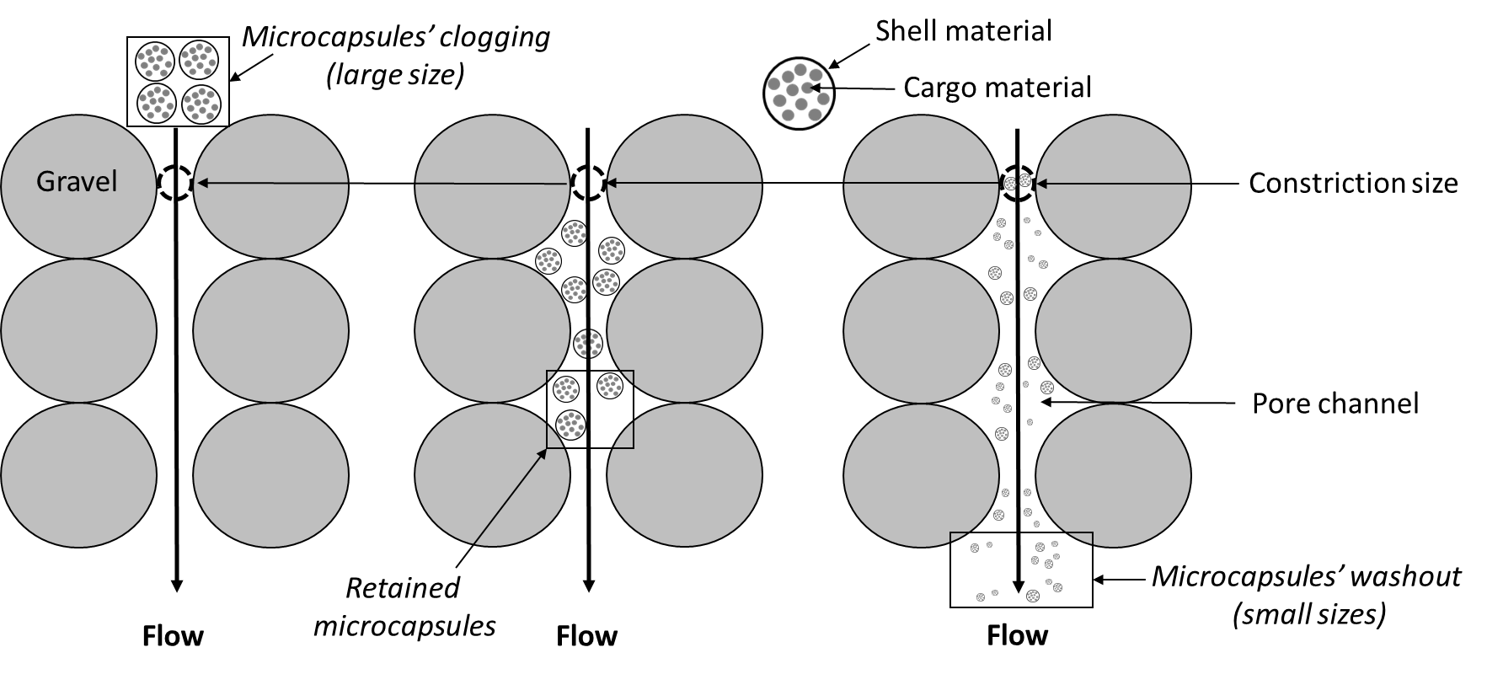
Figure 1. Schematic diagram of microcapsules clogging, retention and washout in porous media.

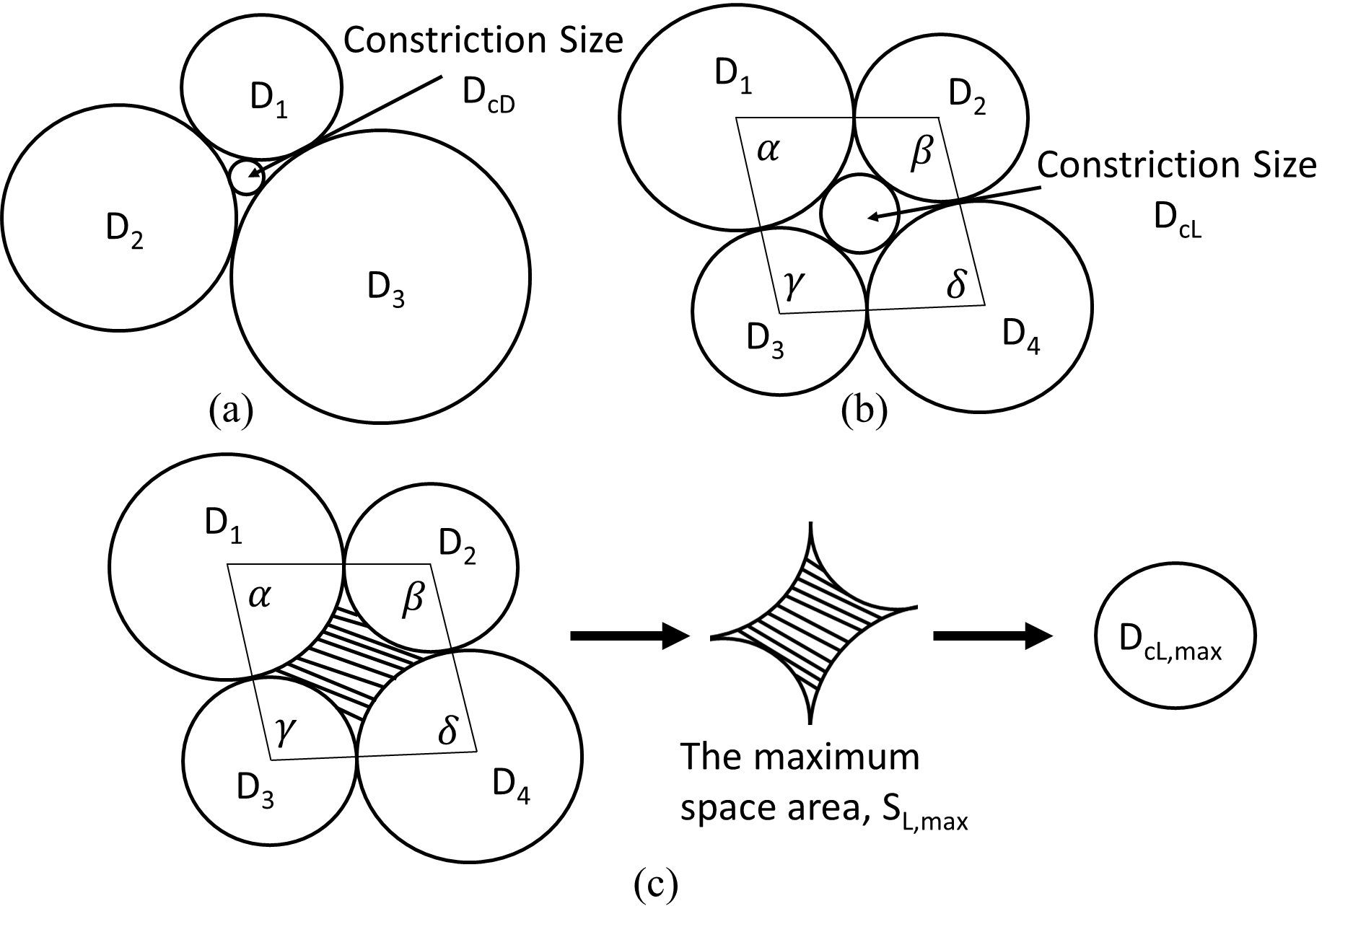
Figure 2. (a) Constriction size for densest state (D_{cD}) of a packing of particles (D₁, D₂, D₃); (b) Constriction size for loose state (D_{cL}); (c) Particle arrangement in the loosest state defined by α, β, γ and δ (angles of the quadrilateral formed connecting the center of the four spheres) and the corresponding maximum constriction area (S_{L, max}) and constriction size (D_{cL, max}).

Figure 3. A typical PSD and the corresponding CSDs with different relative densities based on the output of the constriction size mathematical model (CSD – constriction size distribution, PSD – particle size distribution, L – loose, D – dense, R_{d} – relative density).

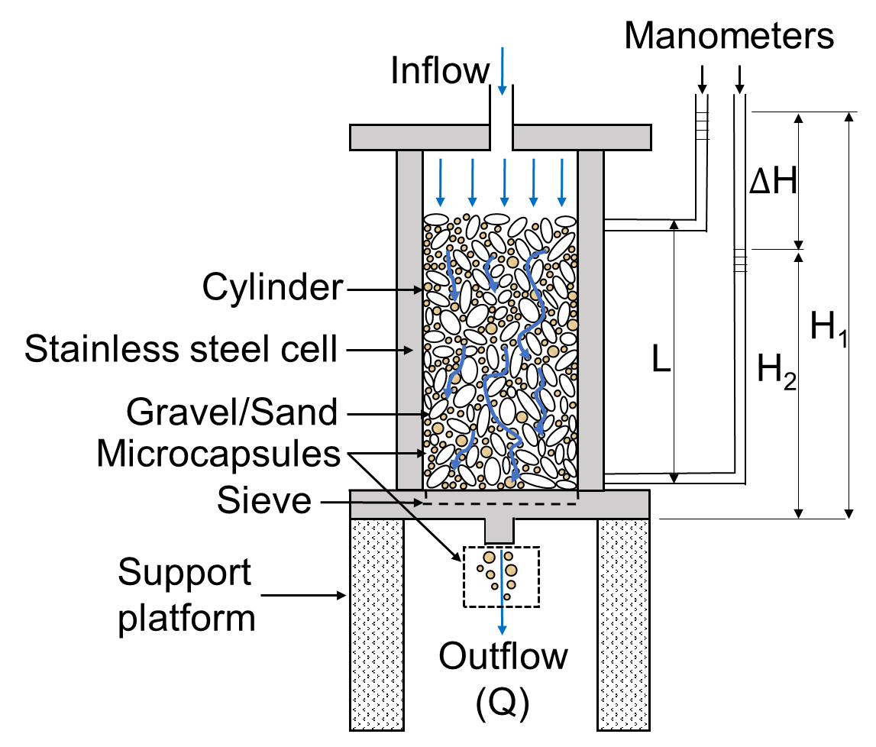
Figure 4. Main body of the apparatus for microcapsules washout test. Q refers to the quantity of inflow with a unit cm³/s, L indicates the distance of the two manometers inserted alongside the cylinder, and ΔH is the water head difference measured from the two manometers.

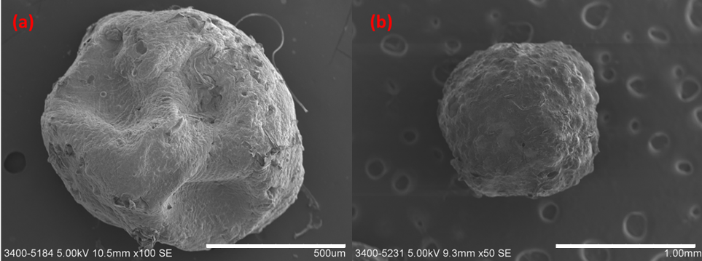Figure 5. Microphotographs of dry calcium alginate/polydimethylsiloxane microcapsules with a particle size range of (a) 0.35-0.75 mm; (b) 1.25-1.80 mm by scanning electron microscopy.

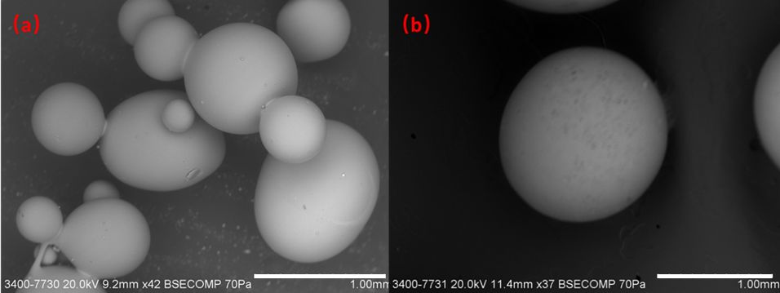Figure 6. Microphotographs of glass beads with a particle size range of (a) 0.30-0.80 mm; (b) 1.00-2.00 mm by scanning electron microscopy.

Figure 7. Gradations of microcapsules/glass beads and CSDs for: (a) gravel with CSDs smaller than MSD and GSD (or d₈₅>D_{c35}) (b) gravel with CSDs larger than MSD and GSD (or d₈₅<D_{c35}), (c) microcapsules and glass beads with varying sizes combined with gravel (CSD - Constriction Size Distributions, MSD - Microcapsules Size Distributions, GSD - Gravel Size Distributions)

Figure 8. Washout tests in gravel-microcapsules mixtures, (a) percentage of washout variations with time; (b) percentage of permeability variations with time.

Figure 9. Washout tests in gravel-glass beads mixtures, (a) percentage of washout variations with time; (b) percentage of permeability variations with time.

Figure 10. Relationship of size ratio (d₈₅/D_{c35}) and percentage of final washout for (a) microcapsule-gravel mixtures; (b) glass bead-gravel mixtures.

Figure 11. Relationship of permeability and percentage of final washout for (a) microcapsule-gravel mixtures; (b) glass bead-gravel mixtures.

Figure 12. Constriction-based criterion to distinguish between effective and ineffective washout tests in gravel for (a) microcapsules; (b) glass beads. (D_{c35} – constriction size at which 35% is finer, d₈₅ – the size of microcapsules or glass beads at which 85% is finer)

Figure 13. Median diameter changes of microcapsules under drying with time.

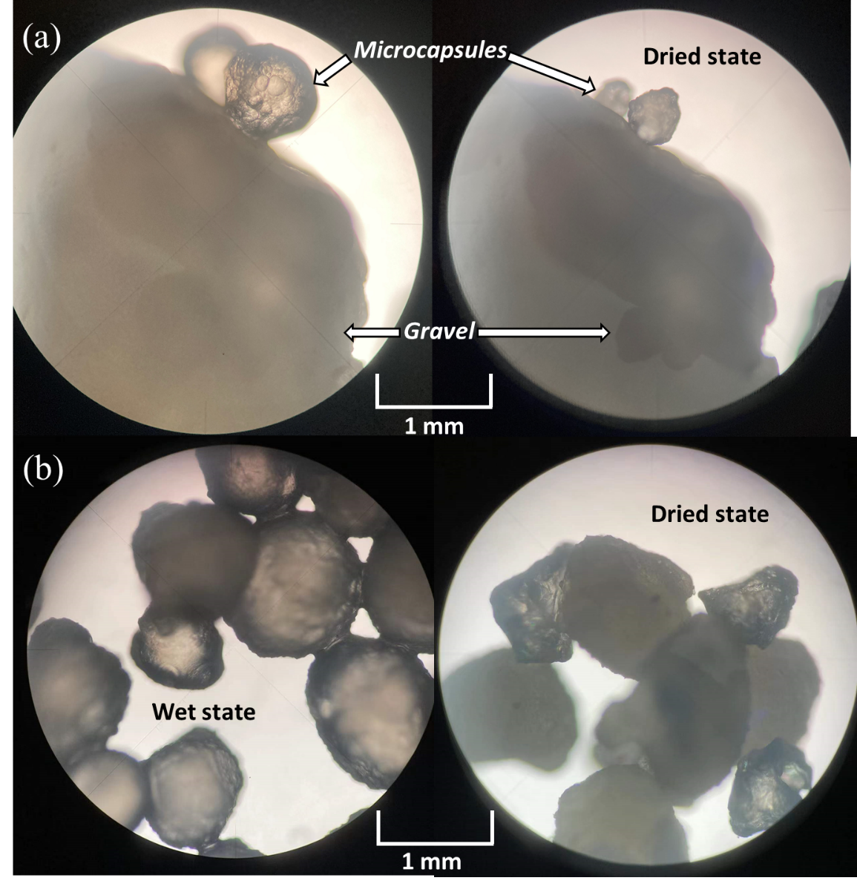
Figure 14. Optical microscope images of (a) microcapsules-gravel mixtures after flushing and then drying; (b) microcapsules under both original and drying conditions.

Figure 15. Quantitative prediction of the relationship between percentage of washout and size ratio (d₈₅/D_{c35}) for microcapsules and glass beads after considering the size change of microcapsules during flooding.

