Advanced strategies in the application of gelatin-based bioink for extrusion bioprinting
Jirong Yang¹ · Huimin He² · Duo Li^{1,3} · Qian Zhang^{1,3} · Lizhi Xu² · Changshun Ruan^{1,3}
1 Research Center for Human Tissue and Organs Degeneration, Institute of Biomedicine and Biotechnology, Shenzhen Institute of Advanced Technology, Chinese Academy of Sciences, Shenzhen 518055, China
2 Department of Mechanical Engineering, The University of Hong Kong, Hong Kong SAR, China
3 University of Chinese Academy of Sciences, Beijing 100049, China

KEYWORDS: Gelatin-based bioink, Extrusion bioprinting, Tissue-like construct
✉ Changshun Ruan cs.ruan@siat.ac.cn

Abstract
The significance of bioink suitability for the extrusion bioprinting of tissue-like constructs cannot be overemphasized. Gelatin, derived from the hydrolysis of collagen, not only can mimic the extracellular matrix to immensely support cell function, but also is suitable for extrusion under certain conditions. Thus, gelatin has been recognized as a promising bioink for extrusion bioprinting. However, the development of a gelatin-based bioink with satisfactory printability and bioactivity to fabricate complex tissue-like constructs with the desired physicochemical properties and biofunctions for a specific biomedical application is still in its infancy. Therefore, in this review, we aim to comprehensively summarize the state-of-the-art methods of gelatin-based bioink application for extrusion bioprinting. We firstly outline the properties and requirements of gelatin- based bioinks for extrusion bioprinting, highlighting the strategies to overcome their main limitations in terms of printability, structural stability and cell viability. Then, the challenges and prospects are further discussed regarding the development of ideal gelatin-based bioinks for extrusion bioprinting to create complex tissue-like constructs with preferable physicochemical properties and biofunctions.

Graphic abstract
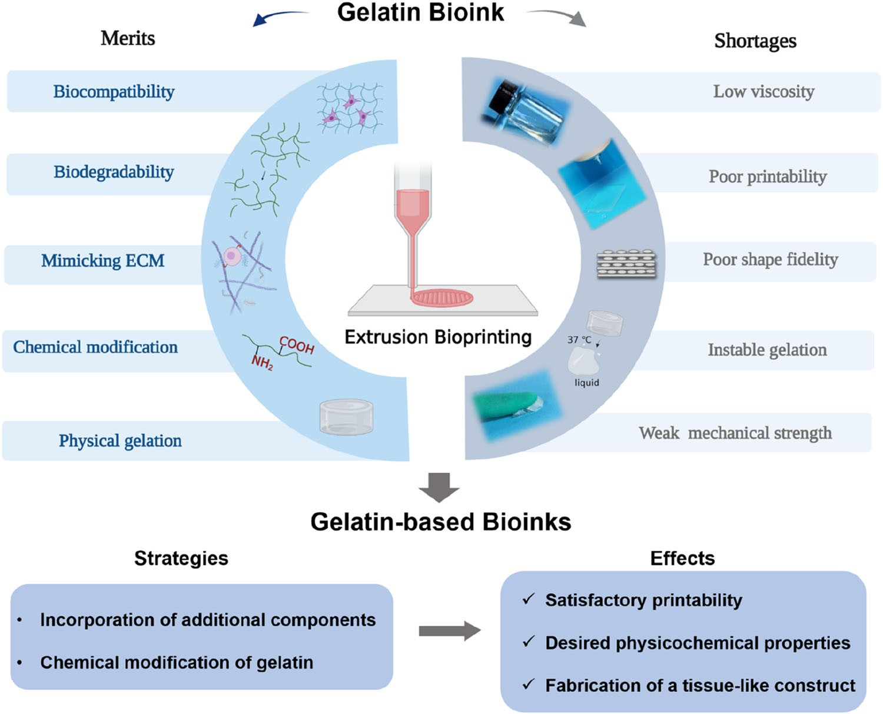

1. Introduction
The emerging field of bioprinting, as an important branch of three-dimensional (3D) printing, employs cells and biomate- rials as bioinks to rapidly generate accurate custom-shaped tissue-like constructs with a great potential for individual- ized tissue regeneration [1–6], drug screening [7–9], and the study of tissue morphogenesis [10–12]. Among the main bioprinting modalities (i.e., extrusion, stereolithogra- phy, inkjet and laser-assisted) [13–16], extrusion bioprinting has become the most widespread method for the fabrica- tion of tissue-like constructs owing to its easy operation, relatively low cost and wide range of available biomate- rials [17–19]. In extrusion bioprinting, bioinks are loaded into a printhead and extruded from the nozzle to form fila- ments under internal pressure, which are deposited (usually in a layer-by-layer manner) to construct desired structures [20–22]. Extrusion bioprinting techniques can be classified into two subcategories: pneumatic extrusion and mechanical extrusion [3, 23]. The development of extrusion bioprint- ing is heavily dependent on the physical and chemical properties of biomaterials in bioinks [24, 25]. Therefore, find- ing suitable bioinks with excellent printability, satisfactory biocompatibility, appropriate biodegradability, high struc- tural fidelity and reliable mechanical strength is of great significance for creating complex tissue-like constructs by extrusion bioprinting [16, 26–29].
Biomaterials (synthetic and natural) provide a structural framework to facilitate the attachment and migration of cells and can drive the differentiation of these cells into tissue- specific cell types [30]. Gelatin, a water-soluble protein derived from natural collagen, has been of great interest due to its unique composition and structural similarities to the extracellular matrix (ECM) [31]. Besides, it shows excellent biocompatibility, biodegradability, bioactivity, and is non- immunogenic. Meanwhile, gelatin can be easily subjected to chemical modification and physical gelation [32, 33]. It was not until 2015 when an exponential increase occurred in the number of publications related to the application of gelatin-based bioinks for bioprinting (Fig. 1a). Especially, gelatin-based bioinks are now attracting the most atten- tion (31%) among all of the potential bioinks (Fig. 1b), and extrusion bioprinting is currently the main applica- tion modality (71%) of gelatin-based bioinks (Fig. 1c). Therefore, gelatin-based bioinks have attracted growing interest as bioinks for the extrusion bioprinting of tissue-like constructs. The intrinsic limitations of gelatin bioink are low viscosity and instable physical gelation, which cause its poor printability, weak shape fidelity and low mechanical strength, seriously limiting its application for the fabrica- tion of complex, large-scale and multicellular constructs (Fig. 1d). Therefore, many efforts have focused on enhancing the viscosity of gelatin bioink to achieve the desired rhe- ological properties for bioprinting, as well as to improve the shape fidelity and mechanical strength of constructs at the same time, especially in physiological operational envi- ronments. In fact, there have been a number of reviews of gelatin-based bioinks. For example, Wang et al. [34] discussed gelatin-based bioinks (such as gelatin/fibrinogen, gelatin/hyaluronan and gelatin/alginate/fibrinogen) used for organ bioprinting. Ying et al. [35] outlined recent advances in the development of gelatin methacryloyl (GelMA)-based bioink formulations (pure GelMA bioink, preformed GelMA bioink, and alginate-GelMA bioink) and suitable strategies for GelMA bioprinting. Rajabi et al. [36] reviewed different studies on bioprinting with GelMA-based components and categorized them into two different groups based on their applications for soft and hard tissue engineering. However, there is still a lack of a systematic and comprehensive review of gelatin-based bioinks in extrusion bioprinting regarding achieving the desired printability, shape fidelity and cell via- bility to fabricate complex tissue-like constructs.
The goal of this review is to present an in-depth overview of the state-of-the-art gelatin-based bioinks. Firstly, the char- acteristics and properties of gelatin are outlined. Then, the requirements of gelatin-based bioinks for extrusion bioprint- ing tissue-like constructs are discussed. Furthermore, on the basis of these requirements, the strategies to overcome the main obstacles of gelatin-based bioinks are summa- rized with an emphasis on how to improve their printability, enhance their stability post-printing by physical or chem- ical crosslinking, and maintain high cell viability. Finally, we comprehensively analyze the challenges and prospects in promoting gelatin-based bioinks to fabricate the next gener- ation of tissue-like constructs with complex structure, large size and biological function.
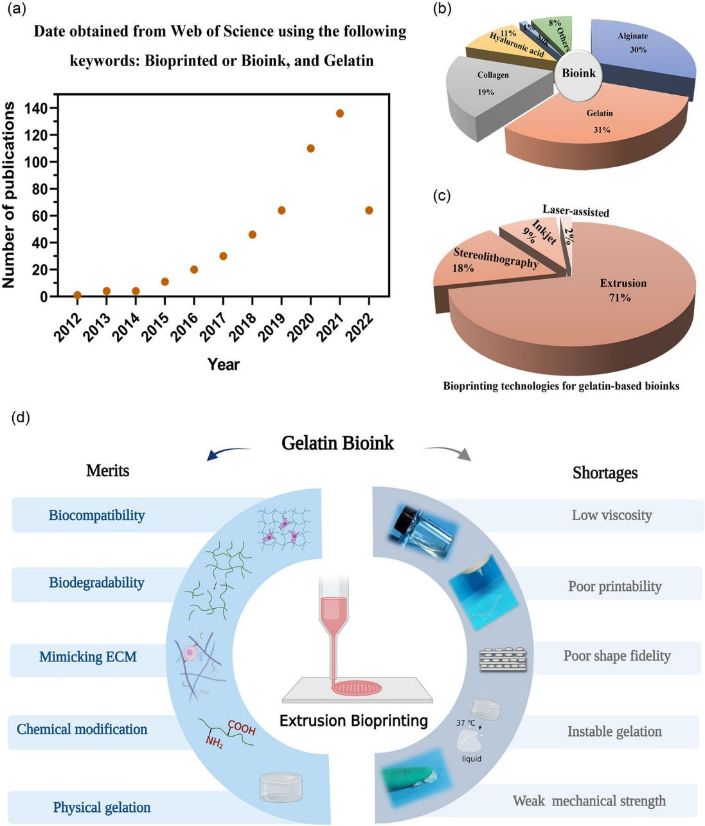
Fig. 1 Literature review of gelatin/gelatin-based bioinks. a Analysis of the publications from 2012 to 1 September 2022. Data were obtained from ISI Web of Science using keywords (bioprint OR bioink, and gelatin). b The proportion of different kinds of bioinks. c The proportion of different kinds of bioprinting technologies for gelatin/gelatin-based bioinks. d The merits and shortages of gelatin bioink applied in extrusion bioprinting. ECM:extracellular matrix.
2. Characteristics and properties of gelatin
Gelatin is a degradation product derived from the partial hydrolysis of collagen, which is the fibrous protein located mainly in bone, cartilage and skin [37]. Gelatin has triplet repetitions denoted as Glycine-X–Y peptide, where X and Y can be any amino acid. Also, it possesses degradable motifs by matrix metalloproteinase (MMP) and contains the arginine–glycine–aspartic acid (RGD) peptide sequence that is beneficial for cell growth [33]. Besides, pure gelatin solu- tion has the unique property of gelation at low temperatures to form physically crosslinked hydrogels. To obtain soluble gelatin, insoluble native collagen is subjected to a hydrolytic process to cleave the hydrogen and covalent bonds. Although enzymatic and chemical hydrolysis are increasingly criti- cal in some processes, the common and acceptable strategy is physical pre-treatment by hot water [38]. The degree of conversion of collagen into gelatin depends on the pH, tem- perature and processing time of hydrolysis. Typically, two types of gelatins, commercially called type-A gelatin (with an isoelectric point of nine) and type-B gelatin (with an iso- electric point of five), are obtained by acidic and alkaline treatment from collagen I, respectively [39]. Few triple- helical structures remain in the gelatin after the hydrolytic process [38]. Therefore, in addition to its favorable bio- compatibility and biodegradability to support the adhesion, spreading, proliferation, and differentiation of encapsulated cells, gelatin has a much lower immunogenicity compared with collagen, making it a promising candidate for cell-laden tissue constructs [34].
The main sources of gelatin are pig skin (46%), bovine hide (29.4%), and pork or cattle bone (23.1%). Fish gelatin accounted for only less than 1.5% in 2007 [40]. Due to the various potential sources of gelatin, non-covalent inter- actions between molecules, such as hydrogen bonding, hydrophobic and electrostatic interactions, and van der Waals forces are also distinctly formed, resulting in differences in the physical properties of the derived product. In general, fish gelatin tends to be weaker and has worse rheological proper- ties compared with those from mammals [41]. Furthermore, the source of gelatin has a significant influence on hydrogels based on it or its derivatives. For instance, there are markedly different properties of GelMA derived from cold water fish skin, cold soluble gelatins and porcine skin. After the mod- ification of gelatin with methacrylic anhydride, the degrees of methacrylation of fish skin GelMA (16%) are the low- est compared to cold soluble (64%) and porcine skin (76%) GelMA is considered to result from fish skin gelatin having fewer hydrophobic amino acids and imino acids than other gelatins from mammalian sources. As a result, the compres- sive Young’s modulus at the concentration of 10% (0.1 g/mL) fish skin GelMA is 7.3 kPa, which is markedly lower than that of cold soluble (14.5 kPa) and porcine skin (24.6 kPa) GelMA. Since the properties of gelatin from distinct sources are significantly different, it is necessary to take this into account when gelatin is used as bioink [42].
3. Basic requirements of gelatin-based bioinks for extrusion bioprinting
Developing a robust system possessing all the desirable merits (printability, shape stability and cell survival) is essential for the successful extrusion bioprinting of tissue- like constructs [43, 44]. The rheological properties are key determinants of printability. In addition, shape stability is affected by the physicochemical properties and crosslink- ing mechanisms of gelatin-based bioinks [24]. In particular, the bioprinting conditions depend on the physicochemical properties of gelatin-based bioinks, which also influence the printability of gelatin-based bioinks. Furthermore, besides the biocompatibility of bioinks for extrusion bioprinting, many factors affect the viability of cells encapsulated in gelatin-based bioinks. The bioprinting conditions (e.g., com- position and concentration of bioink, extrusion pressure, nozzle size, holding temperature and holding time) and the crosslinking processes may also have remarkable effects on the encapsulated cells. The process of extrusion exerts shear stress on cells and may cause cell damage. There- fore, pressure should be controlled within certain limits as high pressure leads to high shear stress [3]. In addition, once the cell-laden constructs have been bioprinted, they will be processed by various crosslinking solidification methods (chemical, physical, enzymatic or a combination of them) to ensure their structural stability and sufficient mechani- cal strength under physiological conditions [45]. Thus, the critical points for achieving satisfied extrusion bioprinting with gelatin-based bioinks are to improve the performance of gelatin-based bioinks in terms of printability, structural stability and cell viability.
3.1 Printablity
The printability of gelatin-based bioinks can be assessed by a two-step method: initial screening and rheological evalu- ation (Fig. 2a) [43, 46, 47]. The first criterion for the initial screening of printable gelatin-based bioinks is the morphol- ogy of bioinks at the needle tip after extrusion. Scaffolds with high shape fidelity can be printed by bioinks that form fila- ments rather than droplets [48]. The second criterion is that extruded filaments have the ability to stack layer-by-layer to form 3D constructs with the binding force between printed layers [49] but without merging. The rheological proper- ties of bioinks play a key role in this process [46] and are generally characterized by yield stress, shear rate-dependent viscosity, and recovery behavior of the materials. Regard- ing the rheological behaviors of bioinks before, during and after extrusion, bioinks have a yield stress upon a shear stress ramp, the shear thinning properties of bioinks facilitate the extrusion, and the recovery of rheology enables the shape fidelity. In general, extrusion bioprinting requires the high dynamic viscosity (from 30 to 6×10⁷ mPa·s, depending on the extruder of the printer) of bioinks to maintain the ini- tial shape after deposition compared to inkjet printing that generally needs low-viscosity bioinks (3–12 mPa·s) [50, 51] and can be subsequently crosslinked [52]. The application of alginate, silk, collagen, and hyaluronic acid bioinks, etc., has demonstrated that appropriate printing viscosity can be achieved by increasing concentrations [53–56]. For example, 5% hyaluronic acid bioink shows shear thinning property and can be successfully extruded to bioprint constructs [29, 57]. The majority of studies were carried out using collagen solu- tions of low concentration—usually, not more than 5 mg/mL and rarely 10 mg/mL [58, 59]. However, gelatin solution has a very low viscosity with the elastic modulus (G^{r}) below 0.1 Pa [60] even with a high solid content of 20% above the sol–gel transition temperature, which will lead to the forma- tion of droplets driven by surface tension after extrusion and the collapse of deposited structures. To impede the formation of droplets, surface tension must be increased by elevating the viscosity of the solution. For instance, by the incorpora- tion of a rheology enhancer (e.g., hyaluronic acid, alginate, silk, nanoclay, Pluronic F-127, gellan gum, and carbomer), the morphology of extruded gelatin-based bioinks turns from droplets to filaments, such that 3D constructs with high shape fidelity can be fabricated [20, 48, 60–63]. For the qualita- tive characterization of printability (Pr), Ouyang et al. [47] developed a new algorithm depending on the geometry of the pores in the fabricated constructs (Fig. 2b). Pr is defined by the following function: $Pr=\frac{L^{2}}{16A}$, where L denotes perimeter and A denotes area of the pore.
A Pr value between 0.9 and 1.1 is believed to have good printability. In addition, other methods to enhance viscosity include increasing the intermolecular interactions by controllable crosslinking [64, 65] and attributing the gelatin temperature-programmable properties (Fig. 2c) [66]. Besides, the gelatin-based microgel can also significantly improve the printability of bioinks for its excellent shear thin- ning property [67–70].
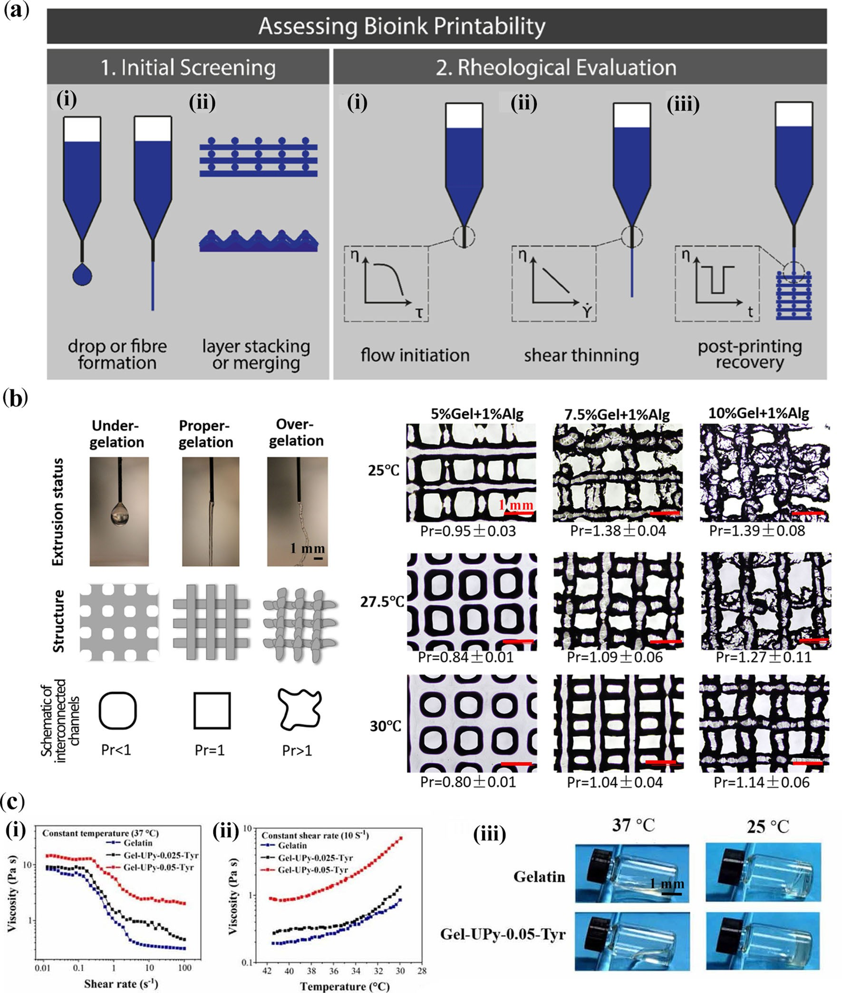
Fig. 2 Evaluation of bioink printability. a Outline of the proposed research method to assess bioink printability (reproduced from [43], Copyright 2017, with permission from IOP Publishing Ltd.). Initial screening of ink formulations to establish (i) fiber formation as opposed to droplet formation, and (ii) successful layer stacking without merging between layers; Rheological evaluations were employed to character- ize (i) the flow initiation properties and yield stress, (ii) the degree of shear thinning to predict the extrusion process and cell survival, and (iii) the recovery behavior of bioinks after printing. b Evaluation of printability (Pr) under three typical gelation statuses, namely, under-, proper- and over-gelation, and optical microscope images at 30 min under different temperatures and concentrations (reproduced from [47], Copyright 2016, with permission from IOP Publishing Ltd.). c Vis- cosity of gelatin with temperature-programmable properties. When the temperature decreased from 37 to 25 °C, the Gel-UPy-0.05-Tyr bioink showed sharply increased viscosity compared with gelatin (reproduced from [66], Copyright 2020, with permission from IOP Publishing Ltd.)
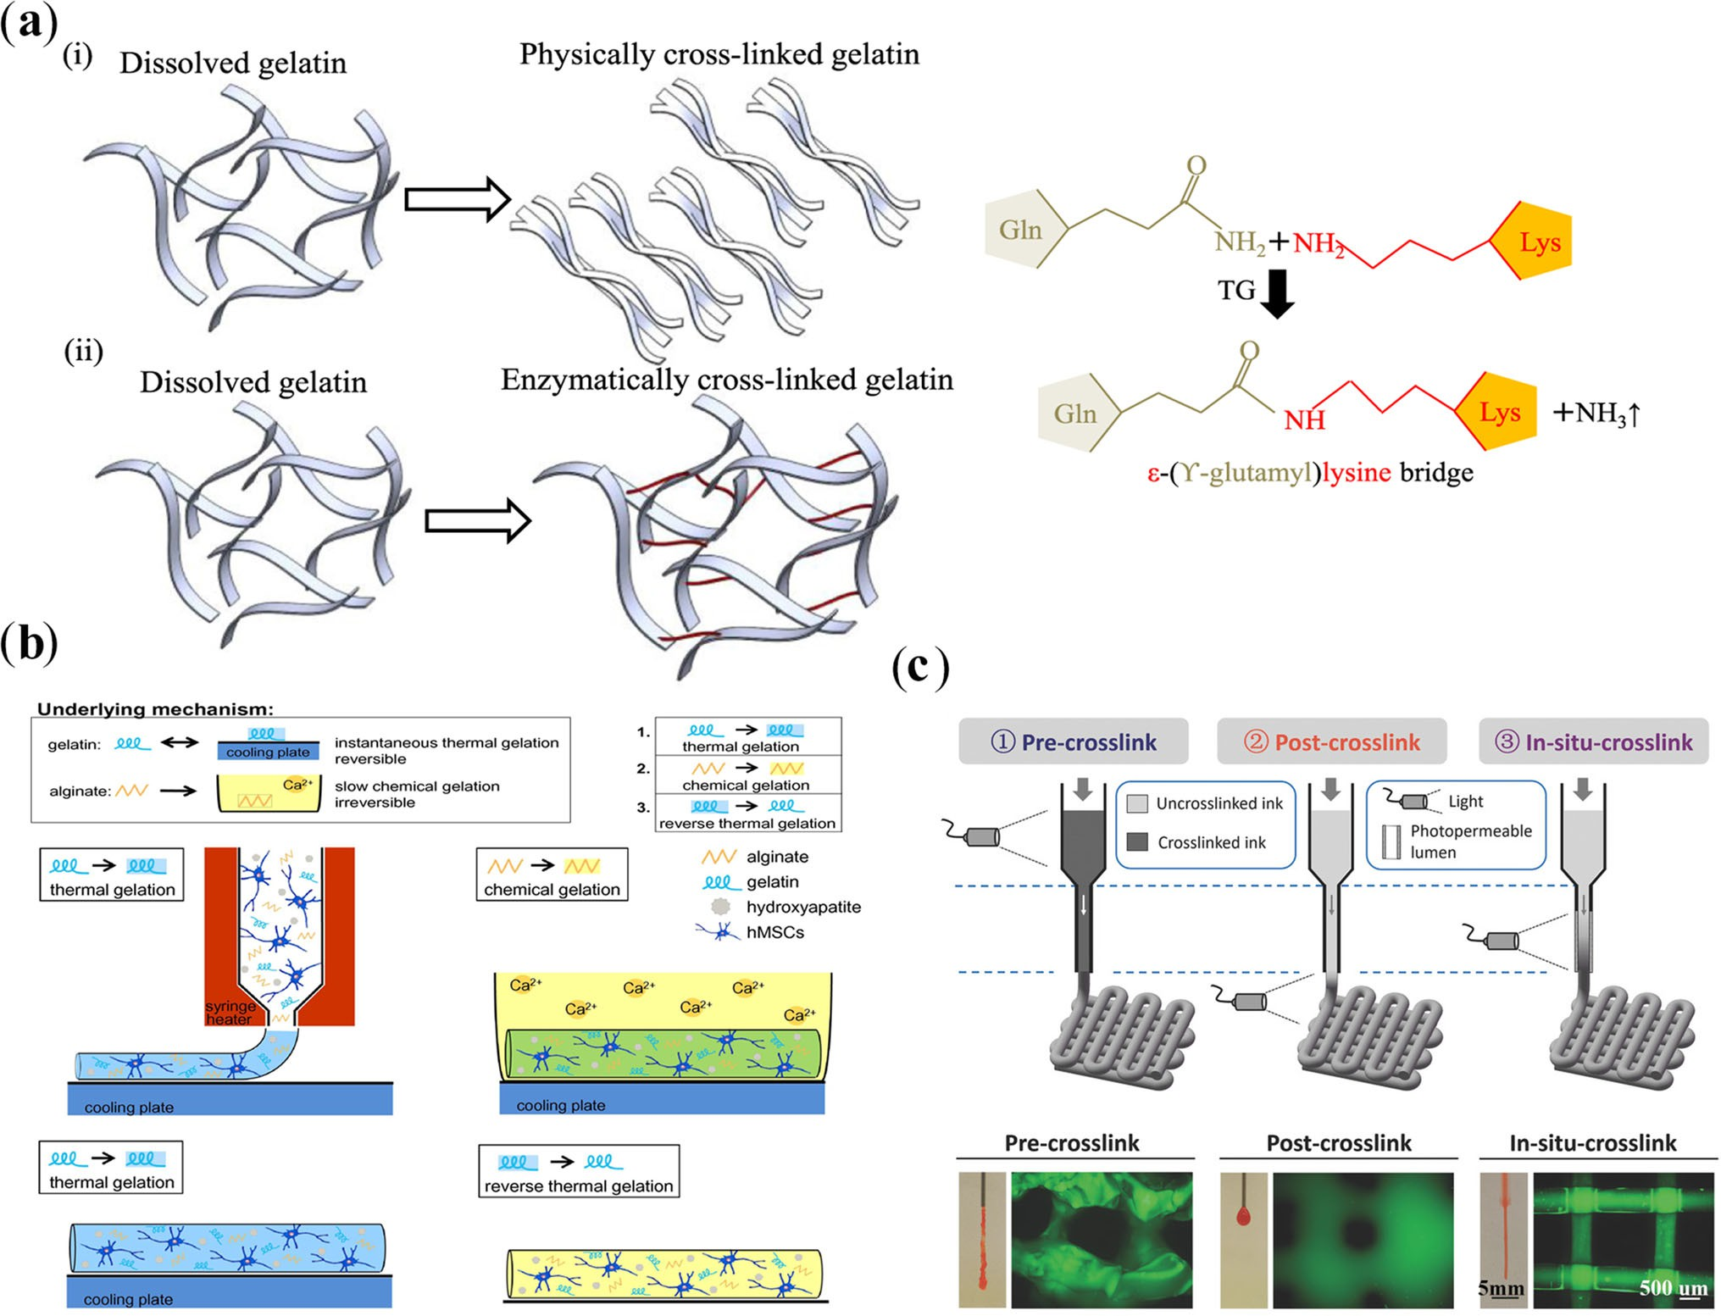
Fig. 3 The crosslinking solidification methods maintain a stable structure. a Enzymatic crosslinking by transglutaminase (TG), where the ε-amino groups of lysine residue are covalently bonded with the γ -carboxamide groups of glutamine residue in gelatin (reproduced from [68], Copyright 2021, with permission from IOP Publishing Ltd.). b Physical crosslinking by mixing gelatin solution with algi- nate, where alginate can act as a thickener for printing and can also be solidified by facial crosslinking with calcium ions (reproduced from [73], Copyright 2013, with permission from Acta Materialia Inc.). c Other chemical crosslinking methods can modify the gelatin, such as gelatin methacryloyl (GelMA), which can be solidified by photopoly- merization (reproduced from [131], Copyright 2016, with permission from WILEY–VCH Verlag GmbH & Co. KGaA, Weinheim). TG: trans- glutaminase; hMSCs: human mesenchymal stem cells.
3.2 Structural stability
Gelatin-based constructs are mostly applied at physiologi- cal temperature (37 °C), which is higher than their physical gelation temperature. Since the physical gelation of gelatin is reversible by changing the temperature, the gelatin-based constructs must be solidified by various crosslinking solid- ification methods, such as enzymatic, physical, chemical, or a combination thereof, to maintain a stable structure with high fidelity [3]. One crosslinking strategy is to use transglutaminase [65, 68]. During the catalytic process by transglutaminase, the ε-amino groups of the lysine residue are covalently bonded with the γ -carboxamide groups of glu- tamine residue in gelatin (Fig. 3a). This crosslinking strategy can also be applied in bioinks whose molecules contain ε- amino groups of lysine residue, such as silk and collagen. However, the low contents of glutamine in gelatin cause the weak covalent-crosslinking networks of gelatin hydrogel, leading to low mechanical strength at physiological tempera- ture. Another crosslinking strategy is to introduce a polymer that can be crosslinked independently or with gelatin chains post-printing [71, 72]. The most common of such methods is to mix the gelatin solution with sodium alginate (Fig. 3b). The latter can not only act as a thickener for printing, but can also be solidified by the facial crosslinking of calcium ions [73]. In addition, the chemical modification of gelatin (gelatin derivative) with functional groups (such as methacrylate) is an efficient strategy to achieve more controllable crosslink- ing (Fig. 3c) [36, 64, 74].
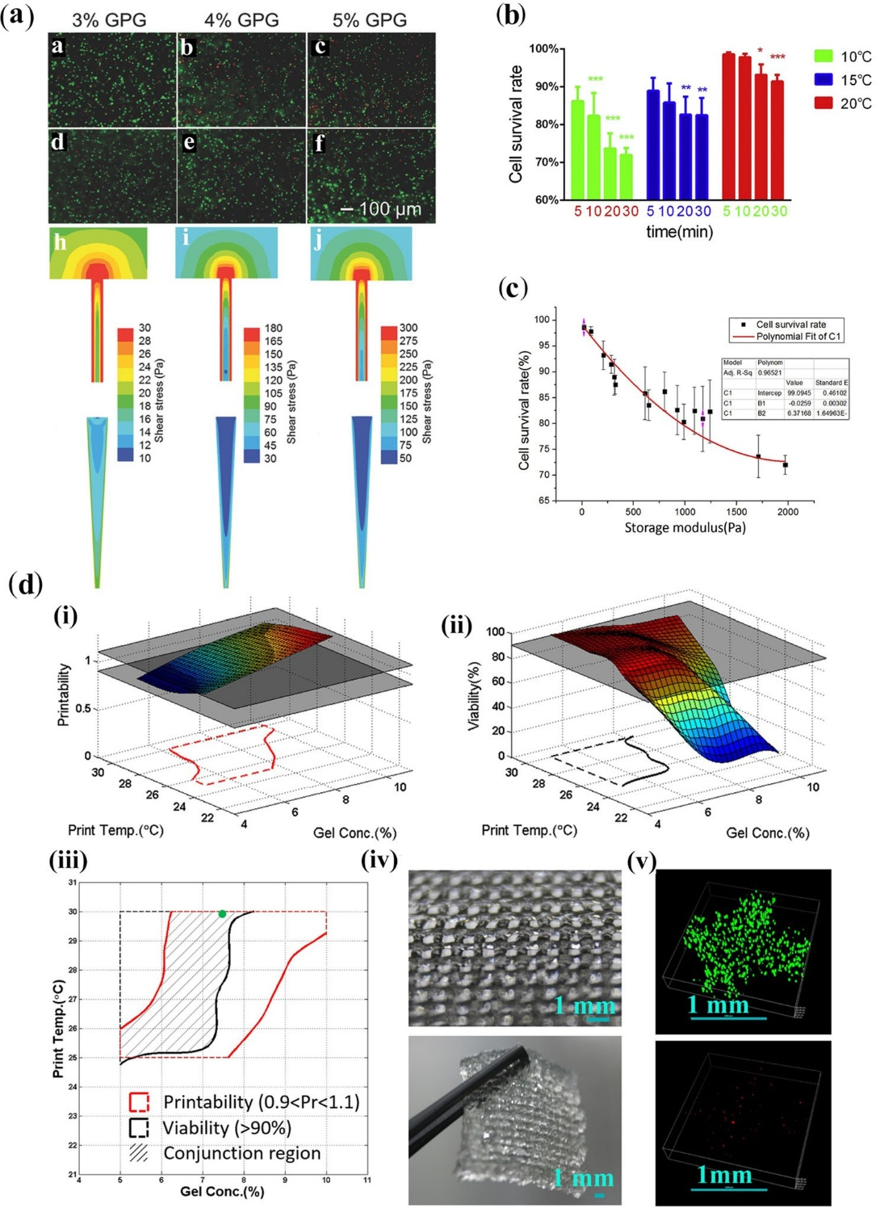
Fig. 4 The factors that affect cell survival during bioprinting include the printing and solidification processes. a Cells experienced lower shear stress in the cone-shaped nozzle compared to the straight nozzle during the bioprinting process, which contributed to higher cell viability (reproduced from [64], Copyright 2017, with permission from WILEY–VCH Verlag GmbH & Co. KGaA, Weinheim). b Influence of different holding time and holding temperature on cell survival rate after 3D cell printing (reproduced from [78], Copyright 2015, with permission from IOP Publishing Ltd.). c Correlation between bioink rheological property and cell survival rate (reproduced from [78], Copyright 2015, with permission from IOP Publishing Ltd.). d Evaluation and balance between printability and viability under different gelatin concentration and printing temperature combinations, with a holding time of 10 min. (i) 3D surface showing the printability as a function of gelatin concentration and printing temperature. (ii) 3D surface showing the viability as a function of gelatin concentration and printing temperature. (iii) The cross section of printability and viability regions determines the balanced region (shaded area). (iv) Morphology of the printed 3D construct. (v) Live/dead staining of cells was obtained by using the parameter combination within the shaded area (green spot) in (iii) (reproduced from [47], Copyright 2016, with permission from IOP Publishing Ltd.). GPG: GelMA physical gel.
Notably, the components and crosslinking methods will markedly influence the swelling and degradation properties of the obtained gelatin constructs [73, 75, 76]. Thus, the swelling properties must be taken into account when a par- ticular size of construct is fabricated. Due to the arbitrary deformation of the final construct caused by the significantly dissimilar swelling behavior, it is challenging to print precise constructs. Swelling behavior is general among hydrogels; for instance, silk fibroin shows a tendency of swelling in the range of 15%–25% [54]. This property may invariably affect the resultant geometry and porosity of the construct. Further- more, compared to some bioinks (e.g., alginate) that lack the ability to biodegrade [77], the biodegradation of gelatin is another factor that influences its structural stability and can- not be ignored. Gelatin is effectively degraded in the presence of collagenase, while chemical modification or mixing with other components will slow down this process. For instance, after the methacrylation of gelatin, the covalent polymer seg- ments will be inserted into the gelatin network by free radical photopolymerization, markedly decreasing its biodegrad- ability [76]. In addition, the incorporation of other stable inorganic or polymer components will reduce the degrada- tion rate of gelatin-based constructs [73]. Nonetheless, the biodegradation of gelatin is favorable for cell behavior and the function of constructs. Hence, controlling the balance of the biofunction and structural stability of construct is a significant aspect. Namely, when the chemical modifica- tion of gelatin or the incorporation of other components is employed to maintain the structural stability of gelatin-based constructs, degradation should also be taken into account.
3.3 Cell survival
Gelatin shows superior performance in supporting the sur- vival of cells compared to alginate, hyaluronic acid, etc., which lack RGD molecules (responsible for cell attach- ment) [53, 77]. However, besides the biocompatibility of the bioink itself, two additional important factors that affect cell survival during extrusion bioprinting are the printing condi- tions and the process of solidification. In the initial printing process, it is crucial to understand how the printing param- eters (composition and concentration of bioink, extrusion pressure, nozzle size and shape, holding temperature, and holding time) influence the printability and cell survival rate in extrusion bioprinting [47, 78]. These parameters depend on the rheological properties of bioinks. More specifically, a viscous bioink with a fast-gelling property will benefit the printing of complex tissue-like constructs with high resolu- tion [79]. However, enhancing the viscosity of bioinks will lead to increased shear stress encountered by cells during the extrusion process, which is one of the main factors causing cell death and injury in extrusion bioprinting [80]. Interest- ingly, Liu et al. [64] demonstrated that cells experienced lower shear stress in a cone-shaped nozzle compared to a straight nozzle during the bioprinting process, contributing to higher cell viabilities for gelatin-based bioinks at all concen- trations (Fig. 4a). Zhao et al. [78] systematically investigated the effects of the rheological properties of gelatin-based bioinks and extrusion bioprinting parameters on printabil- ity and cell survival. Low temperature (below 20 °C) will cause considerable cell apoptosis, even at short holding time (5 min). Especially, when the holding time reaches 20 min, the cell survival will also decrease significantly at a rela- tively high temperature (20 °C) (Fig. 4b). Notably, when the storage modulus of bioinks is in the range of 154–382 Pa, both high cell survival rate and good printability can be achieved in the bioprinting process (Fig. 4c). The viscos- ity of gelatin-based bioinks enhances with the increasing concentration and holding time or the decreasing of holding temperature below the gelation temperature. Ouyang et al.[47] evaluated and balanced printability versus cell viability under different gelatin concentration and printing tempera- ture combinations, with a holding time of 10 min (Fig. 4d). Thus, gelatin-based bioinks should have suitable rheologi- cal properties for bioprinting to meet both the requirements of printability and needs for cell viability. Another key fac- tor that influences cell survival is the crosslinking method in the solidification process to achieve gelatin-based constructs with stable structures. Cell viability in gelatin networks crosslinked by transglutaminase and tyrosine after bioprint- ing were (98.3±1.3)% [65] and more than 90% [81], respec- tively. Thus, enzymatic crosslinking is a favorable strategy, characterized by satisfactory biocompatibility, for the solidi- fication of printed gelatin-based constructs. As for chemical crosslinking (such as photopolymerization), gelatin-based constructs can be formed in situ upon exposure to light (ultraviolet (UV) or visible light) in the presence of photo- initiators; free radicals are generated to initiate polymeriza- tion and finally form crosslinked hydrogel networks [82]. Photopolymerization has been increasingly popular due to the rapid and stable solidification of gelatin-based con- structs. Some studies pointed out that high cell viability can be achieved through controlling the concentration of photo-initiator and the wavelength/intensity of light. For example, when using the Irgacure 2959 (0.00025–0.001 g/mL) and VA086 (0.0025–0.01 g/mL) reaction systems at 365 nm and 2–136 mW/cm2 light intensity, encap- sulated stem cells can reach high viability above 90% [83]. Specifically, VA086 has better biocompatibility com- pared to the conventional Irgacure 2959 [84]. In addition, lithium phenyl(2,4,6-trimethylbenzoyl) phosphinate (LAP) can induce radical crosslinking by visible light and has proven to be much more efficient and less cytotoxic than Irgacure 2959, making it a better photo-initiator for in situ cell encapsulation studies [85]. Meanwhile, the use of near- UV blue or UV light has proved to have the potential to break the stability of chromosomes and genes in cells [86].
Noteworthily, near-UV blue or UV light has a limited penetration depth, which will impede polymerization to fabricate large-scale constructs [87]. In contrast, other photo- initiators, such as Ru/SPS and eosin Y that are triggered by visible light, have significant advantages for bioprinting large-size constructs [76, 87, 88]. Recently, a novel crosslink- ing approach via bisulfite-initiated radical polymerization has been developed, which was successfully used to print complex constructs with cell viability higher than 90% within a support bath including sodium bisulfite [74]. Overall, all these initiators, especially photoinduced ones, may produce reactive oxygen species (ROS) that can exert certain nega- tive effects on cells. This problem might be alleviated by the incorporation of ROS scavengers into the hydrogel formulation [82].
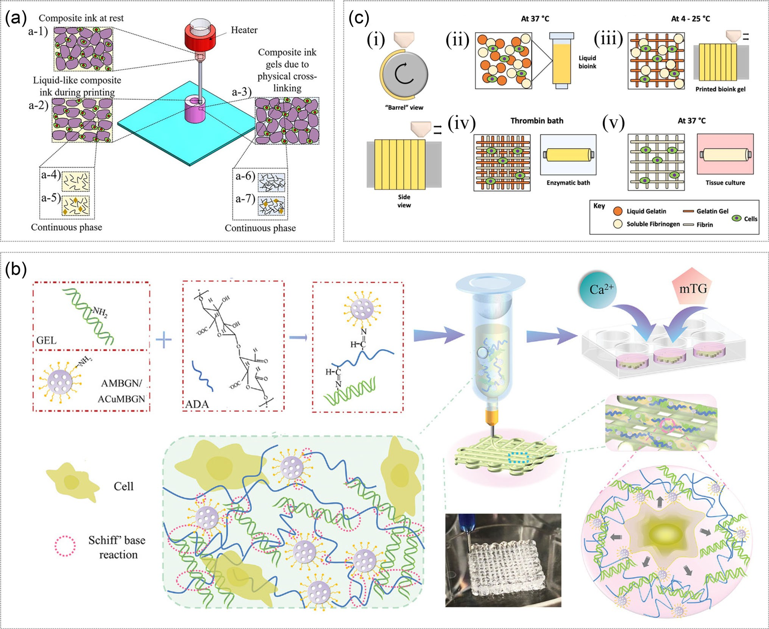
Fig. 5 Approaches of extrusion bioprinting for gelatin bioink and gelatin/polymer bioink. a An injectable gelatin composite bioink that consists of a microgel solid phase (gelled gelatin microgels) and a gelatin solution phase (reproduced from [67], Copyright 2020, with per- mission from American Chemical Society). b Oxidized alginate/gelatin hydrogel with amine-functionalized copper (Cu)-doped mesoporous bioactive glass nanoparticles (ACuMBGNs) for extrusion-based bioprinting (reproduced from [99], Copyright 2022, with permission from the authors, licensed under CC BY). c Gelatin/fibrinogen bioink to attain a desirable shear-thinning property for rotary bioprinting, which can be solidified by thrombin (reproduced from [101], Copy- right 2019, with permission from Acta Materialia Inc.). GEL: gelatin; AMBGN: aminated mesoporous bioactive glass nanoparticle; ADA: alginate dialdehyde; mTG: transglutaminase.

4. Formulation of gelatin-based bioinks for extrusion bioprinting
4.1 Pure gelatin bioinks
The direct printing of gelatin solution by temperature and concentration control suffers many disadvantages, such as poor fidelity, weak mechanical strength and instable struc- ture. Recently, Song et al. [67] proposed an injectable gelatin composite bioink consisting of a microgel solid phase (gelled gelatin microgels) and a gelatin solution phase (Fig. 5a). This composite ink can be printed directly and solidified by physical crosslinking to hold printed structures (i.e., lattice, tube-shaped, cup-shaped, and human anatomical structures) at room temperature. Subsequently, the structures can be immersed in transglutaminase solution to achieve a physio- logically stable construct. To further improve the mechanical strength and stability of fabricated structures, Song et al. [68] developed other gelatin microgel-gelatin solution compos- ite bioinks, which comprise a discrete phase of microgels (enzymatically gelled gelatin microgels) and a crosslinkable continuous gelatin precursor solution-based phase contain- ing transglutaminase (TG); the rheological properties and printability change gradually due to the TG enzyme-induced crosslinking process.
4.2 Gelatin/polymer hybrid bioinks
The incorporation of additional components can efficiently improve the printability of gelatin-based bioinks. Due to the limited number of available methods to form a mechani- cally stable gelatin network, the additive components are prospected to construct a stably crosslinked network. For instance, alginate can be crosslinked through divalent cations (for example, Ca2+), forming a network in water (Fig. 3b) [89]. In addition, silk fibrin can be crosslinked via self- assembly to form β-sheet crystals that feature cytocompat- ibility. In addition to the facile formation of network in the presence of cells, the incorporation of alginate or silk fib- rin can further improve the viscosity of gelatin bioinks for extrusion bioprinting and enhance the mechanical strength of the constructs. Thus, alginate and silk fibrin have become the most widely used additives in gelatin/polymer hybrid bioinks [71, 90–99]. Furthermore, other polymers such as hyaluronic acid [100], fibrinogen [101] and agarose [102] have been uti- lized. Nonetheless, gelatin lacks the ability to form a stable network under physiological conditions, limiting the use of gelatin/polymer bioinks for bioprinting complex tissue-like constructs.
4.2.1 Gelatin/alginate bioinks
Alginate (Alg) and its derivatives are among the most popu- lar additives in gelatin bioink because of their satisfactory thickening effect, biocompatibility and easy crosslinking, which can improve the printability and structural stability of gelatin-based bioinks [77]. The rheological properties of gelatin/Alg mixtures are similar to those of pure gelatin solution, being temperature-responsive and the viscosity increasing sharply when the temperature is below the value of sol–gel transition. Gelatin/Alg can usually be crosslinked in two ways: ionic crosslinking and chemical crosslinking. Owing to its biological benefits, CaCl2 solution is com- monly used for crosslinking gelatin/Alg bioinks through ionic bonds for extrusion bioprinting. Di Giuseppe et al. [103] studied the mechanical properties of gelatin/Alg hydrogel after crosslinking with CaCl2 solution. The ionic crosslink- ing process markedly increased the stability of gelatin/Alg network, with a significant rise in its mechanical strength. The compression modulus and failure stress reached about 40 and 80 kPa, respectively, whereas the failure strain was not sensitive to this process. Due to the intrinsic reversible ionic crosslinking nature of CaCl2, the gelatin/Alg network is also unstable and shows high swelling and degradation properties in water or other aqueous solutions. In contrast, the gelatin/Alg constructs formed by chemical crosslink- ing yield a high-strength network. There are two strategies for the chemical crosslinking of gelatin/Alg bioink: using a crosslinker and the modification of alginate. Shi et al. [104] showed that extruded gelatin (0.1 g/mL)/Alg (0.1 g/mL) scaf- folds crosslinked by carbodiimide-N -hydroxysuccinimide (EDC-NHS) and CaCl2 consecutively had a high Young’s modulus of (240.1±19.9) kPa, a low swelling ratio of about 25%, and a low degradation rate of only 36.5% of dry weight loss after one week. Other chemical crosslinkers, such as glutaraldehyde, have similar enhanced effects on gelatin/Alg scaffolds [105]. Meanwhile, EDC/NHS and glutaraldehyde have slight cytotoxicity, which limits their application in bio- printing. Alginate dialdehyde (oxidized alginate) and gelatin can form dynamic covalent crosslinking [106]. Distler et al. [71] showed that alginate dialdehyde (oxidized alginate) and gelatin, with favorable rheological properties, improved the shape fidelity and structural stability of constructs made by extrusion bioprinting. Zhu et al. [99] developed oxi- dized alginate/gelatin hydrogel with amine-functionalized copper (Cu)-doped mesoporous bioactive glass nanoparti- cles (ACuMBGNs) for extrusion bioprinting (Fig. 5b). The combination of reversible dynamic microenvironment and the impact of cell-adhesive ligands introduced by aminated particles enabled the rapid spreading (within three days) and high survival (>90%) of embedded cells. In addition, the bio- printed alginate dialdehyde-gelatin-ACuMBGN scaffolds could promote osteogenic differentiation and angiogenesis. Gelatin/Alg bioinks can not only improve the printability and mechanical strength of gelatin-based constructs, but also support cell function by bioactive additives. Zhang et al. [95] prepared a human mesenchymal stem cell (hMSC)-laden graphene oxide (GO)/alginate/gelatin composite bioink with better printability, shape fidelity, compressive modulus, cell viability, osteogenic differentiation, and ECM mineralization than the pure alginate/gelatin composite bioink. Li et al. [107] encapsulated Schwann cells in a gelatin/Alg bioink, which could maintain a high viability of (83.35±6.19)% after print- ing and solidification of the constructs. Furthermore, after two weeks of culture, the encapsulated cells showed a via- bility of about 92.34% and enhanced capability to release nerve growth factor compared with that of cells cultured in two-dimensional culture. Hiller et al. [108] used a bioink composed of alginate, gelatin, ECM, and HepaRG liver cells to fabricate 3D liver constructs crosslinked by CaCl2, to study transduction by an adeno-associated virus (AAV) vector and infection with human adenovirus 5 (hAdV5). The results showed that the tissue-like constructs were efficiently trans- duced by AAV vectors of serotype 6 and supported efficient adenoviral replication, making it a suitable platform to study viral biology and develop new antiviral compounds. Further- more, tissue-engineered skin constructs bioprinted by mixing gelatin/Alg with human skin primary fibroblast cells were used as skin engraftment for deep skin thermal wounds after crosslinking with CaCl2 [109]. Liu et al. [110] bioprinted a 3D matrix laden with epithelial progenitors and function guide (BMP-4) and crosslinked by CaCl2. The 3D construct (printed by a nozzle with 300 μm diameter) guided the self- organized formation of sweat gland tissue, which was similar to that of the natural development process. Zhao et al. [111] developed platelet-rich plasma (PRP)-integrated alginate- gelatin (AG) composite hydrogel bioinks and evaluated their biological effects in vitro and in vivo. The integration of PRP not only improved the behavior of seeded cells, but also reg- ulated the tube formation of vascular endothelial cells and macrophage polarization in a paracrine manner.
4.2.2 Gelatin/silk fibroin bioinks
Silk fibroin (SF), one of nature’s strongest fibrous proteins that are both biocompatible and biodegradable, is widely used as an additive for gelatin-based bioinks to optimize the rheology for extrusion bioprinting (printability) and build constructs with tunable degradation and mechanical prop- erties (structural stability) for a range of tissue engineering applications [54, 90–93, 112, 113]. SF transforms from an amorphous to a crystalline phase by a β-sheet structure to form a hydrogel through physical crosslinking, which can be accelerated and induced by sonication and polyols [114]. For instance, constructs were printed using a gelatin/SF bioink and physically stabilized by the addition of non- toxic glycerol according to images extracted from computed tomography scans (CT-scans) of a patient with head and neck tumor mass [115]. The formulation of this bioink was opti- mized with a gelatin concentration above 0.1 g/mL and a ratio of 1:1 of SF to gelation, which presented a good print- ability under physiological conditions (37 °C extrusion and 20–25 °C deposition) and a homogenously stable structure after solidification in a glycerol bath for 1 h. Moreover, the constructs could retain their shape for up to three months with minimal inflammatory response and good integration with tissue. An even more stable structure and higher mechan- ical properties can be achieved by physical and chemical (such as with tyrosinase and genipin) double crosslinking of SF. As an example, the tyrosine residues of gelatin and SF can be oxidized into o-quinone moieties by tyrosinase, which will continue to react with each other or with free amino groups of gelatin and SF. Das et al. [116] prepared a high-viscosity gelatin/SF bioink (15% gelatin, 8% SF) that exhibited an elastic modulus of about 2×105 Pa at 37 °C through partial crosslinking by tyrosinase or physical crosslinking (β-sheet crystals of SF) accelerated by soni- cation. After printing with human nasal inferior turbinate tissue-derived mesenchymal stromal cells (hTMSCs), the dual crosslinking technology allowed the formation of a sta- ble structure and a high cell viability of more than 96%. Furthermore, the gelatin/SF construct crosslinked by tyrosi- nase turned out to be suitable for cartilage regeneration. Chameettachal et al. [117] reported that the hMSC-laden gelatin/SF bioprinted constructs crosslinked with tyrosinase offered a suitable microenvironment for hMSCs, and could upregulate hypoxia (HIF1A) to enhance the expression of chondrogenic markers (Aggrecan, COMP1) of hMSCs com- pared to spheroids (without gelatin/SF). By combining with bone mesenchymal stem cell (BMSC)-specific-affinity pep- tide in bioinks, these optimized constructs exhibited superior performance in cartilage repair of a knee joint; they not only retained adequate BMSCs owing to their efficient recruit- ing ability and acted as a physical barrier for blood clots, but also provided mechanical protection before neocartilage formation and a suitable 3D microenvironment for BMSC proliferation, differentiation, and ECM production [118].
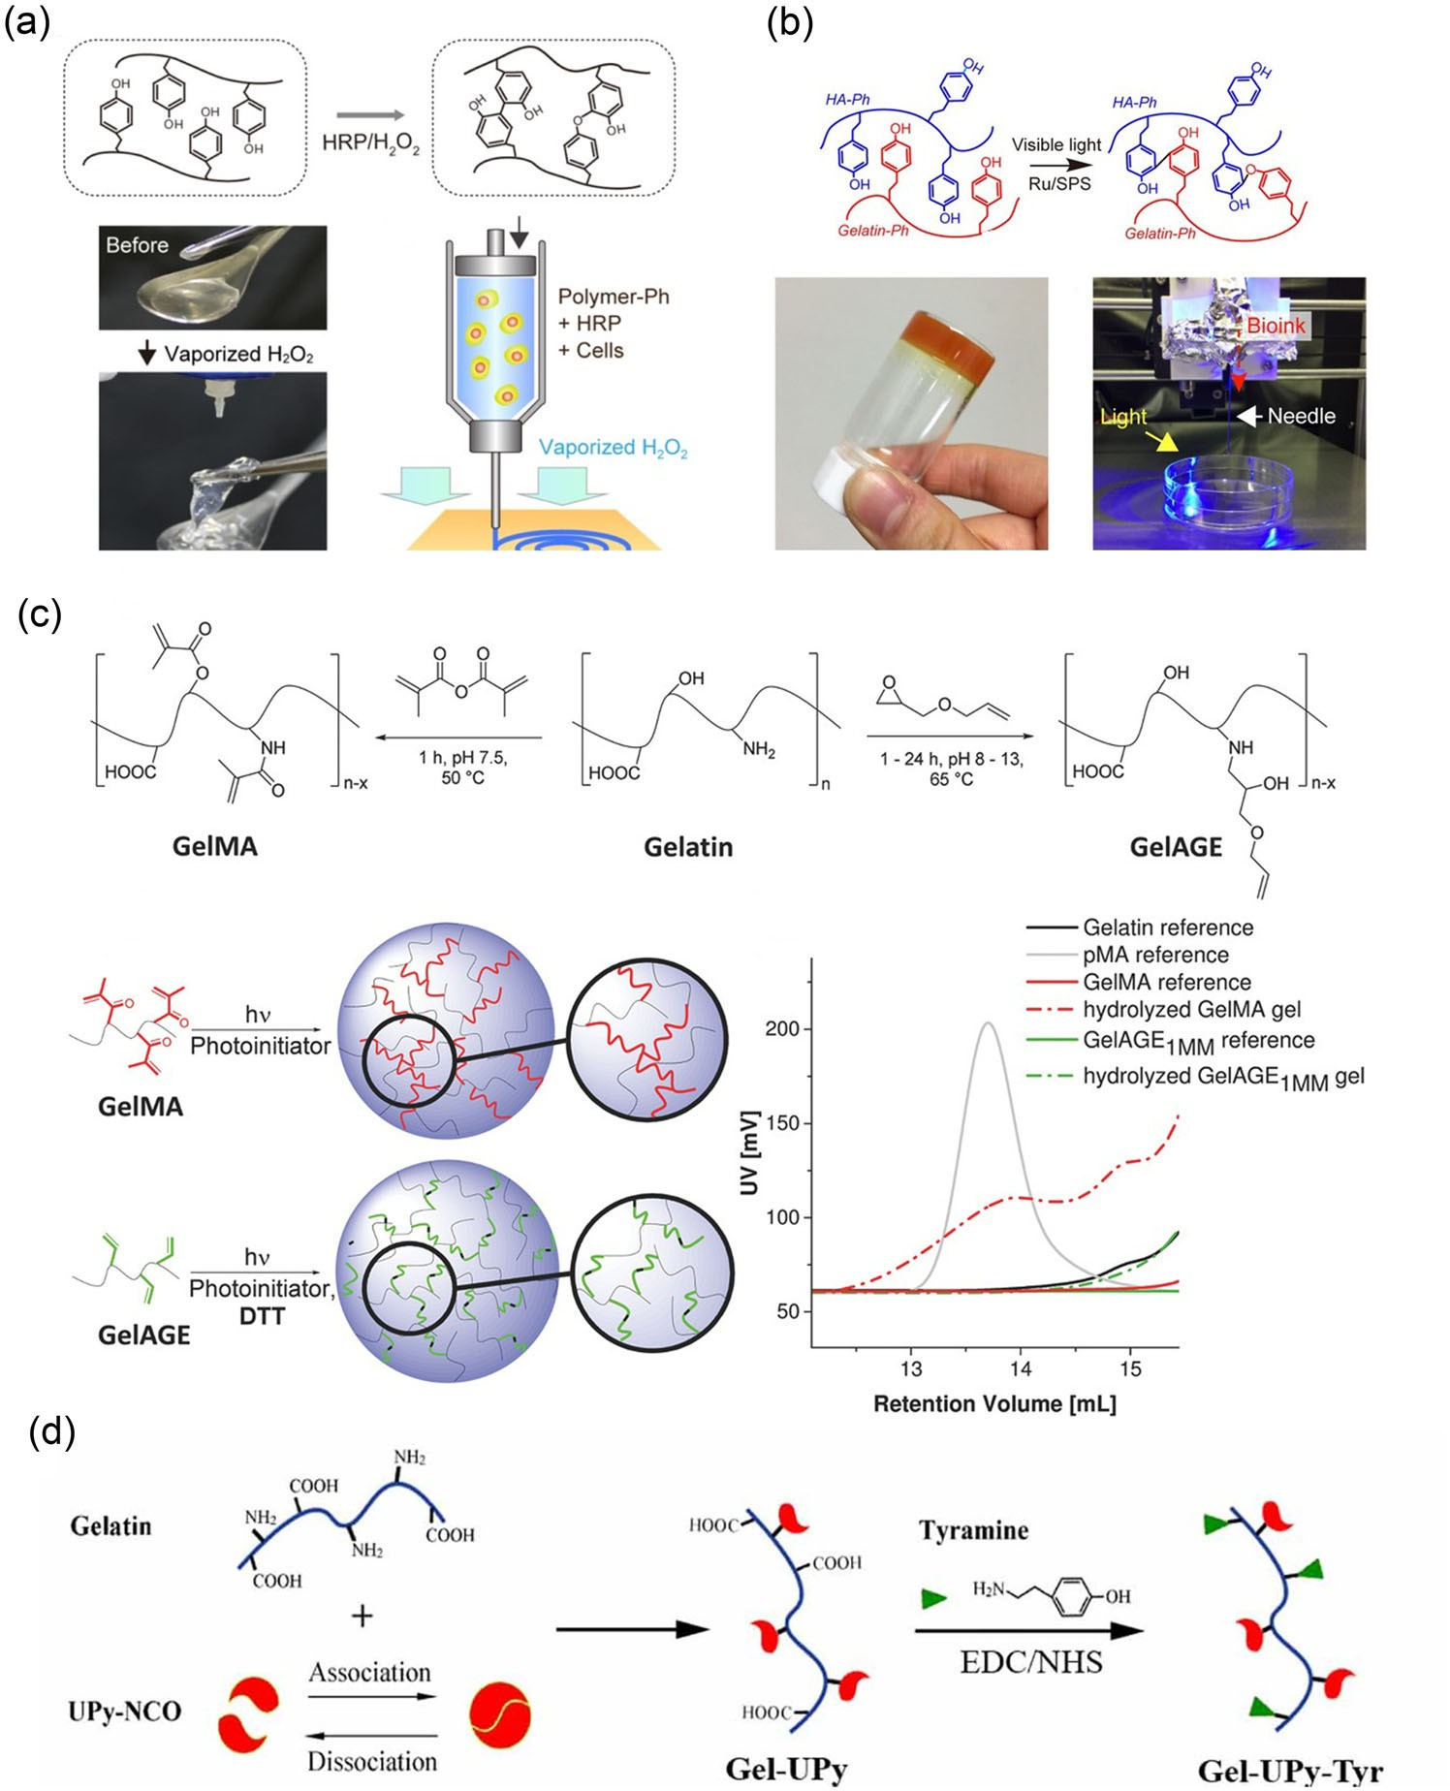
Fig. 6 Other chemical-gelatin based bioinks apart from GelMA bioink. a Illustration of bioprinting using bioink containing gelatin-Ph, HRP, and cells by extrusion in air containing vaporized H2O2 (reproduced from [81], Copyright 2018, with permission from IOP Publishing Ltd.). b Extrusion bioprinting of HA-Ph and Gelatin-Ph crosslinked by Ru/SPS (reproduced from [145], Copyright 2017, with permission from Wiley Periodicals, Inc.). c Scheme of the free radical poly- merization of GelMA in comparison to the controlled dimerization with thiol-ene click chemistry for GelAGE; GPC analysis of gelatin, pMA, hydrolyzed GelMA and GelAGE1MM hydrogels and the cor- responding precursors (reproduced from [76], Copyright 2017, with permission from WILEY–VCH Verlag GmbH & Co. KGaA, Wein- heim). d Modified gelatin with temperature-programmable viscosity and enzyme-controlled solidification by using reversible quadruple- hydrogen-bonded ureido-pyrimidinone (UPy) and enzyme-responsive tyramine moieties (Tyr) (reproduced from [66], Copyright 2020, with permission from IOP Publishing Ltd.). GelMA: gelatin methacryloyl; Ph: phenolic hydroxyl; HRP: horseradish peroxidase; HA: hyaluronic acid; SPS: sodium ammonium persulfate; GelAGE: allylated gelatin; GPC: gel permeation chromatography; EDC/NHS: carbodiimide-N- hydroxysuccinimide.
4.2.3 Gelatin/other polymer bioinks
Other polymers, such as poly(ethylene oxide) (PEO), hyaluronic acid [100], fibrinogen [101], and agarose [102], also have been applied in gelatin/polymer bioinks, which can enhance the viscosity gelatin-based bioink to improve print- ability. When the constructs were fabricated with 3% gelatin and 2% PEO, and crosslinked with microbial transglutami- nase (mTgase), shear thinning property was improved and the subsequent solidification process of bioinks was mild. These constructs could support entrapped cell growth, spreading and proliferation for both HEK293 cells and human umbili- cal vein endothelial cells (HUVECs) [119]. Freeman et al.[101] developed a fibrinogen/gelatin bioink to attain the desired shear-thinning property for rotary extrusion bio- printing, which could be solidified by thrombin (Fig. 5c). Characterizations revealed that not only the concentration of gelatin but also the heat treatment could affect cell viability during printing. Notably, the density of cells in the bioinks influenced printability, and increased collagen deposition and the mechanical strength of construct during two months of culture. Enzymatic crosslinking is a promising crosslinking method for the stabilization of gelatin/polymer under phys- iological conditions; meanwhile, it has the main drawback of low mechanical properties due to the slightly crosslinked network. Employing aldehyde-modified polymers is another strategy to stabilize the network of gelatin/polymer by the interaction of aldehyde and amino groups, such as oxidized dextran [120] and aldehyde-modified cellulose nanocrystals [121]. However, the application of gelatin/polymer bioinks to bioprint tissue-like constructs is currently limited.
4.3 Chemically modified gelatin-based bioinks
An additional approach encompasses conjugating chemical functional moieties to the gelatin chain, that is, preparing gelatin derivatives that can form covalent-crosslinked net- work dependently by stimulation, such as radiation and ions. Chemically modified gelatin has additional advantages in extrusion bioprinting [35, 66]. For instance, it can be bioprinted without further additives, the mechanical prop- erties and degradation rates can be tuned, and other fast and convenient printing technologies can be applied for the mod- ification of gelatin. Moreover, dual solidification processes (i.e., physical and chemical) can be achieved in chemically modified gelatin-based bioinks to enhance the structural sta- bility of constructs. Thus, chemically modified gelatin-based bioinks are gaining increasing attention [122–125].-
4.3.1 Gelatin methacryloyl (GelMA) bioinks
Pure GelMA bioinks GelMA is derived from gelatin by modification with photopolymerizable methacrylate groups, where the gelation of GelMA can be achieved by both the physical crosslinking and photo-induced covalent crosslink- ing of these groups. GelMA has shown a potential as a viable bioink due to the superior biocompatibility, on-demand photo-crosslinkability and broadly tunable physicochemical properties [35, 125–127]. Through a simple cooling process and subsequent photo-induced crosslinking for stabilization, a cell-laden 3D construct can be printed directly by using GelMA bioink [36, 64, 128]. GelMA bioinks (3% GelMA, 1.8 kPa compressive modulus) could be bioprinted success- fully at 21 °C owing to their shear thinning properties [129]. The printed cell-laden constructs with low GelMA concentra- tions showed high porosity, which could effectively support cell survival, as well as enhance cell proliferation and spread- ing. Gu et al. [130] systematically investigated the influence of GelMA concentration and printing temperature on the printability and cell viability. They established that, com- pared to GelMA bioinks with high solid content, GelMA bioinks with low solid contents should be conducted at a rel- atively low printing temperature to achieve good printability, while a low conducting temperature below 20 °C will cause negative effects on cell viability. However, high solid con- tents of the bioinks will limit cell survival, proliferation and spreading; therefore, it is crucial to balance these two aspects for optimal GelMA bioinks.
One strategy to solve the above issue is programming the viscosity of bioinks, or extrusion bioprinting with other methods instead of adjusting the printing temperature. For instance, by partial crosslinking of GelMA using mTgase, the rheological properties of the bioink were well controlled to yield good printability [65]. Furthermore, Ouyang et al. [131] introduced light through a photo-permeable capillary (e.g., silicone tubing and glass) to crosslink GelMA bioink during the extrusion process immediately prior to deposition, which was termed as “in-situ-crosslinking” (Fig. 3c). In this way, the shear forces for extrusion were low and consistent, the printed filament was uniform, and high cell viability (about 95%) was achieved. Moreover, this strategy could be used to print rel- atively complex structures (e.g., core–shell, heterogeneous and hollow structures). Most importantly, maintaining the long-term survival of cells in GelMA hydrogels is crucial for building tissue-like constructs from shape to function.
Combination of GelMA bioink with thickeners Similar to gelatin, the viscosity of GelMA bioinks can be easily increased with rheology enhancers for better printability, such as polymers and nanoclay. As the incorporation of other components will alter the microenvironment of mate- rials, the additive should be suitable for tissue engineering or later removal. Hyaluronic acid (HA) is an abundant natu- ral polymer in human tissues with superior biocompatibility and desirable biological activity [132]. HA methacryloyl (HAMA) shows photocurable property similar to GelMA, which has been one of the most commonly utilized compo- nents in GelMA-based bioink formulas. Due to the incor- poration of viscous HAMA, GelMA (5%)/HAMA (2%) bioink with a low solid content showed good printability and allowed the precise fabrication of complex 3D con- structs, such as human ear- and nose-shaped scaffolds [133]. GelMA/HAMA bioink can also support cell function [134, 135]. van der Valk et al. [134] engineered a 3D human calcific aortic valve disease (CAVD) model using GelMA/HAMA bioink laden with valvular interstitial cells. The novel 3D- bioprinted CAVD model potentiated microcalcification by mimicking the native aortic valve (AV) mechanical environ- ment, and could facilitate high-throughput drug-screening in CAVD. Articular cartilage progenitor cells and multi- potent mesenchymal stromal cells (MSCs) were embedded in GelMA/HAMA/gellan bioink for the fabrication of car- tilage constructs [135]. The incorporation of HAMA in GelMA/gellan bioink increased filament stability, whereas it did not influence the (zone-specific) chondrogenesis of any cell type.
Other photocurable polymers (e.g., polyethylene glycol diacrylate (PEGDA), alginate and carboxymethyl cellulose (CMC) chemically functionalized with methacrylic anhy- dride) have also been used in GelMA-based bioinks. These polymers can increase the viscosity to improve the print- ability of gelatin-based bioinks. In addition, they can be used to fabricate structurally stable and long-lasting scaf- folds for specific applications owing to their relatively slow degradation. García-Lizarribar et al. [136] printed skeletal muscle structures with GelMA–PEGDA, GelMA–AlgMA and GelMA–CMCMA bioinks, which were not only sta- ble but also featured tunable biodegradable and mechanical properties to maintain high cell viability and facilitate myo- genesis. Compared with GelMA–PEGDA bioink, higher cell proliferation and viability were achieved by GelMA–Al- gMA and GelMA–CMCMA bioinks. 3D durable structures could be efficiently fabricated with GelMA–AlgMA and Gel- MA–CMCMA bioinks, which were conductive to forming differentiated and aligned muscle fiber. Gao et al. [137] devel- oped conductive biomimetic scaffolds based on GelMA, HAMA and poly(3,4-ethylenedioxythiophene):sulfonated lignin (PEDOT:LS), which mimicked the native spinal cord and were fabricated by 3D bioprinting. The neural stem cells (NSCs) encapsulated in the scaffolds exhibited good survival rate (higher than 90%). By precisely regulating the light curing time, the conductive hydrogels showed mechanical properties similar to native spinal cord tissues. Apart from the above advantages of GelMA/polymers, they can form a long- lasting matrix for in vitro applications compared to GelMA. To balance the printability and biocompatibility of GelMA bioink, nanoclay or other nanomaterials are generally uti- lized. Due to the thixotropic property of nanoclay, complex scaffolds with high shape fidelity can be easily printed using nanoclay composite [138, 139]. Gao et al. [62] developed a GelMA/nanoclay bioink consisting of 10% GelMA and 4% nanoclay (Laponite) to print complex 3D structures. Com- pared with GelMA, the GelMA/nanoclay scaffolds showed enhanced modulus and strength, albeit lower swelling and degradation ratios. Besides, GelMA/nanoclay had a high biological performance similar to GelMA. GelMA/nanoclay constructs could promote osteogenic and angiogenic tis- sue formation [139]. Liu et al. [140] demonstrated that nano-attapulgite (nano-ATP)/GelMA groups outperformed the control group in terms of printability, indicating that nano-ATP is beneficial for printability. Additionally, after the incorporation of nano-ATP, the mechanical strength of the composite hydrogels was significantly improved, result- ing in adequate mechanical properties for bone regeneration. Their findings showed that cells within the scaffold not only had high viability but also a clear tendency to promote the osteogenic differentiation of BMSCs.
4.3.2 Other chemically modified gelatin-based bioinks
To date, several types of chemically modified gelatin have been developed as bioinks, which can yield a mild solid- ification process to improve cell survival, or enable pro- grammable viscosity to enhance printability. Gelatin con- jugated with polyphenols is one common strategy to form crosslinked gelatin networks by enzymatic crosslinking or photo-crosslinking [81, 141–145]. Phenolic hydroxyl (Ph) moieties can be conjugated with gelatin via the condensa- tion of amino moieties of tyramine and carboxyl moieties of gelatin using commercial EDC/NHS. A bioink contain- ing Gel-Ph, horseradish peroxidase (HRP) and cells was extruded into air containing H2O2, which maintained cell viability above 90%, supporting the migration and spreading of mouse fibroblast 10T2/2 cells (Fig. 6a) [81]. Alternatively, crosslinking Gel-Ph bioink in the presence of Ru/SPS could be triggered by visible light (Fig. 6b), which yielded good cytocompatibility and had a fast gelation below 30 s, while this hydrogel was weak with a Young’s modulus below 3 kPa. Human adipose stem cells (hADSCs) encapsulated in the constructs bioprinted in this manner showed good prolifera- tion and differentiation potential [145]. Similarly, gelatin can be modified with other phenolic hydroxyl moieties, such as gallol- [143] and dopamine-gelatin [142]. Dopamine-gelatin seems a promising choice for neural tissue engineering [141, 142].
Free radical polymerization (e.g., GelMA) will result in the formation of a rather heterogeneous network [146, 147]. Thus, multifunctional molecules coupled with thiol- ene yield more homogeneous networks with characteristics determined by the molecular architecture of the employed educts [148]. Allylated gelatin (GelAGE) can be applied as a thiol-ene clickable bioink for distinct biofabrication appli- cations. Bertlein et al. [76] reported that the curing of this GelAGE system occurred via dimerization and yielded a network with flexible properties that offered a wider bio- printing window than GelMA, without utilizing additional non-degradable components (Fig. 6c). GelAGE could enable more homogeneous networks due to the thiol-ene clickable coupling of multifunctional molecules, and support the long- term viability of encapsulated cells post-printing. In addition, He et al. [66] developed a chemical gelatin (Gel-Upy- Tyr) with temperature-programmable viscosity and enzyme- controlled solidification by using reversible quadruple- hydrogen-bonded ureido-pyrimidinone (UPy) and enzyme- responsive tyramine moieties (Tyr) (Fig. 6d), realizing enhanced printability and superior fidelity. The loaded cells in the construct had high viability of over 90% at 24 h, and exhibited proliferation and protein secretion after one week.
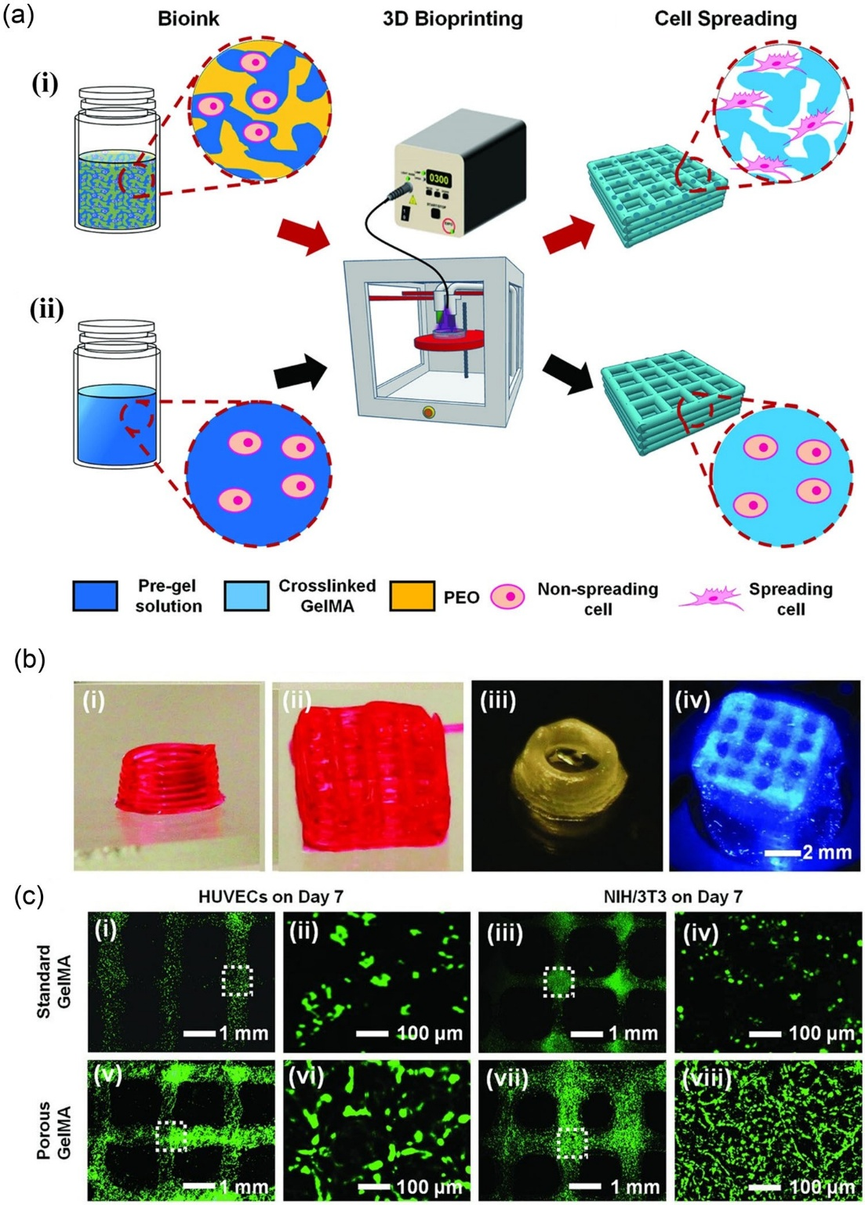
Fig. 7 Preparation of pore-forming GelMA-based bioink for enhancing cell viability (reproduced from [149], Copyright 2018, with permission from WILEY–VCH Verlag GmbH & Co. KGaA, Weinheim). a Extrusion bioprinting of (i) porous hydrogel structure using two-phase aqueous emulsion bioink and (ii) a conventional hydrogel structure. b Photograph of 3D-bioprinted multilayered (i, ii) standard and (iii, iv) porous GelMA hydrogel patterns. c Fluorescence micrographs showing bioprinted HUVECs and NIH/3T3 fibroblasts in (i–iv) standard GelMA hydrogel patterns and (v–viii) porous GelMA hydrogels patterns on Day 7 of culture. GelMA: gelatin methacryloyl; PEO: poly(ethylene oxide); HUVECs: human umbilical vein endothelial cells.
5. Construction of complex, multicellular and large-scale structures based on gelatin-based bioinks
The development progress of gelatin-based bioinks has con- tributed to the biofabrication of complex, multicellular and large-scale constructs widely applied in tissue/organ engi- neering. Maintaining the long-term survival of cells in gelatin-based hydrogels is crucial for building tissue-like constructs from shape to function, especially in large-scale constructs. An alternative strategy is to develop a pore- forming GelMA-based bioink formulation or an embedded vasculature to enhance nutrient delivery and cell growth. The bioprinting of porous hydrogels was achieved by using GelMA mixed with PEO [149]. After the printing of this bioink composed of two immiscible aqueous phases, the porous structure of the 3D-bioprinted hydrogel construct was formed by subsequently removing the PEO phase from the photo-crosslinked GelMA hydrogel (Figs. 7a and 7b). This offered a rapid technology to form porous struc- tures, which showed enhanced cell viability, spreading and proliferation compared to the standard (i.e., non-porous) hydrogel constructs (Fig. 7c). The sacrificial microgel-laden bioink, which contained cell/GelMA mixture and gelled gelatin microgel, was first thermo-crosslinked to fabricate temporary predesigned cell-laden constructs by extrusion bioprinting. Then, the construct was stabilized through photo-crosslinking of GelMA. The pore networks inside the printed constructs were formed after subsequent dissolution of the gelatin microgel. These pore networks allowed for effective oxygen/nutrient diffusion, facilitating the genera- tion of bioactive tissues [150].
Moreover, by combining with sacrificial bioinks, an embedded vasculature can be fabricated within cell-laden GelMA hydrogels. For example, Byambaa et al. [151] fab- ricated micro-structured bone-like constructs containing a perfusable vascular lumen. To form perfusable blood ves- sels inside the bioprinted construct, a central cylinder with 5% GelMA hydrogel characterized by low methacryloyl sub- stitution (GelMALOW) was printed (Fig. 8a). Ouyang et al. [152] fabricated 3D complex vascular networks using a sin- gle bioprinting step and two types of bioink, a gelatin-based templating bioink (e.g., gelatin) and a photo-crosslinkable matrix bioink (e.g., GelMA), which were printed side by side into 3D constructs without any void spaces. By preload- ing endothelial cells (ECs) into the gelatin bioink, ECs were deposited and automatically adhered to the inner sur- face of the channels, which could provide nutrients for cell growth. Shao et al. [153] utilized coaxial 3D bioprinting to generate a large-scale tissue (≥1 cm), which consisted of solid sheath-core (GelMA/desired tissue-gelatin/endothelial cells) fibers and had a self-supporting property to ensure the fidelity of the printed structures during the printing pro- cess (Fig. 8b). When the core fibers dissolved to generate channels, the surface of the core could be efficiently cellularized with a confluent EC layer. This method was the first to successfully fabricate 3D cell-laden vascularized tis- sue constructs with a long-term culture (≥20 d). Moreover, tissue-like constructs with effective oxygen/nutrient diffu- sion and cell growth could be bioprinted. Taymour et al. [154] developed a liver sinusoid-like model that consisted of a core compartment with pre-vascular structures and a shell compartment containing hepatocytes through coaxial extrusion-based 3D bioprinting. Human endothelial cells, laden in the core ink together with human fibroblasts as supportive cells, formed a pre-vascular network in the core both in the absence and presence of HepG2 in the shell. The cellular interactions occurring in this triple culture model enhanced albumin secretion. In conclusion, core–shell bio- printing was shown to be a valuable tool to study cell–cell interactions and to develop complex tissue-like models. He et al. [66] bioprinted a reversible twisting-tension human- scale hBMSC-laden ear and a bicellular tibia-like construct containing hBMSCs and endothelial cells scaffold by using the gelatin-based (Gel-Upy-Tyr) bioink (Fig. 8c), and both types of constructs exhibited good mechanical strength.
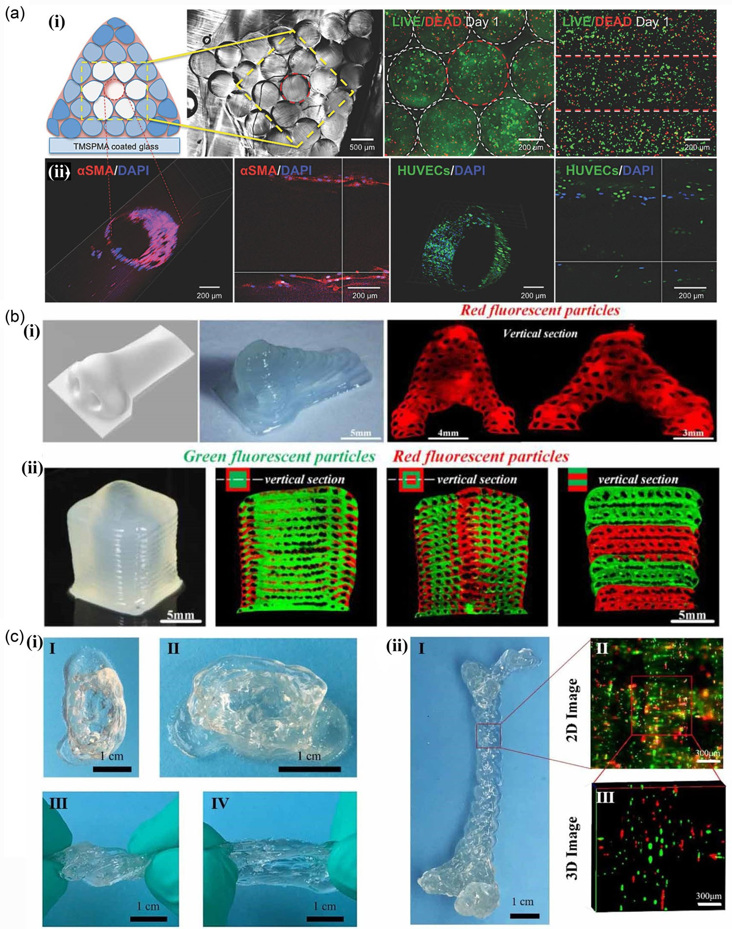
Fig. 8 Bioprinting of complex cell-laden constructs by using gelat- inbased bioinks. a Formation of HUVECs/hMSCs-lined perfusable hollow lumen structure in the bioprinted bone constructs. (i) Cross- sectional view of the whole bioprinted construct and encapsulated cells with live/dead staining. (ii) Demonstration of a HUVEC-lined vessel-like lumen structure within the bioprinted construct; cross- and top-sectioned confocal micrographs of central vessel within the con- struct. The central vessel was stained with DAPI and α-SMA on Day 12 of culture. Encapsulated endothelial cells lined the vascular walls (green fluorescence) and hMSC cells were differentiated into peri- cytes (red fluorescence) (reproduced from [151], Copyright 2017, with permission from WILEY–VCH Verlag GmbH & Co. KGaA, Wein- heim). b Coaxial 3D bioprinting to generate (i) 2D butterfly and leaf patterns: (i) solid nose and (ii) large-scale tissue (≥1 cm) with vascular channels, which consists of solid sheath-core (GelMA/desired tissue- gelatin/endothelial cells) fibers and has a self-supporting property to ensure the fidelity of the printed structures during the printing pro- cess (reproduced from [153], Copyright 2020, with permission from IOP Publishing Ltd.). c Bioprinting of (i) a reversible twisting-tension human-scale hBMSC-laden ear and (ii) a bicellular tibia-like scaf- fold containing hBMSCs and endothelial cells by using gelatin-based (Gel-Upy-Tyr) bioink (repro-duced from [66], Copyright 2020, with permission from IOP Publishing Ltd.). HUVECs: human umbilical vein endothelial cells; hMSCs: human mesenchymal stem cells; DAPI: 4’,6- diamidino-2-phenylindole; α-SMA: α-smooth muscle actin; hBMSCs: human bone mesenchymal stem cells.
6. Challenges and prospects
Despite the numerous advances, the fabrication of gelatin- based bioinks with satisfactory printability and bioactivity into complex tissue-like constructs which have desirable physicochemical properties and biofunctions for specific biomedical applications, still presents several challenges. Specifically, the following requirements for gelatin-based bioinks have remained largely unmet: (1) The printability window of current gelatin-based bioinks is narrow; higher printability and shape fidelity are still expected to achieve complex and sophisticated structures, such as vascular net- works, nephric tubules in the kidney, liver units in the liver and alveolus pulmonis in the lung, etc. (2) The poor mechan- ical strength of gelatin-based hydrogels limits the size and scope of applications for bioprinted constructs. (3) The bio- printing of complex tissue-like constructs calls for precise multicellular arrangement, which is limited by the extru- sion bioprinting technology. (4) The majority of studies currently focus on in vitro experiments, whereas the func- tion of gelatin-based tissue-like constructs in vivo needs to be further verified. Nevertheless, we are confident that there are great prospects for gelatin-based bioinks used in 3D bio- printed constructs with a potential for much more hierarchical structures, diverse cell types, and physiological functions for customized organ regenerative medicine, high-throughput drug screening and the study of tissue morphogenesis.
7. Conclusions
Gelatin has shown great advantages as a bioink material. However, developing a robust system with all the desired merits (printability, shape stability and cell survival) depends on both the physicochemical properties of gelatin-based bioinks and bioprinting conditions. By the incorporation of polymers (e.g., alginate or silk fibrin), hybrid bioinks have demonstrated good printability. Notably, by chemically conjugating functional moieties to the gelatin chain, mod- ified gelatin not only can form networks dependently but also possesses several advantages: it can be printed directly without the incorporation of other components; it is bene- ficial for bioprinting relatively complex structures, such as porous structures and vasculature, or constructs with mul- tiple cell types. Therefore, with the rapid development of gelatin-based bioinks and extrusion bioprinting technology, the bioprinting of complex tissue-like constructs with the desired physicochemical properties and biofunctions for a particular biomedical application will be soon realized.

Acknowledgements The authors gratefully acknowledged the sup- port for this work from the National Key R&D Program of China (No. 2018YFA0703100), the National Natural Sci- ence Foundation of China (Nos. 32122046, 82072082, and 32000959), the Youth Innovation Promotion Association of CAS (No. 2019350), the Guangdong Natural Science Foundation (No. 2019A1515111197), and the Shenzhen Fundamental Research Foun- dation (Nos. JCYJ20190812162809131, JCYJ20200109114006014, JCYJ20210324113001005, and JCYJ20210324115814040).

Author contributions JRY, HMH, LZX and CSR contributed to con- ceptualization; JRY and CSR were involved in methodology; JRY and DL assisted in formal analysis; JRY and CSR acquired the funding; JRY, DL and QZ contributed to investigation; DL and QZ were involved in project administration; JRY and HMH contributed to writing—original draft preparation; JRY and CSR assisted in writing—review and edit- ing; QZ provided sources; LZX and CSR performed supervision. All authors have read and agreed to the published version of the manuscript.

Declarations
Conflict of interest CSR is an Associate Editor of Bio-Design and Man- ufacturing. The authors declare that they have no conflict of interest.
Eihical approval This study does not contain any studies with human or animal subjects performed by any of the authors.

References
1. Kim JH, Kim I, Seol YJ et al (2020) Neural cell integration into 3D bioprinted skeletal muscle constructs accelerates restoration of muscle function. Nat Commun 11(1):1025. https://doi.org/10. 1038/s41467-020-14930-9
2. Qu H, Han Z, Chen Z et al (2021) Fractal design boosts extrusion- based 3D printing of bone-mimicking radial-gradient scaffolds. Research 2021:9892689. https://doi.org/10.34133/2021/9892689
3. Zhang YS, Haghiashtiani G, Hübscher T et al (2021) 3D extrusion bioprinting. Nat Rev Methods Primers 1(1):75. https://doi.org/10. 1038/s43586-021-00073-8
4. Bejleri D, Streeter BW, Nachlas ALY et al (2018) A bio- printed cardiac patch composed of cardiac-specific extracellular matrix and progenitor cells for heart repair. Adv Healthc Mater 7(23):1800672. https://doi.org/10.1002/adhm.201800672
5. Li C, Cui W (2021) 3D bioprinting of cell-laden constructs for regenerative medicine. Eng Regenerat 2:195–205. https://doi.org/ 10.1016/j.engreg.2021.11.005
6. Ahadian S, Khademhosseini A (2018) A perspective on 3D bio- printing in tissue regeneration. Bio-Des Manuf 1(3):157–160. https://doi.org/10.1007/s42242-018-0020-3
7. Daly AC, Davidson MD, Burdick JA (2021) 3D bioprinting of high cell-density heterogeneous tissue models through spheroid fusion within self-healing hydrogels. Nat Commun 12(1):753. https://doi.org/10.1038/s41467-021-21029-2
8. Daly AC, Prendergast ME, Hughes AJ et al (2021) Bioprint- ing for the biologist. Cell 184(1):18–32. https://doi.org/10.1016/ j.cell.2020.12.002
9. Kocak E, Yildiz A, Acarturk F (2021) Three dimensional bio- printing technology: applications in pharmaceutical and biomed- ical area. Colloids Surf B 197:111396. https://doi.org/10.1016/j. colsurfb.2020.111396
10. Park JY, Mani S, Clair G et al (2022) A microphysiological model of human trophoblast invasion during implantation. Nat Commun 13(1):1252. https://doi.org/10.1038/s41467-022-28663-4
11. Brassard JA, Nikolaev M, Hubscher T et al (2021) Recapitulating macro-scale tissue self-organization through organoid bioprint- ing. Nat Mater 20(1):22–29. https://doi.org/10.1038/s41563-020- 00803-5
12. Jin ZZ, Li XD, Liu BX et al (2022) Coaxial bioprinted microfibers with mesenchymal stem cells for glioma microenvironment sim- ulation. Bio-Des Manuf 5(2):348–357. https://doi.org/10.1007/ s42242-021-00155-2
13. Kelly BE, Bhattacharya I, Heidari H et al (2019) Volumetric additive manufacturing via tomographic reconstruction. Science 363(6431):1075–1079. https://doi.org/10.1126/science.aau7114
14. Mota C, Camarero-Espinosa S, Baker MB et al (2020) Bioprint- ing: from tissue and organ development to in vitro models. Chem Rev 120(19):10547–10607. https://doi.org/10.1021/acs.chemrev. 9b00789
15. Vanaei S, Parizi MS, Vanaei S et al (2021) An overview on materials and techniques in 3D bioprinting toward biomedi- cal application. Eng Regenerat 2:1–18. https://doi.org/10.1016/ j.engreg.2020.12.001
16. Mao H, Yang L, Zhu H et al (2020) Recent advances and chal- lenges in materials for 3D bioprinting. Prog Nat Sci Mater Int 30(5):618–634. https://doi.org/10.1016/j.pnsc.2020.09.015
17. Ozbolat IT, Hospodiuk M (2016) Current advances and future perspectives in extrusion-based bioprinting. Biomaterials 76:321–343. https://doi.org/10.1016/j.biomaterials.2015.10.076
18. Santoni S, Gugliandolo SG, Sponchioni M et al (2022) 3D bio- printing: current status and trends—a guide to the literature and industrial practice. Bio-Des Manuf 5(1):14–42. https://doi.org/10. 1007/s42242-021-00165-0
19. Lee A, Hudson AR, Shiwarski DJ et al (2019) 3D bioprinting of collagen to rebuild components of the human heart. Science 365(6452):482–487. https://doi.org/10.1126/science.aav9051
20. Chakraborty J, Mu X, Pramanick A et al (2022) Recent advances in bioprinting using silk protein-based bioinks. Biomaterials 287:121672. https://doi.org/10.1016/j.biomaterials.2022.121672
21. Datta P, Ayan B, Ozbolat IT (2017) Bioprinting for vascular and vascularized tissue biofabrication. Acta Biomater 5:11–20. https://doi.org/10.1016/j.actbio.2017.01.035
22. Fu Z, Naghieh S, Xu C et al (2021) Printability in extrusion bio- printing. Biofabrication 13(3):033001. https://doi.org/10.1088/ 1758-5090/abe7ab
23. Ravanbakhsh H, Karamzadeh V, Bao G et al (2021) Emerg- ing technologies in multi-material bioprinting. Adv Mater 33(49):e2104730. https://doi.org/10.1002/adma.202104730
24. Lee SC, Gillispie G, Prim P et al (2020) Physical and chemical factors influencing the printability of hydrogel-based extrusion bioinks. Chem Rev 120(19):10834–10886. https://doi.org/10. 1021/acs.chemrev.0c00015
25. Askari M, Naniz MA, Kouhi M et al (2021) Recent progress in extrusion 3D bioprinting of hydrogel biomaterials for tissue regeneration: a comprehensive review with focus on advanced fabrication techniques. Biomater Sci 9(3):535–573. https://doi. org/10.1039/d0bm00973c
26. Donderwinkel I, van Hest JCM, Cameron NR (2017) Bio-inks for 3D bioprinting: recent advances and future prospects. Polym Chem 8(31):4451–4471. https://doi.org/10.1039/c7py00826k
27. Schwab A, Levato R, D’Este M et al (2020) Printabil- ity and shape fidelity of bioinks in 3D bioprinting. Chem Rev 120(19):11028–11055. https://doi.org/10.1021/acs.chemrev. 0c00084
28. Ouyang L (2022) Pushing the rheological and mechanical bound- aries of extrusion-based 3D bioprinting. Trends Biotechnol 40(7):891–902. https://doi.org/10.1016/j.tibtech.2022.01.001
29. Liu Y, Peng L, Li L et al (2021) 3D-bioprinted BMSC-laden biomimetic multiphasic scaffolds for efficient repair of osteo- chondral defects in an osteoarthritic rat model. Biomaterials 279:121216. https://doi.org/10.1016/j.biomaterials.2021.121216
30. Gaharwar AK, Singh I, Khademhosseini A (2020) Engineered biomaterials for in situ tissue regeneration. Nat Rev Mater 5(9):686–705. https://doi.org/10.1038/s41578-020-0209-x
31. Bello AB, Kim D, Kim D et al (2020) Engineering and func- tionalization of gelatin biomaterials: from cell culture to medical applications. Tissue Eng Part B Rev 26(2):164–180. https://doi. org/10.1089/ten.TEB.2019.0256
32. Xiao S, Zhao T, Wang J et al (2019) Gelatin methacrylate (GelMA)-based hydrogels for cell transplantation: an effective strategy for tissue engineering. Stem Cell Rev 15(5):664–679. https://doi.org/10.1007/s12015-019-09893-4
33. Xiang L, Cui W (2021) Biomedical application of photo- crosslinked gelatin hydrogels. J Leather Sci Eng 3(1):3. https:// doi.org/10.1186/s42825-020-00043-y
34. Wang X, Ao Q, Tian X et al (2017) Gelatin-based hydrogels for organ 3D bioprinting. Polymers 9(9):401. https://doi.org/10.3390/ polym9090401
35. Ying G, Jiang N, Yu C et al (2018) Three-dimensional bioprinting of gelatin methacryloyl (GelMA). Bio-Des Manuf 1(4):215–224. https://doi.org/10.1007/s42242-018-0028-8
36. Rajabi N, Rezaei A, Kharaziha M et al (2021) Recent advances on bioprinted gelatin methacrylate-based hydrogels for tissue repair. Tissue Eng Part A 27(11–12):679–702. https://doi.org/10.1089/ ten.TEA.2020.0350
37. Yue K, Trujillo-de Santiago G, Alvarez MM et al (2015) Synthesis, properties, and biomedical applications of gelatin methacryloyl (GelMA) hydrogels. Biomaterials 732:54–71. https://doi.org/10. 1016/j.biomaterials.2015.08.045
38. Gomez-Guillen MC, Gimenez B, Lopez-Caballero ME et al (2011) Functional and bioactive properties of collagen and gelatin from alternative sources: a review. Food Hydro- coll 25(8):1813–1827. https://doi.org/10.1016/j.foodhyd.2011.
02.007
39. Lukin I, Erezuma I, Maeso L et al (2022) Progress in gelatin as biomaterial for tissue engineering. Pharmaceutics 14(6):1177. https://doi.org/10.3390/pharmaceutics14061177
40. Gómez-Guillén MC, Pérez-Mateos M, Gómez-Estaca J et al (2009) Fish gelatin: a renewable material for developing active biodegradable films. Trends Food Sci Technol 20(1):3–16. https:// doi.org/10.1016/j.tifs.2008.10.002
41. Liu D, Nikoo M, Boran G et al (2015) Collagen and gelatin. Annu Rev Food Sci Technol 6:527–557. https://doi.org/10.1146/ annurev-food-031414-111800
42. Wang Z, Tian Z, Menard F et al (2017) Comparative study of gelatin methacrylate hydrogels from different sources for biofab- rication applications. Biofabrication 9(4):044101. https://doi.org/ 10.1088/1758-5090/aa83cf
43. Paxton N, Smolan W, Boeck T et al (2017) Proposal to assess print- ability of bioinks for extrusion-based bioprinting and evaluation of rheological properties governing bioprintability. Biofabrication 9(4):044107. https://doi.org/10.1088/1758-5090/aa8dd8
44. Gillispie G, Prim P, Copus J et al (2020) Assessment method- ologies for extrusion-based bioink printability. Biofabrication 12(2):022003. https://doi.org/10.1088/1758-5090/ab6f0d
45. GhavamiNejad A, Ashammakhi N, Wu XY et al (2020) Crosslink- ing strategies for 3D bioprinting of polymeric hydrogels. Small 16(35):e2002931. https://doi.org/10.1002/smll.202002931
46. Townsend JM, Beck EC, Gehrke SH et al (2019) Flow behav- ior prior to crosslinking: the need for precursor rheology for placement of hydrogels in medical applications and for 3D bio- printing. Prog Polym Sci 91:126–140. https://doi.org/10.1016/j. progpolymsci.2019.01.003
47. Ouyang L, Yao R, Zhao Y et al (2016) Effect of bioink properties on printability and cell viability for 3D bioplotting of embryonic stem cells. Biofabrication 8(3):035020. https://doi.org/10.1088/ 1758-5090/8/3/035020
48. Mouser VHM, Melchels FPW, Visser J et al (2016) Yield stress determines bioprintability of hydrogels based on gelatin- methacryloyl and gellan gum for cartilage bioprinting. Biofabrica- tion 8(3):035003. https://doi.org/10.1088/1758-5090/8/3/035003
49. Li H, Tan YJ, Liu S et al (2018) Three-dimensional bioprinting of oppositely charged hydrogels with super strong interface bonding. ACS Appl Mater Interfaces 10(13):11164–11174. https://doi.org/ 10.1021/acsami.7b19730
50. Yoon S, Park JA, Lee HR et al (2018) Inkjet-spray hybrid printing for 3D freeform fabrication of multilayered hydrogel structures. Adv Healthc Mater 7(14):1800050. https://doi.org/10. 1002/adhm.201800050
51. Gudapati H, Dey M, Ozbolat I (2016) A comprehensive review on droplet-based bioprinting: past, present and future. Biomaterials 102:20–42. https://doi.org/10.1016/j.biomaterials.2016.06.012
52. Valot L, Martinez J, Mehdi A et al (2019) Chemical insights into bioinks for 3D printing. Chem Soc Rev 48(15):4049–4086. https:// doi.org/10.1039/c7cs00718c
53. Rastogi P, Kandasubramanian B (2019) Review of alginate- based hydrogel bioprinting for application in tissue engineering. Biofabrication 11(4):042001. https://doi.org/10.1088/1758-5090/ ab331e
54. Chawla S, Midha S, Sharma A et al (2018) Silk-based bioinks for 3D bioprinting. Adv Healthc Mater 7(8):e1701204. https://doi. org/10.1002/adhm.201701204
55. Petta D, D’Amora U, Ambrosio L et al (2020) Hyaluronic acid as a bioink for extrusion-based 3D printing. Biofabrication 12(3):032001. https://doi.org/10.1088/1758-5090/ab8752
56. Lan X, Adesida AB, Boluk Y (2022) Rheological and viscoelastic properties of collagens and their role on bioprinting by micro- extrusion. Biomed Mater 17(6):062005. https://doi.org/10.1088/ 1748-605X/ac9b06
57. Zhai X, Ruan C, Ma Y et al (2018) 3D-bioprinted osteoblast-laden nanocomposite hydrogel constructs with induced microenviron- ments promote cell viability, differentiation, and osteogenesis both in vitro and in vivo. Adv Sci 5(3):1700550. https://doi.org/ 10.1002/advs.201700550
58. Osidak EO, Kozhukhov VI, Osidak MS et al (2020) Collagen as bioink for bioprinting: a comprehensive review. Int J Bioprint 6(3):270. https://doi.org/10.18063/ijb.v6i3.270
59. Guo K, Wang H, Li S et al (2021) Collagen-based thiol- norbornene photoclick bio-ink with excellent bioactivity and printability. ACS Appl Mater Interfaces 13(6):7037–7050. https:// doi.org/10.1021/acsami.0c16714
60. Kolesky DB, Truby RL, Gladman AS et al (2014) 3D bio- printing of vascularized, heterogeneous cell-laden tissue con- structs. Adv Mater 26(19):3124–3130. https://doi.org/10.1002/ adma.201305506
61. Schuurman W, Levett PA, Pot MW et al (2013) Gelatin- methacrylamide hydrogels as potential biomaterials for fabrica- tion of tissue-engineered cartilage constructs. Macromol Biosci 13(5):551–561. https://doi.org/10.1002/mabi.201200471
62. Gao Q, Niu X, Shao L et al (2019) 3D printing of complex GelMA- based scaffolds with nanoclay. Biofabrication 11:035006. https:// doi.org/10.1088/1758-5090/ab0cf6
63. Chen Z, Zhao D, Liu B et al (2019) 3D printing of multifunctional hydrogels. Adv Funct Mater 29(20):1900971. https://doi.org/10. 1002/adfm.201900971
64. Liu W, Heinrich MA, Zhou Y et al (2017) Extrusion bioprinting of shear-thinning gelatin methacryloyl bioinks. Adv Healthc Mater 6(12):1601451. https://doi.org/10.1002/adhm.201601451
65. Zhou M, Lee BH, Tan YJ et al (2019) Microbial transglutam- inase induced controlled crosslinking of gelatin methacryloyl to tailor rheological properties for 3D printing. Biofabrication 11(2):025011. https://doi.org/10.1088/1758-5090/ab063f
66. He H, Li D, Lin Z et al (2020) Temperature-programmable and enzymatically solidifiable gelatin-based bioinks enable facile extrusion bioprinting. Biofabrication 12(4):045003. https://doi. org/10.1088/1758-5090/ab9906
67. Song K, Compaan AM, Chai W et al (2020) Injectable gelatin microgel-based composite ink for 3D bioprinting in air. ACS Appl Mater Interfaces 12(20):22453–22466. https://doi.org/10. 1021/acsami.0c01497
68. Song K, Ren B, Zhai Y et al (2021) Effects of transglutaminase cross-linking process on printability of gelatin microgel-gelatin solution composite bioink. Biofabrication 14(1):015014. https:// doi.org/10.1088/1758-5090/ac3d75
69. Fang Y, Guo Y, Ji M et al (2021) 3D printing of cell-laden microgel-based biphasic bioink with heterogeneous microen- vironment for biomedical applications. Adv Funct Mater 32(13):2109810. https://doi.org/10.1002/adfm.202109810
70. Xie M, Shi Y, Zhang C et al (2022) In situ 3D bioprinting with bioconcrete bioink. Nat Commun 13(1):3597. https://doi.org/10. 1038/s41467-022-30997-y
71. Distler T, Solisito AA, Schneidereit D et al (2020) 3D printed oxi- dized alginate-gelatin bioink provides guidance for C2C12 muscle precursor cell orientation and differentiation via shear stress dur- ing bioprinting. Biofabrication 12(4):045005. https://doi.org/10. 1088/1758-5090/ab98e4
72. Yao B, Hu T, Cui X et al (2019) Enzymatically degradable algi- nate/gelatin bioink promotes cellular behavior and degradation in vitro and in vivo. Biofabrication 11(4):045020. https://doi.org/ 10.1088/1758-5090/ab38ef
73. Wust S, Godla ME, Muller R et al (2014) Tunable hydrogel com- posite with two-step processing in combination with innovative hardware upgrade for cell-based three-dimensional bioprinting. Acta Biomater 10(2):630–640. https://doi.org/10.1016/j.actbio. 2013.10.016
74. Bilici C, Tatar AG, Senturk E et al (2022) Bisulfite-initiated crosslinking of gelatin methacryloyl hydrogels for embedded 3D bioprinting. Biofabrication 14(2):025011. https://doi.org/10. 1088/1758-5090/ac4dd9
75. Yin J, Yan M, Wang Y et al (2018) 3D bioprinting of low- concentration cell-laden gelatin methacrylate (GelMA) bioinks with a two-step cross-linking strategy. ACS Appl Mater Interfaces 10(8):6849–6857. https://doi.org/10.1021/acsami.7b16059
76. Bertlein S, Brown G, Lim KS et al (2017) Thiol-ene clickable gelatin: a platform bioink for multiple 3D biofabrication technolo- gies. Adv Mater 29(44):1703404. https://doi.org/10.1002/adma. 201703404
77. Shams E, Barzad MS, Mohamadnia S et al (2022) A review on alginate-based bioinks, combination with other natural biomate- rials and characteristics. J Biomater Appl 37(2):355–372. https:// doi.org/10.1177/08853282221085690
78. Zhao Y, Li Y, Mao S et al (2015) The influence of printing param- eters on cell survival rate and printability in microextrusion-based 3D cell printing technology. Biofabrication 7(4):045002. https:// doi.org/10.1088/1758-5090/7/4/045002
79. Murphy SV, Atala A (2014) 3D bioprinting of tissues and organs. Nat Biotechnol 32(8):773–785. https://doi.org/10.1038/nbt.2958
80. Robert C, Jae N, Wei S (2008) Effects of dispensing pressure and nozzle diameter on cell survival from solid freeform fabrication- based direct cell writing. Tissue Eng Part A 14(1):41–48
81. Sakai S, Mochizuki K, Qu Y et al (2018) Peroxidase- catalyzed microextrusion bioprinting of cell-laden hydrogel con- structs in vaporized ppm-level hydrogen peroxide. Biofabrication 10(4):045007. https://doi.org/10.1088/1758-5090/aadc9e
82. Qin XH, Ovsianikov A, Stampfl J et al (2014) Additive man- ufacturing of photosensitive hydrogels for tissue engineering applications 15:49. https://doi.org/10.1515/bnm-2014-0008
83. Kang LH, Armstrong PA, Lee LJ et al (2017) Optimizing photo- encapsulation viability of heart valve cell types in 3D printable composite hydrogels. Ann Biomed Eng 45(2):360–377. https:// doi.org/10.1007/s10439-016-1619-1
84. Han WT, Jang T, Chen S et al (2019) Improved cell viability for large-scale biofabrication with photo-crosslinkable hydrogel systems through a dual-photoinitiator approach. Biomater Sci 8(1):450–461. https://doi.org/10.1039/c9bm01347d
85. Xu H, Casillas J, Krishnamoorthy S et al (2020) Effects of Irgacure 2959 and lithium phenyl-2,4,6-trimethylbenzoylphosphinate on cell viability, physical properties, and microstructure in 3D bio- printing of vascular-like constructs. Biomed Mater 15(5):055021. https://doi.org/10.1088/1748-605X/ab954e
86. Dahle J, Kvam E, Stokke T (2005) Bystander effects in UV- induced genomic instability: antioxidants inhibit delayed muta- genesis induced by ultraviolet A and B radiation. J Carcinog 4:11. https://doi.org/10.1186/1477-3163-4-11
87. Lim KS, Schon BS, Mekhileri NV et al (2016) New visible-light photoinitiating system for improved print fidelity in gelatin-based bioinks. ACS Biomater Sci Eng 2(10):1752–1762. https://doi.org/ 10.1021/acsbiomaterials.6b00149
88. Wang Z, Abdulla R, Parker B et al (2015) A simple and high- resolution stereolithography-based 3D bioprinting system using visible light crosslinkable bioinks. Biofabrication 7(4):045009. https://doi.org/10.1088/1758-5090/7/4/045009
89. Sun JY, Zhao X, Illeperuma WRK et al (2012) Highly stretchable and tough hydrogels. Nature 489(7414):133–136. https://doi.org/ 10.1038/nature11409
90. Chakraborty J, Ghosh S (2020) Cellular proliferation, self- assembly, and modulation of signaling pathways in silk fibroin gelatin-based 3D bioprinted constructs. ACS Appl Bio Mater 3(12):8309–8320. https://doi.org/10.1021/acsabm.0c01252
91. Kim SH, Hong H, Ajiteru O et al (2021) 3D bioprinted silk fibroin hydrogels for tissue engineering. Nat Protoc 16(12):5484–5532. https://doi.org/10.1038/s41596-021-00622-1
92. Castilho M, Levato R, Bernal PN et al (2021) Hydrogel-based bioinks for cell electrowriting of well-organized living structures with micrometer-scale resolution. Biomacromol 22(2):855–866. https://doi.org/10.1021/acs.biomac.0c01577
93. Trucco D, Sharma A, Manferdini C et al (2021) Model- ing and fabrication of silk fibroin-gelatin-based constructs using extrusion-based three-dimensional bioprinting. ACS Biomater Sci Eng 7(7):3306–3320. https://doi.org/10.1021/ acsbiomaterials.1c00410
94. Flores-Torres S, Peza-Chavez O, Kuasne H et al (2021) Alginate- gelatin-Matrigel hydrogels enable the development and multi- generational passaging of patient-derived 3D bioprinted cancer spheroid models. Biofabrication 13(2):025001. https://doi.org/10. 1088/1758-5090/abdb87
95. Zhang J, Eyisoylu H, Qin XH et al (2021) 3D bioprinting of graphene oxide-incorporated cell-laden bone mimicking scaf- folds for promoting scaffold fidelity, osteogenic differentiation and mineralization. Acta Biomater 121:637–652. https://doi.org/10.1016/j.actbio.2020.12.026
96. Wang B, Diaz-Payno PJ, Browe DC et al (2021) Affinity-bound growth factor within sulfated interpenetrating network bioinks for bioprinting cartilaginous tissues. Acta Biomater 128:130–142. https://doi.org/10.1016/j.actbio.2021.04.016
97. Hong S, Song JM (2022) 3D bioprinted drug-resistant breast cancer spheroids for quantitative in situ evaluation of drug resistance. Acta Biomater 138:228–239. https://doi.org/10.1016/ j.actbio.2021.10.031
98. Labowska MB, Cierluk K, Jankowska AM et al (2021) A review on the adaption of alginate-gelatin hydrogels for 3D cultures and bioprinting. Materials 14(4):858. https://doi.org/10.3390/ ma14040858
99. Zhu H, Monavari M, Zheng K et al (2022) 3D bioprinting of multifunctional dynamic nanocomposite bioinks incorporating Cu-doped mesoporous bioactive glass nanoparticles for bone tis- sue engineering. Small 18(12):2104996. https://doi.org/10.1002/ smll.202104996
100. Rakin RH, Kumar H, Rajeev A et al (2021) Tunable metacry- lated hyaluronic acid-based hybrid bioinks for stereolithography 3D bioprinting. Biofabrication 13(4):044109. https://doi.org/10. 1088/1758-5090/ac25cb
101. Freeman S, Ramos R, Alexis Chando P et al (2019) A bioink blend for rotary 3D bioprinting tissue engineered small-diameter vascular constructs. Acta Biomater 95:152–164. https://doi.org/ 10.1016/j.actbio.2019.06.052
102. Gong C, Kong Z, Wang X (2021) The effect of agarose on 3D bioprinting. Polymers 13(22):4028. https://doi.org/10.3390/ polym13224028
103. Di Giuseppe M, Law N, Webb B et al (2018) Mechani- cal behaviour of alginate-gelatin hydrogels for 3D bioprint- ing. J Mech Behav Mater 79:150–157. https://doi.org/10.1016/ j.jmbbm.2017.12.018
104. Shi L, Xiong L, Hu Y et al (2018) Three-dimensional printing alginate/gelatin scaffolds as dermal substitutes for skin tissue engineering. Polym Eng Sci 58(10):1782–1790. https://doi.org/ 10.1002/pen.24779
105. Pan T, Song W, Cao X et al (2016) 3D Bioplotting of gelatin/alginate scaffolds for tissue engineering: influence of crosslinking degree and pore architecture on physicochemical
properties. J Mater Sci Technol 32(9):889–900. https://doi.org/ 10.1016/j.jmst.2016.01.007
106. You F, Wu X, Kelly M et al (2020) Bioprinting and in vitro characterization of alginate dialdehyde-gelatin hydrogel bio-ink. Bio-Des Manuf 3(1):48–59. https://doi.org/10.1007/s42242-020- 00058-8
107. Li X, Wang X, Wang X et al (2018) 3D bioprinted rat Schwann cell-laden structures with shape flexibility and enhanced nerve growth factor expression. 3 Biotech 8(8):342. https://doi.org/10. 1007/s13205-018-1341-9
108. Hiller T, Berg J, Elomaa L et al (2018) Generation of a 3D liver model comprising human extracellular matrix in an alginate/gelatin-based bioink by extrusion bioprinting for infec- tion and transduction studies. Int J Mol Sci 19(10):3129. https:// doi.org/10.3390/ijms19103129
109. Ding H, Chang RC (2018) Simulating image-guided in situ bioprinting of a skin graft onto a phantom burn wound bed. Addit Manuf 22:708–719. https://doi.org/10.1016/j.addma.2018. 06.022
110. Liu N, Huang S, Yao B et al (2016) 3D bioprinting matrices with controlled pore structure and release function guide in vitro self- organization of sweat gland. Sci Rep 6:34410. https://doi.org/10. 1038/srep34410
111. Zhao M, Wang J, Zhang J et al (2022) Functionalizing multi- component bioink with platelet-rich plasma for customized in- situ bilayer bioprinting for wound healing. Mater Today Bio 16:100334. https://doi.org/10.1016/j.mtbio.2022.100334
112. Singh YP, Bandyopadhyay A, Mandal BB (2019) 3D bioprint- ing using cross-linker-free silk-gelatin bioink for cartilage tissue engineering. ACS Appl Mater Interfaces 11(37):33684–33696. https://doi.org/10.1021/acsami.9b11644
113. Chawla S, Desando G, Gabusi E et al (2021) The effect of silk–gelatin bioink and TGF-β3 on mesenchymal stromal cells in 3D bioprinted chondrogenic constructs: a proteomic study. J Mater Res 36(19):4051–4067. https://doi.org/10.1557/s43578- 021-00230-5
114. Jose RR, Brown JE, Polido KE et al (2015) Polyol-silk bioink formulations as two-part room-temperature curable materials for 3D printing. ACS Biomater Sci Eng 1(9):780–788. https://doi. org/10.1021/acsbiomaterials.5b00160
115. Rodriguez MJ, Brown J, Giordano J et al (2017) Silk based bioinks for soft tissue reconstruction using 3-dimensional (3D) printing with in vitro and in vivo assessments. Biomaterials 117:105–115. https://doi.org/10.1016/j.biomaterials.2016.11.046
116. Das S, Pati F, Choi YJ et al (2015) Bioprintable, cell-laden silk fibroin-gelatin hydrogel supporting multilineage differenti- ation of stem cells for fabrication of three-dimensional tissue constructs. Acta Biomater 11:233–246. https://doi.org/10.1016/ j.actbio.2014.09.023
117. Chameettachal S, Midha S, Ghosh S (2016) Regulation of chon- drogenesis and hypertrophy in silk fibroin-gelatin-based 3D bioprinted constructs. ACS Biomater Sci Eng 2(9):1450–1463. https://doi.org/10.1021/acsbiomaterials.6b00152
118. Shi W, Sun M, Hu X et al (2017) Structurally and functionally optimized silk-fibroin-gelatin scaffold using 3D printing to repair cartilage injury in vitro and in vivo. Adv Mater 29(29):1701089. https://doi.org/10.1002/adma.201701089
119. Irvine SA, Agrawal A, Lee BH et al (2015) Printing cell-laden gelatin constructs by free-form fabrication and enzymatic protein crosslinking. Biomed Microdevices 17(1):16. https://doi.org/10. 1007/s10544-014-9915-8
120. Du Z, Li N, Hua Y et al (2017) Physiological pH-dependent gela- tion for 3D printing based on the phase separation of gelatin and oxidized dextran. Chem Commun 53(97):13023–13026. https:// doi.org/10.1039/c7cc08225h
121. Prince E, Alizadehgiashi M, Campbell M et al (2018) Patterning of structurally anisotropic composite hydrogel sheets. Biomacromol 19(4):1276–1284. https://doi.org/10.1021/acs.biomac.8b00100
122. Heo DN, Alioglu MA, Wu Y et al (2020) 3D bioprinting of carbohydrazide-modified gelatin into microparticle-suspended oxidized alginate for the fabrication of complex-shaped tissue constructs. ACS Appl Mater Interfaces 12(18):20295–20306. https://doi.org/10.1021/acsami.0c05096
123. De Moor L, Smet J, Plovyt M et al (2021) Engineering microvas- culature by 3D bioprinting of prevascularized spheroids in photo- crosslinkable gelatin. Biofabrication 13(4):045021. https://doi. org/10.1088/1758-5090/ac24de
124. Feng Q, Li D, Li Q et al (2022) Assembling micro- gels via dynamic cross-linking reaction improves printability, microporosity, tissue-adhesion, and self-healing of microgel bioink for extrusion bioprinting. ACS Appl Mater Interfaces 14(13):15653–15666. https://doi.org/10.1021/acsami.2c01295
125. Sun X, Ma Z, Zhao X et al (2021) Three-dimensional bioprint- ing of multicell-laden scaffolds containing bone morphogenic protein-4 for promoting M2 macrophage polarization and accel- erating bone defect repair in diabetes mellitus. Bioact Mater 6(3):757–769. https://doi.org/10.1016/j.bioactmat.2020.08.030
126. Ning L, Mehta R, Cao C et al (2020) Embedded 3D bioprinting of gelatin methacryloyl-based constructs with highly tunable struc- tural fidelity. ACS Appl Mater Interfaces 12(40):44563–44577. https://doi.org/10.1021/acsami.0c15078
127. Martyniak K, Lokshina A, Cruz MA et al (2022) Biomaterial composition and stiffness as decisive properties of 3D bio- printed constructs for type II collagen stimulation. Acta Biomater 152:221–234. https://doi.org/10.1016/j.actbio.2022.08.058
128. Xie M, Yu K, Sun Y et al (2019) Protocols of 3D bioprinting of gelatin methacryloyl hydrogel based bioinks. J Vis Exp 154:1–16. https://doi.org/10.3791/60545
129. Raveendran N, Ivanovski S, Vaquette C (2022) The effect of cul- ture conditions on the bone regeneration potential of osteoblast- laden 3D bioprinted constructs. Acta Biomater 156:190–201. https://doi.org/10.1016/j.actbio.2022.09.042
130. Gu Y, Zhang L, Du X et al (2018) Reversible physical crosslinking strategy with optimal temperature for 3D bioprinting of human chondrocyte-laden gelatin methacryloyl bioink. J Biomater Appl 33(5):609–618. https://doi.org/10.1177/0885328218805864
131. Ouyang L, Highley CB, Sun W et al (2017) A generalizable strategy for the 3D bioprinting of hydrogels from nonviscous photo-crosslinkable inks. Adv Mater 29(8):1604983. https://doi. org/10.1002/adma.201604983
132. Muzzarelli RAA, Greco F, Busilacchi A et al (2012) Chitosan, hyaluronan and chondroitin sulfate in tissue engineering for car- tilage regeneration: a review. Carbohydr Polym 89(3):723–739. https://doi.org/10.1016/j.carbpol.2012.04.057
133. Xia H, Zhao D, Zhu H et al (2018) Lyophilized scaffolds fabri- cated from 3D-printed photocurable natural hydrogel for cartilage regeneration. ACS Appl Mater Interfaces 10(37):31704–31715. https://doi.org/10.1021/acsami.8b10926
134. van der Valk DC, van der Ven CFT, Blaser MC et al (2018) Engineering a 3D-bioprinted model of human heart valve dis- ease using nanoindentation-based biomechanics. Nanomaterials 8(5):296. https://doi.org/10.3390/nano8050296
135. Mouser VHM, Levato R, Mensinga A et al (2018) Bio-ink development for three-dimensional bioprinting of hetero-cellular cartilage constructs. Connect Tissue Res 61(2):137–151. https:// doi.org/10.1080/03008207.2018.1553960
136. García-Lizarribar A, Fernandez-Garibay X, Velasco-Mallorqui F et al (2018) Composite biomaterials as long-lasting scaffolds for 3D bioprinting of highly aligned muscle tissue. Macromol Biosci 18(10):1800167. https://doi.org/10.1002/mabi.201800167
137. Gao C, Li Y, Liu X et al (2023) 3D bioprinted conductive spinal cord biomimetic scaffolds for promoting neuronal differentiation of neural stem cells and repairing of spinal cord injury. Chem Eng J 451:138788. https://doi.org/10.1016/j.cej.2022.138788
138. Jin Y, Liu C, Chai W et al (2017) Self-supporting nanoclay as inter- nal scaffold material for direct printing of soft hydrogel composite structures in air. ACS Appl Mater Interfaces 9(20):17457–17466. https://doi.org/10.1021/acsami.7b03613
139. Cidonio G, Alcala-Orozco CR, Lim KS et al (2019) Osteogenic and angiogenic tissue formation in high fidelity nanocomposite Laponite-gelatin bioinks. Biofabrication 11(3):035027. https:// doi.org/10.1088/1758-5090/ab19fd
140. Liu C, Dai T, Wu X et al (2023) 3D bioprinting of cell-laden nano- attapulgite/gelatin methacrylate composite hydrogel scaffolds for bone tissue repair. J Mater Sci Technol 135:111–125. https://doi. org/10.1016/j.jmst.2022.07.011
141. Haring AP, Thompson EG, Tong Y et al (2019) Process- and bio- inspired hydrogels for 3D bioprinting of soft free-standing neural and glial tissues. Biofabrication 11(2):025009. https://doi.org/10. 1088/1758-5090/ab02c9
142. Zhou X, Cui H, Nowicki M et al (2018) Three-dimensional- bioprinted dopamine-based matrix for promoting neural regen- eration. ACS Appl Mater Interfaces 10(10):8993–9001. https:// doi.org/10.1021/acsami.7b18197
143. Shin M, Galarraga JH, Kwon MY et al (2018) Gallol- derived ECM-mimetic adhesive bioinks exhibiting tempo- ral shear-thinning and stabilization behavior. Acta Biomater 96(1):165–175. https://doi.org/10.1016/j.actbio.2018.10.028
144. Sakai S, Ueda K, Gantumur E et al (2018) Drop-on-drop multi- material 3D bioprinting realized by peroxidase-mediated cross- linking. Macromol Rapid Commun 39(3):1700534. https://doi. org/10.1002/marc.201700534
145. Sakai S, Ohi H, Hotta T et al (2018) Differentiation poten- tial of human adipose stem cells bioprinted with hyaluronic acid/gelatin-based bioink through microextrusion and visible light-initiated crosslinking. Biopolymers 109(2):e23080. https:// doi.org/10.1002/bip.23080
146. Lowe AB, Hoyle CE, Bowman CN (2010) Thiol-yne click chemistry: a powerful and versatile methodology for materials synthesis. J Mater Chem 20(23):4745–4750. https://doi.org/10. 1039/b917102a
147. Hoyle CE, Bowman CN (2010) Thiol-ene click chemistry. Angew Chem Int Ed 49(9):1540–1573. https://doi.org/10.1002/ anie.200903924
148. Stichler S, Jungst T, Schamel M et al (2017) Thiol-ene click- able poly(glycidol) hydrogels for biofabrication. Ann Biomed Eng 45(1):273–285. https://doi.org/10.1007/s10439-016-1633-3
149. Ying GL, Jiang N, Mahar S et al (2018) Aqueous two-phase emul- sion bioink-enabled 3D bioprinting of porous hydrogels. Adv Mater 30(50):1805460. https://doi.org/10.1002/adma.201805460
150. Shao L, Gao Q, Xie C et al (2020) Sacrificial microgel-laden bioink-enabled 3D bioprinting of mesoscale pore networks. Bio-Des Manuf 3(1):30–39. https://doi.org/10.1007/s42242-020- 00062-y
151. Byambaa B, Annabi N, Yue K et al (2017) Bioprinted osteogenic and vasculogenic patterns for engineering 3D bone tis- sue. Adv Healthc Mater 6(16):1700015. https://doi.org/10.1002/ adhm.201700015
152. Ouyang L, Armstrong JPK, Chen Q et al (2020) Void-free 3D bio- printing for in-situ endothelialization and microfluidic perfusion. Adv Funct Mater 30(1):1908349. https://doi.org/10.1002/adfm. 201908349
153. Shao L, Gao Q, Xie C et al (2020) Directly coaxial 3D bioprint- ing of large-scale vascularized tissue constructs. Biofabrication 12(3):035014. https://doi.org/10.1088/1758-5090/ab7e76
154. Taymour R, Chicaiza-Cabezas NA, Gelinsky M et al (2022) Core- shell bioprinting of vascularized in vitro liver sinusoid models. Biofabrication 14(4):045019. https://doi.org/10.1088/1758-5090/ ac9019

