High efficiency inorganic perovskite solar cells based on low trap density and high carrier mobility CsPbI₃ films

Jifeng Yuan, Di Zhang, Binbin, Deng, Jiuyao Du, Wallace C. H. Choy, Jianjun Tian*

Jifeng Yuan, Di Zhang, Binbin, Deng, Jiuyao Du, Jianjun Tian
Institute for Advanced Materials and Technology, University of Science and Technology Beijing, 100083, China.
E-mail: tianjianjun@mater.ustb.edu.cn
Prof. W. C. H. Choy
Department of Electrical and Electronic Engineering
The University of Hong Kong
Pokfulam Road, Hong Kong SAR, China

Keywords: Inorganic metal halide perovskite, solar cell, thiophenol ligands, passivation, efficiency

Abstract
Inorganic perovskite CsPbI₃ has exhibited promising performance in single-junction solar cells, but the grain boundaries (GBs) in its film cause the formation of deep energy level defects and impede the transport of carriers, worsening the efficiency and stability of the solar cells. Here, we devise a CsPbI₃ precursor with thiophenol series ligands (TP-ligands) containing both S-H and π-conjugated molecules. The strong interaction between the S-H group (Lewis base) and PbI₂ (Lewis acid) suppresses the formation of PbI₄²⁻ in perovskite solution, thus suppressing the formation of deep energy defects in the film accordingly. The terminal groups such as -F and -NH₃ are employed to achieve an appropriate evaporation speed of the ligands and prevent the oxidation of the thiophenol group, then a high-quality perovskite film with low trap density was obtained. The functional group π-conjugated molecules also provide additional carrier transmission channels at the GBs to increase carrier mobility. The CsPbI₃ solar cell shows a considerable power conversion efficiency of 20.1% with an open-current voltage of 1.18 V and a high fill factor of 83.5%. The device presented excellent working stability, negligible attenuation following 1000 minutes at its maximum power point under AM 1.5 G illumination simulated sunlight (100 mW cm⁻²).

Introduction
Cesium lead halide perovskite (CsPbI₃) has received a lot of attention for photovoltaics in recent years because the A-site organic cation is replaced by cesium to overcome the intrinsic instability of organic-inorganic hybrid perovskite.^{[1-3]} With a bandgap of 1.68eV, the β-phase CsPbI₃ perovskite is a viable choice for both high-efficiency single-junction perovskite solar cells (PSCs) and top cells with a wide bandgap in tandem solar cells. The toughest issue of the CsPbI₃ perovskite is the nature of structural instability. The size-unmatchable Cs ions barely hold up the construction of [PbI₆]⁻⁴ octahedron, leading to the transformation from black phase (α phase, β phase, γ phase) to yellow phase (no-perovskite phase).^{[4]}
Several attempts have been made to stabilize the CsPbI₃ black phase. For instance, Br⁻ was introduced as the substitution for I⁻, increasing the τ value.^{[5-7]} Unfortunately, the light absorption range becomes narrower correspondingly with the Br component increasing. Dimensionality engineering, such as two-dimensional perovskites and zero-dimensional perovskite quantum dots, is another option.^{[8-13]} The high surface energy provides a strain that prevents the [PbI₆]⁻⁴ octahedron from twisting. However, this process generates dozens of grain boundaries in the film, which may cause a large amount of energy loss in the carriers, leading to a shorter carrier diffusion length. Similar to dimensionality engineering, organic capping also can offer a surface strain to inhibit the phase transformation.^{[14-15]} What’s more, the hydrophobicity of organic materials may lessen moisture erosion. Moisture exposure may trigger the phase transition by lowering the phase transition barrier.^{[16]} Nonetheless, owing to their poor electrical conductivity, organic molecules will obstruct charge transmission, resulting in the poor power conversion efficiency (PCE) of the devices. Nowadays, the most popular technique for CsPbI₃ fabrication is dimethylammonium iodide (DMAI) doping, resulting in a β-phase perovskite film with high efficiency and phase stability. ^{[17-19]} However, because of the evaporation of DMAI during the annealing stage, it still suffers from poor morphology and vacancy defects. ^{[20-21]}
In addition, the sol-gel technique is commonly used for the fabrication of perovskite film, leading to a polycrystalline absorber layer. Defects would unavoidably arise in the grain boundaries (GBs) of the films during the production process. Among these defects, iodine vacancy (V_{I}) is commonly regarded as a type of defect with deep energy levels which acts as Shockley-Read-Hall nonradiative recombination centers, serving as photoluminescence quenching sites and thus resulting in the loss of photogenerated carriers. ^{[22-23]} The phase transformation of the CsPbI₃ perovskite can likewise be easily induced by these defects. According to the Lewis acid/base theory, the ligands with (L) and bidentate (LL) groups usually act as the Lewis base and have the effect of V_{I} passivation, such as O-donor, S-donor, and N-donor.^{[24]} Consequently, the Lewis base S-H has a chance to form an adduct by interacting with the PbI₂, which is known to be a Lewis acid, thus passivating the V_{I} defect.^{[25]} In addition, the π-conjugated molecules normally process superior electrical conductivity because of the unique natures of coplanar π-electrons and the existence of intermolecular π-π interaction.^{[26]} It could be speculated that the functional group would improve the ability to transfer carriers through the perovskite interfaces and GBs.
Here, we devise thiophenol series ligands (TP-ligands) as the multifunctional molecular modulators in the perovskite precursor solution, which contains both the S-H and π-conjugated molecules. The terminal groups such as -F and -NH₃ are employed to adjust the dipole moments of thiophenol to prevent it from oxidation. TP-ligands not only modify the halide vacancy but also provide additional beneficial channels for carrier extraction at the GBs of the perovskite film. Moreover, the crystallization of CsPbI₃ films is improved, leading to the removal of pinholes in perovskite film. As a result, an impressive PCE of 20.1% was achieved with an open-current voltage (V_{OC}) of 1.18V and a high fill factor (FF) of 83.5%. Furthermore, the thiophenol-containing compounds have contributed exceptional long-term durability to perovskite films because of their hydrophobicity.^{[27]} The CsPbI₃ devices exhibit excellent working stability at their maximum power point under AM 1.5 G illumination simulated sunlight.
Results and Discussion
As one of the TP-ligands, the 4-Fluorothiophenol (4-FTP) was first used to study the behavior of the ligands in the CsPbI₃ precursor solution. The perovskite precursor was diluted and measured by ultraviolet-visible (UV-Vis) spectroscopy to explore the effect of TP-ligand on the colloidal characteristics, as shown in Figure 1a and b. When the addition concentration of the precursor was lower than 120 μM, there was an obvious absorption peak of PbI₂ at 325 nm. A red shift occurred gradually in the UV-vis spectra as the precursor concentration increased. In addition, new peaks at 375 nm and 425 nm arose and grew, meaning that PbI₂ underwent complexation to produce soluble PbI₃⁻ and PbI₄²⁻ (the coordinated plumbate species).^{[28-29]} We investigated the effects of the TP-ligands on the dynamics of PbI₃⁻ and PbI₄²⁻ production. Figure 1c demonstrates the both increased rate of the peaks at 375nm and 425 nm with the increase of solution concentration, representing the increased amount of PbI₃⁻ and PbI₄²⁻. The lower growth rate of absorption of PbI₃⁻ and PbI₄²⁻ in the TP-ligand CsPbI₃ solution illustrate that the coordination between TP-ligands and PbI₂ suppresses the formation of PbI₄²⁻. Previous works have demonstrated the formation of PbI₄² in the precursor would increase the defect density in the product perovskite film.^{[30]} Thus, the introduction of TP-ligands will help prepare low defect density perovskite films.
The density functional theory (DFT) calculations were carried out to further demonstrate the behavior of the TP-ligand. The results show the adsorption energy (ΔE) between the S-H group and uncoordinated Pb²⁺ on the CsPbI₃ film in a value of -0.326 eV, indicating that it is easy for TP-ligands to be adsorbed at iodide vacancies (V_{I}) on the surface of CsPbI₃ during the self-assembly process, as illustrated in Figure S1 and Table S1 (Supporting Information). To check for the reliability of these results, the energy dispersive spectroscopy (EDS) of the TP-ligand CsPbI₃ film is presented in Figure S2. The S elements were homogeneously distributed across the perovskite film. The molecular interactions of the ligand with perovskite film were examined by Fourier transform infrared spectroscopy (FTIR), as shown in Figure 1d. By zooming in the spectra, several weak peaks were observed at 1560 cm⁻¹ and 3100 cm⁻¹ from the TP-ligand CsPbI₃ film (20 mins of annealing), which are the vibration peaks of S-H and benzene (Figure S3), respectively. The peak characteristic of the S-H stretching vibration was found in the FTIR spectra at 1555 cm⁻¹ for the TP-ligand solution and 1560 cm⁻¹ for perovskite film. The S-H stretching underwent broadening and shifted to a longer wavelength, indicating the interaction of S-H with uncoordinated Pb²⁺. To confirm this result, the perovskite film was further studied by X-ray photoelectron spectroscopy (XPS), as shown in Figure S4a. The XPS spectra of the TP-ligand CsPbI₃ and control film in the S 2p level range are shown in Figure 1e, with the S 2p peak visible in the TP-ligand CsPbI₃ spectrum. Figure 1f displays the Pb 4f core spectra of the TP-ligand CsPbI₃ and control films. The control film shows two small peaks located at 136 and 140.8 eV, which are caused by the presence of metallic Pb (Pb⁰), a primary deep defect state that substantially impairs the performance and long-term durability of perovskite optoelectronic devices.^{[31]} While the metallic Pb peaks disappeared in the TP-ligand CsPbI₃ film, suggesting the coordination between the ligands and Pb²⁺ ions responsible for the suppression of Pb⁰. In addition, the Pb 4f and I 3d peaks (Figure S4b) in TP-ligand CsPbI₃ shifted to higher binding energy, indicating a decrease in electron density around these species due to the reduction of under-coordinated Pb²⁺ ions via interaction with S-H.
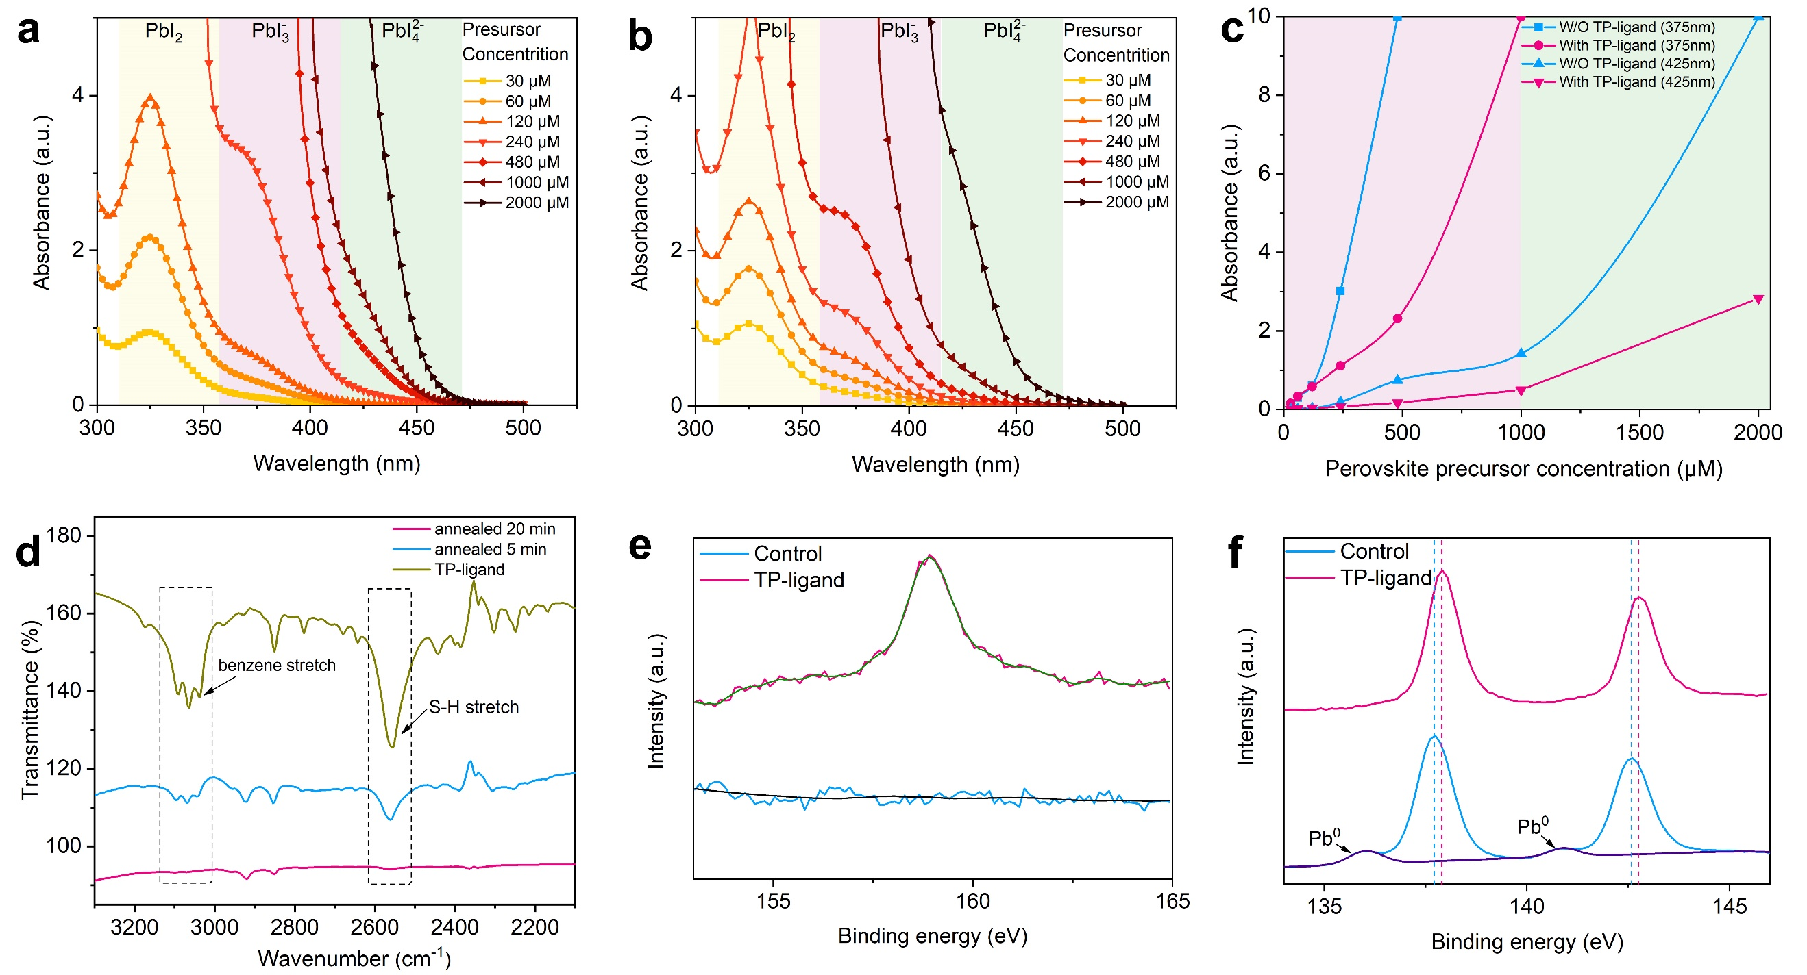
Figure 1. a) control and b) TP-ligand CsPbI₃ precursor. c) The absorption of perovskite solution at 375 nm and 425nm. The yellow region, pink region, and green region illustrate the absorption peak range of PbI₂, PbI₃^{-,} and PbI₄²⁻, respectively. d) FTIR spectra of the TP-ligands, TP-ligand CsPbI₃ films annealed 5 mins and 20 mins. XPS data for e) S 2p and f) Pb 4f_{7/2} and Pb 4f_{5/2} core-level spectra in control and TP-ligand CsPbI₃ films.

In our previous research, we found that the superfluous organic which accumulated at the GBs could obstruct charge transportation.^{[32]} If the residual organic without bounding to perovskite can be removed from the film during the annealing process, the efficiency of devices will be further improved. We devised three TP-ligands with different terminal groups: 4-FTP, 4-aminothiophenol (4-ATP), and 2-aminothiophenol (2-ATP), which have different volatility properties. The volatility of TP-ligands was explored by thermogravimetric analysis (TGA), as shown in Figure S5. Under the annealing temperature, the 4-FTP, 4-ATP, and 2-ATP exhibit evaporation velocity from high to low orderly. X-ray diffraction (XRD) measurements were employed to trace the crystallization of the perovskite films, as shown in Figure S6. The stronger diffraction peaks originating from the β phase of CsPbI₃ reveal the high quality of the 4-ATP and 2-ATP CsPbI₃ films, which can be attributed to their slower evaporation velocity than that of 4-FTP. The slow evaporation velocity of the additive suppresses nucleation, leading to a decrease in the film growth, which is available for obtaining high-quality and morphology-improved perovskite films.^{[33]} As demonstrated in Figure 2a to d, the TP-ligands have a positive impact on the morphology of the perovskite film, where the cracks and pinholes in the original perovskite films appear to have been repaired. As shown in Figure S7, the denser morphology of the films results in a lower leakage current, leading to a higher fill factor (FF) for solar cells. In addition, the scanning electron microscopy (SEM) patterns show the bigger grains and fewer grain boundaries of the TP-ligand films than those of the control sample, resulting in fewer non-radiative combinations due to low trap density. In Figure 2d, the white content should be 2-ATP, indicating the residual after the annealing process because of its low evaporation velocity at the annealing temperature. Figure S8 displays the macroscopical photograph of the films after the annealing process, showing the higher phase stability of TP-ligands. Based on the abovementioned results, we proposed the mechanism of TP-ligands for the formation of CsPbI₃ film: the complexation between TP-ligand (electron-pair donor) and PbI₂ (electron-pair acceptor) form a colloid complex in the perovskite precursor. The formation of PbI₄²⁻ is suppressed in perovskite solution, leading to a low trap density of charge recombination in the CsPbI₃ film. Furthermore, the morphology and crystallinity of the perovskite film are also improved. Whereafter, because of the evaporation effect, the extra TP-ligands can be eliminated during the annealing progresses, and the remnant would combine with the uncoordinated Pb²⁺ by the S-H bond, thus passivating the halide vacancies, as shown in Figure 2e.
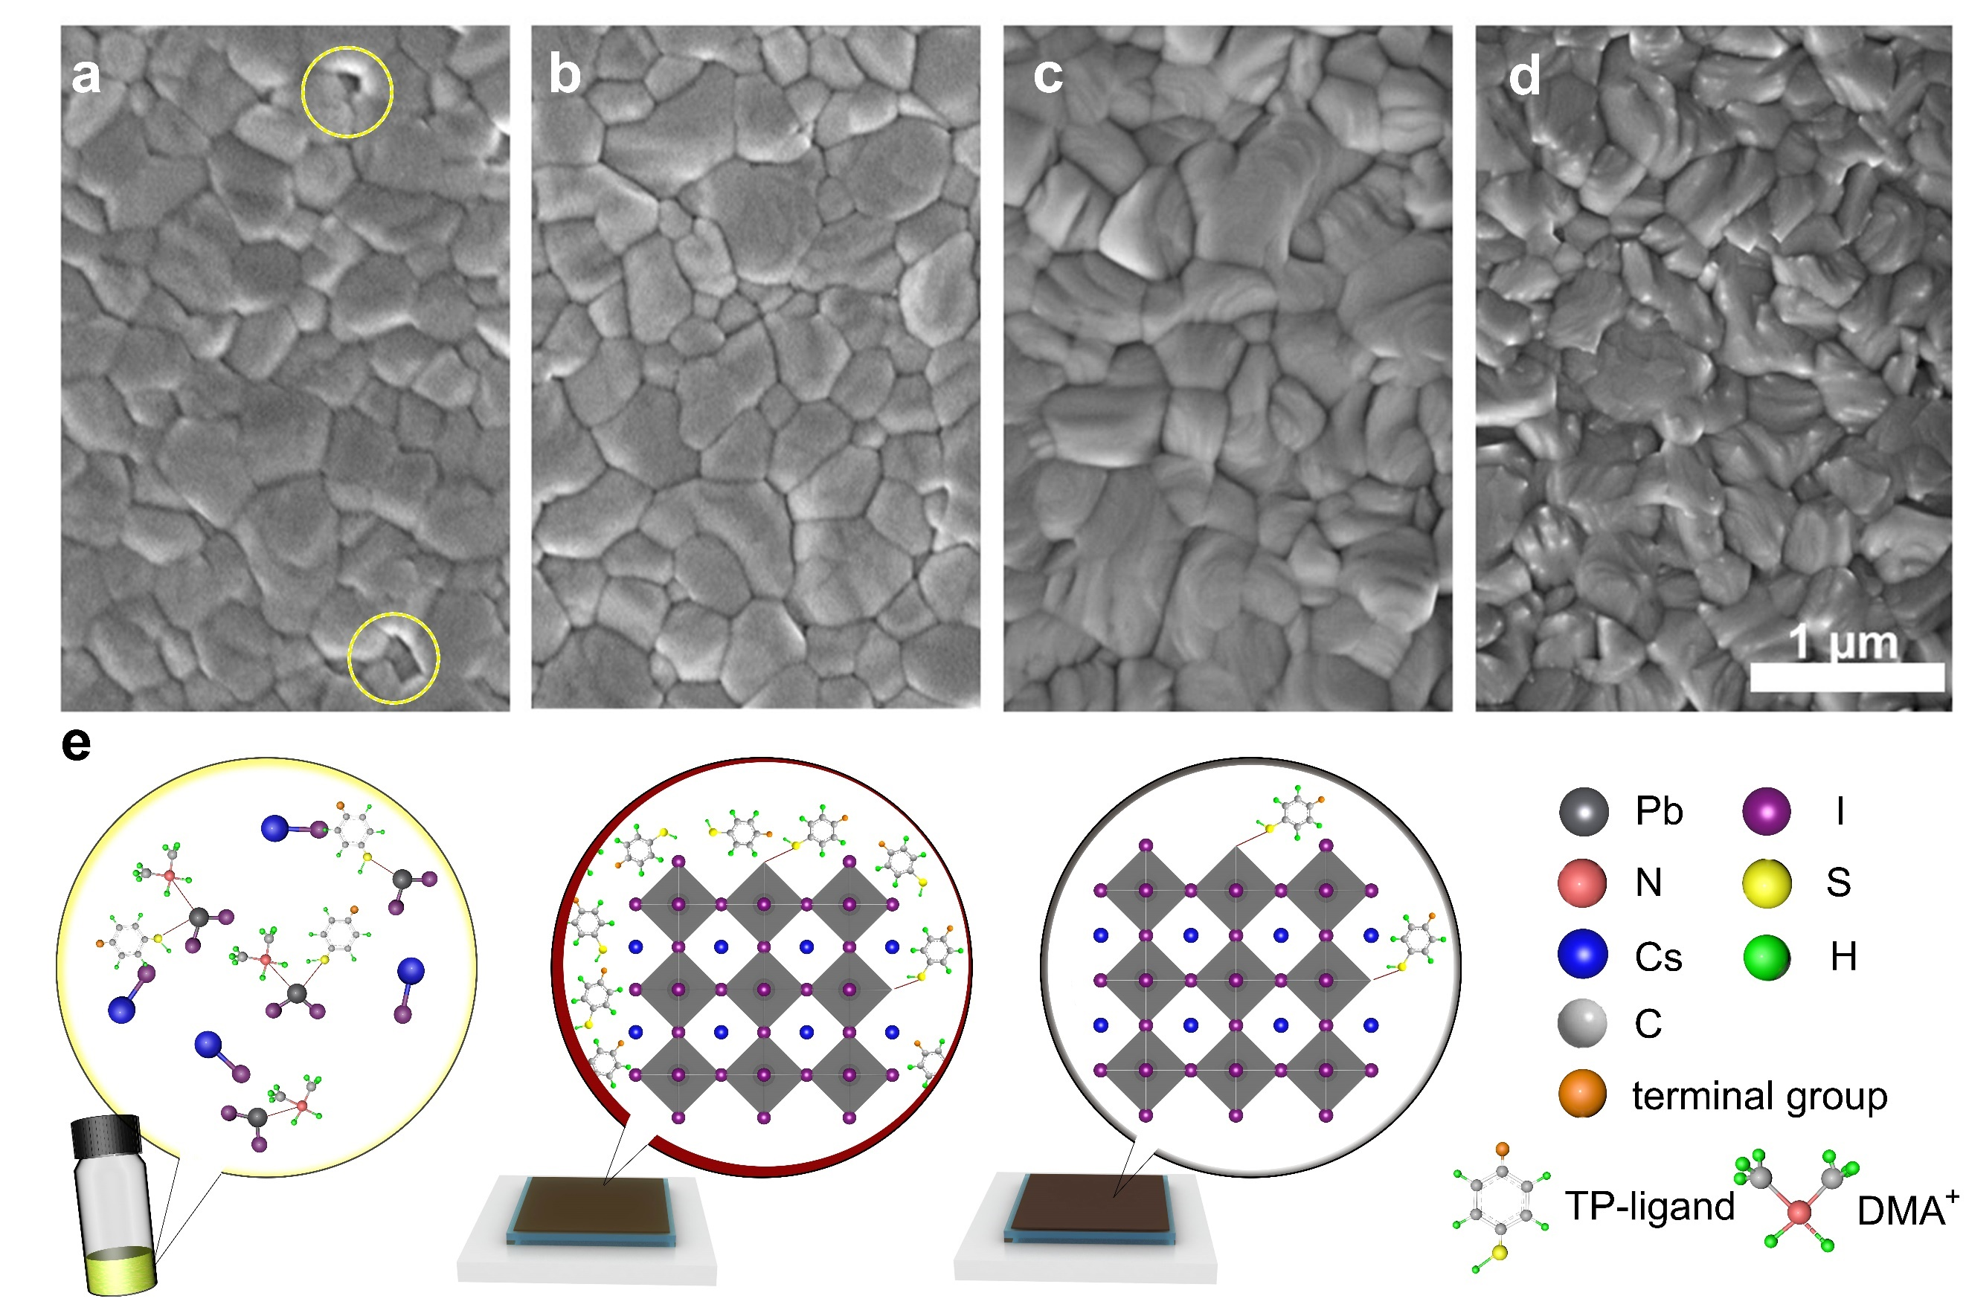
Figure 2. Top-view SEM images of the a) control film b) 4-FTP CsPbI₃ film c) 4-ATP CsPbI₃ film and d) 2-ATP CsPbI₃ film. The pinholes are marked and the scale bar is 1 μm. e) Schematic diagram of the formation of CsPbI₃ films with introduction of TP-ligands.

To investigate the recombination kinetics of the 4-FTP, 4-ATP, and 2-ATP on the CsPbI₃ films, photophysical characteristics were performed. Figure 3a shows the time-resolved photoluminescence (TRPL) results of the TP-ligand and control films. The biexponential fitting parameters are presented in Table S2. The PL lifetime of the TP-ligand samples shows the longer lifetime of carriers and the smaller τ₁ ratio of TP-ligand CsPbI₃ suggests the effective suppression of the formation of nonradiative trap centers. Figure S9 displays the UV-Vis and PL spectrum, with the same absorption edge of 736 nm consistent with the bandgap of β phase CsPbI₃. In addition, the stronger PL peak of the TP-ligand CsPbI₃ reveals the less nonradiative recombination. PL intensity scanning images confirm this result, as shown in Figure 3b and c. In contrast to the control film, the TP-ligand CsPbI₃ exhibits a more uniform emission distribution and a higher absolute PL intensity, which is consistent with the average PL data in Figure S9. We utilized space-charge-limited-current (SCLC) methods to determine the defect density in the TP-ligand CsPbI₃ and control films. Dark current-voltage (J-V) characteristics are collected for single-carrier devices with an FTO/SnO₂/Perovskite/PCBM/Ag architecture, as shown in Figure 3d. The trap-filled limit voltage (V_{TFL}) values of the trap-filling regime are 0.212 V for the control film, 0.171 V for 4-FTP-CsPbI₃, 0.138 V for 4-ATP-CsPbI₃ and 0.199 V for 2-ATP-CsPbI₃ film, respectively. The trap density has effectively decreased from 9.51×10¹⁵ /cm³ to 6.19×10¹⁵ /cm³ by 4-ATP ligand incorporation. Figure 3e depicts the relationship between V_{OC} and light intensity in the solar cells based on the TP-ligand CsPbI₃ and control films. The cross-section SEM image described the device with a structure of FTO/SnO₂/CsPbI₃/spiro-OMeTAD/Ag, as shown in Figure 3g. The TP-ligand CsPbI₃ device shows a slope of 1.46 kT/q (4-FTP), 1.39 kT/q (4-ATP) 1.36 kT/q (2-ATP), (where k is the Boltzmann constant, T is the absolute temperature and q denotes the elementary charge), which is significantly lower than that of the control device (2.12 kT/q), indicating that the trap-assisted recombination is suppressed by the TP-ligands. In addition, the carrier extraction and recombination processes in the solar cells were carefully analyzed through electrochemical impedance spectroscopy (EIS) under illumination, as in Figure 3f. The fitting parameters are listed in Table S3. In the present planar PSCs, the smaller series resistance (R_{s}) and charge transfer impedance (R_{ct}) reveal the better interfacial contact of the TP-ligand CsPbI₃ device, leading to the suppressed recombination and eﬀective charge extraction. Meanwhile, the largest impedance of the 4-ATP-CsPbI₃ device corresponds to a higher-quality active layer with fewer shunt routes due to fewer pinholes and fractures.
We prepared solar cells and their structure as shown in Figure 3g. Compared with the control CsPbI₃ device, the PCEs of the solar cells based on TP-ligand CsPbI₃ films are improved, as shown in Figure 3h and Table 1. The control CsPbI₃ device shows a typical PCE of 17.0% with a short-circuit current density (J_{SC}) of 20.1 mA/cm², a V_{OC} of 1.08 V, and FF of 78.2%. The 4-FTP and 2-ATP solar cells showed improved PCEs of 19.1% and 17.4%, respectively. Surprisingly, the optimized 4-ATP device delivered the best performance with a PCE of 20.1%, V_{OC} of 1.18 V, J_{SC} of 20.4 mA/cm², and FF of 83.5%, which is owed to its high-quality film with low trap density. Besides, negligible hysteresis under forward scan was obtained, as shown in Figure S10. A bias voltage of 1 V was applied to the polarity of the device to assure the reliability of the J-V measurements, resulting in a stable PCE of 19.1%, as shown in Figure S11. Meanwhile, Figure 3i shows the external quantum efficiency (EQE) spectrum, which demonstrates that the integrated photocurrent (19.6 mA/cm², 19.7 mA/cm², 19.3 mA/cm², 19.3 mA/cm²) for the 4-FTP, 4-ATP, 2-ATP and control devices, respectively, which confirm the accuracy of the device efficiency characterizations. To verify the repeatability of the device performance, Figure S12 illustrates the statistical PCE and the detailed parameters of the devices, revealing the higher V_{OC} of the TP-ligand CsPbI₃ solar cells. The performance of the 2-ATP devices shows a very low FF. It can be attributed to the residual 2-ATP cluster on the perovskite film GBs, which blocks the transportation of carriers, leading to a higher series resistor.
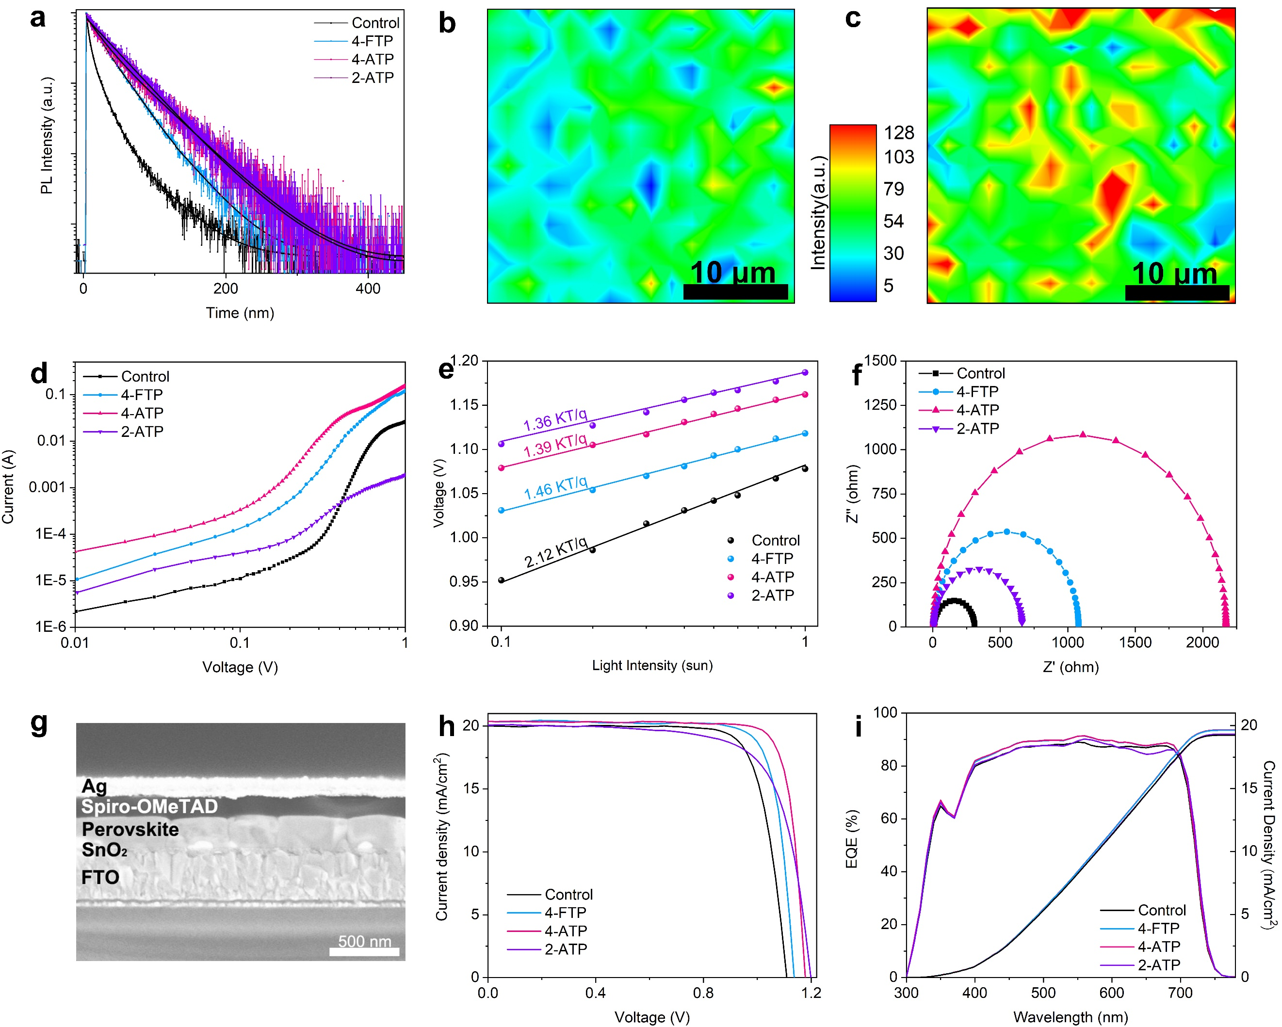
Figure 3. a) TRPL of CsPbI₃ films. PL intensity scanning images of b) controls and c) TP-ligand CsPbI₃ films and the scale bar is 10 μm. d) SCLC patterns of control and TP-ligand CsPbI₃ devices with an FTO/SnO₂/perovskite/PCBM/Ag structure (electron-only devices). e) V_{OC} dependence of the light intensity of the control and TP-ligand CsPbI₃ devices. f) EIS pattern of TP-ligand CsPbI₃ and control PSCs under an illuminated condition. g) Cross-sectional SEM image of the PSCs. h) Current J-V curves of the four PSCs under AM 1.5G irradiation (100 mW/cm²). i) EQE and integrated current density spectra of the four PSCs.

Table 1. Photovoltaic parameters of the champin device upon the control, 4-FTP CsPbI₃, 4-ATP CsPbI₃, and 2-ATP CsPbI₃ under AM 1.5G, 100 mW/cm² illumination.
Samples | V_{OC} (V) | J_{SC} (mA/cm²) | FF (%) | PCE (%)
Control | 1.08 | 20.1 | 78.2 | 17.0
4-FTP | 1.14 | 20.4 | 81.9 | 19.1
4-ATP | 1.18 | 20.4 | 83.5 | 20.1
2-ATP | 1.20 | 20.1 | 72.0 | 17.4

To explore the mechanism of the TP-ligands in high-performance CsPbI₃ solar cells, we studied the contribution of π-conjugated molecules to the film conductive property. From SCLC measurement (Figure 3d), the electronic carrier mobility can be calculated by the Mott–Gurney law in the single-carrier devices. the electronic mobility of the 4-FTP, 4-ATP, 2-ATP, and control CsPbI₃ films are 21.2×cm² V⁻¹ s⁻¹, 18.3×cm² V⁻¹ s⁻¹, 4.5×cm² V⁻¹ s⁻¹, 0.3×cm² V⁻¹ s⁻¹, respectively. The 4-ATP and 4-FTP samples show the highest electronic mobility, indicating the carrier transport property. The residual organic in the 2-ATP film GBs may inhibit the charge transmission, leading to low carrier mobility. Local surface potential and film conduction through local J-V measurements were studied by conductive atomic force microscopy (c-AFM) analysis under a bias voltage of 2 V, as shown in Figure 4a and b. The 4-ATP-CsPbI₃ gave considerably larger currents in the entire measured area than that of the control sample. According to the AFM patterns of this region (Figure S13), we observed the obvious abrupt decreased conducting current at GBs in the control sample, while inconspicuous in the 4-ATP-CsPbI₃, elucidating the additional conductivity channel for carrier extraction at GBs passivated by TP-ligands.
The Exciton behavior in the film was further investigated by normalized steady-state temperature-dependent PL and the spectra were mapped in color-coded images, as shown in Figure 4c and d. The strong peaks appeared both in the control sample and 4-ATP-CsPbI₃ at 100 K. As temperature further increases, PL intensity decreases correspondingly, while the 4-ATP-CsPbI₃ shows a larger decline than the control sample, as shown in Figure S14. To understand the reason, the exciton binding energy (E_{b}) of the two films can be extracted, which represents the overall energy barrier for excitons to be bound to nonradiative centers. As shown in Figure S15. The control film shows the E_{b} of 13.9 meV while it is down to 7.5 meV for the 4-ATP-CsPbI₃ film, which is beneficial to the separation of the exciton, giving rise to more free carriers.
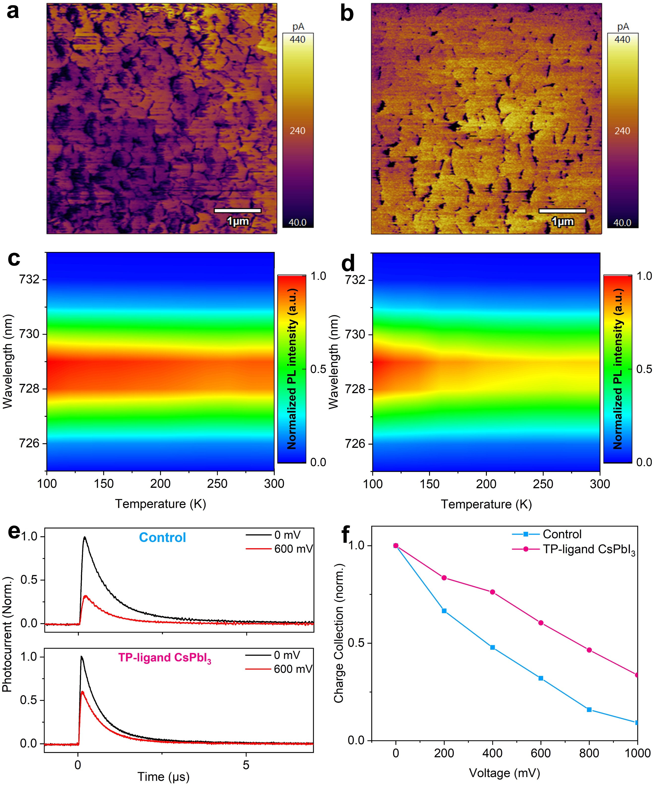
Figure 4. c-AFM images of a) control b) 4-ATP CsPbI₃ film. Temperature-dependent PL of c) control and d) 4-ATP CsPbI₃ film. e) TPC results of the cells at bias voltages of 0 and 600 mV. f) Normalized charge collection of the cells calculated with ΔQ/ΔQ (200 mV), where ΔQ is the total collected photo-induced charge by integrating the transient photocurrents.

Aside from charge recombination, an increased film conductivity may have an impact on the carrier transport capabilities and final charge collection of devices.^{[34-36]} The transient photocurrent (TPC) was measured at various bias voltages as shown in Figure 4e. The energy of the incident pulse laser remains unchanged during the measurement, as the bias voltage increases, the charge collection efficiency declines. When the bias voltages are enhanced from 0 to 600 mV, the intensity of the photocurrent peak on the control sample decline to 30%, whereas the TP-ligand CsPbI₃ device still retains 60%. The total charge collection can be calculated by integrating the photocurrents. Hence, the total collected charge of the different solar cells at varying bias voltages is finally computed and summarized in Figure 4f. At high bias voltages, the charge collection of the solar cells decreases because of the increase in charge recombination. However, a lower descent rate suggests faster charge transmission, which reduces carrier loss and increases charge collection efficiency, leading to a higher FF of the device. TPC and transient photovoltage (TPV) measurements of the various devices were also performed at a bias voltage of 200 mV. As shown in Figure S16 (fitted data in Table S4 and S5). In the TPC pattern, the TP-ligand CsPbI₃ device obtained a shorter decay time of 0.72 μs, indicating a faster charge transport and extraction process than the control sample, which has a decay time of 1.73 μs. The TP-ligand CsPbI₃ device has a longer electron lifetime of 4.76 ms based on the voltage decay time for each device. The longer photovoltage decay time of the TP-ligand CsPbI₃ device is likely due to the preferred orientation, which allows for better carrier flow between perovskites and carrier transport layers.

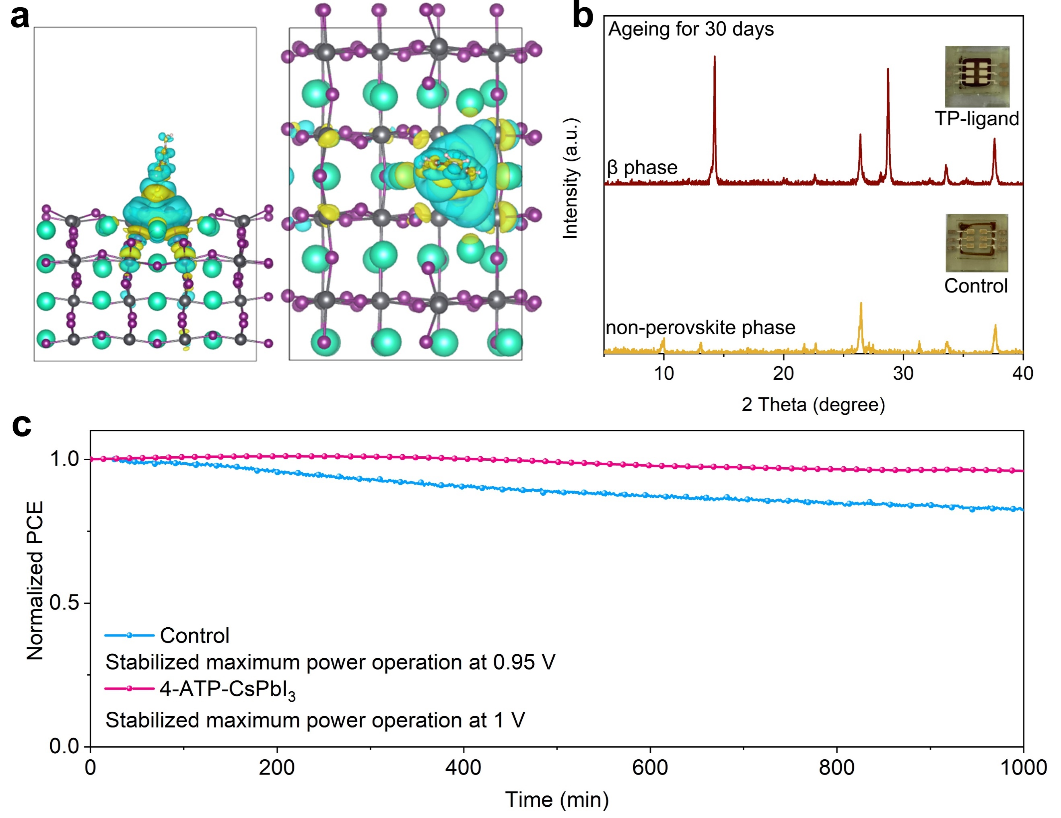
Figure 5. a) Bader charge analysis of the V_{I} defect passivated by TP-ligands. b) Photographs and XRD patterns of various CsPbI₃ films aged for 30 days. c) The operational stability of the perovskite devices at their maximum power point for 1000 mins.

To provide a complete theory between the TP-ligands and carrier transfer, we further estimated the electron transfer nature and electronic interactions with Bader charge analysis. As shown in Figure 5a, there is an increased charge transfer of 0.094 e⁻ from the I atoms of the CsPbI₃ structure to the TP-ligands. In addition, charge transfer is mainly observed between the π-conjugated molecule and the I atoms. We encapsulated the devices in an environment with ≈ 20% relative humidity and tested their long-term stability. Figure S17 shows that after one month of storage, the TP-ligand CsPbI₃ devices maintained 83% of their initial PCE and remained in the black phase, whereas the control sample lost efficacy and the color turned yellow. XRD pattern revealed that the TP-ligand CsPbI₃ film was still in the β phase while the control film had converted to the no-perovskite phase, as shown in Figure 5b. The operational stability was also measured, as shown in Figure 5c. The TP-ligand-CsPbI₃ device showed negligible attenuation following 1000 mins at its maximum power point (a bias voltage of 1 V) under AM 1.5 G illumination simulated sunlight (100 mW cm⁻²). As a contrast, the control device lost its nearly 20% efficiency after 1000 mins. The elevated stabilities are attributed to the hydrophobicity of TP-ligands. To prove it, Figure S18 displays the water contact angle measurement, which can verify the improvement of hydrophobicity for the perovskite films with TP-ligands. The water contact angle increases from 66° to 80° after the introduction of the TP-ligand in the precursor, leading to the hydrophobic surface chemistry of the CsPbI₃ films.

Conclusion
We the novel perovskite precursors with TP-ligands to obtain a high-quality CsPbI₃ film with low trap density and high carrier mobility, resulting in efficient and stable all-inorganic PSCs. The TP-ligands coordinated with Pb²⁺ ions by the S-H group in the percussor, thus suppressing the formation of PbI₄²⁻ to reduce the defect density in the product perovskite film. In addition, the coordination of TP-ligands to the Pb-I octahedrons improved the morphology and crystallinity of the CsPbI₃ film, considerably reducing the non-radiative charge recombination center. The functional group of π-conjugated molecules accelerated the charge separation because of the unique features of coplanar π-electrons. As a result, a progressive PCE of 20.1% was achieved for the CsPbI₃ PSC with a high V_{OC} of 1.18 V, and strikingly FF of 83.5% (one of the highest values for reported devices). The device exhibited excellent operational stability, negligible attenuation following 1000 minutes at its maximum power point (a bias voltage of 1 V) under AM 1.5 G illumination simulated sunlight (100 mW cm⁻²). These results point in a new direction to fabricate efficient and stable all-inorganic PSCs.

Supporting Information
Supporting Information is available from the Wiley Online Library or from the author.

Acknowledgements
J.Y. and D.Z. contributed equally to this work. We thank Dr. Jisngjian Shi and Prof. Qingbo Meng of for their help in modulated electrical transient characterization. We thank Dr. Xuejiao Sun of Institute of Semiconductors, Chinese Academy of Sciences for her help in the ultrafast spectroscopy characteristics. This work was supported by the Beijing Municipal Natural Science Foundation (2222061), National Key Research and Development Program of China (2017YFE0119700), and National Natural Science Foundation of China (51961135107, 51774034, 51772026). W.C.H. would like to acknowledge the support of the General Research Fund (17201819, 17211220, and 17200021) and Collaboration Research Grant (C5037-18G) from the Research Grants Council of Hong Kong Special Administrative Region.

Conflict of Interest
The authors declare no competing financial interest.

Received: ((will be filled in by the editorial staff))
Revised: ((will be filled in by the editorial staff))
Published online: ((will be filled in by the editorial staff))
References
[1] Y. Wang, M. I. Dar, L. K. Ono, T. Zhang, M. Kan, Y. Li, L. Zhang, X. Wang, Y. Yang, X. Gao, Y. Qi, M. Gratzel, Y. Zhao, Science, 2019, 365, 591-595.
[2] J. Duan, Y. Zhao, B. He, Q. Tang, Angew Chem. Int. Ed. Engl., 2018, 57, 3787-3791.
[3] C. Liu, W. Li, C. Zhang, Y. Ma, J. Fan, Y. Mai, J. Am. Chem. Soc., 2018, 140, 3825-3828.
[4] C. C. Stoumpos, M. G. Kanatzidis, Acc. Chem. Res., 2015, 48, 2791-2802.
[5] R. J. Sutton, G. E. Eperon, L. Miranda, E. S. Parrott, B. A. Kamino, J. B. Patel, M. T. Hörantner, M. B. Johnston, A. A. Haghighirad, D. T. Moore, H. J. Snaith, Adv. Energy Mater., 2016, 6, 1502458.
[6] J. Yuan, L. Zhang, C. Bi, M. Wang, J. Tian, Solar RRL, 2018, 2, 1800188.
[7] L. Zhang, B. Li, J. Yuan, M. Wang, T. Shen, F. Huang, W. Wen, G. Cao, J. Tian, J. Phys. Chem. Lett., 2018, 9(13): 3646-3653.
[8] T. Zhang, M. I. Dar, G. Li, F. Xu, N. Guo, M. Gratzel, Y. Zhao, Sci. Adv., 2017, 3, e1700841.
[9] A. Swarnkar, A. R. Marshall, E. M. Sanehira, B. D. Chernomordik, D. T. Moore, J. A. Christians, T. Chakrabarti, J. M. Luther, Science, 2016, 354, 92-95.
[10] J. Yuan, C. Bi, S. Wang, R. Guo, T. Shen, L. Zhang, J. Tian, Adv. Funct. Mater., 2019, 29, 1906615.
[11] C. Bi, X. Sun, X. Huang, S. Wang, J. Yuan, J. X. Wang, T. Pullerits, J. Tian, Chem. Mater., 2020, 32, 6105-6113.
[12] S. Wang, C. Bi, A. Portniagin, J. Yuan, J. Ning, X. Xiao, X. Zhang, Y. Y. Li, S. V. Kershaw, J. Tian, A. L. Rogach, ACS Energy Lett., 2020, 5, 2401-2410.
[13] J. Yuan, C. Bi, J. Xi, R. Guo, J. Tian, J. Phys. Chem. Lett., 2021, 12, 1018-1024.
[14] B. Li, Y. Zhang, L. Fu, T. Yu, S. Zhou, L. Zhang, L. Yin, Nat. Commun., 2018, 9, 1076.
[15] S. Fu, W. Zhang, X. Li, J. Guan, W. Song, J. Fang, ACS Energy Lett., 2021, 6(10): 3661-3668.
[16] J. Lin, M. Lai, L. Dou, C. S. Kley, H. Chen, F. Peng, J. Sun, D. Lu, S. A. Hawks, C. Xie, F. Cui, A. P. Alivisatos, D. T. Limmer, P. Yang, Nat. Mater., 2018, 17, 261-267.
[17] Y. Wang, X. Liu, T. Zhang, X. Wang, M. Kan, J. Shi, Y. Zhao, Angew Chem. Int. Ed. Engl., 2019, 58, 16691-16696.
[18] B. Yu, J. Shi, S. Tan, Y. Cui, W. Zhao, H. Wu, Y. Luo, D. Li, Q. Meng, Angew Chem. Int. Ed. Engl., 2021, 60(24): 202102466.
[19] Y. Wang, G. Chen, D. Ouyang, X. He, C. Li, R. Ma, W. J. Yin, W. C. H. Choy, Adv. Mater., 2020, 32, e2000186.
[20] W. Ke, I. Spanopoulos, C. C. Stoumpos, M. G. Kanatzidis, Nat. Commun., 2018, 9, 4785.
[21] H. Meng, Z. Shao, L. Wang, Z. Li, R. Liu, Y. Fan, G. Cui, S. Pang, ACS Energy Lett., 2019, 5, 263-270.
[22] Q. Jiang, Y. Zhao, X. Zhang, X. Yang, Y. Chen, Z. Chu, Q. Ye, X. Li, Z. Yin, J. You, Nat. Photonics, 2019, 13, 460-466.
[23] H. Uratani, K. Yamashita, J. Phys. Chem. Lett., 2017, 8, 742-746.
[24] H. Zhang, M. K. Nazeeruddin, W. C. H. Choy, Adv. Mater., 2019, e1805702.
[25] J. W. Lee, H. S. Kim, N. G. Park, Acc. Chem. Res., 2016, 49, 311-319.
[26] Y. Lao, S. Yang, W. Yu, H. Guo, Y. Zou, Z. Chen, L. Xiao, Adv. Sci. (Weinh), 2022, e2105307.
[27] L. Xie, J. Chen, P. Vashishtha, X. Zhao, G. S. Shin, S. G. Mhaisalkar, N.-G. Park, ACS Energy Lett., 2019, 4, 2192-2200.
[28] K. G. Stamplecoskie, J. S. Manser, P. V. Kamat, Energy Environ. Sci., 2015, 8, 208-215.
[29] K. Yan, M. Long, T. Zhang, Z. Wei, H. Chen, S. Yang, J. Xu, J. Am. Chem. Soc., 2015, 137, 4460-4468.
[30] R. J. Stewart, C. Grieco, A. V. Larsen, G. S. Doucette, J. B. Asbury, J. Phys. Chem. C, 2016, 120, 12392-12402.
[31] L. G. Wang, H. P. Zhou, J. N. Hu, Science, 2019, 363, 265-270.
[32] B. Li, C. B. Fei, K. B. Zheng, X. Qu, T. Pullerits, G. Cao, J. Tian, J. Mater. Chem. A, 2016, 4, 17018-17024.
[33] P. Wang, X. Zhang, Y. Zhou, Q. Jiang, Q. Ye, Z. Chu, X. Li, X. Yang, Z. Yin, J. You, Nat. Commun., 2018, 9, 2225.
[34] Y. Li, J. Shi, B. Yu, B. Duan, J. Wu, H. Li, D. Li, Y. Luo, H. Wu, Q. Meng, Joule, 2020, 4, 472-489.
[35] J. Shi, Y. Li, Y. Li, D. Li, Y. Luo, H. Wu, Q. Meng, Joule, 2018, 2, 879-901.
[36] J. Shi, D. Li, Y. Luo, H. Wu, Q. Meng, Rev. Sci. Instrum., 2016, 87, 123107.

