Dopant-free NiO_{x} Nanocrystals: A Low-cost and Stable Hole Transport Material for Commercializing Perovskite Optoelectronics
Hong Zhang^{1*#}, Chenxu Zhao^{1,2#}, Jianxi Yao², Wallace C.H. Choy^{3,*}
¹Shanghai Frontiers Science Research Base of Intelligent Optoelectronics and Perception, Institute of Optoelectronics, Fudan University, Shanghai 200433, P. R. China.
²State Key Laboratory of Alternate Electrical Power System with Renewable Energy Sources, Beijing Key Laboratory of Energy Safety and Clean Utilization, North China Electric Power University, Beijing 102206, China.
³Department of Electrical and Electronic Engineering, The University of Hong Kong, Pokfulam Road, Hong Kong, P. R. China.
*Corresponding Authors: hzhangioe@fudan.edu.cn; chchoy@eee.hku.hk
#The authors contributed equally to this work.

Abstract:
Advancing inverted (p-i-n) perovskite solar cells (PSCs) is critical for commercial applications given their compatibility with different bottom cells for tandem photovoltaics, low-temperature processability (≤100 ℃), and promising operational stability. Although inverted PSCs have achieved an efficiency of over 25% using doped or expensive organic hole transport materials (HTMs), their synthesis cost and stability still cannot meet the requirements for their commercialization. Recently, dopant-free and low-cost non-stoichiometric nickel oxide nanocrystals (NiO_{x} NCs) have been extensively studied as a low-cost and effective HTM in perovskite optoelectronics. In this minireview, we summarize the synthesis and surface-functionalization methods of NiO_{x} NCs. Then, the applications of NiO_{x} NCs in other perovskite optoelectronics beyond photovoltaics are discussed. Finally, we provide a perspective for the future development of NiO_{x} NCs for the commercialization of perovskite optoelectronics.
Keywords: Nickel oxide • nanocrystal • hole transport material • perovskite solar cell• mechanical flexibility.
Introduction
Perovskite solar cells (PSCs) have attracted intensive attention owing to their low-cost fabrication, excellent electronic properties, and superior performance. ^{[1]} Particularly, advancing inverted (p-i-n) PSCs is critical for their commercial applications given their compatibility with different bottom cells for tandem photovoltaics^{[2]}, low-temperature processability (≤100 °C)^{[3]}, and promising operational stability^{[4]}. Recently, an increasing global effort has been invested to advance inverted PSCs, and most of the endeavors have been focused on compositional engineering^{[5]}, additive engineering^{[6]}, processing methods^{[7]}, and interfacial engineering^{[1h, 8]}. Although the champion power conversion efficiency (PCE) of inverted PSCs has exceeded 25%, doped or expensive organic hole transport materials (HTMs), such as poly(bis(4-phenyl)(2,4,6-trimethylphenyl)amine) (PTAA) and poly(3,4-ethylenedioxythiophene):poly(styrenesulfonate) (PEDOT:PSS), were initially employed to achieve high performance. Although organic HTMs have been utilized in the highest efficiency of p-i-n structure PSCs, their drawbacks such as high fabrication cost, intrinsic poor stability, and poor wetting capacity, hinder their large-scale applications towards commercialization. Alternatively, various inorganic p-type semiconductors (e.g., CuSCN^{[9]}, NiO_{x}^{[10]}, and Cu₂O^{[11]}) could replace these organic HTMs for inverted PSCs because of their high stability and intrinsically high carrier mobility and conductivity. Among them, dopant-free NiO_{x} has been extensively investigated as inorganic HTM for inverted PSCs owing to its advantages of wide band gap (> 3.5 eV), high transmittance in the visible range, energetically favorable energy level alignment with most perovskite absorbers and stable chemical properties.
Traditionally, NiO_{x} films can be grown with a wide range of deposition techniques, such as sputtering^{[12]}, pulsed laser deposition (PLD)^{[13]}, atomic layer deposition (ALD)^{[14]}, and sol-gel coating^{[10a, 15]}. However, all of the reported NiO_{x} films require sophisticated conditions such as high-temperature (300 °C −500 °C) thermal annealing and/or high vacuum procedures during the fabrication process. Such stringent conditions increase the fabrication cost and hinder their practical uses. The high annealing temperature will also make the fabrication of devices on flexible substrates difficult. To address these challenges, our group invented a simple chemical precipitation method to synthesize highly crystalline and dopant-free NiO_{x} NCs inks, enabling the preparation of a room-temperature solution-processed hole transport layer (HTL) for high-efficiency inverted PSCs with a PCE of 17.60% and 14.53% on rigid and flexible substrates respectively. Then, dopant-free NiO_{x} NCs were extensively studied as a low-cost and highly efficient HTM in single-junction and tandem perovskite photovoltaics (Figure 1)^{[2a-c, 4b, 7b, 8c, 16]}. To date, the most efficient NiO_{x} NCs-based single-junction and tandem PSCs have achieved PCEs of 23.91%^{[8c]} and 27.40%^{[2b]}, respectively. In this minireview, we summarize the synthesis and surface-functionalization methods for NiO_{x} NCs. Then, the applications of NiO_{x} NCs in the other perovskite optoelectronics beyond photovoltaics are discussed. Finally, we provide a perspective for the future development of NiO_{x} NCs promoting the commercialization of perovskite optoelectronics.
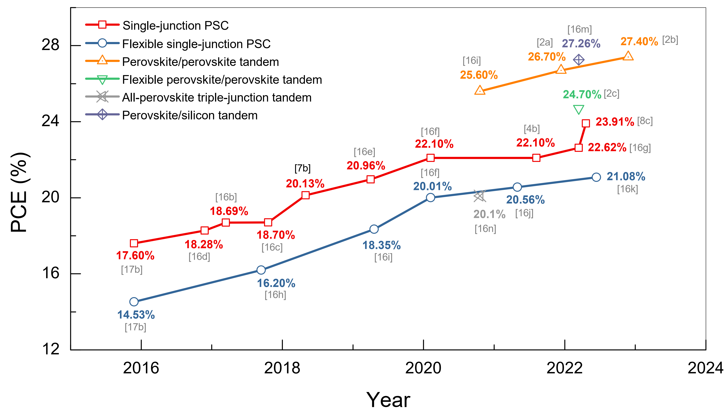
Figure 1. Progress of NiO_{x} NCs-based PSCs.

2. Synthesis of dopant-fee NiO_{x} NCs
The synthesis of dopant-free and organic ligand-free NiO_{x} NCs was first reported by our group using an unprecedented chemical precipitation method (Figure 2).^{[17]} First, the commercially available raw materials of nickel salts and base were easily dissolved in deionized water. After dropwise adding the base solution, the clear green aqueous solution turned turbid. Through accurately controlling the solution pH value to 10, an ultrafine nickel hydroxide Ni(OH)₂ participant was obtained in a considerable yield (Equation 1). The obtained apple green product was dried and calcined at 270 °C for 2 h in air to decompose into dark black NiO_{x} NCs (Equation 2). This calcination procedure is based on the thermal decomposition of Ni(OH)₂ to produce dopant-free NiO_{x} NCs with a diameter of approximately 3–5 nm. The calcination atmosphere has a significant influence on the decomposition of Ni(OH)₂ and the compositions of the resulting NiO_{x} NCs.^{[18]} The product of NiO_{x} NCs and the corresponding dispersion aqueous inks are shown in Figure 2.
$Ni{({NO}_{3})}_{2}+NaOH→ {Ni(OH)}_{2}+Na{({NO}_{3})}_{2}$ Equation (1)
$Ni{(OH)}_{2}→ {NiO}_{x}+H_{2}O$ Equation (2)
The calcination temperature of 270°C was rationally selected to achieve highly crystalline and dopant-free NiO_{x} NCs as well as stable colloidal inks. The incomplete decomposition of the byproduct nickel hydroxide (Ni(OH)₂) (see Equations 1 and 2) at temperatures below 270 °C and the poor dispersibility of the NiO_{x} NCs calcined at temperatures higher than 270 °C were identified as causes of the poor ability of the synthesized NiO_{x} NCs to form high-quality HTLs^{[17a, 19]}.
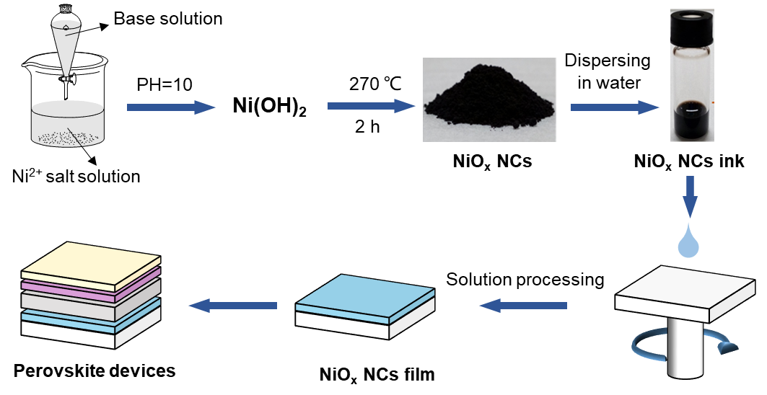
Figure 2. Schematic illustration of the NiO_{x} NCs preparation, film formation and the relevant device fabrication. [ref]
To further identify the fundamental mechanism, Jaramillo et al. conducted a detailed characterization study of NiO_{x} NCs and their colloidal dispersions.^{[20]} As shown by the scanning transmission electron microscopy (STEM) in Figures 3a-c, crystalline NiO_{x} NCs (bright pixels) were immersed in an amorphous interconnected phase, which is relevant to the formation of stable colloidal dispersions. This amorphous interconnected phase strongly diminished with the increasing calcination temperature of Ni(OH)₂ from 270 °C to 330 °C. The thermogravimetric analysis (TGA), Fourier transform infrared (FTIR), and in situ Raman spectroscopy characterization of the NiO_{x} NCs show the presence of some reaction byproducts in the amorphous phase, especially nitrates, hydroxide and sodium (Figures 3d-g). These byproducts in the amorphous phase have a relevant role in the stabilization of the colloidal dispersion of NiO_{x} NCs and ensure connectivity in the final deposited compact film. As discussed above, the amorphous phase plays a critical role in stabilizing the colloidal dispersion of NiO_{x} NCs and the f quality of the formed film. Different synthesis routes have also been developed to control the formation dynamics and minimize the surface defects of NiO_{x} NCs.
*** add a paragraph to briefly describe the arrangement of the sub-sections below? ***
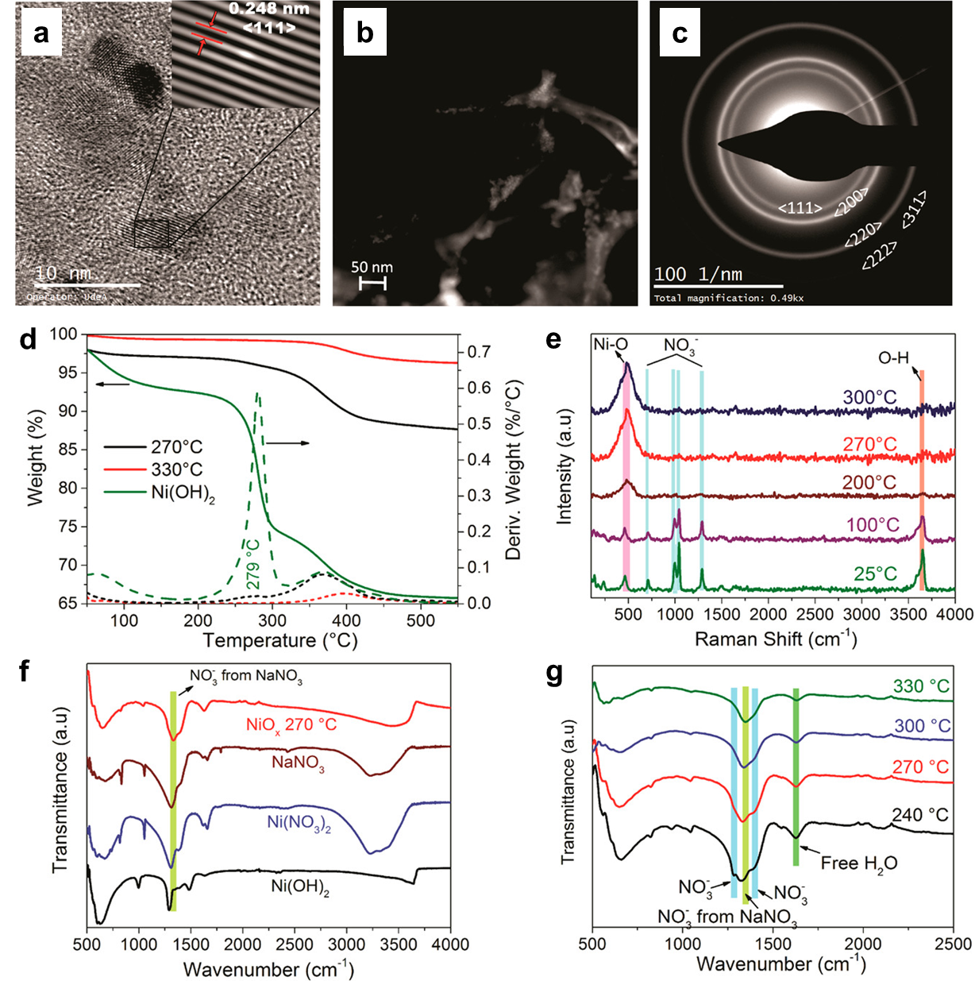
Figure 3. Characterizations of synthesized NiO_{x} NCs. (a) HRTEM analysis reveals crystalline NiO_{x} NCs sized below 5 nm. (b) STEM enabled identifying a crystalline NiO_{x} phase (bright pixels) immersed in an amorphous interconnected phase. (c) Corresponding diffraction pattern of the NiO_{x} NCs confirming the presence of crystalline and amorphous NiO_{x} phases. (d) TGA curves for the precipitated Ni(OH)₂ and the NiO_{x} NCs obtained at 270 and 330 °C. (e) Raman in situ for the conversion of Ni(OH)₂ to NiO_{x}. (f) FT-IR spectra of the possible compounds present as byproducts of the synthesis of NiO_{x} NCs. (g) FT-IR spectra of NiO_{x} NCs obtained at different temperatures indicating the loss of NO₃– ions. Adapted with permission from ref.^{[20]}
2.1 Bases
In the reaction shown in equation 1, since NaOH is a strong base, the PH value of 10 during the precipitation process should be precisely controlled to obtain well-dispersed NiO_{x} NCs. Recently, other flexible precipitation methods have been reported for the stable mass production of highly disperse NiO_{x} NCs by replacing NaOH with other soft bases. Tai et al. reported the use of ammonia as a soft base for the precipitation process and systematically studied the influence of the amount of ammonia addition on the crystallinity, particle size, and yield of the NiO_{x} NCs.^{[21]} They found that highly dispersed NiO_{x} NCs could be readily synthesized with considerable yield under a wide pH window from weak acidic (pH ∼5.5) to weak basic (pH ∼9). The as-prepared NiO_{x} NCs were used as HTMs for fabricating efficient FASnI₃-based lead-free PSCs with a PCE of ∼8%. Recently, organic base with a tunable cation structure has been reported to synthesize NiO_{x} NCs with tunable sizes and energy levels. For example, using tetraalkylammonium hydroxides (TAAOHs, alkyl = methyl, ethyl, propyl, butyl) as precipitating bases, the particle size of the NiO_{x} NCs depends strongly on the alkyl chain length of TAAOHs and the average particle size can be gradually tuned from 4.04 nm to 2.13 nm by altering the alkyl chain from methyl group to butyl group. This phenomenon could be understood in two ways: (i) the alkalinity of the TAAOHs decreases with the increase of the alkyl chain length from ethyl to butyl, deceleration the growth rate of the Ni(OH)₂ precipitates;^{[22]} (ii) the steric effect caused by the bulky cation becomes prominent as the alkyl chain length increases, which will also leads to the reduced growth rate of the Ni(OH)₂ precipitates.^{[22-23]} These two reasons eventually determine the size of the final NiO_{x} NCs after the decomposition of Ni(OH)₂. Meantime, the valence band maximum (VBM) of the corresponding NiO_{x} NCs shows a downshift trend from −5.04 eV in the methyl case to −5.30 eV in the butyl case due to the different Ni³⁺ contents in the NCs, providing an opportunity to adjust the energy level alignment between the VBM of the NiO_{x} NCs and the highest occupied molecular orbital of the perovskite to minimize the energy loss for hole injection at the NiO_{x}/perovskite interface. However, the presence of the Ni³⁺ species at the surface of the NiO_{x} film is highly detrimental to both the efficiency and photostability of PSCs. After further passivating the detrimental Ni³⁺ species on the surface of the NiO_{x} HTL with PTAA, a PCE approaching 23% was obtained, which is currently one of the highest PCEs reported for NiO_{x}-based inverted PSCs.
2.2 Nickel salts
The ions in the precursor induce electrostatic interactions between the reactive materials, which strongly affect the morphology of the resulting NiO_{x} NCs. Therefore, the role of anions in nickel salts in the morphological evaluation during the synthesis of NiO_{x} NCs has been investigated.^{[24]} Three nickel salts, namely, Ni(CH₃COO)₂·4H₂O, Ni(NO₃)₂·6H₂O, and NiCl₂·6H₂O were selected as raw materials to prepare NiO_{x} NCs using the chemical precipitation method^{[17]}. The resulting NCs are noted as NiO_{x}-Ac, NiO_{x}-NO₃ and NiO_{x}-Cl, respectively. All the newly prepared NiO_{x} NCs can be uniformly dispersed in water and show a pure black color. Notably, no obvious agglomeration and layering can be observed in the NiO_{x}-NO₃ ink even after one month. By contrast, the NiO_{x}-Cl solution appears gray black and irregular in shape, while the NiO_{x}-Ac shows serious precipitation. The NiO_{x} NCs prepared from Ni(NO₃)₂·6H₂O have excellent dispersity in water and solution stability. The difference in solution stability and dispersion in water of the resulting NiO_{x} NCs reveals that the as-prepared NiO_{x} NCs possess different nano particle sizes. The average particle size of the NiO_{x}-NO₃ ink is approximately 25 nm, while the average sizes of the NiO_{x}-Cl and NiO_{x}-Ac inks are approximately 250 nm and 2.5 mm, indicating the serious aggregation of NiO_{x}-Cl nanoparticles and the precipitation of the large NiO_{x}-Ac nanoparticles. The much smaller and uniform particle size of NiO_{x}-NO₃ result in better dispersion in water and stability in solution, which further improve the crystallinity with a sharp and high X-ray diffraction (XRD) peak intensity.
These variations in performance and morphology can be attributed to the three different anions possessing the same valence states of -1, and different sizes and electrostatic actions, which might lead to adsorption on the precipitates by electrostatic action and influence the precipitation process. Even if the size of these three anions follows the Ac⁻ > NO₃⁻ > Cl⁻ regulation, the as prepared NiO_{x} NCs show different rules because the Cl⁻ has strongest electrostatic attractions [19] with Ni²⁺. Therefore, the existence of Cl⁻ leads to the mutual attraction between Ni(OH)₂ particles, resulting in bigger particles. Meanwhile, the loose adhesion of Ac⁻ on the Ni(OH)₂ particles facilitates aggregation to form a precipitate. NO₃⁻ anions show the proper electrostatic force on the Ni(OH)₂ clusters, which results in a uniform NiO_{x} NCs size and well dispersion in water. As a result, the PSC using Ni(NO₃)₂ fabricated HTL exhibits performance of 18.4% with good reproducibility and stability, which is much higher than the 16.3% of PSCs with a NiCl₂ fabricated NiO_{x} layer. Similarly, Choi reported that NiO_{x} NCs from Ni(NO₃)₂·6H₂O show more uniform particle shapes with lower sizes and better dispersibility in the solvent than NiCl₂·6H₂O, additionally improving the stability and photovoltaic performance of devices^{[25]}.
2.3 Additives
Although the existence of ions, such as NO₃⁻, can adjust the size of colloidal particles and improve the dispersion and stability in the solution, the impurity of as-prepared NiO_{x} NCs films with embedded ions is detrimental to the efficiency and long-term stability of the relevant PSCs due to the large number of defects at the perovskite/NiO_{x} interface. Li et al. reported that ionic liquid can be employed as an additive in the synthesis process of NiO_{x} NCs to effectively remove residual ions, presenting a very promising way of synthesizing high-quality NiO_{x} NCs with good dispersion in the solvent^{[16g]}. Specifically, 1-butyl-3-methylimidazolium tetrafluoroborate ([BMIm]BF₄) was added into the Ni(NO₃)₂ precursor before reacting with the NaOH aqueous solution. The simulation results show that the low adsorption energy between [BMIm]⁺ and Ni(OH)₂ promotes the combination by a strong hydrogen bond, which inhibits the adsorption of NO₃⁻ impurity ions and provides an important prerequisite for the subsequent production of NiO_{x} NCs. The advantages of replacing NO₃⁻ with the [BMIm]⁺ cation are as follows: (i) two-fold increases in the conductivity and hole mobility of NiO_{x} NCs films, (ii) better energy level matching with perovskite films, and (iii) inhibition of the interfacial degradation reaction at the perovskite/NiO_{x} interface. Consequently, ionic liquid modified NiO_{x} NCs as HTL endowed the hysteresis-free PSC with an efficiency of up to 22.62% and excellent operational stability. This strategy provides a new understanding of the surface chemistry of NiO_{x} NCs, which is vital in improving the relevant device performance and stability.
3. Surface modification of NiO_{x} NC films
Although the PCEs of inverted PSCs based on dopant-free NiO_{x} NCs have reached over 21%^{[26]}, the high density of defects and energy-level misalignment at the NiO_{x}/perovskite interface constrain the further improvement of their performance and operational stability.^{[2c, 8a, 16h]} Such interfacial defects result in poor contact between the NiO_{x} film and the perovskite layer, which not only influences the perovskite crystallinity and morphology but also causes charge recombination and decreased photovoltage.^{[2c, 8a]} Meanwhile, the NiO_{x} interface redox reaction with perovskite has been reported to cause challenging issues in device stability.^{[8a, 27]} The reactions mainly involve the following chemical reaction:
${2Ni}^{3+}+ {2I}^{-}→ {2Ni}^{2+}+I_{2}$ Equation (3)
To reduce the density of defects and inhibit the redox reactions at the NiO_{x}/perovskite interface, modifying the surface properties of the NiO_{x} NCs film with tailored molecules (e.g., small molecules, polymers, ionic liquids, and organic ammoniums) has been demonstrated to be an effective strategy, as shown in Figure 4. Given the rich hydroxylated groups on the surface of NiO_{x} NCs, Jen et al. first systematically investigated the separate role of the chemical interaction between the NiO_{x} NCs film and the perovskite layers by inserting suitable para-substituted benzoic acid self-assembled monolayers (SAMs)^{[16h]}. SAMs with different dipole moments were used because of the following reasons: i) to serve as a “binder” to improve the adhesion between the NiO_{x} film and the perovskite layer to facilitate the charge transfer by passivating the inorganic surface trap states^{[28]}; ii) to modify the work function of the NiO_{x} NCs through their molecular ordering induced by the permanent dipole moments^{[29]}; iii) to change the perovskite crystallinity and morphology through chemical interactions through different terminated functional groups^{[30]}. The Br-BA SAM modifier was found to have a positive effect that largely enhances the PCE to 18.4% with an increased open-circuit voltage (V_{OC}) of 1.11 V, a short-circuit current density (J_{SC}) of 21.7 mAcm⁻², and a FF of 76.3%. In addition, the device stability was improved owing to the minimization of the energy level offset, the reduced surface trap states, the increased perovskite crystallinity, and the enhanced wetting between NiO_{x} and the perovskite layers, outperforming the control group (PCE of 15.5%) in terms of PCE and stability. Moreover, we incorporated the Br-BA SAM into the flexible PSCs (F-PSCs) and achieved one of the highest PCE of 16.2% on the polyethylene terephthalate (PET) substrate with a remarkable power-per-weight of 26.9 W g⁻¹. More recently, Choy et al. synthesized benzoic acid with a -NH₃⁺ substituted tail group, namely, 4-(2-aminoethyl) benzoic acid bromide (ABABr)^{[8e]}, which chemically reacts with the NiO_{x} NCs via electrostatic attraction on one hand and forms a strong hydrogen bond via the -NH₃⁺ group with perovskites layers, on the other hand, directly diminishing the redox reaction between the NiO_{x} and the perovskites layers and passivating the layer surfaces. Additionally, the ABABr interface modification leads to significant improvements in perovskite film morphology, crystallization, and band alignment.
Phosphonic acid-based SAMs have also been employed to modify the surface properties of NiO_{x} NCs and improve the performance of inverted PSCs.^{[2b, 31]} For example, Tan et al. reported a molecule-bridged hole-selective contact to mitigate interfacial recombination and facilitate hole extraction in inverted PSCs by anchoring a hole-selective SAM on the low temperature-processed NiO_{x} NCs film. Considering the excellent hole selectivity and effective chemical bonding formation, two types of molecule, namely, 2PACz ([2-(9H-carbazol9-yl)ethyl] phosphonic acid) and MeO—2PACz ([2-(3,6-dimethoxy-9H-carbazol-9-yl)ethyl]phosphonic acid), were investigated. The 2PACz and MeO—2PACz molecules anchor on the surface of NiO_{x} NCs via the phosphonic acid group. Meanwhile, the oxygen from the phosphoryl of the 2PACz passivates the defects in the buried interface of the perovskite films via forming the Pb—O chemical bonding, as confirmed by first-principle calculations. The anchoring of 2PACz and MeO—2PACz with different molecular dipole moments (2.0 debye vs. 0.2 debye) can also tune the energy-level alignment between NiO_{x} and perovskites. Thus, the interfacial non-radiative recombination is suppressed at the interface between the NiO_{x} and the perovskite, contributing to the improved photovoltaic performance of flexible single-junction PSCs. Furthermore, this strategy can be employed to fabricate flexible all-perovskite tandem solar cells with a certified PCE of 24.4%, which represents the highest performance among all the types of flexible thin-film solar cells reported to date. Meanwhile, the surface-reconstruction of NiO_{x} NCs with hole-selective molecules improves the mechanical and operational stability of flexible PSCs.
Figure 4. Schematic illustration of inverted PSCs based on (a) pristine NiO_{x} NCs film and (b) NiO_{x} NCs film modified by tailored passivators and (c) the representative chemical structure of the passivators.
In addition to SAM materials, other small organic molecules and polymers have been investigated to modify the NiO_{x}/perovskite interface. Their molecular structures are shown in Figure 4c. Min et al. reported a bidentate chelating ligand 2,2’-bipyridine (2,2’-BiPy) to modulate the interfacial properties between NiO_{x} and the perovskite via its strong chemical interactions with the two layers.^{[32]} The improved interfacial contact is beneficial to the crystal growth of the perovskite with enhanced crystallinity and reduced trap states, in contrast with the perovskite film on the pristine NiO_{x} layer. Li et al. reported that the polyethylenimine cations (PEI⁺) modifier can not only effectively passivate the surface defects of the NiO_{x} NCs film, but also induce the in-situ-generation of PEI-based 2D perovskite interlayers at the NiO_{x}/MAPbI₃ interface. Such PEI-based 2D perovskite interlayer dramatically mitigates the lattice mismatch between NiO_{x} and perovskites to suppress the formation of interfacial defects and promote the high-quality crystal nucleation and growth of the above perovskite films.^{[33]} Meanwhile, the molecular weights of the PEI have a critical role in controlling the nucleation quality of perovskites. When employing a PEI with molecular weight of 10,000 (PEI-1000), a high-crystalline perovskite film with large-sized grains and reduced interfacial defects is obtained, and the champion PSC delivers a PCE of 19.23% with a weak hysteresis effect and improved reproducibility and stability. The polymer PTAA could effectively passivate the surface defects of NiO_{x} films and enhance hole transport.^{[5-6, 34]} Furthermore, a mesoporous alumina (Al₂O₃) thin layer deposited on the top of the PTAA layer can effectively improve the interface contact and carrier dynamics. Park et al. reported a newly design 5,11-dihydroindolo[3,2-b]carbazole-based polymeric macromolecule (PSIC_{x}) that can enhance the interfacial characteristics between the solution-processed NiO_{x} NCs and perovskite, consequently improving the performance and stability of inverted PSCs.^{[35]}
Recently, ionic liquids and inorganic salts have also been employed to modify the properties of the NiO_{x}/perovskite interface. For example, Bi et al. reported a kind of ionic liquid, 1-ethyl-3-methylimidazolium aminoacetate (EMIMAE), which was adopted as an interfacial modifier at the NiO_{x}/perovskite interface.^{[8b]} The positive and negative charges of the EMIMAE interface layer can interact with PbI₂ and NiO_{x}, respectively. On this basis, the interfacial layer modifies the NiO_{x}/perovskite interface and improves the perovskite film quality with high crystallinity and few defects. Additionally, an EMIMAE interface layer can reduce the interfacial charge accumulation and enhance the hole transport. As a result, the EMIMAE-modified NiO_{x} based inverted PSCs obtain an optimal PCE of 18.6% with good operational stability. Choy et al. reported that inorganic salts, such as potassium thiocyanate (KSCN), can not only effectively reduce the defects on the surfaces of NiO_{x} and perovskite but also result in the improved energy level alignment between NiO_{x} and perovskite.^{[8d]} Benefiting from these improvements, the charge carrier extraction and transport are significantly promoted. The KSCN treated inverted PSCs based on the NiO_{x} NCs achieved a PCE of 21.23%, which is superior to that of the device based on pristine NiO_{x} (18.69%).
4. Applications beyond PV
In addition to their successful applications in PSCs, our dopant-free NiO_{x} NCs have also been employed as effective HTMs in perovskite-based light-emitting diodes (PeLEDs) and photodetectors (PDs), as illustrated in Figure 5. For instance, Choy et al. reported a high-performance blue PeLEDs using NiO_{x} NCs as HTL for the first time.^{[36]} Introducing a thin polymer layer of poly(sodium-4-styrene sulfonate) (PSSNa) on the NiO_{x} for forming a bilayer HTL structure, simultaneously suppresses the nonradiative recombination through the reduction of the defect states in NiO_{x} films and improves the morphology of perovskite film by reducing the film roughness and minimizing the pinholes. As a result, the optimized blue PeLEDs exhibit an impressive luminance of 5737 cd/m², a very low turn-on voltage of 3.31 V, and an external quantum efficiency (EQE) of 1.45%. Xie et al. reported a simple H₂O treatment of as-prepared NiO_{x} films, which effectively enhances the brightness and light-emitting efficiency of blue PeLEDs simultaneously by improving the uniformity and morphology of NiO_{x} films.^{[37]} The blue PeLEDs employing H₂O-treated NiO_{x} as the anode interfacial layer show a maximum luminance of 9052 cd/m² and a maximum EQE of 1.80% (emission peak located at 482 nm). Recently, NiO_{x} was also employed as HTL in a blue PeLED based on a pure bromide system by Liang et al.^{[38]} The NiO_{x} NCs with multiple –OH groups on their surface are more favorable for the formation of a CsPbBr₃:Cs₄PbBr₆ blue-emitting perovskite film than the traditional PEDOT:PSS HTL. The NiO_{x}-based all-inorganic PeLEDs show excellent thermal and spectral stability and a maximum EQE of 1.58% at an EL wavelength of 491 nm. These dopant-free NiO_{x} NCs have also been employed to form NiO_{x}:PbI₂ nanocomposite structures as an effective HTL for perovskite-based PDs.^{[39]} The nanocomposite structures provide a large electron injection barrier and favorable hole extraction and passivates the surface of the perovskite, leading to suppressed dark current and enhanced photocurrent. By optimizing the NiO_{x}:PbI₂ nanocomposite structures, a low dark current density of 2 ×10⁻¹⁰A/cm² at −200 mV and a large linear dynamic range of 112 dB are achieved. Meanwhile, a high responsivity in the visible spectral range of 450−750 nm, a large measured specific detectivity approaching 10¹³ Jones, and a fast fall time of 168 ns are demonstrated. In summary, these works demonstrate that dopant-free NiO_{x} NCs are effective HTMs for achieving high-performance perovskite-based optoelectronic devices.
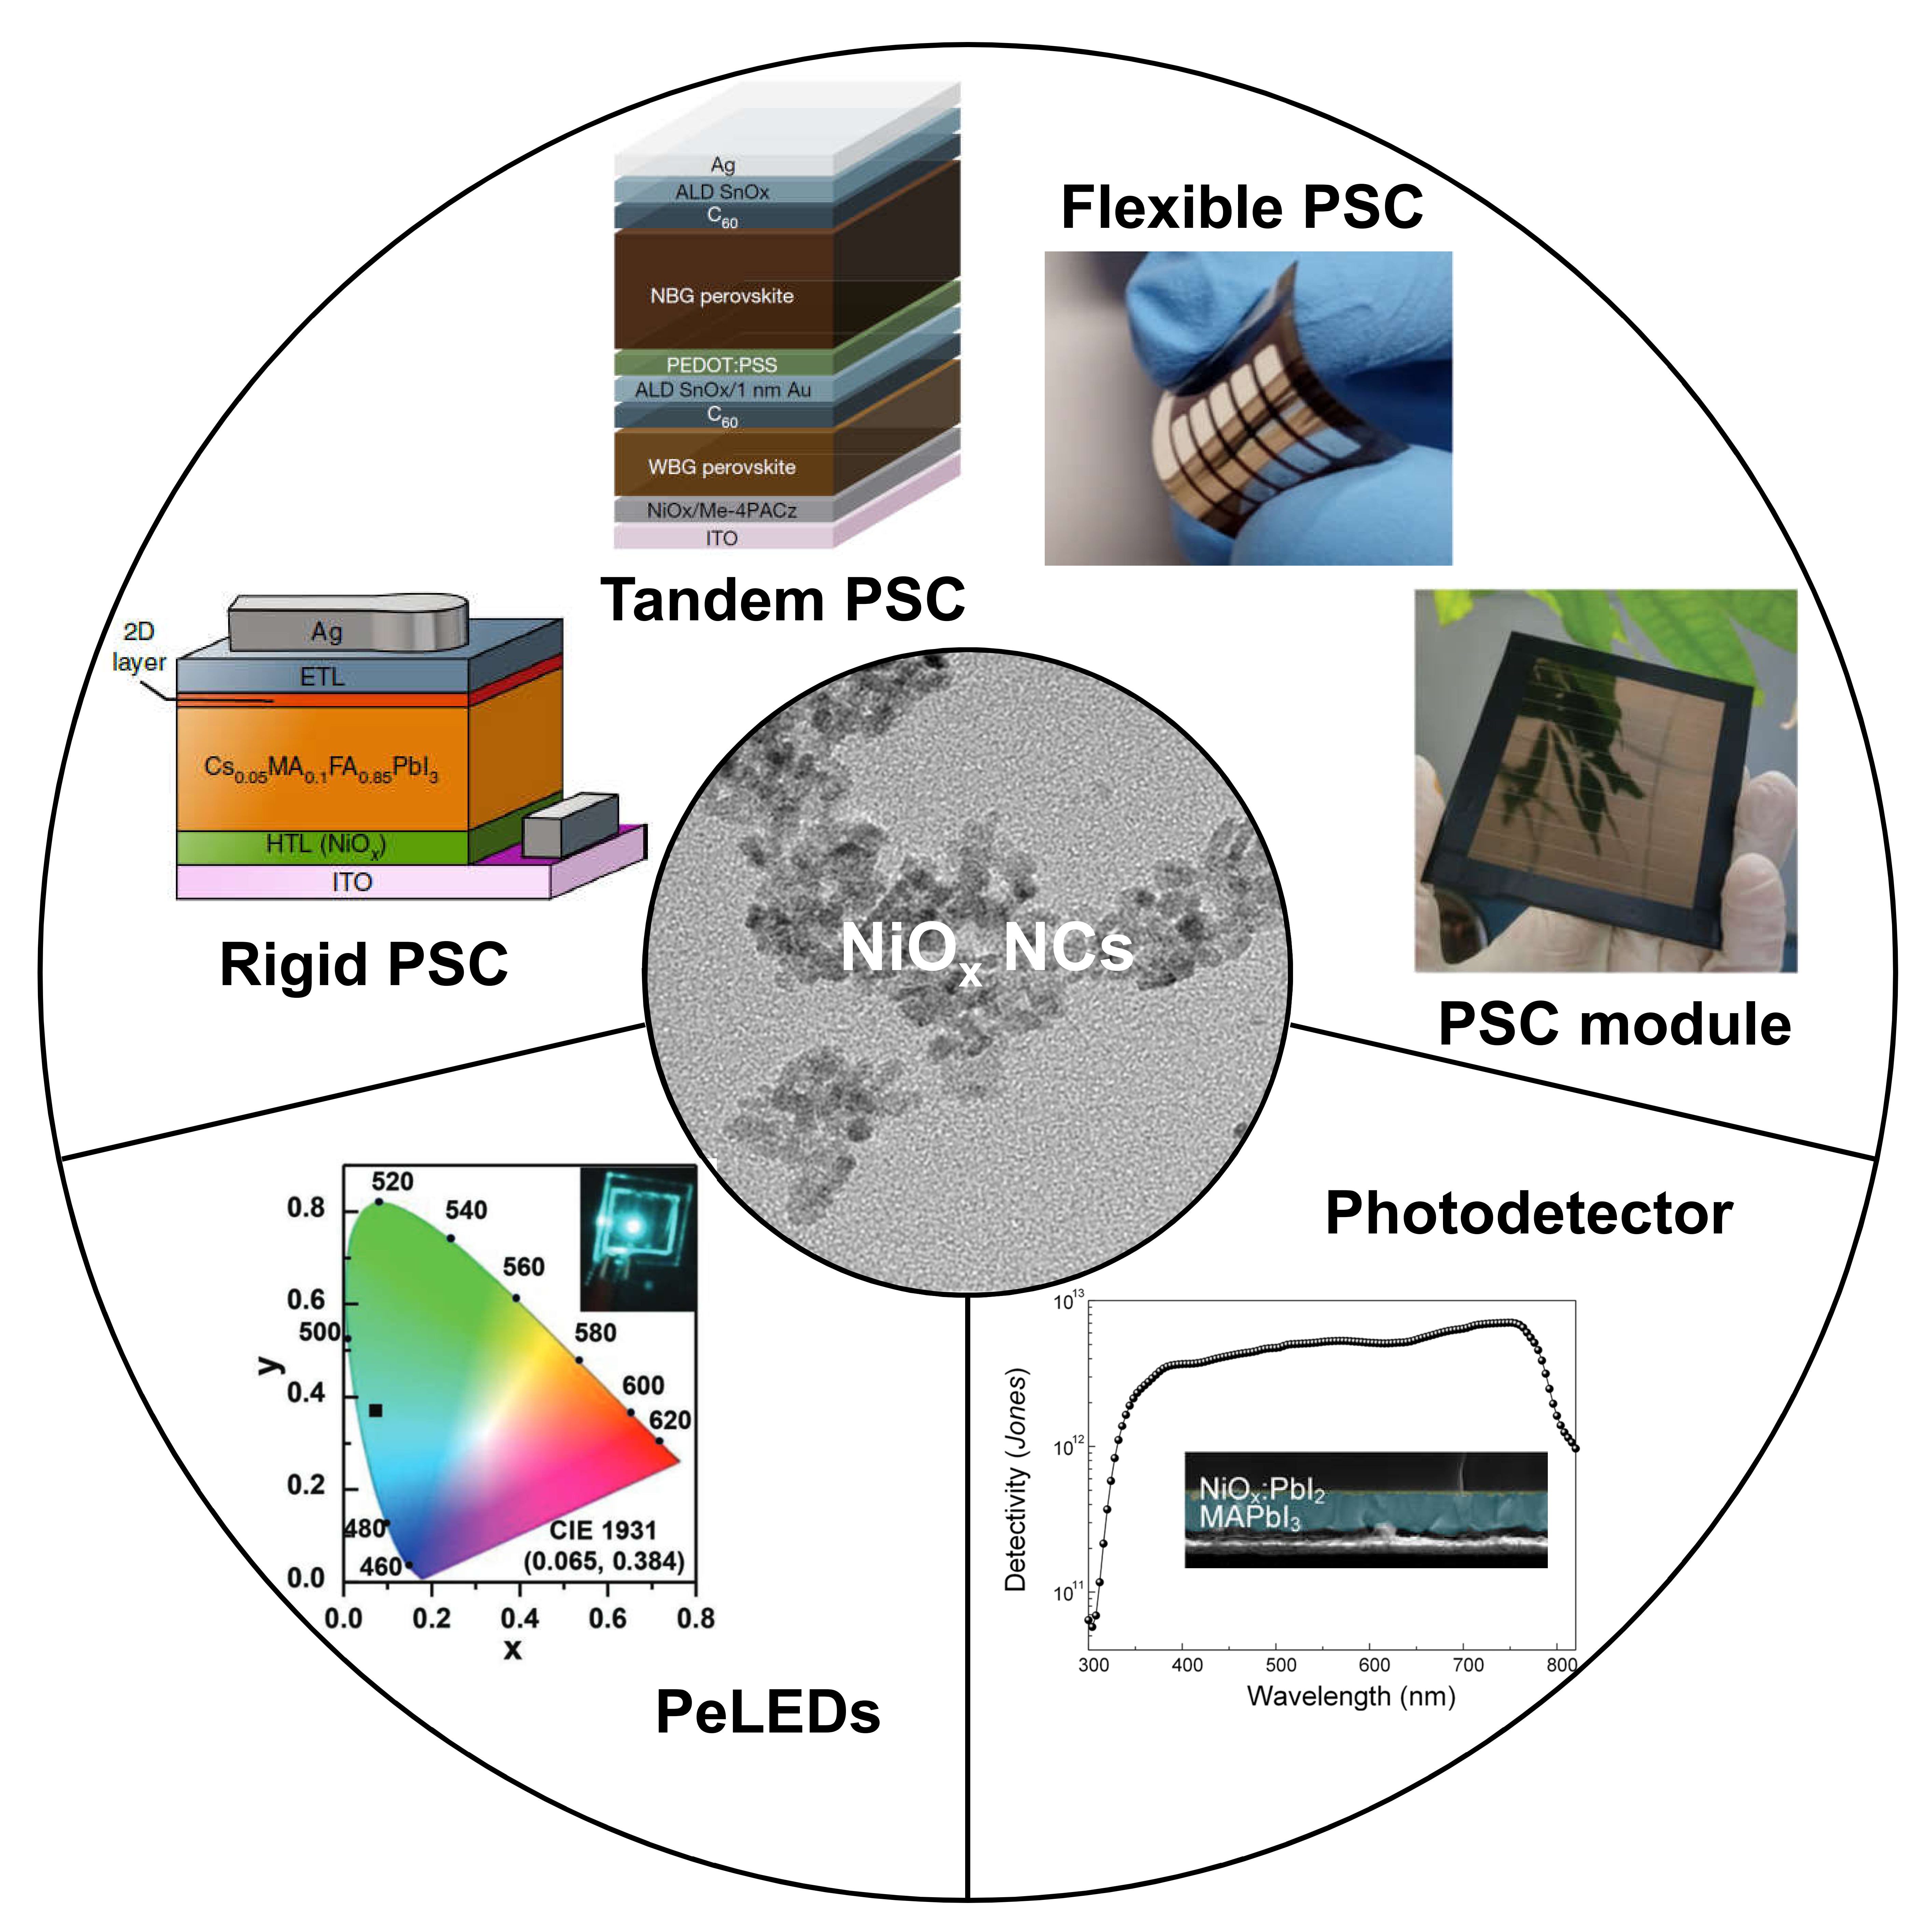
Figure 5. Applications of NiO_{x} NCs in perovskite-based optoelectronic devices. Adapted with permission from refs. ^{[2b, 8c, 16f, 17b, 36, 39]}.
5. Conclusion and Outlook
In this review, we summarize the preparation/modification methods and application prospects of NiO_{x} NCs, which show a bright future as an efficient and low-cost HTMs for perovskite-based optoelectronic devices. The surface chemical properties of NiO_{x} NCs are vital for maximizing the device performance and long-term stability. Therefore, more advanced characterizations and comprehensive studies should be conducted to fully understand the formation mechanism of well-dispersed NiO_{x} NCs and their surface chemistry. The superior dispersion stability and low-temperature processing of the NiO_{x} NCs ink also make it promising for wide applications in flexible optoelectronic devices and tandem solar cells fabricated by scalable coating methods, such as blade coating, ink-jet printing, slot-die, and spraying. Although the modification of the NiO_{x}/perovskite interface has been demonstrated to be an effective strategy for reducing the interface defect density and manipulating the film quality of perovskite films, revealing the passivation mechanism is also important for guiding the future design of highly effective modification materials. Machine learning may accelerate the development of this process.
References
[1] aY. Zhao, F. Ma, Z. Qu, S. Yu, T. Shen, H.-X. Deng, X. Chu, X. Peng, Y. Yuan, X. Zhang, J. You, Science 2022, 377, 531-534; bL. Wang, H. Zhou, J. Hu, B. Huang, M. Sun, B. Dong, G. Zheng, Y. Huang, Y. Chen, L. Li, Science 2019, 363, 265-270; cS. Sidhik, Y. Wang, M. De Siena, R. Asadpour, A. J. Torma, T. Terlier, K. Ho, W. Li, A. B. Puthirath, X. Shuai, A. Agrawal, B. Traore, M. Jones, R. Giridharagopal, P. M. Ajayan, J. Strzalka, D. S. Ginger, C. Katan, M. A. Alam, J. Even, M. G. Kanatzidis, A. D. Mohite, Science 2022, 377, 1425-1430; dJ.-W. Lee, S. Tan, S. I. Seok, Y. Yang, N.-G. Park, Science 2022, 375, eabj1186; eR. Lin, K. Xiao, Z. Qin, Q. Han, C. Zhang, M. Wei, M. I. Saidaminov, Y. Gao, J. Xu, M. Xiao, Nature Energy 2019, 4, 864-873; fH. Zhang, F. T. Eickemeyer, Z. Zhou, M. Mladenović, F. Jahanbakhshi, L. Merten, A. Hinderhofer, M. A. Hope, O. Ouellette, A. Mishra, P. Ahlawat, D. Ren, T.-S. Su, A. Krishna, Z. Wang, Z. Dong, J. Guo, S. M. Zakeeruddin, F. Schreiber, A. Hagfeldt, L. Emsley, U. Rothlisberger, J. V. Milić, M. Grätzel, Nature Communications 2021, 12, 3383; gH. Min, D. Y. Lee, J. Kim, G. Kim, K. S. Lee, J. Kim, M. J. Paik, Y. K. Kim, K. S. Kim, M. G. Kim, T. J. Shin, S. Il Seok, Nature 2021, 598, 444-450; hQ. Jiang, J. Tong, Y. Xian, R. A. Kerner, S. P. Dunfield, C. Xiao, R. A. Scheidt, D. Kuciauskas, X. Wang, M. P. Hautzinger, R. Tirawat, M. C. Beard, D. P. Fenning, J. J. Berry, B. W. Larson, Y. Yan, K. Zhu, Nature 2022, 611, 278-283; iS. Macpherson, T. A. Doherty, A. J. Winchester, S. Kosar, D. N. Johnstone, Y.-H. Chiang, K. Galkowski, M. Anaya, K. Frohna, A. N. Iqbal, Nature 2022, 607, 294-300; jD. H. Kim, J. B. Whitaker, Z. Li, M. F. van Hest, K. Zhu, Joule 2018, 2, 1437-1451.
[2] aR. Lin, J. Xu, M. Wei, Y. Wang, Z. Qin, Z. Liu, J. Wu, K. Xiao, B. Chen, S. M. Park, G. Chen, H. R. Atapattu, K. R. Graham, J. Xu, J. Zhu, L. Li, C. Zhang, E. H. Sargent, H. Tan, Nature 2022, 603, 73-78; bH. Chen, A. Maxwell, C. Li, S. Teale, B. Chen, T. Zhu, E. Ugur, G. Harrison, L. Grater, J. Wang, Z. Wang, L. Zeng, S. M. Park, L. Chen, P. Serles, R. A. Awni, B. Subedi, X. Zheng, C. Xiao, N. J. Podraza, T. Filleter, C. Liu, Y. Yang, J. M. Luther, S. De Wolf, M. G. Kanatzidis, Y. Yan, E. H. Sargent, Nature 2022; cL. Li, Y. Wang, X. Wang, R. Lin, X. Luo, Z. Liu, K. Zhou, S. Xiong, Q. Bao, G. Chen, Y. Tian, Y. Deng, K. Xiao, J. Wu, M. I. Saidaminov, H. Lin, C.-Q. Ma, Z. Zhao, Y. Wu, L. Zhang, H. Tan, Nature Energy 2022; dA. F. Palmstrom, G. E. Eperon, T. Leijtens, R. Prasanna, S. N. Habisreutinger, W. Nemeth, E. A. Gaulding, S. P. Dunfield, M. Reese, S. Nanayakkara, T. Moot, J. Werner, J. Liu, B. To, S. T. Christensen, M. D. McGehee, M. F. A. M. van Hest, J. M. Luther, J. J. Berry, D. T. Moore, Joule 2019, 3, 2193-2204.
[3] Z. Li, B. Li, X. Wu, S. A. Sheppard, S. Zhang, D. Gao, N. J. Long, Z. Zhu, Science 2022, 376, 416-420.
[4] aX. Li, W. Zhang, X. Guo, C. Lu, J. Wei, J. Fang, Science 2022, 375, 434-437; bQ. Cao, Y. Li, H. Zhang, J. Yang, J. Han, T. Xu, S. Wang, Z. Wang, B. Gao, J. Zhao, X. Li, X. Ma, S. M. Zakeeruddin, W. E. I. Sha, X. Li, M. Grätzel, Science Advances 2021, 7, eabg0633.
[5] Y. S. Wang, H. Ju, T. Mahmoudi, C. Liu, C. L. Zhang, S. H. Wu, Y. Z. Yang, Z. Wang, J. L. Hu, Y. Cao, F. Guo, Y. B. Hahn, Y. H. Mai, Nano Energy 2021, 88, 11.
[6] M. J. Li, H. Y. Li, Q. X. Zhuang, D. M. He, B. B. Liu, C. Chen, B. X. Zhang, T. Pauporte, Z. G. Zang, J. Z. Chen, Angew. Chem.-Int. Edit. 2022, 61, 12.
[7] aK. Xiao, Y.-H. Lin, M. Zhang, R. D. J. Oliver, X. Wang, Z. Liu, X. Luo, J. Li, D. Lai, H. Luo, R. Lin, J. Xu, Y. Hou, H. J. Snaith, H. Tan, Science 2022, 376, 762-767; bH. Zhang, X. Ren, X. Chen, J. Mao, J. Cheng, Y. Zhao, Y. Liu, J. Milic, W.-J. Yin, M. Grätzel, Energy & Environmental Science 2018, 11, 2253-2262; cH. Zhang, J. Cheng, D. Li, F. Lin, J. Mao, C. Liang, A. K. Y. Jen, M. Grätzel, W. C. Choy, Advanced Materials 2017, 29, 1604695.
[8] aC. C. Boyd, R. C. Shallcross, T. Moot, R. Kerner, L. Bertoluzzi, A. Onno, S. Kavadiya, C. Chosy, E. J. Wolf, J. Werner, J. A. Raiford, C. de Paula, A. F. Palmstrom, Z. J. Yu, J. J. Berry, S. F. Bent, Z. C. Holman, J. M. Luther, E. L. Ratcliff, N. R. Armstrong, M. D. McGehee, Joule 2020, 4, 1759-1775; bY. Li, J. Song, Y. Zhang, T. Kong, X. Liu, D. Bi, The Journal of Physical Chemistry Letters 2022, 10597-10602; cH. Chen, S. Teale, B. Chen, Y. Hou, L. Grater, T. Zhu, K. Bertens, S. M. Park, H. R. Atapattu, Y. Gao, M. Wei, A. K. Johnston, Q. Zhou, K. Xu, D. Yu, C. Han, T. Cui, E. H. Jung, C. Zhou, W. Zhou, A. H. Proppe, S. Hoogland, F. Laquai, T. Filleter, K. R. Graham, Z. Ning, E. H. Sargent, Nature Photonics 2022, 16, 352-358; dZ. W. Gao, Y. Wang, D. Ouyang, H. Liu, Z. F. Huang, J. Kim, W. C. H. Choy, Small Methods 2020, 4, 7; eS. Ahmad, R. Ma, J. Zheng, C. K. Gary Kwok, Q. Zhou, Z. Ren, J. Kim, X. He, X. Zhang, K. M. Yu, W. C. H. Choy, Small Methods 2022, 6, 2200787.
[9] N. Arora, M. I. Dar, A. Hinderhofer, N. Pellet, F. Schreiber, S. M. Zakeeruddin, M. Grätzel, Science 2017, 358, 768-771.
[10] aJ. You, L. Meng, T.-B. Song, T.-F. Guo, Y. M. Yang, W.-H. Chang, Z. Hong, H. Chen, H. Zhou, Q. Chen, Nature nanotechnology 2016, 11, 75-81; bJ. Y. Jeng, K. C. Chen, T. Y. Chiang, P. Y. Lin, T. D. Tsai, Y. C. Chang, T. F. Guo, P. Chen, T. C. Wen, Y. J. Hsu, Advanced materials 2014, 26, 4107-4113.
[11] C. Zuo, L. Ding, Small 2015, 11, 5528-5532.
[12] K.-C. Wang, P.-S. Shen, M.-H. Li, S. Chen, M.-W. Lin, P. Chen, T.-F. Guo, ACS applied materials & interfaces 2014, 6, 11851-11858.
[13] J. H. Park, J. Seo, S. Park, S. S. Shin, Y. C. Kim, N. J. Jeon, H. W. Shin, T. K. Ahn, J. H. Noh, S. C. Yoon, Advanced Materials 2015, 27, 4013-4019.
[14] S. Seo, I. J. Park, M. Kim, S. Lee, C. Bae, H. S. Jung, N.-G. Park, J. Y. Kim, H. Shin, Nanoscale 2016, 8, 11403-11412.
[15] aZ. Zhu, Y. Bai, T. Zhang, Z. Liu, X. Long, Z. Wei, Z. Wang, L. Zhang, J. Wang, F. Yan, S. Yang, Angewandte Chemie International Edition 2014, 53, 12571-12575; bW. Chen, Y. Wu, J. Liu, C. Qin, X. Yang, A. Islam, Y.-B. Cheng, L. Han, Energy & Environmental Science 2015, 8, 629-640.
[16] aQ. Han, Y. Wei, R. Lin, Z. Fang, K. Xiao, X. Luo, S. Gu, J. Zhu, L. Ding, H. Tan, Science Bulletin 2019, 64, 1399-1401; bW. Chen, L. Xu, X. Feng, J. Jie, Z. He, Advanced Materials 2017, 29, 1603923; cZ. Huang, X. Hu, C. Liu, L. Tan, Y. Chen, Advanced Functional Materials 2017, 27, 1703061; dW. Chen, G.-n. Zhang, L.-m. Xu, R. Gu, Z.-h. Xu, H.-j. Wang, Z.-b. He, Materials Today Energy 2016, 1-2, 1-10; eW. Chen, Y. Zhou, G. Chen, Y. Wu, B. Tu, F.-Z. Liu, L. Huang, A. M. C. Ng, A. B. Djurišić, Z. He, Advanced Energy Materials 2019, 9, 1803872; fP. Ru, E. Bi, Y. Zhang, Y. Wang, W. Kong, Y. Sha, W. Tang, P. Zhang, Y. Wu, W. Chen, X. Yang, H. Chen, L. Han, Advanced Energy Materials 2020, 10, 1903487; gS. Wang, Y. Li, J. Yang, T. Wang, B. Yang, Q. Cao, X. Pu, L. Etgar, J. Han, J. Zhao, X. Li, A. Hagfeldt, Angewandte Chemie International Edition 2022, 61, e202116534; hQ. Wang, C.-C. Chueh, T. Zhao, J. Cheng, M. Eslamian, W. C. H. Choy, A. K.-Y. Jen, ChemSusChem 2017, 10, 3794-3803; iX. Duan, Z. Huang, C. Liu, J. Yang, L. Tan, Y. Chen, Chemical Communications 2019, 55, 3666-3669; jX. Hu, X. Meng, X. Yang, Z. Huang, Z. Xing, P. Li, L. Tan, M. Su, F. Li, Y. Chen, Y. Song, Science Bulletin 2021, 66, 527-535; kB. Fan, J. Xiong, Y. Zhang, C. Gong, F. Li, X. Meng, X. Hu, Z. Yuan, F. Wang, Y. Chen, Advanced Materials 2022, 34, 2201840; lK. Xiao, R. Lin, Q. Han, Y. Hou, Z. Qin, H. T. Nguyen, J. Wen, M. Wei, V. Yeddu, M. I. Saidaminov, Y. Gao, X. Luo, Y. Wang, H. Gao, C. Zhang, J. Xu, J. Zhu, E. H. Sargent, H. Tan, Nature Energy 2020, 5, 870-880; mR. Li, B. Chen, N. Ren, P. Wang, B. Shi, Q. Xu, H. Zhao, W. Han, Z. Zhu, J. Liu, Q. Huang, D. Zhang, Y. Zhao, X. Zhang, Advanced Materials 2022, 34, 2201451; nK. Xiao, J. Wen, Q. Han, R. Lin, Y. Gao, S. Gu, Y. Zang, Y. Nie, J. Zhu, J. Xu, H. Tan, ACS Energy Letters 2020, 5, 2819-2826.
[17] aF. Jiang, W. C. H. Choy, X. Li, D. Zhang, J. Cheng, Advanced Materials 2015, 27, 2930-2937; bH. Zhang, J. Cheng, F. Lin, H. He, J. Mao, K. S. Wong, A. K. Y. Jen, W. C. H. Choy, ACS Nano 2016, 10, 1503-1511.
[18] Y. X. Guo, X. T. Yin, J. Liu, Y. W. Yang, W. Chen, M. D. Que, W. X. Que, B. W. Gao, Electrochim. Acta 2018, 282, 81-88.
[19] X. T. Yin, P. Chen, M. D. Que, Y. L. Xing, W. X. Que, C. M. Niu, J. Y. Shao, Acs Nano 2016, 10, 3630-3636.
[20] J. Ciro, D. Ramirez, M. A. M. Escobar, J. F. Montoya, S. Mesa, R. Betancur, F. Jaramillo, Acs Applied Materials & Interfaces 2017, 9, 12348-12354.
[21] X. L. Tong, F. J. Li, J. J. Jin, X. Y. Guo, J. H. Li, F. Yan, X. Z. Zhao, Q. D. Tai, J. Phys. D-Appl. Phys. 2021, 54, 7.
[22] P. H. Lee, T. T. Wu, C. F. Li, D. Glowienka, Y. H. Sun, Y. T. Lin, H. W. Yen, C. G. Huang, Y. Galagan, Y. C. Huang, W. F. Su, Chemical Engineering Journal 2021, 412, 10.
[23] V. V. Paike, P. S. Niphadkar, V. V. Bokade, P. N. Joshi, Journal of the American Ceramic Society 2007, 90, 3009-3012.
[24] T. H. Guo, Z. Q. Zhang, L. T. Yu, H. B. Yuan, J. Zhang, X. H. Liu, Z. Y. Hu, Y. J. Zhu, J. Alloy. Compd. 2021, 860, 7.
[25] F. P. CHOI, Turkish Journal of Physics 2021, Vol. 45: No. 1, Article 2.
[26] Y. Zhao, H. Zhang, X. Ren, H. L. Zhu, Z. Huang, F. Ye, D. Ouyang, K. W. Cheah, A. K. Y. Jen, W. C. H. Choy, ACS Energy Letters 2018, 3, 2891-2898.
[27] W. A. Dunlap-Shohl, T. Li, D. B. Mitzi, ACS Applied Energy Materials 2019, 2, 5083-5093.
[28] L. Liu, A. Mei, T. Liu, P. Jiang, Y. Sheng, L. Zhang, H. Han, Journal of the American Chemical Society 2015, 137, 1790-1793.
[29] H. L. Yip, S. K. Hau, N. S. Baek, H. Ma, A. K. Y. Jen, Advanced Materials 2008, 20, 2376-2382.
[30] L. Zuo, Z. Gu, T. Ye, W. Fu, G. Wu, H. Li, H. Chen, Journal of the American Chemical Society 2015, 137, 2674-2679.
[31] J. Mangalam, T. Rath, S. Weber, B. Kunert, T. Dimopoulos, A. Fian, G. Trimmel, Journal of Materials Science: Materials in Electronics 2019, 30, 9602-9611.
[32] Y.-W. Zhang, P.-P. Cheng, J.-M. Liang, W.-Y. Tan, Y. Min, Synthetic Metals 2019, 258, 116197.
[33] C. Wang, H. Yang, X. Xia, X. Wang, F. Li, Applied Surface Science 2021, 548, 149276.
[34] X. X. Cui, J. J. Jin, J. J. Zou, Q. Tang, Y. Ai, X. Zhang, Z. Wang, Y. Zhou, Z. K. Zhu, G. Q. Tang, Q. Cao, S. Liu, X. W. Liu, Q. D. Tai, Advanced Functional Materials 2022, 32, 8.
[35] H. Park, H. Kye, B. H. Jeong, J. Heo, S. Hwang, B. G. Kim, H. J. Park, Dyes Pigment. 2022, 197, 10.
[36] Z. Ren, X. Xiao, R. Ma, H. Lin, K. Wang, X. W. Sun, W. C. H. Choy, Advanced Functional Materials 2019, 29, 1905339.
[37] H. Wang, Y. Xu, L. Chen, J. Wu, Q. Wang, B. Zhang, Z. Xie, Organic Electronics 2021, 98, 106299.
[38] K. Sun, Z. Bao, X. Guo, J. Ou, Y. Lv, D. Zou, L. Song, Y. Li, X. Liu, J. Liang, Journal of Materials Chemistry C 2022, 10, 9538-9545.
[39] H. L. Zhu, J. Cheng, D. Zhang, C. Liang, C. J. Reckmeier, H. Huang, A. L. Rogach, W. C. H. Choy, ACS Nano 2016, 10, 6808-6815.

Acknowledgements
This work is sponsored by Shanghai Pujiang Program (22PJ1401200), the seed funds (Grant Nos. 202011159254 and 202111159113), from the University Grant Council of the University of Hong Kong, the General Research Fund (Grant Nos. 17201819, 17211220 and 17200021), Collaborative Research Fund (Grant No. C7035-20G) from Hong Kong Special Administrative Region, China, and the support from Innovation and Technology Fund (MRP/040/21X and ITS/277/21FP).

