Influence of initial crack length on fracture properties of limestone using DIC technique

Dengkai Liu ^{a, c}, Hongniao Chen ^{a, d,} *, Ray Kai Leung Su ^{b,} *, Lijie Chen ^{b}, Kun Liang ^{b}

ª Research Center of Space Structures, Guizhou University, Guiyang 550025, China
^{b} Department of Civil Engineering, The University of Hong Kong, Hong Kong, China
^{c} College of Civil Engineering, Guizhou University, Guiyang 550025, China
^{d} Key Laboratory of Structural Engineering of Guizhou Province, Guiyang 550025, China

Abstract
Due to limitations in equipment and testing methods, there is currently little literature studying the effect of initial crack length (a₀) on fracture parameters. Considering that limestone is often associated with the construction of cultural heritage buildings, monuments, tunnels, subways and power stations, so limestone beams were used as the experimental objects, and were used to conduct three-point bending (3-p-b) tests based on digital image correlation (DIC) technique to study the influence of a₀ on fracture parameters, including critical crack tip opening displacement (CTOD_{c}), nominal strength without considering the crack (σ_{N}), nominal strength considering the crack (σ_{n}), critical mid-span deflection (δ_{c}), critical crack mouth opening displacement (CMOD_{c}), unstable fracture toughness (Kun Ic), fracture energy (G_{f}) and fully developed fracture process zone length (l_{mFPZ}). In addition, based on the boundary effect model (BEM), the relationships between the crack-to-depth ratio (α₀=a₀/D) with Kun Ic and G_{f} were analyzed. The findings indicate that, as a₀ increases, σ_{N}, Kun Ic, G_{f}, and l_{mFPZ} decrease gradually, while CMOD_{c}, CTOD_{c}, and δ_{c} increase gradually; as two important parameters of the BEM, the boundary influence length (A₁) and size-independent fracture energy (G_{F}) are 27.08 mm and 74.67 N/m, respectively.
Keywords: limestone, fracture properties, crack length, crack opening, boundary effect, digital image correlation

- Introduction
Fracture parameters, including crack tip opening displacement (CTOD), unstable fracture toughness (Kun Ic), crack mouth opening displacement (CMOD), and fracture energy (G_{f}), are often used to evaluate the safety and stability of rock masses or masonry structures under tension, making it necessary to research the fracture of related building materials. For quasi-brittle building materials [1-3], the fracture process zone (FPZ) is present at the real crack tip [4, 5]. Previous studies show that specimen size and shape affect the FPZ, and further affect fracture parameters [6-8]. The question of how to predict changes in fracture parameters, according to specimen shape and size, has thus become an important subject.
In evaluating the effects of specimen size and shape on fracture parameters, existing experimental research has mainly focused on two aspects: (1) study of the influence of specimen size when it changes proportionally; and (2) study of the influence of initial crack length (a₀) when specimen size remains unchanged. The first case has been extensively studied, and many results have been obtained [6, 7, 9-11]. However, few studies have focused on the second case due to various problems, as discussed herein.
First, some fracture parameters, such as CMOD, have been conventionally measured directly by a clip gauge, but due to the limitations of the instrumentation, CTOD is not obtainable by this method [6]. Second, the brittle post-peak failure behavior of some materials, such as semi-circle bending granite and sandstone specimens [12], under three-point bending (3-p-b) tests means that G_{f} cannot be obtained from the load versus displacement curve. Furthermore, inconsistent results on the effect of a₀ on some fracture parameters have been found. For example, with increased a₀, Fan et al. [8] found that the Kun Ic of reinforced concrete increased gradually while Tang et al. [13] pointed out that the Kun Ic of graphite remained largely unaffected; Chen et al. [14] reported that the CTOD of self-compacting concrete gradually decreased while Tang et al. [13] showed that the CTOD of graphite remained essentially unchanged.
The above problems have necessitated further research into how a₀ related to fracture parameters of quasi-brittle building materials. Recently, non-contact full-field optical measurement technology has developed rapidly [15]. Digital image correlation (DIC) and electronic speckle pattern interferometry (ESPI) techniques have been widely employed in many fields and have become practical tools to investigate material fracture parameters. For example, the ESPI method has been employed with rock [16], concrete [17, 18], mortar [19], pressure pipe [20], and graphite [21], while the DIC method has been employed with concrete [22-25], rock [26], aerospace materials [27], concrete-concrete interfaces [28], rock-concrete interfaces [15] and graphite [29]. The application and development of these monitoring techniques create an excellent base for the comprehensive study of material fracture parameters.
As a widely distributed rock in the crust, limestone is often used in cultural heritage buildings and monuments [30]. In addition, limestone is related to the construction of many underground projects such as tunnels, subways, and power stations. For example, the construction of the Taoziya Tunnel in China [31], the Prada Tunnel in Spain [32], the KVMRT Metro Station in Singapore [33], and the Houziyan Hydropower Station in China [34, 35] all incorporated limestone. Therefore, the importance of limestone is self-evident. In this study, a total of 15 limestone beams in five groups with different initial crack lengths were employed to conduct 3-p-b tests using the DIC technique. The effects of a₀ on peak load (P_{max}), critical crack tip opening displacement (CTOD_{c}), critical mid-span deflection (δ_{c}), critical crack mouth opening displacement (CMOD_{c}), fracture energy (G_{f}), unstable fracture toughness (Kun Ic) and fully developed FPZ length (l_{mFPZ}) was systematically investigated. The conclusions are helpful to evaluate the fracture properties of limestone.

- Test program
  - Digital image correlation technique
In this study, digital image correlation (DIC) technique (as proposed by Japanese professor, Yamaguchi I [36], in 1981) was employed due to its advantages of simple data acquisition, low experimental environmental requirements, simple specimen preparation, high measurement accuracy, and wide application field. Before the use of the technique, speckles should be sprayed on the specimen surface. Speckles making process can be divided into three steps: 1) to wipe the specimen surface to avoid the impact of dust on the experimental results; 2) to spray a layer of white matte paint on the surface; and 3) to spray black matte paint on the specimen surface to form high contrast spots.
As shown in Fig. 1, the square region with P(x_{i}, y_{i}) as the center and 2N+1 pixels as the side length is the reference subset (represented by ABCD) prior to the specimen deformation; the square region with P(x_{i}, y_{i}) as the center and 2M+1 pixels as the side length is the research subset after the specimen deformation; the quadrilateral region with 2N+1 pixels as the side length in the research subset is the deformation subset (represented by A_{i}B_{i}C_{i}D_{i}). By using a specified correlation function, it is easy to obtain the correlation coefficient between each deformation subset and the reference subset. When the coefficient is minimum or maximum, the corresponding deformation subset is considered the target subset with Pʹ(xʹ_{i}, yʹ_{i}) as the center; that is, the reference subset in the deformation image. Thus, the displacement of Pʹ(xʹ_{i}, yʹ_{i}) and P(x_{i}, y_{i}) can be obtained. Using the approach described above, the displacement of each point on specimen surface can be obtained.

Fig. 1 Fundamental tenet of DIC.
The selection of the correlation function is very important in ensuring calculation accuracy and speed. The zero-normalized cross-correlation coefficient (ZNCC) and the zero-normalized sum of squared difference coefficient (ZNSDC) [37] are two popular correlation functions and can be expressed by:
(1)
(2)
(3)
(4)
(5)
(6)
Where f and F_{m} represent the gray and average gray before the deformation. g and g_{m} represent the gray and average gray after the deformation. In this study, VIC-2D was used to calculate the deformation of the specimens while the ZNSDC was employed as the correlation function. In addition, to increase the reliability of DIC analysis results, the noise level has been calibrated, and the impact of noise was reduced by implementing low-pass filters and high-order interpolation.
  - Specimens
The limestone used in this study was taken from Hebei Province, China. The tensile strength (f_{t}) of the limestone is approximately 7.77 MPa. The microstructure of the limestone (see Fig. 2) shows that the surface of the limestone is smooth. The mineral elements of the limestone (see Fig. 3) shows that calcium and magnesium account for 23% and 0.2% of the total elements, respectively. According to the proportion of molecular weight and order of chemical affinity [38, 39], the content of dolomite and calcite can be calculated as follows:
(7)
(8)
(9)
(10)
Fig. 2 Microstructure of limestone. | Fig. 3 Energy spectrum.
Through the above calculation, dolomite content was found to be 2.26% of calcite in the limestone. When studying the mode-Ⅰ fracture of rock, four testing geometries – namely, cracked chevron notched Brazilian disc, chevron bend, short rod, and semi-circular bend – are recommended by the ISRM [40-42], and two testing geometries – namely, single-edge-notch bending (SENB) and compact tension – are recommended by the ASTM [43]. Because the DIC technique is particularly useful for measuring the surface deformation of SENB beams, the limestone was processed into SENB beams, to research the influence of a₀ on fracture properties.
A total of 15 specimens were made and grouped into five groups, each group containing three specimens, as shown in Table 1. The initial crack in the specimens was prepared using a wire-cutting machine, and the thickness was controlled to within 1 mm (see Fig. 4). To enable the results could well be compared, all specimens were obtained from the same rock with good compactness and uniformity.

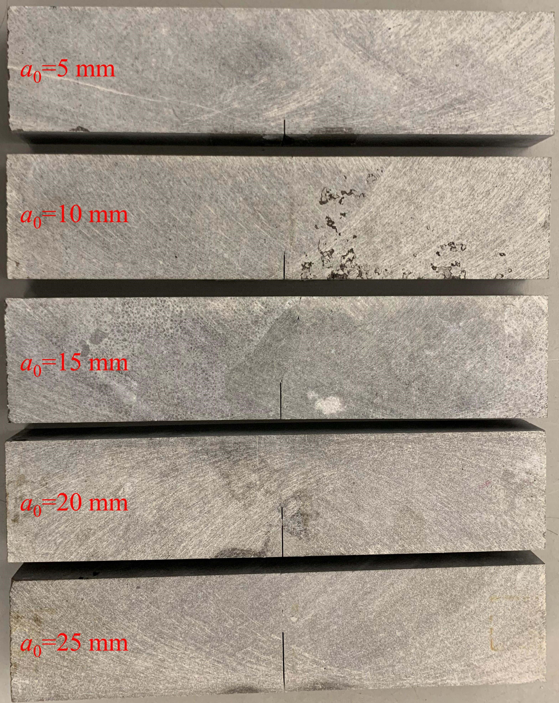
Fig. 4 SENB beams.

 | Table 1 Sizes of limestone specimens.
Group | L (mm) | S (mm) | B (mm) | D (mm) | a₀ (mm)
A | 220 | 200 | 25 | 50 | 5
B | 220 | 200 | 25 | 50 | 10
C | 220 | 200 | 25 | 50 | 15
D | 220 | 200 | 25 | 50 | 20
E | 220 | 200 | 25 | 50 | 25
Notes: D, B, L, and a₀ represent the depth, thickness, length, and initial crack length, respectively. S refers to the distance between two supports.
  - Experimental setup
In this study, the beams were tested at The University of Hong Kong using a 50 kN MTS loading machine by setting a loading rate of 0.1 µm/s. A 2 mm clip gauge and two 25 mm LVDTs were adopted to measure the CMOD and deflection (δ), respectively. In addition, Canon EOS 80D camera (see Table 2) was placed in front of the beam to record the beam deformation, with light sources located on both sides of the camera to reduce the camera exposure and motion blur，and ensure that an image with sufficient brightness and good contrast is obtained, as shown in Fig. 5. Before the test, the time of the data logger and the DIC computer was calibrated to ensure that the data obtained by the data logger would match those obtained by the DIC.
Table 2 Technical specifications of the camera.
Parameter | Technical specifications
Sensor type | CMOS
Sensor size | APS-C
Resolution | 6000×4000 pixels
Max resolution | 25.80 megapixels
Effective resolution | 24.20 megapixels
Lens model | EF-S18-55mm f/3.5-5.6 IS STM
Focal length | Adjustable, 18-55 mm

(a) | 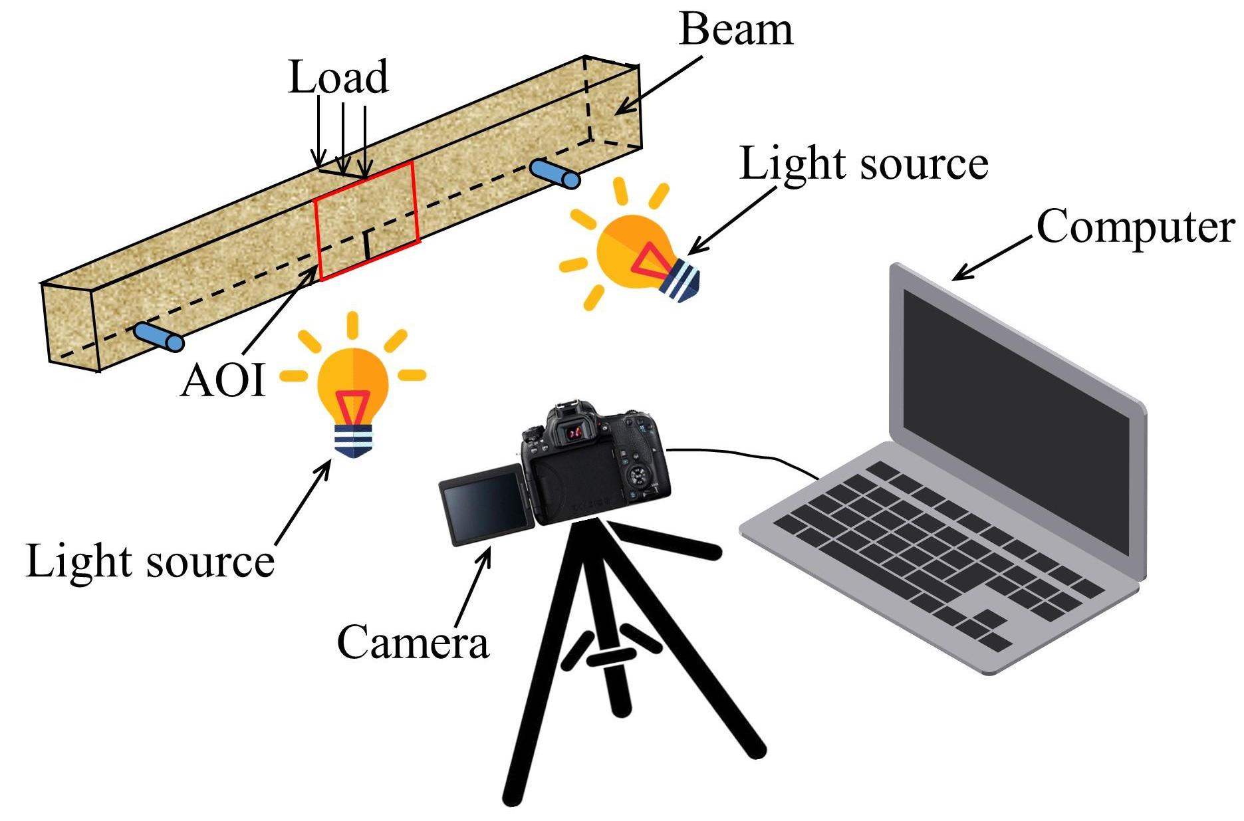  (b)
Fig. 5 Test setup: (a) in-site photo; (b) schematic of the DIC equipment layout.

- Results analysis
  - DIC results verification
Taking E-2 beam as an example, the CMOD versus loading time (t) curves are shown in Fig. 6. Obviously, high coincident can be seen between the CMOD calculated by the DIC and clip gauge, implying that calculating the deformation of specimens by way of the DIC is reliable.
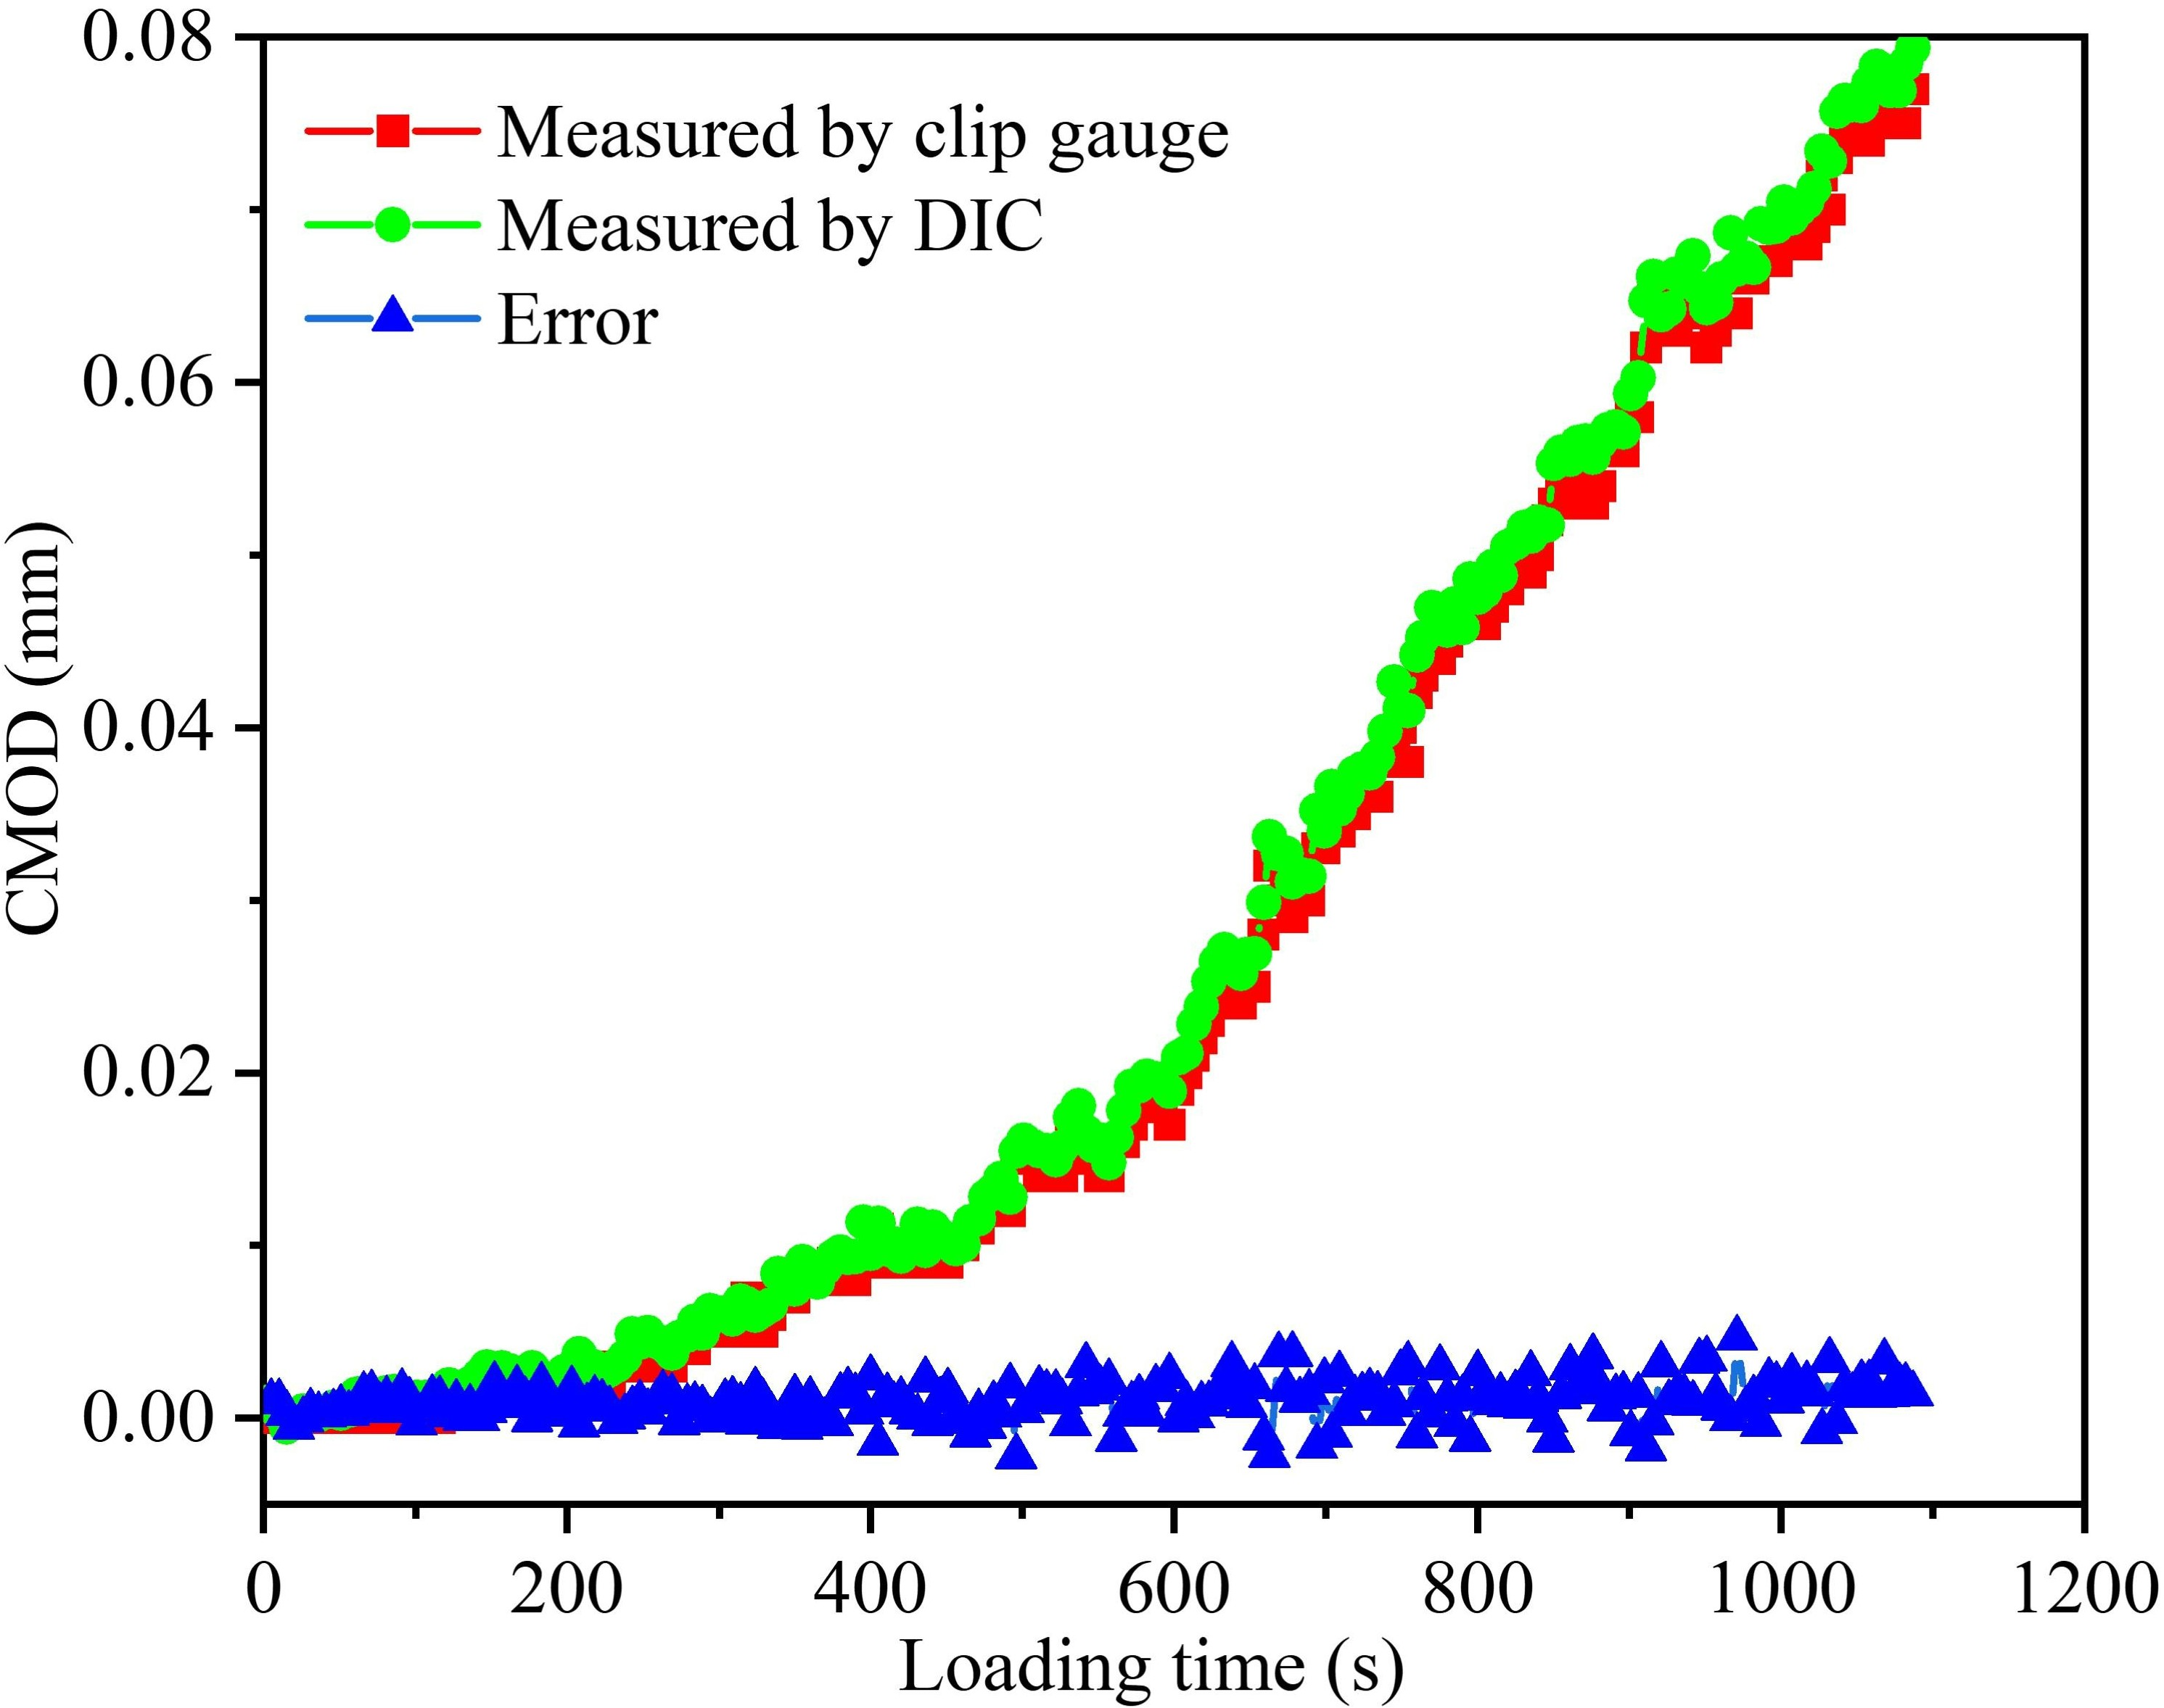
Fig. 6 Crack mouth opening of E-2 beam.
  - Load-displacement curves
As shown in Fig. 7, with increased a₀, the slopes of the curves at the pre-peak stage gradually decrease, implying that the rigidity of the beams decreases gradually; the load drop rate decreases gradually at the post-peak stage, indicating better-controlled crack propagation. When a₀ = 5 mm, the specimens are rapidly destroyed after reaching the peak, indicating that the specimens are brittle.
(a)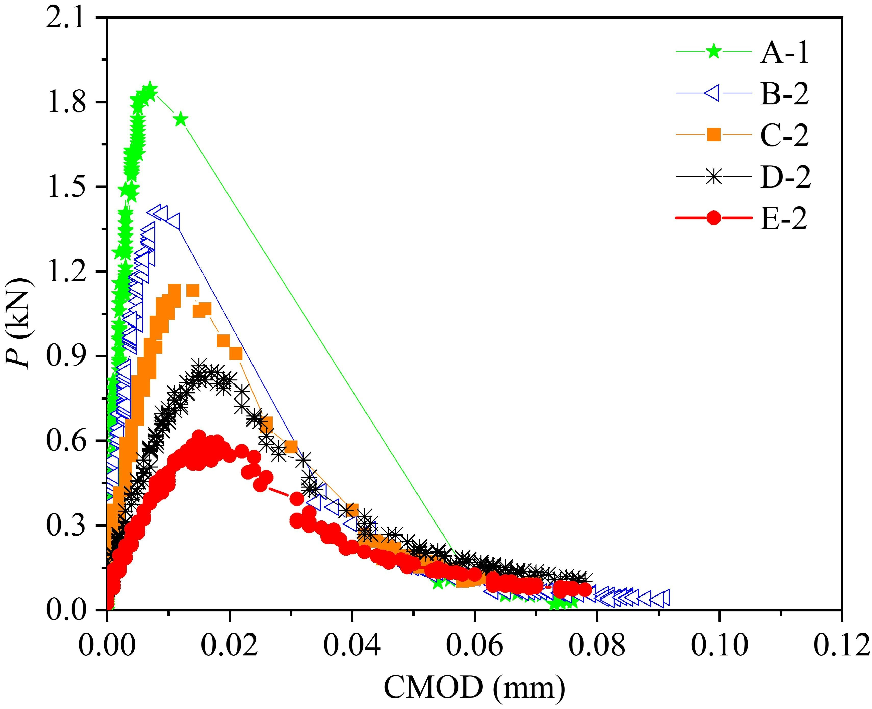 | (b)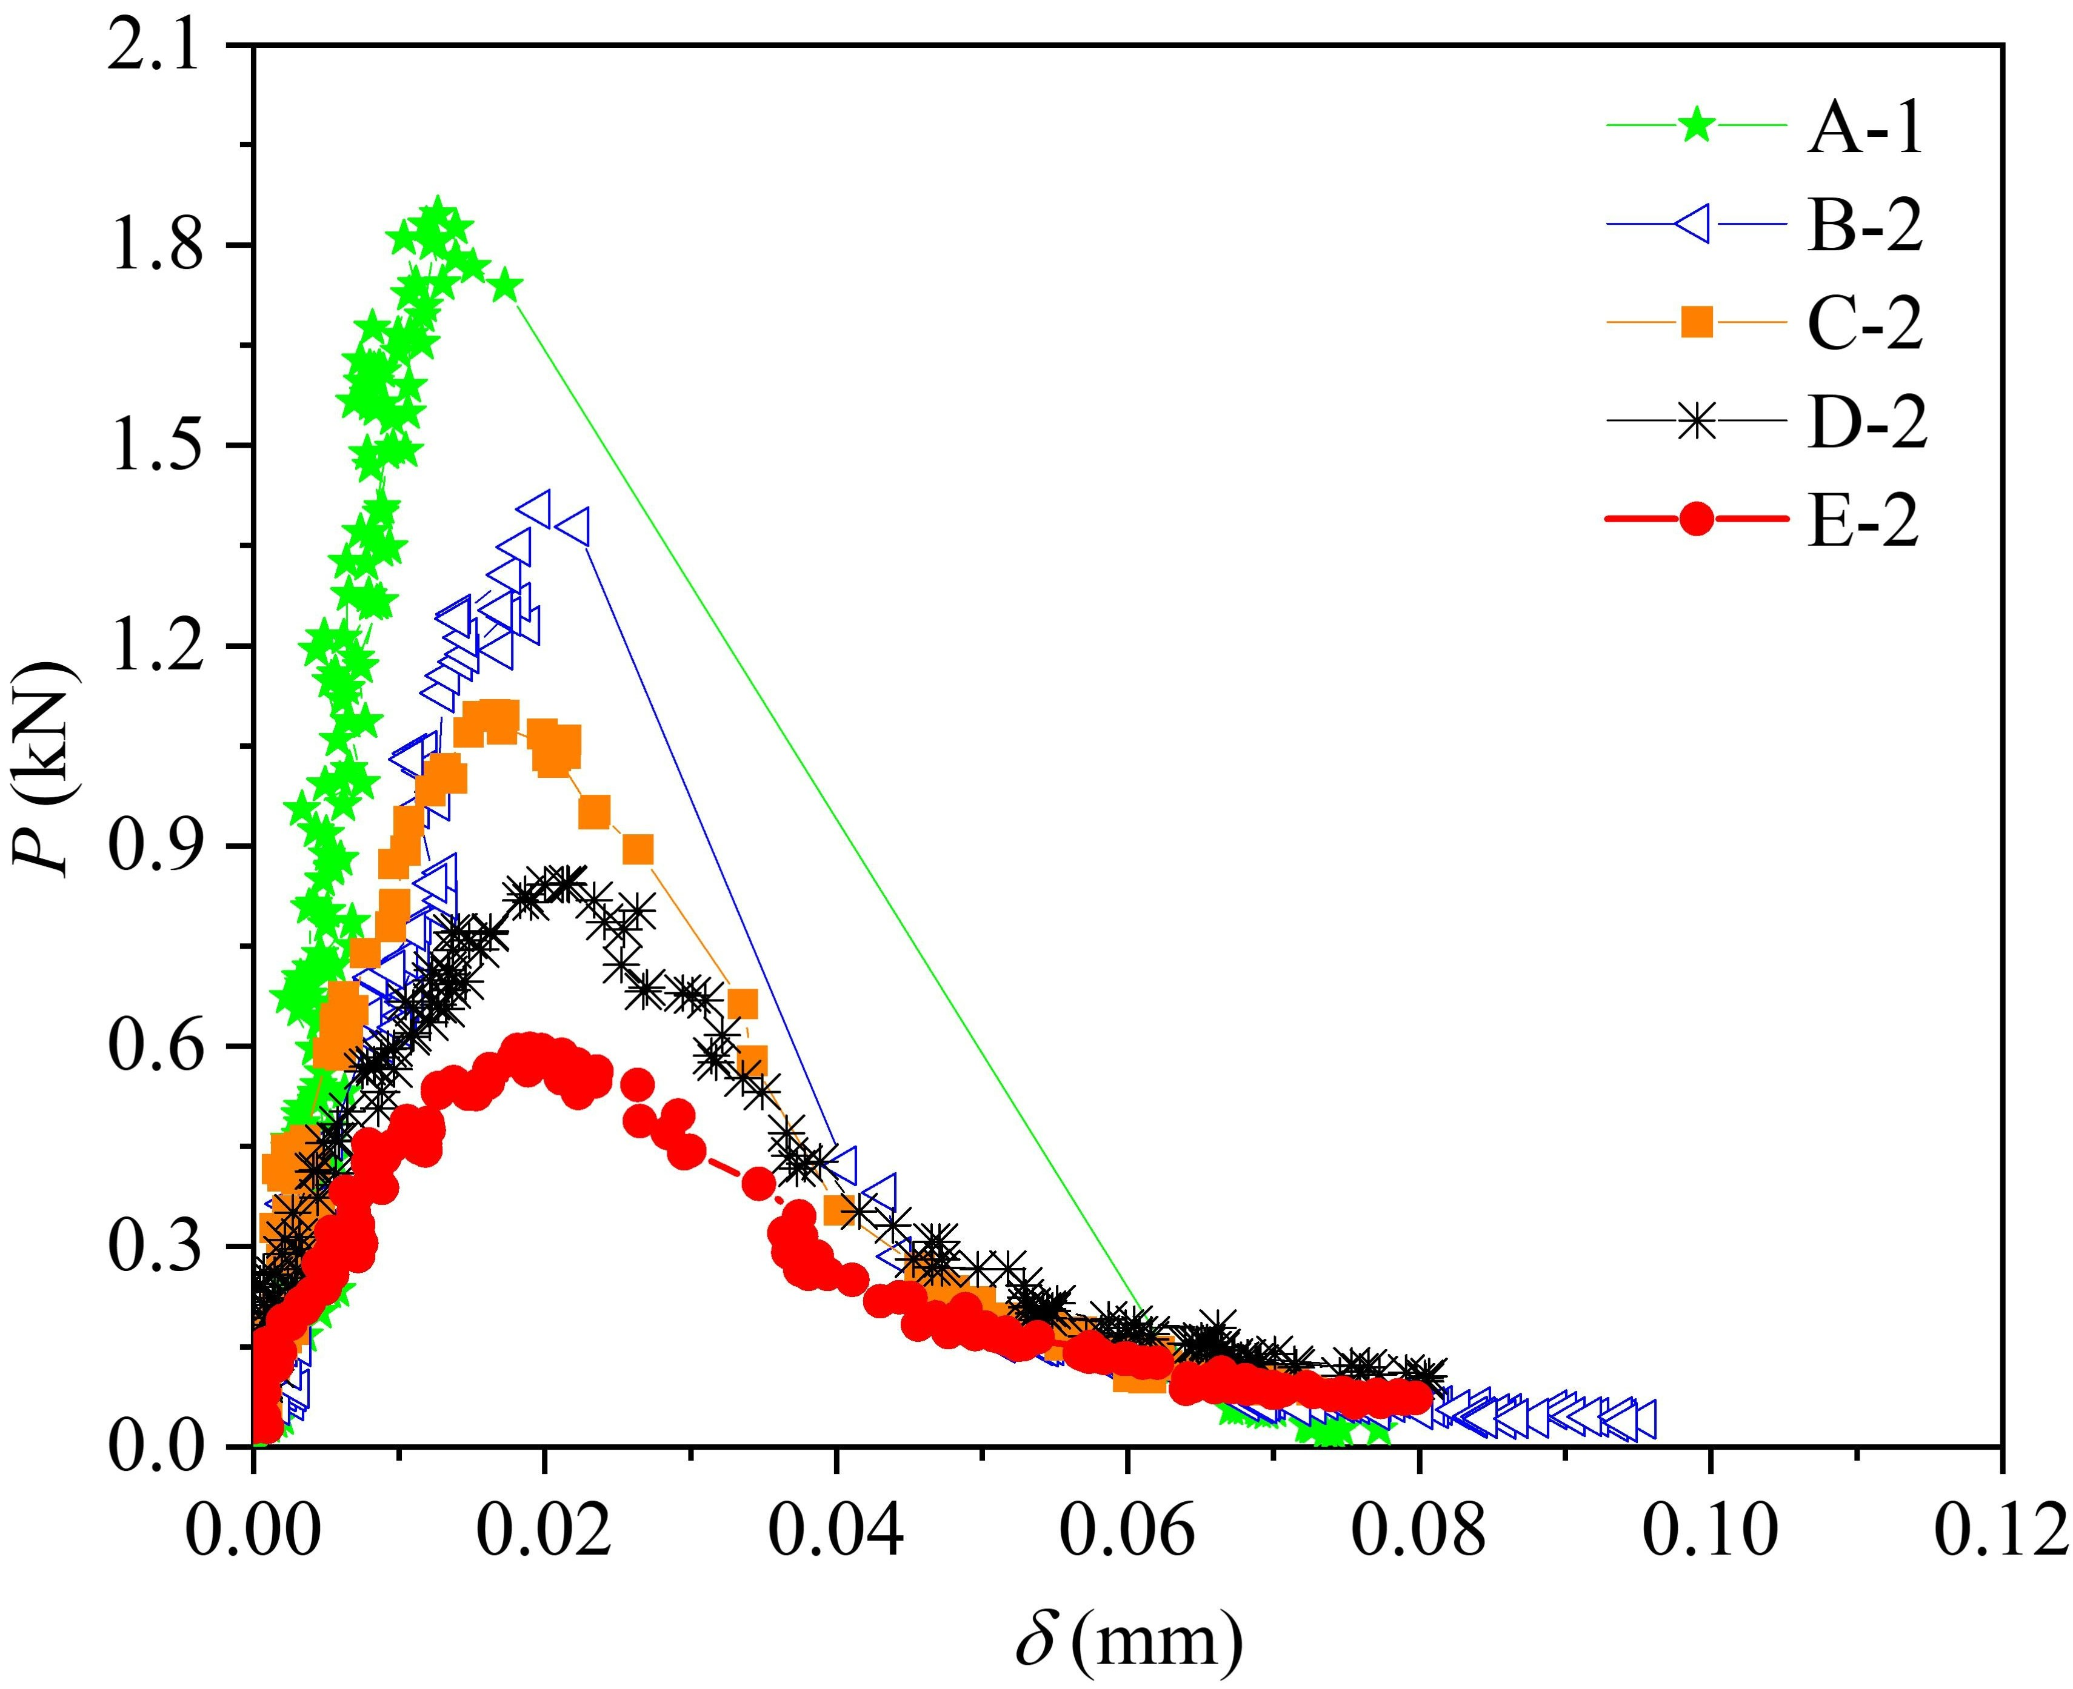
Fig. 7 Load versus displacement curves: (a) P-CMOD curve; (b) P-δ curve.
In accordance with the LEFM, Tada et al. [44] gave the relationship between P and CMOD:
(11)
Where α₀ and E refer to the crack-to-depth ratio (a₀/D) and elastic modulus, respectively. By randomly selecting several points from the linear segment of the P-CMOD curve, and substituting these points into Eq. (11), E can be calculated. Table 3 shows the calculated E of E-2 beam, which is about 64.84 GPa.
Table 3 Elastic modulus of limestone.
Specimen no. | CMOD  (mm) | P  (kN) | E  (GPa) | Mean  (GPa) | Coefficient of variation
E-2 | 0.0015 | 0.0674 | 63.47 | 64.84 | 2.42%
E-2 | 0.0017 | 0.0796 | 66.55 | 64.84 | 2.42%
E-2 | 0.0021 | 0.0944 | 64.49 | 64.84 | 2.42%
The peak load (P_{max}) with the α₀ is shown in Fig. 8. With increased α₀, P_{max} gradually decreases, indicating that limestone is sensitive to the change of a₀. A similar phenomenon to which has been found in plain concrete [45]. When α₀ increases from 0.1 to 0.5, P_{max} decreases from approximately 1.97 kN to 0.63 kN. This is because the greater the a₀, the smaller the ligament length (D-a₀), and so the smaller the external force required to maintain the stability of the beams. After P_{max} is obtained, two different nominal strengths (i.e. σ_{N} and σ_{n}) can be calculated by [46, 47]:
(12)
Where σ_{n} and σ_{N} are nominal strength with and without considering the crack, respectively [6]. As shown in Fig. 9, with increased α₀, σ_{N} gradually decreases, indicating that σ_{N} is related not only to material properties but also to specimen size. Based on the LEFM, σ_{N} can be obtained by [46, 47]:
(13)
Where K_{Ic} refers to the fracture toughness without considering nonlinearity. Eq. (13) can be written as [46, 47]:
(14)
Where α* is a reference crack length. g(α₀) refers to a geometry factor. σ_{n} fitted by Eq. (14) is shown in Fig. 9. Obviously, the fitting result is good.
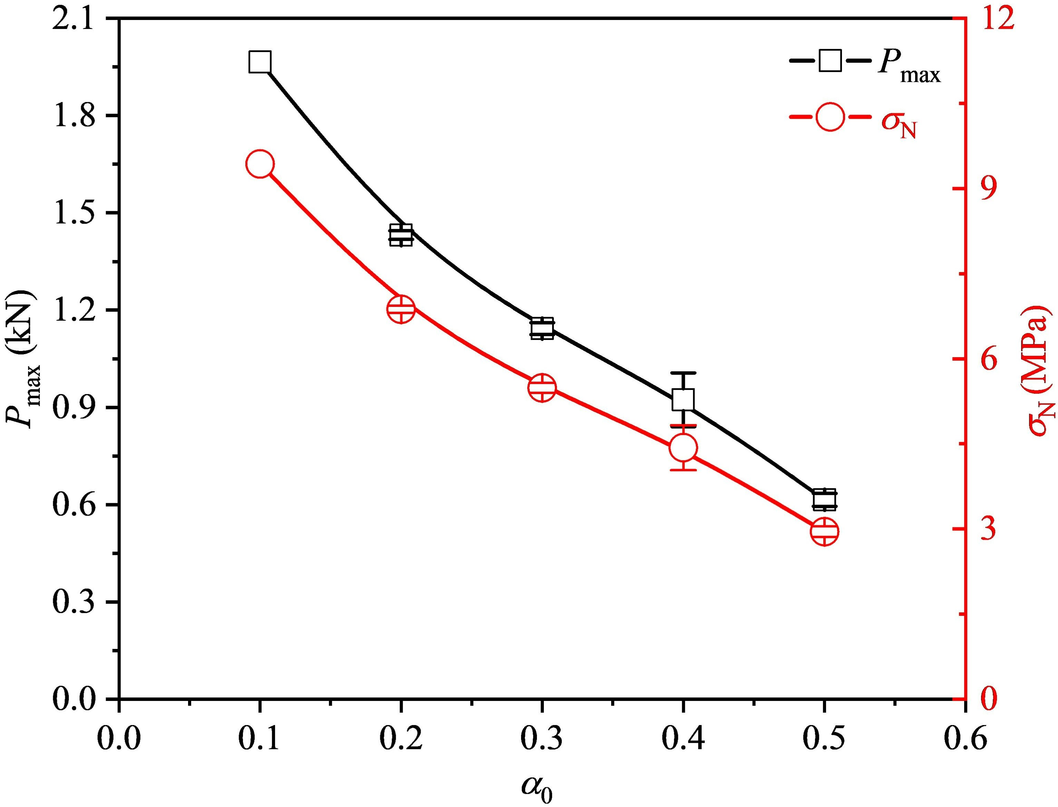 | 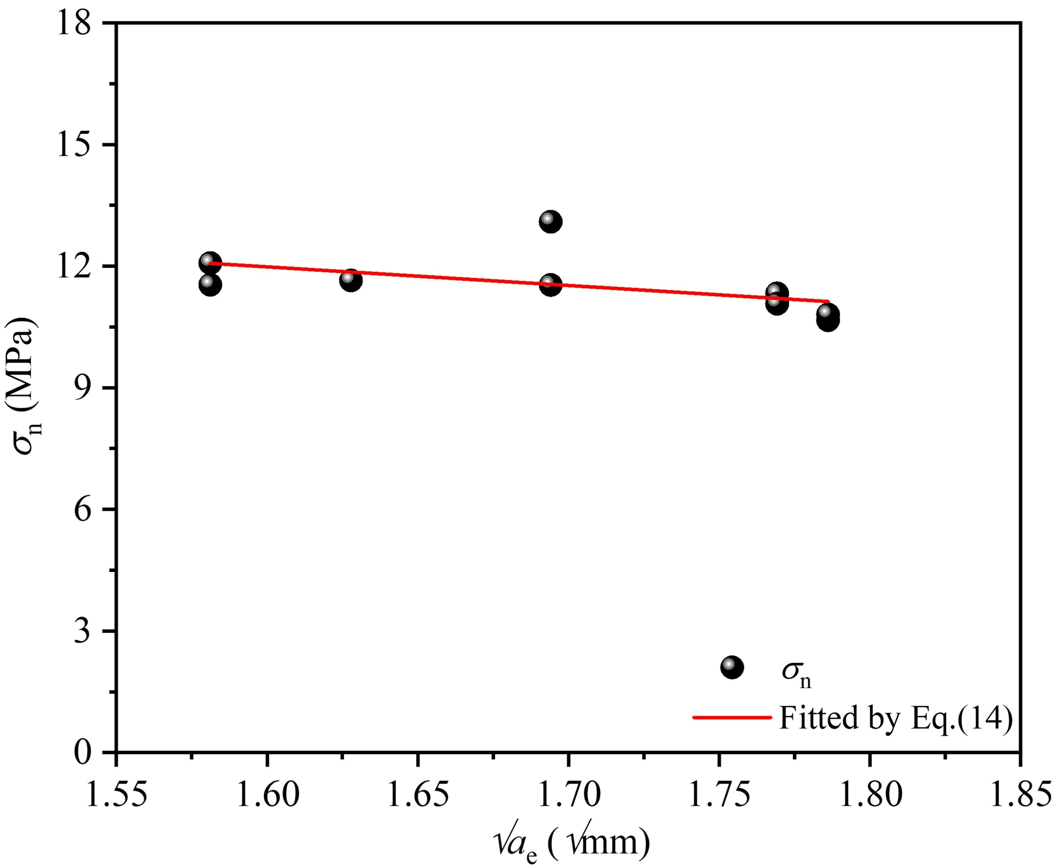
Fig. 8 Variations of P_{max} and σ_{N} with α₀. | Fig. 9 Variation of σ_{n} with √a_{e}.
The CMOD_{c} of each specimen is shown in Fig. 10. Obviously, CMOD_{c} gradually increases with increased α₀, and similar trends can be seen with graphite [13]. When α₀ increases from 0.1 to 0.5, CMOD_{c} increases from approximately 0.007 mm to 0.015 mm. The CMOD_{c} obtained by the DIC and clip gauge are largely consistent, but a slight difference is evident. This can be explained from two aspects: (1) the shooting time of speckle patterning cannot completely match the time at P_{max}; (2) even if the shooting time of speckle patterning can match the time at P_{max}, when DIC post-processing software is used to calibrate the distance (i.e., the relationship between the pixel and length), errors will inevitably occur.
The CTOD_{c} with the α₀ is shown in Fig. 11. With increased α₀, CTOD_{c} gradually increases. When α₀ increases from 0.1 to 0.5, CTOD_{c} increases from approximately 0.0011 mm to 0.0053 mm.
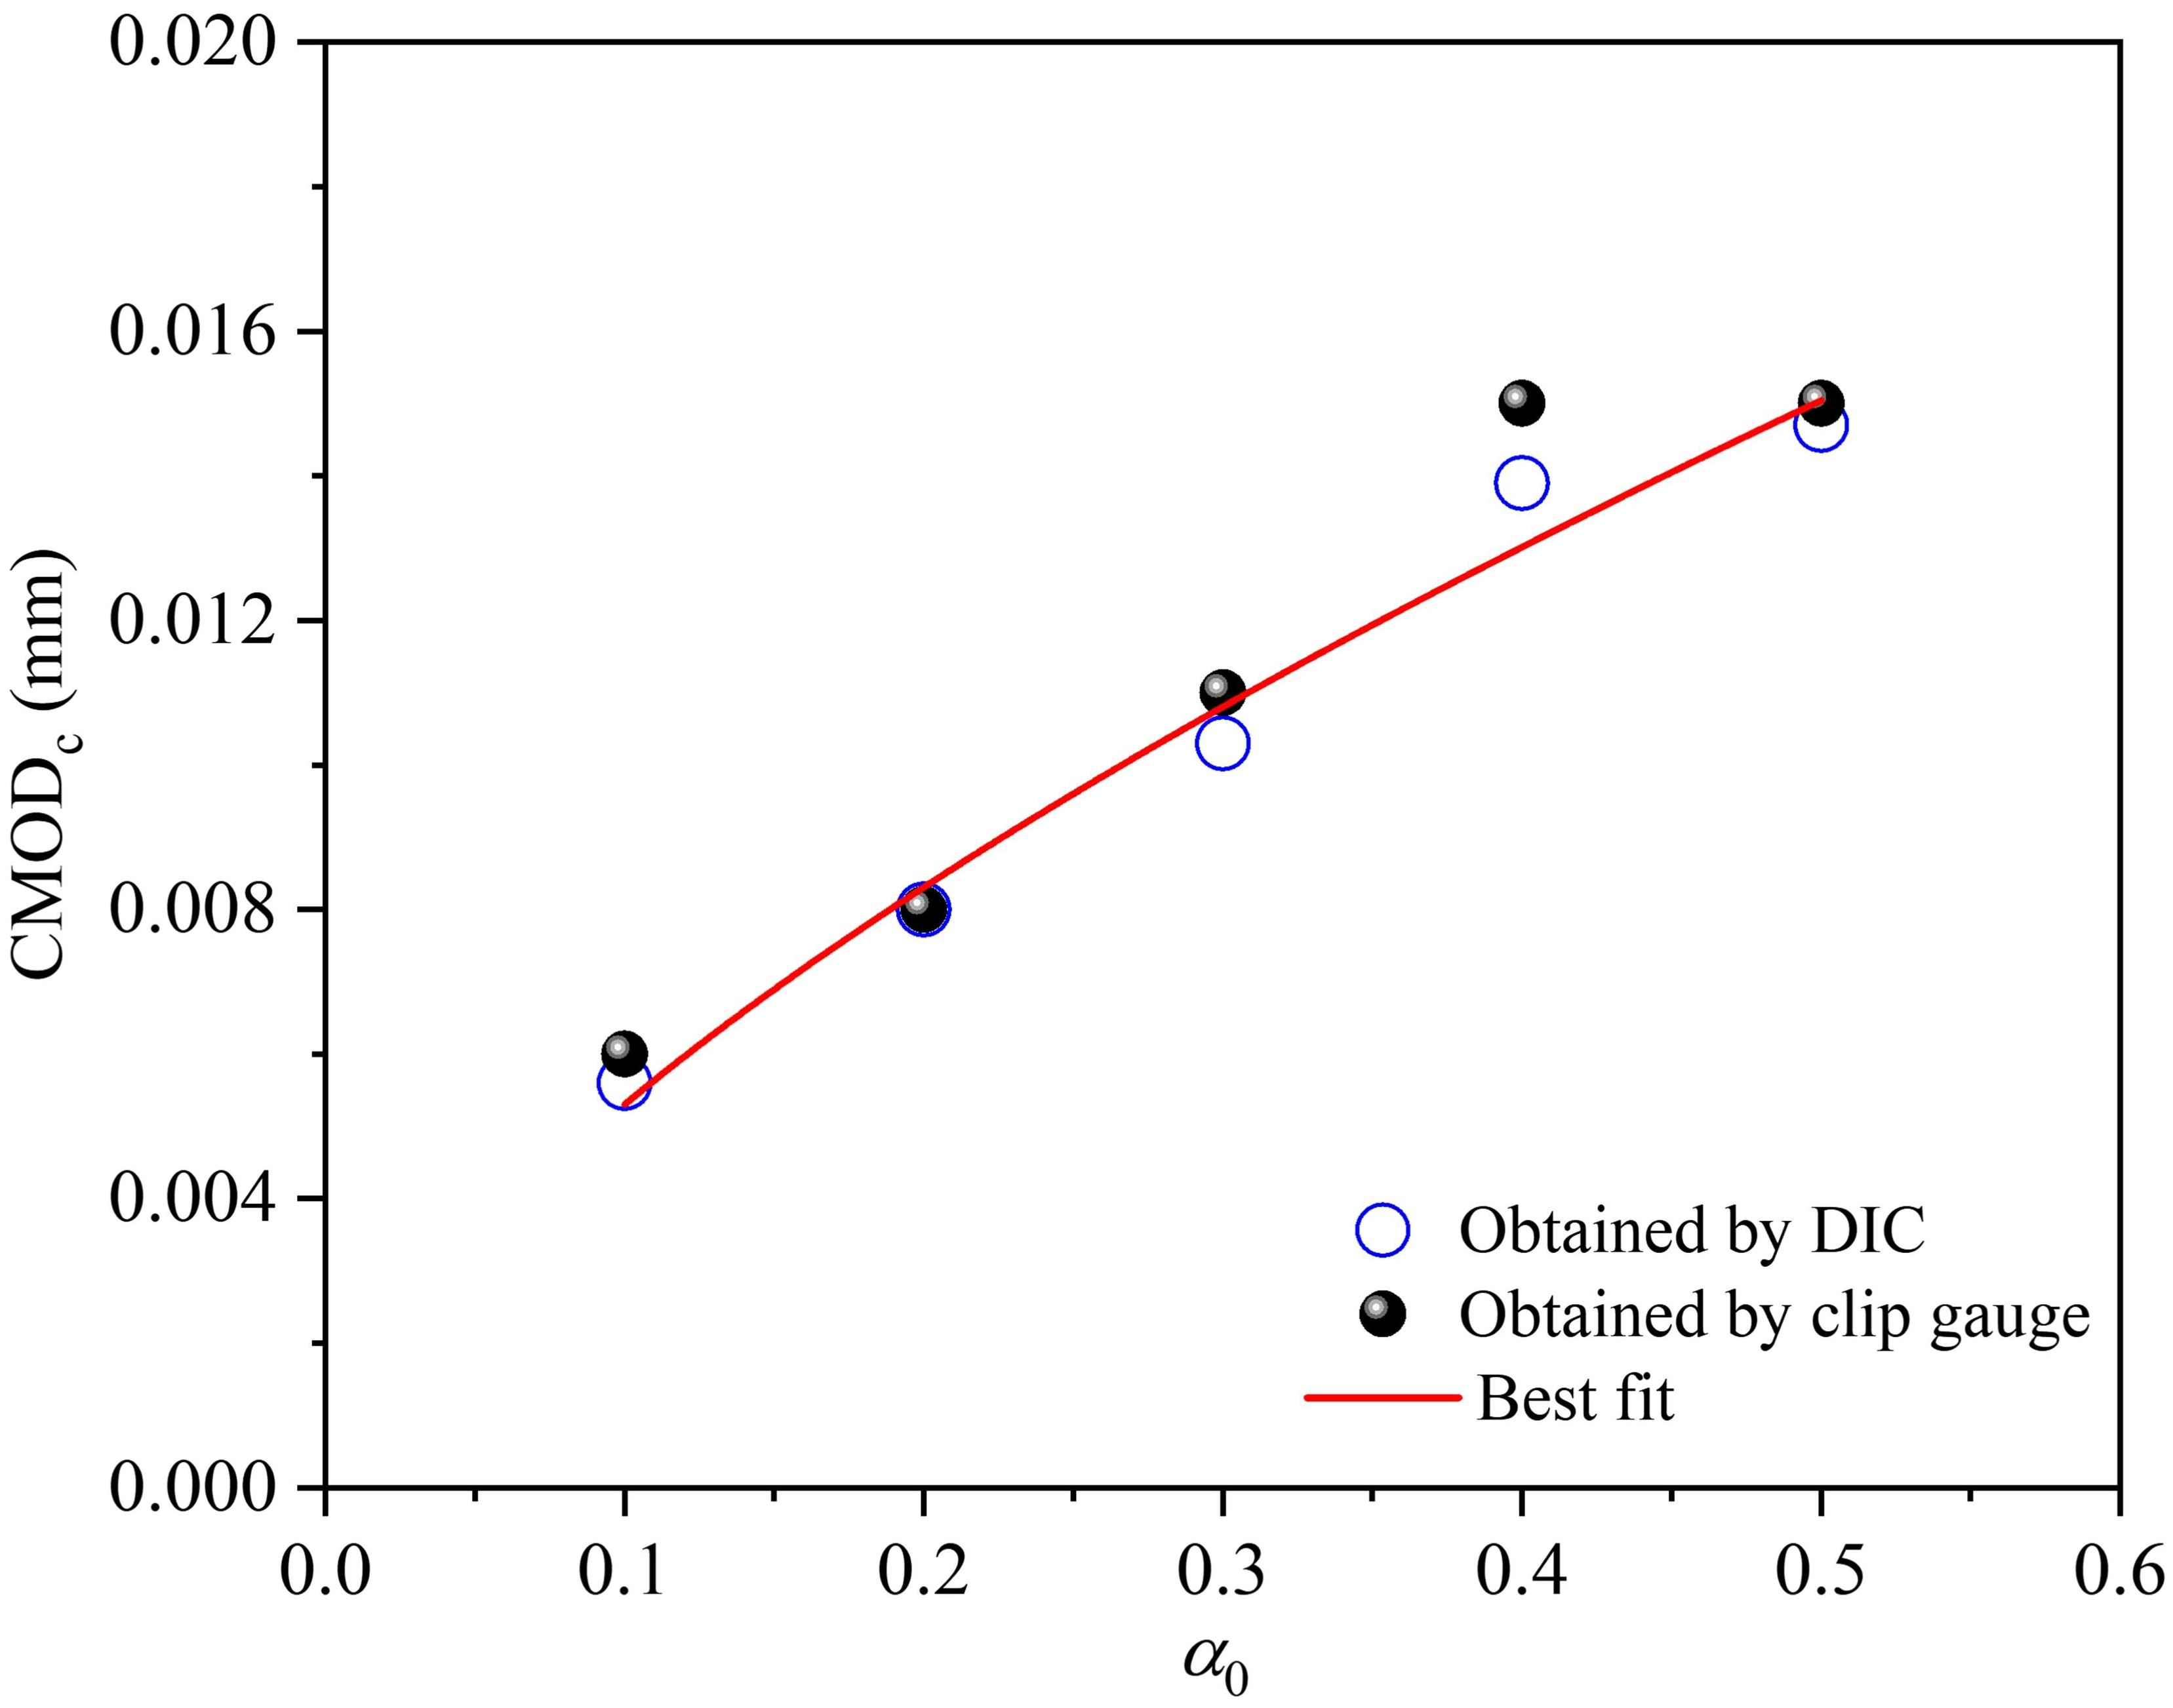 | 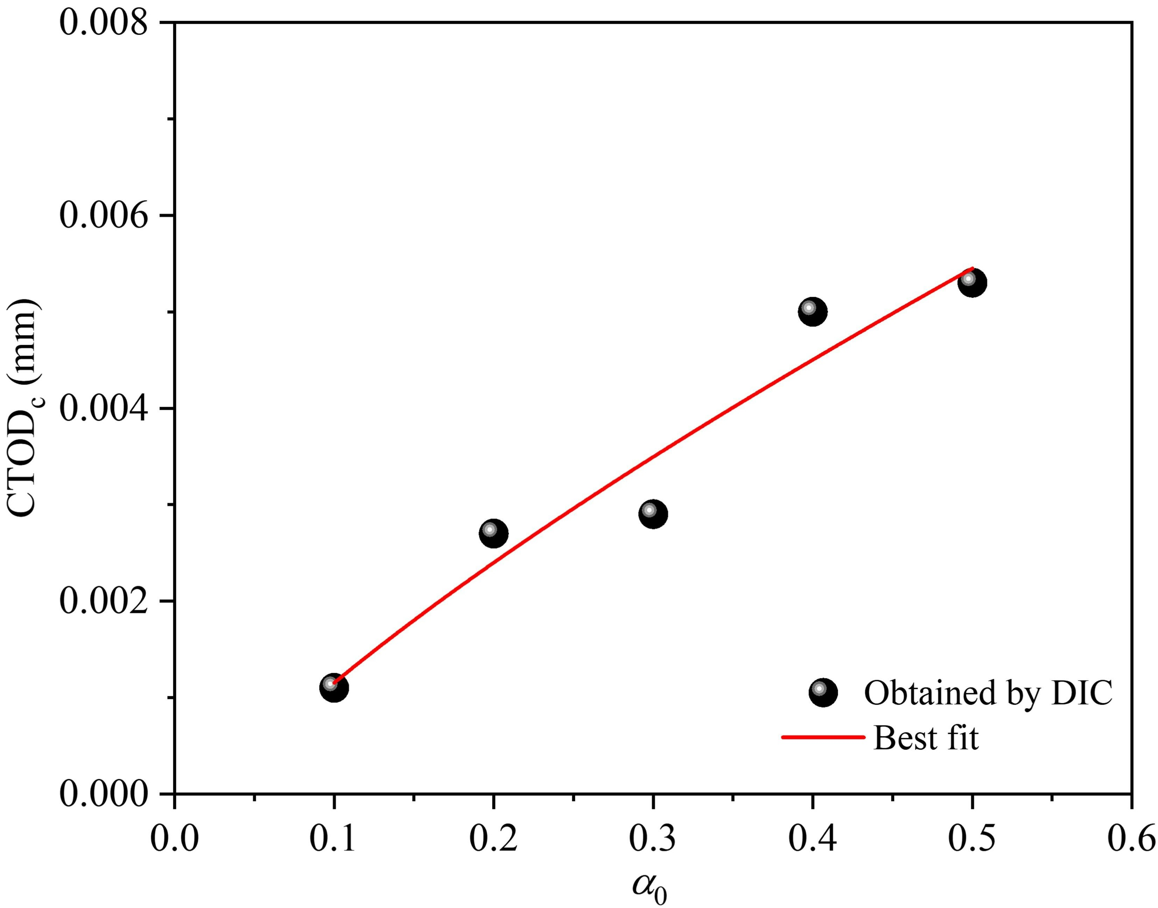
Fig. 10 Variation of CMOD_{c} with α₀. | Fig. 11 Variation of CTOD_{c} with α₀.
The relationship between α₀ and δ_{c} is shown in Fig. 12. Obviously, δ_{c} calculated by the DIC increases gradually with increased α₀. When α₀ increases from 0.1 to 0.5, δ_{c} increases from approximately 0.0122 mm to 0.0216 mm.

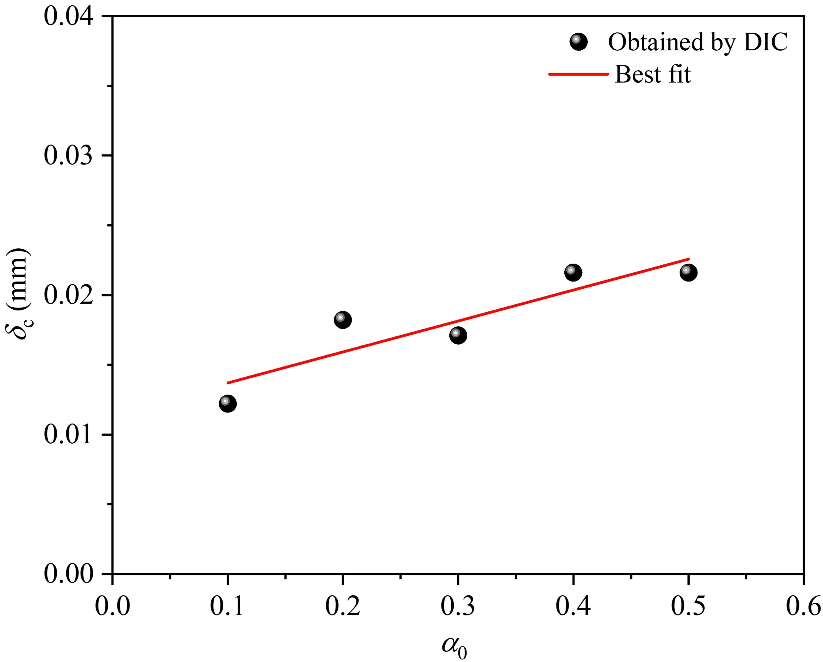
Fig. 12 Variation of δ_{c} with α₀.
  - Crack evolution
From the displacement fields obtained by the DIC, crack propagation can be observed. Fig. 13 shows the horizontal displacements of E-2 beam. At pre-peak 70% P_{max} (see Fig. 13a), along the initial crack, the left part of the beam moved to the left (negative) while the right part moved to the right (positive). However, the crack did not initiate at this stage as the deformation was too small. As the test continued, the opening displacements of the specimen gradually increased. When the beam was loaded to post-peak 35% P_{max} (see Fig. 13b), crack propagation was seen.
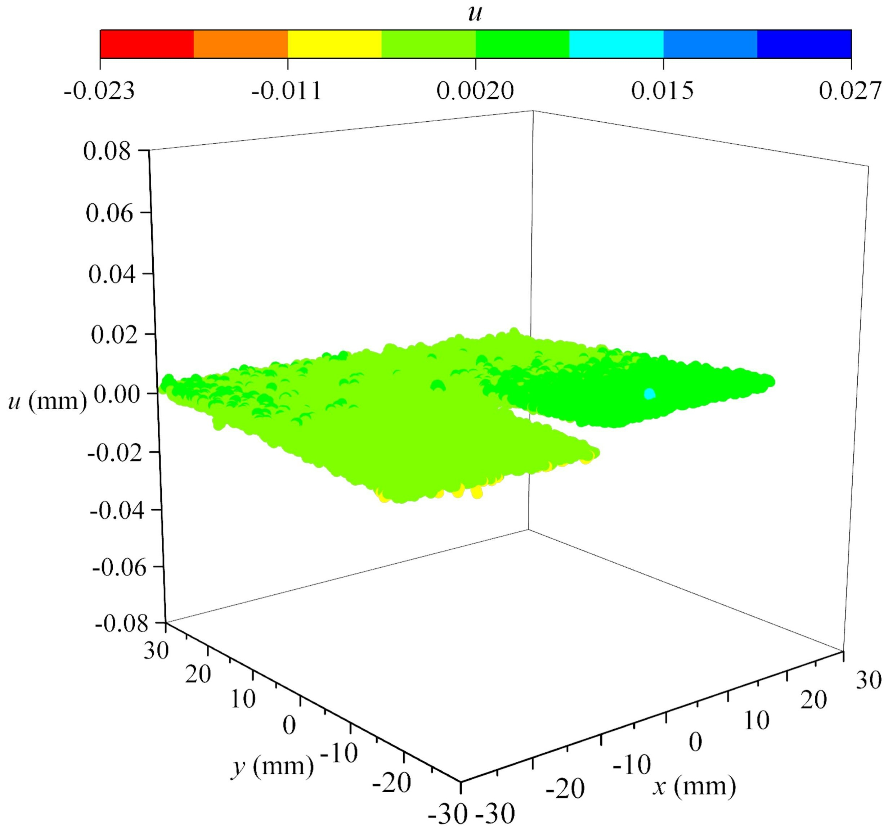 | 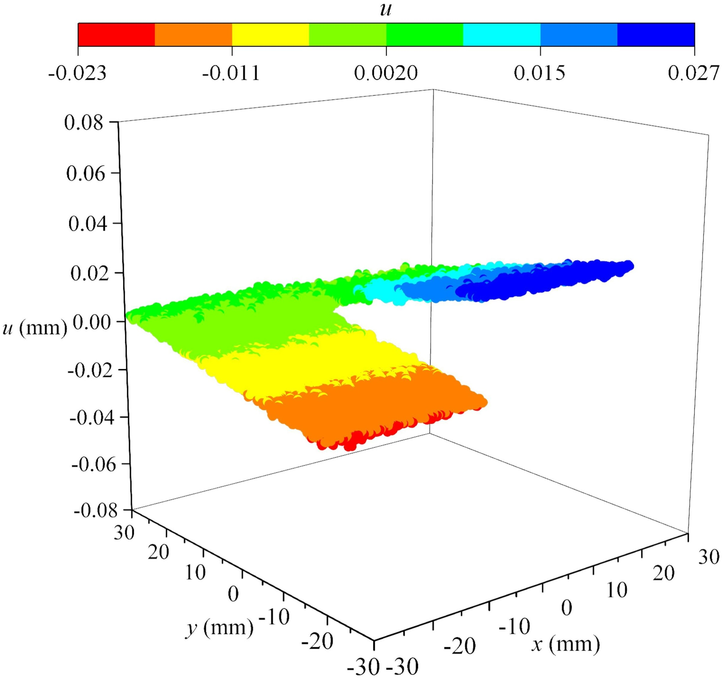
(a) Pre-peak 70％ P_{max} | (b) Post-peak 35％ P_{max}
Fig. 13 Horizontal displacement of E-2 at two loading stages.
Similarly, the crack evolution can be observed from the strain fields. The horizontal strains of E-2 beam are shown in Fig. 14. At pre-peak 70% P_{max}, the strain was small and a strain concentration zone (SCZ) cannot be seen, implying that the beam was elastic. At P_{max}, the crack had formed above the initial crack tip due to an obvious SCZ formed. At post-peak 90%, the length of the SCZ was greater than that at P_{max}, indicating that the crack had propagated upwards. The crack growth path was not linear but jagged, caused by various micro-voids and microcracks in the specimen.
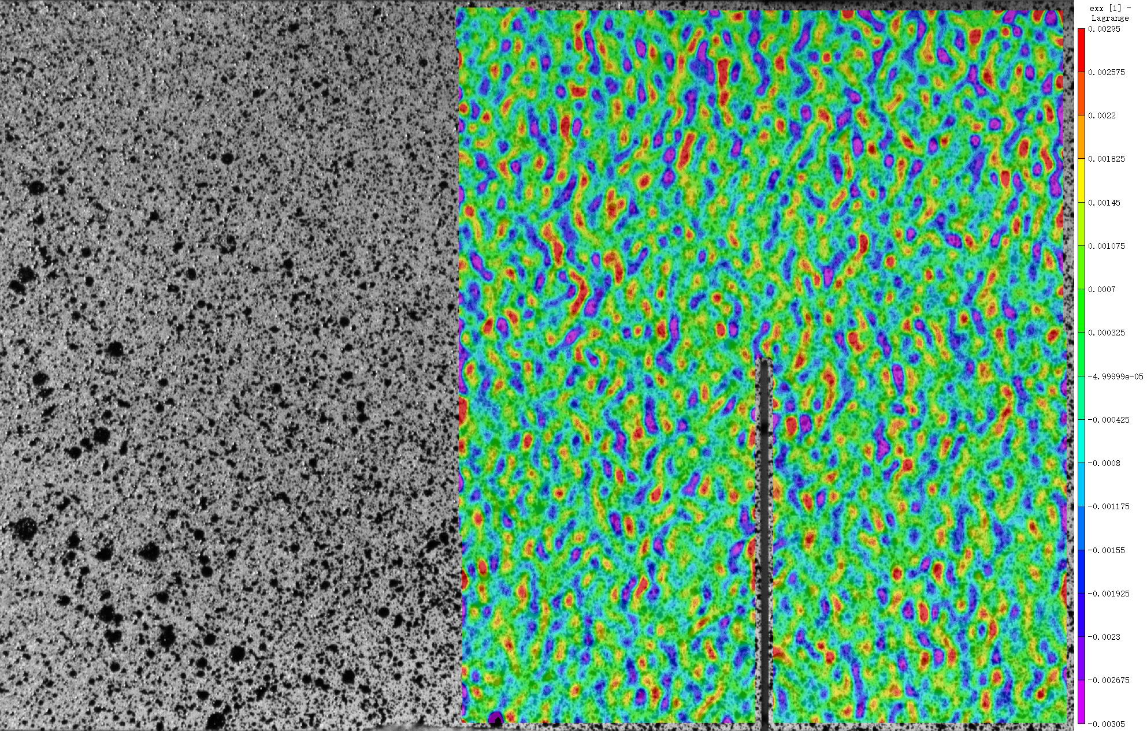 | 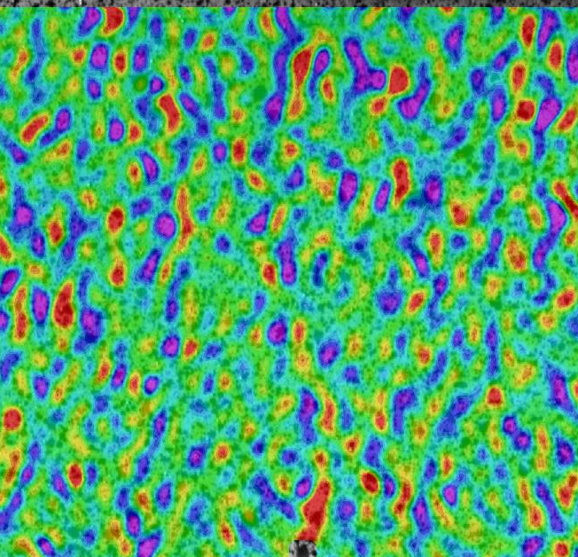
Pre-peak 70% P_{max} | P_{max}
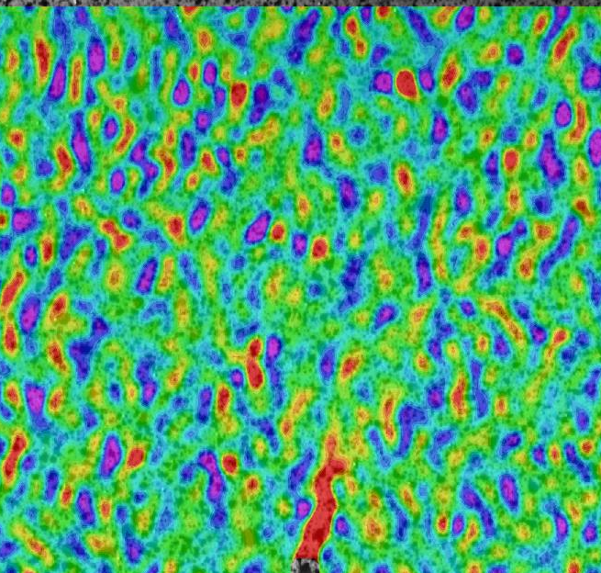 | 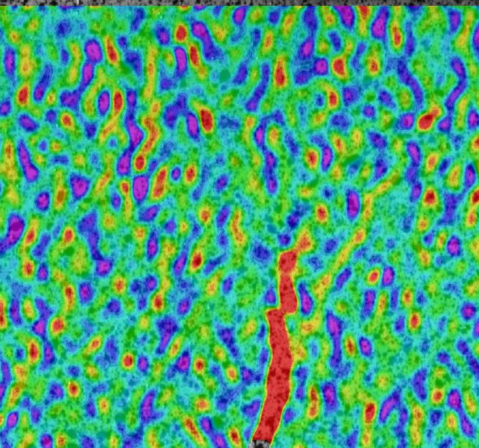
Post-peak 90% P_{max} | Post-peak 70% P_{max}
Fig. 14 Horizontal strain of E-2 beam at different loading stages.
To quantify the effective crack length (l_{c}), the crack tip needs to be determined first. According to previous studies [13, 48, 49], the crack tip can be solved by setting a strain threshold (ε_{c}). According to the definition of the bilinear softening law [50, 51], ε_{c} can be obtained by:
(15)
By substituting f_{t} and E into Eq. (15), ε_{c} can be obtained, and its value is approximately 120 µε.
Besides the above method, the crack tip can also be determined based on the horizontal displacement field. For example, An et al. [52] considered that the crack tip is located at a turning point where the slope of the horizontal displacement changes; Shah et al. [53] pointed out that it is located at a point with a crack opening of zero.
Taking E-2 beam as an example, l_{c} obtained by the above three methods is shown in Fig. 15. Compared to the slope of the l_{c}-t curve before P_{max}, it is larger after P_{max}, indicating that the crack begins to enter an unstable growth stage. When the line length from the crack tip to the loading boundary is less than a certain value (approximately 7.55 mm for E-2 beam), the crack growth rate begins to decrease, which is caused by the boundary effect. In addition, l_{c} obtained by the strain threshold is highly compatible with that obtained by observing the turning point, but is quite different from that obtained by observing the crack opening, indicating that l_{c} obtained by observing the crack opening is overestimated.
The difference (l_{f}) between the l_{c} at P_{max} and a₀ is shown in Fig. 16. As can be seen, l_{f} has relatively large discretion but is less than 5 mm, indicating that the specimens are brittle; with increased α₀, l_{f} seems to increase gradually, indicating that the longer the a₀, the more serious the stress concentration.
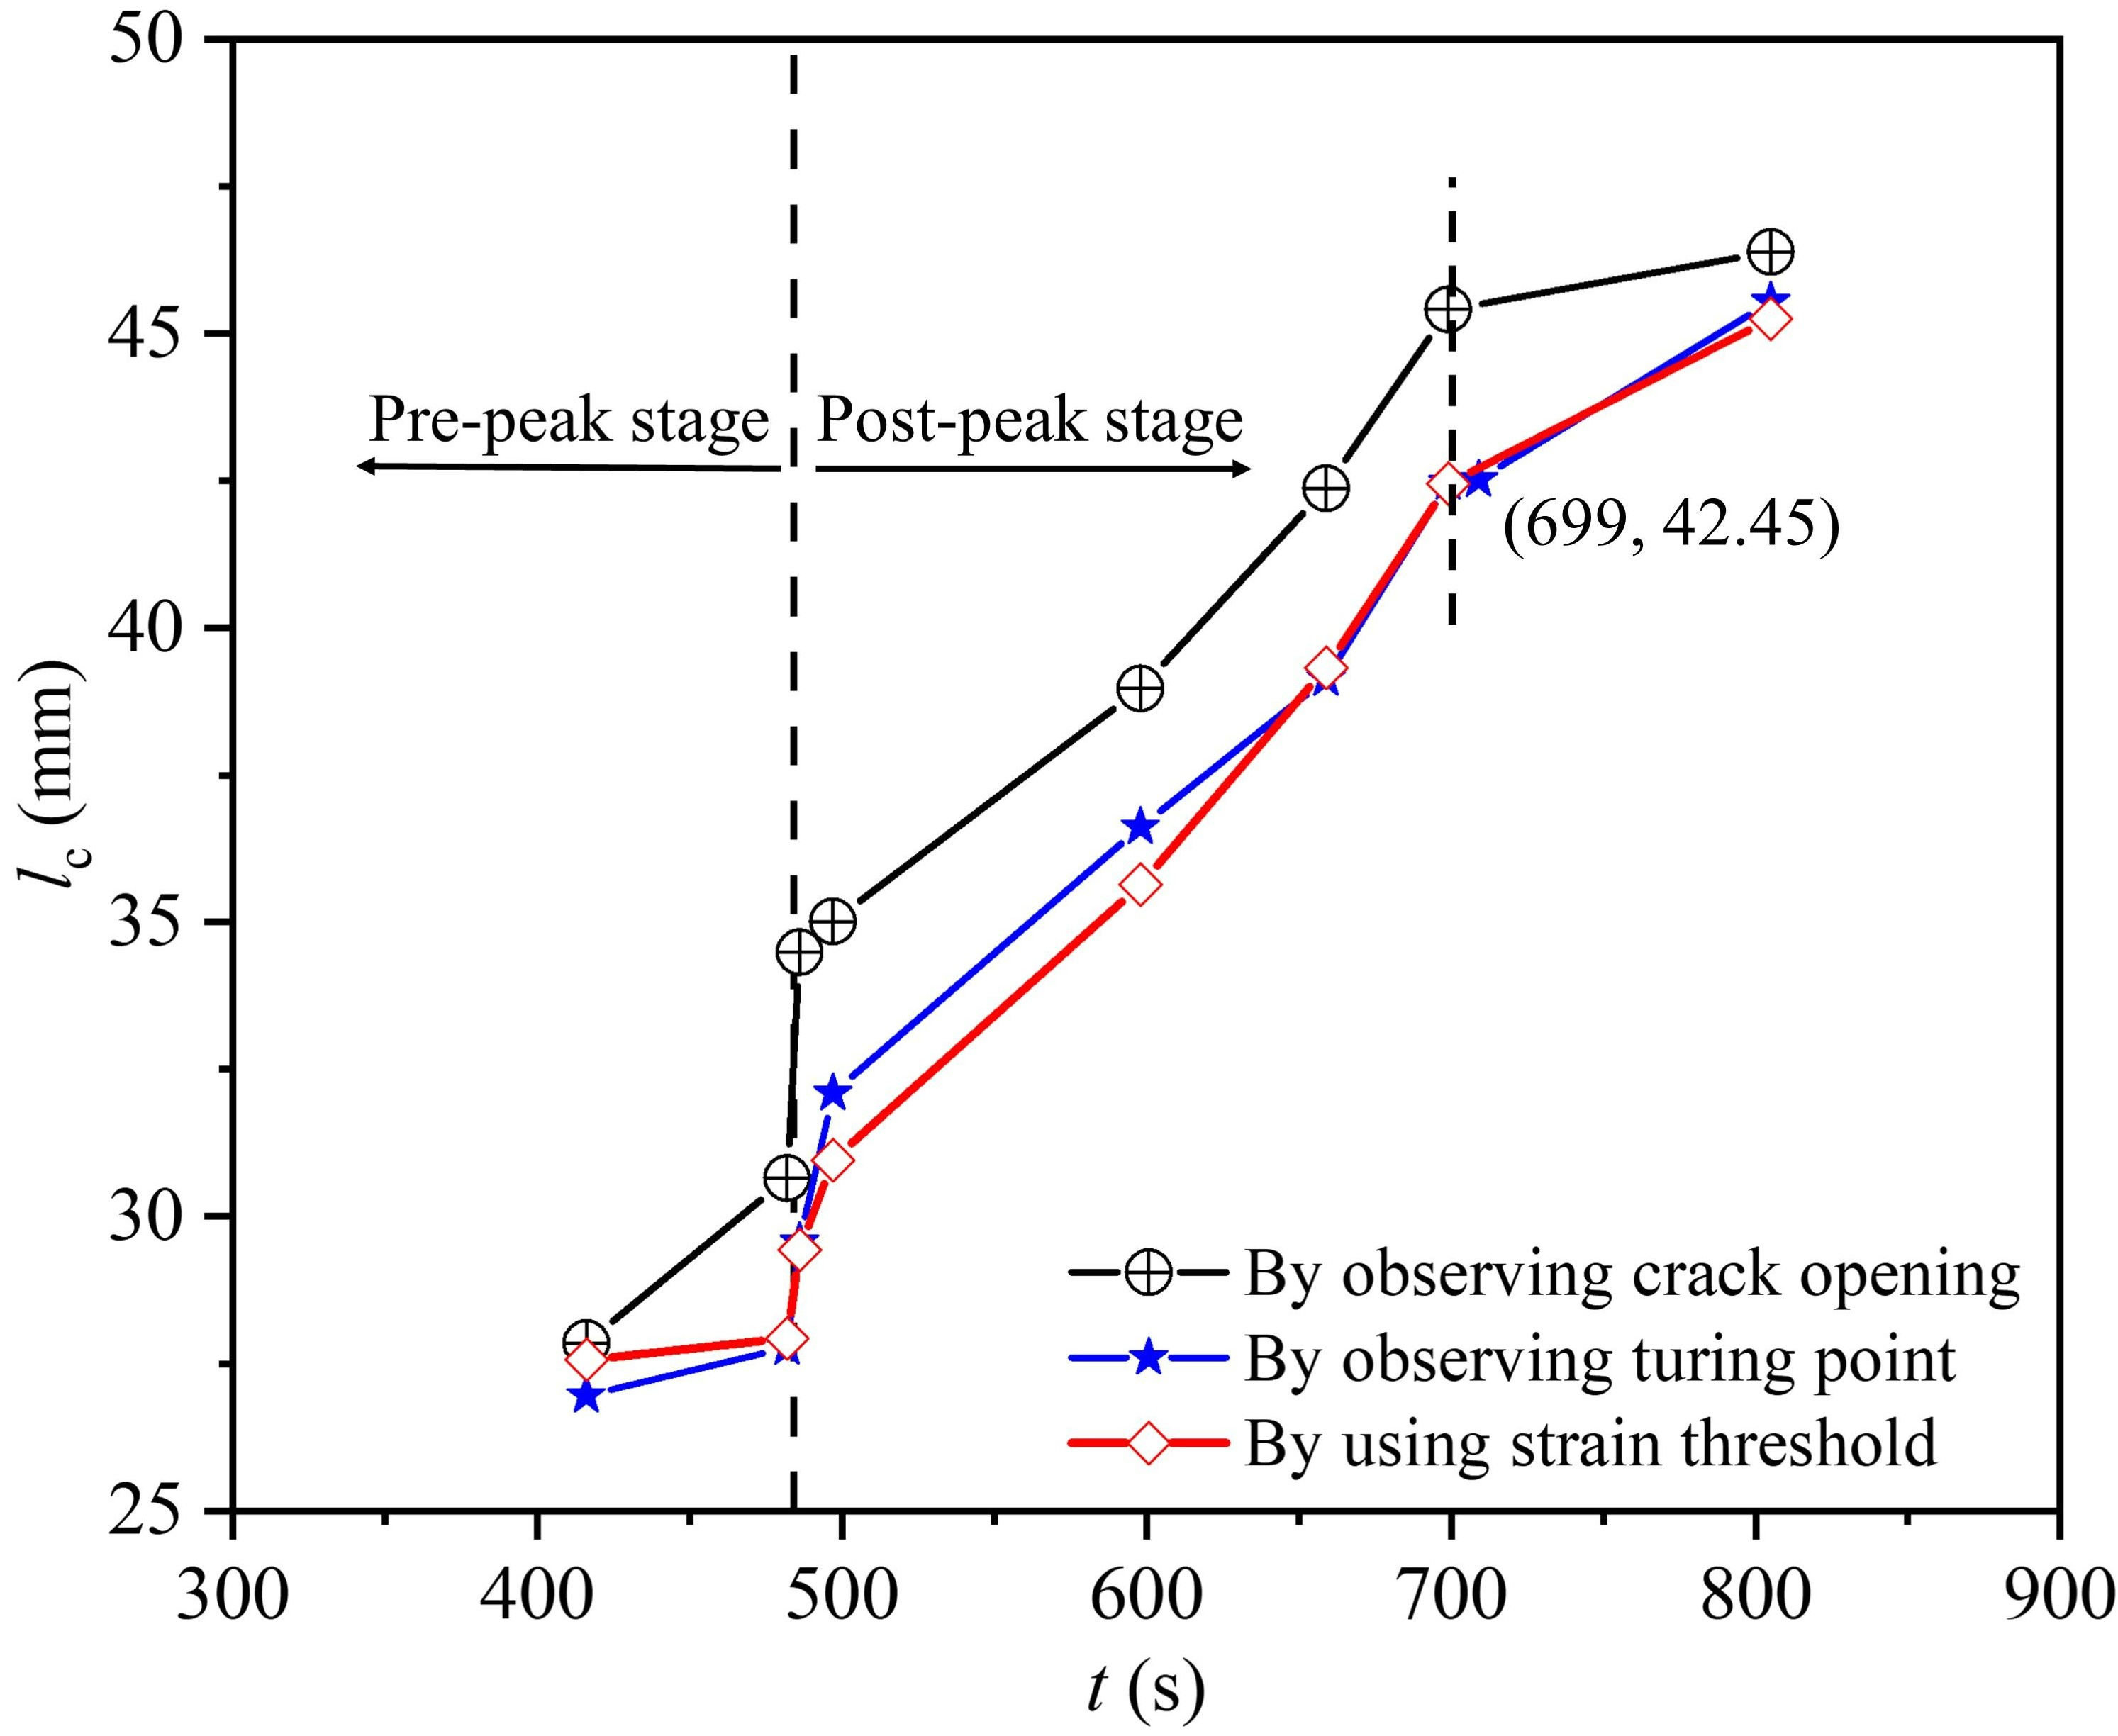 | 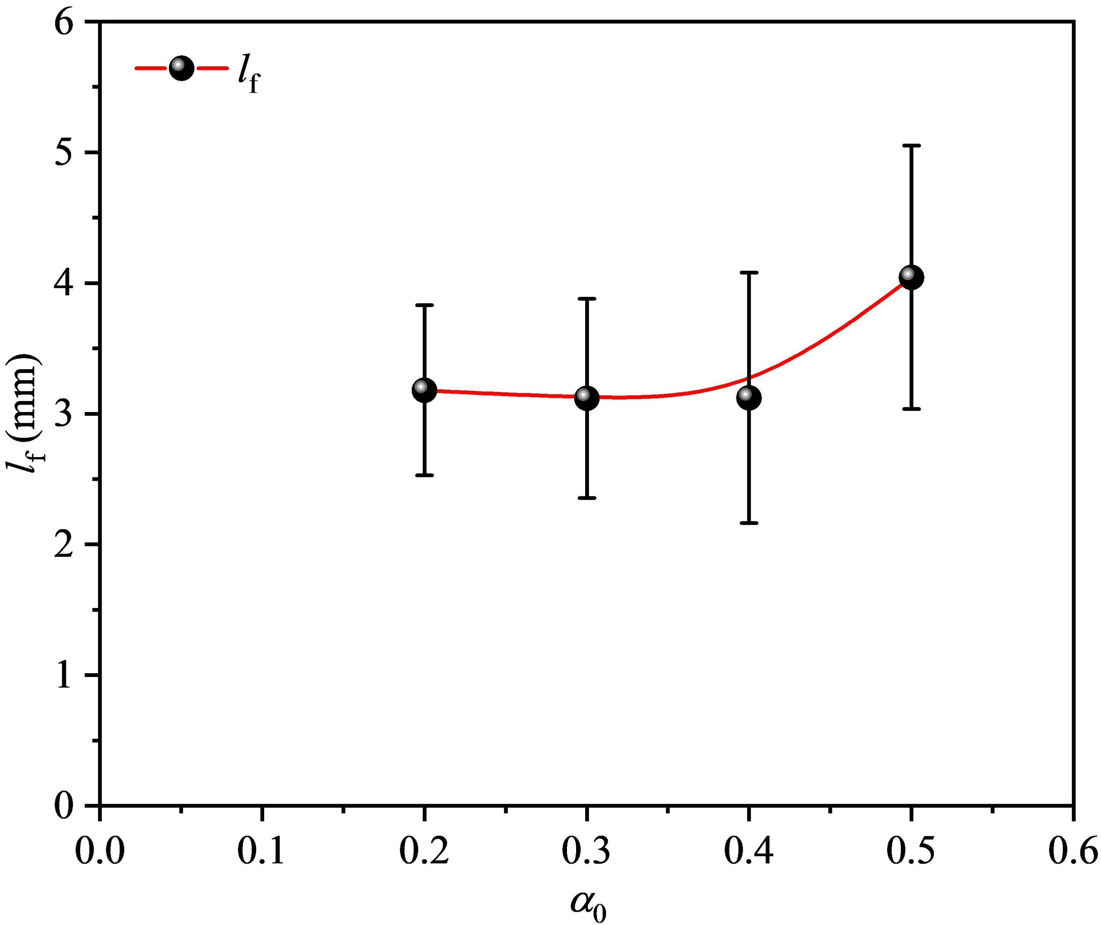
Fig. 15 l_{c}-t curve. | Fig. 16 Variation of l_{f} with α₀.
  - Fracture energy
To describe fracture properties from the perspective of energy, fracture energy (G_{f}) was proposed [54]. According to the RILEM [55], after the complete P-δ curve is obtained, the G_{f} can be obtained by:
(16)
Where W refers to the area under the complete P-δ curve. Fig. 17 shows the G_{f} with the α₀. G_{f} gradually decreases with increased α₀. A similar trend has been found in plain concrete [56], UHPC [57], and graphite [13]. When α₀ increases from 0.1 to 0.5, G_{f} decreases from approximately 57.38 N/m to 33.59 N/m, indicating that G_{f} is affected by specimen size [58].

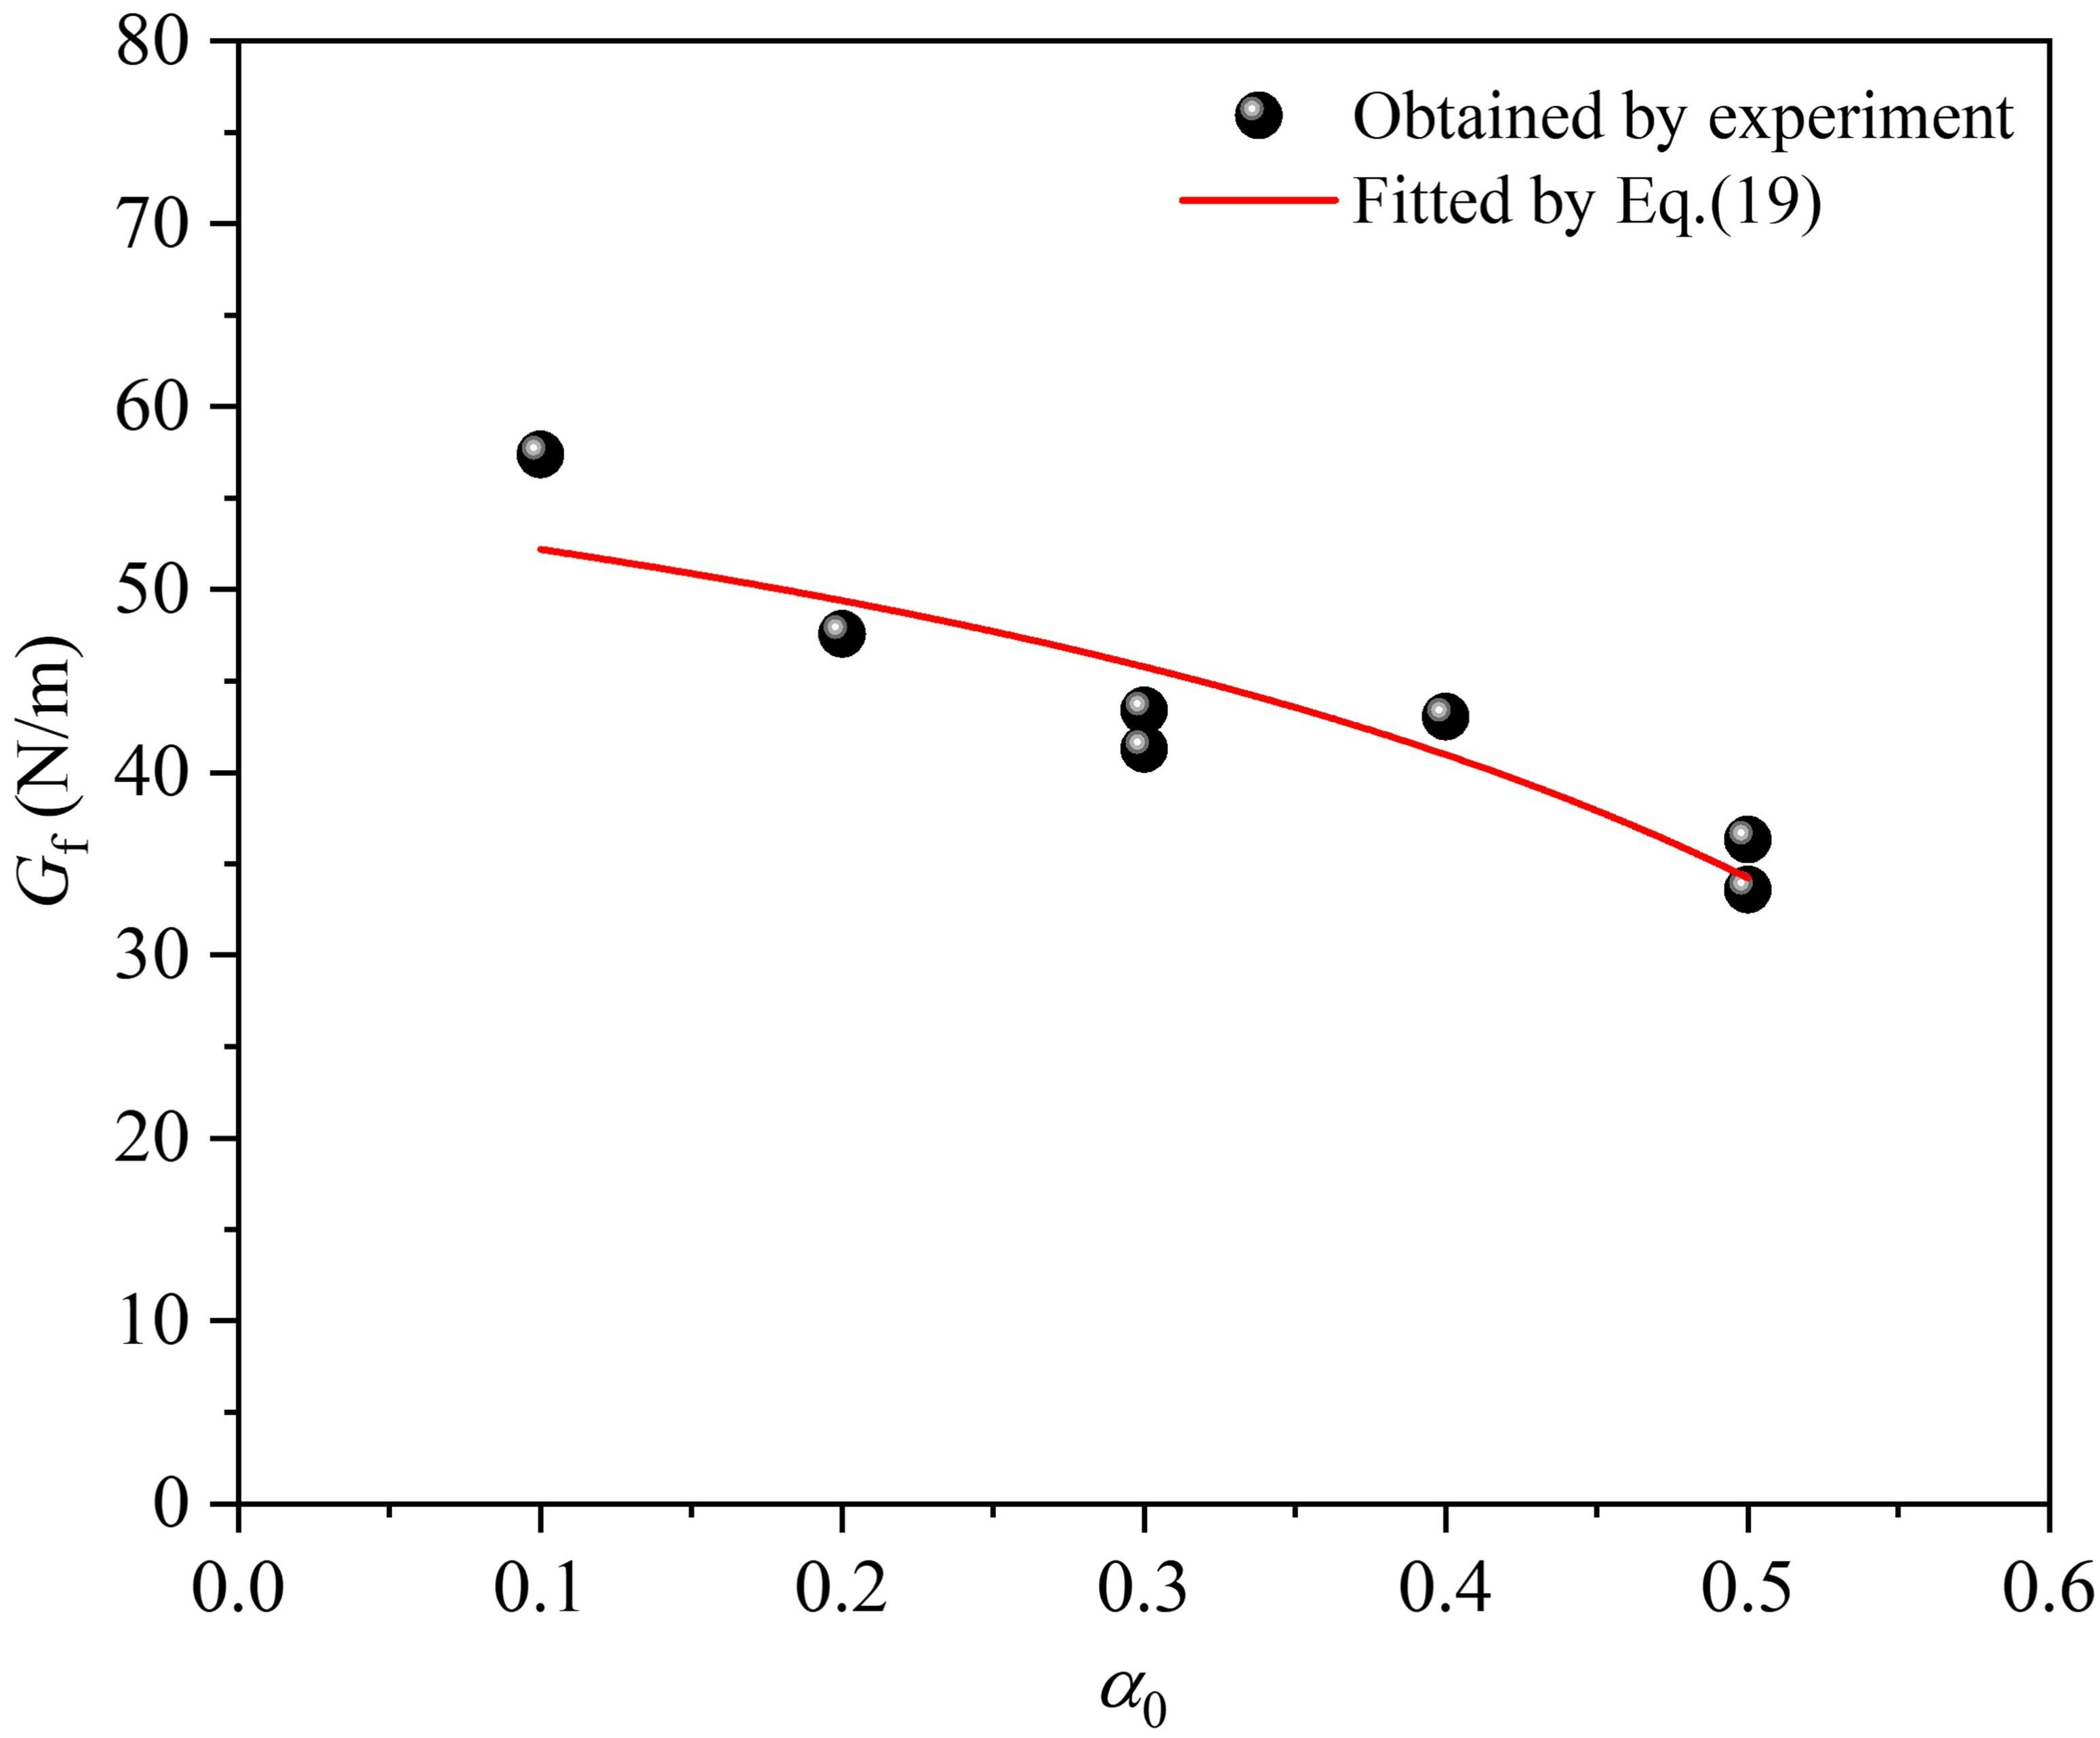
Fig. 17 Relationship between G_{f} and α₀.
To describe the relationship between G_{f} and specimen size, local fracture energy (g_{f}) was proposed. The distribution characteristics of g_{f} are shown in Fig. 18. If the ligament length is greater than the boundary influence length (A₁), there is a zone in which g_{f} remains unchanged and equal to size-independent fracture energy (G_{F}); in addition, there is a zone in which g_{f} decreases gradually along the crack propagation direction. g_{f} can be calculated as follows:
(17)
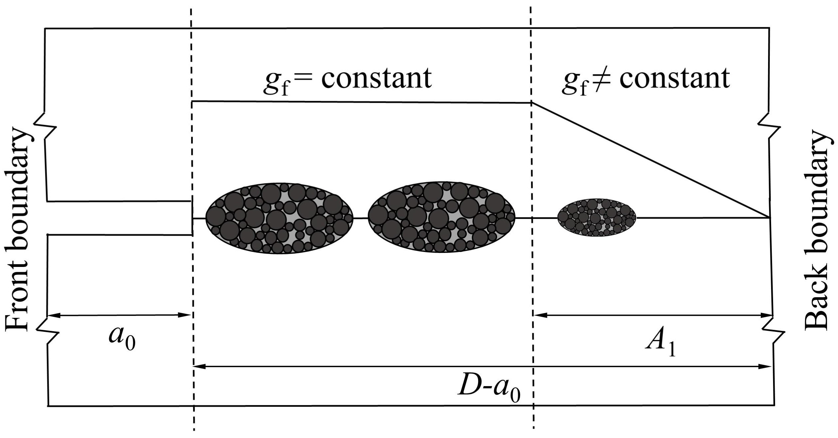
Fig. 18 Distribution characteristics of g_{f}.
When the crack develops to the back boundary, specimen completely fails, so it can be considered that g₀=0. By analyzing g_{f}, it is easy to obtain the equation about g_{f} and G_{f}:
(18)
By substituting Eq. (18) into Eq. (17), the equation about G_{f} and G_{F} can be obtained by:
(19)
G_{f} is fitted with Eq. (19) and the fitting result is shown in Fig. 17. The fitted A₁ and G_{F} are 27.08 mm and 74.67 N/m, respectively.
  - Fracture toughness
To reflect the ability to resist the crack propagation of materials, unstable fracture toughness (Kun Ic) was proposed:
(20)
The Kun Ic of each specimen is shown in Fig. 19. Obviously, Kun Ic gradually decreases with increased α₀. Zhang et al. [59] noticed similar behavior in concrete. When α₀ increases from 0.1 to 0.5, Kun Ic decreases from approximately 1.46 MPa·m^{1/2} to 1.23 MPa·m^{1/2}. It is supposed that the relationship between Kun Ic and G_{f} can be expressed as:
(21)
By substituting Eq. (21) into Eq. (19), the relationship between Kun Ic and α₀ when D(1-α₀)>A₁ can be expressed as:
(22)
The effect of fitting Kun Ic using Eq. (22) is shown in Fig. 19. The fitting effect is good and the fitted λ is 0.0253, indicating that the ratio of stress intensity factor to energy release rate is not fixed. It is supposed that the equation about G_{F} and size-independent fracture toughness (K* Ic) can be expressed by:
(23)
By substituting G_{F}, E, and λ into Eq. (23), K* Ic can be calculated and is approximately 1.76 MPa·m^{1/2} here. The K* Ic (1.76 MPa·m^{1/2}) of limestone is greater than that of plain concrete (1.53 MPa·m^{1/2}), as measured by Chen et al. [60] using 3-p-b testing, which can be explained by the fact that the f_{t} of limestone (approximately 7.77 MPa) is higher than that of concrete (approximately 3.03 MPa), and so limestone has greater inherent toughness than concrete. It should be noted that the relationship between G_{F} and K* Ic mentioned above is a hypothesis only and further study is necessary to obtain the true relationship between the two.
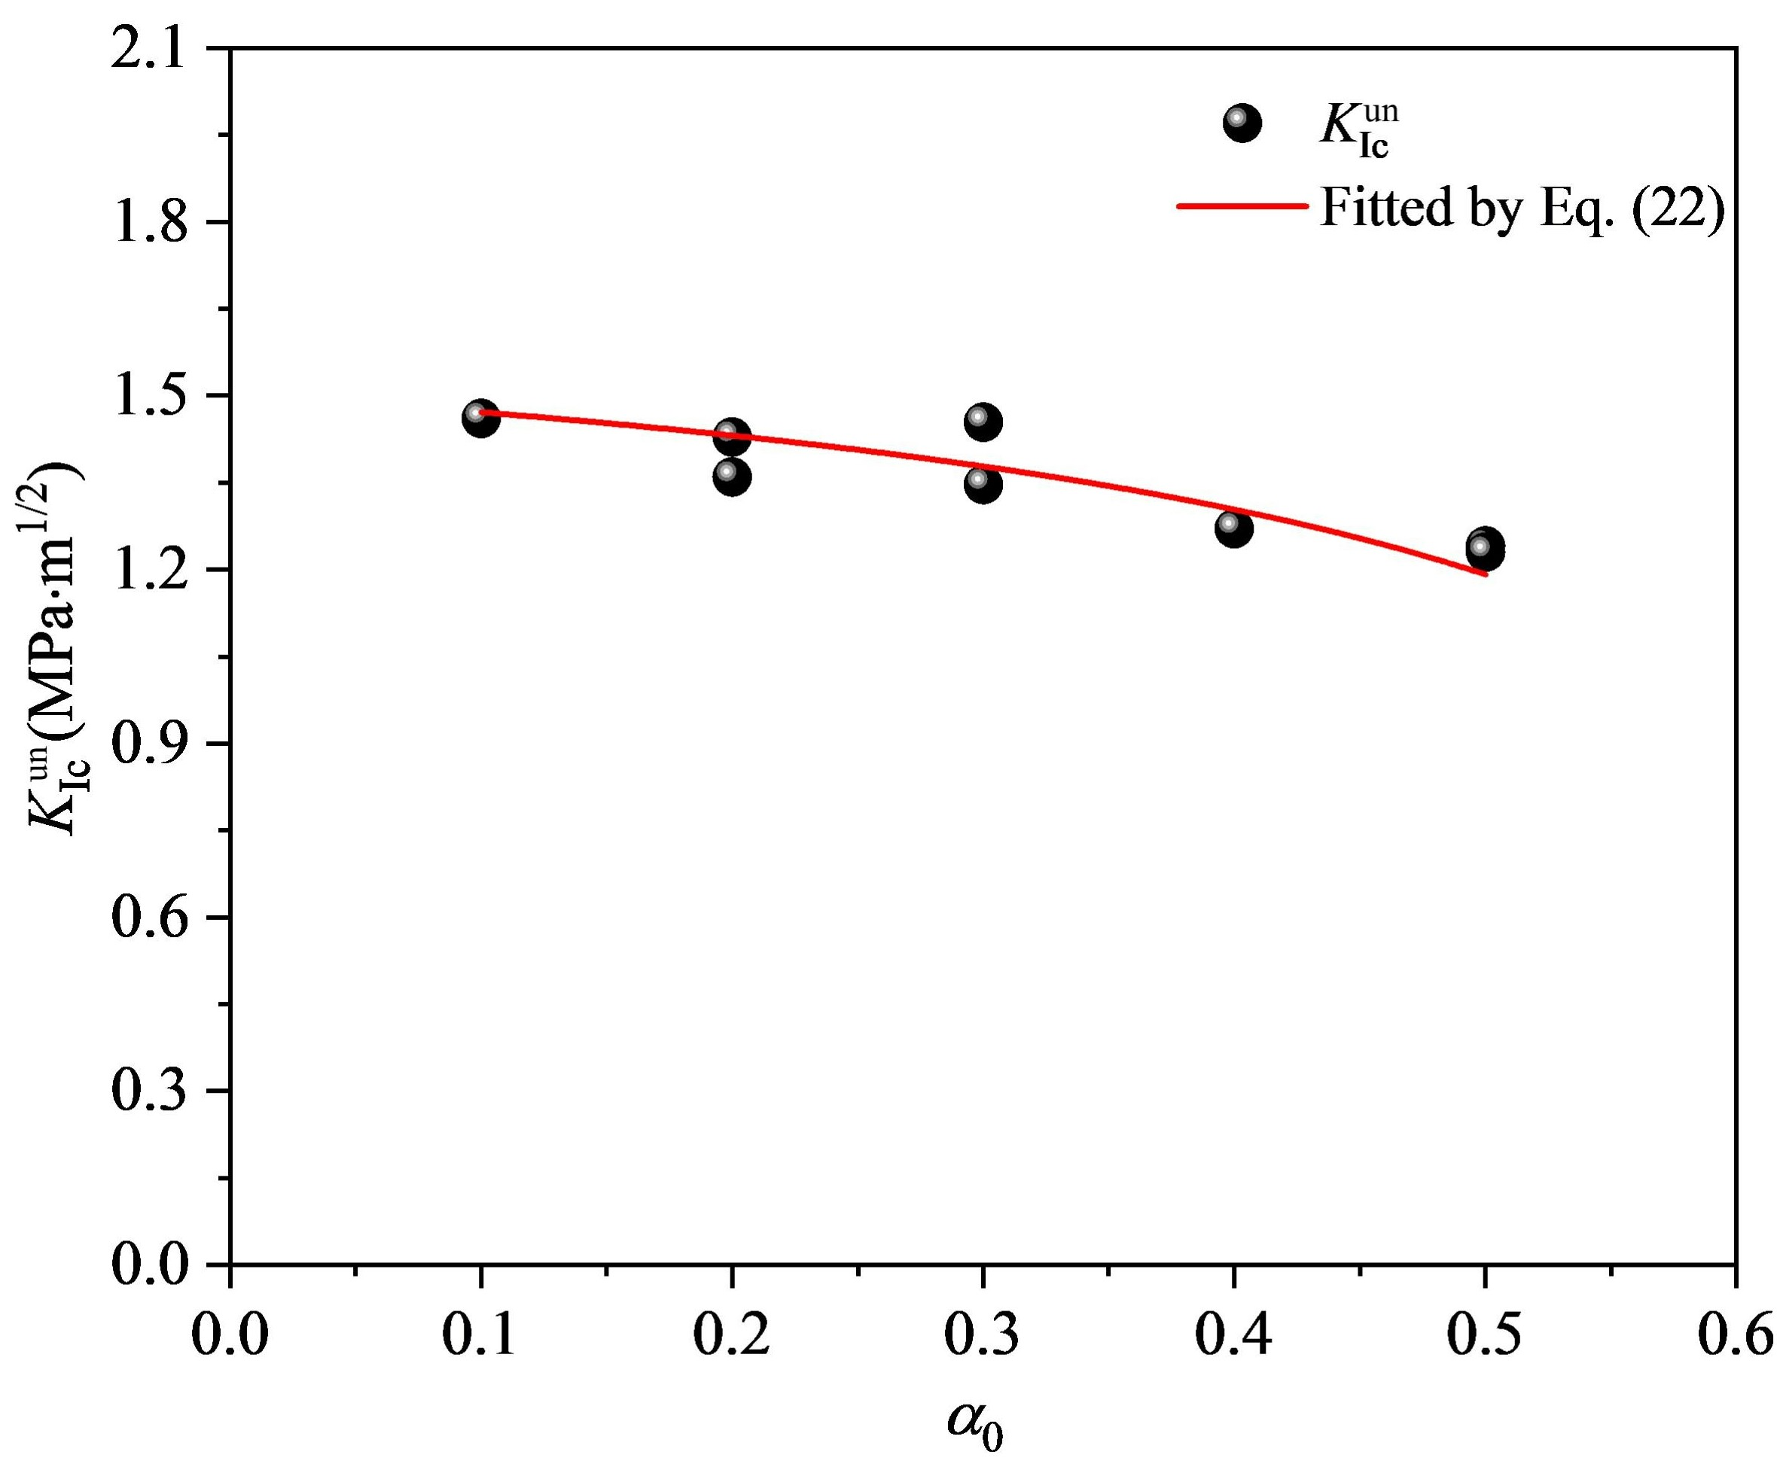
Fig. 19 Variation of Kun Ic with α₀.
  - Fracture process zone
To calculate the FPZ length (l_{FPZ}), the FPZ tip and rear need to be determined first. The location of the tip was considered to be at the point of the maximum y-coordinate in the area surrounded by ε_{c} (120 µε), while that of the rear was identified by observing the initial crack tip opening. If the initial crack tip opening was not greater than the critical crack opening (w_{f}), the rear would be seen as located at the initial crack tip; otherwise, the rear would be considered to have moved upwards. The w_{f} can be calculated by [61]:
(24)
By substituting f_{t} and G_{f} of each beam into Eq. (24), w_{f} can be calculated. Fig. 20 shows the evolution of l_{FPZ} of E-2 beam. Notably, l_{FPZ} first increases, as the test continues, it then decreases. A similar law has been found in concrete [62] and graphite [13]. An interesting finding emerged in that, when the initial crack tip opening reached w_{f}, l_{FPZ} reached the maximum, indicating that the FPZ was fully developed. To research the effect of α₀ on fully developed FPZ length (l_{mFPZ}), l_{mFPZ} of each specimen was calculated, as shown in Fig. 21. It is notable that l_{mFPZ} gradually decreased with increased α₀. A similar trend has been found in concrete [62]. When α₀ increases from 0.2 to 0.5, l_{mFPZ} decreases from approximately 23.09 mm to 12.66 mm. This shows that, when specimen size is consistent, the larger the α₀, the more obvious the effect of the loading boundary on the FPZ [63].
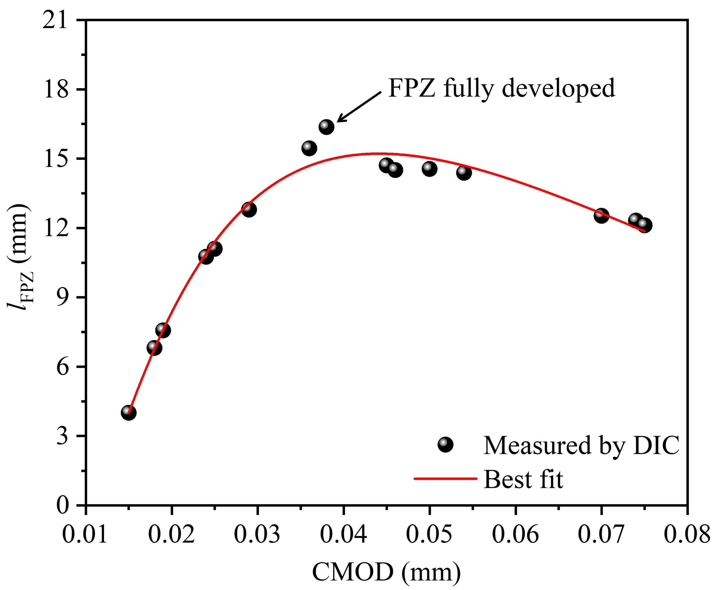 | 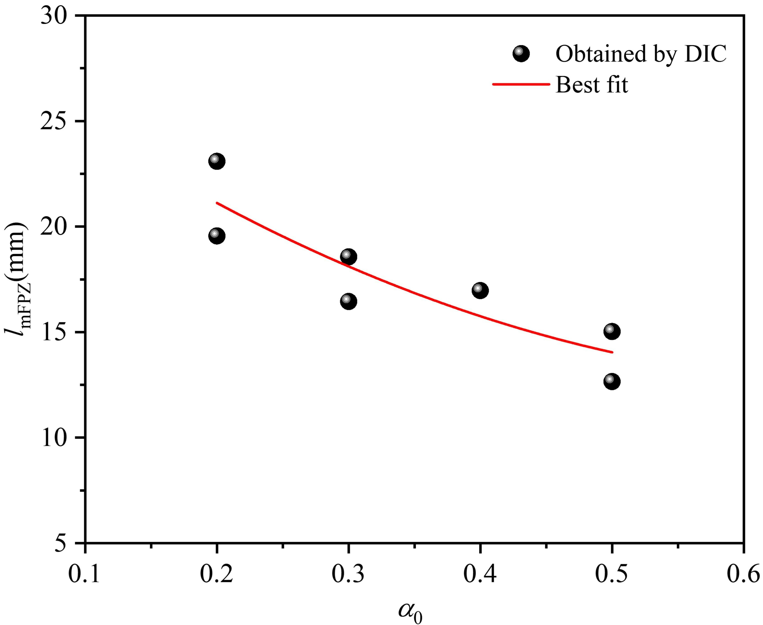
Fig. 20 Variation of l_{FPZ} with CMOD. | Fig. 21 Influence of α₀ on l_{mFPZ}.

- Conclusions
The fracture parameters of limestone beams with the same geometry but different initial crack lengths were studied. The followings were the key conclusions:
- The DIC was applied to determine the deformation of the limestone beams. By contrasting the CMOD obtained by the DIC and clip gauge, the accuracy of the DIC in measuring materials deformation was proved.
- According to the strain and displacement fields obtained by the DIC, the crack evolution was analyzed qualitatively and quantitatively. The effective crack length (l_{c}) obtained using the strain threshold was close to that obtained by observing the turning point but was much smaller than that obtained by observing the crack opening which overestimated the l_{c}.
- With increased a₀, P_{max}, σ_{N}, Kun Ic and G_{f} decreased gradually, while CMOD_{c}, CTOD_{c}, and δ_{c} increased gradually. With increased a_{e}, σ_{n} decreased gradually.
- According to the BEM, the relationship between α₀ and G_{f} was fitted, and the boundary influence length (A₁) and the size-independent fracture energy (G_{F}) were obtained, which were 24.37 mm and 68.88 N/m, respectively.
- Once the strain threshold (ε_{c}) and critical crack opening (w_{f}) had been determined, FPZ length (l_{FPZ}) was determined by the DIC. By studying the influence of α₀ on fully developed FPZ length (l_{mFPZ}), it was found that l_{mFPZ} gradually decreased with increased α₀.

Acknowledgements
The work described in this paper is supported by the National Natural Science Foundation of China (Grant No. 52278251) and Guizhou Provincial Science and Technology Projects (Qiankehe foundation-ZK [2022] focus 007).

Disclosure statement
The authors declare that they have no known competing financial interests or personal relationships that could have appeared to influence the work reported in this paper.

References
1. Golewski, G.L., Combined Effect of Coal Fly Ash (CFA) and Nanosilica (nS) on the Strength Parameters and Microstructural Properties of Eco-Friendly Concrete. Energies, 2023. 16(1): p. 452.
2. Golewski, G.L. and B. Szostak, Strength and microstructure of composites with cement matrixes modified by fly ash and active seeds of CSH phase. Structural Engineering and Mechanics, An Int'l Journal, 2022. 82(4): p. 543-556.
3. Golewski, G.L., Fracture performance of cementitious composites based on quaternary blended cements. Materials, 2022. 15(17): p. 6023.
4. Hillerborg, A., M. Modéer, and P.E. Petersson, Analysis of crack formation and crack growth in concrete by means of fracture mechanics and finite elements Cement and Concrete Research, 1976. 6(6): p. 773-781
5. Tang, Y. and H. Chen, Characterizations on fracture process zone of plain concrete. Journal of Civil Engineering and Management, 2019. 25(8): p. 819-830.
6. Chen, H., et al., An investigation of fracture properties and size effects of concrete using ESPI technique. Magazine of Concrete Research, 2019: p. 1-41.
7. Baant, Z.P., Size Effect in Blunt Fracture: Concrete, Rock, Metal. Journal of Engineering Mechanics, 1984. 110(4): p. 518-535.
8. Fan, X. and S. Hu, Influence of crack initiation length on fracture behaviors of reinforced concrete. Applied clay science, 2013. 79: p. 25-29.
9. Duan, K., X.Z. Hu, and F.H. Wittmann, Size effect on fracture resistance and fracture energy of concrete. Materials and Structures, 2003. 36(256): p. 74-80.
10. Bažant, Z.P. and J. Planas, Fracture and Size Effect in Concrete and Other Quasibrittle Materials. 1998, CRC Press.
11. Issa, M.A., et al., Size effects in concrete fracture - Part II: Analysis of test results. International Journal of Fracture, 2000. 102(1): p. 25-42.
12. Muñoz-Ibáñez, A., J. Delgado-Martín, and R. Juncosa-Rivera, Size effect and other effects on mode I fracture toughness using two testing methods. International Journal of Rock Mechanics and Mining Sciences, 2021. 143: p. 104785.
13. Tang, Y., R. Su, and H. Chen, Characterization on tensile behaviors of fracture process zone of nuclear graphite using a hybrid numerical and experimental approach. Carbon, 2019. 155: p. 531-544.
14. Chen, X., et al., Experimental study on loading rate and notch-to-depth ratio effects on flexural performance of self-compacting concrete with acoustic emission and digital image correlation technologies. The Journal of Strain Analysis for Engineering Design, 2021. 56(3): p. 148-160.
15. Dong, W., et al., An experimental study on crack propagation at rock-concrete interface using digital image correlation technique. Engineering Fracture Mechanics, 2017. 171: p. 50-63.
16. Haggerty, M., Q. Lin, and J.F. Labuz, Observing Deformation and Fracture of Rock with Speckle Patterns. Rock Mechanics and Rock Engineering, 2010. 43(4): p. 417-426.
17. Chen, H.H. and R.K.L. Su, Tension softening curves of plain concrete. Constr. Build. Mater., 2013. 44: p. 440-451.
18. Tang, Y., H. Chen, and J. Xiao, Size effects on the characteristics of fracture process zone of plain concrete under three-point bending. Construction and Building Materials, 2022. 315: p. 125725.
19. Miller, R.A., S.P. Shah, and H.I. Bjelkhagen, Crack Profiles in Mortar Measured by Holographic-Interferometry. Experimental Mechanics, 1988. 28(4): p. 388-394.
20. K.S. Kim, et al., Analysis of an Internal Crack of Pressure Pipeline using ESPI and Shearography. Optics and Laser Technology, 2003. 35: p. 639-643.
21. Tang, Y. and H. Chen, Characterization on crack propagation of nuclear graphite under three-point bending. Nuclear Materials and Energy, 2019. 20: p. 100687.
22. Xie, Z.L., et al., An investigation into fracture behavior of geopolymer concrete with digital image correlation technique. Construction and Building Materials, 2017. 155: p. 371-380.
23. Golewski, G.L., An extensive investigations on fracture parameters of concretes based on quaternary binders (QBC) by means of the DIC technique. Construction and Building Materials. 351.
24. Golewski, G.L., Comparative measurements of fracture toughgness combined with visual analysis of cracks propagation using the DIC technique of concretes based on cement matrix with a highly diversified composition. Theoretical and Applied Fracture Mechanics. 121.
25. Lian, H., et al., Research on the fracture mechanical performance of basalt fiber nano-CaCO3 concrete based on DIC technology. Construction and Building Materials, 2022. 329: p. 127193-.
26. Kramarov, V., P.N. Parrikar, and M. Mokhtari, Evaluation of fracture toughness of sandstone and shale using digital image correlation. Rock Mechanics and Rock Engineering, 2020. 53(9): p. 4231-4250.
27. Sutton, M.A., et al. Measurement of crack tip opening displacement and full-field deformations during fracture of aerospace materials using 2D and 3D image correlation methods. in Iutam Symposium on Advanced Optical Methods and Applications in Solid Mechanics. 2000. Springer.
28. Shah, S. and J. Chandra Kishen, Fracture properties of concrete–concrete interfaces using digital image correlation. Experimental mechanics, 2011. 51(3): p. 303-313.
29. Lai, S., et al., A New Method to Measure Crack Extension in Nuclear Graphite Based on Digital Image Correlation. Science and Technology of Nuclear Installations, 2017. 2017: p. 1-10.
30. Gutiérrez-Moizant, R., et al., Experimental verification of the boundary conditions in the success of the Brazilian test with loading arcs. An uncertainty approach using concrete disks. International Journal of Rock Mechanics and Mining Sciences, 2020. 132: p. 104380.
31. Liu, Q.-S., et al., Study and discussion on point load test for evaluating rock strength of TBM tunnel constructed in limestone. Yantu Lixue/Rock and Soil Mechanics, 2018. 39(3): p. 977-984.
32. Martinez-Ibanez, V., et al., Micro and macro-structural effects of high temperatures in Prada limestone: Key factors for future fire-intervention protocols in Tres Ponts Tunnel (Spain). Construction and Building Materials, 2021. 286.
33. Tan, J.G., L.H. Ooi, and H.K. Yeoh, Considerations of deep excavation in Kenny Hill and Kuala Lumpur limestone formations at the KVMRT. Geotechnical Engineering, 2016. 47(4): p. 152-163.
34. Wang, H., W. Chen, and T. Li, Implementation of the intelligent ans continuous optimization method in underground engineering, part i. parametric design and optimization method [J]. Journal of Hydraulic Engineering, 2014. 45(01): p. 42-49.
35. Wang, H., et al., Deformation characteristics and stability of surrounding rock of underground powerhouse group of hydropower station during construction. Journal of Central South University (Science and Technology), 2017. 4(48): p. 1096-1103.
36. Yamaguchi, I., Speckle displacement and decorrelation in the diffraction and image fields for small object deformation. Optica Acta: International Journal of Optics, 1981. 28(10): p. 1359-1376.
37. Pan, B., H. Xie, and Z. Wang, Equivalence of digital image correlation criteria for pattern matching. Applied optics, 2010. 49(28): p. 5501-5509.
38. Cheng-dong, L., et al., Geochemical characteristics of calcite and dolomite in sandstone of Dongying Sinking, Shandong Province, China. Procedia Earth and Planetary Science, 2013. 7: p. 504-507.
39. Zhang, W. and C. Lv, Effects of mineral content on limestone properties with exposure to different temperatures. Journal of Petroleum Science and Engineering, 2020. 188: p. 106941.
40. Fowell, R., et al. Suggested method for determining mode I fracture toughness using cracked chevron notched Brazilian disc (CCNBD) specimens. in International Journal of Rock Mechanics and Mining Sciences and Geomechanics Abstracts. 1995.
41. Kuruppu, M.D., et al., ISRM-suggested method for determining the mode I static fracture toughness using semi-circular bend specimen. Rock Mechanics and Rock Engineering, 2014. 47(1): p. 267-274.
42. Wei, M.D., et al., An experimental and theoretical comparison of CCNBD and CCNSCB specimens for determining mode I fracture toughness of rocks. Fatigue & Fracture of Engineering Materials & Structures, 2018. 41(5): p. 1002-1018.
43. Ayatollahi, M., et al., Effects of support friction on mode I stress intensity factor and fracture toughness in SENB testing. Theoretical and Applied Fracture Mechanics, 2019. 103: p. 102288.
44. Tada, H., Paris, S. P. and Irwin, G. R., The Stress Analysis of Cracks Handbook. 1985.
45. Kumar, S. and S. Barai, Size-effect of fracture parameters for crack propagation in concrete: a comparative study. Computers & Concrete, 2012. 9(1): p. 1-19.
46. Duan, K., X. Hu, and F.H. Wittmann, Scaling of quasi-brittle fracture: Boundary and size effect. Mechanics of Materials, 2006. 38(1-2): p. 128-141.
47. Duan, K. and X. Hu, Asymptotic analysis of boundary-effect on strength of concrete. 2004.
48. Wu, Z., et al., An experimental investigation on the FPZ properties in concrete using digital image correlation technique. Engineering Fracture Mechanics, 2011. 78(17): p. 2978-2990.
49. Li, S., et al., Development of fracture process zone in full-graded dam concrete under three-point bending by DIC and acoustic emission. Engineering Fracture Mechanics, 2020. 230: p. 106972.
50. Hoover, C.G. and Z.P. Bažant, Cohesive crack, size effect, crack band and work-of-fracture models compared to comprehensive concrete fracture tests. International Journal of Fracture, 2014. 187(1): p. 133-143.
51. Li, D., et al., Experimental study on fracture and fatigue crack propagation processes in concrete based on DIC technology. Engineering Fracture Mechanics, 2020. 235: p. 107166.
52. An, D., et al., Experimental study on incubation and acoustic emission characteristics of rock fracture process zones. Chinese Journal of Rock Mechanics and Engineering, 2021. 40(2): p. 290-301.
53. Shah, S.G. and J.M.C. Kishen, Fracture properties of concrete-concrete interfaces using digital image correlation. Experimental Mechanics, 2011. 51(3): p. 303-313.
54. Hillerborg, A., The theoretical basis of a method to determine the fracture energy G_{F} of concrete. Materials and Structures 1985. 18(4): p. 291-296.
55. RILEM, D.R., Determination of the fracture energy of mortar and concrete by means of three-point bend tests on notched beams. Materials and structures, 1985. 18(106): p. 285-290.
56. Xu, P., et al., Fracture energy analysis of concrete considering the boundary effect of single-edge notched beams. Advances in Civil Engineering, 2018. 2018.
57. Meng, W., et al., Effects of loading rate and notch-to-depth ratio of notched beams on flexural performance of ultra-high-performance concrete. Cement and Concrete Composites, 2017. 83: p. 349-359.
58. Duan, K., X. Hu, and F.H. Wittmann, Size effect on specific fracture energy of concrete. Engineering Fracture Mechanics, 2007. 74(1-2): p. 87-96.
59. Zhang, P., et al., Effect of prefabricated crack length on fracture toughness and fracture energy of fly ash concrete reinforced by nano-SiO2 and fibers. Iranian Journal of Science and Technology, Transactions of Civil Engineering, 2016. 40(1): p. 69-74.
60. Chen, H., et al., An investigation of fracture properties and size effects of concrete using the ESPI technique. Magazine of Concrete Research, 2020. 72(17): p. 888-899.
61. Petersson, P.E., Crack growth and development of fracture zones in plain concrete and similar materials Report No. TVBM 1006, Division of Building Materials, LTH, Lund university 1981.
62. Wu, Z.M., et al., An experimental investigation on the FPZ properties in concrete using digital image correlation technique. Engineering Fracture Mechanics, 2011. 78: p. 2978–2990.
63. Zhang, S., et al., Experimental study on development characteristics and size effect of rock fracture process zone. Engineering Fracture Mechanics, 2021. 241: p. 107377.

* Corresponding author. hqchen@gzu.edu.cn (HN Chen)
* Corresponding author. klsu@hku.hk (RKL Su)

