Laser projection proximity transfer for deterministic assembly of microchip arrays at scale
HU JinLong^{1,2†,} CHEN FuRong^{1,2†}, BIAN Jing^{1,2,3}, SUN NingNing^{1,2}, WANG KaiXin^{1,2}, LING Hong^{1,2}, YU HaiYang^{1,2}, GAI MengXin^{1,2}, XU LiZhi⁴, HUANG YongAn^{1,2*}
¹ State Key Laboratory of Digital Manufacturing Equipment and Technology, Huazhong University of Science and Technology,
Wuhan 430074, China;
² Flexible Electronics Research Center, Huazhong University of Science and Technology, Wuhan 430074, China;
³ College of Electronic and Optical Engineering & College of Microelectronics, Nanjing University of Posts and Telecommunications,
Nanjing 210023, China;
⁴ Department of Mechanical Engineering, The University of Hong Kong, Hong Kong SAR 999077, China
KEYWORDS: microtransfer printing, microLED display, laser lift-off, interfacial adhesion

Abstract
Deterministic assembly techniques that enable programmatic and massively parallel integration of chips are essential for the development of novel electronic systems such as microLED displays. However, large-area integration of ultrathin micro-chips with high yield and transfer accuracy remains a great challenge due to the difficulties in selective transfer, adhesion switchability, and transfer deviation. Here, a “laser projection proximity transfer (LaserPPT)” technique is presented for the deterministic assembly of microchip arrays at scale. One of the remarkable features is that the transfer status between the chip and the receiver substrate evolves from the original non-contact mode to contact mode for high-precision transfer, which overcomes the strict requirements of the flatness of stamp and substrate in contact-style transfer, and flight deviation of microchip array in non- contact-style transfer. Another feature is the rapid modulation of interfacial adhesion for reliable transfer via the use of thermally expandable microspheres to form microstructures and combining with a laser-induced blister. The adhesion regulation range is over 20 times without any damage to chip arrays. The results show that the transfer accuracy has been improved substantially with a minimum relative error of ~0.5%. Combined with a laser beam projection system, demonstrations of LaserPPT for selective assembly of fragile objects onto challenging non-adhesive/cured surfaces in batch illustrate its potential in the high- precision integration of microscale chips at scale.

- Introduction
Deterministic assembly techniques based on microtransfer printing (μTP), which utilizes a transfer stamp (e.g., PDMS [1,2], shape memory polymers [3,4]) to release microscale chips from the donor/growth substrate and move them to the backplane/receiver substrate with high precision and relia- bility, are essential for the development of next-generation electronic systems, such as flexible and stretchable inorganic electronics [5,6], curvilinear electronics [7–9], sensitive ro- botic skins [10] and micro light-emitting diode (microLED) displays [11–13]. The transfer effect (i.e., transfer yield, transfer accuracy, and transfer efficiency) of μTP critically depends on the ability to moderate the adhesion status of the stamp/ink interface between strong for pick-up and weak for printing. Various strategies based on switchable dry ad- hesives have been proposed. Examples include the kineti- cally controlled μTP technique by loading rate [1,14], the roll-to-roll stamp technique by controlling the degree of shear load [15–17], the balloon μTP or surface-relief-assisted by controlling the contact area [18,19], the universal μTP technique by controlling the embedding of chips into a shape memory polymer stamp [20,21]. All these μTP techniques are promising for the heterogeneous integration, and they all require the aid of the receiver substrate to release inks (i.e., the initial distance between the chip and the target surface is zero, and the chips are always in contact with the receiver substrate during printing) due to the limited switchable ad- hesion capability. As a result, these contact μTP techniques transfer (e.g., ~1.5 μm [22]) require geometrical character- istics properties (e.g., good flatness) of the stamp to guar- antee high transmission accuracy (e.g., ~1.5 μm [22]). Meanwhile, there are limitations in terms of batch selective transfer capability, which requires the development of pat- terned stamps (e.g., with tiny columns or (~10800 columns) or with pneumatic cavities).
To achieve massively parallel selectivity, non-contact μTP techniques have attracted wide attention as an approach that provides infinite adhesion switchability (i.e., there is an in- itial distance between the chip and the target surface during the printing process). As the most promising non-contact printing approaches, the laser-assist μTP techniques have been widely used to deposit precise patterns of multi-com- ponents due to the intrinsic features of fast response and excellent programmability [23]. Especially, the transfer rate of the massively parallel laser transfer technique can achieve ~100 million units per hour [24]. Typically, three laser-as- sisted transfer printing strategies have been used to transfer the chips: (1) laser-induced forward transfer technique (LIFT) [25,26], which relies on the laser-induced decom- position of the generated gas to release chips at an un- desirably high laser power. (2) Laser-induced thermal strain mismatch (LITSM) [27,28]. The chips are rapidly heated by the laser, which causes a thermal strain mismatch in the stamp-chip interface to release chips. (3) Laser-induced shape-changing (LISP) [29,30], transfer chips by construct- ing changes in stamp shape induced by laser heating (e.g., Blister-base laser-induced forward transfer (BB-LIFT), Blister-base shape-conformal stamp (BB-SCS)). However, an ideal laser-assisted μTP technique requires not only fast and parallel modulation of the interfacial adhesion capability but also avoidance of laser spots, induced shocks, deforma- tions, etc., resulting in accuracy and damage during non- contact transfer. For example, in the LIFT process, the shock wave is found to be faster than the chip, which will be re- flected by the receiver and interact with the flying chip [31,32]. As a result, such interactions may lead to unwanted deviation of chip orientation, as well as chip damage. In LITSM or BB-SCS processes, the modulation of interfacial adhesion requires laser radiation to the surface of the chip to generate heat. Therefore, in addition to the limitations of the transferred chips (i.e., only light-absorbing materials), parameters such as laser energy need to be strictly controlled; otherwise, it may lead to thermal damage to the chip. BB- LIFT, despite extremely small chips (e.g., ~15 μm) are able to be integrated by laser-induced blister and kinetic energy. However, bending deformation of the chip needs to be avoided. These laser-assisted μTP techniques exhibit ex- cellent parallelism-selective integration performance to achieve an ultra-weak adhesion strength, but lack strategies to ensure transfer accuracy and reduce chip transfer damage in non-contact printing processes, which is highly desired for future applications (e.g., microLED displays).
Here, we present a new parallel laser-assisted μTP tech-nique termed “laser projection proximity transferring (La- serPPT)”. The distinctive feature of LaserPPT is the adoption of thermally expandable microspheres combined with laser- induced blisters for quick modulation of interface adhesion and improved transfer efficiency. By accurately controlling the transfer distance, the LaserPPT can easily shift from the original non-contact mode to the contact mode, which greatly improves the transfer accuracy. Experimental and numerical studies reveal the chip transfer mechanism and provide insights into the design and operation of the transfer yield, transfer accuracy, and tuning adhesive. Finally, com- bined with shadow masks and laser beam projection systems to form spot arrays of any shape, the strong ability of the LaserPPT for micro-assembly of microscale silicon chips and inorganic microLED chips have been well demonstrated.

- Experimental section
  - Materials
PDMS matrix and curing agent (Sylgard 184, Dow Corning) were mixed at a 10:1 weight ratio. Then, expandable mi crospheres (Beijing Hu Jin Technology Co.) were added at different weight percentages of 3%, 5%, 8%, 10%, 15%, and 20%,andtheresulting mixture was mechanically stirred with a speed of 2000 r/s for 30 min to ensure that the mixture was well mixed and degassed.
  - Preparation of stamps
The stamp was prepared by a series of spin coating and curing processes, as illustrated in Figure S1 (Supporting Information). At first, the PI films were prepared by spin coating and curing process of adhesive of non-photosensitive polyimide precursor (Beijing POME Technology Co., ZKPI 305) on transparent substrates. Subsequently, these samples were soft-baked at 120°C for 2 min and hard-baked at 240°C for 4 h. Finally, the PDMS-microsphere mixture was spin coated onto the top surface of PI film, and placed on the 80°C hot plate curing 8 min. The thickness of the PI layer and adhesive composite layer was controlled by adjusting the rotating speed and spin-coating layers, which can be mea sured by a laser scanning confocal microscope (LSCM, KEYENCE VK-X200K).
2.3 Adhesion strength test
The test equipment (model 5944, INSTRON) is shown in Figure S2, Supporting Information. During the test, the stamp is fixed to the equipment fixture by strong double- sided tape, and the silicon wafer is bonded to the self-made aluminum block and held by the equipment fixture. After the stamp and the wafer are leveled and the sensor is zeroed, the distance between the chip and the stamp is slowly adjusted and brought into contact with the pre-pressure until the set pre-pressure is reached and then held for the 30 s, and then pulled upward at a fixed speed. The maximum tensile force is obtained from the force/displacement curve at the given pre- pressure and stretching speed and the adhesion strength is calculated.
2.4 Laser experimental platform
The automated laser experimental platform (HUST La-serPeeler α1) is shown in Figure S3, Supporting Information. The platform incorporated an excimer laser (OptoSys- temsCL7020, wavelength: 308 nm, pulse time: 20 ns), a displacement control system (consisting of two displacement consoles), a laser light path projection system (consisting of four main components, including an energy attenuator, telescope, homogenizer, and imaging lens) and camera ob- servation. Before irradiations, the laser energy E0 can be adjusted by the attenuator, and the average pulse energy was obtained by measuring 20 pulses with an energy meter (Coherent J-50MUV-248). The stamp was placed on the upper displacement stage while the receiver was placed on the lower displacement stage. The distance between them can be controlled by the two displacement consoles. Laser- driven transfer printing with parallelism is then achieved by controlling the displacement consoles with a computer program.
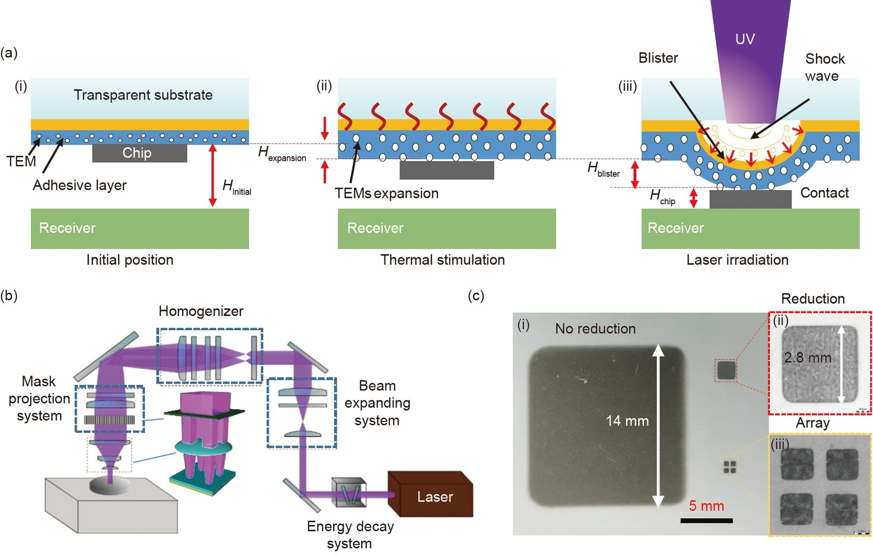
Figure 1 (Color online) (a) Schematic illustration of the LaserPPT principle: (i) the stamp is removed above the receiver substrate; (ii) the stamp is heated and forms microstructures on the surface of the stamp/chips interface; (iii) the stamp is radiated by the laser and large bulges are formed in the dynamic release layer. (b) Experimental laser projection setups. (c) Spot projection photos: (i) comparison of spot size before and after projection; (ii) the spot size after projection is 2.8 mm×2.8 mm; (iii) array spot after projection.
3. Results and discussion
3.1 Laser projection proximity transfer process
Figure 1 schematically shows the design and parallelism transfer principle of LaserPPT. Here, the stamp is made up of three components: a composite adhesive layer embedded in thermally expandable microspheres (TEMs), a dynamic re- lease layer (DRL, e.g., polyimide), and a transparent sub-strate (e.g., sapphire), as illustrated in (Figure 1(a)). Initially, the TEMs (e.g., radius 7.5 μm) do not affect the flatness of the stamp, which ensures enough contact and adhesion be- tween the stamp and the chips, and the distance between the stamp and the receiver substrate is H_{initial} (Figure 1(a-i)). Once the stamp is heated, the TEMs will expand dramatically, resulting in numerous microstructures appearing at the interface between the stamp and the chips. As a result, the contact area and adhesion strength of the stamp/chip inter- face are initially reduced by the expanded TEMs on the surface, and the thickness of the adhesive layer is increased (H_{TEM}) by the expansion of the internal TEMs, which brings the chip closer to the receiver substrate (Figure 1(a-ii)). To facilitate the selective transfer of chips, the DRL is irradiated by a low-energy laser to generate a blister accompanied by shock waves (Figure 1(a-iii)). The blister generated with height H_{blister} by shock wave not only further reduces the chip/stamp interface adhesion, but also reduces the transfer distance, resulting in the transfer of the chip at the receiver. In this case, with the increase in the thickness of the adhesive layer (H_{expansion}) and the blister height (H_{blister}) of DRL, the non-contact mode (Figure 1(a-i)) evolves to contact mode (Figure 1(a-iii)). Thus, the transfer accuracy is guaranteed.
To demonstrate the mechanism of LaserPPT and the capability of transferring chip arrays, the experimental platform (HUST LaserPeeler α1, Figure S1 in Supporting Informa- tion) with a XeCl excimer laser (OptoSystems CL7020, pulse duration 20 ns) was developed. The laser beam pro- jection system (Figure 1(b)) was used to improve the re- solution and transfer accuracy, which allows the original laser beam area to be made smaller 25 times and converted into a square beam with uniform spatial energy distribution. Figure 1(c) shows an example of the variation of the laser spot, the spot size after homogenization is 14 mm×14 mm tributed microstructures. Therefore, a mixing ratio of 5% was used in this work.
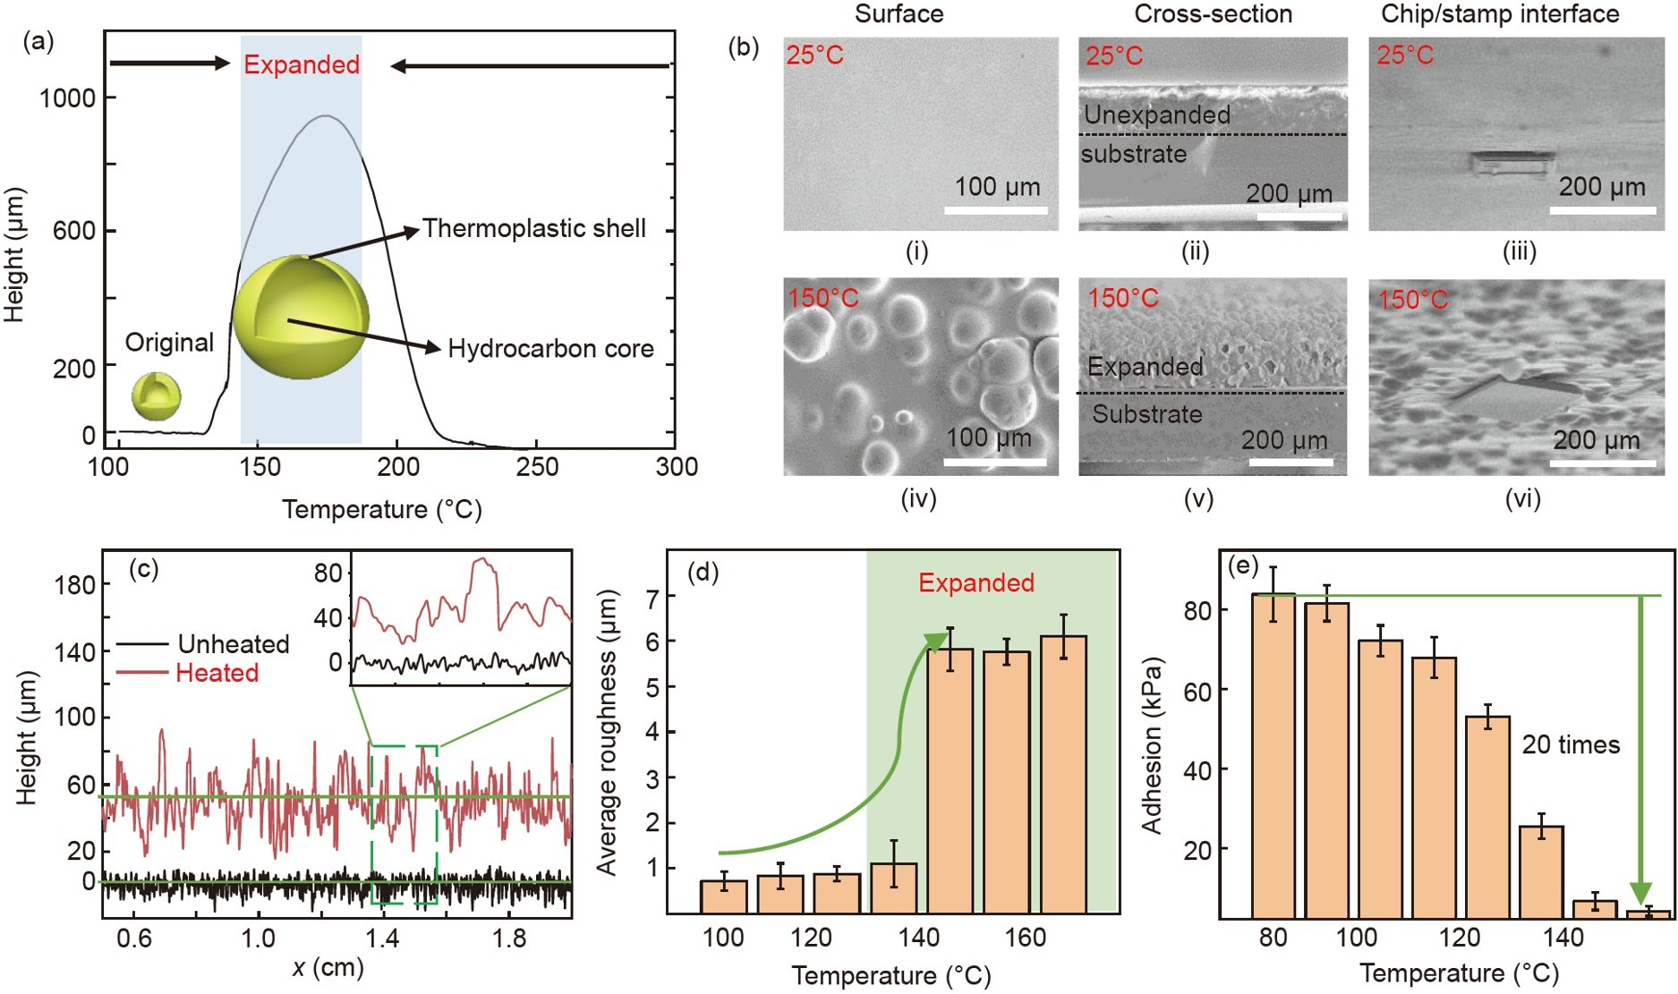
Figure 2 (a) Schematic representation of th(b) SEM images for surface, cross-section, and chip/stamp interface morphologies at 25°C and 150°C; (c) morphological changes of the stamp before and after heating; (d) measured average roughness of the stamp surface at different temperatures; (e) the measured adhesion strength of the stamp surface at different temperatures.e expansion of the TEMs;
3.2 Adhesion characteristics of LaserPPT stamp
Figure 2(a) shows the expansion rate of the TEMs as a function of temperature. Typically, the TEM is composed of a low boiling point hydrocarbon liquid and a thermoplastic polymer spherical shell. When it is heated, the thermoplastic polymer shell softens and vaporizes the hydrocarbons, al- lowing the TEM to expand 20–40 times. If the heating continues, the thin shell cannot withstand the gas pressure, causing the shell to rupture and the gas to escape. Mean- while, when the temperature drops, the TEMs can only still maintain the changed state as the shell cools and hardens. Therefore, the TEM can only be used once, and the TEM expansion process is divided into 3 stages (Figure 2(a)): unexpanded (<135°C), expanded (135°C–175°C), shrunken (>175°C). The temperature is set to 150°C to make the TEM expand sufficiently and avoid damage. The SEM images in Figure 2(b) show the surface, cross-section, and chip/stamp interface morphologies of the composite adhesive layer from 25°C to 150°C. At 25°C (~5 min), the surface of the adhesive layer is flat without microstructures (Figure 2(b-i)), and TEMs inside the adhesion layer are not expanded (Figure 2 (b-ii)). After reaching the expansion temperature (Figure 2 (b-iv)), the microstructures appear on the surface and TEMs have expanded (Figure 2(b-v)). Simultaneously, compared with the images before and after heating, the microstructure clearly appears at the chip/stamp interface after heating (Figure 2(b-iii) and (b-vi)). Furthermore, to quantify the re- lationship between surface roughness and temperature, the surface profile of the adhesive layer before and after foaming is recorded (~40 experimental data sets) by a surface profiler.
After heating, the surface roughness (R_{a} = $\frac{1}{l}\int_{0}^{1}{\left|y\right|dx}$, l is the measured length, and y is the distance from each point on the contour to the mid-line) of the stamp increases sharply (Figure 2(c)), which is 6 times higher than its initial status (Figure 2(d)). To characterize the influence of expanded TEMs on stamp adhesion, pull tests are carried out under various preloads and retraction speeds for a stamp/glass in- terface. The measurement setup (Figure S4, Supporting In- formation) consists of a material testing system, a manual tilt stage, and a thermal stage. The glass slide approached the stamp at a speed of 300 μm/s and a pre-pressure of 40 N (Figure S5, Supporting Information). Figure 2(e) shows ad- hesion strength at different temperatures. Between 80°C– 120°C, the adhesion strength of the stamp gradually de- creases with increasing temperature and then reduces rapidly (20 times) after TEMs are fully foamed. The above series of results demonstrate that expansion of TEMs can form mi- crostructures and dramatically reduce the contact area of the chip/stamp interface, which facilitates the subsequent transfer printing process.
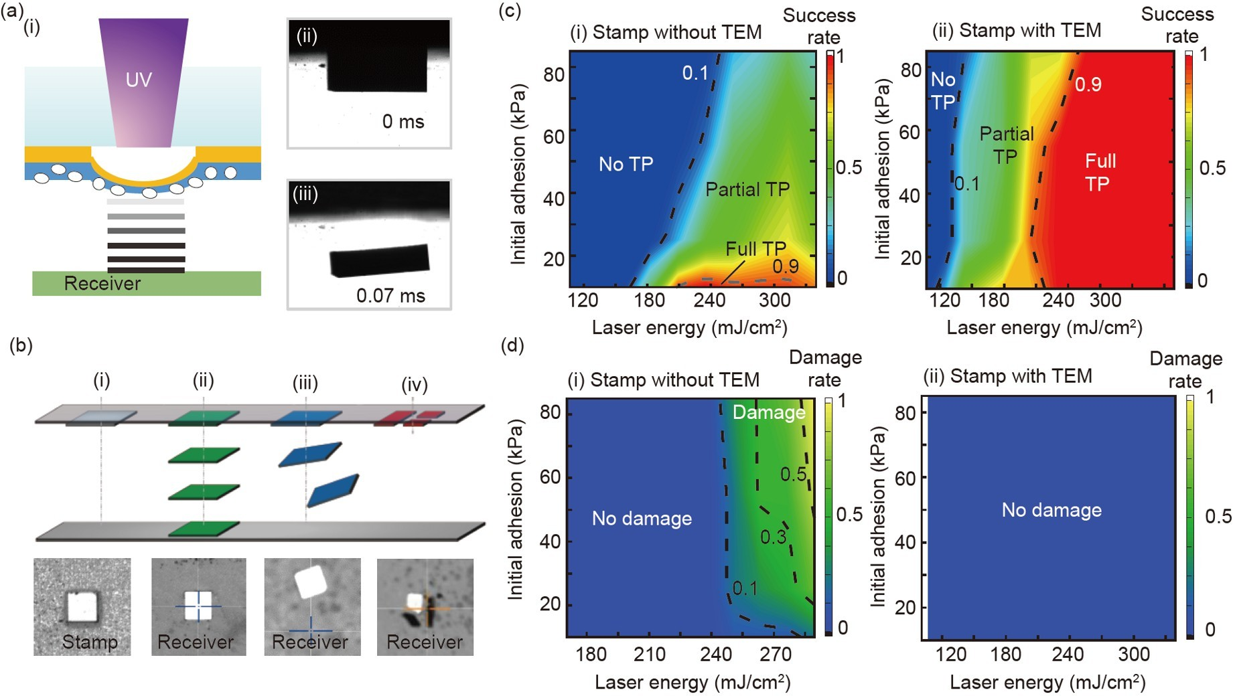
Figure 3 (a) Schematic illustration of laser non-contact transfer process in the experiment and shadow image of chip transfer: (i) laser non-contact transfer process in the experiment; (ii) shadow image of chip transfer. (b) The schematic diagram and images of different transfer state: (i) chips remain on the stamp; (ii) chips are successfully transferred to the receiver substrate without deviation; (iii) a chip transfer process with deviation; (iv) chip is destroyed. (c) Transfer success rate window at the corresponding stamp without TEMs (i) and stamp with TEMs (ii). (d) Transfer damage rate window at the corresponding stamp without TEMs (i) and stamp with TEMs (ii).
With the expansion of TEMs, only low laser energy is required to further transfer chips with low chip damage and high transfer yields. To compare the modulated adhesion and transfer damage, laser non-contact transfer chip (Figure 3(a- i)) behavior was investigated before (i.e., stamp without TEMs) and after (i.e., stamp with TEMs) the TEMs expan- sion of the stamp. In the experiments, a projection spot of 620 μm×620 μm and a laser density of 240 mJ/cm² were used to illuminate the transferred 600 μm×600 μm chips. Due to the small thermal effect region of the 308 nm laser in the stamp thickness direction (~ only 400 nm) and the strong interfacial adhesion of the Pi/transfer substrate, the laser- induced blisters will not affect the printing of adjacent inks. Chip transfer status (Figure 3(a-ii)) was recorded by time- resolved imaging. Initially, the chip remained on the stamp, and after laser radiation, the chip dropped at a speed of ~2500 mm/s, the drop time is ~0.7 ms, the chip transfer situation is divided into three cases: not transferred (i.e., Fig- ure 3(b-i)), partial transfer (i.e., some of the chips remain on the stamp, some of the chips are transferred to the receiver substrate with or without deviation (Figure 3(b-ii) and (b-iii)) and broken (Figure 3(b-iv)), and successful transfer (i.e., 100% successful transfer efficiency). The chip damage phenomenon occurs mainly due to excessive laser impact and chip/stamp interface adhesion energy, where the bending stress on the chip is greater than the critical fracture strength of the chip. And chip deviation is attributed to initial spot/ chip alignment errors and initial distance.
Figure 3(c) shows the transfer success rate with and without TEMs at 25 repetitions of the experiment. The re- sults show that for the stamps without TEM, the laser energy threshold is ~180 mJ/cm², and for the stamp with TEMs, ~120 mJ/cm² is required due to the reduced adhesion strength. Also, the 100% success transfer window of the stamp with TEM is greatly expanded. Figure 3(d) shows the damaged window for the two sets of partial transfer experi- ments described above. The damage rate decreases to zero (Figure 3(d), 280 mJ/cm²). The primary reason for the low damage is that the expanded TEMs make the stamp/chip interface adhesion reduction, which makes it easy to crack at the stamp/chip interface and reduces the laser impact to produce bending stress on the chip. These comparative data well illustrate the excellent adhesion modulation and low- damage performance of LaserPPT.
3.3 Transfer distance of LaserPPT
Another significant feature of LaserPPT is the transition from non-contact transfer mode to contact transfer mode, to ensure transfer accuracy. Figure 4(a) shows the relative po- sition of the chip and the receiver substrate at different times during the heating process. The transition distance gradually decreases with the increase of heating time. Figure 4(b) shows an example of LaserPPT transfer from non-contact to contact transfer. Starting with laser irradiation, a blister de- formation is created on the stamp (Figure 4(b-i)–(b-iii)). As the laser scans, the chips start to touch the receiver substrate (Figure 4(b-ii)) one by one, and finally, all chips are trans- ferred due to the strong modification of interfacial adhesion. The max initial distance H ^{max} between chip and receiver (Figure 1(a), i.e., H ^{max} ≤H_{expansion}+H_{blister}) needs to be strictly controlled and is determined by two processes: (1) the in- creased thickness of the adhesive layer H_{expansion} during the heating process, and (2) the blister height H_{blister} when laser irradiation of the DRL causes gas bulging of the PI. There- fore, the heating parameters and laser parameters are im- portant factors in determining the initial distance.
initial
initial
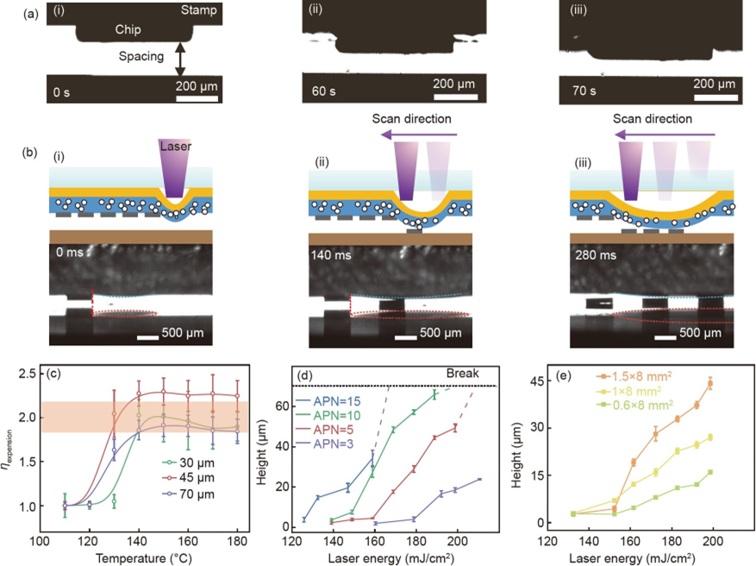
Figure 4 (a) Optical pictures show the height change of the adhesion layer, during the heating process: (i) start heating, (ii) heating 60 s, (iii) heating 70 s. (b) Schematic diagram of the chip transfer process from non-contact to contact transfer and shadow image of chip transfer. The upper part of the image is the stamp and the lower part is the receiver substrate. The chip that can be seen on the receiver substrate is the mirror image of the receiver substrate. (c) The thickness expansion ratio as a function of heating temperature. (d) The measurement of blister height under different conditions of laser energy and APN with a laser spot size of 2 mm×8 mm. (e) The measurement of blister height under different conditions of laser energy and laser spot size with 5 APN.
To investigate the numerical relationship between the in- creasing thickness H_{expansion} of the adhesive layer and the temperature, the thickness expansion ratio η_{expansion} (ηexpansion= (Hinitial-adhesion+Hexpansion)/Hinitial-adhesion, Hinitial-adhesion is the thickness of the adhesion layer when the TEM is not yet expanded) of the composite adhesive layers of different thicknesses at different temperatures was explored (Figure 4(c)). The results show that the thickness expansion ratio η_{expansion} does not change significantly after 150°C and is about two times. The main reason is that the expansion of TEMs (5% mass fraction) reaches saturation, while the thermal expansion coefficient of PDMS is only 6.1×10⁻⁴/K and thermal deformation is negligible. Therefore, the initial thickness of the adherent layer can be increased to obtain a larger transfer distance.
In the laser-induced blister process, the high temperature (>800°C) caused by the strong absorption of laser energy near the surface/interface leads to the bond-breaking within the PI. The broken bonds of PI will create gas products, which are mainly CO molecules cleaved from imide rings, thus causing blistering. The amount of gas products is related to the laser energy, the accumulated pulse number (APN, the irradiation number that a unit area experiences during laser scanning) and laser spot size [33,34]. To analyze the phe- nomena of PI films after laser scanning, a laser scanning confocal microscope (LSCM, EYENCE VK-X200K) is employed. Figure 4(d) shows the increase in blister height with increasing laser energy (APN=5) in the scanning area with a laser spot of 2 mm×8 mm. The main reason is that the amount of PI ablation increases with laser energy per unit area, resulting in stronger gas pressure and larger blister height. Alternatively, the APN can be added to enhance the gas pressure by accumulating the amount of gas PI ablation, as shown in Figure 4(d). Meanwhile, as shown in Figure 4(e), the laser spot size can be further expanded to make the ab- lation area of PI large, thus adding ablation volume and blister height. However, as the laser energy and APN in- crease, the ablated gas generates a larger pressure, leading to plastic deformation and break of the PI layer (Figure S6, Supporting Information), which results in gas depletion. Therefore, the critical threshold of laser energy and APN determines whether the PI is destroyed or not.
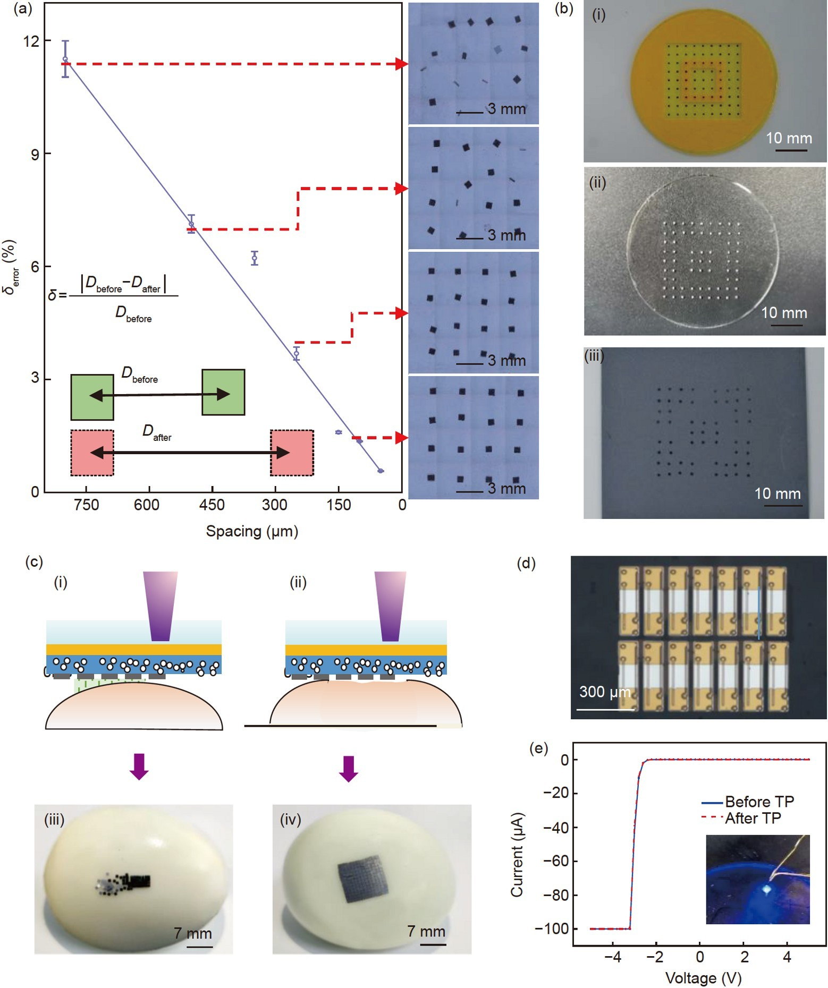
Figure 5 (a) Relationship between transfer error and distance and the stitched image after transfer. (b) Results of transferring chips: (i) a silicon chip array is placed on the stamp; (ii) programmable μTP of the silicon chips onto a PDMS substrate; (iii) programmable μTP of the silicon chips onto a sandpaper substrate. (c) Transfer results on a curved surface: (i), (ii) schematic diagram of noncontact transfer and contact; (iii), (iv) a silicon chip array is transferred to an egg substrate. (d) MicroLED transferred by LaserPPT. (e) Electrical properties of LED chips before and after transfer printing onto the receiver substrate.
3.4 Transfer printing capabilities enabled by laserPPT
To show the accurate transfer capability of LaserPPT, the relative errors of two adjacent chips before and after transfer were measured by Ultra-Depth Three-Dimensional Micro- scope (DSX 510), where the adhesion layer thickness is 40 μm, the laser energy is 180 mJ/cm2 and APN is 5 (i.e., the max initial distance H max =100 μm). The results show that the relative error δ (δ=Dafter−Dbefore, Dafter=3 mm is the dis- tance of adjacent chips in the chip transfer to the receiver substrate, Dbefore is the distance of adjacent chips on the original stamp) decreases with the transfer distance. Mean- while, the transfer error is almost 0, when the transfer dis- tance is 50 μm. While the silicon wafer gradually misaligns or deflects after the transfer distance is >100 μm. Even when the distance is larger than the chip length (600 μm), chips will flip over, resulting in some chips standing on the re- ceiver substrate (Figure 5(a)). Obviously, LaserPPT can achieve high precision by controlling the heating and laser parameters to modulate the distance.
The extraordinary ability of the LaserPPT is demonstrated by programmable transfer printing of silicon chips (600 μm× 600 μm×75 μm) and micro-scale LED chips (400 μm× 80 μm×8 μm) onto challenging non-adhesive substrates, such as flat PDMS substrates and curved substrates, which are not easily realizable via other adhesive schemes. As an example, the desired patterns can be achieved by applying a photomask template of a stamp with a 9×9 array of silicon chips (Figure 5(b-i)). Consequently, Si chips in pattern areas that were directly exposed to UV laser irradiation were successfully transferred to the PDMS substrate (Figure 5(b- ii)). Similarly, array silicon chips can also be transferred to be printed onto rough and non-stick sandpaper with the pattern shape (Figure 5(b-iii)). Also, LaserPPT can not only transfer to flat substrates, but also curved substrates with high accuracy. Taking the egg surface with a maximum ra- dius of curvature of 2.5 cm and no adhesion as an example, Figure 5(c-i) and (c-ii) show a schematic of the program- mable transfer printing of silicon chips to the egg surface, the distance between chips and the egg substrate varies with the egg curvature. Figure 5(c-iii) and (c-iv) show the optical picture of the transfer chip onto the egg substrate, in which there is no obvious transfer bias of the area with a small distance, and chips are scattered with increasing space. Ex- amples of enhanced capabilities of printing 2×7 microLED chips enabled by the LaserPPT are shown in Figure 5(d). A microLED chip is illuminated by the probe station and semiconductor characterization system (4200-scs, SUMMIT 1100) after transfer printing (Figure 5(e)), and its voltage- current characteristic curve is measured at the same time. The consistency of these two curves shows that the perfor- mance of the device is not influenced by the gripping and manipulation. These demonstrations illustrate the great po- tential of the LaserPPT for deterministic assembly as well as heterogeneous material integration applications.
4. Conclusion
In this paper, an innovative laser-assisted transfer technique is reported, namely, LaserPPT, which not only possesses the ability to selectively transfer by eliminating interfacial ad- hesion but also provides a new strategy to achieve transfer accuracy like contact μTP. By controlling the initial distance and process parameters, the original non-contact transfer mode for chip and receiver substrate is transitioned to contact transfer, which greatly improves the transfer accuracy. The strict requirements for stamps and substrate flatness in con- tact transfer and the flight deviation of chip arrays in non- contact transfer are overcome. Meanwhile, the rapid mod- ulation of the interfacial adhesion and the stamp-to-substrate distance is accomplished by a combination of TEMs and laser-induced blister. Systematically experimental studies reveal that LaserPPT expands the successful transfer window due to dual interfacial adhesion modulation. Especially, it has a remarkable effect in transferring chips with 600 μm with- out damage. By laser beam projection system, the excellent performance of LaserPPT in volume selective assembly with good adaptability to different receiver substrates was de- monstrated in demonstration cases of transferring microscale Si chips and microLEDs. Therefore, although the ability of LaserPPT to transfer smaller chips (e.g., ~1 μm) and the reliability of multi-chip transfer (e.g., transfer rate, transfer yield) need to be further explored in the future, it is believed that the limitations of chip size and efficiency can be over- come by exploring the optimal scheme of interface theory and TEMS size, laser energy, and vesicle height interactions. In summary, the above results can provide guidance for the optimization of adhesive and transfer accuracy, which is critical in applications requiring rapid manipulation of in- dividual inks, such as stretchable electronics and microLED displays.

This work was supported by the National Natural Science Foundation of China (Grant Nos. 51925503, 52188102, and 52105576), and the Natural Science Foundation of Hubei Province of China (Grant No. 2020CFA028). The general characterization facilities are provided by the Flexible Elec- tronics Manufacturing Laboratory in Comprehensive Experiment Center for Advanced Manufacturing Equipment and Technology at Huazhong Uni- versity of Science and Technology.
Supporting Information
The supporting information is available online at tech.scichina.com and link.springer.com. The supporting materials are published as submitted, without typesetting or editing. The responsibility for scientific accuracy and content remains entirely with the authors.

References
- Meitl M A, Zhu Z T, Kumar V, et al. Transfer printing by kinetic control of adhesion to an elastomeric stamp. Nat Mater, 2006, 5: 33– 38
- Luo A, Turner K T. Mechanics of crack path selection in microtransfer printing: Challenges and opportunities for process control. J Mech Phys Solids, 2020, 143: 104066
- Linghu C, Zhang S, Wang C, et al. Universal smp gripper with mas- sive and selective capabilities for multiscaled, arbitrarily shaped ob- jects. Sci Adv, 2020, 6: eaay5120
- Xue Y, Zhang Y, Feng X, et al. A theoretical model of reversible adhesion in shape memory surface relief structures and its application in transfer printing. J Mech Phys Solids, 2015, 77: 27–42
- Carlson A, Bowen A M, Huang Y, et al. Transfer printing techniques for materials assembly and micro/nanodevice fabrication. Adv Mater, 2012, 24: 5284–5318
- Linghu C, Zhang S, Wang C, et al. Transfer printing techniques for flexible and stretchable inorganic electronics. npj Flex Electron, 20182: 1–4
- Ko H C, Shin G, Wang S, et al. Curvilinear electronics formed using silicon membrane circuits and elastomeric transfer elements. Small, 2009, 5: 2703–2709
- Huang Y A, Wu H, Xiao L, et al. Assembly and applications of 3D conformal electronics on curvilinear surfaces. Mater Horiz, 2019, 6: 642–683
- Zhang W, Zhang L, Liao Y, et al. Conformal manufacturing of soft deformable sensors on the curved surface. Int J Extrem Manuf, 2021, 3: 042001
- Kim R H, Kim D H, Xiao J, et al. Waterproof AlInGaP optoelectronics on stretchable substrates with applications in biomedicine and ro- botics. Nat Mater, 2010, 9: 929–937
- Lee H E, Shin J H, Park J H, et al. Micro light-emitting diodes for display and flexible biomedical applications. Adv Funct Mater, 2019, 29: 1808075
- Wierer Jr J J, Tansu N. III-nitride micro-leds for efficient emissive displays. Laser Photon Rev, 2019, 13: 1900141
- Anwar A R, Sajjad M T, Johar M A, et al. Recent progress in micro- led-based display technologies. Laser Photon Rev, 2022, 16: 2100427
- Zhou H, Qin W, Yu Q, et al. Transfer printing and its applications in flexible electronic devices. Nanomaterials, 2019, 9: 283
- Choi M, Jang B, Lee W, et al. Stretchable active matrix inorganic light-emitting diode display enabled by overlay-aligned roll-transfer printing. Adv Funct Mater, 2017, 27: 1606005
- Yang S Y, Carlson A, Cheng H, et al. Elastomer surfaces with di- rectionally dependent adhesion strength and their use in transfer printing with continuous roll-to-roll applications. Adv Mater, 2012, 24: 2117–2122
- Cheng H, Wu J, Yu Q, et al. An analytical model for shear-enhanced adhesiveless transfer printing. Mech Res Commun, 2012, 43: 46–49
- Carlson A, Wang S, Elvikis P, et al. Active, programmable elastomeric surfaces with tunable adhesion for deterministic assembly by transfer printing. Adv Funct Mater, 2012, 22: 4476–4484
- Kim S, Wu J, Carlson A, et al. Microstructured elastomeric surfaces with reversible adhesion and examples of their use in deterministic assembly by transfer printing. Proc Natl Acad Sci USA, 2010, 107: 17095–17100
- Huang Y, Zheng N, Cheng Z, et al. Direct laser writing-based pro- grammable transfer printing via bioinspired shape memory reversible adhesive. ACS Appl Mater Interfaces, 2016, 8: 35628–35633
- Seo J, Eisenhaure J, Kim S. Micro-wedge array surface of a shape memory polymer as a reversible dry adhesive. Extreme Mech Lett, 2016, 9: 207–214
- Gomez D, Ghosal K, Moore T, et al. Scalability and yield in elastomer stamp micro-transfer-printing. In: Proceedings of the 2017 IEEE 67th Electronic Components and Technology Conference (ECTC). Orlan- do, 2017
- Bian J, Zhou L, Wan X, et al. Laser transfer, printing, and assembly techniques for flexible electronics. Adv Electron Mater, 2019, 5: 1800900
- Marinov V R. Laser-enabled extremely-high rate technology for μLED assembly. SID Symposium Digest of Technical Papers, 2018, 49: 692–695
- Shaw-Stewart J, Chu B, Lippert T, et al. Improved laser-induced forward transfer of organic semiconductor thin films by reducing the environmental pressure and controlling the substrate-substrate gap width. Appl Phys A, 2011, 105: 713–722
- Rapp L, Constantinescu C, Larmande Y, et al. Smart beam shaping for the deposition of solid polymeric material by laser forward transfer. Appl Phys A, 2014, 117: 333–339
- Li R, Li Y, Lü C, et al. Thermo-mechanical modeling of laser-driven non-contact transfer printing: Two-dimensional analysis. Soft Matter, 2012, 8: 7122–7127
- Gao Y, Li Y, Li R, et al. An accurate thermomechanical model for laser-driven microtransfer printing. J Appl Mech, 2017, 84: 064501
- Zhang S, Luo H, Wang S, et al. A thermal actuated switchable dry adhesive with high reversibility for transfer printing. Int J Extrem Manuf, 2021, 3: 035103
- Luo H, Wang C, Linghu C, et al. Laser-driven programmable non- contact transfer printing of objects onto arbitrary receivers via an active elastomeric microstructured stamp. Natl Sci Rev, 2020, 7: 296– 304
- Feinaeugle M, Gregorčič P, Heath D J, et al. Time-resolved imaging of flyer dynamics for femtosecond laser-induced backward transfer of solid polymer thin films. Appl Surf Sci, 2017, 396: 1231–1238
- Fardel R, Nagel M, Nüesch F, et al. Laser-induced forward transfer of organic led building blocks studied by time-resolved shadowgraphy. J Phys Chem C, 2010, 114: 5617–5636
- Bian J, Chen F, Yang B, et al. Laser-induced interfacial spallation for controllable and versatile delamination of flexible electronics. ACS Appl Mater Interfaces, 2020, 12: 54230–54240
- Bian J, Chen F, Ling H, et al. Experimental and modeling study of controllable laser lift-off via low-fluence multiscanning of polyimide- substrate interface. Int J Heat Mass Transf, 2022, 188: 122609

