Integrated Hydraulic-Driven Wearable Robot for Knee Assistance
ZHAO Yafei^{1†} (赵亚飞), HUANG Chaoyi^{2†} (黄超逸), ZOU Yuying² (邹玉莹), ZOU Kehan¹ (邹可涵), ZOU Xiaoyang⁴ (邹笑阳), XUE Jiaqi⁴ (薛嘉琦), LI Xiaoting⁴ (李晓婷), KOH Keng Huat⁴ , WANG Xiaojun³ (王小军), LAI Wai Chiu King⁴ (赖伟超), HU Yong³(胡勇),
XI Ning^{1*} (席宁), WANG Zheng^{5*} (王峥)
(^{1.}Department of Industrial and Manufacturing Systems Engineering, The University of Hong Kong, Hong Kong, China; ^{2.}Department of Mechanical Engineering, The University of Hong Kong, Hong Kong, China; ^{3.}Department of Orthopaedics and Traumatology, The University of Hong Kong, Hong Kong, China; ^{4.}Department of Biomedical Engineering, City University of Hong Kong, Hong Kong, China; ^{5.}Department of Mechanical and Energy Engineering, Southern University of Science and Technology, Shenzhen, Guangdong, 518055, China)
Abstract: Knee joints are vital for weight-bearing and movement, playing a crucial role in daily life activities. Age-related diseases can lead to knee joint misfunction, making knee assistance necessary through the use of robotic wearable braces. However, existing wearable robots face challenges in force transmission and human motion adaptation, particularly among the elderly. Although soft actuators have been used in wearable robots, achieving rapid response and motion control while maintaining portability remains challenging. To address these issues, we propose a soft-robotic knee system integrated with multiple sensors and a direct-drive hydraulic actuation system. This approach allows for controlled and rapid force output on the portable hydraulic system. The multi-sensor feedback structure enables the robotic system to collaborate with the human body through human physiological signal and body motion information. The human user tests demonstrate that the knee robot provides assistive torques to the knee joint by being triggered by the EMG signal and under human motion control.
Key words: wearable robot, soft robot, assistance device
CLC number: TP 242.6 Document code: A

1 Introduction
The knee joint, the largest joint^{[1]} in the human body, plays a vital role in activities of daily living (ADLs)^{[2]}. Aging process-related diseases may lead to a decline in functional performance of knee joints, such as difficulties in movement and inability to bear forces, which brings the demand for assistive knee robots. Conventional rigid exoskeleton robots have been demonstrated to assist in lower-limb activities ^{[3-4]} However, most current exoskeletons are based on motors, and up to 50% of the mechanical energy of existing rigid exoskeleton robots is absorbed by human soft tissues ^{[5]}. Thus, a potential misalignment of rigid exoskeletons occurs during daily movement; this misalignment and the occurrence of incorrect mounting procedures may cause resistive torque to the user ^{[6]}. Therefore, a more secure and adaptable paradigm may be needed for wearable robotics applications.
Soft-robotic methods have emerged as valuable human-robot interaction tools ^{[7]}. Natural interaction safety for the human body and compliance with unstructured environments make these tools suitable for developing wearable robots. Currently, soft wearable robots achieve actuation using pneumatic soft actuators (PSAs) such as soft-inflatable ^{[8]}, inflatable wrinkle ^{[9]}, and pleated pneumatic interference actuators ^{[10]}. However, wearable robots need to fulfill the requirements for controllable rapid response and portability. The compensation of air pressure for PSAs may be realized by connecting and disconnecting pneumatic air tanks. However, applying dynamic control to a system whose input has only on and off states is challenging. The compressibility of gas also makes pressurization slower. Attempts have been made to apply a rapid response to pneumatic soft actuators; however, two problems hinder the global performance of the device. Rapid response for PSAs requires high pneumatic pressure and fast inflow and outflow, and this leads to the adoption of generally bulky pneumatic components (i.e., compressors and gas reservoirs), which may add additional weight to the robots. High-power air pumps have also been used in these attempts to enhance such systems' response. Nevertheless, the pneumatic uses gas like suitable pure nitrogen and air is compressible and governed by the ideal gas law, which causes the actual inflow rate to vary over the internal pressure state; therefore, achieving precise control may be difficult.
The volume and internal pressure of PSAs can vary under different load conditions owing to the high compressibility of gas, making modeling and controlling the actuator's performance can be complicated. Thus, through utilizing PSAs, realizing rapid generation of the effective torque on the knee joint following the body motion can be challenging with direct control methods and portable systems. However, in the case of a larger force payload, hydraulic actuation can achieve improved performance. Compared with pneumatic actuation, the incompressibility of the fluid results in better positional accuracy, response speed, and force output ^{[11]}. The efficiency of hydraulic actuation can reach 60%; whereas the pneumatic method reaches approximately 30% ^{[12–14]}. Based on this analysis, in our proposed device, we did not use the hydraulic valve to achieve pressure control but directly used PWM to control the gear pump motor to generate pressure. This not only reduced the weight but also increased the efficiency of the system.
With feedback from humans and robots, wearable robotic systems can realize apply assistive torques to the human knee joint according to the actual state of body movement. Therefore, sensor systems integrated into these robots need to detect both robot states and human user information. Currently, these sensor systems include pressure gauges for the measurement of actuator pressure ^{[15]}, inertial measurement units (IMUs) for the calculation of the human posture and joint angle ^{[16]}, ground reaction force (GRF) sensors for gait phases analysis ^{[9]}, and some electromyography (EMG) methods ^{[17]}. Human movement intention activates muscles to generate action potentials, which can be detected by EMG. The motion sensor is used to measure the knee joint state during motion. The force generation of the actuators is controlled by pressure feedback ^{[18–19]}.
Thus, we proposed a novel soft robotic knee brace (SRKB) with an integrated multi-sensor system designed to assist the elderly in daily activities. The use of 3D-printed soft actuators and portable system modules allows for easy customization and application to different users. To enable effective feedback during human movement, we employed three levels of multi-sensor systems: human physiological signals, body motion, and robotic actuation feedback.
The remainder of this paper is organized as follows. In Section 2, we present the concept of the SRKB system and the structure of the multi-sensor system. Section 3 describes the design of the soft actuator, and in Section 4, we present the experimental results of the SRKB and user tests.

2. Soft Robot Knee-Brace Control System

2.1 System Concept
The primary objective of this study was to develop a robotic system capable of providing rapid assistance to the knee joint during daily activities, particularly aiding elderly individuals in standing up from a seated position. To achieve this, we integrated actuators and sensors into a soft, yet inextensible fabric brace, which allowed for self-adaptation, as depicted in Figure 1. The soft actuator was designed to generate bending torque in designed direction only, while the other direction was constrained to prevent unwanted deformation. The multi-sensor system utilized surface electromyography (sEMG) signals to monitor the activity of standing-related muscles and angle sensors for the bending angle of the knee joint.
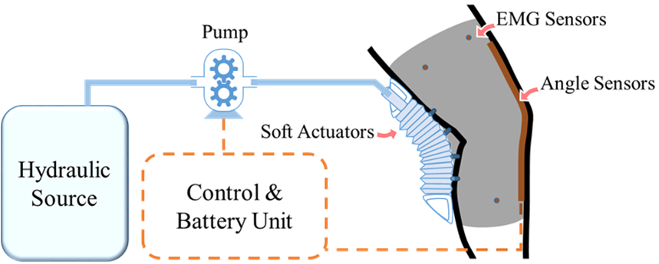
Fig. 1 Concept and design of SRKB
As shown in Fig. 2, this system consists of a three-layer control loop comprising hydraulic pressure, knee angle, and muscle electromyography feedback. The deformation of a soft origami actuator made of thermoplastic polyurethanes is related to the inner pressure of the chamber. A larger inner pressure results in a larger deformation in the free space situation. Based on this mechanism, we applied a hydraulic pressure control method to control the soft actuators' motion behavior indirectly. We could control the soft robot knee brace to stretch or pull back by controlling the hydraulic pressure generation and transmission. The gear pump was selected as the hydraulic pressure generator for the soft robot knee brace because of the approximately linear relationship between the pump's hydraulic pressure and the motor’s electrical input. We adopted the desired pressure control profile by controlling the electrical parameters and PWM input of the direct current motor attached to the gear pump. A hydraulic sensor is incorporated into the hydraulic pipeline system, which makes it available to provide feedback to control the hydraulic pressure output. The actual hydraulic pressure in the pipeline system was transferred to the microcontroller, which was used to calculate the input of the motor. By minimizing the error of the desired and actual hydraulic pressure, we achieved an inner feedback loop of the pressure.
The middle loop of the soft robot knee-brace control system is designed to process the kinematic data of the human body such that it can generate the desired pressure input for the inner hydraulic pressure loop. Although the time taken by users to stand up is different, the relationship between the knee position and bending torque used for assisting standing up is relatively consistent. The assistance torque was transmitted along the joint to lift the human body against gravity, and this relationship is based on the lower limbs' relative position. Therefore, the joint angle could be an apt choice as the benchmark to describe the kinematic performance of the human body.
The activation of the SRKB system is initiated by the user's intention to start the standing-up motion. We employed a straightforward method to differentiate between the effective activation signals of the muscle. This method involves determining if the voltage generated by the sEMG sensor surpasses the threshold and is maintained for a specific duration. The activation of the muscle is considered the beginning of the stand-up motion, which activates the SRKB system. This approach proved to be simple yet effective in triggering the soft knee brace motion in our laboratory and user study tests. By modifying the threshold of the activation level and the time parameter, we can adapt to the different muscle activation characteristics among individuals.
Fig. 2 Control structure diagram of SRKB

2.2 Embedded Multi-sensor Structure
The proposed robotic system incorporates a three-layer sensor feedback loop, which utilizes multiple sensor inputs from the robotic, human motion, and human physiological levels. This multi-sensor system is crucial for achieving close-loop control and accurate feedback, as illustrated in the control diagram. Specifically, the hydraulic pressure sensor provides feedback on the robotic level, the wearable strain sensor detects human motion, and the sEMG sensor measures physiological signals. This comprehensive feedback mechanism enables the robotic system to respond to the user's movements and adjust the assistive torque accordingly, providing a more adaptive and effective knee assistance.

2.2.1 Pressure Sensor
A hydraulic sensor (KE-240 YiGuan Co., Ltd.) is applied to the robotic hydraulic system for hydraulic feedback to control the pressure output. We assume that any change in pressure of gear-type power pump is transmitted undiminished to the soft actuator, which means that the pressure difference between the hydraulic source and the end is negligible.

2.2.2 Bending Angle Sensor
An ultra-flexible polyurethane yarn-based wearable strain sensor ^{[20]} was applied to the robotic sensor system. The PU yarn, multilayer GNSs/Au/GNSs, and PDMS wrapping layer can be integrated into the textiles of the knee brace. The deformation of the fabric knee brace can be calculated by measuring the relative resistance change of the PU yarn-based sensors. Therefore, the robot adopted linear interpolation to calculate the knee joint's angle because the angle has a linear mapping relationship with the sensor's resistance.

2.2.3 sEMG Sensor
sEMG signals can provide information about muscle activation patterns and timing during various movements ^{[21]}. In this study, sEMG sensors were used to detect the activation signals of the standing-related muscles and trigger the soft robotic knee brace's assistance procedure. As shown in Fig. 3, a group of sEMG electrodes is placed on the skin above four target muscles (rectus femoris, medial hamstrings, tibialis anterior, and gastrocnemius), which are most related to the stand-up motion. The recorded sEMG signals were then analyzed to determine the onset and duration of muscle activation, which were used as triggers for the soft robotic knee brace assistance.
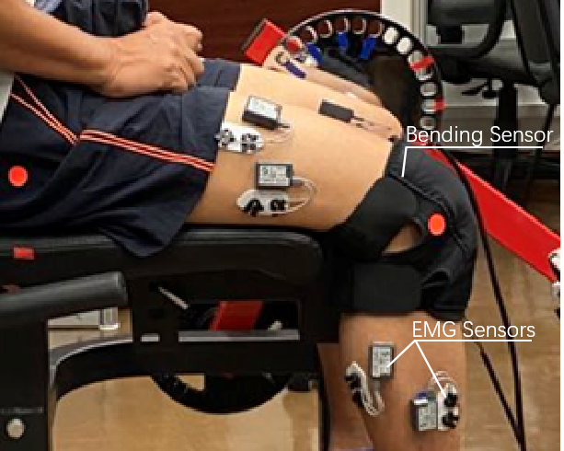
Fig. 3 Bending and sEMG sensor setting on human body

3 Soft Actuator Design
We chose the selective laser sintering (SLS) 3D printing method to manufacture soft actuators that are designed based on joint features. The soft actuator design was based on the Yoshimura pattern ^{[22]}. Based on the origami features, the mechanical design and material properties can be modified to achieve the desired deformation range and force output. As shown in Fig. 4, to accommodate the length adaptation of soft tissue and knee joint angle, one side of the soft actuator is longer than the other. Two soft actuators were incorporated into the soft knee brace to provide the necessary actuation. The entire soft knee brace, including the hydraulic actuation system, weighs 1.4 kg without hydraulic fluids, with a single actuator weighing 85 g. The soft actuators are fixed onto a soft sewing base, which prevents elongation of one side of the actuator and ensures a snug fit to the lower limb. Additionally, two rigid blocks are placed at the end of each soft actuator to further constrain elongation and promote bending motion towards the outside. Based on our previous research^{[23]}, we obtained a model for describing the bending range of an origami-shaped actuator to design an actuator with the desired demand.
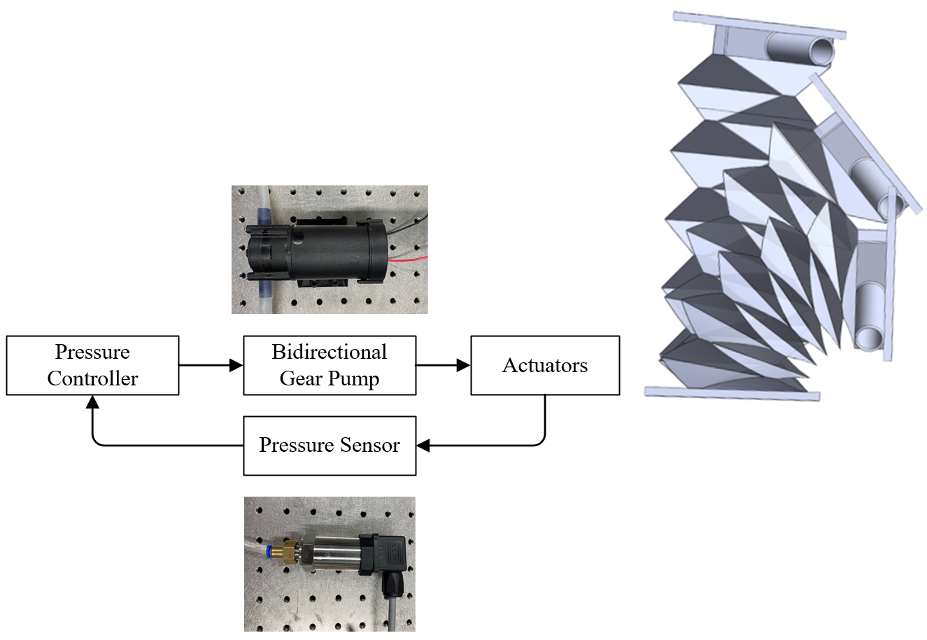
Fig. 4 Bending soft actuator actuation principle

4 Experiment

4.1 Performance Validation
Figure 5 presents the experimental platform used to test the torque applied to the dummy leg model using soft actuators. The dummy leg was fixed at the bottom and attached to a horizontal bar with a slider placed vertically When the soft actuator is pressurized, the slider tends to rise to apply a force on the force sensor. A portable hydraulic actuation system was used to drive soft robotic actuators and circulate the hydraulic flow. The actuation package comprised bidirectional rotary gear pumps (ZC-760, Zhongchuang Electronic Co., Ltd.), a motor driver AQMD2410NS (AKELC Co., Ltd.), and a Li-Po battery (ACE 3S 4000 mAh, Shenzhen Grepow Battery). Additional valves were removed to reduce the actuation system’s weight and improve the hydraulic transmission efficiency; the number of pumps can be adjusted according to the application scenario. Here, in the experimental platform, we used two pumps for the hydraulic system.
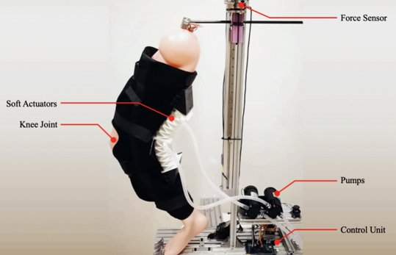
Fig. 5 Experimental platform for torque output test
To verify the torque-generation ability of the soft actuator system, a static experiment was performed to validate its performance. The model leg was manually fixed at 90° to 160°, and the actuator was pressurized to 60 kPa at each angle. The torque generated on the knee brace is given by
$T_{knee}=FL_{1}cos(θ/2)$, (1)
where F is the vertical force applied to the sensor, $θ$ is the angle of the knee joint, and L₁ is the length between the knee joint and the thigh fixed point.
The experimental results are shown in Figure 6, which shows the characteristics of the torque generation in the standing condition with three repetitions of the experiment for each angle. The torque achieves the largest 36 N·m output at the beginning and rapidly decreases to approximately 20 N·m after the first 30° range. This is mainly because a larger deformation will increase the hydraulic power to the actuator’s elastic potential energy.
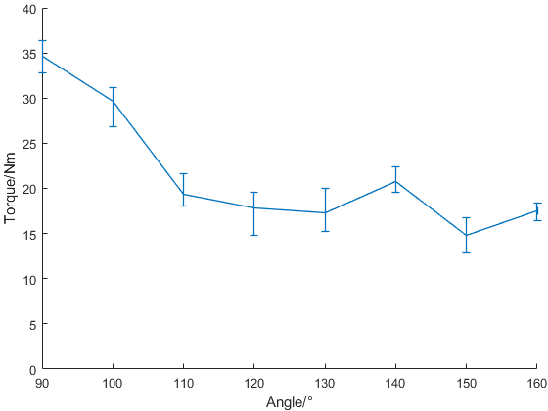
Fig. 6 Torque generated at different knee angles

4.2 Control System Validation
The direct-actuation method employed in the portable hydraulic actuation system enabled a rapid response, as demonstrated by the results of the force sensor test presented in Figure 7. The control signal triggered the actuation, and in the robot test platform, this signal was generated by the controller (STM32f429ZET6), while the hydraulic and force signals were collected concurrently using a hydraulic pressure sensor (KE-240/ ( −1-10) BG4B and a force sensor (ZNBSQ-V20KG). The response time of the hydraulic drive system was quantified in this experiment, and the results confirmed its fast response capabilities. In practical applications, the control signal could be generated by a human body sensor, such as an sEMG sensor, which could be integrated into the robot control system.
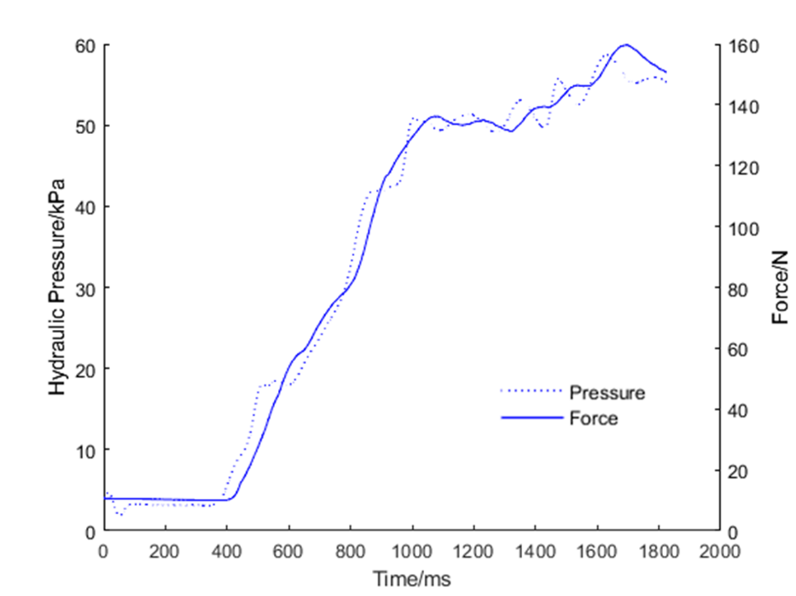
Pressure, Force
Fig. 7 Response time of hydraulic direct-drive method
The following experiment aimed to verify the effectiveness of the pressure control method using PWM-based motor control. Based on the mechanical principle of the gear pump, the output pressure is controlled by the torque of the drive motor. The inner pressure of the actuator can be directly adjusted by changing the output signal of the motor driver. By changing the motor inputs, the soft knee brace could achieve the desired force output and motion modes. To evaluate the motion control performance of the soft knee brace, we conducted an experiment using a dummy leg model without any additional load. The change in motion mode was reflected in the bending angle variation of the knee joint. As shown in Fig. 8, three green-dot stickers were placed on the model leg for video capture to identify the ankle, knee joint, and thigh. By placing a video camera facing the platform, the distance between the camera and model could be seen as equal, which would not cause obvious image distortion. The actual angle of the bent knee brace was calculated based on the colored spot's location.
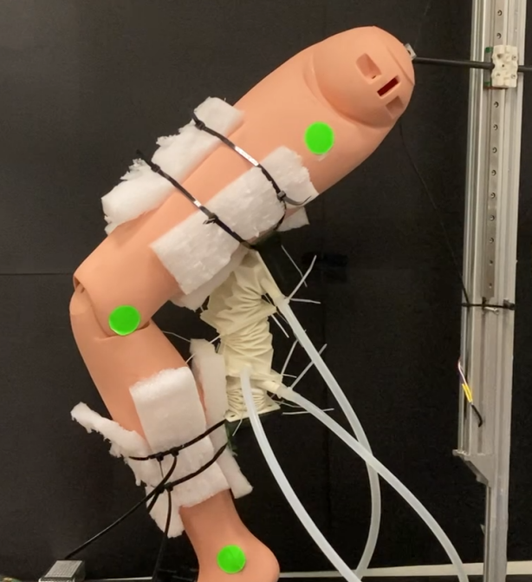
Fig. 8 Experimental platform for motion control validation
As shown in Fig. 9, the results show the performance of the direct-drive hydraulic pressure control method. Three types of control modes were used in this test. Mode A is the full-power supply mode, which provides the maximum voltage output. Mode B involves a rapid increase at first and a gradual decrease at rest, which is the opposite of Mode C, which involves a slow rise followed by a fast fall. The amplitude and duration of the voltage change the bending speed and final angle. Based on this, we could control the bending motion of the knee brace by programming the PWM output of the motor driver to the input for pump motors. Both the bending angle and rotation speed could be adjusted using this method; this could be used for future personalized motion modes.
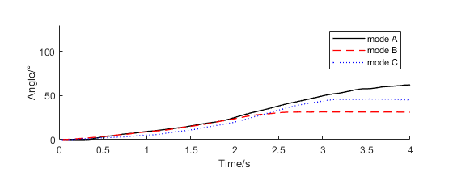
(a) Angle response of the knee brace under Modes A, B, and C
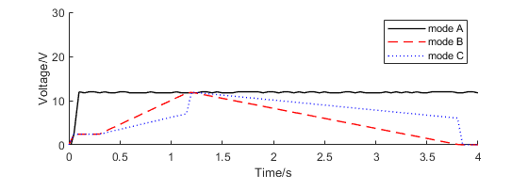
(b) Time-variable motor input voltage of Modes A, B, and C.
Mode A, Mode B, Mode C
Fig. 9 Experimental result of Modes A, B, and C bending motion

4.3 User Test
To evaluate the proposed robotic system based on integrated multi-sensor soft robots, we conducted experiments on sitting-to-stand activity with human user (male; age = 27; mass = 75.2 kg; height = 1.83 m). This part of the test aimed to verify the effectiveness of the pressure control strategy using the direct-driver method and the cooperation between the robotic sensor system and the human body. To accomplish this, a user wearing the SRKB was instructed to perform stand-ups from a chair. As shown in Fig. 10, an onboard microcontroller collected and utilized feedback signals from embedded multi-sensor system. During the test, sEMG activity, robot signals, and kinematic data were collected and uploaded to a computer using a microcontroller (stm32f4). The four-channel sEMG sensors recorded the action potential of rectus femoris, medial hamstrings, tibialis anterior, and gastrocnemius. The pressure of the robot hydraulic system was collected using a pressure sensor, and the knee angle sensor was collected using a wearable bending angle sensor that transmits strains to analog signals.
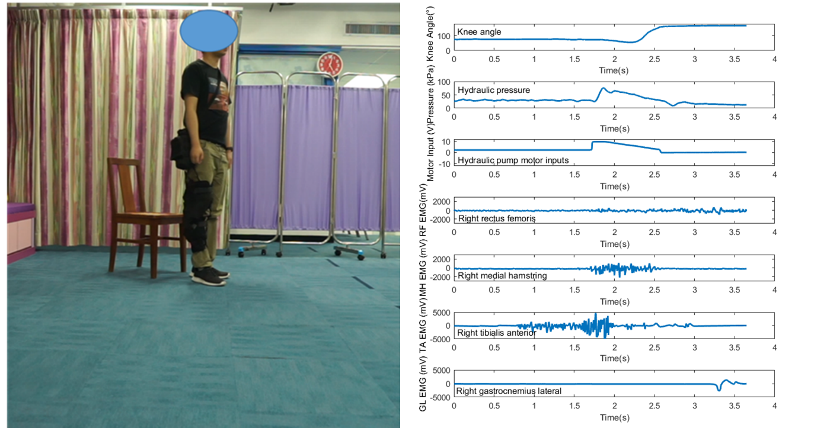
Fig. 10 Verification test and experimental results of SRKB
The right tibialis anterior muscle was selected as the trigger for the SRKB system based on the amplitude and duration of its sEMG signal. Additionally, data from the soft bending angle sensor is used to compute human motion information, which is the knee joint angle. The hydraulic pressure of the SRKB actuator is detected by using hydraulic sensors. Using this human motion profile, the pressure controller generates target voltages for the hydraulic pump motors. The bidirectional rotary gear pumps regulate the hydraulic flow in and out to pressurize the corresponding soft actuators. Our results demonstrated that the sEMG signal successfully triggered the system, and the desired pressure output was achieved.
5 Conclusion
We developed a soft robotic knee brace (SRKB) that utilizes soft hydraulic actuators to provide physical support and assistive torque to the knee joint. The SRKB is embedded with a multi-sensor feedback system that enables the robotic system to collaborate with the human body by utilizing physiological signals and motion information. The portable hydraulic actuation system allows for a rapid response, and we conducted a verification test to demonstrate the feasibility and effectiveness of the direct-drive hydraulic pressure control method. This novel soft robotic portable hydraulic system can transfer different motion patterns, such as bending angle and movement speed, to knee joints through pump motor input control. In addition, we conducted a user test to verify the feasibility of the multi-sensor feedback system for measuring physiological and motion levels in the human body for robot control.
In our future work, we aim to enhance the hydraulic direct-drive system by focusing on improving the pipelines and pumps to further enhance its fast response-ability. Specifically, we will aim to reduce the loss and delay of the pipeline to achieve an even faster response time. Additionally, we plan to explore the potential of using electrical signals from human muscles to determine the force output of the muscle in real-time, allowing us to fit different assistive strategies for users. Furthermore, we plan to conduct further user studies to evaluate the performance of the soft robotic knee brace in real-world scenarios and to explore the potential of using these methods for other wearable robots.

References
[1] KULOWSKI J. THE CLASSIC: Flexion contracture of the knee [J]. Clinical Orthopaedics & Related Research, 2007, 464: 4-10.
[2] HYODO K, MASUDA T, AIZAWA J, et al. Hip, knee, and ankle kinematics during activities of daily living: A cross-sectional study [J]. Brazilian Journal of Physical Therapy, 2017, 21(3): 159-166.
[3] TAGLIAMONTE N L, SERGI F, CARPINO G, et al. Human-robot interaction tests on a novel robot for gait assistance [C]//2013 IEEE 13th International Conference on Rehabilitation Robotics. Seattle: IEEE, 2013: 1-6.
[4] QUINTERO H A, FARRIS R J, GOLDFARB M. A method for the autonomous control of lower limb exo-skeletons for persons with paraplegia [J]. Journal of Medical Devices, 2012, 6(4): 0410031-0410036.
[5] YOUNG A J, FERRIS D P. State of the art and future directions for lower limb robotic exoskeletons [J]. IEEE Transactions on Neural Systems and Rehabilitation Engineering, 2017, 25(2): 171-182.
[6] SCHIELE A. Ergonomics of exoskeletons: Subjective performance metrics [C]//2009 IEEE/RSJ International Conference on Intelligent Robots and Systems. St. Louis: IEEE, 2009: 480-485.
[7] RUS D, TOLLEY M T. Design, fabrication and control of soft robots [J]. Nature, 2015, 521(7553): 467-475.
[8] NISHIOKA Y, UESU M, TSUBOI H, et al. Development of a pneumatic soft actuator with pleated inflatable structures [J]. Advanced Robotics, 2017, 31(14): 753-762.
[9] PARK J, CHOI J, KIM S J, et al. Design of an inflatable wrinkle actuator with fast inflation/deflation responses for wearable suits [J]. IEEE Robotics and Automation Letters, 2020, 5(3): 3799-3805.
[10] SRIDAR S, NGUYEN P H, ZHU M J, et al. Development of a soft-inflatable exosuit for knee rehabilitation [C]//2017 IEEE/RSJ International Conference on Intelligent Robots and Systems. Vancouver: IEEE, 2017: 3722-3727.
[11] FOCCHI M, GUGLIELMINO E, SEMINI C, et al. Control of a hydraulically-actuated quadruped robot leg [C]//2010 IEEE International Conference on Robotics and Automation. Anchorage: IEEE, 2010: 4182-4188.
[12] BLACKBURN J F, REETHOF G, SHEARER J L. Fluid Power Control [M]. Cambridge: The MIT Press, 1960
[13] KRUTZ G W, CHUA P S K. Water hydraulics: Theory and applications 2004[C]//Workshop on Water Hydraulics, Agricultural Equipment Technology Conference. Louisville: Local Committee, 2004: 1-33.
[14] MELLER M A, BRYANT M, GARCIA E. Reconsidering the McKibben muscle: Energetics, operating fluid, and bladder material [J]. Journal of Intelligent Material Systems and Structures, 2014, 25(18): 2276-2293.
[15] Martinez-Hernandez U, Dehghani-Sanij A A. Probabilistic identification of sit-to-stand and stand-to-sit with a wearable sensor[J]. Pattern Recognition Letters, 2019, 118: 32-41.
[16] PARK Y L, CHEN B R, PÉREZ-ARANCIBIA N O, et al. Design and control of a bio-inspired soft wearable robotic device for ankle-foot rehabilitation [J]. Bioinspiration & Biomimetics, 2014, 9(1): 016007.
[17] SRIDAR S, QIAO Z, MUTHUKRISHNAN N, et al. A soft-inflatable exosuit for knee rehabilitation: Assisting swing phase during walking [J]. Frontiers in Robotics and AI, 2018, 5: 44.
[18] Ben-Dov D, Salcudean S E. A force-controlled pneumatic actuator[J]. IEEE Transactions on Robotics and Automation, 1995, 11(6): 906-911.Veale, A. J., Staman, K., & Van Der Kooij, H. (2021). Soft, wearable, and pleated pneumatic interference actuator provides knee extension torque for sit-to-stand. Soft Robotics, 8(1), 28-43.
[19] Abbasi P, Nekoui M A, Zareinejad M, et al. Position and force control of a soft pneumatic actuator[J]. Soft Robotics, 2020, 7(5): 550-563.
[20] LI X T, KOH K H, FARHAN M, et al. An ultraflexible polyurethane yarn-based wearable strain sensor with a polydimethylsiloxane infiltrated multilayer sheath for smart textiles [J]. Nanoscale, 2020, 12(6): 4110-4118.
[21] REAZ M B I, HUSSAIN M S, MOHD-YASIN F. Techniques of EMG signal analysis: Detection, processing, classification and applications [J]. Biological Procedures Online, 2006, 8(1): 11-35.
[22] BURI H, WEINAND Y. ORIGAMI – folded plate structures, architecture [C]// 10th World Conference on Timber Engineering. Miyazaki: Enigineered Wood Products Association, 2008: 2090-2097.
[23] YI J, CHEN X J, SONG C Y, et al. Customizable three-dimensional-printed origami soft robotic joint with effective behavior shaping for safe interactions [J]. IEEE Transactions on Robotics, 2019, 35(1): 114-123.

Accepted: 2023-2-9 Foundation item: the Theme-based Research Scheme from the Research Grant Council of the Hong Kong Special Administrative Region Government (No. T42-717/20-R), and the National Natural Science Foundation of China (No. 51975268), Shenzhen 518055, Guangdong, China, to this work. * E-mail: xining@hku.hk, wangz@sustech.edu.cn

