Names and naming for modular construction
Jinfeng Lou, Weisheng Lu, Jinying Xu*, Xiao Li, and Jing Wang

Abstract
The renaissance of modular construction (MC) around the world necessitates more efficient information management (IM). A name can be used to manage its associated information in a more indexing way than usual. With the increasing complexity of modern construction, names and naming need to be considered more consciously for better IM. This paper reports the process of developing a naming convention for components to enable better IM in MC projects in the digital era by adopting a design thinking approach. Firstly, the criteria on eligible names are derived from current construction practice and other matured naming practices and information quality requirements. Then, a naming convention that confers names upon MC components is proposed by collaborating with industrial stakeholders, validated and refined by a frontline-level case study and a policy-level focus meeting. It is found that the naming convention is welcomed by construction stakeholders as a timely solution for their demands. Stakeholders have diverse information needs and tend to focus on their own needs only. We thus argue that a proper naming standard should balance different needs and form a common understanding to improve construction IM. This study articulates the widespread but rarely explored needs for formulating a qualified naming convention.
Keywords: Information management; Name; Naming; Nomenclature; Digital construction; Design thinking; Component

1 Introduction
Modular construction (MC) refers to volumetric modules with finishes, fixtures, and fittings are manufactured in a prefabrication factory and then transported to construction site for assembly. It represents one promising trend towards construction industrialization (HKCIC, 2020) by shifting 80–95% of onsite construction to mass factory production in a controllable environment (Smith, 2016). MC is widely considered to offer enormous benefits, such as controlled quality, improved sustainability, reduced risks, and less time and cost (Lu et al., 2018; Zhai et al., 2019). However, managing an MC project presents several new challenges. The prolonged logistics and supply chain (LSC) associated with MC projects increases fragmentation in construction processes (Smith, 2016). With most of the construction works completed in an offsite factory or even an offshore place, the manufacturer is added as a key stakeholder and production and transportation become new significant stages. Such changes further complicate and burden the communication among stakeholders during different stages. MC projects thus require carefully consideration of factors like transportation vehicles, routes, onsite storage conditions, and hoisting methods (Lawson et al., 2014) and close interconnection among stakeholders from the very early project phases (Li et al., 2016). All these characteristics cumulate into a compelling demand for developing efficient information management (IM) tools to improve fragmented LSC and promote smooth collaboration.

Names can be used to categorize, filter, identify, and locate items quickly, providing a feasible and straightforward way to manage information (Baca, 2016). Names often come from people’s experiences and understandings. They play a critical role in interpersonal communications. They are also a language to reflect people’s perception of the world. Naming is the act that bestows a name to a thing. Olson (2002) stated, “naming is a means of structuring reality”. There are many evidences indicating that people value names in both physical and digital worlds. In physical worlds, for example, when people know nothing about a certain thing, they instinctively obtain its name first. So far, over 40 terminologies, including forename, surname, nickname, pseudonym, toponym, patronymic, metronymic, and others (Boonpaisarnsatit, 2011) have been carefully designed to suit different scenarios and aid in disentangling the complex world. Particularly in the digital era, naming, or labelling information with understandable nametags, provides a means of handling exponential information growth (Duval et al., 2002; Kang & Choi, 2015).

The importance of names in construction project management has been emphasized in previous literature (Gandhi & Jupp, 2014; Shafiq et al., 2012). Two profound trends further highlight the roles of names and naming in construction. First, with the increasing complexity and globalization of modern construction projects, resources are increasingly sourced offshore, which complicates LSC management. Informatively named, these resources are more amenable to management (e.g., through categorizing, locating, tracing, and communicating) among LSC stakeholders. Second, digital transformations enabled by various paradigms, e.g., building information modeling (BIM) and digital twin (DT), have been widely advocated (Lu et al., 2020). These technologies represent a physical construction in cyberspace and mobilize information flow between cyber-physical systems to enable a series of value-added applications (Pan & Zhang, 2021; Yuan & Anumba, 2020). Names that connect the physical and cyber worlds are essential to enable these digital transformations.

Despite the pronounced importance of names and naming, current naming practices have their limitations. First, construction naming has traditionally occurred intuitively and sporadically, giving rise to designations such as “the column at the southwest corner”, or “that beam on the fifth floor”. Worse still, different participants may describe the same content with different terms (e.g., “curtain wall” for contractors and “façade” for architects), which could be the trigger of the coordination issues and conflicts (Taylor, 2007). Second, although there exists some naming standards that constrain the form of names, these standards prefer a one-size-fits-all naming convention for all the projects. It is questionable whether such conventions could serve all types of projects, e.g., MC projects. The views from name users, i.e., project stakeholders, should be carefully considered. Third, among similar statements about the significance of naming made by most construction literature, only few have taken a step forward to introduce explicit naming conventions suitable within their predefined context (Chen et al., 2017; Quinn et al., 2020). Strictly speaking, these explorations only exhibit a final result (e.g., a naming standard, a plug-in), without elaborations of rationale or process. Thus, it impedes possible learning from their developments.

Rising above these limitations, this paper aims to report the diverse concerns, processes, and final products of naming convention development to facilitate IM and communication in construction projects. To ensure the feasibility, this study narrows its scope in two aspects, namely, making MC projects (the targeted project types) and components (the specific items to be named) as the focuses. The reason is that the typical fragmented nature of MC projects necessitates more smooth communication where names can assist, and the components are the main organization units of project IM system. Thus, the aim of this study can be translated into two research questions: what are the criteria for evaluating a naming convention in current construction industry (RQ1); how is a qualified naming convention formulated for MC projects based on these criteria (RQ2). To address these two research questions, the design thinking method was employed. As such, naming conventions can be devised by the designer’s close observations and thorough understanding of what is wanted, needed, and liked (Brown, 2008; Brown & Wyatt, 2010). The rest of this research is organized as follows. Section 2 reports the detailed research method. Sections 3 reviews the literature on names and naming and presents the derived criteria. The naming convention is developed in Section 4 with a real MC case to validate and refine it. Discussion and conclusions are presented in Sections 5 and 6, respectively.

2 Research methods
As there is limited research of its kind, this study adopts design thinking methodology “that imbues the full spectrum of innovation activities with a human-centered design ethos” (Brown, 2008). The methodology has five stages, i.e., empathize, define, ideate, prototype, and test. The empathize stage aims to gain an understanding of what people do, how they think, and what they need. The define stage involves stating what the problem is, what the constraints are, and what to change. At the ideate stage, the designer thinks about how new innovations can help solve the problem and what the innovation should look like. At the prototype stage, creative products are developed. Finally, the innovation is executed, verified, and communicated in the test stage. The different stages are non-linear and not always sequential but reiterative.

Under the umbrella of design thinking, we used multiple research methods, e.g., literature review, survey, and case study, to develop different interconnected deliverables (see Figure 1) (Xu et al., 2021). At the empathize stage, literature review and archival study were used to collect existing naming conventions and understand the current issues. Based on the results from empathy, the criteria for qualified names were summarized in the define stage. For the ideate stage, the candidate information for naming and corresponding vocabulary were proposed through brainstorming. At the prototype stage, the candidate information are further filtered and consolidated into an eligible naming convention for MC projects by surveying with experts. Finally, the case study and focus group meeting were adopted to verify and communicate the MC naming convention in the test stage.
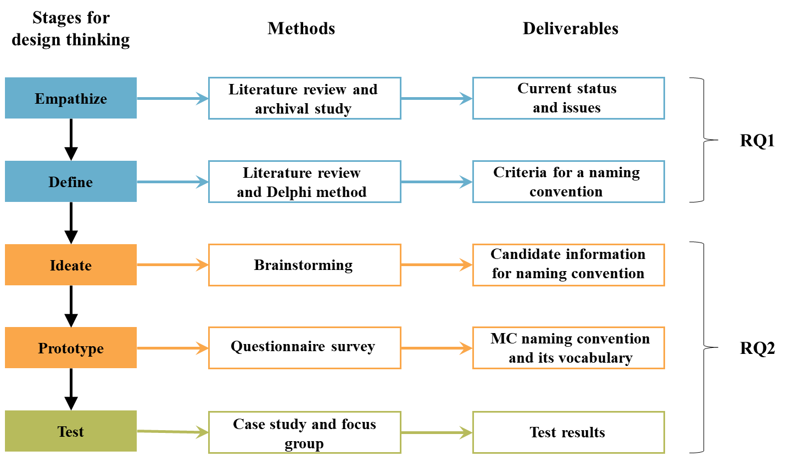
Figure 1. The design thinking methodology applied in this research

2.1 Empathize
The archival study, a certain type of document analysis, offers a systematic procedure for reviewing and/or evaluating secondary data, e.g., standards and project records (Audia et al., 2000; Bowen, 2009). Besides, literature review has become a more appropriate research method than ever to catch up with state-of-the-art research (Snyder, 2019). Both these two methods can assist in learning from past experiences and garnering insights of current gaps. Thus, we conducted an archival study to find, select, and summarize the relevant discourses about naming from standards, guidelines, regulations, and documents of past projects, gaining a general understanding of existing naming conventions. Meanwhile, the literature of names and naming with its emphases on physical, digital, and construction aspects was collected and reviewed to identify the existing naming conventions, as well as the current issues.

2.2 Define
The define stage aims to define the criteria on names in current construction industry. This was done by appraising the issues from empathy and reviewing similar criteria from literature in other disciplines, such as onomastics and computer science. As names are a kind of information that describes information, a.k.a., meta-information, the criteria for information quality (IQ) are of great reference value (Baca, 2016). Thus, the criteria derived from current issues and various disciplines were compared and synthesized with the IQ criteria. The synthesis process was carried out by Delphi method. Delphi method works well when there exists potential conflicts between involved parties (Hallowell & Gambatese, 2010). Four researchers first did the synthesis independently, and then these researchers reconsidered their subjective answers and wrote the new responses. After three rounds of Delphi, a consensus on the criteria was finally reached. These criteria served as guidelines for the development of MC naming conventions in this study.

2.3 Ideate
Names should contain certain information that describes the characteristics of the referents to facilitate the recognition process. To propose as many naming solutions as possible, brainstorming is adopted to identify the candidate information at the ideate stage. To give a hint for brainstorming, this study developed a layered hierarchy in MC projects. The rationale is a compelling analogy between the MC projects and human society as both are organized in a layered hierarchy. One can easily identify individuality by forename and the relationship with others by surname. Similarly, an MC project can be broken down into simple and unitary parts that are organized under a layered hierarchical structure. Drawn from the human naming practice, candidate information from each layer was supposed to be organized to provide abundant information in individuality and relationship. In this study, the experimenter first informed the group of the general issues, rules and hints of brainstorming and took notes of the ideas generated (Putman & Paulus, 2009). A group of six experts (2 experts on BIM, 2 experts on MC, and 2 researchers, all with at least 8 years of construction industry experience) were encouraged to devise the candidate information from each layer and brainstorm candidate information for an MC naming convention, after which synthesis and evaluation was conducted.

2.4 Prototype
This stage aims to present an eligible naming convention by questionnaire surveys. A survey is a research method widely used to collect information and insights about characteristics, actions, or opinions from a predefined group of people (Pinsonneault & Kraemer, 1993). As Olson (2002) contends, naming is a process of encoding bias and selecting what should be emphasized. Therefore, to make sure names are easily perceived by stakeholders, a common understanding is required. Such common understanding is investigated by surveying the stakeholders’ selection from the candidate information. The surveys were conducted in three MC-related workshops, where most of the attendees are MC stakeholders with different professional skills. In the workshops, the attendees were given some basic instructions about naming, including functions, criteria, and examples. Then, these professionals were invited to finish the questionnaires, which consists of two parts investigating respondents’ demographic information and their selection of candidature information, respectively. Considering other potential information beyond those identified by brainstorming, the respondents were also welcome to add other information that they need in the second part. A total of 106 questionnaires were distributed with 88 returned. To ensure the quality of the survey, responses indicating invalid or incomplete answers, not a stakeholder of MC projects, and less than one year MC experience of respondents were excluded, and 65 valid responses were analyzed. The descriptive information of respondents is shown in Table 1. Based on the survey results, the MC naming convention and the corresponding vocabularies were formulated.

Table 1. Descriptive information of respondents
Measure | Item | Frequency | Percentage
Role | Owner | 12 | 18%
Role | Designer | 14 | 22%
Role | Manufacturer | 12 | 18%
Role | Transporter | 11 | 17%
Role | Contractor | 16 | 25%
Education | High diploma/Associate degree | 4 | 6%
 | Bachelor | 36 | 55%
 | Master or above | 25 | 38%
Experience in construction | 1-2 years | 4 | 6%
Experience in construction | 3-5 years | 9 | 14%
Experience in construction | 5-10 years | 32 | 49%
Experience in construction | 10 years or more | 20 | 31%
Experience in MC | 1-2 years | 8 | 12%
Experience in MC | 3-5 years | 15 | 23%
Experience in MC | 5-10 years | 31 | 48%
Experience in MC | 10 years or more | 11 | 17%

2.5 Test
The methods of case study and focus group were adopted to test the proposed naming convention from the perspective of frontline stakeholders and policy-makers, respectively. The case study is particularly useful when a thorough and in-depth investigation of a unique problem, feature, or unit of analysis is required to facilitate the investigators’ understanding of the case (Kruth, 2015; Noor, 2008). At the frontline of the case study is an iconic MC project. The modules, including sets of components (e.g., windows, doors, embedded furniture, and utilities) are manufactured offshore and transported onshore for assembly. Communication during design, manufacturing, cross-border LSCM, and assembly is onerous, so a BIM is developed to facilitate it. Using serial numbers to name components is unhelpful, and the client is keen to use a proper naming convention to couple BIM and physical construction for more efficient communication. The research team work closely with the project stakeholders to solve the naming issues.

Focus group meeting was used to solicit the comments from policy-makers through interactive discussions (Wilkinson, 1998). At the policy level, a local statutory institute endeavors to devise a standard corresponding to the government’s strategy to promote MC. Deeply rooted in laissez-faire, the institute put itself in a bridging role between government and industry, adopting a clever strategy to listen to industry and welcome all stakeholders’ input to develop MC standards. The research team had an opportunity to work with the institute’s task force, specifically on the naming part of the MC standard. The focus meeting involved 11 participants, including 4 from the research team and 7 officials from the institute, among which 3 officials had more expertise on BIM, while the other 4 focused more on MC. All the officials had at least 9 years of experience in the industry. A professor from the research team served as the moderator to introduce the whole development process and loosely direct the discussions. After the meeting, some vague information was verified and clarified again via group emails. The meeting and the relevant correspondences were carefully recorded for further analysis.

3 Current status, issues and criteria for naming

3.1 Current status of naming in construction
A name, according to the Oxford English Dictionary (2010), is a “word or set of words by which a person or thing is known, addressed, or referred to”. Practices to assign names to things in some disciplines, e.g., chemistry, often refer to the term “nomenclature” (Cahn & Dermer, 2013). Nomenclature, a system of names or a set of rules to form these names, is synonymous with the naming convention in this study.

Names are indispensable for labelling and communicating construction components, particularly in modern construction projects often involving millions of such items (Choi et al., 2018; Lee et al., 2012). Figure 2 illustrates several common naming scenarios in construction. Practitioners often adopt a pragmatic approach that requires the naming convention “practical” with minimum effort input. Experienced practitioners can easily interpret the information, e.g., the factory of manufacture, the client, or the position in which a precast component should stand.
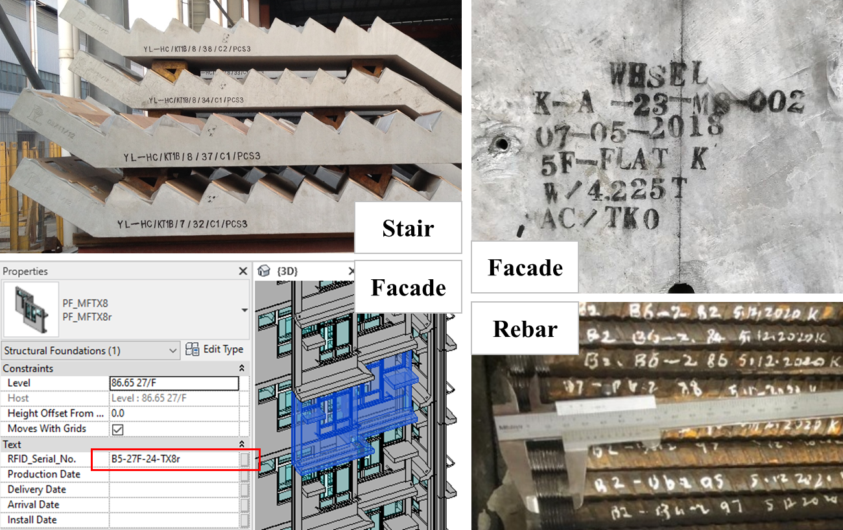
Figure 2 Names and naming in real-life construction scenarios

Several regional-level BIM standards have also defined naming conventions (see Table 1). With digitization in the construction industry, most information has been transferred into BIM, so BIM standards generally have a brief section stating naming conventions for objects or components. Objects (a.k.a. entities) are loadable and discrete items provided by modelers or BIM authoring systems (NATSPEC, 2018), e.g., families in Revit. Components (a.k.a. instance) are individuals of an entity at a particular location and orientation within a model (NBS, 2019), e.g., instances of families. Although the focus of this study is on naming the components, both conventions are summarized for reference. As shown in Table 1, existing naming conventions usually consist of several fields containing certain information and concatenated with a hyphen (-) or underscore (_). Generally, the field information used in naming includes Type, Subtype, Originator, Manufacturer, Description, and Sequential number.

Table 1. Summary of construction naming conventions
Reference | Reference type | Country or region | Level of application | Subject of naming | Naming convention
ISO (1998) | Standard | Global | Region | Component | <IfcSubtype><Sequential number>
Bloomberg et al. (2012) | Standard | US | Region | Object | <Category> - <Type*> - <Subtype*> - <Manufacturer*> - <Description>
USC (2012) | Standard | US | Company | Object | <Type>-<Description>
USC (2012) | Standard | US | Company | Component | <Type>-<ID>
BSI (2012) | Standard | UK | Region | Object | <Role>_<Classification>_<Presentation*>_<Originator>_<Type>_<Subtype*>
ANZRSC (2012) | Standard | Australia and NZ | Region | Object | <Type>_<Subtype>_<Manufacturer>_<Description*>
HKNWCON (2016) | Standard | HK | Company | Object | <Type>_<Material><Description>
Chen et al. (2017) | Journal paper | HK | Region | Component | <Type>_<Subtype>_<Location>_<Sequential number>_<Description*>
HKCIC (2019) | Standard | HK | Region | Object | <Type>-<Subtype>-<Originator>-<Description 1>-<Description 2>
NATSPEC (2018) | Standard | Australia | Region | Object | <Type>_<Subtype>_<Manufacturer>_<Product/Range identifier>_<Description>_<Originator>
NBS (2019) | Standard | UK | Region | Object | <Originator>_<Manufacturer>_<Type>_<Subtype >_<Description*>
USGSA (2019) | Standard | US | Region | Component | <Type>-<Description>
Note: 1. The asterisk (*) means that this field is optional.
2. Different naming conventions might use different words to represent the same information, for example, “Descriptor” and “Description”. For better comparison, the authors select one word to express the same information.

3.2 Issues of naming in construction
There are many naming standards about objects, but seldom do they concern about components, or instances. BIM object names often contain unnecessary information for component naming, e.g., originator (the one who creates or owns the virtual BIM object). Object names are more suitable for the establishment of BIM object library, instead of project management. To enhance project management, every component in a project needs a proper name. However, current component naming practices suffer from the following problems:
(1) Inability to meet practical requirements. Each type of project has unique considerations for component naming (Chen et al., 2017). The requirement of conformance demands sufficient understanding of practical needs.
(2) Disordered naming. Naming of components can be arbitrary, e.g., in assigning random IDs (Goedert & Meadati, 2008). Following different taxonomies contributes to this disorder (Lee et al., 2012), and user-assigned names are often affected by different languages, cultures, disciplines, and habits (Lee et al., 2012; Taylor, 2007). Thus, standardization of naming convention and vocabulary is required.
(3) Need for much manual work. Naming components manually is tedious, error-prone, and even impossible for some large and complex projects (Williams et al., 2014). It is much desired that naming, particularly in a digital environment, be machine-processable. This issue claims for standardization again.
(4) Inaccurate names. Names should reflect the ongoing condition of components. However, in real-life practice, a name remains largely unchanged once it is assigned, unless the information maintainer takes the initiative to modify it, which cannot represent the true status of the components and leads to the information inaccuracy and user distrust (Anderson et al., 2012). Thus, names should maintain accurate.

3.3 Synthesis of criteria on names
As digital transformations proliferate in construction, names designed to link corresponding construction components within physical and cyber spheres need to consider the requirements of physical, digital, and construction aspects. For the construction side, the criteria were derived in line with the aforementioned issues. In this section, the criteria from the physical and digital aspects were derived from extensive literature. Then, the criteria from these three aspects were further synthesized with IQ requirements.

In physical worlds, names and their referents are indirectly linked through the cognition of interpreters (Ogden & Richards, 1923) who have different understandings of the denotation, connotation, and description of names. Most linguists agree that a name has a unique denotation, i.e., its referent (Kripke, 1972; Loizides, 2014). Others believe that a name can have optional connotative meanings, which are usually derived from culture, history, and politics (Frege, 1948). For example, the name “Venus” is closely related to Greek mythology. Hofmann (2013) argues that a name also has descriptive meaning. For example, one can easily identify the individuality and relationship by Anglo-Saxon names because these names contain the social hierarchy information as perceived by people. To summarize, naming physical components requires informativeness, at least implying the meanings of denotation and description.

In digital worlds, naming is the basis of efficient information management. Various naming schemes have been proposed, e.g., digital object identifier (DOI), uniform resource identifier (URI), and international standard book number (ISBN). Digital information naming has several considerations, including uniqueness, extendibility, persistence, and self-certification. Of these, uniqueness is most important (Paskin, 2006). With unique names, information can be retrieved and reused without consulting the publisher of the information. Extendibility is the ability of a naming system to handle the growing amount of information (Ghodsi et al., 2011), while persistence means names should be fixed irrespective of changes in storage location or content owner (Dannewitz et al., 2010). Self-certification enables direct certification of the accurate connection between the name and its linked information (Jacobson et al., 2009).

For IQ requirements, Wang and Strong (1996) proposed one of the most widely accepted conceptual frameworks that include fifteen elements of IQ, which were chosen for appraising names. By Delpi, five of these elements were considered as unsuitable to describe the quality of names, namely, timeliness, value-added, completeness, accessibility, and access security, as they need to be considered within the context of a specific task. The remaining ten IQ requirements were used to integrate with physical, digital and construction criteria. The integrated criteria with their explanations within the context of naming components are shown in Table 2, which served as guidelines for the development of MC naming conventions in this study.

Table 2. Criteria for naming construction components and their origins
Criteria | Description | Physical | Digital | Construction | IQ
Uniqueness | Every component should have a unique name to allow differentiation and retrieval. |  | Uniqueness
Informativeness | Every name should contain sufficient meaning comprehensible to a trained worker. | Informativeness |  |  | Appropriate amount of information, interpretability, ease of understanding
Conformity | The information in the name and the order thereof should conform with the requirements of diversified stakeholders. |  |  | Conformity
Standardization | The standardized naming conventions and vocabularies are consensual by users of the names and should be followed consistently. |  |  | Standardization | Consistency
Relevancy | Names should only reflect the relevant component features and not be affected by changes of some external factors, e.g., authoring tools, modelling methods. |  | Persistency |  | Relevancy
Accuracy | A name should accurately and objectively reflect the content that the name refers to. In case of content changes, the name should be changed as needed so that one can still identify the content by name. |  | Self-certification | Accuracy | Accuracy, believability, objectivity, reputation
Extendibility | The naming convention should have better extendibility to cope with an increase in both number and variety of construction items. |  | Extendibility
Conciseness | The name should contain only necessary information and any extra characters or spaces should be removed. |  |  |  | Conciseness

4 Towards a naming convention for MC projects
To formulate the naming convention, three steps were conducted: 1) determining the candidate information, 2) formulating the naming convention, and 3) validate the proposed naming convention. They are elaborated as follows.

4.1 Determining the candidate information
The candidate information were brainstormed based on a layered hierarchy of MC projects. Learning from the Anglo-Saxon names, the information from each layer can be combined to show the relationship and individuality within the MC hierarchy. The layered hierarchy represents how MC projects and construction components are organized. Figure 3 shows the layered MC project hierarchy developed from Ramaji and Memari (2016). In it, each rectangular box represents a type of component, which can be atomic (e.g., doors) or complex assembled components (e.g., volumetric modules). The relationship information depicted in Figure 3 includes composition relationship and inheritance relationship, distinguished by different arrows. The composition relationship refers to the relationship between assembly and subassembly, such as the relationship between the volumetric module and floor. The inheritance relationship connects a type of component to its super-type of components. For example, the volumetric module and planar module are generalized to module, which has major features of its two subtypes. Three general layers can be identified in this hierarchical structure. Layer 1 represents the whole MC project. Layer 2 illustrates high-level assemblies, including volumetric and planar modules, while Layer 3 shows the low-level subassemblies. Ideally, names containing information from all three layers can clearly indicate the relationship and individuality of components.
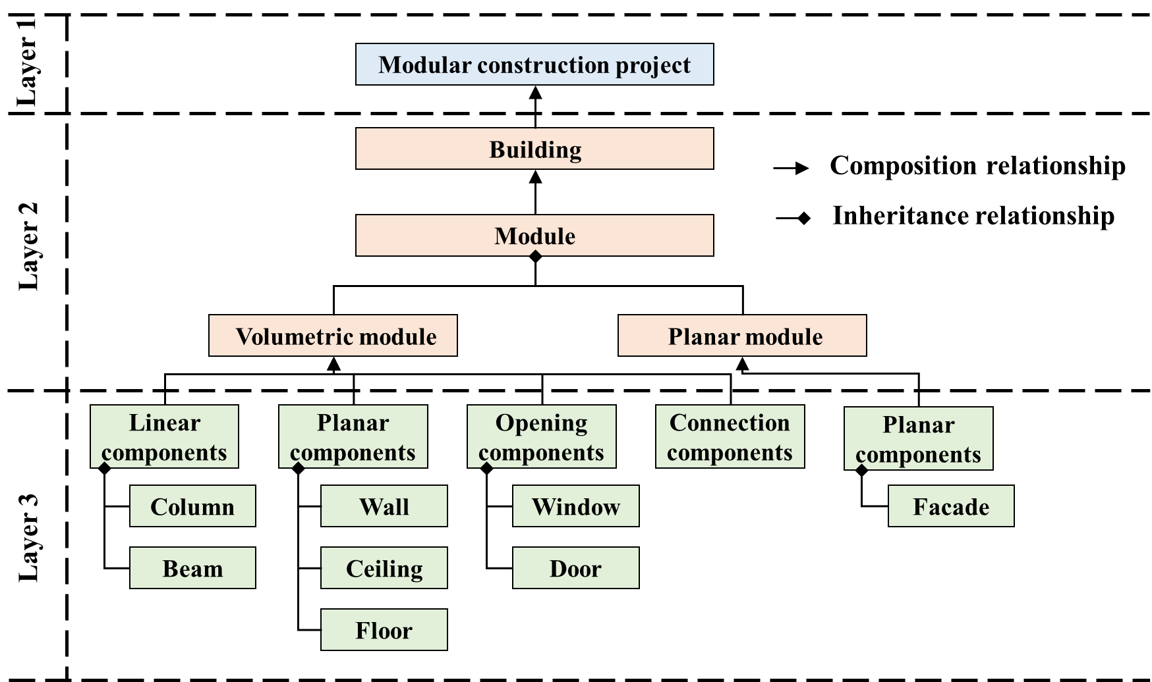
Figure 3. Generic hierarchy in modular construction projects
Based on the above hierarchy, a brainstorming session aimed at raising as much information as possible and the possible standard vocabulary for each piece of information is conducted by the authors. After synthesis and evaluation, there were 42 items of candidature information. The information was generally categorized into basic and additional information and organized in multiple lines (see Table 3). Basic information was derived from the three-layer hierarchy, while additional information was added because the authors considered that information about MC process, i.e., production, transport, and installation, was also critical to project management and described the component itself from another dimension. Detailed explanations of these items can be found in the Appendix.
Table 3. The organized candidate information
Category | Sub-category | Organized candidate information in multiple lines
Basic Information | Project Information (Layer 1) | <Owner>_<Contractor>_<Sub-contractor>_<Manufacturer>
Basic Information | Project Information (Layer 1) | <Project code>_<Project location>_<Project type>
Basic Information | Module Location (Layer 2) | <Block>_<Zone>_<Floor>_<Unit>_< Module ID>
Basic Information | Module Information (Layer 2) | <Module type>_<Module function description>_<Module structure type>_<Module dimensions>_<Module weight>_<Module quality inspection and test history and result>
Basic Information | Component Information (Layer 3) | <Component type>_<Component subtype>_<Component description>_<Sequential number>
Basic Information | Component Information (Layer 3) | <Component classification code>_<Component material>_<Component quality inspection and test history and result>
Additional Information | Production Information | <Factory code>_<Product acceptance date>
Additional Information | Production Information | <Mold type>_<Mold ID>_<Product sequential number>
Additional Information | Transport Information | <Transporter>_<Pickup location>_<Delivery location>_<Loading order>_<Unloading order>
Additional Information | Transport Information | <Transportation method>_<Protection method>_<Custom clearance status>
Additional Information | Installation Information | <On-site installation date>
Additional Information | Installation Information | <Installation crew>_<Inspector>_<Installation quality inspection and test history and result>

4.2 Formulating the naming convention
To ensure conformity, the information needs of name users or stakeholders were surveyed through questionnaire. After weeding out the invalid returns, we received 65 feedback from five types of stakeholders. Table 4 shows different stakeholders’ selection of information. Information with a selection rate above 50% was presented here mainly because it represents the needs of the majority. Different roles have different preferences regarding information in names. For example, owners pay much attention to module function description, while designers have special needs, e.g., for module structure type. Manufacturers underline the information about component material and module and component quality inspection and test history and result. Transporters require more information about logistics, such as loading and unloading order, and protection method. Contractors may focus on information about module location and installation quality inspection and test history and result.
Table 4. The information selection of different stakeholders
Layer | Candidate information | Owner (n=12) | Designer (n=14) | Manufacturer (n=12) | Transporter (n=11) | Contractor (n=16)
1 | Project code | 10 | 11 | 11 | 11 | 15
1 | Project location | 9 | 10 | 7 | 11 | 13
1 | Project type |  | -- | 9 | 8 | 12
1 | Owner | 6 | -- | -- | -- | --
2 | Module type | 12 | 14 | 12 | 9 | 16
2 | Module location | 12 | 13 | 9 | 7 | 16
2 | Module function description | 11 | 12 | 6 | -- | 13
2 | Module structure type | 6 | 11 | 10 | -- | 11
2 | Module dimensions | -- | 10 | 11 | 9 | 14
2 | Module weight | -- | -- | 8 | 11 | 14
2 | Module quality inspection and test history and result | -- | -- | 12 | -- | 13
3 | Component type | 11 | 13 | 12 | 9 | 13
3 | Component subtype | 10 | 12 | 7 | 7 | 10
3 | Component material | -- | 10 | 11 | -- | 8
3 | Component description | 6 | -- | -- | -- | --
3 | Component quality inspection and test history and result | 8 | -- | 12 | -- | 10
3 | Component classification code | -- | 8 | -- | -- | --
Additional | Product sequential number | -- | -- | 11 | -- | --
Additional | Product acceptance date | -- | -- | 10 | -- | --
Additional | Mold type | -- | -- | 10 | -- | --
Additional | Factory code | -- | -- | 9 | 7 | --
Additional | Mold ID | -- | -- | 9 | -- | --
Additional | Loading and unloading order | -- | -- | -- | 11 | --
Additional | Pickup location | -- | -- | -- | 10 | --
Additional | Delivery location | -- | -- | -- | 10 | --
Additional | Protection method | -- | -- | -- | 10 | --
Additional | Transportation method | -- | -- | -- | 9 | --
Additional | Custom clearance status | -- | -- | -- | 8 | --
Additional | Transporter | -- | -- | -- | 6 | --
Additional | Inspector | -- | -- | -- | -- | 15
Additional | Installation crew | -- | -- | -- | -- | 13
Additional | Installation quality inspection and test history and result | -- | -- | -- | -- | 13
Additional | On-site installation date | -- | -- | -- | -- | 11

For every layer, the commonly selected information with relatively high selection rate can be identified: project code (Layer 1), module type (Layer 2), and component type (Layer 3) (see Table 4). The choices of additional information vary greatly, and no commonly selected additional information can be obtained. The commonly selected information is the basis of a shared understanding among stakeholders about certain components, based on which our naming convention was developed. The convention should organized in a hierarchical form to show information from three layers (i.e., project-module-component). Each layer’s information should be unique to the upper-layer’s information that precedes it. To ensure such uniqueness, the module location and differentiator were added into the convention. Each module can occupy only one location, module location thus uniquely identifies modules under a project. The differentiator is used to differentiate components within a module and could contain sequential numbers or any description. With three commonly selected fields and two added fields, the proposed naming convention is shown in Table 5.
While the proposed naming convention stipulates the syntax of naming, a controlled vocabulary is still needed to ensure common understanding of names. According to Olson (2002), a controlled vocabulary is limited, with one and only one term for one concept. Benefits of these vocabularies include: (1) Recognizable abbreviations are likely to be developed to ensure names are concise; (2) Enhanced common understanding of stakeholders, alleviating confusion in project collaboration from unclear references; (3) Avoiding disorder in naming from simultaneously following different taxonomy systems; (4) No duplicate terms express the same concept so that the recall and accuracy of searching is improved. The suggested vocabulary is also presented in Table 5.
Table 5. The proposed naming convention and its suggested vocabulary
Naming convention
<Project code>_<Module type>_<Module location>_<Component type>_<Differentiator>
Suggested vocabulary
Project code | The project code should be a unique identifier, which could be derived from the consultancy agreement or construction contract.
Module type | The modules in a project can be classified into different types depending on the size and shape of the modules. Each module type could be labeled with a capital letter “M” followed by a sequential number, e.g., “M1”.
Module location | The module location indicates the information about block, zone, floor, unit, etc. It can be denoted by a string of alphanumeric characters in line with the specific project requirements.
Component type | The component type should indicate the general category based on the same classification system. Existing classification systems that can be used include OmniClass, Uniclass, UniFormat, IfcType, and others.
Differentiator | The differentiator could be either a sequential number or a description. The description should display different information from the above field in line with a few predefined rules.
The eight criteria guide the naming development to deliver an appropriate convention. Table 6 illustrates the measures that have been taken in this study to fulfill these criteria in the development. The proposed naming convention thus has sufficient benefits and successfully bridged physical components and their digital counterparts.
Table 6. Measures adopted to satisfy the criteria
Criteria | Measures adopted to satisfy the criteria
Uniqueness | Different information and differentiators were aggregated to ensure the concatenated names unique in the project.
Informativeness | Layered hierarchies were established to model the MC projects. Information from each layer was explicitly contained to enhance the meaning of names to humans.
Conformity | The information requirements from stakeholders were considered and the commonly selected information was used to formulate the naming convention.
Standardization | The naming convention and vocabularies were standardized and, subsequently, the naming process could be standardized with the help of the convention and vocabularies.
Relevancy | The external and irrelevant factors were not included so that the component names could remain persistent.
Accuracy | Controlled vocabularies were defined to ensure that these terms in vocabularies can describe the component exactly and accurately without ambiguity.
Extendibility | The hierarchical and aggregate form of names was adopted to ensure the naming convention can handle numerous items. The final field was user-defined, which also enables the convention to gain some extendibility.
Conciseness | The hierarchy of MC projects was divided into as few layers as possible (3 layers in this study). Thus, less information was mandatorily included. Moreover, controlled vocabularies were defined to allow abbreviation of terms.

4.3 Testing the proposed naming convention
The naming convention was evaluated by industrial stakeholders at policy and frontline level. The frontline-level evaluation focused on directly using the naming convention in a project to facilitate construction works, while the policy-level experts were focused on making a standard for MC and BIM, with naming an indispensable section.

4.3.1 Using the naming convention in the case project
The proposed naming convention was used in the selected case, an ongoing MC project located in Hong Kong. For example, a door component was assigned the name “XXX_M1_A09FS05_WD_N” (Figure 4(a)). The three-layer hierarchy project-module-component can be identified in this name:
(1) In the project layer (Layer 1), three capital letters were used as the project code with stakeholder agreement (Figure 4(b)). Here, the project code was substituted by “XXX” as requested by the project.
(2) For the module layer (Layer 2), five module types were identified in accordance with their three-dimensional sizes (Figure 4(c)), represented by “M1~M5”. In addition, the numbers of block, floor, and unit were concatenated to indicate the specific and unique location of the module (Figure 4(d)), e.g., “A09FS05”.
(3) The information from the component layer (Layer 3) included component type and differentiator. The OmniClass classification system was employed to display the component type due to local government recommendation and its ability to satisfy the project needs. Each OmniClass title uniquely corresponded to an abbreviation for conciseness. For example, the wood door (OmniClass number: 23-17 11 15) was abbreviated as “WD” (Figure 4(e)). Also, to distinguish the components of the same type in a module, differentiators were designed by customizing some rules and extracting information based on different component types. When the component was an opening component, e.g., door, the project chose its orientation as the differentiator. In the example, “N” means the door faces north.
Although the above example is for a door only, the proposed naming convention was applied to the whole project for communication amongst stakeholders, particularly for cross-border LSC management. Figure 4(f) shows the user interface of a customized mobile application (APP) to streamline the inspection workflow and visualize the project progress. All names in the APP ensured the mutual understanding of stakeholders and represented a unique reference for every component. Names thus demonstrated their usefulness in linking the physical components and their digital information and in facilitating project management.
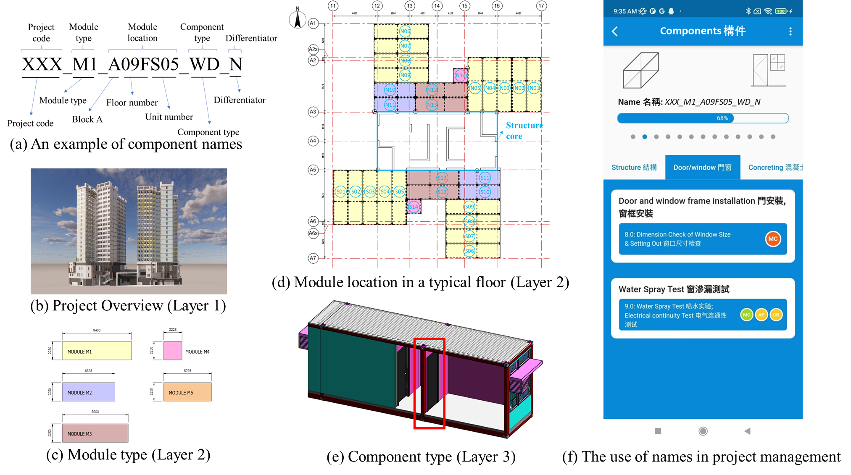
Figure 4. An example name of a door component following the proposed naming convention

4.3.2 Evaluating the naming convention with policymakers
Like the frontline stakeholders, policymakers from a Hong Kong statutory body also endorsed the importance of an operable naming convention. In the engagement at policy level, we first introduced the development process and applications of such a naming conventions, followed by a fruitful discussion. Their valuable comments were well incorporated in the convention. Beyond those very detailed comments, three main observations were made in the discussion. Firstly, policymakers lay much emphasis on the vocabularies. Standard vocabularies are key to the standardization of naming, which ensures every stakeholders to understand the meanings of names and direct to the right referents. Most of the comments they provided try to align the vocabularies to the local context. For example, local government has created and kept updating a lists of agent responsible codes for naming CAD files and layers, including almost all local parties or organizations related to construction, such as governments, consultants, and contractors. Moreover, the policymakers said, “the responsibility of localizing and maintaining a well-established component taxonomy with three-digit abbreviations for every item will be handed over to us”. They contended that the industry should make full use of these existing resources. While existing local vocabularies are not enough to cover every aspect of construction naming, the policymakers have shown great interest in developing and maintaining such controlled vocabularies. This could further improve the extensibility of the naming convention and increase the acceptance of the local industry.
Secondly, to consider the conciseness meanwhile maintaining a certain level of informativeness seems a consensus reached at the policy level with regards to names and naming of MC projects. These two criteria are to some extent contradictory. Different stakeholders need diversified information and it is impossible to incorporate all the relevant information in concise names. Taking only the basic requirements of stakeholders into account thus becomes possible solutions to balance conciseness and informativeness. Our prior experience with the frontline has provided good evidence materials for such solutions.
Thirdly, the relationship between standardization and extensibility also requires careful handling, which could be another contrary pair. In some scenarios, the convention needs enough standarization to be dictative, otherwise, the resulting names may be too varied to provide information ‘knobs’ with any form of uniformity to parties. In other scenarios, it needs to be democratic to allow users to have more flexibility in extending names for their construction use. Given this concern, our proposed naming convention stipulates the general form and standard vocabularis while retaining some extensibility by the last field, differentiator, which allows users to add their special information.
Overall, the development of the naming convention received positive feedback. Meanwhile, those policymakers also showed their prudent side when standing at a relatively high level within the industry. They said “your proposal is a very good reference for sharing, more industrial cases are needed before making statutory requirements”. Our developments will be first shared as reference materials to the industry in a local standard.

5 Discussion
This research was inspired by the construction industry’s widely expressed interest in an eligible naming convention. Currently, naming methods are just too diverse to allow efficient IM in construction. It is not too difficult to formulate a naming convention as similar provisions exist in many standards of BIM and construction management. However, the questions, why such conventions are made and how they can fit various types of projects, are still unclear. The client in the case study has expressed their need for a proper name more than once. This study thus takes MC projects as the starting point and aims at illustrating how a qualified naming convention is obtained. The naming convention was developed by learning from matured naming practices, e.g., in the human society, or in the digital world, and exploring from various stakeholder’s perspectives within the modular construction context.
This research makes several contributions. Firstly, it articulates the need for eligible names and naming standards for every single component amid the global trend towards sophisticated construction projects and adopting more international procurement strategies. Secondly, it links this need to the literature, e.g., on onomastics, naming in human society and digital world, and IQ, to make the assertion that naming in construction deserves more conscious considerations and synthesize these considerations into eight criteria for a ‘good’ name. Thirdly, it not only develops an applicable naming convention for MC projects, but also exhibits to readers the development process with industry. The three-level hierarchy of MC projects developed from Ramaji and Memari (2016) and the candidate information list brainstormed from this hierarchy are intended to enrich names with hierarchical information so that both relationship and individuality can be identified. The surveys on various stakeholders’ information requirements are to filter out the basic information and ensure the common understanding between stakeholders. The relationships between conciseness and informativeness, standardization and extensibility are carefully handled. On the way it is developed, all the processes are useful when other types of projects require naming conventions for components. Lastly, the design thinking method seems ideal for investigating topics in construction that cannot be addressed using traditional methods such as experiments.
This study has several limitations to be explored in future research. Firstly, the optimal level of components to be bestowed upon a name needs to be further investigated. Next, manually naming all the components in a large-scale construction project is tedious, costly, and error-prone (Williams et al., 2014). Automatic tools that can retrieve the names, annotate them, and check information correctness and completeness are highly desired. The research team tried to develop software tools but failed because of the incomplete information in BIM. This can be linked to the semantic enrichment literature (Belsky et al., 2016). It can be foreseen that such automatic naming tools will change the cost and convenience of inputting names. Lastly, the use of name for value-added applications (e.g., facilitating communication, LSC management, linking the cyber physical systems) is desired.

6 Conclusion
Names and naming are indispensable to perceiving and constructing our worlds, facilitating communication in complex scenarios, and managing the information explosion in the digital era. Despite its responsibility to materialize our physical infrastructure, naming occurs sporadically in construction. This research develops a component naming convention for modular construction (MC) projects that meets the criteria of uniqueness, informativeness, conformity, standardization, relevancy, accuracy, extendibility, and conciseness. The naming convention comprises five information field, i.e., project code, module type, module location, component type, and differentiator, each with detailed descriptions and vocabularies (e.g., OmniClass, UniClass). It meets practitioners’ requirements for a balance between informativeness and conciseness, and standardization and extensibility. Used persistently, it will help streamline existing naming practices, which are considered too diverse for efficient IM in real-life construction works.
The research also makes methodological contributions through its adoption of design thinking with its highly structured and interactive stages, each utilizing traditional methods such as literature review, survey, and case study. It is a powerful tool for achieving a new, highly creative research task (i.e., developing a naming convention for the construction sector) and needs close engagement with stakeholders (e.g., users or regulators of the naming convention). The research reports not only final results, but also reveals the interim processes and stakeholders’ concerns in developing the naming convention.
Future research is also needed in this area. Firstly, the less modular and hierarchical nature of traditional cast-in-situ construction may add complexity to its implementation in this context. Secondly, the benefits of having a comprehensive set of informative names are accompanied by the costs of keying in and maintaining them in a sizeable project with a multitude of components. Under this circumstance, an automatic or semi-automatic naming robot is desired to be developed.

Acknowledgment
The research is sponsored by the Hong Kong Innovation and Technology Commission (ITC) with the Innovation and Technology Fund (ITF) (No. ITP/029/20LP).

Data Availability Statement
Some or all data, models, or code that support the findings of this study are available from the corresponding author upon reasonable request.

References
Anderson, A., Marsters, A., Dossick, C. S., & Neff, G. (2012). Construction to Operations Exchange: Challenges of Implementing COBie and BIM in a Large Owner Organization Construction Research Congress 2012, West Lafayette.
ANZRSC. (2012). Australian and New Zealand Revit Standards. ANZRSC.
Audia, P. G., Locke, E. A., & Smith, K. G. (2000). The paradox of success: An archival and a laboratory study of strategic persistence following radical environmental change. Academy of management Journal, 43(5), 837-853. https://doi.org/10.5465/1556413
Baca, M. (2016). Introduction to metadata (3rd ed.). Getty Publications.
Belsky, M., Sacks, R., & Brilakis, I. (2016). Semantic enrichment for building information modeling. Computer‐Aided Civil and Infrastructure Engineering, 31(4), 261-274.
Bloomberg, M. R., Burney, D. J., & D., R. (2012). BIM Guidelines. Department of Design + Construction. Retrieved April 9, 2021 from http://www.nyc.gov/html/ddc/downloads/pdf/DDC_BIM_Guidelines.pdf
Boonpaisarnsatit, N. (2011). Names and Naming: Semiotic, Linguistic and Anthropological Perspectives. FEU Academic Review, 5(1), 5-20.
Bowen, G. A. (2009). Document Analysis as a Qualitative Research Method. Qualitative Research Journal, 9(2), 27-40. https://doi.org/10.3316/QRJ0902027
Brown, T. (2008). Design thinking. Harvard business review, 84(6), 84.
Brown, T., & Wyatt, J. (2010). Design thinking for social innovation. Development Outreach, 12(1), 29-43. https://doi.org/10.1596/1020-797X_12_1_29
BSI. (2012). Library objects for architecture, engineering and construction. Identification and classification - code of practice (BS 8541-1:2012). BSI. Retrieved April 9, 2021 from https://www.thenbs.com/PublicationIndex/documents/details?Pub=BSI&DocId=301198
Cahn, R. S., & Dermer, O. C. (2013). Introduction to chemical nomenclature. Butterworth-Heinemann.
Chen, K., Lu, W., Wang, H., Niu, Y., & Huang, G. G. (2017). Naming objects in BIM: A convention and a semiautomatic approach. Journal of construction engineering and management, 143(7), 06017001. https://doi.org/10.1061/(ASCE)CO.1943-7862.0001314
Choi, J., Leite, F., & De Oliveira, D. P. (2018). BIM-based benchmarking system for healthcare projects: Feasibility study and functional requirements. Automation in Construction, 96, 262-279. https://doi.org/10.1016/j.autcon.2018.09.015
Dannewitz, C., Golic, J., Ohlman, B., & Ahlgren, B. (2010). Secure naming for a network of information 2010 INFOCOM IEEE conference on computer communications workshops, San Diego, CA, USA.
Duval, E., Hodgins, W., Sutton, S., & Weibel, S. L. (2002). Metadata principles and practicalities. D-lib Magazine, 8(4), 1-10. https://doi.org/10.1045/april2002-weibel
Frege, G. (1948). Sense and reference. The philosophical review, 57(3), 209-230. https://doi.org/10.2307/2181485
Gandhi, S., & Jupp, J. (2014). BIM and Australian green star building certification 2014 International Conference on Computing in Civil and Building Engineering Orlando, Florida, United States.
Ghodsi, A., Koponen, T., Rajahalme, J., Sarolahti, P., & Shenker, S. (2011). Naming in content-oriented architectures. ACM SIGCOMM workshop on Information-centric networking, Toronto, Ontario, Canada.
Goedert, J. D., & Meadati, P. (2008). Integrating construction process documentation into building information modeling. Journal of construction engineering and management, , 134(7), 509-516. https://doi.org/10.1061/(ASCE)0733-9364(2008)134:7(509)
Hallowell, M. R., & Gambatese, J. A. (2010). Qualitative research: Application of the Delphi method to CEM research. Journal of construction engineering and management, 136(1), 99-107.
HKCIC. (2019). Production of BIM Object Guide - General Requirements. HKCIC. Retrieved April 9, 2021 from https://www.bim.cic.hk/en/resources/publications_detail/65
HKCIC. (2020). What is MiC? Retrieved April 9, 2021 from http://mic.cic.hk/en/AboutMiC
HKNWCON. (2016). BIM Standard – Standard Method of Modelling (SMM). New World Construction Company Limited.
Hofmann, T. R. (2013). Realms of meaning: An introduction to semantics. Routledge.
ISO. (1998). ISO 4157-1:1998 Construction drawings — Designation systems — Part 1: Buildings and parts of buildings. Retrieved April 9, 2021 from https://www.iso.org/standard/26189.html
Jacobson, V., Smetters, D. K., Thornton, J. D., Plass, M. F., Briggs, N. H., & Braynard, R. L. (2009). Networking named content. 5th international conference on Emerging networking experiments and technologies, Rome, Italy.
Kang, T. W., & Choi, H. S. (2015). BIM perspective definition metadata for interworking facility management data. Advanced Engineering Informatics, 29(4), 958-970. https://doi.org/10.1016/j.aei.2015.09.004
Kripke, S. A. (1972). Naming and Necessity. In D. D. & H. G. (Eds.), Semantics of Natural Language. Springer. https://doi.org/10.1007/978-94-010-2557-7_9
Kruth, J. G. (2015). Five qualitative research approaches and their applications in parapsychology 1. The Journal of Parapsychology, 79(2), 219.
Lawson, M., Ogden, R., & Goodier, C. (2014). Design in modular construction. CRC Press.
Lee, J. K., Lee, J., Jeong, Y. S., Sheward, H., Sanguinetti, P., Abdelmohsen, S., & Eastman, C. M. (2012). Development of space database for automated building design review systems. Automation in Construction, 24, 203-212. https://doi.org/10.1016/j.autcon.2012.03.002
Li, C. Z., Hong, J., Xue, F., Shen, G. Q., Xu, X., & Mok, M. K. (2016). Schedule risks in prefabrication housing production in Hong Kong: a social network analysis. Journal of Cleaner Production, 134, 482-494. https://doi.org/10.1016/j.jclepro.2016.02.123
Loizides, A. (2014). Mill's A System of Logic: Critical Appraisals. Routledge.
Lu, W., Xu, J., & Söderlund, J. (2020). Exploring the Effects of Building Information Modeling on Projects: Longitudinal Social Network Analysis. Journal of construction engineering and management, 146(5), 04020037.
Lu, W. S., Chen, K., Xue, F., & Pan, W. (2018). Searching for an optimal level of prefabrication in construction: An analytical framework. Journal of Cleaner Production, 201, 236-245. https://doi.org/10.1016/j.jclepro.2018.07.319
NATSPEC. (2018). Open BIM Object Standard (OBOS). Retrieved April 9, 2021 from https://bim.natspec.org/images/NATSPEC_Documents/OBOS_V1.0_2018.pdf
NBS. (2019). NBS BIM Object Standard v2.1. Retrieved April 9, 2021 from https://www.nationalbimlibrary.com/en/nbs-bim-object-standard/
Noor, K. B. M. (2008). Case study: A strategic research methodology. American journal of applied sciences, 5(11), 1602-1604. https://doi.org/10.3844/ajassp.2008.1602.1604
Ogden, C. K., & Richards, I. A. (1923). The meaning of meaning: A study of the influence of thought and of the science of symbolism. Harcourt, Brace & World, Inc.
Olson, H. A. (2002). The power to name: locating the limits of subject representation in libraries. Springer Science & Business Media. https://doi.org/10.1007/978-94-017-3435-6
Pan, Y., & Zhang, L. (2021). A BIM-data mining integrated digital twin framework for advanced project management. Automation in Construction, 124, 103564.
Paskin, N. (2006). Naming and meaning of Digital Objects. 2nd International Conference on Automated Production of Cross Media Content for Multi-channel Distribution, UK.
Pinsonneault, A., & Kraemer, K. (1993). Survey Research Methodology in Management Information Systems: An Assessment. Journal of Management Information Systems, 10(2), 75-105. https://doi.org/10.1080/07421222.1993.11518001
Putman, V. L., & Paulus, P. B. (2009). Brainstorming, Brainstorming Rules and Decision Making. The Journal of Creative Behavior, 43(1), 29-40. https://doi.org/10.1002/j.2162-6057.2009.tb01304.x
Quinn, C., Shabestari, A. Z., Misic, T., Gilani, S., Litoiu, M., & McArthur, J. (2020). Building automation system-BIM integration using a linked data structure. Automation in Construction, 118, 103257.
Ramaji, I. J., & Memari, A. M. (2016). Product architecture model for multistory modular buildings. Journal of construction engineering and management, 142(10), 04016047. https://doi.org/10.1061/(ASCE)CO.1943-7862.0001159
Shafiq, M. T., Matthews, J., & Lockley, S. R. (2012). Requirements for model server enabled collaborating on building information models. International Journal of 3-D Information Modeling (IJ3DIM), 1(2), 8-17. https://doi.org/10.4018/ij3dim.2012100102
Smith, R. E. (2016). Off-Site Construction Implementation Resource: Off-site and modular construction explained. N. I. o. B. Sciences.
Snyder, H. (2019). Literature review as a research methodology: An overview and guidelines. Journal of Business Research, 104, 333-339. https://doi.org/10.1016/j.jbusres.2019.07.039
Stevenson, A. (2010). Oxford dictionary of English. Oxford University Press, USA.
Taylor, J. E. (2007). Antecedents of successful three-dimensional computer-aided design implementation in design and construction networks. Journal of construction engineering and management, 133(12), 993-1002. https://doi.org/10.1061/(ASCE)0733-9364(2007)133:12(993)
USC. (2012). Building Information Modeling (BIM) Guidelines (version 1.6). USC Capital Construction Development and Facilities Management Services. Retrieved April 9, 2021 from https://facilities.usc.edu/uploads/documents/cas/BIMGuidelines_VS1_6_2012.pdf
USGSA. (2019). BIM Technical Standards: Parametric Components. US General Services Administration. Retrieved April 9, 2021 from https://www.gsa.gov/real-estate/design-construction/3d4d-building-information-modeling/guidelines-for-bim-software/guidelines/technical-standards/bim-technical-standards-parametric-components
Wang, R. Y., & Strong, D. M. (1996). Beyond accuracy: What data quality means to data consumers. Journal of Management Information Systems, 12(4), 5-33.
Wilkinson, S. (1998). Focus group methodology: a review. International journal of social research methodology, 1(3), 181-203.
Williams, G., Gheisari, M., & Irizarry, J. (2014). Issues of Translating BIM for Mobile Augmented Reality (MAR) Environments Construction Research Congress 2014, Atlanta.
Xu, J., Ye, M., Lu, W., Bao, Z., & Webster, C. (2021). A four-quadrant conceptual framework for analyzing extended producer responsibility in offshore prefabrication construction. Journal of Cleaner Production, 282, 124540.
Yuan, X., & Anumba, C. J. (2020). Cyber-Physical Systems for Temporary Structures Monitoring. In Cyber-Physical Systems in the Built Environment (pp. 107-138). Springer.
Zhai, Y., Chen, K., Zhou, J. X., Cao, J., Lyu, Z., Jin, X., Shen, G. Q. P., Lu, W., & Huang, G. Q. (2019). An Internet of Things-enabled BIM platform for modular integrated construction: a case study in Hong Kong. Advanced Engineering Informatics, 42, 100997. https://doi.org/10.1016/j.aei.2019.100997

PhD student, Department of Real Estate and Construction, Faculty of Architecture, The University of Hong Kong, Hong Kong, China. Email: waseljf@connect.hku.hk
Professor, Department of Real Estate and Construction, Faculty of Architecture, The University of Hong Kong, Hong Kong, China. Email: wilsonlu@hku.hk
Post-Doctoral Fellow, Department of Real Estate and Construction, Faculty of Architecture, The University of Hong Kong, Hong Kong, China. Email: drjyxu@hku.hk (Corresponding author)
Post-Doctoral Fellow, Department of Real Estate and Construction, Faculty of Architecture, The University of Hong Kong, Hong Kong, China. Email: xl1991@hku.hk
Engineer (Data Scientist), WSP (Asia) Limited. Kowloon, Hong Kong, China. Email: Jing.Wang@wsp.com. * Corresponding author

