In-situ measurement of plastic strain in martensite matrix induced by austenite-to-martensite transformation
Y.Z. Li, M. Wang, M.X. Huang*
Department of Mechanical Engineering, The University of Hong Kong, Pokfulam Road, Hong Kong, China
*Corresponding author, email: mxhuang@hku.hk

Abstract
Employing in-situ tensile test under scanning electron microscope and micro-scale digital image correlation, the present work, for the first time, measures quantitatively the plastic strain in the martensite matrix that is induced by the martensitic transformation of retained austenite. The plastic strain is rationalized as a consequence of the large internal stresses triggered by the volume change associated with the martensitic transformation. The in-situ experimental evidence indicates that the energy barrier or the free energy change associated with martensitic transformation transformation may need modifications to explicitly consider the associated plastic strain energy in the matensite matrix.
Keywords: Mechanically induced martensitic transformation; Q&P steel; Stress assisted transformation; Micro-DIC; Model

Increasing demand in automotive industries for developing the third-generation advanced high strength steels (AHSSs) has been driven by the pursuit to further reduce carbon emission [1]. The third-generation AHSSs, such as the medium manganese steels and the quenching and partitioning (Q&P) steels [2], exhibit an improved combination of strength and ductility due to the mechanically induced martensitic transformation (MIMT) of the retained austenite.
The kinetics of MIMT has aroused considerable interests during the past decades, but few existing models are consistent with all the experimental observations. Olson and Cohen [3] proposed a popular one by assuming that the dislocations generated during the plastic deformation in the austenite can promote the nucleation of martensite, and this has become the foundation for the strain-induced martensitic transformation model. On the other hand, Tamura [4] suggested that MIMT is driven by stress rather than plastic strain and proposed a stress-induced transformation model based on the concept of the mechanical driving force raised by Patel and Cohen [5]. In this stress-assisted model, the austenite (γ)-to-martensite (α’) transformation is expected to occur until the chemical and non-chemical free energies associated with martensitic transformation reach a balance [6]. The non-chemical free energy change due to martensitic transformation has been formulated to include primarily the surface energy increment and the elastic strain energy stored in the fresh martensite, whereas the internal stresses and the associated micromechanical responses of the surrounding martensite matrix have largely been ignored. In fact, the effect of internal stresses on martensitic transformation has been theoretically described [7] and has been indirectly supported by some experiments [8, 9], but further validation of this idea requires direct experimental evidences which are still lacking. Prompted by such a limitation, here we employed a high-resolution microscopic digital image correlation (µ-DIC) technique to capture the local plastic strains of a typical region undergoing the MIMT during tensinle test of a Q&P 1500 steel. It was found that the volume expansion due to MIMT causes a considerable reverse plastic deformation of the adjacent martensite matrix, thus serving as a direct evidence for the strong internal stresses and the associated extra plastic strain energy. Such an additional plastic strain energy may serve as an extra energy barrier to the martensitic transformation. The result seems to confirm that the formalization of the energy criterion for the stress-assisted MIMT may be further improved by incorporating this observed phenomenon.
The Q&P 1500 steel investigated in this work, with a chemical composition of Fe-3Mn-1.5Si-0.3C (wt. %), was provided by Ansteel (China) in the form of 1.18 mm thick sheets. Two types of dog-bone shaped rectangular specimens, with gauge dimensions of 32 mm × 6 mm for the normal tensile tests, and 7.8 mm × 3 mm for the µ-DIC experiments, were cut from the sheets by electrical discharge machining, and the loading direction for all the tensile specimens were parallel to the rolling direction. Uniaxial tensile tests were performed at room temperature and at a constant strain rate of 10⁻³ s⁻¹ using the MTS 810 testing system. An Epsilon Model 3542 extensometer with 25 mm gauge length was used to measure the engineering strain. The surface of the in-situ tensile specimens was prepared by electro-polishing using a solution of 25 % perchloric acid and 75 % ethanol (vol. %) at room temperature after mechanical polishing. A square array of evenly spaced low-load Vickers indentations with 500 µm neighboring distance were made on the in-situ tensile specimens. The initial microstructure of the electro-polished specimens was characterized by scanning electron microscopy (SEM) and electron backscatter diffraction (EBSD) using Zeiss Sigma 300 at 5 kV and 20 kV, respectively. X-ray diffraction (XRD) measurements were performed on a laboratory Rigaku diffractometer using Co Kα radiation with a wavelength of 0.179 nm. Colloidal silica nanoparticles were dispersed onto the in-situ specimen surface to form speckle patterns, which enabled the mapping of local strains at the microscopic level with high spatial resolutions. The µ-DIC experiments were performed by in-situ tensile tests on a Kammrath & Weiss in-situ tensile stage located inside the Zeiss Sigma 300 SEM chamber. The mechanical loading was conducted under displacement control with a constant crosshead speed of 3 μm/s. The global engineering strains of the in-situ specimen were determined by measuring the distance between the neighboring indentations. Secondary electron (SE) image mode was applied under an operating voltage of 3 kV to optimize the image resolution. SE images for the fixed region of interest were captured at various strain levels. The recorded images were used for Von Mises equivalent microstrain analysis using the commercial software GOM Correlate [10]. For this microstrain analysis, the facet size and the facet overlap were determined as 150 nm and 40 %, respectively, for optimizing the accuracy without losing the computation of surface component.
The Q&P steel possesses a dual-phase microstructure in which the retained austenite is distributed in the matrix of martensite, as shown in Fig. 1a. The retained austenite is found to be mostly film-like (inset in Fig. 1a), and the thickness is several hundred nanometers. The dual-phase microstructure is also confirmed by the XRD patterns showing both the γ phase and the α’ phase reflections of the initial sample, as given in Fig. 1b. The significant decrease in the intensity of the γ peaks for the sample strained to 5 %, compared with the initial sample, indicates that the majority of the retained austenite has been transformed into the fresh martensite at the early stage of deformation. Fig. 2 shows the room-temperature engineering stress-strain curve of the Q&P steel measured at 10⁻³ s⁻¹. The yield strength (0.2 % offset) and the ultimate tensile strength are measured to be 1140 MPa and 1457 MPa, respectively, and the uniform elongation is determined as 17 %. A serrated flow is evident on a portion of the stress-strain curve, due to the dynamic strain aging (DSA) effect caused by the continuous unpinning of dislocations from the Cottrell atmosphere [11], which is common in carbon-added alloys with body-centered cubic (bcc) crystal structures. Based on the XRD profiles of samples strained to various levels, the volume fraction of the retained austenite as a function of engineering strain has been calculated and shown in Fig. 2, suggesting that more than 50 % of the retained austenite has been transformed to the fresh martensite after a small strain of 5%.
In-situ tensile tests under SEM were conducted to further investigate the micromechanical behavior of MIMT during the rapid martensitic transformation process occurred at small strains (e.g. less than 5 %). A fixed rectangular region of interest with a dimension of 17 × 17 µm² under SEM is selected (Fig. 3a, Fig. 4a₁), and its corresponding EBSD phase map is shown in Fig. 4a₂. The area fraction of the retained austenite in this region is measured to be ~ 21 %, consistent with the XRD result. Some regions are dominated by coarse retained austenite grains, and typical ones are marked by the green solid circles in Fig. 4a₂. These retained austenite grains divide the martensite matrix into several isolated areas (white dashed circles in Fig. 3c) that are of particular interest for analyzing the local strain evolution. In terms of creating speckle patterns that are key for capturing the displacement fields and forming the micro-strain maps, the most popular approach suggests the direct use of the contrast of microstructures such as interfaces and boundaries [12-14]. Although this approach may provide localized strains in a relatively large area, its resolution may not be high enough to resolve the micro-strains inside a micro-sized feature [15]. To solve this problem, the sample surface was deposited with randomly distributed colloidal silica particles with an average size of ~ 50 nm and with a high contrast to track the displacement field of this region during the in-situ tensile test, as demonstrated in Fig. 3b. This artificial patterning method has several advantages over other commonly used patterning techniques [16, 17], including: (i) no damage on the microstructure as compared with focused ion beam (FIB) milling, (ii) much higher efficiency than the lithography method, and (iii) no heat treatment involved as compared with vapor deposition method [15]. The EBSD phase map of the same region at the final global strain of 4 % was shown in Fig. 4e. The comparison indicates that about half of the retained austenite transformed into the martensite, consistent with the XRD result shown in Fig. 2.
Figs. 4c, d exhibit the micro-strain maps of the studied region (Figs. 3a, 4a₁, 4a₂) at different global engineering strains. At each global strain, SEM scanning was performed at a complete unloading state to eliminate the superimposed elastic micro-strains caused by the externally applied load. It is clearly observed from Figs. 4c, d that the strain distributions are inhomogeneous. The perfect match between the retained austenite region (blue color in Fig. 4a₂) and the region with concentrated strains (Fig. 4c₁) at 0.6 % global strain suggests that the yielding of the Q&P 1500 steel is achieved dominantly by the microplasticity of the retained austenite rather than the martensite. Since the retained austenite is not fully transformed into the fresh martensite at this stage, the microplasticity can be attributed to the dislocation plasticity of the retained austenite in addition to its possible transformation-induced plasticity, owing to the lower yield strength of the retained austenite than that of the surrounding martensite phase. This localized plasticity becomes increasingly obvious at the global strain of 1.9 %, as shown in Fig. 4c₂, and the plastic strains in the martensite regions (white dashed circles) remain low. At the global strain of 3.5 %, plasticity in the martensite phase can be identified by the positive strain values of the martensite regions indicated by the white dashed circles in Fig. 4d₁, suggesting that the load at this stage has been successfully transferred from the austenite to the martensite. Interestingly, when the specimen is further deformed with small global strain increments, the positive strain values in these martensite regions decrease (Fig. 4d₂, 4d₃). Based on these µ-DIC results, the average von Mises equivalent strains in the seven martensite regions as a function of global strains are summarized in Fig. 4b. Of particular interest here is the stage of reverse plasticity marked by an obvious decrease of local strains with further global straining ≥ 3.5 %, which is in contrast to the normal plasticity behavior of the martensite matrix occurred at small global strains. The magnitude of the local strains in the martensite regions during the reverse plasticity are beyond the elastic range (Fig. 4b), suggesting that these martensite regions undergo plastic compression rather than the relaxation of elastic strains. To investigate the mechanism for this interesting phenomenon, the EBSD phase map (Fig. 4e) of the same region at the global strain of 4 % is obtained, demonstrating that the film-like retained austenite (green solid circles in Fig. 4a₂), which initially surround the martensitic regions, has partially been transferred to the fresh martensite (Fig. 4e). It may thus be concluded that the observed compression of the martensite matrix during the tensile straining is caused by the volume expansion of austenite-to-martensite transformation and the associated internal stresses with compressive stress components. The amount of extra plastic strain energy accompanied by such additional compressive plastic deformation may serve as an additional energy barrier to the ongoing MIMT process. This finding suggests that the martensitic transformation model may need further modifications to consider the observed reverse compression effect.
In general, the martensitic transformation is described by a process called the Bain distortion [18]. The energy barrier ${ΔG}^{γ→α’}$, or the free energy change per unit volume associated with martensitic transformation, is expressed as [6]
 | $${ΔG}^{γ→α’}={ΔG}_{C}^{γ→α’}+{ΔG}_{NC}^{γ→α’}$$ | (1)
where ${ΔG}_{C}^{γ→α’}<0$ is the change of chemical free energy which serves as the driving force for martensitic transformation, and ${ΔG}_{NC}^{γ→α’}>0$ is the non-chemical free energy change opposing the transformation from austenite to martensite. The second term ${ΔG}_{NC}^{γ→α’}$ has traditionally been considered to primarily consist of the interfacial energy change ${ΔG}_{INT}^{γ→α’}$ due to the newly created $γ/α’$ interfaces and the change in elastic strain energy ${ΔG}_{E}^{γ→α’}$ due to the shear associated with the Bain transformation, i.e.,
 | $${ΔG}_{NC}^{γ→α’}={ΔG}_{INT}^{γ→α’}+{ΔG}_{E}^{γ→α’}$$ | (2)

The detailed expressions of ${ΔG}_{INT}^{γ→α’}$ and ${ΔG}_{E}^{γ→α’}$ for an ellipsoidal martensite plate can be found in [19, 20]. Here, based on the present experimental observation, the non-chemical component of the free energy change can be reasonably modified to include the extra energy barrier ${ΔG}_{P}^{γ→α’}$ induced by the reverse compression of the martensite matrix as
 | $${ΔG}_{NC}^{γ→α’}={ΔG}_{INT}^{γ→α’}+{ΔG}_{E}^{γ→α’}+{ΔG}_{P}^{γ→α’}$$ | (3)
where ${ΔG}_{P}^{γ→α’}>0$ is the change of the plastic strain energy. This positive value of ${ΔG}_{P}^{γ→α’}$ indicates that the observed compressive plastic deformation of the martensitic matrix always serves as a resistance to the martensitic transformation of retained austenite. In other words, the observed plasticity of the surrounding martensite matrix associated with MIMT may enhance the mechanical stability of the retained austenite, which is a major factor controlling the overall mechanical response of the current Q&P 1500 steel. It is thus proposed that the stability of retained austenite depends not only on the well-known factors such as local carbon content [21] and the grain size [22] but also on the surrounding martensite phase. This is in accord with the previous studies [8, 9] based on indirect experimental evidence.
In conclusion, this work presents for the first time the direct experimental evidence of the reverse plastic deformation of the martensite matrix during the tensile straining of a Q&P 1500 steel, owing to the internal stresses associated with the MIMT of the surrounding retained austenite. The observed reverse plasticity of the martensite matrix requires an additional plastic strain energy, thus leading to the increase of the energy barrier for MIMT and enhancing the mechanical stability of the retained austenite. This direct experimental evidence indicates that the existing energy criterion for the stress-induced martensitic transformation may be further modified to incorporate the reverse plasticity of the surrounding martensite.
Acknowledgment
M.X. Huang acknowledges the financial support from the National Key Research and Development Program of China (No. 2019YFA0209900) National Natural Science Foundation of China (No. U1764252), Research Grants Council of Hong Kong (No. R7066-18, 17255016), and Guangzhou Municipal Science and Technology Project (No.201907010011).

Reference
[1] D.K. Matlock, J.G. Speer, Microstructure and texture in steels, Springer2009, pp. 185-205.
[2] J.G. Speer, F.C.R. Assunção, D.K. Matlock, D.V. Edmonds, Materials Research 8(4) (2005) 417-423.
[3] G. Olson, M. Cohen, Metallurgical transactions A 6(4) (1975) 791.
[4] I. Tamura, Metal Science 16(5) (1982) 245-253.
[5] J. Patel, M. Cohen, Acta metallurgica 1(5) (1953) 531-538.
[6] H. Bhadeshia, C. Wayman, Physical metallurgy, Elsevier2014, pp. 1021-1072.
[7] Q. Meng, Y. Rong, T. Hsu, Metallurgical and Materials Transactions A 37(5) (2006) 1405-1411.
[8] P. Jacques, F. Delannay, J. Ladrière, Metallurgical and materials transactions A 32(11) (2001) 2759-2768.
[9] I. Timokhina, P. Hodgson, E. Pereloma, Metallurgical and Materials Transactions A 35(8) (2004) 2331-2341.
[10] GOM, GOM Correlate, https://www.gom.com/3d-software/gom-correlate.html. (Accessed November 5, 2020).
[11] R. Picu, Acta Materialia 52(12) (2004) 3447-3458.
[12] J. Kang, Y. Ososkov, J.D. Embury, D.S. Wilkinson, Scripta Materialia 56(11) (2007) 999-1002.
[13] H. Ghadbeigi, C. Pinna, S. Celotto, J. Yates, Materials Science and Engineering: A 527(18-19) (2010) 5026-5032.
[14] M. Kapp, T. Hebesberger, O. Kolednik, International journal of materials research 102(6) (2011) 687-691.
[15] D. Yan, C.C. Tasan, D. Raabe, Acta Materialia 96 (2015) 399-409.
[16] P. Shade, M. Groeber, M. Uchic, R. Wheeler, Microscopy and Microanalysis 18(S2) (2012) 720.
[17] W. Scrivens, Y. Luo, M.A. Sutton, S. Collette, M.L. Myrick, P. Miney, P. Colavita, A.P. Reynolds, X. Li, Experimental Mechanics 47(1) (2007) 63-77.
[18] S. HAR, H. SOHN, Fundamentals of Metallurgy (2005) 270.
[19] J. Christian, Acta Metallurgica 6(5) (1958) 377-379.
[20] M. Cohen, C.M. Wayman, Metallurgical treatises (1981) 445-468.
[21] R. Blondé, E. Jimenez-Melero, L. Zhao, J. Wright, E. Brück, S. Van der Zwaag, N. Van Dijk, Acta Materialia 60(2) (2012) 565-577.
[22] E. Jimenez-Melero, N. Van Dijk, L. Zhao, J. Sietsma, S. Offerman, J. Wright, S. Van der Zwaag, Scripta Materialia 56(5) (2007) 421-424.

Figures
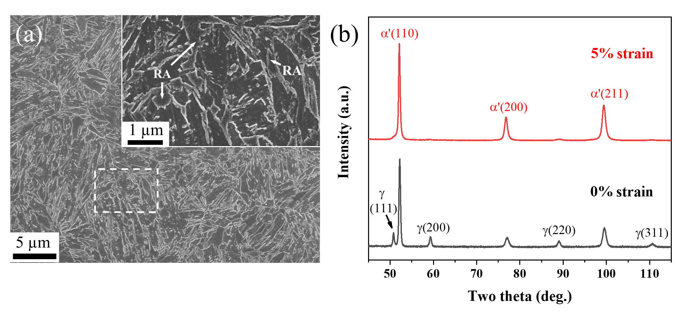
Figure 1. (a) SEM image of the as-received Q&P 1500 steel. The inset corresponding to the magnified view of the dashed rectangle shows the morphology of the retained austenite (RA). (b) XRD diffraction patterns of the Q&P 1500 steel showing the loss of austenite peak intensity with increasing tensile straining.

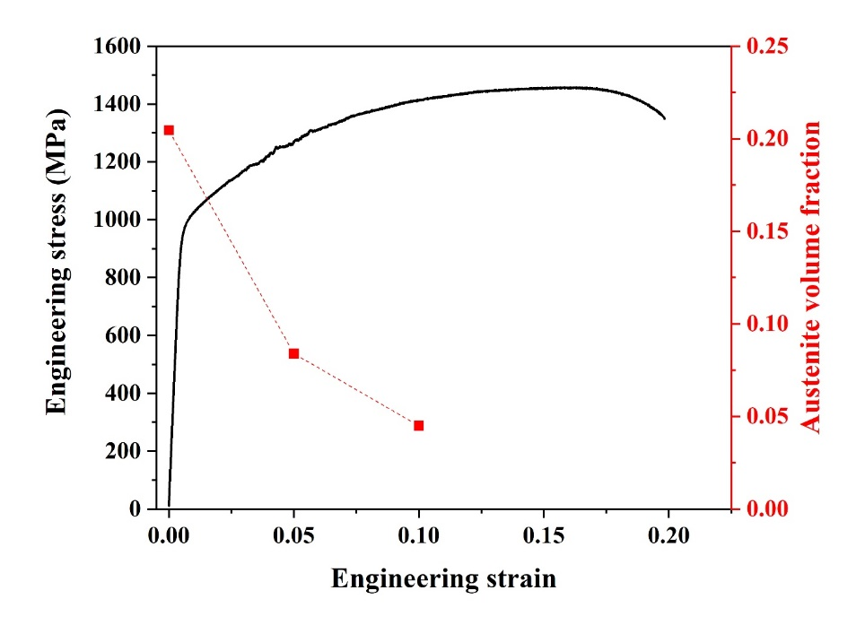
Figure 2. Room-temperature engineering stress-strain curve of the Q&P 1500 steel measured at 10⁻³ s⁻¹ (black) and the corresponding evolution of volume fraction of the retained austenite (red).

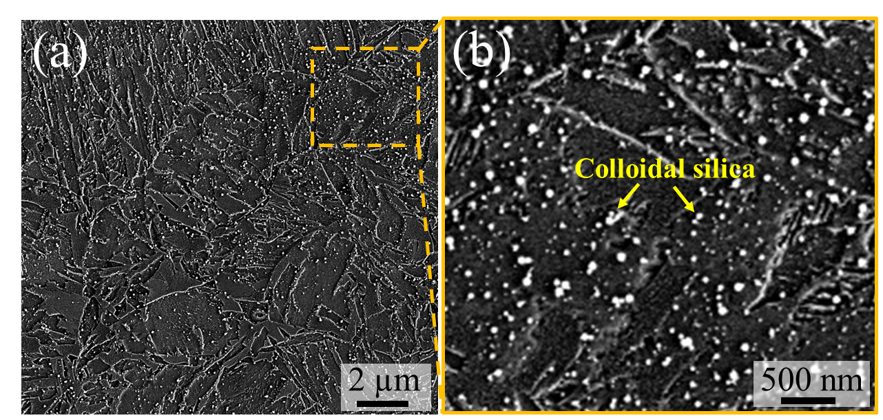
Figure 3. (a) SEM image of the fixed region prior to the deformation for local strain measurement during the in-situ tensile straining. (b) Magnified view of the dashed rectangle in (a) showing the colloidal silica particles serving as artificial speckle patterns.

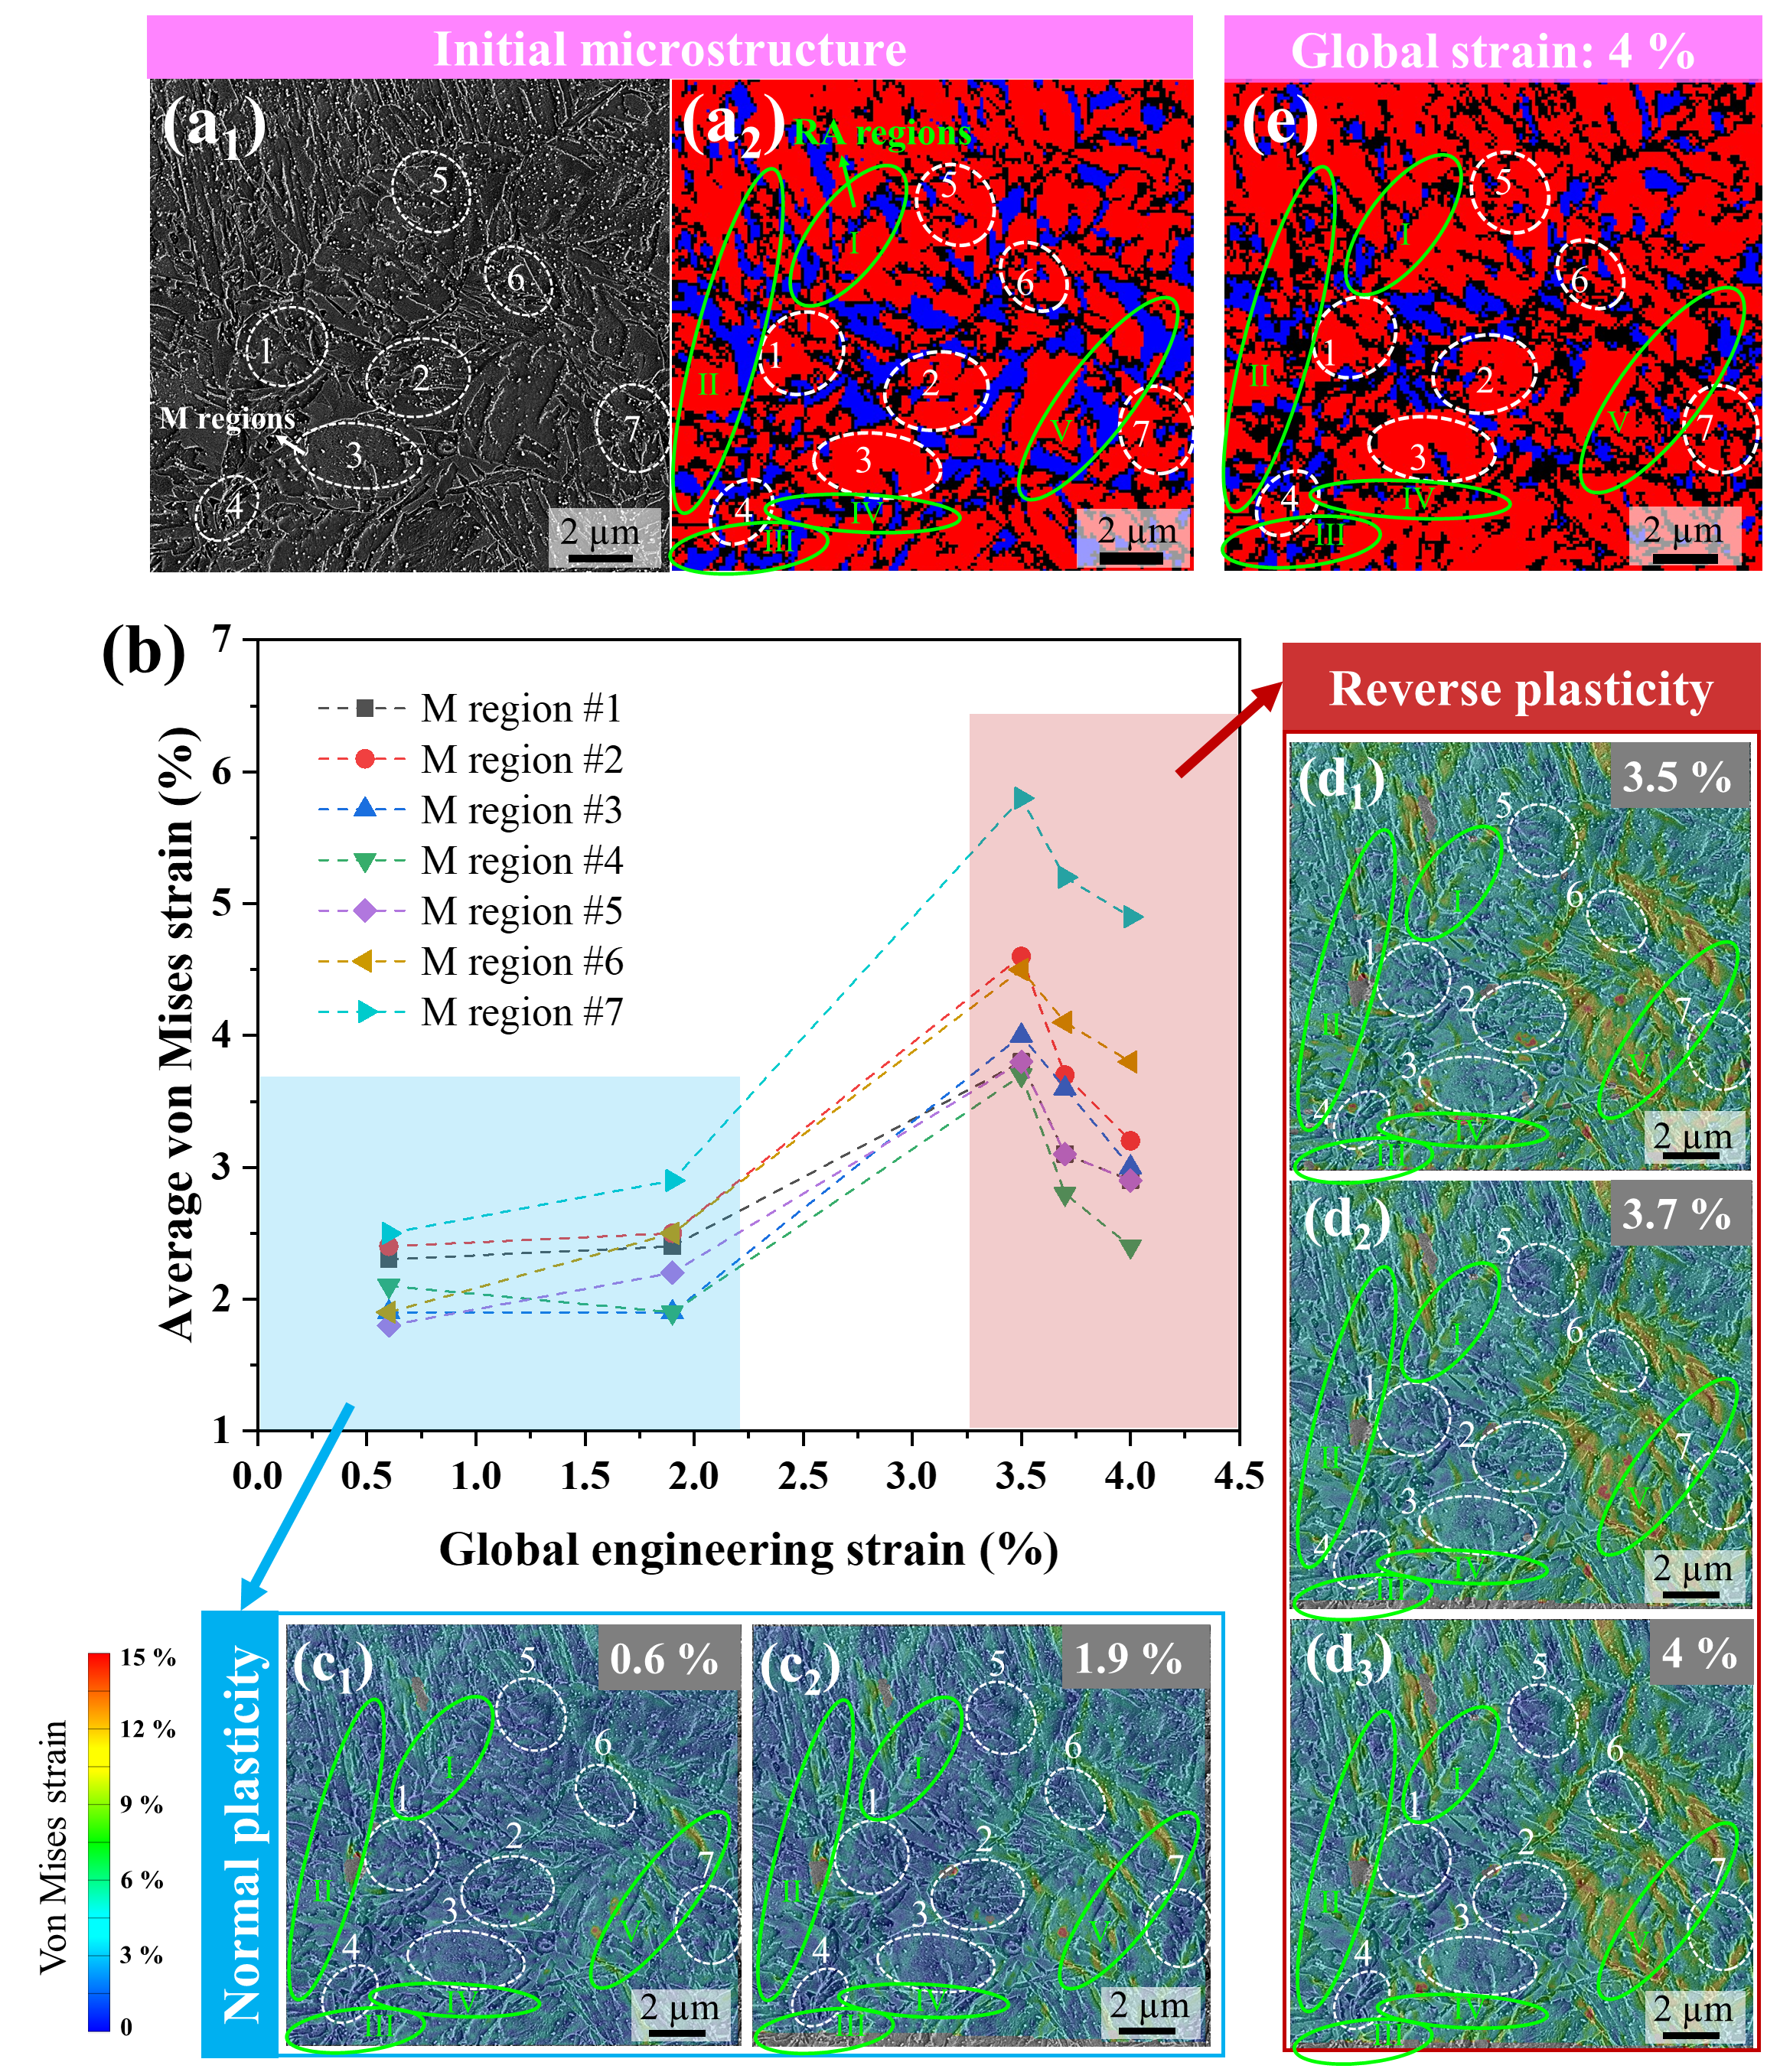
Figure 4. (a) SEM image (a₁) and EBSD phase map (a₂) of the initial microstructure of the fixed region in Figure 3(a). The martensite (M) regions and the retained austenite (RA) regions are marked by the white dashed circles and the green solid circles, respectively. In the EBSD phase map, austenite is in blue and martensite is in red. (b) The evolution of the average von Mises equivalent strains in the martensite regions with the change of global strains. (c) The microstrain maps at the global strain of 0.6 % (c₁) and 1.9 % (c₂), showing the concentrated plasticity at the regions dominated by the retained austenite. (d) The microstrain maps at the global strain of 3.5 % (d₁), 3.7 % (d₂), and 4 % (d₃), showing reverse plastic deformation in the martensite region (white dashed circles) with further tensile straining. (e) EBSD phase map of the fixed region at the global strain of 4 %, showing a fraction of retained austenite transformed into martensite.

