Ontology-based Mapping Approach for Automatic Work Packaging in Modular Construction
Xiao Li, Chengke Wu, Fan Xue, Jinfeng Lou, Weisheng Lu

Abstract
Many cross-knowledge domain tasks involving various professional backgrounds have been transferred from construction sites to factories in modular construction (MC). In MC, handling the complexity of product breakdown structures and dynamics of project progress is critical for task planning and execution. However, forming MC work packages is time-consuming and ineffective because it is performed manually while not adequately considering domain knowledge. To address the problem, this study proposes a dynamic ontology-based mapping (DOM) approach to automatically generate semantic-enriched work packages. For this purpose, ontologies of MC products, topology, and tasks are established to incorporate domain knowledge. Then, a customized Latent Dirichlet Allocation model for mapping products to tasks and a weighted hierarchical clustering model for grouping dynamic tasks into work packages are developed. The effectiveness of the DOM approach is tested in an MC case project and controlled experiments. The results demonstrate that the DOM approach can significantly increase the accuracy and efficiency of the dynamic work packaging process while reducing planning time compared to conventional methods, thus improving the collaborative working and performance of MC projects.

Keywords: Work Package; Ontology; Hierarchical clustering; Latent Dirichlet Allocation; Modular Construction; Project Planning

Introduction
Modular construction (MC) is an innovative construction method to manufacture the facility (e.g., infrastructure, building) products in the factory and deliver them to the site for assembly [1-3]. MC has the potentials to reach Construction 4.0, as it has been recognized with compelling advantages over traditional cast-in-situ construction, such as shortened construction times [4], ensured quality [5], reduced site labor [6], and better working environment [7]. As MC involves multi-specialty and cross-domain knowledge in producing facilities, it still requires assigning tasks to various subcontractors, specialized work teams, or even robotics and automatic machinery [8, 9]. For example, a single residential housing module requires a dozen trades working on various building systems, e.g., structure, door/window, wall, wet, print, mechanical, electrical, and plumbing (MEP) equipment [10]. These physically connected systems in MC modules are manufactured by coordinating interdependent tasks, which need seamless project interface planning [11].
Work Breakdown Structure (WBS) was jointly developed by the U.S. Department of Defense, NASA, and the U.S. aerospace industry, which is an effective tool for project planning and has been extensively applied in the construction industry [12-16]. A WBS is a hierarchical decomposition of the total work scope in a project, and a work package is the smallest element in WBS for planning one or more executable tasks [17]. The responsibility for executing a work package is normally assigned to a single crew or organizational unit. Owing to the fine granularity obtained by implementing work packaging, it can help manage MC projects in the following aspects: 1) it offers the fragmented project team members with clear instructions of roles and responsibilities; 2) it allows concurrent MC tasks to be simultaneously and smoothly executed; 3) it facilitates the application of certain techniques (e.g., earned value methods) for measuring schedule and cost performance; 4) it supports identification, investigation, and control of project risks, constraints, and disturbances at the detailed task level [18-22].
The formation of work packages is the first step for project planning. However, in current practice, work packages are mainly formed through manually decomposing the WBS based on experience and knowledge from project managers. Thus, it is inefficient, time-consuming, and prone to omit critical tasks [23]. To address this issue, Ibrahim et al. [24] automatically generated work packages based on attributes of components extracted from the project BIM model. Isaac et al. [25] considered topological relations, sequences, and interfaces among BIM components for more effective work packaging. Although previous studies use BIM objects to provide rich and objective information for defining and developing work packages, challenges remain when implementing work packaging in product-oriented MC. For example, 1) mapping rules (i.e., which products should be associated with which tasks and packages) between MC products and tasks are manually defined rather than automatically modeled based on domain knowledge; 2) The contents in work packages (e.g., involved tasks and materials) commonly vary while the project progresses, and existing studies do not consider such dynamic features. Hence, the industry lacks an efficient approach to automatically form semantic-enriched work packages by dynamically mapping products to tasks and grouping tasks into packages.
This study aims to develop a dynamic ontology-based mapping (DOM) approach for generating semantic-enriched work packages. It has three concrete objectives: 1) to build ontologies of products, topology, and tasks, which contain rich domain knowledge; 2) based on the domain knowledge, to develop mapping models among products, tasks, and work packages; 3) to develop a work packages generation approach and validate it in a case project and controlled experiments. The following contents are organized as follows. Section 2 introduces existing research in WBS, work package formation, domain ontologies, and clustering methods. Section 3 delineates the research method, including three ontologies for MC products, topology, and tasks, respectively, the customized Latent Dirichlet Allocation [26] model for mapping products to tasks, and the weighted hierarchical clustering model for grouping tasks into packages. Section 4 presents experimental results of applying the proposed DOM approach to demonstrate its usefulness in automated work package generation and can save time in project planning. Section 5 discusses the contributions and limitations of the approach. Section 6 concludes the study.

Literature review
This study involves four relevant topics: WBS generation, work package formation, domain ontologies, and data mining through clustering techniques. The review of the first two topics helps identify limitations of current work packaging, and studies of another two topics reveal and justify the applicability of addressing these limitations using state-of-the-art methods, i.e., developing ontologies to model the knowledge of products, tasks, and their relations to facilitate work packaging, and using clustering models for product-task mapping and task-package grouping. The details have been summarized below:

WBS generation
The first type of relevant study is to generate WBS. As mentioned, WBS is a useful management tool that can significantly reduce project complexity by hierarchically decomposing a project into manageable pieces and finally forming a tree structure. Golpayegani and Emamizadeh [27] and Siami-Irdemoosa et al. [13] trained neural networks to recognize the patterns of components and relationships in WBSs for automatically creating WBS structures in complex construction projects. Torkanfar and Azar [28] proposed a similarity measurement method that supports semantic comparison of WBSs’ structures for knowledge reuse. To enable dynamic WBS generation in ongoing projects, Lee et al. [29] proposed a system to support bi-directional transformation between processes and WBS using the design structure matrix. Park and Cai [30] proposed an automated linking mechanism between tasks and BIM objects to help generate dynamic BIM databases. In MC, the incompatibility between product-oriented off-site fabrication and activity-oriented onsite assembly largely affects seamless interface and integration for WBS generation. Thus, Sutrisna et al. [14] developed a hybrid WBS-matrix to bridge the off-site product breakdown structure (PBS) with onsite WBS, where each prefabricated module is regarded as a work package. Although many studies are conducted for WBS auto-generation, they focus on developing WBS structures rather than dynamically defining the smallest and executable units (i.e., work packages at the bottom-level of the WBS tree) which, however, are essential for instructing onsite tasks. Thus, the project team still lacks a manageable connection between planning and execution.

Work package formation
The second type of relevant study is to define effective work packages in project management. It is pretty challenging because it requires decoupling and coupling the dependencies between tasks. For example, Raz and Globerson [31] defined work packages by considering the factors of cost and schedule estimation, progress control, network construction, internal cohesion, cash flow, and risk management. Abuwarda and Hegazy (2016) determined work packages by selecting network paths and construction methods. As the project scope is difficult to be fully decomposed through the above dynamic factors, recent studies employed dynamic project databases or BIM to help work packages generation. For example, Isaac et al. [25] used BIM to identify construction sequences and topological relations between components for generating work packages. Wang et al. (2020) generated work packages with templates stored in BIM databases. However, in current studies, the mapping rules between objects and work packages are manually defined instead of automatically modeled. The low-level automation largely affects the usefulness and practicality of work packages, especially in MC projects with massive products, materials, and tasks.

Domain ontology development
The third type of relevant study is to develop ontologies in the construction industry. Ontology is a graphical approach to map domain knowledge with nodes (entities or classes) and edges (relations) [32]. Studies in this field mainly cover three aspects: 1) information extraction, 2) knowledge modeling, 3) reasoning and conformance check. For example, Liu et al. [20] developed an ontology-based approach to extract quantity take-off information for workface planning. An et al. [33] linked the knowledge of product assemblies and manufacturing resources to guide module production in MC projects; Zhang et al. [34] modeled safety knowledge with ontologies for auto-compliance checking by inter-linking construction tasks, methods, and job hazards. Wu et al. [35] combined reasoning rules and ontologies for constraints management. Han et al. [36] built an ontology for construction sequence rationale to enrich WBS for progress monitoring, including physical links among components, path interference, code regulations, and trade interactions. However, the industry lacks ontologies of work packages in MC projects, particularly for mapping relationships among products, spatial topology, and prefabrication tasks.

Data mining techniques
The fourth type of relevant study is to mine project information with unsupervised clustering models, generally including topic modeling and distance-based clustering. Topic modeling intends to identify distinct topics from existing data (this is called training data and is mainly texts), based on which new data can be distributed into clusters. There are various topic models, including Probabilistic Latent Semantic Analysis (PLSA), LDA, and variants of LDA, e.g., correlated LDA, social LDA, and dynamic LDA) [37]. The naïve LDA is the most popular topic model in the sector, which works by deriving distributions between words-topics and topics- documents. The variants of LDA further consider correlations and dynamics of documents and words. However, they do not necessarily achieve better performance [38]. On the other hand, distance-based models cluster data based on the distance among data samples and between existing cluster centroids (e.g., the average and median of data samples in a cluster). Many distance-based models (e.g., K-means, K-medians, K-medoids, and hierarchical clustering) are proposed, depending on the methods to compute cluster centroids and measure distance (e.g., Euclidean and cosine distance). These models are applied in various studies, including organizing project documents [26, 39, 40], identifying main onsite issues and their changes over time [41], understanding government perceptions towards environmental impacts of highway projects [42], investigating dominant types of lawsuit cases [43], and categorizing main hazards in injury reports [44]. They are very effective in terms of mapping and grouping entities with similar attributes. In addition, it is very convenient to implement clustering models which require minimal human intervention during training, meaning they can be repetitively applied to process project data along the project progresses. The features satisfy engineers’ demands of managing work packages in practice, i.e., mapping products to tasks and grouping tasks into packages with dynamic project information. Hence, clustering models have substantial potential to enhance current work packaging, which, however, are not covered in existing studies.

Research method
To address the inefficiency of current work packaging identified in above review, this study proposes the DOM approach for automatically generating semantic-enrich work packages in ongoing projects. As illustrated in Figure 1, the approach includes three parts: three ontologies that model domain knowledge of MC, product-task mapping with customized LDA, and task-work package mapping with weighted hierarchical clustering.
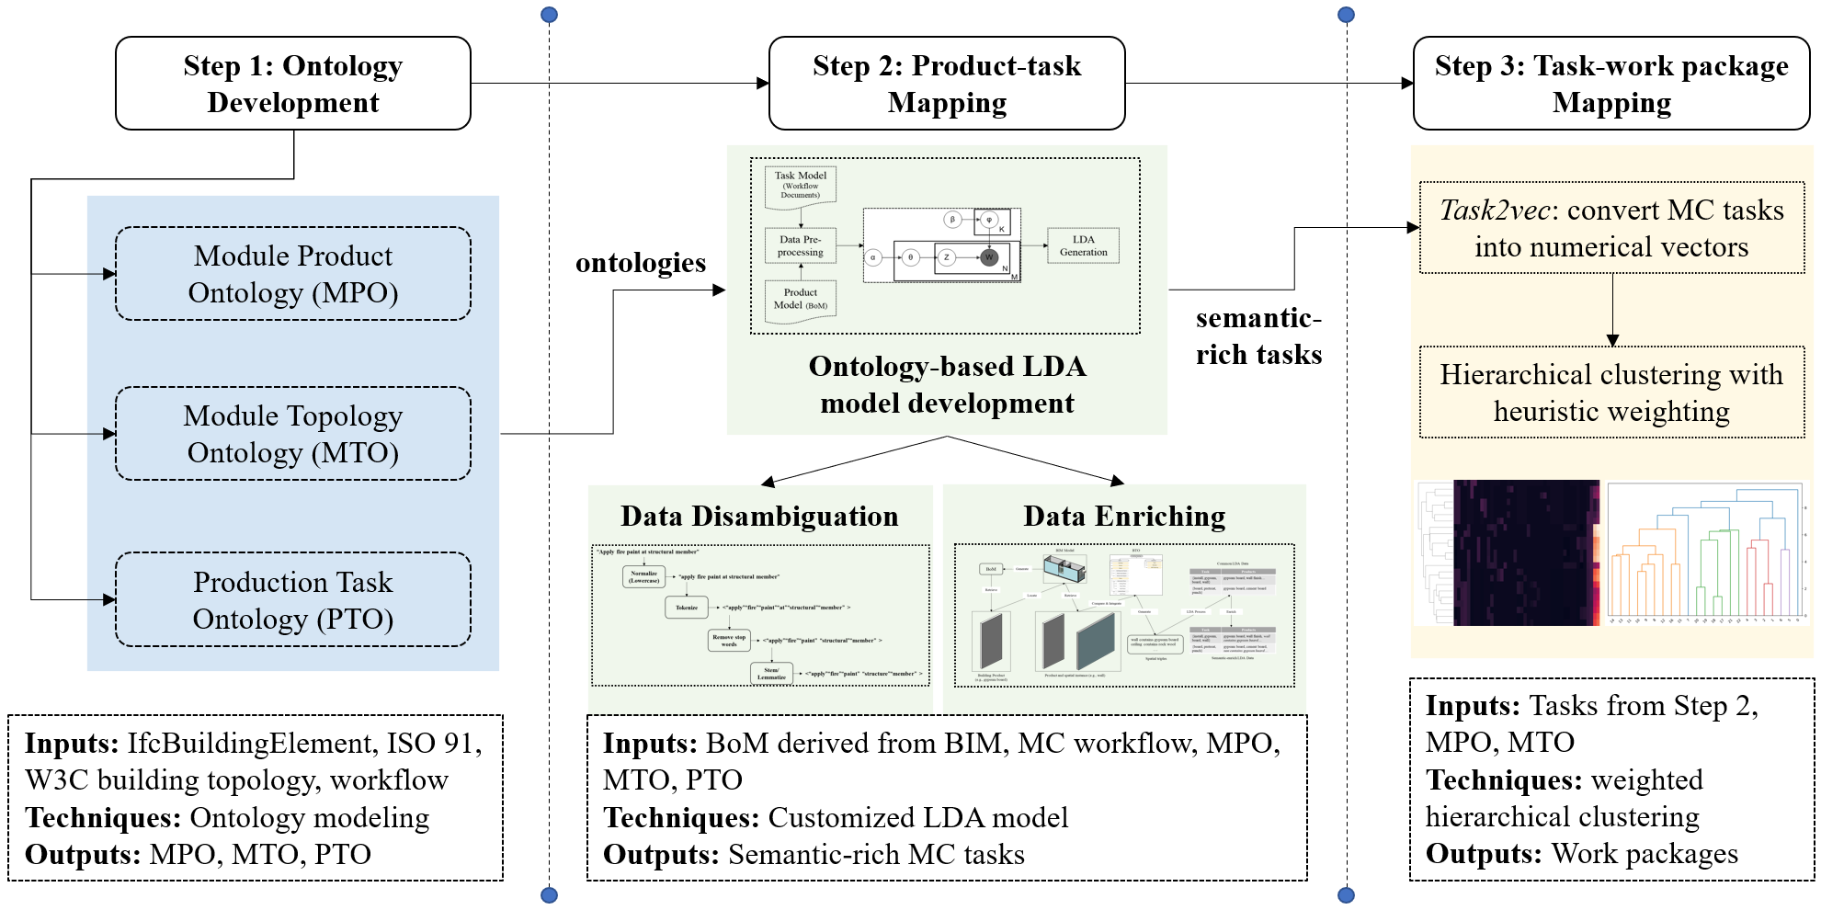
Figure 1 The proposed method: DOM approach

Ontology development
Ontologies model domain knowledge using classes, entities (each entity belongs to a class), and semantic relations, which are defined between classes and can be inherited by entities of the classes.

Module product ontology (MPO)
This ontology (see Figure 2) includes two main branches to cover common classes of components and materials in MC projects under the top class ‘Module Product.’ The ontology has four class levels, e.g., {Module Product, Component, Beam, T-Beam}. The ‘Component’ branch is built by referring to the IfcBuildingElement ontology of buildingSmart and is modified based on features of MC projects. For instance, the ‘Furniture’ class is added, as installing furniture is critical when producing housing modules. The ‘Material’ branch is built based on material classification standards [45], which is critical for generating task2vec vectors (see Section 3.3). However, the MPO is not employed to search for spatial relations to enrich LDA data (see Section 3.2.3). Thus, no semantic relations are defined in MPO except the ‘subclass’ relation (e.g., ‘T-Beam subclass-of Beam’).
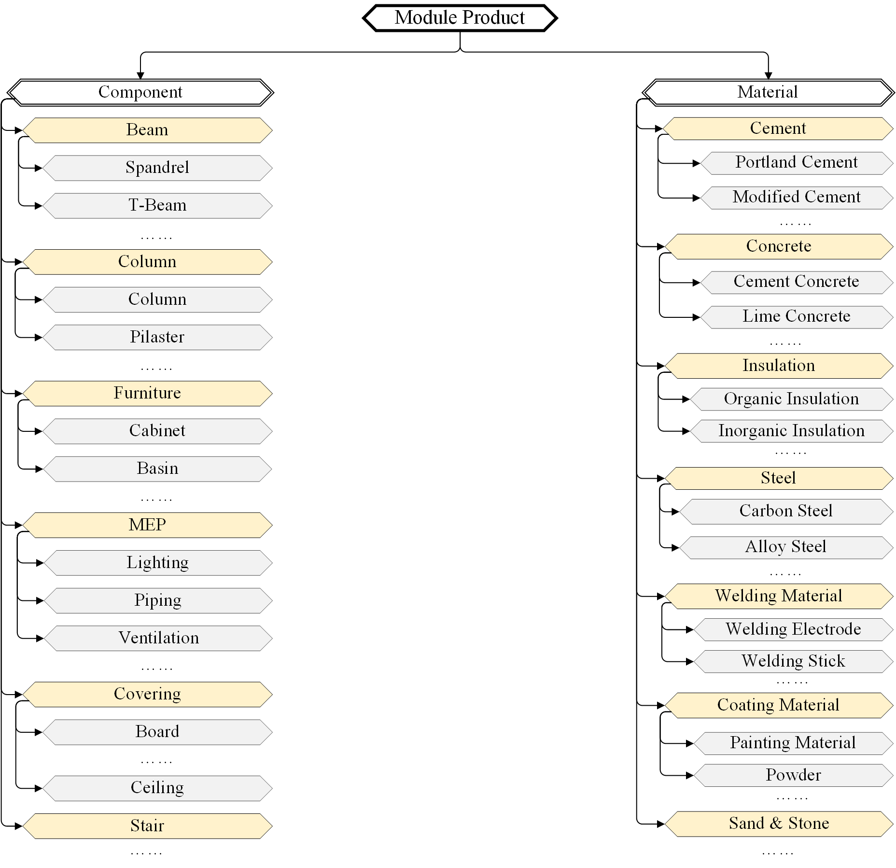
Figure 2 Conceptual structure of the MPO (not fully expanded)
    - Module topology ontology (MTO)
The MTO defines the spatial topology of MC modules. The ontology released by the W3C, the minimal ontology for defining relationships among module products, is used to develop MTO. Figure 3 shows classes and relations in this ontology. The MTO has two main classes (‘Zone’ and ‘Interface’) and five class levels. The ‘Interface’ class models relationships among products or zones, e.g., a door in a wall. This class has three sub-classes representing standard interfaces, i.e., door, window, and MEP openings. Instances of MPO classes can be linked to instances of ‘Interface’ classes using the relation ‘interface-of.’ On the other hand, ‘Zone’ defines a spatial concept extensible in the 3D space and has four sub-classes: ‘Building,’ ‘Story,’ ‘Space,’ and ‘Plane.’ The main relation considered is ‘contains,’ which defines subsumption relationships among zones and products. For instance, a building contains multiple stories; a story contains one or more spaces that are horizontally connected and provide certain functions (e.g., a toilet and kitchen); a space contains vertical (e.g., a wall) and horizontal planes (e.g., a floor and ceiling); finally, spatial instances can ‘contains’ MC products, e.g., a room (belonging to the ‘Room-level Space’ class) contains cabinets (belonging to the ‘Furniture’ class).
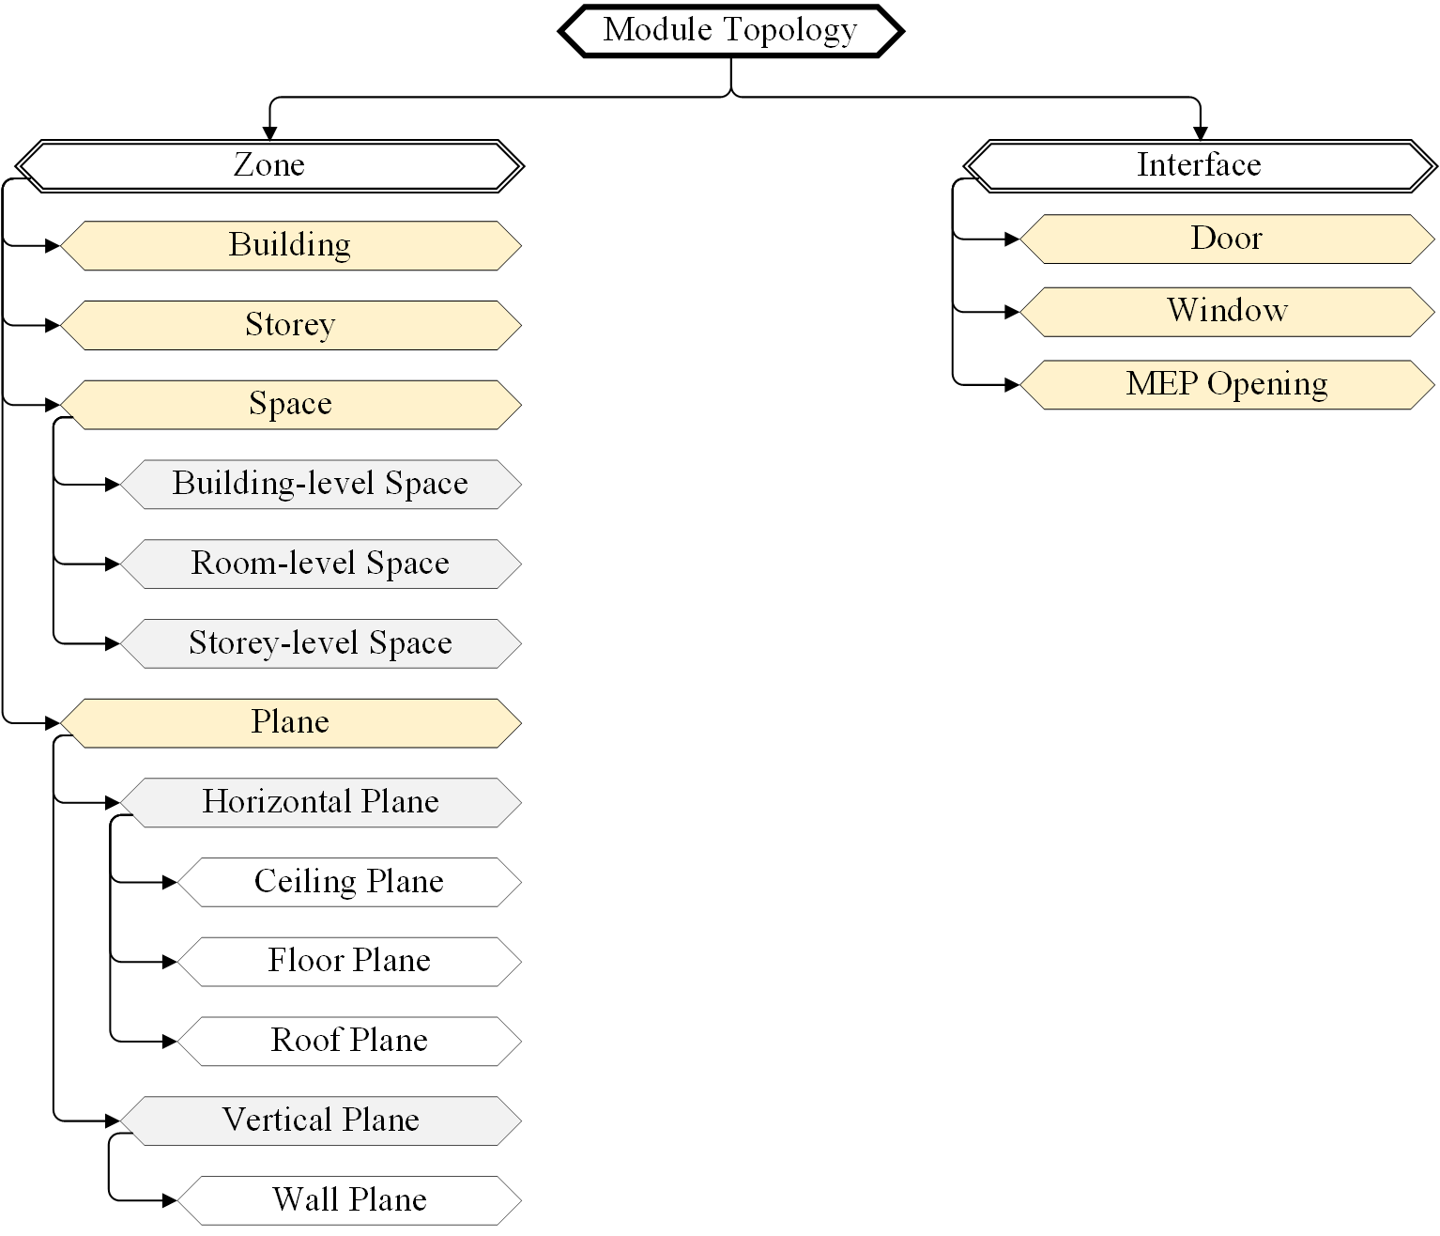
Figure 3 Conceptual structure of the MTO

Production task ontology (PTO)
This ontology defines essential tasks to fabricate MC modules. A module is made of many module products and can require different methods. The construction of the PTO is based on these distinct methods referring to the work in An et al. (2019). Figure 4 shows the conceptual structure of the PTO, which has a three-class level. The PTO is built to form the lexicon for disambiguation (see Section 3.2.2). Hence, it also only considers one semantic relation, i.e., ‘subclass-of’.
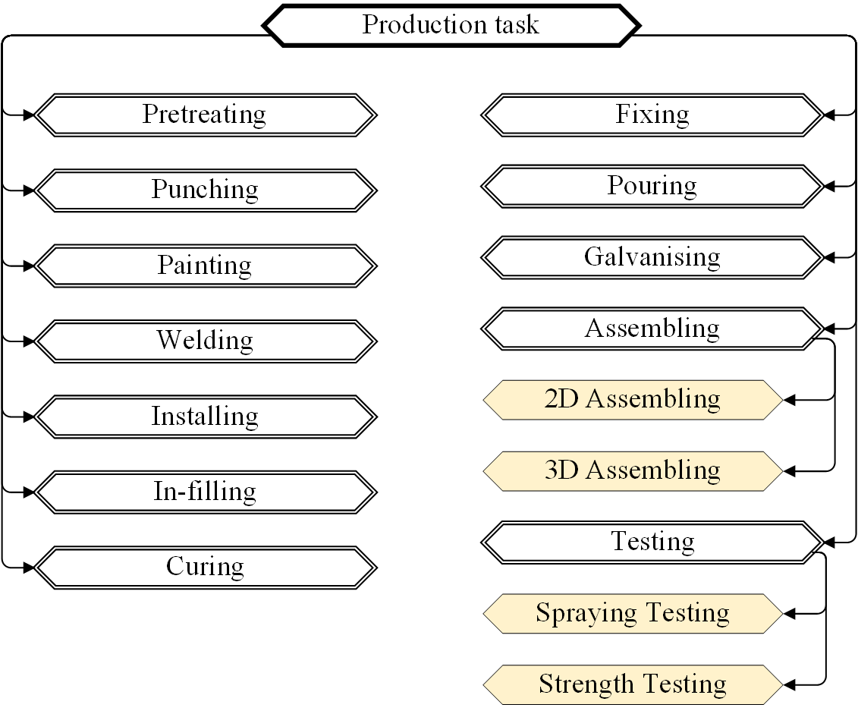
Figure 4 Conceptual structure of the PTO

3.2. Product-task mapping using LDA

3.2.1. LDA model development and training
As mentioned, the LDA model is used initially to identify topics of texts. It assumes each document is described by topics, and each topic has a distribution over words. The model is trained by simulating the process of generating documents based on topics and words. LDA relies on two Dirichlet distributions, i.e., DD1 $P(θ;α)$ and DD2 $\left(ϕ;β\right)$, and two multinominal distributions, i.e., MD1 $P\left(Z|θ\right)$ and MD2 $P(W|Z)$. The α and β are hyper-parameters, θ and ϕ are latent variables, and Z and W represent topics and words, respectively. For each of the M documents to be generated, the DD1 determines the topic of the document, from which MD1 is derived to determine the topic of each word in the document. The MD1 is repetitively applied N times (N is the number of words, i.e., the document length). In this stage, each word only has a topic. To generate specific words, the DD2 associating topics to words is adopted to develop K MD2 (K is the number of topics), and each MD2 determines specific words of a certain topic [37, 46]. Eq. 1 describes the document generation process, which is also shown in Figure 5.
$\prod_{j=1}^{M}{P(θ_{j};α)}\prod_{i=1}^{K}{\left(ϕ_{i};β\right)}\prod_{n=1}^{N}{P\left(Z_{j, n}|θ_{j}\right)P(W_{j, n}|Z_{j, n})}$ Eq. 1
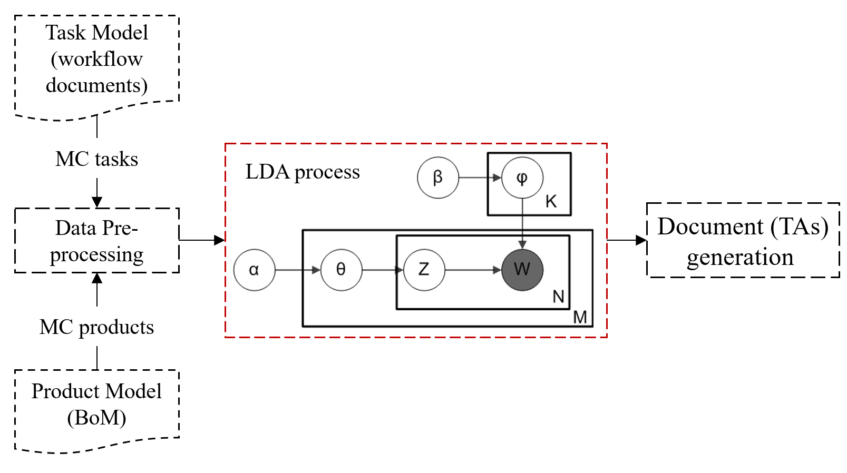
Figure 5. LDA document (TAs) generation process
This study borrows the above idea, except that: 1) task assignments (TAs) (more details are introduced below) are generated to replace the role of documents; and 2) the task types and products are treated as topics and words, respectively. The DD1 decides probabilities that a TA belongs to different task types, and the DD2 decides the probabilities of MC products being used in a TA given the task type. In other words, in this study, the M, K, and N in Eq. 1 represent the number of TAs, task types, and products in a TA, respectively. Figure 5 shows the workflow of the LDA model. The training data comes from two sources: 1) the MC production workflow, where unique tasks are extracted as LDA topics (i.e., MC task types), and 2) bill of materials (BoM), where each item is taken as an MC product. Then, the products are manually associated with task types, generating task assignments (TAs) as inputs to train the model. Each TA includes one task type and a set of MC products, and Table 1 lists several examples.
Training the LDA model requires estimating the parameters α and β so that the model can maximize the probability of generating TAs similar to those in the training data. This is realized by Gibbs sampling, which works as follows: 1) randomly assigns a task type to an MC product in the training data, 2) summarizes the number of products belonging to each task type in each TA and the number of products belonging to each task type in the entire dataset, 3) for each product, recalculates MD2 based on statistics obtained in the last step, 4) reassigns a new task type to each product using the newly obtained MD2, 5) repeats the process until parameters in the MD1 and MD2 converge [47]. The maximum number of iterations is usually predefined to save time and computation power. After training, each task type can be represented by key building products ranked by MD2 distributions (see examples in Section 4). However, it should be noted that adopting the LDA model aims to map MC products to tasks, which does not involve generating TAs. Hence, only DD2 produced by training the LDA model is employed in model testing and case study (see Section 4).

3.2.2. Data disambiguation
A challenge when implementing the customized LDA model is that project engineers often freely write the names of tasks and products in MC workflow and BoM. This can cause ambiguity, e.g., different words are used to describe the same task. Thus, as suggested in [21], a heuristic method is proposed to 1) generate standard expressions (SEs) for MC products and tasks during training; and 2) match new products and tasks to the SEs during testing (i.e. implementing the LDA model in practice).
- Data standardization
The number of unique products for MC modules is not very large, and ambiguity of products’ names often comes from their variations (e.g., studs and stud) and different orders of words when the name contains multiple words. Therefore, pre-processing is applied to products’ names (see an example in Figure 6), and includes four steps: normalization (e.g., lowercasing), tokenization (i.e., dividing a name into words, also called tokens), stop words removal (i.e., removing meaningless words), and stemming (i.e., converting a word to its basic form). More details of the pre-processing steps can be found in [48]. As such, the pre-processing results in a large corpus of SEs representing common MC products, which is suitable for LDA training. However, it is difficult to standardize MC tasks in this way as their names contain too many variations while expressing the same semantics. For instance, ‘installing wall studs’ and ‘installing studs in walls’. Hence, simple pre-processing cannot distinguish these tasks and result in too many LDA topics. To address the challenge, a lexicon is manually constructed based on practical experience, previous literature, and the three ontologies (i.e., MPO, MTO, and PTO). The lexicon covers 150 dominant task types for fabricating MC modules, and each has unambiguous meanings and is formed by supplementary usage of classes in the three ontologies. Several examples are presented in Table 2.
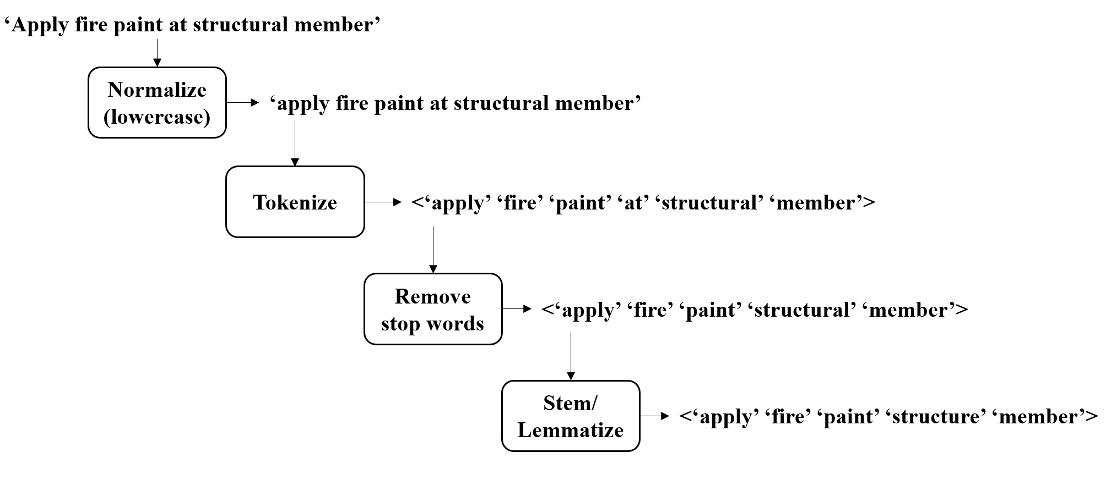
Figure 6 Example of four steps in data pre-processing
- Similarity matching
A similarity matching mechanism is carried out during the testing stage to find SEs for newly encountered products and tasks. The four-step similarity matching is based on word embeddings, where a new product or task: 1) undergoes the pre-processing steps; 2) averages word embeddings of its tokens (produced by pre-processing) to form a single vector; 3) traverses each SE in the corpus or lexicon and extracts the item’s representing vector as the averaged word embeddings of its tokens; 2) computes a similarity value s of each vector pair with Eq. 2 (i.e., cosine similarity), where $e^{s}$ and $e^{e}$ are representing vectors of the SE and new product/task, respectively; 3) replaces the new product/task with the SE gaining the highest s. Word embeddings are adopted for similarity matching, as they are low-dimension vectors that can capture semantic meanings of words despite different expressions. Word embeddings can be learned through machine learning models (e.g., word2vec). However, training such models is data-demanding and time-consuming. Thus, it is common to utilize word embeddings trained by others [49]. Table 1 lists several examples to demonstrate the effect of the disambiguation process.
$s=\frac{\sum_{i=1}^{n}{e_{i}^{s}×e_{i}^{e}}}{\sqrt{\sum_{i=1}^{n}{{\left(e_{i}^{s}\right)}^{2}}}×\sqrt{\sum_{i=1}^{n}{{\left(e_{i}^{e}\right)}^{2}}}}$ (n=the dimension of the word embedding) Eq. 2

3.2.3. Data enriching based on spatial relations
Following the conventional approach to develop LDA models, a TA only consists of associated products. However, such simple data cannot suit situations in practical MC projects. One common problem is that when producing an MC module, a product is required in multiple tasks thus should be included in multiple TAs. For instance, a gypsum board simultaneously belongs to the tasks ‘board pre-treatment and punching’ and ‘installation of the board at wall surface’. Thus, the naïve LDA model cannot distinguish such differences and can only randomly guess when mapping a new ‘gypsum board’ product.
To address the issue, spatial relations of MC products are identified by referring to the project BIM model and MTO to enrich TA data. The process includes three steps. First, as the BoM is derived from the project BIM model, spatial instances of MTO classes of each MC product are extracted from BIM. For instance, ‘wall plane’ and ‘door interface’ in BIM are extracted given the product ‘door.’ Second, spatial relations are inferred and established between spatial instances and products. Simple conditional reasoning is applied: 1) if spatial instances belong to ‘Zone’ classes, then a ‘contains’ relation is established; 2) if spatial instances belong to ‘Interface’ classes, then an ‘interface-of’ relation is established between the product and spatial instances in the same plane (e.g., layer or elevation in BIM) of the extracted interface. For instance, ‘contains’ is established between ‘wall plane’ and ‘door,’ while ‘interface-of’ is established between ‘door’ and ‘wall plane.’ Third, triples taking the form subject-relation-object are added to TA data (e.g., ‘wall plane contains door’). If no spatial relation is found, for instance, the product is used in pre-installation tasks (e.g., board punching), a triple ‘non contains product’ is added. As such, the same products used in different tasks are distinguished by different spatial relations with spatial instances. Figure 7 illustrates the process and differences between TAs before and after enriching.
Moreover, after investigating the workflow charts of MC projects in Hong Kong, it is found that: 1) the basic unit for managing MC projects is individual rooms (e.g., housing modules); 2) spatial instances with similar functions are treated as one system (e.g., all wall instances form the wall system), and tasks performed on the instances are managed as one package (e.g., installing studs in all walls of a room module forms a single package). Therefore, it is unlikely that the same triple (e.g., ‘wall contains studs’) appears multiple times in TAs and confuses the model.
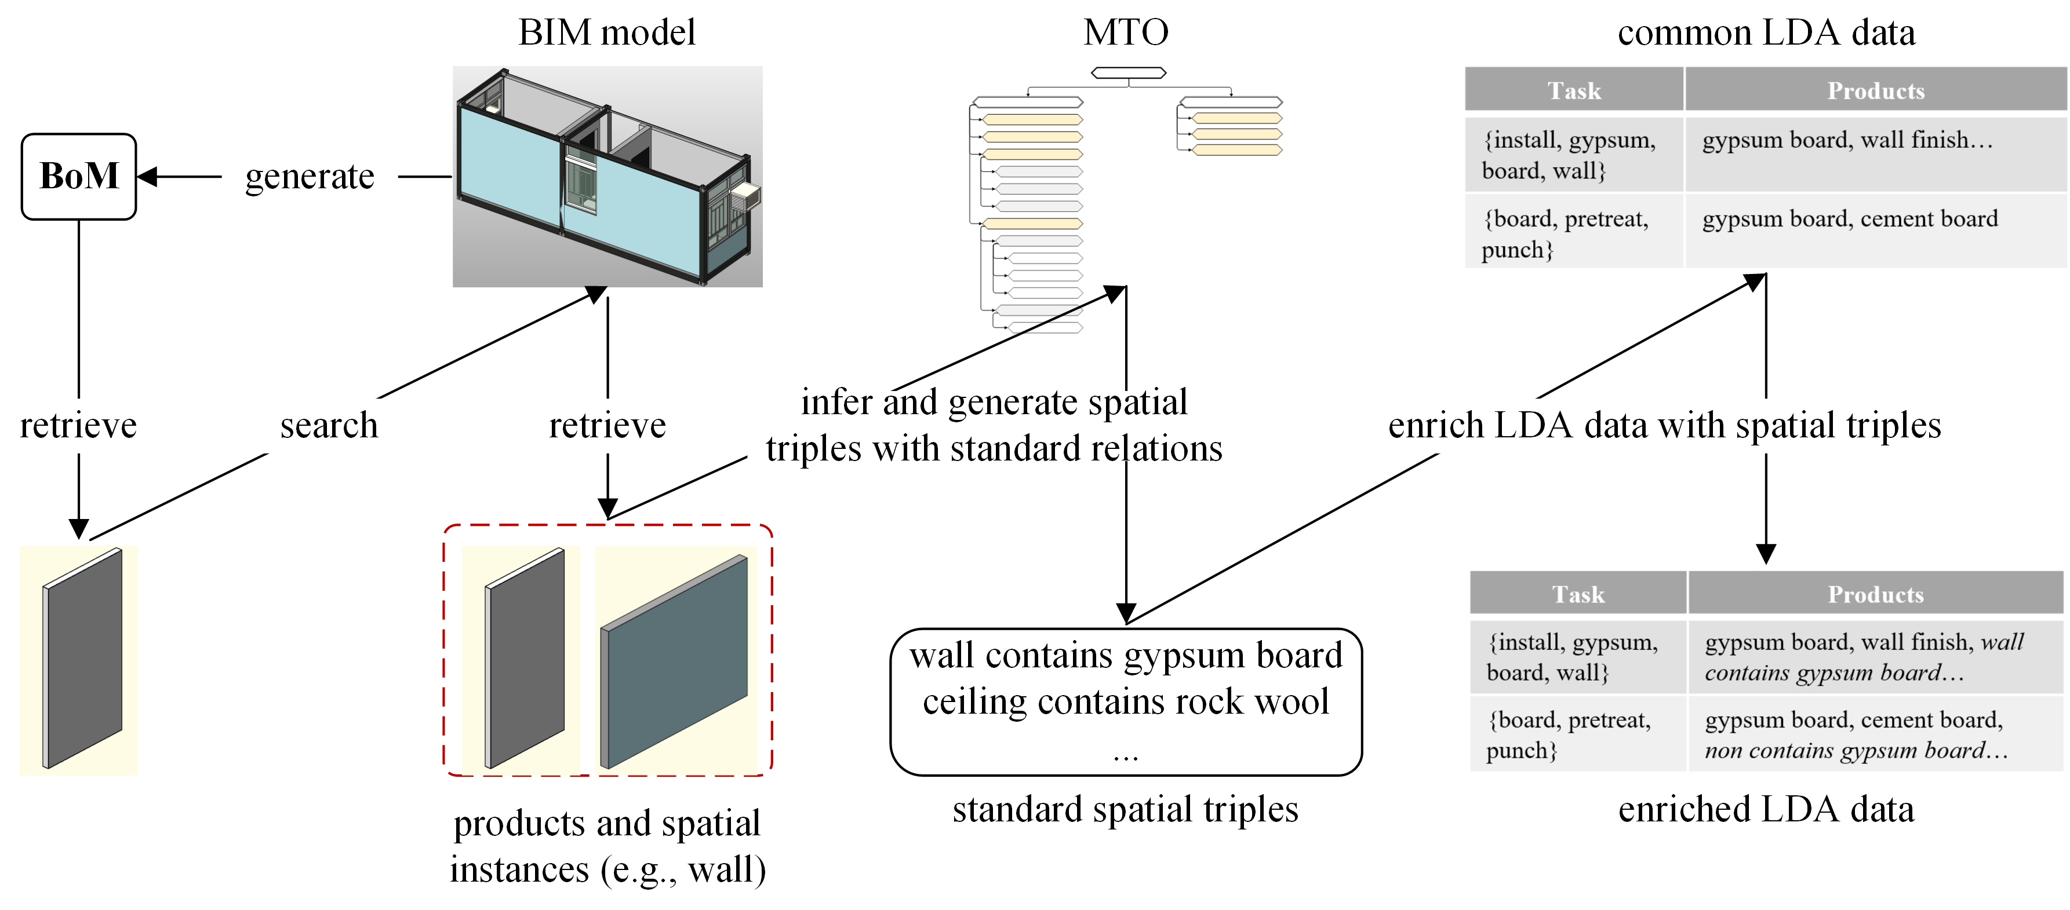
Figure 7 TA data enriching process
Table 1 Examples of TA data (before enriching)
Product (before disambiguation) | Product (after disambiguation)
Metal skeletons, Shear Studs, RUnner, the panel of wall, TRACK, channels, wall Tiles, some noggins, braces | metal skeleton, shear stud, runner, panel wall, track, channel, wall tile, noggin, brace
2D Panels, Corner Casting, Steel COLUMN, Steel Angles, Shear StuDS, CandleLoc System, ceiling beam, Purlins, FLOOR beam | 2D panel, corner cast, steel column, steel angle, shear stud, candleloc system, ceiling beam, purlins, floor beam
Ironmongery of DOOR aluminum window, FRP Timber door, glass PANEL, Hinges, hanDLes, latches | ironmongery door, aluminum window, frp timber door, glass panel, hinge, handle, latch
Table 2 Examples in the standard task lexicon
Task | Task pre-processed | Product lexicon | MTO | MPO | PTO
2D panel assembly | {2d assembl} | {Panel, Assembling} | N/A | Panel | Assembling
Stud installation at wall | {stud instal wall} | {Wall, Stud, Installing} | Wall | Stud | Installing
Door and window frame installation | {door window frame instal} | {Door, Window, Door Interface, Window Interface, Installing} | {Door Interface, Window Interface} | {Door, Window} | Installing

3.3. Task-work package mapping using weighted hierarchical clustering

3.3.1. Ontology-based task numerical presentation – Task2vec
The automated task-package mapping depends on clustering MC tasks, which requires transforming tasks to vectors according to their attributes. Based on literature review and discussion with engineers in MC projects, three critical attributes are identified when packaging tasks: task relationships, spatial relations, and resource demands [50].
Task relationships concern sequential (preceding and succeeding), parallel, and coupled relations between two tasks. Figure 8 illustrates the three relationships. In particular, the coupled relationship indicates that two tasks are interchangeably performed, such as ‘2D panel assembly’ and ‘butt and fillet welding.’ When packaging tasks, planned schedules are often available. Thus, tasks for fabricating a module can be indexed from 1 to T based on their dependencies. Then, the dependency vector $v^{d}∈R^{3}$ can be generated, where each entry is the index of another task holding the preceding, succeeding, and parallel relation with it (the value is -1 if no parallel task is found). The coupled relation is not explicitly covered in $v^{d}$, as it can be modeled if two tasks are indexed as predecessors and successors of one another simultaneously.
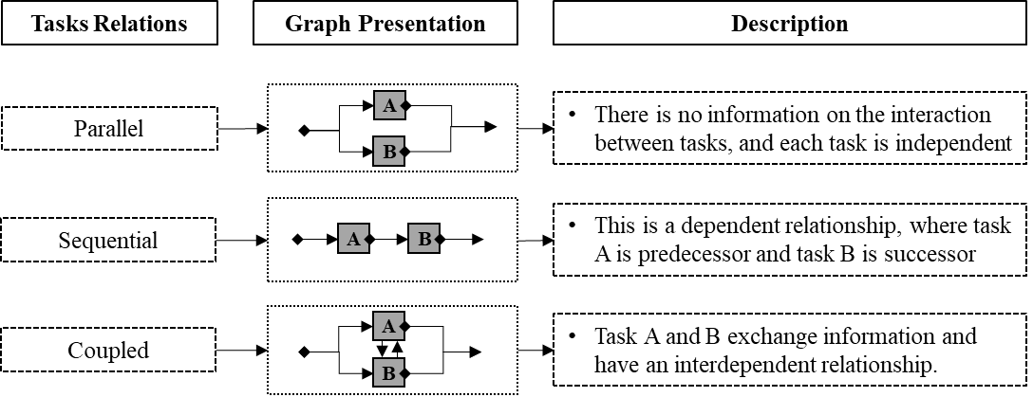
Figure 8 Tasks relations
The spatial attributes of a task are determined by the spatial instances of the products associated with the task in the product-task mapping process. Hence, a spatial vector $v^{s}$ is generated for each MC task using one-hot encoding as follows: 1) $v^{s}$ is initialized as a zero vector of shape $∈R^{C}$ (C is the total number of classes in MTO, and each entry represents one class); 2) the bottom-level spatial instance associated with each product belonging to the task is extracted by referring to spatial triples introduced previously (e.g., ‘ceiling’ is extracted from ‘ceiling contains rockwool’); 3) a spatial class list is constructed by searching for super-classes in the MTO, e.g., the list {Zone, Space, Room-Level Space, Horizontal Plane, Ceiling} can be constructed given the instance ‘ceiling,’ whereas the list {Interface, MEP Opening} can be formed given ‘conduits’; 3) a complete list is generated by integrating information from lists of all products of the task; 4) $v^{s}$ is re-evaluated, where the entries are set as one if their corresponding ontological classes exist in the complete list, while the other places remain zero. Locations (i.e., local coordinates in BIM) of all products associated with the same task should be the same in a module (e.g., studs and tiles used in the same task ‘wall stud installation’ are located in the same place). Therefore, generating $v^{s}$ needs to only consider one product, but the above process considers all products to avoid missing information [11]. Moreover, many MC tasks require distinct material resources, e.g., painting materials for painting and coating tasks and welding materials for assembling tasks. As such, the resource vector $v^{r}∈R^{D}$ can be formed following a similar procedure that generates spatial vectors, where D is the number of classes in the MPO. Then, the three vectors (i.e., $v^{d}, v^{s},v^{r}$) are concatenated into a single long vector $v^{t}∈R^{3+C+D}$ to convert an MC task into a numerical vector. Figure 9 presents the pseudo-code of the process.
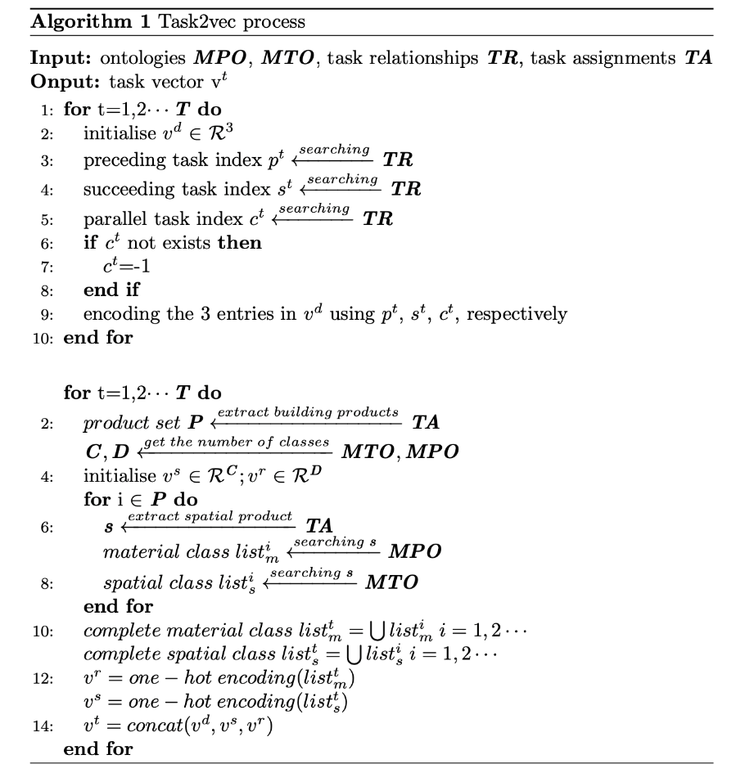
Figure 9 The pseudo-code of task2vec process

3.3.2. Hierarchical clustering with heuristic weighting
Hierarchical clustering is a simple but effective unsupervised algorithm to divide m data samples into L clusters automatically. It works in a bottom-up manner and features an iterative process which: 1) regards each data sample as a separated cluster, 2) computes the distance between each pair of clusters to evaluate their similarity values, where the straightforward Euclidean distance (Eq. 3) is used; 3) merges two clusters with the highest similarity and then averages their centroids as the centroid of the merged cluster; 4) repeats above steps until all data samples are merged as a single cluster. In practice, it is common to specify the desired number of clusters (i.e., L), which works as a threshold and terminates the clustering when L clusters are obtained [51].
$Similarity=1/{\sqrt{\sum_{i=1}^{3+C+D}{{(T_{i}^{(j)}-T_{i}^{(k)})}^{2}}+λ}} j,k=1,2…T;j≠k$ Eq. 3
However, naïve hierarchical clustering can cause many errors if it is applied to task vectors directly. For instance, the two tasks ‘door ironmongery installation’ and ‘door frame installation’ will be grouped in one cluster (i.e., one package) despite that in practice, they are separated by a dozen of tasks and managed in two packages. This is mainly because most parts of representing vectors (i.e., $v^{s},v^{r}$) of the two tasks are similar due to similar class lists, and the differences between $v^{d}$ cannot impose its impact. On the other hand, it is important to ensure enough classes are covered in $v^{s}$ and $v^{r}$, otherwise closely related MC tasks can be grouped in different packages. To address this problem and achieve a trade-off between the vectors, before clustering, vectors $v^{s},v^{r}$ are normalized using the mean and standard deviation of all data samples, while $v^{d}$ remains unchanged. In this way, the clustering algorithm can pay more attention (i.e., assigning more weights) to attributes of task relationships. In addition, parallel tasks should not be packaged, to incorporate this rule in clustering, a penalty $λ$ is added when computing distance, where a large $λ$ (e.g., 10) is applied if a parallel task of the current task $T^{(i)}$ is found to exist in the current cluster.
Another issue is that the one-hot encoding can result in similar vectors where most entries are 0, making it difficult to distinguish clusters. Hence, a heuristic weighting method is proposed. It is reasonable to assign more weights to more abstract classes while fewer weights to more specific classes during the task2vec process. For instance, installing windows and doors should be packaged together, as they are instances of installing ‘Furniture’, although they have different bottom-level MPO classes (i.e., ‘Window’ and ‘Door’) in the class lists. Therefore, descending integer weights are assigned based on class levels of the MPO and MTO, e.g., weights {4, 3, 2, 1} are assigned to the level 1 to 4 classes in the MPO, respectively, resulting in a weighted vector w. Then, for all task vectors, the $v^{s},v^{r}$ parts related to ontological classes are multiplied with w through Hadamard production before clustering, which makes differences among vectors more distinct. The pseudo-code of the weighted hierarchical clustering is shown in Figure 10.
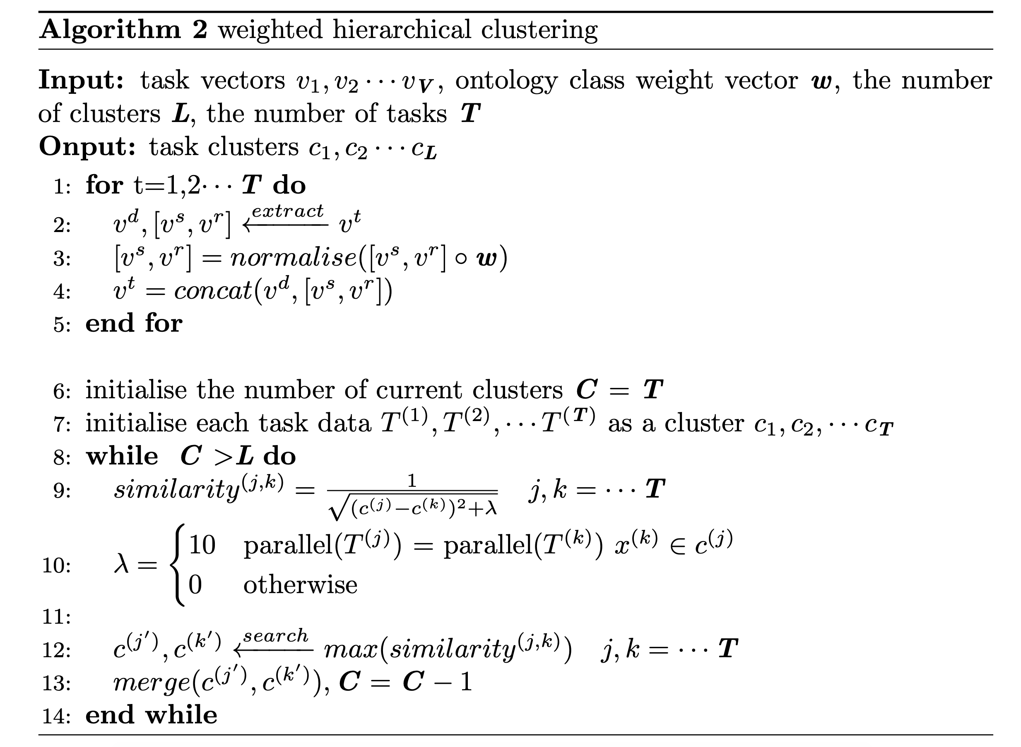
Figure 10 The pseudo-code of weighted hierarchical clustering
Finally, the number of clusters L (i.e., the number of packages) must be determined as the termination threshold. This study uses the extensively adopted gap statistic (GP) method to find the optimal L. The clustering model can be evaluated by the distortion value, i.e., the sum squared error (SSE) of the Euclidian distance between each data sample (i.e., a task) and its assigned cluster centroid (see Eq. 4). The GP method can find L automatically, which works as follows: 1) generates random data samples using a uniform distribution; 2) applies the hierarchical clustering to these generated samples and compute SSE; 3) repeats above two steps multiple times (often through Monte Carlo simulation) and then computes the GP value following Eq. 5; 5) determines the optimal L as the one gaining the largest GP value. More details of the method can be found in [52].
$SSE=\sum_{i}^{m}{\left\|T^{(j)}-C_{i}\right\|} j=1,2…T$ Eq. 4
$Gap(K)=E\left(\log{{SSE}_{k}}\right)-\log{{SSE}_{k}}$ Eq. 5

Experiments
Experiments have been conducted to evaluate the performance of the DOM approach (implemented using Python 3.8) for automatically generating work packages in a real MC project in Hong Kong. This project is a student residence with two 17-floor towers comprising 1224 prefabricated hostel rooms and other supporting facilities (e.g., prefabricated toilet, kitchen). The graphical details of the project are illustrated in Figure 11. All MC modules are produced at an off-shore factory in Mainland China, and the project is currently under the mock-up stage. The project features large-scale and complex production, where the factory will simultaneously produce around 400 modules with a peak of 600 workers at the subsequent mass production stage.
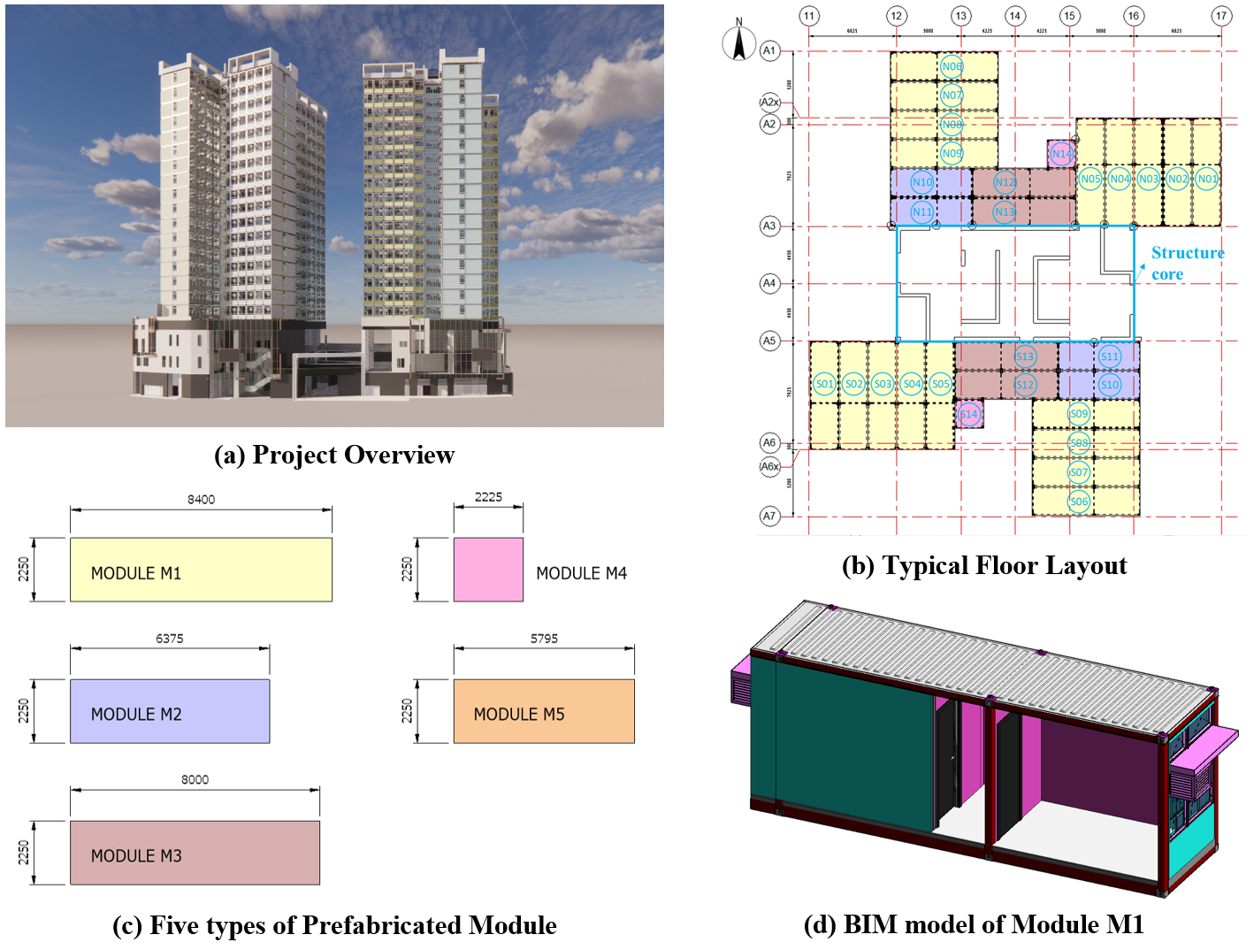
Figure 11 Overview of the MC project for this experiment

Data preparation
As the project progresses, more than ten versions of workflows (generating tasks) and BIM models (generating BoM and products) have been generated and updated for fabricating module M1 (see Figure 11). The number of products and tasks keeps increasing along with the project progress. The initial version (T-10) and the one for the latest mock-up stage (T-23) are selected for experiments, including 10 and 23 tasks, respectively. The differences in the two versions lead to changes in work package contents. Hence, the experiments not only demonstrate the performance of the DOM approach in terms of dynamically generating work packages but also prove that the approach can be repeatable in varied datasets.

Results Analysis

Product-task mapping results
Figure 12 presents the results of mapping MC products to tasks with LDA, using both T-10 and T-23 data. After running the model 100 times, the average accuracy is 0.904 and 0.938 for T-10 data, 0.883 and 0.968 for T-23 data, respectively, which can to-a-large-extent satisfy practical management demands. The data-enriching process is the main innovation of the customized LDA model, and the experiments demonstrate its overall effect in Figure 12, where the mapping accuracy of the model enriched by spatial relations is significantly improved.
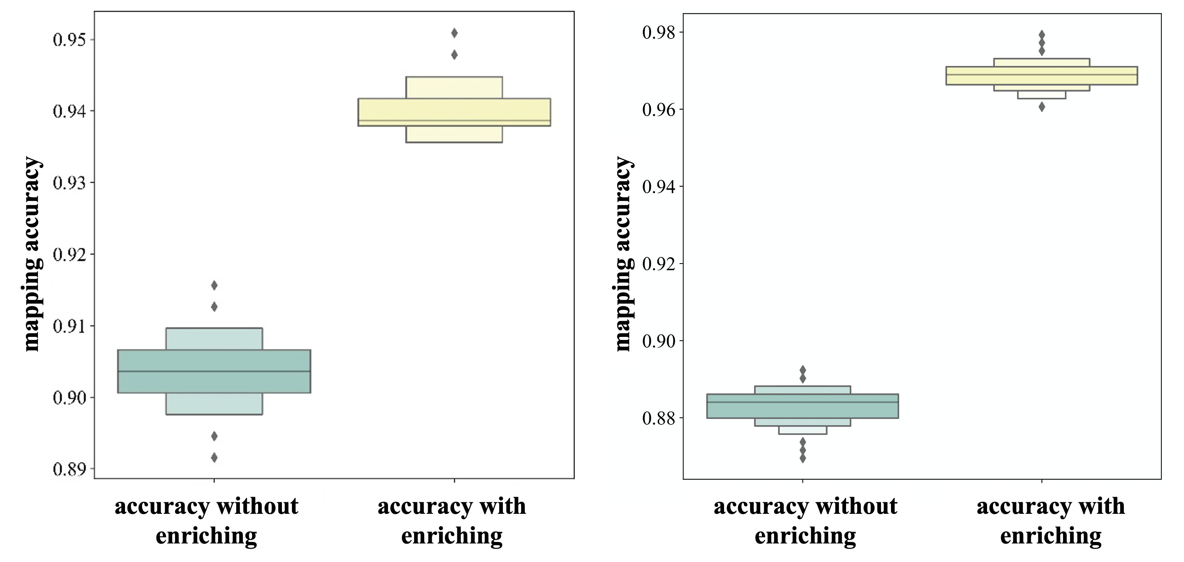
(a) T-10 (b) T-23
Figure 12 Accuracy of product-task mapping
The confusion matrices in Figure 13 present differences between products with and without data enriching in detail. It should be noted that: 1) in the figures, both x and y-axis are task IDs, and specific tasks names are listed in Tables 3-4; 2) in Tables 3-4, true task sequences in the project are indicated in parentheses in the ‘task’ column. For instance, according to the matrices, in the T-23 data, the product ‘steel column beam’ can belong to either ‘3D assembly’ (task-5) or ‘installing ceiling studs’ (task-1). The matrix in Figure 13(c) shows that seven ‘steel ceiling beam’ products required in task-5 ‘3D assembly’ are wrongly mapped to task-1 ‘stud installation at the ceiling’ (see the red boxes). Figure 13(d) shows that the error is addressed by data enriching, where all ‘steel ceiling beam’ products are correctly mapped to task-5.
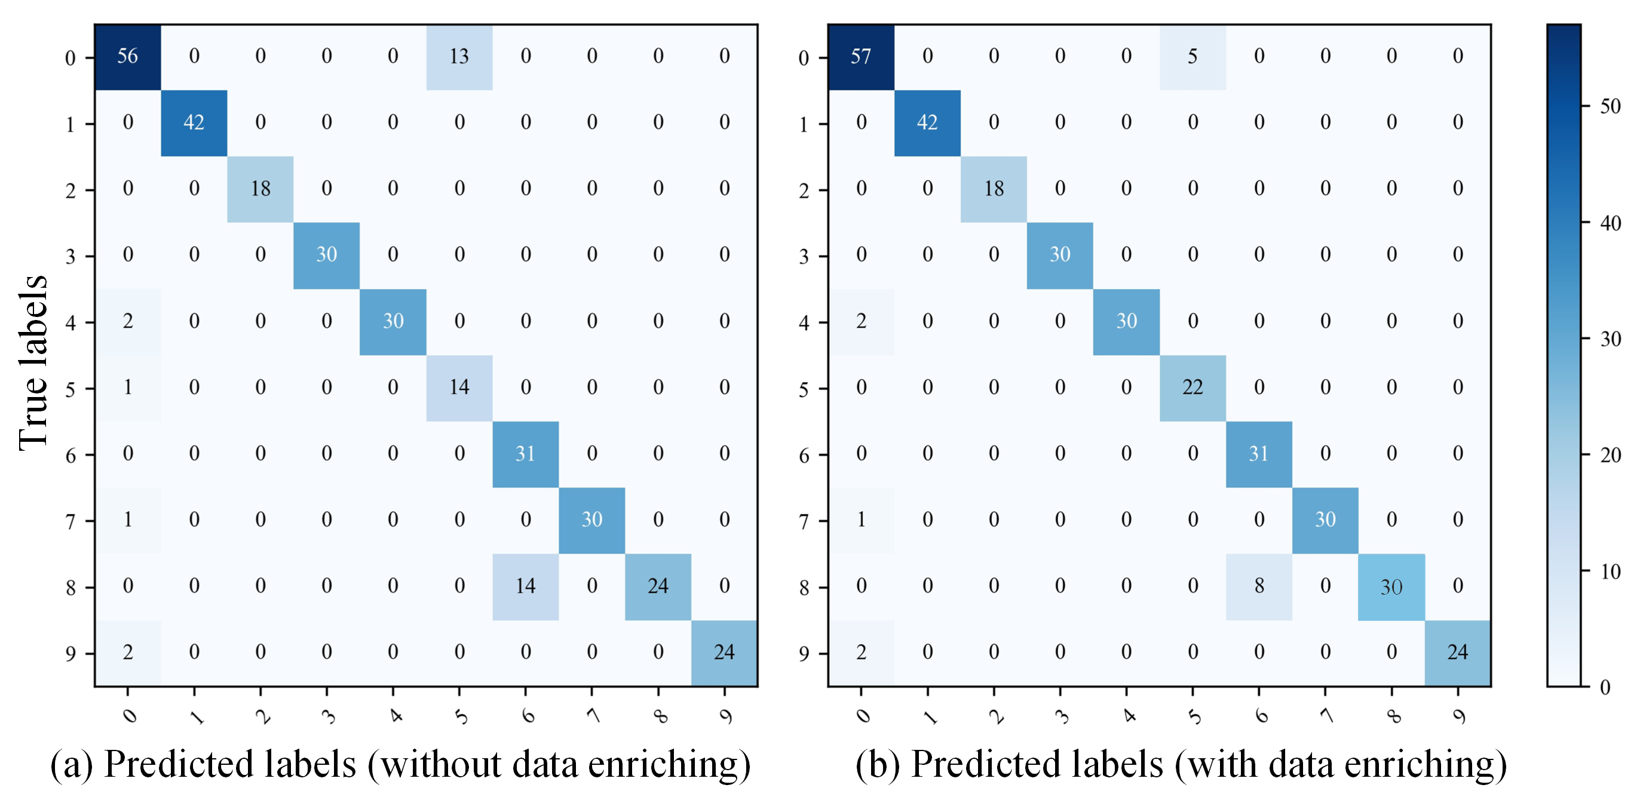
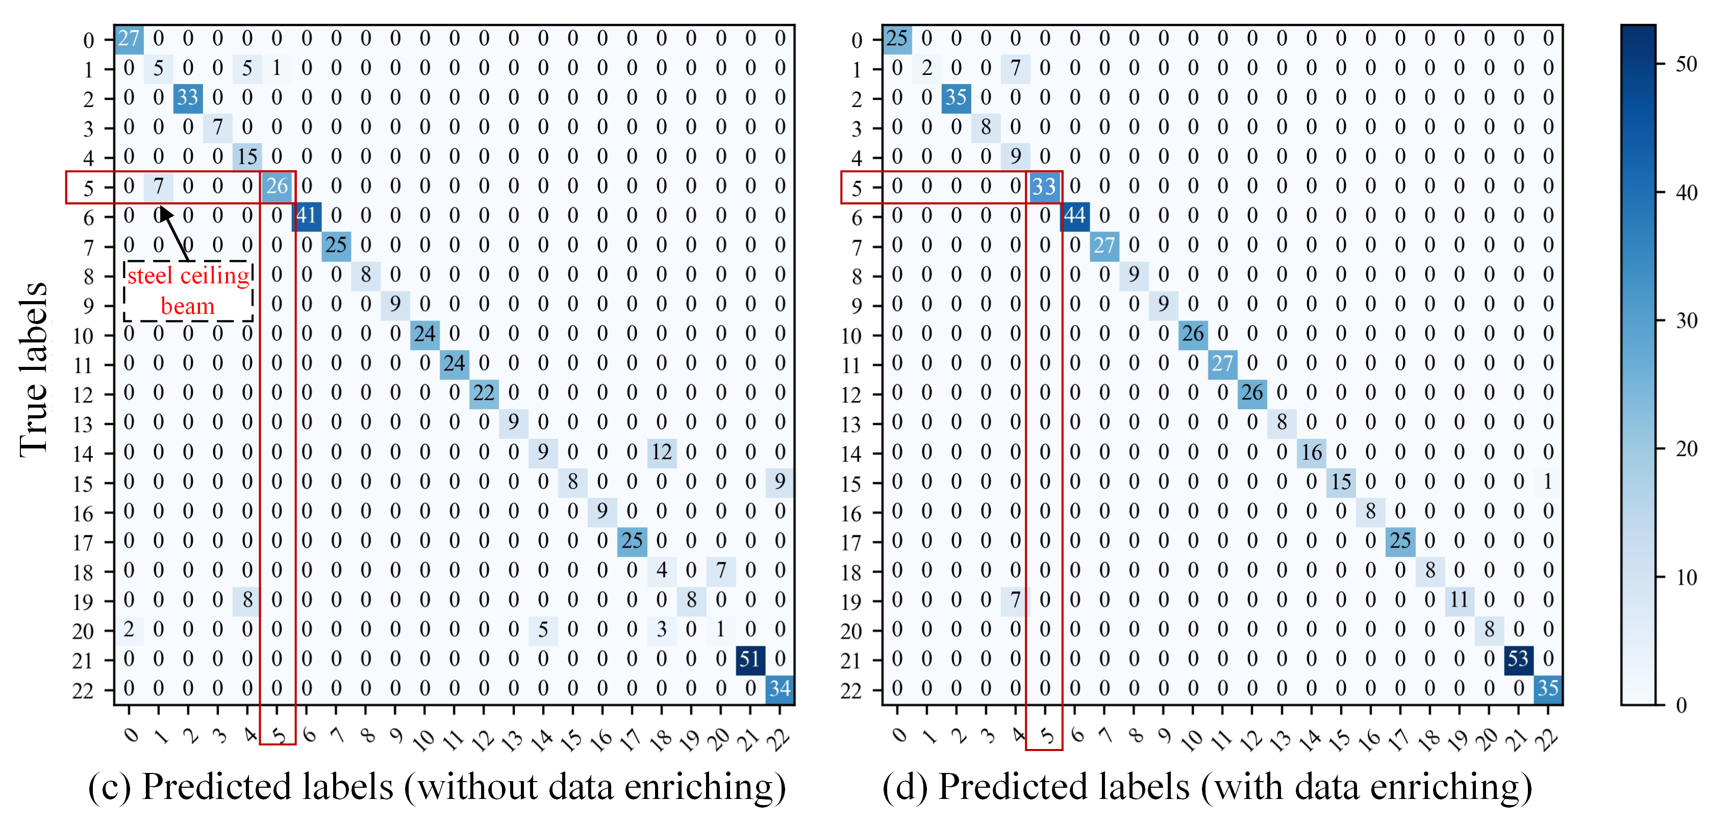
Figure 13 Confusion matrices of product-task mapping (see Tables 3-4 for task names)
Table 3 Comparison of task-package mapping results
Task ID | Task | Manual | Non-weighted | Weighted
6 | Board pretreatment and punching (0) | 1 | 1 | 1
5 | 2D panel assembly (1) | 2 | 2 | 2
2 | Butt weld and fillet weld (2) | 2 | 2 | 2
0 | 3D assembly (3) | 3 | 3 | 3
7 | Apply fire paint at structural member (4) | 3 | 3 | 3
4 | Rebar Fixing (5) | 4 | 4 | 4
9 | Pouring and curing Concrete (6) | 4 | 4 | 4
3 | Door and window frame installation (7) | 5 | 5 | 5
1 | Stud installation at the ceiling (8) | 6 | 6 | 6
8 | Rockwool in-fill and fire board (9) installation at the ceiling (10) | 6 | 5 | 6
Table 4 Comparison of task-package mapping results
Task ID | Task | Manual | Non-weighted | Weighted
14 | Board pretreatment and punching (1) | 1 | 1 | 1
13 | 2D panel assembly (2) | 2 | 2 | 2
16 | Butt weld and fillet weld (3) | 2 | 2 | 2
5 | 3D assembly (4) | 3 | 2 | 3
17 | Fire painting at structural member (5) | 3 | 2 | 3
2 | Rebar Fixing (6) | 4 | 3 | 4
3 | Pouring and curing Concrete (7) | 4 | 3 | 4
6 | Door and window frame installation (8) | 5 | 4 | 5
15 | Installation of MEP at the ceiling (9) | 6 | 6 | 6
1 | Stud installation at the ceiling (10) | 6 | 5 | 6
18 | Rockwool in-fill and fire board installation at the ceiling (11) | 6 | 5 | 6
19 | Stud installation at wall (12) | 6 | 5 | 7
20 | Rockwool in-fill and fire board installation at wall (13) | 6 | 5 | 7
0 | Installation of MEP in the wall (14) | 6 | 6 | 7
8 | Installation of gypsum board at the wall surface (15) | 6 | 5 | 7
4 | Layer and coat painting (16) | 7 | 7 | 8
9 | Installation of pipes (17) | 8 | 8 | 9
12 | Electrical cable wiring (18) | 8 | 8 | 9
21 | Window type AC installation (19) | 9 | 9 | 10
22 | Installation of lighting (20) | 9 | 9 | 10
10 | Installation of vinyl floor (21) | 9 | 9 | 10
7 | Installation of cabinets (22) | 9 | 10 | 10
11 | Installation of door/window ironmongery (23) | 9 | 4 | 10
The additional errors of the naïve LDA model are due to inadequate information to distinguish products. Figure 14 shows a few examples where the counts are obtained by running the naïve LDA model 100 times and counting task assignment results of products using the T-23 data. Some products are only used in a particular task (e.g., electrodes for the welding task), which can be handled by the naïve model. However, certain products (e.g., ‘promatect h-board’ and ‘ceiling panel’) can belong to two or more tasks. The ambiguation also happens when mapping products ‘shear stud’ and ‘gypsum board’ in the T-10 data. As such, the naïve model cannot distinguish such ambiguous product-task relations, thereby making wrong assignments.
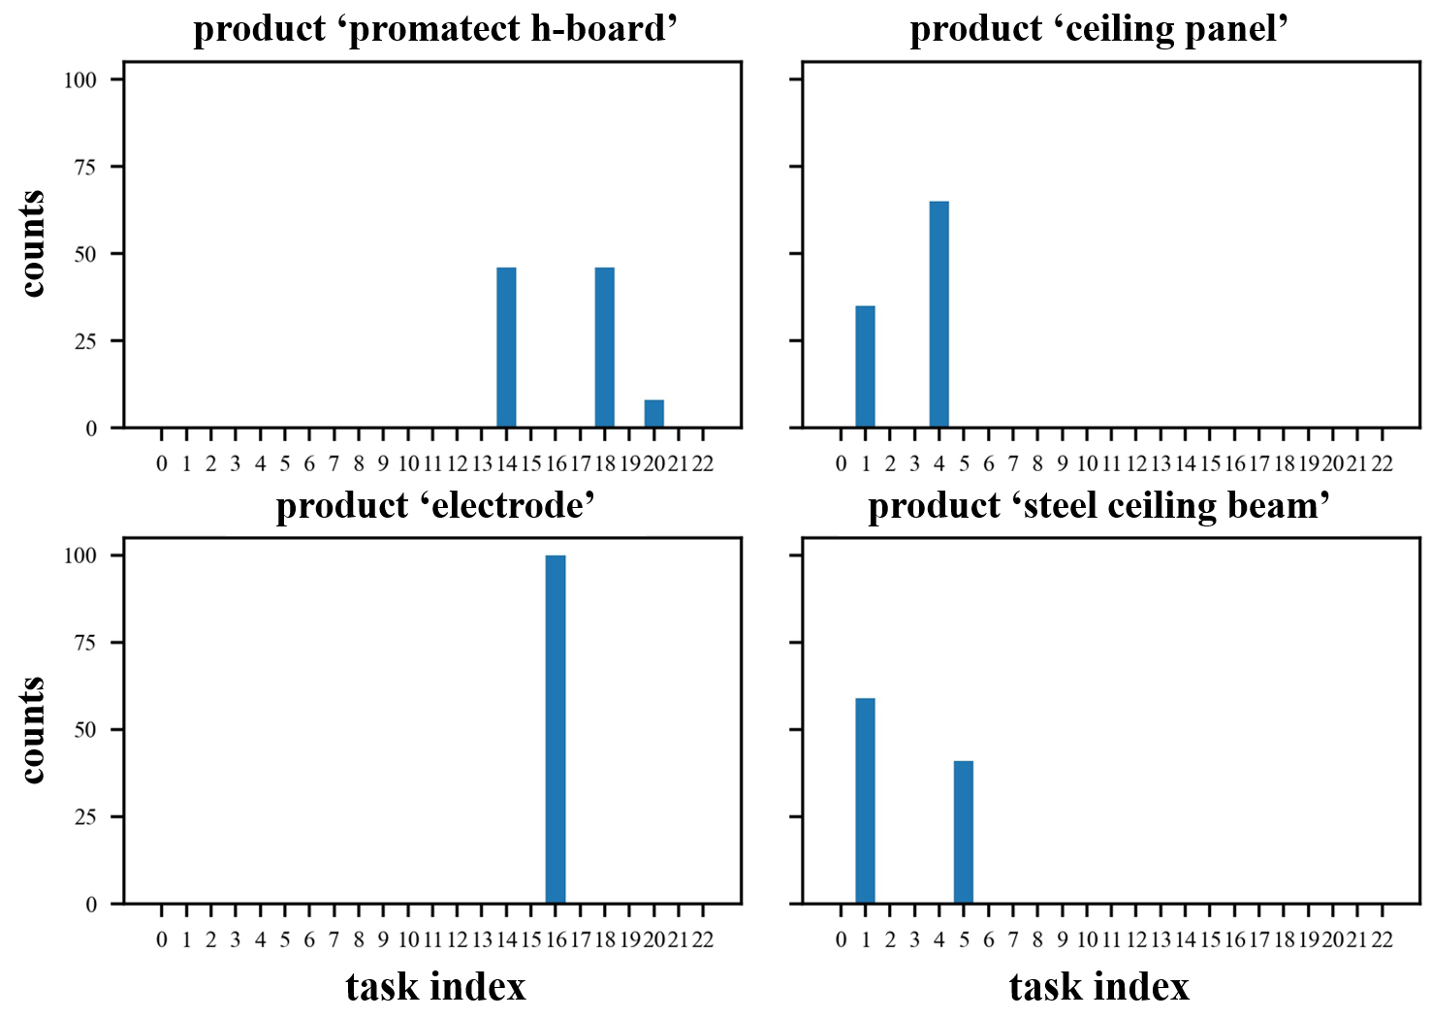
Figure 14 Examples of errors occurring without data enriching
However, errors still occur when mapping a few products, even spatial relations are incorporated. For instance, the product ‘ceiling panel’ in the T-23 data is used in task-1, ‘stud installation at the ceiling.’ However, the customized LDA model maps it to task-4 ‘layer and coat painting ceiling’, as the product holds the same spatial relations with the ‘ceiling’ instance in both tasks.

Task-package mapping results
In this section, the weighted hierarchical clustering model is tested in packaging tasks for producing module M1. As mentioned, the optimal number of packages L is determined automatically using the GP method to minimize subjective judgment. As shown in Figure 15, the method suggests six and ten work packages for T-10 and T-23 data, respectively.
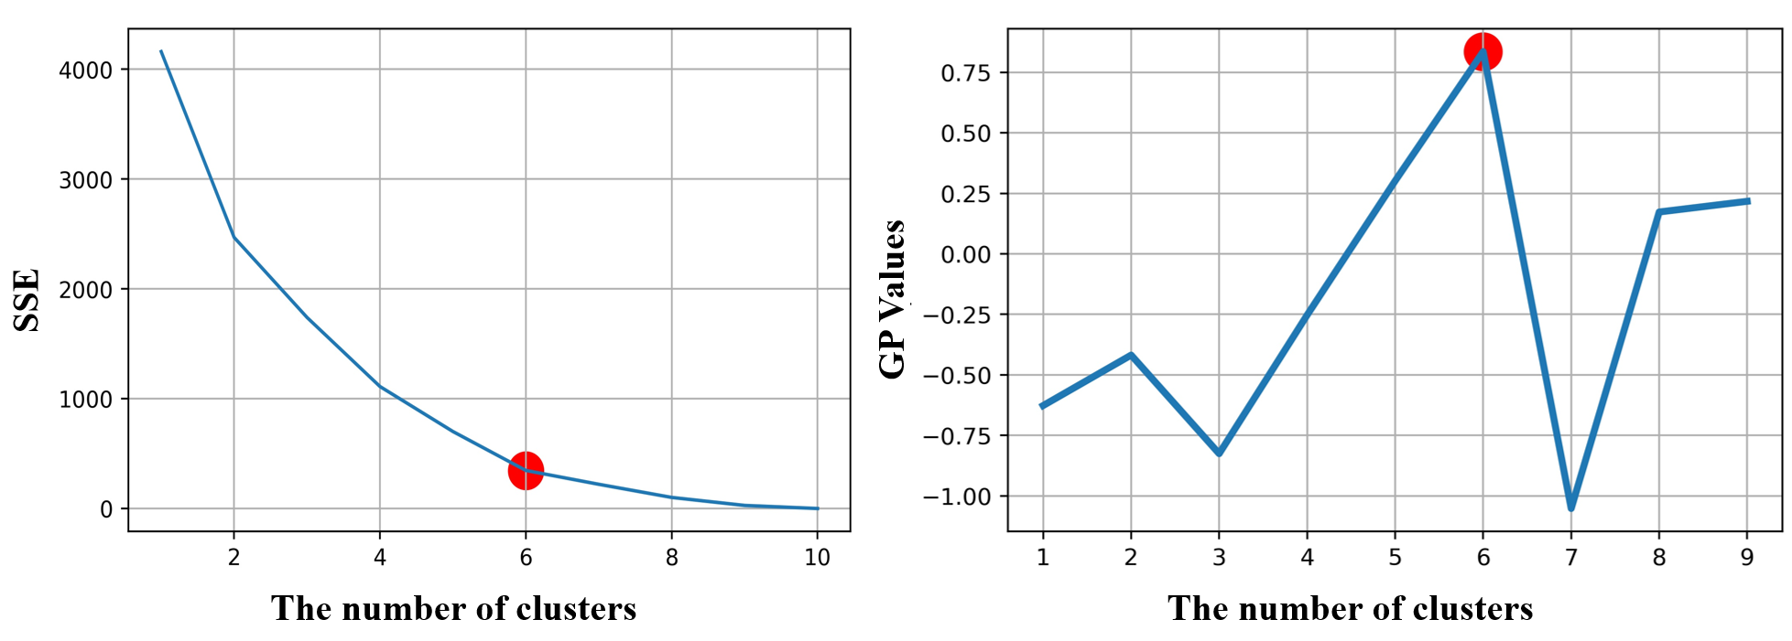
Figure 15 Determining the optimal number of clusters (work packages)
Tables 3-4 compare task-package mapping results using manual assignment (based on project engineers’ experience and regarded as ground truth), non-weighted, and weighted hierarchical clustering. In Table 3, the mapping results produced by the hierarchical clustering model are identical to those produced by manual assignment. However, the naïve model wrongly packages tasks 7-9, separated by task 8, which is impractical given the close dependencies. This is because they have similar spatial and resource attributes, which outweigh the impact of task relationships without proper weighting. In addition, Table 4 shows that when applying the naïve model to the T-23 data, it does not separate tasks 2-4 because their attribute vectors (without weighting and normalization) are not distinct enough to be separated (i.e., many entries are 0 and only a few are 1). Besides, tasks 8 and 23 are again packaged together using non-weighted clustering, despite being separated by many tasks. A similar problem happens when packaging tasks 12-14.
In contrast, when handling the 23 tasks, the proposed hierarchical clustering model addresses the above issues and produces the most practical results, which are also very similar to the manual packaging results. The only difference is that fabricating the wall and ceiling is divided into two packages instead of one. It is because the manual packaging suggests nine packages, whereas the hierarchical clustering model suggests ten. It is also reasonable as tasks for wall and ceiling can be separated by the spatial relations, and they can also be executed concurrently and combined as the wall work package in practice.
Figure 16 shows the results of packaging the tasks graphically. In the heatmaps, the y-axis and x-axis represent MC tasks and task attributes (i.e., $v^{s},v^{r},v^{d}$), respectively. The right two columns in the heatmaps have much lighter colors as vectors $v^{s},v^{r}$ are normalized, whereas $v^{d}$ remains unchanged, which therefore have larger values. The hierarchical clustering thus groups tasks with similar attributes iteratively and forms the tree structure at the right side of the figure.
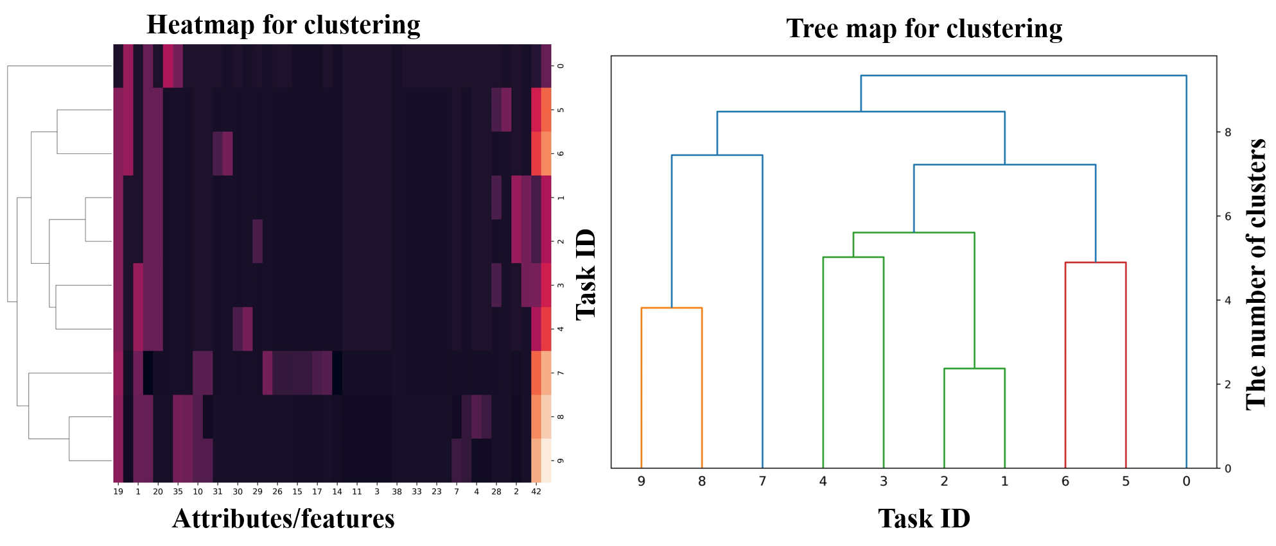
(a) T-10
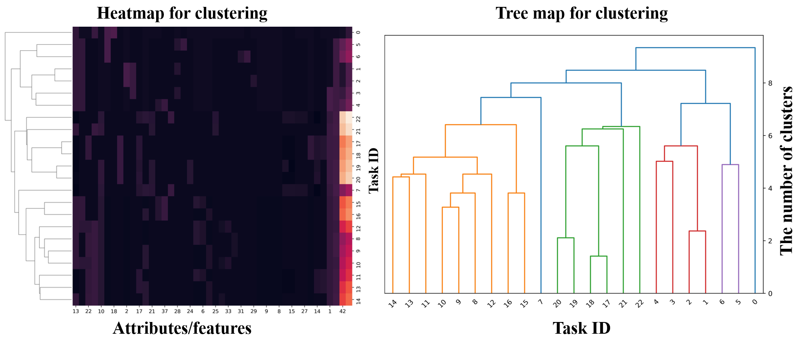
(b) T-23
Figure 16 Overview of hierarchical clustering results
Finally, the hierarchical clustering is applied to all 368 tasks in this case project using the more complex T-23 version, which has similar names and contents to those demonstrated before. The model is evaluated using two mainstream metrics, i.e., the Silhouette Coefficient and Calinski-Harabaz index. The metrics evaluate the SEE and data co-variance within each cluster (a work package) and between clusters (work packages), and both metrics favor large values. According to the results, it can be argued that the proposed hierarchical weighting clustering model significantly improves the mapping performance, and the improvement is more evident when more tasks are involved (i.e., when the project situation is more complex).
Table 4 Comparison between clustering metrics
Task | Non-weighted model | Weighted model
Silhouette Corfficient (T-10) | 0.582 | 0.855
Calinski-Harabaz index (T-10) | 307.057 | 548.161
Silhouette Corfficient (T-23) | 0.440 | 0.569
Calinski-Harabaz index (T-23) | 97.196 | 487.660

Project performance improvements
To better demonstrate the usefulness of the proposed DOM approach in practical MC project planning, the study compared it with the traditional manual approach in terms of product-task and task-work package mapping, using both T-10 and T-23 data. Twenty engineers with 3-5 years of working experience and Master’s students from the field of construction and engineering management participated in the experiments. They were divided into two groups randomly. The authors explained the idea and working mechanism of the DOM approach to one group and provided them the Python package, which can read BoM and workflow texts, ontologies, and BIM data then produce mapping results with one line code. The other control group carried out the mapping manually. The time consumed for finishing the mapping is recorded and presented in Table 5. The time for manually mapping MC products to tasks is at least about 1000 times (T-10 version) that of the customized LDA model. The advantages of automated mapping can be more evident when planning becomes more complex when the project progresses (T-23 version). The time for finishing task-package mapping presents similar patterns. Even when the time for manually checking and modifying errors caused by the DOM approach is considered, it still only takes 1/15-1/4 time compared to the manual approach.
Table 5 Comparison between time (s) consumed for manual and automated mapping
 | Product-task mapping (T-10) | Product-task mapping (T-23) | Task-package mapping (T-10) | Task-package mapping (T-23)
Manual | 148 | 638 | 64 | 211
Customized LDA | 0.13 | 0.32 | N/A | N/A
Customized LDA* | 25 | 42 | N/A | N/A
Hieratical clustering | N/A | N/A | 0.08 | 0.14
Hieratical clustering* | N/A | N/A | 17 | 49
* indicates the time, including manual checking and modification

Discussion
The proposed DOM approach is a brand-new method to enrich the semantics of tasks and generate the work packages more accurately and automatically. Compared with the previous studies, three aspects of the DOM approach’s novelty are summarized as follows.
- First, three ontologies, i.e., MPO, MTO, and PTO, are established to 1) model domain classes of MC products, the spatial topology of the products, and mainstream tasks; 2) form relationships among these classes and their instances. Previous works (e.g., An et al., 2019) developed domain ontologies of MC resources, working procedures, and products, which focused on wood frames instead of the entire module prefabrication process and lacked consideration of spatial topology. Thus, the proposed ontologies are more comprehensive and semantic-rich, which not only standardize MC tasks for disambiguation but also provide critical information for automated product-task and task-package mapping in practical project planning.
- Second, the customized LDA model enriches MC products using spatial topology relations to improve the product-task mapping performance. The naïve LDA model adopted in existing studies in the sector does not consider semantic relations of words (i.e., products in this study) [38, 53, 54]. This can hurt model performance when applied to MC project planning, where two products with similar names but different spatial relations can be wrongly assigned to the same task. This study uses the MTO to enrich the product data, effectively distinguishing ambiguous products, thereby increasing the accuracy of product-task mapping by 4%-8%.
- Third, this study is the first in the sector that proposes the task2vec method, which transforms tasks to numerical vectors based on their dependency, topology, and resource attributes. Then, a hierarchical clustering model is applied to package semantic-rich tasks into practical work packages. Previous studies adopted the design structure matrix to form work packages, which is less efficient as it only considers task dependencies and relies on manual planning [55]. Moreover, the study designs a heuristic weighting method based on different roles of task attributes when forming the vectors. This improves packaging results by increasing coherence within clusters while enlarging differences among clusters.
- Forth, the practical usage of the DOM approach in terms of improving traditional management performance (i.e., planning time) is tested in controlled experiments. The results show that it can significantly reduce planning time by automatically generating dynamic and semantic-enrich work packages, especially in complex projects. Hence, the DOM approach can directly release engineers from repetitive and intensive planning work, enabling them to pay attention to more valuable management activities (e.g., optimizing resource allocation). In addition, through fast planning, the DOM can also indirectly benefit project quality and costs by facilitating collaboration between management and execution.
Despite these contributions, the study still has several limitations.
- First, the customized LDA model requires a proper level of details (LoD) of products and tasks to maximize mapping accuracy. Compared with the naïve LDA model restricted by the inability to capture correlations of products, the proposed LDA model can to-some-extent accurately distinguish MC products by leveraging spatial relationships. However, ambiguity still arises if the LoD is too deep (i.e., data granularity is too high). For instance, if the task ‘stud installation’ is further divided into first- and second-layer stud installation, the customized LDA model cannot correctly map the product ‘stud.’ The reason is twofold: 1) the number of products in each TA data can be too small for the detailed tasks; 2) the generated tasks are not independent and orthogonal, as there are more overlapping of tasks compositions with high LoD, namely, different products (even enriched) have similar spatial triples and appear in multiple MC tasks with similar names. Both make it difficult for the model to learn distinct patterns of product co-occurrences during training.
- Second, the hierarchical clustering model only generates the smallest units of the holistic work packaging process. In practice, these small packages can be further grouped into larger ones (i.e., the packages of packages), which is not covered in this study thus can affect overall management performance. However, such a process relies on determining optimized package sizes subject to various factors (e.g., schedule, costs, workload, and economies of scale). Solving complex problems can require sophisticated multi-objective optimization techniques that are beyond the scope of the study.

Conclusion
MC is the main enabler of construction 4.0, as it follows industrialized principles that provide a collaborative working environment among workers, robotics, and machines. Current MC tasks involve cross-domain knowledge, which requires dynamic and collaborative planning, especially during mass production. This study proposed a dynamic ontology-based mapping (DOM) approach to automatically generate work packages along the project progresses. Firstly, three ontologies, i.e., MPO, MTO, PTO, are created to model critical domain knowledge of MC products, spatial topology, and tasks. Then, the customized LDA model is developed to map MC products (enriched by spatial relations) to tasks. Finally, MC tasks are converted into vectors according to their dependency, topology, and resource attributes, which are grouped into optimal work packages using the weighted hierarchical clustering model. Experiments are conducted to demonstrate the algorithmic performance and practical effectiveness of DOM. The results show that the proposed approach can automatically and efficiently form optimal work packages when project workflow and BoM change. MC companies and engineers in practice can benefit from the study. For one thing, those with less project experience can better understand the mechanism by which work packages are formed based on various knowledge of MC products, topology, and tasks. For another, they can use the DOM approach to automatically generate work packages in mass production, which can significantly reduce planning and collaboration time and costs by efficiently instructing task execution of workers and machines in a complex production environment.
Several topics remain open for future studies. First, the product-task mapping can be improved by considering more semantic features. For one thing, sophisticated spatial relations apart from the ‘contains’ and ‘interface-of’ can be applied. For instance, ‘intersects,’ ‘above,’ and ‘below’ can be adopted to model complex spatial topology. For another, additional ontologies in the sector can be created to incorporate more domain knowledge, such as material and manufacturer information. Both methods can help the model distinguish MC products with high LoD. Second, the current formation of work packages ignores optimal package sizing. Hence, it is beneficial to develop more sophisticated models using state-of-the-art optimization techniques, which can simultaneously generate work packages and then group them using automatically estimated optimal package sizes. In conclusion, the present study can enhance collaborative planning and performance of MC projects while encouraging further research on this topic.

Acknowledgment
This research was financially supported by the Hong Kong Innovation and Technology Fund (ITF) (No. ITP/029/20LP) and the Fellowship of China Postdoctoral Science Foundation (No. 2021M692169).

Reference
1. Teng, Y., Mao, C., Liu, G., and Wang, X., Analysis of stakeholder relationships in the industry chain of industrialized building in China. Journal of Cleaner Production, 2017. 152, pp. 387-398. https://doi.org/10.1016/j.jclepro.2017.03.094.
2. Ekanayake, E., Shen, G.Q., and Kumaraswamy, M.M., Identifying supply chain capabilities of construction firms in industrialized construction. Production Planning and Control, 2021. 32(4), pp. 303-321. https://doi.org/10.1080/09537287.2020.1732494.
3. Gann, D.M., Construction as a manufacturing process? Similarities and differences between industrialized housing and car production in Japan. Construction Management and Economics, 1996. 14(5), pp. 437-450. https://doi.org/10.1080/014461996373304.
4. Eriksson, P.E., Olander, S., Szentes, H., and Widén, K., Managing short-term efficiency and long-term development through industrialized construction. Construction Management and Economics, 2014. 32(1-2), pp. 97-108. https://doi.org/10.1080/01446193.2013.814920.
5. Goh, M. and Goh, Y.M., Lean production theory-based simulation of modular construction processes. Automation in Construction, 2019. 101, pp. 227-244. https://doi.org/10.1016/j.autcon.2018.12.017.
6. Xu, Z., Zayed, T., and Niu, Y., Comparative analysis of modular construction practices in mainland China, Hong Kong and Singapore. Journal of Cleaner Production, 2020. 245, pp. 118861. https://doi.org/10.1016/j.jclepro.2019.118861.
7. Hammad, A.W., Akbarnezhad, A., Wu, P., Wang, X., and Haddad, A., Building information modelling-based framework to contrast conventional and modular construction methods through selected sustainability factors. Journal of Cleaner Production, 2019. 228, pp. 1264-1281. https://doi.org/10.1016/j.jclepro.2019.04.150.
8. Zhu, A., Pauwels, P., and De Vries, B., Smart component-oriented method of construction robot coordination for prefabricated housing. Automation in Construction, 2021. 129, pp. 103778. https://doi.org/10.1016/j.autcon.2021.103778.
9. Arashpour, M., Kamat, V., Bai, Y., Wakefield, R., and Abbasi, B., Optimization modeling of multi-skilled resources in prefabrication: Theorizing cost analysis of process integration in off-site construction. Automation in Construction, 2018. 95, pp. 1-9. https://doi.org/10.1016/j.autcon.2018.07.027.
10. Lawson, M., Ogden, R., and Goodier, C.I., Design in modular construction. Vol. 476. 2014, Boca Raton, US: CRC Press. 9780367865351.
11. Salama, T., Salah, A., Moselhi, O., and Al-Hussein, M., Near optimum selection of module configuration for efficient modular construction. Automation in Construction, 2017. 83, pp. 316-329. https://doi.org/10.1016/j.autcon.2017.03.008.
12. DOD and NASA, DOD and NASA guide: PERT COST systems design. U.S. Department of Defense and U.S. National Aeronautics and Space Administration, 1962. https://catalog.hathitrust.org/Record/001621597. Accessed on 12th Sep 2021.
13. Siami-Irdemoosa, E., Dindarloo, S.R., and Sharifzadeh, M., Work breakdown structure (WBS) development for underground construction. Automation in Construction, 2015. 58, pp. 85-94. https://doi.org/10.1016/j.autcon.2015.07.016.
14. Sutrisna, M., Ramanayaka, C.D., and Goulding, J.S., Developing work breakdown structure matrix for managing offsite construction projects. Architectural Engineering and Design Management, 2018. 14(5), pp. 381-397. https://doi.org/10.1080/17452007.2018.1477728.
15. Jung, Y. and Woo, S., Flexible work breakdown structure for integrated cost and schedule control. Journal of Construction Engineering and Management, 2004. 130(5), pp. 616-625. https://doi.org/10.1061/(ASCE)0733-9364(2004)130:5(616).
16. Li, D. and Lu, M., Automated generation of work breakdown structure and project network model for earthworks project planning: a flow network-based optimization approach. Journal of Construction Engineering and Management, 2017. 143(1), pp. 04016086. https://doi.org/10.1061/(ASCE)CO.1943-7862.0001214.
17. PMI, A Guide to the Project Management Body of Knowledge. Project Management Institute, 2021. https://www.pmi.org/pmbok-guide-standards/foundational/PMBOK. Accessed on 12th Sep 2021.
18. Li, X., Shen, G.Q., Wu, P., Xue, F., Chi, H.-l., and Li, C.Z., Developing a conceptual framework of smart work packaging for constraints management in prefabrication housing production. Advanced Engineering Informatics, 2019. 42, pp. 100938. https://doi.org/10.1016/j.aei.2019.100938.
19. Liu, H., Al-Hussein, M., and Lu, M., BIM-based integrated approach for detailed construction scheduling under resource constraints. Automation in Construction, 2015. 53, pp. 29-43. https://doi.org/10.1016/j.autcon.2015.03.008.
20. Liu, H., Lu, M., and Al-Hussein, M., Ontology-based semantic approach for construction-oriented quantity take-off from BIM models in the light-frame building industry. Advanced Engineering Informatics, 2016. 30(2), pp. 190-207. https://doi.org/10.1016/j.aei.2016.03.001.
21. Wu, C., Wu, P., Wang, J., Jiang, R., Chen, M., and Wang, X., Developing a hybrid approach to extract constraints related information for constraint management. Automation in Construction, 2021. 124, pp. 103563. https://doi.org/10.1016/j.autcon.2021.103563.
22. Li, X., Wu, C., Wu, P., Xiang, L., Shen, G.Q., Vick, S., and Li, C.Z., SWP-enabled constraints modeling for on-site assembly process of prefabrication housing production. Journal of Cleaner Production, 2019. 239, pp. 117991. https://doi.org/10.1016/j.jclepro.2019.117991.
23. Ramasesh, R.V. and Browning, T.R., A conceptual framework for tackling knowable unknown unknowns in project management. Journal of Operations Management, 2014. 32(4), pp. 190-204. https://doi.org/10.1016/j.jom.2014.03.003.
24. Ibrahim, Y., Lukins, T.C., Zhang, X., Trucco, E., and Kaka, A., Towards automated progress assessment of workpackage components in construction projects using computer vision. Advanced Engineering Informatics, 2009. 23(1), pp. 93-103. https://doi.org/10.1016/j.aei.2008.07.002.
25. Isaac, S., Curreli, M., and Stoliar, Y., Work packaging with BIM. Automation in Construction, 2017. 83, pp. 121-133. https://doi.org/10.1016/j.autcon.2017.08.030.
26. Caldas, C.H., Soibelman, L., and Han, J., Automated classification of construction project documents. Journal of Computing in Civil Engineering, 2002. 16(4), pp. 234-243. https://doi.org/10.1061/(ASCE)0887-3801(2002)16:4(234).
27. Golpayegani, S.A.H. and Emamizadeh, B., Designing work breakdown structures using modular neural networks. Decision Support Systems, 2007. 44(1), pp. 202-222. https://doi.org/10.1016/j.dss.2007.03.013.
28. Torkanfar, N. and Azar, E.R., Quantitative similarity assessment of construction projects using WBS-based metrics. Advanced Engineering Informatics, 2020. 46, pp. 101179. https://doi.org/10.1016/j.aei.2020.101179.
29. Lee, J., Deng, W.-Y., Lee, W.-T., Lee, S.-J., Hsu, K.-H., and Ma, S.-P., Integrating process and work breakdown structure with design structure matrix. Journal of Advanced Computational Intelligence and Intelligent Informatics, 2010. 14(5), pp. 512-522. https://www.csie.ntu.edu.tw/~jlee/publication/jc14-5-4386.pdf.
30. Park, J. and Cai, H., WBS-based dynamic multi-dimensional BIM database for total construction as-built documentation. Automation in Construction, 2017. 77, pp. 15-23. https://doi.org/10.1016/j.autcon.2017.01.021.
31. Raz, T. and Globerson, S., Effective sizing and content definition of work packages. Project Management Journal, 1998. 29(4), pp. 17-23. https://doi.org/10.1177/875697289802900403.
32. Zhou, Z., Goh, Y.M., and Shen, L., Overview and analysis of ontology studies supporting development of the construction industry. Journal of Computing in Civil Engineering, 2016. 30(6), pp. 04016026. https://doi.org/10.1061/(ASCE)CP.1943-5487.0000594.
33. An, S., Martinez, P., Ahmad, R., and Al-Hussein, M. Ontology-based knowledge modeling for frame assemblies manufacturing. 36th International Symposium on Automation and Robotics in Construction (ISARC). 2019. Banff Alberta, Canada, IAARC Publications. pp. 709-715. https://doi.org/10.22260/ISARC2019/0095.
34. Zhang, S., Boukamp, F., and Teizer, J., Ontology-based semantic modeling of construction safety knowledge: Towards automated safety planning for job hazard analysis (JHA). Automation in Construction, 2015. 52, pp. 29-41. https://doi.org/10.1016/j.autcon.2015.02.005.
35. Wu, C., Wu, P., Wang, J., Jiang, R., Chen, M., and Wang, X., Ontological knowledge base for concrete bridge rehabilitation project management. Automation in Construction, 2021. 121, pp. 103428. https://doi.org/10.1016/j.autcon.2020.103428.
36. Han, K.K., Cline, D., and Golparvar-Fard, M., Formalized knowledge of construction sequencing for visual monitoring of work-in-progress via incomplete point clouds and low-LoD 4D BIMs. Advanced Engineering Informatics, 2015. 29(4), pp. 889-901. https://doi.org/10.1016/j.aei.2015.10.006.
37. Blei, D.M., Ng, A.Y., and Jordan, M.I., Latent dirichlet allocation. Journal of machine Learning research, 2003. 3, pp. 993-1022. https://dl.acm.org/doi/10.5555/944919.944937.
38. Hoffman, M., Bach, F., and Blei, D., Online learning for latent dirichlet allocation. Advances in Neural Information Processing Systems, 2010. 23, pp. 856-864. https://dl.acm.org/doi/10.5555/2997189.2997285.
39. Al-Anazi, S., AlMahmoud, H., and Al-Turaiki, I., Finding similar documents using different clustering techniques. Procedia Computer Science, 2016. 82, pp. 28-34. https://doi.org/10.1016/j.procs.2016.04.005.
40. Pessiot, J.-F., Kim, Y.-M., Amini, M.R., and Gallinari, P., Improving document clustering in a learned concept space. Information Processing & Management, 2010. 46(2), pp. 180-192. https://doi.org/10.1016/j.ipm.2009.09.007.
41. Lin, J.-R., Hu, Z.-Z., Li, J.-L., and Chen, L.-M., Understanding on-Site inspection of construction projects based on keyword extraction and topic modeling. IEEE Access, 2020. 8, pp. 198503-198517. https://doi.org/10.1109/ACCESS.2020.3035214.
42. Wu, L., Ye, K., Gong, P., and Xing, J., Perceptions of governments towards mitigating the environmental impacts of expressway construction projects: A case of China. Journal of Cleaner Production, 2019. 236, pp. 117704. https://doi.org/10.1016/j.jclepro.2019.117704.
43. Jallan, Y., Brogan, E., Ashuri, B., and Clevenger, C.M., Application of natural language processing and text mining to identify patterns in construction-defect litigation cases. Journal of Legal Affairs and Dispute Resolution in Engineering and Construction, 2019. 11(4), pp. 04519024. https://doi.org/10.1061/(ASCE)LA.1943-4170.0000308.
44. Zhong, B., Pan, X., Love, P.E., Sun, J., and Tao, C., Hazard analysis: a deep learning and text mining framework for accident prevention. Advanced Engineering Informatics, 2020. 46, pp. 101152. https://doi.org/10.1016/j.aei.2020.101152.
45. ISO, Construction materials and building. International Organization for Standardization, 2021. https://www.iso.org/ics/91/x/. Accessed on 14th July 2021.
46. Newman, D., Asuncion, A.U., Smyth, P., and Welling, M. Distributed inference for latent dirichlet allocation. 21st Annual Conference on Neural Information Processing Systems. 2007. British Columbia, Canada. pp. 1081-1088. https://dl.acm.org/doi/10.5555/2981562.2981698.
47. Gelfand, A.E., Gibbs sampling. Journal of the American Statistical Association, 2000. 95(452), pp. 1300-1304. http://doi.org/10.1080/01621459.2000.10474335.
48. Denny, M.J. and Spirling, A., Text preprocessing for unsupervised learning: Why it matters, when it misleads, and what to do about it. Political Analysis, 2018. 26(2), pp. 168-189. https://doi.org/10.1017/pan.2017.44.
49. Church, K.W., Word2Vec. Natural Language Engineering, 2017. 23(1), pp. 155-162. https://doi.org/10.1017/S1351324916000334.
50. Li, C.-L. and Hall, N.G., Work package sizing and project performance. Operations Research, 2019. 67(1), pp. 123-142. https://doi.org/10.1287/opre.2018.1767.
51. Tsai, C.-Y. and Chiu, C.-C., Developing a feature weight self-adjustment mechanism for a k-means clustering algorithm. Computational Statistics and Data Analysis, 2008. 52(10), pp. 4658-4672. https://doi.org/10.1016/j.csda.2008.03.002.
52. Yan, M. and Ye, K., Determining the number of clusters using the weighted gap statistic. Biometrics, 2007. 63(4), pp. 1031-1037. https://doi.org/10.1111/j.1541-0420.2007.00784.x.
53. Baskara, A.R., Sarno, R., and Solichah, A. Discovering traceability between business process and software component using latent dirichlet allocation. 2016 International Conference on Informatics and Computing (ICIC). 2016. IEEE. pp. 251-256. https://doi.org/10.1109/IAC.2016.7905724.
54. Marcus, A. and Maletic, J.I. Recovering documentation-to-source-code traceability links using latent semantic indexing. 25th International Conference on Software Engineering. 2003. Portland, USA, IEEE. pp. 125-135. https://doi.org/10.1109/ICSE.2003.1201194.
55. Lee, J., Park, M., Lee, H.-S., Kim, T., Kim, S., and Hyun, H., Workflow dependency approach for modular building construction manufacturing process using dependency structure matrix (DSM). KSCE Journal of Civil Engineering, 2017. 21(5), pp. 1525-1535. https://doi.org/10.1007/s12205-016-1085-1.

RGC Postdoctoral Fellow, Department of Real Estate and Construction, The University of Hong Kong, Hong Kong SAR. Email: xl1991@hku.hk, Tel.: (852) 5537 0842, ORCiD: 0000-0001-9702-4153;
School of Design and Built Environment, Curtin University, Bently 6102, Western Australia, Australia. Email: chengke.wu@postgrad.curtin.edu.au, Tel.: (852) 5537 0842, ORCiD: 0000-0001-9702-4153; *: Corresponding author
Assistant Professor, Department of Real Estate and Construction, The University of Hong Kong, Hong Kong SAR. Email: xuef@hku.hk, Tel.: (852) 3917 4174, ORCiD: 0000-0003-2217-3693
Ph.D. student, Department of Real Estate and Construction, The University of Hong Kong, Hong Kong SAR. Email: waseljf@connect.hku.hk, Tel.: (852) 9423 1962, ORCiD: 0000-0001-5748-0146
Professor, Department of Real Estate and Construction, The University of Hong Kong, Hong Kong SAR. Email: wilsonlu@hku.hk, Tel.: (852) 3917 7981, ORCiD: 0000-0003-4674-0357

