Digital twin-enabled smart modular integrated construction system for on-site assembly
Yishuo Jiang¹, Ming Li^{2,3}, Mingxing Li¹, Xinlai Liu¹, Ray Y. Zhong¹, Wei Pan⁴, and George Q. Huang^{1,}*
¹Department of Industrial and Manufacturing Systems Engineering, The University of Hong Kong, Hong Kong, China
²School of Intelligent Systems Science and Engineering, Jinan University (Zhuhai Campus), Zhuhai 519070, China
³Institute of Physical Internet, Jinan University (Zhuhai Campus), Zhuhai 519070, China
⁴Department of Civil Engineering, The University of Hong Kong, Hong Kong, China

Abstract
Planning, scheduling, and execution (PSE) are essential for coordinating tasks during on-site assembly in prefabricated construction. Real-time synchronization supports collaborative decision making for planning and scheduling, and the dynamic adjustment of execution in on-site assembly. However, simple and resilient mechanisms are lacking for on-site task allocation and performance in urban areas with limited buffers, and real-time information hasn’t been fully used for automatic generation and adjustment of PSE. This paper proposes a digital twin-enabled real-time synchronization system (DT-SYNC), which aims to facilitate PSE using real-time resource status and construction progress information obtained from high-fidelity digital twins. Inspired by functional tickets in graduation ceremony, a real-time synchronization model with cyber-physical visibility and traceability is designed to organize and coordinate operations and resources with enhanced simplicity and resilience, which guarantees that appropriate resources are spatiotemporally allocated to appropriate activities. Corresponding numerical experiment and robotic testbed demonstration are conducted for proof of concept.
Keywords: Digital Twin; Synchronization; Planning, Scheduling, and Execution (PSE); On-Site Assembly; Prefabricated Construction

1. Introduction
On-site assembly is one of the most complex stages in prefabricated construction projects aiming to address the housing problem especially in megacities, which occupies a range of benefits, such as improved quality, productivity, safety, and sustainability [50]. Prefabricated components produced in off-site factories are transported to construction sites for installation and jointing to form the building structures [4]. Multiple stakeholders in prefabrication projects are often confronted with information fragmentation and inconsistency issues during on-site task allocation and execution in the dynamic and changeable environments [22]. In addition, the space for on-site buffers is limited in megacities and the inventory capacity is poor, and material delays frequently cause lags in construction projects. Thus, planning, scheduling, and execution (PSE) are essential for organizing and coordinating on-site tasks [21]. Planning mainly involves project period definition, design review, site deployment, and major resources requirements, and scheduling involves dividing major activities into detailed sequential or parallel work packages [2,51]. Based on the planning and scheduling decisions, execution is the final construction stage to implement on-site tasks, such as lifting, installing, casting, and jointing [32].
Previous studies have adopted many cutting-edge technologies to support PSE in construction, such as Internet-of-Things (IoT), cloud computing, and Cyber-Physical System (CPS) [15,50]. Traditional PSE in industry is a typical complex and stochastic optimization problem, and determining the sequence of several operations and material supplies at different stages is an NP-hard problem in most industrial cases. Most PSE models are able to generate theoretically optimal solutions, but these solutions may not be ideal in practice because the uncertainties are not well tackled in the dynamic and changeable environments [27]. Facilitated by digital twins, PSE processes are reshaped in such a real-time visible, traceable, and interconnected smart environment. The massive generated real-time data has huge potential to bring enhanced simplicity for the traditional PSE mechanism. Thus, solving the PSE problem at smart construction sites by leveraging the advantages of real-time cyber-physical visibility and traceability provided by digital twins needs to be explored, where the real-time data-enabled synchronization of resources and operations is essential [9,24]. Accurate and timely information about the appropriate operations and resources should be available at the correct time and location in PSE processes, which are often based on just-in-time (JIT) mode and lean construction concept [14,19,24]. On-site tasks should be cooperated with the supply of materials and different tasks should be coordinated with a rolling horizon based on the constraints such as task precedence. Collaborative decision-making for planning and scheduling can be implemented based on the real-time resource status and construction progress [16,33]. Potential disturbances in changeable and uncertain environments can be detected in a timely manner and addressed with dynamic adjustments.
Several challenges exist in current PSE mechanisms for precast on-site assembly. First, the real-time integration of information flows and construction progress is limited in PSE [17]. The collected information is usually outdated, and the feedback is generally fragmented and error-prone [3]. Second, there is a lack of simple and effective mechanisms for task allocation and execution that fully consider the real-time data, such as the real-time resource status and construction progress information. Although IoT-based devices can collect valuable data in construction projects, real-time information has not been fully used for the automatic generation and adjustment of PSE tasks [17,30]. Third, construction sites are inherently dynamic and complex with notable variations between the planned master program and real progress. These differences are caused by disturbances, such as material transportation delays, machine breakdowns, and worker absenteeism [14]. Buffers are also small in megacities and the inventory capacity is limited, frequently leading to material supply delays and lags in construction progress. Some mathematical models and algorithms are ideal for implementing static schedules with enhanced preciseness and efficiency, but they are not intelligent enough to cope with uncertainties in changeable and dynamic environments [27]. To address these challenges, the objectives of this paper are as follows: (1) to achieve real-time cyber-physical integration and interoperation to support PSE in precast on-site assembly; (2) to develop a real-time synchronization model with reduced complexity and improved effectiveness based on real-time data; and (3) to enhance the resilience of the PSE model to handle the uncertainties and disruptions that occur during on-site assembly.
To meet the above objectives, a digital twin-enabled real-time synchronization system (DT-SYNC) is proposed for PSE in precast on-site assembly. DT-SYNC can facilitate collaborative decision-making of high-level planning and scheduling, and the dynamic control of low-level execution through real-time data-driven digital twins. First, digital twin as an emerging technology which provides cyber-physical visibility and traceability is applied for PSE of precast on-site assembly. Bidirectional interoperation is achieved under the digital twin-enabled smart construction site. From the physical-to-digital flow, based on the real-time visibility and traceability provided by digital twins, the current resource status and construction progress can be monitored in real time, blind spots in the complex and uncertain environments can be observed, and historical statuses can be checked through timestamps. From the digital-to-physical flow, automatic navigations and alerts are provided for on-site workers to facilitate daily tasks, and schedules of material supply and operation execution are adjusted based on real-time resource status and construction progress. Thus, real-time monitoring and dynamic control functions are achieved to form the cyber-physical bidirectional interoperation under digital twin-enabled construction site. Second, inspired by the functional tickets used in university graduation ceremony [10,29], a ticket-based decision-making model is proposed for logistics-assembly synchronization and multi-operation synchronization, in which four kinds of tickets (e.g. job tickets, setup tickets, operation tickets, and logistics tickets) are designed to coordinate relevant operations and resources with enhanced simplicity and effectiveness. The real-time functional tickets can guarantee that the right resources are allocated to the right activities at the right time in the right location. Third, DT-SYNC is characterized by high resilience to cope with spatiotemporal uncertainties with unqualified simultaneity and minimize the adverse effects. Within a short time window, job delays are measured and adjustments are conducted through normalized prioritization based on several key indicators to cope with uncertainties. A numerical experiment and a robotic testbed demonstration are conducted for the proof of concept about DT-SYNC both from the perspectives of theoretical verification and technical realization.
The remainder of this paper is organized as follows. Section 2 provides a literature review of digital twins in smart construction and PSE for synchronization. In Section 3, the smart environment of digital twin-based precast on-site assembly with real-time cyber-physical visibility and traceability is introduced. Section 4 explains the real-time synchronization mechanism of PSE inspired by the ticket queuing system for synchronization. In Section 5, for the proof of concept about DT-SYNC, a numerical experiment is conducted for theoretical verification and a robotic testbed demonstration is implemented for technical realization. Finally, in Section 6, final remarks are conducted to discuss the innovations, conclusions, and future research.

2. Literature Review
In this section, the related researches, including studies of digital twins in smart construction, and planning, scheduling, and execution for synchronization, are reviewed.

2.1 Digital Twins in Smart Construction
Digital twin is an integrated multi-physics, multi-scale, probabilistic simulation of an object or an activity, which functions to mirror the life of its corresponding physical twin [40]. Digital twin can reflect both the semantic and geometric properties and behaviors through virtual models and data to achieve real-time sensing, dynamic control, and information sharing services for different industrial domains [16,31,41]. In construction industry, digital twin can serve the same functions as BIM to encompass procedures, technologies and data schemas involving physical and functional characteristics of buildings. However, compared with traditional BIM, digital twin provides more complete sociotechnical and process-oriented mappings of building components by integrating virtual-data-physical architecture with several cutting-edge technologies to support collaborative management and operation and achieve a close-loop control system [3,37]. One key difference between digital twin and BIM is that BIM lacks the completeness of cyber-physical interaction such as real-time sensing network and control system, while digital twins can achieve the real-time integration and interoperation between physical space and digital space for real-time progress monitoring and dynamic control mainly facilitated by Internet-of-Things (IoT) technology [7,15,42]. Thus, unlike BIM, construction digital twins not only replicate the physical entities, but also can automatically update themselves following the changing processing of physical twins and can be real-timely controlled based on the feedbacks [37]. For the theoretical modelling of digital twins, a five-dimensional model of a digital twin system is proposed containing five key components, including physical entity, corresponding virtual model, smart services, fusion data, and real-time cyber-physical connection [42]. Based on the five-dimensional model, the basic framework of digital twin system for construction industry is developed with three layers (e.g. physical twin layer, digital twin layer, and service layer) for integration and cohesion of semantic properties, virtual models, and artificial intelligence [3], which paves the way towards the transformation of digitalization, automation, and finally intelligence in construction industry. Task/worker-centered process models with 4D visualization were built to simulate task execution and worker cooperation, and they were based on process mining and time series analysis [35]. A dynamic planning model (DPM) that couples a system dynamics model with conventional network-based tools was introduced to facilitate strategic and operational project management, which fully considers the complex and uncertain nature of construction industry [21]. Scheduling generation and adjustment have also been facilitated by digital twins as follows. A BIM-based integrated scheduling mechanism is developed with automatic generation of optimized task-level schedules under resource constraints by integrating BIM and work package data [30]. Moreover, smart work package (SWP)-enabled constraint modeling can provide workers with the capacity to automatically analyze constraints and simulate the corresponding impact on schedule performance based on smart construction objects [28]. Site-based spatial-temporal data were formalized into a 4D model for worker safety management considering work period and work zone, and this approach included activity data, which applied spatial-temporal data as one important decision factor to support construction projects and decision making [5].

2.2 Planning, Scheduling, and Execution for Synchronization
Planning, scheduling, and execution (PSE) have tremendous impacts on the prefabricated construction projects. Planning consists of operations ranging from site selection to resource preparation, scheduling divides construction activities into detailed work packages to assist daily operations, and execution is the final stage to implement specific operations, such as lifting, installing, casting, and jointing [21]. To some extent, the PSE for synchronization in precast on-site assembly scenario is similar to a queuing problem with one channel and multiple servers and phases in series, where the queue discipline follows a non-preemptive priority rule. Queuing systems have been widely applied to coordinate and synchronize the operations and material supplies in different industrial domains, including manufacturing, logistics, and construction [25]. In construction industry, there are many situations where waiting lines and queues form in the PSE process. Proper and timely input data with highly spatial-temporal accuracy and synchronization can enhance the reliability of decision-making for the queuing system on construction site and in construction supply chain. One typical example of a construction queuing system is the arrival of dump trucks in a loading area where excavators or front end loaders load them with soils. The key factors (e.g. arrival process, service process, and queue disciplines) and different types of queuing systems in construction industry are analyzed, and the designed algorithms are described for knowledge discovery [1]. A non-queue-based discrete-event simulation is developed for precise modeling of control policies, such as dispatching and allocation of resources on construction site. It applies hierarchical control conceptual modeling which is more beneficial for construction project where determining effective decision-making mechanisms is important for optimizing transportation and resource utilization [8]. The subjective uncertainty of the service time and interarrival time can be considered by applying fuzzy queuing theory with discrete-event simulation. This approach can enhance the capability of calculating queue performance measures such as the average queue length and waiting time in construction projects [38]. However, uncertainties are more and more common due to COVID-19 in different industrial domains, while construction industry is not an exception [48]. The dynamics of construction projects cannot be tackled with fixed schedules, and the huge impact of uncertainties during transportation or on-site assembly has not been considered in most studies. Many types of on-site demand variations, such as inclement weather, transportation delays, and productivity fluctuations, can be captured by stochastic programming model for the optimization of prefabricated construction planning and scheduling [13]. For the on-site operation execution, holonic execution system is proposed for self-organization and is verified as robust to disturbances under the dynamic and complex environments of construction sites [32]. For the on-site buffer management, a coordination scheme for buffer space hedging in prefabricated construction is proposed to hedge against unfavorable impacts caused by the improper delivery of components through three models with power structures [47]. Just-in-time concept is combined with a single machine batch scheduling, proposed for the production of components during offsite-to-onsite prefabricated construction. This approach abandons traditional PSE mode of thumb rule and applies an enhanced objective production scheduling method for maximum production efficiency [20]. However, for the PSE of product assembly or prefabrication assembly, most studies have not fully reflected the dynamics of shop-floor or site situation in mathematical models as well as the solutions to tackle various uncertainties.
To improve the resilience and simplicity of queuing system and the capacity to cope with uncertainties, a ticket queuing system named the graduation-inspired manufacturing system (GiMS) with several control tickets is proposed for the real-time synchronization [29]. Accurate operations are conducted for the appropriate resources at the correct time and location during PSE processes in an agile, resilient, and cost-efficient way with enhanced visibility and traceability, which forms the real-time synchronization for industry [10]. IoT and CPS are integrated to generate smart objects and smart tickets to update the real-time multi-dimensional information for synchronization among operations and material supplies [10]. Based on dynamic customer demands and production capacity constraints, real-time ticket pool is proposed to manage production tasks through GiMS [11]. This real-time synchronization mechanism ensures that right resources are allocated and utilized to the right activities at the right time [12]. A five-layer GiMS framework is developed with finite meshing, smart digitalization, out-of-order ticketing, visibility and traceability analytics, and synchronization for spatial-temporal production and material supply management. Supported by this framework, GiMS leverages the strengths of real-time sensing data to support decision-making in synchronized production-intralogistics process with higher flexibility and resilience [25]. GiMS has contributed much for the real-time synchronization and operation management in manufacturing.
This ticket queuing model based on GiMS with real-time data-driven properties and cyber-physical visibility and traceability has considerable potential for application in the construction industry. Supported by high-fidelity digital twins, the stochastic parameters in DT-SYNC are converted into deterministic parameters through the real-time digital twin data about construction resources and operations. Managers and operators can understand what is happening in current time window and what will happen in the next time window, which simplifies PSE decision-making with deterministic parameters and improves resilience for uncertainties by fully considering the real-time variation of parameters.

3. Digital Twin-Enabled Smart Precast On-Site Assembly
Prefabricated construction process mainly consists of three stages: precast production, logistics, and on-site assembly. On-site assembly is the main stage in which resources and operations should be synchronized, and it is characterized by high complexity and uncertainty, as shown in Fig. 1.

3.1 PSE for Precast On-Site Assembly
On-site assembly of prefabricated components to form complete buildings is the final stage in a prefabrication project. The construction site for a prefabrication project is spatially divided and fragmented and two main spaces are included: buffer and superstructure.
- Buffer: A buffer is used to temporarily store materials, such as prefabricated components, concrete, steel, and fit-out materials. Buffer can be classified into two types: static buffer and dynamic buffer. A static buffer is a specifically allocated area for inventory storage over long periods and in large spaces, such as an empty ground area used to store components and steel. A dynamic buffer is a changeable space to store JIT arrived materials over shorter time windows and in smaller area, such as waiting trucks and temporarily vacant spaces.
- Superstructure: A superstructure is the main working area for installation, jointing, casting, and fit-out in as-built construction. The spatial characteristics of superstructures are dynamic and change over time. When construction begins on a new floor, the structure height increases and a new working environment is established. Thus, temporary infrastructures (e.g. scaffolds, safety nets, temporary elevators, and cement pumps) are needed, and a tower crane is used to reach specific floors.
Buffers and superstructures can have both vertical and horizontal spatial distance deviations. Heavy materials are lifted from a buffer to the upper parts of a structure using a tower crane. Liquid cement is transported to the top floor of a structure through high-pressure pumps. For traditional PSE in precast on-site assembly, site managers first confirm the construction materials, including components, steel, cement, tools, and machines, based on the predefined plan. Then, site managers group the materials based on the block/floor configuration, and sequence the tasks. Construction materials are transported to the buffer and temporally stored. Workers on ground hoist the prefabricated components and crane operator lifts the components to the superstructure. Next, superstructure workers install the components at the appropriate positions according to the layout survey. The KPIs of the construction project are tracked and evaluated on a real-time basis. Finally, the site manager checks the construction quality, and the owner confirms the project.
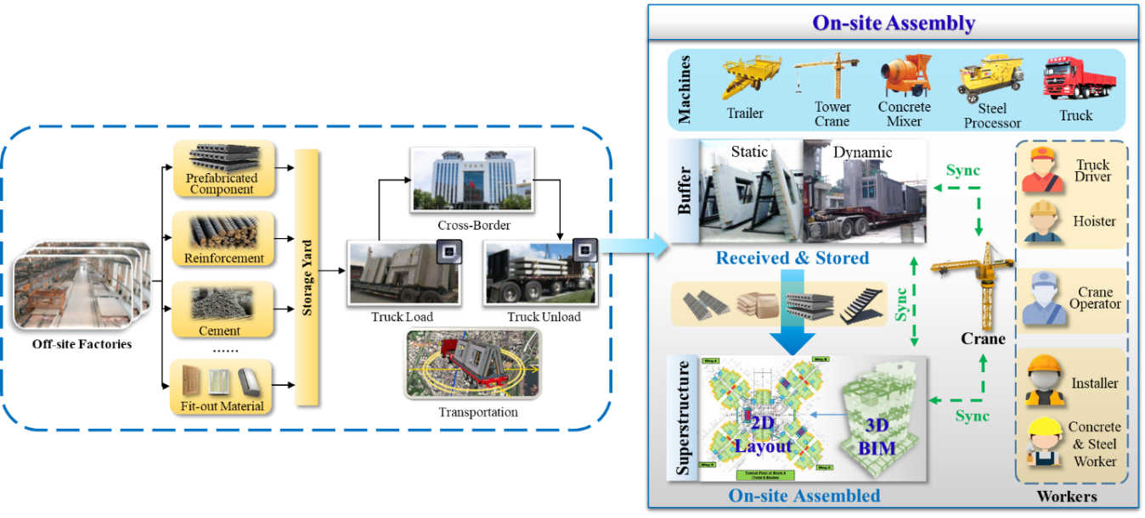
Fig. 1. On-site assembly scenario in prefabricated construction

3.2 Digital Twin-Enabled Smart Construction Site
Digital twin-enabled smart construction sites are pervasive, context-aware, and augmented with intelligence for synchronized PSE with real-time cyber-physical visibility and traceability. Real-time data-enabled visibility and traceability, as well as the real-time sensing and control services, are the core characteristics of digital twins. As shown in Fig. 2, traditional construction resources are converted into smart construction objects (SCOs), which are augmented with real-time sensing and reaction abilities through IoT-based devices, such as RFID, iBeacon, and UWB. There are three main types of SCOs: smart machines, smart materials, and augmented workers. Smart machines and smart materials can collect the real-time nD data (e.g. status, location, health level, and ambient information) and update their corresponding digital twins to reflect current states. Meanwhile, they can be remotely controlled and perform automatic actions to achieve real-time cyber-physical interoperation. Augmented workers are on-site workers equipped with industrial wearables (e.g. smart gloves and smart watches) that aid in task navigation (e.g. target resource position and assembly task information) and allow managers to know the real-time locations and statuses of workers to allocate and organize on-site tasks with improved flexibility and convenience. Notably, only some key construction resources are required to be converted into SCOs to limit costs. Additionally, a storage box is embedded on the surface of each SCO to store and recycle smart devices. When an SCO completes one round of usage, the attached smart devices are recycled from the storage box, and reused in other SCOs to reduce the cost. Digital twins for construction resources are established in cloud space through semantic and virtual definitions for item-level mapping and characterization. Smart mobile gateway (SMG) as a lightweight middleware is applied to seamlessly manage, control, and coordinate SCOs with digital twins through wireless communication in an easy-to-deploy and simple-to-use approach [26]. The digital twins of SCOs can be shared, monitored, and managed based on a uniform standard with real-time integration and interoperation that involves multiple stakeholders. Moreover, static structures (e.g. building structures, site terrain, and temporary facilities) and variables (e.g. temperature, humidity, and wind speed) are detected and updated using computer vision, laser scanning, and environmental sensors to obtain the complete digital twin of site conditions. Multiple stakeholders can monitor the real-time construction progress through high-fidelity virtual models, and on-site workers can efficiently complete daily tasks with automatic navigations and alerts.
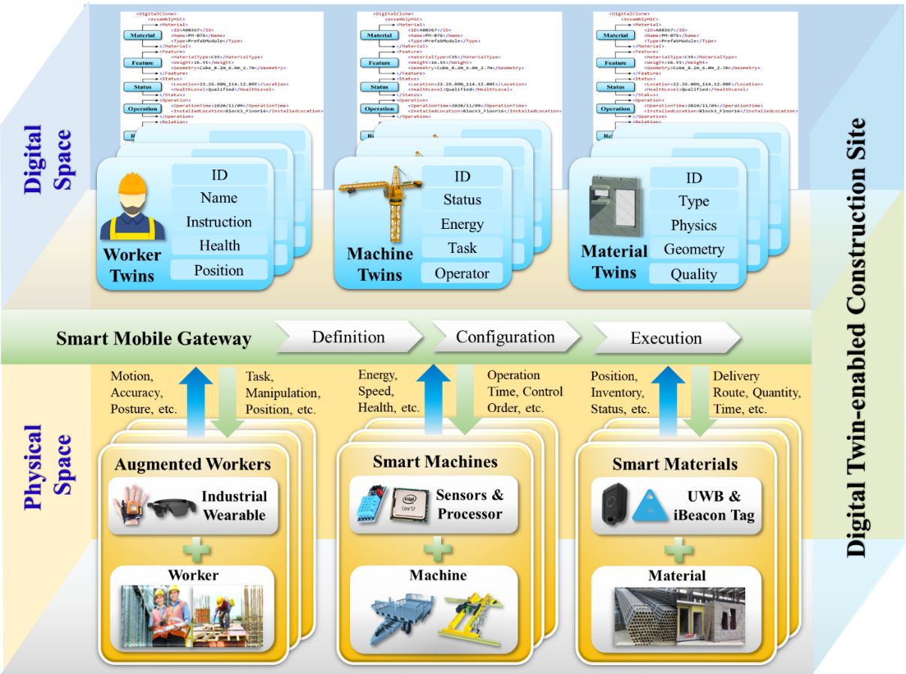
Fig. 2. Digital twin-enabled smart construction site

3.3 Real-Time Cyber-Physical Visibility and Traceability
The key function of digital twins on smart construction site is to provide real-time data-driven cyber-physical visibility and traceability for real-time supervision and remote control, as shown in Fig. 3. Operators can receive the automatic navigation and alert to efficiently and accurately complete their daily tasks with real-time feedbacks through the cloud. Blind spots in complex and uncertain environments on construction sites can be observed with both physical visibility and cyber visibility in real time. When SCOs are installed at the right positions on the building structure, the virtual construction model will be automatically updated to match the construction progress based on the real-time sensing data. The real-time statuses of building structures and buffers deployed with IoT devices can be detected to facilitate on-site operations. Several real-time statuses of smart prefabricated components can be visualized through different colors, described as {produced, arrived, processing, installed}. Meanwhile, these real-time statuses will also be updated to cloud Kanban to remind the on-site managers. According to the real-time statuses of SCOs and construction progress visualized by S-curves, only the right SCO within the appropriate time window in the correct location is allowed to be lifted. For PSE decision-making supports, based on the real-time digital twin data about construction progress in current time window t, the completion time of the processing assembly task in the next time window t+1 can be estimated to facilitate the subsequent PSE decision-making. Similarly, the arrival time of SCOs can be also estimated based on the real-time positions that are updated by GPS devices during the logistics process. Workers can also cooperate through cyber-physical visibility mechanisms in a semi-automated environment when conducting on-site operations. Some workers remotely control the robotic crane, with the visibility information mainly provided by digital twins. Other workers on the construction site can physically check the real-time positions and statuses of SCOs during lifting and installation. Digital twin explorers can be browser-based or mobile-app-based interfaces that provide useful information. Real-time sensing data are visualized and dynamic controls are implemented through digital twin explorers. Visibility and traceability tools provide high-fidelity virtual models and analytical tools through cloud, and historical data is stored to check resource status and assess construction progress as needed.
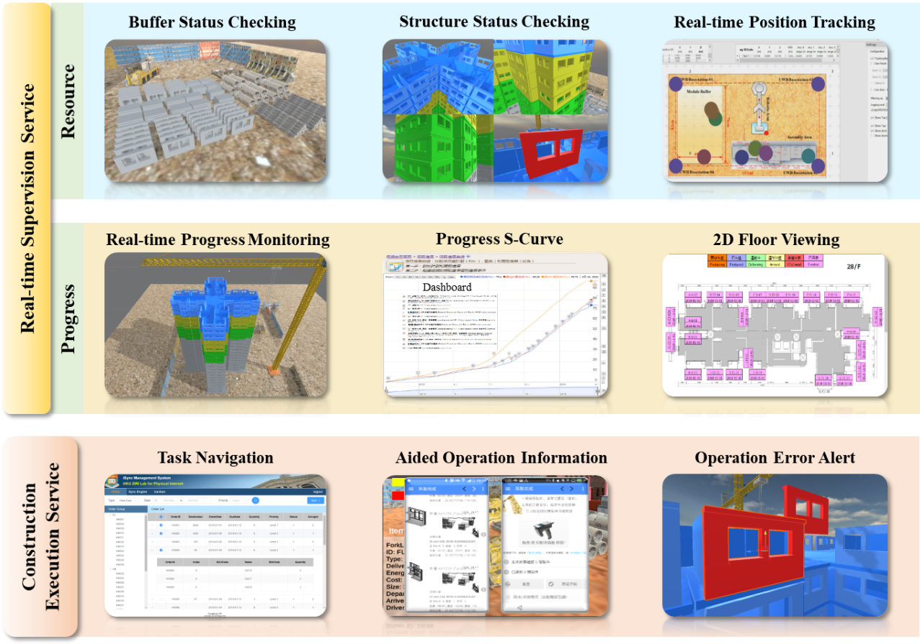
Fig. 3. Real-time data-driven cyber-physical visibility and traceability for real-time supervision and remote control services

4. Digital Twin-Enabled Real-Time Synchronization System (DT-SYNC) for Precast On-Site Assembly
A digital twin-enabled real-time synchronization system (DT-SYNC) is proposed for PSE in precast on-site assembly. A resilience mechanism to cope with uncertainties and disturbances is designed based on the ticket queuing system used at university graduation ceremonies. Real-time resource status and construction progress information is fully applied for the dynamic adjustment of PSE tasks based on the cyber-physical visibility and traceability provided by digital twins.

4.1 Functional Ticket-Based System Used at Graduation Ceremony
The functional ticket-based system used at university graduation ceremony is presented in Fig. 4 [10,25,29]. Four parties, including students, working staff (WS), principal, and department head (DH), are included in this system. Three tickets are used to organize and coordinate the graduation ceremony: admission tickets, program tickets, and name tickets. The basic procedure of the functional ticket-based system at a graduation ceremony is described as follows: (1) Students are assigned with admission tickets and name tickets. WS1 will check the students’ admission tickets at the gate. Only the students with the appropriate admission tickets are permitted to enter the auditorium; (2) Students are grouped according to specific rules related to programs, faculties, and graduation degree levels; (3) Students wait in the queue before entering the stage area under the guidance of WS3; (4) WS2 will give a program ticket to the first student in each program, which has the corresponding program name on it. When one student with a program ticket joins the queue, WS4 will take the program ticket and inform the DH on the stage about the program change; (5) Students go to the stage one by one and hand their name tickets to the DH. The DH announces the name on the name ticket, and the student goes to the principal. The principal turns the tassel and awards the degree. With the real-time synchronization and coordination provided by functional tickets, the university ceremony is conducted in an orderly fashion for students with various programs and degrees. This approach helps stakeholders understand whether the right operations are executed at the right time in the right place during the ceremony process with looking-forward visibility and looking-back traceability. Disturbances and uncertain events can also be effectively avoided by functional tickets. For example, following the real-time student queuing with name tickets, the principal can synchronously award the right degree to the right student without consideration of the attendance or absence of students.
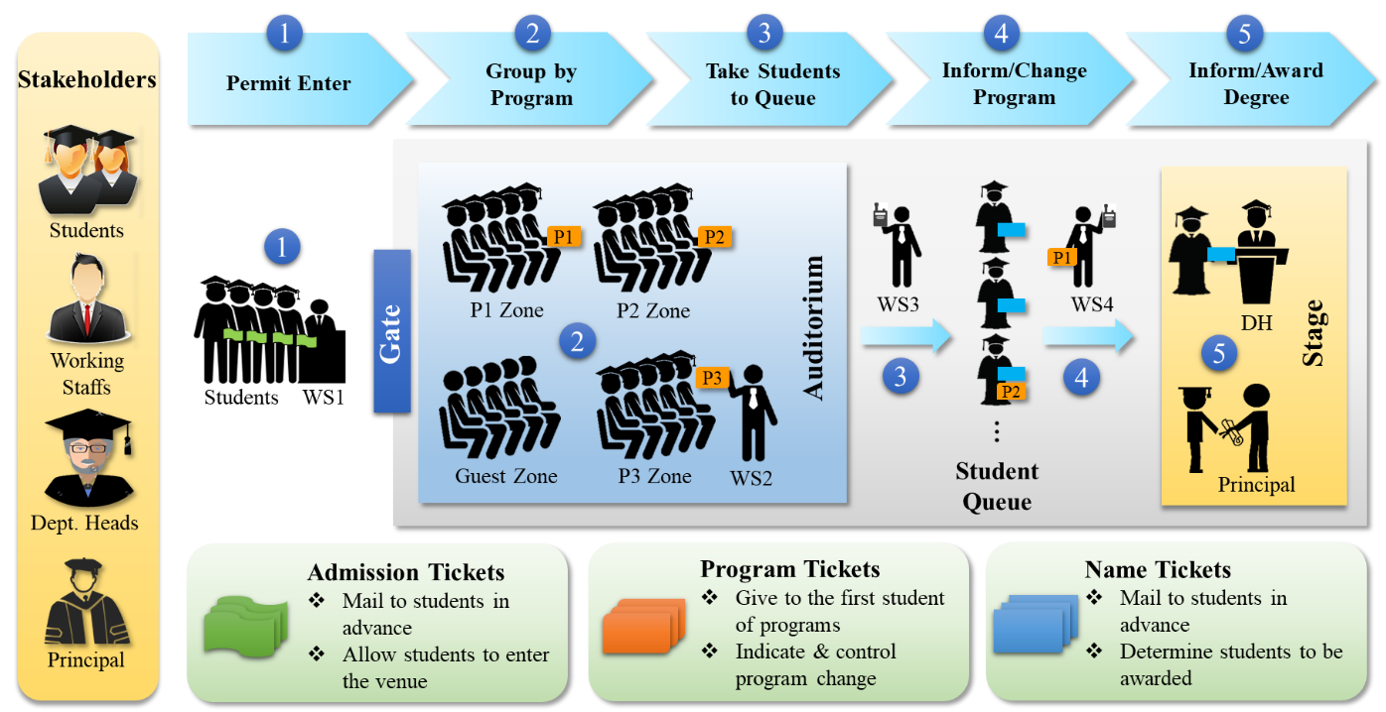
Fig. 4. Functional ticket-based system used at graduation ceremony with simplicity and resilience

4.2 Real-Time Synchronization for Precast On-Site Assembly
Inspired by the ticket queuing system used at graduation ceremony, DT-SYNC is proposed to synchronize and coordinate the operations and resources while promoting simplicity and resilience based on real-time status and construction progress information, as shown in Fig. 5. Through analogy to four tickets used in the graduation ceremony, four kinds of tickets are designed, including job ticket (JT), setup ticket (ST), operation ticket (OT), and twined logistics ticket (LT):
- JTs are used to permit the right jobs considering project demands and construction capacities. Only qualified jobs with the right JTs at the right time in the right location are permitted to be implemented. JTs consist of several key elements, such as material attributes (e.g. ID, type, volume, weight, and cost), project relations (e.g. inspector, machine, and connected material), construction statuses (e.g. priority and danger level), and corresponding OTs and LTs.
- STs are designed for controlling the preparation of the working environment of superstructures when conducting jobs in a new work package, especially for the setup of a new floor. The key elements of STs include setup attributes (e.g. floor, block, and working hour), correlative construction jobs (e.g. end time of the previous work package and start time of the current work package), and related OTs and LTs.
- OTs and LTs are designed to synchronize and coordinate the operations and JIT delivery for various construction materials in the buffer. OTs include operation attributes (e.g. ID, name, and navigation), related resource information (e.g. operator ID, tool ID, and material ID), and construction statuses (e.g. location, start time, and end time); LTs contain logistics attributes (e.g. ID, name, and navigation), demanded resource information (e.g. operator ID, trailer ID, and material ID), and construction statuses (e.g. location, start time, and end time).
The reengineered process for on-site assembly in prefabricated construction with DT-SYNC is as follows:
(1) The types and quantities of construction materials (e.g. components, steel, and cement) are confirmed and prepared according to the project demands with BIM and CAD design files.
(2) Several prefabricated components with similar functional or spatially adjacent relationships are grouped into one job. Only the permitted jobs with appropriate JTs at the correct time and locations can be performed. When jobs on a new floor start to be constructed, setup tasks are implemented to prepare the new working environment. Temporary infrastructures (e.g. scaffolds, safety nets, temporary elevators, and cement pumps) must be established, and a tower crane should be used to reach specific floors. An ST that indicates the details of the setup work is assigned in this case.
(3) Construction materials are transported to buffers based on the demands of the real-time construction scheme. Only with right LTs, the related materials are permitted to enter the buffer and operated according to the LT instructions.
(4) When a new JT is issued, the required construction materials are prepared in the buffer in advance with intra-logistics navigation methods. Some materials are temporarily stored in the buffer for later use. Other materials, such as some prefabricated components, are used in JIT mode and lifted by cranes instantly after arriving on site. Only when all the required materials are prepared and can be used instantly to fulfill the simultaneity, the related JT is allowed to be executed.
(5) Each JT is equipped with a set of OTs based on the related operations. On-site operations include various types, such as component hoisting, crane operation, signal communication, installation, measuring, cement processing, and steel binding. Some specific operations should be simultaneously implemented. Through the real-time synchronized instructions provided by OTs, buffer, crane, and superstructure workers can coordinately operate to install components within a same time window.
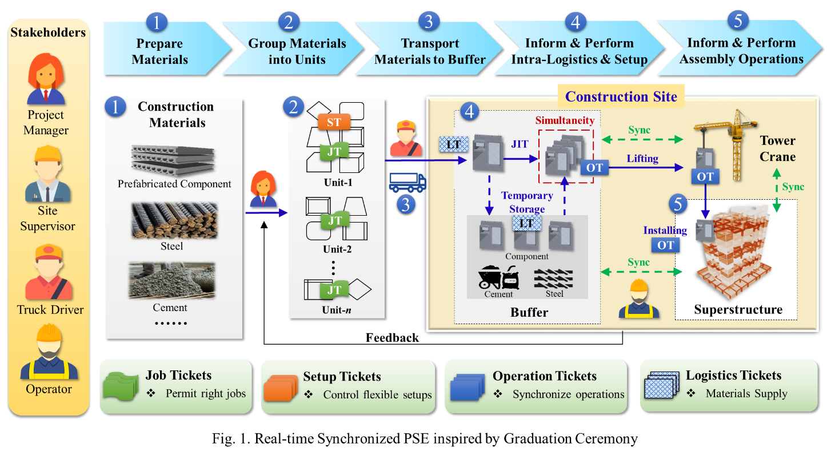
Fig. 5. Real-time synchronization for PSE of on-site assembly
As shown in Fig. 6, SCOs with functional tickets are augmented with IoT-based technology, consisting of three parts: iBeacon/UWB/RFID devices, ticket explorers, and smart digitization. Smart devices are the basic carrier of tickets, and they can update the real-time statuses and track the locations of tickets and related SCOs. Control orders are also fed back to SCOs for cyber-physical interoperation on a real-time basis. Ticket explorers (e.g. mobile phone apps and personal computers) can enhance the visualization of tickets for timely and accurate acquisition of construction progress and site conditions. Functional tickets are also converted into digital twins by smart digitization based on JSON/XML-based files with an appropriate set of information. Through the cyber-physical visibility and traceability of functional tickets, the real-time statuses of resources and operations can be shared among buffer workers, superstructure workers, and crane operators for the seamless collaboration.
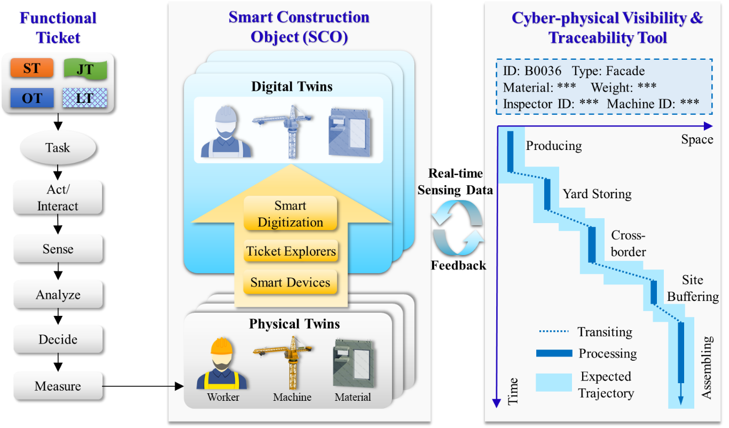
Fig. 6. Cyber-physical visibility and traceability provided by digital twins under DT-SYNC

4.3 On-Site Simultaneity with DT-SYNC
On-site simultaneity concerns the variation in the completion times of operations and materials for the same job, and can be used to reduce buffer inventory as well as improve construction efficiency. Simultaneity could be considered as a measure in a real-time synchronization system, and it is also the prerequisite of subsequent operations. Only when the corresponding simultaneity condition of a JT is fulfilled, the related OTs are allowed to be executed. Several assumptions are made in this case: (1) An ST is required to switch among different JTs to establish the new working environment and preparing required materials; (2) Within the same time window, only one JT is allowed to be executed on a given floor; (3) After the tasks associated with a JT start, they must be finished without interruption; (4) Some parallel JTs can be implemented on the same floor without precedence constraint; and (5) Some JTs on the same floor can only be implemented after certain previous JTs are completed, which have precedence constraints. The relevant notations and descriptions are shown in Table 1.
Table 1. Notations and Descriptions
Notations | Descriptions
$$T\left({JT}_{f,j}\right), t({JT}_{f,j})$$ | Start time and processing duration of JT for job j on floor f
$$T\left({ST}_{f,j}\right),t({ST}_{f,j})$$ | Start time and processing duration of ST for job j on floor f
$$T_{D}\left({LT}_{f,j,i}\right),T_{A}\left({LT}_{f,j,i}\right), t({LT}_{f,j,i})$$ | Departure time, arrival time, and delivery duration of LT for material i in job j on floor f
$$T\left({OT}_{f,j,l}\right),t({OT}_{f,j,l})$$ | Start time and processing duration of OT for operation l in job j on floor f
$T^{*}\left({JT}_{f,j}\right)$,$t^{*}({JT}_{f,j})$ | Actual start time and predicted processing time based on real-time data of job j on floor f
$T_{D}^{*}({LT}_{f,j,i})$,${ T}_{A}^{*}({LT}_{f,j,i})$,$t^{*}({LT}_{f,j,i})$ | Actual departure time, arrival time, and predicted delivery duration based on real-time data for material i in job j on floor f
CD | Allowed total construction project duration
$${CS}_{f}$$ | Duration of concrete solidification and related works duration after floor f is completed
$$t_{a},t_{j}$$ | Processing time of jobs a and j
$$r_{a},r_{j}$$ | Similar rate of operations in jobs a and j
$$d\left(a,j\right)$$ | Euclidean distance between jobs a and j for matching
u, v | Weights of duration time and operation similar rate to calculate $d\left(a,j\right)$
$$∆t_{LJ}^{j,f}$$ | Holding time for required materials in job j on floor f
$$∆t_{JJ}^{j,f}$$ | Interval time between the start time of job ${JT}_{f,j}$ and finish time of the previous job ${JT}_{f,j-1}$ on floor f
TD | Actual total construction project duration
$${WT}_{j,f}$$ | Waiting time considering simultaneity of on-site resources for job j on floor f
$$w_{1},w_{2}$$ | Weights of $d\left(a,j\right)$ and ${WT}_{j,f}$
M | Sufficiently large constant for the weight of precedence priority
$$P_{j,a}$$ | Comprehensive priority of job j to replace disturbed job a

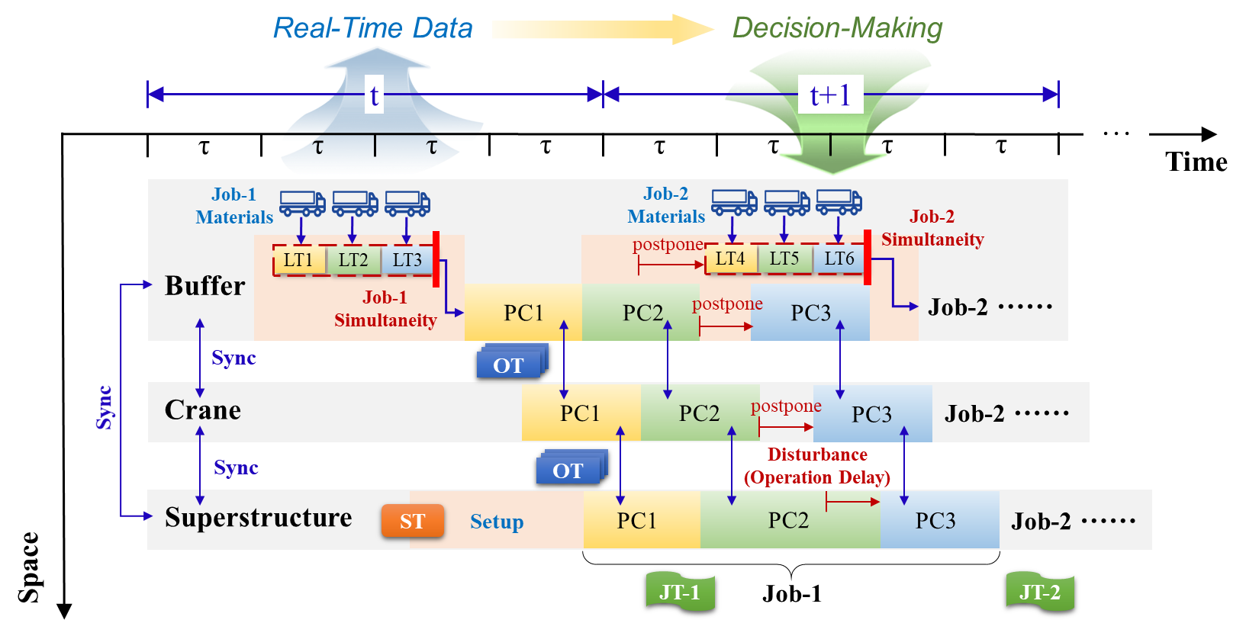
Fig. 7. Real-time synchronization process based on digital twins for PSE of precast on-site assembly
Simultaneity is important for construction materials. Only when all the required materials are prepared in a buffer and can be used instantly without uncertainty, the related JT is allowed to be executed. The key concept of DT-SYNC model is applying the real-time digital twin data collected in time window t to estimate the subsequent status of operations and materials in the next time window t+1, as shown in Fig. 7. The parameters with note “*” are real-time sensing data in the time window t, which are truly happening during the actual construction process and used to determine PSE decision variables in the next time window t+1. As described in formula (1), the allowed execution time $T({JT}_{f,j})$ for job j on floor f should be later than the simultaneity time point for required materials given by LT. $T({JT}_{f,j})$ should also be later than the estimated arrival time of related materials based on the real-time data $T_{D}^{*}({LT}_{f,j,i})$ and $t^{*}({LT}_{f,j,i})$ updated by SCOs. Moreover, $T({JT}_{f,j})$ should be later than the actual arrival time $T_{A}^{*}({LT}_{f,j,i})$ of related materials based on the real-time data, as described in formula (2). It’s obvious that $T_{A}\left({LT}_{f,j,i}\right)=T_{D}\left({LT}_{f,j,i}\right)+t\left({LT}_{f,j,i}\right)$ is always valid for the same construction material. After a JT begins being processed, several involved OTs are assigned to related workers, as described in formula (3).
$$T\left({JT}_{f,j}\right)≥T_{D}^{*}\left({LT}_{f,j,i}\right)+t^{*}\left({LT}_{f,j.i}\right), ∀i, j,f$$ | (1)
$$T\left({JT}_{f,j}\right)≥T_{A}^{*}\left({LT}_{f,j,i}\right), ∀i,j,f$$ | (2)
$$T({OT}_{f,j,i})≥T^{*}({JT}_{f,j}) , ∀i,j,f$$ | (3)
To improve the simultaneity of materials for each job j, the departure times $T_{D}\left({LT}_{f,j,i}\right)$ are adjusted to reduce the differences in the arriving times of all materials, as described in formula (4). In the context of the transportation function $T_{A}\left({LT}_{f,j,i}\right)=T_{D}\left({LT}_{f,j,i}\right)+t\left({LT}_{f,j,i}\right)$, the arrival time $T_{A}\left({LT}_{f,j,i}\right)$ should be later than the start time of the previous job $T^{*}\left({JT}_{f,j-1}\right)$, with a time lag $d_{f,j,i}$ assigned for storing the newly arrived material in a vacant space in the buffer. Additionally, $T_{A}\left({LT}_{f,j,i}\right)$ should be earlier than the start time of the current job, and is approximately equal to the completion time of the previous job based on the real-time data $T^{*}\left({JT}_{f,j-1}\right)$ and $t^{*}\left({JT}_{f,j-1}\right)$, as described in formula (5).
$$T_{D}\left({LT}_{f,j+1,i}\right)≥T^{*}\left({JT}_{f,j}\right)-t\left({LT}_{f,j+1,i}\right)+d_{f,j+1,i}, ∀i,j,f$$ | (4)
$$T_{D}\left({LT}_{f,j+1,i}\right)≤T^{*}\left({JT}_{f,j}\right)+t^{*}\left({JT}_{f,j}\right)- t\left({LT}_{f,j+1,i}\right)-d_{f,j+1,i}, ∀i,j,f$$ | (5)
The simultaneity for each job j on floor f can be measured through two indicators: holding time $∆t_{LJ}^{j,f}$ and job interval $∆t_{JJ}^{j,f}$ [12]. $∆t_{LJ}^{j,f}$ is the holding time of the materials in the buffer for each job j, which is the interval between the arrival time of related logistic task ${LT}_{f,j,i}$ and the start time of job ${JT}_{f,j}$, as described in formula (6). Job interval $∆t_{JJ}^{j,f}$ is the interval between the start time of job ${JT}_{f,j}$ and the finish time of the previous job ${JT}_{f,j-1}$, as described in formula (7).
$$∆t_{LJ}^{j,f}=\sum_{i∊{LT}_{i}}{[}T\left({JT}_{f,j}\right)-T_{A}({LT}_{f,j,i})]$$ | (6)
$$∆t_{JJ}^{j,f}=T\left({JT}_{f,j}\right)-[T\left({JT}_{f,j-1}\right)+t\left({JT}_{f,j-1}\right)]$$ | (7)

4.4 DT-SYNC Mechanism
A real-time synchronization mechanism for DT-SYNC is defined for precast on-site assembly, as shown in Fig. 8. During a planning horizon H (1 month to 3 months), tickets are grouped to define the main jobs performed on each floor according to the project demands (e.g. material quantity (MQ), quality standard (QS), arrival date (AD), and due date (DD)) and construction constraints (e.g. capacity constraints and precedence constraints). During a rolling time window T (1 week), a job ticket pool is established to sequence and allocate the tickets to related machines and operators. During a shorter time window t (1 day to 3 days), the simultaneity of materials associated with one JT is analyzed based on the real-time data collected by SCOs. Only when the simultaneity conditions of a JT are met, the related OTs and LTs are allowed to be executed. Otherwise, a JT with unqualified simultaneity will be delayed and replaced by other JTs.
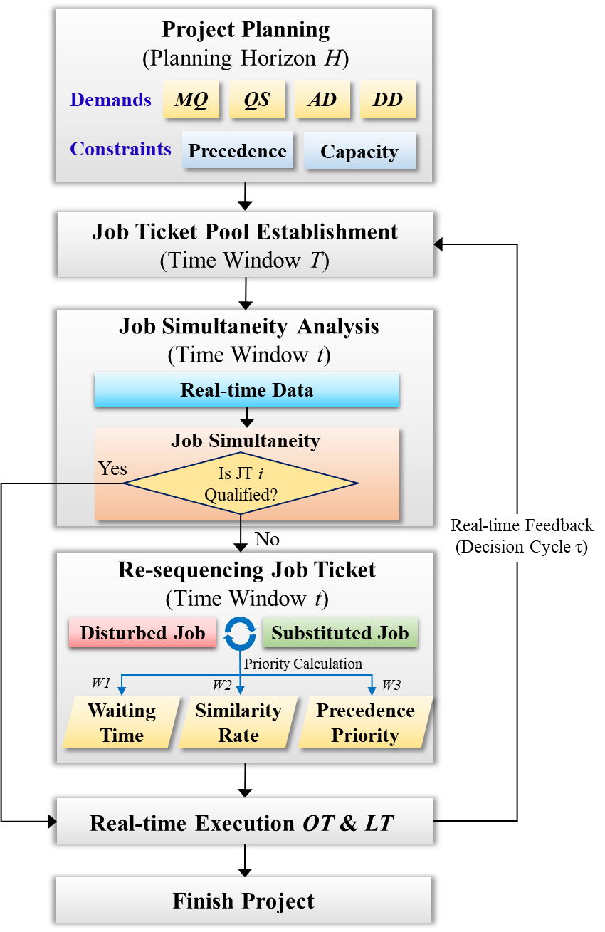
Fig. 8. Real-time synchronization mechanism for PSE of precast on-site assembly
According to assumptions 4 and 5, parallel JTs can be implemented without precedence constraints based on the current site conditions, and sequential JTs can only be conducted when certain previous JTs are completed. A precedence index ${PRE}_{f} \left(m,n\right)$ based on partial order relation is used to define the precedence priority of jobs, where partially ordered set (Poset) $Ω$ contains JTs, as shown in formula (8). The partial order relation for parallel JTs with no precedence constraint is described as ${JT}_{f,m}={JT}_{f,n}$, while the related precedence index ${PRE}_{f} \left(m,n\right)$ is 0. Only when ${PRE}_{f} \left(m,n\right)$ is 0, these two JTs are allowed to be exchanged. If ${JT}_{f,m}$ must be performed after ${JT}_{f,n}$, the partial order relation is described as ${JT}_{f,m}>{JT}_{f,n}$, and the precedence index ${PRE}_{f} \left(m,n\right)$ is 1. The setup associated with an ST should be completed before the corresponding JTs are implemented, as described in formula (9). The setup time of an ST on floor f should not precede the completion dates of the lower floors, as described in formula (10). The total construction duration required to assemble all the floors, which are accumulated by processing time and concrete solidification time, should not exceed the allowed total duration CD, as described in formula (11). During the execution phase, real-time resource statuses and construction progress information are collected and uploaded for dynamic project adjustment by managers. Within each decision cycle τ (5 minutes to 30 minutes), managers can reallocate and resequence JTs based on the real-time feedback. Only one JT can be processed within a time window on the current floor, as described in formula (12). Some specific operations $T^{'}\left({OT}_{f,j,l}\right)$ and $T^{''}\left({OT}_{f,j,l}\right)$ should be simultaneously implemented with a limited time lag $d_{f,j,l}$, such as the installation of a component requires cooperation between crane operators and workers on the superstructure, as described in formula (13).
$${PRE}_{f} \left(m,n\right)=\left\{\begin{aligned}1, if {JT}_{f,m}>{JT}_{f,n} \\ 0, if {JT}_{f,m}={JT}_{f,n} \end{aligned}\right. , {JT}_{f,m},{ JT}_{f,n}∊Ω$$ | (8)
$$T\left({JT}_{f,j}\right)≥T\left({ST}_{f,j}\right)+t({ST}_{f,j}) , ∀j,f$$ | (9)
$$T\left({ST}_{f+1,j}\right)≥Max\left\{T\left({JT}_{f,j}\right)+t\left({JT}_{f,j}\right)\right\}, ∀j,f$$ | (10)
$$\sum_{f=1}^{F}{\{Max\left[\left(T\left({JT}_{f,j}\right)+t\left({JT}_{f,j}\right)\right)-T\left({ST}_{f,1}\right)\right]+{CS}_{f}\}}≤CD, ∀j$$ | (11)
$$T\left({JT}_{f,j+1}\right)≥T\left({JT}_{f,j}\right)+t\left({JT}_{f,j}\right), ∀j,f$$ | (12)
$$T^{''}\left({OT}_{f,j,l}\right)-d_{f,j,l}≤T^{'}\left({OT}_{f,j,l}\right)≤T^{''}\left({OT}_{f,j,l}\right)+d_{f,j,l}, ∀l,j,f$$ | (13)
DT-SYNC provides high resilience to limit uncertainty. JTs with unqualified simultaneity will be replaced with other JTs. The replacement of JTs is based on the priority measure, which is calculated considering the job precedence, similarity rate, and waiting time. Precedence is the dominant constraint for the substitution of jobs in the context of disturbances, and it is given the highest weight among the system constraints. Some JTs can only be executed when certain previous JTs are completed. The precedence priority is calculated using the precedence index ${PRE}_{f} \left(m,n\right)$ based on the partial order relation in previous formula (8). Only when ${PRE}_{f} \left(m,n\right)$ is 0, ${JT}_{f,m}$ and ${JT}_{f,n}$ are allowed to be exchanged.
A delayed JT is generally replaced by a JT with a high similarity rate. The similarity rate between disturbed job a and substituted job j on floor f is measured by calculating their Euclidean distance $d\left(j,a\right)$ considering the job duration and the operation similarity rate. A shorter Euclidean distance is associated with a high similarity rate, which results in a high priority score. As represented in formula (14), $t_{a}$ and $t_{j}$ are the estimated job durations, and $r_{a}$ and $r_{j}$ are the operation similarity rates, where u and v are the corresponding weights.
$$d\left(j,a\right)=\sqrt{u∙{\left(t_{j}-t_{a}\right)}^{2}+v∙{\left(r_{j}-r_{a}\right)}^{2}}$$ | (14)
The waiting time ${WT}_{j,f}$ is the preparation time required to ensure the simultaneity of on-site materials for job j on floor f, as shown in formula (15), where $T^{*}$ is an absolute real-time point. A shorter waiting time is associated with high priority for substituted jobs.
$${WT}_{j,f}=Max\left\{T_{D}\left({LT}_{f,j,i}\right)+t\left({LT}_{f,j.i}\right)\right\}-T^{*}$$ | (15)
The comprehensive priority $P_{j,a}$ of substituted job j when a disturbance influences job a is a weighted set of precedence ${PRE}_{f} \left(j,a\right)$, similarity rate $d\left(j,a\right)$, and waiting time ${WT}_{j,f}$ values, as described in formula (16).
$$P_{j,a}=-M∙norm\left[{PRE}_{f} \left(j,a\right)\right]-w_{1}∙norm\left[d\left(j,a\right)\right]-w_{2}∙norm\left({WT}_{j,f}\right)+K$$ | (16)
where $w_{1}$, $w_{2}$, and M are the weights of the similarity rate, waiting time, and precedence. Notably, M is an extremely large number to reflect the dominance of precedence, K is a constant used to adjust the priority value, and norm is the normalization function used to eliminate the effects of different measurement units.

5. Numerical Experiment and Testbed Demonstration
In this section, a numerical experiment is conducted to evaluate the performance of the proposed DT-SYNC model based on the previous data of one pilot project, and a robotic testbed assembly is used to demonstrate the implementation framework of the digital twin-enabled smart construction site, as shown in Fig. 9. Thus, the theoretical verification of the PSE model and the technical realization of digital twin-enabled smart construction site are both conducted for the proof of concept about DT-SYNC. A real-life smart prefabrication project to build a 37-story residential building in Tuen Mun District, Hong Kong, is used as a reference for the experiment. These smart prefabricated components and trucks are equipped with RFID and GPS devices to enhance real-time cyber-physical visibility and traceability, which are also converted into digital twins in the web-based platform. These components are produced in an off-site factory in Greater Bay Area (GBA), and then delivered to the construction site in Hong Kong for on-site assembly.

Fig. 9. Numerical experiment and robotic testbed demonstration for the proof of concept about DT-SYNC

5.1 Implementation of DT-SYNC for Precast On-Site Assembly
A robotic testbed demonstration is used to present the implementation framework of a digital twin-enabled smart construction site, as shown in Fig. 10. Four kinds of functional tickets (e.g. JTs, STs, OTs, and LTs) are used to synchronize and coordinate the operations and resources on a real-time basis during on-site assembly. Smart prefabricated components with UWB and RFID tags are coordinated with their digital twins and synchronized based on functional tickets. The real-time data of departure times and real-time positions of trucks combined with corresponding LTs are used to determine the simultaneity of SCOs. A network of UWB base-stations is deployed to receive signals from tags with mobile transmitters to determine the corresponding locations with a maximum 20-centimeter deviation. UWB is also applied to approximately locate the real-time positions of materials being transported and estimate the corresponding arrival times. Smart mobile gateway as a lightweight middleware is applied to transmit the real-time sensing data to digital twins, and send the control orders to SCOs. Smart mobile gateway can consistently check the real-time statuses of JTs, STs, LTs, and OTs with corresponding SCOs, as well as automatically monitor the mistakes and uncertainties during on-site assembly. To achieve the bidirectional interoperation on a real-time basis, message queuing telemetry transport (MQTT) is adopted to connect and coordinate physical twin and digital twin. Cloud-based services are provided for managers and workers through browser-based or mobile-app-based terminals. Supported by the cyber-physical visibility and traceability of digital twins, the real-time statuses of resources and operations can be shared among buffer workers, superstructure workers, and crane operators for seamless collaboration to install components. Operation execution services, such as ticket visualization and real-time task navigation/alert, are offered for on-site workers mainly through mobile phones. Construction progress monitoring services, such as dynamic Gantt charts and S-curves, are provided for project managers and clients for collaborative decision-making.
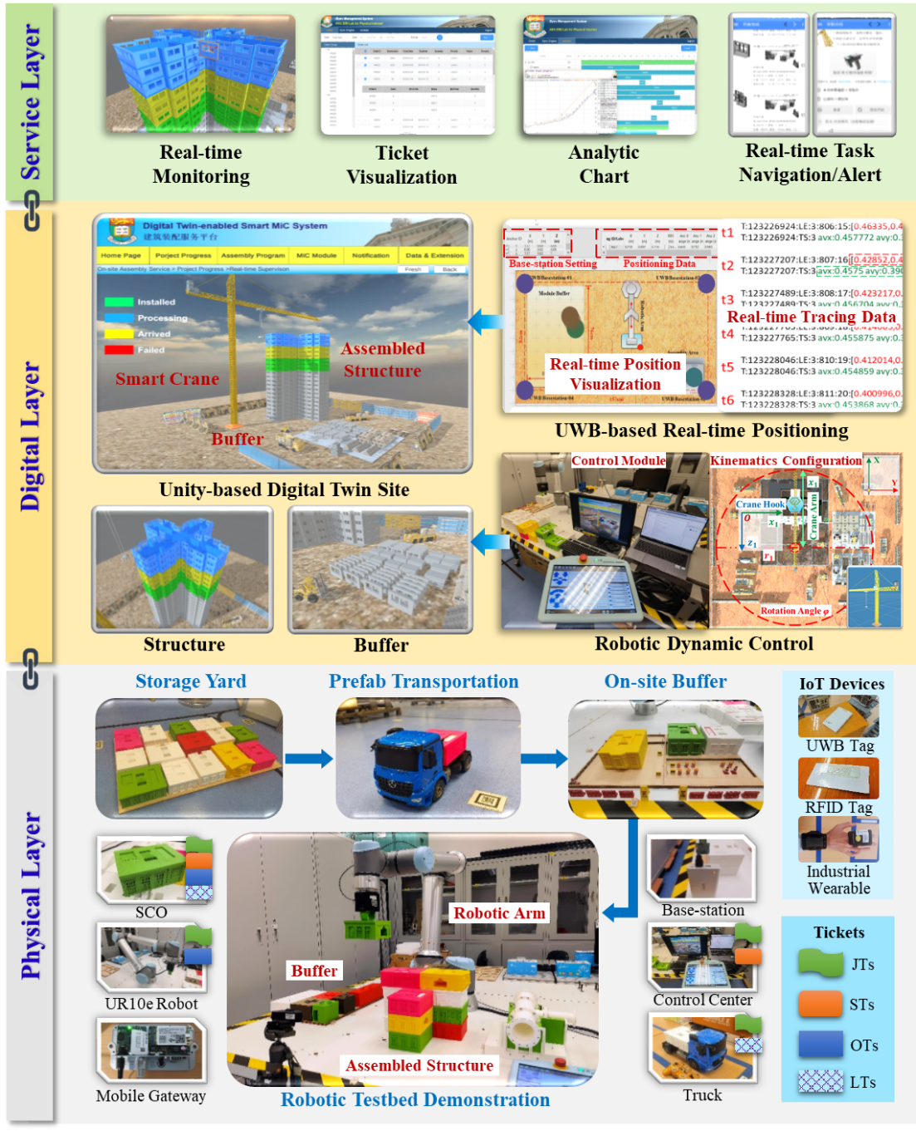
Fig. 10. Implementation framework of digital twin-enabled smart construction site for DT-SYNC

5.2 Parameter Setting
The 8th-35th stories of one residential building in Tuen Mun project (Block No.5) are composed of 4200 prefabricated components. This case study involves 336 JTs. Each floor is composed of 12 JTs, and the unit in each wing on each floor requires 3 JTs related to the installation of facades, interior walls, and slabs. Each JT includes 2 LTs for transporting these prefabricated components. An ST is implemented when a new floor begins to be established. Several OTs associated with a JT are synchronously distributed to buffer workers, structure workers, and crane operators. Parameters setting is shown in Table 2.
Table 2. Configuration of the numerical experiment for DT-SYNC
Class | Parameter | Value
Main building structure | Floors | 28
Main building structure | {JTs, STs, LTs} | {336, 28, 672}
Prefabricated component | {Facades, Interior walls, Slabs} (One floor) | {42, 72, 36}
Prefabricated component | Average transportation time | 128 min
Prefabricated component | Average unit assembly time | 206 min
Prefabricated component | Setup duration | [60 min, 120 min]
Prefabricated component | Transportation delay rate (>600 min) | 2.3%
Prefabricated component | Assembly rework rate | 1.4%
In this subsection, an original PSE approach (OPSE) is adopted as a reference. OPSE allows operators to strictly follow predetermined schedules based on component arrival times and task start times without a primary focus on the real-time data. To validate the proposed synchronization method and guarantee the reliability of performance comparison between DT-SYNC and OPSE, the algorithms used in the two PSE methods were run 30 times. To assess the feasibility of using DT-SYNC to punctually and simultaneously finish the explored project in a JIT mode with limited buffer, DT-SYNC is deployed with a buffer area which can only store the components for 1 JT, while larger buffer area is prepared for OPSE which can store components for 3 JTs. Several disruptions of on-site assembly are considered based on previous studies: inclement weather, worker’s productivity fluctuations, delayed transportation, resource confirmation issues, and crane’s operation issues [6,13]. These disruptions can be classified into two levels: operation level (e.g. weather, productivity fluctuations, and crane issues) and transportation level (e.g. confirmation issues and later transportation). These uncertain events are believed to be common sources of variability in prefabricated construction. The data patterns and probability distributions are set to be similar to those in the studies of previous prefabricated construction projects [23,46,50]. Different parameter combinations are used to generate stochastic scenarios with different uncertainty levels {Low Uncertainty (LU), Medium Uncertainty (MU), High Uncertainty (HU)}, as shown in Table 4. Additionally, different coefficients of variation $cv$ are conducted to simulate different project situations, where random parameters are generated based on unified distribution $U=[\left(1-cv\right)p, \left(1+cv\right)p]$. The installation duration of one JT fluctuates, and exhibits a positive growth rate according to the height of the processing floor. Parameters related to material supplies are set according to the data from a previous project. The probability and duration of long delay of material supply both increase from LU to HU scenario. Under one run with the same uncertainty level, all the input parameters are kept the same in DT-SYNC and OPSE algorithms for comparison.
Table 3. Uncertainty generation setting
Class | Parameter | Value
Transportation | Standard transportation duration $D_{T}$ | 128 min
Transportation | Long delay rate $P_{d}$ | 2.3%
Transportation | Long delay duration $D_{d}$ | [600 min, 1600 min]
Operation | Standard installation duration $D_{I}$ | [154 min, 285 min]
Operation | Standard rework rate $P_{r}$ | 1.4%
Uncertainty scenario  {$cv(D_{T})$, $cv(D_{I})$, $D_{d}$, $P_{d}$, $P_{r}$} | Low uncertainty (LU) | {0.08, 0.03, [400, 500], 1.15%, 0.7%}
 | Medium uncertainty (MU) | {0.16, 0.06, [800, 1000], 2.3%, 1.4%}
 | High uncertainty (HU) | {0.32, 0.12, [1600, 2000], 5.6%, 2.8%}

5.3 Performance Evaluation
The performance results of the comprehensive analysis of 30 runs and one typical scheme are given in Fig. 11 to Fig. 14. The experiment data of 30 runs under three uncertainty scenarios are listed in Table. 4. The related key indicators (e.g. disturbance frequency, project duration, holding time, and job interval) of this typical scheme are around the median values, which has the following disturbance configuration: {disturbedJT_LU = {34, 65, 281} (No.11), disturbedJT_MU = {49, 113, 163, 173, 196, 263, 305, 333} (No.13), disturbedJT_HU = {26, 50, 87, 114, 129, 134, 155, 179, 181, 206, 226, 238, 243, 258, 266, 281} (No.26)}. For the holding times of construction materials in the buffer, DT-SYNC outperforms OPSE and the decrease of holding time is significant in medium-uncertainty and high-uncertainty scenarios, as shown in Fig. 11. The boxplot ranges for DT-SYNC are generally smaller than those for OPSE, which indicates that the material buffering of DT-SYNC is more stable. From the line chart in Fig. 11, the holding time in the OPSE method increases with construction progress, especially in the medium-uncertainty and high-uncertainty scenarios. This increasing holding time is caused by the lack of flexible adjustment to cope with the cumulative effects of disturbances in OPSE. The line chart of the holding time in the DT-SYNC exhibits no growth trend with the construction progress, suggesting that DT-SYNC provides a better buffering capacity to handle material delays. According to the S-curve of construction progress in Fig. 12, DT-SYNC exhibits higher resilience than OPSE due to the flexible dynamic adjustment scheme using real-time data. Progress lags are smoothly eliminated by DT-SYNC in the low-uncertainty scenario and medium-uncertainty scenario. However, interestingly, the degree of disturbance seems to exceed the maximum resilience capacity of DT-SYNC in high-uncertainty scenario, which also results in more lags in construction progress. As shown in Fig. 13, the number of abnormally high job intervals increases with the uncertainty level for both DT-SYNC and OPSE. Both the quantity and magnitude of high-value points are smaller for DT-SYNC than for OPSE. However, some job intervals of DT-SYNC are also high in the high-uncertainty scenario, which also indicates that some excessive disturbances may exceed the maximum resilience capacity of DT-SYNC. As shown in Fig. 14, with the increasing of uncertainty level, the average project duration increases in the two PSE methods, and the project durations in different scenarios with OPSE are all higher than those obtained with DT-SYNC. The average holding time (per job) achieved with DT-SYNC is lower than that obtained with OPSE, especially at medium-uncertainty and high-uncertainty levels, which indicates that DT-SYNC can be applied for projects in narrow urban areas and small-scale sites. In addition, the average holding time is also stable with DT-SYNC regardless of the uncertainty level, which implies that the real-time visibility and traceability provided by the use of functional tickets can enhance resilience for on-site material supplies. Job interval increases with the uncertainty level both in the two PSE methods, and DT-SYNC outperforms OPSE in all the scenarios, which indicates the tardiness of assembly operations caused by the uncertainties are limited through the real-time synchronization mechanism in DT-SYNC.
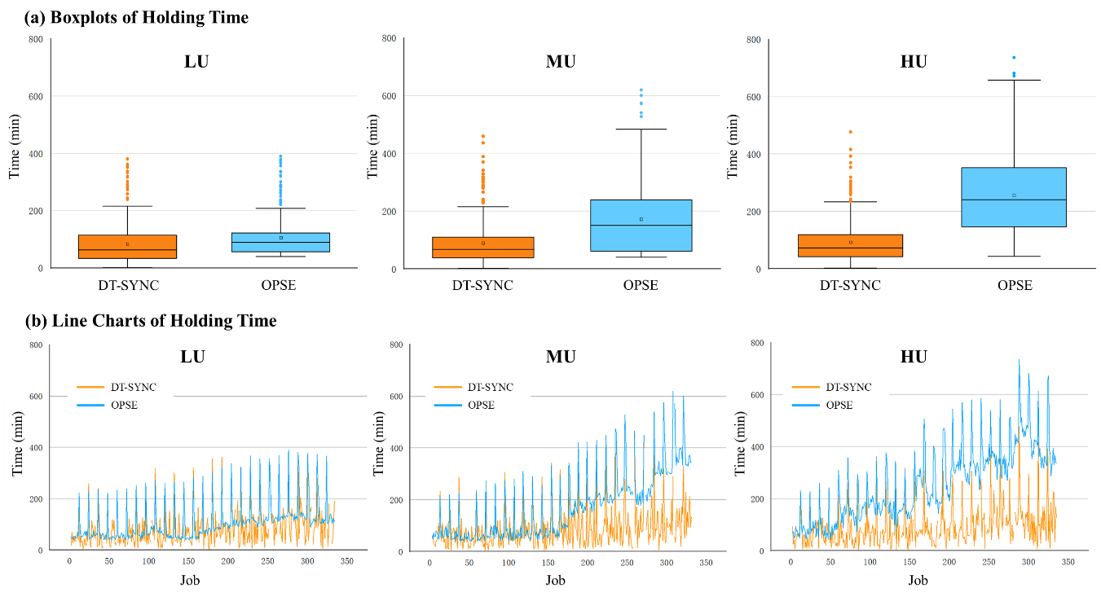
Fig. 11. Holding times for DT-SYNC and OPSE in different uncertainty scenarios
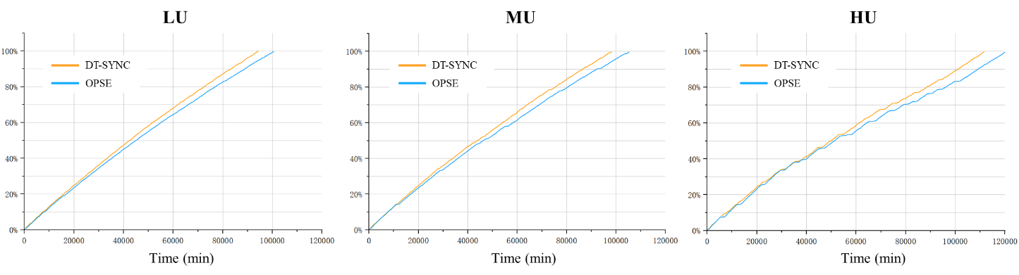
Fig. 12. S-curves of construction progress for DT-SYNC and OPSE in different uncertainty scenarios
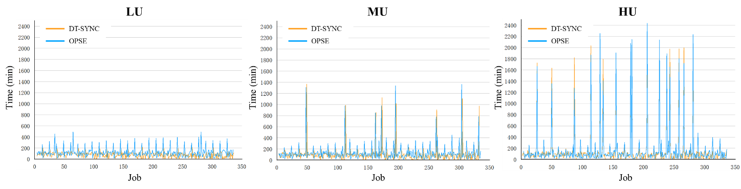
Fig. 13. Line charts of job intervals for DT-SYNC and OPSE in different uncertainty scenarios
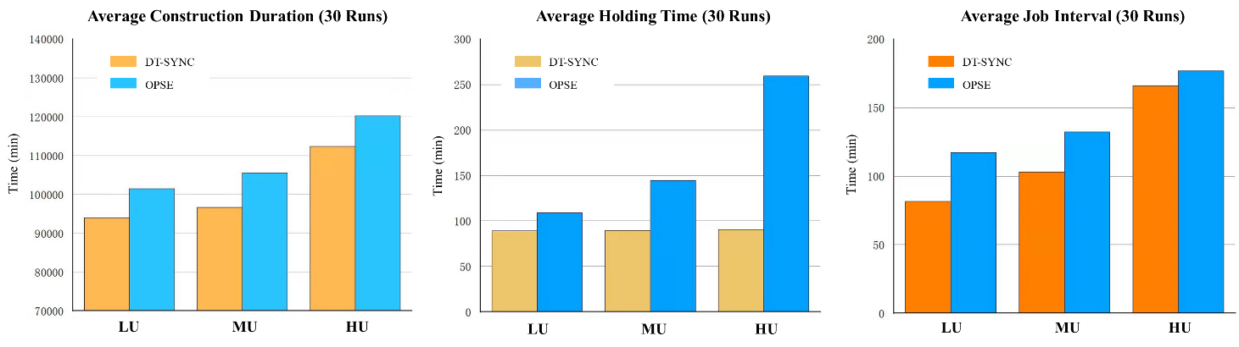
Fig. 14. Effects of uncertainty levels on the average construction duration, average holding time, and average job interval (30 runs)
No. | Low Uncertainty (LU) |  |  |  | Medium Uncertainty (MU) |  |  |  | High Uncertainty (HU)
No. | DT-SYNC |  | OPSE |  | DT-SYNC |  | OPSE |  | DT-SYNC |  | OPSE
No. | Project Duration | Holding Time | Project Duration | Holding Time | Project Duration | Holding Time | Project Duration | Holding Time | Project Duration | Holding Time | Project Duration | Holding Time
1 | 93096.6 | 91.6 | 99080.4 | 100.5 | 96448.4 | 90.3 | 103349.0 | 188.6 | 112405.3 | 89.3 | 122843.5 | 185.5
2 | 93201.9 | 90.2 | 104072.5 | 129.6 | 97155.0 | 86.3 | 110985.6 | 162.5 | 113353.6 | 86.0 | 121784.4 | 255.5
3 | 92965.7 | 90.1 | 102385.7 | 104.9 | 97894.2 | 96.2 | 109469.3 | 179.7 | 102767.8 | 86.2 | 111383.9 | 345.6
4 | 93450.8 | 86.1 | 102180.2 | 103.5 | 95503.2 | 98.9 | 103912.4 | 120.7 | 112363.1 | 88.9 | 119553.5 | 246.8
5 | 94214.8 | 84.4 | 101100.7 | 93.2 | 95667.6 | 91.1 | 104194.5 | 110.0 | 110117.4 | 87.8 | 117858.3 | 137.1
6 | 93263.8 | 85.7 | 101595.3 | 95.9 | 96419.3 | 91.7 | 103081.7 | 213.6 | 113811.2 | 91.5 | 117808.9 | 211.6
7 | 93248.7 | 93.0 | 101055.2 | 94.1 | 97989.4 | 89.6 | 107178.1 | 101.9 | 116525.0 | 90.6 | 122295.9 | 260.6
8 | 93725.7 | 91.9 | 101198.1 | 96.3 | 97717.1 | 89.8 | 108964.2 | 99.8 | 113348.7 | 94.8 | 115616.0 | 280.8
9 | 93135.7 | 89.5 | 100371.7 | 94.2 | 96658.0 | 85.3 | 103838.4 | 149.3 | 106590.3 | 87.7 | 116859.9 | 241.8
10 | 94569.0 | 92.8 | 100722.7 | 110.1 | 96363.7 | 92.3 | 106210.1 | 105.6 | 106302.2 | 90.2 | 108950.7 | 339.4
11 | 94060.4 | 88.7 | 100627.3 | 105.9 | 95149.6 | 90.1 | 101637.0 | 152.2 | 110657.1 | 91.1 | 119854.3 | 526.2
12 | 93450.8 | 87.4 | 102180.2 | 103.5 | 98434.5 | 86.0 | 107611.6 | 217.8 | 112015.7 | 91.1 | 119758.1 | 238.9
13 | 94214.8 | 85.1 | 101100.7 | 93.2 | 98244.9 | 91.6 | 105381.1 | 172.1 | 111747.4 | 85.1 | 119864.9 | 500.0
14 | 94171.5 | 86.2 | 101656.1 | 100.6 | 95907.1 | 89.7 | 104908.6 | 149.8 | 110032.2 | 90.2 | 118172.5 | 174.6
15 | 93271.9 | 94.3 | 102242.7 | 96.2 | 96217.2 | 85.7 | 105257.1 | 111.8 | 116525.0 | 90.6 | 122295.9 | 260.6
16 | 94800.0 | 85.9 | 102175.6 | 120.5 | 96302.9 | 87.5 | 106632.4 | 122.6 | 111597.7 | 91.6 | 122611.3 | 157.4
17 | 94147.7 | 87.3 | 101873.5 | 129.9 | 95784.3 | 92.7 | 106671.2 | 88.8 | 124321.4 | 94.9 | 135080.5 | 164.2
18 | 95533.6 | 89.0 | 102952.6 | 91.3 | 96491.8 | 89.4 | 105813.4 | 112.7 | 109016.7 | 91.5 | 120510.6 | 235.9
19 | 93356.6 | 89.3 | 101375.6 | 97.4 | 96937.3 | 89.9 | 104952.5 | 86.6 | 111844.8 | 91.3 | 119577.5 | 192.4
20 | 94539.4 | 85.1 | 101967.4 | 106.8 | 95967.2 | 96.4 | 104447.8 | 267.9 | 111948.7 | 90.5 | 125047.2 | 388.6
21 | 95145.6 | 92.8 | 100925.4 | 126.6 | 98022.5 | 84.3 | 107305.2 | 108.9 | 114773.9 | 94.1 | 122697.3 | 172.5
22 | 94788.0 | 90.1 | 100966.6 | 172.4 | 94565.8 | 90.6 | 102878.8 | 109.3 | 110523.7 | 92.4 | 120177.5 | 278.3
23 | 94221.7 | 90.1 | 101093.4 | 103.9 | 97605.9 | 85.3 | 106082.9 | 163.4 | 118360.9 | 90.4 | 121988.3 | 190.8
24 | 93450.5 | 82.4 | 101276.3 | 131.4 | 97701.3 | 86.8 | 109844.2 | 103.9 | 111055.8 | 89.1 | 116398.6 | 338.0
25 | 94374.4 | 94.0 | 101748.8 | 139.3 | 97753.3 | 92.0 | 103133.5 | 106.9 | 115512.9 | 92.2 | 122537.2 | 221.6
26 | 94007.2 | 92.1 | 101691.9 | 107.9 | 95463.7 | 86.7 | 102467.0 | 243.0 | 111663.8 | 92.3 | 120330.6 | 255.9
27 | 93226.2 | 90.3 | 100730.7 | 106.9 | 98718.9 | 85.7 | 105950.1 | 169.1 | 115031.7 | 91.0 | 122978.0 | 166.1
28 | 94216.6 | 88.6 | 102148.5 | 106.1 | 96460.8 | 89.0 | 103999.8 | 122.5 | 112880.0 | 87.5 | 118630.8 | 214.9
29 | 92752.5 | 90.5 | 102677.7 | 118.2 | 96453.4 | 90.4 | 105243.1 | 203.4 | 110071.1 | 89.3 | 121754.0 | 298.5
30 | 94002.6 | 88.7 | 100433.7 | 90.5 | 94406.7 | 92.1 | 104264.7 | 94.9 | 113558.4 | 94.8 | 122222.4 | 297.7
AVG | 93886.8 | 89.1 | 101520.2 | 109.0 | 96680.2 | 89.8 | 105522.2 | 144.6 | 112357.5 | 90.5 | 120248.1 | 259.3
Table 4. Performance results of DT-SYNC and OPSE (30 runs)

5.4 Discussion
Based on the results of the numerical experiment and testbed demonstration, several managerial implications were noted. First, massive real-time datasets related to on-site resources and operations are captured by SCOs during precast on-site assembly, thus providing project managers with real-time visibility and traceability capacities. The proposed DT-SYNC is proven effective in facilitating real-time PSE with enhanced simplicity to handle uncertainties using real-time data. Although the arrival time and operation time are uncertain in some ways, real-time data allows these uncertainties to be treated as deterministic parameters. Supported by the real-time cyber-physical visibility and traceability from digital twins, managers and workers can clearly understand what is happening in current time window and what will happen in the next time window. This property provides vast potential for simplifying PSE decision-making during prefabricated on-site assembly; Second, compared with the traditional PSE method used in precast on-site assembly, DT-SYNC allows construction tasks to be consistently and efficiently implemented even on narrow urban areas and small-scale sites. The holding times of materials in the buffer are significantly reduced, and the production fluctuations are smaller in the DT-SYNC approach. Buffering stability under DT-SYNC is highly improved to handle the temporal variance of material supply. Thus, DT-SYNC is more suitable for the prefabricated construction projects in megacities with only limited buffer areas, such as Hong Kong; Third, DT-SYNC and OPSE both have the capacity to handle minor disturbances, although the holding cost is higher in OPSE, especially in urban areas without large buffers. To cope with long delay disturbances, DT-SYNC provides higher resilience than OPSE through flexible dynamic adjustment based on real-time status and progress information. However, excessive uncertainties of assembly operations and material logistics may exceed the maximum resilience capacity of DT-SYNC, especially for the uncontrollable factors such as long transportation distances. The serious disturbances during component logistics and on-site assembly will also break the stability of PSE process under DT-SYNC.
Although valuable managerial and technical information is obtained, this experiment and demonstration also have some limitations. First, due to the long construction project duration, the scheduling of rest time for workers influences construction PSE about assembly operation and material supply. However, the numerical experiment is conducted without considering break time; Second, some innovative construction methods based on prefabrication, such modular integrated construction (MiC), have not been evaluated. Applying DT-SYNC for these emerging methods may yield different outcomes than those obtained for traditional prefabricated construction; Third, for the technical realization of digital twin-enabled smart construction site, there are some challenges waiting to be overcome. Construction site is in outdoor condition, and the communication signal must be affected by many uncertain factors, such as cloudy and rainy conditions, site dust, and miscellaneous communication. How to construct a stable information transmission environment is important for the digital twin-enabled PSE system on construction site.

6. Final Remarks
In this paper, a digital twin-enabled real-time synchronization system (DT-SYNC) is introduced for PSE in precast on-site assembly with enhanced simplicity and resilience, especially when applied in urban areas with limited buffers and small sites. A systematic framework of digital twin-enabled smart construction site is proposed to collect real-time data and support PSE decision-making. The real-time synchronization model with cyber-physical visibility and traceability is introduced using smart construction objects managed by smart mobile gateway. For the proof of concept of DT-SYNC, a numerical experiment is conducted for theoretical verification and a robotic testbed demonstration is implemented for technical realization.

6.1 Innovations of DT-SYNC
The proposed DT-SYNC model from this research mainly has three innovations as follows:
(1) Improved simplicity and determinacy based on real-time digital twin data: In traditional PSE model, many studies have applied stochastic functions to estimate parameters, where the arrival time of system inputs and related operation processing time are independent, identically distributed, and nonnegative random variables [1,18,43]. The randomness of the mathematical model brings higher temporal and spatial computing complexity. However, facilitated by high-fidelity digital twins, the stochastic parameters in DT-SYNC are converted into deterministic inputs through the real-time digital twin data about component transportation and assembly operation, which are dynamically updated by IoT-enabled smart construction objects. These real-time data from digital twins provide the real-time cyber-physical visibility and traceability for stakeholders, which are used to determine and adjust the schedules of resources and operations. Thus, supported by digital twin-enabled PSE synchronization system, managers and workers can understand what is happening in current time window and what will happen in the next time window, which hugely simplifies PSE decision-making with deterministic parameters;
(2) Enhanced resilience and dynamics: Traditional PSE optimization models are useful for generating solutions that could obtain theoretically optimal value with enhanced preciseness and efficiency [36,39,48]. However, most of these solutions are not sufficient for practical projects, because they are not capable of handling uncertainties in construction sites. Objective functions are widely applied to generate a static blueprint for the allocation and scheduling of tasks in traditional PSE models, but DT-SYNC mainly considers what is truly happening during the actual construction processes and determines what to do next based on the current situation. DT-SYNC performs the optimal decisions at each current time window based on real-time data from digital twins obtaining a near-optimization of holistic performance of the prefabrication project. Through this, it provides better resilience to cope with different uncertainties considering the real-time variation of various parameters;
(3) Core objectives of simultaneity and just-in-time in queuing system: To some extent, the precast on-site assembly is similar to a queuing problem with one channel and multiple servers and phases in series, where the queue discipline follows a non-preemptive priority rule. Queuing theory mainly involves three types of research problems: performance analysis problems, statistical problems, and optimization problems. PSE for precast on-site assembly is a typical optimization problem. The core objectives of traditional optimization models of queuing systems focus on the makespan or service time [34,38,44,45]. However, the adjustments of the original plan based on real-time situation or disturbances in the actual construction progress will influence the performance of the predefined optimization PSE scheme [9,27]. Moreover, for the precast on-site assembly, traditional KPIs such as makespan is not the pain point or the requirement of the highest priority [25,46]. The unqualified synchronization of operations with the corresponding resources and operations with other operations will bring more losses and risks for the construction project [49]. Therefore, DT-SYNC innovates the intralogistics-operation and multi-operations synchronizations, which requires the appropriate operations with right resources at the right time and right place. Holding time of material (interval between the arrival time of logistic task and the start time of assembly operation) and operation interval (interval between the start time of assembly operation and the finish time of the previous operation) are the key indicators for evaluation. Just-in-time of on-site activities and simultaneity between material supplies and multiple operations are the main objectives for the allocation and implementation of tasks with DT-SYNC.

6.2 Conclusions and Future Research
The contributions of this paper are threefold: (1) A real-time PSE synchronization model based on functional tickets is designed to coordinate and synchronize on-site operations and resources with enhanced simplicity and resilience, considering real-time data related to resource status and construction progress to cope with uncertainties. Thus, managers and workers can understand what is happening in current time window and forecast what will happen in the next time window, providing vast potential for simplifying PSE decision-making. The results of the numerical experiment also indicate that construction tasks can be efficiently conducted, even in narrow urban areas and at small sites in a consistent and smooth manner using DT-SYNC; (2) Most of these conventional PSE models using objective functions and capacity or precedence constraints are not practical for the real projects, because they are hard to handle uncertainties in changeable environments. DT-SYNC mainly considers what is truly happening during the actual construction process and determines what to do next based on the current situation. Thus, DT-SYNC can guarantee the optimization of key performance indicators, and provide better resilience to cope with different uncertainties; (3) DT-SYNC can be applied for PSE in other industrial domains such as fit-out or manufacturing. This real-time functional ticket-based PSE mode ensures the appropriate activities with the right resources at the right time and right location.
Future research can be conducted on the following topics. First, the proposed DT-SYNC with real-time data-driven synchronization and cyber-physical visibility and traceability could be applied in other construction scenarios, such as traditional in-situ casting and even construction fit-out. Second, the quantitative results only provide a straightforward understanding of the benefits of real-time data-driven synchronization and cyber-physical visibility and traceability. A cost-effective analysis is required to explore the feasibility of applying DT-SYNC in real-life construction projects. Third, some workflow control methods, such as Petri nets, can be further researched to support DT-SYNC in allocating and synchronizing operation tickets and logistics tickets for efficient management.

References
[1] R. Akhavian, A.H. Behzadan, Evaluation of queuing systems for knowledge-based simulation of construction processes, Automation in Construction 47 (2014) 37-49. https://doi.org/10.1016/j.autcon.2014.07.007.
[2] M. Andayesh, F. Sadeghpour, The time dimension in site layout planning, Automation in Construction 44 (2014) 129-139. https://doi.org/10.1016/j.autcon.2014.03.021.
[3] C. Boje, A. Guerriero, S. Kubicki, Y. Rezgui, Towards a semantic Construction Digital Twin: Directions for future research, Automation in Construction 114 (2020). https://doi.org/10.1016/j.autcon.2020.103179.
[4] K. Chen, G. Xu, F. Xue, R.Y. Zhong, D. Liu, W. Lu, A Physical Internet-enabled Building Information Modelling System for prefabricated construction, International Journal of Computer Integrated Manufacturing 31 (4-5) (2017) 349-361. https://doi.org/10.1080/0951192x.2017.1379095.
[5] S. Choe, F. Leite, Construction safety planning: Site-specific temporal and spatial information integration, Automation in Construction 84 (2017) 335-344. https://doi.org/10.1016/j.autcon.2017.09.007.
[6] R.M. Choudhry, M.A. Aslam, J.W. Hinze, F.M. Arain, Cost and Schedule Risk Analysis of Bridge Construction in Pakistan: Establishing Risk Guidelines, Journal of Construction Engineering and Management 140 (7) (2014). https://doi.org/10.1061/(asce)co.1943-7862.0000857.
[7] M. Deng, C.C. Menassa, V.R. Kamat, From BIM to digital twins: a systematic review of the evolution of intelligent building representations in the AEC-FM industry, Journal of Information Technology in Construction 26 (2021) 58-83. https://doi.org/10.36680/j.itcon.2021.005.
[8] H. Golzarpoor, V.A. González, M. O'Sullivan, M. Shahbazpour, C.G. Walker, M. Poshdar, A non-queue-based paradigm in Discrete-Event-Simulation modelling for construction operations, Simulation Modelling Practice and Theory 77 (2017) 49-67. https://doi.org/10.1016/j.simpat.2017.05.004.
[9] D. Guo, M. Li, Z. Lyu, K. Kang, W. Wu, R.Y. Zhong, G.Q. Huang, Synchroperation in industry 4.0 manufacturing, International Journal of Production Economics 238 (2021). https://doi.org/10.1016/j.ijpe.2021.108171.
[10] D. Guo, R.Y. Zhong, P. Lin, Z. Lyu, Y. Rong, G.Q. Huang, Digital twin-enabled Graduation Intelligent Manufacturing System for fixed-position assembly islands, Robotics and Computer-Integrated Manufacturing 63 (2020). https://doi.org/10.1016/j.rcim.2019.101917.
[11] D. Guo, R.Y. Zhong, S. Ling, Y. Rong, G.Q. Huang, A roadmap for Assembly 4.0: self-configuration of fixed-position assembly islands under Graduation Intelligent Manufacturing System, International Journal of Production Research 58 (15) (2020) 4631-4646. https://doi.org/10.1080/00207543.2020.1762944.
[12] D. Guo, R.Y. Zhong, Y. Rong, G.G.Q. Huang, Synchronization of Shop-Floor Logistics and Manufacturing Under IIoT and Digital Twin-Enabled Graduation Intelligent Manufacturing System, IEEE Trans Cybern PP (2021). https://doi.org/10.1109/TCYB.2021.3108546.
[13] P.-Y. Hsu, P. Angeloudis, M. Aurisicchio, Optimal logistics planning for modular construction using two-stage stochastic programming, Automation in Construction 94 (2018) 47-61. https://doi.org/10.1016/j.autcon.2018.05.029.
[14] W. Jeong, S. Chang, J. Son, J.-S. Yi, BIM-Integrated Construction Operation Simulation for Just-In-Time Production Management, Sustainability 8 (11) (2016). https://doi.org/10.3390/su8111106.
[15] Y. Jiang, M. Li, D. Guo, W. Wu, R.Y. Zhong, G.Q. Huang, Digital twin-enabled smart modular integrated construction system for on-site assembly, Computers in Industry 136 (2022). https://doi.org/10.1016/j.compind.2021.103594.
[16] Y. Jiang, X. Liu, K. Kang, Z. Wang, R.Y. Zhong, G.Q. Huang, Blockchain-enabled cyber-physical smart modular integrated construction, Computers in Industry 133 (2021). https://doi.org/10.1016/j.compind.2021.103553.
[17] C. Kan, Y. Fang, C.J. Anumba, J.I. Messner, A cyber–physical system (CPS) for planning and monitoring mobile cranes on construction sites, Proceedings of the Institution of Civil Engineers - Management, Procurement and Law 171 (6) (2018) 240-250. https://doi.org/10.1680/jmapl.17.00042.
[18] W.M. Kempa, I. Paprocka, Analytical Solution for Time-Dependent Queue-Size Behavior in the Manufacturing Line with Finite Buffer Capacity and Machine Setup and Closedown Times, Applied Mechanics and Materials 809-810 (2015) 1360-1365. https://doi.org/10.4028/www.scientific.net/AMM.809-810.1360.
[19] C. Kim, T. Park, H. Lim, H. Kim, On-site construction management using mobile computing technology, Automation in Construction 35 (2013) 415-423. https://doi.org/10.1016/j.autcon.2013.05.027.
[20] L. Kong, H. Li, H. Luo, L. Ding, X. Luo, M. Skitmore, Optimal single-machine batch scheduling for the manufacture, transportation and JIT assembly of precast construction with changeover costs within due dates, Automation in Construction 81 (2017) 34-43. https://doi.org/10.1016/j.autcon.2017.03.016.
[21] S.H. Lee, F. Peña-Mora, M. Park, Dynamic planning and control methodology for strategic and operational construction project management, Automation in Construction 15 (1) (2006) 84-97. https://doi.org/10.1016/j.autcon.2005.02.008.
[22] C.Z. Li, J. Hong, F. Xue, G.Q. Shen, X. Xu, L. Luo, SWOT analysis and Internet of Things-enabled platform for prefabrication housing production in Hong Kong, Habitat International 57 (2016) 74-87. https://doi.org/10.1016/j.habitatint.2016.07.002.
[23] C.Z. Li, G.Q. Shen, X. Xu, F. Xue, L. Sommer, L. Luo, Schedule risk modeling in prefabrication housing production, Journal of Cleaner Production 153 (2017) 692-706. https://doi.org/10.1016/j.jclepro.2016.11.028.
[24] C.Z. Li, F. Xue, X. Li, J. Hong, G.Q. Shen, An Internet of Things-enabled BIM platform for on-site assembly services in prefabricated construction, Automation in Construction 89 (2018) 146-161. https://doi.org/10.1016/j.autcon.2018.01.001.
[25] M. Li, G.Q. Huang, Production-intralogistics synchronization of industry 4.0 flexible assembly lines under graduation intelligent manufacturing system, International Journal of Production Economics 241 (2021). https://doi.org/10.1016/j.ijpe.2021.108272.
[26] M. Li, G. Xu, P. Lin, G.Q. Huang, Cloud-based mobile gateway operation system for industrial wearables, Robotics and Computer-Integrated Manufacturing 58 (2019) 43-54. https://doi.org/10.1016/j.rcim.2019.02.004.
[27] M. Li, R.Y. Zhong, T. Qu, G.Q. Huang, Spatial–temporal out-of-order execution for advanced planning and scheduling in cyber-physical factories, Journal of Intelligent Manufacturing (2021). https://doi.org/10.1007/s10845-020-01727-2.
[28] X. Li, C. Wu, P. Wu, L. Xiang, G.Q. Shen, S. Vick, C.Z. Li, SWP-enabled constraints modeling for on-site assembly process of prefabrication housing production, Journal of Cleaner Production 239 (2019). https://doi.org/10.1016/j.jclepro.2019.117991.
[29] P. Lin, L. Shen, Z. Zhao, G.Q. Huang, Graduation manufacturing system: synchronization with IoT-enabled smart tickets, Journal of Intelligent Manufacturing 30 (8) (2018) 2885-2900. https://doi.org/10.1007/s10845-018-1429-4.
[30] H. Liu, M. Al-Hussein, M. Lu, BIM-based integrated approach for detailed construction scheduling under resource constraints, Automation in Construction 53 (2015) 29-43. https://doi.org/10.1016/j.autcon.2015.03.008.
[31] X. Liu, Y. Jiang, Z. Wang, R.Y. Zhong, H.H. Cheung, G.Q. Huang, imseStudio: blockchain-enabled secure digital twin platform for service manufacturing, International Journal of Production Research (2021) 1-20. https://doi.org/10.1080/00207543.2021.2003462.
[32] B. Naticchia, A. Carbonari, M. Vaccarini, R. Giorgi, Holonic execution system for real-time construction management, Automation in Construction 104 (2019) 179-196. https://doi.org/10.1016/j.autcon.2019.04.018.
[33] Y. Niu, W. Lu, D. Liu, K. Chen, C. Anumba, G.G. Huang, An SCO-Enabled Logistics and Supply Chain–Management System in Construction, Journal of Construction Engineering and Management 143 (3) (2017). https://doi.org/10.1061/(asce)co.1943-7862.0001232.
[34] R. Nurdiansyah, I.H. Hong, P.-K. Lee, Real-time admission control in a queue-time loop production system, Computers & Industrial Engineering 161 (2021). https://doi.org/10.1016/j.cie.2021.107617.
[35] Y. Pan, L. Zhang, A BIM-data mining integrated digital twin framework for advanced project management, Automation in Construction 124 (2021). https://doi.org/10.1016/j.autcon.2021.103564.
[36] R. Paul, S. Anand, Optimization of layered manufacturing process for reducing form errors with minimal support structures, Journal of Manufacturing Systems 36 (2015) 231-243. https://doi.org/10.1016/j.jmsy.2014.06.014.
[37] R. Sacks, I. Brilakis, E. Pikas, H.S. Xie, M. Girolami, Construction with digital twin information systems, Data-Centric Engineering 1 (2020). https://doi.org/10.1017/dce.2020.16.
[38] N. Sadeghi, A. Robinson Fayek, N. Gerami Seresht, Queue performance measures in construction simulation models containing subjective uncertainty, Automation in Construction 60 (2015) 1-11. https://doi.org/10.1016/j.autcon.2015.07.023.
[39] T.L. Silva, E. Camponogara, A computational analysis of multidimensional piecewise-linear models with applications to oil production optimization, European Journal of Operational Research 232 (3) (2014) 630-642. https://doi.org/10.1016/j.ejor.2013.07.040.
[40] E.H.G.D.S. Stargel, <The digital twin paradigm for future NASA.pdf>, 53rd AIAA/ASME/ASCE/AHS/ASC Structures, Structural Dynamics and Materials Conference 20th AIAA/ASME/AHS Adaptive Structures Conference 14th AIAA 1818 (2012).
[41] F. Tao, Q. Qi, L. Wang, A.Y.C. Nee, Digital Twins and Cyber–Physical Systems toward Smart Manufacturing and Industry 4.0: Correlation and Comparison, Engineering 5 (4) (2019) 653-661. https://doi.org/10.1016/j.eng.2019.01.014.
[42] F. Tao, M. Zhang, Digital Twin Shop-Floor: A New Shop-Floor Paradigm Towards Smart Manufacturing, IEEE Access 5 (2017) 20418-20427. https://doi.org/10.1109/access.2017.2756069.
[43] J. Wang, K. Cui, K. Zhou, Y. Yu, Based on regular expression matching of evaluation of the task performance in WSN: a queue theory approach, ScientificWorldJournal 2014 (2014) 654974. https://doi.org/10.1155/2014/654974.
[44] J. Wang, Y. Wang, D. Zhang, L. Wang, C. Chen, J.W. Lee, Y. He, Real-time and generic queue time estimation based on mobile crowdsensing, Frontiers of Computer Science 11 (1) (2017) 49-60. https://doi.org/10.1007/s11704-016-5553-z.
[45] K. Wu, L. McGinnis, Performance evaluation for general queueing networks in manufacturing systems: Characterizing the trade-off between queue time and utilization, European Journal of Operational Research 221 (2) (2012) 328-339. https://doi.org/10.1016/j.ejor.2012.03.019.
[46] Y. Zhai, K. Chen, J.X. Zhou, J. Cao, Z. Lyu, X. Jin, G.Q.P. Shen, W. Lu, G.Q. Huang, An Internet of Things-enabled BIM platform for modular integrated construction: A case study in Hong Kong, Advanced Engineering Informatics 42 (2019). https://doi.org/10.1016/j.aei.2019.100997.
[47] Y. Zhai, R.Y. Zhong, G.Q. Huang, Buffer space hedging and coordination in prefabricated construction supply chain management, International Journal of Production Economics 200 (2018) 192-206. https://doi.org/10.1016/j.ijpe.2018.03.014.
[48] Y. Zhang, G. Zhang, W. Du, J. Wang, E. Ali, S. Sun, An optimization method for shopfloor material handling based on real-time and multi-source manufacturing data, International Journal of Production Economics 165 (2015) 282-292. https://doi.org/10.1016/j.ijpe.2014.12.029.
[49] Z. Zheng, Z. Zhang, W. Pan, Virtual prototyping- and transfer learning-enabled module detection for modular integrated construction, Automation in Construction 120 (2020). https://doi.org/10.1016/j.autcon.2020.103387.
[50] R.Y. Zhong, Y. Peng, F. Xue, J. Fang, W. Zou, H. Luo, S. Thomas Ng, W. Lu, G.Q.P. Shen, G.Q. Huang, Prefabricated construction enabled by the Internet-of-Things, Automation in Construction 76 (2017) 59-70. https://doi.org/10.1016/j.autcon.2017.01.006.
[51] J. Zhou, P.E.D. Love, X. Wang, K.L. Teo, Z. Irani, A review of methods and algorithms for optimizing construction scheduling, Journal of the Operational Research Society 64 (8) (2017) 1091-1105. https://doi.org/10.1057/jors.2012.174.

