Pareto-efficient solutions and regulations of congested ride-sourcing markets with heterogeneous demand and supply

Abstract
Ride-sourcing services have experienced dramatic growth over the past decade but aroused debates on whether and how the government should regulate the ride-sourcing platform. To tackle this critical issue, this paper investigates the regulatory outcomes of various representative government regulations, including price-cap regulation, vehicle fleet size control, wage (per-order) regulation, income (hourly earnings) regulation, car utilization rate regulation, commission charge regulation, etc. In particular, we try to answer two key questions: (1) whether a regulation leads to a Pareto-efficient outcome; (2) what are the impacts of the regulations on the platform’s decisions and the resulting realized passenger demand and driver supply. By conducting theoretical and numerical studies, we offer some interesting and useful managerial insights for the government in designing appropriate regulations. Notably, some prevailing regulations, such as fleet size control and wage regulation, fail to achieve a Pareto-efficient outcome, while the maximum commission regulation and minimum service level (demand) regulation can achieve Pareto-efficient outcomes in markets with homogeneous drivers and mild traffic congestion. In addition, drivers’ heterogeneity and traffic congestion substantially affect the regulatory outcomes of various regulations. For example, in markets with homogeneous drivers, the income regulation does not take effect, while in markets with heterogeneous drivers, the income regulation does influence the platform’s decisions but still cannot achieve a Pareto-efficient outcome. We also show that the government behaves quite differently under mild or heavy traffic congestion: it tends to encourage more drivers to participate in the market by a minimum fleet size regulation when traffic congestion is light, but restrain the vehicle fleet size by a maximum fleet size regulation when traffic congestion is severe.
Keywords: ride-sourcing, regulation, Pareto-efficient, traffic congestion, drivers’ heterogeneity

Introduction
Recent years have witnessed the rapid growth of ride-sourcing services offered by Uber, Lyft, Didi and their rivals. As an innovative sharing economy and gig-economy that connects travelers who want an on-demand ride and private car users who work as full-time or part-time ride service providers, the ride-sourcing service has attracted much attention from researchers.
While the emergence of ride-sourcing services brings convenience to travelers, it also arouses many debates and challenges. One major question is whether and how the government should regulate the ride-sourcing market. In fact, some regulations or policies already took effect, especially in metropolitan cities. For example, New York City sets a minimum per-trip payment standard for all drivers working for High-Volume For-Hire Services (referring to ride-sourcing services, such as Uber). As per the minimum rates as of Feb 01, 2020, the wheelchair-accessible vehicles (WAV) should be paid at a rate higher than $1.429 per mile and $0.502 per minute, while the non-WAV should be paid at a rate higher than $1.103 per mile and $0.502 per minute, by Uber, Lyft, among other ride-sourcing companies (see NYC, 2020). Although it does not directly control drivers’ mean earnings per hour, the minimum per-trip Payment Formula would result in estimated typical gross hourly earnings before expenses of at least $25.76 per hour for drivers (see NYC rules, 2020a). In addition, New York City has regulations on the utilization rate of vehicles. As per the NYC rules for the utilization rate (see NYC rules, 2020b), namely, the percentage of a driver’s on-duty time spent with a passenger in their car, the ride-sourcing companies with lower utilization rates than a certain standard would be required to pay higher driver compensation per trip to offset the time their drivers are waiting for dispatching. As reported (see NY daily news, 2019), under the new regulation announced by Mayor Bill de Blasio in June 2019, Uber, Lyft and their competitors must mandate their drivers to carry a passenger at least 69% of their time while operating in Manhattan below 96th Street.
On Sep 10, 2019, California legislators approved a landmark bill, i.e., Assembly Bill 5 (AB5), that requires companies like Uber and Lyft to treat their drivers as employees (Conger and Scheiber, 2019). Under this new regulation, ride-sourcing drivers are no longer contractors but employees who will be guaranteed by ride-sourcing platforms with basic protections like a minimum wage and unemployment insurance. This regulation is essentially a minimum income regulation that mandates the platform to ensure the drivers’ income per hour is larger than the minimum wage. However, Voters in California recently approved a ballot measure that exempts drivers for ridesharing services from AB5. More specifically, drivers for app-based ride-sourcing companies are classified as independent contractors instead of employees unless the companies set drivers’ hours, compel acceptance of specific ride requests, or prevent drivers from working for other companies (O’Brien, 2020). In December 2018, the Court of Appeal in UK supported the rules of the Employment Tribunal, under which Uber drivers are classified as employees instead of self-employed contractors, and should be entitled to employee benefits, such as national minimum wage and holiday-pay.
Starting from 2016, Didi Chuxing and its rivals are required by the authorities of Beijing and Shanghai to only employ local permanent residents as their drivers (Li, 2016). This regulation is similar to the fleet size control in taxi markets, which controls the number of drivers by issuing a limited number of licenses. There are two major motivations for this policy: first, the traffic congestion is severe in big cities thus the government tries to restrain the vehicle fleet size, second, the emergence of ride-sourcing services substantially compromises the benefits of taxi drivers, who protest against ride-sourcing drivers. However, a reduction in vehicle fleet size may also undermine the rights of non-local residents to work as a ride-sourcing driver, and compromise the benefits of passengers by increasing their waiting time (as a result of the supply shortage).
Clearly, the interests and benefits of different stakeholders, including drivers, passengers ride-sourcing platforms and others, are typically in partial conflicts with each other. Due to the complexity of ride-sourcing markets, it remains a challenge to understand the aggregate implications of these regulatory schemes on different stakeholders’ interests. It is still unclear whether these regulations can effectively strike a good balance between these partially conflicted concerns. In addition, it is also interesting and important to explore some other effective regulatory schemes that have never been implemented but can potentially lead to a socially desirable outcome.

To address these issues, in this study we attempt to provide a systematic analysis of a few important regulatory schemes by discussing whether each of them can achieve a targeted Pareto-efficient outcome, and what are their impacts on the platform’s decisions and the resulting realized demand and supply. We will investigate these issues under several market scenarios, such as the markets with homogeneous/heterogeneous drivers, the markets with mild/heavy traffic congestion. By conducting this, we are able to spell out the impacts of drivers’ heterogeneity and traffic congestion externality on the performance of various regulatory schemes. Our study contributes to the literature by offering a few interesting and new managerial insights, which include but are not limited to:
- In the market scenarios with homogeneous drivers and no/mild traffic congestion, only by regulating the commission and service level can the government induces the platform to choose the targeted Pareto-efficient strategy. If drivers have heterogeneous reservation rates, the commission regulation is still effective, but the service level regulation does not work. In the presence of traffic congestion, both commission and service level regulations are not Pareto-efficient.
- The optimal trip fares decrease while the optimal wages increase along the Pareto-efficient frontier as it moves from monopoly optimum to social optimum, when drivers are homogeneous. In contrast, the optimal wages exhibit an opposite trend along the frontier when drivers are heterogeneous. This property affects the designs of regulations in different market scenarios, e.g., only a minimum wage regulation influences the platform’s decision in the former case, while only by utilizing a maximum wage regulation can the government affects the platform’s choices.
- Heavy traffic congestion may flip over the trends of key variables, such as trip fare, wage, fleet size, along the Pareto-efficient frontier moving from monopoly optimum to social optimum. This substantially affects the government’s policies: with light traffic congestion, the government tends to use price cap or minimum fleet size provision to force the platform to increase consumer and driver surplus; in contrast, with heavy traffic congestion, the government will try to mitigate the negative impacts of traffic congestion externality by capping the vehicle fleet size, setting a minimum wage or a minimum utilization rate.
- Under some regulations, such as minimum per-hour income regulation, the platform may select a part of drivers who are willing to join the platform by driver rationing. If no regulation is imposed, the platform will choose to recruit all drivers who intend to participate.
This paper is organized as follows. Section 2 introduces a model for depicting the equilibrium state of a ride-sourcing market, and presents a bi-objective maximization problem to obtain the set of Pareto-efficient solutions. Section 3 explores some important properties of the Pareto-efficient frontier, while Section 4 investigates the regulatory effects of a variety of regulatory regimes for the government to achieve a predetermined or targeted Pareto-efficient solution. Section 5 carries out extensive numerical studies to elucidate the theoretical results found in Section 4 and provide additional managerial insights. Finally, Section 6 concludes the paper and discusses future research directions.

Literature review
A wide variety of issues have been examined so far, including the stationary equilibrium analyses of the ride-sourcing market (Zha et al., 2016; Ke et al., 2020), geometrical matching and order dispatching (Xu et al., 2017; Zha et al., 2018b; Yang et al., 2020a), coordination between supply and demand (Bai et al., 2018), spatial, temporal, surge, static pricing strategies (Cachon et al., 2017; Castillo et al., 2017; Bimpikis et al., 2019), drivers’ working schedules through a whole day (Zha et al., 2018a; Ke et al., 2019), supply curve analyses (Xu et al., 2020b), modelling drivers’ movements for trip delivery and idle cruising on a spatial network (Xu et al., 2020a), ride sharing and ride-pooling services (Yan et al., 2019; Ke et al., 2020), electrified ride-sourcing vehicles (Wang et al., 2018; Ke et al., 2019; Mo et al., 2020), network modelling for ride-sourcing services (Ban et al., 2019; Xu et al., 2019), competitions between ride-sourcing platforms (Nikzad, 2017; Bai and Tang, 2018; Séjourné et al., 2018; Bernstein et al., 2019; Zhou et al., 2020), uncertainty of drivers’ opportunity costs and customers’ valuation (Taylor, 2018), impacts on transit usage, taxi drivers, traffic congestion (Nie, 2017; Erhardt et al., 2019; Zhu et al., 2020), female customers’ safety concerns (Guo et al., 2018), among others. Readers may refer to Wang and Yang (2019) for a latest comprehensive review.
There are a few research studies directed towards the influences of government regulations in recent years. Zha et al. (2016) illustrate that, by capping commission per order charged by the platform, the government is able to achieve a second-best solution which maximizes social welfare and maintains a certain level of platform profit. Besides, they show that regulating price or vehicle fleet size alone does not lead to a second-best solution, and also discuss government regulations in a duopoly market. This is one of the earliest attempts to look into regulation issues of ride-sourcing services. Zha et al. (2018a) further demonstrated the potential of the capping commission regulation to increase market efficiency and limits the market power of the monopoly platform in a time-dependent ride-sourcing market with surge pricing. Parrott and Reich (2018) examine the likely impacts of the regulations imposed by New York City (NYC) by carrying out simulation studies based on the TNC administrative data in NYC. They show that the minimum wage guarantee regulation will increase drivers’ income by 22.5%, but passengers will experience a 5% higher trip fare and an additional waiting time (12-15s). Li et al. (2019) claim that imposing a minimum per-hour wage regulation can motivate ride-sourcing companies to hire more drivers and serve more passengers, while the ride-sourcing company suffers and its profit shrinks. They also find that a fleet size control (maximum fleet size regulation) will reduce the income of drivers, since the platform will hire cheaper labor by reducing the average drivers’ pay. Yu et al. (2019) argue that the taxi services will be ruled out, if no government regulation is applied, and they agree that by regulating the maximum number of registered Uber/Didi drivers, the government well balances multiple objectives, including business and job creation, viability of taxi service, and consumer welfare. Zhang and Nie (2019) observe that multi-homing may lead to disastrous outcomes (with lower consumer surplus, provider surplus and platform profit) in an unregulated duopoly market, but the minimum wage regulation could help mitigate the dilemma caused by multi-homing. Vignon et al. (2020) discuss how to regulate ride-sourcing services in markets with differentiated products and traffic congestion externality. They show that a second-best solution can be achieved by combining the commission cap regulation and a congestion toll. Wei et al. (2020) proposed two congestion pricing schemes to regulate the toll levels on solo-driving and ridesharing vehicles. One scheme is to price all vehicles, including both solo-driving and ridesharing vehicles, while the other scheme prices the solo-driving vehicles only. Their results indicate the proposed congestion pricing schemes can effectively reduce congestion and improve system performance, and the scheme of pricing both solo-driving and ridesharing vehicles has a better performance. Jiang et al. (2020) argued that drivers’ behavioural biases, such as regret aversion, should be taken into account when designing government regulations. Yang et al. (2020b) propose a reward scheme as a supplement to surge pricing: passengers pay extra fares to a reward account to gain faster order responses during peak hours, and can choose to use the balance in their reward account to pay trip fares during off-peak hours. This reward scheme is shown to benefit all stakeholders, including passengers, drivers, and ride-sourcing platforms, and potentially a power tool for ride-sourcing system operations.
Although these studies examine a few regulatory schemes from different aspects, there are still some research gaps. First, few of the previous studies spell out properties of solutions along a Pareto-efficient frontier that moves from monopoly optimum to social optimum. A good understanding of this will help us determine whether the government should set a lower or upper bound in a regulation. For example, if vehicle fleet size at social optimum is always larger than that at monopoly optimum, then it makes no sense to regulate the market by imposing an upper bound on the fleet size. Instead, the government should try to force the platform to make its fleet size as close to the fleet size at social optimum as possible (the larger one), thus a lower bound on fleet size should be used for regulation. Second, although some of these studies, e.g., Zha et al. (2016), discuss whether a regulation can achieve the second best, they do not elaborate what are the impacts of a regulation on the platform’s strategies and the resulting demand and supply. However, it is unclear whether the demand and supply led by the platform’s strategy under a regulation are smaller or larger than those at the targeted Pareto-efficient solution (or the second best), which is also interesting and worth exploration. Third, previous studies have not fully figured out the implications of drivers’ heterogeneous reservation rates and traffic congestion on the regulatory effects of different regulatory schemes. It is worth noting that Vignon et al. (2020)’s model considers traffic congestion externality, but they focus on the regulation that combines commission cap and congestion toll. Forth, some regulatory schemes, such as the utilization rate regulation and service level regulation, have never been discussed in previous studies. The reward scheme proposed by Yang et al. (2020b) is a platform operational strategy that achieve a societally beneficial market outcome, while our study focuses on government regulations and their influences on the platform’s operating strategy and market equilibrium.

Modelling settings
This section first presents a model to delineate the intriguing relationship between the endogenous variables and decision variables of a standard ride-sourcing market, which serves as a foundation for the analyses of government regulations. Consider a market where passengers can opt for ride-sourcing service offered by a monopoly ride-sourcing platform or other transportation modes (such as public transit service). Denote by $F$ the average trip fare per order charged to passengers, by $E$ the average wage per order paid to drivers, by $Q$ the passenger demand (i.e., effective arrival rate of passengers) for ride-sourcing service, by $N$ the vehicle fleet size (number of active ride-sourcing vehicles working for the platform).
We assume that the platform adopts a first-come-first-serve (FCFS) matching mechanism with an infinite matching radius, in which a passenger will be immediately matched with the nearest idle driver after he/she raises an order request no matter how far away the passenger is from the driver. This matching mechanism is first adopted for ride-sourcing service by Castillo et al. (2017) and used by some follow-up studies, such as Ke et al., (2020), while a similar “first-dispatch” protocol is used for a taxi dispatching system. It is worth noting that passengers’ waiting time consists of two components: the matching time after order request and before the online order confirmation and the pick-up time a driver takes to pick up a passenger after online confirmation. Under this matching mechanism, matching time is nearly negligible due to the instant matching, and each passenger experiences a non-negligible pick-up time $w$ and an average in-vehicle or ride time $t$. We shall acklowdge that some platforms may adopt a batch matching mechanism with finite matching radius in actual operations. However, the models developed for batch matching with finite matching radius (Xu et al., 2020b; Yang et al., 2020a) are generally too complex to to perform in-depth theoretical analyses, thus we establish our model based on the FCFS matching mechanism for analytical tractability.
Let $l_{r}$ (assumed to be a constant), and $l_{p}$ be the average ride and pick-up distance, $v$ be the average network speed, then the average ride and pick-up time are given by $t=l_{r}/v$ and $w=l_{p}/v$, respectively. Average pick-up distance $l_{p}$ is generally be regarded as a convex and decreasing function of the number of idle vehicles $N^{v}$, with the following properties: $l_{p}=l_{p}\left(N^{v}\right)$, ${l_{p}}^{'}=dl_{p}/dN^{v}<0$, ${l_{p}}^{''}=d^{2}l_{p}/d{\left(N^{v}\right)}^{2}>0$, $l_{p}→0$ as $N^{v}→∞$, $l_{p}→∞$ as $N^{v}→0$. A widely used pick-up distance function is $l_{p}∝1/{\left(N^{v}\right)}^{2}$, which is first proposed by Daganzo (1978) and satisfies all of these properties.
Diao et al. (2021) find that the entrance of TNCs led to increased road congestion in terms of both intensity (by 0.9%) and duration (by 4.5%). Erhardt et al. (2019) claim that TNCs are the biggest contributor to growing traffic congestion in San Francisco, using data scraped from Uber and Lyft, combined with observed travel time data. Their research indicates between 2010 and 2016, weekday vehicle hours of delay increased by 62% compared to 22% in a counterfactual 2016 scenario without TNCs. To characterize traffic congestion effects, the average travel speed is assumed as a decreasing function of the ride-sourcing fleet size $N$:
 | $$v=v\left(N\right).$$ | (1)
Note that the speed also depends on other exogenous variables, such as the arrival rate of normal private car users (normal vehicle demand) QnQn, total network length $\overline{L}$, and speed-density relationship.
On the demand side, suppose all passengers are homogeneous in value of time (VOT) $β$ and they are heterogeneous in their reservation price (i.e., willingness to pay) for a ride,. The distribution of reservation price is continuously distributed across potential passengers with a cumulative distribution function $G_{d}\left(∙\right)$ and ${G_{d}}^{'}>0$. The aggregated passenger demand is thus governed by average trip fare, average waiting time $w$ and average ride time $t$, as follows:
 | $$Q=\overline{Q}∙\left(1-G_{d}\left(F+β\left(w+t\right)\right)\right)=\overline{Q}∙\left(1-G_{d}\left(F+β\left(\frac{l_{r}+l_{p}\left(N^{v}\right)}{v\left(N\right)}\right)\right)\right)$$ | (2)
where $\overline{Q}$ refers to the potential passenger demand and it is exogenously given, the term $F+β\left(\frac{l_{r}+l_{p}\left(N^{v}\right)}{v\left(N\right)}\right)$ represents the average generalized cost per ride (full ride price), and the demand function (2) indicates that passenger demand decreases with the average generalized cost. Moreover, in a stationary equilibrium state, each vehicle can be in one of the following three statuses: (1) idle and waiting for an online matching (idle phase); (2) on the way to pick up a passenger after the online matching (pick-up phase); (3) delivering a passenger to his/her destination (in-trip phase). Thus, the following vehicle conservation equation should hold:
 | $$N=N^{v}+Qw+Qt=N^{v}+Q\frac{l_{p}\left(N^{v}\right)}{v\left(N\right)}+Q\frac{l_{r}}{v\left(N\right)}$$ | (3)
which indicates that the vehicle fleet size equals the summation of the number of idle vehicles $N^{v}$, the number of vehicles in pick-up phase $Q\frac{l_{p}\left(N^{v}\right)}{v\left(N\right)}$, and the number of vehicles in in-trip phase $Q\frac{l_{r}}{v\left(N\right)}$.
On the supply side, depending on the average income per unit time for providing ride-sourcing service and drivers’ reservation rate (the opportunity cost for other job options), drivers decide whether to enter the market and provide ride-sourcing service. Drivers’ average income per unit time, denoted by $R$, is given by,
 | $$R=\frac{EQ}{N}$$ | (4)
where $EQ$ is the total income of all $N$ drivers per unit time, thus $EQ/N$ denotes the average income of each driver per unit time. As shown by Yang et al. (2005), drivers’ average income is generally a decreasing function of the vehicle fleet size.
Two competing primary theories exist in understanding how ride-sourcing drivers choose their work-shift hours. The neoclassical theory claims that drivers work longer when their wage rate is higher, indicating a positive hourly wage rate elasticity of working hours (Farber, 2005; 2015). In contrast, the income-targeting theory expects drivers to exit the market when they reach the target income levels, implying a negative labor supply elasticity (Camerer et al., 1997; Farber, 2015). Both theories can be explained by empirical analyses with different datasets. Recently, Sheldon (2016), Chen and Sheldon (2016) and Angrist (2017) reported positive labor supply elasticity using real driver working dataset from Uber. Based on a high-resolution Didi dataset, Sun et al. (2019) also find a positive working hour elasticity. In our proposed model, the supply side adopts the neoclassical approach, where a higher average revenue rate corresponds to a larger labor supply.
Suppose each ride-sourcing driver has a reservation earning rate $r$ and the aggregate labor supply has a continuous distribution of reservation rate across potential providers with a cumulative distribution function $G_{s}\left(∙\right)$. A potential ride-sourcing driver is assumed to enter the market if the average income $R$ is larger than his/her reservation rate, i.e., $R=EQ/N≥r$. It is worth mentioning that, the monopoly platform will not necessarily recruit all drivers who are willing to join the ride-sourcing services; instead, it can choose only a part of the willing-to-join drivers. We denote this selection as driver rationing, and let $α$ denote the rationing factor, i.e. the percentage of recruited drivers among all the drivers who want to enter the ride-sourcing market, then the aggregate supply function and drivers’ total provider surplus (PS) are given by
 | $$N=α\overline{N}G_{s}\left(R\right)=α\overline{N}G_{s}\left(\frac{EQ}{N}\right)$$ | (5)
and
 | $$PS=α\overline{N}\int_{0}^{\frac{N}{α\overline{N}} }{\left(\frac{EQ}{N}-r\right)dG_{s}\left(r\right)}=EQ-α\overline{N}\int_{0}^{\frac{N}{α\overline{N}} }{rdG_{s}\left(r\right)}$$ | (6)
respectively, where $α∈\left(0\right.,\left.1\right]$ and $\overline{N}$ is the potential driver supply. In particular, when $α=1$, this model reduces to a market scenario where the platform will recruit all drivers willing to participate, as in many previous studies (Castillo et al., 2017; Yu et al., 2018). For the sake of simplicity, we let
 | $$C\left(N,α\right)=N{G_{s}}^{-1}\left(\frac{N}{α\overline{N}}\right)$$ | (7)
 | $$C_{p}\left(N,α\right)=α\overline{N}\int_{0}^{\frac{N}{α\overline{N}} }{rdG_{s}\left(r\right)}$$ | (8)
where $C\left(N,α\right)$ represents the cost of recruiting N drivers from the labor market and at equilibrium, it equals to drivers’ total revenue EQ; $C_{p}\left(N,α\right)$ is the cumulative of those N drivers’ reservation earning rate. Both CN,α and CpN,α are strictly increasing functions of $N$, while $C\left(N,α\right)$ exhibits increasing returns to scale for a given $α$ and any increasing function $G_{s}\left(⋅\right)$.
To sum up, the stationary equilibrium state of a ride-sourcing market can be characterized by a system of non-linear equations consisting of Eq. (2)-(5). Clearly, there are three independent variables, and seven undetermined variables, including $F$, $E$, $Q$, $N$,$N^{v}$, $R$ and $α$. Therefore, the equilibrium can be solved by giving any three of these undetermined variables. Although trip fare $F$ and wage $E$ are the direct decision variables of the platform, it can also affect the market equilibrium by choosing two indirect decision variables of passenger demand $Q$ and vehicle fleet size $N$. In the following optimization problem for maximizing platform profit, social welfare or finding Pareto-efficient solutions, we treat $Q$, $N$ and $α$ as decision variables, and $F$, $E$, $R$, $N^{v}$ as endogenous variables solved by the market equilibrium. For convenience of exposition, we let $B\left(Q\right)=G_{d}^{-1}\left(1-\frac{Q}{\overline{Q}}\right)$, then from the demand function, trip fare can be written as:
 | $$F=B\left(Q\right)-β\left(w\left(Q,N\right)+t\right)=B\left(Q\right)-β\left(\frac{l_{p}\left(Q,N\right)}{v\left(N\right)}+\frac{l_{r}}{v\left(N\right)}\right)$$ | (9)
where the waiting time $w\left(Q,N\right)$ and pick-up distance $l_{p}\left(Q,N\right)$ are regarded as functions of $Q$ and $N$, and implicitly given by Eq. (3). Clearly, Eq. (9) can also be regarded as the formula of trip fare as a function of $Q$ and $N$. In the meantime, by combining Eq. (4), Eq. (5) and Eq.(7), the average wage $E$ can be easily given by $C\left(N,α\right)/Q$. Take the partial derivatives of both sides of Eq. (3) with respect to $Q$ and $N$ respectively, we can obtain:
 | $$\frac{∂N^{v}}{∂Q}=-\frac{l_{r}+l_{p}}{v+Ql_{p}'}$$ | (10)
 | $$\frac{∂N^{v}}{∂N}=\frac{v+Q\frac{\left(l_{r}+R\right)v^{'}}{v}}{v+Ql_{p}'}$$ | (11)
Then the partial derivatives of $l_{p}\left(Q,N\right)$ with respect to $Q$ and $N$ are given by:
 | $$\frac{∂l_{p}\left(Q,N\right)}{∂Q}=l_{p}'\frac{∂N^{v}}{∂Q}=-\frac{l_{r}+l_{p}}{v+Q{l_{p}}^{'}}l_{p}'$$ | (12)
 | $$\frac{∂l_{p}\left(Q,N\right)}{∂N}=l_{p}'\frac{∂N^{v}}{∂N}=l_{p}'\frac{v+Q\frac{\left(l_{r}+R\right)v^{'}}{v}}{v+Ql_{p}'}$$ | (13)
It can be found that, if $v+Ql_{p}'<0$, $\frac{∂w\left(Q,N\right)}{∂Q}=\frac{1}{v}\frac{∂l_{p}\left(Q,N\right)}{∂Q}<0$. Passengers’ waiting time decreases with passenger demand; if $v+Ql_{p}'>0$, $w\left(Q,N\right)$ increases with passenger demand. The former case indicates the wild goose chase (WGC) regime, which is generally considered as a market failure where the number of idle drivers is extremely scarce, while drivers spend substantial time on picking up passengers (Castillo et al., 2017). In this case, the number of idle vehicles increases with passenger demand such that the average waiting time decreases with passenger demand. In contrast, the latter case is referred to as the non-WGC regime, which indicates the normal situations where the average waiting time increases with passenger demand. However, the signs of $∂N^{v}/∂N$ are undetermined in the WGC regime with $v+Q{l_{p}}^{'}<0$. In addition, even in the normal non-WGC regime, we are unable to determine the sign of $∂N^{v}/∂N$ since it contains an additional term associated with traffic congestion effects, i.e., $Q{\left(l_{r}+R\right)v^{'}}/v$, whose sign is negative and different from $v$.

Optimal solutions and their properties
Generally speaking, the platform aims to maximize its own profit while the government is concerned with the social welfare. As shown by many previous studies (Yang and Yang, 2011; Zha et al., 2016), the first-best solution (social optimum) is unattainable since the platform earns a negative profit and will not participate in the market at social optimum, unless a certain amount of government subsidy is implemented. Therefore, the government may set a targeted social welfare that may ensure a certain level of platform profit. The objective of the government is to induce the platform to choose a strategy such that the targeted social welfare is achieved. In this section, we first find out the optimal operating strategies for maximizing platform profit (monopoly optimum) and social welfare (social optimum). We then examine the properties of the Pareto-efficient frontier, along which neither platform profit nor social welfare can be unilaterally improved without harming the other one.

Monopoly optimum
We first consider the monopoly optimum where the ride-sourcing platform chooses a combination of decision variables to maximize its profit per unit time $Π$=$\left(F-E\right)Q$, where $F-E$ is the net profit of each completed order, while $Q$ is the arrival rate of realized (served) demand. Without the loss of generality, we don’t consider the operations cost of the platform. As aforementioned, both $F$ and $E$ can be solved by the equilibrium conditions, when we treat $Q$, $N$ and $α$ as decision variables. Then the profit maximization problem can be formulated as:
 | $$\max{Π\left(Q,N,α\right)=\left(F-E\right)Q=Q\left[B\left(Q\right)-β\left(\frac{l_{r}+l_{p}\left(Q,N\right)}{v\left(N\right)}\right)\right]-C\left(N,α\right)}$$ | (14)
where $l_{p}\left(Q,N\right)$ is implicitly solved by Eq. (3). The first-order conditions of this problem are:
 | $$\frac{∂Π\left(Q,N,α\right)}{∂Q}=\left[B\left(Q\right)-β\left(\frac{l_{r}+l_{p}\left(Q,N\right)}{v\left(N\right)}\right)\right]+Q\left[B^{'}\left(Q\right)-β\frac{∂l_{p}\left(Q,N\right)}{∂Q}\frac{1}{v\left(N\right)}\right]=0$$ | (15)
 | $$\frac{∂Π\left(Q,N,α\right)}{∂N}=-βQ\frac{\frac{∂l_{p}\left(Q,N\right)}{∂N}v\left(N\right)-v'\left(N\right)\left(l_{r}+l_{p}\left(Q,N\right)\right)}{v^{2}\left(N\right)}-\frac{∂C\left(N,α\right)}{∂N}=0$$ | (16)
 | $$\frac{∂Π\left(Q,N,α\right)}{∂α}=-\frac{∂C\left(N,α\right)}{∂α}=\frac{N^{2}}{α^{2}\overline{N}}{\left({G_{s}}^{-1}\left(\frac{N}{α\overline{N}}\right)\right)}^{'}>0$$ | (17)
Eq. (17) implies the monopoly optimum rationing factor is $α_{mo}^{*}=1$. Then combining Eq. (15) and Eq. (16) with $α_{mo}^{*}=1$ gives rise to:
 | $$C'\left(N_{mo}^{*},1\right)\left(1+Q_{mo}^{*}\frac{l_{p,mo}^{'*}}{v\left(N_{mo}^{*}\right)}\right)=-βQ_{mo}^{*}\frac{l_{p,mo}^{'*}}{v\left(N_{mo}^{*}\right)}+βQ_{mo}^{*}\frac{l_{r}+l_{p,mo}^{*}}{v^{2}\left(N_{mo}^{*}\right)}v^{'}\left(N_{mo}^{*}\right)$$ | (18)
 | $$B\left(Q_{mo}^{*}\right)+Q_{mo}^{*}B'\left(Q_{mo}^{*}\right)==\left(β+C'\left(N_{mo}^{*},1\right)\right)\frac{l_{r}+l_{p,mo}^{'*}}{v\left(N_{mo}^{*}\right)}-{\left(\frac{l_{r}+l_{p,mo}^{'*}}{v\left(N_{mo}^{*}\right)}\right)}^{2}\frac{βQ_{mo}^{*}v^{'}\left(N_{mo}^{*}\right)}{v\left(N_{mo}^{*}\right)+Q_{mo}^{*}l_{p,mo}^{'*}}$$ | (19)
where $C^{'}\left(N_{mo}^{*},1\right)={\left.\frac{∂C\left(N,1\right)}{∂N}\right|}_{N=N_{mo}^{*}}$ and $Q_{mo}^{*}$, $l_{p,mo}^{*}$, $l_{p,mo}^{'*}$, $B^{'}\left(Q_{mo}^{*}\right)$ are the passenger demand, average pick-up distance, derivative of average pick-up distance with respect to the number of idle vehicles, derivative of the inverse demand function at monopoly optimum, respectively. It should be noted that the first-order conditions in Eq. (18)-(19) can be obtained by solving the profit maximization problem that takes any two of the six undetermined variables $F$, $E$, $Q$, $N$,$N^{v}$, $R$ as decision variables with $α_{mo}^{*}=1$ (including but not limited to the combination of $Q$ and $N$). This indicates that, without government regulations, the platform will not ration the willing-to-join drivers.

Social optimum
Next, we consider the social optimum maximization problem of choosing the best combination of $Q$, $N$ and $α$ to maximize the social welfare, which is given by:
 | $$S\left(Q,N,α\right)=\int_{0}^{Q}{B(z)dz}-\left\{F+β\left(\frac{l_{r}+l_{p}\left(Q,N\right)}{v\left(N\right)}\right)\right\}Q+PS\left(Q,N,α\right)+Π\left(Q,N,α\right)-βQ^{n}\frac{l_{r}}{v\left(N\right)}$$ | (20)
where social welfare $S\left(Q,N\right)$ equals the summation of consumer surplus (the sum of the first and second term at right-hand-side (RHS) of Eq. (20)), platform profit $Π\left(Q,N,α\right)$ and provider surplus $PS\left(Q,N,α\right)$ minus the travel cost of regular private cars $βQ^{n}\frac{l_{r}}{v\left(N\right)}$ (to measure the effects of traffic congestion on background traffic). By substituting Eqs. (6) and (14) into Eq. (20), the social welfare maximization problem can be formally written as:
 | $$\max{S\left(Q,N,α\right)}=\int_{0}^{Q}{B\left(z\right)dz}-Qβ\left(\frac{l_{r}+l_{p}\left(Q,N\right)}{v\left(N\right)}\right)-C_{p}\left(N,α\right)-βQ^{n}\frac{l_{r}}{v\left(N\right)}$$ | (21)
where $l_{p}\left(Q,N\right)$ is an implicit function of $Q$ and $N$, determined by Eq. (3). The first-order conditions of the social welfare maximization problem are:
 | $$\frac{∂S\left(Q,N,α\right)}{∂Q}=B\left(Q\right)-β\left[\frac{l_{r}+l_{p}\left(Q,N\right)}{v\left(N\right)}\right]-βQ\frac{∂l_{p}\left(Q,N\right)}{∂Q}\frac{1}{v\left(N\right)}=0$$ | (22)
 | $$\frac{∂S\left(Q,N,α\right)}{∂N}=-βQ\frac{\frac{∂l_{p}\left(Q,N\right)}{∂N}v\left(N\right)-v'\left(N\right)\left(l_{r}+l_{p}\left(Q,N\right)\right)}{v^{2}\left(N\right)}-\frac{∂C_{p}\left(N,α\right)}{∂α}+βQ^{n}l_{r}\frac{v'\left(N\right)}{v^{2}\left(N\right)}=0$$ | (23)
 | $$\frac{∂S\left(Q,N,α\right)}{∂α}=\frac{EQ}{α}-\overline{N}\int_{0}^{\frac{N}{α\overline{N}} }{rdG_{s}\left(r\right)}=\overline{N}\int_{0}^{\frac{N}{α\overline{N}} }{\left(\frac{EQ}{N}-r\right)dG_{s}\left(r\right)}>0$$ | (24)
Eq. (24) implies the social optimum rationing factor is $α_{so}^{*}=1$. Then combining Eq. (22) and (23) with $α_{so}^{*}=1$ gives rise to:
 | $$C_{p}^{'}\left(N_{so}^{*},1\right)\left(1+Q_{so}^{*}\frac{l_{p,so}^{'*}}{v\left(N_{so}^{*}\right)}\right)=-βQ_{so}^{*}\frac{l_{p,so}^{'*}}{v\left(N_{so}^{*}\right)}+βQ_{so}^{*}\frac{l_{r}+l_{p,so}^{*}}{v^{2}\left(N_{so}^{*}\right)}v'\left(N_{so}^{*}\right)+\left(1+Q_{so}^{*}\frac{l_{p,so}^{'*}}{v\left(N_{so}^{*}\right)}\right)βQ^{n}l_{r}\frac{v'\left(N_{so}^{*}\right)}{v^{2}\left(N_{so}^{*}\right)}$$ | (25)
 | $$B\left(Q_{so}^{*}\right)=\left({β+C}_{p}^{'}\left(N_{so}^{*},1\right)\right)\frac{l_{r}+l_{p,so}^{*}}{v\left(N_{so}^{*}\right)}-{\left(\frac{l_{r}+l_{p,so}^{*}}{v\left(N_{so}^{*}\right)}\right)}^{2}\frac{βQ_{so}^{*}}{\left(v+Q_{so}^{*}l_{p,so}^{'*}\right)}v'\left(N_{so}^{*}\right)-\frac{l_{r}+l_{p,so}^{*}}{v^{3}\left(N_{so}^{*}\right)}βQ^{n}l_{r}v'\left(N_{so}^{*}\right)$$ | (26)
where $C_{p}^{'}\left(N_{so}^{*},1\right)={\left.\frac{∂C_{p}\left(N,1\right)}{∂N}\right|}_{N=N_{so}^{*}}$ and $Q_{so}^{*}$, $l_{p,so}^{*}$, $l_{p,so}^{'*}$, $B^{'}\left(Q_{so}^{*}\right)$ denote the passenger demand, average pick-up distance, derivative of average pick-up distance with respect to the number of idle vehicles, derivative of the inverse demand function at social optimum, respectively. Similarly, the first-order conditions in Eq. (25)-(26) can be obtained by solving the social welfare maximization problem that takes any two of the six undetermined variables $F$, $E$, $Q$, $N$,$N^{v}$, $R$ as decision variables with $α_{so}^{*}=1$ as decision variables (including but not limited to the combination of $Q$ and $N$).

Pareto-efficient solutions
The government and the monopoly platform have different objectives which are in partial conflict – the government hopes to maximize the social welfare while the platform is interested in its own profit. We are thus interested in the Pareto-efficient frontier, along which both the platform and government cannot make itself better off (namely, improving their objectives) without compromising the interests/benefits of the other stakeholder.
The set of Pareto-efficient solutions can be obtained by solving a bi-objective maximization problem that aligns with the social welfare given by (21) and platform profit given by (14), both of which are functions of passenger demand $Q$, vehicle fleet size $N$ and rationing factor $α$, as follows:
 | $$\max_{\left(Q,N,α\right)∈Ω}\left(\begin{matrix}S(Q,N,α) \\ Π(Q,N,α)\end{matrix}\right)$$ | (27)
where $Ω=\{\left(Q,N,α\right):Q≥0, N≥0,α∈\left(0,\left.1\right]\right.\}$ as defined above. Instead of determining the combination of $Q$, $N$ and $α$ for maximizing either $S$ or $Π$, which leads to the social optimum and monopoly optimum, respectively, this bi-objective problem aims to seek a set of decision variables that determines the Pareto-efficient frontier of the two objectives. The monopoly optimum and social optimum are the two endpoints of the Pareto-efficient frontier, and neither $S$ nor $Π$ can be further increased without reducing the other along the Pareto-efficient frontier, including the two endpoints. Suppose $\left(Q^{*},N^{*},α^{*}\right)$ is a Pareto-efficient solution, then it must solve the following maximization problem (Geoffrion, 1967; Yang and Yang, 2011):
 | $$\max{S(Q,N,α)}=\int_{0}^{Q}{B\left(z\right)dz}-Qβ\left(\frac{l_{r}+l_{p}\left(Q,N\right)}{v\left(N\right)}\right)-C_{p}\left(N,α\right)-βQ^{n}\frac{l_{r}}{v\left(N\right)}$$ | (28)
subject to
 | $$Π\left(Q,N,α\right)=Q\left[B\left(Q\right)-β\left(\frac{l_{r}+l_{p}\left(Q,N\right)}{v\left(N\right)}\right)\right]-C\left(N,α\right)≥Q^{*}\left[B\left(Q^{*}\right)-β\left(\frac{l_{r}+l_{p}\left(Q^{*},N^{*}\right)}{v\left(N^{*}\right)}\right)\right]-C\left(N^{*},α^{*}\right)$$ | (29)
To solve this constrained maximization problem, we form the following Lagrange function:
 | $$L\left(Q,N,α\right)=\int_{0}^{Q}{B\left(z\right)dz}-Qβ\left(\frac{l_{r}+l_{p}\left(Q,N\right)}{v\left(N\right)}\right)-C_{p}\left(N,α\right)-βQ^{n}\frac{l_{r}}{v\left(N\right)}+ξ\left(\left\{Q\left[B\left(Q\right)-β\left(\frac{l_{r}+l_{p}\left(Q,N\right)}{v\left(N\right)}\right)\right]-C\left(N,α\right)\right\}-\left\{Q^{*}\left[B\left(Q^{*}\right)-β\left(\frac{l_{r}+l_{p}\left(Q^{*},N^{*}\right)}{v\left(N^{*}\right)}\right)\right]-C\left(N^{*},α^{*}\right)\right\}\right)$$ | (30)
where $ξ≥0$ is a Lagrange multiplier. Then the first order conditions of the Lagrange problem can be written as:
 | $$\frac{∂L}{∂Q}=0⇒\frac{∂S}{∂Q}+ξ\frac{∂Π}{∂Q}=0$$ | (31)
 | $$\frac{∂L}{∂N}=0⇒\frac{∂S}{∂N}+ξ\frac{∂Π}{∂N}=0$$ | (32)
 | $$\frac{∂L}{∂α}=\frac{∂S}{∂α}+ξ\frac{∂Π}{∂α}>0$$ | (33)
From Eq. (33) we can get the Pareto-efficient rationing factor $α^{*}=1$. By substituting Eqs. (15)-(16) and Eqs. (22)-(23) into Eqs. (31)-(32) with $α^{*}=1$, we are ready to obtain the Pareto-efficient solutions as follows:
 | $$\frac{C_{p}^{'}\left(N^{*},1\right)+ξC^{'}\left(N^{*},1\right)}{1+ξ}\left(1+Q^{*}\frac{l_{p}^{'*}}{v\left(N^{*}\right)}\right)=-βQ^{*}\frac{l_{p}^{'*}}{v\left(N^{*}\right)}+βQ^{*}\frac{L+l_{p}^{*}}{v^{2}\left(N^{*}\right)}v^{'}\left(N^{*}\right)+\frac{1}{1+ξ}\left(1+Q^{*}\frac{l_{p}^{'*}}{v\left(N^{*}\right)}\right)βQ^{n}\frac{l_{r}}{v^{2}\left(N^{*}\right)}v^{'}\left(N^{*}\right)$$ | (34)
 | $$B\left(Q^{*}\right)+\frac{ξ}{1+ξ}Q^{*}B^{'}\left(Q^{*}\right)=\left(β+\frac{C_{p}^{'}\left(N^{*},1\right)+ξC^{'}\left(N^{*},1\right)}{1+ξ}\right)\frac{l_{r}+l_{p}^{*}}{v\left(N^{*}\right)}-\left({\left(\frac{l_{r}+l_{p}^{*}}{v\left(N^{*}\right)}\right)}^{2}\frac{βQ^{*}}{\left(v\left(N^{*}\right)+Q^{*}l_{p}^{'*}\right)}+\frac{1}{1+ξ}\frac{l_{r}+l_{p}^{*}}{v^{3}\left(N^{*}\right)}βQ^{n}l_{r}\right)v^{'}\left(N^{*}\right)$$ | (35)
where $C^{'}\left(N^{*},1\right)={\left.\frac{∂C\left(N,1\right)}{∂N}\right|}_{N=N^{*}}$, $C_{p}^{'}\left(N^{*},1\right)={\left.\frac{∂C_{p}\left(N,1\right)}{∂N}\right|}_{N=N^{*}}$ and $Q^{*}$, $l_{p}^{*}$, $l_{p}^{'*}$, $B^{'}\left(Q^{*}\right)$ refer to the passenger demand, average pick-up distance, derivative of average pick-up distance with respect to the number of idle vehicles, derivative of the inverse demand function along the Pareto-efficient frontier, respectively. It can be seen that these Pareto-efficient solutions are linear combinations of monopoly optimum and social optimum solutions. It can be found that Eq. (34) always holds along the Pareto-efficient frontier (independent of the Lagrange multiplier) and has the same form as Eq. (18) at monopoly optimum and Eq. (25) at social optimum. In addition, by reorganizing Eq. (35), together with the definition $F^{*}=B\left(Q^{*}\right)-β\left({\left(l_{r}+l_{p}^{*}\right)}/{v\left(N^{*}\right)}\right)$, we shall have:
 | $$F^{*}=\frac{C_{p}^{'}\left(N^{*}\right)+ξC^{'}\left(N^{*}\right)}{1+ξ}\frac{l_{r}+l_{p}^{*}}{v\left(N^{*}\right)}-\frac{ξ}{ξ+1}Q^{*}B^{'}\left(Q^{*}\right)-\left({\left(\frac{l_{r}+l_{p}^{*}}{v\left(N^{*}\right)}\right)}^{2}\frac{βQ^{*}}{\left(v\left(N^{*}\right)+Q^{*}l_{p}^{'*}\right)}+\frac{1}{1+ξ}\frac{l_{r}+l_{p}^{*}}{v^{3}\left(N^{*}\right)}βQ^{n}l_{r}\right)v^{'}\left(N^{*}\right)$$ | (36)
which indicates the pricing formula along the Pareto-efficient frontier. The first term at RHS of this formula, $\frac{C_{p}^{'}\left(N^{*}\right)+ξC^{'}\left(N^{*}\right)}{1+ξ}\frac{l_{r}+l_{p}^{*}}{v\left(N^{*}\right)}$ refers to the marginal waiting time and travel time cost of a driver for serving a passenger at a solution along the Pareto-efficient frontier. Meanwhile, the term $Q^{*}B^{'}\left(Q^{*}\right)$ indicates the monopoly mark-up that reflects the market power of a monopoly platform to distort the trip fare from its socially efficient level. The multiplier $ξ$ measures the relative position of a specific Pareto-efficient solution along the Pareto-efficient frontier that connects the monopoly optimum and social optimum. As $ξ=0$, the pricing formula in Eq. (36) becomes a social optimum pricing formula; as $ξ→∞$, the pricing formula in Eq. (36) becomes a monopoly optimum pricing formula. Besides that, the finding of $α^{*}=1$ indicates that the platform should recruit all the drivers who intends to enter the ride-sourcing market along the Pareto-efficient frontier.

Pareto-efficient properties
In what follows, we aim to discuss how the key decision and endogenous variables (such as vehicle fleet size, utilization rate, passenger demand, average waiting time), as well as market measures (such as platform profit, social welfare), varies towards the optimal solution that moves from social optimum to monopoly optimum along the Pareto-efficient frontier. We first look into the utilization rate and vacancy rate of ride-sourcing vehicles, which measures the efficiency of the vehicle usage. Denote by $U=Qt/N$ the utilization rate, namely, the proportion of occupied vehicles among all vehicles, and by $V=N^{v}/N$ the vacancy rate, namely, the proportion of idle vehicles among all vehicles. Note that due to the existence of the pick-up phase, $U+V<1$. Then from the vehicle conservation equation (3), we shall have:
 | $$N^{v}=N-Qt-Qw=Qt\left(\frac{1}{U}-1-\frac{w}{t}\right)$$ | (37)
 | $$N^{v}=N-Qt-Qw=Q\left(t+w\right)\left(\frac{1}{1-V}-1\right)$$ | (38)
We further consider a specific form of the average pick-up time $w$ as a function of $N^{v}$ and $N$ as follows:
 | $$w\left(N^{v},N\right)=\frac{D\left(N^{v}\right)}{v\left(N\right)}=\frac{A{\left(N^{v}\right)}^{-γ}}{v\left(N\right)}$$ | (39)
where $A$ (measured in hours) and $γ$ (dimensionless) are two parameters. Especially, when there is no traffic congestion externality, i.e., $v\left(N\right)$ is a constant, this waiting (pick-up) time function can be regarded as a generalized version of the prevailing waiting time functions for taxi and ride-sourcing services in the literature. For example, as $γ=1/2$, the average waiting time is inversely proportional to the square root of the number of idle vehicles, which is identical to the waiting time function used in Arnott (1996) and Zha et al. (2016); as $γ=1$, the average waiting time is inversely proportional to the number of idle vehicles, which corresponds to passengers’ average waiting time at taxi spots (Yang and Yang, 2011; Douglas, 1972). We are then able to obtain the following important analytical result:
Lemma 1. If the labor supply is sufficient and drivers have a homogeneous reservation rate $c$, when the traffic speed is a constant $v$ and passengers’ waiting time is given by $w\left(N^{v}\right)=\frac{A{\left(N^{v}\right)}^{-γ}}{v}$, the following relationships always hold along the Pareto-efficient frontier:
- Passengers’ average waiting time $w^{*}$decreases with the utilization rate $U^{*}$, and increases with the vacancy rate $V^{*}$;
- The utilization rate $U^{*}$ increases with the number of idle vehicles $N^{v*}$, while the vacancy rate $V^{*}$ decreases with $N^{v*}$;
- $U^{*}$ increases with passenger demand $Q^{*}$, while $V^{*}$ decreases with $Q^{*}$;
- Passengers’ average waiting time $w^{*}$ is linearly proportional to the inverse of the utilization rate $U^{*}$.
See the proof in Appendix A.1.
This lemma indicates several important monotonic relationships among the utilization rate, vacancy rate, waiting time and passenger demand, along the Pareto-efficient frontier with a Pareto-efficient set of decision variables. Recall that $U_{mo}^{*}$, $U_{so}^{*}$,$V_{mo}^{*}$, $V_{so}^{*}$, $Q_{mo}^{*}$, $Q_{so}^{*}$, $N_{mo}^{v*}$, $N_{so}^{v*}$, $w_{mo}^{*}$, $w_{so}^{*}$ refer to the utilization rate, vacancy rate, passenger demand, number of idle vehicles, and average waiting time at monopoly optimum and social optimum, respectively. Notice that Lemma 1 holds for the situation with homogeneous drivers and in the absence of traffic congestion (or with mild traffic congestion). It is intractable to theoretically prove such monotonic properties for situations with heterogeneous drivers and/or traffic congestion. Nevertheless, by conducting some numerical studies, we discuss whether the impacts of drivers’ heterogeneity in reservation rate and traffic congestion externality on the properties identified in Lemma 1 in Section 4. In addition, let $P$ denote the commission charge, which is given by the difference between trip fare $F$ and wage $E$, then we are ready to have the following finding:
Proposition 1. If the labor supply is sufficient and drivers have a homogeneous reservation rate $c$, when the traffic speed is a constant $v$ and passengers’ waiting time is given by $w\left(N^{v}\right)=\frac{A{\left(N^{v}\right)}^{-γ}}{v}$, as the Pareto-efficient solution moves from the social optimum to monopoly optimum, we can observe that:
- the passenger demand $Q^{*}$ strictly decreases along the frontier, and $Q_{so}^{*}>Q_{mo}^{*}$;
- the platform profit $Π^{*}$ strictly increases along the frontier, and $Π_{so}^{*}<Π_{mo}^{*}$;
- the social welfare $S^{*}$ strictly decreases along the frontier, and $S_{so}^{*}>S_{mo}^{*}$;
- the vehicle utilization rate $U^{*}$ strictly decreases along the frontier, and $U_{so}^{*}>U_{mo}^{*}$;
- the vehicle vacancy rate $V^{*}$ strictly increases along the frontier, and $V_{so}^{*}<V_{mo}^{*}$;
- the average waiting time $w^{*}$ strictly increases along the frontier, and $w_{so}^{*}<w_{mo}^{*}$;
- the number of idle vehicles $N^{v*}$ strictly decreases along the frontier, and $N_{so}^{v*}>N_{mo}^{v*}$;
- the vehicle fleet size $N^{*}$ strictly decreases along the frontier, and $N_{so}^{*}>N_{mo}^{*}$;
- the average trip fare $F^{*}$ generally increases along the frontier, and $F_{so}^{*}<F_{mo}^{*}$;
- the average wage per ride $E^{*}$ strictly increases along the frontier, and $E_{so}^{*}<E_{mo}^{*}$.
- the commission per ride $P^{*}$ strictly increases along the frontier, and $P_{so}^{*}<P_{mo}^{*}$.
See the proof in Appendix A.1.
These findings offer valuable managerial insights for the government which may need to strike a balance between social welfare and platform profit by imposing some regulatory policies, such as price regulation, entry limitation, minimum requirements of utilization rate, etc. Some of the policies are able to reach a Pareto-efficient solution, while others are not and thus deemed to be inefficient. We will discuss various types of regulations and their effects in the following section. It is noteworthy that some of the findings in Proposition 1 are consistent with the findings of previous studies, e.g. Yang and Yang (2011) and Zha et al. (2016), which approximates the matching frictions by a Cobb-Douglas type matching function. For example, Zha et al. (2016) finds that $w^{*}$ and $Q^{*}$ changes in the opposite direction if the matching function shows increasing returns to scale. Yang and Yang (2011) shows for the street-hailing taxi market that $U_{so}^{*}>U_{mo}^{*}$ and $w_{so}^{*}<w_{mo}^{*}$ when the matching function exhibits increasing returns to scale. This, in turn, implies that our model corresponds to their models when the matching function shows increasing returns to scale. However, some of the analytical results have not been exploited by previous studies. Without considering drivers’ heterogeneous reservation rate and traffic congestion externality, we observe that both the trip fare and wage increase as moving from SO to MO along the Pareto-efficient frontier, while the commission (gap between trip fare and wage) increases at the same time. This indicates that, compared to the socially efficient level, the platform tends to charge a higher fare and pay a higher wage, together with a higher commission charge. Notice that Zha et al. (2016) proves that, by regulating the commission alone, the policy makers will achieve the second-best solution if the matching function shows increasing returns to scale, however, they do not elucidate the moving trend of the commission, trip fare and wage along the Pareto-efficient frontier.

Analytical results of government regulations
As aforementioned, the objective of government regulation is to induce the platform to voluntarily choose the predetermined (or targeted) Pareto-optimal solution set by the government. This section will investigate multiple regulatory schemes and attempt to answer two major questions: (1) can the government induce the platform to voluntarily choose the targeted Pareto-optimal solution by using these regulations? (2) what are the impacts of these regulations on the realized demand and supply? To answer these questions, we formulate a group of optimization problems that maximize the platform profit subject to some constraints, in order to find out the platform’s decisions under each of the regulatory schemes. A set of regulatory schemes will be examined, including the price-cap regulation, fleet size control, wage regulation, drivers’ minimum earning guarantee, utilization rate regulation, commission regulation, service level regulation, etc.
In all regulations considered below, we assume that the government predetermines a targeted Pareto-efficient operating strategy associated with an average trip fare $F^{*}$ and average wage $E^{*}$, while the trip fare and wage chosen by the platform under such regulation are denoted by $F^{\#}$ and $E^{\#}$, respectively. From the modelling framework developed so far, the equilibrium state and the resulting endogenous variables (e.g., waiting time) and market measures (e.g., consumer surplus) can be solved given a combination of $F$ and $E$. Therefore, we are able to compare the effective demand and supply resulting from the targeted strategy ($F^{*}$, $E^{*}$) and the consequential strategy chosen by the platform ($F^{\#}$, $E^{\#}$). In particular, a regulation is said to be Pareto-efficient if $F^{\#}=F^{*}$ and $E^{\#}=E^{*}$, which means the platform voluntarily chooses the government’s targeted Pareto-optimal strategy.

Outcomes of government regulations
Mathematically, the platform’s optimal strategy for maximizing platform profit under different regulatory schemes is given by,
 | maxΠF,E,α=F-EQ | (40)
 | (P1) s.t.F≤F* and equilibrium conditions
 | (P2) s.t.N≤N* and equilibrium conditions
 | (P3) s.t.N≥N* and equilibrium conditions
 | (P4) s.t.E≥E* and equilibrium conditions
 | (P5) s.t.E≤E* and equilibrium conditions
 | (P6) s.t.F-E≤P* and equilibrium conditions
 | (P7) s.t.U≥U* and equilibrium conditions
 | (P8) s.t.Q≥Q* and equilibrium conditions
 | (P9) s.t.EQ/N≥E*Q*/N* and equilibrium conditions
where (P1) – (P9) correspond to the constraints of price-cap regulation, maximum fleet size regulation, minimum fleet size regulation, minimum wage regulation, maximum wage regulation, commission regulation, minimum utilization rate regulation, service level (demand) regulation, and income (earning per hour) regulation, respectively. Variables with a superscript * refer to the targeted Pareto-efficient variables given a targeted Pareto-efficient trip fare and wage F*,E*.
We should mention that, the income regulation or earning per hour regulation is different from the wage regulation: the former requires the platform to ensure the earning per hour of drivers is not less than a certain threshold, while the latter regulates the wage per order. The maximum wage regulation may sound counter-intuitive, but as shown in Proposition 1, the average wage for drivers per ride E* strictly increases along the Pareto-efficient frontier, moving from social optimum to monopoly optimum. This is partially because, drivers’ surplus is always zero when drivers’ reservation rates are homogeneous, then the social welfare majorly depends on consumer surplus, which will benefit from a lower wage.
For these regulatory schemes, the outcomes of different regulatory schemes, including whether a regulation is Pareto-efficient, and whether the platform will choose a lower/higher demand/supply under such a regulation, are demonstrated in Table 1. Notice that Table 1 is for the market with sufficient homogeneous drivers and without considering traffic congestion and driver rationing. The regulatory effects of all these P1-P9 regulations can be strictly proven in this case (see the proof in Appendix A.1).
Table 1. Summary of the regulatory outcomes with homogeneous drivers, no traffic congestion externalities, and no driver rationing
Regulatory regime | Effects on effective demand/supply | Pareto-efficiency
(P1) Price-cap regulation $F≤F^{*}$ | $Q^{\#}<Q^{*}$, $N^{\#}<N^{*}$ | No
(P2) Maximum fleet size control $N≤N^{*}$ | $Q^{\#}=Q_{mo}^{*}<Q^{*}$, $N^{\#}=N_{mo}^{*}<N^{*}$ | No
(P3) Minimum fleet size control $N≥N^{*}$ | $Q^{\#}<Q^{*}$, $N^{\#}=N^{*}$ | No
(P4) Minimum wage regulation $E≥E^{*}$ | $Q^{\#}=Q_{mo}^{*}<Q^{*}$, $N^{\#}=N_{mo}^{*}<N^{*}$ | No
(P5) Maximum wage regulation $E≤E^{*}$ | $Q^{\#}<Q^{*}$, $N^{\#}<N^{*}$ | No
(P6) Commission regulation $P≤P^{*}$ | $Q^{\#}=Q^{*}$, $N^{\#}=N^{*}$ | Yes
(P7) Utilization rate regulation $U≥U^{*}$ | $Q^{\#}<Q^{*}$, $N^{\#}<N^{*}$ | No
(P8) Demand regulation $Q≥Q^{*}$ | $Q^{\#}=Q^{*}$, $N^{\#}=N^{*}$ | Yes
(P9) Income regulation EQ/N≥E*Q*/N* | Q#=Qmo*<Q*, N#=Nmo*<N* | No

However, Table 1 does not hold when drivers’ reservation rates are heterogeneous. For example, for the income regulation, when drivers’ reservation rates are heterogeneous, drivers’ average income is no longer equal to a homogeneous reservation rate at equilibrium. Instead, the equilibrium is achieved at a point each driver decides to participate in the market if his/her individual reservation income rate is larger than the average income/earning per hour. Theoretically, we can prove that
Proposition 2. When drivers’ reservation rates are heterogeneous, there is no traffic congestion effect, and the platform does not implement driver rationing, the income regulation is inefficient and cannot induce the platform to voluntarily choose a targeted Pareto-efficient strategy. When drivers’ income is regulated, the platform will choose a strategy such that passenger demand is smaller than that at the Pareto-efficient solution, for profit maximization.

F*,E*F≤F*
maxΠF,E,α=F-EQ
s.t.F≤F*
F#E#F*,E*
cv

N
maxΠF,E,α=F-EQ
s.t.N≤N*
N*NFEF*,E*N*
maxΠF,E,α=F-EQ
s.t.N≥N*

cv

N=N*Q<Q*

maxΠF,E,α=F-EQ
s.t.E≥E*
E*E*E*
maxΠF,E,α=F-EQ
s.t.E≤E*

cv

F*,E*PP*=F*-E*
maxΠF,E,α=F-EQ
s.t.F-E≤P*

cv

F*,E*U*
maxΠF,E,α=F-EQ
s.t.U≥U*

cv

α*=1EQ=cNE=cN/Q=ct/UE≤E*U≥U*

Q*F*, E*
maxΠF,E,α=F-EQ
s.t.Q≥Q*

cv

maxΠF,E,α=F-EQ
s.t.EQ/N≥E*Q*/N*
RR=EQ/N=cF*,E*,Q*, N*R*
cv

To summarize, in this subsection, we provide a systematic analysis of a collection of regulation rules and their impacts on the platform’s decisions. Due to the complexity of the model, we shall acknowledge that some propositions can only be proven in the markets with heterogeneous drivers’ reservation rates and without traffic congestion effect, e.g. Proposition 2, while some outcomes of government regulations are only proven in the markets with homogeneous drivers’ reservation rates and without traffic congestion effect and driver rationing, e.g. results in Table 1. Nevertheless, we provide extensive numerical examples in the next section to discuss the regulatory outcomes of all the above mentioned regulations in a few situations, including the market with no/mild traffic congestion and homogeneous drivers, the market with no/mild traffic congestion and heterogeneous drivers, the market with heavy traffic congestion and heterogeneous drivers. It is also worth mentioning that the above analytical findings are derived in the scenarios where the platform does not implement driver rationing. We will use numerical studies to discuss the impacts of driver rationing on the effects of these regulations in the next section. More importantly, we point out the similarity and difference of these regulatory outcomes between different situations, and offer rational explanations.
Some of these analytical results are consistent with those found in previous studies. For example, by adopting a Cobb-Douglas type matching function to characterize matching frictions, Zha et al. (2016) discuss whether a regulation can achieve the second best in ride-sourcing market. They find that, regulating trip fare or vehicle fleet size only will not work, while regulating the commission alone will achieve the second-best if the matching function exhibits increasing returns to scale. These are consistent with the results shown in Table 1. While Zha et al. (2016) examine a static market, in their follow up studies (Zha et al., 2018a, b), the commission rate can vary with respect to time of day or locations. However, their study does not discuss other important regulatory schemes, such as the wage regulation, utilization rate regulation and service level regulation. Also, they do not examine the situation with heterogeneous drivers, in which we show that only regulating drivers’ earning per hour will not achieve the target Pareto-efficient solution (second-best). In addition, their study does not compare the resulting demand and supply chosen by the platform under a regulation with the targeted demand and supply. In contrast, for most of the regulations, we discern whether the platform will choose a strategy such that demand and supply are larger or smaller than those along the Pareto-efficient curve. Li et al. (2019) find that a minimum per-hour wage regulation will force the platform to increase both demand and supply. This is different from our study in the sense that their study does not set a targeted Pareto-efficient solution, and thus does not compare the strategy chosen by the platform under a regulation with the second-best solution.

Main analytical insights
When drivers have a homogeneous reservation rate, there is no traffic congestion externality and driver rationing, we show that, only the commission regulation and service level (demand) regulation are Pareto-efficient, namely, they can induce the platform to choose the targeted Pareto-efficient solution voluntarily. This is because other regulations, such as price regulation, wage regulation and fleet size regulation, only regulate one side of the market⸺demand side or supply side, thus the platform can adjust its operating strategy for the other side to deviate from the targeted Pareto-efficient solution. In contrast, the commission regulation directly caps the profit the platform extracts from each passenger order, and thus is able to force the platform to choose the targeted Pareto-efficient solution. Meanwhile, the demand regulation directly controls the realized or effective demand, which is an outcome of the supply-demand interaction under equilibrium, and thus can induce the platform to choose the targeted Pareto-efficient solution.
To the best of the authors’ knowledge, the commission regulation has not been implemented in actual operations (as aforementioned, it is first discussed by Zha et al., 2016). Service level regulation has neither been implemented nor discussed by previous studies. For actual operations, the commission regulation directly sets a ceiling for the commission charged by the platform per ride and thus is more practical and easier to implement than the demand regulation. Nevertheless, as mentioned by Bai et al. (2018), the ride-sourcing firms often set a targeted service level (which also reflects the market share) during the initial phase of their operations. Therefore, the government may negotiate with a monopoly ride-sourcing platform and requires it to guarantee a reasonable service level over a month or a year. Since commission regulation is easier for implementation than demand regulation, we suggest that the government can set a reasonable commission cap to achieve socially desriable market outcomes.
The abovementioned theoretical results also provide some evaluations for the existing regulations that have already been implemented in some cities. The first example is the fleet size control. Beijing only allows its local residents to provide ride-sourcing services, which is essentially a fleet size control, similar to the entry limitation of taxi regulation. In our analyses, when drivers are homogeneous and there is no traffic congestion, both the maximum and minimum fleet size regulations are shown to be not Pareto-efficient. Particularly, the maximum fleet size regulation does not even affect the decisions of the platform since the social optimum fleet size is inherently larger than the monopoly optimum fleet size. However, the impacts of vehicle fleet size on traffic congestion are a big concern for metropolitans, such as Beijing. The fleet size regulation imposed by Beijing may attend to reduce the severe traffic congestion, while the consumer surplus may be a less important concern (our subsequent numerical studies will reflect the impacts of traffic congestion).
The second example is the wage regulation. The minimum wage regulation is imposed by New York City Taxi and Limousine Commission (TLC), which sets a minimum per-trip payment to drivers in the so-called High-Volume For-Hire Service (that is ride-sourcing service), but does not directly regulate drivers’ income per hour. However, our analyses (based on a system with no/mild traffic congestion) indicate that the minimum wage regulation is not Pareto-efficient, if the government targets a Pareto-efficient solution between the monopoly optimum and social optimum. This is because when the wage at social optimum is lower than the wage at monopoly optimum, the platform will directly choose the monopoly solution (as shown in Table 1) and wage regulation does not affect the decisions of the platform. When the wage at the social optimum is higher than the wage at the monopoly optimum, we can set a minimum wage that is larger than the monopoly optimum wage. In this situation, although the regulation can indeed affect the decisions of the platform (which may raise the trip fare to ensure its profit), the target itself is never on the Pareto-efficient frontier such that the regulation will not be Pareto-efficient. The latter case (social optimum wage is larger than monopoly optimum wage) happens in the markets with moderate or heavy traffic congestion, which will be extensively discussed in the next section. In such a situation, the city greatly suffers from traffic congestion, thus an additional driver entering the market will make the traffic even worse and bring substantial negative impacts on customers’, drivers’ and other travelers’ benefits. As a result, the government tends to set a higher wage bar to restrict the active number of drivers participating in the system.
The third example is the minimum utilization rate regulation that is recently implemented in New York City. Under this new regulation, Uber, Lyft and their competitors by August 2020 must set up a system mandating their drivers to carry a passenger at least 69% of the time while operating in Manhattan below 96th St. However, we show that this regulation is not Pareto-efficient either, since the platform will choose a set of decision variables to serve fewer passengers and employ fewer drivers under mild congestion.

Numerical studies on regulatory outcomes
In this section, we conduct numerical studies to examine the regulatory outcomes of the regulations discussed so far, under market scenarios where the theoretical results cannot be obtained: (1) with heterogeneous drivers and without traffic congestion; (2) with heterogeneous drivers and traffic congestion. For the ride-sourcing market with homogeneous drivers and without traffic congestion, the numerical studies are provided in Appendix A.2.

Q=Q∙1-GdF+βw+t=Q∙1-0F+βw+tκe-κdx=Qexp-κ∙F+β∙w+t
Q1κQ=1.0×104κ=0.06β=27.69v=a-bkk=Nn+NL=QnlrLv+NLab
vN=aL-bN+aL-bN2-4LbQnlr2L
a=25 (mph)b=-0.07 (mph∙mi2veh)lr=3.808L=25lp=ANv-1/2At=lrvNw=ANv-1/2vNv=13.6 (mph)
rcl,ch
N=NGsEQN=NEQN-clch-cl
Ncl=3.968 $/hch=99.20N=4.0×103c=19.84
κβlrvcclch

FN

Numerical settings
The demand function is assumed to be of the following form:
 | Q=Q∙1-GdF+βw+t=Q∙1-0F+βw+tκe-κdx=Qexp-κ∙F+β∙w+t | (59)
where Q is the potential passenger demand, the distribution of passengers’ reservation price follows an exponential distribution with mean is 1κ. In this numerical example, we assume: Q=1.0×104 (trips/h), κ=0.06 (1/$), β=27.69 ($/h). To characterize the traffic congestion effects, we employ a linear speed-density function: v=a-bk, where k=Nn+NL=QnlrLv+NL is the traffic density, a and b are two positive parameters. Here we restrict our discussions to the normal flow regime, then the average travel speed is given by
 | vN=aL-bN+aL-bN2-4LbQnlr2L | (60)
where the parameter values are set to be a=25 (mph), b=-0.07 (mph∙mi2veh), lr=3.808 (mi) and L=25 (mi). The average pick-up distance is assumed to be inversely proportional to the square root of the number of vacant vehicles, i.e., lp=ANv-1/2, where A is set as 83.07 (mi). In addition, we have t=lrvN and w=ANv-1/2vN. The free-flow travel speed in the absence of traffic congestion is set as v=13.6 (mph).
On the supply side, drivers’ reservation rate r is assumed to be uniformly distributed in an interval cl,ch, so that the number of drivers who choose to provide ride-sourcing services satisfies
 | N=NGsEQN=NEQN-clch-cl | (61)
where N is the number of potential drivers. We assume cl=3.968 ($/h), ch=99.20 ($/h) and N=4.0×103 (vehicles/h).
Note that the value of κ, β, lr, v, c, cl and ch are based on the actual mobility data collected in the City of Chicago (please refer to Zhang and Nie, 2019). Other parameter values are chosen with partial references to previous studies (e.g., Yang and Yang, 2011, Ke et al., 2020, Vignon et al., 2020) just for illustrative purposes. In actual operations, one may calibrate all the parameters of the proposed functions and identify their properties with real data.

Market with heterogeneous drivers and no traffic congestion
Without driver rationing, the regulatory outcomes of different regulations/policies introduced in Section 4 with heterogeneous drivers are demonstrated in Figure 1 and Table 2. The green and blue dot refer to the social optimum and monopoly optimum, respectively. The soiled black line indicates the projection of the Pareto-efficient frontier on different axes (e.g., F v.s. N in Figure 1a). The solid grey line indicates the regulation set by the government, which allows the platform to make decisions on the unshaded space (namely, the platform cannot choose a strategy from the shaded space), and the red dot indicates the projection of the strategy chosen by the platform under the corresponding regulation on the two-dimensional space.
From Figure 1a, we can see that the platform is only allowed to choose a strategy below the binding curve in terms of the targeted Pareto-efficient trip fare (the solid grey line). Under this regulation, the platform eventually chooses the red dot at which the profit contour is tangent to the binding curve. It can be found that the red dot is not coincident with the targeted Pareto-efficient solution (the black dot) and has a relatively smaller vehicle fleet size. Thus, the maximum trip fare regulation is shown to be not Pareto-efficient. Figure 1b indicates that the maximum fleet size regulation that requires the platform to set a fleet size smaller than a targeted Pareto-efficient fleet size (the solid grey line) does not affect the decisions of the platform. Since the monopoly optimum inherently has a smaller fleet size than the social optimum, the platform will directly choose the monopoly optimum under such a regulation. In contrast, as the government sets a minimum fleet size regulation, as shown in Figure 1c, the platform will set a fleet size equal to the targeted fleet size but set a larger trip fare than the target, which leads to a not Pareto-efficient outcome.
Interestingly, in situations with homogeneous drivers, the monopoly optimal wage is higher than the socially optimal one, i.e., $E_{mo}^{*}>E_{so}^{*}$. In contrast, in the heterogeneous drivers’ scenario, the average wage at monopoly optimum is lower than that at social optimum, as shown in Figure 1d and 1e. This is because the drivers’ surplus is no longer zero when drivers have heterogeneous reservation rates, and drivers’ surplus increases with $E$, which improves the optimal wage at a socially efficient level. Due to the different relationships between the average wage at monopoly and social optima, the regulatory outcomes of minimum wage regulation and maximum wage regulation in homogeneous drivers’ scenario and heterogeneous drivers’ scenario are also different. From Figure 1d, we can see that the minimum wage regulation will affect the decisions of the platform, although it cannot induce the platform to choose the targeted Pareto-efficient solution. In particular, the platform will choose a higher fare than the targeted Pareto-efficient level to maximize its profit. Figure 1e indicates that the maximum wage regulation does not affect the decision of the platform and the platform will straight-forwardly choose the monopoly optimum. These effects are in contrast with the regulatory effects identified in Section 4 for the market scenarios with homogeneous drivers’ reservation rates.
In Figure 1f, we illustrate that the minimum utilization rate regulation imposed in NYC is also not Pareto-efficient, since the platform will choose a strategy leading to a lower passenger demand than the Pareto-efficient target. From Figure 1g, we can see that the government can achieve its target by simply imposing a maximum commission regulation, under which the platform’s best strategy is coincident with the targeted Pareto-efficient solution.
Figure 1h demonstrates that the minimum service level (demand) regulation is not Pareto-efficient and induces the platform to achieve a larger utilization rate than a targeted Pareto-efficient utilization rate. Since $U=Qt/N$, Figure 1h also implies that under the minimum demand regulation, the platform will choose a relatively small fleet size.
The findings presented in Proposition 2 on per-hour income regulation are validated with the numerical experiments in Figure 1i, where we can see that the platform will choose a strategy leading to a larger trip fare than a targeted Pareto-efficient trip fare and a driver’s income equal to the targeted Pareto-efficient income. When the platform is required to guarantee drivers’ income, the platform will raise the trip fare to protect its profit, which however will compromise passengers’ benefits.

F≤F* | Q#<Q*N#<N*
N≤N* | Q#=Qmo*<Q*N#=Nmo*<N*
N≥N* | Q#<Q*N#=N*
E≥E* | Q#<Q*N#<N*
E≤E* | Q#=Qmo*<Q*N#=Nmo*<N*
P≤P* | Q#=Q*N#=N*
U≥U* | Q#<Q*N#<N*
Q≥Q* | Q#=Q*N#<N*
R≥R* | Q#<Q*N#=N*

Emo*>Eso*E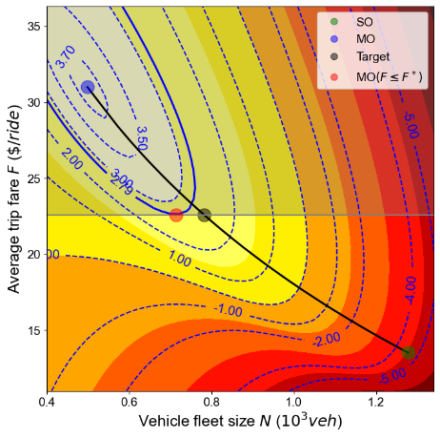 | 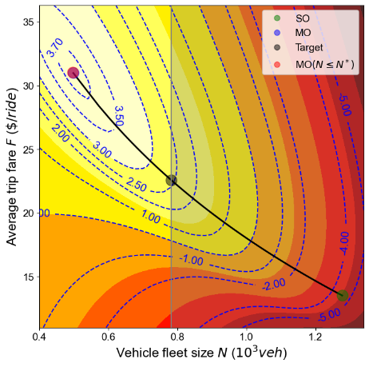 | 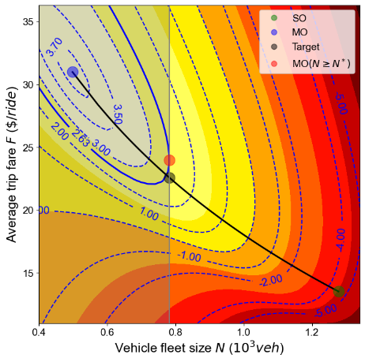
- Maximum fare regulation | - Maximum fleet size regulation | - Minimum fleet size regulation
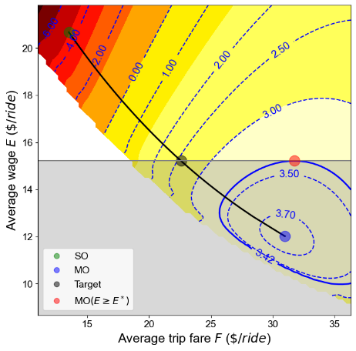 | 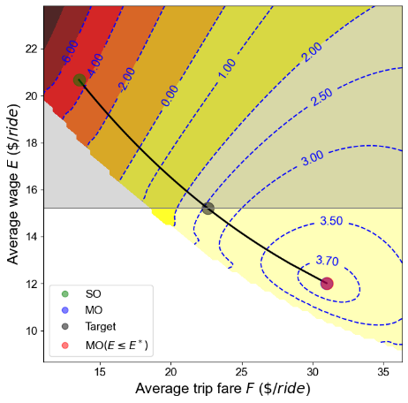 | 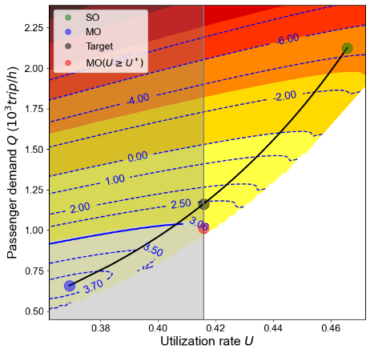
- Minimum wage regulation | - Maximum wage regulation | - Minimum utilization regulation
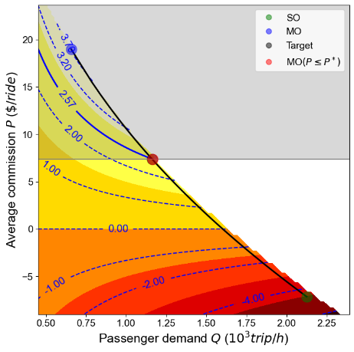 | 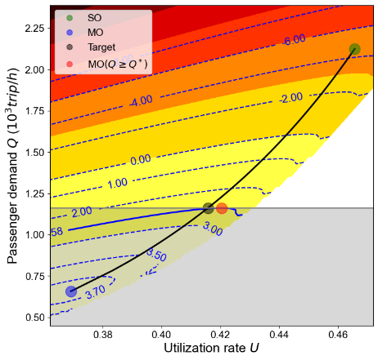 | 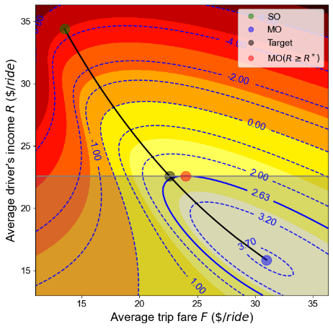
- Maximum commission regulation | - Minimum demand regulation | - Minimum income regulation
Figure 1. Regulatory outcomes of various regulations/policies with heterogeneous drivers

Market with heterogeneous drivers and traffic congestion
One of our central concerns in the numerical example is the impact of traffic congestion on the ride-sourcing market equilibrium. Figure 2a depicts how the profit of the platform and social welfare respond to the level of normal vehicle demand (level of congestion). Figure 2b-2i plot the changes of monopoly optimum solution and social welfare optimum solution with respect to different levels of normal vehicle demand, respectively, in terms of passenger demand, vehicle fleet size, trip fare, driver’s wage, driver’s income, utilization rate and passenger’s travel cost.
From Figure 2a we can see, the profit of the platform decreases with an increasing level of congestion. This is because the level of congestion increases passenger’s travel cost, which leads to a decrease in passenger demand (as shown in Figure 2i and Figure 2b). To cover the profit loss from the decrease in passenger demand, the platform chooses to increase its trip fare, commission and wage to attract more drivers without reducing profit per order under monopoly optimum (as shown by the blue line in Figure 3d - 3f). Figure 2g and 2h demonstrate drivers’ income and the utilization rate decrease due to the increasing level of congestion. The reason for its observation is traffic congestion increases the pick-up time (passenger’s waiting time). Figure 2g and 2c illustrate that as driver’s income decreases, the number of drivers participates in the ride-sourcing market also decreases.
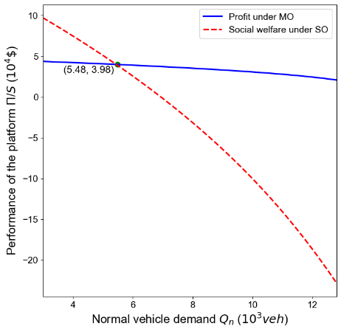 | 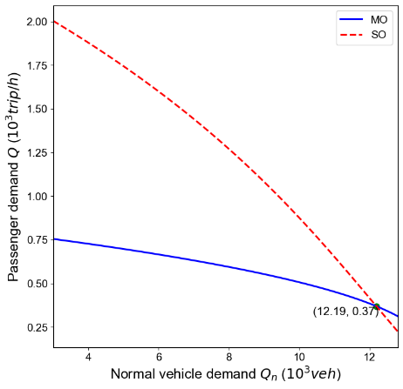 | 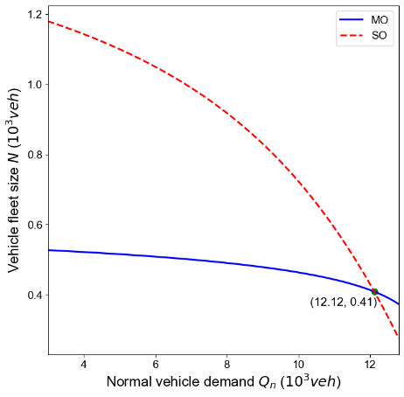
- Variation of profit and social welfare | - Variation of passenger demand | - Variation of vehicle fleet size
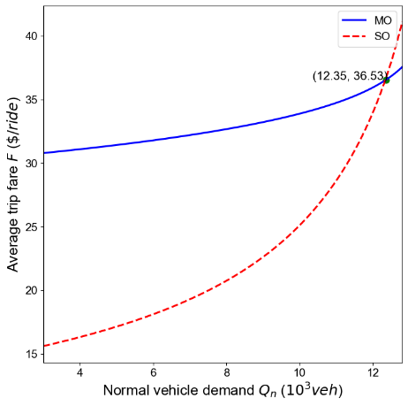 | 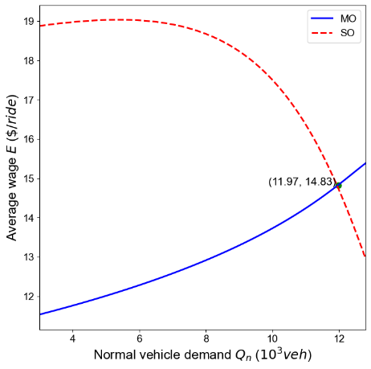 | 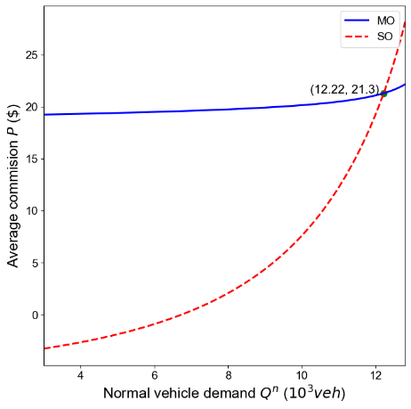
- Variation of average trip fare | - Variation of average wage | - Variation of average commission
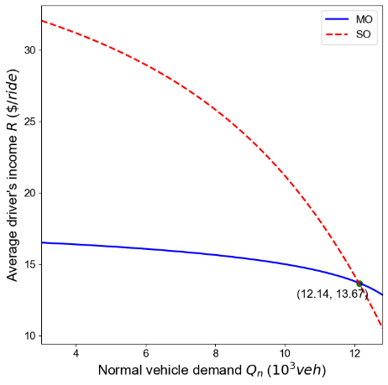 | 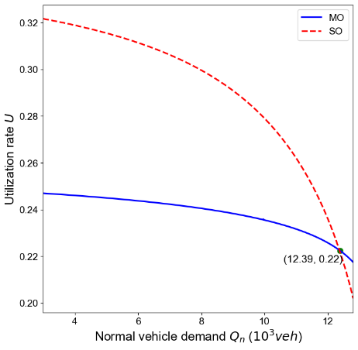 | 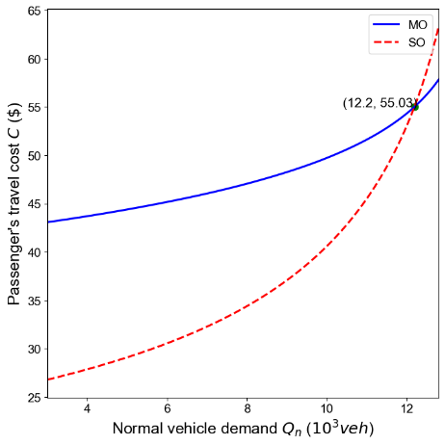
- Variation of average driver’s income | - Variation of utilization rate | - Variation of passenger’s travel cost
Figure 2. Impacts of the level of congestion $Q_{n}$
As shown in Figure 2, the optimal social welfare changes more dramatically than the optimal profit (the red line goes down or up faster than the blue line). The reason is that the social welfare also includes the travel cost of regular private cars such that the changes in the level of congestion will contribute more to the social welfare at optimum. Meanwhile, as demonstrated in Figure 2b - 2i, the level of traffic congestion significantly affects the relative magnitude of the key endogenous variables, such as passenger demand, vehicle fleet size, trip fare, wage, utilization rate at monopoly optimum and social optimum. When the congestion level is low (e.g., $Q_{n}=5.0×{10}^{3}$ (vehicles /h)), the passenger demand, vehicle fleet size, average wage, driver’s income and utilization rate has larger values at social optimum than monopoly optimum (the red line is above the blue line), while the trip fare and average commission has smaller values at social optimum than monopoly optimum (the blue line is above the red line). This is consistent with the findings in Section 5.2 in the absence of traffic congestion. It also implies a low level of congestion doesn’t change the regulatory outcomes of different regulations/policies.
In contrast, if the congestion level is high (e.g., $Q_{n}=1.28×{10}^{4}$ (vehicles/h)), the social welfare optimum solutions in terms of the passenger demand, vehicle fleet size, average wage, driver’s income, utilization rate are smaller, while the trip fare and average commission are larger than those at monopoly optimum. In other words, the relative magnitudes of the key endogenous variables at monopoly optimum and social welfare optimum are now reversed of that when the level of congestion is low. The reason is that, when the congestion level is low, the impact of traffic congestion externality is small and unable the reverse the inherent variable relationship between the monopoly optimum solution and social optimum in markets without traffic congestion. When the congestion level is high, since the social welfare optimum solution changes more dramatically than the monopoly optimum solution, the value relationship between the monopoly optimum solution and social optimum solution will also change.

F≤F* | Q#<Q*N#<N*
N≤N* | Q#=Qmo*<Q*N#=Nmo*<N*
N≥N* | Q#<Q*N#=N*
E≥E* | Q#<Q*N#<N*
E≤E* | Q#=Qmo*<Q*N#=Nmo*<N*
P≤P* | Q#=Q*N#=N*
U≥U* | Q#<Q*N#<N*
Q≥Q* | Q#=Q*N#<N*
R≥R* | Q#<Q*N#=N*
Without considering rationing drivers, we let $Q_{n}$ be $1.28×{10}^{4}$ (vehicles /h) and portray the regulatory outcomes of different regulations/policies introduced in Section 4 with heterogeneous drivers and a high level of congestion in the following Figure 3. To avoid unnecessary duplication, numerical studies under a low level of congestion does not provide here, since the results are similar with the no congestion situation, which have been shown in Subsection 5.2.

F≤F* | Q#=Qmo*>Q*N#=Nmo*>N*
N≤N* | Q#<Q*N#=N*
N≥N* | Q#=Qmo*>Q*N#=Nmo*>N*
E≥E* | Q#=Qmo*>Q*N#=Nmo*>N*
E≤E* | Q#>Q*N#>N*
P≤P* | Q#=Qmo*>Q*N#=Nmo*>N*
U≥U* | Q#=Qmo*>Q*N#=Nmo*>N*
Q≥Q* | Q#=Qmo*>Q*N#=Nmo*>N*
R≥R* | Q#=Qmo*>Q*N#=Nmo*>N*

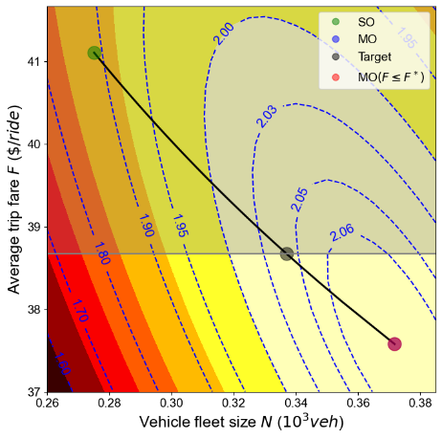 | 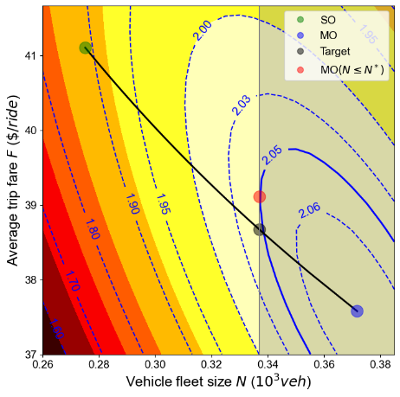 | 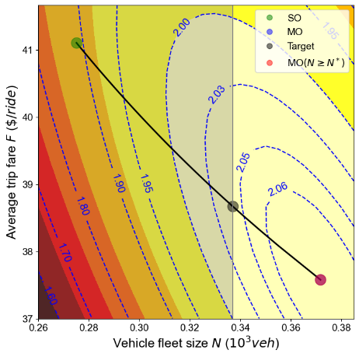
- Maximum fare regulation | - Maximum fleet size regulation | - Minimum fleet size regulation
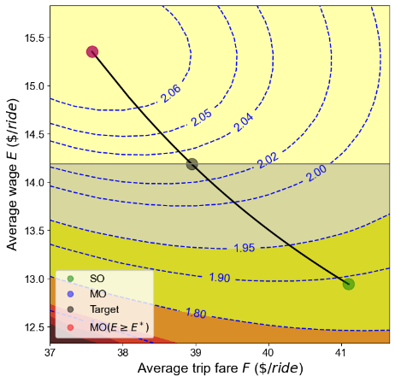 | 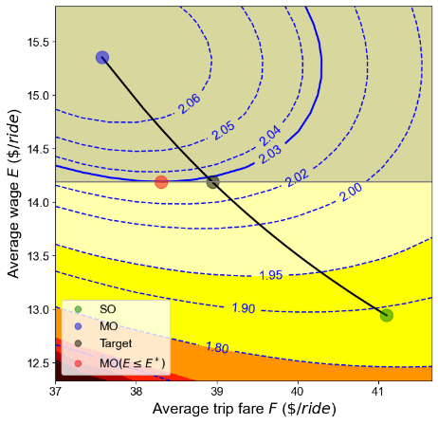 | 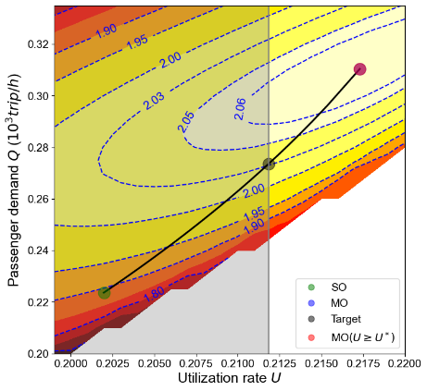
- Minimum wage regulation | - Maximum wage regulation | - Minimum utilization regulation
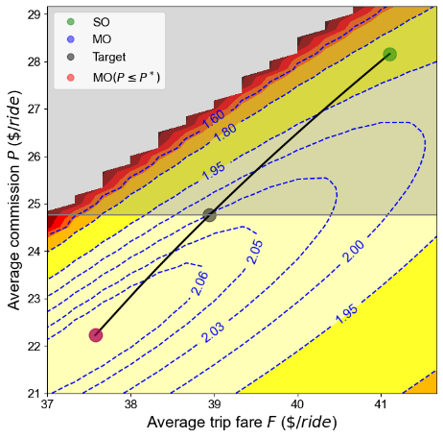 | 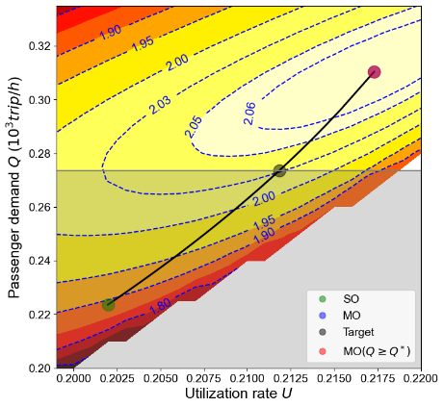 | 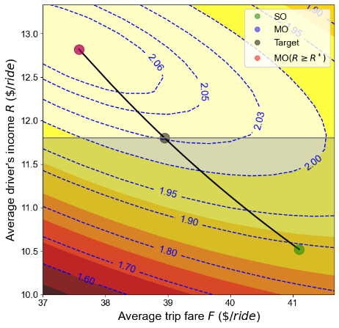
- Maximum commission regulation | - Minimum demand regulation | - Minimum income regulation
Figure 3. Regulatory outcomes of various regulations/policies with heterogeneous drivers and a high level of congestion

αmo*=1
F,NQ,Uαmo*=1EE<16 ($ride)EE>18 ($ride)FF<17 ($ride)Pα∈0,1α=1

 |  |  | αmo*
F≤F* | Q#<Q*N#<N*
N≤N* | Q#=Qmo*<Q*N#=Nmo*<N*
N≥N* | Q#<Q*N#=N*
E≥E* | Q#<Q*N#<N*
E≤E* | Q#=Qmo*<Q*N#=Nmo*<N*
P≤P* | Q#=Q*N#=N*
U≥U* | Q#<Q*N#<N*
Q≥Q* | Q#=Q*N#<N*
R≥R* | Q#<Q*N#=N*

The impact of driver rationing
In Section 5.1- 5.3, the regulation outcomes are analyzed under the assumption that the number of drivers recruited by the platform exactly matches the labor supply curve, which implies the platform doesn’t ration drivers. However, as mentioned in Section 2 and Section 3, for a monopoly ride-sourcing platform, it has the power to ration drivers to maximize its profit. When the implemented regulation/policy is non-binding, such as the maximum fleet size and maximum wage regulation for heterogeneous drivers with a low level of congestion, the platform will set the rationing factor as αmo*=1 as analyzed in Section 3, which means all the drivers who intend to enter the ride-sourcing market should be recruited. However, after implementing a binding regulation/policy, such as minimum income regulation for heterogeneous drivers without congestion externalities, the binding regulation/policy may rise to an excess supply of drivers, so that, the monopoly platform may not recruit all the drivers who intend to enter the ride-sourcing market. By considering driver rationing, the regulatory outcomes of different binding regulations introduced in Section 4 with heterogeneous drivers and mild traffic congestion are demonstrated in Figure 4. In Figure 4, for each point (a combination of two variables shown in x and y axis) in the contours, the rationing factor is optimized to obtain the maximal profit given these two specific x and y variables.
Compare Figure 4 and Figure 1, it can be found that Figure 4a-4d, and 4h are the same as Figure 1a, 1c-1d, 1f and 1h, respectively, which indicates when the two fixed decision variables are F,N or Q,U, the monopoly optimum rationing factor for the platform is αmo*=1. As shown in Figure 4c and Figure 1d, when wage E is small (e.g. E<16 ($ride)), the outcome profit for the platform are the same; while when wage E is large (e.g. E>18 ($ride)) and trip fare F is small (e.g. F<17 ($ride)) the outcome profit is larger under the driver rationing scenario. This implies when the commission P is small, the platform will cut off the number of trips by hiring fewer drivers to reduce the profit loss and the optimum rationing factor for the platform αmo*≠1. Figure 4e and Figure 1g show that, the feasible solution area is larger when the platform can ration drivers. This is because the feasible domain of rationing factor is α∈0,1 in Figure 4e but α=1 in Figure 1g, and the larger feasible domain of the rationing factor also enlarges the feasible solution area. Meanwhile, the resulting profit under the binding minimum income regulation is larger in Figure 4g than in Figure 1i. Since the minimum income regulation improves ride-sourcing drivers’ income and raises an excess supply of the market, for the platform, the recruitment cost is relatively high and it may cherry pick some of the drivers to avoid excessive expenses. For this reason, under the minimum income regulation, αmo*≠1 and in this numerical example, αmo*=0.776.
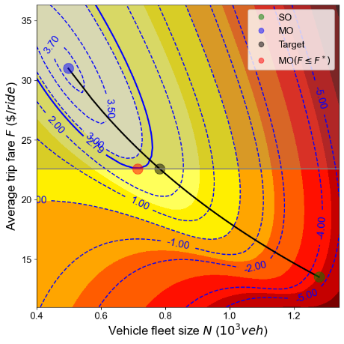 |  | 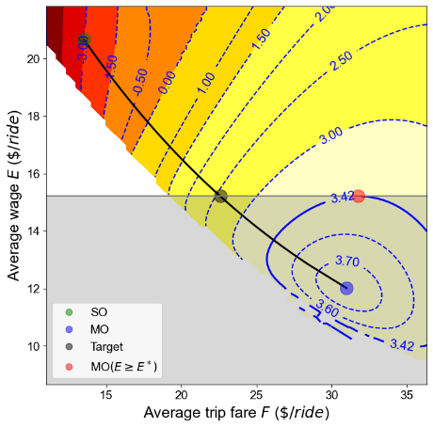
- Maximum fare regulation | - Minimum fleet size regulation | - Minimum wage regulation
 | 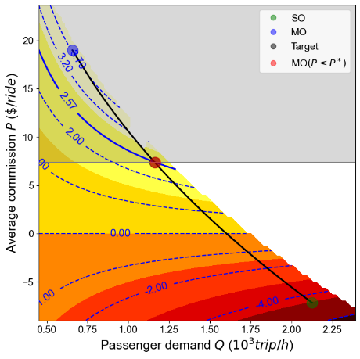
- Minimum utilization regulation | - Maximum commission regulation | - Minimum demand regulation
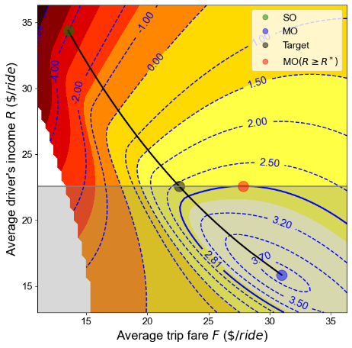
- Minimum income regulation
Figure 4. Regulatory outcomes of various regulations/policies with heterogeneous drivers and driver rationing

Summary and discussion

F≤F* |  | Q#=Qmo*>Q*  N#=Nmo*>N*
N≤N* |  | Q#<Q*N#=N*
N≥N* |  | Q#=Qmo*>Q*  N#=Nmo*>N*
E≥E* |  | Q#=Qmo*>Q*  N#=Nmo*>N*
E≤E* |  | Q#>Q*N#>N*
P≤P* |  | Q#=Qmo*>Q*  N#=Nmo*>N*
U≥U* |  | Q#=Qmo*>Q*  N#=Nmo*>N*
Q≥Q* |  | Q#=Qmo*>Q*  N#=Nmo*>N*
R≥R* |  | Q#=Qmo*>Q*  N#=Nmo*>N*
Table 2 shows the regulatory outcomes of different regulations/policies introduced in Section 4 with heterogeneous drivers.
Compare Table 2 with Table 1, we can see that some regulatory outcomes are changed due to drivers’ heterogeneity. First, in the case with heterogeneous drivers and a mild congestion, only by imposing a commission regulation, can the government achieve its Pareto-efficient target. Second, demand regulation is no longer Pareto-efficient. Third, drivers’ heterogeneous reservation rates cause an opposite moving trend of wage from monopoly optimum to social optimum. As a result, the minimum wage regulation affects markets with heterogeneous drivers (although it is still unable to yield a Pareto-efficient outcome), while it does not affect the platform’s decisions in markets with homogeneous drivers. Fourth, we find that, when the platform has to ensure drivers’ earnings per hour as required by the government, it will raise trip fare beyond the Pareto-efficient solution to protect its profit. In this case, the consumer surplus will be suppressed due to the increased trip fare. Besides that, the
mild traffic congestion does not change the regulatory outcomes of different regulations/policies.
Table 2 shows that none of the government regulations can reach its Pareto-efficient target with a heavy congestion. This indicates that, when the traffic congestion is severe, the normal vehicles have a significant impact on traffic flow and ride-sourcing passenger demand, leading to a situation where simply regulating the ride-sourcing market is not enough.
It can be found that, in the market with heavy traffic congestion, the regulations of price-cap, minimum vehicle fleet size, minimum per-order wage, maximum commission, minimum utilization, minimum service level (demand) and minimum per-hour income, do not take effect, namely, the platform will straight-forwardly choose the monopoly optimum under these regulations. The reason is that traffic congestion is so heavy to significantly influence consumer surplus, drivers’ surplus and delay cost of background traffic vehicles, which reverses the changing trends of key endogenous variables from MO to SO. This tells us that the government should adjust the regulatory schemes according to the levels of traffic congestion in different cities. For example, in cities like Manhattan, the traffic congestion is heavy such that the social optimum fleet size and utilization rate are smaller than the values at monopoly optimum, thus the government should cap the fleet size and/or regulate the minimum utilization rate to alleviate the congestion and enhance the social welfare. However, for suburban areas with light traffic congestion, the optimal fleet size and drivers’ income per hour are larger at social optimum than at monopoly optimum, thus the government should encourage the platform to recruit more drivers to improve both consumers’ and drivers’ surpluses.
It is noteworthy that regulating commission alone will not achieve a Pareto-efficient outcome in the market with moderate or heavy congestion. As suggested by Vignon et al. (2020), the commission cap needs to be supplemented by the congestion tolling to ride-sourcing vehicles or congestion fees to users. In fact, congestion pricing coupled with utilization rate regulation and price cap is implemented in NYC. We shall acknowledge that our study focuses on the regulatory outcomes of single regulation, it is also interesting to examine the implications of joint regulatory schemes on the system and the platform’s decisions. Intuitively, by using more regulations simultaneously, the government is more likely to achieve a Pareto-efficient target. Nonetheless, imposing multiple regulations at one time will undoubtedly increase administrative costs.
Compare Figure 4 with Figure 1, we can see that, although the regulatory outcomes are similar with and without driver rationing, the rationing factor are not the same. Under the minimum income regulation, the platform will only recruit $77.6\%$ of those drivers who intend to enter the ride-sourcing market. This implies, the minimum income regulation may not protect drivers’ incomes, since the platform may choose only a part of drivers who are willing to join, in order to protect their profit. As a result, some drivers cannot get the job opportunity even though they intend to join the ride-sourcing market.
Table 2. Summary of the regulatory outcomes with heterogeneous drivers and no driver rationing
Regulatory regime | Effects on effective demand/supply |  | Pareto-efficiency
Regulatory regime | no/mild congestion | heavy congestion | no/mild congestion | heavy congestion
Price-cap regulation F≤F* | Q#<Q*, N#<N* | Q#=Qmo*>Q*,  N#=Nmo*>N* | No | No
Maximum fleet size control N≤N* | Q#=Qmo*<Q*,  N#=Nmo*<N* | Q#<Q*, N#=N* | No | No
Minimum fleet size control N≥N* | Q#<Q*, N#=N* | Q#=Qmo*>Q*,  N#=Nmo*>N* | No | No
Minimum wage regulation E≥E* | Q#<Q*, N#<N* | Q#=Qmo*>Q*,  N#=Nmo*>N* | No | No
Maximum wage regulation E≤E* | Q#=Qmo*<Q*,  N#=Nmo*<N* | Q#>Q*, N#>N* | No | No
Commission regulation P≤P* | Q#=Q*, N#=N* | Q#=Qmo*>Q*,  N#=Nmo*>N* | Yes | No
Utilization rate regulation U≥U* | Q#<Q*, N#<N* | Q#=Qmo*>Q*,  N#=Nmo*>N* | No | No
Demand regulation Q≥Q* | Q#=Q*, N#<N* | Q#=Qmo*>Q*,  N#=Nmo*>N* | No | No
Income regulation R≥R* | Q#<Q*, N#=N* | Q#=Qmo*>Q*,  N#=Nmo*>N* | No | No

Conclusion
This paper first discusses the properties of the Pareto-efficient frontier that connects the social optimum and monopoly optimum, and then investigates the regulatory effects of various regulation approaches, including price-cap regulation, fleet size regulation, wage regulation, minimum utilization regulation, commission regulation, and demand regulation. It is interesting to find that many endogenous variables exhibit monotonic properties along the Pareto-efficient frontier. For example, as the solution moves from social optimum to monopoly optimum along the Pareto-efficient frontier, both the trip fare and wage increases, while the commission also increases. It indicates that, the monopoly platform will raise both the trip fare and wage from their efficient levels (at social optimum), but raise trip fare more heavily, to grab the monopoly profit.
We examine the choices of the platform under different regulatory schemes, and compare the resulting effective demand and supply with the targeted Pareto-efficient solutions. For example, we prove that the fare regulation will push the platform to decrease both supply and demand away from the Pareto-efficient frontier, resulting in a non-Pareto-efficient outcome. In contrast, the commission regulation will directly induce the platform to choose the targeted Pareto-efficient outcome. In addition, we consider the market scenarios with heterogeneous drivers and traffic congestion, which substantially influence the regulatory outcomes of different regulations. For example, the wage regulations and vehicle fleet size regulations under scenarios with homogeneous and heterogeneous drivers exhibit opposite effects, while the demand regulation is efficient in the scenario with homogeneous drivers but inefficient in the market with heterogeneous drivers. We find that, by requiring the platform to ensure a minimum level of drivers’ per-hour income, the government cannot achieve a desirable Pareto-efficient outcome; instead, the platform will try to raise the trip fare to protect its profit, which compromises passengers’ interests. Moreover, due to the consideration of the welfare of background traffic, a high level of traffic congestion may flip over the optimal trip fares, wages and fleet sizes along the Pareto-efficient frontier, and thus affect the effectiveness of regulatory schemes. One typical example is that cities with heavy traffic congestion shall use maximum fleet size regulation to reduce traffic congestion, while cities with mild traffic congestion may wish to encourage the platform to recruit more drivers in order to enhance consumer surplus and drivers’ surplus.
Several research directions merit further explorations. To name a few, (1) it is interesting to investigate the ride-sourcing market coupled with public transit systems, and design suitable regulatory schemes to enhance the complementary effects between ride-sourcing services and public transit services and avoid their substituting effects; (2) we may design some incentive schemes, e.g., subsidizing trips on off-peak hours or trips from/to transit stations, together with regulatory schemes, to enhance social welfare over space and over time; (3) it is also of immerse interest to examine the effects of different regulatory schemes in ride-sourcing markets with multiple platforms competing with each other; (4) it is important to examine the ride-sourcing markets under non-stationary and dynamic environments with stochasticity, and to design appropriate dynamic control strategies to avoid system failure, such as hyper-congested flow regimes; (5) the current model assumes the background traffic is exogenously given, but demand for ride-sourcng services may influence background traffic since some people may switch from using ride-sourcing services to purchasing their own cars. In the future, one may consider riders’ choices among driving alone (contributing to background traffic), taking public transits, and hailing on-demand rides, in equilibrium models.

Reference
Angrist, J.D., Caldwell, S., Hall, J.V., 2017. Uber vs. Taxi: A Driver’s Eye View (No. w23891).National Bureau of Economic Research.
Arnott, R., 1996. Taxi travel should be subsidized. Journal of Urban Economics, 40(3), 316–333.
Bai, J., and Tang, C. S., 2018. Can two competing on-demand service platforms be both profitable? Available at SSRN 3282395.
Bai, J., So, K. C., Tang, C. S., Chen, X., & Wang, H. 2018. Coordinating supply and demand on an on-demand service platform with impatient customers. Manufacturing & Service Operations Management.
Ban, X. J., Dessouky, M., Pang, J. S., and Fan, R., 2019. A general equilibrium model for transportation systems with e-hailing services and flow congestion. Transportation Research Part B: Methodological, 129, 273-304.
Bernstein, F., DeCroix, G., and Keskin, N. B., 2019. Competition between two-sided platforms under demand and supply congestion effects. Manufacturing & Service Operations Management.
Bimpikis, K., Candogan, O. and Saban, D., 2019. Spatial pricing in ride-sharing networks. Operations Research, 67(3), 744-769.
Cachon, G.P., Daniels, K.M. and Lobel, R., 2017. The role of surge pricing on a service platform with self-scheduling capacity. Manufacturing & Service Operations Management, 19(3), 368-384.
Camerer, C., Babcock, L., Loewenstein, G., & Thaler, R., 1997. Labor supply of New York City cabdrivers: One day at a time. The Quarterly Journal of Economics, 112(2), 407-441.

Castillo, J. C., Knoepfle, D. and Weyl, G. 2017. Surge pricing solves the wild goose chase. In Proceedings of the 2017 ACM Conference on Economics and Computation (pp. 241-242). ACM.
Chen, M. K. and Sheldon, M., 2016. Dynamic Pricing in a Labor Market: Surge Pricing and Flexible Work on the Uber Platform. Ec, 455(10.1145), 2940716-2940798.

Daganzo, C. F., 1978. An approximate analytic model of many-to-many demand responsive transportation systems. Transportation Research, 12(5), 325-333.
Diao, M., Kong, H., and Zhao, J., 2021. Impacts of transportation network companies on urban mobility. Nature Sustainability, 1-7.
Douglas, G.W., 1972. Price regulation and optimal service standards: the taxicab industry. Journal of Transport Economics and Policy 6 (2), 116–127.
Farber, H. S., 2005. Is tomorrow another day? The labor supply of New York City cabdrivers. Journal of political Economy, 113(1), 46-82.
Farber, H. S., 2015. Why you can’t find a taxi in the rain and other labor supply lessons from cab drivers. The Quarterly Journal of Economics, 130(4), 1975-2026.

Erhardt, G. D., Roy, S., Cooper, D., Sana, B., Chen, M., and Castiglione, J., 2019. Do transportation network companies decrease or increase congestion? Science advances, 5(5), eaau2670.
Geoffrion, A.M., 1967. Solving bicriterion mathematical programs. Operations Research 15 (1), 39–54.
Guo, P., Tang, C. S., Tang, Y., and Wang, Y., 2018. Gender-based operational issues arising from on-demand ride-hailing platforms: safety concerns and system configuration. Available at SSRN: https://ssrn.com/abstract=3260427 or http://dx.doi.org/10.2139/ssrn.3260427.
Jiang ZZ, Kong G, Zhang Y, 2020Making the most of your regret: Workers’ relocation decisions in on-demand platforms.Manufacturing & Service Operations Management.
Ke, J., Cen, X., Yang, H., Chen, X., and Ye, J., 2019. Modelling drivers’ working and recharging schedules in a ride-sourcing market with electric vehicles and gasoline vehicles. Transportation Research Part E: Logistics and Transportation Review, 125, 160-180.
Ke, J., Yang, H., Li, X., Wang, H., and Ye, J., 2020. Pricing and Equilibrium in On-demand Ride-Splitting Markets. Transportation Research Part B: Methodological, 139, 411-431.
Li, S., Tavafoghi, H., Poolla, K. and Varaiya, P. 2019. Regulating TNCs: Should Uber and Lyft Set Their Own Rules? Transportation Research Part B: Methodological, 129, 193-225.
Mo, D., Yu, J., and Chen, X. M., 2020. Modeling and managing heterogeneous ride-sourcing platforms with government subsidies on electric vehicles. Transportation Research Part B: Methodological, 139, 447-472.
Nie, Y. M., 2017. How can the taxi industry survive the tide of ridesourcing? Evidence from Shenzhen, China. Transportation Research Part C: Emerging Technologies, 79, 242-256.
Nikzad A., 2017. Thickness and competition in ride-sharing markets. Available at SSRN 3065672.
Parrott, J.A., Reich, M., 2018. An Earning Standard for New York City app-based Drivers: Economic Analysis and Policy Assessment. The New School, Center for New York City Affairs.
Séjourné, T., Samaranayake, S., and Banerjee, S., 2018. The price of fragmentation in mobility-on-demand services. Proceedings of the ACM on Measurement and Analysis of Computing Systems, 2(2), 1-26.
Sheldon, M. 2016. Income targeting and the ridesharing market. Unpublished manuscript. Available at: https://static1. squarespace. com/static/56500157e4b0cb706005352d, 56, 1457131797556.

Sun, H., Wang, H. and Wan, Z., 2019. Model and analysis of labor supply for ride-sharing platforms in the presence of sample self-selection and endogeneity. Transportation Research Part B: Methodological, 125, 76-93.
Taylor, T. A., 2018. On-demand service platforms. Manufacturing & Service Operations Management, 20(4), 704-720.
Vignon, D., Yin, Y. and Ke, J., 2020. Regulating Ride-sourcing Services with Product Differentiation and Congestion Externality. Available at SSRN 3531372.
Wang, X., Yang, H., and Zhu, D., 2018. Driver-rider cost-sharing strategies and equilibria in a ridesharing program. Transportation Science, 52(4), 868-881.
Wang, H. and Yang H., 2019. Ride-sourcing systems: a framework and review. Transportation Research Part B: Methodological, 129, 122-155.
Xu, Z., Chen, Z., Yin, Y., and Ye, J., 2019. Equilibrium Analysis of Urban Traffic Networks with Ride-Sourcing Services. Available at SSRN 3422294.
Xu, Z., Yin, Y. and Zha, L., 2017. Optimal parking provision for ride-sourcing services. Transportation Research Part B: Methodological, 105, 559-578.
Xu, Z., AMC Vignon, D., Yin, Y., & Ye, J., 2020a. An empirical study of the labor supply of ride-sourcing drivers. Transportation Letters, 1-4.
Xu, Z., Yin, Y., and Ye, J., 2020b. On the supply curve of ride-hailing systems. Transportation Research Part B: Methodological, 132, 29-43.
Yan, C., Zhu, H., Korolko, N., and Woodard, D. 2019. Dynamic pricing and matching in ride‐hailing platforms. Naval Research Logistics, in press.
Yang, H. and Yang, T., 2011. Equilibrium properties of taxi markets with search frictions. Transportation Research Part B: Methodological, 45(4), 696-713.
Yang, H., Qin, X., Ke, J., & Ye, J. 2020. Optimizing matching time interval and matching radius in on-demand ride-sourcing markets. Transportation Research Part B: Methodological, 131, 84-105.
Yang, H., Shao, C., Wang, H., Ye, J., 2020. Integrated Reward Scheme and Surge Pricing in a Ride-Sourcing Market. Transp. Res. Part B., 134, 126-142.
Yang, H., Ye, M., Tang, W.H., and Wong, S.C., 2005. Regulating taxi services in the presence of congestion externalities. Transportation Research Part A, Policy and Practice, 39(1), 17-40.

Yu J., Tang C.S., Shen Z.M. and Chen X., 2019. A balancing act of regulating on-demand ride services. Management Science, in press.
Zha, L., Yin, Y., and Du, Y., 2018a. Surge pricing and labor supply in the ride-sourcing market. Transportation Research Part B: Methodological, 117, 708-722.
Zha, L., Yin, Y., and Xu, Z., 2018b. Geometric matching and spatial pricing in ride-sourcing markets. Transportation Research Part C: Emerging Technologies, 92, 58-75.
Zha, L., Yin, Y., and Yang, H., 2016. Economic analysis of ride-sourcing markets. Transportation Research Part C: Emerging Technologies, 71, 249–266.
Zhang, J., Lindsey, R., and Yang, H., 2018. Public transit service frequency and fares with heterogeneous users under monopoly and alternative regulatory policies. Transportation Research Part B: Methodological, 117, 190-208.
Zhang, K., and Nie, M., 2019. To pool or not to pool: Equilibrium, pricing and regulation. Pricing and Regulation (December 3, 2019).
Zhou, Y., Yang, H., Ke, J., Wang, H. and Li, X., 2020. Competitive ride-sourcing market with a third-party integrator. Available at arXiv:2008.09815.
Zhu, Z., Qin, X., Ke, J., Zheng, Z., and Yang, H., 2020. Analysis of multi-modal commute behavior with feeding and competing ridesplitting services. Transportation Research Part A: Policy and Practice, 132, 713-727.
Web reference
NYC 2020. Driver Pay Rates set by New York City Taxi and Limousine Commission. Accessed on August, 2020. https://www1.nyc.gov/site/tlc/about/driver-pay-rates.page.
NYC rules 2020a. On August 14, 2018 Mayor de Blasio signed into law legislation Intro 890-B and Intro 144-B for for-hire vehicle (FHV) service companies. Accessed on August, 2020. https://rules.cityofnewyork.us/tags/utilization-rate.
NYC rules 2020b. NYC rules for utilization rate. Accessed on August, 2020. https://rules.cityofnewyork.us/tags/utilization-rate.
NY daily news 2019. NYC to impose some of the world’s toughest regulations on Uber and Lyft. Accessed on Jun 12, 2019. https://www.nydailynews.com/new-york/ny-uber-lyft-cap-fhv-regulations-tlc-20190612-pspo2afygje63mxm4lr55s57jq-story.html.
Conger, K., and Scheiber, N., 2019. California Bill Makes App-Based Companies Treat Workers as Employees. Accessed on Sept. 11, 2019 https://www.nytimes.com/2019/09/11/technology/california-gig-economy-bill.html
O'Brien, S., 2020. Accessed on Nov, 2020. https://edition.cnn.com/2020/11/04/tech/california-proposition-22/index.html
Li, C., 2016. China’s New Ride-Hailing Rules Focus on Where Drivers Call Home. Accessed on Dec 21, 2016. https://www.nytimes.com/2016/12/21/business/china-didi-driver-rules-uber.html.
Appendix A.1 Mathematical proofs
Proof for Lemma 1.
Based on the analysis in Section 3, we can get $α_{mo}^{*}=α_{so}^{*}=α^{*}=1$, then there are only two decision variables for the platform and we treat $Q$ and $N$ as the two decision variables. When passengers have a homogeneous reservation rate $c$ and the potential driver supply is sufficient, at the market equilibrium, drivers will keep entering the market until the average income of each driver reduces to the homogeneous reservation rate $c$, namely, $R=\frac{EQ}{N}=c$. Then the profit maximization and the social welfare maximization problems in a ride-sourcing market without traffic congestion externalities can be reduced to Eqs. (62)-(63):
 | $$\max{Π\left(Q,N\right)=Q\left[B\left(Q\right)-β\left(w\left(Q,N\right)+t\right)\right]-cN}$$ | (62)
 | $$\max{S\left(Q,N\right)}=\int_{0}^{Q}{B\left(z\right)dz}-Qβ\left[w\left(Q,N\right)+t\right]-cN$$ | (63)
And the Lagrange function of the Pareto-efficient problem is
 | $$L\left(Q,N\right)=\int_{0}^{Q}{B\left(z\right)dz}-Qβ\left[w\left(Q,N\right)+t\right]-cN+ξ\left(\left\{Q\left[B\left(Q\right)-β\left(w\left(Q,N\right)+t\right)\right]-cN\right\}-\left\{Q^{*}\left[B\left(Q^{*}\right)-β\left(w\left(Q^{*},N^{*}\right)+t\right)\right]-cN^{*}\right\}\right)$$ | (64)
By the first-order condition of the Lagrange function, we can get the Pareto-efficient solutions as follows:
 | $$c\left(Q^{*}w^{'*}+1\right)=-βQ^{*}w^{'*}$$ | (65)
 | $$B\left(Q^{*}\right)+\frac{ξ}{ξ+1}Q^{*}B^{'}\left(Q^{*}\right)=\left(β+c\right)\left(w^{*}+t\right)$$ | (66)
and the Pareto-efficient price is
 | $$F^{*}=c\left(w^{*}+t\right)-\frac{ξ}{ξ+1}Q^{*}B^{'}\left(Q^{*}\right)$$ | (67)
where $Q^{*}$, $w^{*}$, $w^{'*}$, $B^{'}\left(Q^{*}\right)$ refer to passenger demand, average waiting time, derivative of average waiting time with respect to the number of idle vehicles, derivative of the inverse demand function along the Pareto-efficient frontier, respectively.
When the traffic speed is a constant $v$, $w\left(N^{v},N\right)=w\left(N^{v}\right)$. The first-order derivative of $w\left(N^{v}\right)$ is $w^{'}\left(N^{v}\right)=dw/dN^{v}=-α\frac{A{\left(N^{v}\right)}^{-γ-1}}{v}=-γw/N^{v}$. Substituting $w\left(N^{v}\right)=\frac{A{\left(N^{v}\right)}^{-γ}}{v}$ into Eq. (65) gives rise to:
 | $$cN^{v*}=γ\left(β+c\right)Q^{*}w^{*}$$ | (68)
By combining Eqs. (37)-(38) and Eq. (68), we can obtain:
 | $$w^{*}=\frac{A{\left(N^{v*}\right)}^{-γ}}{v}=\frac{ct}{γ\left(β+c\right)+c}\left(\frac{1}{U^{*}}-1\right)$$ | (69)
 | $$w^{*}=\frac{A{\left(N^{v*}\right)}^{-γ}}{v}=\frac{ct\frac{V^{*}}{1-V^{*}}}{γ\left(β+c\right)-c\frac{V^{*}}{1-V^{*}}}$$ | (70)
which indicates $w^{*}$ can be written as a univariate function of $U^{*}$ or $V^{*}$ along the Pareto-efficient frontier. For simplicity, we let,
 | $$ϕ_{1}=\frac{ct}{γ\left(β+c\right)+c}$$ | (71)
Combining Eq. (3) and the definition $U=Qt/N$, we have:
 | $$Q=\frac{N^{v}}{\left(\frac{1}{U}-1\right)t-w\left(N^{v}\right)}$$ | (72)
which holds for all equilibrium solutions, including the Pareto-efficient solutions. By combining Eq. (69) and Eq. (72), we are ready to have:
 | $$Q^{*}={\left[\frac{ϕ_{1}}{A}\right]}^{-\frac{1}{γ}}\frac{1}{\left(t-ϕ_{1}\right)}{\left(\frac{1}{U^{*}}-1\right)}^{-\frac{1}{γ}-1}$$ | (73)
which implies that passenger demand $Q^{*}$ is monotonically increases with the utilization rate $U^{*}$, and vice versa, along the Pareto-efficient frontier. In addition, Combining Eq. (3) and the definition $V=N^{v}/N$, we have:
 | $$Q=\frac{\left(\frac{1}{V}-1\right)N^{v}}{w\left(N^{v}\right)+t}$$ | (74)
which holds for any equilibrium solutions, which should certainly include the Pareto-efficient solutions. Combining Eq. (70) and Eq. (74) yields:
 | $$Q^{*}=\frac{\left(\frac{1}{V^{*}}-1\right){\left[\frac{v}{A}\frac{ct}{γ\left(β+c\right)\left(\frac{1}{V^{*}}-1\right)-c}\right]}^{-\frac{1}{γ}}}{\frac{ct}{γ\left(β+c\right)\left(\frac{1}{V^{*}}-1\right)-c}+t}$$ | (75)
which indicates $Q^{*}$ can be written as a univariate function $V^{*}$. It can be found that $Q^{*}$ decreases with $V^{*}$ along the Pareto-efficient frontier.
Re-organizing Eqs. (69) and (70), we have:
 | $$U^{*}=\frac{ct}{\left[γ\left(β+c\right)+c\right]w^{*}+ct}$$ | (76)
 | $$V^{*}=\frac{1}{\frac{ct}{γ\left(β+c\right)w^{*}}+1+\frac{c}{γ\left(β+c\right)}}$$ | (77)
It indicates that both $U^{*}$ and $V^{*}$ can be regarded as a univariate function of $w^{*}$. It can be seen from Eqs. (76) and (77) that, $U^{*}$ decreases with $w^{*}$ and $V^{*}$ increases with $w^{*}$. Since $w^{*}$ is a decreasing function of $N^{v*}$, we can readily prove that $U^{*}$ increases with $N^{v*}$ while $V^{*}$ decreases with $N^{v*}$. In addition, from Eq. (73), we show that $Q^{*}$ increases with $U^{*}$, and from Eq. (75), we know that $Q^{*}$ decreases with $V^{*}$.
This completes the proof.
In the following proofs, the rationing factor is set as $α^{*}=1$, therefore, there are only two decision variables, and we choose $Q$ and $N$ as these two decision variables.
Proof for Proposition 1.
Obviously, when the Pareto-efficient solution moves from the social optimum to the monopoly optimum along the Pareto-efficient frontier, the total profit increases and the social welfare decreases. Since the social welfare equals the sum of the platform profit and consumer surplus, then the consumer surplus must decrease as the Pareto-efficient solution shifts from the social optimum to the monopoly optimum along the Pareto-efficient frontier. In addition, when drivers are homogeneous in their reservation rates and there are no traffic congestion externalities, the consumer surplus is given by:
 | $$CS=\int_{0}^{Q}{B(z)dz}-\left\{F+β\left(w+t\right)\right\}Q$$ | (78)
From Eq. (76), we also know that the consumer surplus is an increasing function of passenger demand $Q$. We thus conclude that passenger demand $Q^{*}$ decreases along the Pareto-efficient frontier from social optimum to monopoly optimum, which also implies that $Q_{so}^{*}>Q_{mo}^{*}$.
In addition, if labor supply is sufficient, and drivers’ reservation rates are homogeneous, from Lemma 1, we know that $U^{*}$ increases with passenger demand $Q^{*}$, while $V^{*}$ decreases with $Q^{*}$. Thus we are ready to prove that the vehicle utilization rate $U^{*}$ decreases while the vacancy rate $V^{*}$ increases along the Pareto-efficient frontier from social optimum to monopoly optimum. This also implies that $U_{so}^{*}>U_{mo}^{*}$ and $V_{so}^{*}<V_{mo}^{*}$. Meanwhile, it is shown in Lemma 1 that Passengers’ average waiting time $w^{*}$is decreasing with the utilization rate $U^{*}$, and increasing with the vacancy rate $V^{*}$. Thus, we thus show that $w^{*}$ increases along the Pareto-efficient frontier from social optimum to monopoly optimum, and $w_{so}^{*}<w_{mo}^{*}$. Since $w^{*}$ is a decreasing function of $N^{v*}$, we further show that $N^{v*}$ decreases along the Pareto-efficient frontier from social optimum to monopoly optimum, and $N_{so}^{v*}>N_{mo}^{v*}$.
Besides, since $V^{*}=N^{v*}/N^{*}$, $V^{*}$ increases along the frontier, and $N^{v*}$ decreases along the frontier, we must have $N^{*}$ strictly decreases along the Pareto-efficient frontier moving from social optimum to monopoly optimum, and $N_{so}^{*}>N_{mo}^{*}$. From the optimal pricing formula along the Pareto-efficient frontier given by Eq. (66), we can see that, as the solution moves from social optimum to monopoly optimum, the term $c\left(w^{*}+t\right)$ monotonically increases along the frontier. Meanwhile, the monopoly markup given by $-Q^{*}B^{'}\left(Q^{*}\right)$ is always positive, thus we are ready to prove that the monopoly optimum trip fare $F_{mo}^{*}$ is larger than the social optimum trip fare $F_{so}^{*}$. Although it cannot be strictly proven, the average trip fare generally increases along the frontier, as the Pareto-efficient solution moves from the social optimum to monopoly optimum. In the scenario with sufficient supply and homogeneous reservation rate, we shall have $EQ=cN$, thus $E=cN/Q=ct/U$, which indicates that the average driver wage per hour is inversely proportional to the utilization rate. Therefore we can conclude that the average wage per ride $E^{*}$ strictly increases along the frontier, and $E_{so}^{*}<E_{mo}^{*}$. Moreover, the platform profit can be written as $PQ$, where $P$ is the commission given by $F-E$. As the Pareto-efficient solution moves from the social optimum to monopoly optimum, the platform profit increases but the passenger demand decreases, thus we must have the commission $P$ increases.
This completes the proof.
Suppose the labor supply is sufficient and drivers have a homogeneous reservation rate 𝑐, when the traffic speed is a constant $v$, and the platform does not implement driver rationing. In that case, the outcomes of government regulations are proved as follows.
Proof for the effect of price-cap regulation.
The price-cap regulation allows the ride-sourcing platform to set a price below or equal to a price ceiling predetermined by the government. Suppose, for a targeted Pareto-efficient solution $\left(F^{*},N^{*}\right)$, the government sets the price ceiling as $F^{*}$. Based on Proposition 1, the average trip fare generally increases along the Pareto-efficient frontier from the social optimum to monopoly optimum. Therefore, one can easily conclude that the platform will choose $F=F^{*}$, and the platform’s optimal strategy for maximizing platform profit can be given by,
 | $$\max{ Π(N)=F^{*}Q-cN}$$ | (79)
As aforementioned, the market equilibrium can be jointly determined by any two of the undetermined variables. Now we let trip fare $F$ and vehicle fleet size $N$ be the two decision variables, then for a given $F=F^{*}$, passenger demand $Q$ (as well as the number of idle vehicles $N^{v}$) can be implicitly represented as a univariate function of vehicle fleet size $N$, denoted by $Q(N)$. This implies that, the vehicle fleet size $N$ can also be written as a function of $Q$, denoted by $N(Q)$. Moreover, the second term in Eq. (79) $cN$ also increases with $N$, then the profit maximization problem now becomes:
 | $$\max{ Π(Q)=F^{*}Q-cN\left(Q\right)}$$ | (80)
where $Π(Q)$ is a univariate function of passenger demand $Q$. If the targeted Pareto-efficient solution $\left(F^{*},N^{*}\right)$ is exactly the monopoly optimum solution, then the platform will straight-forwardly choose $\left(F^{*},N^{*}\right)$ to maximize its profit. By contrast, if the targeted Pareto-efficient solution $\left(F^{*},N^{*}\right)$ is not the monopoly optimum solution, then we must have $∂Π(Q)/∂Q<0$ at the point $Q=Q^{*}$ for the following reasons. First, $∂Π(Q)/∂Q=0$ at the point $Q=Q^{*}$ is excluded since it is not the monopoly optimum solution. Second, if $∂Π(Q)/∂Q>0$, then an increase of $Q$ from $Q=Q^{*}$ will result in an increase of platform profit. Meanwhile, an increase of $Q$ leads to an increase of consumer surplus, and as a result, the social welfare (given by the sum of consumer surplus and platform profit) also increases. This implies that a deviation from the Pareto-efficient solution $\left(F^{*},N^{*}\right)$ can increase both platform profit and social welfare. However, it violates the inherent property of Pareto-efficient solution that neither platform profit nor social welfare can be unilaterally increased without reducing the other (it is thus impossible that both of them are simultaneously increased). Being aware of the inference of $∂Π(Q)/∂Q<0$ at the point $Q=Q^{*}$, we shall conclude that the platform must choose a set of decision variables such that $Q<Q^{*}$ to maximize its profit under the price-cap regulation. This indicates that, the targeted Pareto-efficient solution will not be voluntarily chosen by the platform under the price-cap regulation. Moreover, taking the partial derivative of $N$ with respect to $Q$ at the market equilibrium yields:
 | $$\frac{∂Q}{∂N}=\frac{{βw^{'}}/{B'\left(Q\right)}}{\left(Qw^{'}+1\right)+{βw^{'}\left(w+t\right)}/{B'\left(Q\right)}}$$ | (81)
Along the Pareto-efficient frontier, we shall have $Qw^{'}+1>0$, and thus $∂Q/∂N>0$, which in turn indicates that $N(Q)$ is an increasing function of $Q$ for a given $F=F^{*}$. As a result, the finding of $Q<Q^{*}$ as mentioned above also implies $N<N^{*}$.
This completes the proof.
Proof for the effect of fleet size regulation.
If the driver supply is sufficient and drivers’ reservation costs are homogeneous, we show in Proposition 1 that the vehicle fleet size at social optimum is larger than that at monopoly optimum, i.e. $N_{so}^{*}>N_{mo}^{*}$, and the optimal vehicle fleet size decreases along the Pareto-efficient frontier moving from social optimum to monopoly optimum. In this case, if the government targets at a Pareto-efficient solution $\left(F^{*},N^{*}\right)$, and only imposes a maximum fleet size regulation that requires $N≤N^{*}$, then the platform will not be affected by this regulation and simply choose $N=N_{mo}^{*}$, which is smaller than the regulated maximize fleet size $N^{*}$.
By contrast, for a targeted Pareto-efficient solution $\left(Q^{*},N^{*}\right)$, the minimum fleet size regulation requires the platform to guarantee the vehicle fleet size is larger than or equal to $N^{*}$. In this case, the platform’s optimal strategy for maximizing platform profit can be given by,
 | $$\max{ Π(Q,N)=FQ-cN}$$ | (82)
 | $$s.t.{ N≥N^{*}}$$ | (83)
where passenger demand $Q$ and vehicle fleet size $N$ are treated as the two decision variables. If the optimal solution is achieved at $N>N^{*}$, which means that the constraint $N≥N^{*}$ is non-binding, then the optimal solution is exactly the Monopoly Optimum. However, from Proposition 1, we know that the vehicle fleet size at monopoly optimum is the smallest one along the Pareto-efficient frontier, which contradicts with the hypothesis that the optimal solution is achieved at $N>N^{*}$. Therefore, we shall have $N=N^{*}$ at the problem (82), which thus can be rewritten as an unconstraint maximization problem of demand $Q$ as follows:
 | $$\max{ Π\left(Q\right)=\left[B\left(Q\right)-β\left(w\left(Q,N^{*}\right)+t\right)\right]Q-cN^{*}}$$ | (84)
Suppose the targeted Pareto-efficient solution $\left(Q^{*}, N^{*}\right)$ is not the monopoly optimum solution, we must have $∂Π(Q)/∂Q<0$ at the point $Q=Q^{*}$. Otherwise, $∂Π(Q)/∂Q>0$ at $Q=Q^{*}$ implies that a positive deviation of $Q$ from $Q=Q^{*}$ will not only lead to an increase in platform profit, but also an increase in consumer surplus and then social welfare, which contradict with the presumption that $\left(Q^{*},N^{*}\right)$ is a Pareto-efficient solution.
This completes the proof.
Proof for the effect of per-order wage regulation.
From Proposition 1, we show that the average wage for drivers per ride $E^{*}$ strictly increases along the Pareto-efficient frontier moving from social optimum to monopoly optimum. Thus, for a targeted Pareto-efficient solution $\left(F^{*},E^{*}\right)$, setting a minimum wage $E≥E^{*}$ does not affect the decision of the platform, since the platform will naturally set a higher wage (together with a higher trip fare and a higher commission) to maximizes its own profit, than that at the targeted Pareto-efficient solution. By contrast, for a targeted Pareto-efficient solution $\left(F^{*},E^{*}\right)$, the government may require the platform to set a wage smaller than the Pareto-efficient wage, namely, $E≤E^{*}$. In this case, the platform will certainly choose $E=E^{*}$ (since $E^{*}$ increases along the frontier), and the platform’s optimal strategy for maximizing platform profit can be given by,
 | $$\max{ Π=\left(F-E^{*}\right)Q}$$ | (85)
where the demand $Q$ only depends on $F$, which indicates that $F$ can also be written as a function of $Q$, thus the platform profit $Π$ can be regarded as a function of $Q$, namely, $Π=Π\left(Q\right)$, given $E=E^{*}$. If the targeted Pareto-efficient solution $\left(F^{*},E^{*}\right)$ is exactly the monopoly optimum solution, then the platform will straight-forwardly choose $\left(F^{*},E^{*}\right)$ to maximize its profit. On the contrary, if the targeted Pareto-efficient solution $\left(F^{*},E^{*}\right)$ is not the monopoly optimum solution, then we must have $∂Π(Q)/∂Q<0$ at the point $Q=Q^{*}$. This is because, if $∂Π(Q)/∂Q>0$ at the point $Q=Q^{*}$, the platform is able to increase the platform profit by increasing $Q$ from $Q^{*}$. Meanwhile, the increase of $Q$ will increase the consumer surplus, and as a result, the social welfare is also increased. This violates the property of the Pareto-efficient solutions, at which the platform profit and social welfare cannot be simultaneously increased. Therefore, to maximize its profit, the platform will choose a $Q<Q^{*}$. From Proposition 1, this further indicates that the trip fare chosen by the platform $F<F^{*}$. In the scenario with sufficient labor supply and homogeneous drivers’ reservation rates, the relationship $E^{*}Q=cN$ holds, and thus we shall have $N<N^{*}$.
This completes the proof.
Proof for the effect of commission regulation.
From Proposition 1, we shall find that the platform will choose $P=P^{*}$ and its optimal strategy for maximizing platform profit can be given by,
 | $$\max{ Π=P^{*}Q=\left(F^{*}-E^{*}\right)Q}$$ | (86)
where $F^{*}-E^{*}$ is fixed, and thus the platform profit is a strictly increasing function of passenger demand $Q$. In other words, the platform will maximize its passenger demand, under the commission regulation. However, $Q$ must satisfy $Q≤Q^{*}$ for the following reason. An increase of $Q$ from the point $Q=Q^{*}$ will lead to an increase in platform profit and the consumer surplus, which further indicates the social welfare is improved as well. This violates the property of the Pareto-efficient solution, at which the platform profit and social welfare cannot be simultaneously improved. In this case, the platform will always choose the maximum demand $Q=Q^{*}$, namely, the Pareto-efficient strategy, to maximize its profit. This indicates that the platform will voluntarily choose the targeted Pareto-efficient solution under the commission regulation. To summarize, we have:
This completes the proof.
Proof for the effect of minimum utilization rate regulation.
From Proposition 1, the vehicle utilization rate $U^{*}$ strictly decreases along the Pareto-efficient frontier, and $U_{so}^{*}>U_{mo}^{*}$, if the driver supply is sufficient and drivers’ reservation rates are homogeneous. In this case, if the government targets at a Pareto-efficient solution $\left(Q^{*},U^{*}\right)$, and sets a regulation to require the utilization rate $U$ of the platform is larger than $U^{*}$, the platform will choose a strategy such that $U=U^{*}$. In view of $U=Qt/N$, the profit maximization problem now becomes:
 | $$\max{ Π\left(Q\right)=FQ-c\frac{Qt}{U^{*}}}$$ | (87)
Using Eq. (2), the platform profit can be written as a function of $Q$ below,
 | $$Π=\left[B\left(Q\right)-β\left(w\left(Q,U^{*}\right)+t\right)\right]Q-C\left(\frac{Qt}{U^{*}}\right)$$ | (88)
where $U^{*}$ is a given value, and thus $Π$ can be regarded as a univariate function of $Q$. If the targeted Pareto-efficient solution $\left(Q^{*},U^{*}\right)$ is exactly the monopoly optimum solution, then the platform will straight-forwardly choose $\left(Q^{*},U^{*}\right)$ to maximize its profit. By contrast, if the targeted Pareto-efficient solution $\left(Q^{*},U^{*}\right)$ is not the monopoly optimum solution, then we must have $∂Π(Q)/∂Q<0$ at the point $Q=Q^{*}$. The reasons are: (1) $∂Π(Q)/∂Q=0$ is excluded since the solution is not monopoly optimum; (2) if $∂Π(Q)/∂Q>0$ at the point $Q=Q^{*}$, the platform can increase its profit by making a positive deviation from $Q^{*}$, which will increase the consumer surplus, and thus increase the social welfare as well. However, this violates the property of the Pareto-efficient solutions, at which the platform profit and social welfare cannot be simultaneously increased. As a result, the platform will choose a $Q<Q^{*}$ to maximize its profit. In view of the definition $U=Qt/N$, we shall conclude that $N<N^{*}$, which indicates the platform will implement an operating strategy associated with a smaller vehicle fleet size.
This completes the proof.
Proof for the effect of service level regulation.
Under the demand regulation by the government for a targeted Pareto-efficient solution $\left(Q^{*}, N^{*}\right)$, the ride-sourcing platform is allowed to make decisions such that the resulting realized demand is larger than a certain level $Q≥Q^{*}$.
From Proposition 1, the demand decreases along the Pareto-efficient frontier moving from the social optimum to monopoly optimum, thus under the demand regulation, the platform will naturally choose $Q=Q^{*}$ for profit maximization. Note that the social welfare is uniquely determined by the sum of platform profit and consumer surplus, and consumer surplus is uniquely determined by the demand $Q$. Therefore, as the platform chooses $Q=Q^{*}$, we must have $S(Q^{*},N)=S\left(Q^{*}, N^{*}\right)$, which indicates that the resulting social welfare under the platform’s choice $Q=Q^{*}$ must be the targeted Pareto-efficient solution. From Eq. (73), for a given $Q=Q^{*}$, the utilization rate $U$ is uniquely determined. Additionally, in view of $U=Qt/N$, the fleet size $N$ is also uniquely determined as $N^{*}$. Given $Q^{*}$ and $N^{*}$, the optimal average trip fare $F$ and wage $E$ can also be determined, and equal to $F^{*}$ and $E^{*}$ respectively.
This completes the proof.
Proof the effect of income regulation.
If drivers’ supply is sufficient and their reservation rates are homogeneous, without considering rationing drivers, drivers’ average income R always satisfies R=EQ/N=c, which is a constant. In other words, if don’t consider the platform may ration drivers, for a targeted Pareto-efficient solution F*,E*,Q*, N*, the targeted drivers’ average income R* is the same as the drivers’ average income at monopoly optimum. Thus, the income regulation will not affect the platform’s decision and cannot induce it to voluntarily choose the targeted Pareto-efficient solution.
Proof for Proposition 2.
Under the income regulation by the government for a targeted Pareto-efficient solution, the ride-sourcing platform is allowed to make decisions such that the resulting realized income is not less than a certain level $R≥R^{*}=E^{*}Q^{*}/N^{*}$.
Eq. (66) indicates drivers’ supply only depends on the income level and when the income is $R^{*}$ the vehicle fleet size can be determined and equal to $N^{*}$. If the targeted strategy happens to be the solution of the profit-maximization problem (14), then $∂Π\left(Q\right)/∂Q$ is equal to zero and $\left(F^{*},E^{*},Q^{*}, N^{*}\right)$ is also the monopoly optimum. This in turn implies that, if $\left(F^{*},E^{*},Q^{*}, N^{*}\right)$ is not the monopoly optimum solution, then it is not the optimal solution of profit-maximization problem (14), and thus $∂Π\left(Q\right)/∂Q≠0$. If $\left(F^{*},E^{*},Q^{*}, N^{*}\right)$ is not monopoly optimum, then we must have $∂Π\left(Q\right)/∂Q<0$ at the point $Q=Q^{*}$ for the following two reasons: (1) $∂Π\left(Q\right)/∂Q=0$ is excluded since it is not monopoly optimum; (2) if $∂Π\left(Q\right)/∂Q>0$ at $Q=Q^{*}$, then increasing a unit of $Q$ from $Q^{*}$ will lead to an increase in platform profit. Meanwhile, it also increases the consumer surplus, which is an increasing function of $Q$. The provider surplus only depends on income level $R$ (which is enforced to be $R^{*}$), and thus does not change. As a result, the social welfare, as the sum of platform profit, consumer surplus and provider surplus, increases as well. This, however, contradicts with the Pareto-optimality $\left(F^{*},E^{*},Q^{*}, N^{*}\right)$. As a result, for profit maximization, the platform will choose a passenger demand less than the targeted Pareto-efficient target demand.
Besides that, based on Eq. (9) and Eq. (12) we can obtain the average trip fare $F$ decreases with passenger demand $Q$ when the vehicle fleet size is set as $N^{*}$. Therefore, the minimum income regulation also requires the platform to choose a larger average trip $F$, as indicated in Figure 3i.
This completes the proof.

Appendix A.2 Numerical studies under market with homogeneous drivers and no traffic congestion
Without driver rationing, the regulatory outcomes of different regulations/policies examined in Section 4, with drivers have a homogeneous average operating cost of a vehicle per hour as c=19.84 ($/h) are demonstrated in Figure 5. Clearly, these outcomes are consistent with the analytical results in Table 1, and therefore verify our theoretical findings in Appendix A.1.
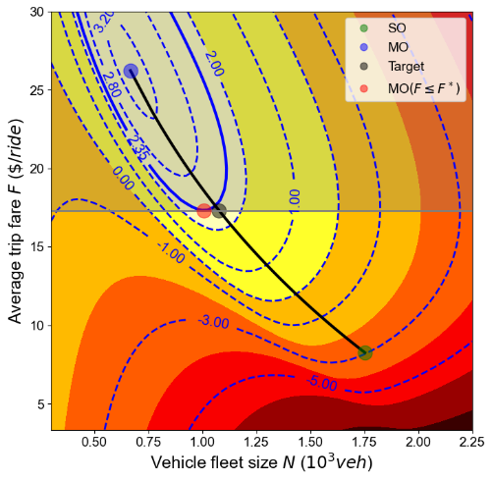 | 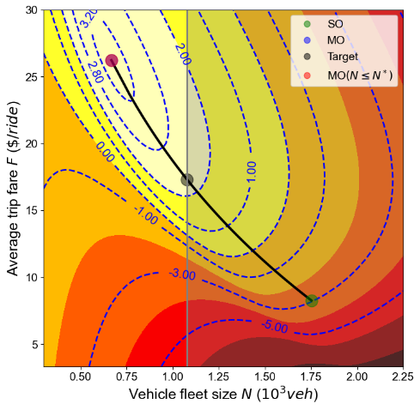 | 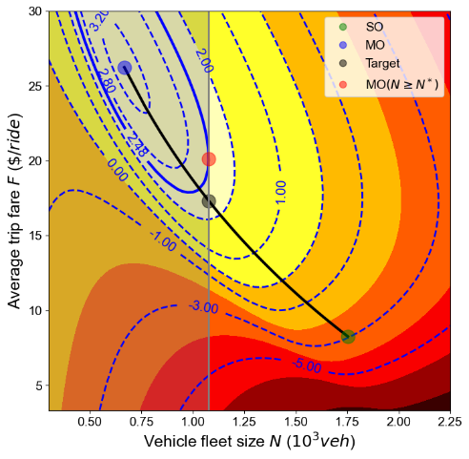
- Maximum fare regulation | - Maximum fleet size regulation | - Minimum fleet size regulation
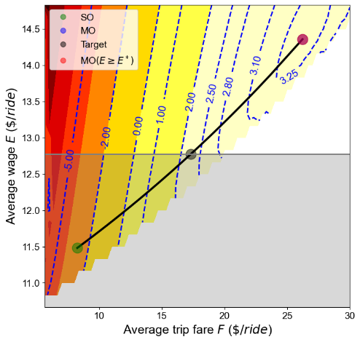 | 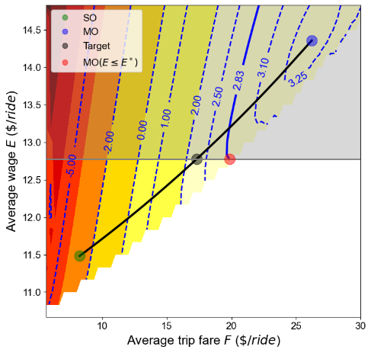 | 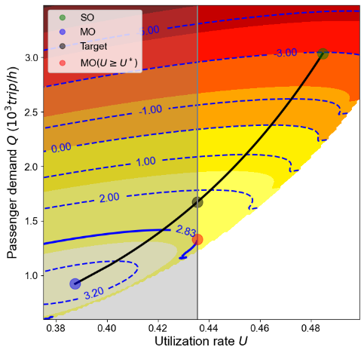
- Minimum wage regulation | - Maximum wage regulation | - Minimum utilization regulation
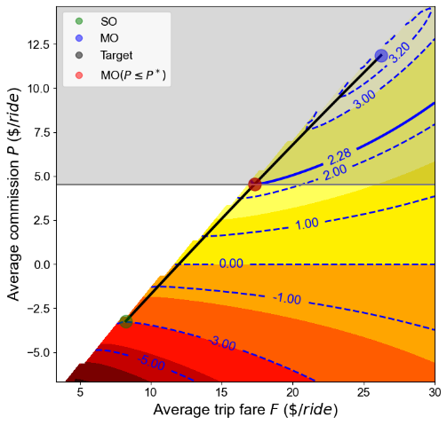 | 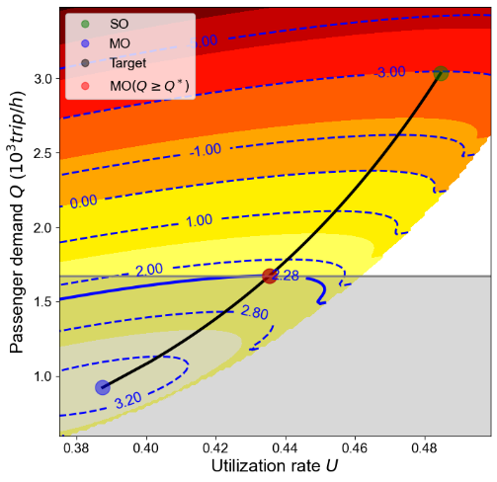
- Maximum commission regulation | - Minimum demand regulation
Figure 5. Regulatory outcomes of various regulations/policies with homogeneous drivers

Assembly Bill 5. https://leginfo.legislature.ca.gov/faces/billTextClient.xhtml?bill_id=201920200AB5
Some of the examined regulations in our study have been discussed by previous studies, e.g. commission regulation in Zha et al. (2016), but some have not been examined so far, e.g. utilization rate regulation and service level regulation. For those regulations discussed by other studies, we also have some new findings, e.g. effectiveness of commission regulation under different market scenarios.
Here we assume the normal vehicle demand Qn is an exogenous variable and do not consider the lost potential ride-sourcing demand which goes to normal vehicles. Since many potential ride-sourcing passengers are non-car owners, this assumption is valid when the share of the lost potential ride-sourcing demand which goes to normal vehicles is small compared to normal vehicle demand.
Here we assume that passengers are homogeneous in terms of their value of time but heterogeneous in terms of their reservation trip price. This will greatly simplify our problem since we can have a normal demand function that strictly decreases with price by using an appropriate distribution function of reservation price.
We can consider a general situation when passengers are heterogeneous with respect to both their reservation price and value of time. In this case, we can use a joint probability density function of the distribution of reservation price and value of time across potential passengers. Then, the demand for the platform can be expressed in terms of the integration of the density function over the attractive domain or market segment of the platform that offers differentiated services to heterogeneous passengers (Zhang et al., 2018).
According to Little’s Law, the number of vehicles in pick-up and in-trip phases at any stationary equilibrium state equals the arrival rate of vehicles (which is the same as the arrival rate of passenger demand $Q$) and the average pick-up time and travel (in-trip) time.
When the distribution of ride-sourcing drivers’ reservation rate is a one-point distribution, it implies the ride-sourcing drivers have a homogeneous reservation rate $c$. If the potential driver supply is sufficient, as the assumption made in Zha et al. (2017), at the market equilibrium, drivers will keep entering the market until the average income of each driver reduces to the homogeneous reservation rate $c$, namely, $R=\frac{EQ}{N}=c$.
Reported by New York Times at https://www.nytimes.com/2016/12/21/business/china-didi-driver-rules-uber.html
TLC’s driver pay rules apply to any driver working for a High-Volume For-Hire Service (Uber, Lyft, Via, and Juno). https://www1.nyc.gov/site/tlc/about/driver-pay-drivers.page
Reported by New York Daily News at https://www.nydailynews.com/new-york/ny-uber-lyft-cap-fhv-regulations-tlc-20190612-pspo2afygje63mxm4lr55s57jq-story.html.

