The impact of shared mobility services on housing values near subway stations

Ya Zhaoª, Jintao Ke^{b*}
ª Department of Real Estate and Construction, the University of Hong Kong, Hong Kong, China
^{b} Department of Civil Engineering, the University of Hong Kong, Hong Kong, China

Abstract
With the rapid development of smart phones and mobile internets, shared mobility services have become increasingly popular among travellers, and may influence housing values through their effects on people’s demand on subway services. This paper makes one of the first attempts to investigate the aggregate impact of different shared mobility services on housing values near subway stations, by conducting an empirical analysis on a dataset of apartment resale records in Beijing. We find that, the on-demand ride service offered by transportation network companies (like Didi) is more of a substitute than a complement to subway, leading to a reduction in house price in the vicinity of subway stations. In contrast, dockless bikesharing service brings about a greater complementary effect than substitution effect on subway usage, resulting in house price appreciation in the proximity of subway station. The effects are found to be heterogenous at different temporal and spatial scales.

Keywords: ridesourcing, shared mobility, bikesharing, subway, housing price

1. Introduction
The proliferation of smart phones and wireless communication technologies in recent years has catalyzed rapid growth of shared mobility, an innovative transportation strategy that satisfies travellers’ on-demand needs by the shared use of a car, bicycle, or other modes (Shaheen et al., 2015). The realm of shared mobility encompasses ridesourcing, ridesharing, bikesharing, carsharing, scooter sharing, etc. (Machado et el., 2018). Ridesourcing services rely on smartphone apps to connect customers who request on-demand rides and drivers who provide ride services for profit. There are various alternative terms for ridesourcing service, including on-demand ride service, ride-hailing, e-hailing service, while the platforms for providing the smartphone apps are termed as transportation network companies (TNCs). Typical examples of TNCs include Uber, Lyft, Didi, Grab, and Ola, which have undergone rapid market expansion in recent years. Uber is now operating its services in over 700 metropolitan areas and 65 countries, with around 100 million monthly active users (DMR, 2021a). Didi, as the largest TNC in China, is offering a variety of on-demand ride services to more than 550 million travellers in around 400 cities, with 30 million daily trips on average (DMR, 2021b). Different from ridesourcing services provided by dedicated drivers who act like taxi drivers, ridesharing services (such as carpooling and vanpooling) facilitate shared rides between passengers and non-dedicated drivers who share similar itinerary and schedule (Ke et al., 2020). Some TNCs, such as Didi, not only provide access to ridesourcing services, but also offer dynamic ridesharing services, such as Didi Hitch, which match individual drivers and passengers on short notice. Bikesharing, as another rapid growing shared mobility service, enables customers to access bikes on an as-needed basis from either fixed stations (for docked bikesharing) or roadside (for dockless bikesharing). Since 2016, Ofo and Mobike, the two largest dockless bikesharing companies in China, have jointly deployed 17 million dockless shared bikes in over 200 cities worldwide, and each firm has more than 200 million registered users as of 2017 (Chu et al., 2021). Readers may refer to Shaheen et al. (2015), Machado et el. (2018), Laporte et al. (2018), Wang and Yang (2019), for comprehensive reviews of shared mobility.
Undoubtedly, shared mobility services have achieved great success in business and greatly transformed the way people travel. However, their entry into cities has also brought up intense debates on the impacts of different shared mobility services on traffic congestion, public transit usage and other environmental issues. Schaller Consulting (2018) reveals that the entry of Uber and Lyft has added 5.7 billion vehicle miles travelled annually in major metropolitan areas of the United States, including Boston, New York, Chicago, Los Angeles, Miami, Philadelphia, San Francisco, Seattle and Washington DC. Using a difference-in-difference design, Hall et al. (2018) explore the net effect of Uber on public transit ridership, and find that Uber is more of a complement for public transit agency, increasing transit ridership by 5% after two years since its entry. However, using metropolitan statistical area level data to estimate a set of fixed-effect panel models, Diao et al. (2021) reach an opposite conclusion that the entrance of ridesourcing services has led to an increase in traffic congestion with intensity increased by 0.9% and duration increased by 4.5%, whereas, a decrease in public transit ridership by 8.9% is induced. Compared with ridesourcing and ridesharing services, the impacts of bikesharing on urban environment are relatively less controversial. Dockless shared bikes can act as a feeder for subway access by addressing the “first-mile/last-mile” issues in regions with inadequate public transit access. Although bikesharing can also be a direct substitute for subway trips, Fan and Zheng (2020) find that the complementary effect of bikesharing services on subway ridership is much more significant than their substitution effect.
Apart from affecting transportation systems, the emerging shared mobility services may influence real estate markets through their effects on public transportation systems. As proposed by location theory (﻿Alonso, 1964; Muth, 1969), consumer’s choice on house location depends on various factors, among which the commuting cost is one of the most significant factors. Generally, consumers are willing to purchase apartments with shorter distance to the nearest public transit station, leading to a “subway house price premium” (Dewees 1976, Bajic 1983, Coulson and Engle 1987; Yang et al., 2020c) for apartments near subway stations. Consumers essentially make a trade-off between commuting cost savings (money and time) and house prices when they make a choice on home location. In other words, locations accessible to subway stations are associated with lower commuting costs and the saved costs will be captured into property price, leading to a price appreciation of apartments in these locations.
As portrayed in Figure 1, shared mobility services exert both complementary and substitution effects on subway services, thereby influencing consumers’ purchasing decisions through two mechanisms. On one hand, shared mobility services can complement public transit services and address the first-mile/last-mile issues as consumers living around subway stations can get access to subway stations more easily using shared mobility services instead of walking. This could drive up the demand for the apartments around subway stations, especially in regions requiring relatively longer walking time. As a result of this effect, ceteris paribus, the price of housing units in the proximity of subway stations will increase, after the entry of the shared mobility services. The demand surge and price enhancement will be larger for apartments distant from subways stations, for which the complementary effect of shared mobility services is more salient. Hence, the slope of house price towards subway proximity will be moderated and housing price gradient will be flattened.
On the other hand, shared mobility services can be a direct substitute for subway. Some passengers may give up taking public transport and directly use shared mobility services to fulfill their mobility needs. Therefore, as more consumers switch from public transit to shared mobility services, the demand for apartments near subway stations will shrink, leading to decreased prices for these apartments. In addition, the demand change could be uneven across apartments with different distances to subway stations. There is some evidence supporting that travellers with poor public transit accessibility are more prone to switch to shared mobility (Wang and Noland, 2021), which implies that the substitution effect is more pronounced for apartments relatively distant from subways stations. Thus, the demand and price drop could be more significant for apartments far away from subway stations than apartments very close to subway stations, steepening the slope of house price with respect to distance to subway stations. Due to the two opposite complementary and substitution effects, the aggregate impact of shared mobility services on subway house price gradient and real estate value is uncertain and lacks sufficient empirical evidence.

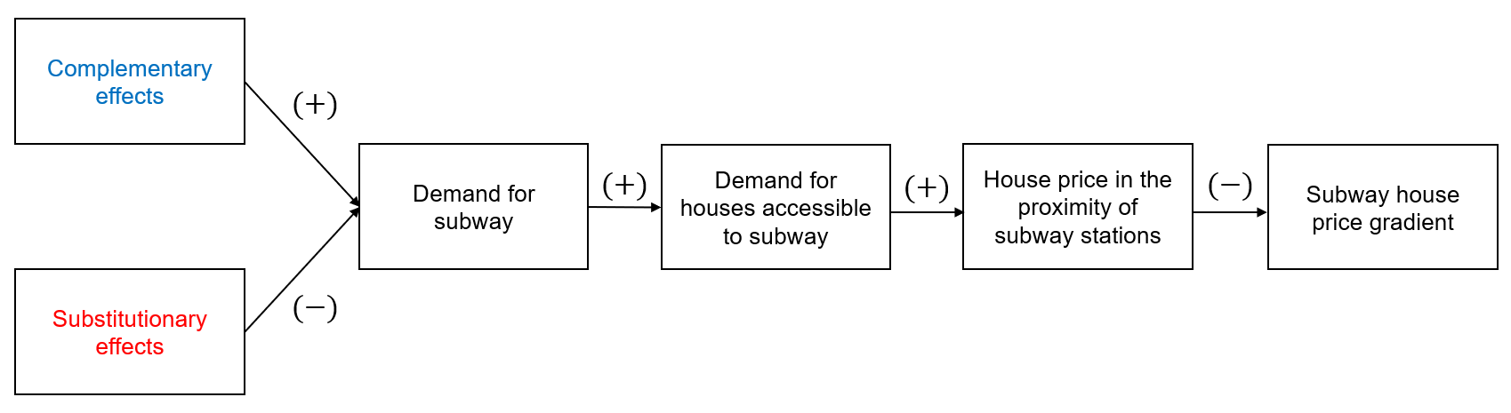
Figure 1. The substitution and complementary effects of shared mobility on subway house price

In this research, we study the effects of multiple shared mobility services, encompassing ridesourcing, ridesharing, and dockless bikesharing services, on property value in the proximity of subway stations. We utilize a dataset with detailed information of over 200,000 second-hand apartments from 3626 housing complexes in Beijing, and exploit the staggered entry of Didi, Uber China, Ofo, Mobike, and Didi Hitch into Beijing at different time points, to conduct an empirical analysis at apartment level. Didi is the largest TNC in China accounting for a market share of 93%, while Uber China was the major competitor of Didi in 2014-2016. Didi and Uber China merged on August, 2016. Didi Hitch is a widely used dynamic ridesharing program developed by Didi to match riders with individual drivers who have their own itineraries. Ofo and Mobike are two top dockless bikesharing firms in China. In the empirical study, we identify the effects of these different shared mobility services by comparing the spatial variations in prices of housing units at different distances to the identical subway station before and after the entry of diverse shared mobility services.
Our empirical analysis reveals that the substitution effect associated with the prevalence of TNCs is stronger than the complementary effect, steepening the house price gradient by 1.26 percentage points. In contrast, the succeeding popularity of dockless bikesharing services turnovers the situation by flattening the house price gradient by 2.61 percentage points, since the complementation effect on subway overwhelms the substitution effect. It is found that both effects intensify over time as the corresponding shared mobility service proliferates. More prominent effects are observed for apartments located at neighborhoods with relatively worse commuting conditions.
The major contributions of this study are concluded as follows. First, it has made one of the first attempts to identify the synergetic relationship between different shared mobility services, including ridesourcing, ridesharing, and dockless bikesharing, and subway proximity capitalization effect. Second, the findings provide a few novel and interesting managerial insights, which could have far-reaching implications for TNCs, dockless bikesharing firms, house buyers/travellers, property developers, as well as policymakers.
The remainder of the paper is organized as follows. Section 2 reviews the literature related to this research. Section 3 describes the data, Section 4 presents the research methods, and Section 5 summarizes the major findings. Section 6 concludes the paper and outlooks future research directions.

2. Literature Review
This study is related to the growing literature on shared mobility services. As a typical sharing economy, shared mobility has made significant impacts on urban transportation systems, land use developments, air pollution, and other urban issues. Shared mobility services affect travellers’ choices, transportation system performance, and the environment through multiple channels, resulting in different net effects on the efficiency and sustainability of urban systems. Therefore, dependent on when, where and how the data are collected, current empirical studies have reached mixed conclusions on the aggregate impacts of shared mobility services. Through a simulation study based on people’s mobile phone records, Alexander et al. (2015) claim that ridesharing can help reduce the total number of vehicles required for satisfying a given travel demand level, if there is a sufficient number of ridesharing adopters from private car owners. Wang et al. (2018) argue that initiating a dynamic ridesharing program is quite difficult, thus it is necessary for the government to encourage drivers’ and riders’ participation through subsidies at the initial phase of development. Using data retrieved from Uber and Urban Mobility Report, Li et al. (2016) discover that the entry of Uber can help reduce traffic congestion in metropolitan areas of the United States as of 2016. Conversely, Schaller Consulting (2018) argues that the entry of Uber and Lyft put 2.8 new vehicle miles travelled (VMT) onto the road whenever they take off each mile of private car usage, leading to an aggregate increase in traffic congestion. Erhardt et al. (2019) find that the entry of TNCs is the biggest contributor to the deterioration of traffic conditions in San Francisco, increasing vehicle hours delay by 62%. Based on a survey-based experiment, Henao et al. (2019) demonstrate that on-demand ride services operated by TNCs result in approximately 83.5% more VMT. In addition to the social impacts of shared mobility, there is an extensive body of literature on improving the efficiency, sustainability and connectivity of shared mobility services through appropriate platform operations and government regulations (Santi et al., 2014; Zha et al., 2016; Alonso-Mora et al., 2017; Vazifeh et al., 2018; Chen et al., 2020; Yang et al., 2020a).
Notably, there have been heated discussions on comparing the relative magnitude of substitution and complementary effects of transportation network companies on public transit ridership. Using the public data of Didi in Chengdu, Kong et al. (2020a) identify that 33% of Didi trips could potentially substitute for public transit, and the substitution effect is stronger in downtown areas with easy access to subway stations. As mentioned above, Hall et al. (2018) find that the emerging Uber service in the US has stronger substitution effect than complementation effect on public transit usage. On the contrary, using metropolitan statistical area level data in the US, Diao et al. (2021) observe that the entry of TNCs is more of a direct substitute for public transit, giving rise to a decline in public transit usage. The mixed outcome arises from the fact that the emergence of TNC offers two additional choices to travellers: (1) hailing an on-demand ride directly from their origins to destinations; (2) hailing a ride to nearby public transit stations and then taking the public transit (Zhu et al., 2020). The first choice enhances the substitution effect while the second choice strengthens the complementation effect, thus the aggregate effect depends on riders’ choices.
As for the influence of bikesharing services on public transit ridership, most of the existing studies suggest that bikesharing is more of a complement than a substitute for public transit systems. Ma et al. (2015) quantify the impact of bikesharing services on public rail ridership in Washington, D.C., reporting that a 10% enhancement in bikesharing ridership is associated with a 2.8% increase in metro ridership. Utilizing 3.2 million geo-coded bike-sharing trips over two weeks in 2017, Fan and Zheng (2020) investigate the interaction between dockless bikesharing services and subway networks of Beijing, by differentiating subway-complementing trips from subway-substituting trips. They find that the subway lines with higher density of dockless sharing bikes report 8% larger growth rate in subway usage than those with lower density, while the substitution effect of shared bikes on subway trips is insignificant. This observation demonstrates that the synergy between dockless bikesharing and subway outweighs the substitution effect. Using data of the 2017 National Household Travel Survey in the US, Zhang and Zhang (2018) observe a significantly positive relationship between the frequency of public transit usage and bikesharing usage, suggesting that bikesharing service is majorly a complement to public transit.
However, there is scant research on the implications of shared mobility on real estate markets. With a quasi-experiment design, Pelechrinis et al. (2017) find that the docked shared bikes have boosted both sale and rental prices of apartments in regions with shared bike stations installed. Employing a big data analysis on ﻿75,197 house rental records in Beijing, Qiao et al. (2020) report that the improvement of accessibility to dockless bikesharing is associated with an enhancement in housing rentals. Utilizing a difference-in-difference approach to examine resale apartment data in ten Chinese cities, Chu et al. (2021) discover that the entry of dockless bikesharing services can reduce the slope of housing price versus distance to the nearest subway station. In other words, after the entry of dockless bikesharing, there is a relative increment in the price of and demand for apartments distant from, vis-`a-vis proximate to, subway stations. These studies only concentrate on bikesharing services, which typically have stronger complementary effects than substitution effects. Yet, other shared mobility services, such as ridesourcing (UberX, Didi Express) and ridesharing (Didi Hitch), may have either prominent complementary or substitution effects, and their net effects on housing prices are less intuitive. This study attempts to fill this research gap by looking into the aggregate impacts of a variety of shared mobility services, including ridesourcing, ridesharing and dockless bikesharing, on values of apartment properties with heterogeneous accessibility to subway stations.
Beyond the shared mobility literature, our work is also related to the literature on public transit proximity capitalization. A vast strand of studies confirms that properties accessible to public transit are sold with positive premiums (﻿Bajic, 1983; McMillen and McDonald, 2004; ﻿Gibbons and Machin, 2005; ﻿Cervero and ﻿Kang, 2011; Li et al., 2016; Yang et al., 2019; Yang et al., 2020b). The transit proximity effects depend on a set of factors, thereby resulting in the heterogenous responses of property values with respect to the change of transit proximity, across transit modes, property subgroups and neighborhood conditions (﻿Ryan, 2005; Ghebreegziabiher et al, 2007; Duncan, 2009; Trojanek and Gluszak, 2018; ﻿Seo and Nam, 2019; Yang et al., 2020d). The recent literature on urban economics has also examined the interaction between subway proximity and people’s travel mode, which also inspires our research. Xu et al. (2015) find evidence that the private driving restriction policy in Beijing accelerates consumer’s willingness to pay for subway proximate properties by altering residents’ travel mode. Zhang et al. (2017) unveil the connection between residential location choice and car ownership. They observe that households living in zones with better access to subway are at lower probability of owning a car. Our result is consistent with the traditional wisdom that apartments near subway stations are transacted at higher prices, since residents living in these apartments can enjoy more convenient public transit services. Our study arguments the literature by revealing that different shared mobility services may exert different impacts on the prices of apartments near subway stations, due to the complementary and substitutive relationships between shared mobility and public transit services.

3. Data
To infer the impact of shared mobility on house prices, we utilize a dataset of apartment resale records in the platform of Lianjia, which is the largest real estate agency in China. The dataset contains 262,028 second-hand apartments within 3 km radius of subway stations in Beijing and sold from Jan 2012 to Dec 2017. It comprises detailed information of each apartment as listed in Table 1. These apartments are affiliated to 3,626 residential complexes, and the precise latitude and longitude of each residential complex are provided. The spatial distribution of the communities in Beijing is demonstrated in Figure 2, where each dot represents the location of a community and its color reflects the average house price of this complex (the darker the color, the higher the mean house price).

Table 1
Variable definitions
Variable | Description
Panel A: Key Variables
Price | Total transaction price of the apartment
Unit price | The average price per square meter
Log(price) | The logarithm of total price
Distance to subway station | Distance to nearest subway station
TNC entry | Equals 1 if the first transportation network company, i.e., Didi, has entered Beijing when the apartment is transacted, otherwise equals 0
DBS entry | Equals 1 if the first dockless bikesharing company, i.e., Mobike, has entered Beijing when the apartment is transacted, otherwise equals 0
Baidu Index of TNC | Sum of Baidu Index of Didi and Uber in Beijing when the apartment is transacted, which indicates the penetration level of transportation network companies in Beijing
Baidu Index of DBS | Sum of Baidu Index of Mobike and Ofo in Beijing when the apartment is transacted, which indicates the penetration level of dockless bikesharing in Beijing
Distance to city center | Distance to city center of Beijing, i.e., Tian An Men Square
Number of stations within 3 km | Number of subway stations within 3 km away from the apartment
Interchange station | Whether the nearest subway station is an interchange station or not
Panel B: Control Variables
Size | Size of the apartment
Building age | The age of the building structure
Bedroom | Number of bedrooms
Living room | Number of living rooms
Kitchen | Number of kitchens
Bathroom | Number of bathrooms
Building type | Including tower (1) combination of slab and tower (2) and slab (3)
Decoration | Decoration condition including other (1), no decoration (2), basic decoration (3) and fine decoration (4)
Building structure | Including mixed (1) brick and concrete (2) and steel and concrete (3)
Elevator ratio | The number of apartments per floor divided by the number of elevators
Elevator | Whether the apartment has an elevator
5-year property | Whether the owner hold the property for more than 5 years
Floor level | The floor level of the apartment, including ground level (1), low level (2), medium level (3), high level (4), and top level (5)
Building height | Total number of floors of the building
Station ID | ID of the nearest subway station of apartment
Year-month | Year-month ID of the apartment transaction time
Complex ID | ID of the residential complex where the apartment is located
District ID | ID of the administrative district where the apartment is located

In order to measure the accessibility of apartments to subway services, we further collect information of the metro network in Beijing, with longitude and latitude of each station. We then calculate the geodesic distance from each apartment to the nearest subway station, which is the key variable for our research. In reality, travellers may be more concerned with the walking distance than geodesic distance to subway stations, but the geodesic distance is also widely used in the literature. As pointed out by Chu et al., (2021), the measures of walking and geodesic distance are highly consistent with a correlation coefficient of 0.89, and it is more intuitive to illustrate the house price gradient through the geodesic distance to subway stations. A dummy variable is created to indicate whether the nearest subway station is an interchange station, a station where customers can transfer from one subway line to another. In addition, we calculate the geodesic distance from each apartment to the city center of Beijing, i.e., the Tian An Men Square. The probabilistic density distributions of distance to the nearest subway stations and city center are displayed in Figure 3 (a) and (b), respectively.

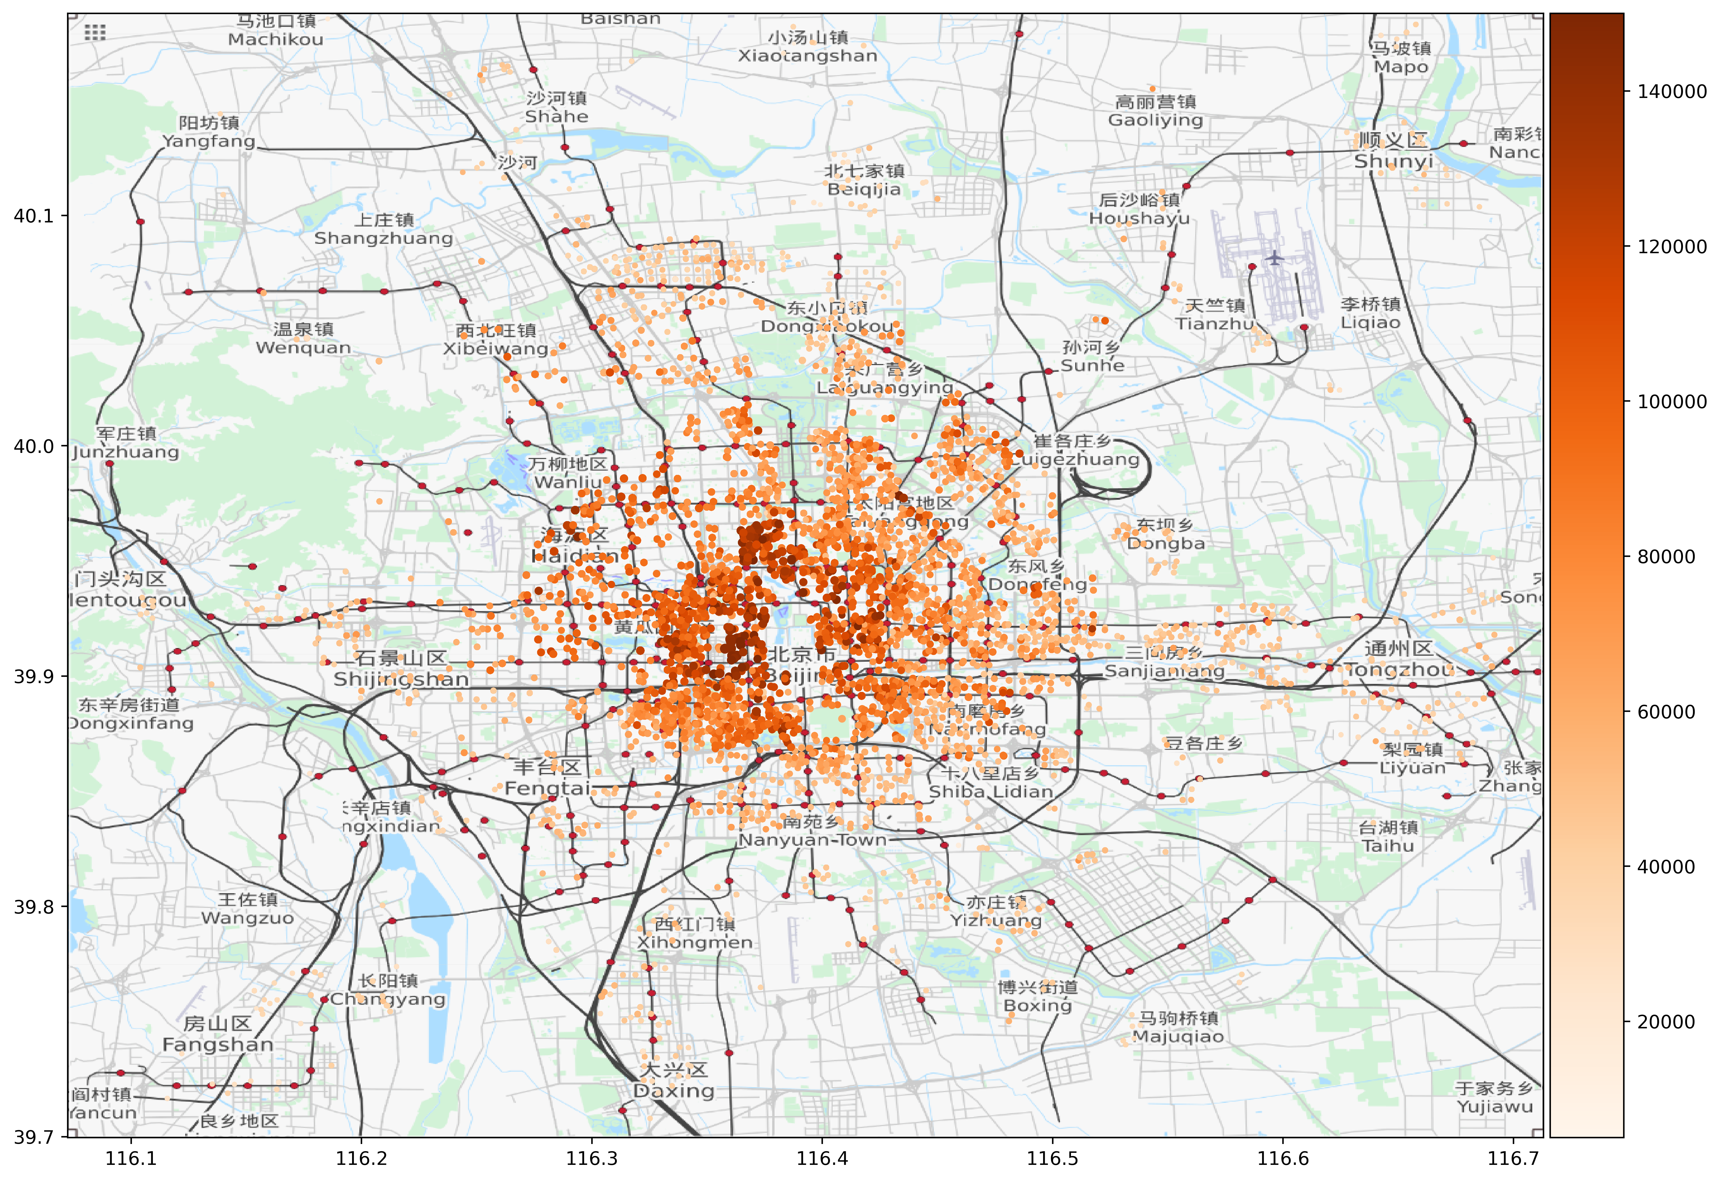
Figure 2. Spatial distribution of apartments in Beijing

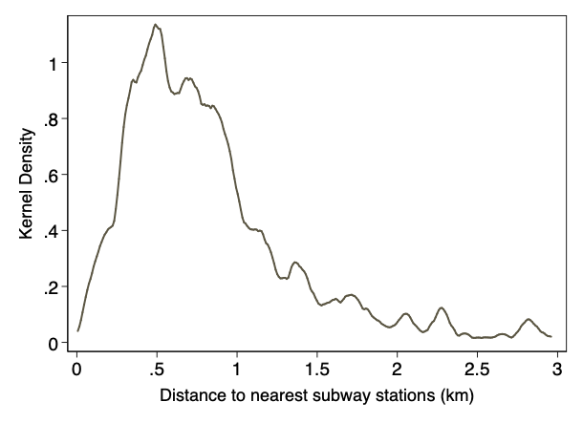 | 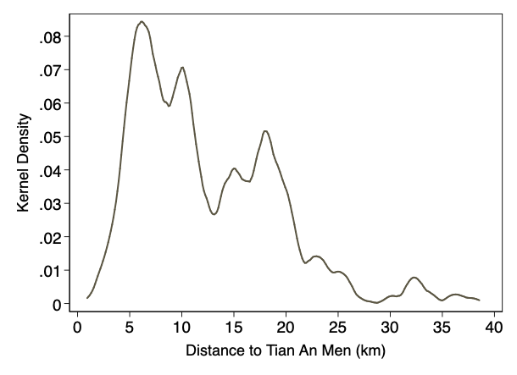
(a) Distance to nearest subway stations | (b) Distance to Tian An Men
Figure 3. Distribution of apartments by distance to nearest subway stations and city center (Tian An Men Square)
To measure the effects of shared mobility services, we collect the entry dates of Didi, Uber, Didi Hitch (a ridesharing program), Mobike and Ofo, which are reported in Table 2. Inspired by Hall et al. (2018), which use Google Index as a proxy for the penetration of Uber and Lyft in the United States, we exploit the daily Baidu Index of keywords related to different shared mobility services, for approximating the penetration of these shared mobility services. For example, the keywords for Didi include not only “Didi Chuxing” (current company name) but also “Didi Dache” and “Kuaidi Dache” (the predecessors of Didi Chuxing). As shown in Figure 4, there is typically a surge in the related Baidu Index after the entry of each shared mobility service, while the corresponding index before the entry stays in a comparatively low level.
The entry dates of Mobike, Ofo, Uber are retrieved from the official website of each company and partially cross-validated with Cao et al. (2018). The entry date of Uber is the date when Uber officially entered China’s market. As for the entry date of Didi, we select Jan, 2014, when Didi Dache and Kuaidi Dache started nation-wide marketing campaigns and the demand for these two APPs surged. This is because, although Didi Dache was founded on June, 2012 and Kuaidi Dache was founded on May, 2012, their apps were immature and not widely used by commuters in the initial stage of establishment between 2012 and 2013. This is supported by the trend of Baidu Index in Figure 4(a), which exhibits a sharp demand surge exactly after Jan 2014, the start time of the price war between Didi Dache and Kuaidi Dache (Wang and Yang, 2019).
Table 2
Entry dates of shared mobility operators in Beijing
Shared Mobility Operator | Date
Didi | 2012-06
Didi Surge | 2014-01
Uber | 2014-07
Didi Hitch (Ridesharing) | 2015-06
Mobike | 2016-09
Ofo | 2016-10

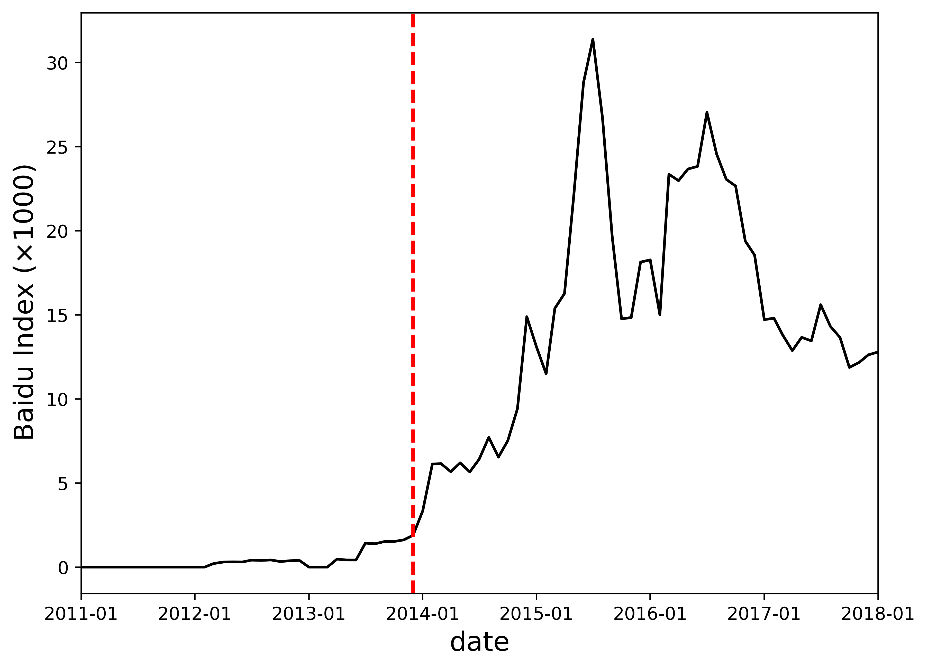 | 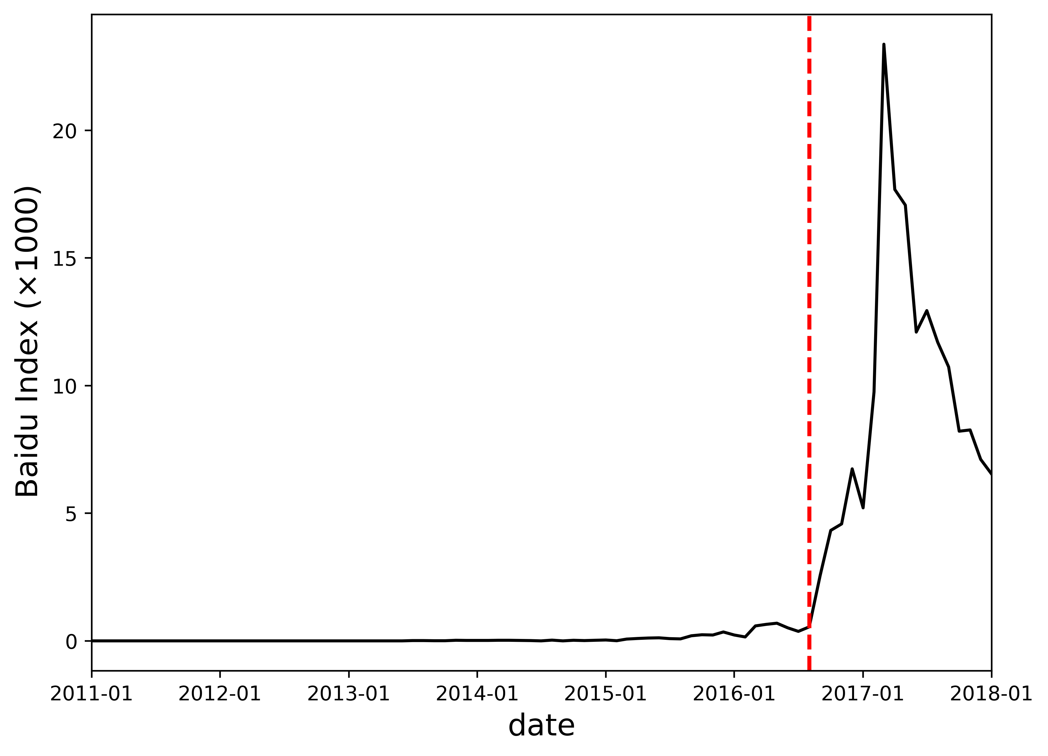
(a) Baidu Index of TNC | (b) Baidu Index of bikesharing
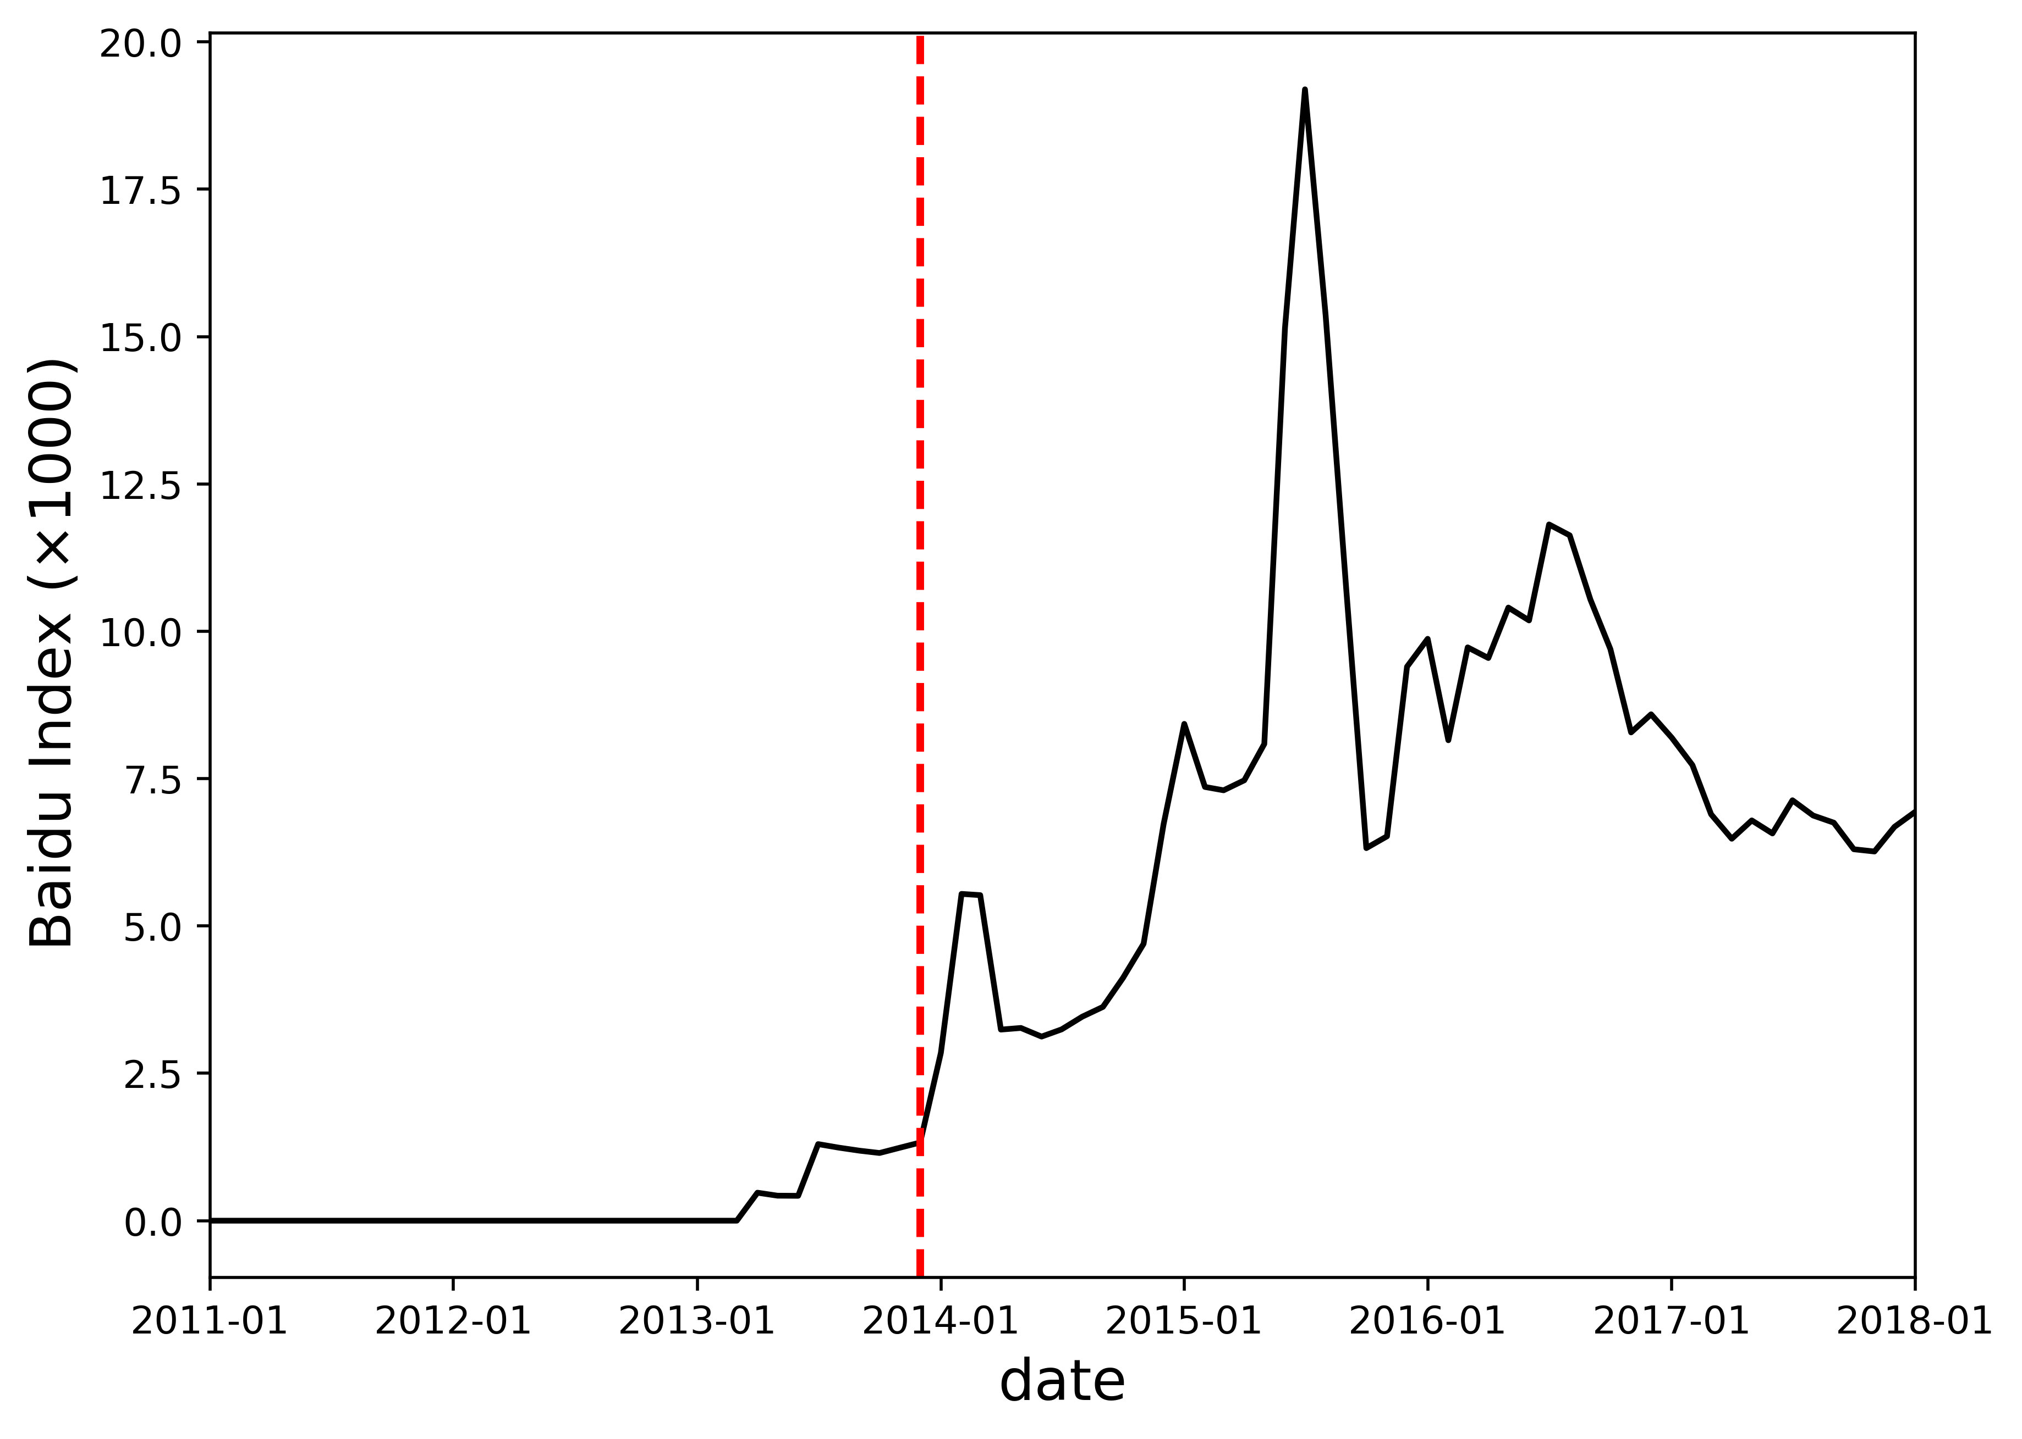 | 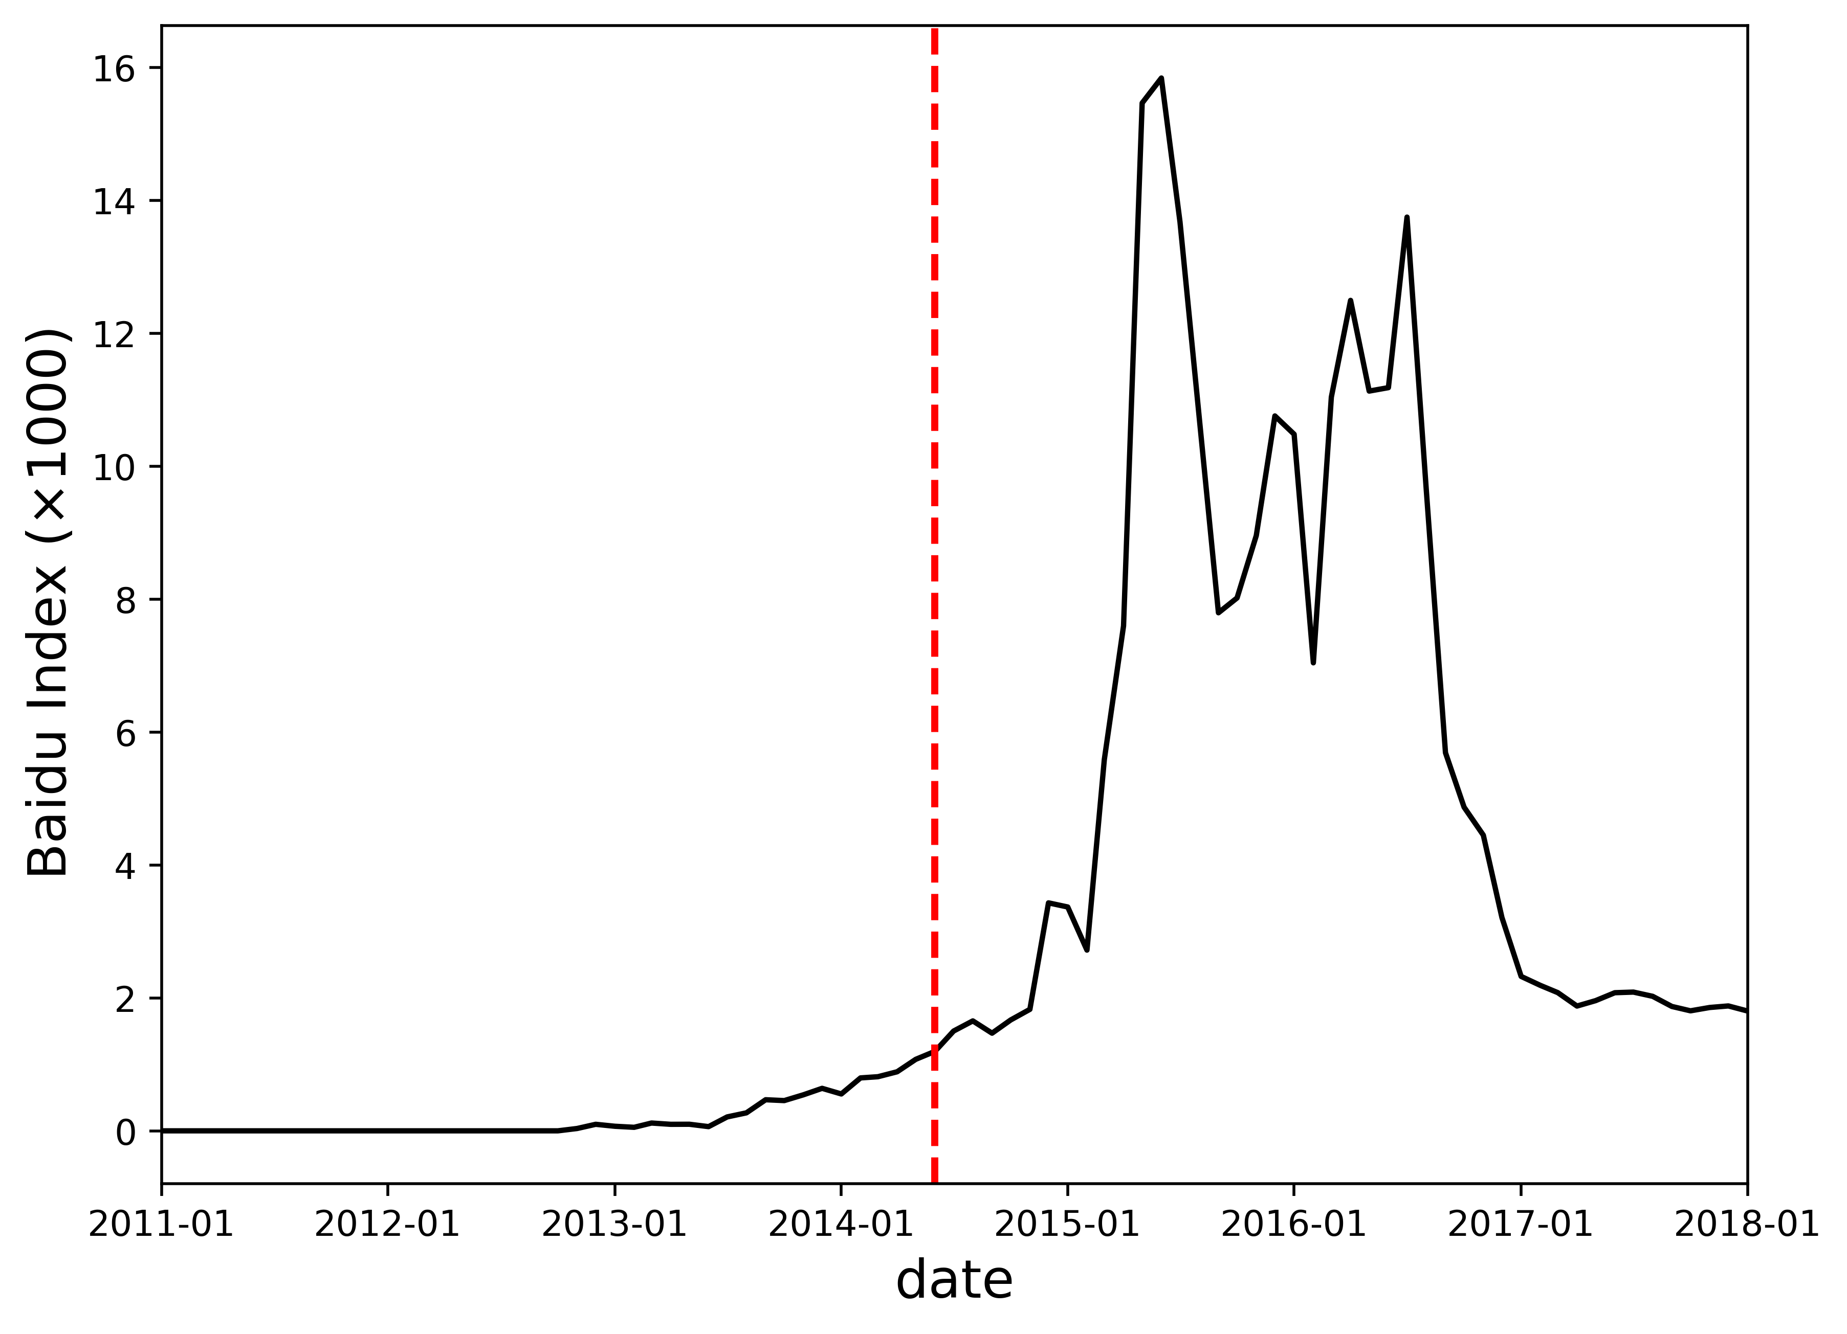
(c) Baidu Index of Didi | (d) Baidu Index of Uber
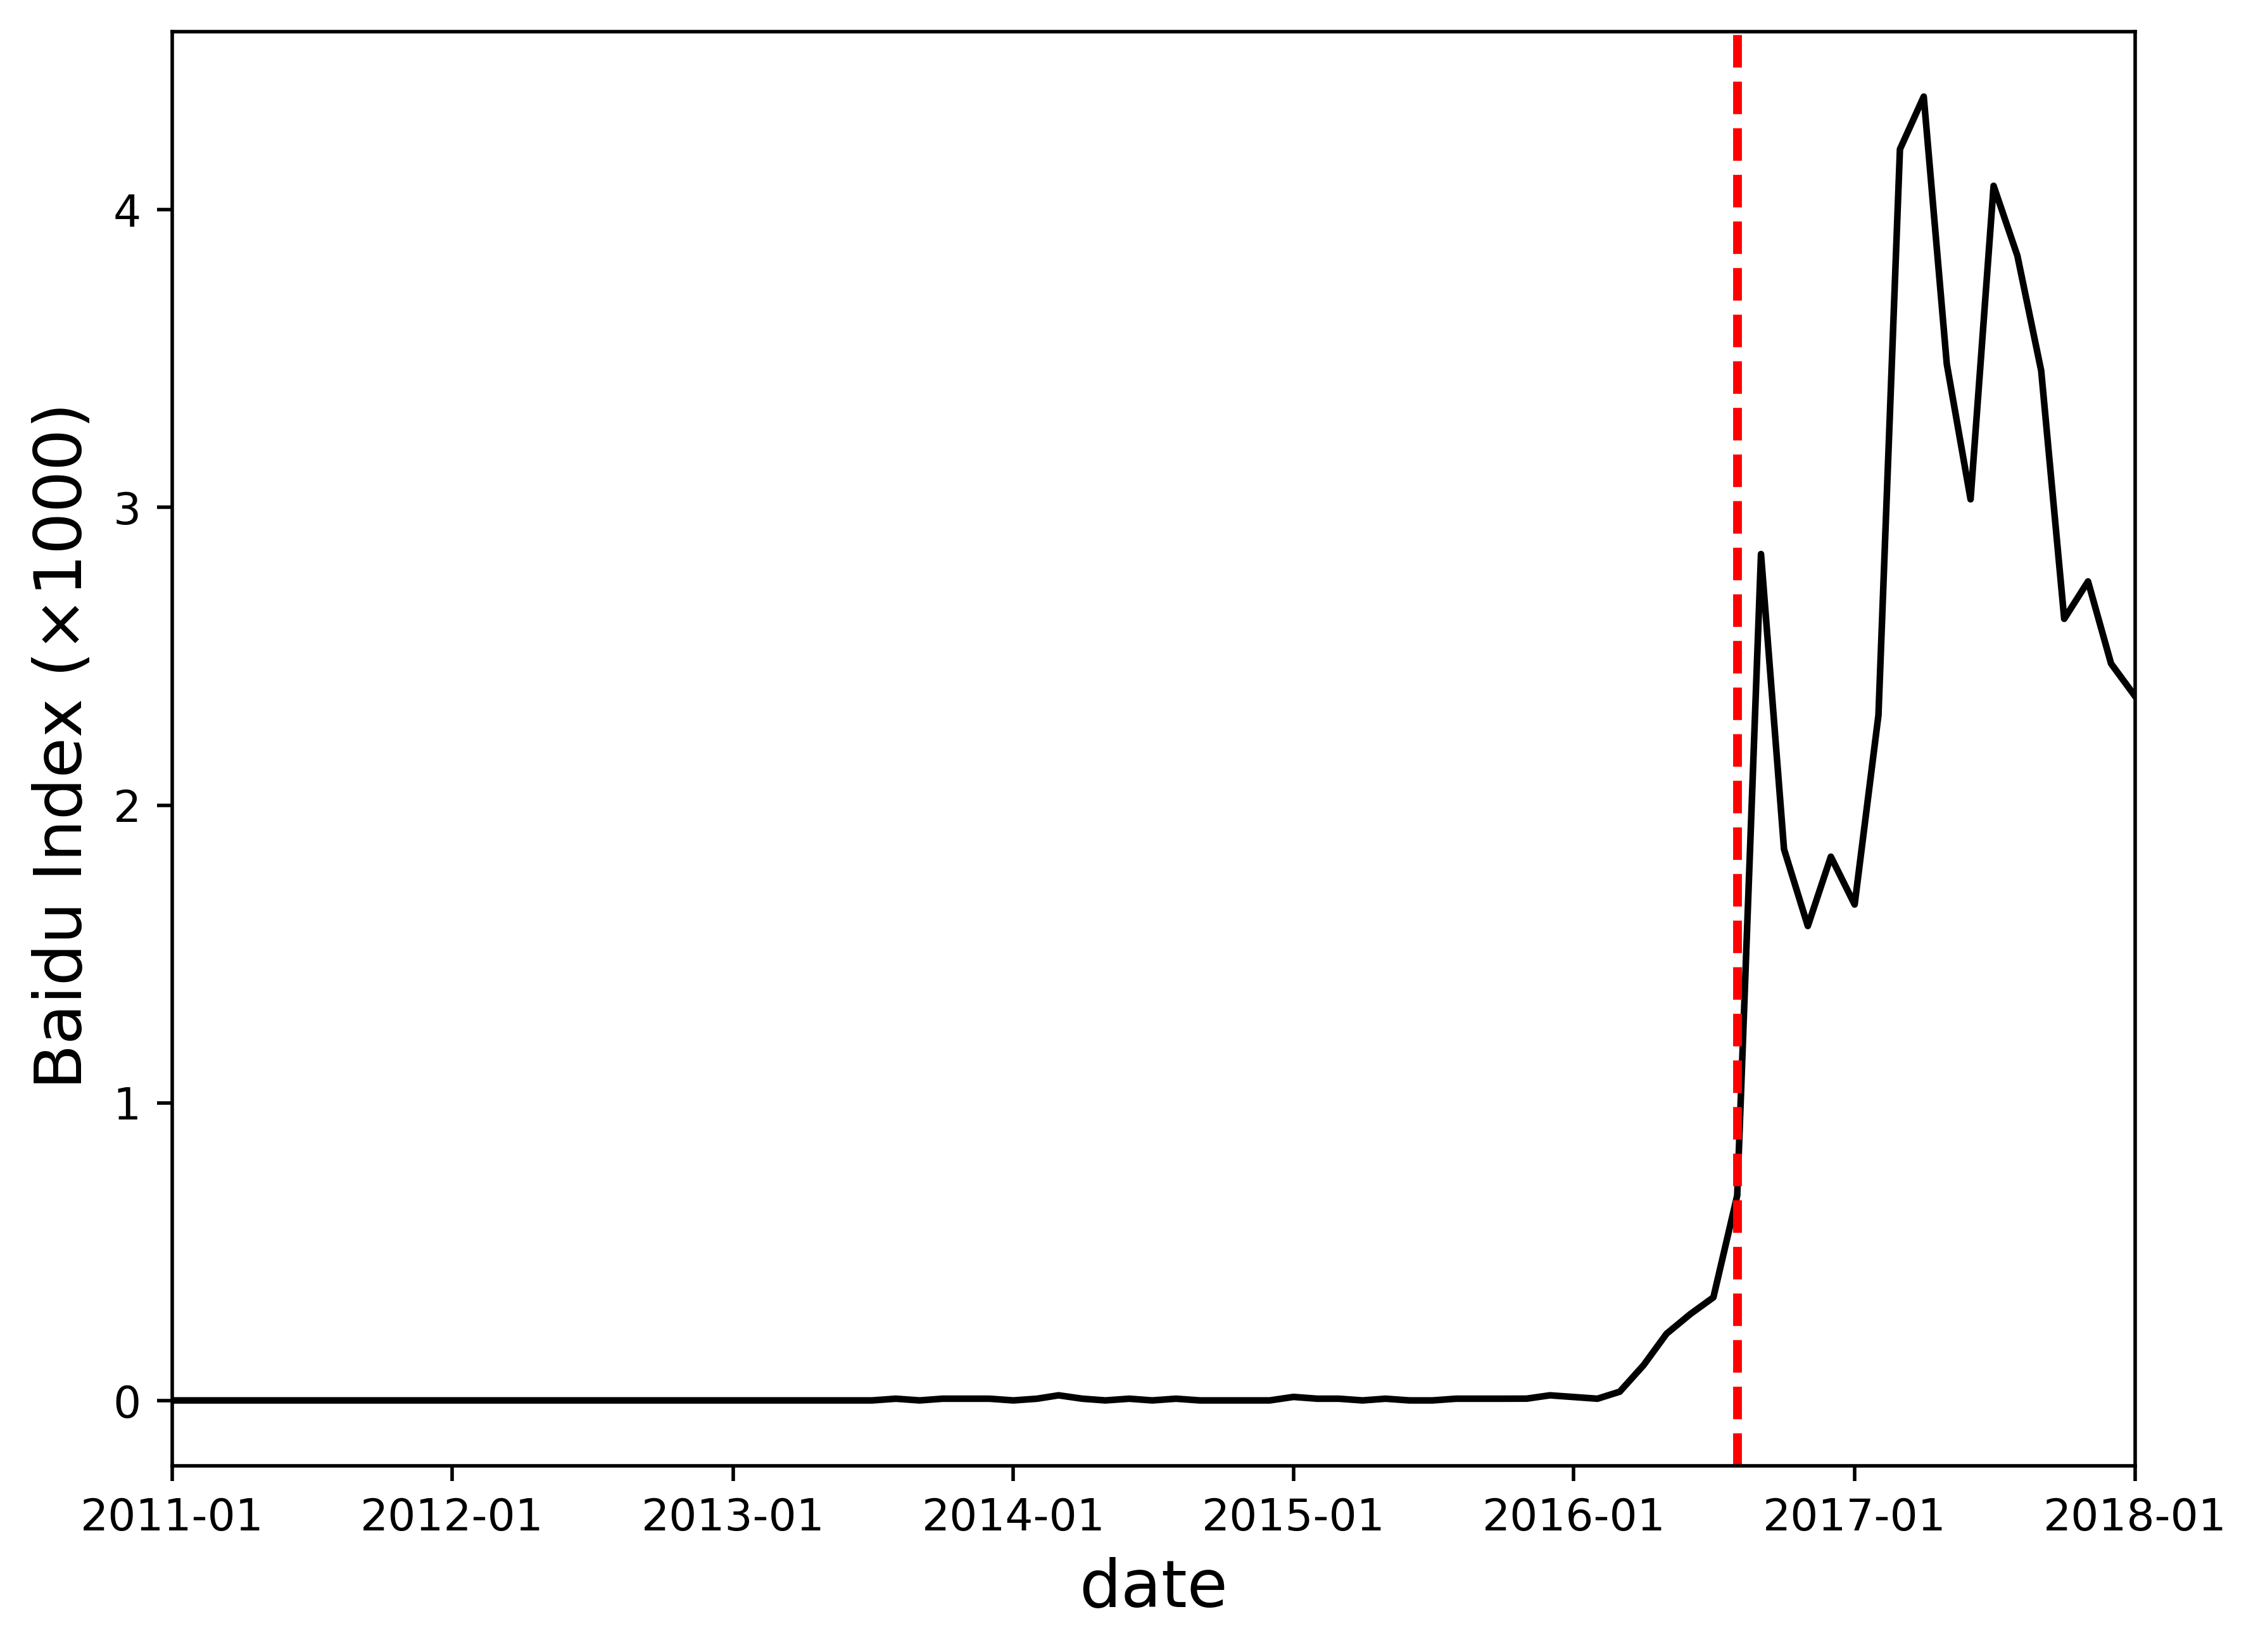 | 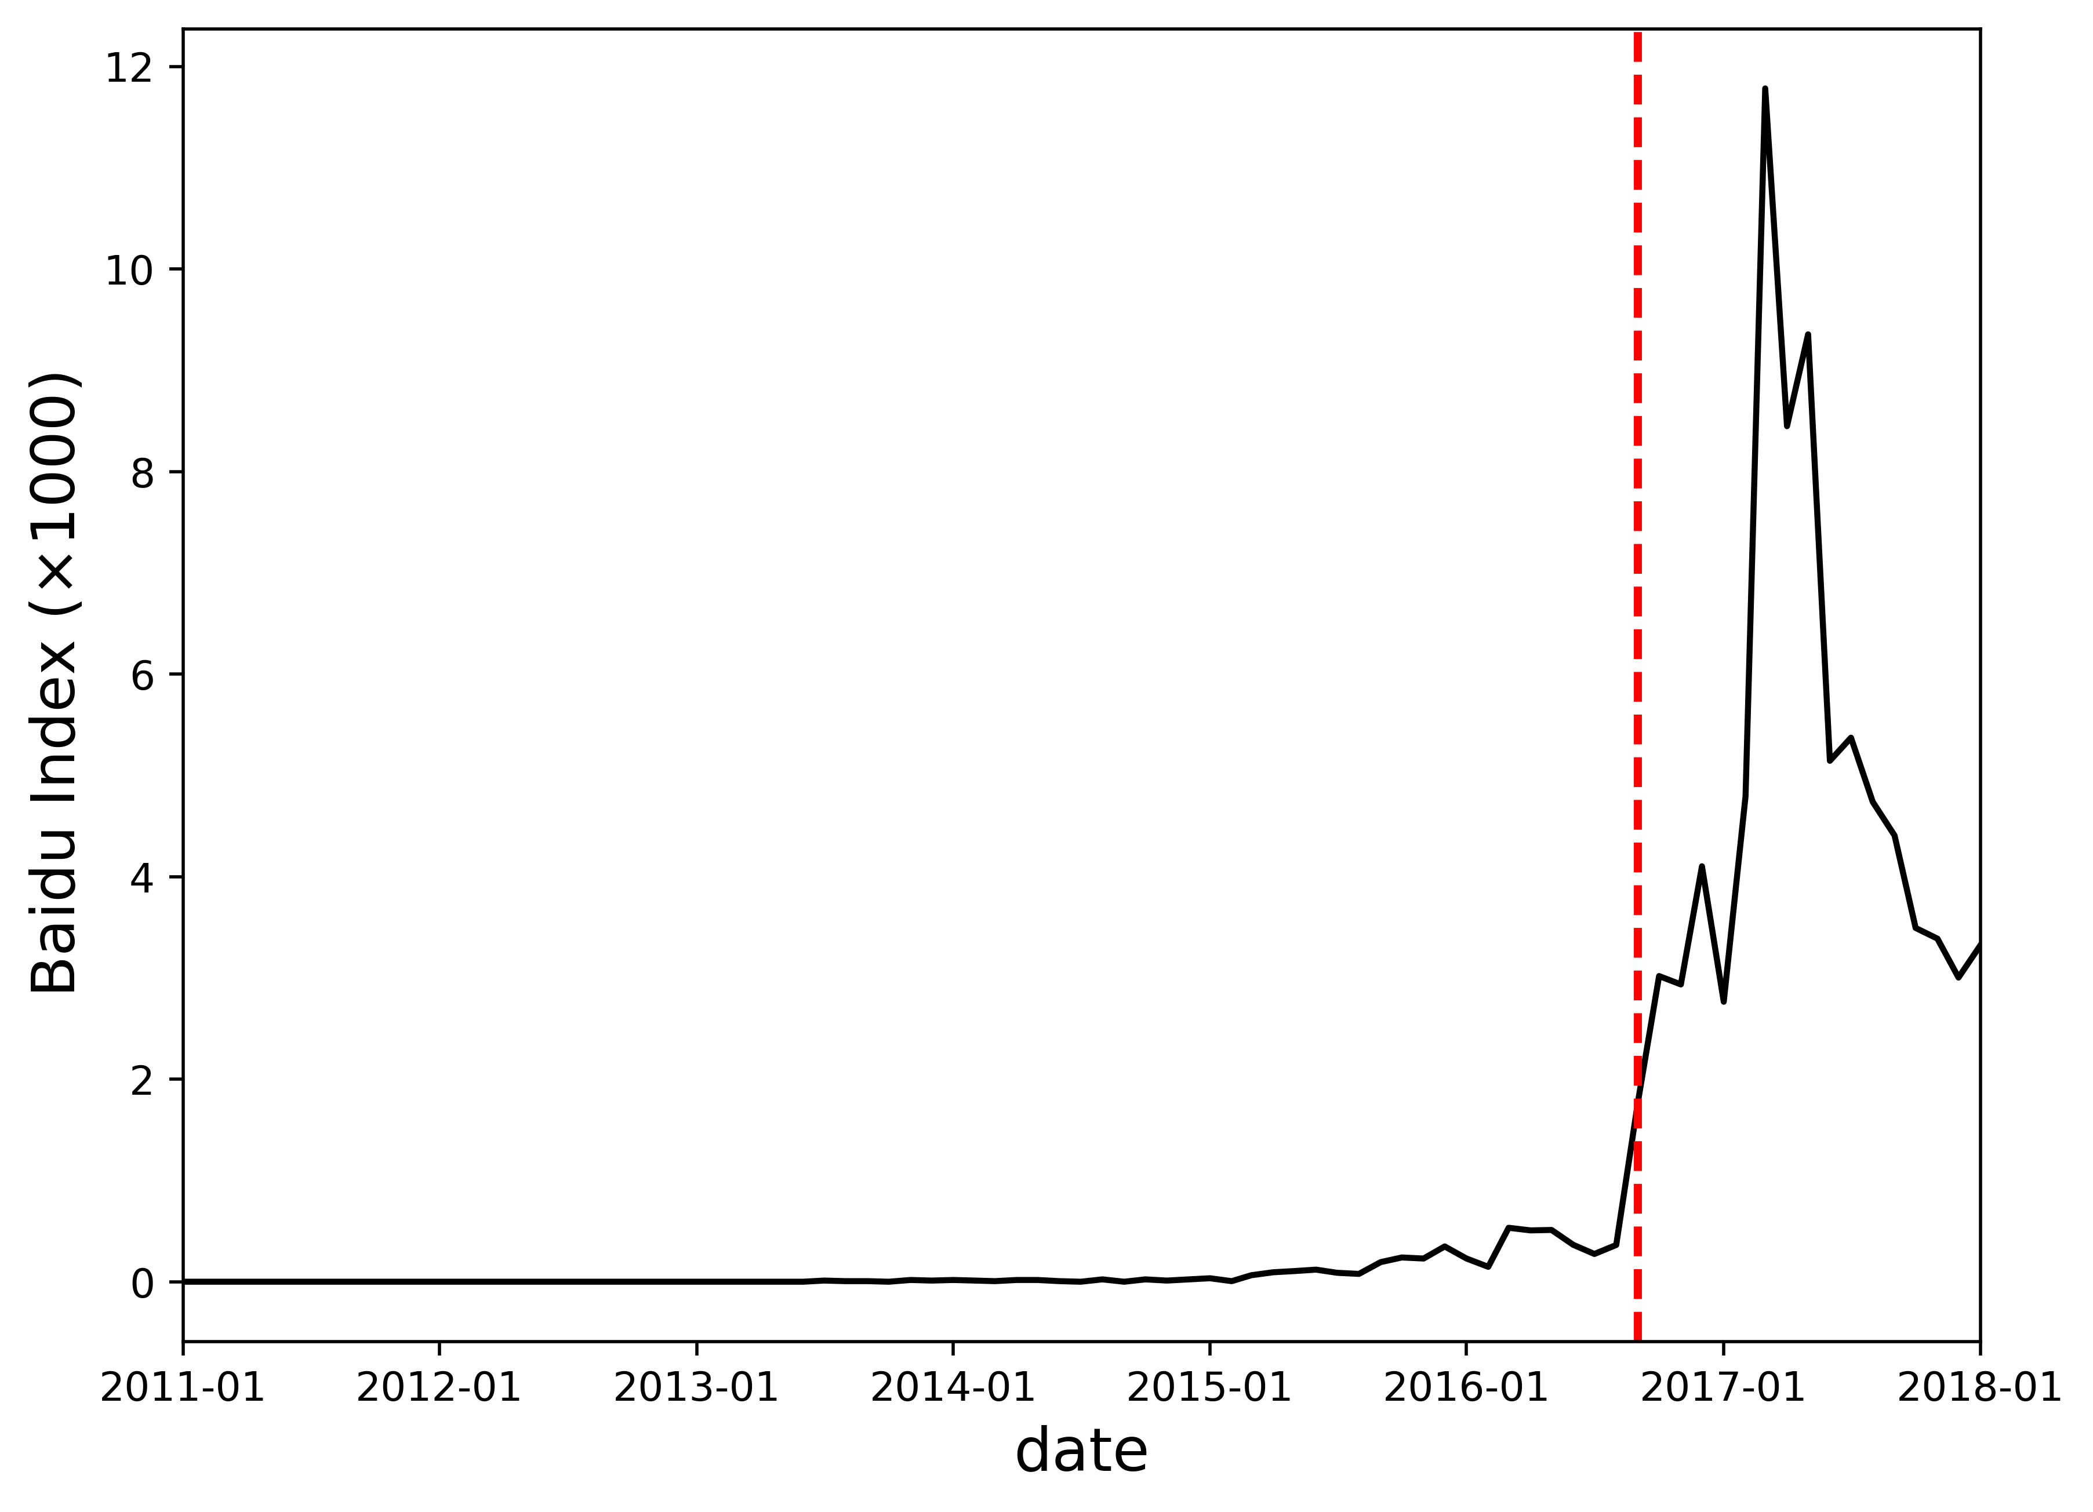
(e) Baidu Index of Mobike | (f) Baidu Index of Ofo
Figure 4. Baidu Index and entry date (red line) of different shared mobility services

The summary statistics are presented in Table 3. The top panel reports key variables for this study and the bottom panel introduces the control variables. In total, there are 262,028 observations, with an average total house price of 3.62 million CNY, an average size of 83.87 square meters and an average building age of 15.96 years. An average apartment has 2.05 bedrooms, 1.23 living rooms, 1 kitchen and 1.19 bathrooms. 39% of condominiums are equipped with elevators and 67% of apartments have been owned over 5 years by the sellers. The mean distance to nearest subway stations and city center are 0.83 km and 12.33 km, respectively. Figure 5 portrays the monthly apartment transaction volumes in Beijing throughout the investigated period, while the entry dates of different shared mobility services are marked and annotated.

Table 3
Descriptive statistics
Variable | Unit | Obs | Mean | Std. Dev. | Min | Max
Panel A: Key Variables
Log(price) | / | 262028 | 14.96 | .53 | 11.92 | 17.48
Price | 10,000CNY | 262028 | 361.61 | 221.92 | 15 | 3900
Unit price | CNY/m² | 262028 | 44635.8 | 21639.76 | 5008 | 150000
Distance to subway station | km | 262028 | .83 | .54 | .01 | 2.96
TNC entry | Indicator | 262028 | .76 | .43 | 0 | 1
BS entry | Indicator | 262028 | .22 | .41 | 0 | 1
Baidu Index of TNC | / | 262028 | 12.05 | 9.1 | 0 | 32.87
Baidu Index of DBS | / | 262028 | 1.85 | 3.58 | 0 | 15.99
Distance to city center | km | 262028 | 12.33 | 6.82 | .92 | 38.55
Number of stations within 3 km | Count | 262028 | 11.19 | 7.22 | 1 | 34
Interchange station | Indicator | 262028 | .16 | .37 | 0 | 1
Panel B: Control Variables
Size | m² | 262028 | 83.87 | 34.33 | 15 | 349.71
Building age | Year | 262028 | 15.96 | 8.53 | 1 | 50
Bedroom | Count | 262028 | 2.05 | .73 | 1 | 6
Living room | Count | 262028 | 1.23 | .42 | 1 | 2
Kitchen | Count | 262028 | 1 | .05 | 1 | 2
Bathroom | Count | 262028 | 1.19 | .41 | 1 | 4
Building type | Indicator | 262028 | 2.29 | .86 | 1 | 3
Interior decoration | Indicator | 262028 | 2.64 | 1.3 | 1 | 4
Building structure | Indicator | 262028 | 2.19 | .96 | 1 | 3
Elevator ratio | / | 262028 | .39 | .18 | .01 | 2
Elevator | Indicator | 262028 | .56 | .5 | 0 | 1
5-year property | Indicator | 262028 | .67 | .47 | 0 | 1
Floor level | Indicator | 262028 | 3.1 | 1.1 | 1 | 5
Building height | Floor | 262028 | 13.15 | 7.78 | 1 | 57
Station ID | Indicator | 262028 | 101.77 | 70.73 | 1 | 303
Year-month | Indicator | 262028 | 40.97 | 18.94 | 1 | 72
District ID | Indicator | 262028 | 6.7 | 2.79 | 1 | 13
Complex ID | Indicator | 262028 | 1153.18 | 815.27 | 1 | 3626

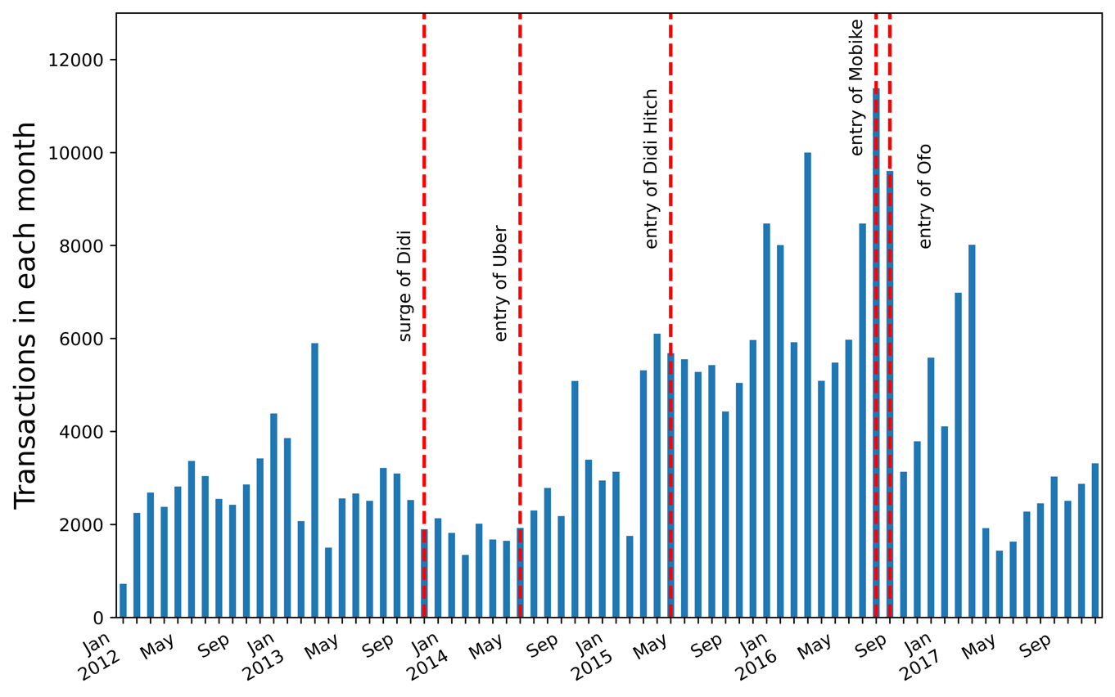
Figure 5. Monthly secondary-hand apartment sales volume

4. Method
To estimate the housing price gradients of subway station accessibility, we develop a hedonic price model (Rosen, 1974), which is a commonly used approach to estimate the implicit prices of a set of housing attributes, e.g., unit-specific attributes and surrounding amenities. Interactions between distance to subway and indicators of the entry of different shared mobility services are employed to capture the effect of shared mobility services on subway housing gradient.

$${log(Price}_{i})=β_{0}+β_{1}{Dist_sub}_{i}+β_{2}{Dist_sub}_{i}×{TNC}_{t}+β_{3}{Dist_sub}_{i}×{DBS}_{t}+{βX}_{i}+γ_{s}+δ_{d}+θ_{ym}+ε_{i}$$ | (1)

In this hedonic model specification, $i$ and $t$ represent apartment and time respectively; the dependent variable${log(Price}_{i})$ is the ﻿logarithm-transformed total price of apartment $i$; ${Dist_sub}_{i}$ is the distance of apartment $i$ to the closest subway station; ${TNC}_{t}$ is an indicator of the entry of transportation network companies in Beijing at time $t$; ${DBS}_{t}$ is an indicator of the entry of dockless bikesharing in Beijing at time $t$; $X_{i}$ is a vector of apartment $i$’s characteristics, including apartment size, distance to city center, building age, number of bedrooms, number of living rooms, number of kitchens, number of bathrooms, building type, interior decoration, building structure, elevator ratio, elevator, 5-year property, floor level and building height;$γ_{s}$, $δ_{d}$ and $θ_{ym}$ are subway station, administrative district and year-month fixed effects respectively.
Particularly, subway station fixed effects control for neighborhood conditions which affect the variations in the use of shared mobility services. In addition, condominium units located within 3-km vicinity of a subway station are homogenous regarding location-specific factors e.g., school quality, proximity to POIs. Thus, these variables become insignificant and can be excluded in the model. Administrative district and year-month fixed effects capture district-specific circumstances and city-level policies which might affect housing market or shared mobility services.
$β_{2}$ and $β_{3}$ measure the change in the price gradient of subway accessibility after the entry of TNCs and dockless bikesharing firms respectively. As previously discussed, if shared mobility services are substitutes for public transport, i.e., subway, we expect $β_{2}$ and $β_{3}$ to be negative. In contrast, if shared mobility services mainly contribute to solving the “last-mile problem” and hence perform as complements to public transport, we expect $β_{2}$ and $β_{3}$ to be positive.
To take account of the gradual penetration of shared mobility services, we exploit Baidu search index of TNC and dockless bikesharing service (DBS) as a proxy for the market penetration of respective treatment, and develop a regression model as:

$${log(Price}_{i})=β_{0}^{'}+{β_{1}^{'}Dist_sub}_{i}+β_{2}^{'}{Dist_sub}_{i}×{TNC_index}_{t}×{TNC}_{t}+β_{3}^{'}{Dist_sub}_{i}×{DBS_index}_{t}×{DBS}_{t}+{βX}_{i}+γ_{s}+δ_{d}+θ_{ym}+ε_{i}$$ | (2)

where ${TNC_index}_{t}$ represents the Baidu search index of TNC at time $t$, ${DBS_index}_{t}$ denotes the Baidu search index of DBS at time $t$. Other variables are the same as specified in model (1). $β_{2}^{'}$ and $β_{3}^{'}$ reflect the change in consumers’ willingness to pay for subway proximity with the market penetration of TNC and dockless bikesharing respectively. Negative $β_{2}^{'}$ and $β_{3}^{'}$ imply that the corresponding shared mobility service exert more significant substitutive impact on subway housing gradient as it penetrates, whereas positive $β_{2}^{'}$ and $β_{3}^{'}$ reveal stronger complementary effect is associated with the expansion of respective shared mobility service.

5. Empirical Results

5.1 Main result
Model (1) is estimated by OLS with robust standard errors clustered by individual apartment and the estimated coefficients are reported in Table 4. Around 90% of the price variations of resale housing unit can be explained by this model. The coefficients on distance to subway station are all negative and stable across columns, which confirms that the subway proximity has been capitalized into housing prices in Beijing. Column (1) and Column (2) present the estimates of average effect of TNC and dockless bikesharing on subway housing gradient respectively. The coefficient on Distance to subway × TNC entry is negative (-0.0126, p<0.01), which indicates the prevalence of TNC decreases the price of housing unit near subway station. Contrarily, the positive coefficient of Distance to subway × DBS entry (0.0261, p<0.01) implies an increase in price of an identical apartment is associated with the entry of dockless bikesharing service (DBS). Column (3) is the baseline analysis combining the interaction terms of both shared mobility services with distance to subway. On average, the entry of TNC diminishes the prices of housing units located 1 km away from subway station by 1.32%. This can also be interpreted as the enhancement of subway house price gradient by 1.32 percentage points or 82.5% (0.0132/0.016) every km from the subway station. The subsequent entry of dockless bikesharing escalates the prices of apartments within 1 km range of subway by 2.51%, which leads to a decline of the subway proximity gradient by 2.51 percentage points or 86.0% (0.0251/(0.016+0.0132)). For an average apartment priced at 3.62 million CNY in total and 44,636 CNY per square meter, the estimated total and unit price adjustments caused by TNC and dockless bikesharing at different subway-vicinity zones are calculated and exhibited in Table 5. For an average apartment 1 km away from subway station, the TNC resulted total price reduction is equivalent to 47,784 CNY, while the rise in total price accruing to the prevalence of dockless bikesharing is 90,862 CNY. As the distance increases to 2 km, the TNC induced decline is improved to 95,568 CNY and dockless bikesharing related increment is boosted to 181,724 CNY. An even larger TNC induced decrease of 143,352 CNY and dockless bikesharing related rise of 272,586 CNY are linked to an average apartment 3 km away from subway station.
The results in Column (4) and Column (5) where we extend the study area to zones within 4 km and 5 km from subway stations are in line with the benchmark estimation. The magnitude of the coefficient on Distance to subway × DBS entry shrinks as distance from subway stops increases, which implies a smaller influence of DBS on subway house price gradient. It is consistent with prior research evidence that dockless bikesharing services complement subway trip in a relatively short commuting distance (Guo and He, 2020). Column (6) reports that the ﻿parameter estimates with standard errors clustered by housing complex are statistically the same as those estimated with standard errors clustered by individual apartment. Based on the results presented in Table 4, we can infer that the dominating effect linked to the entry of TNC is substitution effect rather than complementation effect. This effect reduces the price of apartments in the vicinity subway stations and leads to a steeper house price gradient. Nevertheless, the succeeding popularity of dockless bikesharing service turnovers the situation by escalating the apartment prices near subway stations and flattening house price gradient, since dockless bikesharing service is a complement to instead of a substitute for subway service.

Table 4
Effects of shared mobility services on subway house price gradient
 | (1) | (2) | (3) | (4) | (5) | (6)
VARIABLES | TNC entry  Within 3 km | DBS entry  Within 3 km | Baseline Within 3 km | Baseline Within 4 km | Baseline Within 5 km | Cluster SE by complex
Distance to subway | -.0136*** | -.0284*** | -.016*** | -.0124*** | -.0174*** | -.016*
 | (.0015) | (.0011) | (.0015) | (.0013) | (.0013) | (.0091)
Distance to subway | -.0126*** |  | -.0132*** | -.011*** | -.004*** | -.0132**
$×$TNC entry | (.0015) |  | (.0016) | (.0014) | (.0013) | (.0060)
Distance to subway |  | .0261*** | .0251*** | .0249*** | .0208*** | .0251***
$×D$BS entry |  | (.0015) | (.0015) | (.0013) | (.0012) | (.0039)
_cons | 14.11*** | 14.35*** | 14.23*** | 14.24*** | 14.24*** | 14.23***
 | (.0129) | (.0130) | (.0113) | (.0113) | (.0112) | (.0285)
Observations | 204,547 | 198,768 | 262,028 | 265,354 | 267,252 | 262,028
Adjusted R² | .885 | .893 | .901 | .901 | .901 | .901
Control variables | Yes | Yes | Yes | Yes | Yes | Yes
Station-fixed effect | Yes | Yes | Yes | Yes | Yes | Yes
Year-month-fixed effect | Yes | Yes | Yes | Yes | Yes | Yes
District-fixed effect | Yes | Yes | Yes | Yes | Yes | Yes
Notes: The dependent variable of all columns is the logarithm of total price. Control variables are apartment attributes indicated in Table 1. TNC entry is an indicator for the entry of Didi and $D$BS entry is an indicator for the entry of Mobike. Column (1) is estimated based on transactions completed from Jan 2012-Aug 2016 before the entry of dockless bikesharing firms; Column (2) is estimated based on transactions completed from Jan 2014--Dec 2017 after the entry of transportation network companies; Column (3)-(6) are based on apartments transacted from Jan 2012-Dec 2017. Apartments within 3 km reach of subway station are used in Column (1)-(3) and Column (6); apartments within 4 km and 5 km radius are used in Column (4) and Column (5) respectively. Standard errors are clustered by individual apartment in Column (1)-(5); standard errors are clustered by residential complex in column (6).
*** p<.01, ** p<.05, * p<.1; robust standard errors are in parentheses.

Table 5
House price adjustments associated with the presence of TNC and dockless bikesharing service
Shared Mobility Services | 1 km away from subway station | 2 km away from subway station | 3 km away from subway station
Panel A: Total price
Transport Network Companies | - 47,784 CNY | - 95,568 CNY | - 143,352 CNY
Dockless Bikesharing | + 90,862 CNY | + 181,724 CNY | + 272,586 CNY
Panel B: Unit price
Transport Network Companies | - 589 CNY/m² | - 1,178 CNY/m² | - 1,767 CNY/m²
Dockless Bikesharing | + 1,120 CNY/m² | + 2,240 CNY/m² | + 3,360 CNY/m²
Notes: The monetary price adjustments are calculated based on the estimated coefficients on Distance to subway ×TNC entry and Distance to subway ×DBS entry in column (3) of Table 4.

To further investigate the dynamic effect of share mobility services on subway house price gradient over time, we add interaction terms of distance to subway stations and month dummies to the baseline model specification. A nonlinear price adjustment process linked to multiple TNC services is observed and ﻿visualized on Figure 6. We have not identified a significant change in subway proximity house gradient immediately after Didi, the first TNC in Beijing, starts to prevail. The coefficient on the investigated interaction term of distance to subway station with time dummy shows a negative sign and its size is enlarged as TNCs penetrate, especially after the introduction of Didi Hitch, a dynamic ridesharing program, in June 2015. This indicates intensified substitution effect pertains to the gradual expansion of TNCs, notably after the launch of ridesharing service. The magnitude of the coefficient shrinks shortly before the entry of dockless bikesharing firms. Meanwhile, the temporally heterogeneous effect exerted by Mobike and Ofo on subway house price gradient is reported on Figure 7. The sign of the coefficient turns positive after the emergence of dynamic dockless bikesharing service. Based on this shift, we infer that the complementation effect of dockless bikesharing service overwhelms the substitution effect of TNC service and hence flattens the housing price gradient.
Figure 6. Temporally heterogeneous effects of TNC on subway housing price gradient
Notes: This figure plots the coefficients on the interaction terms of distance to subway station with month dummies after the entry of transportation network companies and before the presence of dockless bikesharing, controlling for apartment characteristics as well as fixed effects in the baseline regression model. The vertical red dotted lines indicate the time points when Didi, Uber and ridesharing service of Didi started the operation in Beijing respectively. It displays the dynamic effects of transportation network companies on subway house price gradient. It is estimated based on transactions completed from Jan 2012--Aug 2016 before the entry of dockless bikesharing. The magnitude of the coefficient indicates the net effect of transportation network companies on subway housing price gradient. Bars represent 95% confidential intervals.

Figure 7. Temporally heterogeneous effects of DBS on subway housing price gradient
Notes: This figure plots the coefficients on the interaction terms of distance to subway station with month dummies after the entry of dockness bikesharing firms, controlling for apartment characteristics as well as fixed effects in the baseline regression model. The vertical red dotted lines indicate the time point when Mobike and Ofo started the operation in Beijing respectively. It displays the dynamic effects of of dockness bikesharing services on subway house price gradient. It is estimated based on transactions completed from Jan 2014--Dec 2017 after the entry of transportation network companies. The magnitude of the coefficient indicates the net effect of dockness bikesharing services on subway housing price gradient. Bars represent 95% confidential intervals.

To explore the spatial heterogeneity of shared mobility services on subway housing gradient at different subway distance segments, we categorize the condominium units into 3 subgroups according to the distance to subway station: within 1 km, from 1 km to 2 km and from 2 km to 3 km. Each group is indicated by a dummy measure to identify the effect differentiations across properties with different subway access. As portrayed in Figure 8, the coefficient on distance to subway station interacting with TNC dummy is significantly positive for properties within 1 km vicinity of subway stations, but is significantly negative for comparable properties at 1 km-2 km proximity buffer and 2 km-3 km proximity buffer. It depicts a more precise image on the influence exerted by TNC, which serves a complement to subway travel in locations within 1 km reach from subway station, whilst substituting for public transit for those with distance between 1 km and 3 km. In other words, we can infer a trend that a significant number of commuters switch from using a combined mode of ridesourcing service and public transit to directly hailing an on-demand ride for travelling to the destination, as the distance from home to subway station increases. It is also found that, the coefficient on distance to subway station interacting with DBS dummy is significantly positive for properties from all distance subgroups, suggesting that dockless bikesharing services consistently complement public transit for households residing in subway proximity areas, i.e., within 3 km radius.

Figure 8. Spatially heterogeneous effect of shared mobility services on subway housing price gradient
Notes: This figure plots the coefficients on distance to subway station interacting with TNC/DBS dummy and distance subgroup indicators (0-1 km, 1-2 km, 2-3 km), controlling for apartment characteristics as well as fixed effects in the benchmark regression model. It depicts the heterogeneous effects of shared mobility services on subway housing gradient at different subway distance segments. Bars represent 95% confidential intervals.

In Table 6, a robustness check is conducted with Baidu search index as a proxy for the market ﻿penetration of TNC and dockless bikesharing service. In column (1) and (2), the original interactive terms of distance to subway and indicators of the entry of shared mobility services further interact with the search index of TNC and dockless bikesharing service respectively to capture the differentiations arising from the change of ﻿penetration rates. The results maintain the same sign as the estimates in benchmark specification. As presented in column (1), a 10-units enhancement in the search index of TNC is linked with a decrease in subway house price gradient by 0.8 percentage point, whereas a rise of 1.9 percentage point is induced by the same change of dockless bikesharing service’s search index. In column (3)-(6), we replace the continuous measures with the dummy measures indicating the level of search index, i.e., above median and below median. The results are analogous to the those estimated in column (1) and (2) using continuous measure. The significance of estimated parameters is consistent when standard errors are clustered by residential complex, as indicated in column (2) and (6).

Table 6
Effects of market penetration of shared mobility services on subway house price gradient
 |  |  |  | Log(Price)
VARIABLES | (1) |  | (2) | (3) | (4) | (5) | (6)
VARIABLES | Continuous  TNC& DBS  penetration  (Apartment) |  | Continuous  TNC& DBS  penetration  (Complex) | Dummy TNC penetration  (Apartment) | Dummy  DBS penetration  (Apartment) | Dummy  TNC& DBS  penetration  (Apartment) | Dummy  TNC& DBS  penetration  (Complex)
Distance to subway | -.0143*** |  | -.0143* | -.0135*** | -.0284*** | -.0159*** | -.0159*
 | (.0013) |  | (.0087) | (.0015) | (.0011) | (.0015) | (.0091)
TNC index $×$ | -.0008*** |  | -.0008***
Distance to subway$×$ TNC entry | (.0001) |  | (.0003)
DBS index $×$ | .0019*** |  | .0019***
Distance to subway $×$DBS entry | (.0002) |  | (.0005)
Below median TNC index $×$ |  |  |  | -.0047** |  | -.0052*** | -.0052
Distance to subway $×$TNC entry |  |  |  | (.0018) |  | (.0018) | (.0048)
Above median TNC index $×$ |  |  |  | -.0174*** |  | -.0179*** | -.0179**
Distance to subway $×$TNC entry |  |  |  | (.0017) |  | (.0017) | (.0070)
Below median DBS index $×$ |  |  |  |  | .024*** | .018*** | .018***
Distance to subway$×$BS entry |  |  |  |  | (.0020) | (.0021) | (.0045)
Above median DBS index $×$ |  |  |  |  | .0282*** | .0193*** | .0193***
Distance to subway$×$BS entry |  |  |  |  | (.0019) | (.0022) | (.0050)
_cons | 14.23*** |  | 14.23*** | 14.11*** | 14.35*** | 14.23*** | 14.23***
 | (.0114) |  | (.0285) | (.0129) | (.0130) | (.0114) | (.0285)
Observations | 262,028 |  | 262,028 | 204,547 | 198,768 | 262,028 | 262,028
Adjusted R² | .901 |  | .901 | .885 | .893 | .901 | .901
Control variables | Yes |  | Yes | Yes | Yes | Yes | Yes
Station-fixed effect | Yes |  | Yes | Yes | Yes | Yes | Yes
Year-month-fixed effect | Yes |  | Yes | Yes | Yes | Yes | Yes
District-fixed effect | Yes |  | Yes | Yes | Yes | Yes | Yes
Notes: The dependent variable of all columns is the logarithm of total price. Control variables are apartment attributes indicated in Table 1. TNC entry is an indicator for the entry of Didi and $D$BS entry is an indicator for the entry of Mobike. TNC index and DBS index are continuous Baidu search index of TNC and dockless bikesharing service on the day when the apartment is transacted. Below median TNC index is a dummy indicating the TNC index is below median on the day the apartment is sold. Above median TNC index is a dummy indicating the TNC index is above median. Below median DBS index is a dummy indicating the DBS index is below median. Above median DBS index is a dummy indicating the DBS index is above median. Column (3) is estimated based on transactions completed from Jan 2012-Aug 2016 before the entry of dockless bikesharing service; Column (4) is the estimated based on transactions completed from Jan 2014--Dec 2017 after the entry of transportation network companies; Column (1), (2), (5) and (6) are based on apartments transacted from Jan 2012-Dec 2017. Apartments within 3 km reach of subway station are used in all regressions. Standard errors are clustered by individual apartment in regression (1), (3), (4) and (5); standard errors are clustered by residential complex in regression (2) and (6).
*** p<.01, ** p<.05, * p<.1; robust standard errors are in parentheses.

Moreover, the housing price gradient will be affected by the improvement in subway networks associated with the opening of new subway lines. To address this concern, we limit the time windows for examining the effects of TNC service and dockless bikesharing to periods without new subway stations opening in Beijing. On account of the fact that several subway stations came into use shortly before the surge of Didi, we limit the study period to a time span with no other new subway stations except for those opening one month prior to the surge of Didi. We have excluded apartments within 3-km buffer of the new subway stations to rule out the effects arising from new subway lines. The estimates using the subsamples are presented in column (1), (3) and (5) of Table 7, which capture the net influence of TNCs, ridesharing service and dockless bikesharing service respectively. Though year-month fixed effects have been included in the baseline model for capturing the influence of time variant confounders at city level, to further rule out the effects from unobserved factors at community level, we narrow the time window to 3 months before and after the entry of ridesharing in column (4) of Table 7 and 3 months before and after the entry of dockless bikesharing in column (6) of Table 7. Since the time span between the surge of two leading TNCs, i.e., Didi and Uber, is 6 months, the time window for examining the impacts of TNC service is 3 months before Didi surge and 3 months after Uber entry in column (2) of Table 7. The estimated coefficients are all consistent with the results estimated in the baseline model.

Table 7
Robustness checks by excluding new subway stations and narrowing time window
VARIABLES | (1) | (2) | (3) | (4) | (5) | (6)
VARIABLES | TNC  Jun 2013-  Nov 2014 | TNC  Oct 2013-  Sep 2014 | Ridesharing  Jan 2015-  Nov 2015 | Ridesharing Mar 2015-  Aug 2015 | DBS  Jan 2016-  Nov 2016 | DBS  Jun 2016-  Nov 2016
Distance to subway | -.0126*** | -.0108** | -.0201*** | -.0198*** | -.0234*** | -.0214***
 | (.0030) | (.0051) | (.0026) | (.0030) | (.0019) | (.0026)
Distance to subway | -.0075** | -.0093*
$×$TNC entry | (.0030) | (.0048)
Distance to subway |  |  | -.0127*** | -.0086***
$×$RS entry |  |  | (.0027) | (.0033)
Distance to subway |  |  |  |  | .028*** | .0186***
$×D$BS entry |  |  |  |  | (.0031) | (.0033)
_cons | 14.06*** | 14.09*** | 14.17*** | 14.13*** | 14.42*** | 14.55***
 | (.0233) | (.0346) | (.0256) | (.0375) | (.0239) | (.0292)
Observations | 35,742 | 19,592 | 50,109 | 31,236 | 70,341 | 38,369
Adjusted R2 | .867 | .864 | .880 | .882 | .879 | .875
Control variables | Yes | Yes | Yes | Yes | Yes | Yes
Station-fixed effect | Yes | Yes | Yes | Yes | Yes | Yes
Year-month-fixed effect | Yes | Yes | Yes | Yes | Yes | Yes
District-fixed effect | Yes | Yes | Yes | Yes | Yes | Yes
Notes: The dependent variable of all columns is the logarithm of total price. Control variables are apartment attributes indicated in Table 1. TNC entry is an indicator for the entry of Didi. RS entry is an indicator for the entry of Didi Hatch. $D$BS entry is an indicator for the entry of Mobike﻿﻿. Column (1) limits to an 18-month time window and excludes apartments within 3-km radius of new subway stations. Column (3) and Column (5) limit to periods with no new subway stations opening in Beijing. Column (2) limits to apartments transacted 3 months before the entry of Didi and 3 months after the presence of Uber. Apartments within 3-km buffer of new subways stations are excluded in Column (2). ﻿ ﻿Column (4) limits to apartments transacted 3 months before and after the presence of ridesharing service of Didi. ﻿Column (6) limits to apartments transacted 3 months before and after the entry of Mobike. Standard errors are clustered by individual apartment.
*** p<.01, ** p<.05, * p<.1; robust standard errors are in parentheses.

5.2 Heterogeneity arising from commuting conditions and property subgroups
In this subsection, we explore the heterogeneity in the effect of different share mobility services on subway housing gradient behind the average impact. Table 8 reports the spatial variations in treatment effects of TNC and dockless bikesharing service with respect to proximity to an interchange station, distance from city center and number of stations within 3 km reach. The estimation in column (1) suggests that both effects on housing units in the vicinity of interchange stations are attenuated compared with properties proximate to non-interchange stations. The impact of TNC on subway housing gradient drops by 0.79 percentage point or 59.8% (0.0079/0.0132), while that of dockless bikesharing service shrinks by 1.68 percentage point or 66.9% (0.0168/0.0251). Additionally, the estimated coefficients in column (2) and (3) indicate that the house price discount associated with TNC and appreciation linked to dockless bikesharing service are fully captured by the terms: Distance to city center is above median × Distance to subway× TNC (DBS) entry and Number of stations within 3 km is below median × Distance to subway× TNC (DBS) entry. This observation implies that the substitution effect of TNC and complementary effect of dockless bikesharing service only apply to apartments far away from city center (above 12.33 km) or with low density of stations ﻿in the adjacent area within 3-km radius (below 12). Our results reveal that both TNC and dockless bikesharing service exert a greater and more significant impact on properties located in neighborhoods with relatively worse commuting conditions, i.e., in the proximity of a non-interchange station, at a long distance from city center and with a low density of station within 3 km reach.

Table 8
Heterogeneous effects and moderators
VARIABLES | (1) | (2) | (3)
VARIABLES | Interchange station | Distance to Tian An Men Square | Number of stations within 3 km
Distance to subway | -.0162*** | -.0184*** | -.0183***
 | (.0015) | (.0015) | (.0015)
Distance to subway$×$TNC entry | -.0132*** | .0069*** | .0071***
 | (.0016) | (.0022) | (.0025)
Is a interchange station  $×$Distance to subway$×$TNC entry | .0079***  (.0026)
Distance to city center is above median  $×$ Distance to subway$×$ TNC entry |  | -.0207***  (.0015)
Number of stations within 3 km is below median  $×$Distance to subway$×$TNC entry |  |  | -.0189***  (.0018)
Distance to subway$×$DBS entry | .0251*** | -.0008 | -.007**
 | (.0015) | (.0026) | (.0031)
Is a interchange station  $×$Distance to subway$×$ DBS entry | -.0168***  (.0030)
Distance to city center is above median  $×$ Distance to subway$×$ DBS entry |  | .0262***  (.0020)
Number of stations within 3 km is below median  $×$Distance to subway$×$TNC entry |  |  | .0296***  (.0024)
_cons | 14.23*** | 14.23*** | 14.23***
 | (.0114) | (.0114) | (.0114)
Observations | 262,028 | 262,028 | 262,028
Adjusted R² | 0.901 | 0.901 | 0.901
Control variables | Yes | Yes | Yes
Station-fixed effect | Yes | Yes | Yes
Year-month-fixed effect | Yes | Yes | Yes
District-fixed effect | Yes | Yes | Yes
Notes: The dependent variable of all columns is the logarithm of total price. Control variables are apartment attributes indicated in Table 1. TNC entry is an indicator for the entry of Didi and $D$BS entry is an indicator for the entry of Mobike. Column (1)-(3) show how the effect is moderated by whether the nearest station is a interchange station, whether the distance to city center is above median and whether the number of stations within 3 km is below median correspondingly. All the estimations are based on apartments within 3 km reach of subway station and transacted from Jan 2012-Dec 2017. Standard errors are clustered by individual apartment.
*** p<.01, ** p<.05, * p<.1; robust standard errors are in parentheses.

Table 9 and Table 10 demonstrate how the effects of TNC and dockless bikesharing service vary across different price quantiles using dummy measure and continuous measure of share mobility operation respectively. Table 9 reports a steady increment in the magnitude of the focal coefficient, i.e., coefficient on distance to subway station interacting with TNC/DBS indicators, as property prices increase. The result is of the same sign as the estimates in Table 4 and reveals an incremental effect of both TNC and dockless bikesharing service as total price of an apartment increase. This pattern persists in Table 10, where continuous measures of search index are added for robustness checks. It implies that the public transport substitution or complementation attributed to shared mobility services has a larger influence on housing units with higher total prices.

Table 9
Heterogeneous effects across price quantiles by entry
 | (1) | (2) | (3) | (4) | (5)
VARIABLES | 10% quantile | 25% quantile | 50% quantile | 75% quantile | 90% quantile
Distance to subway | -0.0227*** | -0.0206*** | -0.0229*** | -0.0215*** | -0.0156***
 | (0.0027) | (0.0020) | (0.0018) | (0.0018) | (0.0021)
Distance to subway | -0.00541* | -0.0129*** | -0.0106*** | -0.0155*** | -0.0205***
$×$TNC entry | (0.0031) | (0.0023) | (0.0021) | (0.0021) | (0.0025)
Distance to subway | 0.0123*** | 0.0178*** | 0.0219*** | 0.0269*** | 0.0313***
$×D$BS entry | (0.0030) | (0.0024) | (0.0019) | (0.0020) | (0.0027)
_cons | 13.17*** | 13.24*** | 13.36*** | 13.54*** | 13.66***
 | (0.0338) | (0.0162) | (0.0159) | (0.0148) | (0.0223)
Observations | 262,028 | 262,028 | 262,028 | 262,028 | 262,028
Adjusted R² | 0.839 | 0.844 | 0.846 | 0.844 | 0.839
Control variables | Yes | Yes | Yes | Yes | Yes
Station-fixed effect | Yes | Yes | Yes | Yes | Yes
Year-month-fixed effect | Yes | Yes | Yes | Yes | Yes
District-fixed effect | Yes | Yes | Yes | Yes | Yes
Notes: The dependent variable of all columns is the logarithm of total price. Control variables are apartment attributes indicated in Table 1. TNC entry is an indicator for the entry of Didi and $D$BS entry is an indicator for the entry of Mobike. Column (1)-(5) present the estimation at 10%, 25%,50%,75% and 90% quantile respectively. All the estimations are based on apartments within 3 km reach of subway station and transacted from Jan 2012-Dec 2017. Standard errors are clustered by individual apartment.
*** p<.01, ** p<.05, * p<.1; robust standard errors are in parentheses.

Table 10
Heterogeneous effects across price quantiles by penetration
 | (1) | (2) | (3) | (4) | (5)
VARIABLES | 10% quantile | 25% quantile | 50% quantile | 75% quantile | 90% quantile
Distance to subway | -0.0211*** | -0.0205*** | -0.0209*** | -0.0215*** | -0.0186***
 | (0.0022) | (0.0018) | (0.0016) | (0.0015) | (0.0020)
Distance to subway$×$ | -0.0005*** | -0.0007*** | -0.0007*** | -0.0008*** | -0.0008***
TNC index$×$TNC entry | (0.0001) | (0.0001) | (0.0001) | (0.0001) | (0.0001)
Distance to subway$×$ | 0.0016*** | 0.0016*** | 0.0019*** | 0.0023*** | 0.0026***
DBS index$×$DBS entry | (0.0003) | (0.0002) | (0.0002) | (0.0002) | (0.0003)
_cons | 13.17*** | 13.24*** | 13.36*** | 13.55*** | 13.66***
 | (0.0436) | (0.0176) | (0.0148) | (0.0150) | (0.0265)
Observations | 262,028 | 262,028 | 262,028 | 262,028 | 262,028
Adjusted R² | 0.839 | 0.844 | 0.846 | 0.844 | 0.839
Control variables | Yes | Yes | Yes | Yes | Yes
Station-fixed effect | Yes | Yes | Yes | Yes | Yes
Year-month-fixed effect | Yes | Yes | Yes | Yes | Yes
District-fixed effect | Yes | Yes | Yes | Yes | Yes
Notes: The dependent variable of column is the logarithm of total price. Control variables are apartment attributes as indicated in Table 1. TNC entry is an indicator for the entry of Didi and $D$BS entry is an indicator for the entry of Mobike. TNC index and DBS index are the continuous Baidu search index of TNC and dockless bikesharing service on the day when the apartment is transacted. Column (1)-(5) present the estimation at 10%, 25%,50%,75% and 90% quantile respectively. All the estimations are based on apartments within 3 km reach of subway station and transacted from Jan 2012-Dec 2017. Standard errors are clustered by individual apartment.
*** p<.01, ** p<.05, * p<.1; robust standard errors are in parentheses.

6. Conclusion
﻿The advanced wireless communication technologies have contributed to a rapid market expansion of shared mobility services, including TNC service (e.g., Uber, Lyft, Didi) and dockless bikesharing service (e.g., Mobike and Ofo). While shared mobility services have attained prominent progress in business and extremely affected people’s travel mode, their emergence in cities has induced intense debates on their impacts on public transit use, traffic congestion and other environmental issues. In addition, the prevalence of mobility services might exert an impact on real estate market through the influence on people’s commuting mode. Shared mobility services, such as ridesourcing and bikesharing, may serve as either a complement to or a substitute for public transit, hence the consequent aggregate effects on real estate market are still unclear. This study intends to fill this research gap by examining the aggregate impacts of two typical types of shared mobility services, TNC service and dockless bikesharing service, on market prices of condominium properties with heterogeneous accessibility to subway stations. This study makes one of the first attempts to investigate the synergetic relationship between different shared mobility services and the capitalization of subway proximity.
Based on a comprehensive dataset comprising of over 200,000 apartment resale records in more than 3,600 apartment complexes of Beijing from 2012 to 2017, we develop a hedonic price model for empirical analysis. On average, the boom of TNCs escalates house price gradient by 1.32 percentage points and elevates subway proximity house gradient by 82.5% (0.0132/0.016) per kilometer from the subway station. It can be interpreted as a 1.32% decline in the prices of condo units 1 km away from the nearest subway station. The subsequent emergence of dockless bikesharing service flattens house price gradient by 2.51 percentage points and depressed subway proximity house gradient by 86.0% (0.0251/(0.016+0.0132)). In other words, dockless bikesharing service enhances the prices of apartments with 1 km distance from subway by 2.51%. For an average apartment of 3.62 million CNY with 1 km away from subway station, the house price drop pertaining to TNC is equivalent to 47,784 CNY, whereas dockless bikesharing resulted house price appreciation is 90,862 CNY. The magnitude of price adjustment is larger for apartments with longer distance from subway station. As discussed in Introduction, the results indicate that the entrance of TNCs has stronger substitution effect than complementary effect on subway use, while the subsequent surge of dockless bikesharing service majorly acts as a feeder to subway, and the complementation effect of dockless bikesharing service counteracts and even overwhelms the substitution effect caused by TNC.
By examining the dynamic responses of housing market, we can infer an incremental impact of TNCs and a comparatively stable effect of dockless bikesharing service over time. A further analysis suggests that TNC service serves as a complement to subway within 1 km reach from subway station, while substituting for subway travel at distance between 1 km and 3 km. In the meantime, the complementary effect of dockless bikesharing service persists within 3 km radius of subway station. This pattern is robust when we add Baidu search index in the baseline model specification as a proxy for the market penetration of TNC service or dockless bikesharing service. We find that a 10-units increase in the search index of TNCs is associated with a 0.8 percentage point enhancement in subway house price gradient and a 1.9 percentage point reduction is resulted by the same change of the search index of dockless bikesharing service. The results are consistent when new subway stations are excluded and keep robust in a narrower time window. The results also reveal that both effects are heterogeneous across communities and are more salient in neighborhoods of relatively poor commuting networks, i.e., in the vicinity of a non-interchange station, at longer distance from city center and with smaller number of subway stations within 3 km reach. Moreover, we conclude that the public transit substitution or complementation arising from shared mobility services has greater influence on condo units of higher total prices.
The findings offer preliminary insights into the economic influence of emerging transportation modes, including TNCs and dockless bikesharing service, by demonstrating their impacts on widening or narrowing the price gap between condo units with difference distances to subway stops in a metropolitan city. Beyond facilitating the understanding of the effect of shared mobility services, this paper has implications for policymakers, share mobility companies and real estate developers. Given the empirical evidences that TNC service substitutes for public transit at community with poor subway accessibility and dockless bikesharing service complements public transit by solving the last mile problem in the vicinity of subway stations, the local governments may integrate share mobility services into the existing multimodal transport system and facilitate the cooperation between share mobility companies and public transit operators. This could help promote sustainable mobility, maximize economic gains associated with the rapid proliferation of shared mobility services, and optimize the distribution of such economic gains. Furthermore, on the basis of the fact that the impacts of shared mobility services have been captured into housing prices, real estate developers may devote to exploring how to make use of the exogenous technology shock in traffic industry, i.e., the proliferation of shared mobility, for boosting real estate values. Specifically, developers operating real estate properties distant from subway stations may pay TNC operators for enhanced service quality and discounted trip fares, while those holding properties in the proximity of subway stations may subsidize dockless bikesharing companies for increasing the supply of bikes around their residential complexes, and offering price discount to residents living in their apartments.
The variations of transport modes and residence preferences across cities might influence the synergy between shared mobility services and subway house gradient, thereby resulting in a different story from Beijing. More comprehensive research is needed to explore the heterogeneous impacts of shared mobility on subway proximity house gradient across cities. Additionally, this study infers the substitution and complementary effect of shared mobility services based on the apartment price adjustments stemming from the change of demand for condo units in the proximity of subway stations. For future study, more empirical analyses on the underlying mechanisms, particularly, the switch of household’s commuting mode choices and the shift of the public transit ridership after the entry of shared mobility services, would be highly worthwhile. Moreover, since TNC and dockless bikesharing trips are unevenly distributed in the spatial scale, it is of great interest to quantify the heterogenous effects of shared mobility trips on real estate value across regions within a city.

Acknowledgement
The authors wish to thank the editor-in-chief, guest editors and three anonymous reviewers, whose useful comments have improved the exposition of the paper.

References
﻿Alexander, L. P., and González, M. C., 2015. Assessing the impact of real-time ridesharing on urban traffic using mobile phone data. Proceedings of UrbComp, 15, 1–9.
Alonso, W., 1964. Location and land use. Harvard University Press.
Alonso-Mora, J., Samaranayake, S., Wallar, A., Frazzoli, E., and Rus, D., 2017. On-demand high-capacity ride-sharing via dynamic trip-vehicle assignment. Proceedings of the National Academy of Sciences, 114(3), 462–467.
Bajic, V., 1983. The effects of a new subway line on housing prices in metropolitan Toronto. Urban studies, 20(2), 147–158.
Cao G, Jin GZ, and Zhou L-A., 2018. Market expanding or market stealing? Platform competition in bike-sharing. NBER Working Paper No. 24938, National Bureau of Economic Research, Cambridge, MA.
Chen, X. M., Zheng, H., Ke, J., and Yang, H., 2020. Dynamic optimization strategies for on-demand ride services platform: Surge pricing, commission rate, and incentives. Transportation Research Part B: Methodological, 138, 23–45.
Chu, J., Duan, Y., Yang, X., and Wang, L., 2021. The last mile matters: Impact of dockless bikesharing on subway housing price premium. Management Science, 67(1), 297–316.
Coulson, N. E., and Engle, R. F., 1987. Transportation costs and the rent gradient. Journal of Urban Economics, 21(3), 287–297.
Debrezion, G., Pels, E., and Rietveld, P., 2007. The impact of railway stations on residential and commercial property value: a meta-analysis. The Journal of Real Estate Finance and Economics, 35(2), 161–180.
Dewees, D. N., 1976. The effect of a subway on residential property values in Toronto. Journal of Urban Economics, 3(4), 357–369.
Diao, M., Kong, H., and Zhao, J., 2021. Impacts of transportation network companies on urban mobility. Nature Sustainability, 1–7.
DMR, 2021a. https://expandedramblings.com/index.php/Didi-chuxing-facts-statistics/
DMR, 2021b. https://expandedramblings.com/index.php/Uber-statistics/
Duncan, M., 2011. The impact of transit-oriented development on housing prices in San Diego, CA. Urban studies, 48(1), 101–127.
Erhardt, G. D., Roy, S., Cooper, D., Sana, B., Chen, M., and Castiglione, J., 2019. Do transportation network companies decrease or increase congestion? Science advances, 5(5), eaau2670.
Fan, Y., and Zheng, S., 2020. Dockless bikesharing alleviates road congestion by complementing subway travel: evidence from Beijing. Cities, 107, 102895.
Gibbons, S., and Machin, S., 2005. Valuing rail access using transport innovations. Journal of urban Economics, 57(1), 148–169.
Guo, Y., & He, S. Y. (2020). Built environment effects on the integration of dockless bike-sharing and the metro. Transportation Research Part D: Transport and Environment, 83, 102335.
Hall, J. D., Palsson, C., and Price, J., 2018. Is Uber a substitute or complement for public transit?. Journal of Urban Economics, 108, 36–50.
Henao, A., and Marshall, W. E., 2019. The impact of ride-hailing on vehicle miles traveled. Transportation, 46(6), 2173–2194.
Kabra, A., Belavina, E., and Girotra, K., 2020. Bike-share systems: Accessibility and availability. Management Science, 66(9), 3803–3824.
Ke, J., Yang, H., Li, X., Wang, H., and Ye, J., 2020. Pricing and equilibrium in on-demand ride-pooling markets. Transportation Research Part B: Methodological, 139, 411–431.
Kong, H., Zhang, X., and Zhao, J., 2020a. How does ridesourcing substitute for public transit? A geospatial perspective in Chengdu, China. Journal of Transport Geography, 86, 102769.
Laporte, G., Meunier, F., and Calvo, R. W., 2018. Shared mobility systems: an updated survey. Annals of Operations Research, 271(1), 105-126.
Li, S., Yang, J., Qin, P., and Chonabayashi, S., 2016. Wheels of fortune: Subway expansion and property values in Beijing. Journal of Regional Science, 56(5), 792-813.
Li, Z., Hong, Y. and Zhang, Z., 2016. Do ride-sharing services affect traffic congestion? An empirical study of Uber entry. Social Science Research Network, 2002, 1–29.
Ma, T., Liu, C., and Erdoğan, S., 2015. Bicycle sharing and public transit: does Capital Bikeshare affect Metrorail ridership in Washington, DC? Transportation research record, 2534(1), 1-9.
Machado, C. A. S., de Salles Hue, N. P. M., Berssaneti, F. T., & Quintanilha, J. A. (2018). An overview of shared mobility. Sustainability, 10(12), 4342.
McMillen, D. P., and McDonald, J., 2004. Reaction of house prices to a new rapid transit line: Chicago's midway line, 1983–1999. Real Estate Economics, 32(3), 463-486.
﻿Muth, R., 1969. Cities and Housing. Chicago, IL: University of Chicago Press
Pelechrinis, K., Zacharias, C., Kokkodis, M., and Lappas, T., 2017. Economic impact and policy implications from urban shared transportation: The case of Pittsburgh’s shared bike system. PloS one, 12(8), e0184092.
Qiao, S., Yeh, A. G. O., and Zhang, M., 2021. Capitalisation of accessibility to dockless bikesharing in housing rentals: Evidence from Beijing. Transportation Research Part D: Transport and Environment, 90, 102640.
Rayle, L., Dai, D., Chan, N., Cervero, R., and Shaheen, S., 2016. Just a better taxi? A survey-based comparison of taxis, transit, and ridesourcing services in San Francisco. Transport Policy, 45, 168-178.
Rosen, S., 1974. Hedonic prices and implicit markets: product differentiation in pure competition. Journal of political economy, 82(1), 34-55.
Ryan, S., 2005. The value of access to highways and light rail transit: evidence for industrial and office firms. Urban studies, 42(4), 751-764.
Santi, P., Resta, G., Szell, M., Sobolevsky, S., Strogatz, S. H., and Ratti, C., 2014. Quantifying the benefits of vehicle pooling with shareability networks. Proceedings of the National Academy of Sciences, 111(37), 13290-13294.
Schaller Consulting, 2018. The New Automobility: Lyft, Uber and the Future of American Cities. http://www.schallerconsult.com/rideservices/automobility. pdf.
Seo, W., and Nam, H. K., 2019. Trade-off relationship between public transportation accessibility and household economy: Analysis of subway access values by housing size. Cities, 87, 247-258.
Shaheen, S., Chan, N., Bansal, A., & Cohen, A. (2015). Shared mobility: A sustainability & technologies workshop: definitions, industry developments, and early understanding.
Trojanek, R., and Gluszak, M., 2018. Spatial and time effect of subway on property prices. Journal of Housing and the Built Environment, 33(2), 359-384.
Vazifeh, M. M., Santi, P., Resta, G., Strogatz, S. H., and Ratti, C., 2018. Addressing the minimum fleet problem in on-demand urban mobility. Nature, 557(7706), 534-538.
Wang X., Yang H. and Zhu D., 2018. Driver-rider cost sharing strategies and equilibrium in a ridesharing program. Transportation Science, 52 (4), 868–881.
Wang, H. and Yang H., 2019. Ride-sourcing systems: a framework and review. Transportation Research Part B: Methodological, 129, 122-155.
Wang, S., and Noland, R. B., 2021. Variation in ride-hailing trips in Chengdu, China. Transportation Research Part D: Transport and Environment, 90, 102596.
Xu, Y., Zhang, Q., and Zheng, S., 2015. The rising demand for subway after private driving restriction: Evidence from Beijing's housing market. Regional Science and Urban Economics, 54, 28-37.
Yang, H., Qin, X., Ke, J., and Ye, J., 2020a. Optimizing matching time interval and matching radius in on-demand ride-sourcing markets. Transportation Research Part B: Methodological, 131, 84-105.
Yang, L., Chau, K. W., Szeto, W. Y., Cui, X., and Wang, X., 2020b. Accessibility to transit, by transit, and property prices: Spatially varying relationships. Transportation Research Part D: Transport and Environment, 85, 102387.
Yang, L., Chen, Y., Xu, N., Zhao, R., Chau, K. W., and Hong, S., 2020c. Place-varying impacts of urban rail transit on property prices in Shenzhen, China: Insights for value capture. Sustainable Cities and Society, 58, 102140.
Yang, L., Chu, X., Gou, Z., Yang, H., Lu, Y., and Huang, W., 2020d. Accessibility and proximity effects of bus rapid transit on housing prices: Heterogeneity across price quantiles and space. Journal of Transport Geography, 88, 102850.
Yang, L., Zhou, J., Shyr, O. F., and Huo, D. D., 2019. Does bus accessibility affect property prices?. Cities, 84, 56-65.
Zha, L., Yin, Y., and Yang, H., 2016. Economic analysis of ride-sourcing markets. Transportation Research Part C: Emerging Technologies, 71, 249-266.
Zhang, Y., and Zhang, Y., 2018. Associations between public transit usage and bikesharing behaviors in the United States. Sustainability, 10(6), 1868.
Zhang, Y., Zheng, S., Sun, C., and Wang, R., 2017. Does subway proximity discourage automobility? Evidence from Beijing. Transportation Research Part D: Transport and Environment, 52, 506-517.
Zhu, Z., Qin, X., Ke, J., Zheng, Z., and Yang, H., 2020. Analysis of multi-modal commute behavior with feeding and competing ridesplitting services. Transportation Research Part A: Policy and Practice, 132, 713-727.

It is not surprising that the Baidu Index before the entry is not zero, because there are some promotions and advertisements for the services before their official launch.
These two companies⸺Didi Dache and Kuaidi Dache⸺merged on Feb, 2015 and then acquired the largest market share of ridesourcing market in China. The merged company was rebranded to Didi Chuxing, the current company name, on September, 2015.

