Blockchain-enabled Cyber-Physical Smart Modular Integrated Construction

Abstract
Modular Integrated Construction (MiC) has been one of the most innovative solutions to address the ever-growing housing demands in megacities such as Hong Kong. MiC offers a range of benefits including cost-effectiveness, high productivity, and high sustainability for construction industry. Multiple stakeholders in MiC project, such as project client, module manufacturer, logistics company, and building contractor, normally use their own proprietary and centralized Enterprise Information System (EIS). However, stakeholders are facing challenges to share information throughout MiC projects. “Islands of Information” issue is commonly existing and creates information fragmentation and discontinuity. As an emerging Information and Communication Technology (ICT), blockchain provides unified standards and protocols for information sharing based on decentralized P2P framework with enhanced transparency and security. Aiming to address the information fragmentation and discontinuity in MiC project, this paper proposes a blockchain-enabled cyber-physical smart MiC platform to facilitate cross-enterprise information sharing among multiple stakeholders based on User-Centered Design (UCD) method. A practical roadmap is presented for the design, development, deployment, and application of MiC blockchain with new opportunities and guidelines. Initial investigations based on an industrial collaborated company are analyzed and the blockchain-enabled cyber-physical MiC workflow is designed. The user-centered blockchain explorers with high-fidelity digital twins are illustrated. Some preliminary results are found that MiC blockchain not only facilitates cyber-physical construction progress traceability, and real-time KPI visualization & evaluation, but also improves the information reliability, immutability, and transparency in MiC projects.
Keywords: Blockchain; Modular Integrated Construction (MiC); Cyber-Physical System (CPS); Information Communication and Sharing

1. Introduction
Housing production has been challenging in Megacities [23]. Taking Hong Kong as an example, site spaces are limited, urban labor costs are high, city traffics are affected by construction logistics, and project durations must be controlled to minimize the negative impacts on the surrounding environment [60]. In order to tackle these challenges, Modular Integrated Construction (MiC) has been proposed and adopted in construction industry [35,58]. MiC standardizes functional building blocks into prefabricated modules produced at offsite factories and transported to construction sites for assembly [33,53]. In Hong Kong, over 71,000 units have been built using MiC and 2,500 flats are under construction process [59].
However, MiC is associated with unique processes resulting in poor data sharing and communication [54]. MiC projects are usually conducted through the collaborative works with four key stakeholders, including client, prefab manufacturer, logistics company, and building contractor. These multidisciplinary stakeholders have different expectations, interests, and motives, which causes poor information transparency, inefficient transactions, and even frauds [29]. Moreover, many outsourcing companies are involved in a MiC project. The main contractor only implements a small portion of the project, and major works are finished by subcontractors. In this process, data could be absent due to the short-term relationships among stakeholders, which can also cause information fragmentation and discontinuity [23]. An efficient information sharing system can enhance information transparency, reduce information asymmetry, and facilitate collaborative works during MiC project lifecycle. Managers can more comprehensively monitor the real-time construction progress, provide timely feedbacks for the existing problems, and avoid the potential problems, such as delivery delay, worker absenteeism, and machine breakdown. Effective information sharing can also coordinate the tasks among managers and workers, and improve the communication efficiency to optimize the construction process.
Previous studies have adopted many innovative Information and Communication Technology (ICT) to facilitate the information collection, sharing, and management in construction [54]. For example, Internet of Things (IoT) and cloud computing-enabled systems are widely explored for the information collection, communication, service sharing, and automatic decision support throughout the construction project [21,49,50,55,59]. Moreover, Cyber-Physical System (CPS) and digital twin have been utilized to combine with Building Information Modelling (BIM) to integrate the virtual/semantic model and real construction process [6,26]. Thus, the cyber-physical bidirectional information coordination can facilitate the information sharing with enhanced visibility and traceability during MiC lifecycle management [4,6,9,20,40].
Despite these studies exhibit great benefits, several current challenges still hinder the information sharing in construction based on the primary investigations from our collaborator - Chun Wo Development Holdings Limited (Chun Wo). Firstly, key data in construction projects are owned and managed by large companies. These large companies are self-guarded of business interest, so they cannot completely share their data or open their EISs with others, which causes “Islands of Information” issue. Secondly, due to the long-term lifecycle of building management, historical data needs to be traced for maintenance of the building. Poor data traceability hinders the historical construction situation checking and root cause determination. It is an error-prone process with low operational efficiency to track and trace data with paper-based operations in current construction industry. Thirdly, a secure and transparent information sharing environment with smooth transactions, trustable data storage, and credible data retrieval is hard to be ensured in MiC projects. Numerous disputes and quality frauds have hindered clients and contractors to verify the true information, such as professional qualification, building material certification, as well as module deliverable timing and quality. Finally, data in construction projects could be absent in some situations, due to the short-term relationships among stakeholders. If an outsourcing company withdraws from the project or goes bankrupt, the data owned by the company is lost and cannot be inquired anymore.
As an emerging ICT in recent years, blockchain provides unified standards and protocols for information sharing with decentralized P2P framework, and guarantees the security and privacy based on the cryptographic mechanism, which is suitable to address the mentioned challenges. Though starting with digital currency [31], blockchain has been recently applied in many industries, such as manufacturing [25,30], medicine [44], and energy [39], etc. As a conventional industry, construction has some deep-rooted problems which can be solved through the application of blockchain [16,51]. Supported by blockchain network, transactions data can be simultaneously shared with all the stakeholders and each participant has the authority to manage the data. Stakeholders can easily trace any previous transactions by accessing any node, which can also facilitate the root cause determination and accountability. Moreover, blockchain can permanently and securely store all the data in projects, and the data recorded cannot be tampered with, deleted, altered, concealed, or falsified. However, very few studies of blockchain can be found in MiC industry. The aim of this paper is to propose a blockchain-enabled platform integrating IoT and CPS to address the fragmentation and discontinuity in information sharing among multiple MiC stakeholders. The specific objectives are: (1) To propose an overall framework of blockchain-enabled platform for information sharing among MiC stakeholders; (2) To present the considerations and solutions of design, development, deployment, and application of the proposed framework; and (3) To demonstrate and evaluate the cyber-physical traceability, visualization for construction progress and KPI program.
To achieve the above objectives, this study proposes a blockchain-enabled cyber-physical smart platform to facilitate cross-enterprise information integration and sharing among multiple stakeholders. The overall research is developed based on the methodology of User-Centered Design (UCD), which focuses on the goals, demands, requirements, and activities of key stakeholders in MiC projects, including client, manufacturer, logistics company, and building contractor. UCD can both support users’ needs and performances in an effective and efficient manner [2,14]. The users’ needs and activities are placed at the center of the design considerations and this research structure is organized in an outside-to-inside way based on UCD. The system framework incorporates the recent innovations in cyber-physical system to achieve the integration of cyber space and physical space. Not only can information be integrated, but also the planning, execution, and monitoring of MiC project are supported. The main work of this paper is conducted as follows. Firstly, the proposed blockchain-enabled framework provides cyber-physical information integration and sharing among four key MiC stakeholders. The data (e.g. man-power, machine, and material) could be simultaneously uploaded into distributed ledgers through IoT-based solutions and shared with all stakeholders. Secondly, a practical roadmap is discussed for design, development, deployment, and application of MiC blockchain with a reengineered smart cyber-physical workflow. Four blockchain explorers are developed for client, manufacturer, logistics company, and building contractor based on UCD. Thirdly, through the system implementation and performance evaluation, preliminary results are found that MiC blockchain not only facilitates cyber-physical construction progress traceability, and real-time KPI visualization & evaluation for master program, but also enhances the information reliability, immutability, and transparency.
The rest of this paper is organized as follows. Section 2 is the literature review of Modular Integrated Construction (MiC), cyber-physical construction with digital twin, and blockchain in construction. Section 3 presents the design considerations based on UCD method, considering system framework, user explorer, cyber-physical MiC workflow, key constructs, and applications. Section 4 and 5 introduce the development, deployment, implementation, and performance evaluation of MiC blockchain. Section 6 discusses the conclusion and future research.

2. Literature Review
Related research is reviewed under three categories: Modular Integrated Construction (MiC), cyber-physical construction with digital twin, and blockchain in construction.

2.1 Modular Integrated Construction (MiC)
MiC is a game-changing disruptively-innovative construction technique in which free-standing integrated modules are engineered in a prefabrication factory and then transported to construction site for building installation [34]. This technology belongs to the Off-Site Construction (OSC) methods, such as prefabrication, panelized, and hybrid-construction [1]. Typically, housing production based on MiC forms a multi-echelon construction supply chain and three main stages are involved, including module production, logistics, and on-site assembly. MiC enhances the traditional construction approach through removing cast-in-situs to the off-site factory for taking advantage of mass production with higher quality, productivity, safety, and sustainability [59]. MiC embraces the theories of modularization, forces, industrial production, value engineering, and lean construction, leading to the wide adoption in many countries, such as U.K., Japan, Australia, and China [34]. Insights are provided for structural analysis about high-rise MiC, including conceptual design, structural framing, serviceability drift performance, ultimate member strength testing, connection details, overall stability and robustness [42]. Conceptual models are proposed to examine the co-evolution of innovative building technologies and verified using a case study of MiC and robotics which was conducted in Hong Kong [11]. One of the most influential risk factor is regarded as the information fragmentation and discontinuity among stakeholders in MiC project through a systematic review [54].

2.2 Cyber-Physical Construction with Digital Twin
With the rapid applications of ICT such as BIM, RFID, and GIS, the construction industry is moving towards automation, industrialization, and cyber-physical integration [11]. Chen et al. highlighted the importance of synchronization between BIM and real-life building processes by applying IoT technology [7], and Zhong et al. proposed a multi-dimensional BIM platform with enhanced real-time visibility and traceability to provide decision support services [60]. Xu et al. introduced an integrated cloud-based IoT platform to manage the heterogeneous cloud assets and share them in cloud through a unified model [55]. These studies provide preliminary insights for the subsequent development of cyber-physical construction focusing more on the bidirectional interoperation between real construction progress and digital system. Emergency of digital twin brings new opportunities and changes, which is a comprehensive digital representation of the physical entity for cyber-physical convergence and synchronization, containing the properties, conditions, and behaviors of the real-life objects using virtual models and data [8,45]. Construction digital twin (CDT) presents the socio-technical and process-oriented mapping with Virtual-Data-Physical architecture integrated several ICTs for collaborative management and operation, providing the basic framework and roadmap to develop cyber-physical construction [6]. 4D visualization and job/operator-centered modeling are established in BIM based on data mining to support daily work execution, which considers the key role of big data to support planning, scheduling, execution in construction project [36]. A digital twin-enabled decision support system is designed for construction site logistics monitoring to address the complexity of operational decision-making with multiple data sources. This study explorers the management for on-site materials based on digital twins, emphasizing the spatiotemporal and dynamic characteristics of construction site [13]. Kan et al. proposed a construction CPS to monitor the mobile crane operations and make collaborative plans with the real-time feedback. Through the bidirectional mapping between physical objects and virtual representations, the system can avoid mobile crane failures and accidents, however, lacking a practical scenario for the cyber-physical interoperation and a persuasive performance evaluation [19].

2.3 Blockchain in Construction
Blockchain as an emerging ICT has shown its greatest potentials to deliver business values in construction, which improves the information traceability, transparency, security, and sustainability [37,46]. To explore more opportunities and possibilities, researchers and practitioners have conducted many insightful studies about blockchain in construction.
Theoretical studies mainly focus on the potentials of blockchain in construction sector, including digitalization, information management, resource traceability, cost saving, and integration with BIM [10,15,38,41,47]. Furthermore, several investigations in consideration of implementation and framework design with case studies have been conducted. For example, Wang, et al. [48] used three types of blockchain-enabled applications to improve the current processes of contract management, supply chain management, and equipment leasing. It reveals that blockchain can help to optimize resources and reduce the construction sector’s fragmentation. A conceptual architecture of BIM+blockchain smart contract transactions is developed for sustainable building design coordination and collaboration in multiple building life-cycle stages [27]. Another smart contract security payment system is developed for reducing payment issues under construction projects by guaranteeing the security of timely and transparent payment without administrative costs and burdens of trusted intermediaries [3]. More recently, Hunhevicz and Hall [18] proposed an integrated framework to match blockchain type design options with desired characteristics of a use case to guide future implementers toward more connected and structured thinking between the technological properties of blockchain type in construction. Similarly, Wang, et al. [52] built a blockchain-based information management framework for a precast supply chain with three main stages including production, logistics, and on-site assembly, which provides a referential scenario for the application of blockchain in MiC. This wonderful study suggests that the proposed blockchain framework facilitates the information communication among users and the traceability of resources and events through the precast supply chain. A Two-layer Adaptive Blockchain-based Supervision (TABS) model is proposed for the supervision of off-site modular housing production with a main chain and a sidechain, which occupies advanced block data structure and technical system design [24]. If more innovative ICT such as IoT and CPS can be applied for the automatic data collection, work efficiency and data accuracy can be improved in MiC projects. Another research integrates blockchain and CPS to form the smart Product Service System (PSS) for the sustainability of prefabricated construction, where automatic data collection, real-time schedule/status/cost/labor monitoring, resource and event tracking are achieved [22]. Apart from insights regarding theoretical considerations of blockchain technology, other studies aim at blockchain adoption with practical applications. For example, Yang, et al. [57] used Hyperledger Fabric (a private, permissioned and open source blockchain platform) and Ethereum (a public blockchain platform) respectively, to illustrates the process, benefits, and challenges of adopting two types of blockchain with implemented cases.
In summary, the literatures mentioned above provide important concepts and strategies for the blockchain-enabled information sharing in MiC projects. However, several research gaps are identified. Firstly, MiC scenario has higher integration and stereoscopic characteristics than cast-in-situ construction and even typical prefabricated construction. But the research focusing on information integration and sharing during MiC process gets less attention than other construction approaches, which is valuable to be explored; Secondly, there is a lack of practical roadmap for design, development, deployment, implementation, and evaluation of blockchain with new opportunities and guidelines in construction industry; Thirdly, there are limited studies for the integration and interoperation of blockchain and CPS to provide enhanced visibility and traceability of real-time resource status and construction progress.

3. Design Considerations of MiC Blockchain
The overall framework of blockchain-enabled cyber-physical smart MiC platform is presented in Fig. 1. The users’ needs and activities are placed at the center of design considerations for MiC blockchain from manufacturing stage to on-site assembly stage following the methodology of User-Centered Design (UCD).
The research structure is organized in an outside-to-inside way based on UCD, including five steps [2,14]: (1) Context of use specification: MiC projects are usually conducted through the collaborative works among four key stakeholders (e.g. client, prefab manufacturer, logistics company, and building contractor) considered as the main users of MiC blockchain, based on the investigations from our collaborator in construction industry - Chun Wo Development Holdings Limited and previous projects of prefabricated construction in Hong Kong; (2) User requirement specification: The objectives, demands, responsible tasks, and activities of four key stakeholders in MiC scenario are identified based on the industrial investigations and implemented projects; (3) Design solution: Based on users’ requirements, MiC blockchain explorers as the user interfaces between stakeholders and blockchain are introduced for the system frontend design. Then, reengineered cyber-physical MiC workflow is designed for users’ responsible activities and tasks. Backend design of blockchain mechanisms and applications with CPS are discussed to support the frontend design and reengineered workflow; (4) Development solution: The technical roadmap of development and deployment of MiC blockchain is introduced for the technicians and programmers, who are also considered as the potential users for the further development of construction blockchain; and (5) Use case and evaluation: System implementation and performance evaluation of MiC blockchain are conducted in an experiment to test three key functions at business level and two key indicators at system level.
Several design hypotheses are assumed as follows: (1) MiC project is assumed to only involve four types of stakeholders, which are deployed on four nodes in blockchain; (2) All the IoT-based devices work properly and all the processed data are correct, where all the RFID and UWB tags attached on prefabricated modules are assumed not to be damaged during transportation or assembly processes; and (3) Off-chain distributed systems such as InterPlanetary File System (IPFS) have enough space to store all the large files (e.g. rendered 3D building models, site diary with record photos). This section focuses on design considerations of MiC blockchain. Discussions are unfolded along the following dimensions, including MiC blockchain explorers, blockchain-enabled cyber-physical smart MiC workflow, blockchain mechanisms/constructs, and BAPPs.
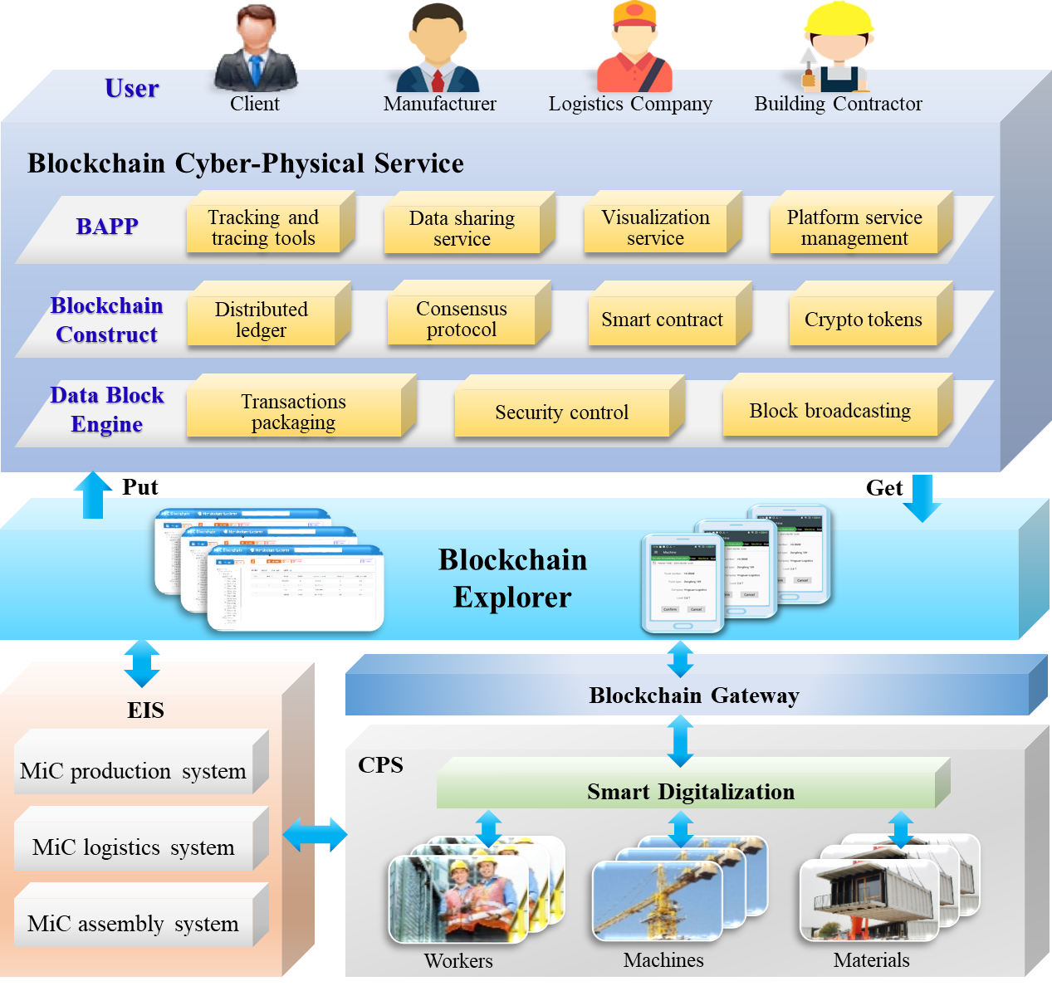
Fig. 1. Framework of blockchain-enabled cyber-physical smart MiC platform

3.1 MiC Blockchain Explorers
MiC blockchain explorers aim to provide user interfaces between MiC stakeholders and blockchain to support their requirements and daily activities. MiC blockchain explorers could be a browser-based or mobile-app-based interfaces to put/get data into/from blockchain. The main users include the project client, production managers, logistic company, and building contractor. The inputs are the orders, man-power, machines, and materials from CPSs and EISs. The outputs are the transactions to MiC blockchain network.
Different types of data in MiC projects are uploaded to blockchain explorers, such as Request for Inspection and Survey Check Form (RISC Form), material recording, design files, and site dairy. Data formats contain text, number, time, location, user ID, checkbox, URL, file, and image. Two data capturing methods are used, including manual input and automatically updating through APIs. Blockchain explorers could upload the captured data to Data Block Engine (DBE) after the confirmation by specific users. DBE packs the collected transactions into a block and uploads the block to ledger. Through blockchain explorers, on-chain metadata, off-chain metadata and the corresponding hash are stored in blockchain, while the huge off-chain data could be stored in secured cloud environments linked with relevant block. By this way, it not only guarantees the blockchain system performances in data storage and computation, but also meets the data privacy requirements of MiC stakeholders.
Four user-centered MiC blockchain explorers are developed, including client explorer, manufacturer explorer, logistics company explorer, and building contractor explorer, as shown in Fig. 2. Client explorer is designed for clients to make project planning & scheduling, monitor the real-time MiC project progress, and make collaborative decisions. Manufacturer explorer is designed for manufacturers to receive order data of prefabricated modules (identity, due time, specific requirement, material, and BIM & CAD files, etc.), manage production tasks, and trace production materials. Logistics explorer is designed for logistics companies to trace the current statuses and positions of prefabricated modules, and receive planning & scheduling information during MiC process. On-site contractor explorer is designed to monitor the modules statuses & construction progress through high-fidelity models with enhanced traceability, and support the collaborative management and operations of on-site tasks for building contractors.
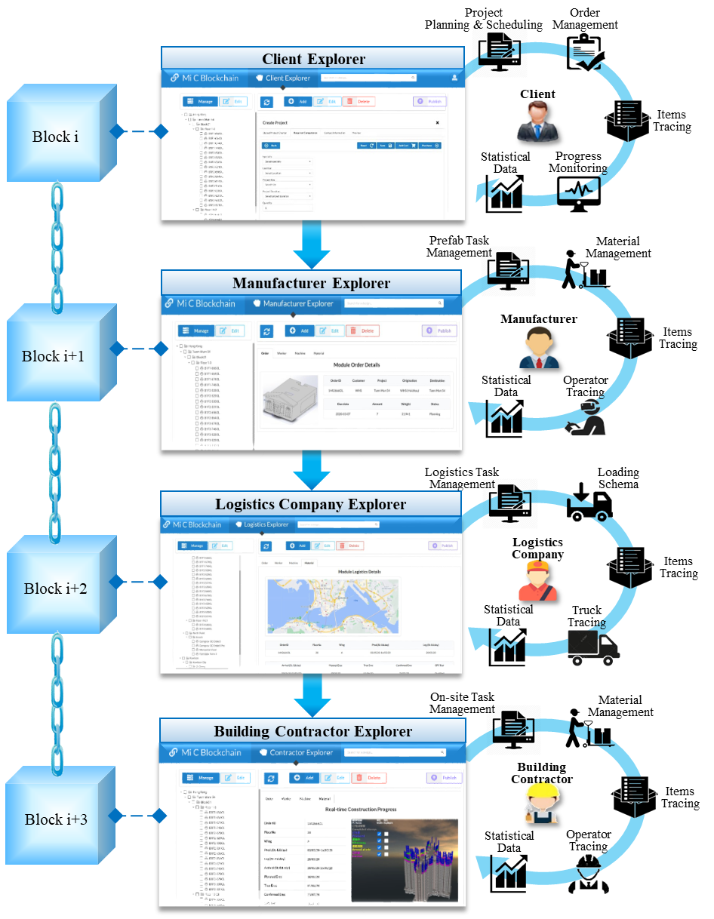
Fig. 2. MiC blockchain explorers for stakeholders

3.2 Blockchain-enabled Cyber-Physical Smart MiC Workflow
Reengineered workflow is conducted based on the blockchian-enabled cyber-physical MiC platform. Users with their responsible activities are arranged in the workflow chart, as shown in Fig. 3.
1) Production stage: Firstly, the client of the MiC project shares the orders and CAD & BIM files of prefabricated modules in the blockchain. The CAD & BIM files are reviewed, checked, and analyzed whether the module designs are qualified. If the evaluation of the design is qualified, MiC blockchain can automatically generate an order list containing the data of required modules (ID, size, weight, cost, installed position etc.) through smart contract. After that, the generated order is sent to the production manager. If an order needs to be adjusted, the adjustment information is updated to blockchian and shared among multiple stakeholders.
Production manager can establish the production plan and schedule shared with other stakeholders through MiC blockchain. Workers can receive the information of daily tasks through mobile phone-based blockchain explorers, including quantity, type, and volume of the modules. Workers can also view the design drawings and make more preparations for production tasks, such as the establishment of mould or the installation of reinforcement. Tests are made to check whether the quality of the modules can fulfill the project's requirements. Workers can scan the RFID tags of the qualified modules and share the module ID through MiC blockchian. Relative data can be transmitted to the workers’ mobile phone-based explorers and the statuses of the modules are recorded to “Produced” automatically through smart contract. Finally, the produced modules are moved to the storage yard before transportation, which are scanned by RFID readers to convert the status from “Produced” to “In Storage”. Data Block Engine (DBE) will automatically upload the statuses and other information of modules to MiC blockchain.
2) Logistics stage: The delivery orders are transferred to the logistics manager through MiC blockchain and visualized in browser-based explorers for planning and scheduling. Workers in the storage yard can receive loading tasks in mobile phone-based explorers. Before loading onto the trucks, workers scan RFID tags on the modules for identification and recording. After the confirmation, workers select the loaded modules through mobile phone explorers and scan the tag on the trailer. This operation can bind these modules with the related trailer and the loading time is also recorded and transmitted to the MiC blockchain network.
Before the delivery, all the transportation tasks are reviewed and evaluated to identify their priorities. After that, drivers and trucks are assigned to each task based on the transportation plan. The information of each task, as well as the related trucks and drivers, are automatically stored in MiC blockchain through smart contract. Drivers use mobile phone-based blockchain explorers to check and confirm the transportation tasks. Then, they drive the trucks to the storage yard in the production plant to pick the produced modules. Drivers scan the smart modules to ensure the right items are picked. If any wrong module is picked, the mobile phone-based blockchain explorers will make an alert to the drivers. After confirmation, the statuses of the loaded modules will automatically transfer from “In storage” to “Delivery” in blockchain through smart contract. The contractor and client can select the virtual modules in web-based blockchain explorers to check the real-time statuses. Once the truck arrives on the construction site, the status of the module transfers from “Delivery” to “Received” in MiC blockchian.
3) On-site assembly stage: Firstly, the main contractor receives the prefabricated modules transported by the logistics company. On-site operators check the quality and quantity of the modules. If the modules are qualified, operators will scan the RFID tags on modules to record and share the qualified module IDs in MiC blockchain. Then, the contractor allocates the on-site resources and tasks in blockchain, such as preparing crane and arranging workers.
For the assembly execution, on-site operators can view their tasks with detailed navigations on the mobile phone-based blockchain explorers, such as module ID, assembly sequence, and installed position. If the operators find the target modules on the buffer, they will use RFID readers to scan the modules. Then, the mobile phone-based explorer shows the detailed information downloaded from blockchain. Thus, operators can ensure whether the target module is ready to be installed. Besides, operators can test whether the module is installed at the right position through GPS or UWB positioning technolgies. The deviation between the current position of the module and the designed position can be noticed. If the module is installed in a wrong location, the error alter is updated to operators through blockchain explorers. After the module installation, operators scan the RFID tag and the related status transfers from “Received” to “Installed” in MiC blockchain. Building contractor can check the statuses of the modules in the high-fidelity 3D models to monitor the real-time construction progress through MiC blockchain.

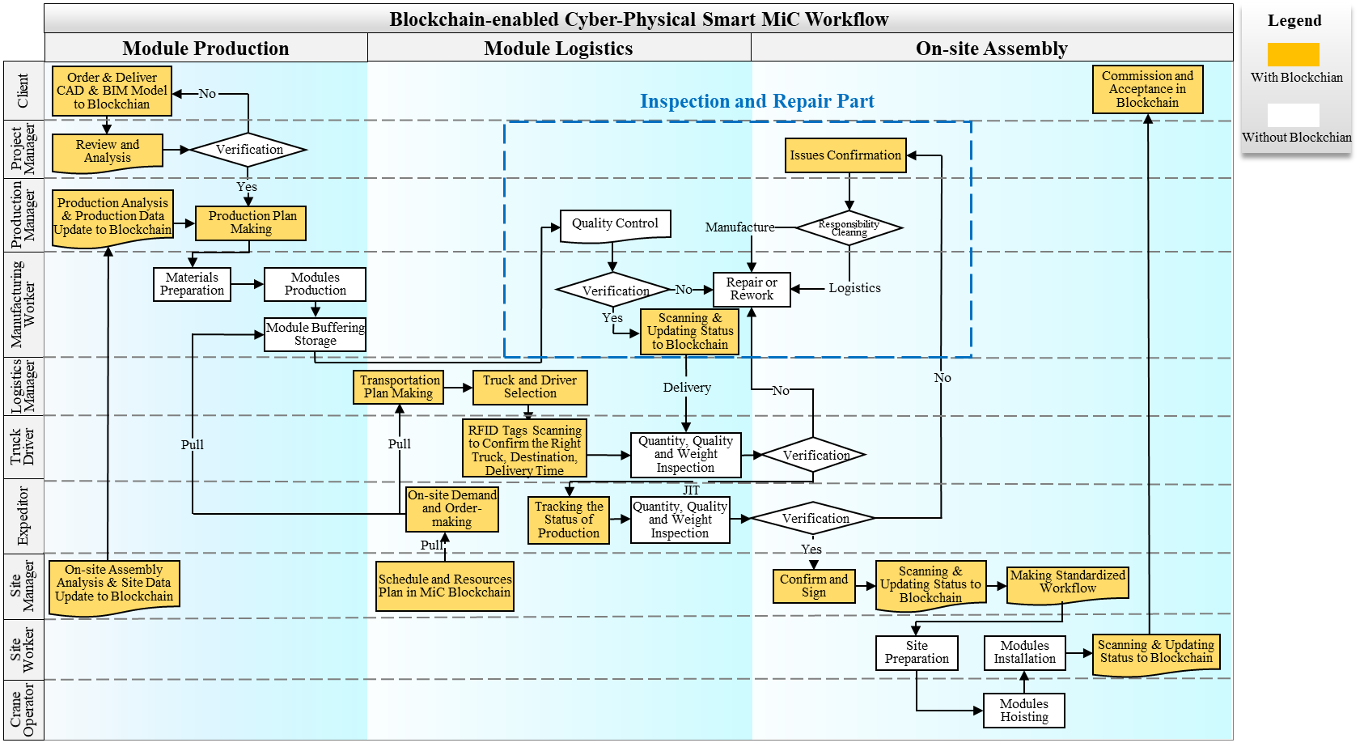
Fig. 3. Blockchain-enabled cyber-physical smart MiC workflow

3.3 MiC Blockchain Mechanisms and Constructs
The second design consideration discusses the mechanisms and constructs about the blockchain technology cooperated with Cyber-Physical System (CPS) in MiC scenario.
Ledger
Ledger is a series of consistent blocks stored among a distributed network with two key special properties. On the one hand, a distributed ledger is a peer-to-peer network where the MiC stakeholders can share information. On the other hand, ledger works as a distributed database. Instead of storing information in one database, ledger provides multiple scattered space to keep the reliability and immutability of data. As the basic element in a ledger, block is a cryptographically secured package, which carries transactions generated from the construction process and is retrieved by explorers forming a bidirectional data flow, as shown in Fig. 4. A ledger contains the immutable and sequenced records in each block, as well as a state database. Each ledger generally has one channel and several organizations, allowing a subgroup of participants in a single ledger.
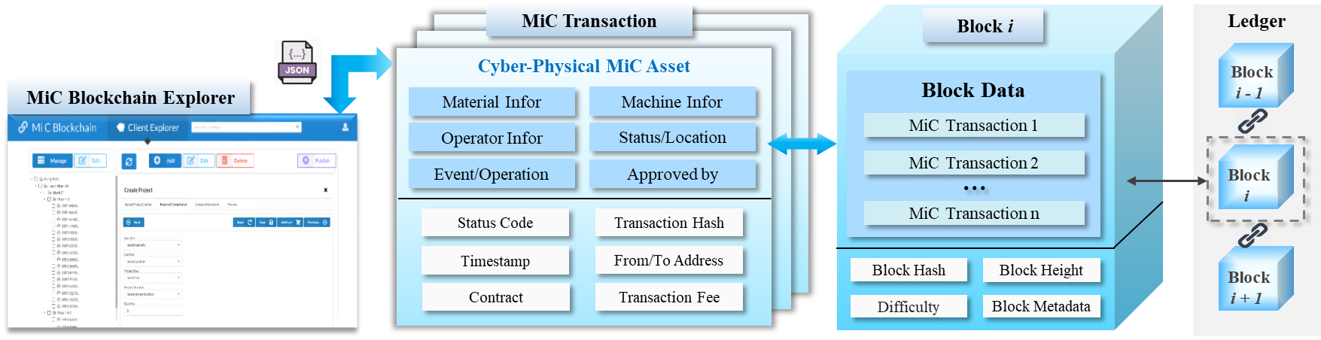
Fig. 4. Data flow through explorer/transaction/block/ledger under MiC blockchain
Smart Contract
The application of smart contract could be streamlined into three aspects, including data storage, computation, and function operation [56]. Storage contract is used to store the data transactions. Computational contract is used to cope with the complex transaction transfer, evaluation, and execution. Functional contract is defined by the users to facilitate the workflow management and control, which is mostly applied in MiC scenarios. For example, the main contractor could sign smart contract with project client about project progress. Once the scheduled work is finished, the main contractor can receive the funds. The site manager could sign the smart contract with consultant supervisor about material quality. Once the material is qualified by the supervisors, the site manager can operate the next operations.
Consensus
Consensus is the core blockchain backend function, which is used to keep all the data consistent in blockchain nodes and directly related to MiC blockchain performances. There are two types of consensus algorithms: trust-based consensus and non-trust-based consensus. Typical trust-based consensus algorithm contains Proof of Authority (PoA), Raft, etc., which has high-performance and cost efficiency advantages. Non-trust-based consensus algorithm contains Proof of Work (PoW), Proof of Stake (PoS), practical Byzantine Fault Tolerance, which has the advantages in data transparency and integrity. In this research, PoA consensus algorithm is selected to keep all the data consistent in all the nodes, due to the better performance in transaction speed and throughput. PoA covers the entire transaction flows, including broadcasting, validation, and commitment.
Cyber-Physical MiC Asset
Cyber-Physical MiC assets are physical construction resources (prefabricated modules, trucks, cranes, etc.) equipped with IoT devices and the corresponding cyber objects with geometrical and semantic descriptions stored in blockchain. Cyber-Physical MiC assets can update the real-time statuses, locations, and related events or operations to blockchain by IoT devices, such as RFID tags, UWB tags, iBeacon devices, and temperature sensors. Blockchain enables the capacity to track and trace assets, transact assets ownership, and share the cyber assets using smart contract.
Another design consideration focuses on data security-related attributes in MiC blockchain. On the one hand, MiC projects often involve a lot of sensitive and private data, such as intra payment and internal documents of contractors. Due to regional policies, business secrets, and many other considerations, these data could only be available to a certain range of stakeholders. On the other hand, data integrity and authenticity are always concerns in MiC projects. There are many manual processes and updates in construction activities, which may lead to information inconsistency, inaccuracy, and even error. To solve this problem, two key blockchain-based mechanisms are presented, including blockchain native cryptographic mechanism and blockchain-based cyber-physical information sharing mechanism.
- Blockchain native cryptographic mechanism: Cryptography could be used to protect the data security and privacy from being misused or forged, such as AES, RSA [32]. All the stakeholders involved in MiC blockchain need a digital signature to confirm the legitimate identity for login permission. It not only encrypts/decrypts the data/file, but also provides a unique digital signature to confirm the data ownership.
- Blockchain-based cyber-physical information sharing mechanism: Blockchain-based information sharing solution is achieved through the peer-to-peer network. It provides transparent and trackable records about the user, time, and hash address etc., which avoids the drawbacks of the centralized file sharing, such as data ownership and data leakage. Therefore, blockchain-based information sharing mechanism facilitates the security and privacy for data exchange and service sharing.

3.4 Blockchain-based Applications (BAPPs)
Four blockchain-based applications (BAPPs) are designed to support stakeholders’ requirements and daily activities based on UCD, including tracking and tracing tools, data sharing service, data visualization service, and platform service management.
Tracking and tracing tools are designed for construction progress traceability, such as master program, and other workflow reports. Traceability provides reliable history records to manage creation, submission, acknowledgement, approval, and completion of assigned tasks. Information sharing service provides MiC stakeholders with a tool to share the relevant files, such as RISC forms, site diaries, and CAD & BIM files. For example, the design teams need to conduct the clash testing regularly through BIM models. The relevant BIM files are shared among different design stakeholders through transparent and secured blockchian network. Blockchain-based information sharing service also provides trackable recordings to confirm the responsibility and intellectual properties. Data visualization service provides a near real-time summary and analytics of the collected data during construction progresses. It helps the senior project managers to access the construction progress with enhanced visibility through high-fidelity virtual models to make further decisions for the collaborative works. Platform service management is used to manage and configure the MiC blockchain platform, such as user assess right, group management etc. As an advanced platform tool, it is only managed by system administrators. The four key BAPPs provide the MiC project administrators with easy tools to monitor the whole MiC project and facilitate information sharing and communication.

4. Development and Deployment of MiC Blockchain
Four key steps of development and deployment are considered, including frontend development, backend development, and node deployment and configuration. The technical roadmap of MiC blockchain development and deployment is shown in Fig. 5.
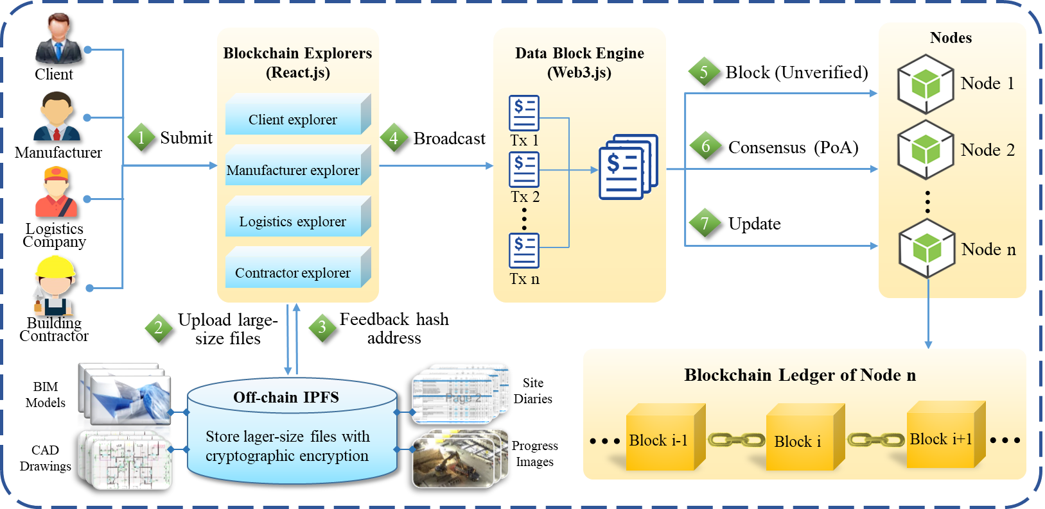
Fig. 5. The technical roadmap of MiC blockchain development and deployment

4.1 Frontend Development of MiC Blockchain
To develop the frontend of MiC blockchain, Visual Studio Code is used as the Integrated Development Environment (IDE). React.js is used as frontend programming language to develop the interfaces of blockchain explorers. Web3.js provides the APIs for blockchain explorers to access the blockchain ledgers. The information revealed in blockchain explorers include text, number, time, location, user ID, checkbox, URL, image, and BIM & CAD file.
Four blockchain-based applications are developed, including tracking & tracing tools, visualization service, data sharing service, and platform service management. The frontend interfaces of these applications are developed using react.js programing language. REST APIs, SDKs, and HTTP are used to bridge the interactions with blockchain backend. The main users of tracking and tracing tools, data sharing service, and visualization service, are the stakeholders in MiC projects, such as site managers, supervisors, and project owners/representatives. The main user of platform service management is the system administrator, who could also be the project owners/representatives. For the development of visualization service, high-fidelity 3D models of machines, workers, materials, and building structure are firstly established using Revit, Maya, or Solidworks. Then these 3D models are imported into a game engine Unity 3D to build the digital twin functions, such as free-moving perspective, multi-view transferring, and collision and gravity simulation. The C#-based construction digital twin is converted into JavaScript language through Web Graphics Library (WebGL) and uploaded into InterPlanetary File System (IPFS), which could be operated on the web-based platform. Fig. 6 shows a simplified data transaction of RISC form for a prefabricated module. The JSON-based restored data in MiC blockchain can be interoperated with the visualized models through Data Block Engine (DBE).
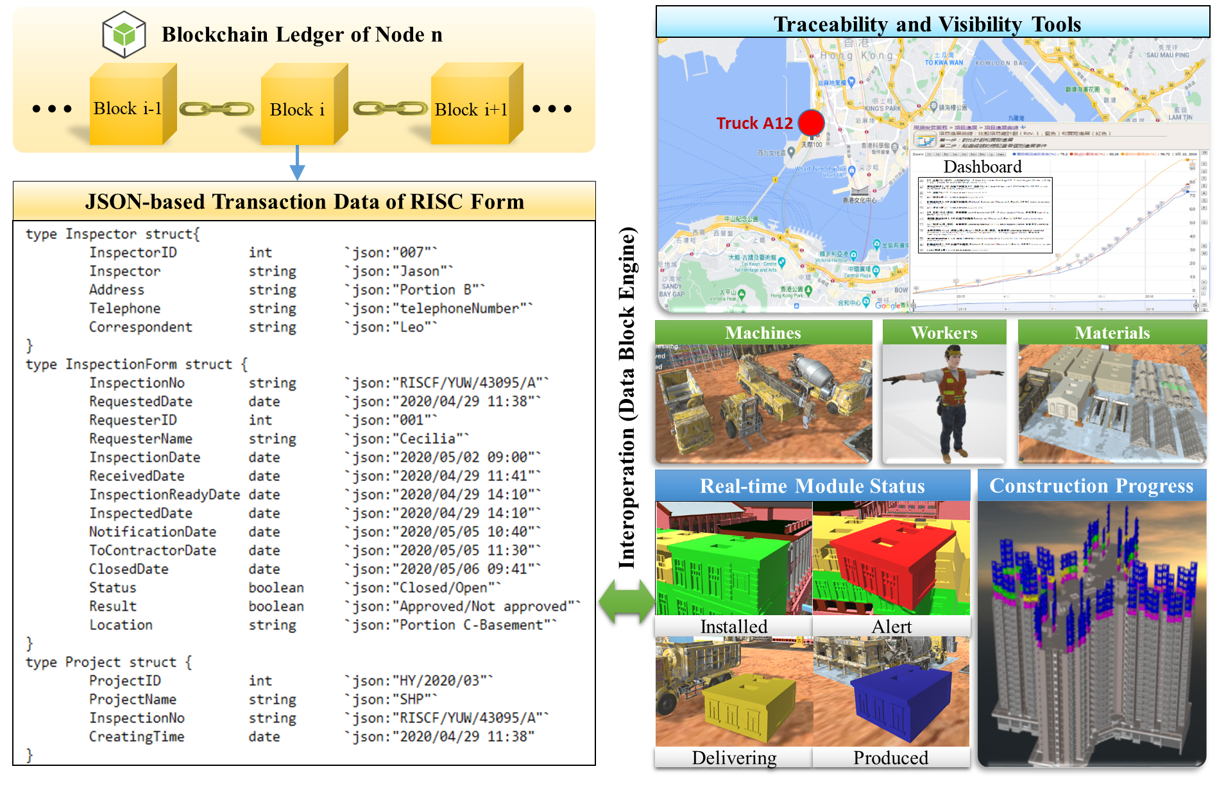
Fig. 6. Traceability and visibility tools in MiC blockchain

4.2 Backend Development of MiC Blockchain
Ethereum-based blockchain is used as the development platform for MiC scenario. Digital signature is applied for login permission, confirm the legitimate identity of stakeholder, and prevent malicious nodes from impersonating in MiC blockchain. Data security is achieved through the combination of Ethereum blockchain and private InterPlanetary File System (IPFS) (V0.5.3) through the access control and hash function. Moreover, Ganache (2.5.4-win-x64) is used as the blockchain backend tool to develop and test with frontend interfaces. Finally, Solidity (V0.5.16) language is used to develop smart contracts and the truffle framework is used for contract management, compiling, debugging, and deployment. Four key components in MiC blockchain backend are developed, including Data Block Engine (DBE), ledger, consensus, smart contract, and InterPlanetary File System (IPFS).
- Data Block Engine (DBE): DBE packs the collected transactions into a block and uploads the block to MiC blockchain ledger. The collected transactions include order transactions, machine transactions, and material transactions. DBE serves as the middleware to connect, manage, and maintain the physical nodes with MiC blockchain. Specifically, DBE is used to achieve the basic blockchain functions using Web3.js, such as transaction ordering & packaging, broadcasting, and consensus. Web3.js is a collection of libraries that allow the users to interact with the local/remote blockchain node using a HTTP connection. Web3.js is applied to achieve the interaction between blockchain explorers and blockchain backend through calling the predefined smart contracts.
- InterPlanetary File System (IPFS): IPFS is a peer-to-peer file system used to store off-chain large-size files. Because construction design files and semantic recording files in MiC projects have large sizes, which need to be stored off-chain, such as BIM models, CAD drawings, UAV (Unmanned Aerial Vehicle) inspection images, and site diaries, etc. There are three steps to build the private IPFS cluster. The swarm key is firstly applied to achieve the local private building. Secondly, the bootstrap IPFS node is used by client nodes to connect to the private IPFS network. Finally, it needs to start the private IPFS network and limit the node access by configuring the environment variable “LIBP2P_FORCE_PNET”. Thus, private IPFS cluster is built to store the large-sized files, while blockchain is used to store its permalinks/hash address with the timestamp, metadata, and version information. This combined solution not only saves vast blockchain storage space but also increases the platform performances.
- Smart Contract: Functional smart contract is defined by the stakeholders to facilitate the workflow management and control, which is mostly applied in MiC blockchain. For example, smart contract could be invoked by frontend MiC applications when the users need to interact with blockchain ledger, as shown in Table 1. There are two directions of information flows: adding records to blockchain ledger and querying data from state database, which represents two basic behaviors: “Put” and “Get” data into/from MiC blockchain.

Table 1. Smart contract for MiC information interaction and sharing
Smart contract: Data interaction rule between cyber-physical MiC.
Input: MiC orders with varied attributes, such as moduleID, client name, project ID, etc.
Output: Uploaded orders information for sharing among MiC stakeholders.
1: struct moduleOrder {
2: string moduleID;
3: string client;
4: string project;
5: string origination;
6: string destination;
7: string orderStatus;
8: }
9: function submitJob (
10: string memory _moduleID,
11: string memory _client,
12: string memory _project,
13: string memory _origination,
14: string memory _destination,
15: string memory _moduleStatus,
16: ) public mustBeClient{
17: ordersTotalCount[msg.sender] = ordersTotalCount[msg.sender] + 1;
18: orders[msg.sender][ordersTotalCount[msg.sender]] = OrderStruct({
19: moduleID: _moduleID,
20: client: _client,
21: project: _project,
22: origination: _origination,
23: destination: _destination,
24: moduleStatus: _moduleStatus,
25: });
26: emit orderEvent[msg.sender, ordersTotalCount[msg.sender]], _orderID, 27:_client,_project,_origination,_destination,_moduleStatus);
28: }
29: function getModuleOrder() public mustBeClient view returns (string memory) {
30: string memory global = "";
31: for (uint i = 0; i <ordersTotalCount[msg.sender]; i++ ){
32: string memory moduleID = orders[msg.sender][i].moduleID;
33: string memory client = orders[msg.sender][i].client;
34: string memory project = orders[msg.sender][i].project;
35: string memory origination = orders[msg.sender][i].origination;
36: string memory destination = orders[msg.sender][i].destination;
37: string memory moduleStatus = orders[msg.sender][i].moduleStatus;
38: global = string(abi.encodePacked(global,"_", moduleID,"_",client,"_",project,"_",origination,"_",destination,"_", 31:orderStatus));
39: }
40: return global;

4.3 Node Deployment and Configuration
The node configuration and deployment of MiC blockchain can affect the security and privacy for key data. There are five key nodes in MiC blockchain following UCD method, including client node, manufacturer node, logistics company node, building contractor node, and service provider node (boot node), as shown in Fig. 7. (1) Project client node is the initiator of the MiC project, such as housing and public infrastructure. Client node has the ownership of lands and offers the financial supports for the construction project. It also provides orders and CAD & BIM design files of prefabricated modules, monitors the project progress, as well as controls the overall project quality and cost; (2) Manufacturer node is deployed for stakeholders in off-site factory to receive orders and upload production information, such as production APS and execution process; (3) Logistics company node is provided for transportation managers to track the positions and statuses of modules, and manage the logistics from production factory to construction site; (4) Building contractor node is deployed to support supervision and operation of on-site assembly with enhanced traceability and visibility; and (5) Service provider node (boot node) is deployed, which is used to manage and maintain the blockchain network. Meanwhile, boot node also provides browser-based explorers, mobile phone APPs, and other software services to support other stakeholders in MiC projects. Four nodes of MiC stakeholders are required with the knowledge of daily tasks and engineering informatics. These MiC stakeholders should be familiar with the routine digitalized files such as site diary, RISC form, CAD & BIM files during the three stages in MiC project (e.g. module production, module logistics, on-site assembly). Semantic model such as Industry Foundation Classes (IFC) to describe the construction resources and structures are also needed for the MiC stakeholders during the blockchain-enabled information sharing. Service provider at the boot node is required with the knowledge of administering and maintaining the MiC blockchain platform. The knowledge includes the development, deployment, and application of Ubuntu server, Linux virtual machine, smart contract, Nginx reverse proxy, etc. Ubuntu server and Linux virtual machine are used to start the server side to run the MiC blockchain platform. Smart contract is developed by Solidity programming language and deployed using truffle framework. Nginx reverse proxy is used to open the port to the client side to increase the security of the server side.
Five full nodes are configured to maintain the block data in MiC project, which run separately in two Ubuntu Linux servers. The first node is deployed on Ubuntu Linux 18.04 for the clients to place the order information of prefabricated modules, and CAD & BIM files. The rest four nodes, including manufacturer, logistics company, on-site contractor, and service provider node (boot node) are deployed on Ubuntu Linux 20.04. There are five steps to configure the MiC blockchain. The first step is to use the puppeth program to generate the genesis block “MiCblockchain.json” and set up authoritative nodes. The second step is to use the go-ethereum client to create the consortium blockchain nodes using “MiCblockchain.json”. The third step is to set the Proof of Authority (PoA) as the consensus algorithm due to better transaction speed and throughput. The fourth step is to use the boot node for connecting all the nodes and form the consortium blockchain network. The interval block generation time is about 10 seconds. The last step is to deploy the smart contracts and related-applications in the consortium blockchain. After the above steps, MiC blockchain could be deployed and configured successfully to share information in MiC projects.
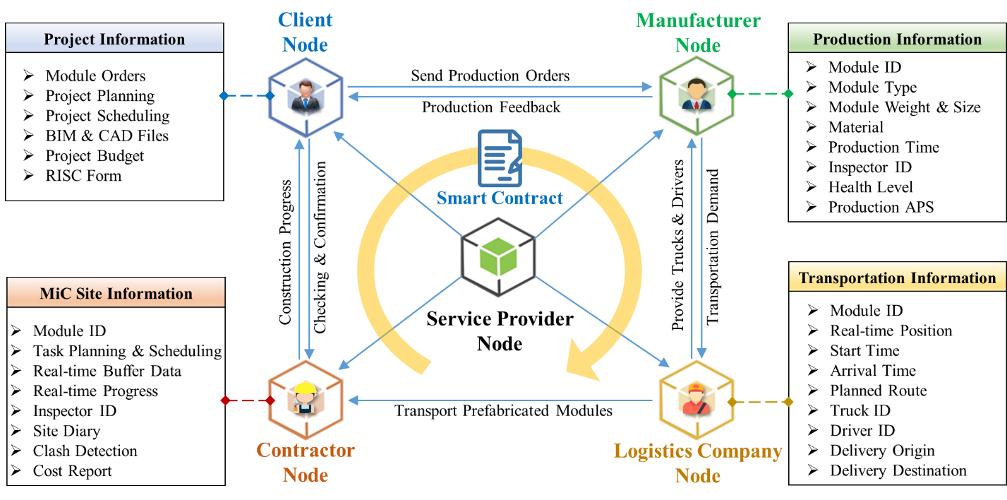
Fig. 7. Node deployment and configuration for MiC blockchain based on UCD

4.4 Integration with External MiC Systems
MiC processes rarely run in isolation. Various Enterprise Information Systems (EISs) are needed to integrate data, optimize decision-making, and timely monitor workflow, such as Manufacturing Execution System (MES), Building Information Modeling (BIM), Geographic Information System (GIS), and Enterprise Resource Planning (ERP) etc. Therefore, the development of the MiC blockchain must consider the integration with these existing systems and applications.
To achieve integration, there are three key aspects to consider, including standardization, middleware for messaging, and access control [5,12]. First, standards are required to facilitate the interoperability between MiC blockchain and external systems. These standards can be XML (eXtensible Markup Language), JSON (JavaScript Object Notation), or EDI (Electronic Data Interchange) formats, which are well-adopted communication form. Second, middleware for messaging refers to a middle medium to exchange data with external systems through event processors. The external application can listen to specific events from the hub and perform certain tasks accordingly. For example, a set of libraries, APIs, and SDKs can be developed and leveraged to accelerate for a unified connection with the existing systems and applications, such as Web3.js and Axios. Thirdly, access control is necessary to guarantee security during the interaction processes. Blockchain network supports data encryption and decryption, and operates complex permission for participants in MiC projects. Through the integration between MiC blockchain and external systems, a standardized information sharing and collaboration is provided, and a significant cost impact is achieved on company business and accumulation data value.

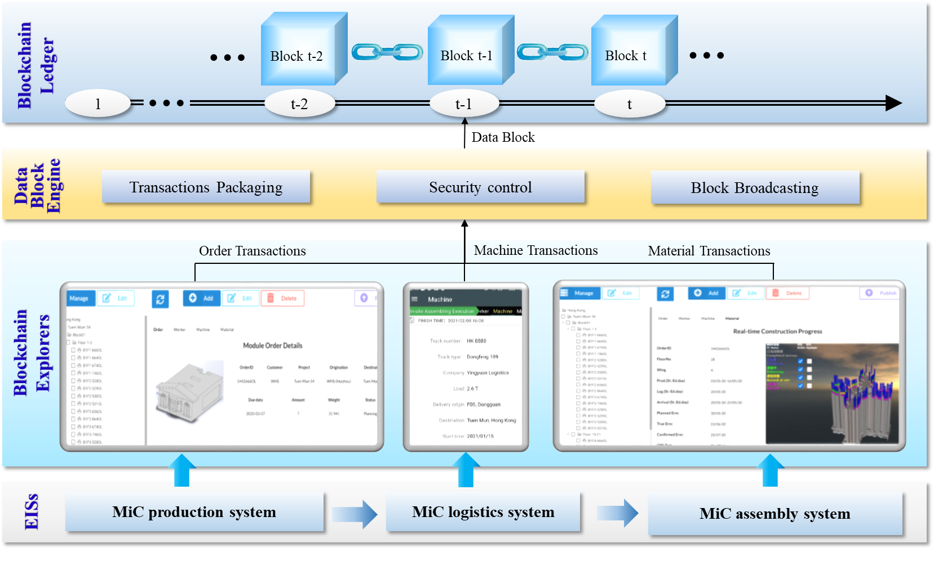
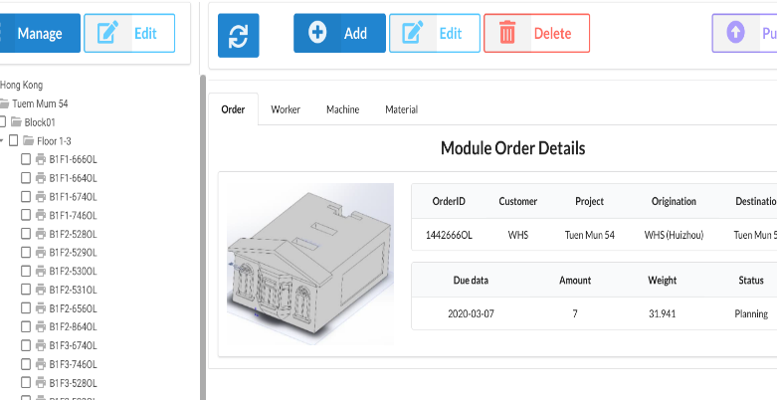
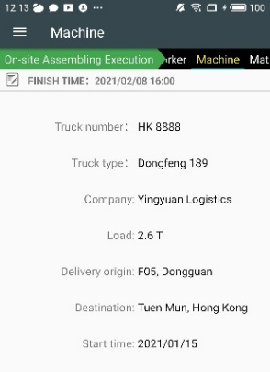
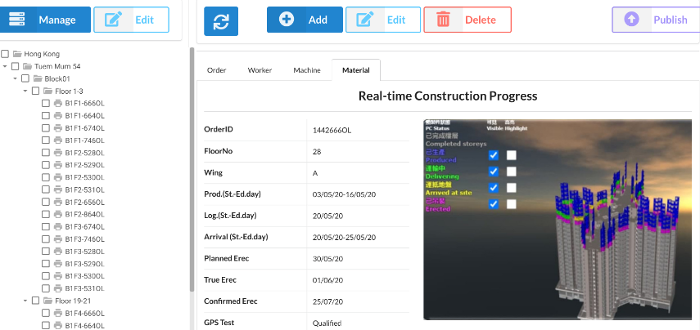
Fig. 8. Block generation process in MiC blockchain

5. Implementation and Evaluation of MiC Blockchain
MiC blockchian platform generates data block for information sharing to facilitate the collaborative decision makings and daily operations in MiC projects. An experiment of performance evaluation is run under the HPE-ProLiant DL380 Gen10 server with two virtual machines (Ubuntu Linux 18.04 and Ubuntu Linux 20.04). Five blockchain nodes are deployed by Go-Ethereum 1.10.3. Three key functions at business level are tested, including data block generation, cyber-physical construction progress traceability, and real-time KPI visualization & evaluation. Quantitative evaluation is also conducted to test two key indicators at system level, including time latency and throughput.

5.1 Data Block Generation in MiC Blockchain
Fig. 8 shows the data block generation process, which aims to test the blockchain information updating mechanism in MiC projects. The major inputs are orders, operators, machines, and materials, while the output is the data block.
The process of block generation has three stages. The first stage is that blockchain explorers receive data from EISs, such as MiC production system, MiC logistics system, MiC assembly system. All these EISs contain the project information, such as orders (e.g. production orders, transportation orders, and purchase orders, etc.), workers (e.g. manufacturing operators, logistics operators, and on-site workers, etc.), machines (e.g. trucks and cranes, etc.), and materials (e.g. raw materials, work-in-process, and finished prefabricated modules, etc.). Some critical information is transferred to blockchain explorers through predefined APIs. The second stage is that blockchain explorers update the critical information to DBE. Blockchain explorers could be a browser-based or mobile app-based interfaces. For example, when the logistics truck is attached with an RFID tag, operator could use the mobile application to scan the tag and obtain the truck information, such as the truck number and load capacity. Then, operator presses “Confirm” button if the collected information is right. After that, operator presses “Publish” to upload the truck information to MiC blockchain as “transactions”. The third stage is that DBE packs the collected transactions into a block and uploads the block to the blockchain ledger. DBE is used to collect transactions (e.g. order transactions, machine transactions, and material transactions, etc.) from the blockchain explorers. Three key components are included, namely transactions packaging, security control, and block broadcasting. Transactions packaging is used for packaging transactions in a certain time interval to form a block. Security control can guarantee data privacy and safety through the native cryptographic approaches. Block broadcasting is used to send the generated block to the blockchain network. After consensus, the uploaded block is stored in blockchain ledger. The data records of accounts, blocks, and transactions of MiC blockchain are shown in Fig. 9. The connection between blockchain and EISs is achieved through blockchain explorers and DBE. It not only provides an easy way for users to upload information to blockchain network, but also facilitates the information sharing for MiC stakeholders.
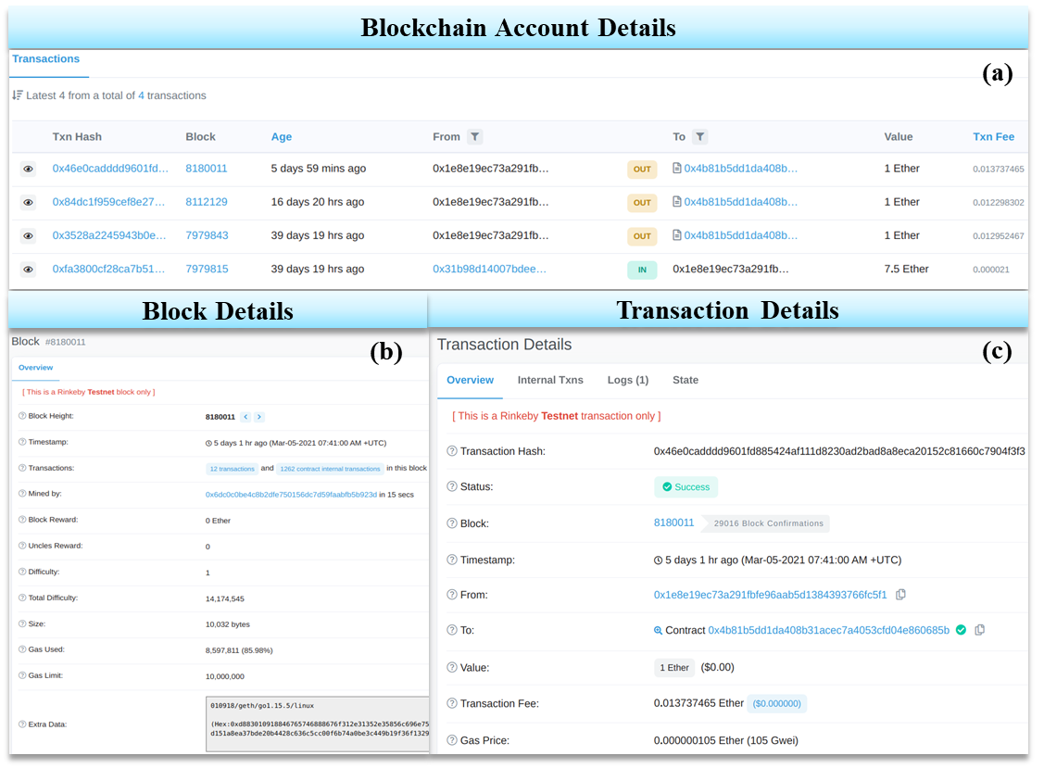
Fig. 9. Results of data block generation: (a) Blockchain account details; (b) Block details; and (c) Transaction details.
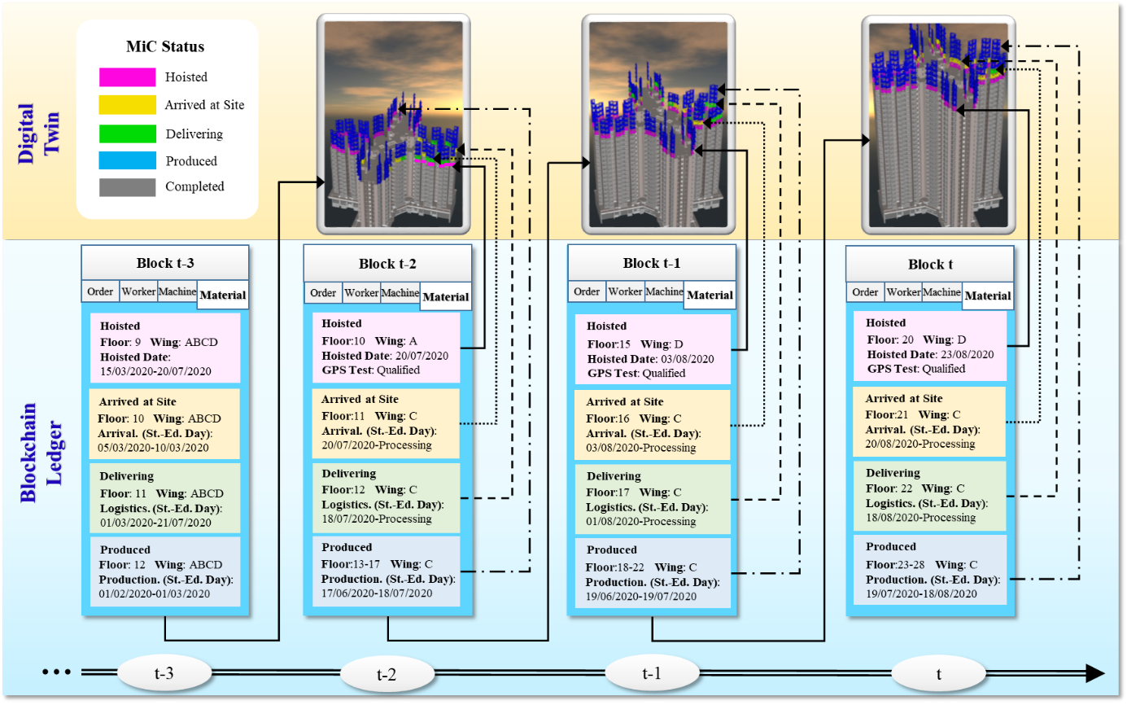
Fig. 10. Traceability and digital twin of MiC construction progress

5.2 Traceability and Digital Twin for MiC Progress
Fig. 10 shows the blockchain-enabled traceability and the corresponding digital twin for MiC progress. It aims to test the traceability and visibility of the key information during construction progress, consisting of the blockchain ledger and the digital twin. Blockchain ledger is used to store and trace the historical information, including worker, machine, material, and order. Digital twin is used to visualize the construction progress in high-fidelity virtual models based on traceability data, which performs as the user interface and the control center for stakeholders.
In the blockchain ledger, the statuses of prefabricated modules on each floor and each wing can be traced through the timeline. The statuses of prefabricated modules include {produced, delivering, arrived, hoisted, completed}. Key information in construction progress is automatically updated to the block at a time point. The updated information contains floor, wing, hoisted date, GPS test, as well as the transaction ID and operation time. In the digital twin, the bidirectional mapping between MiC progress and digital space is established based on the traceability data. High-fidelity digital models of building are created to simulate the real construction progress. Through integrating and visualizing the traceability data, digital twin can reveal the complete sight of the statuses of prefabricated modules for stakeholders. Thus, stakeholders could make better planning, scheduling, and execution for further steps. Digital twin can also examine the root causes of current problems by visualizing the historical situation in MiC progress. With the traceability and digital twin, the details of all the operations performed in MiC progress can be traced and revealed. The original errors that cause quality defects or time delays can also be detected. Following the principles of UCD method, stakeholders are facilitated to monitor the construction progress and make rapid adjustments in specific situations.
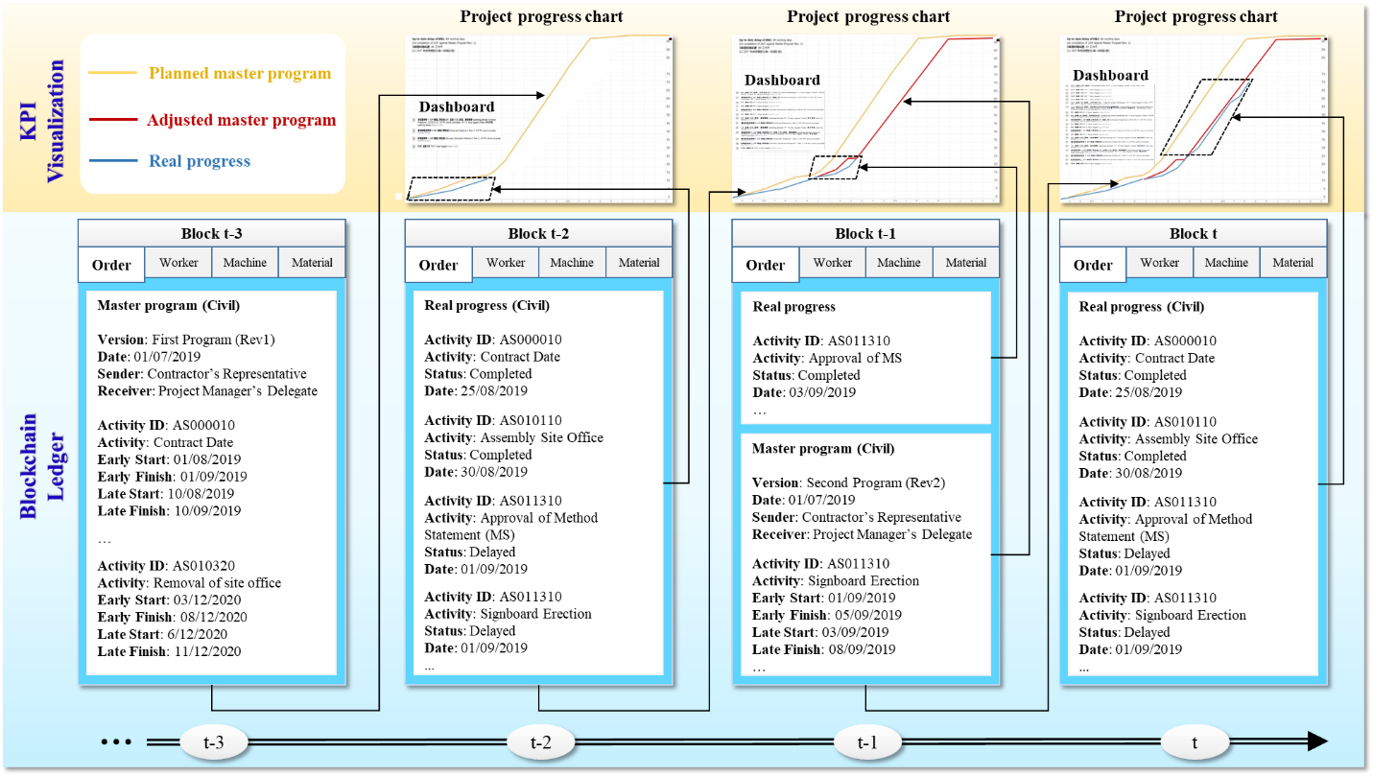
Fig. 11. KPI tracking and visualization for construction master program

5.3 KPI Tracking and Visualization for MiC Master Program
Fig. 11 shows the KPI tracking and visualization for MiC master program. It aims to test the ability of MiC blockchain to track and visualize KPIs of MiC master program, which consists of blockchain ledger and KPI visualization. Blockchain ledger serves as a bridge to share master program for stakeholders and track real construction progress. KPI visualization displays relevant KPIs in a concise and visually appealing manner.
In the Blockchain ledger, three types of information are stored, including planned master program, adjusted master program, and real progress. At time t-3, a planned master program for a MiC project is formulated by contractors and then uploaded to the blockchain ledger. A master program defines activities and their key dates, and outlines the scope of activities. In the project progress chart, one line represents the planned master program. At time t-2, the real progress of planned activities is recorded and represented with a line in the dotted box. In addition, some critical events are recorded and shown in a dashboard. Usually, the statuses of activities are recorded as well as key dates. At time t-1, with the implementation of the MiC project, an adjusted master program is developed and represented with another line as the planned master program becomes infeasible. At time t, the real progress of the MiC project is recorded and visualized in the project progress chart. With KPI tracking and visualization, stakeholders can track the construction progress effectively, due to the shared information on the real progress. In addition, the construction progress can be controlled more efficiently, since an adjusted master program can be informed timely.

5.4 Performance Analysis of Latency & Throughput
MiC blockchain platform with four explorers supports the information sharing, resource status tracking, and progress monitoring. The experiment is run under the HPE-ProLiant DL380 Gen10 server with two virtual machines (Ubuntu Linux 18.04 and Ubuntu Linux 20.04). PoA is configured as the consensus algorithm with a five seconds interval to generate a new block. Two key performance indicators (KPIs) of blockchain are tested for the evaluation: Time Latency and Throughput [28]. Time latency is the difference between the start time and the end time of publishing operations; Throughput is the quantity of completed transactions per second (TPS) in four explorers of MiC blockchain. Throughput equals to the block size divided by time latency, described in Formula (1). Block size refers to the quantity of transactions contained in a block, which equals to the block gas limit divided by transaction gas limit, described in Formula (2).
Throughput=Block-Size / Time-Latency | (1)
Block-Size=Block-Gas-Limit / Transaction-Gas-Limit | (2)
where gas is the measurement index of the computational resource for one operation in blockchain, and gas limit is the maximum quantity of gas that can used to execute transactions [43]. Gas limit and the corresponding block size can be adjusted by blockchain service provider. To ensure universality, time latency and throughput are tested under the several environments with differentiated connected nodes (range$∈$[2,5]) and differentiated block sizes (range$∈$[50,500], common difference=50).
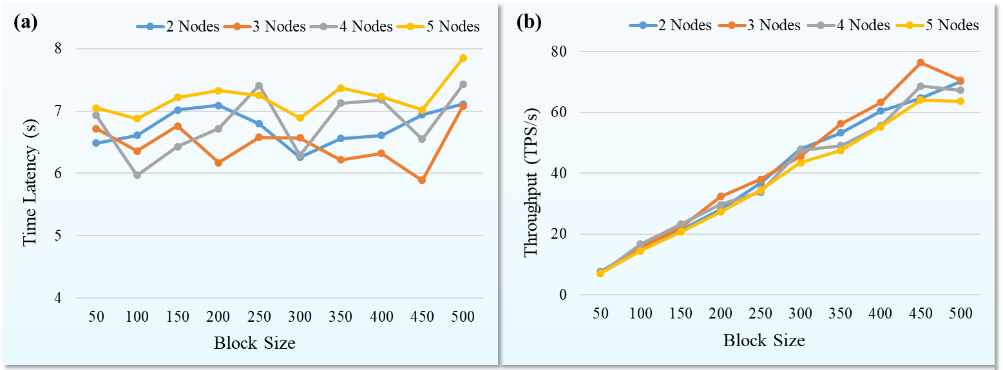
Fig. 12. Performance evaluation of MiC blockchain: (a) Time Latency (s); (b) Throughput (TPS/s)
The quantitative results of performance evaluation for MiC blockchain are shown in Fig. 12. For time latency of publishing, the average latency is basically controlled within the range of 6s to 8s, as shown in Fig. 12(a). More connected nodes lead to higher time latency, because all the nodes need to spend time to reach the consensus for publication. Maximum average latency is 7.209s with 5 nodes, and minimum average latency is 6.467s with 3 nodes. The change of block size has no observable influence for the time latency based on the testing results. Retrieval is another action in MiC blockchain, which is tested to show a near-real-time manner in this experiment. In actual MiC scenarios, some nodes may face larger number of HTTP requests within a time period. Those nodes with heavy load will experience slightly higher time latency [17]. Considering the limited number of users that the platform faces in one MiC project, it is impracticable that more than 100 requests need to access the blockchain within a short time period (for example, within 100 milliseconds), so the time delays only have a few milliseconds differences, which can be negligible compared to the time of reaching consensus. For throughput, the testing result is in a linear proportional relationship with the block size, as shown in Fig. 12(b). With a standard block size (250), the average throughput of MiC blockchain is around 35.743 TPS/s. Based on formula (1), the slope k of throughput is relatively stable due to the low variation of time latency, while the average k is 7.235 through linear fitting and the corresponding $R^{2}$ is 0.992. The number of connected nodes has no observable influence on the throughput of MiC blockchain.

5.5 Discussions
Based on the experimental study, some managerial implications are obtained. MiC blockchain has provided a positive effect for the information sharing among stakeholders. Transactions data are simultaneously shared with enhanced transparency and security, and each stakeholder has the authority to manage the data. Previous transactions can be easily traced to facilitate the root cause determination and accountability. The details of operations performed in construction progress can be traced and revealed in high-fidelity models supported by digital twin. Stakeholders can also track the KPIs of master program effectively through statistical curves.
However, several limitations of MiC blockchain are also found from the experiment, which are listed as follows: (1) MiC scenario can generate huge data, while some data should be shared on chain and other data should be shared off chain. In this study, the on-chain shared information is mainly concerned about the prefabricated modules. But more information may need to be shared through blockchain in other MiC projects. How to design the content of on-chain/off-chain shared information is a key question; (2) Block size and time interval of block generation are also important variables during the implementation of real MiC projects. Experiments based on mathematical models are lacked for the design of optimal block size and time interval; and (3) Updated information has time latency due to the time interval of block generation based on consensus mechanism. Thus, some emergency information such as operation alert can’t be shared for stakeholders on a real-time basis, which may cause potential problems during MiC process.

6. Conclusion and Future Research
This paper proposed a blockchain-enabled cyber-physical platform to support information integration and sharing among multiple stakeholders and address the information fragmentation and discontinuity in MiC project based on UCD methodology. Firstly, the overall framework not only provides a cyber-physical information integration, but also achieves a unified standard for secured information communications and sharing with high transparency. Initial investigations based on an industrial collaborator Chun Wo Limited are analyzed, and the blockchain-enabled cyber-physical MiC business process is designed. Secondly, four user-centric functional blockchain explorers are developed as the interactive interfaces for client, manufacturer, logistics company, and building contractor, to put/get data into/from blockchain backend. An automatic information integration is also achieved from cyber-physical systems with EISs. Thirdly, four key BAPPs are designed, including tracking and tracing tools, data sharing service, data visualization service, and platform service management. Through the demonstrative applications of the prototype system, it is found that the BAPPs are effective and feasible for MiC managers and operators by providing easy tools, so as to facilitate the information integration and sharing.
Several key contributions are significant. Firstly, the information sharing among stakeholders is improved with the decentralized framework of MiC blockchain. Each operation requires the confirmations from all stakeholders. The approved records can’t be modified by any user, which improves the authenticity of data. Secondly, a practical roadmap is discussed for design, development, deployment, implementation, and evaluation of MiC blockchain with new opportunities and guidelines. Finally, construction progress is traced through ledgers and revealed in digital twin, and KPIs of master program are tracked and visualized through analytical charts with enhanced information reliability, immutability and transparency.
In order to make continuous improvements, it is recommended that future research can be carried out from several aspects. Firstly, huge data could be generated in construction process and only a part of data is shared through blockchain. Further experiments and statistical models are needed to design the optimal block size, and time interval of block generation. Secondly, MiC supply chain involves a lot of interactive works with many updating files, such as site diary, RISC form etc. It is well worthy to explore more about the blockchain-based smart supply chain management. Thirdly, operational alert service and financial contract service in MiC projects could be further developed to improve efficiency and save administrative costs through deeper application of smart contract.

References
[1] S. Abdelmageed, T. Zayed, A study of literature in modular integrated construction - Critical review and future directions, Journal of Cleaner Production 277 (2020).
[2] C. Abras, D. Maloney-Krichmar, J.J.B. Preece, W. Encyclopedia of Human-Computer Interaction. Thousand Oaks: Sage Publications, User-centered design, 37 (4) (2004) 445-456.
[3] S. Ahmadisheykhsarmast, R. Sonmez, A smart contract system for security of payment of construction contracts, Automation in Construction 120 (2020).
[4] A. Akanmu, S. Professor Monty, A. Profes, C.J. Anumba, Cyber-physical systems integration of building information models and the physical construction, Engineering, Construction and Architectural Management 22 (5) (2015) 516-535.
[5] A. Banerjee, Integrating blockchain with ERP for a transparent supply chain, Perspectives (2018) 1-13.
[6] C. Boje, A. Guerriero, S. Kubicki, Y. Rezgui, Towards a semantic Construction Digital Twin: Directions for future research, Automation in Construction 114 (2020).
[7] K. Chen, W. Lu, Y. Peng, S. Rowlinson, G.Q. Huang, Bridging BIM and building: From a literature review to an integrated conceptual framework, International Journal of Project Management 33 (6) (2015) 1405-1416.
[8] C. Cimino, E. Negri, L. Fumagalli, Review of digital twin applications in manufacturing, Computers in Industry 113 (2019).
[9] F.R. Correa, Cyber-Physical Systems for Construction Industry, 2018 IEEE Industrial Cyber-Physical Systems (ICPS), St. Petersburg, Russia, 2018.
[10] Z. Dakhli, Z. Lafhaj, A. Mossman, The potential of blockchain in building construction, Buildings 9 (4) (2019) 77.
[11] A. Darko, A.P.C. Chan, Y. Yang, M.O. Tetteh, Building information modeling (BIM)-based modular integrated construction risk management – Critical survey and future needs, Computers in Industry 123 (2020).
[12] N. Gaur, L. Desrosiers, V. Ramakrishna, P. Novotny, S.A. Baset, A. O'Dowd, Hands-on blockchain with hyperledger: building decentralized applications with hyperledger fabric and composer, Packt Publishing Ltd, 2018.
[13] T. Greif, N. Stein, C.M. Flath, Peeking into the void: Digital twins for construction site logistics, Computers in Industry 121 (2020).
[14] J. Gulliksen, B. Göransson, I. Boivie, S. Blomkvist, J. Persson, Å. Cajander, Key principles for user-centred systems design, Behaviour & Information Technology 22 (6) (2003) 397-409.
[15] V. Hargaden, N. Papakostas, A. Newell, A. Khavia, A. Scanlon, The role of blockchain technologies in construction engineering project management, 2019 IEEE International Conference on Engineering, Technology and Innovation (ICE/ITMC), IEEE, 2019, pp. 1-6.
[16] A. Heiskanen, The technology of trust: How the Internet of Things and blockchain could usher in a new era of construction productivity, Construction Research and Innovation 8 (2) (2017) 66-70.
[17] G.T.S. Ho, Y.M. Tang, K.Y. Tsang, V. Tang, K.Y. Chau, A blockchain-based system to enhance aircraft parts traceability and trackability for inventory management, Expert Systems with Applications 179 (2021).
[18] J.J. Hunhevicz, D.M. Hall, Do you need a blockchain in construction? Use case categories and decision framework for DLT design options, Advanced Engineering Informatics 45 (2020) 101094.
[19] C. Kan, Y. Fang, C.J. Anumba, J.I. Messner, A cyber–physical system (CPS) for planning and monitoring mobile cranes on construction sites, Proceedings of the Institution of Civil Engineers - Management, Procurement and Law 171 (6) (2018) 240-250.
[20] S.H. Khajavi, N.H. Motlagh, A. Jaribion, L.C. Werner, J. Holmstrom, Digital Twin: Vision, Benefits, Boundaries, and Creation for Buildings, IEEE Access 7 (2019) 147406-147419.
[21] J.H. Lee, J.H. Song, K.S. Oh, N. Gu, Information lifecycle management with RFID for material control on construction sites, Advanced Engineering Informatics 27 (1) (2013) 108-119.
[22] C.Z. Li, Z. Chen, F. Xue, X.T.R. Kong, B. Xiao, X. Lai, Y. Zhao, A blockchain- and IoT-based smart product-service system for the sustainability of prefabricated housing construction, Journal of Cleaner Production 286 (2021).
[23] C.Z. Li, J. Hong, F. Xue, G.Q. Shen, X. Xu, L. Luo, SWOT analysis and Internet of Things-enabled platform for prefabrication housing production in Hong Kong, Habitat International 57 (2016) 74-87.
[24] X. Li, L. Wu, R. Zhao, W. Lu, F. Xue, Two-layer Adaptive Blockchain-based Supervision model for off-site modular housing production, Computers in Industry 128 (2021).
[25] Z. Li, W.M. Wang, G. Liu, L. Liu, J. He, G.Q. Huang, Toward open manufacturing: A cross-enterprises knowledge and services exchange framework based on blockchain and edge computing, Industrial Management & Data Systems 118 (1) (2018) 303-320.
[26] Y.-C. Lin, Y.-P. Chen, H.-W. Yien, C.-Y. Huang, Y.-C. Su, Integrated BIM, game engine and VR technologies for healthcare design: A case study in cancer hospital, Advanced Engineering Informatics 36 (2018) 130-145.
[27] Liu, Jiang, Osmani, Demian, Building Information Management (BIM) and Blockchain (BC) for Sustainable Building Design Information Management Framework, Electronics 8 (7) (2019).
[28] X.L. Liu, W.M. Wang, H. Guo, A.V. Barenji, Z. Li, G.Q. Huang, Industrial blockchain based framework for product lifecycle management in industry 4.0, Robotics and Computer-Integrated Manufacturing 63 (2020).
[29] L. Luo, G. Qiping Shen, G. Xu, Y. Liu, Y. Wang, Stakeholder-Associated Supply Chain Risks and Their Interactions in a Prefabricated Building Project in Hong Kong, Journal of Management in Engineering 35 (2) (2019).
[30] C. Mandolla, A.M. Petruzzelli, G. Percoco, A. Urbinati, Building a digital twin for additive manufacturing through the exploitation of blockchain: A case analysis of the aircraft industry, Computers in Industry 109 (2019) 134-152.
[31] S. Nakamoto, Bitcoin: A peer-to-peer electronic cash system, Manubot, 2009.
[32] M. Naz, F.A. Al-zahrani, R. Khalid, N. Javaid, A.M. Qamar, M.K. Afzal, M. Shafiq, A secure data sharing platform using blockchain and interplanetary file system, Sustainability 11 (24) (2019) 7054.
[33] S. Niu, Y. Yang, W. Pan, Logistics planning and visualization of modular integrated construction projects based on BIM-GIS integration and vehicle routing algorithm, Modular and Offsite Construction (MOC) Summit Proceedings (2019) 579-586.
[34] W. Pan, C.K. Hon, Briefing: Modular integrated construction for high-rise buildings, Proceedings of the Institution of Civil Engineers - Municipal Engineer 173 (2) (2020) 64-68.
[35] W. Pan, C.K. Hon, Modular integrated construction for high-rise buildings, Proceedings of the Institution of Civil Engineers-Municipal Engineer, Thomas Telford Ltd, 2018, pp. 1-5.
[36] Y. Pan, L. Zhang, A BIM-data mining integrated digital twin framework for advanced project management, Automation in Construction 124 (2021).
[37] B. Penzes, Blockchain technology in the construction industry, Institution of Civil Engineering, 2018.
[38] S. Perera, S. Nanayakkara, M. Rodrigo, S. Senaratne, R. Weinand, Blockchain technology: Is it hype or real in the construction industry?, Journal of Industrial Information Integration 17 (2020) 100125.
[39] I. Petri, M. Barati, Y. Rezgui, O.F. Rana, Blockchain for energy sharing and trading in distributed prosumer communities, Computers in Industry 123 (2020).
[40] Z. Pučko, N. Šuman, D. Rebolj, Automated continuous construction progress monitoring using multiple workplace real time 3D scans, Advanced Engineering Informatics 38 (2018) 27-40.
[41] X.A. Qian, E. Papadonikolaki, Shifting trust in construction supply chains through blockchain technology, Engineering, Construction Architectural Management to be printed (to be printed) (2020).
[42] S. Shan, D. Looi, Y. Cai, P. Ma, M.-T. Chen, R. Su, B. Young, W. Pan, Engineering modular integrated construction for high-rise building: a case study in Hong Kong, Proceedings of the Institution of Civil Engineers - Civil Engineering 172 (6) (2019) 51-57.
[43] M. Spain, S. Foley, V. Gramoli, The impact of ethereum throughput and fees on transaction latency during ICOs, International Conference on Blockchain Economics, Security and Protocols (Tokenomics 2019), Schloss Dagstuhl-Leibniz-Zentrum für Informatik, 2020.
[44] A. Tandon, A. Dhir, A.K.M.N. Islam, M. Mäntymäki, Blockchain in healthcare: A systematic literature review, synthesizing framework and future research agenda, Computers in Industry 122 (2020).
[45] F. Tao, J. Cheng, Q. Qi, M. Zhang, H. Zhang, F. Sui, Digital twin-driven product design, manufacturing and service with big data, The International Journal of Advanced Manufacturing Technology 94 (9-12) (2017) 3563-3576.
[46] D. Tapscott, R.V. Vargas, How Blockchain Will Change Construction, Harvard Business Review, Vol. https://hbr.org/2019/07/how-blockchain-will-change-construction, 2019.
[47] Ž. Turk, R. Klinc, Potentials of blockchain technology for construction management, Procedia Engineering 196 (2017) 638-645.
[48] J. Wang, P. Wu, X. Wang, W. Shou, The outlook of blockchain technology for construction engineering management, Frontiers of Engineering Management (2017) 67-75.
[49] M. Wang, M.S. Altaf, M. Al-Hussein, Y. Ma, Framework for an IoT-based shop floor material management system for panelized homebuilding, International Journal of Construction Management 20 (2) (2018) 130-145.
[50] M. Wang, Y. Ma, M.S. ALTAF, M. AL-HUSSEIN, IoT-based Inventory Control System Framework for Panelized Construction, 2018 Modular and Offsite Construction (MOC) Summit, Hollywood,US, 2018, pp. 1-8.
[51] Z. Wang, T. Wang, H. Hu, J. Gong, X. Ren, Q. Xiao, Blockchain-based framework for improving supply chain traceability and information sharing in precast construction, Automation in Construction 111 (2020).
[52] Z. Wang, T. Wang, H. Hu, J. Gong, X. Ren, Q. Xiao, Blockchain-based framework for improving supply chain traceability and information sharing in precast construction, Automation in Construction 111 (2020) 103063.
[53] I.Y. Wuni, G.Q. Shen, Critical success factors for modular integrated construction projects: a review, Building Research & Information 48 (7) (2020) 763-784.
[54] I.Y. Wuni, G.Q.P. Shen, A.T. Mahmud, Critical risk factors in the application of modular integrated construction: a systematic review, International Journal of Construction Management (2019) 1-15.
[55] G. Xu, M. Li, C.-H. Chen, Y. Wei, Cloud asset-enabled integrated IoT platform for lean prefabricated construction, Automation in Construction 93 (2018) 123-134.
[56] X. Xu, I. Weber, M. Staples, Architecture for blockchain applications, Springer, 2019.
[57] R. Yang, R. Wakefield, S. Lyu, S. Jayasuriya, F. Han, X. Yi, X. Yang, G. Amarasinghe, S. Chen, Public and private blockchain in construction business process and information integration, Automation in Construction 118 (2020) 103276.
[58] Y. Yang, M. Pan, W. Pan, ‘Co-evolution through interaction’of innovative building technologies: The case of modular integrated construction and robotics, Automation in Construction 107 (2019) 102932.
[59] Y. Zhai, K. Chen, J.X. Zhou, J. Cao, Z. Lyu, X. Jin, G.Q.P. Shen, W. Lu, G.Q. Huang, An Internet of Things-enabled BIM platform for modular integrated construction: A case study in Hong Kong, Advanced Engineering Informatics 42 (2019).
[60] R.Y. Zhong, Y. Peng, F. Xue, J. Fang, W. Zou, H. Luo, S. Thomas Ng, W. Lu, G.Q.P. Shen, G.Q. Huang, Prefabricated construction enabled by the Internet-of-Things, Automation in Construction 76 (2017) 59-70.

