Zhang, T., Ma, L., Wang, L., Xu, F., Wei, Q., Wang, W., Lin, Y. & Chu, Z. (2021).
Scalable Fabrication of Clean Nanodiamonds via Salt-Assisted Air Oxidation: Implications for Sensing and Imaging.ACS Applied Nano Materials.
doi: 10.1021/acsanm.1c01751

Scalable Fabrication of Clean Nanodiamonds via Salt-Assisted Air Oxidation: Implications for Sensing and Imaging

Tongtong Zhang
Linjie Ma
Lingzhi Wang
Feng Xu
Qiang Wie
Weiping Wang
Yuan Lin
Zhiqin Chu

Department of Electrical and Electronic Engineering
The University of Hong Kong

College of Polymer Science and Engineering
Sichuan University

Department of Pharmacology and Pharmacy
The University of Hong Kong

Department of Mechanical Engineering
The University of Hong Kong

School of Biomedical Sciences
The University of Hong Kong

Corresponding author:
Zhiqin Chu, Department of Electrical and Electronic Engineering, Joint Appointment with School of Biomedical Sciences, The University of Hong Kong, Hong Kong, China.
Email: zqchu@eee.hku.hk

Submitted to ACS Applied Nano Materials July 1 2021
Accepted August 11 2021
Author Biographies
Tongtong Zhang, PhD, is a postdoctoral researcher in the Department of Electrical and Electronic Engineering at The University of Hong Kong. His research interests are in nanomaterials and quantum technologies.
Linjie Ma is a research postgraduate student in the Department of Electrical and Electronic Engineering at The University of Hong Kong. His research interests focus on electrical engineering, material processing, and characterization techniques.
Lingzhi Wang is a research postgraduate student in the Department of Electrical and Electronic Engineering at The University of Hong Kong. Her research interests focus on the optimization of quantum sensing protocols and nitrogen-vacancy centers.
Feng Xu, PhD, is a postdoctoral researcher in the Department of Electrical and Electronic Engineering at The University of Hong Kong. His research interests are in quantum and biological sensing.
Qiang Wei, PhD, is Professor in the College of Polymer Science and Engineering at Sichuan University. His research interests focus on polymer science, surface chemistry, and biomaterials engineering.
Weiping Wang, PhD, is Associate Professor in the Department of Pharmacology and Pharmacy at The University of Hong Kong. His research interests include drug delivery systems, pharmacology, and nanomedicine.
Yuan Lin, PhD, is Professor in the Department of Mechanical Engineering at The University of Hong Kong. His research interests focus on solid mechanics, biomechanics, and biophysics.
Zhiqin Chu, PhD, is Associate Professor in the Department of Electrical and Electronic Engineering and holds a Joint Appointment with the School of Biomedical Sciences at The University of Hong Kong. His research interests are in precision biosensing, biophysics, and diamond technologies.

Scalable Fabrication of Clean Nanodiamonds via Salt-Assisted Air Oxidation: Implications for Sensing and Imaging

Abstract
Nanodiamonds (NDs) have many potential applications, but their development is dependent on obtaining a well-defined surface through cleaning. Several purification methods, like the promising air oxidation together with centrifugation, have been developed to remove the surface adsorbed impurities on NDs. These stochastic impurities mainly consist of both ultra-small NDs and non-diamond structures (e.g., disordered carbons), which are unavoidably generated during the synthesis and processing of diamond materials. However, it is difficult to eliminate those unwanted parts using existing methods, which restrict the widespread usage of NDs. Here, we developed a simple, reliable and reproducible purification method, namely the salt-assisted air oxidation (SAAO) treatment, requiring only one additional pre-step, i.e., mixing NDs with a proper amount of salt crystals (e.g., sodium chloride) prior to conventional oxidation. The developed method enables scale-up manufacturing of clean NDs, with a rounded shape transformed from the original shard-like shape. Furthermore, we uncovered the exact role of salt crystals in eliminating impurities during oxidation. These findings will significantly enhance the scope of these little gemstones in diverse scientific and industrial fields, particularly in demanding areas such as biomedical and quantum sensing requiring stable and sound surface functionalities.

Keywords: nanodiamond, purification, salt-assisted, air oxidation, clean surface, rounded shape

1. Introduction
Nanoscale diamond particles, generally known as nanodiamonds (NDs), have several outstanding material qualities, offering a wide range of potential for basic science and industrial applications.¹⁻⁷ In particular, a number of optically addressable impurity defects, such as nitrogen-vacancy (NV) centers residing in the diamond lattice, have been deployed for next-generation quantum technologies due to their unique spin properties.²⁻¹⁰ Currently, there are mainly two methods for the large-scale fabrication of NDs: “bottom-up” detonation NDs¹¹ and “top-down” high-pressure high-temperature (HPHT) NDs.¹² It is well known that the raw ND powders (i.e., detonation or HPHT) contain a considerable amount of unwanted impurities (e.g., ultra-small (<10 nm) sized NDs, disordered carbons, metal, and metal oxides), which are naturally introduced during synthesis and processing.¹¹⁻¹⁸ However, previous reports have demonstrated that the non-diamond phases present at the surface of NDs are detrimental to the properties of embedded quantum defects (e.g., NV centers).¹⁹⁻²⁵ Therefore, the removal of those impurities becomes a critical step before the ultimate applications of the NDs. For example, the fluorescence lifetime and spin-coherence time (T₂) of NV centers in NDs could be significantly improved by cleaning the surface quenchers (e.g., fluorescent graphitic carbon).²²⁻²⁵ This has proven to be quite beneficial for potential applications in photonics, quantum sensing, and imaging.²⁶ Moreover, a sufficiently clean and uniform surface of NDs, desired for favorable Nano-Bio interactions, is a pre-requisite for potential biomedical applications in drug delivery, biolabeling, and biosensing.^{17, 18}
At present, the most commonly used method of removing non-diamond carbons involves the oxidation of raw NDs in the presence of air at 400 – 600 °C for several hours.^{24, 27-31} The resultant oxygenated functional groups on the surface of the NDs have been shown to stabilize the NV charge states,^{32, 33} increase the colloidal stability in aqueous solution,³³ and prolong the NV spin coherence times.²³⁻²⁵ Alternatively, wet chemical treatments (e.g., HNO₃/H₂SO₄/HClO₄) have also been adopted to remove both non-diamond carbons and metallic impurities in NDs.¹⁴ However, the use of these liquid-phase protocols is costly, and the employment of hazardous chemicals carries environmental risks.¹⁴ Despite the considerable effort devoted to overcoming these challenges, it is still difficult to obtain NDs with a well-defined surface, especially when examined at the individual particle level.
In accordance with the well-established procedure for the liquid etching of bulk diamonds,^{34, 35} the NDs have already been intensively etched with molten potassium nitrate (KNO₃),^{33, 36-38} i.e., heated at 500 – 600 °C for several minutes. This intensive etching treatment has been shown to produce NDs with a much cleaner surface and more rounded morphology than those treated with gas oxidation methods. The rounded NDs also exhibit improved optical properties and excellent colloidal stability.^{33, 38} However, this molten-salt process involves complicated procedures, requires professional protective equipment, and these disadvantages have so far prevented its general adoption.³³⁻³⁵ Thus, there is a pressing need for the development of a more convenient method for producing NDs of similar quality.
In this paper, we describe a salt-assisted air oxidation (SAAO) method recently developed by our team, which achieves all of these aims. Our inspiration for this method came from the cooking procedure used in the preparation of a well-loved Chinese snack, fried chestnuts with stones. The role of the salt crystals added in NDs powder is closely analogous to that of the stones added in the Chinese snack, and ensures that the NDs (the “chestnuts”) are evenly and thoroughly etched by SSAO. Our method rounds the original shard-like shape of the NDs with clean surface, and can be scaled up to permit their manufacture in large quantities. We also investigated the underlying mechanism of the SSAO process, i.e., the “salt-assisted etching atmosphere” would easily etch away non-diamond impurities and significantly accelerate the oxidation of NDs as well. This important breakthrough will speed the development of practical applications for NDs, such as labelling, imaging, sensing, and drug delivery.

2. Experimental section
2.1. Conventional air oxidation of NDs
NDs with a mean particle size of 200 nm (HPHT, PolyQolor, China) were used as the starting material. Typically, 0.5 g NDs were heated at 500 °C for 5 h in air. 100 mg of the resultant sample was directly dispersed in 1 mL deionized (DI) water for further characterizations. For the cleaning process, 100 mg of the resultant sample was dispersed in 1 mL DI water and sonicated for 1 h, and the NDs were then purified with DI water three times by centrifugation (11000 rcf, 10 min). And the purified NDs were re-dispersed in 1 mL DI water and sonicated for 10 min to obtain well-dispersed NDs suspension for further study. To study their surface stability, the well-washed NDs suspension was left undisturbed for 50 days, and then processed for TEM imaging.

2.2. Salt-assisted air oxidation (SAAO) of NDs
The same with the conventional approach, HPHT NDs with a mean particle size of 200 nm were used as the starting material. Typically, 0.5 g NDs were mixed with 2.5 g Sodium Chloride (NaCl, 99.5 %, Sigma-Aldrich), and they were heated at 500 °C for 5 h in air. And 600 mg of the resultant sample was dispersed in 1 mL deionized (DI) water and sonicated for 1 h, and the NDs were then purified with DI water three times by centrifugation (1st: 1000 rcf, 5 min; 2nd: 3000 rcf, 5 min; 3rd: 8000 rcf, 10 min). And the purified NDs were re-dispersed in DI water and sonicated for 10 min to obtain well-dispersed NDs suspension for further study.

2.3. Study of ensemble NDs
To investigate the observed impurities in conventional air-oxidized NDs at ensemble particles level, 100 mg of the particles (i.e., raw NDs, conventional 2 h and 5 h air-oxidized NDs) were firstly dispersed in 1 mL DI water, and the suspensions were left undisturbed for 7 days. At the end of the experiment, most of the NDs were settled down to form precipitation as expected, while the upper solutions looked almost transparent. To confirm the content inside, a drop of the upper solutions was carefully taken out and processed for electron microscopy characterizations.

2.4. Study of single ND
Prior to the single particle study, the NDs were salt-assisted air-oxidized at 500 °C for 1 h and sonicated for 1 h to obtain well-dispersed NDs suspension. After sonication, the NDs were purified with DI water three times by centrifugation, and the purified NDs were re-dispersed in DI water, which were further deposited onto a PELCO® Silicon Nitride (Si₃N₄) film coated TEM grid (with high-temperature resistance, up to 1000 °C) for the single ND air oxidation study. One chosen ND was first viewed and located by TEM (Step 1). After that, the Si₃N₄ TEM grid carrying the selected ND was carefully transferred to a furnace for air oxidation at 500 °C for 1 h, and then moved back for TEM observation again (Step 2). Such process (i.e., sample air oxidized at 500 °C for 1 h and viewed by TEM) was repeated 3 times (from Step 3 to Step 5). For the last step (Step 6), the oxidative duration was prolonged to 2 h.

2.5. The universality of the developed SAAO method
The developed SAAO method was not limited to 200 nm NDs or NaCl only, clean and rounded NDs of ~50 nm could also be achieved by potassium chloride (KCl, 99.5 %, Sigma-Aldrich) assisted air oxidation at 500 °C for 2 h (Supporting Information, Figure S8). Typically, 0.5 g NDs (HPHT, PolyQolor, China) with a mean particle size of 50 nm were mixed with 2.5 g KCl, and they were heated at 500 °C for 2 h in air.

2.6. Characterizations
The morphology of NDs was analyzed using transmission electron microscopy (TEM, Tecnai G2 20 S-TWIN, FEI; CM100, Philips), scanning electron microscopy (SEM, S-4800, Hitachi), and atomic force microscopy (AFM, NanoWizard 4, JPK BioAFM, Bruker). The element compositions of the sample were analyzed by the energy-dispersive X-ray spectroscopy (EDX) equipped on the Hitachi S-4800. The dynamic light scattering (DLS) size distribution and zeta potential of NDs were recorded with a Malvern Zetasizer (Malvern Instruments Ltd.). The crystallinity of NDs was analyzed using X-ray Powder Diffraction (XRD, D8 Advance, Bruker). The NDs surface chemistry was analyzed through Fourier transform infrared (FTIR) spectroscopy (Nicolet FTIR, Thermo Scientific), and X-ray photoelectron spectroscopy (XPS, K-Alpha XPS, Thermo Scientific). The thermogravimetric analysis and differential scanning calorimetry (TGA-DSC, Q600 SDT, TA Instruments) measurements were conducted to study the mechanism of the SAAO method.

3. Results and discussions:
3.1. Unremoved impurities associated with conventional air oxidation
To evaluate the performance of the conventional air oxidation approach (Scheme 1a), the raw NDs powder was directly heated alone in a furnace at 500 °C for 5 h in air. The resultant sample was dispersed in deionized (DI) water for further characterizations. As indicated by the electron microscopy images (Figure 1a, b), the air-oxidized NDs were normally found to be covered by a large quantity of small-sized (< 50 nm) nanoparticles (indicated by yellow arrows in Figure 1b). In fact, the observed phenomenon was almost the same as that in the untreated sample (Figure S1a, b). Our observations confirmed that it was impossible to obtain NDs with a well-defined surface using the conventional air oxidation treatment. Next, 3 rounds of washing procedure (with high-speed centrifugation, 11000 rcf, 10 min) were tried to clear these unwanted impurities, but there was almost no improvement after the cleaning treatment (Figure S1d, e). Even the harsh tri-acid washing method cannot help, as evidenced by the commonly observed small-sized nanoparticles associated with commercial NDs that are known to have already been tri-acid washed (Figure S1g, h). Due to their ultra-small size and high surface energy,³⁹ these small-sized nanoparticles showed a high binding affinity to the surface of the NDs. This strong binding affinity might be attributable to their ionic interactions, van der Waals interactions and hydrogen bonding, which is similar to the reported strong affinities of oxygen-terminated NDs toward various proteins.^{40, 41} Thus, these small-sized nanoparticles (impurities) were hard to remove using common separation methods (Figure S1d-h).
Surprisingly, we noticed that there seemed to be some newly generated portions (< 50 nm) after the conventional air oxidation treatment, as indicated by the significantly broadened DLS spectrum of the resultant NDs powder directly dispersed in water (red line in comparison with the black line in Figure 1e). One hypothesis for these observed impurities is that the ultra-small-sized NDs were formed by the milling process,^{12, 13} which is a necessary step in the production of HPHT NDs. These portions could also be attributed to the desorption of the ultra-small-sized NDs from the “bigger” ones after oxidation, as their mutual interactions might have been weakened through the high-temperature treatment. Therefore, some of those desorbed nanoparticles might fall off when dispersing the oxidized NDs in water for DLS measurement (Figure 1e), which induced the broadened DLS spectrum and a reduction in the measured average size (from ~200 nm to ~120 nm). Another possibility might be that these impurities were newly emerging materials rather than NDs. Our detailed investigation of the observed newly generated impurities will be discussed in a later section. The existence of unremoved impurities significantly limits the potential usefulness of NDs, affecting their morphology, binding capacity, and optical properties (e.g., charge states, fluorescence lifetime).²²⁻²⁵ Furthermore, the uncertainty of the nonspecific interactions between those impurities and NDs means that the host particles have a time-varying surface (Figure S1i) which inhibits their use in many potential applications.

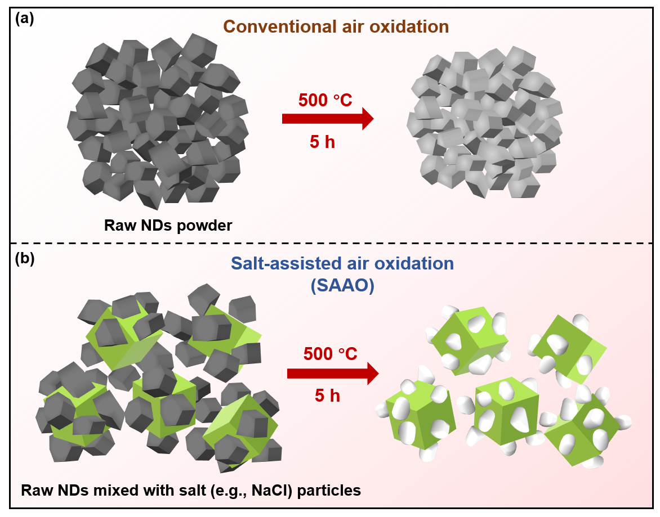
Scheme 1. Schematic illustration of the (a) conventional air oxidation and (b) SAAO processes.

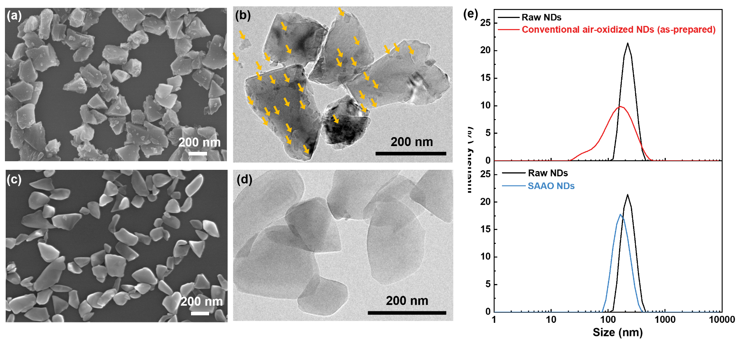
Figure 1. (a) SEM and (b) TEM images of the conventional air-oxidized (500 °C, 5h) NDs. The small-sized nanoparticles on the surface of the NDs are indicated by yellow arrows in the TEM image. (c) SEM and (d) TEM images of the SAAO (500 °C, 5h) NDs. (e) DLS size distribution of the raw, conventional air-oxidized and SAAO NDs.

3.2. Clean and rounded NDs by SAAO method
We suspected that the failure to remove the adsorbed impurities on the surface of NDs was due partly to the close packing of ND powder, and partly to deficiencies (e.g., incomplete or spontaneous oxidation) in the oxidation process. To overcome this, we proposed the so-called SAAO method, i.e., mixing NDs with salt crystals (i.e., NaCl or KCl) before the thermal treatment. In a typical experiment, the raw ND powder was mixed well with NaCl crystals with a mass ratio of 1:5, and the mixture was then routinely processed (heated at 500 °C in a furnace for 5 h in air), as depicted in Scheme 1b. After the SAAO treatment, the representative SEM (Figure 1c) and bright-field TEM (Figure 1d) images of the resultant NDs clearly showed a homogeneous distribution of resultant NDs containing a clear boundary and clean surface which is rarely, if ever, found in NDs oxidized in the conventional way (Figure 1b). The DLS result (Figure 1e) also showed that the size distribution of the NDs had shifted by tens of nm, involving a considerable reduction in the average size of the resultant NDs (from ~200 nm to ~170 nm), and this observation was consistent with the results of electron microscopy images. Significantly, the NDs also lost their original shard-like shape and became rounded (Figure S2 shows the quantitative results).
To further evaluate the performance of this novel method, we carefully characterized the detailed morphology features of individual NDs using a TEM-AFM correlated microscopy imaging technique (Figure 2). A randomly chosen ND, either SAAO treated or raw, was first viewed and located by TEM, and subsequently measured by AFM. As shown in Figure 2b, the randomly picked line profile indicated a smooth surface of the chosen particle treated by our SAAO method, and this was consistent with the reconstructed three-dimensional (3D) AFM image. By comparison, the raw ND particle showed a rough surface associated with unavoidably adsorbed small-sized nanoparticles, as evidenced by the line profile and reconstructed 3D AFM image (Figure 2a). The implications of this breakthrough are considerable, i.e., unlike the use of highly oxidized molten nitrates (KNO₃), we used the solid-state, non-oxidizing alkali chlorides (e.g., NaCl and KCl) on NDs oxidation, but achieved the same shape evolution (rounding effect), smoother and cleaner surface of NDs. The improved optical properties, reduced surface spin noise, improved surface roughness, reduced friction in-between particles and reduced anisotropy present in our SAAO NDs enable them to be used in a wide range of different applications, including photonics, quantum sensing, and imaging.²²⁻²⁵ At the same time, the surface chemistry of the SAAO NDs was identical with the conventional air-oxidized NDs (see the FTIR and XPS results in Figure S3).

Figure 2. TEM-AFM correlated characterizations. (a) raw and (b) SAAO ND. Panel (a), from left to right, shows a TEM image of a raw ND, an AFM topographic image of the same ND, the height profile as indicated by the red line in the topographic image, and a reconstructed 3D AFM image of the same ND. Panel (b), from left to right, shows a TEM image of a SAAO ND, an AFM topographic image of the same ND, the height profile as indicated by the blue line in the topographic image, and a reconstructed 3D AFM image of the same ND.

To find the optimized condition for the SAAO method, we compared it with the conventional method at different temperatures and durations. As summarized in Table S3, starting from 2 h (500 °C), the SAAO method would get clean and rounded NDs with a yield (i.e., the weight ratio of NDs after/before oxidation) of ~77 %. On the other hand, the yield of the conventional air-oxidized NDs was reduced gradually from ~96 % to ~77 % when the oxidation time increased from 1 h to 20 h, and small-sized nanoparticles adsorbed on NDs surface remained unchanged until the oxidation time reached 20 h. From the SEM image (Figure S4), only a few small-sized nanoparticles were still adsorbed on the surface (indicated by red circles) for the 20 h conventional air-oxidized NDs, however, the shard-like shape was remained unchanged (i.e., no rounding effect), which was different from the 2 h SAAO NDs even though they had the similar yield (~77 %). At the same time, 400 °C (2 h) could hardly oxidize NDs, while 600 °C (2 h) was too strong to control (with extremely low yields, ~6 % for the conventional method, and ~0 % for the SAAO method, respectively). Therefore, 500 °C, 2 h of SAAO might be the ideal condition for the treatment of the NDs with a clean surface and a relatively high yield. As for the most frequently discussed condition (i.e., 500 °C, 5 h), the yield of the SAAO method (~20 %) was greatly lower than that of the conventional method (~90 %), indicating that the presence of NaCl would accelerate the oxidation process of NDs (the underlying mechanisms will be discussed in the last section of the paper).

3.3. The newly generated “impurities” during conventional oxidation
As indicated from the abovementioned results (Figure 1e), a significant portion of nanoparticles (< 50 nm) was found in NDs just after conventional air oxidation. In contrast, this was not the case in our SAAO sample at all. To identify the origin of those newly generated “impurities”, we carefully separated them from the main portion of the sample (“bigger” NDs with a size of ~ 200 nm) by putting them undisturbed in DI water for 7 days (see illustrations in Figure 3a). Next, we observed a large quantity of small-sized nanoparticles, with distinct size and morphology compared with “bigger” NDs (Figure 3b), in the supernatant. Furthermore, we confirmed the majority of these small-sized nanoparticles were amorphous materials, as indicated by the TEM diffraction patterns (see insert in Figure 3c). And the corresponding elemental analysis (EDX spectra in Figure S5) showed the observed small-sized nanoparticles were mainly consisting of carbon. By comparison, only NDs (a few nm to ~200 nm) were observed in the supernatant of the aqueous dispersion of raw NDs after similar separation (Figure S6a), indicating the non-diamond impurities (amorphous carbon nanoparticles) should be generated during the conventional air oxidation process.
On the other hand, we performed a time-dependent oxidation study (Figure 3d) on pre-cleaned single ND (randomly chosen) directly on the TEM grid (details could be found in the Experimental Section). To rule out the possible influence of originally involved non-diamond impurities which were occasionally found in uncleaned raw NDs (Figure S1c), we chose the pre-cleaned NDs (with high-level cleanliness) as the starting material. As shown in Figure 3e (TEM image of one typical ND before the time-dependent oxidation study), nothing was found either on the surface or in the vicinity of this chosen particle. Gradually, some ultrasmall dots (~2 nm) emerged either near or on the ND (indicated by blue circles and red arrow in Figure 3f) after several rounds of oxidation which were designed to accumulate the quantity of those generated impurities. As a result, we attributed the observed small dots (judged by their morphology and TEM contrast) to amorphous carbon nanoparticles generated during the process of oxidation. In fact, the generation of amorphous carbon species has been well known when the carbon-related materials (e.g., NDs) are undergoing thermal treatments.⁴²⁻⁴⁵

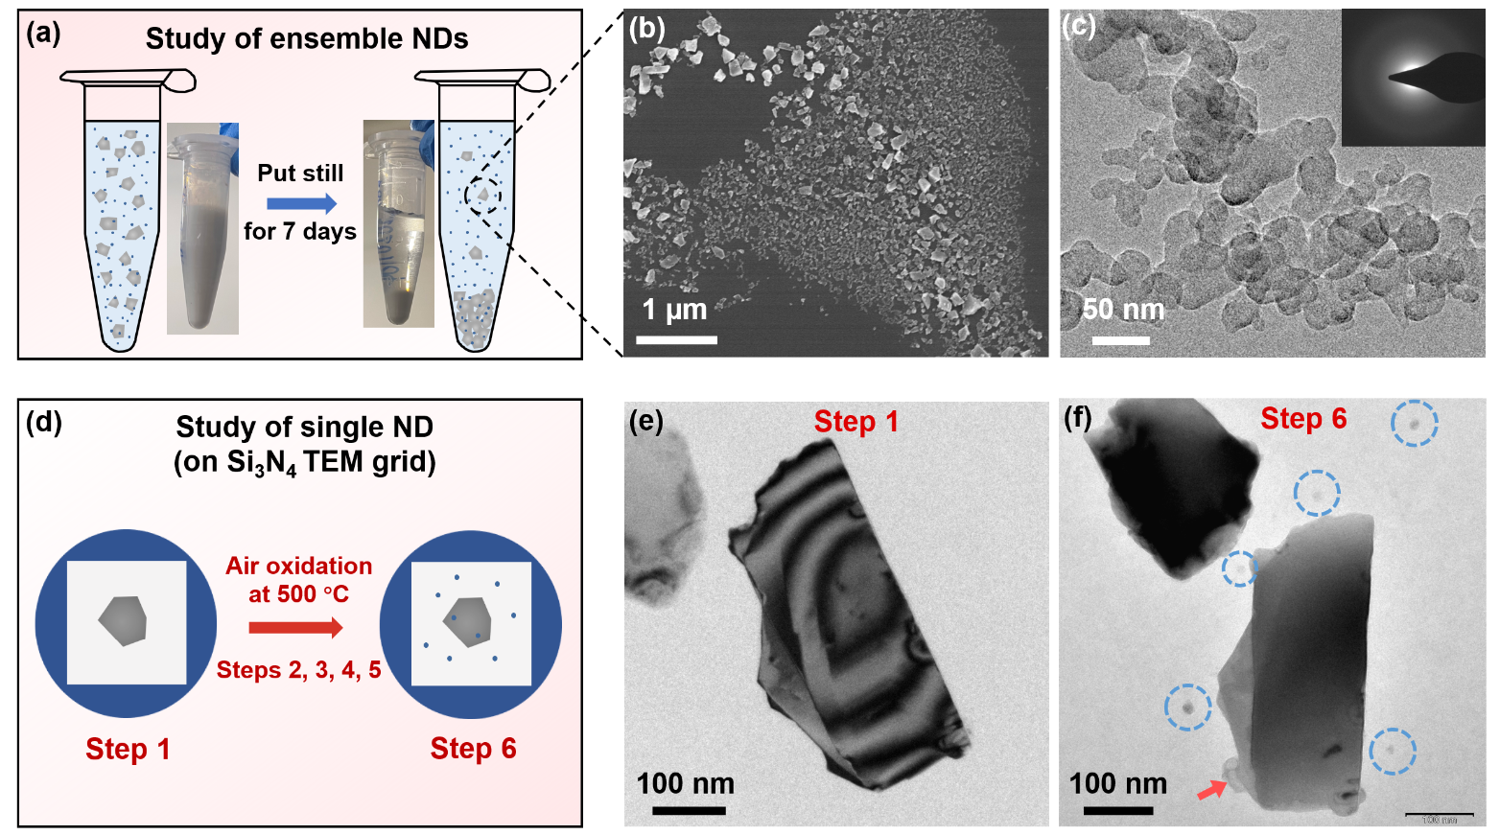
Figure 3. The origin of the observed newly generated impurities during oxidation. (a) Schematic illustration of the collection process of impurities in conventional air-oxidized NDs. (b) SEM image of the content in the upper solution. (c) TEM image of the non-diamond particles. The inset of (c) is the SAED pattern of the same clusters. (d) Schematic illustration of the process of the air oxidation study of single ND. Pre-cleaned NDs were first deposited onto Si₃N₄ film supported TEM grid, and one chosen ND was viewed and located by TEM (Step 1). The sample was then air oxidized at 500 °C for 5 times (Step 2, 3, 4 and 5: 1 h; Step 6: 2 h) and viewed again under TEM after each time. The TEM images of the chosen ND after Steps 1 and 6 are shown in (e) and (f), respectively. In (f), some amorphous carbon nanoparticles are circled in blue and indicated by red arrow.

3.4. The mechanism of the SAAO method
To investigate the underlying mechanisms of the developed SAAO method, we first checked the mixtures of NDs and NaCl (after oxidation) to see if the cleanliness of NDs on salt particles were changed directly without any further clean processes (e.g., washing and centrifugation). As shown in Figure 4a, the adsorbed NDs, on the surface of salt particles (size in a few hundred µm), were already found to be clean without any apparent small-sized nanoparticles adsorbed. And the modality of NDs (a thin “layered” film) on the salt surface was quite different from that involved in the conventional oxidation process (highly aggregated powder form). Therefore, considering the difference of NDs’ modality during oxidation, we first hypothesized that the salt particles might be served as thermal managing agents among particles like spacers, leading to a more even and rapid etching of the NDs. To verify this, we performed an air oxidation experiment (Figure S9) that NDs were coated on the non-salt substrate (i.e., Si wafer) mimicking the salt surface. Unfortunately, nothing happened to the NDs on Si wafer after air oxidized at 500 °C for 5 h. This indicated the formation of “layered” NDs film could not be the actual mechanism for the SAAO method.
The above results reminded us that the NaCl might also be involved in the oxidation process of NDs, not just acting like spacers. Inspired by the well-known fact that the chloride salts (e.g., NaCl and KCl) could extensively corrode metals or alloys at the temperature of 400 ‒ 700 °C due to the generated highly corrosive gases,⁴⁶⁻⁵¹ we further thought that the “etching atmosphere” generated by NaCl at high temperature (Figure 4b) would also significantly improve the etching rate of NDs (e.g., etching away the adsorbed small-sized nanoparticles and rounding NDs). To verify this hypothesis, we performed the TGA-DSC measurements (Figure 4c-e), which are used as a golden standard used to check the potential chemical reactions among solid substances. The measurements were conducted under the same conditions which were adopted to oxidize NDs as indicated in the Experimental Section, e.g., heated from room temperature (RT) to 500 °C with a heating rate of 5 °C/min and kept at 500 °C for 5 h in the air (indicated by the red lines in Figure 4c-e). The differences between the mixture of NDs and NaCl (Figure 4c) and NDs alone (Figure 4d) were clearly observed during the heat preservation period (5 h at 500 °C). The weight of NDs + NaCl decreased rapidly from 100 min to 250 min (i.e., the first 150 min after the temperature reached 500 °C), and it decreased slowly subsequently due to most of the NDs had already been oxidized (the weight of NaCl was assumed unchanged, obtained from Figure 4e), indicating that NaCl accelerated the oxidation process of NDs. At the same time, a peak at ~130 min (i.e., around 30 min after the temperature reached 500 °C, indicated by the dashed circle) was only observed in the mixture (NDs + NaCl) sample’s DSC curve, indicating that certain chemical reactions indeed happened there. On the other hand, the oxidation of pure NDs was a rather mild process, the weight loss gradually reached 37.40 % after the 5 h oxidation. The results above demonstrated that NaCl would accelerate the oxidation process of NDs under the help of the “salt-assisted etching atmosphere” generated at high temperature, leading to the etching of both diamond and non-diamond carbons, other impurities like metals, etc.⁵¹

Figure 4. The mechanism of the SAAO method. (a) SEM images of the NDs and NaCl mixtures (NDs + NaCl) after oxidation without any further cleaning processes. (b) Schematic illustration of the “salt-assisted etching atmosphere” generated during high-temperature air oxidation. The TGA-DSC curves of (c) NDs + NaCl, (d) NDs, and (e) NaCl, all of which were recorded under the same conditions, i.e., heated from room temperature (RT) to 500 °C with a heating rate of 5 °C/min and kept at 500 °C for 5 h.

4. Conclusions
We here report a simple and efficient method, recently developed by our team, for purifying NDs by SAAO. Our method allows the production of clean and rounded NDs. The impurity particles adsorbed on NDs were found to be etched by “etching atmosphere” introduced by NaCl at high temperature. These findings represent a significant scientific breakthrough together with a high commercial value. The ability to produce clean NDs simply and cost-effectively will remove many of the obstacles for using NDs in practical applications, especially those requiring high quality materials.

Supporting Information
Additional SEM and TEM images of the raw, well-washed conventional air-oxidized, and tri-acid treated NDs; the distribution of circularity of the raw and SAAO NDs; XRD, FTIR and XPS spectra of the raw, conventional air-oxidized, and SAAO NDs; the zeta potentials of the air-oxidized NDs; the salinity of the supernatant of the SAAO NDs aqueous solution after centrifugation; the detailed comparison (yields and SEM images) of the conventional and SAAO method; TEM, SEM images and EDX spectra of the upper solution content of raw and conventional air-oxidized NDs suspensions; the detailed schematic illustration and additional TEM images of the chosen ND in the time-dependent air oxidation study; the TEM image of 50 nm SAAO NDs; schematic illustration and SEM images of the NDs oxidation on Si wafer.

Conflict of Interest
The authors declare the following competing financial interests: A US provisional patent application has been filed with application No. 63/109,956.

Acknowledgments
This work was funded by HKSAR Research Grants Council (RGC) General Research Fund (GRF, No. 14306117), Early Career Scheme (ECS, No. 27202919); HKSAR Innovation and Technology Fund (ITF): Platform Projects of the Innovation and Technology Support Programme (ITSP, No. ITS/293/19FP); HKU Start-Up Grant, Small Equipment Grant (No. 102009812) and the Seed Fund (No. 201810159001). The authors are grateful for Prof. P.T. Lai (Dept. of Electrical & Electronic Engineering, The University of Hong Kong) for help with the furnace used in current work.

References
(1) Mochalin, V. N.; Shenderova, O.; Ho, D.; Gogotsi, Y., The Properties and Applications of Nanodiamonds. Nat. Nanotechnol. 2011, 7, 11−23.
(2) Kucsko, G.; Maurer, P. C.; Yao, N. Y.; Kubo, M.; Noh, H. J.; Lo, P. K.; Park, H.; Lukin, M. D., Nanometre-Scale Thermometry in a Living Cell. Nature 2013, 500, 54−58.
(3) Ziem, F. C.; Gotz, N. S.; Zappe, A.; Steinert, S.; Wrachtrup, J., Highly Sensitive Detection of Physiological Spins in a Microfluidic Device. Nano Lett. 2013, 13, 4093−4098.
(4) Schirhagl, R.; Chang, K.; Loretz, M.; Degen, C. L., Nitrogen-Vacancy Centers in Diamond: Nanoscale Sensors for Physics and Biology. Annu. Rev. Phys. Chem. 2014, 65, 83−105.
(5) Rendler, T.; Neburkova, J.; Zemek, O.; Kotek, J.; Zappe, A.; Chu, Z.; Cigler, P.; Wrachtrup, J., Optical Imaging of Localized Chemical Events Using Programmable Diamond Quantum Nanosensors. Nat. Commun. 2017, 8, 14701.
(6) Xia, K.; Liu, C.-F.; Leong, W.-H.; Kwok, M.-H.; Yang, Z.-Y.; Feng, X.; Liu, R.-B.; Li, Q., Nanometer-Precision Non-Local Deformation Reconstruction Using Nanodiamond Sensing. Nat. Commun. 2019, 10, 3259.
(7) Miller, B. S.; Bezinge, L.; Gliddon, H. D.; Huang, D.; Dold, G.; Gray, E. R.; Heaney, J.; Dobson, P. J.; Nastouli, E.; Morton, J. J. L.; McKendry, R. A., Spin-Enhanced Nanodiamond Biosensing for Ultrasensitive Diagnostics. Nature 2020, 587, 588−593.
(8) Rondin, L.; Tetienne, J. P.; Hingant, T.; Roch, J. F.; Maletinsky, P.; Jacques, V., Magnetometry with Nitrogen-Vacancy Defects in Diamond. Rep. Prog. Phys. 2014, 77, 056503.
(9) Casola, F.; van der Sar, T.; Yacoby, A., Probing Condensed Matter Physics with Magnetometry Based on Nitrogen-Vacancy Centres in Diamond. Nat. Rev. Mater. 2018, 3, 17088.
(10) Zhang, T.; Pramanik, G.; Zhang, K.; Gulka, M.; Wang, L.; Jing, J.; Xu, F.; Li, Z.; Wei, Q.; Cigler, P.; Chu, Z., Toward Quantitative Bio-sensing with Nitrogen−Vacancy Center in Diamond. ACS Sens. 2021, 6, 2077−2107.
(11) Volkov, K. V.; Danilenko, V. V.; Elin, V. I., Synthesis of Diamond from the Carbon in the Detonation Products of Explosives. Combust., Explos.Shock Waves 1990, 26, 366−368.
(12) Boudou, J. P.; Curmi, P. A.; Jelezko, F.; Wrachtrup, J.; Aubert, P.; Sennour, M.; Balasubramanian, G.; Reuter, R.; Thorel, A.; Gaffet, E., High Yield Fabrication of Fluorescent Nanodiamonds. Nanotechnology 2009, 20, 235602.
(13) Boudou, J.-P.; Tisler, J.; Reuter, R.; Thorel, A.; Curmi, P. A.; Jelezko, F.; Wrachtrup, J., Fluorescent Nanodiamonds Derived from HPHT with a Size of Less than 10 nm. Diamond Relat. Mater. 2013, 37, 80−86.
(14) Schrand, A. M.; Hens, S. A. C.; Shenderova, O. A., Nanodiamond Particles: Properties and Perspectives for Bioapplications. Crit. Rev. Solid State Mater. Sci. 2009, 34, 18−74.
(15) Nunn, N.; Torelli, M.; McGuire, G.; Shenderova, O., Nanodiamond: A High Impact Nanomaterial. Curr. Opin. Solid State Mater. Sci. 2017, 21, 1−9.
(16) Shenderova, O. A.; Shames, A. I.; Nunn, N. A.; Torelli, M. D.; Vlasov, I.; Zaitsev, A., Review Article: Synthesis, Properties, and Applications of Fluorescent Diamond Particles. J. Vac. Sci. Technol. B 2019, 37, 030802.
(17) Tinwala, H.; Wairkar, S., Production, Surface Modification and Biomedical Applications of Nanodiamonds: A Sparkling Tool for Theranostics. Mater. Sci. Eng. C 2019, 97, 913−931.
(18) Reina, G.; Zhao, L.; Bianco, A.; Komatsu, N., Chemical Functionalization of Nanodiamonds: Opportunities and Challenges Ahead. Angew. Chem. Int. Ed. 2019, 58, 2−14.
(19) Sangtawesin, S.; Dwyer, B. L.; Srinivasan, S.; Allred, J. J.; Rodgers, L. V. H.; De Greve, K.; Stacey, A.; Dontschuk, N.; O’Donnell, K. M.; Hu, D.; Evans, D. A.; Jaye, C.; Fischer, D. A.; Markham, M. L.; Twitchen, D. J.; Park, H.; Lukin, M. D.; de Leon, N. P., Origins of Diamond Surface Noise Probed by Correlating Single-Spin Measurements with Surface Spectroscopy. Phys. Rev. X 2019, 9, 031052.
(20) Dwyer, B. L.; Rodgers, L. V.; Urbach, E. K.; Bluvstein, D.; Sangtawesin, S.; Zhou, H.; Nassab, Y.; Fitzpatrick, M.; Yuan, Z.; De Greve, K., Probing Spin Dynamics on Diamond Surfaces Using a Single Quantum Sensor. arXiv preprint arXiv:2103.12757 2021.
(21) Kumar, R.; Yoon, S. J.; Lee, K. G.; Pal, P.; Pant, R. P.; Suman, C. K.; Dhakate, S. R.; Kumar, R.; Avasthi, D. K.; Singh, D. K., Purification Method Dependent Fluorescence from Nitrogen-Vacancy (NV) Centers of Nano-Diamonds. RSC Adv. 2016, 6, 47164−47173.
(22) Smith, B. R.; Gruber, D.; Plakhotnik, T., The Effects of Surface Oxidation on Luminescence of Nano Diamonds. Diamond Relat. Mater. 2010, 19, 314−318.
(23) Tisler, J.; Balasubramanian, G.; Naydenov, B.; Kolesov, R.; Grotz, B.; Reuter, R.; Boudou, J.-P.; Curmi, P. A.; Sennour, M.; Thorel, A., Fluorescence and Spin Properties of Defects in Single Digit Nanodiamonds. ACS Nano 2009, 3, 1959−1965.
(24) Tsukahara, R.; Fujiwara, M.; Sera, Y.; Nishimura, Y.; Sugai, Y.; Jentgens, C.; Teki, Y.; Hashimoto, H.; Shikata, S., Removing Non-Size-Dependent Electron Spin Decoherence of Nanodiamond Quantum Sensors by Aerobic Oxidation. ACS Appl. Nano Mater. 2019, 2, 3701−3710.
(25) Peng, Z.; Dallas, J.; Takahashi, S., Reduction of Surface Spin-Induced Electron Spin Relaxations in Nanodiamonds. J. Appl. Phys. 2020, 128, 054301.
(26) Balasubramanian, G.; Neumann, P.; Twitchen, D.; Markham, M.; Kolesov, R.; Mizuochi, N.; Isoya, J.; Achard, J.; Beck, J.; Tissler, J.; Jacques, V.; Hemmer, P. R.; Jelezko, F.; Wrachtrup, J., Ultralong Spin Coherence Time in Isotopically Engineered Diamond. Nat. Mater. 2009, 8, 383−387.
(27) Bradac, C.; Gaebel, T.; Pakes, C. I.; Say, J. M.; Zvyagin, A. V.; Rabeau, J. R., Effect of the Nanodiamond Host on a Nitrogen-Vacancy Color-Centre Emission State. Small 2013, 9, 132−139.
(28) Wolcott, A.; Schiros, T.; Trusheim, M. E.; Chen, E. H.; Nordlund, D.; Diaz, R. E.; Gaathon, O.; Englund, D.; Owen, J. S., Surface Structure of Aerobically Oxidized Diamond Nanocrystals. J. Phys. Chem. C 2014, 118, 26695−26702.
(29) Stehlik, S.; Varga, M.; Ledinsky, M.; Jirasek, V.; Artemenko, A.; Kozak, H.; Ondic, L.; Skakalova, V.; Argentero, G.; Pennycook, T.; Meyer, J. C.; Fejfar, A.; Kromka, A.; Rezek, B., Size and Purity Control of HPHT Nanodiamonds down to 1 nm. J. Phys. Chem. C 2015, 119, 27708−27720.
(30) Bradac, C.; Osswald, S., Effect of Structure and Composition of Nanodiamond Powders on Thermal Stability and Oxidation Kinetics. Carbon 2018, 132, 616−622.
(31) Kumar, R.; Singh, D. K.; Kumar, P.; Kumar, R.; Dhakate, S. R., Influence of Degree of Air Oxidation and Functionality on Ensemble Emission from Nitrogen Vacancy Centers in Nano-diamonds. Diamond Relat. Mater. 2019, 97, 107431.
(32) Fu, K. M. C.; Santori, C.; Barclay, P. E.; Beausoleil, R. G., Conversion of Neutral Nitrogen-Vacancy Centers to Negatively Charged Nitrogen-Vacancy Centers Through Selective Oxidation. Appl. Phys. Lett. 2010, 96, 121907.
(33) Havlik, J.; Petrakova, V.; Rehor, I.; Petrak, V.; Gulka, M.; Stursa, J.; Kucka, J.; Ralis, J.; Rendler, T.; Lee, S. Y.; Reuter, R.; Wrachtrup, J.; Ledvina, M.; Nesladek, M.; Cigler, P., Boosting Nanodiamond Fluorescence: Towards Development of Brighter Probes. Nanoscale 2013, 5, 3208−3211.
(34) Johnson, C. E., Chemical Polishing of Diamond. Surf. Coat. Technol. 1994, 68, 374−377.
(35) Cherian, K.; Litster, J.; Rudolph, V.; White, E., Chemical Etching of Diamond Revisited: Past Basic Research as Guide to New Processing Technologies. MRS Online Proc. Libr. 1997, 495, 419−424.
(36) Chu, Z.; Zhang, S.; Zhang, B.; Zhang, C.; Fang, C. Y.; Rehor, I.; Cigler, P.; Chang, H. C.; Lin, G.; Liu, R.; Li, Q., Unambiguous Observation of Shape Effects on Cellular Fate of Nanoparticles. Sci. Rep. 2014, 4, 4495.
(37) Zhang, B.; Feng, X.; Yin, H.; Ge, Z.; Wang, Y.; Chu, Z.; Raabova, H.; Vavra, J.; Cigler, P.; Liu, R.; Wang, Y.; Li, Q., Anchored but Not Internalized: Shape Dependent Endocytosis of Nanodiamond. Sci. Rep. 2017, 7, 46462.
(38) Hui, Y. Y.; Chen, O. Y.; Azuma, T.; Chang, B.-M.; Hsieh, F.-J.; Chang, H.-C., All-Optical Thermometry with Nitrogen-Vacancy Centers in Nanodiamond-Embedded Polymer Films. J. Phys. Chem. C 2019, 123, 15366−15374.
(39) Vollath, D.; Fischer, F. D.; Holec, D., Surface Energy of Nanoparticles - Influence of Particle Size and Structure. Beilstein J. Nanotechnol. 2018, 9, 2265−2276.
(40) Chang, I. P.; Hwang, K. C.; Ho, J. A.; Lin, C. C.; Hwu, R. J.; Horng, J. C., Facile Surface Functionalization of Nanodiamonds. Langmuir 2010, 26, 3685−3689.
(41) Aramesh, M.; Shimoni, O.; Ostrikov, K.; Prawer, S.; Cervenka, J., Surface Charge Effects in Protein Adsorption on Nanodiamonds. Nanoscale 2015, 7, 5726−5736.
(42) Zeiger, M.; Jäckel, N.; Mochalin, V. N.; Presser, V., Review: Carbon Onions for Electrochemical Energy Storage. J. Mater. Chem. A 2016, 4, 3172−3196.
(43) Duan, X.; Tian, W.; Zhang, H.; Sun, H.; Ao, Z.; Shao, Z.; Wang, S., sp2/sp3 Framework from Diamond Nanocrystals: A Key Bridge of Carbonaceous Structure to Carbocatalysis. ACS Catal. 2019, 9, 7494−7519.
(44) Lin, Y.; Sun, X.; Su, D. S.; Centi, G.; Perathoner, S., Catalysis by Hybrid sp²/sp³ Nanodiamonds and Their Role in the Design of Advanced Nanocarbon Materials. Chem. Soc. Rev. 2018, 47, 8438−8473.
(45) Sahoo, B. N.; Kandasubramanian, B., Photoluminescent Carbon Soot Particles Derived from Controlled Combustion of Camphor for Superhydrophobic Applications. RSC Adv. 2014, 4, 11331.
(46) Cha, S. C.; Spiegel, M., Local Reactions of KCl Particles with Iron, Nickel and Chromium Surfaces. Mater. Corros. 2006, 57, 159−164.
(47) Jonsson, T.; Folkeson, N.; Svensson, J. E.; Johansson, L. G.; Halvarsson, M., An ESEM in situ Investigation of Initial Stages of the KCl Induced High Temperature Corrosion of a Fe–2.25Cr–1Mo Steel at 400 °C. Corros. Sci. 2011, 53, 2233−2246.
(48) Liu, L.; Li, Y.; Wang, F., Corrosion Behavior of Metals or Alloys with a Solid NaCl Deposit in Wet Oxygen at Medium Temperature. Sci. China: Technol. Sci. 2011, 55, 369−376.
(49) Larsson, E.; Gruber, H.; Hellström, K.; Jonsson, T.; Liske, J.; Svensson, J. E., A Comparative Study of the Initial Corrosion of KCl and PbCl₂ on a Low-Alloyed Steel. Oxid. Met. 2017, 87, 779−787.
(50) Guo, L.; Mi, N.; Mohammed-Ali, H.; Ghahari, M.; Plessis, A. D.; Cook, A.; Street, S.; Reinhard, C.; Atwood, R. C.; Rayment, T.; Davenport, A. J., Effect of Mixed Salts on Atmospheric Corrosion of 304 Stainless Steel. J. Electrochem. Soc. 2019, 166, C3010−C3014.
(51) Fan, L.; Liu, L.; Lv, Y.; Wang, H.; Fu, A.; Yuan, J.; Li, Y.; Wang, F.; Yin, C., Effects of Pre-Oxidation on the Corrosion Behavior of Pure Ti Under Coexistence of Solid NaCl Deposit and Humid Oxygen at 600 °C: the Diffusion of Chlorine. Sci. Rep. 2020, 10, 16291.

