Bian, Ce, Wei Cao, Manli Hu, Zhiqin Chu, and Ruohui Wang. "2-in-1 Dual-Fiber Probe Integrated With Nanodiamonds for Optical Thermometry Measurements." IEEE Photonics Technology Letters 33, no. 23 (2021): 1321-1324. DOI: 10.1109/LPT.2021.3119351
2-in-1 Dual-Fiber Probe Integrated with Nanodiamonds for Optical Thermometry Measurements
Ce Bian
Wei Cao
Manli Hu
Zhiqin Chu
Ruohui Wang
Department of Electrical and Electronic Engineering
The University of Hong Kong
Corresponding author: Ruohui Wang, School of Physics, Northwest University, Xi’an, China. Email: rwang@nwu.edu.cn
Zhiqin Chu, Department of Electrical and Electronic Engineering, The University of Hong Kong, Hong Kong. Email: zqchu@eee.hku.hk
Submitted to IEEE PHOTONICS TECHNOLOGY LETTERS September 23, 2021
Accepted 7 October 2021
Ce Bian is a PhD student in the Department of Physics at Northwest University, Xi’an, China. His research interest includes optical fiber humidity sensing technology.
Wei Cao is a PhD student in the Department of Physics at Northwest University, Xi’an, China. His research interest includes optical sensing technology.
Manli Hu, PhD, is professor in the School of Physics at Northwest University. His research interests include information photonics, fiber sensors, and photoelectric inspection technology.
Zhiqin Chu, PhD, is Associate Professor in the Department of Electrical and Electronic Engineering and holds a Joint Appointment with the School of Biomedical Sciences at The University of Hong Kong. His research interests are in precision biosensing, biophysics, and diamond technologies.
Ruohui Wang, PhD, is professor in the School of Physics at Northwest University. His research interests include optical fiber sensing technology and microresonator sensors.

2-in-1 Dual-Fiber Probe Integrated With Nanodiamonds for Optical Thermometry Measurements
Ce Bian, Wei Cao, Manli Hu, Zhiqin Chu , Member, IEEE, and Ruohui Wang
Abstract
We here propose and demonstrate a novel “2-in-1” ﬁber consisting of two freely separated ﬁber ends and one ﬁber tip mounted with nanodiamonds (NDs) containing nitrogen vacancy (NV) centers. The ﬁber tip with ball lens is fabricated by fusing two parallel multimode ﬁber with arcing discharge. The excitation and collection of the integrated NV centers through the two ﬁber ends, can be optimized by manipulating the fabricated lens. We also demonstrate the feasibility of all-optical thermometry using this device. This endoscopy-like probe paves the way for developing ﬁber-based quantum device for ﬂexible thermometry and magnetometry.
I. INTRODUCTION
THE electron spin associated with a negatively charged nitrogen vacancy (NV) center in diamond has attracted wide attention for applications in sensors for magnetic ﬁelds [1]–[3], electric ﬁelds [4], [5], pressure [6] and temperature [7]–[9]. To efﬁciently use the NV centers in these applications, it is necessary to enhance the excitation and collection of ﬂuorescence (FL) by the color centers. In previous reports, the observations of the spin state of the NV centers and the analysis of FL lines using optical elements guided by multiple lenses, objectives, and dichromatic mirrors [10]–[13]. The bulky size and poor ﬂexibility of these optical components limit their portability and ﬂexibility. In recent years, the method of combining optical ﬁbers with NV centers has shown great potential for simplifying NV sensing systems. For example, a popular method is to couple nanodiamonds (NDs) to tapered ﬁbers [14]. However, tapered ﬁbers are unstable and easily disturbed by mechanical stresses. Duan and Schroderet et al. proposed two kinds of FL collection systems based on ﬁber probe structures [15], [16]. The FL intensity excited/collected by coupling micron-scale diamonds with optical ﬁbers in Ref. 15 is 150 times stronger than that excited/collected by coupling a single ND in Ref. 16. Although a single ND has the advantage of high resolution, its low FL collection efﬁciency cannot meet the requirements of most test environments. In addition, due to their size, micron-scale diamonds lack the ﬂexibility and advantageous high spatial resolution of NDs, and their NV centers have poor optical and spin properties.
In this letter, an integrated method combining a dual-ﬁber lens with NDs is proposed. Speciﬁcally, NDs were mixed with UV adhesive at a proper ratio and then coated onto the dual-ﬁber lens surface. The UV adhesive had very strong adhesion to a quartz material after curing [17], which guaranteed a robust attachment of the NDs to the dual-ﬁber lens surface. Two multimode ﬁbers (MMFs) were used for excitation and collection. The design of the sensor structure not only combines the advantages of ND and micron-scale diamonds but also reduces the sizes of the optical elements while ensuring the functioning of the probe structure, which further improves the integration of the whole system. Compared with temperature sensing based on the optically detected magnetic resonance (ODMR) technique [18], [19], the current conﬁguration, which facilitates all-optical thermometry, has the advantages of being simple and straightforward [20], and it can be readily implemented in any spectrometer. The results show that the excitation/collection efﬁciency is related to the shape of the dual-ﬁber lens probe, which offers many advantages, such as simple fabrication, compact size, and good collection efﬁciency.
II. FABRICATION OF THE PROBE
Fig. 1 depicts the fabrication process of the dual-ﬁber endoscope-like probe. Two MMFs (GI2017-A, YOFC. Core diameter: 105 µm, cladding diameter: 125 µm, NA: 0.30±0.02) are aligned side by side in a special fusion splicer (Fujikura FSM-100P+) for arcdischarge to form a lens structure; the 2-in-1 integrated ﬁber structure means that MMF1and MMF2 are used for excitation and collection, respectively.
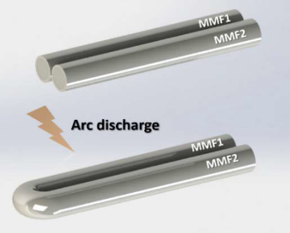
Fig. 1. Fabrication of the sensing probe.
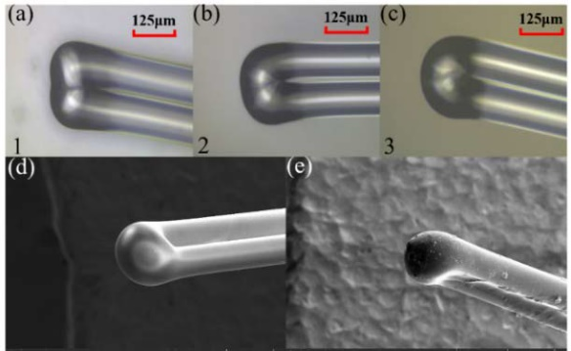
Fig. 2.(a)–(c) Micrographs of three dual ﬁber probes; (d)–(e) SEM images of uncoated and coated UV adhesive on lens surface.
After many trials, we found that different lens shapes can be obtained by changing the discharge parameters. Fig. 2. (a)-(c) shows three fabricated probes marked as samples 1, 2 and 3. By appropriately increasing the arcing power and duration, the curvature radius of the lens can be further reduced. For the fabrication of probe 1, the discharge power and time are 60 bits and 1200 ms, respectively. Although the two optical ﬁbers have been fused in parallel, the lens structure is not perfect, and there are some pits at the joints. When the discharge power and time were increased to 80 bits, 1400 ms and 100 bits, 1600 ms, we obtained lens with curvature radii of approximately 175 µm and 115 µm, respectively, as shown in Fig. 2 (b) and (c). It should be noted that the distance between the arc tip and the ﬁber tip is about 180 µm when making the three different shaped probes. Fig. 2 (d) presents the scanning electron microscope (SEM) image of probe 3. The surface is very smooth, and the lens shape is standard, which is necessary to improve the excitation and collection efﬁciency [21], [22].
The UV adhesive was prepared by mixing 0.1 mg diamond powder with a particle diameter of 100 nm and 5 µl of an optical adhesive (Norland optical adhesive 68, n =1.58). The mixture was then dispersed for 30 minutes using ultrasound to form a uniform solution with a concentration of 20 mg/mL prior to ﬁlm deposition. Probe 3 was inserted vertically into the mixture and slowly removed, and the surface of the lens was coated with a ﬁlm of ∼15 µm, as shown in Fig. 2 (e). The ﬁlm was ﬁnally cured after half an hour with a UV lamp, and the NDs were ﬁrmly ﬁxed on the lens surface. The amount of NDs in the lens ﬁlm can be easily adjusted by changing the proportion of NDs in the UV adhesive, an advantage that is not available with micron-scale diamonds.
III.RESULTS AND DISCUSSION
To evaluate the performance of the fabricated probes, an experimental apparatus for optical measurements was con- structed, as shown in Fig. 3. The excitation light from a 532 nm laser was delivered to the NDs through MMF1, and the excited FL signals from the NV centers were subsequently delivered through MMF2 to the spectrometer for detection.
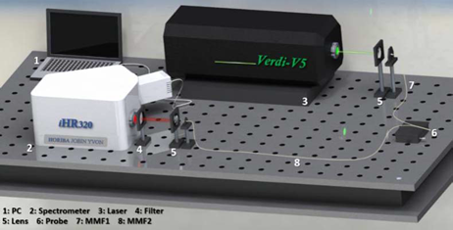
Fig. 3. A schematic diagram of the experimental setup.

A long-pass ﬁlter (600 nm) was placed in front of the spectrometer to ﬁlter out the pump laser. Unlike the setup for a single-ﬁber probe, the setup for the 2-in-1 dual-ﬁber probe does not require beam splitters, which simpliﬁes the system. The impact of lens shape on FL collection efﬁciency was simulated by the ray tracing method. In the simulation, we assume that the three probes have the same number of beams through the lens and UV adhesive. The refractive indices of the NDs, core and cladding are set to 2.4, 1.45 and 1.44, respectively, and the NDs are randomly arranged in the UV adhesive. The simulated results of the excitation using the geometrical optics method are shown in Fig. 4. When the thickness of the ﬁlm remains constant, the shape of the lens becomes increasingly rounded, and the radius of curvature decreases. More excited light is reﬂected in MMF2, which also indicates that more FL is collected back into MMF2.

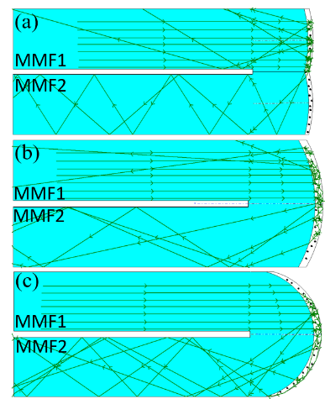
Fig. 4. Ray tracing simulations are shown in (a)–(c). The simulations are conducted using Optgeo.
In the experiment, we connected the three probes to the established optical system to evaluate their FL excitation/collection efﬁciency. Fig. 5 shows the FL signal intensity collected by the three probes at 10 mW and 20 mW laser power. At an excitation power of 10mW, the FL signal collection intensity of probes1, 2and3 corresponds to 14204 counts, 25812 counts and 36368 counts, respectively. The FL collection efﬁciency of probe 2 and probe 3 is approximately 82% and 156% higher than that of probe 1. This proves that the decrease in curvature radius of the dual ﬁber lens enhances the FL collection efﬁciency, which is consistent with the simulation results. If the excitation power is adjusted to 20 mW, the FL collection efﬁciency of the probe is further improved. Because the maximum threshold of the spectrom- eter is 65000 counts, the maximum FL collection intensity of probe 3 is saturated in the spectrum. Fig.6 compares the FL collection intensity between single-ﬁber and dual-ﬁber probes coated with NDs, and the inset is an optical micrograph of a single-ﬁber probe. The concentration of the mixture of UV adhesive and NDs is the same for dual-ﬁber and single ﬁber lenses; however, the coating on the single-ﬁber lenses is thicker than that on the dual-ﬁber lens. Even with a thinner coating, the FL collection intensity of the dual-ﬁber probe lens enhances the FL collection efﬁciency, which is consistent with the simulation results. If the excitation power is adjusted to 20 mW, the FL collection efﬁciency of the probe is further improved. Because the maximum threshold of the spectrumeter is 65000 counts, the maximum FL collection intensity of probe 3 is saturated in the spectrum. Fig. 6 compares the FL collection intensity between single-ﬁber and dual-ﬁber probes coated with NDs, and the inset is an optical micrograph of a single-ﬁber probe. The concentration of the mixture of UV adhesive and NDs is the same for dual-ﬁber and single-ﬁber lenses; however, the coating on the single-ﬁber lenses is thicker than that on the dual-ﬁber lens. Even with a thinner coating, the FL collection intensity of the dual-ﬁber probe (probe 3) is still much higher than that of the single-ﬁber probe. At an excitation power of 10 mW, the FL collection intensity of the single-ﬁber probe is 27180 counts, which is approximately 74.7% of that of the dual ﬁber probe, indicating that the FL collection efﬁciency of the dual-ﬁber probe is approximately 33.8% higher than that of the single-ﬁber probe.
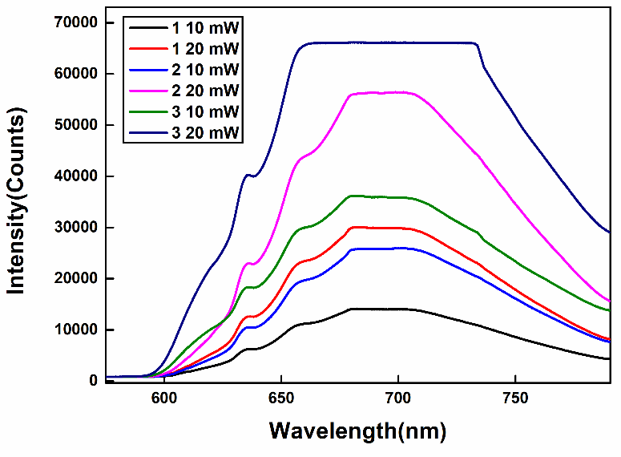
Fig. 5. The FL energy of three probes at different excitation power.
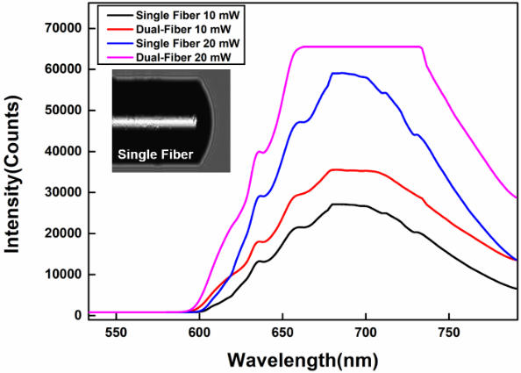
Fig. 6. Comparison of FL collection intensity between single ﬁber and dual-ﬁber.
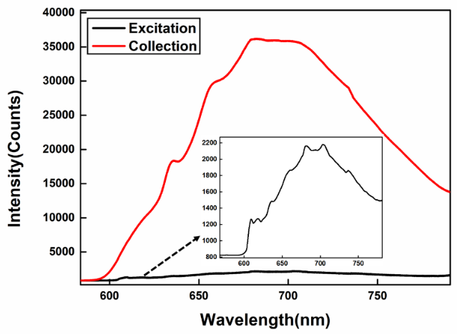
Fig. 7. FL intensity of excitation end and collection end of probe 3.
Next, we modiﬁed the experimental setup to detect the FL intensity at the excitation end of a probe (MMF1). A dichromatic mirror, which can transmit 532 nm green light and reﬂect FL signals, is placed between the laser and the lens. Then, the ﬁlter and the receiver port of the spectrometer are adjusted in the direction of the 45-degree reﬂection angle of the dichromatic mirror to receive the FL signal reﬂected from the excitation end, while the positions of the remaining components remain unchanged. Figure 7 shows that the FL signal intensities of the collection and excitation ends of probe 3 are signiﬁcantly different at the excitation power of 10 mW. As shown in the inset, the FL signal of the excitation end is 2180 counts, which only accounts for 5% of the total FL signal intensity, indicating that almost all the FL signals are collected by MMF2. The results prove that the probe has a high FL collection efﬁciency.
We also experimentally verify the feasibility of the all-optical temperature measurement technique. Most optical ﬁber thermometers based on NV centers in diamond use theODMR method for temperature measurement, but this method may damage the circuit or biological properties and is itself susceptible to radiofrequency interference [23]. This complexity can be avoided by directly observing the wavelength redshift and broadening of the zero-phonon line (ZPL) to read the temperature change information [20]. This all-optical temperature measurement method can read the temperature information by directly observing the ZPL shift. In Ref. 20, the temperature sensitivity of ZPL was 0.015 nm/◦C.
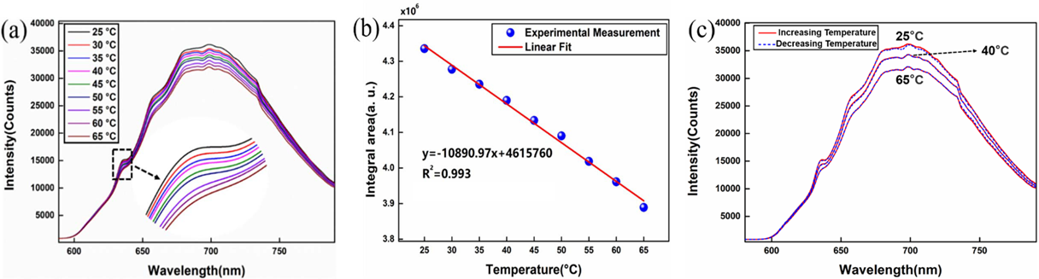
Fig. 8. (a) The temperature response FL signal spectra of probe 3; (b) The increase temperature ﬁtting curve of probe 3; (c) Comparison of increasing and decreasing temperature of probe 3.
The principle of the all-optical temperature measurement method proposed in this letter is based on the refractive index change of the UV adhesive at different temperatures. A RI change indirectly leads to a change in the collection efﬁciency of the FL signals, and therefore, we can directly read the change to obtain the temperature. In the temperature sensing experiment, probe 3 was ﬁxed 2 cm above the water surface in a water bath, and the excitation power was set to 10 mW. As shown in Fig. 8 (a), FL spectra were recorded
at intervals of 5 ◦C in the range of 25 ◦C ∼ 65 ◦C. The energy of the main excitation peak decreases with increasing temperature, which proves that the thermal expansion of the UV adhesive reduces its refractive index, leading to the leakage of the excitation light and FL signal. The decrease in FL intensity at high temperatures due to an increase in nonradiative pathways also contributes to the intensity reduction of ZPL [8], however the thermal expansion of UV glue is still the main reason for the reduction of FL energy [20]. Fig. 8 (b) presents the ﬁtting curve showing the integrated spectral area versus temperature of probe 3, and it can be concluded that for every 1 ◦C increase in temperature, the corresponding integral area decreases by 10891 units. In Fig. 8 (c), we took three temperature points (25 ◦C, 45 ◦C, 65 ◦C) and compared the spectra while increasing and decreasing the temperature. The spectral lines at each temperature are coincident, and the good coincidence proves the probe’s high reproducibility.
IV. CONCLUSION
An efﬁcient coupling method for NDs based on a 2-in-1double-ﬁber probe is proposed. Simulation and experimental results show that changing the shape and radius of curvature of the dual-ﬁber lens affects the FL excitation and collection efﬁciency of the probe. The maximum FL collection intensity was 36368 counts at 10 mW excitation power. We tested the temperature of the probe using an all-optical method, and for every 1 ◦C increase, the integrated spectral area of the sensing probe decreased by 10891 units. The probe also demonstrated good repeatability and stability and has potential for applications in temperature and magnetic ﬁeld measurements.
REFERENCES
[1] H. J. Mamin et al., “Nanoscale nuclear magnetic resonance with a nitrogen-vacancy spin sensor,” Science, vol. 339, no. 6119, pp. 557–560, Feb. 2013.
[2] S. Hong et al., “Nanoscale magnetometry with NV centers in diamond,” MRS Bull., vol. 38, no. 2, pp. 155–161, Feb. 2013.
[3] H. Clevenson, M. E. Trusheim, C. Teale, T. Schröder, D. Braje, and D. Englund, “Broadband magnetometry and temperature sensing with a light-trapping diamond waveguide,” Nature Phys., vol. 11, no. 5, pp. 393–397, May 2015.
[4] F. Dolde et al., “Electric-ﬁeld sensing using single diamond spins,” Nature Phys., vol. 7, no. 6, pp. 459–463, Jun. 2011.
[5] F. Dolde et al., “Nanoscale detection of a single fundamental charge in ambient conditions using the NV−center in diamond,” Phys. Rev. Lett., vol. 112, no. 9, Mar. 2014, Art. no. 097603.
[6] M. W. Doherty et al., “Electronic properties and metrology applications of the diamond NV−center under pressure,” Phys. Rev. Lett., vol. 112, no. 4, Jan. 2014, Art. no. 047601.
[7] A. A. Lanin et al., “Fiber-optic electron-spin-resonance thermometry of single laser-activated neurons,” Opt. Lett., vol. 41, no. 23, pp. 5563–5566, 2016.
[8] D. Duan et al., “Laser-induced heating in a high-density ensemble of nitrogen-vacancy centers in diamond and its effects on quantum sensing,” Opt. Lett., vol. 44, no. 11, p. 2851, Jun. 2019.
[9] G. Kucsko et al., “Nanometer scale quantum thermometry in a living cell,” Nature, vol. 500, no. 7460, p. 54, Oct. 2013.
[10] P. Neumann et al., “High-precision nanoscale temperature sensing using single defects in diamond,” Nano Lett., vol. 13, no. 6, pp. 2738–2742, Jun. 2013.
[11] L. Rondin, J.-P. Tetienne, T. Hingant, J.-F. Roch, P. Maletinsky, and V. Jacques, “Magnetometry with nitrogen-vacancy defects in diamond,” Rep. Prog. Phys., vol. 77, no. 5, May 2014, Art. no. 056503.
[12] D. M. Toyli, C. F. de las Casas, D. J. Christle, V. V. Dobrovitski, and D. D. Awschalom, “Fluorescence thermometry enhanced by the quantum coherence of single spins in diamond,” Proc. Nat. Acad. Sci. USA, vol. 110, no. 21, pp. 8417–8421, May 2013.
[13] D. Duan, V. K. Kavatamane, S. R. Arumugam, Y.-K. Tzeng, H.-C. Chang, and G. Balasubramanian, “Tapered ultra-high numerical aperture optical ﬁber tip for nitrogen vacancy ensembles based endoscope in a ﬂuidic environment,” Appl. Phys. Lett., vol. 116, no. 11, Mar. 2020, Art. no. 113701.
[14] L. Liebermeister et al., “Tapered ﬁber coupling of single photons emitted by a deterministically positioned single nitrogen vacancy center,” Appl. Phys. Lett., vol. 104, no. 3, Jan. 2014, Art. no. 031101.
[15] D. Duan et al., “Efﬁcient nitrogen-vacancy centers’ ﬂuorescence excitation and collection from micrometer-sized diamond by a tapered optical ﬁber in endoscope-type conﬁguration,” Opt. Exp., vol. 27, no. 5, pp. 6734–6745, Mar. 2019.
[16] T. Schröder, A. W. Schell, G. Kewes, T. Aichele, and O. Benson, “Fiber-integrated diamond-based single photon source,” Nano Lett., vol. 11, no. 1, pp. 198–202, Jan. 2011.
[17] P. A. Mohammed, “Optical and mechanical properties of self-written polymer waveguide between single mode optical ﬁbers using UV photocurable monomer system,” Eur. Polym. J., vol. 139, Oct. 2020, Art. no. 109950.
[18] I. V. Fedotov et al., “Fiber-based thermometry using optically detected magnetic resonance,” Appl. Phys. Lett., vol. 105, no. 26, Dec. 2014, Art. no. 261109.
[19] J. P. Tetienne et al., “‘Scanning nanospin ensemble microscope for nanoscale magnetic and thermal imaging,” Nano Lett., vol. 16, no. 1, pp. 326–333, 2015.
[20] P. C. Tsai et al., “Measuring nanoscale thermostability of cell membranes with single gold-diamond nanohybrids,” Angew. Chem., vol. 56, no. 11, p. 3025, 2017.
[21] Y. Z. Chen, J. W. Cui, and J. B. Tan, “Analysis of the coupling efﬁciency of a dual-ﬁber spherical coupler and improvement of the coupling efﬁciency with a polished spherical coupler,” IEEE Photon. J., vol. 10, no. 4, Aug. 2018, Art. no. 7203108.
[22] H. Y. Choi et al., “‘Microlensed dual-ﬁber probe for depth-resolved ﬂuorescence measurements,” Opt. Exp., vol. 19, no. 15, pp. 14172–14181, 2011.
[23] S. M. Blakley et al., “Photonic-crystal-ﬁber quantum probes for high-resolution thermal imaging,” Phys. Rev. A, Gen. Phys., vol. 13, no. 4, Apr. 2020, Art. no. 044048.

