Development of Radio-Frequency Identification (RFID) Sensors Suitable for Smart-Monitoring Applications in Sewer Systems
Sundra R. Tatiparthi ¹, Yashika G. De Costa ¹, Colin N. Whittaker ¹, Shihu Hu ², Zhiguo Yuan ², Ray Y. Zhong ^{1,3*}, and Wei-Qin Zhuang ^{1*}

¹Department of Civil and Environmental Engineering, Faculty of Engineering, The University of Auckland, Symonds St, Auckland, 1010, New Zealand
² Advanced Water Management Centre, The University of Queensland, St Lucia, QLD 4072, Australia
³ Department of Industrial and Manufacturing Systems Engineering, The University of Hong Kong, Pokfulam Road, Hong Kong

*Corresponding author e-mail: wq.zhuang@auckland.ac.nz (Wei-Qin Zhuang)
*Co-corresponding author e-mail: zhongzry@hku.hk (Ray Y. Zhong)

Abstract

Sanitary and stormwater sewers are buried assets that play important roles in the prevention of diseases and the reduction of health risks for our societies. Due to their hidden nature, these assets are not frequently assessed and maintained to optimal conditions. The lack of maintenance can cause sewer blockages and overflows that result in the release of pathogens into the environment. For cities, monitoring sewer conditions on a large-scale can be costly, time-consuming, and labor-intensive if using current low-throughput technologies, such as dye testing or closed-circuit television. Alternatively, smart sensor systems can provide low-cost, high-throughput, and automatic data-driven features for real-time monitoring applications. In this study, we developed ultrahigh-frequency radio-frequency identification (UHF RFID)-based sensors that are flushable and suitable for sanitary and stormwater pipes quick surveys. 3D printed RFID sensors were designed to float at the water-air interface and minimize the water interference to RF signal communications. The optimal detection range was also determined to support the design and installation of the reader in various utility holes. Field trials demonstrated that the UHF RFID system is a low-cost, high-throughput, and robust solution for monitoring blockage, illicit-connection, and water flow in sewer networks.

Keywords:
Radio-frequency identification (RFID); smart sewer networks; passive UHF-RFID sensors; high-throughput monitoring; sewer blockages; surface flow rate.
Abbreviations
CCTV Closed-circuit television
D Maximum antenna dimension
DTS Distributed temperature sensing
dBiC Decibel above the gain of an isotropic antenna
dBi Decibel relative to isotropic
d_{f} Effective reading distance
G_{r} The gain of the receiving tag antenna
G_{t} The gain of the transmitting antenna
HRT Hydraulic retention time
IC Integrated circuit
IoT Internet of Things
IPS Insulated paper substrate
PLA Polylactic acid
P_{tag} Tag sensitivity
r Radiating near field distance
Re Reynolds number
RFID Radiofrequency identification
RF Radiofrequency
RSSI Received signal strength indication
SGT Stormwater gully trap
SWM Stormwater utility hole
UHF Ultra-high frequency
WGT Wastewater gully trap
WWM Wastewater utility hole
Z_{d} Maximum reading distance
$λ$ Wavelength

Introduction

In metropolises, sewer defects are becoming more frequent due to aging infrastructure, insufficient rehabilitation, and climate change associated infiltration/inflow uncertainties (Hvitved-Jacobsen et al., 2013; Murali et al., 2019; Semadeni-Davies et al., 2008). Furthermore, the widespread application of sustainable practices (i.e., water conservation practices) have resulted in decreased wastewater inflows and increased solid concentrations, which have severely altered biochemical processes occurring in sewer networks (Butler, 2018; Hvitved-Jacobsen et al., 2013; Marleni et al., 2012; Murali et al., 2019). For example, the increasing quantities of fat, oil, and grease discharged into the sewer systems can trap and accumulate sediments on sewer beds and eventually lead to fatberg formations (Butler, 2018; Ugarelli et al., 2009), causing frequent blockages, corrosion, and odor problems in sewer pipes (Gosset et al., 2016; Gross et al., 2017; Hvitved-Jacobsen et al., 2013). Blockages can lead to sewer overflows, which would release raw sewage containing a range of contaminants in particulate and soluble forms to both aquatic and terrestrial ecosystems (Rodríguez et al., 2012; ten Veldhuis et al., 2010).

To avoid sewer blockages and deteriorations, sewer conditions should be frequently accessed. Currently, there are a few technologies on the market, including visual inspections using closed-circuit television, utility hole inspection camera, dye testing, smoke testing, and acoustic technologies, that are suitable for their respective niche applications (Panasiuk et al., 2015; Plihal et al., 2014). However, these technologies are low-throughput, time-consuming, labor-intensive, or lacking real-time monitoring capabilities. The need for high-throughput, robust, cost-effective sewer monitoring is mounting. In many other fields, battery-free wireless sensing technologies have received increasing interest due to their unobtrusive nature, energy-efficient operation, and minimal sensor costs (Edmondson et al., 2018; Potyrailo et al., 2012; Tanguy et al., 2015). However, such sensing technologies are still rare in the field of sewer monitoring and assessment.
Radiofrequency identification (RFID) technology, especially ultra-high frequency (UHF)-RFID (865–928 MHz), has been widely applied in many industries and large-scale Internet of Things (IoT) applications due to its simple architecture, real-time sensing capability, and versatile detection ranges (Arnaud et al., 2015; Cassel et al., 2017b; Colin et al., 2019; Jun et al., 2016; Sun et al., 2013; Tanguy et al., 2015). Compared to battery-operated sensor tags known as active tags, passive RFID tags are much more popular because of their battery-free nature, longer life span, small size, and low-cost (Jun et al., 2016). However, the application of RFID-based sensors in environmental engineering, particularly in water environments, is still scarce because radio wave transmissions are extremely sensitive to air and water conductivity, among a number of other essential factors (Benelli et al., 2011; Benelli and Pozzebo, 2013; Bertoni et al., 2010; Chapuis et al., 2014; Tatiparthi et al., 2020). For example, studies have reported that a change in RFID tag orientation from horizontal to vertical resulted in a 26%-76% reduction in tag detection ranges (Papangelakis et al., 2019; Tsakiris et al., 2015). Although possessing superb reading ranges, UHF-RFID is even more sensitive to water, creating a challenge to apply this technology for sanitary or stormwater network monitoring.

This study aims to design and evaluate passive UHF-RFID-based sensors for sewer blockage and illicit-connection monitoring applications. We first investigated the performance of a suite of UHF-RFID tags to determine their optimum reading ranges related to tag-antenna interplay. Then, we tested the tags in a laboratory hydraulic flume to determine the effect of water flow conditions on the received signal strength indication (RSSI) values. Finally, the RFID systems were field-tested in both sanitary and stormwater networks. Through this study, we demonstrated that low-cost, high-throughput, and non-invasive approaches for monitoring buried utility service infrastructures are achievable.

Materials and Methods
In this section, only some essential information of our experimental materials and methods are provided. Additional experimental materials and methods used in this study are provided in the Supporting Information, section S1 Materials and Methods. Subsections in the Supporting Information were designated sequentially as S1.1, S1.2, S1.3, or S2.1, S2.2, S2.3, and so forth. All Figures and Tables in the Supporting Information sections are designated sequentially as Figure S1, Figure S2, Figure S3, or Table S1, Table S2, Table S3, and so forth.
  - RFID Equipment
The RFID equipment used in this study were obtained from two suppliers. The first reader, designated as M6e (Figure S1[A]) was a four-channel ThingMagic Mercury 6e UHF-RFID reader (JADAK, USA). The frequency range of the reader antenna was 865–928 MHz. Two antennae typologies from the MTI Wireless Edge Ltd, USA were connected to the M6e reader: (i) 9 dBiC circular polarization antenna (Figure S1[B]), (ii) 12.5 dBi linear polarization antenna (Figure S1[C]). The second RFID reader (Shenzhen RUIFAN Electronics, China), designated as SZRF, contained an inbuilt 8 dBiC circular polarization antenna (Figure S1[D]) within the reader and an interface connected through a computer to RS232 serial communication. Additional details of the RFID equipment are presented in the Supporting Information, section S1.1.

  - Determination of effective reading zones of UHF-RFID sensor tags
Twelve types of UHF-RFID sensor tags were tested (for additional details of these tags, see Table S1 and section S1.2 in the Supporting Information) with the 8 dBiC, 9 dBiC, and 12.5 dBi antennae for the identification of the maximum reading distances${ (Z}_{d})$. Five randomly selected sensor tags out of 20 from each type were measured at least ten times with the 8 dBiC, 9 dBiC, and 12.5 dBi antennae, respectively. Initially, each tag was placed in the center of each antenna (defined as x₀, y₀). Then, $Z_{d}$ was measured by moving the tag away from the antenna center slowly (Figure S2).

Finally, Tag 7, Tag 8, and Tag 9 were selected for further evaluation based on their better $Z_{d}$ ranges and smaller physical sizes that are appropriate for sewer applications. Because the vertical and horizontal orientations of RFID tags can significantly affect their actual reading ranges (creating a three-dimensional space), the detecting ranges of the selected tags were tested by rotating them from α = 0° (designated as the horizontal position, -H) and α = 90° (designated as the vertical position, -V) relative to the antenna plane (x_{i}, y_{i}, z_{i}) (also see in section S1.3). Each of the selected tags was measured at least ten times with the 8 dBiC, 9 dBiC, and 12.5 dBi antennae at 12 positions (every 30° increment) with respect to the antenna in the horizontal and vertical axes (Figure S3).

  - Evaluation of UHF-RFID-based sensors in aquatic environments
Testing in a controlled aquatic environment was conducted in a 19 m long, 0.45 m wide, and 0.5 m deep flume with a slope of 1/50 (m/m) in the Fluid Mechanics Laboratory at the University of Auckland. The detailed experimental setups of the reader antenna are provided in the Supporting Information section S1.4, S1.5, and Figure S4. A series of tests were designed to assess the propagation of RF waves and their detection limits at changing flow rates (~ 7-71 L/s) under turbulent flow conditions (Reynolds number (Re) ~ 10000-73000). In general, ten of Tag 7 and ten of Tag 9 were fixed on a wooden board with a 5-cm interval (Figure S4-S6), and the signal strengths of both sensors under various flow rates and water depths (below and above water levels) were measured. The Tag 7 group and Tag 9 group sensors were designated as Tag 7-01 to -10 and Tag 9-01 to -10, respectively, based on their relative positions on the wooden board in the flume. The identification number of each tag and its received signal strength indication (RSSI) were continuously measured and recorded using URA (Universal Reading Assistance) software. At each run (total 12 runs), the tag signals were recorded for at least five minutes to attain several values of RSSI in different water depths (Table S2). The RSSI values in dBm and their descriptive data statistics were processed using Origin Lab software, version 9.7 (OriginLab Corporation, USA), throughout each run. Three replicates of experiments were recorded in each test run (Table S2), and flow conditions were set identically in all the 12 runs.

Finally, two field trials were conducted in two catchment areas in the City of Auckland, New Zealand, to evaluate the performance of the designed RFID sensors in a segment of sanitary sewer and stormwater pipes. The total material costs for fabricating UHF-RFID-based sensors and other equipment costs for the field trials are summarized in Table 1. In each segment of the pipe, one utility hole was opened for the temporary installation of the RFID system. The RFID reader with two antennae (9 dBiC) was positioned (according to the effective reading range design shown in Figure 2) in two utility holes at a time during the field trials. In all utility holes, antennae were adjusted to be within the effective reading distance ($d_{f}$) between 0.57-3.5 m, which is based on the depth and actual water surface of the utility hole. In one catchment, RFID antennae were temporarily installed just below the rim-level of a stormwater utility hole (~2 m deep) and a sanitary utility hole (~ 2.5 m deep) because their depths fall within the effective reading distance ($d_{f}$). In another catchment, an RFID antenna was temporarily installed deep inside a sanitary utility hole (~ 6 m deep) using a scaffold modified from a heavy-duty tripod. However, in this particular catchment, RFID antenna installation in the stormwater utility hole was not permitted by the on-site manager due to accessibility and safety issues. All antenna installations in this study were temporary because no permanent scaffold or modifications to the interior of the utility holes were allowed by the authority during our field trials.

Afterward, we flushed polylactic acid (PLA) encapsulated (Tag 7 and Tag 9) UHF-RFID-based sensors (n=109) through a total of 39 household properties via their wastewater gully-traps. The sensors were released during low domestic sewage inflows in each catchment (between 10 am and 4 pm), and its percentage of detection rates were evaluated in downstream utility holes.

Table 1. RFID systems material costs estimation per property in field applications.
Item | Description | Quantity | Cost per unit | Cost per 100 properties | Per property = [Item (1) + (2) + (3)]/100 in USD
1 | Purchase of UHF-RFID sensors cost (e.g., three tags per house). | 300 | $1.5 per tag | $ 450.00 | $ 20.50
2 | Purchase of RFID reader, two antennae, one computer, power source to readers ($ 2000 initial x 20% depreciation per year for five years with no salvage value. | Lump sum | $ 400 per year | $ 400.00  (assume only 100 properties per year) | $ 20.50
3 | Labor costs for sensor releasing, data collection, equipment set up. Lump sum of 12-person hour work time for 100 properties. | four workers | $ 25/h | $ 1,200.00  (cost reduction discussed later) | $ 20.50

Results and Discussion
This section covers key discoveries in this study. Additional results and discussion can be found in the Supporting Information, section S2 Results and Discussion.

3.1 Determination of maximum reading distances of UHF-RFID sensor tags
The reading range (i.e., backscattering sequence) between the center of an RFID-reader antenna and an RFID sensor tag is based on a number of factors and could be influenced by different environmental surroundings (Koo et al., 2011; Lee et al., 2015; Rao et al., 2005). These factors include the tag response threshold, orientation, impedance matching between the tag dipole antenna and its integrated circuit (IC) chip. Therefore, we tested 12 different types of UHF-RFID sensor tags in order to identify their sensing ranges with different reader-antenna combinations. It can be clearly seen from Figure 1 that sensor tags exhibited a broad spectrum of reading ranges (ANOVA; p < 0.05) when detected with the 8 dBiC, 9 dBiC, and 12.5 dBi antennae, respectively. The sensing performance of all the measured sensor tags revealed that some types of tags have consistently longer reading ranges (e.g., up to 8 m), while others achieved no more than 4 m (e.g., Tags 1-5) due to the reflected signal morphology of a combination of amplitude and phase of sensor tags that, changed the detection ranges. However, reading distances were considerably higher for all tags with the 12.5 dBi antenna than with the 9 dBiC and 8 dBiC antennae. Compared to other tags, the highest mean reading ranges were achieved with Tag 7, Tag 8, and Tag 9, at 6.51 m, 6.61 m, and 7.95 m, respectively. As a result, Tag 7, Tag 8, and Tag 9 were chosen for further study because of their low-cost (about USD 3 to 6 dollars per tag), small sizes, and satisfactory maximum reading distances (Figure 1).
Figure 1. Initial comparison of the performance and material cost of various UHF-RFID tags. Maximum reading ranges ($Z_{d}$) of various UHF-RFID sensor tags measured using mid-range and long-range 8 dBiC, 9 dBiC, and 12.5 dBi antennae by placing RFID tags at the center of the RFID reader antenna (the average reading range of 5 tags calculated from 10 measurements per tag).

3.2 Effective reading zones affected by RFID tags’ orientations and positions to an antenna

The reading ranges of the RFID tags have been shown to depend heavily on the orientation of the tag relative to the antenna plane, as reported in pebble tracking in rivers (Arnaud et al., 2015; Chapuis et al., 2014; Papangelakis et al., 2019), food industry, warehouses, and logistics applications (Allan et al., 2013; Alyahya et al., 2016; Barge et al., 2019; Lim et al., 2013). Therefore, the orientation effect of the tags used in this study must be known for better sensor design before deploying these sensors for field applications. Specific detection responses and sensitivity of the three RFID sensors (Tags 7, 8, and 9) were determined for their respective horizontal and vertical orientations (Figure S3). As shown in Figure 2A (a)-(f), sensing ranges were better with the 12.5 dBi antenna gain as compared to the 8 dBiC or the 9 dBiC antennae except for Tag 8, which responded better to the 9 dBiC antenna. The highest reading ranges of the tags were achieved at approximately 120 and/or 275 degrees. Overall, when the tags were positioned along the bottom edge of an antenna, the maximum reading distances decreased presumably due to the change in the signals' reflection range. This highlights that the orientation and the relative position of a tag to the antenna are crucial variables when assessing the detection limits in an application (Chapuis et al., 2014).

From Figure 2A, we noticed that, as tags moved away from the bottom edge of the antenna, a sharp reduction in reading detections was observed. As a result of the change in tag orientation, the sensitivity of the tags reduced and fell below the $Z_{d }$ shown in Figure 1. For example, for Tag 9, with a 12.5 dBiC (at the center) antenna, $Z_{d }$ was 8 m; while at the edge of the antenna, this range drastically reduced to 3.5 m with α = 0° and to 0.20 m with α = 90°.

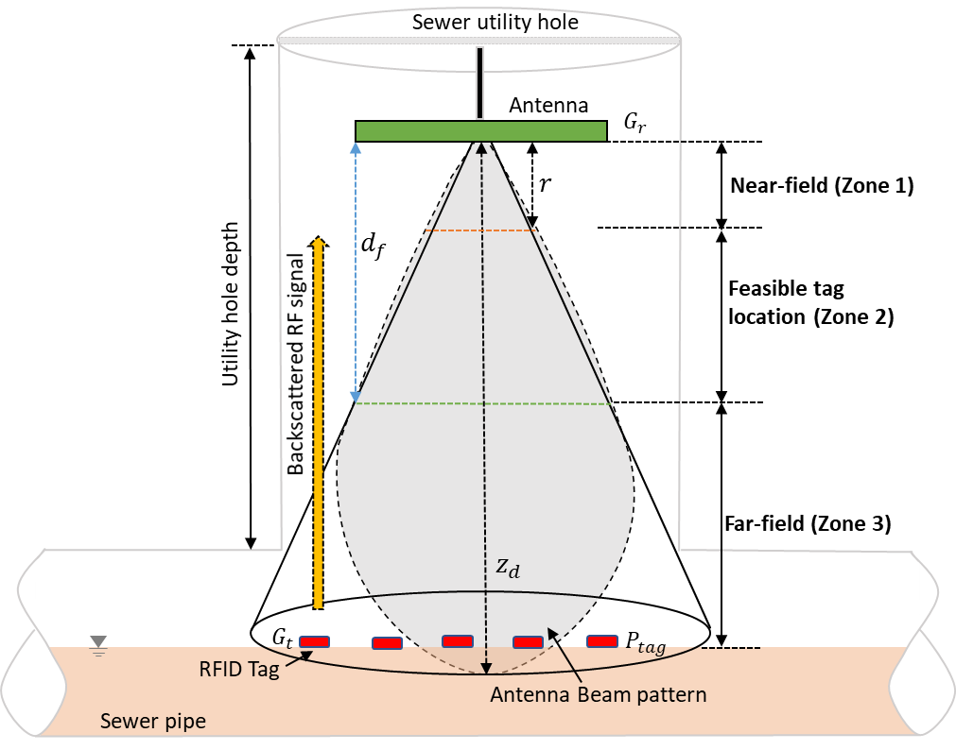
(A)
(B)
Figure 2. Determining effective reading ranges of UHF-RFID tags relative to a specific antenna plane for setting up the system in utility holes. (A) Tag 7, Tag 8, and Tag 9 exhibited various reading ranges related to their horizontal (H) orientation (α = 0°) and vertical (V) orientation (α = 90°) relative to the antenna plane on the bottom edge of the 8 dBiC, 9 dBiC, and 12.5 dBi antennae. The sweep direction effect of each tag relative to α = 0° (a-c) and α = 90° (d-e) are shown here with more information described in section S1.2 and S1.3. (B) Schematic diagram of the developed UHF-RFID tag with RFID reader antenna plane (x_{i}, y_{i}, z_{i}) installation in a sewer utility hole showing the reading range information. Maximum reading range ($Z_{d}$), the gain of the transmitting antenna ($G_{t}$), the gain of the receiving tag antenna ($G_{r}$), effective reading distance ($d_{f}$), the minimum threshold power necessary for the RFID tag’s IC chip and the tag sensitivity ($P_{tag}$) and radiating near field distance ($r$).

In practice, the effective reading distance ($d_{f}$) is the key performance index in determining the position of the RFID reader antenna and the method of deployment (i.e., deep shaft v.s. shallow shaft sewer and stormwater utility holes). It can also be deduced from the literature that space confinement, effective depth, water flowrate, flow-turbulence, and other geometric parameters of a sewer or stormwater environment could alter the response of the electromagnetic waves between the RFID tag and the RFID reader antenna (Bekkali et al., 2014; Loo et al., 2009; Pillai, 2006). Thus, an RFID tag-antenna combination should be thoroughly evaluated for its effective reading ranges (i.e., close to a 100% successful detection probability) before any deployment.

Figure 2B illustrates a schematic of an RFID reader positioning in a utility hole. If the sensor is too close to the transmitting antenna (zone-1), a near-field electromagnetic inference phenomenon can occur, resulting in blind spots. On the other hand, if the tag is far away from this antenna (zone-3), insufficient forward link (i.e., backscattered signal) becomes the limiting factor that prevents the RFID sensor-tag communication. Previous studies reported that in the near-field region, electromagnetic coupling between reader and tag antennas occurs due to different angular and radial dependence, which limits the reading ranges of tags (Bekkali et al., 2014; Nikitin et al., 2007; Rao et al., 2005). Practically, to avoid the reactive near-field and the radiative near-field interferences, radiating near field distance ($r$) should be $≤2D^{2}/\left(λ\right)$, where D is the maximum antenna dimension, and $λ$ is the wavelength, which equal to the speed of light divided by signal frequency (Nikitin et al., 2007). For example, at a resonant frequency, 915 MHz (a center of 902–928 MHz) and 0.45 m (12.5 dBiC antenna dimensions), the radiating near-field distance ($r$) is 1.24 m. The radiation pattern varies with the change of the size of the antenna and signal frequency. Therefore, to avoid near field interference, the deployment distance between tag and RFID reader antenna should be more than 1.24 m for the 12.5 dBiC antenna and 0.57 m for the 9 dBiC antenna. Our results (Figure 2A) indicate that for a specific combination of an antenna and a type of RFID tag deployed into the field, a specific reading range should be determined, as depicted in zone-2 (Figure 2B). The reading range dictates the installation position of an antenna in a utility hole. For example, sanitary sewers are designed for peak flows during high infiltration/inflow conditions (depth of flow = ~ diameter of the pipe, 0.15-0.60 m) with a probability value such as the 95th percentile (Water New Zealand, 2015). The system we developed can have an effective range of 0.57-3.5 m above the wastewater surface in the utility hole when using a 9 dBiC antenna. This means that the designed antenna position can still have a flexible range that allows it to reach the optimal option for a particular utility hole, depending on its peak flow conditions of the catchment area.

In conclusion, the optimum design of the RFID systems for sewer applications, at the base of a utility hole where wastewater flows through, should be within zone-2 between near-field and far-field. Also, the orientation of an RFID sensor should be horizontal with respect to the reader antenna when carried by wastewater flow through the utility hole. These criteria were used to design RFID sensors that ensure their horizontal position when passing the antenna and determine the antenna setup position within utility holes for real-world applications.

3.3 Sensory evaluation in aquatic environments

In the real sewer environment, we expect to see unsteady sewer flows/turbulence in pipes. Therefore, to maximize the detection probability, it becomes necessary to ensure the orientation of the tag remains horizontal. This implies that with a proper tag position/orientation to the antenna, larger reading ranges can be achieved with uniform RF wave distribution in its reading area. A statistically significant difference in terms of RSSI values (one-way ANOVA; p < 0.05) between the Tag 7 group (mean -69.96 dBm) and Tag 9 group sensors (mean -66.02 dBm) was observed with a dry flume condition (Figure S7). In the rest of the tests with a range of water velocities from 0.18 m/s to 0.61 m/s (Re from 10000 to 73000), the measured RSSI values and standard deviation (SD) ranges exhibited significant differences among the Tag 7 group (Figure 3A) and Tag 9 group (Table S4 & S5) tags, respectively. These RSSI value variations were due to a combination of a few parameters, including distances between the tag and reader antenna, the tag position in the flume, water depth and effect, and potential interference from surrounding environmental conditions that cannot be controlled. Also, to simplify data analysis, we assumed an even distribution of RF signals from the antenna to both group sensors with the fixed antenna (9 dBiC) position at 45° (Figure S5).

On the other hand, increased reflection was observed with increased flow speeds (10000 < Re < 41000) up to 3% for Tag 7-01 to -03 tags (ANOVA; p > 0.05). The Tag 7-04 and -05 tags were not significantly different (p > 0.2) in fully turbulent conditions (Re > 41000). However, in the fully turbulent conditions, a significant increase in the percentage of RSSI values was observed up to a certain point (~18%) before decreasing for both Tag 7-04 and Tag 7-05 tags. The reason for this phenomenon remains unclear. Nevertheless, these results indicate that the sensitivity of the UHF-RFID tags used in this study somehow increased due to an increase in the turbulence intensity. We hypothesize that this was caused by increased randomness in the flow itself caused by bubble frequency (i.e., air inflow from the bed surface) in highly turbulent conditions. We further hypothesize that these effects resulted in the high permeability of electromagnetic signals that backscattered the RF wave and its communication between the RFID antenna and tags to a certain point.

(A)
(B)
(C)

Figure 3. Evaluate UHF-RFID sensors detectability in the water-air interface environment. (A) Variation of received signal strength indication (RSSI) values for the group Tag 7-01 to -05 below the water according to varying flow rates. RSSI values were measured with no flow and with flow conditions (Re = 0, and Re = 10000-730000, respectively). (B) Maximum reading distance of sensors (median values calculated from n = 15 measurements per tag) on the water surface with three substrate materials including wood surface, insulated paper substrate (IPS), polylactic acid (PLA) substrate. (C) Top: Floatability of RFID sensors measured on the upstream and downstream in the flume (19m X 0.45m X 0.5m) with two antennae (n=22 (tags), accuracy measured with three tails). Bottom inset: Designed PLA encapsulations for Tag 7, Tag 8, and Tag 9.

It is worth to note that the penetration depth of UHF RFID (at 915MHz) in freshwater with a conductivity value of 200 mS/m is ~ 3.75 cm, and in wastewater (~50 mS/m) is ~7.4 cm (Benelli and Pozzebo, 2013). This penetration depth typically decreases with an increase in water conductivity and frequency of radio signals. However, our results indicated that the RSSI values of the Tag 7 group tags were still detectable between the range of 10-17 cm below the water surface in continuous flows (~7-71 L/s, 18.3 mS/m). The higher penetration depth values in our study compared to previously reported values call for further investigation (Arnaud et al., 2015; Cassel et al., 2017a).

3.4 Effective sensing ranges affected by RFID sensor tags supporting materials
The reflection of the radio wave of UHF-RFID sensor tags Tag 7-01 to -05 and Tag 9-01 to -05 decreased when the water depth increased in the flume (Table S4 & S5) due to the attenuation of electromagnetic waves across the water-air interface. The increasing water-air interface between the antenna and the tag leads to impedance mismatches between the IC chip and antenna, so the RFID tag averts the radar cross-section, resulting in diminished reflection (Arnaud et al., 2015; Benelli and Pozzebo, 2013; Jun et al., 2016). As demonstrated above, the UHF-RFID tag signals cannot be detected if their presence is more than 17 cm underwater. Therefore, we needed a reliable mechanism to keep the tags floating if they are to be used in an aquatic environment, e.g., in sanitary sewer systems. Several materials, including wood surface, the insulated paper substrate (IPS), and polylactic acid (PLA) plastic substrate, were tested to provide buoyancy to the tags. As depicted in Figure 3B, the maximum reading ranges of Tag 7, Tag 8, and Tag 9 on the water surface varied when attached to different materials. For Tag 7 and Tag 8, the reliable detection limits on the wood substrate were 1.80 ± 0.10 m and 1.30 ± 0.06 m, respectively, whereas Tag 9 was still detected at more than 3.50 ± 0.02 m (ANOVA; p < 0.05).

Comparatively, an increase was observed in the detection ranges when the tags were placed on the PLA substrate. In this case, the tag absolute percentage of detection increased by up to 87% (mean 3.33 m, Tag 7) and 114% (mean 2.78 m, Tag 8) compared to detection ranges on the plane wood (ANOVA; p > 0.05). The performance of Tag 9 detection heights across all cases was recorded at more than 3.50 m and exhibited enhancement in sensing performance to that of other sensor tags. These variations in detection heights can be related to attenuation of signal intensity to the water-air interface caused by tag antenna reactance and its chip impedance on the saturation of the wooden plank surface (Cassel et al., 2017a; Che et al., 2010). When tags were attached to different substrates, a change in impedance state modulates, causing a signal backscatter was believed to result in variations in the reading range. Additionally, these variations may have caused a low loss in signal strengths on supporting materials (e.g., PLA substrate). This indicates that PLA can be used to design carriers to alter the buoyancy of RFID tags to ensure that they can float on the surface of the wastewater.

To summarize the results up to this point, it is clear that using UHF-RFID-based sensors for applications in an aquatic environment is possible as long as two simple criteria can be fulfilled: (1) sensor tags remain floating on the water surface; and (2) sensors remain in a horizontal position to achieve larger reading ranges.

Based on our results, we designed the PLA sensor tag encapsulations to ensure that encapsulated sensors meet the mentioned criteria. One remaining question is whether these RFID-based sensors can be detected under high flow rates, particularly when a number of them passing underneath an antenna at the same time.

In the City of Auckland, sewer and stormwater systems are designed for peak wastewater flow of 7.5-10 L/s and peak wet weather flow of 60-80 L/s (Water New Zealand, 2015). To evaluate the effectiveness of our sensors in field scenarios, these PLA-encapsulated UHF-RFID-based sensors were tested to understand the sensitivity and robustness at flow rates up to 71 L/s (flow velocity 0.18-0.61 m/s) in the flume. Figure 3C illustrates the responses of PLA-encapsulated Tag 7, Tag 8, and Tag 9. Our results explicated that as the inflow turbulence intensity increased, a lower sensitivity in sensor responses was found within the water-air interface between reader antenna and tag communication. Measured at upstream of the flume with antenna-1 and downstream with antenna-2, a loss in RFID tag signals were observed with flow rates at 71 L/s, up to 9%, and 12% (n = 66), respectively (ANOVA; p > 0.05). With the varying turbulence in a flume, a few sensors exhibited sensitivity to water caused by the absence of RF waves communication with the antenna. However, sensor tags with PLA encapsulations achieved a good level of signal responses, which can be considered effective for the intended monitoring applications. It is also suggested that, for a single point application, multiple sensors can be used to maximize the detection rates in networks.

3.5 Field test of the RFID-based sensor system in sanitary and stormwater pipes

For one field trial catchment, we selected a segment of the gravity sewer with a diameter of 100 mm and a length ranging from 118-177 m of each household on the network (Figure 4A). Out of the initial 101 UHF-RFID-based sensors (three sensors per property except for one property) flushed into sanitary sewer pipes, 95 of them were detected and registered by our RFID sensing system deployed in the field (Figure 4B, C & E, and Figure S9). Six sensors were missing, which were subsequently attributed to two properties (designated as Property A & Property B). We flushed another batch of three sensors per property down to the sanitary sewer. The three sensors from property A were detected from the stormwater utility hole that is collecting stormwater from the catchment. Two more sensors were flushed again from the same property and detected again from the stormwater utility hole. These results confirmed an illicit connection from this particular property. On the other hand, the other three sensors flushed from property B were still missing. This indicated a potential severe blockage of the sewer lateral, which shall be confirmed using CCTV visual inspection (out of the scope of the current study). Based on the in and out time stamps of each tag recorded by the detector, the surface flow velocity and hydraulic retention time (HRT) of water in the sewer were determined, which was varied from ~0.28-0.97 m/s and 3-7 min within the catchment, respectively. The RFID sensing mechanism provides a more accurate approach for assessing the in-sewer conditions by computation of real-time HRT and flow velocities, which are useful for sewer system design in realistic conditions.

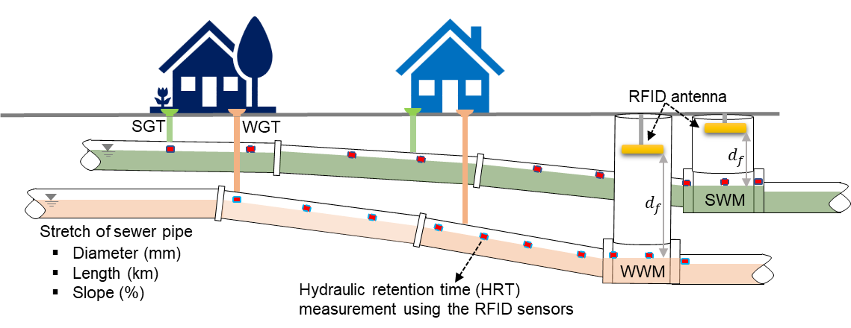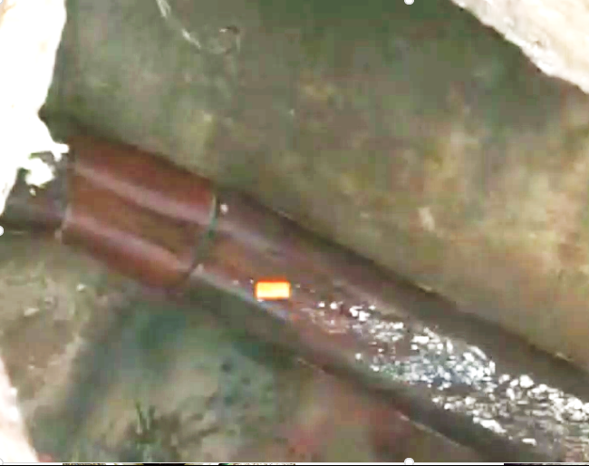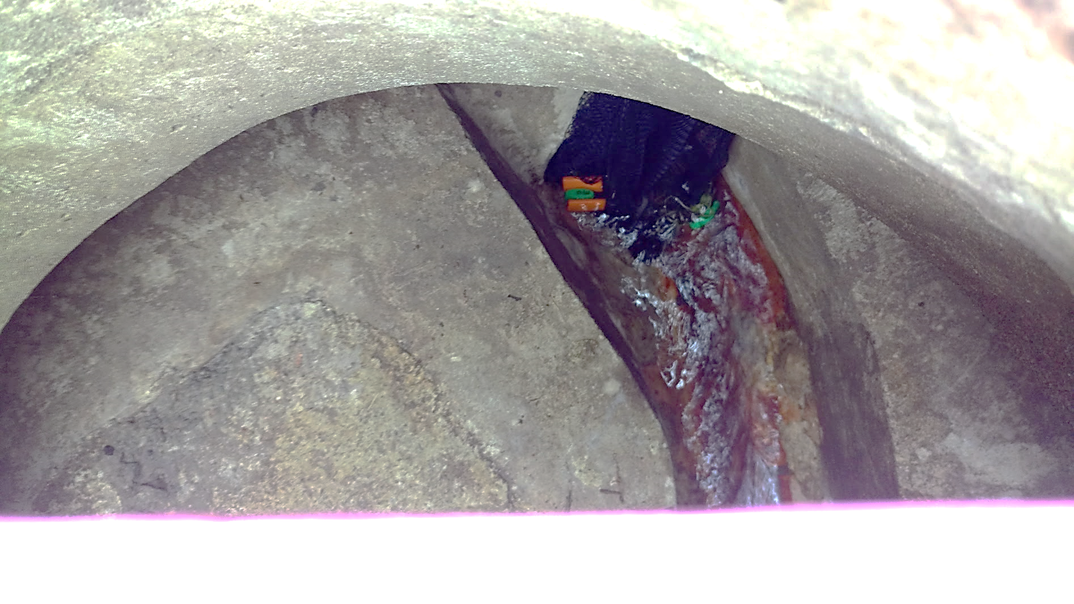
Figure 4[B] is a newly added illustration depicting equipment set up during the trials.
Four RFID sensors
Floating RFID sensor tag
(D)
(C)
(B)
(A)
Figure 4. Illustrations of the field trials conducted to test RFID systems in real-life sanitary and stormwater networks. (A) Schematic representation of the field trial conducted in gravity sewers with RFID sensor tags. SWM = stormwater utility hole, WWM = wastewater utility hole, SGT= stormwater gully-trap, WGT = wastewater gully-trap and $d_{f}$ = effective reading distance. (B) Right: Temporary installation of RFID antenna on SWM in ~ 2.0 m deep, which was the same level as the utility hole cover. Left: RFID antenna position in a ~ 6.0 m deep WWM (note: figures not drawn to scale). The RFID antenna photos are shown in Supporting Information Figure S9. (C) Sensor flowability and moment in the stormwater pipeline. (D) Four sensor tags were visible in the stormwater network, although they were flushed in wastewater gully traps in different household units. The encapsulated sensor tags are printed in fluorescent colors for better visualization.

3.6 RFID system cost analysis for field applications

Several conventional technologies on the market have been used to identify illicit connections and sewer blockages, including utility hole visual inspection, smoke testing, dye testing, CCTV inspection, infra-red (IR) camera, and distributed temperature sensing (DTS) method (Tables S6 & 7). Although each technology has its niche market in identifying an illicit connection or blockage, a suite of these technologies needs to be used in concert to accurately locate the issues. Whereas the UHF-RFID-based sensors can be used more independently to pinpoint an illicit connection more efficiently, as depicted in Figure 5. For example, comparing to conduct survey on each individual property using dye testing or smoke testing, multiple sensors can be flushed from many households within a community simultaneously. Then, these sensors can still be detected by the antenna downstream because the antenna can pick up around 500 tags simultaneously. Therefore, using high-throughput sensors can greatly reduce the time and labor cost if a large community needs to be surveyed.

Moreover, the running cost and accuracy of the conventional technologies can vary significantly. We estimated that the average cost (including labor, equipment, consumables) of using UHF-RFID-based sensors in the field trials is $ 21 per property with a very large margine. It is still quite cost-effective compared to other sewer network survey methods, such as visual inspection ($ 178), dye testing ($ 94), smoke testing ($ 302), CCTV inspection ($ 277), and DTS method ($ 252). More information can be found in Tables S6 & S7 in the Supporting Information. We further estimated that the RFID survey cost could be further reduced by up to 70% if the households could flush three sensors through their toilet directly by themselves. Also, monitoring with RFID systems may require minimum traffic management because the only interruption time would be to install an RFID antenna in a utility hole for data collection. A well trained technician can complete the installation within 30 minutes. It can greatly reduce traffic control costs and congestion issues associated with methods like CCTV inspection or dye testing where a utility hole has remain opened all the time.
(B)
(A)
Figure 5. Flowchart diagrams showing the identification of illicit-connection or sewer blockage using the conventional technologies or UHF-RFID-based sensors. (A) A generalized procedure of using conventional technologies to locate an illicit connection or a sewer blockage. (B) Using the UHF-RFID-based sensor method can significantly decrease the time and cost for identifying abnormities in the sewer systems.

4 Conclusions
Overall, the UHF-RFID-based sensors that we designed can deliver a high-throughput, robust, and non-invasive method to survey sewer systems almost real-time. The design ensures that the beneficial properties of UHF-RFID (e.g., accuracy, long reading distance, and large bandwidth) are not compromised by abnormal flow conditions and the presence of other solids, such as toilet paper and organic solids in a drain line as seen during the field trials. Therefore, this study can provide a foundation for more novel applications of these passive UHF-RFID-based wireless sensors in real-time data collection or tracking hydraulic flow rates and solid velocities in sewer networks. In the future, we will use the UHF-RFID sensors to measure the surface velocity of stormwater and wastewater in pipes and use the information to predict blockage and infiltration/inflow events. Moreover, the high-throughput property of the sensors can allow us to efficiently re-map existing networks that are dated. The information can be used to correct Geographic Information System databases. Combined with the surface velocity data, we can calibrate and re-calculate current hydraulic models widely used in stormwater management practice or more precisely predict solid residential times in wastewater networks. We can also more precisely predict lead time for wastewater treatment facilities or local authorities if any toxic chemical spills or accidental discharges should happen.

Supplementary materials
- Detailed information about experimental methods followed by the determination of effective reading zones of UHF-RFID sensor tags, evaluation of UHF-RFID-based sensors in aquatic environments, tags readability on supporting materials on the water surface, and additional data, figures, tables, and observations.

Acknowledgments
W.-Q.Z. thanks MaDE-MaD-IMM seed fund, for supporting the research. Y.G.D C. is supported by the Faculty of Engineering, Ph.D. Scholarship at the University of Auckland, New Zealand.

References

Allan, I.J., Bæk, K., Haugen, T.O., Hawley, K.L., Høgfeldt, A.S. and Lillicrap, A.D. 2013. In vivo passive sampling of nonpolar contaminants in brown trout (Salmo trutta). Environmental Science & Technology 47(20), 11660-11667.
Alyahya, S., Wang, Q. and Bennett, N. 2016. Application and integration of an RFID-enabled warehousing management system–a feasibility study. Journal of Industrial Information Integration 4, 15-25.
Arnaud, F., Piegay, H., Vaudor, L., Bultingaire, L. and Fantino, G. 2015. Technical specifications of low-frequency radio identification bedload tracking from field experiments: Differences in antennas, tags and operators. Geomorphology 238, 37-46.
Barge, P., Biglia, A., Comba, L., Gay, P., Aimonino, D.R. and Tortia, C. 2019. The influence of food composition and tag orientation on UHF RF IDentification. Journal of Food Engineering 246, 242-252.
Bekkali, A., Zou, S., Kadri, A., Crisp, M. and Penty, R.V. 2014. Performance analysis of passive UHF RFID systems under cascaded fading channels and interference effects. IEEE Transactions on Wireless Communications 14(3), 1421-1433.
Benelli, G., Panzardi, E., Pozzebon, A., Bertoni, D. and Sarti, G. 2011 An analysis on the use of LF RFID for the tracking of different typologies of pebbles on beaches pp. 426-431, IEEE.
Benelli, G. and Pozzebo, A. (2013) Radio Frequency Identification from System to Applications.
Bertoni, D., Sarti, G., Benelli, G., Pozzebon, A. and Raguseo, G. 2010. Radio Frequency Identification (RFID) technology applied to the definition of underwater and subaerial coarse sediment movement. Sedimentary Geology 228(3-4), 140-150.
Butler, D., James Digman, C., Makropoulos, C., Davies, J. 2018. Urban Drainage, Fourth Edition. Boca Raton: CRC Press.
Cassel, M., Dépret, T. and Piégay, H. 2017a. Assessment of a new solution for tracking pebbles in rivers based on active RFID. Earth Surface Processes and Landforms 42(13), 1938-1951.
Cassel, M., Piegay, H. and Lave, J. 2017b. Effects of transport and insertion of radio frequency identification (RFID) transponders on resistance and shape of natural and synthetic pebbles: applications for riverine and coastal bedload tracking. Earth Surface Processes and Landforms 42(3), 399-413.
Chapuis, M., Bright, C.J., Hufnagel, J. and MacVicar, B. 2014. Detection ranges and uncertainty of passive Radio Frequency Identification (RFID) transponders for sediment tracking in gravel rivers and coastal environments. Earth Surface Processes and Landforms 39(15), 2109-2120.
Che, X., Wells, I., Dickers, G., Kear, P. and Gong, X. 2010. Re-evaluation of RF electromagnetic communication in underwater sensor networks. IEEE Communications Magazine 48(12), 143-151.
Colin, T.o., Meikle, W.G., Wu, X. and Barron, A.B. 2019. Traces of a neonicotinoid induce precocious foraging and reduce foraging performance in honey bees. Environmental Science & Technology 53(14), 8252-8261.
Edmondson, V., Cerny, M., Lim, M., Gledson, B., Lockley, S. and Woodward, J. 2018. A smart sewer asset information model to enable an ‘Internet of Things’ for operational wastewater management. Automation in Construction 91, 193-205.
Gosset, A., Ferro, Y. and Durrieu, C. 2016. Methods for evaluating the pollution impact of urban wet weather discharges on biocenosis: a review. Water Research 89, 330-354.
Gross, M.A., Jensen, J.L., Gracz, H.S., Dancer, J. and Keener, K.M. 2017. Evaluation of physical and chemical properties and their interactions in fat, oil, and grease (FOG) deposits. Water Research 123, 173-182.
Hvitved-Jacobsen, T., Vollertsen, J. and Nielsen, H.A. 2013. Sewer processes: microbial and chemical process engineering of sewer networks: CRC Press.
Jun, J., Oh, J., Shin, D.H., Kim, S.G., Lee, J.S., Kim, W. and Jang, J. 2016. Wireless, room temperature volatile organic compound sensor based on polypyrrole nanoparticle immobilized ultrahigh frequency radio frequency identification tag. ACS Applied Materials & Interfaces 8(48), 33139-33147.
Koo, T.W., Kim, D., Ryu, J.I., Seo, H.M., Yook, J.G. and Kim, J.C. 2011. Design of a Label-Typed UHF RFID Tag Antenna for Metallic Objects. IEEE Antenn Wirel Pr 10, 1010-1014.
Lee, J.S., Oh, J., Jun, J. and Jang, J. 2015. Wireless Hydrogen Smart Sensor Based on Pt/Graphene-Immobilized Radio-Frequency Identification Tag. ACS Nano 9(8), 7783-7790.
Lim, M.K., Bahr, W. and Leung, S.C. 2013. RFID in the warehouse: A literature analysis (1995–2010) of its applications, benefits, challenges and future trends. International Journal of Production Economics 145(1), 409-430.
Loo, C., Elsherbeni, A., Yang, F. and Kajfez, D. 2009. Experimental and simulation investigation of RFID blind spots. Journal of Electromagnetic Waves and Applications 23(5-6), 747-760.
Marleni, N., Gray, S., Sharma, A., Burn, S. and Muttil, N. 2012. Impact of water source management practices in residential areas on sewer networks - A review. Water Science and Technology 65(4), 624-642.
Murali, M.K., Hipsey, M.R., Ghadouani, A. and Yuan, Z. 2019. The development and application of improved solids modelling to enable resilient urban sewer networks. Journal of Environmental Management 240, 219-230.
Nikitin, P.V., Rao, K. and Lazar, S. 2007 An overview of near field UHF RFID, pp. 167-174, IEEE 2007 International Conference on RFID.
Panasiuk, O., Hedström, A., Marsalek, J., Ashley, R.M. and Viklander, M. 2015. Contamination of stormwater by wastewater: A review of detection methods. Journal of Environmental Management 152, 241-250.
Papangelakis, E., Muirhead, C., Schneider, A. and MacVicar, B. 2019. Synthetic Radio Frequency Identification Tracer Stones with Weighted Inner Ball for Burial Depth Estimation. Journal of Hydraulic Engineering 145(12), 06019014.
Pillai, V. 2006 Impedance matching in RFID tags: to which impedance to match?, pp. 3505-3508, IEEE 2006 Antennas and Propagation Society International Symposium.
Plihal, H., Kretschmer, F., Schwarz, D. and Ertl, T. 2014. Innovative sewer inspection as a basis for an optimised condition-based maintenance strategy. Water Practice and Technology 9(1), 88-94.
Potyrailo, R.A., Nagraj, N., Tang, Z., Mondello, F.J., Surman, C. and Morris, W. 2012. Battery-free radio frequency identification (RFID) sensors for food quality and safety. Journal of Agricultural and Food Chemistry 60(35), 8535-8543.
Rao, K.V.S., Nikitin, P.V. and Lam, S.F. 2005. Antenna design for UHF RFID tags: A review and a practical application. IEEE T Antenn Propag 53(12), 3870-3876.
Rodríguez, J.P., McIntyre, N., Díaz-Granados, M. and Maksimović, Č. 2012. A database and model to support proactive management of sediment-related sewer blockages. Water Research 46(15), 4571-4586.
Semadeni-Davies, A., Hernebring, C., Svensson, G. and Gustafsson, L.-G. 2008. The impacts of climate change and urbanisation on drainage in Helsingborg, Sweden: Combined sewer system. Journal of Hydrology 350(1-2), 100-113.
Sun, C., Jiang, F. and Jiang, S. 2013. Research on RFID Applications in Construction Industry. Journal of Networks 8(5), 1221-1228.
Tanguy, N.R., Fiddes, L.K. and Yan, N. 2015. Enhanced radio frequency biosensor for food quality detection using functionalized carbon nanofillers. ACS Applied Materials & Interfaces 7(22), 11939-11947.
Tatiparthi, S.R., De Costa, Y.G., Zhong, R.Y. and Zhuang, W.-Q. 2020 A Performance Analysis Framework for Passive UHF RFID for Environmental Applications, pp. 248-253, IEEE 16th International Conference on Automation Science and Engineering.
ten Veldhuis, J.A.E., Clemens, F.H.L.R., Sterk, G. and Berends, B.R. 2010. Microbial risks associated with exposure to pathogens in contaminated urban flood water. Water Research 44(9), 2910-2918.
Tsakiris, A.G., Papanicolaou, A.N., Moustakidis, I.V. and Abban, B.K. 2015. Identification of the Burial Depth of Radio Frequency Identification Transponders in Riverine Applications. Journal of Hydraulic Engineering 141(6), 04015007.
Ugarelli, R., Kristensen, S.M., Røstum, J., Sægrov, S. and Di Federico, V. 2009. Statistical analysis and definition of blockages-prediction formulae for the wastewater network of Oslo by evolutionary computing. Water Science and Technology 59(8), 1457-1470.
Water New Zealand 2015 Infiltration & Inflow Control Manual Practical Guidelines, p. 68.

