Chen, L., An, X., Jing, J., Jin, H., Chu, Z., & Li, K. H. (2020). Ultracompact chip-scale refractometer based on an InGaN-based monolithic photonic chip. ACS Applied Materials & Interfaces.
doi: 10.1021/acsami.0c13144
An Ultra-Compact Chip-Scale Refractometer based on an InGaN-based Monolithic Photonic Chip
Liang Chen
Xiaoshuai An
Jixiang Jing
Haotian Jin
Zhiqin Chu
Kwai Hei Li
Department of Electrical and Electronic Engineering
Faculty of Engineering
The University of Hong Kong
Corresponding author: Kwai Hei Li, School of Microelectronics, Southern University of Science and Technology, Shenzhen 518055, China.
Email: khli@sustech.edu.cn
Submitted to ACS Applied Materials & Interfaces Jul 21 2020
Accepted Oct 2020

Author Biographies

Liang Chen received the B.Eng. and M.Eng. degrees in 2003 and 2011, respectively, from the Huazhong University of Science and Technology, Wuhan, China, where he is currently working toward the Ph.D. degree. He is also a visiting Scholar with the School of Microelectronics, Southern University of Science and Technology, Shenzhen, China. His research interests include design, fabrication, and packaging of GaN optoelectronic devices.

Xiaoshuai An received his M.S. degree from the Harbin Institute of Technology, Shenzhen. He is currently a joint Ph.D. student at the Southern University of Science and Technology and the University of Hong Kong. His research interests include GaN-based monolithic photonic chips, wearable electronics, and microfluidics.

Jixiang Jing, phD, is working as a post-doctor at the Hong Kong University. His research interests include GaN monolithic sensing chips and diamond membranes fabrication.

Haotian Jin received the B.Eng. and M.Eng from the Huazhong University of Science and Technology, Wuhan, China. His research interests include GaN stacked chips and DBR reflectors.

Zhiqin Chu is currently an Assistant Professor in the Department of Electrical and Electronic Engineering (Joint Appointment with the School of Biomedical Sciences) at the University of Hong Kong. His current research interests include quantum sensing, biophysics, biophotonics, and materials-biology interface.

Kwai Hei Li is currently working as an assistant professor in the School of Microelectronics at the Southern University of Science and Technology. His current research interests include the design, fabrication, and characterization of III-nitride optoelectronic devices.

An Ultra-Compact Chip-Scale Refractometer based on an InGaN-based Monolithic Photonic Chip
Abstract:
Optical refractometer constitutes the core element for many applications, from determining the purity and concentration of pharmaceutical ingredients to measuring the sugar content in food and beverages, and the analysis of petroleum. Here, we demonstrated the monolithic integration of light-emitting diodes (LEDs) and photodetectors (PDs) to fabricate ultra-compact refractometers with a chip size of 475 × 320 μm². The light emission and photodetection properties of the devices containing the same InGaN/GaN multi-quantum wells (MQWs) have been characterized, confirming that the PD can respond to the emission of the LED. The flip-chip assembly of the chip makes the exposed sapphire substrate in direct contact with the solution, and the refractive-index sensing capability governed by the change of critical angle and Fresnel reflection at the sapphire/solution interface has been investigated. The processing of the optically smooth surface of sapphire and the integration of high-reflectance distributed Bragg reflector beneath the devices facilitate the amount of light received by the PD. The monolithic chip is capable of detecting solutions with a refractive index ranging from 1.3325 to 1.5148 RIU and exhibits a sensitivity of 7.77 μA/RIU and a resolution of 6.4 x 10⁻⁶ RIU at the LED current of 10 mA. Rapid real-time responses of 33.9 ms for rise time and 34.7 ms for fall time are obtained in the detected photocurrent, thereby verifying the feasibility of the chip-scale refractometer.

Keywords: gallium nitride; refractometer; refractive index sensing; monolithic; photonic integration
1. INTRODUCTION
Refractive index measurement has been extensively used in chemical and biological sensing fields, such as clinical diagnosis, food safety testing, and environmental monitoring.¹⁻² Refractometer constructed based on the optical fiber is a promising approach, ³⁻⁶ but often requires expensive and complex manufacturing processes. Aiming to develop compact optical structures with high sensitivity, various geometric modulations of the micro-/nano-scale optical structures have been proposed, including diffraction gratings, nano-cavities, surface plasmon resonators, which are capable of sensing the change in the surrounding refractive index by determining the spectral shift of optical modes.⁷⁻¹¹ Existing demonstrations rely heavily on the use of external light source, photodetector, and optical interconnects, which require additional alignment steps to achieve efficient light coupling between the optical components, leading to low throughput, limited integration capacity, and bulky system. The complexness of integrated systems and instruments also makes mass production impractical.
With the increasing demand for system miniaturization, the development of compact and robust refractometers is essential for chip-level high-density integration. The external components can be eliminated by integrating photonic elements on a microchip,¹²⁻¹³ which provides attractive advantages of high transient response, low power consumption, simple assembly process, miniature footprints, and improved robustness and stability of the integrated system. Among the possible material platforms for constructing optoelectronic devices, III-nitride semiconductor is a promising candidate with distinct characteristics such as high efficiency, long operational lifetime, and high physical and chemical stability, due to the tremendous progress in device microfabrication process and material growth technique.¹⁴⁻¹⁶ As the InGaN/GaN multi-quantum wells (MQWs) structures can provide the dual functions of optical emission and reception,¹⁷⁻¹⁹ photonic integrated systems for intensity/color output stabilization and on-chip visible light communication have been recently reported.²⁰⁻²²
In this study, we propose and develop a novel chip-scale refractometer via a monolithic integration approach. The photonic chips consisting of light-emitting diodes (LEDs) and photodetectors (PDs) are formed onto a single GaN-based material platform through wafer-scale fabrication processes. The InGaN/GaN MQWs provide functions of light emission in the LED and photodetection in the PD. By packaging the devices in flip-chip configurations, various solutions can be applied directly to the transparent and chemically inert sapphire substrate. The electrical and optical properties of the LED and PD are comprehensively investigated and the sensing mechanism is also studied. The sapphire substrate used as the sensing medium enables the optical coupling between the LED and PD and the refractive index changes of the solutions can be monitored without the use of additional optics. The development of a photonic chip based on monolithic integration method will overcome the problems related to the external integration of complicated parts, thereby effectively strengthening the efficiency, compactness, and robustness of the refractometer chip.

2. EXPERIMENTAL SECTION
The epitaxial structures consisting of InGaN/GaN MQWs are grown on a 4-inch c-plane sapphire substrate by metal-organic chemical vapor deposition (MOCVD). A series of standard microfabrication processes are utilized to fabricate the emitters and detectors on a single wafer. An indium-tin-oxide (ITO) film acted as a current spreading layer with a thickness of 120 nm is coated onto the p-GaN by reactive plasma deposition. The mesas of the LED and the PD are defined to be the same dimension of 445 × 115 μm² by photolithography. The sample is dry-etched using Cl₂-based inductively coupled plasma (ICP) to expose the n-GaN surface. Another photolithography step is used to define the masked pattern that isolates the LEDs and the PDs, followed by the removal of the uncovered GaN region by ICP-etching. The p-electrodes and n-electrodes are respectively coated on the ITO surface and n-GaN surface by electron-beam evaporation. A 360-nm thick SiO₂ layer is coated to the wafer by plasma-enhanced chemical vapor deposition (PECVD), followed by the deposition of SiO₂/TiO₂ distributed Bragg reflection stacked layers by optical thin-film coater. The p-pad and n-pad areas are defined by photolithography and the metal contacts are electron-beam deposited, followed by lift-off. After rapid thermal annealing, the sapphire substrate is thinned to 115 μm through lapping and polishing processes. The fabricated wafer is then diced into small chips by laser micromachining. Fig. 1(a) shows the schematic diagram of the devices flip-chip bonded on a printed circuit board (PCB) package. The LED and PD are respectively connected to a current source for current injection and an ammeter for photocurrent measurement. The LED and PD are with the same device structure schematically depicted in Fig. 1(b). Figs. 1(c)-(d) show the optical microphotographs of the packaged chip with a size of 475 × 320 μm².
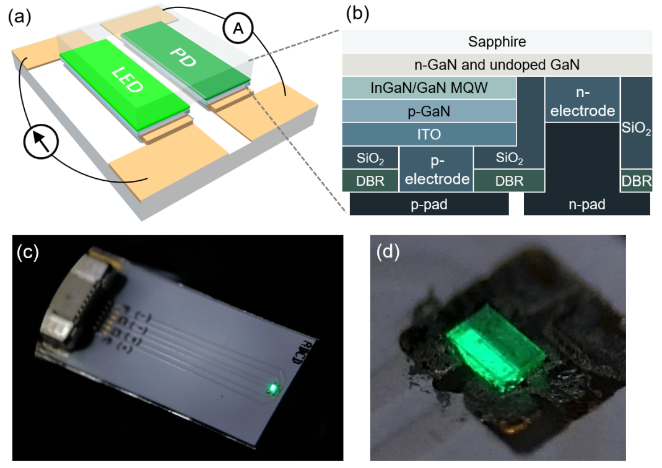
Figure 1. (a) Schematic illustration depicting the resultant photonic chip consisting of the LED and PD. (b) Schematic diagram showing the cross-sectional view of the device structure. (c) Optical image of the fabricated chip mounted on a PCB. (d) Zoomed-in image of the packaged chip with LED operated at a bias current of 0.5 mA.

3. Results and Discussion
The optical photograph in Fig. 2(a) shows the operating chip immersed in a small tank of oil. Green luminescence is observable from the chip as the light emitted by the LED can be partially refracted through the transparent sapphire. Fig. 2(b) schematically illustrates the working mechanisms of devices fabricated from the same device structure using the same MQWs structure. Light emission occurs due to the recombination of confined carriers in the InGaN/GaN MQW, and the light emitted by the LED is partially absorbed by the InGaN layers of the PD to create electron-hole pairs. During the measurement process, stable emission is provided by the LED biased with a fixed current and the optical reflectance of the sapphire/solution interface changes with the refractive index of the ambient solution, thereby altering the amount of light received by the PD.

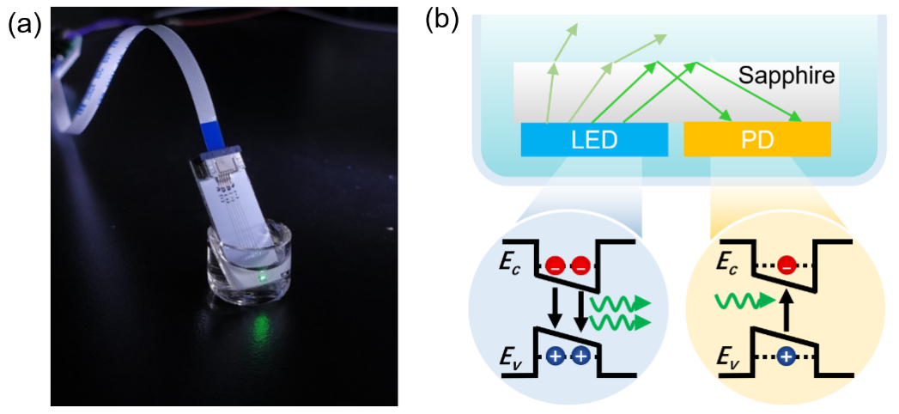
Figure 2. (a) Optical photograph of the operating chip immersed into the oil. (b) Schematic diagram illustrating the working principle of the proposed refractometer.

As the exposed top surface of sapphire is in direct contact with the solution, the surface smoothness is a key factor affecting its reflective properties. After the device fabrication, atomic force microscopy (AFM) is employed to measure the morphology of the exposed sapphire surface. An optically-smooth surface with an RMS roughness of 2.51 nm (∼λ/208) is determined, as evidenced by the 20×20 μm² AFM image in Fig. 3(a). Moreover, to reduce the absorption of downward emission by the bottom metals and packaging components, the insertion of a reflector beneath the LED is a straightforward method that does not affect the epitaxial structure. Among the possible reflective coatings, a distributed Bragg reflector (DBR), which is generally composed of a multilayer of alternating materials with varying refractive index, is a promising optical structure that can provide high reflectance in the required wavelength range. A detailed description of the DBR design is presented in the Supporting Information. From the cross-sectional field-emission scanning electron microscopy (FE-SEM) images displayed in Fig. 3(b), the TiO₂/SiO₂ multilayer stack is firmly coated on the device surface and appears to be free of cracks. Fig. 3(c) shows the measured reflectance spectrum of the DBR. In the 470–580 nm spectral range covering the entire emission band of InGaN/GaN MQWs, high reflectance of >98 % is obtained. The presence of high-reflectance DBR not only minimizes the optical absorption by the package but also redirects a large portion of the emitted light to the sapphire.
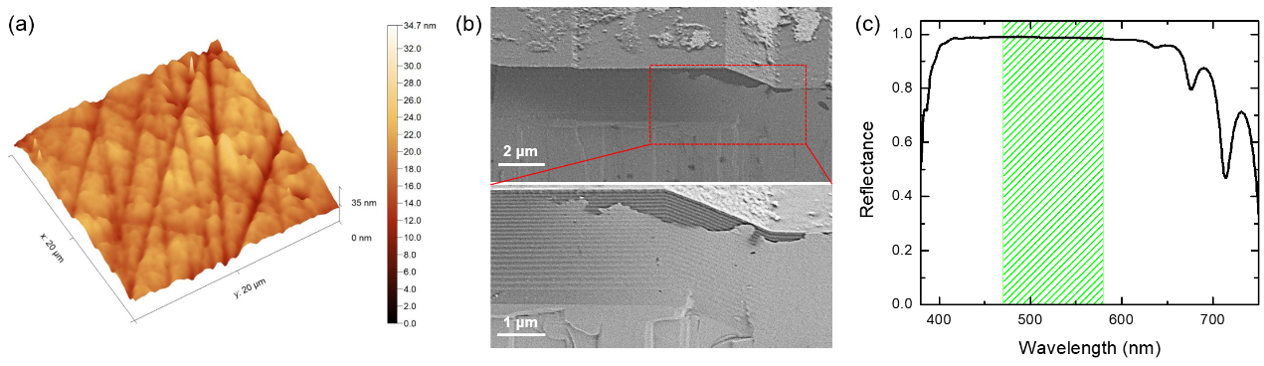
Figure 3. (a) AFM image of the surface morphology of the exposed sapphire surface. (b) Cross-sectional FE-SEM images of the DBR structure. (c) Measured reflectance of the DBR. The region shaded in green represents the emission band from InGaN/GaN MQW.

The current-voltage (I-V) characteristics of LED are obtained by using KEITHLEY 2450 sourcemeter to study the electrical performance of LED. At a driving current of 10 mA, the measured forward voltage is 2.49 V. The dynamic resistance related to the slope of the linear region of the I-V curve in Fig. 4(a) is determined to be 12.4 Ω. The small values of turn-on voltage and resistance imply that the deposition of the DBR based on flip-chip design does not degrade the electrical performance of the device. From the output power-current (L-I) plot in the inset in Fig. 4(a), it can be seen that the light output power increases linearly with increasing driving current.
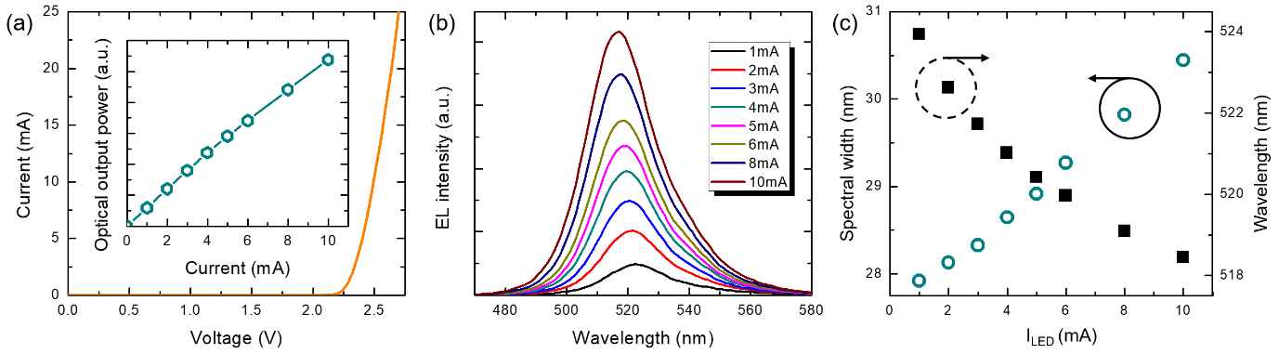
Figure 4. (a) I-V characteristics of the LED. The inset presents the L-I characteristics of the LED. (b) EL spectra of the LED at currents of 1-10 mA measured at room temperature. (c) Spectral widths and peak wavelengths of the LED measured at varying injection currents.

It is known that the emission peak position and the spectral width of InGaN/GaN MQW LEDs vary with the driving current due to the combined effect of the quantum‐confined Stark effect (QCSE) and carrier screening. Such spectral variations may affect the amount of light absorbed by the PD. The electroluminescence (EL) signals of the LED are collected using an optical fiber connected to a calibrated spectrometer and the EL spectra are plotted in Fig. 4(b). The center wavelength and spectral width (FWHM) extracted from Fig. 4(b) are plotted in Fig. 4(c). When increasing the injection current from 1 to 10 mA, the observation of spectral blue-shift of 5.5 nm (from 523.9 to 518.4 nm) and broadening of 2.52 nm can be due to the screening of the piezoelectric field by the injected carriers and the band-filling effect. The LED operating in a low-current-density regime exhibits a spectral blue-shift with increasing current, implying that the self-heating effect is negligible.
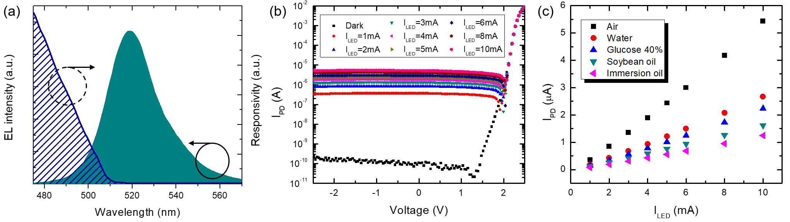
Figure 5. (a) EL spectrum of the LED biased at 5 mA and normalized spectral responsivity of the unbiased PD. (b) I-V curves of the PD measured in darkness and under illumination from the on-chip LED operated at a current range of 1-10 mA. (c) Plot of PD photocurrents versus LED driving currents.

Since the same MQW structure is used as the core part for light emission and detection, the PD is unable to fully respond to the LED emission due to the presence of the Stokes shift between the absorption and emission. Fig. 5(a) plots the EL spectrum of the LED operating at 5 mA together with the normalized responsivity of the unbiased PD. The monochromatic light generated from the use of a broadband light source together with a monochromator is illuminated on the device to obtain the spectral responsivity of the PD. As shown in the figure, it is found that the responsivity of the PD reduces with an increase of wavelength, and the absorption edge is 510 nm. Attributed to the band-tailing effects caused by a combination of the QCSE and indium content fluctuations in the InGaN/GaN MQWs,²³ the responsivity is extended to ∼515 nm, thus providing an overlap of ∼45 nm between the emission and absorption spectra.
The responses of the photonic chip are investigated by measuring the relationship between photocurrent and voltage of the PD under different operating currents from the LED. The PD under reverse bias voltage exhibits very low dark current levels of the order of 10⁻¹⁰-10⁻¹¹ A close to the measurement resolution, as shown in Fig. 5(b). When the LED is biased with a current range of 1-10 mA, the measured photocurrent level increases by more than three orders of magnitude, reaching 0.36-5.43 μA, which reveals that the PD is highly responsive to emission from the LED with an identical structure. Moreover, the low dark current and stable reverse bias photocurrents are obtained since the etched sidewalls of the device are passivated with the SiO₂ layer to effectively suppress the current leakage path, as proved in Fig. 3(b). The linear relation shown in Fig. 5(c) suggests that the detected photocurrents can be scalable by altering the operation current of the LED. Compared with the L-I plot in the inset in Fig. 4(a), a more linear characteristic is obtained from Fig. 5(c) as the spectral blue-shift with increasing LED current leads to a slight increase in the overlap between emission and absorption spectra.
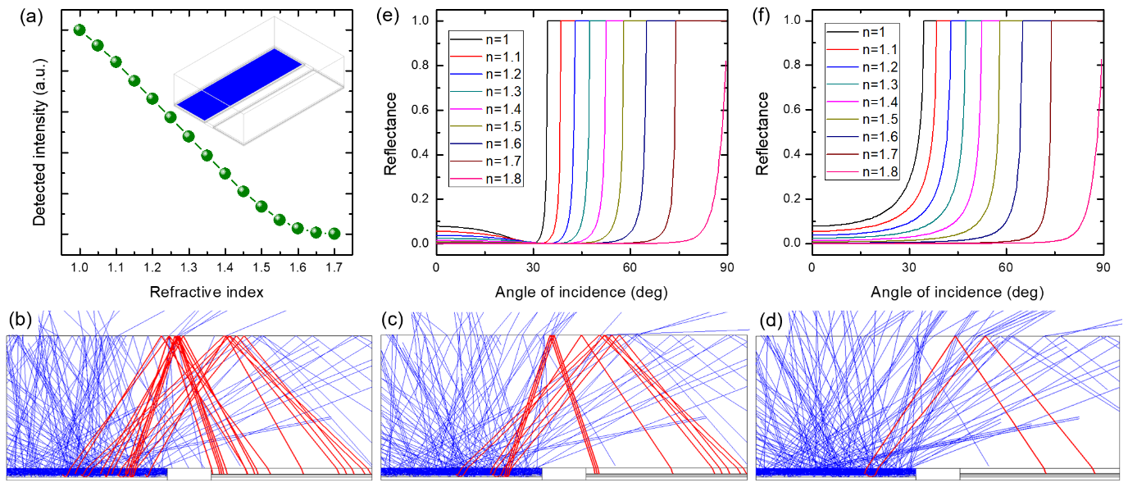
Figure 6. (a) Computed detected intensities as a function of the refractive index of ambient. The inset shows the 3D simulation model and the blue area corresponds to the light-emitting region. The Cross-sectional view of ray-trace simulation results of the monolithic chip surrounded by refractive indexes of (b) 1, (c) 1.33, and (d) 1.47 RIU. Computed (e) p- and (f) s-polarized reflectance of an interface between sapphire and solution with varying refractive indexes.

Since the light entering into the solution is unlikely to be reflected back into the PD, the amount of light received by the PD depends mainly on the refractive index contrast of the interface and less on the absorption of the solution (see Supporting Information for further details). The optical coupling from the LED to the PD in the sapphire substrate is studied through the ray-tracing analysis. The inset in Fig. 6(a) depicts a 3D simulation model of a photonic chip with the same dimensions, structural and optical parameters as the fabricated chip. Figs. 6 (b)-(d) show the propagation behavior of light emitted from an omnidirectional MQW source under different ambient refractive indexes. To have a clear illustration, the rays reaching the PD are selectively highlighted in red. As illustrated in figures, under the same amount of light rays emitted from the active area, the density of rays received by the PD reduces when increasing the refractive index. The intensity received by the PD is further simulated as a function of the ambient refractive index ranging from 1 to 1.7 RIU and summarized in Fig. 6(a). According to the simulated results, the highest amount of detected intensity is obtained when the surrounding refractive index is set to be 1.0, suggesting that a large refractive index contrast of 0.77 RIU at the sapphire-air boundary is beneficial to light reflection.
To further examine this phenomenon, the reflectance at the top boundary of sapphire is calculated. To simplify the calculation, a unit cell is modeled by applying the Floquet-periodic boundary condition on both the top and bottom surfaces of the unit cell. Plane electromagnetic waves propagating towards sapphire (refractive index = 1.77 RIU) is incident upon different media (refractive index = 1.0-1.8 RIU) at various angles (0-90°) and is partially reflected. The calculated p- and s-polarization reflectances as a function of angle of incidence are plotted in Figs. 6(e) and 6(f) respectively. When light is incident on a plane with an angle of incidence greater than 34.5°, the reflectance instantly rises to 1. Consistent with the critical angle (θ_{c}) based Snell’s law, the angle value can be determined by θ_{c}=sin⁻¹(n_{air}/n_{sapphire}) = 34.4°, where n_{air} and n_{sapphire} correspond to the refractive indexes of air and sapphire, respectively. Based on this equation, the refractive index of the ambient medium is inversely proportional to the critical angles, i.e., the angle increases with increasing the refractive index. The conditions of total internal reflection cannot be satisfied at any incident angle for the ambient refractive index larger than 1.77 RIU. For the angle of incidence below the critical angle, the reflectance value is governed by Fresnel reflection and decreases with reducing refractive index contrast at the boundary, as illustrated in Figs. 6(e) and 6(f). As such, with increasing ambient refractive index, the overall reduction in detected intensity observed in Fig. 6(a) can be attributed to the combined effect of reduced identical reflection and increased critical angle.
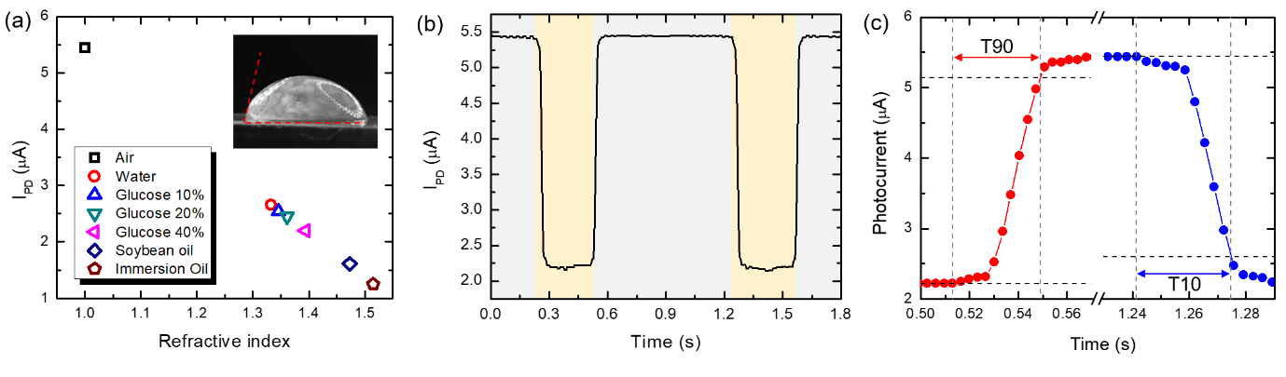
Figure 7. (a) Dependence on the detected photocurrent from the PD with the refractive index values. The inset shows the contact angle of a liquid droplet on the sapphire surface. (b) Transient photocurrent response of the photocurrent. Regions shaded in grey and yellow represent the chip surrounded by air and 40%-glucose solution respectively. (c) An enlarged view of the transient photocurrent response.

To evaluate its sensing ability to the refractive index, the chip is tested by immersing it into various solutions (including water, glucose solutions, soybean oil, and immersion oil) at room temperature. The chip is cleaned between consecutive measurements to ensure that the conditions in each measurement are highly similar. As shown in Fig. 5(c), for all test solutions, the photocurrents of the PDs increase monotonically with the increase of LEDs driving currents. The measured photocurrents are then compared with refractive index values obtained with the Abbe refractometer and their dependence is plotted in Fig. 7(a). Apart from distinct differences in their photocurrent levels, observation of the linear relationship suggests that the PDs can be used to accurately detect the refractive index of solutions. Consistent with the simulation predictions presented in Fig. 6, an increase in the refractive index of solution leads to a decrease in reflection at the upper boundary of the sapphire, resulting in a linear decrease in the detected photocurrent. When the LED is biased with a current of 10 mA, the photocurrent change is measured to be 1.417 μA for the refractive index changing from 1.3325 to 1.5148 RIU. The sensitivity is estimated to be 7.77 μA/RIU. The measurement resolution mainly governed by the resolution of sourcemeter of 0.05 nA corresponds to 6.4 x 10⁻⁶ RIU, which is comparable to the values of previously reported refractometers with similar measurable refractive index ranges.²⁴⁻²⁶ A detailed comparison is provided in the Supporting Information.
The transient response of the chip is investigated by instantaneously entering and leaving a 40%-glucose solution bath. During the measurement process, the PD is zero-biased and the LED current is fixed at 10 mA. Fig. 7(b) shows the photocurrent variations over time measured by the sourcemeter. While immersing the chip from air into the glucose solution, the photocurrent level drops rapidly. An enlarged view of transient response is plotted in Fig. 7(c), from which the rise time (T90) defined as the time to reach 90 % of its maximum output is measured to be 33.9 ms. The rapid transient response can be due to the fast radiative recombination in the InGaN/GaN MQWs. Similarly, the fall time (T10) defined as the time to reach 10 % of its minimum output is determined to be 34.7 ms when the medium surrounding the chip changes from the glucose solution to air. It is found that the fall time is comparable to the rise time, which can be attributed to the hydrophobic surface properties of the sapphire face, as evidenced by the measured contact angle of 77° in Fig. 7(a). This hydrophobic wetting feature is capable of demoting the droplet formation on the sapphire surface when the chip is removed from the solution bath.
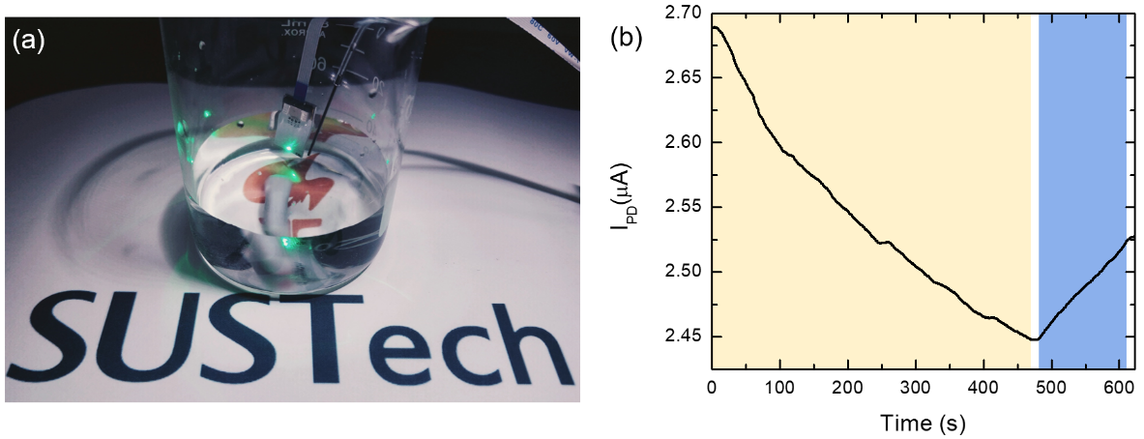
Figure 8. (a) Photograph of measurement setup for monitoring the refractive index change of solution mixture. The SUSTech logo is reproduced with permission from the Southern University of Science and Technology. (b) The time-varying photocurrent when the LED operates at a current of 10 mA. Regions shaded in yellow and blue correspond to the period of injection of the 40%-glucose solution and DI water, respectively.

Having identified the rapid responses, the integrated chip has great potential in real-time monitoring the refractive index change of aqueous solution. The measurement setup for monitoring the refractive index is illustrated in Fig. 8(a), a detailed description of which is provided in Supporting Information. The chip is fully immersed in a beaker containing 30 ml of water, and the on-chip LED is biased at a fixed current of 10 mA. A 30-ml 40%-glucose solution is pumped into the beaker at a rate of 64 μl/s using a pressure adjustable flow controller. A magnetic stirrer is utilized to stir the solution mixture to accelerate its homogeneity and the change in refractive index is tracked by the measured photocurrent, as displayed in the yellow shaded area in Fig. 8(b). With the injection of glucose solution, the photocurrent level reduces gradually due to decreased Fresnel reflection and increased critical angle arising from the reduction of refractive index contrast. At t= 475 s, the photocurrent reaches a stable level of 2.4475 μA, which corresponds to the refractive index of 1.3610 RIU for a 60-ml 20%-glucose solution. Sequentially, 30-ml water is added to the solution mixture at a rate of 230 μl/s. As shown in the blue shaded region, an increased photocurrent trend is obtained due to the increase of ambient refractive index, reaching a photocurrent of 2.5269 μA at t= 610 s, which corresponds to a 90-ml 13.3%-glucose solution.

4. Conclusion
In summary, compact refractometers comprising the LED and PD are fabricated on the same InGaN-based epi-layers grown on a sapphire substrate through wafer-scale microfabrication techniques. The flip-chip configuration enables direct contact between the exposed sapphire surface and the solutions. By adopting the monolithic design, the PD can detect the light emitted by the LED with the same MQW through the optical coupling in the transparent sapphire substrate. The sensing mechanism governed by the change of critical angle and Fresnel reflection at the sapphire/solution interface has been investigated. Attributed to the existence of the optically smooth surface of sapphire and high-reflectance DBR at the top and bottom of the chip respectively, the chip can highly sense solutions with a refractive index between 1.3325 and 1.5148 RIU at room temperature. The sensitivity and resolution are determined to be 7.77 μA/RIU and 6.4 x 10⁻⁶ RIU, respectively. The integrated chip exhibits rapid transient response and in-situ real-time monitoring of refractive index change has also been demonstrated. The availability of photonic chips with compact size, cost-effective, robust, and easy fabrication, paves the way for portable chip-scale refractometers.

Supporting Information. Device process flow, DBR stacking, measurement setup for monitoring the refractive index change of solution mixture, reflectance of sapphire/solution interface, and comparison of reported refractometers

ACKNOWLEDGEMENTS
This work is supported by the Basic and Applied Basic Research of Guangdong Province (2019A1515110772) and the SUSTech Startup Fund (Y01796103).

Notes
The authors declare no competing financial interest.

References
- Chiavaioli, F.; Gouveia, C. A. J.; Jorge, P. A. S.; Baldini, F., Towards a Uniform Metrological Assessment of Grating-Based Optical Fiber Sensors: From Refractometers to Biosensors. Biosensors-Basel 2017, 7 (2), 23.
- Ozcariz, A.; Ruiz-Zamarreno, C.; Arregui, F. J., A Comprehensive Review: Materials for the Fabrication of Optical Fiber Refractometers Based on Lossy Mode Resonance. Sensors-Basel 2020, 20 (7), 1972.
- Urrutia, A.; Del Villar, I.; Zubiate, P.; Zamarreno, C. R., A Comprehensive Review of Optical Fiber Refractometers: Toward a Standard Comparative Criterion. Laser Photonics Rev 2019, 13 (11), 1900094.
- Wu, Q.; Semenova, Y.; Wang, P. F.; Farrell, G., High sensitivity SMS fiber structure based refractometer - analysis and experiment. Opt Express 2011, 19 (9), 7937-7944.
- Zhang, S.; Deng, S. F.; Wang, Z. M.; Geng, T.; Yang, W. L.; Sun, C. T.; Yan, Q.; Li, Y. X.; Tong, C. G.; Dai, Q.; Sun, W. M.; Yuang, L. B., A Compact Refractometer With High Sensitivity Based on Multimode Fiber Embedded Single Mode-No Core-Single Mode Fiber Structure. J Lightwave Technol 2020, 38 (7), 1929-1935.
- Zhou, W. J.; Zhou, Y.; Albert, J., A true fiber optic refractometer. Laser Photonics Rev 2017, 11 (1), 1600157.
- Chen, P. C.; Shu, X. W.; Cao, H. R.; Sugden, K., High-sensitivity and large-dynamic-range refractive index sensors employing weak composite Fabry-Perot cavities. Opt Lett 2017, 42 (16), 3145-3148.
- Calixto, S.; Piazza, V.; Gonzalez-Suarez, A. M.; Garcia-Cordero, J. L.; Bruce, N. C.; Rosete-Aguilar, M.; Garnica, G., Liquid refractive index measured through a refractometer based on diffraction gratings. Opt Express 2019, 27 (24), 34705-34720.
- Del Villar, I.; Arregui, F. J.; Zamarreno, C. R.; Corres, J. M.; Bariain, C.; Goicoechea, J.; Elosua, C.; Hernaez, M.; Rivero, P. J.; Socorro, A. B.; Urrutia, A.; Sanchez, P.; Zubiate, P.; Lopez, D.; De Acha, N.; Ascorbe, J.; Matias, I. R., Optical sensors based on lossy-mode resonances. Sensor Actuat B-Chem 2017, 240, 174-185.
- Elshorbagy, M. H.; Cuadrado, A.; Gomez-Pedrero, J. A.; Alda, J., Opto-Electronic Refractometric Sensor Based on Surface Plasmon Resonances and the Bolometric Effect. Appl Sci-Basel 2020, 10 (4), 1211.
- Wang, Q.; Zhao, W. M., A comprehensive review of lossy mode resonance-based fiber optic sensors. Opt Laser Eng 2018, 100, 47-60.
- Ratcliff, E. L.; Veneman, P. A.; Simmonds, A.; Zacher, B.; Huebner, D.; Saavedra, S. S.; Armstrong, N. R., A Planar, Chip-Based, Dual-Beam Refractometer Using an Integrated Organic Light-Emitting Diode (OLED) Light Source and Organic Photovoltaic (OPV) Detectors. Analytical Chemistry 2010, 82 (7), 2734-2742.
- Tam, H.L.; Choi, W.H.; Zhu, F. Organic Optical Sensor Based on Monolithic Integration of Organic Electronic Devices. Electronics 2015, 4, 623-632.
- Laubsch, A.; Sabathil, M.; Baur, J.; Peter, M.; Hahn, B., High-Power and High-Efficiency InGaN-Based Light Emitters. IEEE T Electron Dev 2010, 57 (1), 79-87.
- Wierer, J. J.; Krames, M. R.; Epler, J. E.; Gardner, N. F.; Craford, M. G.; Wendt, J. R.; Simmons, J. A.; Sigalas, M. M., InGaN/GaN quantum-well heterostructure light-emitting diodes employing photonic crystal structures. Appl Phys Lett 2004, 84 (19), 3885-3887.
- Nakamura, S.; Senoh, N.; Iwasa, N.; Nagahama, S. I., High-Brightness Ingan Blue, Green and Yellow Light-Emitting-Diodes with Quantum-Well Structures. Jpn J Appl Phys 2 1995, 34 (7a), L797-L799.
- Shi, Z.; Yuan, J. L.; Zhang, S.; Liu, Y. H.; Wang, Y. J., Simultaneous dual-functioning InGaN/GaN multiple-quantum-well diode for transferrable optoelectronics. Opt Mater 2017, 72, 20-24.
- Fu, J. W.; Zhu, B. C.; Shi, Z.; Yuan, J. L.; Gao, X. M.; Wang, Y. J., Spatial Audio Acquisition Using a Dual-Functioning MQW-Diode With a Three-Stage Amplifier Circuit. IEEE Access 2018, 6, 8954-8958.
- Jhou, Y. D.; Chen, C. H.; Chuang, R. W.; Chang, S. J.; Su, Y. K.; Chang, P. C.; Chen, P. C.; Hung, H.; Wang, S. M.; Yu, C. L., Nitride-based light emitting diode and photodetector dual function devices with InGaN/GaN multiple quantum well structures. Solid State Electron 2005, 49 (8), 1347-1351.
- Wang, Y. J.; Wang, X.; Zhu, B. C.; Shi, Z.; Yuan, J. L.; Gao, X. M.; Liu, Y. H.; Sun, X. J.; Li, D. B.; Amano, H., Full-duplex light communication with a monolithic multicomponent system. Light-Sci Appl 2018, 7, 83.
- Shi, Z.; Gao, X. M.; Yuan, J. L.; Zhang, S.; Jiang, Y.; Zhang, F. H.; Jiang, Y.; Zhu, H. B.; Wang, Y. J., Transferrable monolithic III-nitride photonic circuit for multifunctional optoelectronics. Appl Phys Lett 2017, 111 (24), 241104.
- Li, K. H.; Cheung, Y. F.; Jin, W. J.; Fu, W. Y.; Lee, A. T. L.; Tan, S. C.; Hui, S. Y.; Choi, H. W., InGaN RGB Light-Emitting Diodes With Monolithically Integrated Photodetectors for Stabilizing Color Chromaticity. IEEE T Ind Electron 2020, 67 (6), 5154-5160.
- Li, K. H.; Lu, H. T.; Fu, W. Y.; Cheun, Y. F.; Choi, H. W., Intensity-Stabilized LEDs With Monolithically Integrated Photodetectors. IEEE T Ind Electron 2019, 66 (9), 7426-7432.
- Chen, P. C.; Shu, X. W.; Cao, H. Y.; Sugden, K., Ultra-sensitive refractive index sensor based on an extremely simple femtosecond-laser-induced structure. Opt Lett 2017, 42 (6), 1157-1160.
- Zhou, X. L.; Chen, K.; Mao, X. F.; Peng, W.; Yu, Q. X., High-resolution optical refractometer based on a long-period grating Michelson interferometer using a cross-correlation signal-processing method. Opt Eng 2015, 54 (12), 126108.
- Shao, L. Y.; Liang, J. W.; Zhang, X. P.; Pan, W.; Yan, L. S., High-Resolution Refractive Index Sensing With Dual-Wavelength Fiber Laser. Ieee Sens J 2016, 16 (23), 8463-8467.

TOC Graphic
