Synchronized Truck and Drone Routing in Package Delivery Logistics
Dyutimoy Nirupam Das, Rohan Sewani, Junwei Wang and Manoj Kumar Tiwari
Abstract—The use of Unmanned Aerial Vehicles (UAVs) in delivery logistics has become an efficient solution with the advancement of autonomous robotics. This paper proposes a novel mechanism that synchronizes drones and delivery trucks; particularly the case where trucks can work as mobile launching and retrieval sites. The problem is a Vehicle Routing Problem with Time Windows and Synchronized Drones. A multi-objective optimization model is developed with two conflicting objectives, minimizing the travel costs and maximizing the customer service level in terms of timely deliveries. A novel Collaborative Pareto Ant Colony Optimization algorithm is proposed to solve the model and Non-dominated Sorting Genetic Algorithm II (NSGA-II) is used to compare and validate the proposed algorithm. The experimental results indicate that the proposed mechanism is an efficient solution to parcel delivery logistics.

Index Terms—Drone delivery, evolutionary algorithms, Multi-Objective Ant colony optimization, Unmanned Aerial Vehicles

INTRODUCTION
U
NMANNED Aerial Vehicles (UAVs) are electrically driven flying devices which are autonomously or remotely controlled. The use of UAVs earlier being limited to defense, security and surveillance purposes is now expanding to commercial purposes. With the global fast development of E-commerce and On-door services, it is desired to design cost-efficient and fast transport logistics solutions [1]. The limitations of UAVs are that they, being small and light, cannot carry much weight in one go and have limited endurance limits in terms of time of flight and distance traveled in one charge. Therefore, to use UAVs’ properties efficiently, this paper designs a novel mechanism combining them with delivery trucks which serve as mobile launching and charging stations for the UAVs along with delivering packages on the go.
While a lot of technical studies aimed to increase the weight carrying capacities and endurance of UAVs, their use in the field of delivery and transportation logistics requires system level research for optimal use in last mile delivery [2]. Many big companies including Amazon and DHL have been working on piloting parcel delivery systems with the incorporation of drones for prioritized quick deliveries. With the changing aerial laws for UAV regulation, different countries like China and Canada allow companies to facilitate deliveries using drones.
This paper studies a new mechanism that includes multiple vehicles in collaboration with multiple drones which work synchronously, with trucks as mobile launching and retrieval sites for drones, to achieve an optimal delivery route in terms of a multi-objective problem. This synchronized delivery problem is formulated as a multiple objective mixed integer programming model; the first objective is to minimize the travel distance and the second objective is to maximize the customer satisfaction which is achieved by scheduling the deliveries in customer-defined time windows. The synchronized truck and drone routing problem is a unique intersection of vehicle routing problem and job-scheduling problem, as different customer nodes can be assigned to be served by either the truck or the drone depending on constraints and optimization of the objectives. A novel Collaborative Pareto Ant Colony Algorithm (Collaborative P-ACO) is designed by inclusion of multiple synchronous drones along with the vehicles in the routing problem to confront this challenge. The Non-dominating Sort Genetic Algorithm II (NSGA-II) is also used to solve the model for evaluating the Collaborative P-ACO. A novel chromosome structure, for NSGA-II, is introduced to represent the convoluted path of the truck drone system.
The remainder of the paper is organized as follows. Section II reviews the relevant literature. Section III formulates the mathematical model of the problem. Section IV gives the solution methodologies for the model. A comparative study on the performance of both algorithms is done in Section V. Section VI concludes the paper.

LITERATURE REVIEW
Last Mile delivery has been a topic of research as it adds extra miles and minutes to delivery, especially in inaccessible and remotely located destinations; many solutions have been proposed in the literature such as different delivery levels [3], autonomous robots[4] and crowdsource enabled deliveries [5] to minimize expenditures on last mile logistics.
With the advancement in technology and availability of cheap and robust electronic devices, the feasibility of using UAVs in logistics has been in the research limelight since the past decade. Many optimization models for drones have been developed for various purposes like surveillance [6] disaster relief activities [7] and parcel deliveries [8]. The model of the drone delivery problem is a modification of the vehicle routing problem. The incorporation of the time-windows makes it similar to the Vehicle Routing with Time Windows (VRPTW) problem statements. Murray et al. [9] suggested to use drones separately with trucks for deliveries. The use of a single truck and a single drone was shown in [10]. Sawadsitang et al. [11] proposed a stochastic approach towards using drones and trucks together for deliveries but not in a synchronized or collaborative way. A traveling salesman problem using a drone, i.e. using one drone and truck was studied in [12]. Marinelli et al. presents an optimization model for enroute launching and recovery of drones with a single truck drone pair [13]. While, the model presented in our work considers the launching and retrieval of drones only on intermediate customer nodes on the truck patch.
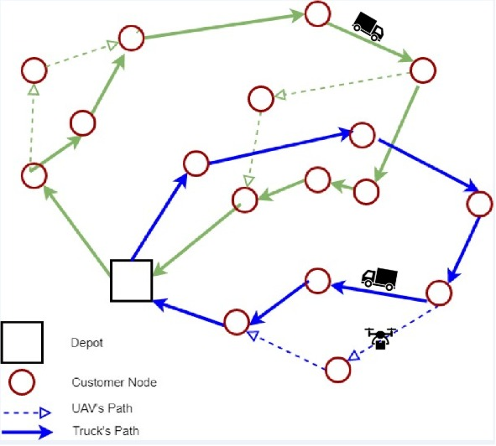
Fig. 1. Vehicle Routing Problem with Synchronized Drones model.

Ref. [14] presents the comparison between a TSP and a drone assisted VRP through numerous worst-case scenarios. In this paper, for the first time, a synchronous multiple trucks and drone problem has been formulated as a multi-objective model. We use the customer satisfaction based on priority of delivery time windows and when the customer is served as a criterion, as in [15]. We also consider soft time windows, so that the delivery to each customer is ensured as accounted in [16] by prioritizing the time windows and not keeping hard bounds for the delivery to take place in specific time windows [17].The incorporation of cost minimization along with customer satisfaction by timely deliveries for multiple vehicles and UAV pairs makes it a more realistic mechanism.
Extensive studies have been done in VRPs with various combinations of conflicting objectives like minimization of travel time [18], minimization of the number of vehicles used [19], and minimization of customer wait time [20]. As different solutions of multi-objective problems can have the same level of optimality, various algorithms have been designed [21]. Nature-inspired algorithms have been prevalent in solving complex routing and scheduling problems, as the problem is NP-Complete. Ref. [22] presents a detailed analysis on the flying side kick problem formulated by Murray et al. [9] and solves it by simulated annealing. The NSGA-II is commonly used to solve multi-objective problems [23]. Our VRPTW formulation is similar to job scheduling problems. ACO algorithm has also been widely used to solve multi-objective VRPs and job scheduling problem [24]-[27]. We propose a novel Collaborative P-ACO Algorithm with two types of ants with collaboration that is an extension of Pareto ACO [28] [29].

Problem formulation
Our problem ensures visit and delivery at each customer node only once, by either a UAV or a truck. There is one UAV assigned to each delivery truck which works in coordination with the truck. The drone launching and retrieval takes place on intermediate customer nodes the delivery path of the corresponding truck, as shown in Fig.1. The fleet of trucks and drones serves each customer within predefined time windows, violation of which leads to loss of consumer satisfaction. The customers are divided into GR groups based on their importance, violation of time windows for customers, and satisfaction loss is based on their importance and the amount of delay in delivery.

Notational Convention
There are n customers with the starting and ending depot comprising total n+2 nodes. The fleets of V_{size} trucks and D_{size} drones are represented by two sets, i.e., V and D. The n customers are divided into GR groups according to importance.

Assumptions
We have the following assumptions for the model.
- Each customer is served only once by a truck or a drone.
- During a drone subtour, it can service only one customer node; however, the truck may visit more than one node during the drone subtour.
- Neither the truck nor the drone can stop at any point other than the nodes which they are serving.
- If the drone is collected at a certain customer node, it can be relaunched from the same node. But, in case the drone is launched from a node it cannot be retrieved by the truck at the same node as neither is the truck allowed to wait nor is it allowed to return to the node.
- A drone is charged instantly, after it is retrieved by the truck after a flight.
- The drone can only be retrieved back by the truck at a customer node and not at along an arc between two nodes in the truck’s path.
- In the case when the sub tour ends at the depot, it cannot be re-launched from the depot; in this case, the drone is taken out of service.
- The case of time windows of different lengths has been considered. There’s a priority score corresponding to each time window for delivery at each node.
- There are multiple time windows which are ranked equally.
- There is only one depot acting as the starting and ending point of the tour.
- The schedule is planned for the whole day’s deliveries.
- The disruption due to weather conditions or node capacity demands are already known at the time of routing.
- The routing is performed such that the trucks are in continuous uniform motion, except at the customer nodes
and there is no idle time at any point on the arc between the customer nodes.
TABLE I
notation
Notation | Definition
N | set of nodes containing only customers
N₊ | set of nodes containing customers including end depot
N₀ | set of nodes containing customers including starting depot
D | set of all drones
V | set of all trucks
GR | set of groups of customers
h, i, j, k, l, m, n | indices for customer and depot
d_{i} | indices for drones where i = 1,….,Dsize
v_{i} | indices for drones where i =1,……,Vsize
$Q_{i }$ | demand at node i N
q | capacity of truck
I | capacity of drone
E_{j} | equals to 1 if node jN can be served by a drone, and 0 elsewise.
$P_{i,tw}$ | Priority of time window tw for customer i
B_{ig} | equals to 1 if customer i is the member of group gGR and 0 elsewise.
$α_{g }$ | Maximum preference rank authorized to assign in group g of customers GR
 | start time of time window
 | end time of time window
$c_{ij}$ | cost of traveling using truck from node i N₀ to node j N₊
β | Factor of traveling cost for drones
$t_{ijv }$ | travel time of truck v from node i to node j N₊
$t _{ijd }^{'}$ | travel time of drone d from node i N₀ to node j N₊
e | endurance of drone
$s_{l}$ | Preparation time to launch drone d
$$s_{r }$$ | Time taken to receive drone d
M | A big positive integer

- The customers are divided into priority groups in accordance with their importance; the corresponding service level priority constraints ensure that the more important groups have a better service level.

Mathematical Formulation
$$\begin{aligned}\sum_{i∈N}{\sum_{tw∈T}{y_{i,tw}P_{i,tw}}}\#\left(B\right)\end{aligned}$$
$\begin{aligned}\sum_{v∈V}{\sum_{i∈N_{0}}{x_{ijv}+}}\sum_{d∈D}{\sum_{i∈N_{0}}{\sum_{k∈N_{+}}{x'_{ijkd}}}}=1 ∀j∈N \#\left(1\right)\end{aligned}$
$\begin{aligned}\sum_{j∈N_{+}}{x_{0jv}=1}​​​​​ ∀v∈V \#\left(2\right)\end{aligned}$
$\begin{aligned}\sum_{i∈N_{0}}{x_{i\left(n+1\right)v}=1}​​​​​∀v∈V \#\left(3\right)\end{aligned}$
$\begin{aligned}x_{ijkd}≤E_{j} ∀i∈N_{0};j∈N;k∈N_{+};d∈D \#\left(4\right)\end{aligned}$
$$\begin{aligned}u_{iv}-u_{jv}+1≤\left(n+2\right)\left(1-x_{ijt}\right)∀i∈N_{0};j∈N_{+};v∈V\#\left(5\right)\end{aligned}$$
TABLE II
Decision variables
Continuous Variables
$$t_{i }$$ | Reaching time Node i N₀ by truck v, it includes launching and receiving time of drone
$${t_{ }^{'}}_{i}$$ | Reaching time Node iN₀ by drone v, it includes launching time of drone
$$St_{i}$$ | Time of service for customer i N₀
Binary Variables
$$y_{i,tw }$$ | if time window tw is selected for node iN_{0,} then y_{i,tw}=1 or else 0
 | if truck v travels from node i to j then value is 1 otherwise 0
$$x_{ijkd }^{'}$$ | if drone d launches from node iN₀ and delivers service to node jN and rendezvous
P_{ij} | P_{ij} equals to one if customer iN is visited at some time before customer jN
u_{iv} | i^{th} position in travel path of truck v

$\begin{aligned}2x'_{ijkd}≤\sum_{\begin{aligned}&h∈N_{0} \\ &h≠i\end{aligned}}{x_{hiv}}+\sum_{\begin{aligned}&l∈N \\ &l≠k\end{aligned}}{x_{lkv}} \#\left(6\right)\end{aligned}$
$$∀i∈N;j∈\{N:j≠i\};k∈N_{+};v∈V;d∈\{D:d=v\}$$
$\begin{aligned}x'_{0jkd}≤\sum_{\begin{aligned}&h∈N_{0} \\ &h≠k\end{aligned}}{x_{hkv}} \#\left(7\right)\end{aligned}$
$∀j∈N;k∈N_{+};v∈V;d∈\{D:d=v\}$
$\begin{aligned}u_{kv}-u_{iv}≥1-(c+2)(1-\sum_{j∈N}{x'_{ijkd})}\#\left(8\right)\end{aligned}$
$$∀i∈N;k∈\left\{N_{+}:k≠i\right\};v∈V;d∈\left\{D:d=v\right\}$$
$\begin{aligned}t'_{id}≥t_{iv}-M(1-\sum_{\begin{aligned}&j∈N \\ &j≠i\end{aligned}}{\sum_{k∈N_{+}}{x'_{ijkd})}}\#\left(9\right)\end{aligned}$
$$i∈N;v∈V;d∈\{D:d=v\}$$
$\begin{aligned}t'_{id}≤t_{iv}+M(1-\sum_{\begin{aligned}&j∈N \\ &j≠i\end{aligned}}{\sum_{k∈N_{+}}{x'_{ijkd})}}\#\left(10\right)\end{aligned}$
$∀i∈N;v∈V;d∈\{D:d=v\}$
$\begin{aligned}t'_{kd}≥t_{kd}-M(1-\sum_{\begin{aligned}&i∈N_{0} \\ &i≠k\end{aligned}}{\sum_{j∈N}{x'_{ijkd})}} ∀k∈N_{+};d∈D\#\left(11\right)\end{aligned}$
$\begin{aligned}t'_{kd}≤t_{kd}+M(1-\sum_{\begin{aligned}&i∈N_{0} \\ &i≠k\end{aligned}}{\sum_{j∈N}{x'_{ijkd})}} ∀k∈N_{+};d∈D\#\left(12\right)\end{aligned}$
$t_{kv}≥t_{hv}+τ_{khv}+s_{l}\left(\sum_{\begin{aligned}&l∈N \\ &l≠k\end{aligned}}{\sum_{m∈N_{+}}{x'_{klmd}}}\right)+$ $\begin{aligned}s_{r}\left(\sum_{i∈N_{0}}{\sum_{j∈N}{x'_{ijkd}}}\right)-M\left(1-x_{hkt}\right)\#\left(13\right)\end{aligned}$
$$∀h∈N_{0};k∈\{N_{+}:k≠h\};v∈V;d∈\{D:d=v\}$$
$\begin{aligned}t'_{jd}≥t'_{ld}+τ'_{ijd}-M\left(1-\sum_{k∈N}{x'_{ijkd}}\right) \#\left(14\right)\end{aligned}$
$$∀j∈N;i∈\{N_{0}:i≠j\};d∈D$$
$\begin{aligned}t'_{kd}≥t'_{jd}+τ'_{jkd}+s_{r}-M\left(1-\sum_{i∈N_{0}}{x'_{ijkd}}\right)\#\left(15\right)\end{aligned}$
$$∀j∈N;k∈\left\{N_{+}:j≠k\right\}; d∈D$$
$$\begin{aligned}t’_{kd}-\left(t’_{jd}-τ’_{ijd}\right)≤e+M\left(1-x’_{ijkd}\right) \#\left(16\right)\end{aligned}$$
$∀k∈N_{+};j∈\{N:j≠k\};i∈N_{0};d∈D$
$$\begin{aligned}u_{i}-u_{j}≥1-\left(c+2\right)P_{ij} ∀i∈N;j∈\left\{N:j≠i\right\} \#\left(17\right)\end{aligned}$$
$$\begin{aligned}u_{i}-u_{j}≤-1+\left(c+2\right)\left(1-P_{ij}\right) ∀i∈N;j∈\left\{N:j≠i\right\} \#\left(18\right)\end{aligned}$$
$$\begin{aligned}P_{ji}+P_{ij}=1 ∀i∈N;j∈\left\{N:j≠i\right\}\#\left(19\right)\end{aligned}$$
$\begin{aligned}t'_{ld}≥t'_{kd}-M\left(\begin{aligned}3-\sum_{\begin{aligned}&j∈N \\ &j≠i\end{aligned}}{x'_{ijkd}} \\ -\sum_{\begin{aligned}&m∈N \\ &m≠i \\ &m≠k \\ &m≠l\end{aligned}}{\sum_{\begin{aligned}&n∈N_{+} \\ &n≠i \\ &n≠k\end{aligned}}{x'_{lmnd}}}-P_{ild}\end{aligned}\right) \#\left(20\right)\end{aligned}$

$$∀i∈N_{0};k∈\left\{N_{+}:k≠i\right\}; l∈\left\{l≠i;l≠k\right\};$$
$$v∈V;d∈\{D:d=v\}$$
$\begin{aligned}st_{j}=\sum_{v∈V}{\sum_{\begin{aligned}&i∈N_{0} \\ &i≠j\end{aligned}}{t_{jv}x_{ijv}}}+\sum_{d∈D}{\sum_{\begin{aligned}&i∈N_{0} \\ &i≠j\end{aligned}}{\sum_{\begin{aligned}&k∈N_{+} \\ &k≠j \\ &i≠k\end{aligned}}{t'_{jd}x'_{ijkd}}}} \#\left(21\right)\end{aligned}$
$$∀j∈N_{+};v∈V;d∈\{D:d=v\}$$
$\begin{aligned}\sum_{tw∈T}{e_{tw}y_{i,tw}≤st_{i}}≤\sum_{tw∈T}{l_{tw}y_{i,tw} ∀i∈N_{+}} \#\left(22\right)\end{aligned}$

$\begin{aligned}\sum_{tw∈T}{y_{i,tw}=1 ∀i∈N_{+}}\#\left(23\right)\end{aligned}$
$\begin{aligned}B_{gi}\sum_{tw∈T}{y_{i,tw}}P_{i,tw}≤α_{g}∀g∈GR;i∈N \#\left(24\right)\end{aligned}$

$\begin{aligned}\sum_{j∈N}{\left(\sum_{i∈N_{0}}{x_{ijv}Q_{j}+}\sum_{i∈N_{0}}{\sum_{k∈N_{+}}{x'_{ijkd}}}Q_{j}\right)} \#\left(25\right)\end{aligned}​$
$$∀v∈V;d∈\{D:d=v\}$$
$\begin{aligned}\sum_{i∈N_{+}}{\sum_{k∈N_{+}}{x_{ijkd}^{'}Q_{j}}}≤I ∀j∈N;d∈D \#\left(26\right)\end{aligned}$

Function (A) denotes the total cost of the route traveled; the first part is the cost of travel of truck and the second part is the cost of the drone subtours. Function (B) denotes the total penalty. Eq. (1) ensures each node to be served exactly once by a drone or a truck. Eqs. (2) and (3) ensure that all trucks leave and enter the depot to ensure completion of routes. Constraint (4) assures that a node is included in a drone path, only if the node satisfies weather and specification condition for delivery. Constraint (5) maintains the order of nodes along a route. Constraints (6) and (7) ensure that the drone must be launched and retrieved by the same corresponding truck at the start and end nodes of its flight. Constraint (8) constricts the drone to reach the retrieval site before the corresponding truck so that the truck does not wait, and the remaining route is not hindered. The presence of truck and drone at the launching node at the same time is ensured by constraints (9) and (10). The constraints (11) and (12) are the time constraints at the retrieval node. Constraints (13)- (15) calculate delivery time. Constraint (16) sets the endurance of the drone. The drone is charged after each retrieval, so the endurance mentioned is for each drone trip from launching and back to retrieval. Constraints (17)- (19) maintain the order of delivery by the truck. Constraint (20) avoids scheduling a relaunch of a drone before its previous retrieval. Constraint (21) calculates start time of delivery at node j. Constraint (22) ensures the delivery is done within the time window. Eq. (23) confirms the delivery at the node is done within one of the time windows. The untimely delivery penalty limit is set by constraint (24). Constraints (25) and (26) limit the capacities of the drone and the truck.

Methodology
Two algorithms, i.e., Collaborative P-ACO and NSGA II to solve the proposed model are discussed in this section.

The proposed Collaborative P-ACO
Pareto ACO is an efficient method to tackle multi-objective problems [30]. ACO was enhanced by introducing individual pheromones for each objective and random weights were assigned to each objective to increase exploration rather than using ant colonies. For the selection of the elite archive solutions an elite archive and scale control based on crowding distance were maintained as described by [28]. P-ACO differs in the process of solution or multiple truck-drone path generation at each iteration with NSGA. The solution for P-ACO is obtained by adding nodes to the travel path based on pheromone level and distance between nodes and tardiness acquired from the path. While NSGA or NSGA-II initial solution is generated randomly.
The synchronized truck and drone routing problem is a unique intersection of vehicle routing problem and job-scheduling problem, as different customer nodes can be assigned to be served by the truck or the drone depending on constraints and objectives. A two-stage formation of the ant path is proposed in section IV-A.2.

Fabrication of Collaborative P-ACO:
In our VRPTW instance, the algorithm optimizes the cost of travel and penalty due to a reduction in customer satisfaction, unlike most literature which optimizes the number of vehicle and cost of travel [25]. As the number of vehicles is fixed and all the nodes are to be serviced, the path for multiple trucks is generated simultaneously. The path of drones is decided after truck routes are found. Initially, instead of a single ant as in ACO [25], a group of v truck ants, equal to the number of trucks, collaborate together to find a feasible solution starting from the depot. The group of child ants return to depot only after they have covered all the nodes. Thus, each ant forms only a part of the solution. Hence, a group of v truck ants together form a single solution. Therefore, we have named the algorithm as Collaborative P-ACO. After the truck paths are decided, the corresponding drones can follow coupled truck paths or choose multiple drone sub tours based on the drone-pheromone matrix similar to truck path selections. While the selection of the drone path, the set of customers and their orders are pre-selected based on the corresponding truck pheromone matrix.

2- stage development of the Solution:
a) Stage 1: Formation of truck paths. The formation of the association of v truck ant paths ( v vehicles) in every iteration should be both explorative and exploitative. The set of v truck ant paths is formed based on the truck-pheromone matrix and heuristic desirability. At each step, an ant chooses the next node from all the remaining customers with a probabilistic approach. Unlike most other ACO algorithms, we decide the path of a group of m truck ants concurrently with respect to time. The group of m truck ants starts from depot together and whenever an ant reaches a node, it uses the pheromone and heuristic desirability to guide it to next node. Thus, all ants move simultaneously. The ant path construction is discussed below and the detailed pseudo-code is in algorithm 1.
Let p(i,j) denote the probability of choosing edge joining node i and node j by ant m at time t. The heuristic measure for the distance is the reciprocal of the distance.
$\begin{aligned}p_{ij}=\frac{((r×τ_{ij})×((1-r)×τ_{ij}^{'}))^{α}×(η_{ij}×{η_{i}^{'}}_{j})^{β} }{\sum_{j∈S}{((r×τ_{ij})×((1-r)×τ_{ij}^{'}))^{α}×(η_{ij}×{η_{i}^{'}}_{j})^{β} }} \#\left(27\right)\end{aligned}$
$∀\text{ i}∈N_{0}\text{ ; j }∈S$
Where, τ_{ij} and τ’_{ij} are pheromone levels for cost of travel objective and tardiness, respectively. η_{ij} and η’_{ij} are heuristic desirabilities for cost of travel objective and tardiness, respectively. α and β are the pheromone and heuristic desirability factors. r is random variable chosen uniformly from range of 0 to 1. S is set of possible next customer node.
$\begin{aligned}η_{ij}=\frac{C}{d_{ij}} \#\left(28\right)\end{aligned}$
Where, d_{ij}= distance between two customer nodes i and j.
$$\begin{aligned}{n^{'}}_{ij}=\frac{C}{{penalty}_{ij}} \#\left(29\right)\end{aligned}$$
Where, penalty_{ij} = penalty occurred due to tardiness, where tardiness is the penalty due to the early or late delivery.
At time t when any ant reaches a node, it selects to move from node i to node j based on roulette model or by taking the best node. The choice is based on parameter q₀ which decides the amount of exploration and exploitation. We generate a random number q from uniformly between 0 to 1. If q≤q₀, best node is chosen; otherwise, it is chosen by roulette model.
Local pheromone update: After ant moves from node I to j, local pheromone update occurs for each objective; see Eq. (30).
$$\begin{aligned}τ_{ij}=\left(1-ξ\right)⋅τ_{ij}+ξ⋅τ_{0}\#\left(30\right)\end{aligned}$$
Where the local evaporation rate is given by ξ and the initial pheromone level is denoted by τ₀.
b) Stage 2: Drone path creation: After a group of m truck ants is assigned routes which are created probabilistically, the drone path is created similarly along corresponding truck ant path. At each customer node, if the drone is not already on a sub tour, it is decided if the next node should be part of the drone sub tour. When the next subtour is decided, not only the node to be serviced by drone is decided but also the node at which it will be received by the truck is to be decided based on endurance constraints. For example, let drone and truck be at node i together, at this state drone has to decide to either to choose a sub tour or continue along truck. Only a set of sub tours which satisfy the endurance condition i.e. distance from i to j and j to k together shouldn’t be more than flight endurance of the drone satisfy the condition to be selected as a drone subtour. i, j and k are decided similarly to truck ant path. Drone ants have a different set of pheromone matrix for the objectives. Four heuristic desirabilities are used for factor in the tardiness and the cost, two for each. For the tardiness, we calculate the heuristic measure of drone similar to truck based on a penalty. We also include the tardiness due to the change in truck path due to the sub tours. Likewise, the heuristic desirability for the distance is the reciprocal of the cost of travel of sub tour as well as comprises of the current distance heuristic measure of the changed truck path. Similar to truck path selection, p_{ijk} selection probability is applied to drone path
$p_{i}=((r×{τ^{d}}_{ijk})×((1-r)×{τ^{'d}}_{ijk}))^{α}$
$\begin{aligned} ×({η^{d}}_{ijk}×{η^{'}}_{ijk}^{d})^{β} ×(ε_{ijk}×ε_{ijk}^{'})^{β}\#\left(31\right)\end{aligned}$
$∀i∈N_{0}\text{ ; j,k }∈S$
$$p_{jk}=((r×{τ^{d}}_{ijk})×((1-r)×{τ^{'d}}_{ijk}))^{α} \\ \begin{aligned} ×({η^{d}}_{ijk}×{η^{'}}_{ijk}^{d})^{β} ×(ε_{ijk}×ε_{ijk}^{'})^{β}\#\left(32\right)\end{aligned}$$
$∀i∈N_{0}\text{ ; j,k }∈S$
$$\begin{aligned}p_{ijk}=\frac{p_{i}}{\sum_{j,k∈S}{p_{jk} }} ∀\text{ i}∈N_{0}\text{ ; j,k }∈S \#\left(33\right)\end{aligned}$$
where, τ^{d}_{ijk} and τ^{’d}_{ijk} are pheromone levels specifically for the cost of travel objective and tardiness of drones, respectively. Similarly, the heuristic desirability’s for drone paths are η_{ijk} and η’_{ijk} for the cost of travel objective and tardiness, respectively. α and β are the pheromone and heuristic desirability factors. r is a uniform random variable within [0, 1]. ε_{ijk} and ε’_{ijk} account for the change in the cost of travel and tardiness in truck path due to sub tour. S is set of possible sub tours starting from i.
$\begin{aligned}{η^{d}}_{ijk}=\frac{C}{d_{ijk}} \#\left(34\right)\end{aligned}$
where, d_{ijk} is the distance covered in the sub tour by drone.
$$\begin{aligned}{η^{'}}_{ijk}^{d}=\frac{C}{penalty_{ijk}} \#\left(35\right)\end{aligned}$$
where, penalty_{ijk} is the total penalty acquired due to tardiness at j and k. where, penalty_{ijk} is the total penalty acquired due to tardiness at j and k. The selection process of drone sub tour is exactly like the edge selection in the truck path. Similarly, local
Algorithm 1 Pseudo-Code of Collaborative P-ACO Algorithm
1: | Input: Available dataset of customer nodes and Tuned parameters
2: | Output: Pareto – optimum front
3: | Initialize pheromone matrix
4: | for iter in range of Max number of iterations do
5: | for m in range of Total number of Ants do
6: | Customer = Set of all customers
7: | while Customer array ≠Ø do
8: | Find vehicle with minimum tour time till now
9: | Evaluate q and $p_{ij}$ for last node, i, off that vehicle
10: | Based on q₀, select next node, j, either roulette method or
 | by taking the best next node
11: | Update the tour time and remove node j and add it to truck path
12: | Update the tour time and remove node j and add it to truck path
13: | local pheromone update
14: | while end
15: | for d in range of Number of Drones do
16: | Traverse along the corresponding truck sequence
17: | while S0 do
18: | Number of possible sub tours,S
19: | while end
20: | Chose sub tour for drone based on endurance,$q,q_{0},p_{ijk}$
21: | Update possible sub tour set
22: | for end
23: | for end
24: | Update Elite Archive
25: | Global pheromone update and evaporation
26:  : | for end
pheromone update occurs for the sub tour chosen.

Elite archive and scale control:
As proposed by [28], an elite archive of pareto optimal solutions is maintained for better convergence rates. The elite archive scale is based on crowding distance. If the number of solutions in the elite archive is more than the maximum number of individuals, MaxEAN, the solution with the least crowding distance is deleted and the crowding distance for other solutions is updated. This is repeated till a number of solutions in the elite archive are equal to MaxEAN. The elite archive is initialized to null. At each iteration, new solutions are added to the elite archive and sorted based on objective values and crowding. The non-dominated front is stored in the elite archive.

The global pheromone update and evaporation:
Global pheromone update occurs for the elite archive ant path only. The amount,, added the pheromone is proportional to the expected fitness value of the objective and inversely proportional to the value of fitness of the current ant path in elite archive and size of the elite archive. The magnitude of pheromone is not allowed to go below τ_{max} or exceed τ_{min}, for better chance to converge to the global optimum pareto front. [31]. The formula for an update for each objective for both drone and truck pheromone matrix in the elite archive is:
$$\begin{aligned}τ_{ij}=τ_{ij}+Δ \#\left(36\right)\end{aligned}$$
And, evaporation occurs for all pheromone values:
$$\begin{aligned}τ_{ij}=\left(1-p\right)⋅τ_{ij}\#\left(37\right)\end{aligned}$$
Similar, update rule for, all pheromone matrices.

P-ACO parameter tuning.

The basic structure and values of parameters were adapted from results obtained by [24]. The following parameters were determined through a series of experiments: α, β, q₀, Q_{c}, Q_{t}, C, ρ, K, MaxIt. Q_{t} (for tardiness penalty objective) and Q_{c} (cost of travel objective) command the amount of pheromone deposited. In P-ACO, the solution space is covered better when these numerical values are similar in order, thus maintaining the diversity of the front. Corresponding to our data, Q_{t} and Q_{c} are kept at a value of 60 and 120, respectively.
The values for heuristic desirabilities were retained at an average value of 10 by tuning parameter C to the value of 1000 through trial and error. Similarly, initial pheromone level was assigned the value of 10. Additionally, max pheromone level was chosen at 20 and minimum pheromone level at 1. [32] α and β parameter, various different configurations were tried out for different size of individual and the best one was selected. The alpha value is kept constant at 1 [33], and β was tuned to a value of 2 as we are modifying the relative weights of the heuristic and β. q₀ and ρ calibrate the measure of exploration and exploitation behavior of the algorithm and are selected through trial and error method based on convergence and number of iterations it takes to converge which in turn decides the computational time and are chosen as q₀=0.5 and ρ=0.15.
For a number of ants K and number of iterations, MaxIt, are empirically decided based on problem size. The size of the problem increases, for example, the number of customer node increases, complexity, and size of solution space increase. To tackle this, K and MaxIt are increased but this results in higher computational time. We need to maintain a balance between the solution quality and computational time. Therefore, for our most complex problem of 50 customer node and 6 trucks and 6 drones, K and MaxIt are chosen as 70 and 170 respectively. Similarly, for the simpler dataset of 25 customer and 2 trucks and 2 drones, K and MaxIt are taken as 30 and 100, respectively.

Non-dominated Sort Genetic Algorithm-II

Chromosome structure and Initialization
The chromosome is designed to incorporate all the trucks and their respective drones in the same chromosome. Each gene of a chromosome represents a customer node and number of genes in each chromone is equal to the number of customer nodes. The chromosome is divided into two parts; the first part comprises of the customer nodes served by trucks and the second part contains path followed and customers served by the drones. Depending on the number of customers served by the drone, the length of the chromosome also changes. This chromosome structure facilitates the exact calculations of the delivery and travel times. The value of cost minimization objective function and the service level objective function can be stored in the last two cells of the corresponding chromosome. While construction of the chromosome, with the incorporation of drones, the constraints of route-feasibility have been kept in mind, as mentioned in constraints (1), (5)-(8); the drone follows the sequential order of the truck and the drone cannot leave the truck again before it comes back from the previous flight (constraint (20). It has been ensured that the constraints (8)-(10) and (16) are not violated in constructing a drone tour.
Initially, a random path is selected for each truck v. Based on the truck path the corresponding drone is made to traverse on it keeping the endurance of the path in mind while serving the nodes which are not serviced in by the trucks. The truck starts from the depot which is denoted by 1. Each time the v^{th} truck return to the depot, the depot is denoted by n+2+0.01*v. This differentiation in representation, return depot, even though they represent the same start depot is maintained to identify and set apart each truck path in the chromosome structure. Fig. 4 shows an example depicting the basic chromosome structure and a crossover operation. As shown in Fig. 4, first truck starts from depot, represented by 1, and serves 2,4,9 and finally returns to the depot, represented by 12.01. While, first truck delivers to 2,4, drone delivers to node 7 and rendezvous with first truck at node 4. Similarly, drone serves to node 6 after launching from 9, and in meant time truck serves 9, 6 and returns to depot. Both meet finally in the depot in this case. In parallel, second truck starts from depot, represented by 1, and serves 3, 5, 8, 10 and returns to depot, represented by 12.02. During the time that the truck serves to 5, 8, 10, the drone serves node 11 after launching from node 5. Both meet again at node 10.

Non-domination sort
For Non-domination sort, the crowding distance, i.e., the measure of closeness between a solution and its nearest neighbors, is calculated for the chromosomes. The value of the crowding distance is appended at the end of the chromosome. Sorting is done on the basis of non-domination. The first front dominates the rest of the population. The second front is dominated by only the first front. All individuals are sorted into fronts. Within a front, the fitness is decided by the crowding distance based on which the solution in the same front is sorted which leads to a better variation in the solutions.

Selection
The set of parent chromosomes is done using Binary Tournament Selection. The scale of the competition can be altered according to the requirements. From the set of the initial chromosomes, the chromosomes are randomly compared to each other and the best ones are selected until the pool size is filled. The comparison is done based on the fronts. If the solutions belong to the same front, the selection is done based on crowding distance.

Offspring generation
For the generation of the offspring population, crossover and mutation are carried out. The crossover operator used is PMX operator [34] with a crossover rate of Pc. The PMX operator and the chromosome structure ensure that the new off-springs generated are feasible in terms of the corresponding routes according to the formulation. The mutation is done using scramble operator is used with a fixed mutation rate of Pm. The chromosome is modified during the mutation and crossover such that the chromosome structure is maintained, and every time the variable parent chromosome is converted to chromosomes of fixed sizes based upon the number of customer nodes and the number of vehicles. Only the node serviced by the drone is allowed in the modified chromosome, the information of launching and receiving node is deleted. Therefore, sub tours are reinitialized again, similar to the process during initialization of chromosome, for the children chromosome. This forces a wider search in the solution space, thus resulting in better quality of solutions. PMX operator and chromosome modification is represented in Fig 5.
`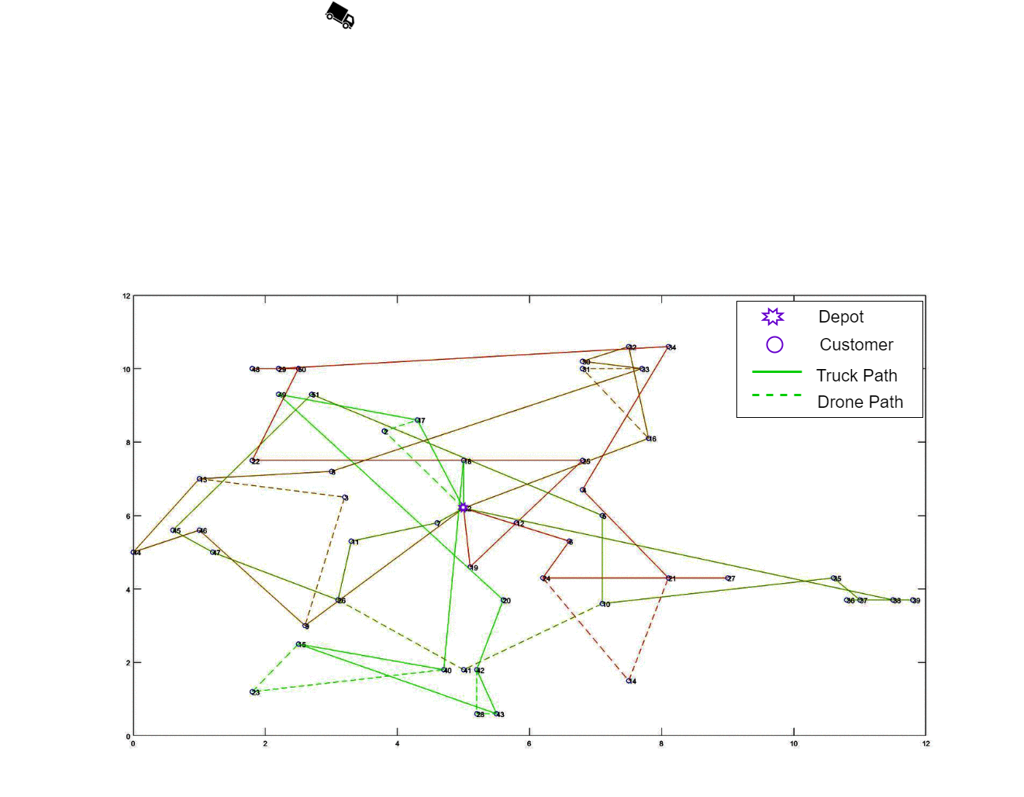
Fig. 2. Optimal routes obtained using CP-ACO

Intersection
NSGA-II shows strong selectivity towards fittest chromosomes. Crowding distance maintains diversity along the front but there is a lack in lateral diversity. To ensure convergence to or near the global Pareto-optimal front, a controlled elitism mechanism suggested by [35] allows a predefined number of individuals from all fronts. In our case, we have used the geometric distribution of a number of the individual from each front. Thus, a total of N individuals from different fronts are selected for the next generation based on their respective front and crowding distance.
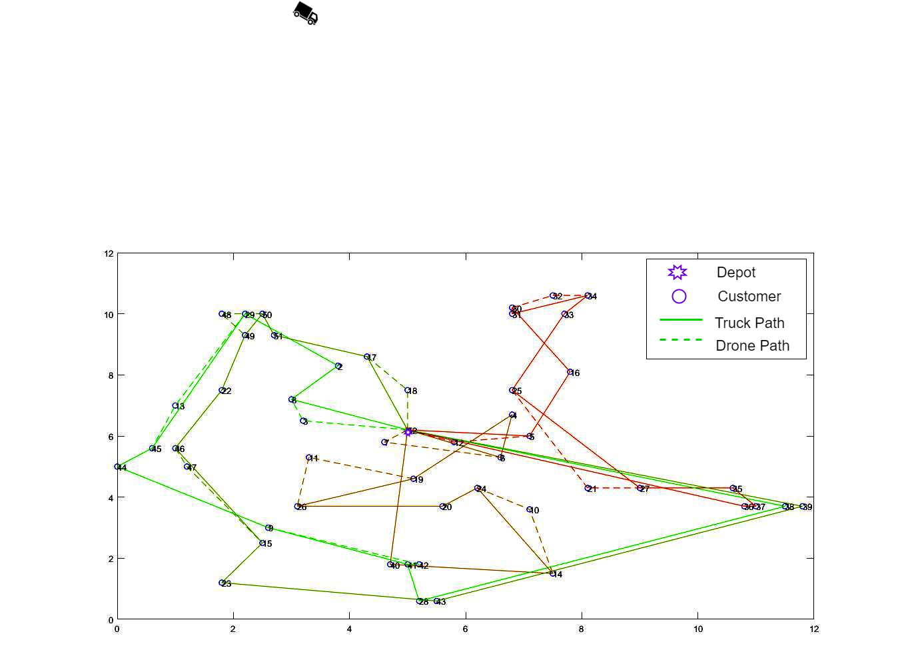
Fig. 3. Optimal routes obtained using NSGA-II

Model Evaluation and Result Analysis
We used Solomon’s benchmark CVRPTW RC dataset to evaluate the model and algorithms, linearly scaled in terms of distance to a level of city logistics. For the evaluation of the robustness of the model and comparison between both algorithms, different cases consisting of a number of truck drone pairs and drone endurance were employed. The endurance of the drone was considered in terms of distance travelled by the drone in single charge. The more is the endurance the more distant nodes can be covered by the drone. The instances used were of sizes, 25 and 50 customer nodes, with the customer nodes distributed as a combination of clustered and randomly distributed points. The results were obtained using Matlab 2017 on intel i5 processor with 4GB RAM. The average time taken for 25 customer node was 204 seconds for NSGA-II and 62 seconds for CP-ACO. In case of 50 customer nodes, NSGA-II takes 514 seconds whereas CP-ACO takes 224 seconds on average. CP-ACO obtains results in much shorter interval time due to difference in time taken in crossover in NSGA-II and child ant path formation in CP-ACO.

Evaluation using Collaborative P-ACO
The Collaborative P-ACO was evaluated on a 50-customer dataset, three different cases of 2, 4, 6 pairs of truck-drone pairs are considered in combination with drone-less, medium endurance drones, and high endurance drones’ cases. In case of medium endurance, the drone can travel 4km in one go and 6km in case of high endurance at constant speed. The optimal solution is visualized in Fig. 2. The convergence to final result is achieved between 120 to 150 iterations for all the cases.

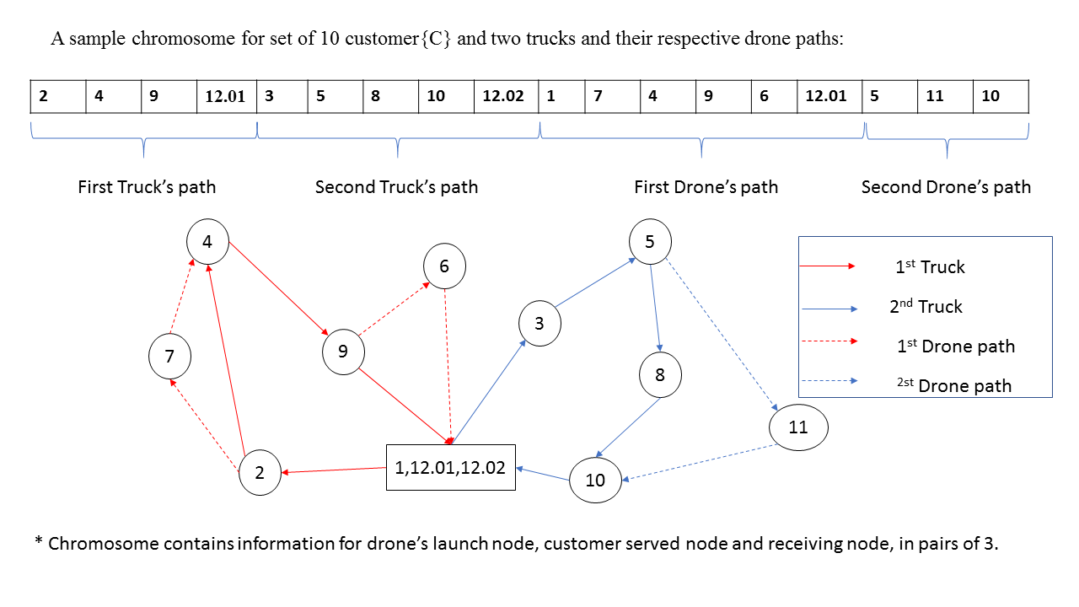
Fig. 4. Chromosome structure

Evaluation using NSGA-II
A combination of a different number of truck-drone pairs and drone endurances are used to evaluate NSGA-II. For the case of 50 customers, the number of truck-drone pairs for the model evaluation are 2, 4 and 6 in combination with the three conditions of no drones (Classical VRPTW), medium endurance and high endurance. The optimal routes are given in Fig. 3. It takes 100 to 120 iterations for the solutions to converge to a constant value of travel cost and tardiness.

Solution analysis and comparative study
The general trend followed by the travel costs and tardiness values with the number of vehicle drone pairs and drone endurance are observed to be complying with real-life situations. The waiting time of the truck was also calculated and listed in Tables III and IV. The Cost is, in general, seen to decrease with the inclusion of drones and with an increase in their endurance; this comes with the fact that the cost of traveling of the drones per unit distance is less than that of the trucks. Fig. 6-A and B show the variation of optimal solutions with varying parameters.
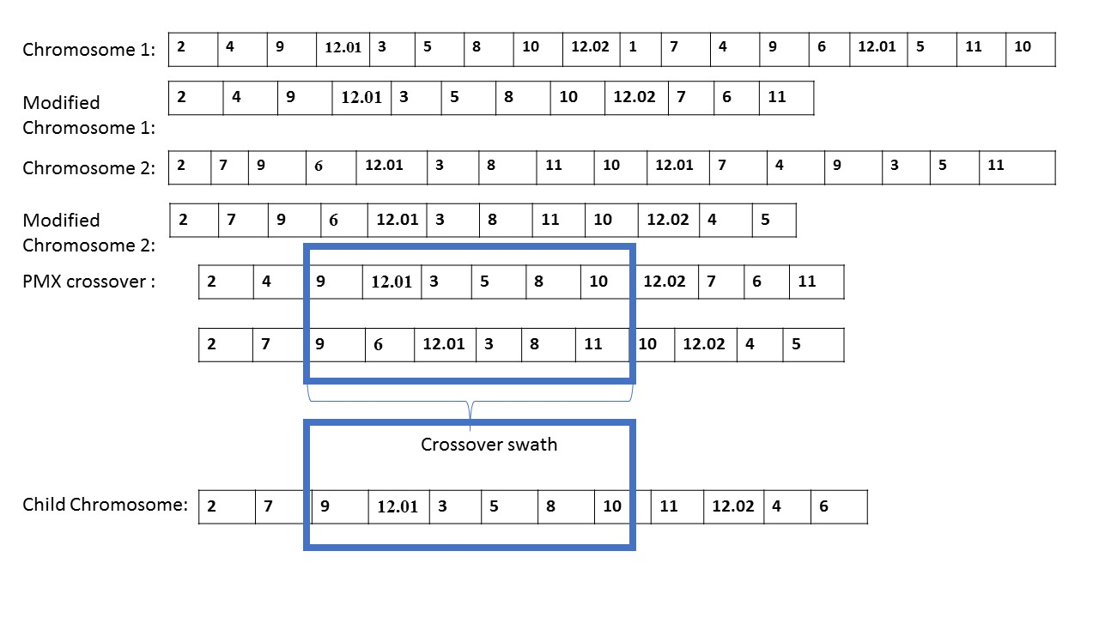
Fig. 5. PMX genetic Operator
When some points are selectively serviced by the drones, some of the extra miles covered by the trucks are replaced by drones and hence the cost decreases. Similarly, with the increase of the endurance of the drones, more traversal by drone is possible hence there is further decrease in the traveling costs. The factor of endurance has been considered by three cases of low, medium and high endurance. The cost is seen to be increasing with the increase in a number of truck drone pairs; this trend is seen as the traveling distance in case of more vehicles are employed as more polygonal paths are created to service the same number of customer nodes.
The tardiness decreased with the inclusion of more number of truck-drone pairs, as it can be understood that a single truck drone pair would cause more delays and untimely deliveries as compared to the cases with more vehicles serving. It is also observed that with the inclusion and increase of the endurance of the drones the tardiness decreases as more timely deliveries can be done in the same duration. The results show that the objective function converges to a certain value after numerous iterations using both the algorithms; see Fig. 6-C. The results show that the Collaborative P-ACO outperforms NSGA-II in terms of the multi-objective solutions. The statistical analysis and results show that the proposed algorithm outperforms NSGA-II both in terms of the optimal values of the costs and service level and also the variability coefficient of the solutions obtained. The time taken to converge to the solution is around half as compared to NSGA-II.
A: Variation of travel cost B: Variation of travel cost C: Pareto optimal front
Fig. 6. Results of 50 nodes instance

Conclusion and Future work
The proposed mechanism of synchronized truck and drone delivery with launching and retrieval of drones on customer nodes on the truck path serves to be a very realistic and optimal solution in the scenario of delivery logistics accounting for both cost minimization and maximization of in-time deliveries. The insights from the results suggest that the use of drones for parcel delivery serves to be a very efficient method in terms of travel cost and customer service. The proposed Collaborative P-ACO algorithm performs well on different instances as compared to the NSGA-II and prove to be a computationally inexpensive meta-heuristic for the truck-drone routing problem. The feasibility of the use of drones in real life scenarios for use in populated regions faces some issues of security and safety. Our model is limited to deterministic demand and fixed truck and drone pairs. More flexibilities in terms of nonuniform fleet of trucks and drones, stochastic changes in demand and launch and retrieval at any points along the arc between two nodes on the truck’s path and exchange of drones between trucks can be included in future research.

TABLE III
Result: Comparative Analysis
Algorithm Used | Parameters |  |  | Cost |  |  |  | Tardiness
Algorithm Used | No of customers | endurance | no of vehicles | mean cost | Max cost | Min Cost | Std dev cost | mean tardiness | Max tardiness | Min tardiness | Std dev tardiness
CP-ACO | 50 | 0 | 2 | 61.2 | 62.6 | 60.6 | 0.62 | 104.1 | 105.8 | 100.8 | 1.4
CP-ACO | 50 | 2 | 2 | 73.8 | 75.3 | 72.4 | 0.87 | 50.1 | 52.6 | 47.8 | 1.7
CP-ACO | 50 | 4 | 2 | 75.7 | 78.9 | 73.6 | 1.4 | 44.4 | 50.8 | 38.8 | 3.5
CP-ACO | 50 | 0 | 4 | 71.8 | 76.1 | 68.7 | 1.9 | 106.3 | 114.4 | 96.2 | 5.5
CP-ACO | 50 | 2 | 4 | 85.8 | 88.5 | 84.1 | 1.2 | 61.3 | 68 | 56.6 | 3.5
CP-ACO | 50 | 4 | 4 | 89.1 | 91.8 | 85.9 | 1.9 | 58 | 61.8 | 51 | 3.6
CP-ACO | 50 | 0 | 6 | 85.1 | 87.7 | 83.4 | 1.5 | 127 | 130.8 | 119.4 | 3.5
CP-ACO | 50 | 2 | 6 | 100.4 | 103 | 98.4 | 1.6 | 79.2 | 81.6 | 76.2 | 1.8
CP-ACO | 50 | 4 | 6 | 101.6 | 103.3 | 100.3 | 0.96 | 75.4 | 80.2 | 70.6 | 3.1
NSGA-II | 50 | 0 | 2 | 111.7 | 128.5 | 105.1 | 6.8 | 2607.2 | 2879.3 | 2428.5 | 141.3
NSGA-II | 50 | 2 | 2 | 94.2 | 106.8 | 86.0 | 6.7 | 2171.2 | 2366.9 | 1925.3 | 141.6
NSGA-II | 50 | 4 | 2 | 90.4 | 103.1 | 73.0 | 8.0 | 1994.8 | 2315.8 | 1473.0 | 308.9
NSGA-II | 50 | 0 | 4 | 147.8 | 161.7 | 132.7 | 10.7 | 1290.6 | 1540.9 | 975.1 | 144.9
NSGA-II | 50 | 2 | 4 | 125.3 | 150.3 | 103.5 | 13.0 | 875.2 | 1296.0 | 480.3 | 218.9
NSGA-II | 50 | 4 | 4 | 117.4 | 136.5 | 105.4 | 10.1 | 725.4 | 1070.6 | 485.3 | 206.3
NSGA-II | 50 | 0 | 6 | 163.9 | 185.4 | 144.0 | 12.0 | 556.4 | 851.8 | 345.2 | 147.1
NSGA-II | 50 | 2 | 6 | 143.4 | 156.2 | 117.1 | 12.7 | 462.3 | 1086.1 | 205.2 | 250.8
NSGA-II | 50 | 4 | 6 | 128.1 | 145.3 | 106.8 | 10.5 | 245.1 | 352.5 | 184.9 | 59.1
TABLE IV
CP-ACO Waiting Time Analysis
Algorithm | Parameters |  |  | waiting time
Algorithm | Cust | Max | vehicles | Mean | Max | Min | Std.Dev
CP-ACO | 50 | 0 | 2 | 0 | 0 | 0 | 0
CP-ACO | 50 | 2 | 2 | 3.9 | 12.3 | 1.1 | 3.8
CP-ACO | 50 | 4 | 2 | 1.3 | 1.5 | 1.2 | 0.1
CP-ACO | 50 | 0 | 4 | 0 | 0 | 0 | 0
CP-ACO | 50 | 2 | 4 | 1.6 | 4.5 | 1 | 1
CP-ACO | 50 | 4 | 4 | 1.6 | 2.4 | 1.4 | 0.4
CP-ACO | 50 | 0 | 6 | 0 | 0 | 0 | 0
CP-ACO | 50 | 2 | 6 | 3.6 | 7.4 | 0.8 | 2.2
CP-ACO | 50 | 4 | 6 | 1.2 | 1.6 | 0.9 | 0.2
NSGA-II | 50 | 0 | 2 | 0.0 | 0.0 | 0.0 | 0.0
NSGA-II | 50 | 2 | 2 | 5.4 | 22.6 | 0.2 | 7.5
NSGA-II | 50 | 4 | 2 | 9.0 | 14.2 | 2.0 | 4.0
NSGA-II | 50 | 0 | 4 | 0.0 | 0.0 | 0.0 | 0.0
NSGA-II | 50 | 2 | 4 | 16.6 | 63.4 | 0.0 | 25.0
NSGA-II | 50 | 4 | 4 | 11.4 | 22.0 | 5.9 | 4.9
NSGA-II | 50 | 0 | 6 | 0.0 | 0.0 | 0.0 | 0.0
NSGA-II | 50 | 2 | 6 | 9.8 | 79.0 | 0.1 | 24.5
NSGA-II | 50 | 4 | 6 | 15.5 | 82.8 | 4.2 | 23.8

References
[1] M. S. Kabugumila, S. Lushakuzi, D. Ph, and J. E. Mtui, “E-Commerce : An Overview of Adoption and Its Effective Implementation,” Int. J. Bus. Soc. Sci., vol. 7, no. 4, pp. 243–252, 2016.
[2] Y. Wang, D. Zhang, Q. Liu, F. Shen, and L. Hay, “Towards enhancing the last-mile delivery : An effective crowd-tasking model with scalable solutions,” Transp. Res. Part E, vol. 93, pp. 279–293, 2016.
[3] O. O. Ozener, “Solving the integrated shipment routing problem of a less-than-truckload carrier,” Discret. Appl. Math., 2017.
[4] N. Boysen, S. Schwerdfeger, and F. Weidinger, “Scheduling last-mile deliveries with truck-based autonomous robots,” Eur. J. Oper. Res., vol. 271, no. 3, pp. 1085–1099, 2018.
[5] N. Kafle, B. Zou, and J. Lin, “Design and modeling of a crowdsource-enabled system for urban parcel relay and delivery,” Transp. Res. Part B, vol. 99, pp. 62–82, 2017.
[6] J. Li, X. Jing, and C. Tong, “Modeling and Simulation of VRP in Wartime Using NSGA II,” in 24th Chinese Control and Decision Conference (CCDC), Taiyuan, 2012, 2012, pp. 997–1001.
[7] B. Rabta, C. Wankmüller, and G. Reiner, “International Journal of Disaster Risk Reduction A drone fl eet model for last-mile distribution in disaster relief operations,” Int. J. Disaster Risk Reduct., vol. 28, no. February, pp. 107–112, 2018.
[8] K. Dorling, J. Heinrichs, G. G. Messier, and S. Magierowski, “Vehicle Routing Problems for Drone Delivery,” IEEE Trans. Syst. Man, Cybern. Syst., vol. 47, no. 1, pp. 70–85, 2017.
[9] C.C. Murry and A. G. Chu, “The flying sidekick traveling salesman problem: Optimization of drone-assisted parcel delivery,” Transp. Res. Part C Emerg. Technol., vol. 54, pp. 86–109, 2015.
[10] J. G. Carlsson and S. Song, “Coordinated Logistics with a Truck and a Drone,” no. November, 2017.
[11] S. Sawadsitang, D. Niyato, and P. Tan, “Joint Ground and Aerial Package Delivery Services : A Stochastic Optimization Approach,” IEEE Trans. Intell. Transp. Syst., vol. PP, pp. 1–14, 2018.
[12] N. Agatz and M. Schmidt, “Optimization Approaches for the Traveling Salesman Problem with Drone,” ERIM Rep. Ser., pp. 1–40, 2016.
[13] M. Marinelli, L. Caggiani, M. Ottomanelli, and M. Dell’Orco, “En route truck–drone parcel delivery for optimal vehicle routing strategies,” IET Intell. Transp. Syst., vol. 12, no. 4, pp. 253–261, 2018.
[14] X. Wang, S. Poikonen, and B. Golden, “The vehicle routing problem with drones: several worst-case results,” Optim. Lett., vol. 11, no. 4, pp. 679–697, 2017.
[15] T. Bulhões, M. Hoàng, R. Martinelli, and T. Vidal, “The vehicle routing problem with service level constraints,” Eur. J. Oper. Res., vol. 265, no. 2, pp. 544–558, 2018.
[16] J. Tang, Z. Pan, R. Y. K. Fung, and H. Lau, “Vehicle routing problem with fuzzy time windows,” Fuzzy Sets Syst., vol. 160, no. 5, pp. 683–695, 2009.
[17] A. K. Beheshti, S. R. Hejazi, and M. Alinaghian, “Computers & Industrial Engineering The vehicle routing problem with multiple prioritized time windows : A case study,” Comput. Ind. Eng., vol. 90, pp. 402–413, 2015.
[18] N. A. El-sherbeny, “The Algorithm of the Time-Dependent Shortest Path Problem with Time Windows,” Appl. Math., vol. 5, no. October, pp. 2764–2770, 2014.
[19] F. T. H. B. M. Ombuki-berman, “Dynamic vehicle routing using genetic algorithms,” Appl Intell, vol. 27, no. November 2006, pp. 89–99, 2007.
[20] S. Hong and Y. Park, “A heuristic for bi-objective vehicle routing with time window constraints,” Int. J. Prod. Econ., vol. 62, pp. 249–258, 1999.
[21] C. A. C. Coello, G. B. Lamont, and D. A. Van Veldhuizen, Evolutionary Algorithms for Solving Multi-Objective Problems Second Edition, 2nd ed. Springer US, 2007.
[22] A. Ponza, “Optimization of Drone-Assisted Parcel Delivery,” p. 80, 2016.
[23] K. Deb, A. Member, A. Pratap, S. Agarwal, and T. Meyarivan, “A Fast and Elitist Multiobjective Genetic Algorithm :NSGA-II,” IEEE Trans. Evol. Comput., vol. 6, no. 2, pp. 182–197, 2002.
[24] X. T. X. Tan, X. L. X. Luo, W. N. Chen, and J. Z. J. Zhang, “Ant Colony System for Optimizing Vehicle Routing Problem with Time Windows,” Int. Conf. Comput. Intell. Model. Control Autom. Int. Conf. Intell. Agents, Web Technol. Internet Commer., vol. 2, no. 60573066, pp. 33–38, 2005.
[25] L. M. Gambardella, E. D. Taillard, and G. Agazzi, “MACS-VRPTW: A Multiple Ant Colony System for Vehicle Routing Problems with Time Windows,” New Ideas Optim., no. IDSIA-06-99, pp. 1–17, 1999.
[26] Q. Ding, X. Hu, L. Sun, and Y. Wang, “An improved ant colony optimization and its application to vehicle routing problem with time windows,” Neurocomputing, vol. 98, pp. 101–107, 2012.
[27] S. Iredi, D. Merkle, and M. Middendorf, “Bi-Criterion Optimization with Multi Colony Ant Algorithms,” Evol. Multi-Criterion Optim., pp. 359–372, 2001.
[28] B. Zhao, J. Gao, K. Chen, and K. Guo, “Two-generation Pareto ant colony algorithm for multi-objective job shop scheduling problem with alternative process plans and unrelated parallel machines,” J. Intell. Manuf., vol. 29, no. 1, pp. 93–108, 2018.
[29] K. N. Androutsopoulos and K. G. Zografos, “An integrated modelling approach for the bicriterion vehicle routing and scheduling problem with environmental considerations,” Transp. Res. Part C Emerg. Technol., vol. 82, pp. 180–209, 2017.
[30] K. Doerner, “Pareto Ant Colony Optimization : A Metaheuristic Approach to Multiobjective Portfolio Selection,” pp. 79–99, 2004.
[31] T. Stützle and H. H. Hoos, “MAX – MIN Ant System,” Futur. Gener. Comput. Syst., vol. 16, pp. 889–914, 2000.
[32] S. Z. T. N. Wong, “Integrated process planning and scheduling : an enhanced ant colony optimization heuristic with parameter tuning,” J. Intell. Manuf., pp. 585–601, 2018.
[33] T. Stützler, M. López-Ibáñez, P. Pellegrini, M. Maur, O. Marco Montes de, and B. Mauro, “Parameter Adaptation in Ant Colony Optimization,” in Autonomous Search,Springer, no. January, 2010.
[34] D. E. Goldberg and J. R. Lingle, “Alleles, loci and the traveling salesman problem,” in Proc. Int. Con$ Genetic Algorithms and Their Applications, Pittsburgh, PA, 1985, pp. 154-159.
[35] K. Deb and T. Goel, “Controlled Elitist Non-dominated Sorting Genetic Algorithms for Better Convergence,” in Evolutionary Multi-Criterion Optimization, 2001, pp. 67–81.


Dyutimoy Nirupam Das was born in Kolkata ,India,1997.He is currently pursuing his Dual Degree :B.Tech in Mechanical Engineering and M.Tech in Mechanical Systems Design from Indian Institute of Technology, Kharagpur. His research interests include formulation and optimization of transport systems, and use of evolutionary algorithms and reinforcement learning and their application to transportation.


Rohan Sewani was born in Kolkata ,India,1997.He is currently pursuing his Dual Degree :B.Tech in Mechanical Engineering and M.Tech in Mechanical Systems Design from Indian Institute of Technology, Kharagpur. His research interests include formulation and optimization of transport systems, and use of evolutionary algorithms and reinforcement learning and their application to transportation.


Junwei Wang received the Ph.D. degree in mechanical engineering from the University of Saskatchewan, Saskatoon, SK, Canada, in 2013 and the Ph.D. degree in systems engineering from the Northeastern University, Shenyang, China, in 2006. He was a Japan Society for the Promotion of Science Postdoctoral Fellow with the Department of Systems Innovation, School of Engineering, The University of Tokyo, Tokyo, Japan, from 2011 to 2013 and a full professor with the Complex Systems Research Center, East China University of Science and Technology, Shanghai, China, from November 2013 to February 2014. Since March 2014, he has been an Assistant Professor with the Department of Industrial and Manufacturing Systems Engineering, Faculty of Engineering, The University of Hong Kong, Pokfulam, Hong Kong. He is the author or coauthor of more than 60 refereed journal papers and 20 refereed conference papers, and he is a coauthor of a book on optimization algorithms. His current research interests include modeling and optimization, service systems engineering, and resilience engineering.


Manoj Kumar Tiwari is working in the domain of Manufacturing System and Supply Chain Management. His research and teaching interests are in modeling the Manufacturing Processes and Operations analysis in Supply Chain Networks. Optimization, Simulation and Computational Intelligence are the main techniques adopted by Prof. Tiwari to automate the decision support system for complex and large scale problems in Manufacturing and Logistics System. His research interests have been supported by several industries, national and international research funding agencies. He has published more than 280 papers (Scopus H-index-42) in the International Journals of repute and he has been rated as Rank 1 among top 100 individual researchers across the world who had published research articles in International Journal of Production Research (Taylor and Francis) during the time period 1985-2010 (International Journal of Production Research, Volume 51, Issue 23-24, 2013). Prof. Tiwari is Fellow of Institute of Industrial Engineers ( IISE USA), and Fellow of Indian National academy of Engineering( INAE) He is listed among Top 20 most productive authors in the area of Production and Operations Management as reported in the last 50 years (Published in a survey article in Int. Journal of Production Economics, 2009, 120, 540-551) and rated 2nd among many researchers working in Logistics and Supply Chain Management in India (Analysis of the logistics Research in India-White paper published in TU Dortmund University, Dortmund Germany-2012). He is serving as Associate editors of IEEE System, Man and Cybernetics- System,(SMCS), International Journal of Production Research(Taylor and Francis), Computers and Industrial Engineering (Elsevier), International Journal of System Science (Taylor and Francis), Journal of Intelligent Manufacturing System (Springer), Sadhana (Springer) and Neuro-computing (Elsevier) and Decision Support Systems (Elsevier). Prof. Tiwari is in the editorial board of several International Journals such as EJOR (2010-14), IJCIM, PPC, RCIM, IJAMT, JTS etc.

This work was supported by the National Natural Science Foundation of China (NSFC) (Grant No. 71571156), by the 2019 Guangdong Special Support Talent Program – Innovation and Entrepreneurship Leading Team (China) (2019BT02S593), by a grant from the Research Grants Council of the Hong Kong Special Administrative Region, China (Project No. [T32-101/15-R]), and by the open project funded by State Key Laboratory of Synthetical Automation for Process Industries (PAL-N201802), and also by Centre of Excellence- E-business ISE IIT KGP by MHRD. D. Das, R. Sewani and M.K. Tiwari are with the Department of Industrial and Systems Engineering, Indian Institute of Technology, Kharagpur 721302, India. (dakash1897@gmail.com, rohanswn7@gmail.com, mkt09@hotmail.com). J. W. Wang (corresponding author) is with Department of Industrial and Manufacturing Systems Engineering and Shenzhen Institute of Research and Innovation, the University of Hong Kong, Hong Kong, China (jwwang@hku.hk).

