A blockchain-based evaluation approach for
customer delivery satisfaction in sustainable urban logistics
Author 1:
Z. G. Tian
Guangdong Provincial Key Laboratory of Computer Integrated Manufacturing Systems, School of Electromechanical Engineering, Guangdong University of Technology, Guangzhou, Guangdong, 510006, China
Email: zonggui0802@gmail.com

Author 2:
Ray Y. Zhong
Department of Industrial and Manufacturing Systems Engineering, University of Hong Kong, Pokfulam Road, Hong Kong, 999077, China
Email: zhongzry@hku.hk

Author 3:
Ali Vatankhah Barenji
Guangdong Provincial Key Laboratory of Computer Integrated Manufacturing Systems, School of Electromechanical Engineering, Guangdong University of Technology, Guangzhou, Guangdong, 510006, China
Email: ali.vatankhah.barenji@gmail.com

Author 4:
Y. T. Wang
Guangdong Provincial Key Laboratory of Computer Integrated Manufacturing Systems, School of Electromechanical Engineering, Guangdong University of Technology, Guangzhou, Guangdong, 510006, China
Email: tezwyt@163.com

Author 5: (*Corresponding author)
Z. Li*
1. Guangdong Provincial Key Laboratory of Computer Integrated Manufacturing Systems, School of Electromechanical Engineering, Guangdong University of Technology, Guangzhou, Guangdong, 510006, China
2. College of Science and Technology, Ningbo University, Ningbo 315212, China
Email: piersli@foxmail.com

Author 6: Yiming Rong
Department of Mechanical and Energy Engineering, Southern University of Science and Technology, Shenzhen, Guangdong, 518055, China
Email: rongym@sustc.edu.cn

Acknowledgement
This work was supported by National Natural Science Foundation of China under Grant [51405089]; Science and Technology Planning Project of Guangdong Province under [2015B010131008] and [2015B090921007]; and China Postdoctoral Science Foundation under [2018M630928]. It was also sponsored by the K. C. Wong Magna Fund in Ningbo University.

Abstract
The rapid development of urbanization and the ever-changing consumers’ demands are constantly changing the urban logistics industry, imposing challenges on logistics service providers to improve customer satisfaction which is one of the indicators for the sustainability of urban logistics. Existing customer satisfaction evaluations are based on a questionnaire survey, which is time-consuming and labor intensive. Moreover, the logistics data are confidential and can only be accessed by the stakeholders in existing logistics models, causing the problem of information non-transparency among logistics enterprises and the third authorities like banks and governments, which may hinder the sustainable development of urban logistics. In this paper, we propose a blockchain-based evaluation approach for customer satisfaction in the context of urban logistics. Four criteria affecting customer satisfaction in urban logistics are identified. A machine learning algorithm Long Short-Term Memory (LSTM) is adopted to predict customer satisfaction in the future period. The implementation is demonstrated to illustrate the proposed approach. A smart contract is designed for compensation and/or refund to customers when their satisfaction with the delivery services is at a low level.

Keywords: urban logistics, blockchain, customer satisfaction, machine learning, sustainability

1. Introduction
Urban logistics aims to improve efficiency, mitigate the negative impact of logistics processes and activities, and support the sustainable development of cities (Anderson et al. 2005, Macário et al. 2008, Lagorio et al. 2016, Graham et al. 2015). Since there is a wide range of main bodies involved in urban logistics, including production enterprises, suppliers, wholesalers, retailers, logistics enterprises, etc., the government usually needs to be involved in planning activities and strategy formulation of urban logistics to achieve sustainable urban logistics (Muñuzuri et al. 2005). However, the notion of sustainability varies for each stakeholder due to the differences in the perspectives (Gonzalez-Feliu et al., 2014). For example, public stakeholders (e.g. the authorities) may be more concerned about environmental issues like congestion, pollution, global warming, and noise, while not harming urban development and creating more employment as possible. Private stakeholders (e.g. logistics service providers, manufacturing enterprises, and retailers) may care more about economic efficiency and benefits because they believe better economic benefits make them survive, and then they can fulfill their social responsibilities and environmental protection and contribute to the sustainability of urban logistics.
Another problem is the data availability for the government to be involved in planning activities and strategy formulation of urban logistics. According to Kaszubowski (2019), when evaluating freight models, data availability refers to two aspects: day-to-day availability of data, and long-term adaptation of data acquisition system (i.e. reliability). Data availability is often regarded as the main problem in urban freight modeling. It enables people the ability to evaluate how policies impact distribution patterns (Nuzzolo and Comi, 2015; Danielis et al., 2010). It is also confirmed that the information barrier is the main problem in the adoption of innovation in transport policies (Marsden et al., 2011). Therefore, authorities need to access related data to make better decisions on policy-making for the sustainability of urban logistics. For example, the authorities in some metropolis usually have traffic control policies, which leads to the restricted passage of urban logistics vehicles. Hence, the authorities must access the data of the logistics service providers to evaluate transportation models for better decision making on policy-making. Logistics cannot be separated from capital flow, and logistics finance can effectively solve the financing difficulties of logistics enterprises. Therefore, financial institutions like the banks need to access the data of logistics service providers to evaluate the state of operation to decide whether and to what extent to give financial support to enterprises such as provide loans to them. As previously mentioned, the economic sustainability of enterprises is the prerequisite of sustainable urban logistics. If the decisions of the authorities or the banks hurt the economic benefits of enterprises, the sustainability of urban logistics will also be indirectly affected.
Customer satisfaction affects market sharing that impacts firms’ benefits, which creates value for enterprises (Streimikiene et al., 2016). Some studies also identified customer satisfaction as one of the indicators of logistics sustainability (Patier and Browne, 2010; Gonzalez-Feliu, 2018a; Gonzalez-Feliu, 2018b). Despite the fact, the evaluation criteria and indicators of customer satisfaction, however, is less mentioned in the context of sustainable urban logistics. Besides, traditional customer satisfaction methods are usually conducted to rely on a questionnaire survey, it can only be conducted among several core collaborative enterprises because of the limitation of time and labor (Hill et al. 2017, Grigoroudis & Siskos, 2009). Moreover, the results are of strong subjectivity since the questions are mainly qualitative rather than quantitative. Therefore, it is necessary to develop a quantitative evaluation approach that does not requires a questionnaire survey for customer satisfaction. However, the information and data on customer satisfaction are private and classified (Zhao et al. 2019). Even if the results are not ideal enough, the logistics enterprises can tamper and falsify the results easily, which may mislead the government, and banks make inappropriate policies and decisions (Lan et al. 2016). This is an obstacle to sustainable urban logistics. Hence, it makes good sense to explore a mechanism of information sharing for stakeholders of urban logistics.
Blockchain is a new application model of distributed data storage, peer-to-peer transmission, consensus mechanism, encryption algorithm, and other computer technologies (Iansiti et al. 2017, Crosby et al. 2016). It allows nodes to build a trust basis through recording the point-to-point decentralized transactions in an immutable way via the attached timestamp, thereby improving system efficiency and reducing the cost without relying on third central agents (Zheng et al. 2018, Li et al. 2018). In this paper, blockchain is utilized to provide a reliable and secure environment to share some logistics information and the result of customer satisfaction evaluation among the network of stakeholders of urban logistics, such as the government, logistics service providers, and banks.
Machine learning is adapted to predict the evaluation results of the next periods. In this paper, we choose four criteria to evaluate customer delivery satisfaction. All the data of these criteria are calculated from the raw data from the logistics system. After converting the raw data in logistics system to the data of evaluation criteria for customer delivery satisfaction, the machine learning is used to predict the performance of the logistics enterprises, which is helpful to the sustainability evaluation by the authorities or the banks, leading to them to make better decisions (Li et al. 2019). In this paper, LSTM, a recurrent neural network (RNN) architecture, is utilized for making predictions of performance for the coming period based on the existing data in the logistics system. LSTM is suitable for processing and predicting important events with a very long interval and delay in time series. It is difficult for traditional neural networks to predict the following results by using the previous information, while LSTM makes a difference. Specifically, the previous data can influence the prediction results of customers' satisfaction of the coming period, and the older the data, the lower the impact. Therefore, LSTM ensures that its predictions are influenced more by recent data, which is usually in accordance with reality.
The main contributions of this paper are as follows: (1) we propose a customer delivery satisfaction evaluation approach in urban logistics based on blockchain. Compared with the existing model, the proposed approach can achieve the automated evaluation of customer satisfaction in urban logistics for social sustainability. (2) The blockchain technology enables the data used to evaluate customer delivery satisfaction are transparent and tamper-proof, ensuring the authenticity of the information, which can help government authorities and banks to know the reality and then make better decisions. (3) An experimental simulation was conducted in the context of a food logistics chain, the feasibility of the proposed approach is evaluated through a three layers logistics structure, which are suppliers, logistics enterprises, and retailers. The time consumption and difficulty of blockchain implementation are also evaluated to verify the feasibility.
The rest of this paper is as follows: section 2 presents a literature review. Section 3 proposes the overall approach. Customer delivery satisfaction is evaluated in section 4. An experimental simulation in the context of a fresh food materials urban logistics is conducted to verify the proposed approach. Discussion and conclusion are presented in sections 6 and 7, respectively.

2. Literature review
In this section, the relevant literature will be reviewed from three aspects: urban logistics, customer satisfaction evaluation, and blockchain in logistics and supply chain.

2.1 Sustainable urban logistics
Urban logistics, also known as city logistics, has not yet been defined uniformly. Taniguchi (1999) defined the urban logistics system as the market activities considering the urban traffic environment, congestion, energy conservation, and labor cost reduction. Muñuzuri et al. (2005) defined urban logistics as an optimal process for logistics and transport activities by logistics providers in urban areas considering the traffic environment, traffic congestion, and energy consumption under the context of a market economy. Gammelgaard (2015) considered urban logistics as the set of all coordinated measures consisting of logistic collection and delivery activities by logistic service providers in urban areas that aim to reduce or prevent the commercial traffic and its negative external effects. Differences definitions lead to a variety of research perspectives. Some studies focused on the impacts on the logistics activities and urban environment of various factors (Melo and Baptista, 2017; Aljohani and Thompson 2016; Sakai et al., 2017). Some studies concentrated on the evaluation criteria and indicators of urban logistics sustainability (Allaoui et al, 2015; Gonzalez-Feliu and Morana 2014; Buldeo et al, 2018). Some researchers were more interested in the technological impacts on urban logistics (Crainic and Montreuil, 2016; Fazili et al., 2017; Pan et al., 2017). Nevertheless, urban logistics involves multiple stakeholder groups, public or private, such as the authorities, logistics service providers, retailers, etc., each of which influences, directly or indirectly urban logistics operations and activities. Moreover, environmental factors, such as traffic and congestions, pollutant emissions, and noise, also impact urban logistics, especially in the context of the rapid development of urbanization and the rise of e-commerce in recent years.
The concept of sustainability was introduced into urban logistics to solve the above problems. Sustainable development is essentially described as an organizational principle aimed at bringing human societies to a desirable future state in which living conditions and the use of resources meet human needs while not constituting a danger to the continuity and development of natural systems (Gonzalez-Feliu, 2018). Sustainability is generally categorized into the economic sphere, environmental sphere, and social sphere. (Behrends et al., 2008; Morana, 2014; Gonzalez-Feliu and Morana, 2014).
Recently, in order to reduce the negative impacts of logistics activities on traffic congestion, and to increase sustainability, many studies on urban logistics planning and sustainable development have made their efforts. Anderson et al. (2005) discuss how urban freight activity can function to meet urban sustainability objectives. It considers the operational, financial, and environmental effects of four policy measures to evaluate the importance and negative impacts of freight transport. Behrends et al. (2008) proposed a definition of sustainable urban freight transport (SUFT) based on existing theories and concepts and develops an indicator set that describes SUFT. Giret et al. (2018) propose a framework that aids to register and measure a set of sustainable Key Performance Indicators (KPIs) for delivery routes and plans in urban zones. The approach is general and based on a set of well-defined KPIs from the specialized research field. Bandeira et al. (2018) proposed a fuzzy multi-criteria model for evaluating sustainable urban freight transportation operations. They studied sustainability from the perspective of the logistics operators. Kaszubowski (2019) presented a method which helps local authorities to evaluate urban freight transport models. A consistent set of criteria was developed to help with parameterizing strategic objectives and the analytical requirements of tools to achieve the objectives of local authorities. Sirjean et al. (2019) address the topic of sustainability in the wholesaling trade by stressing, in particular, the regulatory constraints that weigh on urban logistics and which wholesaling trade must take into account. Szymczyk and Kadłubek (2019) analyzed new solutions for the city distribution tested based on the smart freight concept concerning the problem of urban traffic and zero-emission zones. Ju et al. (2019) focus on integrated LSSCs by using an integrator’s opportunistic behavior as the entry point of research and investigates the factors that affect the sustainability of LSSC performance. The results show that integrators with opportunistic behavior inhibit the information-sharing behavior of supply chain members. To measure the sustainable performance of urban logistics pooling systems, Gonzalez-Feliu and Morana (2014) proposed a database of urban routes from the French Surveys on Urban Goods Transport with the advantage of proposing a dashboard agreed by all involved stakeholders.
These researches have great merits to develop and expand the city logistics, in terms of optimizing the logistics system, analyzing the key factors and improve the sustainability of city logistics. However, it is clear that the notion of sustainability varies for each stakeholder due to the significance they give to the three components (economic, environmental, and social) of sustainability is different (Gonzalez-Feliu et al., 2014). This inconsistency also leads to the lack of widely acknowledged definitions and the diversity of quantification and evaluation of urban logistics. As a result, although the evaluation criteria of sustainability are generally categorized based on the three components, it is difficult to identify the unified evaluation criteria and describe the patterns of sustainable urban logistics.

2.2 Customer satisfaction evaluation
With the advancement of city logistics, especially the rise of e- commerce, high customer satisfaction catalyzes better quality of service and enterprise competitiveness which promotes logistics service providers to gain long-term economic benefits and realize sustainable development. Currently, many related types of research and studies concentrating on the sustainability of urban logistics are only concerned about a certain sphere (e.g. economic, environmental, or social). Besides, many of the researches focus on the environment sphere while ignoring economic and social spheres, and many of them even confound sustainable urban logistics with green urban logistics (Gonzalez-Feliu, 2018a). While the sustainable development of logistics service providers is commonly underemphasized, which is closely related to sustainable development in the economic and social sphere (Shin et al., 2017).
Gonzalez-Feliu (2018a) believes that being economically viablefor a logistics and transport system to ensure its continuity over time is the precondition of sustainability. The coordinated development of logistics and economy is a potential way to achieve sustainability (Lan and Zhong, 2018). Therefore, the sustainable development of logistics service providers is an inevitable requirement for sustainable urban logistics. According to Streimikiene et al. (2016), customer satisfaction affects market share that impacts firms’ benefits, while environmental sustainability has a positive impact on competitive advantage, both of them create value for enterprises. Patier and Browne (2010) identified customer or user’s satisfaction as one of the economic and commercial indicators of sustainability. Similar evaluation criteria and indicators can also be found in the study of Gonzalez-Feliu (2018a), which identifies the customer satisfaction ratio and average customer satisfaction rates as the two main indicators of the social sphere of sustainable urban logistics. Gonzalez-Feliu (2018b) identified delivery service rating and delay service rating as the two main indicators of urban logistics sustainability in the economic sphere. Despite the awareness of the significance of customer satisfaction for sustainability, the evaluation criteria, and indicators of customer satisfaction, however, is less mentioned in the context of sustainable urban logistics.
According to Namkung and Jang (2007) and Suhartanto et al. (2018), product quality, service, and value are the key elements of customer satisfaction. Angelova and Zekiri (2011) convinced that the accuracy of billing, billing timeliness, competitive pricing, service quality, good value, billing clarity, and quick are all the factors that impact on customer satisfaction. Hong et al. (2019) pointed out that logistics is an important aspect of customer satisfaction for fresh e-commerce enterprises. It was also confirmed that convenience, communication, reliability, and responsiveness of logistics service had a significant impact on customer satisfaction. It evaluates customer satisfaction from the perspective of e-commerce enterprises. Meidutė-Kavaliauskienė et al. (2014) analyzed the concept of customer satisfaction and the understanding of service quality to determine how customers evaluate logistics service quality and what is the index of their satisfaction with these services. It was confirmed that the quality of service and the price of logistics service are the most important factors that impact customer satisfaction. However, the primary data were collected through a questionnaire survey. Lan et al. (2016) proposed a customer satisfaction evaluation model for logistics service using a fuzzy analytic hierarchy process. It developed a hierarchical structure to describe the index that impacts customer satisfaction for logistics service. However, the analysis is conducted based on a questionnaire survey.
These studies have contributed to the evaluation of customer satisfaction. However, most of them are conducted based on a questionnaire survey, which is limited in amount, cost, and reliability. Customer satisfaction lacks a trustable and transparent evaluation method, which can be adopted by the public stakeholders like the authorities, and the private stakeholders like external institutions. Due to the lack of transparency, the fake review, less trustable logistics information, etc. will lead to a barrier to improve the quality of the city logistics service. Therefore, it is urgent to develop a transparent and trustable mechanisms to guarantee customer satisfaction in city logistics.

2.3 Blockchain in logistics and supply chain
Blockchain is a term mentioned by Satoshi Nakamoto (2008) in his white paper of a Bitcoin published in 2008. As the core technology of Bitcoin, blockchain has been highly focused recently due to its decentralization, openness, anonymity, non-repudiation, and authenticity. Apart from the financial field, there are increasing numbers of fields try to introduce blockchain to solve some issues within their industries or develop a new business model to benefit from it. Such as Internet of Things (IoT) (Ryu et al.2019, Rathee et al. 2019, Sharma et al. 2017), healthcare (Yue et al. 2016, Kaur et al. 2018, Dagher et al. 2018), manufacturing (Yu et al. 2019, Li et al. 2019, Li et al. 2018, Vatankhah et al. 2019), etc.
Although blockchain has been conceived and proposed for supply chain and logistics, sustainable urban logistics is not frequently mentioned. Some studies focus on the application scenarios and framework of blockchain in the supply chain and logistics. Toyoda et al. (2017) proposed a new POMS (Product Ownership Management System) of RFID-attached products. It is utilized for anti-counterfeits that can be used in the post supply chain. With the use of proposed POMS, a customer can reject the purchase of counterfeits even with genuine RFID tag information, if the seller does not possess their ownership. The simulation result shows that it had a low cost. Choi (2019) emphasized the values of Blockchain technology supported (BTS) platforms for diamond authentication and certification and proposed models and analytically examine both the traditional retail network operations (Model R) and the BTS selling platform (Model PL). They analyzed that the proposed model can reduce cost and itis beneficial to all parties in the luxury supply chain. Chang et al (2019) proposed a Blockchain-based framework with the use of smart contracts, to derive the feasible beneﬁts of the supply chain process design. The proposed framework can achieve a use case of the disintermediation of business processes via a conceptual, shared information ledger. It can also improve transparency and accountability across supply chain processes.
Some studies mentioned the potential of blockchain in sustainable supply chains and logistics. Badzar (2016) explored the potential application of blockchain in logistics in terms of supply chain transparency and transport contract fulfillment concerning sustainability clauses. Kouhizadeh et al. (2018) provided some viewpoints to help advance the discussion and motivate additional practice and research related to green supply chains and blockchain technology. Tijan et al. (2019) pointed out that major challenges in logistics, such as order delay, goods damage,etc. can be diminished through utilizing blockchain technology. They also explored the decentralized data storage represented by blockchain technology and the possibility of its development in sustainable logistics and supply chain management.
These studies provided some valuable insights into the application of blockchain in logistics sustainability. Nevertheless, specific applications of blockchain technology to sustainable logistics remain to be explored.

3. Proposed approach
In this section, we propose a general architecture for sustainable urban logistics. Based on the architecture, a blockchain-based evaluation approach for customer delivery satisfaction is proposed.

3.1 Architecture of sustainable urban logistics
The architecture of the proposed sustainable urban logistics is shown in Figure 1. It consists of six layers, namely data source layer, perception layer, analytical layer, blockchain layer, application layer, and user layer.
Raw data are generated at the source layer by operators, smart devices, cargos, transportation facilities, and other sources. The generated data are captured through sensor networks including various sensors, RFID tags, QR code, readers and GPS, etc. in the perception layer, the core of data collection. The data are then transmitted to the analytical layer through the gateway system, which is used to transform data with heterogeneous data in different structures and protocols into unifying forms. In the analytical layer, the data will be selected and pre-processed to filter out valuable data for further analysis such as data modeling and data analysis. In this paper, we use the Fuzzy Analytic Hierarchy Process (FAHP) for evaluation of customer delivery satisfaction and LSTM to predict it by considering four criteria. The valuable data and analysis results from the analytical layer are then uploaded into the blockchain layer. Based on the blockchain layer, different enterprise applications at the application layer can be enabled. Finally, the main bodies involved in urban logistics such as suppliers, logistics enterprises, retailers, as well as authorities and banks, can be connected based on the blockchain-enabled applications.
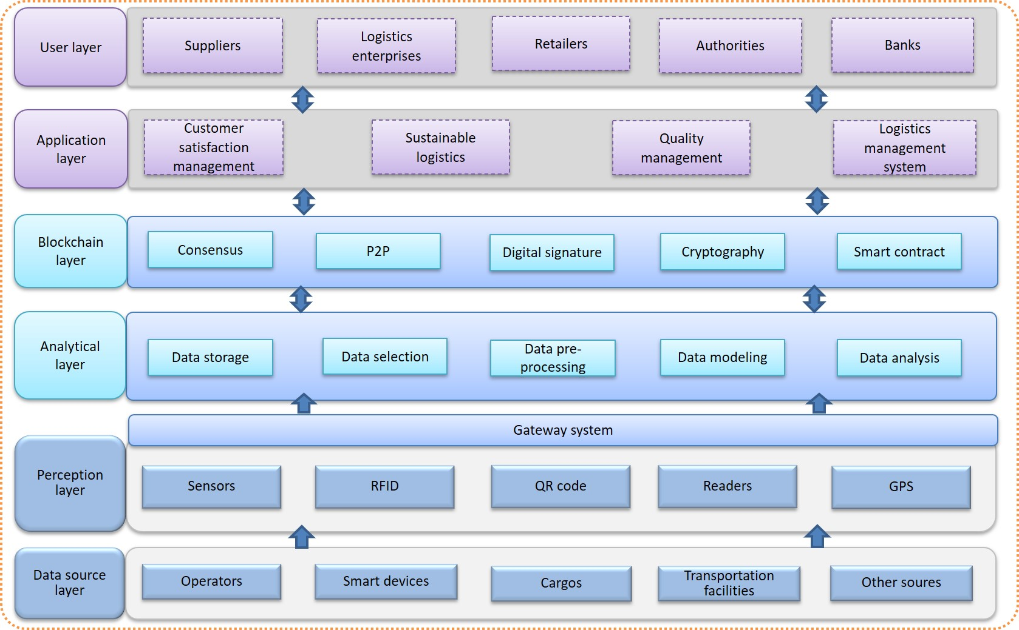
Figure 1: Architecture of sustainable urban logistics

The source layer refers to carriers of data in logistics activities, including operators, smart devices, cargos, transportation facilities like trucks, and another source. The perception layer refers to the IoT devices and sensing devices to collect real-time data from the data source. For operators, the IoT devices are involved in the whole logistics activities like purchase, transportation, storage, circulation processing, loading and unloading, carrying, packaging, sales, logistics information processing. These activities are cannot be carried out without human resources. Therefore, operators’ information needs to be recorded and collected. Smart devices refer to the devices supported by IoT technology. The information of logistics activities needs to be collected through IoT-enabled devices, such as various sensors, readers, and PDAs. They record and collect data through RFID, QR code, wireless network, Bluetooth, etc. All the recorded and collected information will be processed first since the data and information usually come from multiple devices in different formats. This process includes data selection data pre-processing and data storage. Then some models are selected to evaluate the performance of logistics services like customer delivery satisfaction. In this paper, we use FAHP to achieve this. Besides, we also use LSTM to predict the performance of logistic enterprises in terms of customer delivery satisfaction. The evaluation and prediction results will be uploaded onto the blockchain for further applications, like customer satisfaction management, sustainable logistics, quality management, logistics management system, etc.

3.2 Evaluation criteria for customer delivery satisfaction
Order delivery satisfaction of customers is one of the most basic factors to evaluate logistics enterprises, which is directly connected with customer loyalty, as well as the profit and sustainability of logistics enterprises. In this paper, we choose four criteria to evaluate the customer delivery satisfaction. They are presented in table 1.

Table 1. Indicators of customer delivery satisfaction
Indicators | Description
Cargo damages rate (C₁) | the ratio of the total value of goods damaged and the total value of goods. Cargo damages rate is used to measure the rate of cargo damage during delivery to customers.
On-time delivery rate (C₂) | The ratio of the number of accurate orders to the total number of orders.
Cost performance (C₃) | the matching degree of freight paid by costumers and services provided by the logistics enterprise.
Information transparency (C₄) | The openness of relevant information of enterprises involved in all aspects of fresh food from picking to sales, such as location and time information, cargo information, including source, price, number, sale, specifications (such as safety information, ingredients information, etc.)

Cargo damages rate is the ratio between the total number of goods damaged and the total number of goods shipped by cargo during the reporting period (Alipour et al. 2015). It is one of the important indexes to evaluate the freight quality of logistics enterprises. In this paper, we define it as the ratio of the total value of goods damaged and the total value of goods. It is used to measure the rate of cargo damages during delivery to customers. Low cargo damages rate is an essential requirement for the sustainable development of logistics enterprises.
The on-time delivery rate refers to the ratio of on-time delivery orders to total delivery orders in order logistics data (Zhang et al. 2016). It is an important index to evaluate the production capacity and production management level of logistics enterprises. This paper defines it as the ratio of the number of orders delivered on-time to the total number of orders. It is used to measure the ability of logistics enterprises to deliver orders on-time. A high on-time delivery rate is another important index for the sustainable development of logistics enterprises.
Cost performance, with the full name of the ratio between performance and price, which is a quantitative measurement method to reflect the purchasing degree of goods (Esfahbodi et al. 2016). High-cost performance is one of the important reference factors for retailers to purchase goods, and also one of the important indicators to improve the sustainable development of logistics enterprises.
For the fresh logistics industry, information transparency refers to the openness of relevant information of enterprises involved in all aspects of fresh food from picking to sales, which is one of the most concerning indicators for customers (Al-Jabri et al. 2015). In this paper, it is defined as goods information, order logistics data, and the openness of order information. High information transparency is one of the important indicators to evaluate customer satisfaction and the sustainable development of logistics enterprises.
Compared with other products, the fresh food products are characterized by its short shelf life, quality decay over time and fluctuating temperatures, i.e. perishability (Hsu and Chen 2014). Therefore, the fresh food requires strict temperature control and less delivery time during the shipping process. Temperature is the most important factor influencing foods quality. To extend the shelf life of fresh food, the shipping process is usually achieved by the cold chain. However, current cold chains are less transparent. For example, it is difficult for customers to know that if the fresh foods are always in the required temperature in the shipping process because the temperature data are difficult to trace. Further, the temperature data can also be easily tampered. Blockchains can enhance the transparency of supply chains, which is particularly important for cold chains that require extremely high transparency.
Transparency is one of the features of blockchain, and it refers to the openness and availability of the information on the blockchain. In the field of sustainable urban logistics and supply chain, from the perspective of third-party logistics enterprises, transparency is not only for authorities but also for customers. Authorities must access information on the operation status of logistics enterprises for making better policies. It is obvious that transparency of logistics information and process also means a lot to customers because few of them do not care about their goods. Also, transparency benefits logistics enterprises themselves, on the one hand, information transparency has a beneficial impact on the overall planning of city logistics, on the other hand, the transparency brings them the trust of external organizations, like bank’s investment, and customer loyalty, which enhances them economic sustainability. Some studies have examined the relationship between sustainability and transparency in supply chains (Wognum et al., 2011; Gardner et al., 2019). The information sharing and the availability of data for the relationship were emphasized. Information sharing among blockchain has the benefits of low trust cost, which makes information sharing more efficient and convenient. Specifically, customer delivery satisfaction is quite important for the economic sustainability of logistics enterprises.
Among the four criteria, the cost performance and the information transparency are qualitative and others are quantitative. The raw data can be converted into the specific value of the criteria automatically. To evaluate customer delivery satisfaction quantitatively, FAHP is utilized to determine the weights of the four criteria. Lastly, an overall score will be obtained to represent customer delivery satisfaction.

3.3 Utilization of LSTM
LSTM is used to predict customer satisfaction in the next period based on previous data. Figure 2 shows the utilization of LSTM.
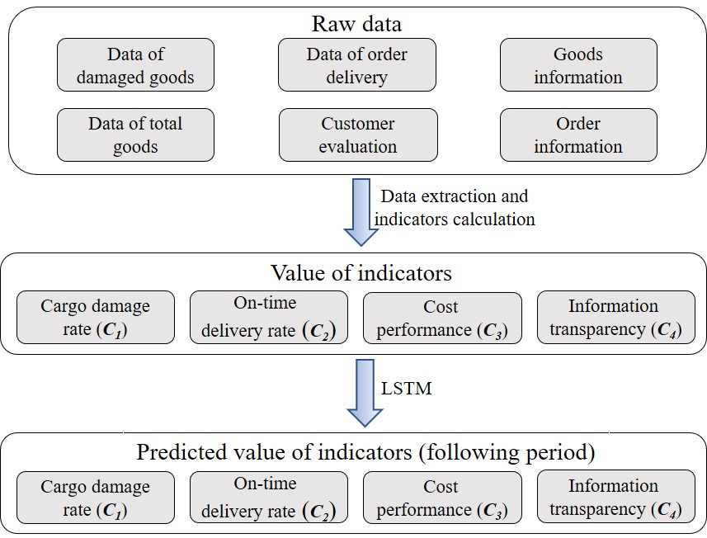
Figure 2. The utilization of LSTM

The raw data of criteria for customer delivery evaluation is the data in the logistics system collected from diverse data sources, including data of damaged goods, data of total goods, data of order delivery, customer evaluation, goods information, and order information. Data on damaged goods refers to the number of damaged goods and the unit prices of damaged goods. Data of total goods includes the total number of goods and unit prices of goods. Data of order delivery refers to the delivery status information in order delivery such as cargo information, location information, and corresponding time, etc. Customer evaluation refers in particular to the data of customer evaluation on logistics delivery service. In this paper, the evaluation data are related to the cost performance and information transparency. Goods information means the source, price, number, specifications, etc. of goods. In this paper, as well as the food safety information. Order information refers to such as shipper’s information, consignee information, including their name, address, contact information, etc.
The utilization of LSTM in this paper contains two phases: the learning phase and the application phase. In the learning phase, historical data in a period is collected automatically through smart devices in the logistics and reviewed manually by the management to determine the specific value of indicators. The data and decision results will be used as the training data for training LSTM. Four LSTM models will be trained since there are four criteria. In the application phase, the trained LSTM model predicts the performance of the next period through cargo damages rate, on-time delivery rate, cost performance, and information transparency from the data collected over a period.

4. Experimental simulation
In this section, we conduct an experimental simulation in a scenario that has one supplier S, one third-party logistics enterprises L, and some retailers R_{i} in a food materials logistics chain to illustrate the evaluation process in the proposed method. Retailers R_{i} ordered a batch of food materials from its upstream supplier S. The supplier S uses the third-party logistics enterprise L to transport the goods considering the cost of the own logistics. Due to the increasing number of logistics enterprises in recent years, as well as the emphasis on the service quality and service efficiency of logistics enterprises by customers and governments. Good logistics enterprises must improve customer satisfaction, which is one of the indicators for the social sustainability of urban logistics so that they can get more orders and share more markets and achieve sustainable development. Given this, choosing logistics service providers based on customer satisfaction is one of the important factors for retailers to consider. Moreover, customer satisfaction can also be reviewed in a blockchain-based system by governments and banks so that they can make better decisions.

4.1 Evaluation of customer delivery satisfaction in urban logistics
After obtaining the specific indicator of each criterion, we hope to evaluate the customer order delivery satisfaction through an overall score, which requires a method to integrate the four indicators of criteria into a comprehensive one. The evaluation method of the customer delivery satisfaction should be comprehensive and reasonable when integrating the cargo images rate, on-time delivery rate, cost performance, and information transparency. Therefore, it is necessary to determine the weight of each indicator. In this paper, we choose FAHP to achieve this.
FAHP, proposed by Saaty (2008), is a common multi-objective decision-making method. This method combines qualitative and quantitative analysis and determines the relative importance of each element through calculation, to make corresponding decisions according to the sequence of schemes.
The triangular fuzzy number is used to indicate the degree to which an eigenvalue x belongs to a fuzzy set M. Triangle fuzzy function is frequently used as a fuzzy membership function. For any triangle fuzzy number x, it is generally expressed as.
Definition 1:
If the fuzzy number x on the domain R is M, then the membership function is expressed as

(1)
Specifically, ,, .
Definition 2:
Suppose that two triangular fuzzy numbers and. Then, the basic operation of triangular fuzzy number is as follows
(2)

4.1.1 Determining the weight of evaluation indicators for logistics
In this paper, three researchers in the logistics industry evaluated the customer delivery satisfaction of logistics companies based on table 2 in terms of the selected four indicators. In order to solve the difference between different indicators of customer satisfaction, we first analyze the relative importance between the indicators given by the three researchers.

Table 2. Evaluation scale of relative importance among different indicators
Scale | Implication
1 | Equally important
3 | Slightly important
5 | Important
7 | Obviously important
9 | Very important
2, 4, 6, and 8 are intermediate importance, that is the scale value corresponding to the intermediate state

We define a_{ij} as the relative importance of C_{i} and C_{j} on customer satisfaction.
The first researcher rated the cargo damages rate C₁, the on-time delivery rate C₂, the cost performance C₃, and the logistics information transparency C₄ as follows:
According to the reciprocal theory, if , then . Thus, the positive reciprocal matrix A₁ of the first researcher's evaluation of these four indicators is as follow:
(3)
Besides, the other two matrixes A₂ and A₃ of the second and third researchers’ evaluation are as follow:
(4)
(5)
Synthesizing the evaluation matrixes of three researchers through, the synthetic fuzzy evaluation matrix FM is obtained. Suppose is the synthetic fuzzy number, and there are G researchers evaluated the importance, then is defined as follows:
(6)
Therefore, the synthetic fuzzy evaluation matrix FM in this paper is as follows:
(7)
To facilitate the expression of formulas, we express this matrix fuzzy evaluation matrix FM as:
(8)
According to an improved FAHP method based on triangular fuzzy number proposed in Luo et al., (2013), the fuzzy evaluation factor matrix E is calculated through the following equation:
(9)
Recording the matrix composed of the mean value m_{ij} of the triangular fuzzy number in FM as matrix M. Then, the judgment matrix Q is defined as:
(10)
The judgment matrix Q is then transformed into the final judgment matrix P whose diagonal is 1 through Matlab:
(11)
Using the compatible matrix analysis method via the following formula to transform matrix P, and the compatible matrix R can be obtained:
(12)
(13)
Then, the weight matrix w of the four evaluation indicators can be obtained lastly:
(14)

4.1.2 Calculation of the customer delivery satisfaction
According to the average data of the fresh food logistics industry, the range of cargo damages rate and on-time delivery rate of goods is shown in Table 3. There is little reference data for cost-performance ratio and information transparency. The assumption range of Table 3 is also given in this paper.

Table 3. The range of the customer delivery satisfaction indicator
Criteria | Scale
Cargo damages rate | 3%~10%
On-time delivery rate | 90%~99%
Cost performance | 50%~100%
Information transparency | 70%~90%
Referring to the ratio range of the corresponding indicators given in Table 3, assume that the relevant data of a third-party logistics enterprise L is:
The calculation method of the specific customer order delivery satisfaction of the logistics enterprise L is as follows:
Taking the cargo damages rate C₁ as an example, we can obtain the score of the company's cargo damages rate C₁:
(15)
Taking the on-time delivery rate C₂ as an example, we can get the score of the enterprise's on-time delivery rate of C₂:
(16)
In the same way, we can get the score of the logistics enterprise cost-effective C₃ and the logistics information transparency C₄ as shown in Table 4.

Table 4. The scores of different indicators of logistics enterprises
Criteria | Score
Cargo damages rate | 80.43
On-time delivery rate | 96.44
Cost performance | 69.20
Information transparency | 71.43
Thus, the satisfaction index score vector S of the logistics enterprise L is obtained.
(17)
Multiply S with the standardized eigenvector W of the four indicators of the company obtained above, and obtain the customer satisfaction score SS of the enterprise.
(18)

4.2 Smart contract for refund and compensation
Considering the delivery process of third-party logistics enterprise to retailers, four indicators are selected to evaluate the customer delivery satisfaction to the third-party logistics enterprise. Section 4 has presented the evaluation process. In this section, we present a smart contract for the third-party logistics enterprise to compensate customers or/and give a refund on the condition that there is low customer delivery satisfaction. Moreover, the gas consumption of the smart contract is also tested and relation analysis between difficulty and time consumption also presented.
In the process of logistics, the cargo damage, failure to deliver on time, dissatisfaction with logistics services, and information opacity will lead to the decline of customer delivery satisfaction. It is assumed that the third-party logistics enterprise promise to compensate or/and give a refund to customers through smart contract when the above four indicators are lower than some certain degrees. In order to simplify the process, it is assumed that the logistics enterprise has confirmed that the goods are in good condition when receiving the goods from the supplier. We describe each of these four cases below.
(1) Cargo damage rate
The damage of the goods will be confirmed together by the deliverer and the customer. After confirmation, the deliverer input cargo damage through the handheld terminal. The total value of goods is recorded in the system, the total value of damaged goods can be calculated through the total number of damaged goods and the unit prices of damaged goods. After that, the customer, i.e. the retailer sing name on the handheld terminal to confirm receiving goods, as well as the information inputted by the deliverer, is correct.
Defining the cargo damage rate as x. It is normal if the cargo damage rate is lower than x₁, and there is no need for a logistics enterprise to give a refund or compensate to customers. When the damage rate is between x₁ and x₂, the amount of compensation C₁ will be the total value of all the damaged goods N₂ and the refund amount R₁ is zero. When the damage rate is higher than x₂, there will be an extra refund of freight M and compensation of a% of the total value of the goods N₁ based on the compensation of N₂. The smart contract for this compensation and refund is shown in Figure 3, and the pseudocode is shown in Figure 4.
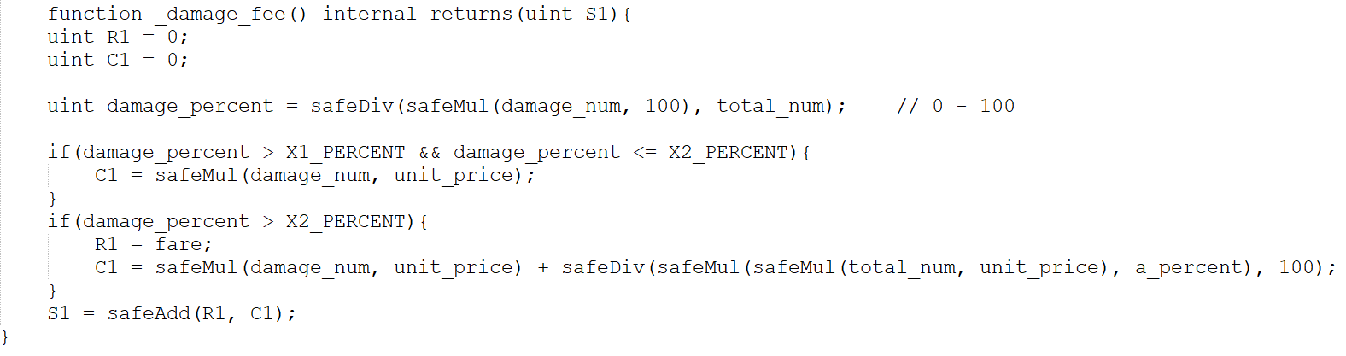
Figure 3: Compensation and refund for cargo damage

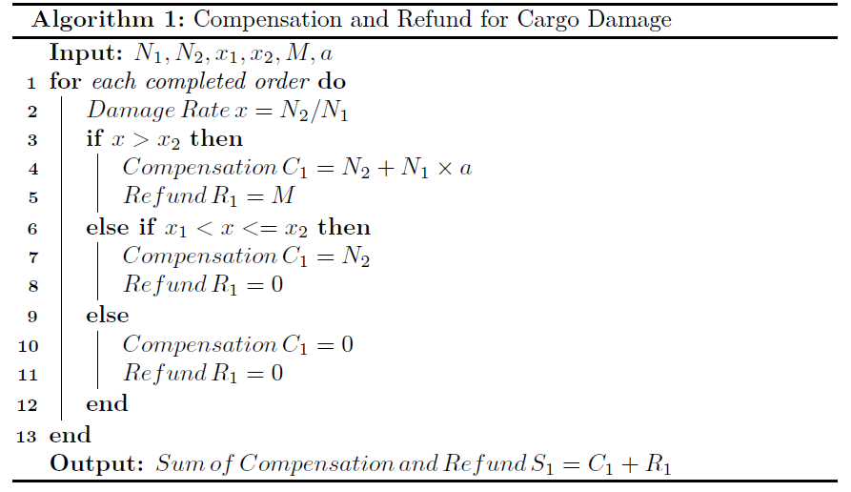
Figure 4. Pseudocode of compensation and refund for cargo damage

(2) On-time delivery
Since the scenario concentrates on the urban logistics for fresh food materials, the order delivery should be quite efficient. We assume that under the background of fresh food materials urban logistics, the third-party logistics enterprise promises to complete the order delivery within 24 hours after the supplier creates the order to the third-party logistics enterprise, and customers also accept this agreement.
When goods are on delivery, deliverers scan bar codes and RFID tags, etc. on the packaging of food materials through handheld terminals such as PDA to record the delivery time. At the same time, customers conduct electronic signature confirmation of receipt on PDA and other handheld terminals after inspecting the damage of goods.
Defining the time when retailer initiates an order to the supplier with a timestamp of T₁; Supplier receives the order with the timestamp of T₂; The supplier initiates the delivery order to the third-party logistics enterprise with the timestamp of T₃; The third-party logistics enterprise receives orders with the timestamp of T₄; The third-party logistics enterprise hand over the goods to the retailer and the customer signing for confirmation with the time stamp of T₅. Therefore, the timeout duration of an order can be defined as t= t₅-t₃-24. If t<=0, then it means that the order has been delivered on-time, it is no need to compensate or give a refund to customers. Otherwise, it is not. If 0< t<= t₁, then give a refund of b% of the freight M. If t₁< t<= t₂, then the refund amount R₂ is c% of the freight M and no need for compensation. If t >t₂, then the refund amount R₂ equals to the freight M, and the compensation amount is d times of the freight M. The smart contract for this compensation and refund is shown in Figure 5, and the pseudocode is shown in Figure 6.
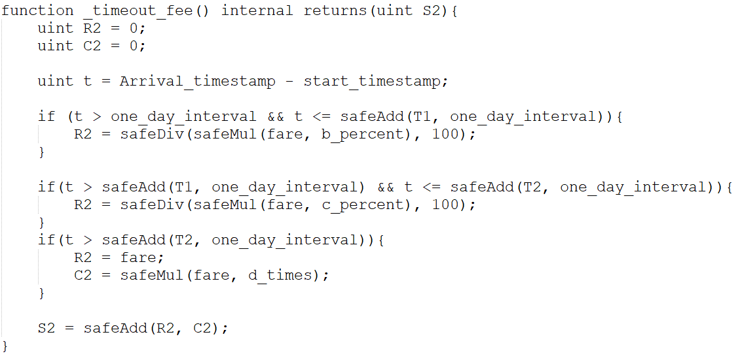
Figure 5: Compensation and refund for a time-out

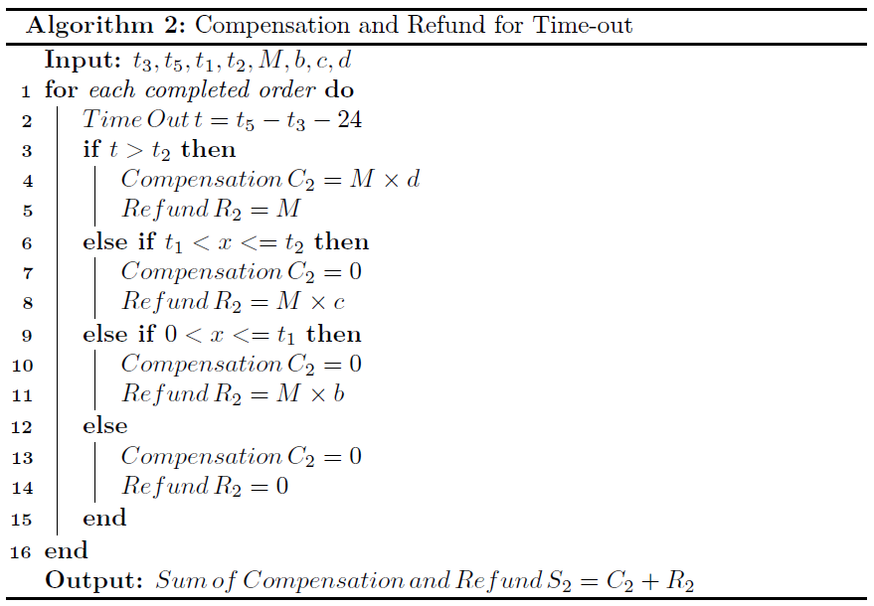
Figure 6. Pseudocode of compensation and refund for a time-out

(3) Cost performance
Cost performance refers to the matching degree of freight paid by costumers and services provided by the logistics enterprise. For governments and banks, they need to know the profit rate of logistics enterprises so that they can make better decisions. Although logistics enterprises are unlikely to disclose shipping costs to customers, there is a matching degree in customers' minds between the freight paid by the customer and the logistics service received. When the goods are delivered, the customer will evaluate the logistics service based on this matching degree. Therefore, we choose the individual indicator cost performance, which can be reflected through the answer to the question of “to what extent the logistics service received worth the freight paid” to reflect some factors attribute to the customer delivery satisfaction.
During the delivery of goods, the customer evaluates the above question with quantitative data range from 0 to 100. 0 means completely unworthy, and 100 means over worth. The answer will be input into a handheld terminal and the customer will confirm it through an electronic signature on the handheld terminal.
Defining the cost performance as p (0<=p<=100). If p>= p₁, then there is no need to compensate or refund. The refund amount R₃ and compensation amount C₃ are all zero. If p₂<= p< p₁, then the refund amount R₃ is b% of the freight M and the compensate amount C₃ is zero. If p₃<= p< p₂, then the refund amount R₃ is c% of the freight M and the compensate amount C₃ is zero. If p< p₃, then the refund amount R₃ equals to the freight M and the compensate amount C₃ is zero. The smart contract for this compensation and refund is shown in Figure 7, and the pseudocode is shown in Figure 8.
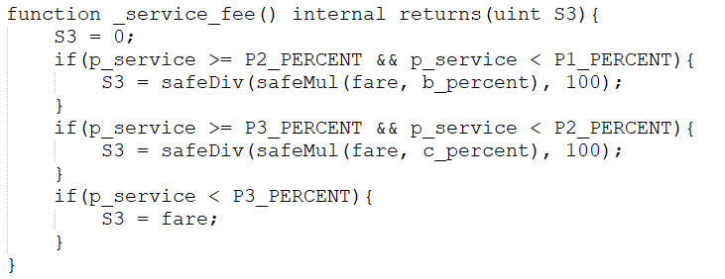
Figure 7. Compensation and refund for low-cost performance

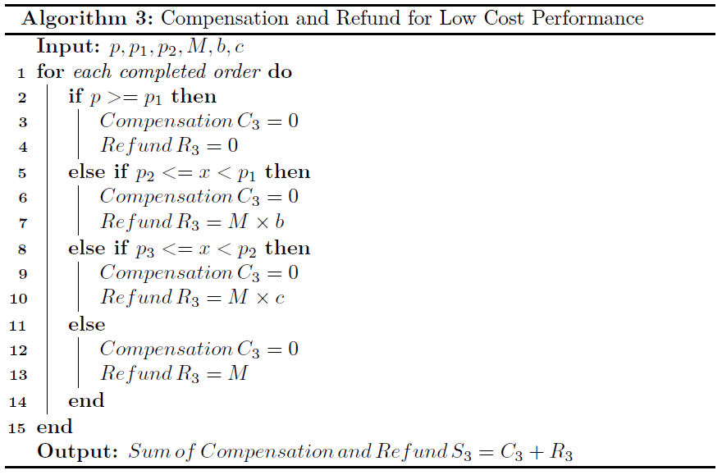
Figure 8. Pseudocode of compensation and refund for low-cost performance

(4) Information transparency
Information transparency is quite crucial to customers. In the premise that the logistics enterprise has confirmed the transparency of relevant safety information of food materials when receiving the goods from the supplier and the customer has confirmed the transparency of relevant safety information of food materials before initiating an order with the supplier, customers care only about the logistics information during the delivery of the order. Whether customers can clearly understand the location of the goods, the route of goods transportation, and the distance from themselves have an important impact on customer delivery satisfaction. In this paper, we choose three aspects as the criteria for the evaluation of information transparency. They are 1) Whether the update of logistics status is timely; 2) Whether the logistics status update is complete without omission; 3) Whether can customer check the logistics status in real-time. Defining 1 refers to yes and 0 for no for the three aspects.
When the deliverer hand over the goods, the customer checks the goods and evaluates the transparency of logistics information based on the above three aspects. The options for each of the three points are only yes or no, represented by 1 or 0. The answer will be input into a handheld terminal and confirmed by the customer through an electronic signature on the handheld terminal. It is worthy to note that any changes made after the customer's signature will be recorded with a time stamp. Therefore, it can be guaranteed that the deliverer cannot modify the data or conduct other operations after the customer's signature, so as to avoid the problem of data falsification and tampering.
Defining the indicator value of real-time update of logistics status is i₁; the indicator value of completeness of logistics status is i₂, the indicator value of real-time access of logistics status is i₃. Defining I= (i₁, i₂, i₃), then the information transparency can be reflected via I. If I= (1,1,1) or (1,1,0) or (1,0,1) or (0,1,1), then the refund amount R₄ and the compensate amount C₄ are all zero. If I= (0,0,0) or (1,0,0) or (0,1,0) or (0,0,1), then the refund amount R₄ equals to the freight M, and the compensate amount C₄ is zero. The smart contract for this compensation and refund is shown in Figure 9, and the pseudocode is shown in Figure 10.
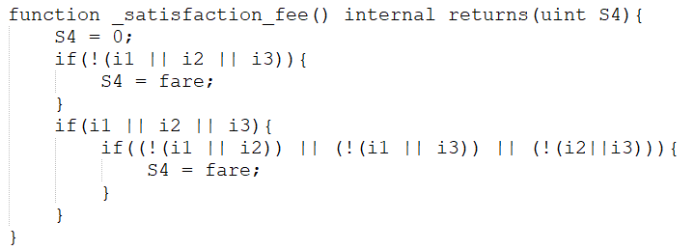
Figure 9. Compensation and refund for low information transparency

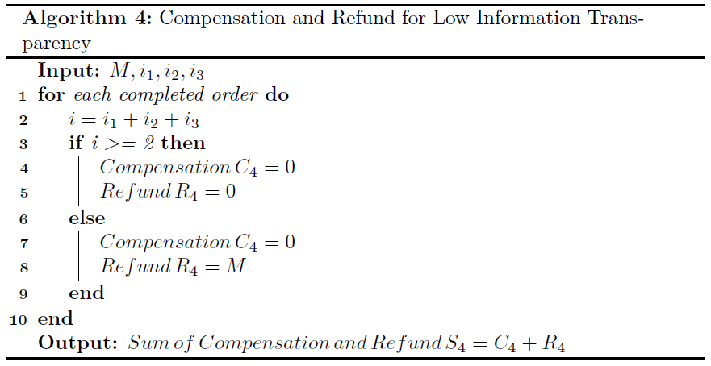
Figure 10. Pseudocode of compensation and refund for low information transparency

If more than one condition for compensation or/and refund is met, the total compensation and refund amount equal to the sum of the compensation and refund amount in four conditions.

4.3 Gas consumption test
As for the contract for compensation and/or refund, we test the gas consumption of the above smart contract. Gas consumption is used to calculate the cost of smart contract execution. The gas consumption in the process of smart contract execution reflects the complexity of the process of in certain degree. It is a type of token that can be exchanged at a certain ratio on Ethereum. Different operations in smart contracts have different gas consumption. Therefore, testing the gas consumption equals to measuring the cost of smart contract execution. In this paper, we selected some major functions in the smart contracts of this system and measured their gas consumption. The gas consumption is tested by using the estimated Gas method provided in the Web3 toolkit. The corresponding gas consumption of major functions in a smart contract is shown in Table 5.

Table 5: Gas consumption of main operations in smart contract
Operation | Gas | Description
constructor | 1982925 | create a new order
order_finished | 157484 | change the status of order when a customer receives the commodity (the Gas consumption is according to the actual situation)
compensate | 29797 | after order finished, the customer gets the compensation
get_over_compensation | 30988 | after a customer gets its compensation, the logistic provider gets back the over money
check_compensation | 21712 | check how many compensations the customer can get
check_status | 21782 | check if the order is finished
check_isCompensated | 21854 | check if the customer has taken its compensation
check_order_balance | 22049 | check how many balance in this order for paying compensation

For example, the gas consumption for the operation of “order_finished” is 157484. Figure 11 shows the corresponding function in the smart contract.
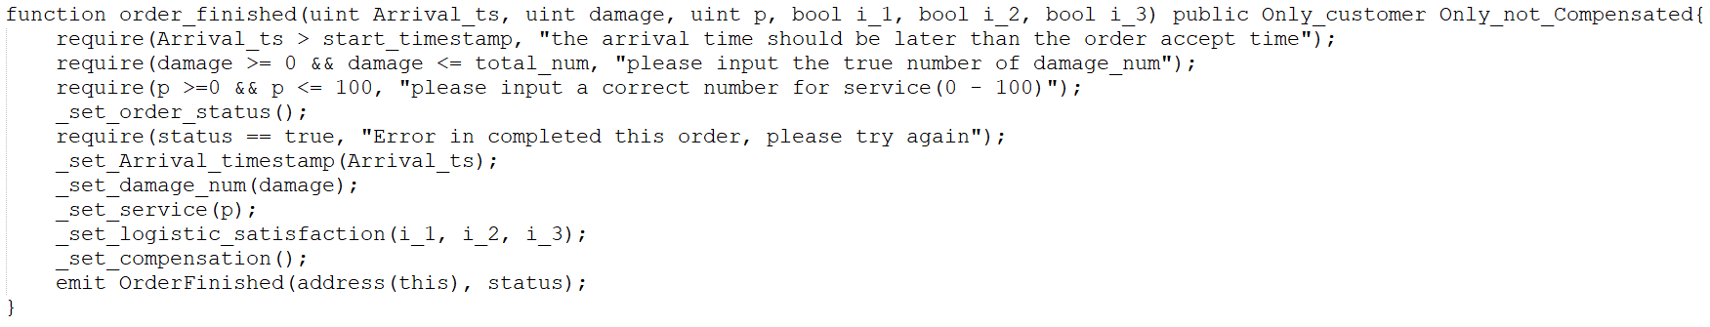
Figure 11: Function of “order_finished” in smart contract

4.4 Analysis between difficulty and time consumption
In a blockchain system with PoW consensus, whenever a block is mined, it is necessary to determine a random number, i.e. nonce, to make the hash value of the new block meet the requirements. Then the new block can be broadcasted and connected into the main chain. Equation 13 shows the relationship between a nonce n and the mining difficulty.
(13)
If the nonce n meets the above equation, it is regarded that the encapsulation of the new block has done enough work and can be broadcasted and accessed to the main chain. To study the relationship between the difficulty of mining and the time of mining a new block, we built a test chain using the go-Ethereum client. We set one node on the chain for mining to ensure the stability of computing resources. The initialization configuration file for the test chain is shown in Figure 12. The number of mining threads is set to 2 (instruction: miner.start(2)). We set the value of the difficulty parameter in the initialization configuration file to 0x400000 (4194304), 0x600000 (6291456), 0x800000 (8388608), and 0x1000000 (16777216) for four different experiments. We then create the test chain and perform the mining operation. We measure the time difference by using the timestamp of blocks. Time consumption and nonce are also measured in the experiments. The relationships between the difficulty and time consumption and between the difficulty and range of n are shown in Figure 13. According to the figure, it shows that under the same computing power, the time consumption increases linearly with the increase of the difficulty parameter, while the nonce value decreases exponentially with the increase of the difficulty parameter.
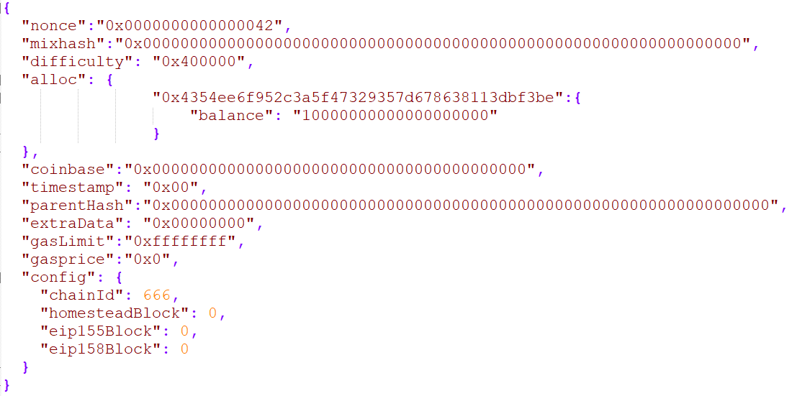
Figure 12: Initialization configuration of the test chain

Figure 13: Relation between difficulty and time consumption and range of n

5. Discussion
In this paper, we first proposed the architecture of sustainable urban logistics. Then we proposed a blockchain-based evaluation approach for customer delivery satisfaction in the context of urban logistics. Four criteria affecting customer satisfaction in urban logistics are identified and defined. A machine learning algorithm Long Short-Term Memory (LSTM) is adopted to convert raw data in logistics system into the specific value of indicators and predict the performance of next period through cargo damages rate, on-time delivery rate, cost performance, and information transparency from the data collected over a period. FAHP is utilized to determine the weight of each indicator for further evaluation of customer delivery satisfaction. We also designed and wrote a smart contract for compensation and/or refund to customers when their satisfaction with the delivery services at a low level. The gas consumption test and analysis between difficulty and time consumption are conducted to simulate the proposed system. The proposed architecture and approach for customer delivery satisfaction introduce blockchain into sustainability in urban logistics. It can help governments and banks evaluate logistics enterprises so that they can make better decisions for sustainable urban logistics. It also benefits the bodies involved in urban logistics such as suppliers, logistics enterprises and detailers, etc for overall sustainable development.
There are some limitations to the proposed approach. For one thing, Blockchain is not yet an industry-ready technology due to the limitations itself. Such as the limited scalability and efficiency in a blockchain system. For another, it is quite difficult for enterprises to introduce a brand-new blockchain-based business model without a suitable incentive. Therefore, there is still a long way to go before the concrete implementation of the approach proposed in this paper. Nevertheless, blockchain still has a huge potential in promoting sustainability for urban logistics.

6. Conclusion
The proposed approach for customer satisfaction evaluation in urban logistics based on blockchain in this paper can help governments and banks to make better decisions for sustainable development. Compared with the existing models, the proposed approach can achieve the automated evaluation of customer satisfaction in urban logistics for social sustainability. The blockchain technology enables the data used to evaluate customer satisfaction are transparent and tamper-proof, ensuring the authenticity of the information, which can help government authorities and banks to know the reality and then make better decisions. An experimental simulation was conducted in the context of a food logistics chain, the feasibility of the proposed approach is evaluated through a three layers logistics structure, which are suppliers, logistics enterprises, and retailers. A smart contract for compensation and refund when the customer delivers satisfaction is at a low level is designed and wrote. The gas consumption of main operations in the smart contract is tested. The time consumption and difficulty of blockchain implementation are also evaluated to verify the feasibility.
In the future, we will enlarge the range of involved bodies in urban logistics based on a blockchain-based system and take more factors to affect sustainability in urban logistics into account to work out a more comprehensive policy and approach. On the other hand, we are planning to come up with a solution to promote the practical application of blockchain in urban logistics for sustainable development.

References
Alipour, P. B., Magnusson, M., Olsson, M. W., Ghasemi, N. H., & Henesey, L. (2015). A Real-time Cargo Damage Management System via a Sorting Array Triangulation Technique. arXiv preprint arXiv:1506.02082.
Al-Jabri, I. M., & Roztocki, N. (2015). Adoption of ERP systems: Does information transparency matter?. Telematics and Informatics, 32(2), 300-310.
Aljohani, K., & Thompson, R. G. (2016). Impacts of logistics sprawl on the urban environment and logistics: Taxonomy and review of literature. Journal of Transport Geography, 57, 255-263.
Allaoui, H., Choudhary, A., Morana, J., & Gonzalez-Feliu, J. (2015). A sustainable urban logistics dashboard from the perspective of a group of operational managers. Management Research Review.
Anderson, S., Allen, J., & Browne, M. (2005). Urban logistics––how can it meet policy makers’ sustainability objectives?. Journal of transport geography, 13(1), 71-81.
Angelova, B., & Zekiri, J. (2011). Measuring customer satisfaction with service quality using American Customer Satisfaction Model (ACSI Model). International journal of academic research in business and social sciences, 1(3), 232.
Bandeira, R. A., D'Agosto, M. A., Ribeiro, S. K., Bandeira, A. P., & Goes, G. V. (2018). A fuzzy multi-criteria model for evaluating sustainable urban freight transportation operations. Journal of cleaner production, 184, 727-739.
Buldeo Rai, H., van Lier, T., Meers, D., & Macharis, C. (2018). An indicator approach to sustainable urban freight transport. Journal of Urbanism: International Research on Placemaking and Urban Sustainability, 11(1), 81-102.
Chang, S. E., Chen, Y. C., & Lu, M. F. (2019). Supply chain re-engineering using blockchain technology: A case of smart contract based tracking process. Technological Forecasting and Social Change, 144, 1-11.
Choi, T. M. (2019). Blockchain-technology-supported platforms for diamond authentication and certification in luxury supply chains. Transportation Research Part E: Logistics and Transportation Review, 128, 17-29.
Crainic, T. G., & Montreuil, B. (2016). Physical internet enabled hyperconnected city logistics. Transportation Research Procedia, 12, 383-398.
Crosby, M., Pattanayak, P., Verma, S., & Kalyanaraman, V. (2016). Blockchain technology: Beyond bitcoin. Applied Innovation, 2(6-10), 71.
Dagher, G. G., Mohler, J., Milojkovic, M., & Marella, P. B. (2018). Ancile: Privacy-preserving framework for access control and interoperability of electronic health records using blockchain technology. Sustainable Cities and Society, 39, 283-297.
Danielis, R., Rotaris, L., & Marcucci, E. (2010). Urban freight policies and distribution channels: a discussion based on evidence from Italian cities. European Transport\Trasporti Europei, (46), 114-146.
Esfahbodi, A., Zhang, Y., & Watson, G. (2016). Sustainable supply chain management in emerging economies: Trade-offs between environmental and cost performance. International Journal of Production Economics, 181, 350-366.
Fazili, M., Venkatadri, U., Cyrus, P., & Tajbakhsh, M. (2017). Physical Internet, conventional and hybrid logistic systems: a routing optimisation-based comparison using the Eastern Canada road network case study. International Journal of Production Research, 55(9), 2703-2730.
Gammelgaard, B. 2015. “The Emergence of City Logistics: The Case of Copenhagen’s Citlogistik-kbh.” International Journal of Physical Distribution and Logistics Management 45 (4): 333–51.
Gardner, T. A., Benzie, M., Börner, J., Dawkins, E., Fick, S., Garrett, R., ... & Mardas, N. (2019). Transparency and sustainability in global commodity supply chains. World Development, 121, 163-177.
Giret, A., Julián, V., Corchado, J. M., Fernández, A., Salido, M. A., & Tang, D. (2018, August). How to Choose the Greenest Delivery Plan: A Framework to Measure Key Performance Indicators for Sustainable Urban Logistics. In IFIP International Conference on Advances in Production Management Systems (pp. 181-189). Springer, Cham.
Gonzalez-Feliu, J. (2018a). Sustainability evaluation of green urban logistics systems: literature overview and proposed framework. In Green Initiatives for Business Sustainability and Value Creation (pp. 103-134). IGI Global.
Gonzalez-Feliu, J. (2018b). Sustainable Urban Logistics: Planning and Evaluation. John Wiley & Sons.
Gonzalez-Feliu, J., & Morana, J. (2014). Assessing urban logistics pooling sustainability via a hierarchic dashboard from a group decision perspective. Sustainable Logistics, 6, 113-135.
Graham, G., Mehmood, R., & Coles, E. (2015). Exploring future cityscapes through urban logistics prototyping: a technical viewpoint. Supply Chain Management: An International Journal, 20(3), 341-352.
Grigoroudis, E., & Siskos, Y. (2009). Customer satisfaction evaluation: Methods for measuring and implementing service quality (Vol. 139). Springer Science & Business Media.
Hill, N., & Brierley, J. (2017). How to measure customer satisfaction. Routledge.
Hong, W., Zheng, C., Wu, L., & Pu, X. (2019). Analyzing the Relationship between Consumer Satisfaction and Fresh E-Commerce Logistics Service Using Text Mining Techniques. Sustainability, 11(13), 3570.
Hsu, C. I., & Chen, W. T. (2014). Optimizing fleet size and delivery scheduling for multi-temperature food distribution. Applied Mathematical Modelling, 38(3), 1077-1091.
Iansiti, M., & Lakhani, K. R. (2017). The truth about blockchain. Harvard Business Review, 95(1), 118-127.
Kaur, H., Alam, M. A., Jameel, R., Mourya, A. K., & Chang, V. (2018). A proposed solution and future direction for blockchain-based heterogeneous medicare data in cloud environment. Journal of medical systems, 42(8), 156.
Kaszubowski, D. (2019). A method for the evaluation of urban freight transport models as a tool for improving the delivery of sustainable urban transport policy. Sustainability, 11(6), 1535.
KKouhizadeh, M., & Sarkis, J. (2018). Blockchain practices, potentials, and perspectives in greening supply chains. Sustainability, 10(10), 3652.
Lagorio, A., Pinto, R., & Golini, R. (2016). Research in urban logistics: a systematic literature review. International Journal of Physical Distribution & Logistics Management, 46(10), 908-931.
Lan, S., Zhang, H., Zhong, R. Y., & Huang, G. Q. (2016). A customer satisfaction evaluation model for logistics services using fuzzy analytic hierarchy process. Industrial Management & Data Systems, 116(5), 1024-1042.
Lan, S. L., & Zhong, R. Y. (2018). Coordinated development between metropolitan economy and logistics for sustainability. Resources, Conservation and Recycling, 128, 345-354.
Li, Z., Guo, H., Wang, W. M., Guan, Y., Barenji, A. V., Huang, G. Q., ... & Chen, X. (2019). A blockchain and automl approach for open and automated customer service. IEEE Transactions on Industrial Informatics.
Li, Z., Liu, X., Wang, W. M., Vatankhah Barenji, A., & Huang, G. Q. (2019). CKshare: secured cloud-based knowledge-sharing blockchain for injection mold redesign. Enterprise Information Systems, 13(1), 1-33.
Li, Z., Wang, W. M., Liu, G., Liu, L., He, J., & Huang, G. Q. (2018). Toward open manufacturing: A cross-enterprises knowledge and services exchange framework based on blockchain and edge computing. Industrial Management & Data Systems, 118(1), 303-320.
Luo, B., F., Wang, Q., X., Zhu, J., H., & Zhou, T., Y. (2013) An evaluation indicator weight determination method based on triangular fuzzy number and analytic hierarchy process. Research on Telecommunication Technology, (6), 9-16.
Macário, R., Galelo, A., & Martins, P. M. (2008). Business models in urban logistics. Ingeniería y Desarrollo, (24), 77-96.
Marsden, G., Frick, K. T., May, A. D., & Deakin, E. (2011). How do cities approach policy innovation and policy learning? A study of 30 policies in Northern Europe and North America. Transport policy, 18(3), 501-512.
Meidutė-Kavaliauskienė, I., Aranskis, A., & Litvinenko, M. (2014). Consumer satisfaction with the quality of logistics services. Procedia-Social and Behavioral Sciences, 110(2012), 330-340.
Melo, S., & Baptista, P. (2017). Evaluating the impacts of using cargo cycles on urban logistics: integrating traffic, environmental and operational boundaries. European transport research review, 9(2), 30.
Morana, J. (2014). Sustainable supply chain management in urban logistics. In Gonzalez-Feliu, J., Semet, F., Routhier, J.L. (eds.) Sustainable urban logistics: Concepts, methods and information systems (pp. 21-35). Springer Berlin Heidelberg.
Muñuzuri, J., Larrañeta, J., Onieva, L., & Cortés, P. (2005). Solutions applicable by local administrations for urban logistics improvement. Cities, 22(1), 15-28.
Nakamoto, S. (2008). Bitcoin: A peer-to-peer electronic cash system.
Namkung, Y., & Jang, S. (2007). Does food quality really matter in restaurants? Its impact on customer satisfaction and behavioral intentions. Journal of Hospitality & Tourism Research, 31(3), 387-409.
Nuzzolo, A., & Comi, A. (2015). Urban freight transport policies in Rome: lessons learned and the road ahead. Journal of Urbanism: International Research on Placemaking and Urban Sustainability, 8(2), 133-147.
Pan, S., Ballot, E., Huang, G. Q., & Montreuil, B. (2017). Physical Internet and interconnected logistics services: research and applications. International Journal of Production Research, 55(9), 2603-2609.
Patier, D., & Browne, M. (2010). A methodology for the evaluation of urban logistics innovations. Procedia-Social and Behavioral Sciences, 2(3), 6229-6241.
Rathee, G., Sharma, A., Kumar, R., & Iqbal, R. (2019). A Secure Communicating Things Network Framework for Industrial IoT using Blockchain Technology. Ad Hoc Networks, 101933.
Ryu, J. H., Sharma, P. K., Jo, J. H., & Park, J. H. (2019). A blockchain-based decentralized efficient investigation framework for IoT digital forensics. The Journal of Supercomputing, 1-16.
Saaty, T. L. (2008). Decision making with the analytic hierarchy process. International journal of services sciences, 1(1), 83-98.
Saberi, S., Kouhizadeh, M., Sarkis, J., & Shen, L. (2019). Blockchain technology and its relationships to sustainable supply chain management. International Journal of Production Research, 57(7), 2117-2135.
Sakai, T., Kawamura, K., & Hyodo, T. (2017). Spatial reorganization of urban logistics system and its impacts: Case of Tokyo. Journal of Transport Geography, 60, 110-118.
Sharma, P. K., Chen, M. Y., & Park, J. H. (2017). A software defined fog node based distributed blockchain cloud architecture for IoT. IEEE Access, 6, 115-124.
Shin, Y., Van Thai, V., Grewal, D., & Kim, Y. (2017). Do corporate sustainable management activities improve customer satisfaction, word of mouth intention and repurchase intention? Empirical evidence from the shipping industry. The International Journal of Logistics Management, 28 (2), 555-570.
Sirjean, S., Morel, C., & Paché, G. (2019). Challenges of Urban Deliveries in the Wholesale Trade: A Comprehensive Analysis of Policy-makers’ Sustainable Strategies. Journal of Supply Chain Management Research and Practice, 13(1), 1-1.
Streimikiene, D., Navikaite, A., & Varanavicius, V. (2016). Company's Value Creation Via Customer Satisfaction and Environmental Sustainability Influence. Montenegrin Journal of Economics, 12(4), 19.
Suhartanto, D., Chen, B. T., Mohi, Z., & Sosianika, A. (2018). Exploring loyalty to specialty foods among tourists and residents. British Food Journal, 120(5), 1120-1131.
Szymczyk, K., & Kadłubek, M. (2019). Challenges in general cargo distribution strategy in urban logistics–comparative analysis of the biggest logistics operators in EU. Transportation Research Procedia, 39, 525-533.
Taniguchi, E., Noritake, M., Yamada, T., & Izumitani, T. (1999). Optimal size and location planning of public logistics terminals. Transportation Research Part E: Logistics and Transportation Review, 35(3), 207-222.
Tijan, E., Aksentijević, S., Ivanić, K., & Jardas, M. (2019). Blockchain technology implementation in logistics. Sustainability, 11(4), 1185.
Toyoda, K., Mathiopoulos, P. T., Sasase, I., & Ohtsuki, T. (2017). A novel blockchain-based product ownership management system (POMS) for anti-counterfeits in the post supply chain. IEEE Access, 5, 17465-17477.
Vatankhah. Barenji. A., Li. Z., Wang. W. M., Huang. G. Q., & Guerra-Zubiaga. D. A. (2019) Blockchain-based ubiquitous manufacturing: a secure and reliable cyber-physical system
Wognum, P. N., Bremmers, H., Trienekens, J. H., van der Vorst, J. G., & Bloemhof, J. M. (2011). Systems for sustainability and transparency of food supply chains–Current status and challenges. Advanced Engineering Informatics, 25(1), 65-76.
Xu, Z. (2000). On consistency of the weighted geometric mean complex judgement matrix in AHP. European Journal of Operational Research, 126(3), 683-687.
Yu, C., Zhang, L., Zhao, W., & Zhang, S. (2019). A blockchain-based service composition architecture in cloud manufacturing. International Journal of Computer Integrated Manufacturing, 1-11.
Yue, X., Wang, H., Jin, D., Li, M., & Jiang, W. (2016). Healthcare data gateways: found healthcare intelligence on blockchain with novel privacy risk control. Journal of medical systems, 40(10), 218.
Zhang, J., Lam, W. H., & Chen, B. Y. (2016). On-time delivery probabilistic models for the vehicle routing problem with stochastic demands and time windows. European Journal of Operational Research, 249(1), 144-154.
Zhao, Y., Xu, X., & Wang, M. (2019). Predicting overall customer satisfaction: Big data evidence from hotel online textual reviews. International Journal of Hospitality Management, 76, 111-121.
Zheng, Z., Xie, S., Dai, H. N., Chen, X., & Wang, H. (2018). Blockchain challenges and opportunities: A survey. International Journal of Web and Grid Services, 14(4), 352-375.

