Simplified seismic axial collapse capacity prediction model for moderately compressed RC shear walls adjacent to transfer structure in tall buildings
Zhiwei Shan¹, Daniel T.W. Looi², Bei Cheng³, Ray K.L. Su¹*
¹Department of Civil Engineering, The University of Hong Kong, Pokfulam Road, Hong Kong, China
²School of Engineering, Swinburne University of Technology, Sarawak Campus, Sarawak, Malaysia
³Department of Civil & Transportation Engineering, Beijing University of Civil Engineering and Architecture, Beijing, China
*Correspondence email: klsu@hku.hk
Funding information: Research Grants Council of the Hong Kong SAR [grant number HKU 17202315].

Summary
Non-seismically detailed reinforced concrete (RC) shear walls adjacent to transfer structure in tall buildings are found to have short shear spans and designed to hold considerable axial load. In a previous paper, a Modified Mohr’s Axial Capacity Model was developed by the authors to estimate the axial collapse of these RC walls in seismic events, which is expressed as an axial load ratio devised based on classical Mohr’s circle framework. It was noted that the previous model can be complicated and appears not suitable for direct adoption in engineering design check. Hence, in this paper, a new simplified seismic axial collapse capacity prediction model is formulated to improvise the previous model. This simplified model typifies the practical range of shear wall geometry, concrete strength, steel reinforcement stress and strain and reinforcement ratio. The final product of the simplified model was founded on three simple variables, i.e. vertical rebar ratio, vertical rebar inelastic buckling stress and maximum shear stress capacity of the shear walls. Simplified charts to estimate maximum shear stress are presented for quicker design check. The complex inelastic buckling stress calculation is simplified into graphs and closed-form equations. The simplified model is corroborated with six shear walls previously tested and is found to be in good congruence. Observations and recommendations are made based on results obtained from Genetic Algorithm search and further justified by parametric studies.

KEYWORDS
RC shear walls; seismic axial collapse; transfer structure; shear failure, out-of-plane buckling failure.

1. INTRODUCTION
Tall buildings featuring the use of reinforced concrete (RC) transfer structure to support non-seismically detailed RC shear walls, are common in low-to-moderate seismicity regions. Shaking table tests [1] demonstrated that critical damage was observed at the perimeter shear walls adjacent to the transfer structure. The damage of the shear walls was later investigated, mainly due to shear stress concentration phenomenon [2-5].
This special class of shear walls (see Figure 1) were found to have unique characteristics [6-8], e.g. short shear span, possess little drift capacity, susceptible to shear failure as opposed to flexural failure, designed to hold considerable axial load and tend to fail in out-of-plane buckling.

1.1. Reconnaissance survey of shear span-to-length ratio (SLR)
SLR in this paper is defined as shear span (a) to wall horizontal length (L) ratio, where the shear span (a) can be derived from lateral moment (M) over lateral storey shear (V), hence SLR = M/(VL). To further identify the SLR of this special class of shear walls, six RC tall buildings (see Figure 2) with 480 pieces of shear walls adjacent to transfer structure were collected and modelled using a standard commercial structural analysis package ETABS [9]. The general geometry, gravity load density and fundamental natural period are shown in Figure 2, to give the readers a better overview of the properties of the buildings. Building A, B and C are located in Hong Kong [10] and X, Y and Z were constructed in Malaysia [8]. These two groups of buildings are similar in terms of the seismicity level (i.e. low-to-moderate regions with peak ground acceleration on rock of 0.07g [11] to 0.12g [12]) but defers in terms of wind intensity (i.e. Hong Kong is subject to typhoon). The SLR of the walls is found to be typically less than 1.5 (see Figure 3(a)). This observation further justifies the short shear span scenario.

1.2. Reconnaissance survey of axial load ratio (ALR)
In this paper, ALR is defined as unfactored gravity force acting on the shear wall at neutral position (P_{o}) over cross-sectional area of the wall (A_{g}) and further normalised by concrete cylinder strength (f_{c}′), where ALR = P_{o}/(A_{g} f_{c}′). From the same reconnaissance survey, Figure 3(b) shows that the ALR has a bias trend at about 0.1 to 0.2. Some RC walls may experience ALR of less than 0.1 or more than 0.2.
From previous tests [6, 10], it was observed that the axial stress-to-shear stress capacity ratio (p/v_{cap}) has a significant influence on the failure modes of short shear span RC shear walls. Figure 4 shows a sub-structure of two levels, adjacent to a transfer structure in a tall building. The building is subject to lateral action in the X-axis and negative X-axis (i.e. reversal), inducing push-pull effects on the transfer structure. The RC walls near to the centroid of the transfer structure are subject to less push-pull effects due to less eccentricity distance, however the walls at the edge may experience higher push-pull effects. For the RC walls near to the centroid of the transfer structure, depending on the intensity of ALR influencing the p/v_{cap} ratio, they are postulated into two scenarios. In Figure 4(a), if the wall is lightly loaded (p/v_{cap} < 1), shear buckling might possibly take place. This is simply due to the vertical load is not able to suppress the lateral actions. For moderately compressed shear wall (1 ≤ p/v_{cap} ≤ 2) shown in Figure 4(b), the boundary edge of the RC shear wall is experiencing a cyclic tension-compression excursion [7]. It should be noted that scenario in Figure 4(b) is the main interest of this paper, as most of the shear walls in the reconnaissance survey are found to lie within this range.
Also, a quick search on the permissible ALR in some RC design codes of practice without considering seismic actions (e.g. BS 8110 [13], Eurocode 2 [14] and HK CoP2013 [15]) shows that, only the HK CoP2013 [15] provides a limit of N_{cr} = N/(0.45 A_{c} f_{cu}) ≤ 0.75, where N is the ultimate axial load, A_{c} is the concrete cross-sectional area and f_{cu} is the characteristic concrete cube strength. It appears that RC shear walls in other regions designed according to BS 8110 [13] or Eurocode 2 [14] alone with no reference to Eurocode 8 [16], has no explicit control imposed on ALR.
For RC walls situated at the edge of the transfer structure, the cyclic lateral loads are essentially transforming the actions into large tension-compression loading, coupled with lateral actions, as shown in Figure 4(c). These shear walls with compression dominant characteristic were experimentally tested in Looi et al. [6] and they should be checked against the collapse drift ratio. It is worth to note that shear walls with tension dominant characteristic subject to cyclic actions were tested elsewhere [17]. Recent literature [18] has also identified shear walls at the edge (but not adjacent to transfer structure) and advocated the testing of axial prism type shear wall.

1.3. Out-of-plane instability of shear walls
The shaded deformed meshes in Figure 4(b) and 4(c) schematically illustrate the out-of-plane buckling of RC shear walls with p/v_{cap} > 1, as an effect of in-plane action. Table 1 recapitulates the evidence of seismic axial collapse and out-of-plane buckling of shear walls. The out-of-plane instability observation which was first discussed by Goodsir [19] but later evidently discovered in recent two earthquakes (i.e. 2010 Chile [20-22] and 2011 Christchurch [23-24]) and investigated in many tests. The RC shear wall tests which reported out-of-plane failure mode covered a wide spectrum, i.e. short shear span [6], medium rise [25], slender walls [26-30] and prism tests [18, 31]. Although many researches had been carried out, very few literatures give pointers to categorise type of out-of-plane buckling failure. Hence, this paper presents some insights for out-of-plane instability of shear walls. Consistent with the discussion of ALR in the previous section, for RC walls with 1 ≤ p/v_{cap} ≤ 2, only part of the length of the shear wall develops compression action which eventually lead to out-of-plane buckling (see Figure 4(b)). For RC walls with p/v_{cap} > 2, it is possible for the whole RC walls to undergo global out-of-plane buckling (see Figure 4(c)).

1.4. Seismic collapse of shear walls
In this paper, seismic axial collapse of shear walls is postulated to associate closely with out-of-plane instability, evidently observed from experiment [10]. Such “assumption” is also consistent with the conventional energy method or kinematic relations (similar to the formulation by Euler [33] for structurally unstable critical load in columns). It is generally assumed that brittle shear damage alone indicates collapse by default, as in the case of lightly reinforced wall pier [34]. However, RC shear walls adjacent to transfer structure (with reinforcement ratio of 1% to 2%) was discovered to have better than expected drift capacity beyond failure, which was largely dependent on the imposed ALR [6] and p/v_{cap} ratio [10].

2. RESEARCH SIGNIFICANCE AND MOTIVATION
The arguments in the previous section are to contend that shear walls adjacent to transfer structure in tall building feature low SLR, moderately compressed, prone to out-of-plane instability and may experience seismic axial collapse. Importantly, no-collapse performance objective under a rare (i.e., long return period) earthquake is typical for low-to-moderate seismicity region (and not the operational performance). Hence, the collapse of shear walls due to seismic action, leading to a wholesale collapse of tall buildings can be disastrous. Thus far, there is only one proposed model, namely the Modified Mohr’s Axial Capacity Model [7] to estimate the axial collapse of these special class of RC walls in seismic events. The previous model was expressed as an ALR devised based on classical Mohr’s circle framework [35] but modified with the inclusion of inelastic rebar buckling [36]. However, it is noted that the previous model can be complicated and appears not suitable for direct adoption in engineering design check [8]. Hence, in this paper, a new simplified seismic axial collapse capacity prediction model is formulated.

3. MODEL DEVELOPMENT AND SIMPLIFICATIONS
3.1. The complex version of Modified Mohr’s Axial Capacity Model
The Modified Mohr’s Axial Capacity Model is reintroduced and discussed here for completeness of this paper and for the convenience of the readers. Nonetheless, the detailed development can be found in Looi and Su [7].

The framework:
The framework of the complex version can be best explained with a compact form in Figure 5, where the abscissa is the normalised normal stress (σ/f_{c}΄) and the ordinate is the normalised shear stress (τ/f_{c}΄). Figure 5(a) shows the contribution of maximum compression capacity of cracked concrete, which can be transformed from its shear stress capacity based on Mohr’s circle concept. Figure 5(b) shows the inclusion of steel rebars by three circles, where the bigger circle on the left is the compression buckling stress capacity (i.e. the focus of this paper), the smaller circle on the right is the horizontal tensile steel capacity and the outer circle in dash line is the combined Mohr’s circle. Figure 5(c) is the schematic form of the ALR product of the model. To avoid axial collapse, the ALR capacity (ALR_{cap}) should be more than the total demand of axial stress (ALR_{dem}) of a finite panel taken from the edge of a shear wall (see Figure 5(d)). The additional axial component coming from lateral shear acting on the small panel element at the edge of the wall is resolved using SLR. These diagrams can be mathematically summarised using Equations (1a) to (1d) for axial capacity and Equations (1e) to (1f) for axial demand.
For axial capacity,
$$\begin{aligned} p_{cap}=p_{cr,c}+ρ_{v}σ_{buck} \#\left(\text{1a}\right)\end{aligned} \\ \begin{aligned}p_{cap}=v_{cap}+ρ_{v}σ_{buck} \#\left(\text{1b}\right)\end{aligned} \\ \begin{aligned}\frac{p_{cap}}{f_{c}'}=\frac{v_{cap}}{f_{c}'} + \frac{ρ_{v}σ_{buck}}{f_{c}'} \#\left(\text{1c}\right)\end{aligned} \\ \begin{aligned}{\text{ALR}}_{\text{cap}}=\frac{v_{cap}}{f_{c}'} +\frac{ρ_{v}σ_{buck}}{f_{c}'} \#\left(\text{1d}\right)\end{aligned}$$
where p_{cap} is the seismic axial stress capacity of shear wall panel, p_{cr,c} is the maximum axial capacity carried by the cracked concrete which can be taken as v_{cap} (due to the equal radius of normal stress and shear stress in a Mohr’s circle, refer to Figure 5(a)), v_{cap} is the maximum shear stress capacity, ρ_{v} is the vertical steel rebar ratio, σ_{buck} is the inelastic buckling stress capacity of the vertical steel rebar and f_{c}′ is the cylinder strength of concrete.
For axial demand,
$$\begin{aligned}{\text{p}}_{\text{dem}}=p+SLR v_{dem} \#\left(\text{1e}\right)\end{aligned}$$
$$\begin{aligned}{\text{ALR}}_{\text{dem}}=\frac{p}{f_{c}'}+SLR\frac{v_{dem}}{f_{c}'} \#\left(\text{1f}\right)\end{aligned}$$
where p_{dem} is the total axial stress demand of shear wall panel, p is the axial stress induced by gravity actions and SLR is used to resolve the vertical component of shear stress demand (v_{dem}) from lateral actions into additional axial stress.
Assuming that the shear stress demand exceeds (or at least equals to) the shear stress capacity (i.e. v_{dem} = v_{cap}), hence the shear wall panel experiences post-shear damage behaviour leading to axial failure. In other words, the model essentially consists of two main parameters to be determined, i.e. maximum shear stress capacity of shear walls (v_{cap}) and inelastic buckling stress capacity of vertical rebars (σ_{buck}). The related models are briefly explained next, to facilitate discussions on the simplifications to be made later in this paper.

Maximum shear stress capacity (v_{cap}):
Equation (2) shows the maximum normalised shear stress developed empirically and suggested for RC walls adjacent to transfer structures [6].
$$\begin{aligned} \left.\frac{v_{cap}}{f_{c}'}=0.02+A (\text{ALR})^{0.4}+B ω_{v}+C ω_{h}+D ω_{v,be}\right\} \begin{matrix}≤ \text{0.2 }\left(\text{design limit}\right) \\ ≤ \text{0.5} \left(\text{upper limit}\right)\end{matrix} \#\left(\text{2a}\right)\end{aligned}$$
where multipliers A to D are the linear functions of a/d, taken as $A=0.15-0.10 a/d$;$B=0.60-0.25 a/d$;$C=0.80-0.20 a/d$ and$D=-0.08+0.10 a/d$. Symbol ‘a’ denotes the shear span of the wall and the effective shear depth (d) is assumed to be 0.8 L, where L is the wall length. ω_{v}, ω_{h} and ω_{v,be} are the mechanical ratio of the vertical reinforcement, horizontal stirrups and vertical reinforcement of the boundary confinement on one side, respectively and are defined in Equation (2b).
$$\begin{aligned}ω_{v}=ρ_{v}\frac{f_{y,v}}{f_{c}'}; ω_{h}=ρ_{h}\frac{f_{y,h}}{f_{c}'}; ω_{v,be}=ρ_{v,be}\frac{f_{y,be}}{f_{cc}'} \#\left(\text{2b}\right)\end{aligned}$$
where ρ_{v}, ρ_{h} and ρ_{v,be} are the vertical reinforcement ratio, horizontal stirrup ratio and vertical reinforcement ratio of the boundary confinement on one side, respectively (all in decimal, not percentage). f_{y,v}, f_{y,h} and f_{y,be} are the yield strength of the vertical vertical reinforcement, horizontal stirrups and vertical reinforcements of the boundary confinement, respectively. f_{cc}′ is the confined concrete strength of the boundary confinement as defined in Equation (2c).
$$\begin{aligned}f_{cc}^{'}=f_{c}^{'} + C_{conf} ρ_{hoopbe,vol} f_{y,hoop}\#\left(\text{2c}\right)\end{aligned}$$
where $C_{conf}=\min\left[1,\sqrt{(\frac{l_{be}}{s_{v,hoop}})(\frac{l_{be}}{s_{h,vbe}})(\frac{1}{ρ_{hoopbe,vol} \frac{f_{y,hoop}}{f_{c}'}})}\right]$, l_{be} is the length of the boundary confinement along the in-plane direction of the wall specimen, s_{v,hoop} is the vertical distance between the hoops on the specimen in the boundary confinement, s_{h,vbe} is the horizontal distance between the vertical reinforcements in the boundary confinement along the in-plane direction of the wall specimen, ρ_{hoopbe,vol} is the volumetric ratio of the hoop steel reinforcements (in percentage) and f_{y,hoop} is the yield strength of the hoops.

Inelastic buckling stress capacity (σ_{buck}):
To estimate the buckling stress of rebars due to out-of-plane instability of RC shear walls, Looi and Su [7] holistically linked the work of Paulay and Priestley [37] in Equation (3), Chai and Elayer [32] in Equation (4) and Dhakal and Maekawa [36] in Equations (5a) to (5c). The equations are listed in the following to facilitate discussions, but the details and the rationale of the selections of the models should be referred to the relevant literature listed above.
The normalised out-of-plane displacement (ξ) due to buckling subject to in-plane lateral cyclic action is formulated as [37]:
$$\begin{aligned}\text{ξ} \text{≤ 0.5 }\left(\text{1 + 2.35 }\text{m }\text{- }\sqrt{\text{5.53 }{\text{m}}^{\text{2}}\text{+4.70 }\text{m}}\right)\#\left(\text{3}\right)\end{aligned}$$
where m is the vertical rebar mechanical ratio equals to ρ_{v} f_{y,v}/f_{c}′. Readers are reminded that the symbol m is used here, following the original literature [37] to avoid confusion, although the same definition for rebar mechanical ratio is denoted as ω_{v} in Equation (2b). All other variables were defined consistently as per Equation (2b).
The maximum tensile strain (ε_{sm}) before out-of-plane buckling occurs in the subsequent reversed load cycle of rebars is taken as [32]:
$$\begin{aligned}ε_{sm} \text{= }\frac{π^{2}}{\text{2}}{\left(\frac{t}{L_{buck}}\right)}^{2} \text{ξ} \text{+ 3}ε_{y} \#\text{(4)}\end{aligned}$$
where t is the thickness of the wall, L_{buck} is the buckling length along the wall height (H) or shear span (a), which is taken as 0.7a for RC walls with more than 2% rebar ratio and 1.0a for RC walls with less than 1% rebar ratio [7]. L_{buck} should not be confused with wall length (L), refer to Figure 1. ξ is defined in Equation (3) and ε_{y} is the yield strength of the vertical reinforcement.
Lastly, the inelastic buckling stress capacity can be computed as follow [36]:
at intermediate point,$\left(ε\text{*, }σ_{l}*\right):$$$\begin{aligned}\frac{ε*}{ε_{y}}=55-2.3\frac{L_{buck}}{φ_{s}}\sqrt{\frac{f_{y}}{100}}≥ 7 \#\left(\text{5a}\right)\end{aligned}$$
$$\begin{aligned}\frac{σ*}{σ_{l}*}=α \left(1.1-0.016\frac{L_{buck}}{φ_{s}}\sqrt{\frac{f_{y}}{100}}\right);σ* ≥ 0.2f_{y} \#\left(\text{5b}\right)\end{aligned}$$
where $α= 0.75+\frac{ε_{u}-ε_{sh}}{300ε_{y}};≤\frac{f_{u}}{1.5f_{y}}; 0.75≤α≤1.0$
at yield plateau, $\left(ε_{y}≤ ε_{sm}≤ ε*\right):$$$\begin{aligned}\frac{σ_{buck}}{σ_{l}}=1-\left(1-\frac{σ*}{σ_{l}*}\right)\left(\frac{ε_{sm}-ε_{y}}{ε*-ε_{y}}\right)\#\left(\text{5c}\right)\end{aligned}$$
at tension strain hardening, compression descending slope$\left(ε_{sm}≥ ε*\right):$$$\begin{aligned}σ_{buck}=σ*-0.02 E_{s}\left(ε_{sm}-ε*\right)≥0.2f_{y,v}\#\left(\text{5d}\right)\end{aligned}$$
where ε* and σ_{l}* are the strain and stress respectively of a special intermediate point on the tension envelope when the compression stress starts to decrease, σ* is the corresponding stress of the intermediate point, σ_{l} is the point-wise stress corresponding to strain ε, ε_{y} denotes the yield strain of steel, ε_{u} denotes the ultimate strain of steel, ε_{sh} denotes the strain of the steel at the beginning of strain-hardening, ε_{sm} was defined in Equation (4), φ_{s} is the diameter of the steel, f_{y,v} is the yield strength of the vertical steel, f_{u} is the ultimate strength of the steel and E_{s} is the modulus of elasticity of the steel.

3.2. The simplified seismic axial collapse capacity prediction model
The ALR_{cap} and ALR_{dem} in Equations (1a) to (1d) and (1e) to (1f), respectively, are rearranged to form an inequality expression in Equations (6a) with the same variables defined previously. The maximum shear stress capacity (v_{cap}) is assumed equal to the shear stress demand (v_{dem}), for the shear wall to experience post-shear damage, leading to axial collapse failure.
$$\begin{aligned}\text{AL}{\text{R}}_{\text{cap}} ≥\text{ AL}{\text{R}}_{\text{dem}} \#\left(\text{6a}\right)\end{aligned}$$
$$\begin{aligned}\frac{v_{cap}}{f_{c}'} +\frac{ρ_{v}σ_{buck}}{f_{c}'} ≥ \frac{p}{f_{c}'}+SLR\frac{v_{dem}}{f_{c}'} \#\left(\text{6b}\right)\end{aligned}$$
$$\begin{aligned}\text{Let} v_{dem}=v_{cap} \text{and rearrange, }\frac{ρ_{v}σ_{buck}}{v_{cap}} ≥ \frac{p}{v_{cap}}+SLR-1 \#\left(\text{6c}\right)\end{aligned}$$
$$\begin{aligned}\text{Let} λ= \frac{ρ_{v}σ_{buck_simp}}{v_{cap}}\text{, hence }λ≥ \frac{p}{v_{cap}}+SLR-1 \#\left(\text{6d}\right)\end{aligned}$$
It can be observed that the final expression in Equation (6d) arrived at a simple ratio, denoted as λ = ρ_{v} σ_{buck_simp}/v_{cap}, which needs to fulfil the requirements of p/v_{cap} and SLR. Although concrete cylinder strength (f_{c}′) has been “removed” from Equation (6b), concrete strength is embedded in the shear stress capacity model (v_{cap}) and simplified buckling model (σ_{buck_simp}) which will be discussed later in this paper.

3.3. Typical geometric and property range of shear wall parameters
The two major parameters, i.e. maximum shear stress capacity in Equation (2) and inelastic buckling stress capacity in Equations (3) to (5) can be complex and thus present challenges if were to apply in practical tall building engineering work. Hence, this paper utilises typical range of RC shear wall parameters, including geometric and material properties (shown in Table 2), to perform parametric study.

3.4. Abridging the maximum shear stress capacity
Equation (2) consists of a constant 0.02 and four expressions with multipliers A to D as functions of a/d (where d = 0.8 L). The multipliers and their components are studied separately.

Parametric study for A (ALR)^{0.4}:
The ALR component with multiplier A is first studied. Figure 6 shows the parametric study of normalised shear stress capacity (v_{cap}/f_{c}′) of RC shear walls with SLR of 0.5 and 1.0. The ALR is varied to 0.7 to demonstrate the trend of the lines, although it is noted that ALR less than 0.4 is more common in practice. The effects of ALR enhances the shear capacity for shorter shear span walls (e.g. SLR = 0.5) and the enhancement effects subsides with longer shear span walls (e.g. SLR = 1.0). Interestingly, RC shear walls with SLR = 1.5 have transitionary shear and flexural behaviour, thus having negative values and are not shown in Figure 6. For a rapid ballpark checking, it should be noted that the value of v_{cap}/f_{c}′ contributed by ALR should be less than 0.06 for typical ALR of less than 0.4.

Parametric study for B ω_{v}:
Figure 7 shows a macro view of the parametric study conducted for multiplier B with vertical steel component, for reinforcement ratio (ρ_{v}) of 1% to 4%. The concrete strength (f_{c}′) and steel yield strength (f_{y,v}) considered are listed in Table 2. It can be observed that increasing of ρ_{v} and f_{y,v}, increases the normalised shear strength. Across Figures 7(a) to 7(c), the value of v_{cap}/f_{c}′ contributed by B ω_{v} decreases with the increase of SLR. Compared to multiplier A and its component ALR, the normalised shear strength value v_{cap}/f_{c}′ contributed by vertical reinforcement is more significant, approximately in the range of 0.025 to 0.35.

Parametric study for C ω_{h}:
The contribution from horizontal steel component and its multiplier C is depicted in Figure 8. Although practically the horizontal steel rebar ratio (ρ_{h}) is lower than the vertical steel, it is shown up to 4% for completeness. The general trend of horizontal steel component is similar to that of vertical steel component, i.e. increasing of ρ_{h} and horizontal yield strength (f_{y,h}), increases the normalised shear stress capacity, on the contrary, increase of SLR decreases the normalised shear stress capacity. The normalised shear stress capacity contributed by horizontal reinforcement is more significant than ALR and vertical rebars, approximately in the range of 0.025 to 0.5.
It was revealed that the boundary element does not add much to shear strength for short shear span RC walls (SLR ≤ 1), but mainly adding to deformability capacity in terms of drift ratio [6]. No parametric study is carried out for multiplier D and its boundary element component (ω_{v,be}). Hence, Equation (2) can be simplified by omitting this last component. Nonetheless, the full Equation (2) can be applied, particularly for RC walls with 1 ≤ SLR ≤ 1.5, exhibiting shear-flexural transitionary behaviour.

3.5 Simplification for the inelastic buckling stress capacity
Buckling stress in Equations (5c) and (5d) can be simplified provided that the influencing parameters are identified. Based on the practical design range of steel material properties in Table 2, the stress and strain of the intermediate points (denoted by ε* and σ*, respectively) in Equation (5a) and (5b) are found to be 7ε_{y} and 0.2f_{y}, respectively. It is noted that Equations (5c) and (5d), the buckling stress (σ_{buck}) is only affected by steel yield stress (f_{y,v}) and maximum tensile strain (ε_{sm}). Tracing back to Equation (4), ε_{sm} is related to the inverse of shear span slenderness ratio (t/L_{buck}) and normalised out-of-plane deformation (ξ). Equation (3) shows that ξ is a function of mechanical rebar ratio (m). Therefore, by compounding the influence of the parameters mathematically in sequel, the buckling stress of the vertical rebars (σ_{buck}) can be determined by only three variables, namely f_{y,v}, t/L_{buck} and m.
The range of f_{y,v} is taken as 400 MPa to 600 MPa as stated in Table 2. A unique t/L_{buck} value equals to 0.18 is found to be the stable point, where thereafter σ_{buck} has a constant value of 0.2f_{y,v}. The lower and upper bounds of m are found to be 0.04 to 0.8, respectively. Parametric study is carried out for the three identified variables and is shown in Figure 9. In view of the complexity of the original model [36], the graphs are plotted for steel strength with interval of 50 MPa. Figure 9(a) illustrates the changes of buckling stress for a t/L_{buck} value of 0.05, approximately correspond to maximum allowable slenderness ratio of 20 to 29 in codes of practice [13, 14, 15], depending on the buckling length (L_{buck}). It is observed that the buckling stress increases exponentially with the mechanical rebar ratio. Depending on the yield strength of the steel, the buckling stress has a range of 180 MPa to 400 MPa for t/L_{buck} = 0.05. It is noted that the t/L_{buck} value has a significant influence on the inelastic buckling stress, hence a closer interval of 0.025 is applied to reduce the error of linear interpolation during application. Figure 9(b) shows a similar exponential trend for walls with t/L_{buck} = 0.075.
Figure 9(c) and 9(d) show the results for t/L_{buck} equals to 0.10 and 0.125, respectively, where constant 0.2f_{y,v} is observed for some lower m values, but thereafter increases exponentially. For Figure 9(e) corresponds to t/L_{buck} = 0.15, the constant value of 0.2f_{y,v} is more profound, spanning across most of the steel grades considered, except for higher steel strength of more than 550 MPa. As pointed out earlier, when t/L_{buck} ≥ 0.18, the buckling stress has constant value of 0.2f_{y,v}.
Alternatively, Equations (7a) to (7f) are formulated by fitting three lines (i.e. f_{y,v} of 400 MPa, 500 MPa and 600 MPa) for the six t/L_{buck} values (refer to Table 3). For t/L_{buck} or f_{y,v} falls between the intervals, linear interpolation is suggested.

3.6. Corroboration of the new simplified axial collapse capacity model with experimental and Dhakal and Maekawa’s buckling model [36]
The simplified axial collapse capacity model in Equations (6) is corroborated with six pieces of short shear span RC walls with SLR 1.2 (Shear wall W1, W2 and W4 [10]; Shear wall W3, W5 and W6 [38]). Dividing the initial applied axial stress with the maximum shear stress obtained in the experiment yields p/v_{cap} ratio of 1.01 to 1.36, which are within the prerequisite of the simplified model (i.e. 1 ≤ p/v_{cap} ≤ 2,). The schematic details of the shear walls specimen are shown in Figure 10. W1 to W3 are normally detailed walls and W4 to W6 are seismically detailed walls with boundary elements. Wall W1 and W3 have similar reinforcement ratio of 2% (typical for shear walls above transfer structure in Hong Kong) and wall W2 has 1.2% of reinforcement ratio (common for shear walls in Malaysia). The concrete cylinder strength is about 26 MPa to 37 MPa. The rest of the design details are listed in Table 4, readers are advised to refer to the publications [10, 38] for the test details. It is important to note that the buckling length (L_{buck}) was previously calibrated based on experimental observation and Equation (4) [7], where wall W2 with a lower reinforcement ratio has a full buckling length along the shear span (a) (i.e., L_{buck} = 1.0a) and other walls matched better to 0.7a.
Table 4 and Table 5 show the shear stress capacity of the tested specimens, acquired from the test (v_{max_exp}) and the model (v_{cap_model}), respectively. The average v_{cap_model}/v_{max_exp} ratio is skewed from unity with a coefficient of variation (COV) of 12.6%. The skewed results of shear capacity of this small sample of six specimens is acceptable and expected, benchmarking to previous research for empirical models calibrated from a large database [6, 39], where the mean value is near to unity and the COV is larger (approximately 20%).
The inelastic buckling stress is challenging to obtain directly from experimental reading; hence the original Dhakal and Maekawa’s buckling model [36] in Equations (5c) and (5d) (denoted as σ_{buck_DM}) is used to estimate the buckling capacity (refer to Table 4). Table 5 shows the inelastic buckling stress computed using the simplified buckling model in Equation (7) (denoted as σ_{buck_simp}). It can be observed from the average σ_{buck_simp}/σ_{DM_exp} ratio, that the simplified buckling model overestimated the buckling strength by an average of 7% and has a low COV of 4.9%. The error is mainly due to the assumption of linear interpolation, hence a small t/L_{buck} interval of 0.025 is provided (see Table 3) to keep the error low.
The last column in Table 5 summarises the ratio of the values computed using the new simplified seismic axial collapse capacity prediction model proposed in Equation (6d) (i.e. λ_{model} = ρ_{v} σ_{buck_simp}/v_{cap_model}) to the maximum shear stress experimental results and the original buckling model [36] (i.e. λ_{DM_exp} = ρ_{v} σ_{buck_DM}/v_{max_exp}). The proposed model (λ_{model}) overestimates the axial collapse capacity by an average of 18%, with a COV of 8.8%. The overestimation is investigated and found that it is a carried over error, mainly due to the underestimation of shear stress capacity.

4. FEASIBLE SHEAR WALL CONFIGURATIONS USING GENETIC ALGORITHM (GA) SEARCH
As pointed out earlier, RC shear walls adjacent to transfer structure have low SLR (≤ 1.5), majority is moderately compressed and are postulated to experience tension-compression cyclic excursion at the edge (for the case of 1 ≤ p/v_{cap} ≤ 2), which eventually leads to out-of-plane buckling (see Figure 4(b)). Hence, three possible cases of SLR (i.e. 0.5, 1.0 and 1.5) can be derived for 1 ≤ p/v_{cap} ≤ 2 based on Equation (6d):
Case 1 for SLR = 0.5:
$$\begin{aligned}\text{λ} \text{≥ }\frac{p}{v_{cap}}-0.5 \#\left(\text{8a}\right)\end{aligned}$$
Case 2 for SLR = 1.0:
$$\begin{aligned}\text{λ} \text{≥ }\frac{p}{v_{cap}} \#\left(\text{8b}\right)\end{aligned}$$
Case 3 for SLR = 1.5:
$$\begin{aligned}\text{λ} \text{≥ }\frac{p}{v_{cap}}+0.5 \#\left(\text{8c}\right)\end{aligned}$$
In searching for the examples of feasible configurations of vertical steel reinforcement ratio (ρ_{v}), inelastic buckling stress (σ_{buck}) and maximum shear stress capacity (v_{cap}) to satisfy λ in Equations (8), a basic Genetic Algorithm (GA) search is carried out using MATLAB [40] with the boundaries set in the three cases in Equations (8a) to (8c), along with the typical properties listed in Table 2. The objective function is to get the minimum of total steel ratio (i.e. sum of ρ_{v} and ρ_{h}).
Table 6 shows the results of the GA optimisation. The GA search was targeted at three specific t/L_{buck} values (i.e. 0.05, 0.10 and 0.15), which corresponds to shear span slenderness ratio of approximately 20 to 29, 10 to 14 and 7 to 10, respectively. The range of the shear span slenderness ratio is due to the inclusion of buckling factor of 0.7 or 1.0 with respect to shear span (a), where buckling length (L_{buck}) lies within 0.7a to 1.0a, as calibrated in previous research [7]. All the examples of possible shear walls configuration found by the GA analysis are plotted in Figure 11, superimposed on the inequality boundary conditions derived in Equations (8a) to (8c). The feasible region features a knife-edge trapezium shape is highlighted according to the boundary conditions.

5. OBSERVATIONS AND RECOMMENDATIONS
5.1 Slenderness ratio and SLR
The GA search domain includes inverse of slenderness ratio (t/L_{buck}) of 0.05 to 0.15, SLR of 0.5 to 1.5 and ALR of 0.1 to 0.4, however not all the walls with the specified t/L_{buck} can yield feasible solutions (e.g. there is no feasible case for stockier walls with t/L_{buck} = 0.15). It appears that slenderer RC shear walls with t/L_{buck} = 0.05 and 1.0 ≤ SLR ≤ 1.5 have higher possibility of seismic axial collapse and hence yield more solutions. Squater walls (SLR < 0.5) have higher shear stress capacity (refer to Figures 7(a) and 8(a)) and may not reach p/v_{cap} ratio of more than unity. Also, stockier walls (t/L_{buck} = 0.15) are difficult to form a constant curvature in out-of-plane direction, hence the use of Equation (1) is not valid.

5.2 Detailing
An obvious observation in Table 6 is that high vertical reinforcement ratio (ρ_{v} > 2%) needs to be provided for these shear walls above transfer structure to avoid seismic collapse. These values are marked by asterisks in Table 6 for ρ_{v} > 3.5%. Due to the objective function is to get an economical solution with minimum total steel ratio, it is noted that some low values of horizontal rebar ratios (ρ_{h}) appear in the GA search. Nonetheless, the engineers are required to make sure these steel ratios are sufficient to cater for shear design under common gravity and wind actions, before checking for seismic axial collapse.
RC design standards [14, 15] stipulated clauses to provide links (also known as transverse rebars or crossties) to protect the vertical steel from local buckling. This detailing seems necessary, nonetheless the wall would still undergo buckling instability as observed in experiments [10, 38, 41]. The use of boundary element with confinement hoops appear to be feasible and is already a requirement in the HK CoP2013 [15].

5.3 Concrete strength
Relatively thin wall thickness (i.e. about 200 mm) are often used for shear walls adjacent to transfer structure and are constructed with a higher concrete strength, aimed at controlling the ALR. However, based on the GA results, it is observed that the concrete strength has a significant influence on the failure modes (depending on p/v_{cap}) and residual axial capacity (λ). This is best to be explained with an example in Figure 12 for a wall with t/L_{buck} = 0.05 and SLR = 1.0, by varying the concrete strength. All other parameters are fixed at minimum steel yield strength of 400 MPa, vertical steel ratio of 0.04 and horizontal steel ratio of 0.0025.
In Figure 12, three λ lines are plotted for f_{c}′ of 30 MPa, 60 MPa and 90 MPa, over ALR of 0 to 0.4. The ALR are connected through grey dashed line to facilitate further discussions. The axial stress (p) is obtained by multiplying concrete strength (f_{c}′) with ALR. For moderately compressed shear wall, i.e. 1 ≤ p/v_{cap} ≤ 2, partial out-of-plane buckling failure mode may occur and hence the simplified model in this paper is applicable. It is observed that the highlighted zone (with a knife-edge trapezium shape) yields more feasible results for lower concrete strength (higher λ value, away from the knife edge) and less feasible results for higher concrete strength (lower λ value, near to the knife edge). For instance, 30 MPa concrete with the pre-fixed parameters for the wall in Figure 12, the applicable ALR has a wider range of 0.2 to 0.34. On the contrary, 60 MPa and 90 MPa concrete have narrower ALR range of 0.12 to 0.15 and 0.08 to 0.1, respectively.
In other words, if higher concrete strength is opted in design, out-of-plane buckling leading to axial collapse is likely to occur, unless ALR can be controlled at a low limit, say at about 0.1 for slenderer walls (t/L_{buck} = 0.05 and SLR = 1.0). Hence, these walls are crucial to be checked and designed with the simplified model in Equation (6d) in this paper for possibility of being moderately compressed and fail in axial collapse.

5.4 Steel strength
Higher steel strength may affect Equation (6d) on both sides, i.e. λ and v_{cap} values. Similar to concrete strength, this is best to be explained with an example in Figure 13 for a wall with t/L_{buck} = 0.05 and SLR = 1.0, by varying the steel yield strength. All other parameters are fixed at concrete strength of 30 MPa, vertical steel ratio of 0.04 and horizontal steel ratio of 0.0025. In Figure 13, three λ lines are plotted for steel yield strength of 400 MPa, 500 MPa and 600 MPa (assumed the same for horizontal and vertical steel). It can be observed that increment of the steel strength enhances the maximum shear stress capacity (v_{cap}) and hence lowers down the p/v_{cap} ratio. Simultaneously, increment of the steel strength also elevates the axial collapse capacity (λ). In general, adopting a higher steel yield strength is beneficial to resist axial collapse.

5.5 Steel ratio
Given that the GA search results showed a high demand of steel ratio, Figure 14 is to show the effect of vertical steel ratio (ρ_{v}) to the axial collapse capacity of the shear walls adjacent to transfer structure, with t/L_{buck} = 0.05 and SLR = 1.0. It is noted that the vertical steel ratio has a significant effect on the maximum shear stress capacity (v_{cap}) and inelastic buckling capacity (σ_{buck}), as graphically shown in Figures 7 and 9, respectively. Hence, increment of the vertical steel ratio decreases the p/v_{cap} ratio and elevates the axial collapse capacity (λ). In general, for a slenderer wall, at least 2% of vertical steel ratio is needed for ALR < 0.15 and 4% is a generous design configuration with higher λ, sitting away from the knife edge. It is noted that from the same analysis (not shown in figure), thicker walls (t/L_{buck} = 0.10 and SLR = 1.0) are less prone to buckling, where partial out-of-plane buckling may occur when ALR > 0.2, although detailed with 4% vertical steel ratio.
Figure 15 shows the effects of horizontal steel ratio (ρ_{h}) to the axial collapse capacity of the shear walls adjacent to transfer structure. Horizontal steel ratio only affects the maximum shear stress capacity (v_{cap}), as graphically shown in Figure 8. Hence the increment of horizontal steel ratio decreases p/v_{cap} ratio and axial collapse capacity (λ) (see Figure 15). Interestingly, providing a high horizontal steel rebars ratio enhances the shear capacity and may result in shear buckling failure. On the contrary, if lesser horizontal steel ratio is designed, it increases the possibility of axial collapse, notwithstanding that the wall is subject to the same ALR.

5.6 Material safety factor
It is noted that most of the material safety factors in λ may be neutralised as both σ_{buck_simp} and v_{cap} have functions of rebars mechanical ratio (i.e. mechanical ratio is defined as rebar ratio multiply by steel yield strength and normalised by concrete strength). The authors are of the opinion that material safety factor can be omitted when using the proposed simplified model to avoid over-conservatism in checking for a no-collapse performance objective under a rare earthquake scenario. In a forensic or checking work, the actual material strength should be used to hold more realistic meaning, on the contrary, mean strength can be utilised for design check.

6. CONCLUSIONS
It is noted that no-collapse performance objective under a rare (i.e., long return period) earthquake is typical for low-to-moderate seismicity region (and not the operational performance). The special class of RC shear walls adjacent to transfer structure in tall buildings deserves special attention, in ensuring its axial load-carrying capacity in a post-earthquake event. Hence, this paper proposed a new simplified seismic axial collapse capacity prediction model to improvise the previous complex version, and now features only three simple parameters (i.e. vertical rebar ratio, inelastic buckling stress of vertical rebars and maximum shear stress capacity of shear walls).
Results of previous experiments [6, 38], in conjunction with original inelastic buckling model [36], supported the new simplified model presented in this paper. The new model has reasonably good accuracy, with some overestimations which appear to be carried over from the over-estimation of shear stress capacity and the trade-off of simplified buckling stress if linear interpolation is made for t/L_{buck} and steel yield strength (f_{y,v}). Nonetheless, the proposed model represents a good tool for checking and design to quantify seismic axial collapse capacity of shear walls.
Observations and recommendations were made, i.e. (i) slenderer RC shear walls with t/L_{buck} = 0.05 and 1.0 ≤ SLR ≤ 1.5 have higher possibility of seismic axial collapse, (ii) ALR must be controlled if higher concrete strength is used, (iii) higher steel yield strength is beneficial to resist axial collapse, (iv) higher vertical steel ratio is beneficial to resist axial collapse and (v) higher horizontal steel ratio may result in shear buckling failure and lower horizontal steel ratio increases the possibility of axial collapse. Readers are reminded to honour the limitation of the model, which include the wall SLR should be less than 1.5, 1 ≤ p/v_{cap} ≤ 2, vertical rebar ratio of at least 1% and out-of-plane instability is associated with axial collapse as per experimental observation.

ACKNOWLEDGEMENT
The research carried out in this paper gratefully acknowledges financial support from the Research Grants Council of the Hong Kong SAR (Project No. HKU 17202315). The contributors of the samples of tall RC buildings with transfer structure in Hong Kong and Malaysia are acknowledged. The structural models compiled by an HKU graduate Mr. LT Poon (now with Hong Kong Water Supply Department) is highly appreciated.

ORCID
Zhiwei Shan https://orcid.org/0000-0002-1293-7189
Daniel T.W. Looi https://orcid.org/0000-0003-1645-2055
Bei Cheng -
Ray K.L. Su http://orcid.org/0000-0003-1052-3190

REFERENCES
[1] C.S. Li, S.S.E. Lam, M.Z. Zhang, Y.L. Wong, Journal of Structural Engineering 2006, 132(11), 1732.
[2] R.K.L. Su, M.H. Cheng, Struct. Des. Tall Spec. Build. 2009, 18(6), 657.
[3] T.O. Tang, R.K.L. Su, Proc. Instit. Civ. Eng: Struct. Build. 2015,168(1), 40.
[4] M. Yacoubian, N.T.K. Lam, E. Lumantarna, J.L. Wilson, Engineering Structures 2017, 148, 639.
[5] M. Yacoubian, N.T.K. Lam, E. Lumantarna, J.L. Wilson, Earthquake and Structures 2018, 15(1), 97.
[6] D.T.W. Looi, R.K.L. Su, B. Cheng, H.H. Tsang, Engineering Structures 2017, 151, 312.
[7] D.T.W. Looi, R.K.L. Su, Journal of Earthquake Engineering 2018, DOI:10.1080/13632469.2018.1475314.
[8] D.T.W. Looi, R.K.L. Su, IOP Conference Series: Materials Science and Engineering 2018, 431(12), 1.
[9] CSI (2008) ETABS integrated building design software introductory user's guide. Computers and Structures, Inc. Berkeley, California, US.
[10] D.T.W. Looi, Seismic Axial Collapse of Short Shear Span Reinforced Concrete Shear Walls, Ph.D. Thesis, Department of Civil Engineering, The University of Hong Kong, Hong Kong, 2017.
[11] D.T.W. Looi, H.H. Tsang, M.C. Hee, N.T.K. Lam, Earthquakes and Structures 2018, 15(1), 67.
[12] R.K.L. Su, C.L. Lee, C.H. He, H.H. Tsang, C.W. Law, HKIE Transactions 2015, 22(3), 179.
[13] BS8110-1:1997, Structural use of concrete - Part 1: Code of practice for design and construction. BSI, London, UK, 1997.
[14] BS EN 1992-1-1:2004. Eurocode 2: Design of concrete structures – Part 1-1: General rules and rules for buildings. BSI, London, UK, 2004.
[15] HK CoP2013, Code of practice for structural use of concrete, Hong Kong Buildings Department (HKBD), 2013.
[16] BS EN 1998-1:2004. Eurocode 8: Design of structures for earthquake resistance. Part 1: General rules, seismic actions and rules for buildings. BSI, London, UK, 2004.
[17] X. Ji, X. Cheng, M. Xu, Engineering Structures 2018, 167, 132.
[18] S.J. Menegon, J.L. Wilson, N.T.K. Lam, E.F. Gad, ACI Structural Journal 2019, 116(6), 213.
[19] W.J. Goodsir, The design of coupled frame-wall structures for seismic actions, Ph.D. Thesis, University of Canterbury, Christchurch, New Zealand, 1985.
[20] A.M. Elnashai, B. Gencturk, O. Kwon, I.L. Al-Qadi, Y. Hashash, J.R. Roesler, S.J. Kim, S. Jeong, J. Dukes, A. Valdivia, The Maule (Chile) Earthquake of February 27, 2010 Consequence Assessment and Case Studies, Mid-America Earthquake Centre, Report No. 10-04, 2010.
[21] L.D. Carpenter, F. Naeim F, M. Lew, N.F. Youssef, F. Rojas, G.R. Saragon, et al., Struct Des Tall Spec Build 2011, 20, 17.
[22] B. Westenenk, J.C. de la Llera, J.J. Besa, R. Junemann, J. Moehle, C. Luders, et al. Earthq. Spectra 2012, 28(S1), 257.
[23] W.Y. Kam, S. Pampanin, Structural Concrete 2011, 12(4), 223.
[24] S. Sritharan, K. Beyer, R.S. Henry, Y.H. Chai, M. Kowalsky, D. Bull, Earthq. Spectra 2014, 30(1), 307.
[25] K.I. Christidis, ACI Structural Journal 2019, 116(1), 195.
[26] R.K.L. Su, S.M. Wong, Engineering Structures 2007, 29(8), 1957.
[27] C. Alarcon, M.A. Hube, J.C. de la Llera. Engineering Structures 2014, 73, 13.
[28] A. Rosso, J.P. Almeida, K. Beyer, Bulletin of Earthquake Engineering 2016, 14(2), 455.
[29] F. Dashti, R.P. Dhakal, S. Pampanin, Earthquake Engng Struct Dyn. 2018, 47, 2944.
[30] A.V. Shegay, C.J. Motter, K.J. Elwood, R.S. Henry, D.E. Lehman, L.N. Lowes, Journal of Structural Engineering 2018, 144, DOI: 10.1061/(ASCE)ST.1943-541X.0002122.
[31] M. Tripathi, R.P. Dhakal, F. Dashti, Engineering Structures 2019, 198, https://doi.org/10.1016/j.engstruct.2019.109544.
[32] Y.H. Chai, D.T. Elayer, ACI Structural Journal 1999, 96(5), 780.
[33] L. Euler, Memoires de l’Academie Royale des Sciences et Belles Lettres 1759, 13, 252 (in French).
[34] J.W. Wallace, K.J. Elwood, L.M. Massone, Journal of Structural Engineering 2008, 134(9), 1548.
[35] L.A. Clark, Magazine of Concrete Research 1976, 28(94), 3.
[36] R.P. Dhakal, K. Maekawa, J. Struct. Eng. 2002, 128(9), 1139.
[37] T. Paulay, M.J.N. Priestley, ACI Structural Journal 1993, 90(4), 385.
[38] M Zhou, Seismic Behaviour Research of Reinforced Concrete Shear wall Strengthened by Slotted Steel Plate, Master Thesis, Beijing University of Civil and Architecture, China, 2017.
[39] S. Grammatikou, D. Biskinis, M.N. Fardis, Bull Earthquake Eng 2015, 13, 3277.
[40] MATLAB and Statistics Toolbox Release 2012b, The MathWorks, Inc., Natick, Massachusetts, United States.
[41] C.L. Segura, J.W. Wallace, ACI Structural Journal 2018, 115, 849.

TABLE 1 Summary of literature to recapitulate the evidence of seismic axial collapse and out-of-plane buckling of shear walls
Researcher | Ref. | Evidence | Remarks
Elnashai et al. | [20] | Real earthquake | Maulle, Chille 2010 earthquake
Carpenter et al. | [21] | Real earthquake | Maulle, Chille 2010 earthquake
Westenenk et al. | [22] | Real earthquake | Maulle, Chille 2010 earthquake
Kam and Pampanin | [23] | Real earthquake | Christchurch, New Zealand 2011 earthquake
Sritharan et al. | [24] | Real earthquake | Christchurch, New Zealand 2011 earthquake
Goodsir | [19] | Lab test | First, before real earthquake
Looi et al. | [6] | Lab test | Short shear span wall – collapse drift ratio with ALR
Chtistidis | [25] | Lab test | Medium rise shear walls
Su and Wong | [26] | Lab test | Slender wall – high axial load
Alarcon et al. | [27] | Lab test | Slender wall – high axial load, experimental investigation after Maulle earthquake
Rosso et al. | [28] | Lab test | Thin slender singly-reinforced wall
Dashti et al. | [29] | Lab test | Experimental investigation after Christchurch earthquake
Shegay et al. | [30] | Lab test | Plastic rotation capacity with ALR
Tripathi et al. | [31] | Lab test | Prism test on special boundary element following the column test of Chai and Elayer [32]
Menegon et al. | [18] | Lab test | Prism test – wall at the edge

TABLE 2 Typical geometric and material properties range of shear wall used for parametric study
Entity | Geometric and material properties | Range
Shear wall | Height or shear span, a (mm) | 2800 – 3500
 | Length, L (mm) | 1800 – 7000
 | Thickness, t (mm) | 200 – 600
 | Shear span-to-length ratio, SLR = a/L | 0.5 – 1.5
 | Shear span slenderness ratio, a/t | 5.0 – 20
 | Thickness-to-out-of-plane buckling length ratio, t/L_{buck} | 0.05 – 0.18
 | Axial load ratio, ALR = P_{o}/A_{g} f_{c}′ | 0 – 0.4
Concrete | Cylinder strength, f_{c}′ (MPa) | 30 – 90
Reinforcement | Yield strength, f_{y} (MPa) | 400 – 600
 | Web vertical rebar ratio at wall end, ρ_{v} (%)# | 1 – 4
 | Horizontal stirrups ratio, ρ_{h} (%) | 0.25 - 2
 | Young’s Modulus, E_{s} (GPa) | 200 – 205
 | Yield strain, ε_{y} | 0.002 – 0.003
 | Ultimate strain, ε_{u} | 0.05 – 0.075*
 | Tensile-to-yield strength ratio, f_{y}/f_{y} | 1.08 – 1.15*
#It should be noted that most of the existing shear walls adjacent to transfer structure are not detailed with boundary element, however it is required in HK CoP2013 [15] for critical zones.
*The values are in accordance to Class B rebar as per HK CoP2013 [15] and EC2 Table C.1 [14].

TABLE 3 Fitted equations for the simplified buckling model
t/L_{buck} | f_{y,v} (MPa) | σ_{buck_simp} (MPa) | Equation
0.05 |  | $$-90.33e^{-\frac{\text{m}}{0.23}}+{\text{A}}_{\text{1}}$$ | (7a)
0.05 | 400 | A₁ = 265 | (7a)
0.05 | 500 | A₁ = 338 | (7a)
0.05 | 600 | A₁ = 411 | (7a)
0.075 | 400 | $$-\text{182}e^{-\frac{\text{m}}{0.29}}+\text{237}$$ | (7b)
0.075 | 500 | $$-\text{203}e^{-\frac{\text{m}}{0.23}}+\text{302}$$ | (7b)
0.075 | 600 | $$-\text{203}e^{-\frac{\text{m}}{0.23}}+\text{376}$$ | (7b)
0.10 | 400 | $$\begin{matrix}\text{80} & \text{for 0.044}<\text{m}≤0.\text{296} \\ -279.6e^{-m/0.4}+214 & \text{for }\text{m}>0.\text{296}\end{matrix}$$ | (7c)
0.10 | 500 | $$\begin{matrix}\text{100} & \text{for 0.044}<\text{m}≤0.\text{212} \\ -298.4e^{-m/0.35}+278 & \text{for }\text{m}>0.\text{212}\end{matrix}$$ | (7c)
0.10 | 600 | $$\begin{matrix}1\text{20} & \text{for 0.044}<\text{m}≤\text{0.128} \\ -319.4e^{-m/0.3}+342 & \text{for }\text{m}>\text{0.128}\end{matrix}$$ | (7c)
0.125 | 400 | $$\begin{matrix}\text{80} & \text{for 0.044}<\text{m}≤0.\text{632} \\ -428e^{-m/1.47}+357 & \text{for }\text{m}>0.\text{632}\end{matrix}$$ | (7d)
0.125 | 500 | $$\begin{matrix}\text{100} & \text{for 0.044}<\text{m}≤0.\text{464} \\ -414e^{-m/0.46}+255 & \text{for }\text{m}>0.\text{464}\end{matrix}$$ | (7d)
0.125 | 600 | $$\begin{matrix}1\text{20} & \text{for 0.044}<\text{m}≤\text{0.296} \\ -401e^{-m/0.58}+359 & \text{for} \text{m}>\text{0.296}\end{matrix}$$ | (7d)
0.15 | 400 | 80 | (7e)
0.15 | 500 | 100 | (7e)
0.15 | 600 | $$\begin{matrix}\text{120} & \text{for 0.044}<\text{m}≤\text{0.59} \\ 274\text{m}-42 & \text{for }\text{m }\text{>} \text{0.59}\end{matrix}$$ | (7e)
≥ 0.18 | 400 to 600 | 0.2 f_{y,v} | (7f)
Where m = mechanical ratio of vertical rebars.
For t/L_{buck} or f_{y,v} falls between the intervals, linear interpolation is suggested.

TABLE 4 Summary of details of previously tested shear walls
Wall ID | Ref. | Remarks | f_{c}′ (MPa) | f_{y,v} (MPa) | ρ_{v} (%)* | f_{y,h} (MPa) | ρ_{h} (%) | m | p_{exp} (MPa) | v_{max_exp} (MPa) | p_{exp}/ v_{max_exp} | σ_{buck_DM} (MPa) | λ_{DM_exp}
W1 | [10] | Normal detailing | 26.4 | 601 | 2 | 289 | 1.4 | 0.45 | 5.94 | 4.79 | 1.24 | 120.2 | 0.49
W2 | [10] | Normal detailing | 30.8 | 601 | 1.2 | 289 | 1.4 | 0.24 | 6.41 | 4.70 | 1.36 | 202.2 | 0.53
W3 | [38] | Normal detailing | 33.7 | 587 | 2 | 368 | 1.4 | 0.34 | 7.66 | 7.04 | 1.09 | 117.4 | 0.33
W4 | [10] | Seismic detailing | 27.3 | 601 | 3 | 289 | 1.4 | 0.87 | 6.56 | 6.07 | 1.08 | 149.6 | 0.73
W5 | [38] | Seismic detailing | 33.7 | 587 | 2 | 368 | 1.4 | 0.34 | 7.66 | 7.23 | 1.06 | 117.4 | 0.32
W6 | [38] | Seismic detailing | 36.9 | 587 | 3 | 368 | 1.4 | 0.63 | 7.66 | 7.61 | 1.01 | 117.4 | 0.45
*Taken at the edge of the wall, i.e. boundary element for W4 to W6.

TABLE 5 Corroboration of seismic axial capacity of proposed model with previously tested shear walls
Wall ID | v_{cap_model} (MPa) | σ_{buck_simp} (MPa) | λ_{model} | v_{cap_model}/ v_{max_exp} | σ_{buck_simp}/ σ_{DM_exp} | λ_{model}/ λ_{DM_exp}
W1 | 5.31 | 135.0 | 0.50 | 1.11 | 1.12 | 1.01
W2 | 3.58 | 199.2 | 0.66 | 0.79 | 0.98 | 1.25
W3 | 6.53 | 121.5 | 0.42 | 0.81 | 1.03 | 1.27
W4 | 6.24 | 162.7 | 0.77 | 1.03 | 1.09 | 1.06
W5 | 6.42 | 121.5 | 0.38 | 0.87 | 1.03 | 1.19
W6 | 7.74 | 132.6 | 0.58 | 0.89 | 1.13 | 1.27
Mean | - | - | - | 0.92 | 1.07 | 1.18
SD | - | - | - | 0.12 | 0.05 | 0.10
COV (%) | - | - | - | 12.6 | 4.9 | 8.8
SD = standard deviation
COV = coefficient of variation

TABLE 6 Examples of feasible shear wall configuration to withstand axial collapse within 1 ≤ p/v_{cap} ≤ 2.
t/L_{buck} | Remarks on shear wall slenderness ratio# | SLR | ALR | f_{c}′ (MPa) | ρ_{v} | ρ_{h} | f_{y,v} (MPa) | f_{y,h} (MPa) | σ_{buck} (MPa) | v_{cap_model} (MPa) | p/v_{cap_model} | λ
0.05 | 20 to 29 | 0.5 | 0.2 | 79 | 0.038* | 0.009 | 400 | 400 | 227 | 14.3 | 1.10 | 0.60
0.05 | 20 to 29 | 0.5 | 0.3 | 56 | 0.038* | 0.003 | 451 | 451 | 278 | 12.5 | 1.34 | 0.84
0.05 | 20 to 29 | 0.5 | 0.4 | 33 | 0.034 | 0.003 | 400 | 400 | 248 | 9.4 | 1.40 | 0.89
0.05 | 20 to 29 | 1.0 | 0.1 | 61 | 0.027 | 0.003 | 400 | 400 | 226 | 5.5 | 1.11 | 1.12
0.05 | 20 to 29 | 1.0 | 0.2 | 30 | 0.025 | 0.003 | 401 | 401 | 243 | 4.4 | 1.36 | 1.36
0.05 | 20 to 29 | 1.0 | 0.3 | 30 | 0.036* | 0.003 | 400 | 400 | 252 | 5.7 | 1.58 | 1.58
0.05 | 20 to 29 | 1.0 | 0.4 | 30 | 0.039* | 0.003 | 470 | 470 | 309 | 7.0 | 1.71 | 1.71
0.05 | 20 to 29 | 1.5 | 0.1 | 59 | 0.037* | 0.004 | 401 | 401 | 236 | 3.0 | 1.97 | 2.93
0.05 | 20 to 29 | 1.5 | 0.2 | 30 | 0.030 | 0.008 | 402 | 402 | 249 | 3.0 | 2.00 | 2.50
0.05 | 20 to 29 | 1.5 | 0.3 | 30 | 0.040* | 0.013 | 434 | 434 | 282 | 4.5 | 2.00 | 2.50
0.05 | 20 to 29 | 1.5 | 0.4 | 30 | 0.037* | 0.013 | 600 | 600 | 409 | 6.0 | 1.99 | 2.49
0.10 | 10 to 14 | 0.5 | 0.2 | 87 | 0.040* | 0.003 | 600 | 600 | 218 | 17.4 | 1.00 | 0.50
0.10 | 10 to 14 | 0.5 | 0.3 | 35 | 0.040* | 0.003 | 406 | 406 | 131 | 10.5 | 1.00 | 0.50
0.10 | 10 to 14 | 0.5 | 0.4 | 43 | 0.039* | 0.004 | 565 | 565 | 256 | 14.7 | 1.17 | 0.67
0.10 | 10 to 14 | 1.0 | 0.2 | 35 | 0.040* | 0.003 | 450 | 450 | 173 | 7.0 | 1.00 | 0.99
0.10 | 10 to 14 | 1.0 | 0.3 | 30 | 0.040* | 0.003 | 497 | 497 | 230 | 7.4 | 1.22 | 1.23
0.10 | 10 to 14 | 1.0 | 0.4 | 30 | 0.040* | 0.003 | 577 | 577 | 303 | 8.8 | 1.36 | 1.38
0.10 | 10 to 14 | 1.5 | 0.1 | 30 | 0.035* | 0.003 | 400 | 400 | 127 | 2.4 | 1.25 | 1.86
0.10 | 10 to 14 | 1.5 | 0.2 | 30 | 0.037* | 0.003 | 488 | 488 | 217 | 3.0 | 2.00 | 2.71
0.10 | 10 to 14 | 1.5 | 0.3 | 30 | 0.040* | 0.006 | 600 | 600 | 323 | 4.5 | 2.00 | 2.87
0.15 | 7 to 10 | No solution found.
#The range for slenderness ratio is due to the inclusion of buckling factor of 0.7 or 1.0 with respect to shear span (a), where buckling length (L_{buck}) is within 0.7a to 1.0a.
*High vertical steel at the wall edge, possible detailing with boundary elements.

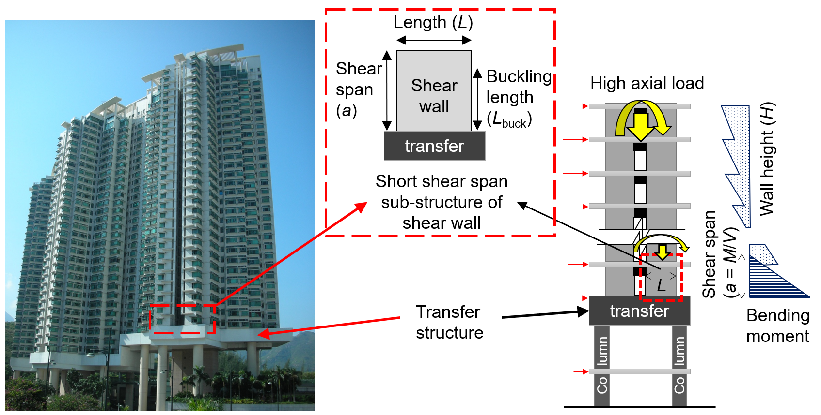
FIGURE 1 An example of RC tall building with shear walls adjacent to transfer structure
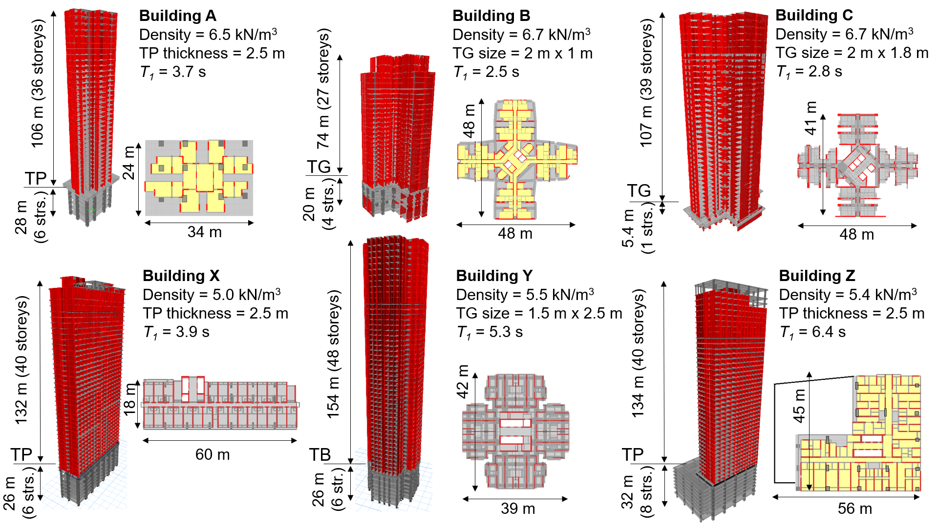
FIGURE 2 General structural information of six RC tall buildings with transfer structure
(TP = transfer plate, TG = transfer girder, T₁ = fundamental natural period)

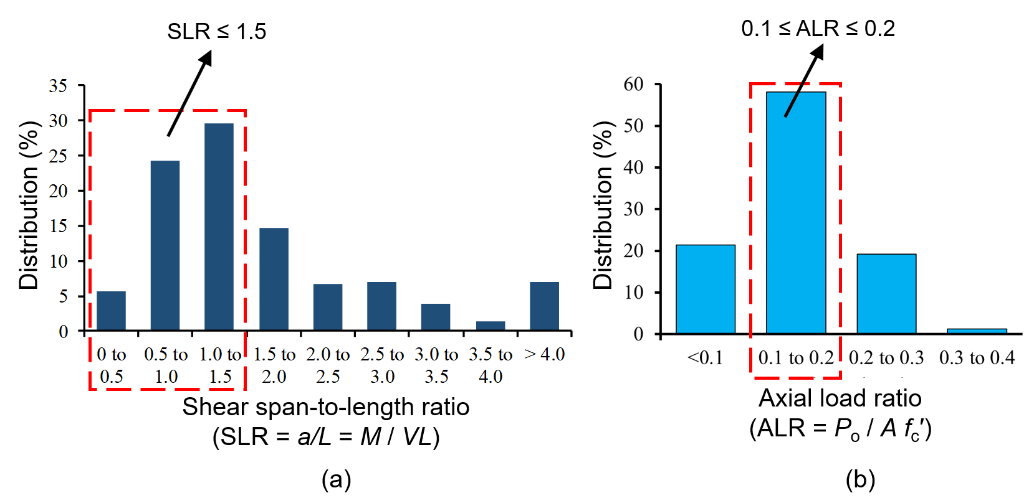
FIGURE 3 Reconnaissance survey of 480 pieces of shear walls adjacent to transfer structure of the six RC tall buildings for (a) shear span-to-length ratio (b) axial load ratio

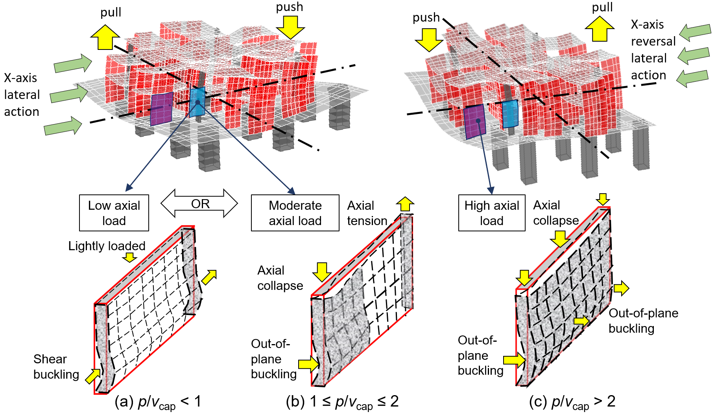
FIGURE 4 Illustration of possible collapse mechanisms of shear walls adjacent to transfer structure with (a) p/v_{cap} < 1(b) 1 ≤ p/v_{cap} ≤ 2 (c) p/v_{cap} > 2
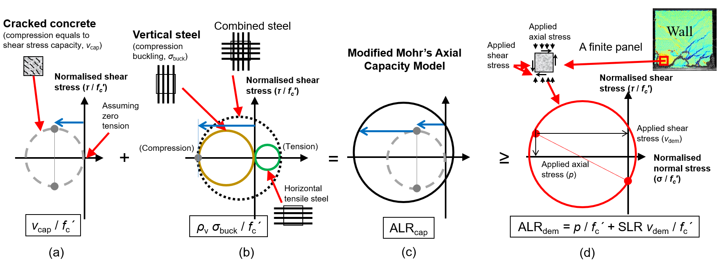
FIGURE 5 Schematic illustration of Modified Mohr’s Axial Capacity Model: (a) contribution from cracked concrete (b) contribution from envelope of steel and (c) ALR capacity (d) ALR demand at edge of shear wall.

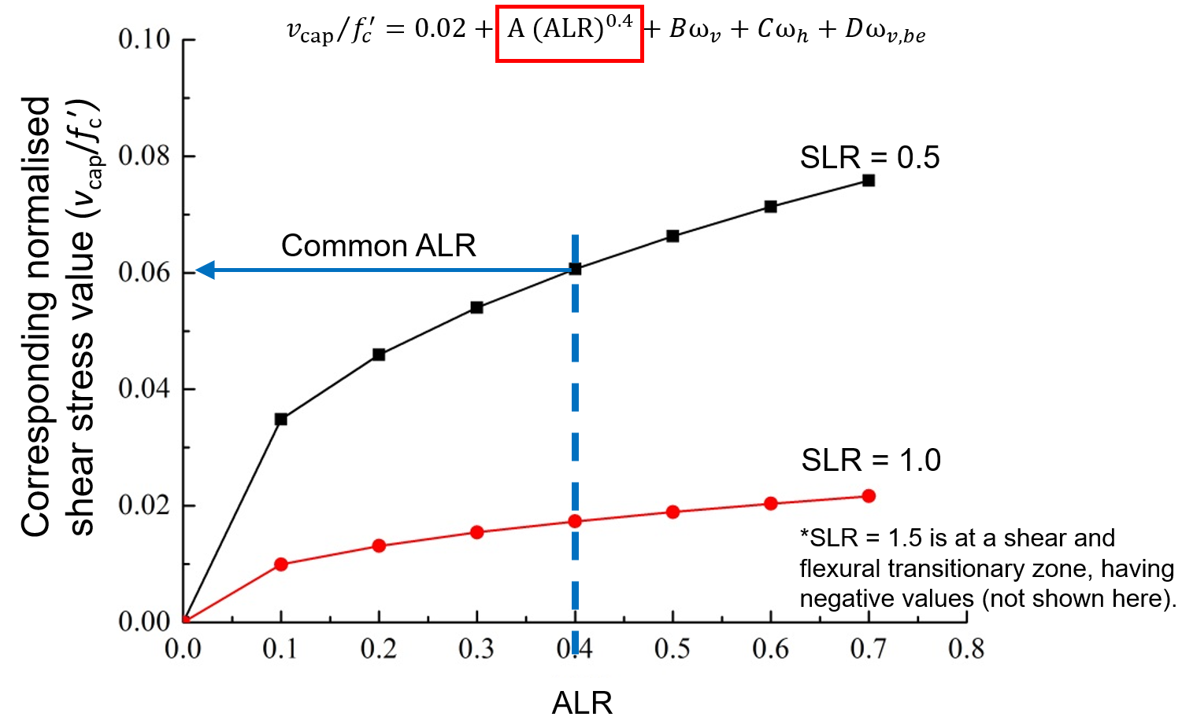
FIGURE 6 Effects of ALR on normalised shear stress capacity

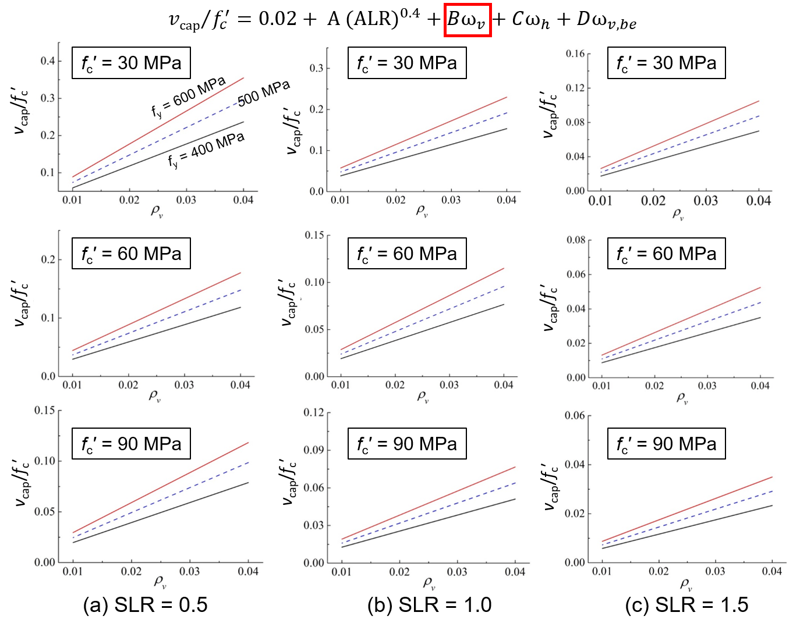
FIGURE 7 Parametric study of vertical steel ratio parameter Bω_{v} on normalised shear stress capacity for (a) SLR = 0.5 (b) SLR = 1.0 and (c) SLR = 1.5
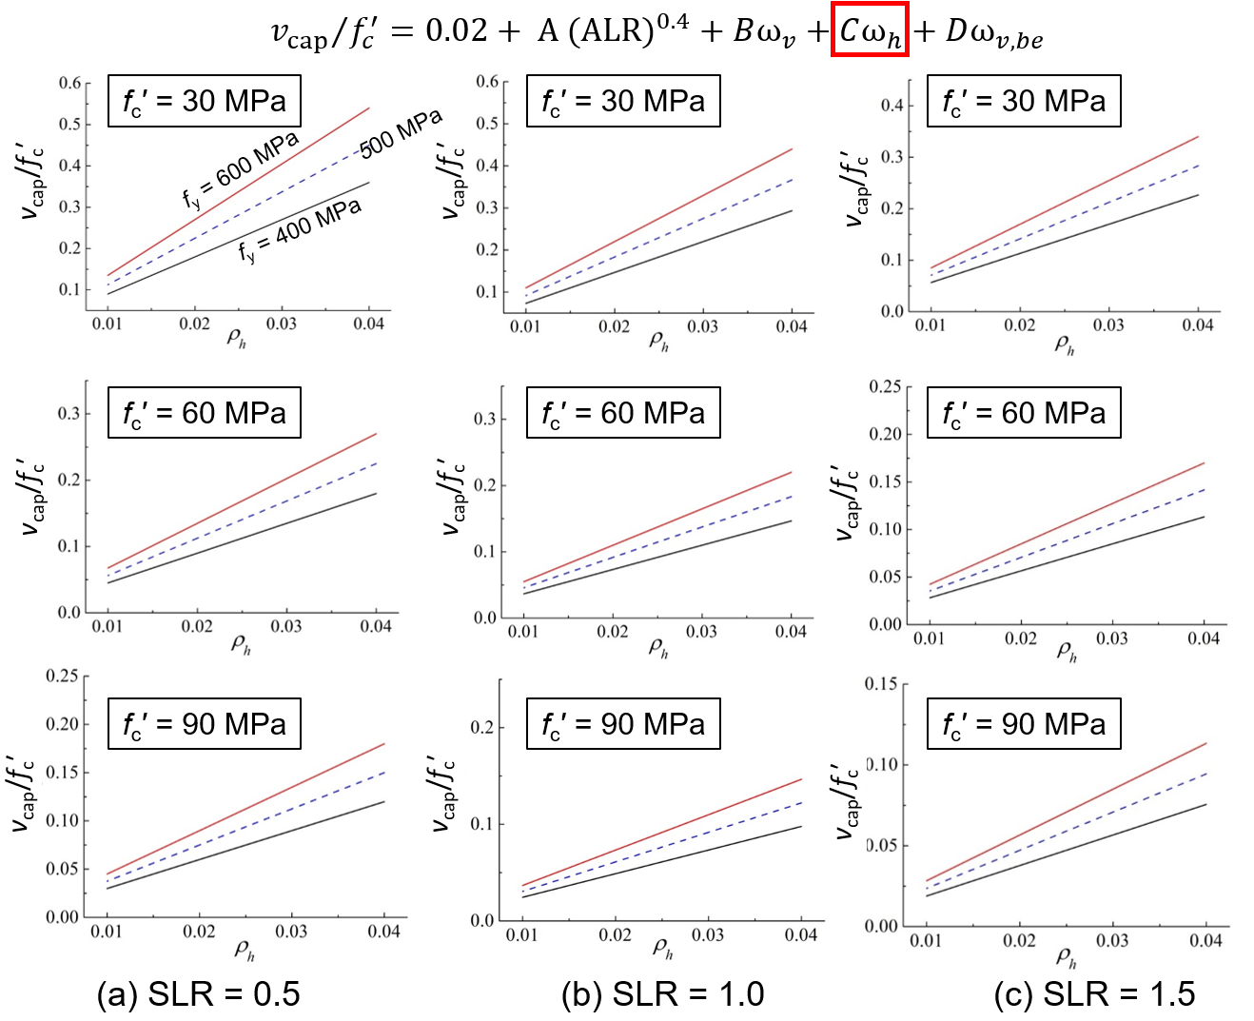
FIGURE 8 Parametric study of horizontal steel ratio parameter Cω_{h} on normalised shear stress capacity for (a) SLR = 0.5 (b) SLR = 1.0 and (c) SLR = 1.5
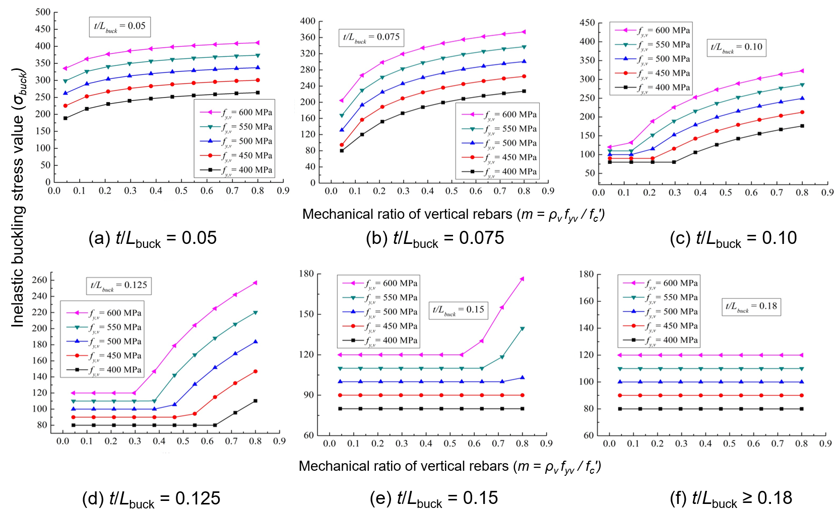
FIGURE 9 Results of parametric study of three variables (rebar yield strength, wall slenderness ratio and vertical rebar mechanical ratio) on buckling stress for (a) t/L_{buck} = 0.05 (b) t/L_{buck} = 0.075 (c) t/L_{buck} = 0.10, (d) t/L_{buck} = 0.125, (d) t/L_{buck} = 0.15 and (e) t/L_{buck} ≥ 0.18
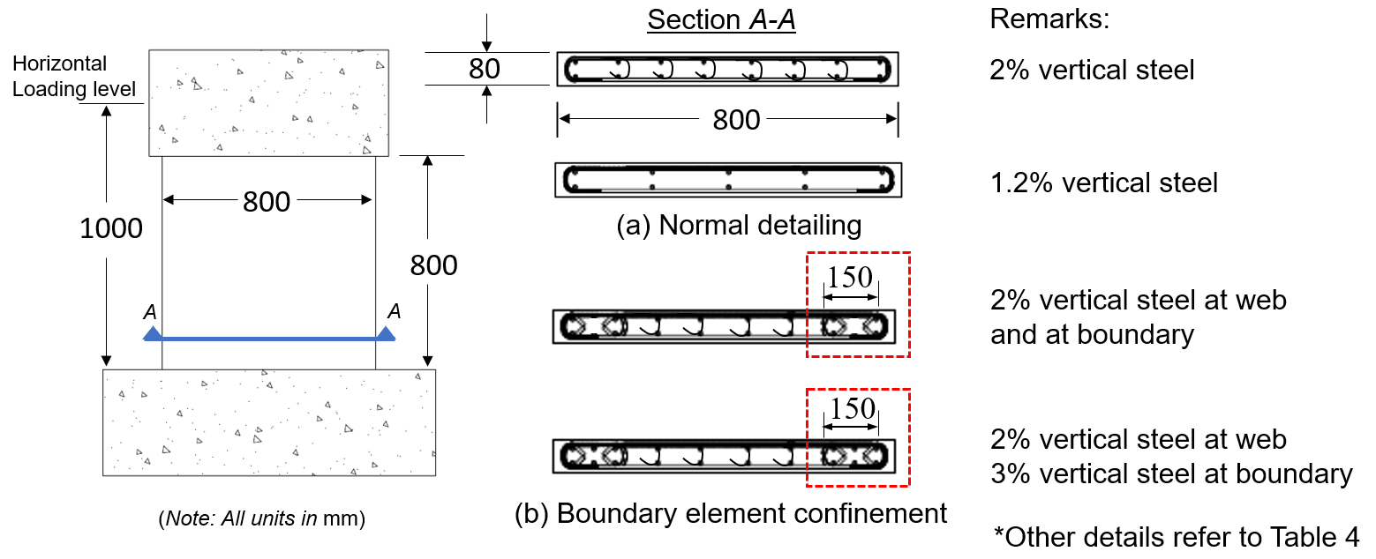
FIGURE 10 Dimension of previously tested shear walls with SLR = 1.2 (a) normal detailing (b) boundary element confinement

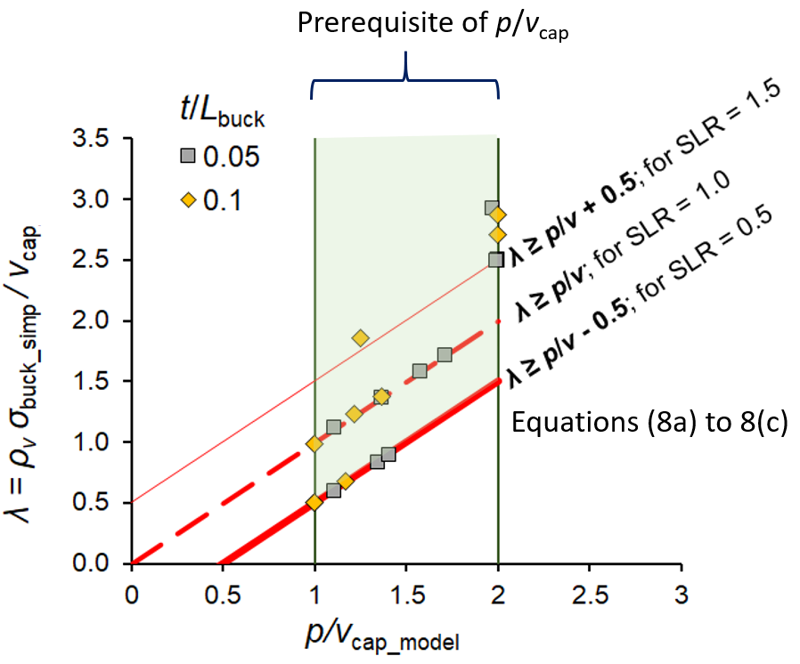
FIGURE 11 Examples of GA-optimised shear wall configuration

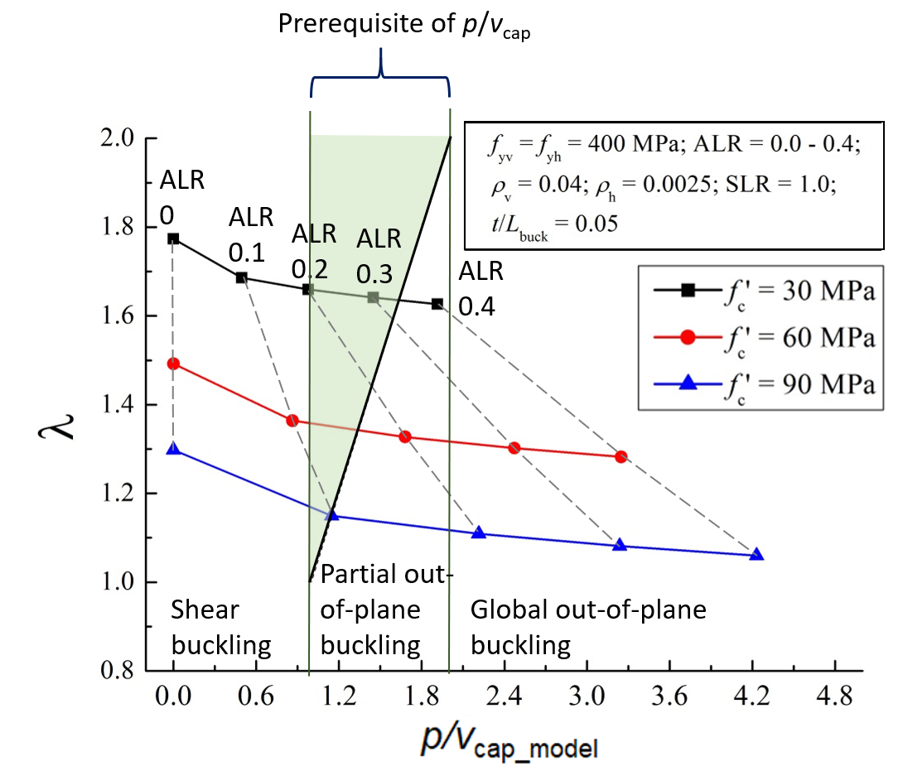
FIGURE 12 Effects of concrete strength (f_{c}’) on axial collapse of shear wall with t/L_{buck} = 0.05 and SLR = 1.0
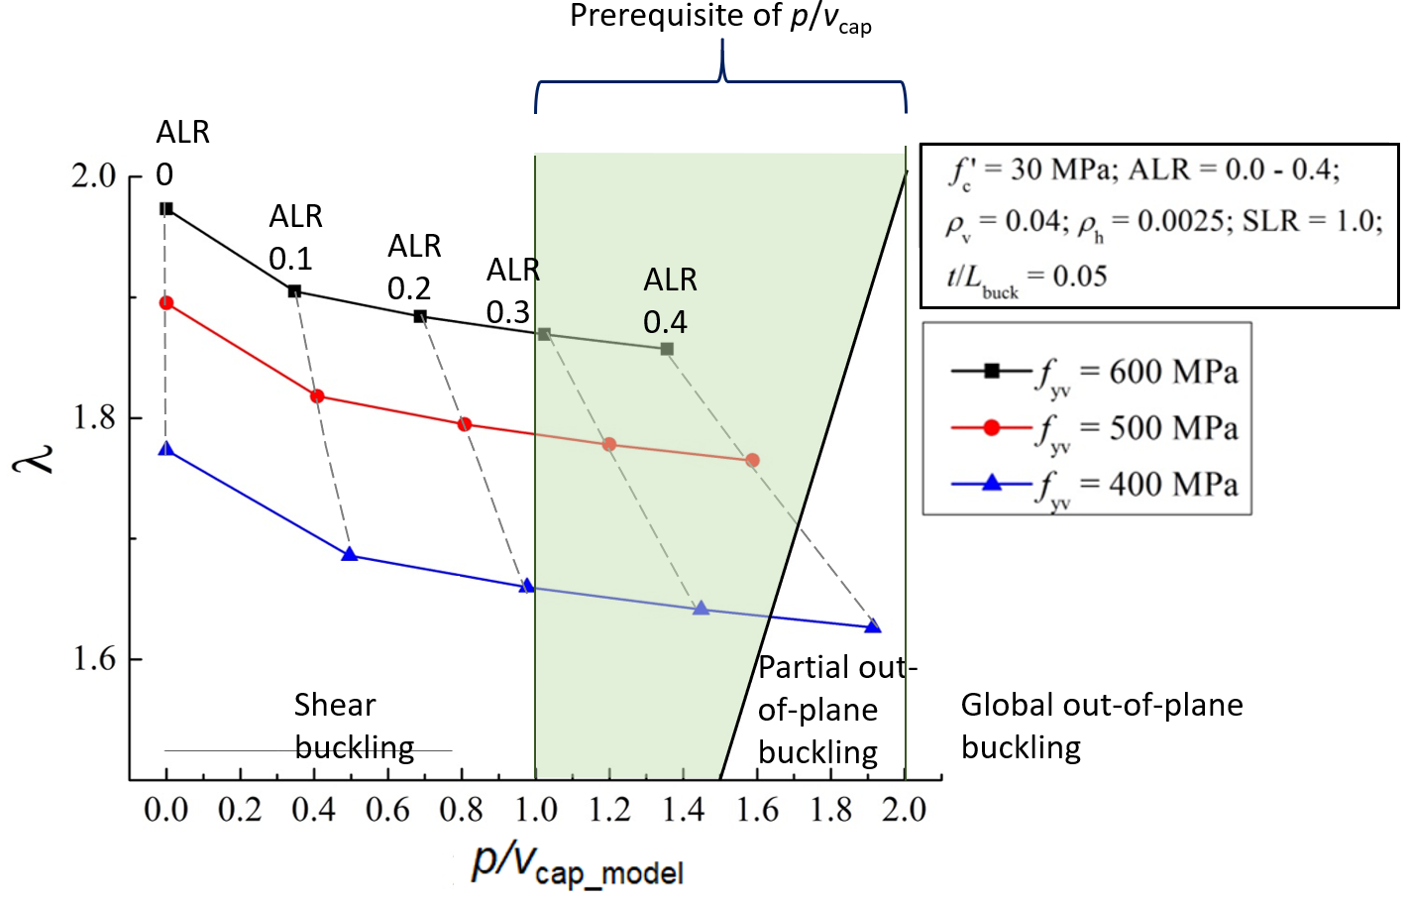
FIGURE 13 Effects of steel yield strength (f_{y}) on axial collapse of shear wall with t/L_{buck} = 0.05 and SLR = 1.0
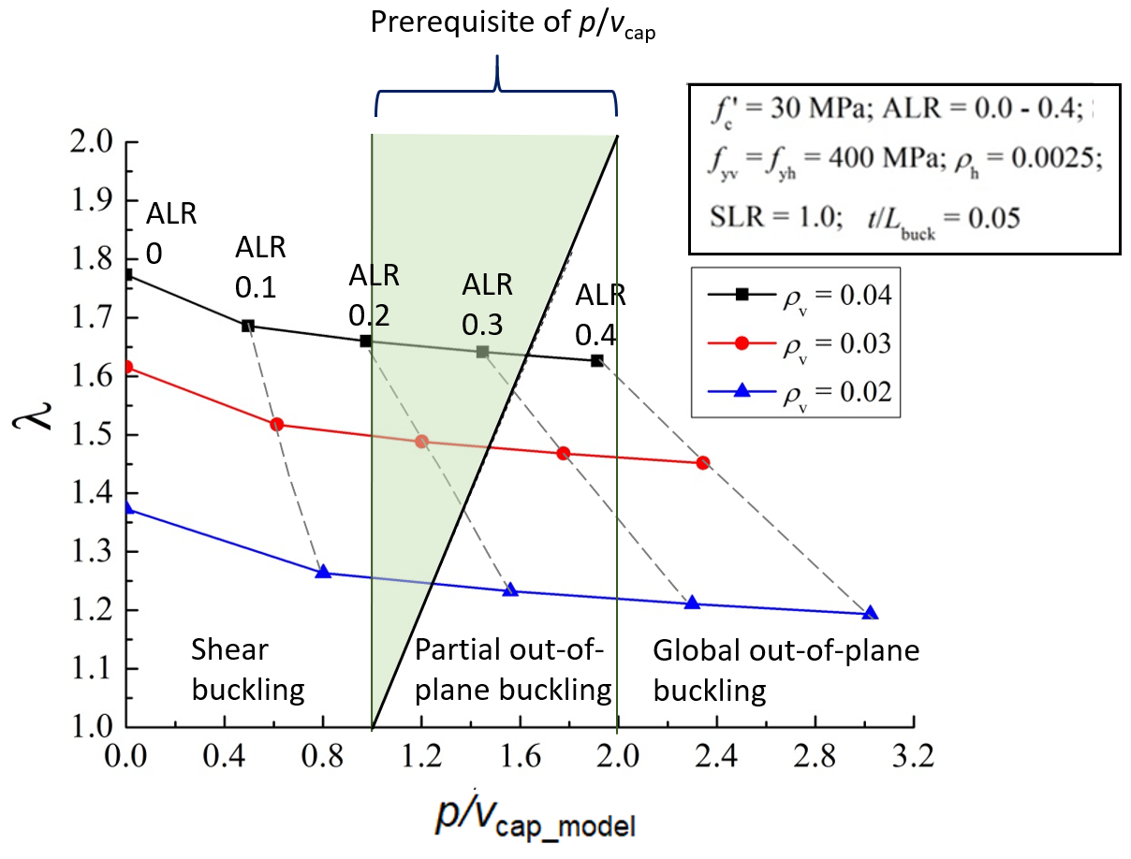
FIGURE 14 Effects of vertical steel ratio (ρ_{v}) on axial collapse of shear wall with t/L_{buck} = 0.05 and SLR = 1.0
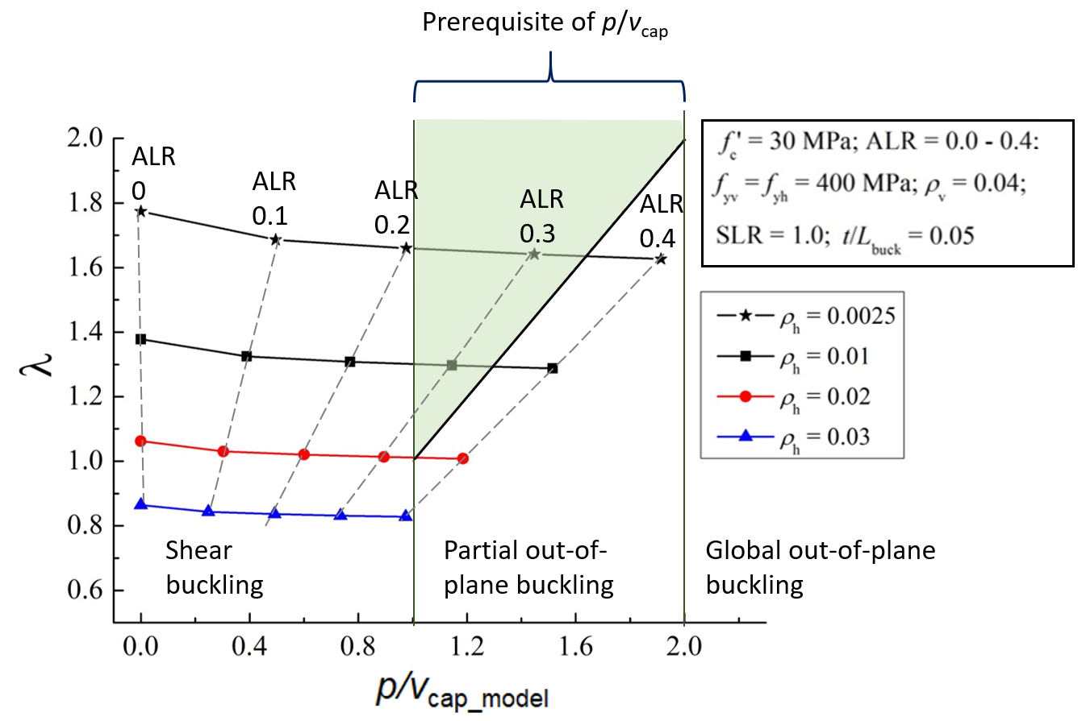
FIGURE 15 Effects of horizontal steel ratio (ρ_{h}) on axial collapse of shear wall with t/L_{buck} = 0.05 and SLR = 1.0

