A Novel Mechanical Parameter to Quantify the Microarchitecture Effect on Apparent Modulus of Trabecular Bone: A Computational Analysis of Ineffective Bone Mass

Authors:
Yongqiang Jinª, Teng Zhang^{a*}, Jason Pui Yin Cheungª, Tak Man Wongª, Xiaoreng Fengª, Tianhao Sun^{c}, Haiyue Zu^{d}, Kam Yim Sze^{b*}, William Weijia Luª

ªDepartment of Orthopaedics and Traumatology, Li Ka Shing Faculty of Medicine, The University of Hong Kong, Hong Kong, China.
^{b}Department of Mechanical Engineering, Faculty of Engineering, The University of Hong Kong, Hong Kong, China.
^{c}Department of Orthopaedics and Traumatology, The University of Hong Kong - Shenzhen Hospital, Shenzhen, China.
^{d}Department of Orthopaedics and Traumatology, Faculty of Medicine, The Chinese University of Hong Kong, Hong Kong, China.

*Corresponding to:
HW 7-21, Faculty of Engineering, The University of Hong Kong, Pok Fu Lam, Hong Kong
Tel: (852) 3917 2637
Email: tgzhang@hku.hk (T. Zhang) kysze@hku.hk (K. Y. Sze)

Abstract
Background: One of the characteristics of osteoporotic bone is the deterioration of trabecular microarchitecture. Previous studies have shown microarchitecture alone can vary the apparent modulus of trabecular bone significantly independent of bone volume fraction (BV/TV) from morphological and topological perspectives. However, the modulus is a mechanical quantity and there is a lack of mechanical explanatory parameter. This study aims to propose a novel mechanical parameter to quantify the microarchitecture effect on the apparent modulus of trabecular bone.

Materials and methods: Fourteen human female cadaveric vertebrae were scanned with a dual-energy X-ray (DXA) equipment followed by a micro-CT (µCT) system at 18 µm isotropic resolution. Four trabecular bone specimens (3.46×3.46×3.46 mm) were obtained from each vertebral body and converted to voxel-based micro finite element (µFE) models. The apparent modulus (E) of the µFE model was computed using linear micro finite element analysis (µFEA). The normalized apparent modulus (E*) was computed as E divided by BV/TV. The relationship between E and BV/TV was analyzed by linear, power-law and exponential regressions. Linear regression was performed between E* and BV/TV. Ineffective bone mass (InBM) was defined as the bone mass with a negligible contribution to the load-resistance and represented by elements with von Mises stress less than a certain stress threshold. InBM was quantified as the low von Mises stress ratio (LS_{VM}R), which is the ratio of the number of InBM elements to the total number of elements in the µFE model. An incremental search technique with coarse and fine search intervals of 10 and 1 MPa, respectively, was adopted to determine the stress threshold for calculating LS_{VM}R of the µFE model. Correlation between E* and LS_{VM}R was analyzed using linear and power-law models for each stress threshold. The threshold producing the highest coefficient of determination (R²) in the correlation between E* and LS_{VM}R was taken as the optimal stress threshold for calculating LS_{VM}R. Linear regression was performed between E and LS_{VM}R. Multiple linear regression of E against both BV/TV and LS_{VM}R was further analyzed.

Results: E significantly (p < 0.001) correlates to BV/TV whereas E* has no significant (p = 0.75) correlation with BV/TV. Incremental search suggests 59 MPa to be the optimal stress threshold for calculating LS_{VM}R. BV/TV alone can explain 59% of the variation in E using power-law regression model (E = 2254.64BV/TV^{1.04}, R² = 0.59, p < 0.001). LS_{VM}R alone can explain 48% of the variation in E using linear regression model (E = 1696.4 – 1647.1LS_{VM}R, R² = 0.48, p < 0.001). With these two predictors taken into consideration, 95% of the variation in E can be explained in a multiple linear regression model (E = 1364.89 + 2184.37BV/TV – 1605.38LS_{VM}R, adjusted R² = 0.95, p < 0.001).

Conclusion: LS_{VM}R can be adopted as the mechanical parameter to quantify the microarchitecture effect on the apparent modulus of trabecular bone.
Keywords: Osteoporosis, trabecular bone, bone biomechanics, fracture risk, µFEA

Introduction
Osteoporosis is a bone disease characterized by low bone mass and microarchitectural deterioration [1-3]. It leads to bone fragility and thus an increased fracture risk [1-4]. About 1 in 5 men and 1 in 2 women at age 50 or above suffer osteoporotic fractures [3-5]. Clinically, bone mineral density (BMD) measured by dual-energy X-ray absorptiometry (DXA) at the hip and lower spine has been recommended as the reference standard of describing osteoporosis [6]. After obtaining BMD, T-score is computed for distinguishing osteoporosis patients (T-score < -2.5) from the normal [6, 7]. However, studies on fallers with and without hip fractures had demonstrated BMD overlaps [8]. Further, almost half of vertebral fractures had occurred on patients with a normal BMD [9, 10]. The explanation of this BMD overlap dilemma may be attributed to microarchitectural deterioration which can influence the mechanical properties of trabecular bone independent of BMD.

In structure engineering, the spatial arrangement of the material varies the mechanical competence of structure significantly. The complex trabecular structure behaves similarly [11]. The lattice network model of vertebral trabecular architecture was proposed by Jensen and Mosekilde [12]. They illustrated the microarchitecture can vary the apparent modulus of trabecular bone (the apparent modulus) by a factor up to 5-10 for the same bone volume [12]. This means microarchitecture alone can affect the mechanical properties of trabecular bone significantly. Many experimental [13-15], clinical [16-18] and computational [12, 19] studies further provided evidence of the independent role of microarchitecture on bone mechanical integrity. Besides the static studies, some computational models [19-22] were also developed to illustrate the dynamic microarchitectural changes during bone adaptation. Using three-dimensional (3D) digital topological analysis (DTA) [23, 24] proposed by Saha et al for characterizing the network of trabecular bone, plate and rod topological features have been studied. Wehrli et al [11] provided the first in-vivo evidence on the structural conversion of trabecular plates to rods and disruption of rods. Based on the established DTA technique, Liu and colleagues studied plate-rod relative contributions to the apparent modulus [25] and they further developed the individual trabecula segmentation (ITS) technique to analyze anisotropic apparent modulus [26]. Studies of Liu et al illustrated plates make a greater contribution than rods to apparent modulus and plate bone volume fraction (pBV/TV) presented a stronger correlation with the apparent modulus than bone volume fraction (BV/TV) [25, 26]. Independently parallel studies carried out by Stauber et al [27-29] also showed the effect of microstructure, especially of the plates, on the apparent modulus. All these studies provided strong evidence that the apparent modulus of trabecular bone is dependent on not only the absolute bone mass but also the trabecular microarchitecture.

Most of the afore-reviewed works emphasized the significance of microarchitecture on the apparent modulus from the morphological and/or topological perspectives (e.g. interconnectivity, trabecular angle or rod-to-plate ratio). However, modulus itself is a mechanical quantity. The goal of this work was to identify a novel mechanical parameter to quantify the variation of apparent modulus resulted from the microarchitecture effect. We hypothesized microarchitecture-induced variation of the apparent modulus of trabecular bone were due to varying ratio of ineffective bone mass that has a negligible load-resistance contribution. Micro CT (µCT) – based finite element analysis (µFEA) was employed to compute the apparent modulus of trabecular bone. A stress variant obtained from µFEA, von Mises stress, was used to explore the novel mechanical parameter for variation of the apparent modulus. Clinically, this study may provide a new criterion for screening patients with high vertebral fracture risk.

Materials and methods

Vertebral imaging
Fourteen cadaveric lumbar (L) vertebrae (2 L1s, 2 L2s, 4 L3s, 4 L4s, 2 L5s) were obtained from 4 female subjects (Age: 65, 68, 69 and 95). Before the dissection, DXA scan (Horizon W, Hologic, USA) was performed to check the BMD range. Seven of these fourteen vertebrae are osteoporotic (T-score < -2.5) and remaining seven are non-osteoporotic (T-score > -2.5). The dissected individual vertebra was scanned with a high-resolution µCT system (Skyscan1076, Bruker, Belgium.) at 18 µm isotropic resolution. Key scan settings included: voltage 88 kVp, current 100 µA, matrix 1336 × 3936, pixel size = 17.3 µm, exposure 560 ms, rotation step 3.6 degrees, scanning duration 1.5 hours.

Segmentation of trabecular bone specimen
Vertebral processes were cropped with only the vertebral body remained from the reconstructed µCT image data. A 3D re-slicing process was performed by DataViewer (Version 1.5.1.2, Bruker) to convert the vertebral body µCT image volume into transverse slices. The subsequent steps for obtaining the trabecular bone specimens were done in CTAn (Version 1.14.4.1, Bruker). The volume of interest (VOI) of each vertebra was a slab at the longitudinal midsection with thickness H equal to 3.46 mm (200-pixel). Within the slab (Fig. 1a), a cuboid (Fig. 1b) of length L = (36.05 ± 2.13 mm or 2084 ± 123 pixels) and width W = (18.29 ± 1.14 mm or 1057 ± 66 pixels), varying according to the slab size, was isolated (Fig. 1c). Four cubic specimens with side-length of 3.46 mm (200 pixels) were then extracted at locations of (L/4, W/4), (3L/4, W/4), (3L/4, 3W/4) and (L/4, 3W/4) (Fig. 1d), and one of these specimens is shown (Fig. 1e). A global thresholding technique [25, 26, 30, 31] was applied to binarize the µCT images of the cubic specimens. After calibrating with two phantoms (SP-4004, large 32 mm BMD phantom set, Micro Photonics, Allentown PA, US) of calcium hydroxyapatite (CaHA) density at 250 and 750 mg/cm³, the equivalent BMD of grayscale was obtained. The grayscale of 43, equivalent to BMD of 311 mg/cm³ which is closest to the previously used threshold of 320 mg/cm³ [31], was employed as the global threshold to remove bone marrow from the cubic specimens. After binarization, isolated voxels were eliminated in the 3D space (Fig. 1f).
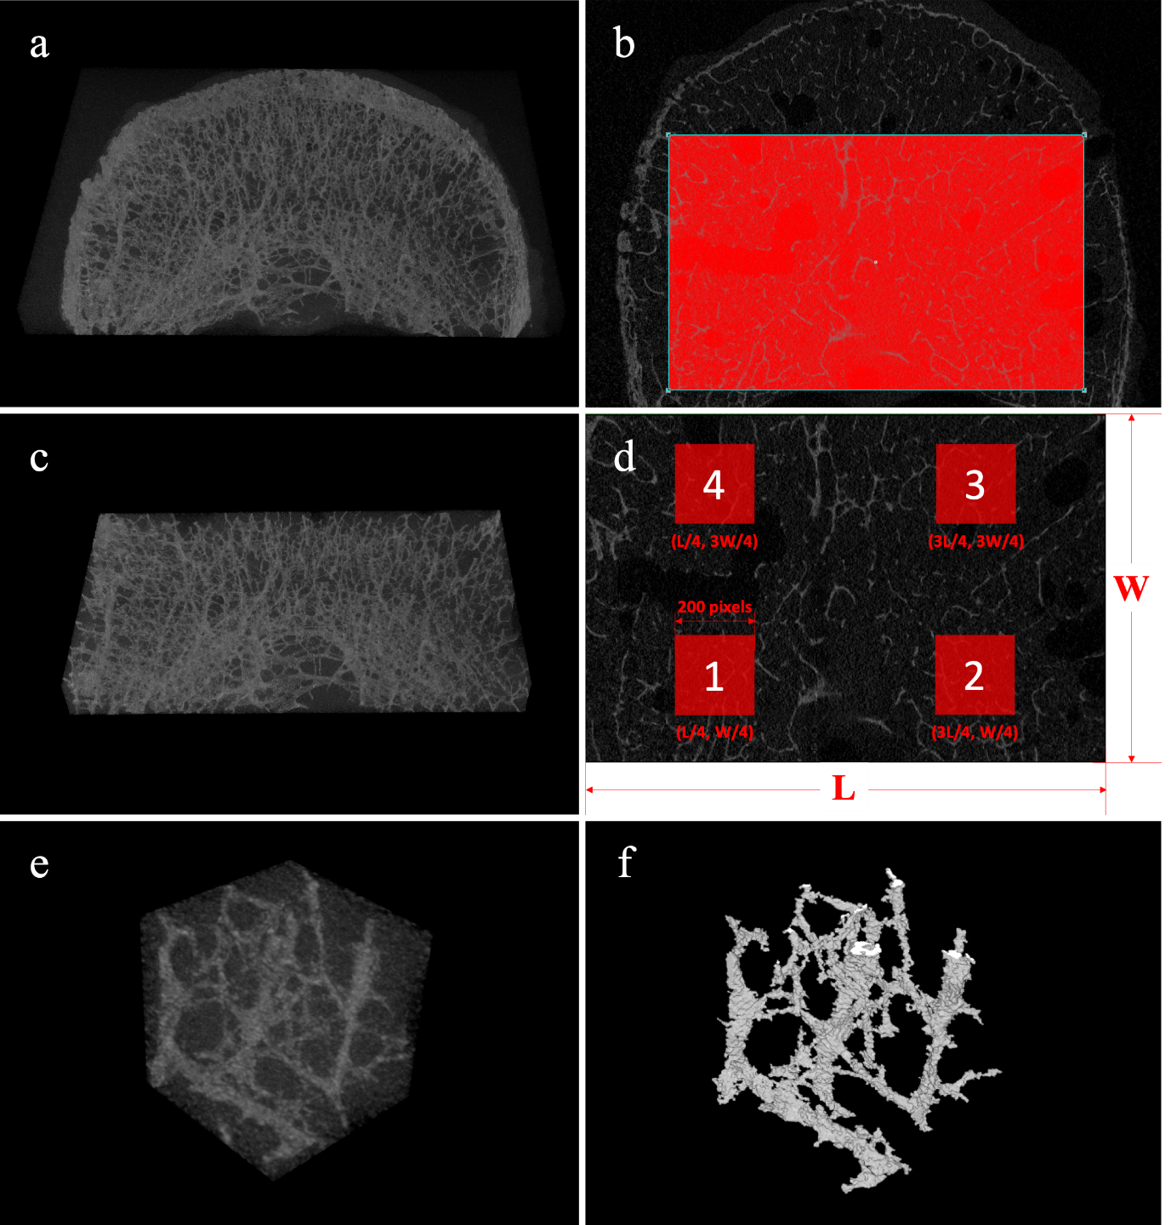
Fig. 1. Procedures to obtain trabecular bone specimens from µCT image data. a) VOI is a slab equivalent to 200 µCT slices from the midsection of each vertebral body. The slab was rotated so that the 3D trabecular struts can be shown clearly. b) A red rectangular mask on the slab for selecting a cuboid. The mask was kept away from the cortical bone so that only trabecular bone would be considered. c) The cuboid isolated from the slab according to the mask. The cuboid was rotated so that the network feature of trabecular bone is displayed clearly. d) Four cubic specimens were extracted from the cuboid through four square masks of side length 3.46 mm (200 pixels) at locations shown in parentheses. Length L and width W was not in proportion. The side length of four squares was not in proportion to length L. e) A cubic specimen was obtained. f) A segmented trabecular bone specimen was obtained after removing the bone marrow with a global BMD threshold of 311 mg/cm3.

Finite element analysis

Finite element models
Binarized µCT images of the segmented trabecular bone were used to build micro finite element (µFE) models through a customized code written in MATLAB (R2019a, MathWorks) that converted each voxel to an 8-node brick element. Fig. 2a shows the µFE model of a segmented trabecular bone specimen in which the superior and inferior nodes are marked in amber and blue, respectively. Fig. 2b shows the image of a 1 mm³ cubic volume at the centroid of the µFE model. In the figure, the brick elements can be seen clearly.
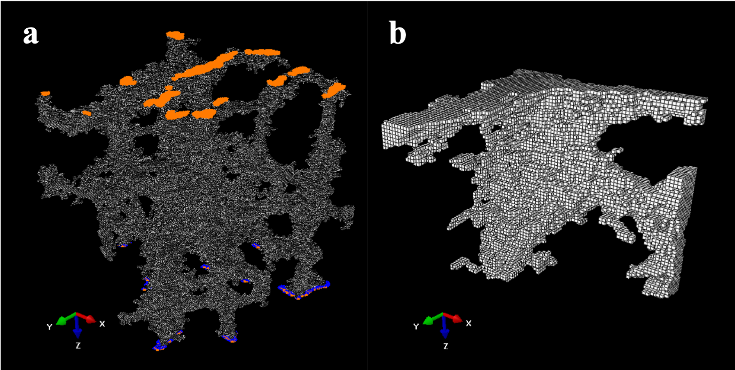
Fig. 2. a) A µFE model converted from the segmented trabecular bone specimen. The nodes in amber and blue are on the superior and inferior planes, respectively. b) A zoomed 1 mm³ volume from a) that shows the brick elements clearly.

Element type and solver
Abaqus/Standard (2018, Dassault) was employed for the static linear micro finite element analysis (µFEA). At 18 µm µCT resolution, the trabecular thickness is 4.64 ± 0.53 pixels computed from CTAn (Version 1.14.4.1, Bruker) which means there are at least 4 elements across the trabecular thickness. The average number of elements in the µFE models is around 1 million. To cope with the large number of elements, the 3D reduced-integrated 8-node hexahedral element (C3D8R in Abaqus/Standard) commonly used for large finite element model was selected. By default, artificial energy is employed to prevent the advent of the “hourglass” mode. Linear elastic isotropic material with elastic modulus 15 GPa and Poisson’s ratio 0.3 [25, 26, 30] was assumed in all elements.

Apparent and normalized apparent modulus of trabecular bone specimen
Linear elastic [32, 33] µFEA was adopted to determine the apparent modulus (E) and normalized apparent modulus (E*) of segmented trabecular bone specimen. Transversal displacements of the superior nodes (Fig. 2a) in the µFE models were restrained whilst longitudinal displacements, along the superior-inferior direction, were prescribed to be 3.46×0.8% mm such that structural strain (ε) was 0.8% [33]. Meanwhile, the inferior nodes were fully restrained [34]. Other nodes were free. These nodal displacement settings are consistent to the previously proposed experimental protocol [32, 33]. E was determined along the superior-inferior (𝑧) direction. The total reaction force (RF) was computed as the sum of the inferior nodal reaction forces in the longitudinal direction. E and E* were computed by the following equations:
$E=\frac{RF/A}{}$ (1)
$E^{*}=\frac{E}{BV/TV}$ (2)
where A = 3.46×3.46 mm is the cross-section area of cubic specimens and BV/TV is computed as the bone volume (BV) divided by the total volume (TV = 3.46³ mm³).

Statistical analysis
Shapiro-Wilk’s tests were employed to test the normality of the measured and computed quantities. Linear, power-law and exponential regressions were employed to analyze the correlation between E and BV/TV. Linear regression was performed between E* and BV/TV. The statistical significance level was set at 5%. All statistical analysis was performed using RStudio (Version 1.1.463, RStudio).

Ineffective bone mass (InBM) was defined as the bone mass contributing negligible loading resistance along the loading direction (superior-inferior). Based on the computed von Mises stress field in µFEA, InBM was represented by elements with von Mises stress less than a stress threshold to be determined. To quantify the portion of the InBM, low von Mises stress ratio (LS_{VM}R) was introduced, which was computed as the ratio of the number of InBM elements divided by the total number of elements.

To determine the optimal stress threshold, a two-stage incremental search was employed. Here, the optimal stress threshold was determined as the stress threshold that yields the highest coefficient of determination (R²) for the correlation between E* and LS_{VM}R in a given stress threshold interval. Both power-law and linear regressions were studied. With the initial search range taken to be 10 to 350 MPa, the optimal stress threshold was first searched using the coarse increment 10 MPa by evaluating LS_{VM}R and, thus, R² at the chosen stress thresholds. After narrowing the search range to 20 MPa, a fine search increment of 1 MPa was employed to locate the optimal stress threshold more accurately. Under the optimal stress threshold, the fitted power-law or linear regression model of E* against LS_{VM}R was illustrated, depending on which of the power-law and linear regressions has a higher R² value.

In addition to regression analyses between E and BV/TV, a linear regression between E and LS_{VM}R was performed. These simple regressions illustrated individual effects of BV/TV and LS_{VM}R on E, i.e. the separate contributions of BV/TV and LS_{VM}R to E. Furthermore, multiple linear regression of E against both BV/TV and LS_{VM}R was performed to illustrate their combined effect on E

Results
Statistics of the measured and computed quantities are shown in Table 1. Based on DXA diagnostic criteria, T-score results show that vertebrae varied from the normal to the osteoporotic [6] range have been included. The ratio of the maximum to the minimum number of elements among µFE models is 6.25. Computed BV/TVs from 4.04% to 25.01% with a mean of 13.56% are consistent with the reported range [26]. Mean E value of about 300 MPa is compatible with experimentally tested results [33]. E has a maximum to minimum ratio of 12.29 while E* has a much lower ratio of 4.77. Shapiro-Wilk’s normality tests show that both T-score and BV/TV are normally distributed. However, both E and E* do not follow the Gaussian distribution.

Table 1. Descriptive statistics of measured and computed quantities.
 | Mean (SD) | Minimum | Maximum | pª
T-score | -2.46 (1.31) | -4.4 | -0.1 | 0.4826
No. of Elements (Millions) | 1.08 (0.42) | 0.32 | 2 | 0.3287
BV/TV (%) | 13.56 (5.04) | 4.04 | 25.01 | 0.3287
E (MPa) | 299.89 (168.12) | 64.60 | 794.25 | 0.0009^{b}
Median of E (MPa) | 258.57
E* (GPa) | 2.20(0.84) | 1.04 | 4.96 | 0.0017^{b}
Median of E* (GPa) | 2.05
ªp-value of Shapiro-Wilk’s normality test. ^{b}Statistically significant at 5%.

Correlation between E and BV/TV
Significant correlations exist between E and BV/TV in both linear (Fig. 3a) and power-law (Fig. 3b) regressions. On the other hand, the exponential regression between E and BV/TV does not converge. Compared to linear regression model (R² = 0.48), BV/TV can explain 11% more of the variation in E using the power-law regression model (R² = 0.59). Even though BV/TV can account for around 60% of the variation in apparent modulus, around 40% of the variation is unexplained. In contrast to E, E* shows no significant correlation (p = 0.75) with BV/TV due to the normalization as seen in Fig. 4.

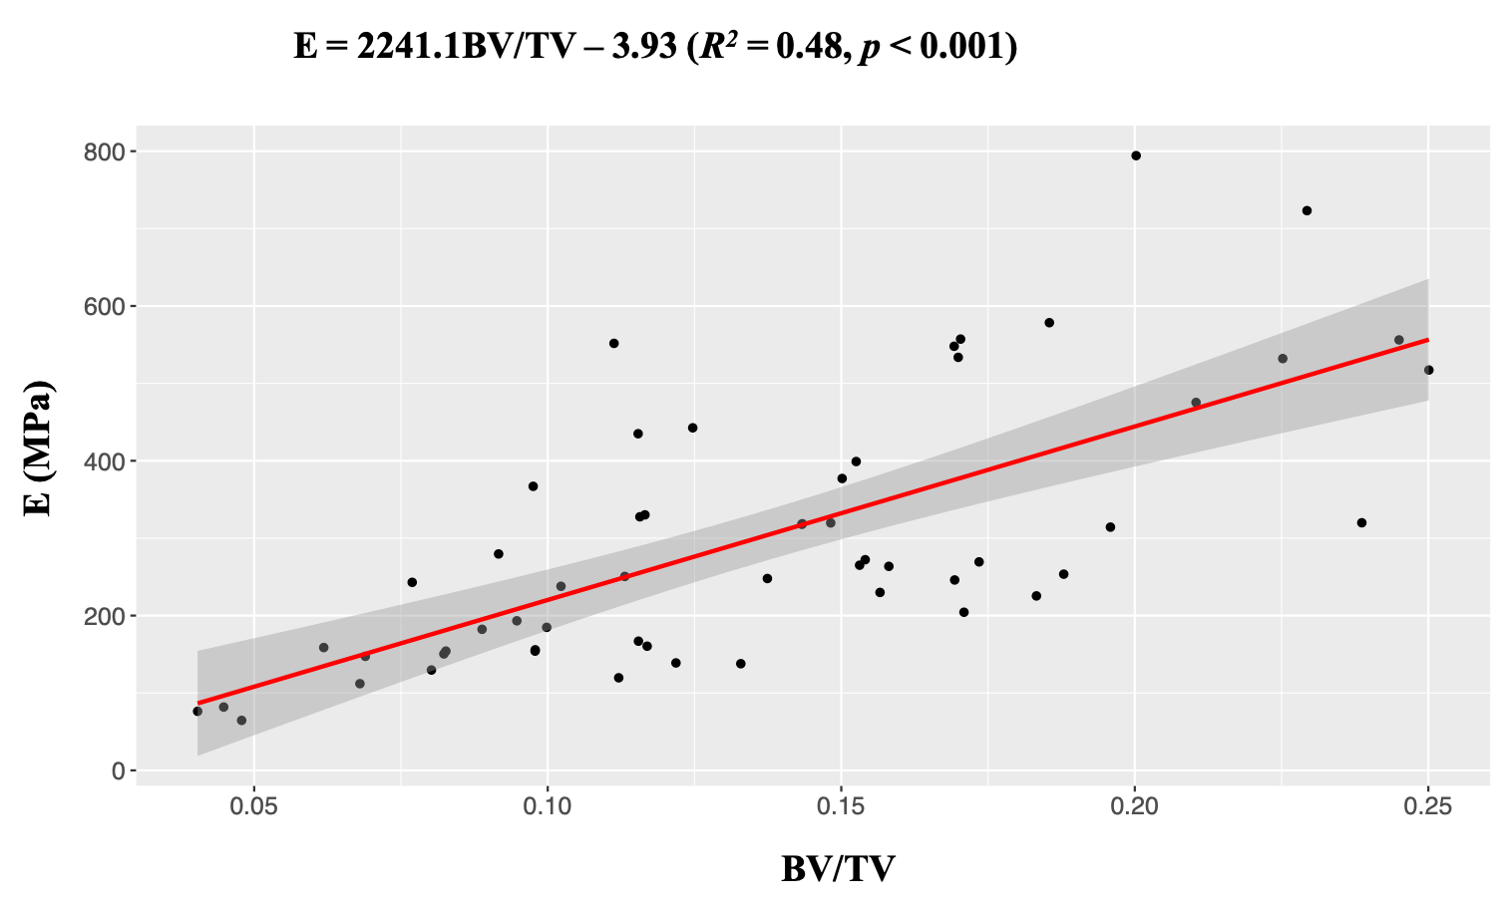
Fig. 3a. Linear regression model between the apparent modulus of trabecular bone (E) and the bone volume fraction (BV/TV). E values were computed from 56 µFE models reconstructed from 14 cadaveric vertebral bodies (L1 to L5). BV/TV values were computed as the bone volume divided by the total volume. A significant positive correlation was found. The red line is the fitted linear regression model and the shaded area is the 95% confidence interval region.

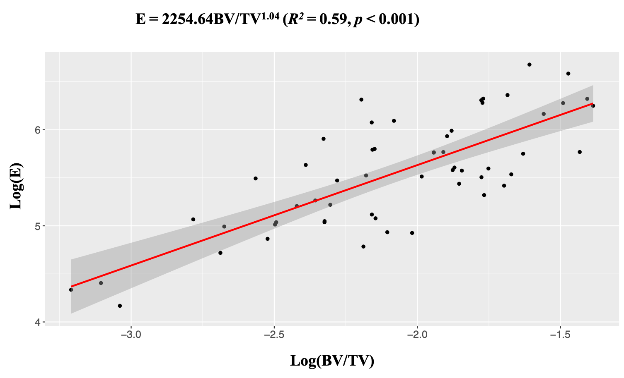
Fig. 3b. Power-law regression model between the apparent modulus of trabecular bone (E) and the bone volume fraction (BV/TV). E values were computed from 56 µFE models reconstructed from 14 cadaveric vertebral bodies (L1 to L5). BV/TV values were computed as bone volume divided by total volume. A significant positive correlation was found. The red line is the fitted power-law regression model and the shaded area is the 95% confidence interval region.

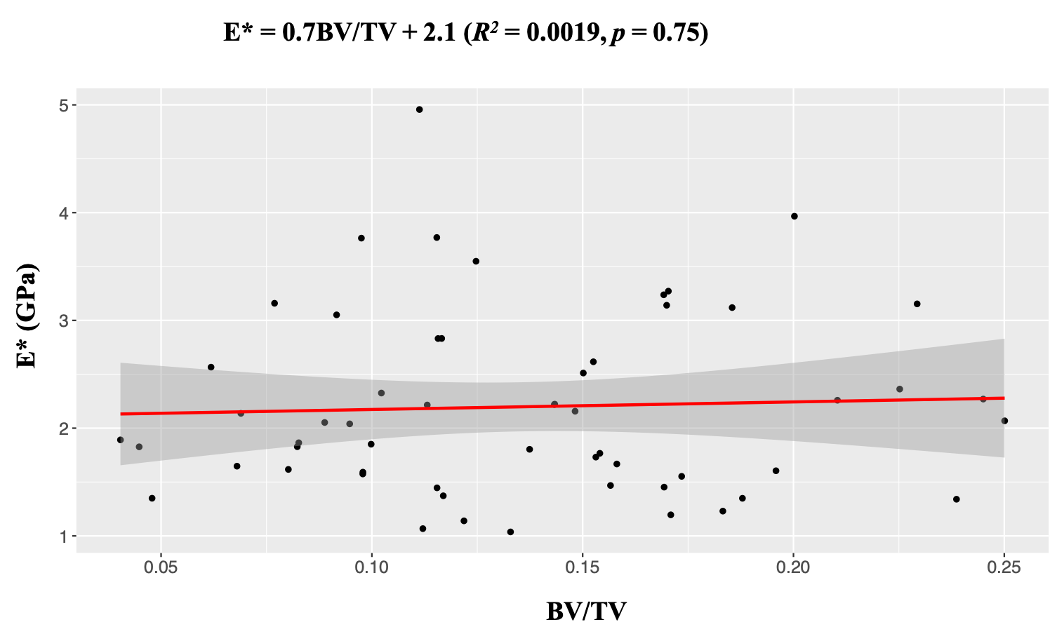
Fig. 4. Linear regression model between the normalized apparent modulus of trabecular bone (E*) and the bone volume fraction (BV/TV). E* equals E/(BV/TV) and E values were computed from 56 µFE models reconstructed from 14 cadaveric vertebral bodies (L1 to L5). BV/TV values were computed as the bone volume divided by the total volume. No significant correlation was found. The red line is the fitted linear regression model and the shaded area is the 95% confidence interval region.

Optimal stress threshold and robustness of LS_{VM}R
The optimal stress threshold was first searched from 10 to 350 MPa using the coarse search increment 10 MPa. For the linear regression, R² increases monotonically from 10 to 60 MPa and then decreases monotonically. The search range was narrowed to be 50 to 70 MPa and the search increment was reduced to 1 MPa. For the power-law regression, R² increases monotonically from 10 to 40 MPa and then decreases monotonically. The search range was narrowed to be 30 to 50 MPa and the search increment was reduced to 1 MPa. Some of the search results using the 10 MPa coarse search increment are listed in Table 2 for both regressions. Some of the search results using the 1 MPa fine search increment for the linear regression are listed in Table 3. Stress thresholds of 58, 59 and 60 MPa all yield the highest R² of 0.9888. Using the 1 MPa fine search increment for the power-law regression, the optimal stress threshold for the power-law regression is 38 MPa with R² equal to 0.9291. Since the linear regression yields higher R² values, the stress threshold given by the linear regression model would be adopted from here onwards. Within the large stress threshold range 50~70 MPa in Table 3, R² is always above 0.985. Thus, LS_{VM}R is robust for interpreting E*. Here, “robustness” means the significant correlation can be maintained when the stress threshold varies in the vicinity of the chosen optimal stress threshold. Besides, the slope (b value) is stable with the coefficient of variation (CV) to be 0.10 in a large threshold range of 20 MPa in linear regression.

Table 2. Partial regression results bounding the optimal stress thresholds when the 10 MPa coarse stress threshold increment was adopted.
Stress | E* = a + b × LS_{VM}R |  |  | E* = a × (LS_{VM}R)^{b}
thresholds (MPa) | b | R² | p | b | R² | p
30 | -8.02 | 0.9324 | < 0.001ª | -2.1217 | 0.9216 | < 0.001ª
40 | -8.84 | 0.9694 | < 0.001ª | -2.6090 | 0.9289 | < 0.001ª
50 | -10.11 | 0.9854 | < 0.001ª | -3.2060 | 0.9197 | < 0.001ª
60 | -12.01 | 0.9888 | < 0.001ª | -4.0280 | 0.9053 | < 0.001ª
70 | -14.85 | 0.9863 | < 0.001ª | -5.2158 | 0.8937 | < 0.001ª
ªStatistically significant at 5%.
Shaded area outlines the search intervals for the 1 MPa fine stress threshold increment.

Table 3. Partial linear regression results bounding the optimal stress thresholds when the 1 MPa fine stress threshold increment was adopted.
Stress | E* = a + b × LS_{VM}R
thresholds (MPa) | b | R² | p
56 | -11.15 | 0.9885 | < 0.001ª
57 | -11.35 | 0.9887 | < 0.001ª
58 | -11.56 | 0.9888 | < 0.001ª
59 | -11.78 | 0.9888 | < 0.001ª
60 | -12.01 | 0.9888 | < 0.001ª
61 | -12.25 | 0.9887 | < 0.001ª
62 | -12.50 | 0.9886 | < 0.001ª
ªStatistically significant at 5%.
Shaded area outlines the optimal thresholds identified by the 1 MPa stress threshold increment.

Correlation analysis between E* and LS_{VM}R under the optimal stress threshold
The optimal stress threshold was found in the interval of 58~60 MPa for the linear regression. Hereafter, 59 MPa was taken to be the stress threshold with which the significant (p < 0.001) negative (-11.782) correlation could be noted between E* and LS_{VM}R (Fig. 5). R² (0.988) indicates that E* values decrease linearly with increasing LS_{VM}R.

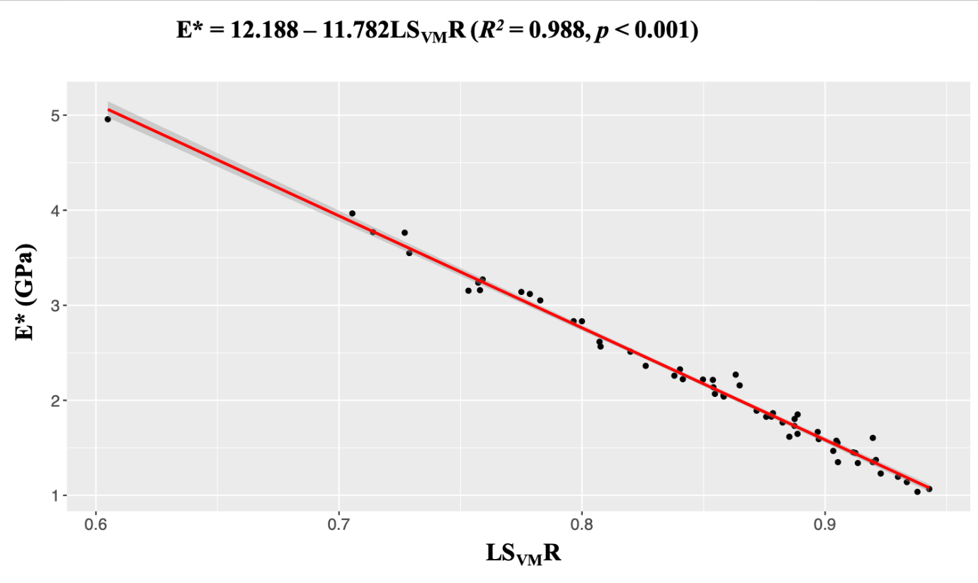
Fig. 5. Linear regression model between the normalized apparent modulus of trabecular bone (E*) and low von Mises stress ratio (LS_{VM}R). E* equals E/(BV/TV). LS_{VM}R values were computed from the von Mises stress predictions in the µFEA using 59 MPa as the stress threshold. The data were based on 56 µFE models from 14 cadaveric vertebral bodies (L1 to L5). A significant negative correlation was found, indicating that E* values decrease linearly with increasing LS_{VM}R. The shaded area is the 95% confidence interval region.

Effective bone mass of two μFE models
Among the 56 μFE models, a pair of models with the closest BV/TV values (the difference is less than 3%) was chosen to illustrate that their LS_{VM}Rs and effective bone mass can differ significantly (Fig. 6). Information on the two models is listed in Table 4. Though two models possess approximately the same BV/TV, E and E* values of model B are three times larger than those of model A. Not surprisingly, with the significant negative correlation demonstrated in Fig. 5, LS_{VM}R of model B is considerably less than that of model A and may explain the large differences in E and E*. In addition to the higher LS_{VM}R, model A also has a more scattered effective bone mass than that of model B (Fig. 6a-2 and Fig. 6b-2). Though massive supporting pillars are seen in the effective bone mass of model B (Fig. 6b-2), SMI of model B computed by CTAn (Version 1.14.4.1, Bruker) is lower than that of model A, indicating that model B is more plate-like than model A (SMI equals 0 for an ideal plate structure and 3 for an ideal rod structure [35, 36]).

Table 4. Information of two μFE models with close BV/TV.
 | A | B
BV/TV (%) | 11.21 | 11.54
E (MPa) | 119.65 | 434.97
E* (GPa) | 1.07 | 3.77
LS_{VM}R | 0.9428 | 0.7140
SMI | 1.73 | 1.38

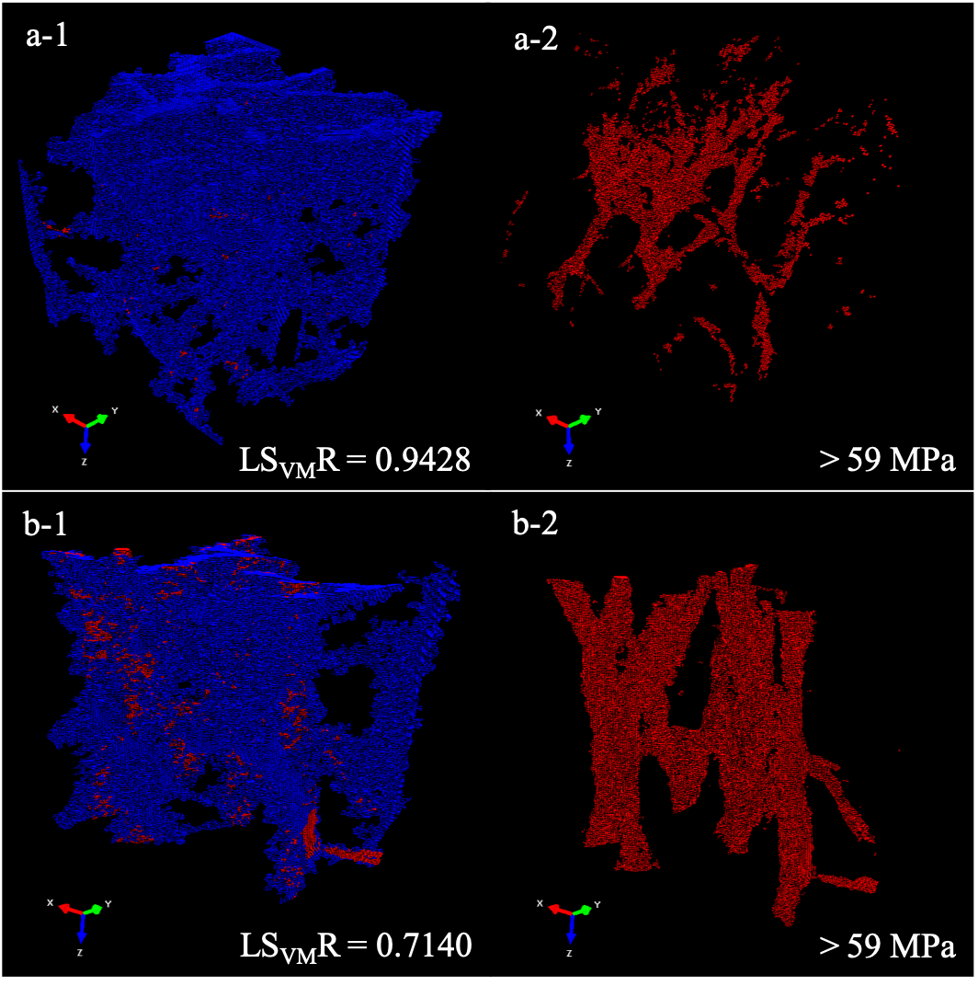
Fig. 6. The von Mises stress results of two µFE models A and B subject to 0.8% superior-inferior strain loadings. Model A (the upper) and model B (the lower) possess almost identical BV/TV (11.21% and 11.54%, respectively) but significantly different E (119.65 and 434.97 MPa, respectively) and E* (1.07 and 3.77 GPa, respectively). In a-1 and b-1, elements with von Mises stress less and greater than 59 MPa are in blue and red, respectively. For clearer distributions of the latter elements, the former elements have been removed in a-2 and b-2. The elements in blue are regarded as the ineffective portion of bone mass for resisting the load. Accordingly, the LS_{VM}R of model A is larger than that of model B.

Correlation analysis between LS_{VM}R and SMI
The linear and power-law regression analyses between LS_{VM}R and SMI yield R² values of 0.20 and 0.22, respectively. The significant (p < 0.001) positive (0.72) correlation (Fig. 7) indicates that LS_{VM}R increases with increasing SMI. Thus, a more rod-like structure would give a higher LS_{VM}R value whilst a more plate-like structure would give a lower LS_{VM}R.

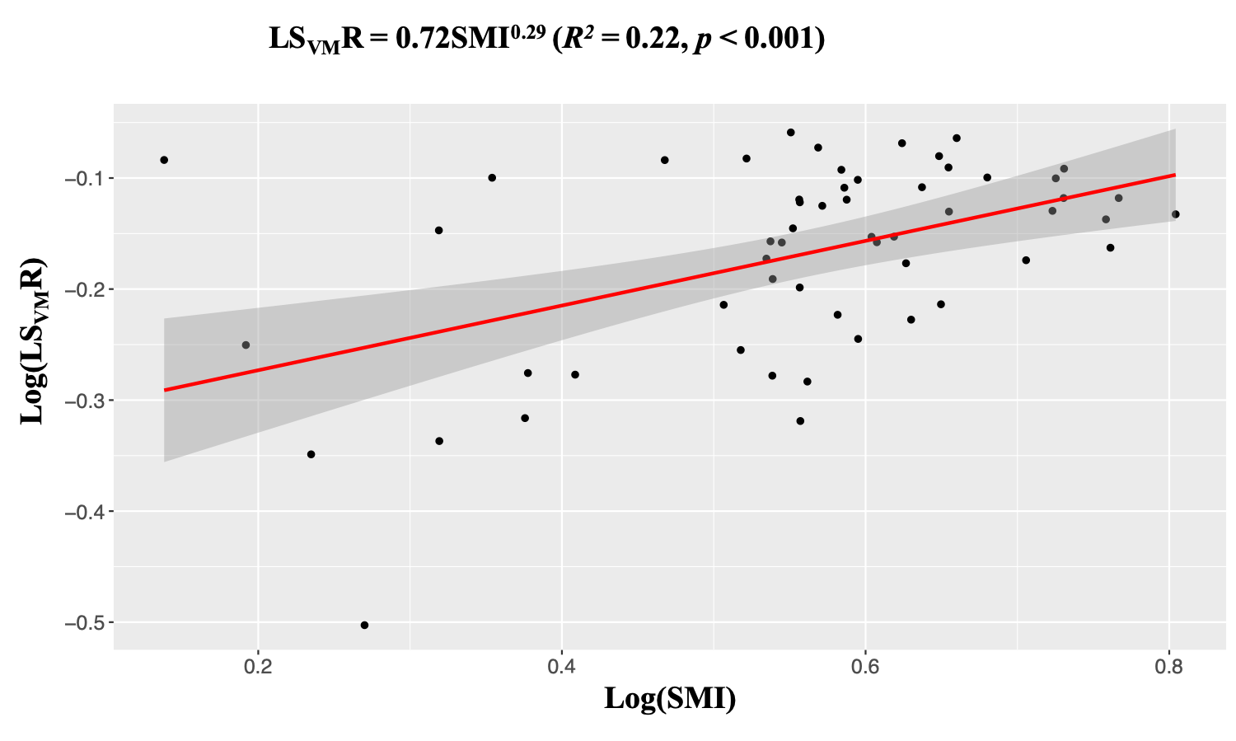
Fig. 7. Power-law regression model between LS_{VM}R and SMI for 56 µFE models from 14 cadaveric vertebral bodies (L1 to L5). LS_{VM}R values were computed from the von Mises stress results of µFEA under the threshold of 59 MPa. Quantitatively, LS_{VM}R was computed as the ratio of the number of elements with von Mises stress less than 59 MPa to the total number of elements in the µFE model. SMI values were computed from the binarized trabecular bone specimens using CTAn (Version: 1.14.4.1, Bruker). The regression model shows that LS_{VM}R increases with increasing SMI. The shaded area is the 95% confidence interval region.

  - Correlation analysis of E against BV/TV and LS_{VM}R
The apparent modulus E is determined by BV/TV and microarchitecture with homogenous material properties assumed. In addition to linear and power-law regressions between E and BV/TV (Fig. 3a and Fig. 3b, respectively), a linear regression between E and LS_{VM}R is performed (Fig. 8). While BV/TV improves the apparent trabecular modulus, the significant (p < 0.001) negative (-1647.1) correlation between E and LS_{VM}R implies that LS_{VM}R deteriorates the apparent modulus of trabecular bone. Besides simple linear regressions, multiple linear regression of E against both BV/TV and LS_{VM}R was further analyzed. Both simple and multiple linear regression results are given in Table 5. From the table, BV/TV can account for about 10% more of the variation in E than LS_{VM}R. With both determinants considered, 95% of the variation in E can be explicated.

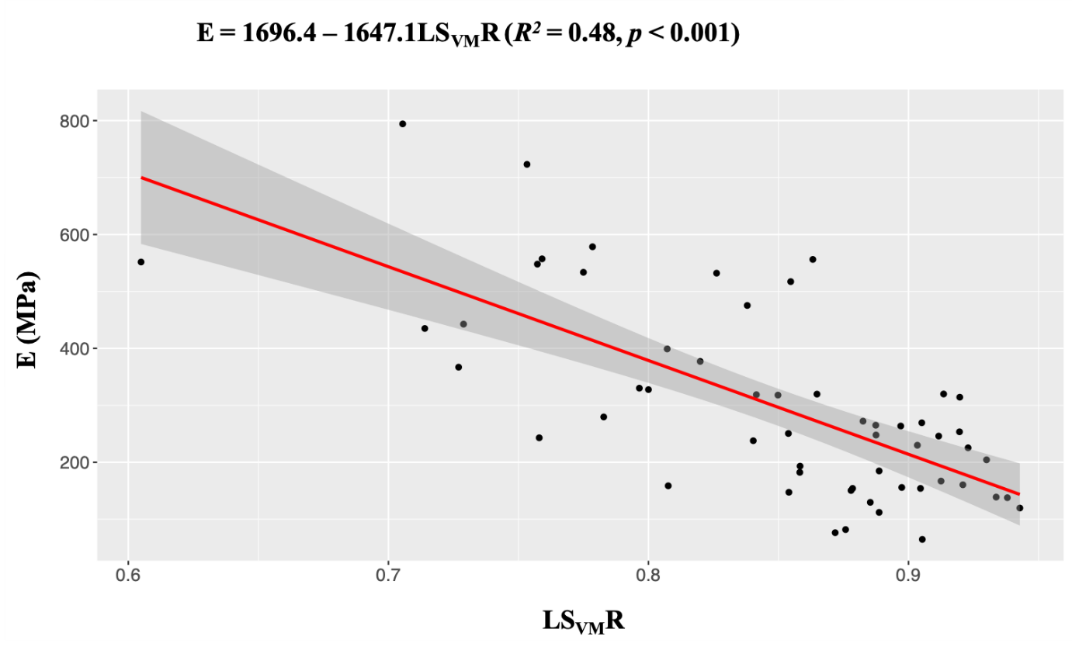
Fig. 8. Linear regression between the apparent modulus (E) and the low von Mises stress ratio (LS_{VM}R). E values were computed using 56 µFE models from 14 cadaveric vertebral bodies. LS_{VM}R values were computed from von Mises stress results of µFEA under the threshold of 59 MPa. Quantitatively, LS_{VM}R was computed as the ratio of the number of elements with von Mises stress less than 59 MPa to the total number of elements in the µFE model. A significant negative correlation was found, which indicates the increased LS_{VM}R could lead to a decrease of E. The shaded area is the 95% confidence interval region.

Table 5. Simple and multiple regressions of E against BV/TV and LS_{VM}R.
Regressions | R² | p
Linear regression: E ~ BV/TV | 0.4787 | < 0.001ª
Power-law regression: E ~ BV/TV | 0.5905 | < 0.001ª
Linear regression: E ~ LS_{VM}R | 0.4775 | < 0.001ª
Multiple linear regression: E ~ BV/TV + LS_{VM}R | 0.9486(adjusted) | < 0.001ª
ªStatistically significant at 5% significance.

Discussion
Previous studies reported that bone mass alone can explain up to 60% mechanical competence of the trabecular bone [11, 14, 19, 37]. Clinically, the BMD overlaps from fracture and non-fracture patients have made a strong request for a more comprehensive bone strength evaluation than BMD. Since the first lattice network model proposed [12], trabecular continuity [15], orientation [13] and connectivity [14, 17, 18] have been experimentally or clinically demonstrated to be important contributors to bone mechanical competence. Morphological and topological analyzes further explored the relative contribution of trabecular rods and plates to the apparent modulus of trabecular bone [11, 16, 25-27, 30]. However, there were few mechanical parameters used to quantify the microarchitecture effect on the apparent modulus E. Since modulus is a mechanical quantity, we propose a novel mechanical parameter to quantify this effect. In this regard, high-resolution µFEA was employed to calculate E with boundary conditions identical to the reported experimental setting [32, 33]. E* obtained from normalizing E with BV/TV was found to be independent of BV/TV and, thus, the explanatory parameter to E* can be employed to quantify the microarchitecture effect on E. Physically, E* can be interpreted as a measure of the modulus per unit bone volume BV with the total volume TV used as a factor to restore the dimension of E* to that of E. Based on von Mises stress, we proposed a novel mechanical parameter LS_{VM}R which quantifies the ratio of the ineffective bone mass in load-resistance to the total bone mass. The significant correlation (R² = 0.988, p < 0.001) between E* and LS_{VM}R indicates that LS_{VM}R can explain the variation of E*, thus, may be used to quantify the microarchitecture effect on E. The significant correlation (R² = 0.48, p < 0.001) between E and LS_{VM}R justifies LS_{VM}R can be the appropriate mechanical parameter we aimed to find. Clinically, this simple but physically meaningful parameter can be conveniently adopted for screening patients against high fracture risk.

As expected, E significantly (p < 0.001) correlates to BV/TV. Our mean BV/TV of 13.6% is close to the value 10.5% reported by Liu et al [26]. Using the consistent loading conditions, our E values obtained from μFEA are in agreement with the reported experimental results [33]. However, our mean E value 300 MPa was less than half of the reported value 673 MPa from μFEA obtained by Liu et al [26]. While Liu et al demonstrated that BV/TV was a significant contributor to E with a power-law regression (R² = 0.78, p < 0.001) [25], our study also showed a significant (p < 0.001) correlation between E and BV/TV but with a lower R² value 0.59. The differences in the mean E and R² values are probably due to the difference of the applied nodal displacement constraints in the μFEA. All nodes away from the superior and inferior planes are allowed to move freely in our study and this is consistent to the experimental conditions [33] while the nodes can move only along the loading direction in the study of Liu et al. Noteworthily, our R² was consistent with previous observations of no more than 60% of mechanical variation can be explained by bone mass [11, 13, 14, 19, 38].

It is worth noting that the explanation power of LS_{VM}R to E* was robust to the stress threshold. With the coarse 10 MPa search increment, the correlations between E* and LS_{VM}R were kept significant (p < 0.001) in the stress threshold range of 10 to 300 MPa. In the narrowed stress threshold range of 50~70 MPa with a fine search increment of 1 MPa, R² values were always greater than 0.985. Therefore, LS_{VM}R was a robust parameter to interpret E*. Besides, it is also worth mentioning the significant (p < 0.001) positive (0.72) correlation (Fig. 7) between LS_{VM}R and SMI. This indicates that the ineffective bone mass portion in trabecular plates is less than that in trabecular rods. In other words, trabecular plates are more effective in resisting loads, thus, can contribute more to the apparent modulus. This result is consistent with the report of Liu et al that trabecular plates make a greater contribution to the apparent modulus of trabecular bone than trabecular rods [25].

LS_{VM}R has the clinical potential to complement the DXA-based BMD test for screening patients with high fracture risk. All trabecular specimens have a side length of 3.46 mm which leads to the same projection area in DXA. Therefore, any two specimens with the same BV/TVs have the same bone volume and, thus, a similar amount of bone mineral content. As a result, DXA would give similar BMD and T-score values for these two specimens. However, as illustrated in Table 4 and Fig. 6, models A and B with similar BV/TV have markedly different apparent moduli so that their mechanical behaviors are significantly distinct. Based on the yielding strain criterion for fracture risk assessment in linear [34, 39] or nonlinear (bilinear) [30, 40, 41] stress-strain relation, model A with lower modulus would be evaluated as being at a higher risk of yield and thus a higher fracture risk. The fracture risk can be explained by LS_{VM}R. Model A has a larger LS_{VM}R, which means a higher portion of bone mass does not play the role of load-resistance. Therefore, model A has a higher fracture risk even though it possesses a similar amount of bone volume as model B. Generally, LS_{VM}R represents the portion of mechanically “cumbersome” bone mass that actually cannot play an effective role in supporting the applied load. However, these bone masses were treated equally in DXA BMD calculation. Our LS_{VM}R parameter can consider static fracture but not necessarily fatigue fracture under daily cyclic loading. Ashley et al demonstrated that transversely oriented struts could enhance structure fatigue life even though they have negligible effects on stiffness and strength [42]. This means that patients with deteriorated transverse trabecular struts are at a high risk of fatigue fracture, irrespective of BMD values. However, those transverse struts may be regarded as the ineffective bone mass in the LS_{VM}R calculation. Therefore, it is imperative to consider both the static and fatigue loadings in assessing trabecular bone quality.

Despite the findings, there are several limitations in this study. First, the number of subjects was limited. The 14 cadaveric vertebrae were obtained from only 4 subjects. Therefore, there may exist the problem of weak sample representation. Second, the 3.46×3.46×3.46 mm specimen size may not be large enough. However, many microarchitecture studies used a specimen size in the range of 3×3×3 mm to 5×5×5 mm [25, 26, 30] and the normal distribution of BV/TV further confirms the representativeness of our specimens. Therefore, the results should not vary significantly even if larger specimen size was adopted. Third, the segmentation of bone from bone marrow was not perfect. We used the global thresholding technique commonly used in previous studies to binarize µCT images [25, 26, 30, 31]. Even though this technique may not be perfect for segmenting bone from bone marrow, the results should be acceptable since the µCT has a high resolution of 18 µm which has been higher than those used in the previous studies [25, 26, 30, 31]. Furthermore, all specimens were segmented with the same gray threshold so that the segmentation will not change the correlation. Fourth, the isolated voxels were removed before converting the binarized images to micro finite element models. This procedure could artificially reduce BV/TV values. However, the error should be small since the eliminated voxels were mainly on the boundary due to the image coring process from the vertebral body. Even though this process could introduce small errors, the relationship between E/E* and BV/TV will not change since all samples undergo the same process. Removal of the isolated voxels is also necessary for the following µFEA work. Otherwise, the numerical analysis cannot be done successfully. Fifth, this study was based on µCT scans at 18 µm resolution which may hinder its application to clinical diagnosis. Fortunately, high-resolution (82 µm isotropic resolution) peripheral quantitative computed tomography (HR-pQCT) has been widely studied and clinically applied in radius and tibia structural analysis and fracture risk predictions on femoral and lumbar vertebral failures [43-47].

Conclusions
Under the hypothesis that the bone volume fraction BV/TV and the microarchitecture are the major contributing factors to the apparent modulus of trabecular bone E, this study first revealed that the normalized apparent modulus E* (= E/(BV/TV)) is independent of BV/TV. Thus, E* should be affected by the microarchitecture only and the explanatory parameter to E* could help quantify the microarchitecture effect on E. In the search of the optimal stress threshold below which bone will be classified as ineffective, LS_{VM}R was noted to be a robust explanatory parameter to E*. From the significant correlation between E and LS_{VM}R, it can be concluded that LS_{VM}R could be adopted as the mechanical parameter to quantify the microarchitecture effect on the apparent modulus of trabecular bone.

Declaration of competing interest
None.

Acknowledgements
Funding: This work was supported by Theme-based Research Scheme (TRS), The Research Grants Council, Hong Kong [grant number: T13-402/17-N]. The funding agency had no role in the design and conduct of the study; in the collection, analysis and interpretation of the data: or in the preparation, review, or approval of the manuscript.

The authors would like to thank Chi Hong Liu in the Department of Orthopaedics and Traumatology, The University of Hong Kong for his work on micro-CT scanning and assistance on micro-CT image processing.

References:
1. NIH, Osteoporosis Overview. 2018.
2. Consensus development conference. Diagnosis, prophylaxis and treatment of osteoporosis. American journal of medicine, 1993. 94: p. 646-50.
3. ASBMR, Call to action to address the crisis in the treatment of osteoporosis, in ASBMR 2016 Annual Meeting. 2016: Atlanta,Geogia,USA. .
4. Kanis, J.A., et al., Long-term risk of osteoporotic fracture in Malmö. Osteoporos Int, 2000. 11(8): p. 669-674.
5. Johnell, O. and J. Kanis, An estimate of the worldwide prevalence and disability associated with osteoporotic fractures. Osteoporos Int, 2006. 17(12): p. 1726-1733.
6. Kanis, J.A., et al., A reference standard for the description of osteoporosis. Bone, 2008. 42(3): p. 467-475.
7. Shepherd, J.A. and G.M. Blake, T-scores and Z-scores. Journal of Clinical Densitometry, 2007. 10(4): p. 349-350.
8. Greenspan, S.L., et al., Fall severity and bone mineral density as risk factors for hip fracture in ambulatory elderly. JAMA, 1994. 271(2): p. 128-133.
9. Schuit, S.C.E., et al., Fracture incidence and association with bone mineral density in elderly men and women: the Rotterdam Study. Bone, 2004. 34(1): p. 195-202.
10. Cosman, F., et al., Spine fracture prevalence in a nationally representative sample of US women and men aged ≥40 years: results from the National Health and Nutrition Examination Survey (NHANES) 2013-2014. Osteoporos Int, 2017. 28(6): p. 1857-1866.
11. Wehrli, F.W., et al., Digital topological analysis of in vivo magnetic resonance microimages of trabecular bone reveals structural implications of osteoporosis. Journal of Bone and Mineral Research, 2001. 16(8): p. 1520-1531.
12. Jensen, K. and L. Mosekilde, A model of vertebral trabecular bone architecture and its mechanical properties. Bone, 1990(11): p. 417-423.
13. Oden, Z.M., et al., The Effect of trabecular structure on DXA-based predictions of bovine bone failure. Calcif Tissue Int, 1998. 63(1): p. 67-73.
14. Gordon, C.L., C.E. Webber, and P.S. Nicholson, Relation between image-based assessment of distal radius trabecular structure and compressive strength. Canadian Association of Radiologists journal = Journal l'Association canadienne des radiologistes, 1998. 49(6): p. 390-397.
15. Mosekilde, L., L. Mosekilde, and C.C. Danielsen, Biomechanical competence of vertebral trabecular bone in relation to ash density and age in normal individuals. Bone, 1987. 8(2): p. 79-85.
16. Kleerekoper, M., et al., The role of three-dimenstional trabecular microstructure in the pathogenesis of vertebral compression fractures. Calcif Tissue Int, 1985. 37: p. 594-597.
17. Recker, R., Architecture and vertebral fracture. Calcif Tissue Int, 1993. 53: p. S139-S142.
18. Legrand, E., et al., Trabecular bone microarchitecture, bone mineral density, and vertebral fractures in male osteoporosis. Journal of Bone and Mineral Research, 2000. 15(1): p. 13-19.
19. Siffert, R.S., et al., Dynamic relationships of trabecular bone density, architecture, and strength in a computational model of osteopenia. Bone, 1996. 18(2): p. 197-206.
20. Weinans, H., R. Huiskes, and H.J. Grootenboer, The behavior of adaptive bone-remodelling simulation models. J Biomechanics, 1992. 25(12): p. 1425-1441.
21. Mullender, M.G., R. Huiskes, and H. Weinans, A physiological approach to the simulation of bone remodelling as a self-organizational control process. J Biomechanis, 1994. 27(11): p. 1389-1394.
22. Müller, R., Long-term prediction of three-dimensional bone architecture in simulations of pre-, peri- and post-menopausal microstructural bone remodeling. Osteoporos Int, 2005. 16(2): p. S25-S35.
23. Saha, P.K., B.R. Gomberg, and F.W. Wehrli, Three‐dimensional digital topological characterization of cancellous bone architecture. International Journal of Imaging Systems and Technology, 2000. 11(1): p. 81-90.
24. Gomberg, B., et al., Application of topological analysis to magnetic resonance images of huaman trabecular bone. IEEE Trans Med Imaging, 2000. 19: p. 166-174.
25. Liu, X.S., et al., Quantification of the roles of trabecular microarchitecture and trabecular type in determining the elastic modulus of human trabecular bone. Journal of Bone and Mineral Research, 2006. 21(10): p. 1608-1617.
26. Liu, X., et al., Complete volumetric decomposition of individual trabecular plates and rods and its morphological correlations with anisotropic elastic moduli in human trabecular bone. J. Bone Miner. Res., 2008. 23(2): p. 223-235.
27. Stauber, M., et al., Importance of individual rods and plates in the assessment of bone quality and their contribution to bone stiffness. Journal of Bone and Mineral Research, 2006. 21(4): p. 586-595.
28. Stauber, M. and R. Müller, Volumetric spatial decomposition of trabecular bone into rods and plates—A new method for local bone morphometry. Bone, 2006. 38(4): p. 475-484.
29. Stauber, M. and R. Müller, Age-related changes in trabecular bone microstructures: global and local morphometry. Osteoporos Int, 2006. 17(4): p. 616-626.
30. Liu, X.S., et al., Micromechanical analyses of vertebral trabecular bone based on individual trabeculae segmentation of plates and rods. Journal of Biomechanics, 2009. 42(3): p. 249-256.
31. Yamada, S., et al., Correlation between vertebral bone microstructure and estimated strength in elderly women: An ex-vivo HR-pQCT study of cadaveric spine. Bone, 2019. 120: p. 459-464.
32. Keaveny, T.M., et al., Trabecular bone exhibits fully linear elastic behavior and yields at low strains. Journal of Biomechanics, 1994. 27(9): p. 1127-1136.
33. Kopperdahl, D.L. and T.M. Keaveny, Yield strain behavior of trabecular bone. Journal of Biomechanics, 1998. 31(7): p. 601-608.
34. Crawford, R.P., C.E. Cann, and T.M. Keaveny, Finite element models predict in vitro vertebral body compressive strength better than quantitative computed tomography. Bone, 2003. 33(4): p. 744-750.
35. Hildebrand, T. and P. Ruegsegger, Quantification of bone microarchitectrue with the structure model index. Comp Meth Biomech BIomed Eng, 1997(1): p. 15-23.
36. Hildebrand, T., et al., Direct three-dimensional morphometric analysis of human cancellous bone: microstructural data from spine, femur, iliac crest, and calcaneus. Journal of bone and mineral research : the official journal of the American Society for Bone and Mineral Research, 1999. 14(7): p. 1167-1174.
37. Goldstein, S., R. Goulet, and D. McCubbrey, Measurement and significance of three-dimensional architecture to the mechanical integrity of trabecular bone. Calcif Tissue Int, 1993. 53.
38. Rice, J., S. Cowinc, and J. Bowman, On the dependence of the elasticity and strength of cancellous bone on apparent density. J Biomech, 1988(21): p. 155-168.
39. Bessho, M., et al., Prediction of strength and strain of the proximal femur by a CT-based finite element method. Journal of Biomechanics, 2007. 40(8): p. 1745-1753.
40. Niebur, G.L., et al., High-resolution finite element models with tissue strength asymmetry accurately predict failure of trabecular bone. Journal of Biomechanics, 2000. 33(12): p. 1575-1583.
41. Imai, K., Analysis of vertebral bone strength, fracture pattern, and fracture location: a validation study using a computed tomography-based nonlinear finite element analysis. Aging and disease, 2015. 6(3): p. 180-187.
42. Torres, A.M., et al., Bone-inspired microarchitectures achieve enhanced fatigue life. Proceedings of the National Academy of Sciences of the United States of America, 2019. 116(49): p. 24457-24462.
43. Silveira, F., et al., Reproducibility of high-resolution periphjeral quantitative computed tomography (HR-pQCT) measurements in women with noraml BMD and postmenopausal women with osteoporosis. Osteoporosis Int., 2011. 22: p. 43-44.
44. Ural, A., et al., A new fracture assessment approach coupling HR-pQCT imaging and fracture mechanics-based finite element modeling. Journal of Biomechanics, 2013. 46(7): p. 1305-1311.
45. Nishiyama, K., et al., Women with previous fragility fractures can be classified based on bone microarchitecture and finite element analysis measured with HR-pQCT. Osteoporos Int, 2013. 24(5): p. 1733-1740.
46. Kawalilak, C., et al., Characterizing microarchitectural changes at the distal radius and tibia in postmenopausal women using HR-pQCT. Osteoporosis International, 2014. 25(8): p. 2057-66.
47. Kroker, A., et al., Distal skeletal tibia assessed by HR-pQCT is highly correlated with femoral and lumbar vertebra failure loads. Journal of Biomechanics, 2017. 59: p. 43-49.

